**Introduction of JavaScript**

1. **Basic Structure of html, css & JavaScript (info-class-01.html)**

Introduction of “html + css + js”

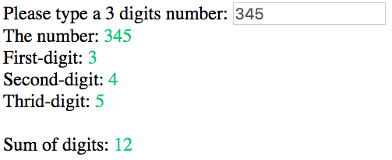

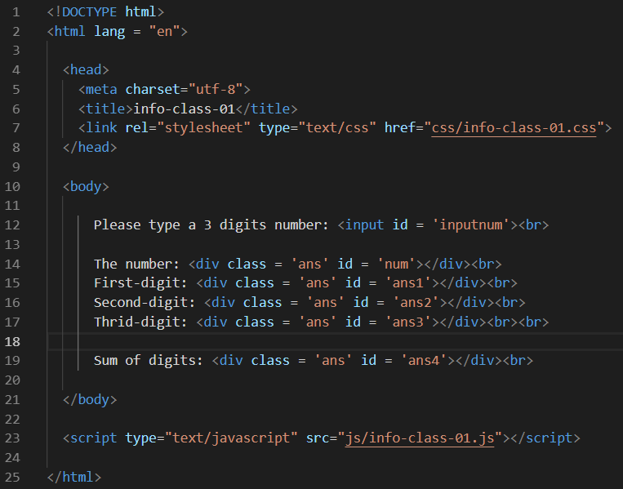

1. **List and if logic (info-class-02.html)**

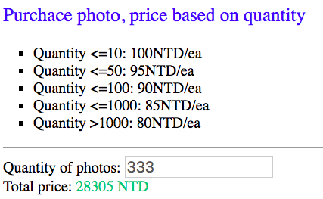

1. **Input and if logic (info-class-03.html)**

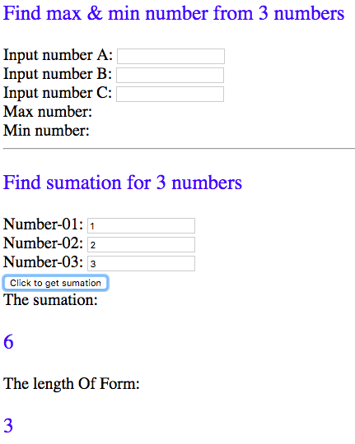

1. **Form and function (info-class-04.html)**

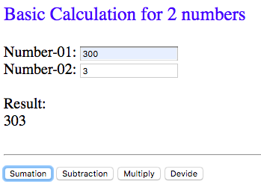

1. **Form, function, if (break), switch logic, css (info-class-05.html)**

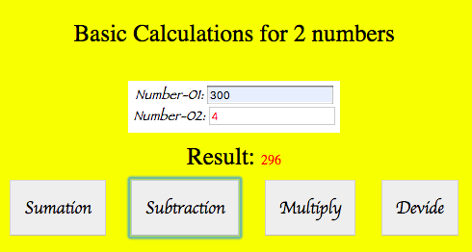

1. **Form, if (else if) (info-class-06.html)**

Electricity bill calculation

hrs < 30 $10

hrs <=70 $13

hrs <=120 &15

hrs <=200 $20

hrs >= 200 $30

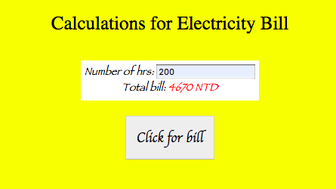

1. **Form, if (else) (info-class-07.html)**

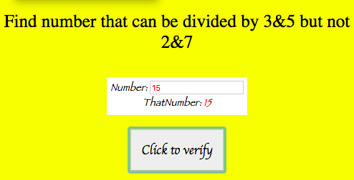

1. **Summation of a number field (info-class-08)**

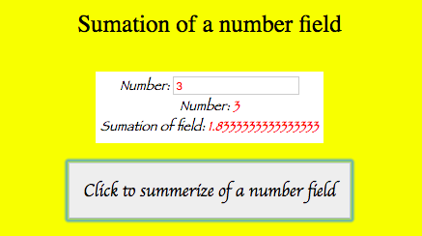

1. **Prime number (info-class-09)**

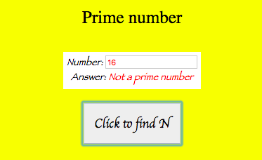

1. **How many digits in an integer (info-class-10)**

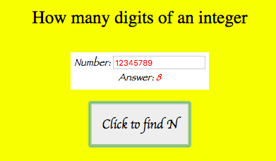

1. **Multiple loops (info-class-11)**

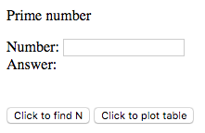

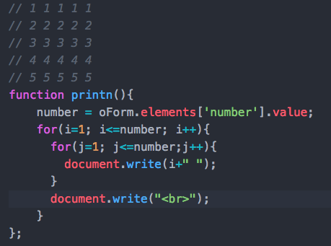

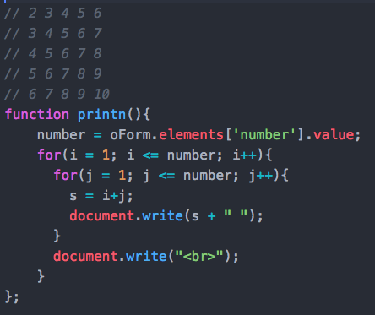

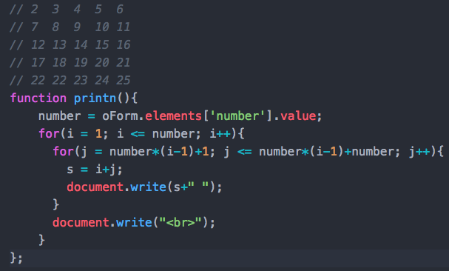

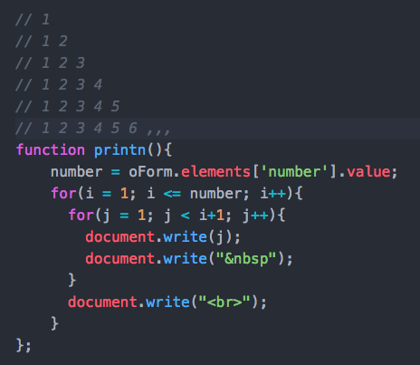

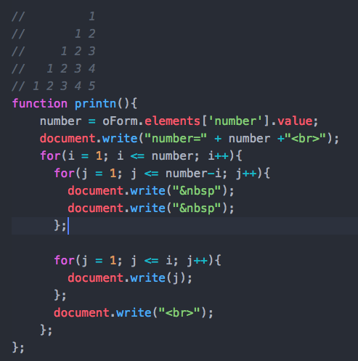 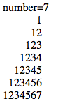

1. **Table (info-class-12)**

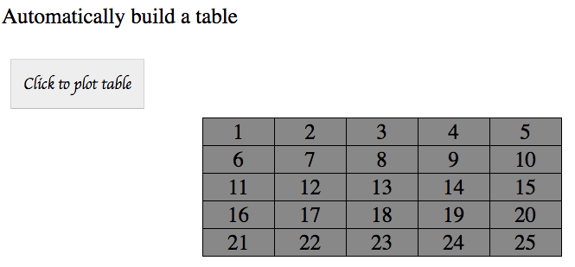

1. **Table (info-class-13)**

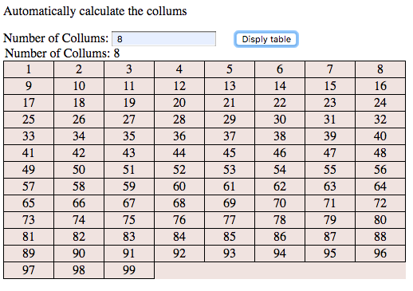

1. **1D array (info-class-14)**

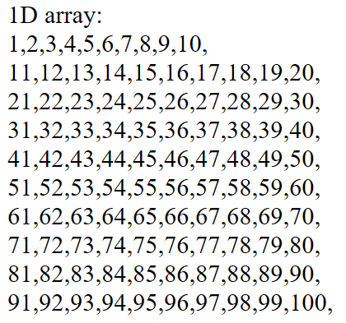 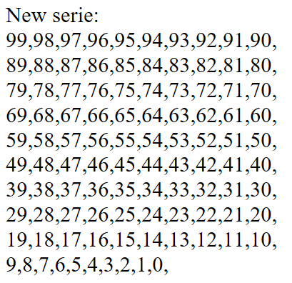

1. **1D array (info-class-15)**

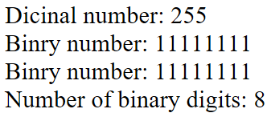

1. **1D array (info-class-16)**

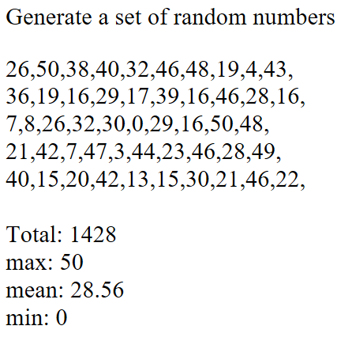

1. **1D array sorter (info-class-17)**

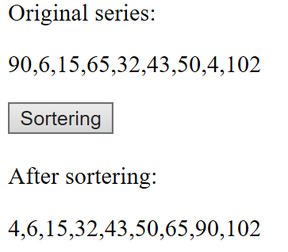

1. **1D array wash (info-class-18)**

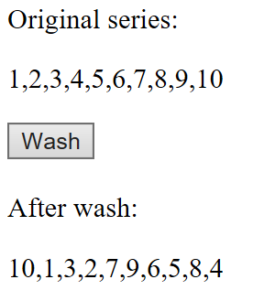

1. **1D array wash & distribute cards (info-class-19)**

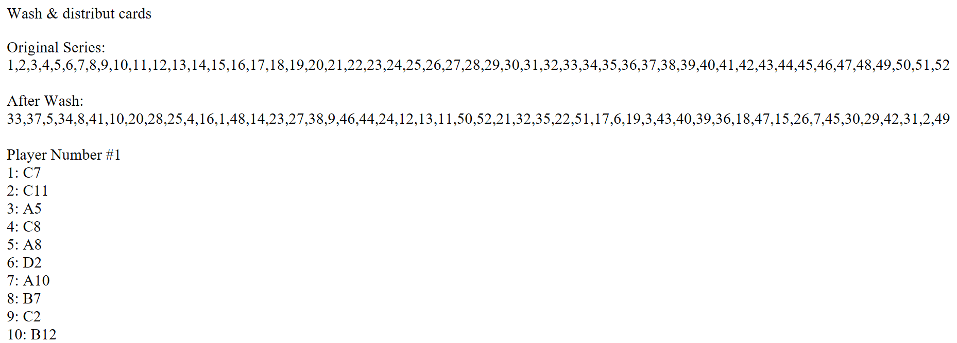

1. **1D array sorter & binary search (info-class-20)**

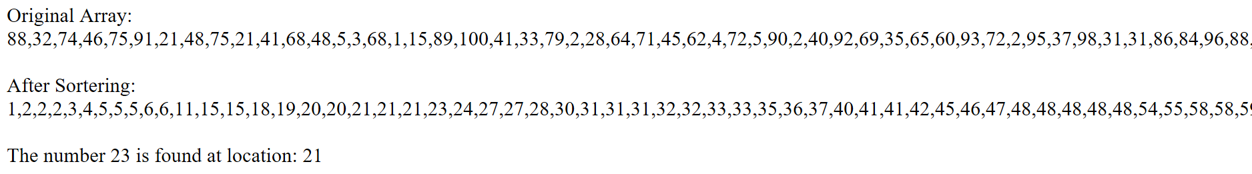

1. **1D array sorter & find repetitions (info-class-21)**

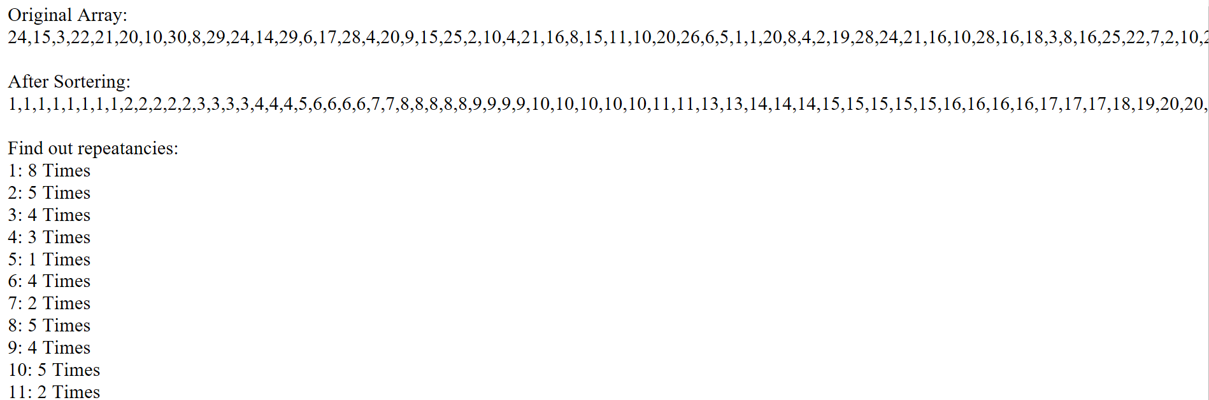

1. **2D matrix (info-class-22)**

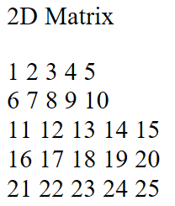

1. **2D matrix (info-class-23)**

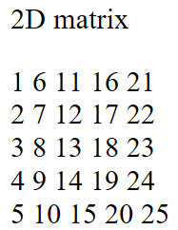

1. **2D Matrix manipulation (info-class-24)**

**Objective:**

Product A,B,C,D, Need to get summation in for:

Each product in a week;

Total production in a day;

Total production in a week.

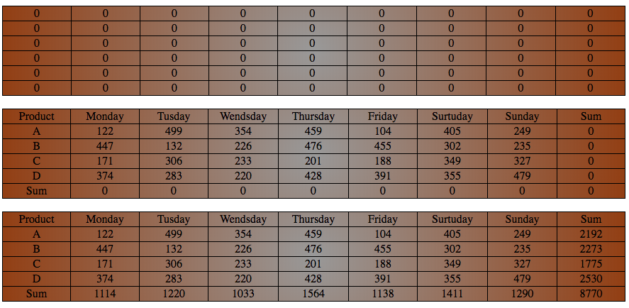

1. **Sorting for the above table (info-class-25)**

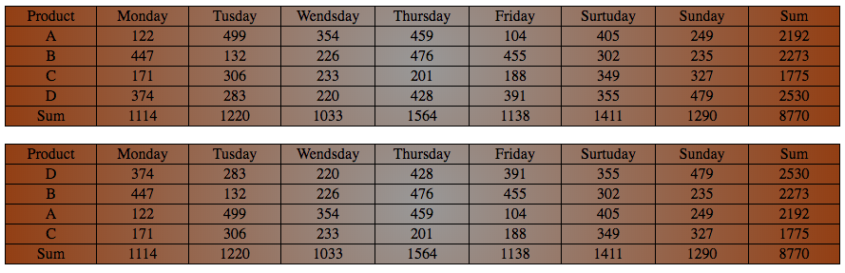

1. **Long integer operation (info-class-026)**

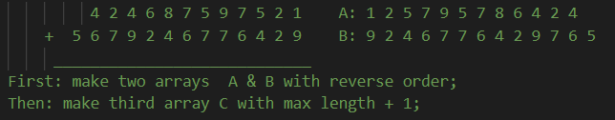

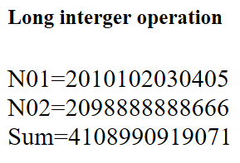

1. **Matrix multiplication C = AxB (info-class-27)**

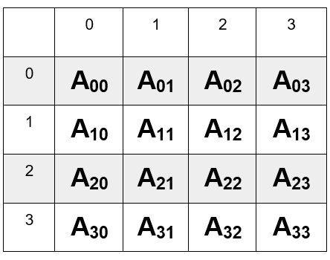**x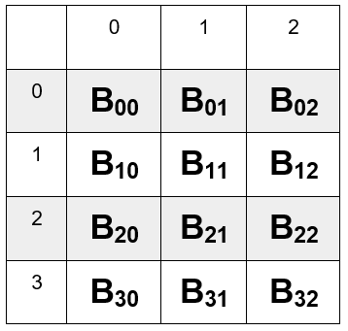=** 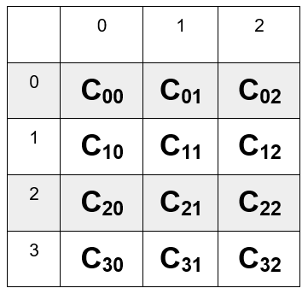

C00 = A00xB00 + A01xB10 + A02xB20 + A03xB30

C01 = A00xB01 + A01xB11 + A02xB21 + A03xB31

C02 = A00xB02 + A02xB12 + A02xB22 + A03xB32

C10 = A10xB00 + A11xB10 + A12xB20 + A13xB30

C11 = A10xB01 + A11xB11 + A12xB21 + A13xB31

C12 = A10xB02 + A12xB12 + A12xB22 + A13xB32

C20 = A20xB00 + A21xB10 + A22xB20 + A23xB30

C21 = A20xB01 + A21xB11 + A22xB21 + A23xB31

C22 = A20xB02 + A22xB12 + A22xB22 + A23xB32

C30 = A30xB00 + A31xB10 + A32xB20 + A33xB30

C31 = A30xB01 + A31xB11 + A32xB21 + A33xB31

C32 = A30xB02 + A32xB12 + A32xB22 + A33xB32

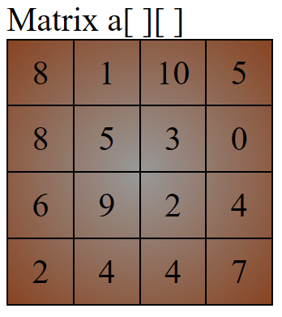x 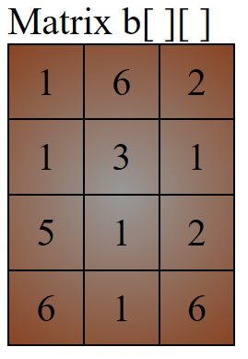= 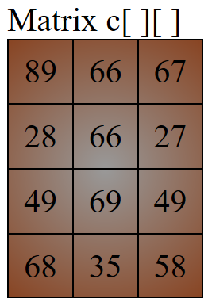

|  |  |  |  |  |
| --- | --- | --- | --- | --- |
|  | 0 | 1 | 2 | 3 |
| 0 | **A00** | **A01** | **A02** | **A03** |
| 1 | **A10** | **A11** | **A12** | **A13** |
| 2 | **A20** | **A21** | **A22** | **A23** |
| 3 | **A30** | **A31** | **A32** | **A33** |

|  |  |  |  |
| --- | --- | --- | --- |
|  | 0 | 1 | 2 |
| 0 | **B00** | **B01** | **B02** |
| 1 | **B10** | **B11** | **B12** |
| 2 | **B20** | **B21** | **B22** |
| 3 | **B30** | **B31** | **B32** |

|  |  |  |  |
| --- | --- | --- | --- |
|  | 0 | 1 | 2 |
| 0 | **C00** | **C01** | **C02** |
| 1 | **C10** | **C11** | **C12** |
| 2 | **C20** | **C21** | **C22** |
| 3 | **C30** | **C31** | **C32** |