# Idea create java project:

1. [File]→[New]→[Project]

2. select Java

3.Project SDK select 1.8 (use New to locate sdk directory)

4.Next

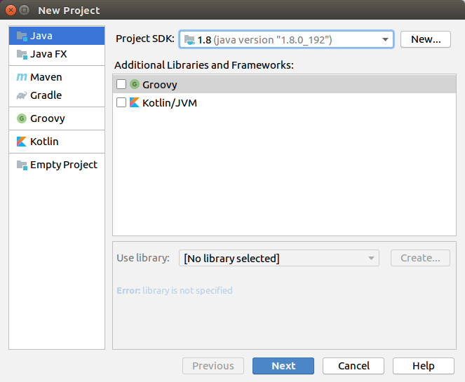5.check Create project from template

6.select Command Line App

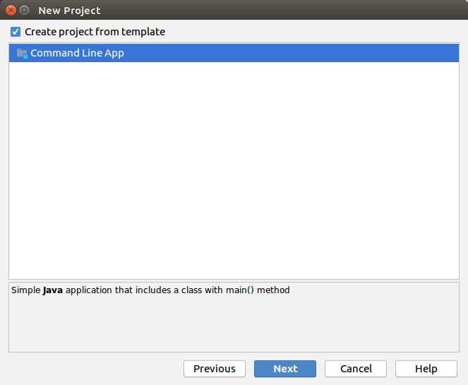

7.input project name

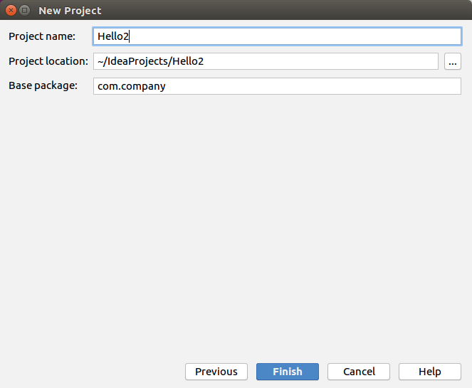

8.Edit the codes

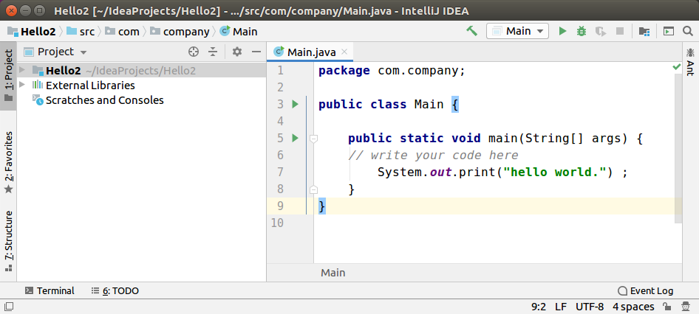

9.Run the app

menu:[Run]→[Run Main]

# Hadoop MapReduce API Demo Program

1.launch iDea to create a empty project **HelloWordCount**

2. [File]→[Project Structure]

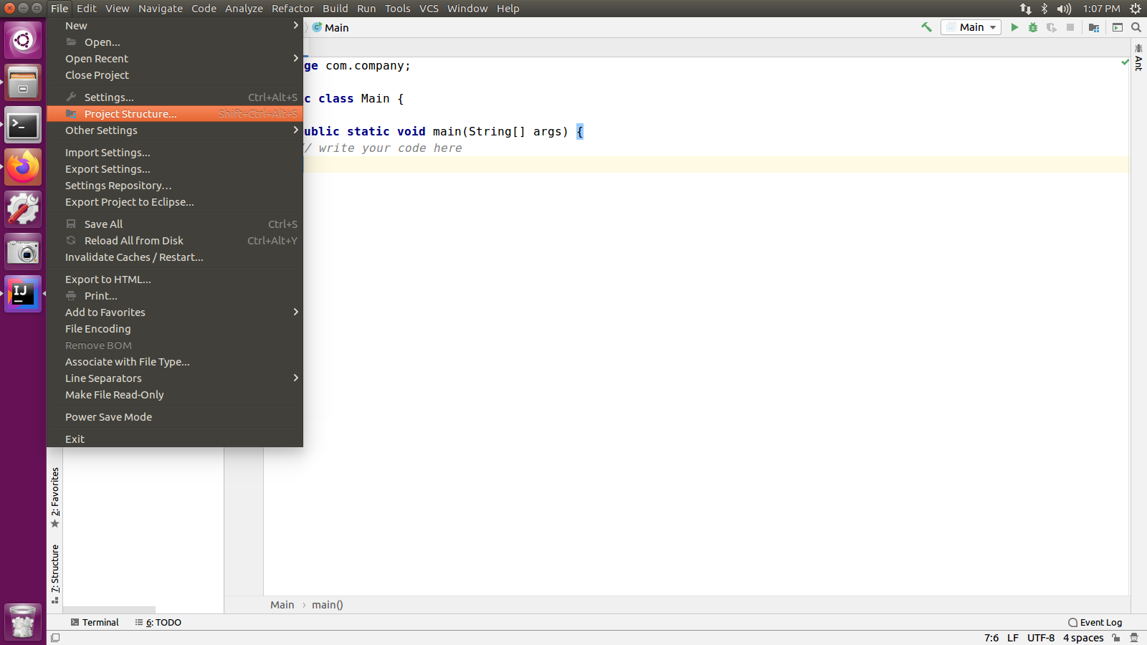

3. In Project Structure Panel->Libraries->Java

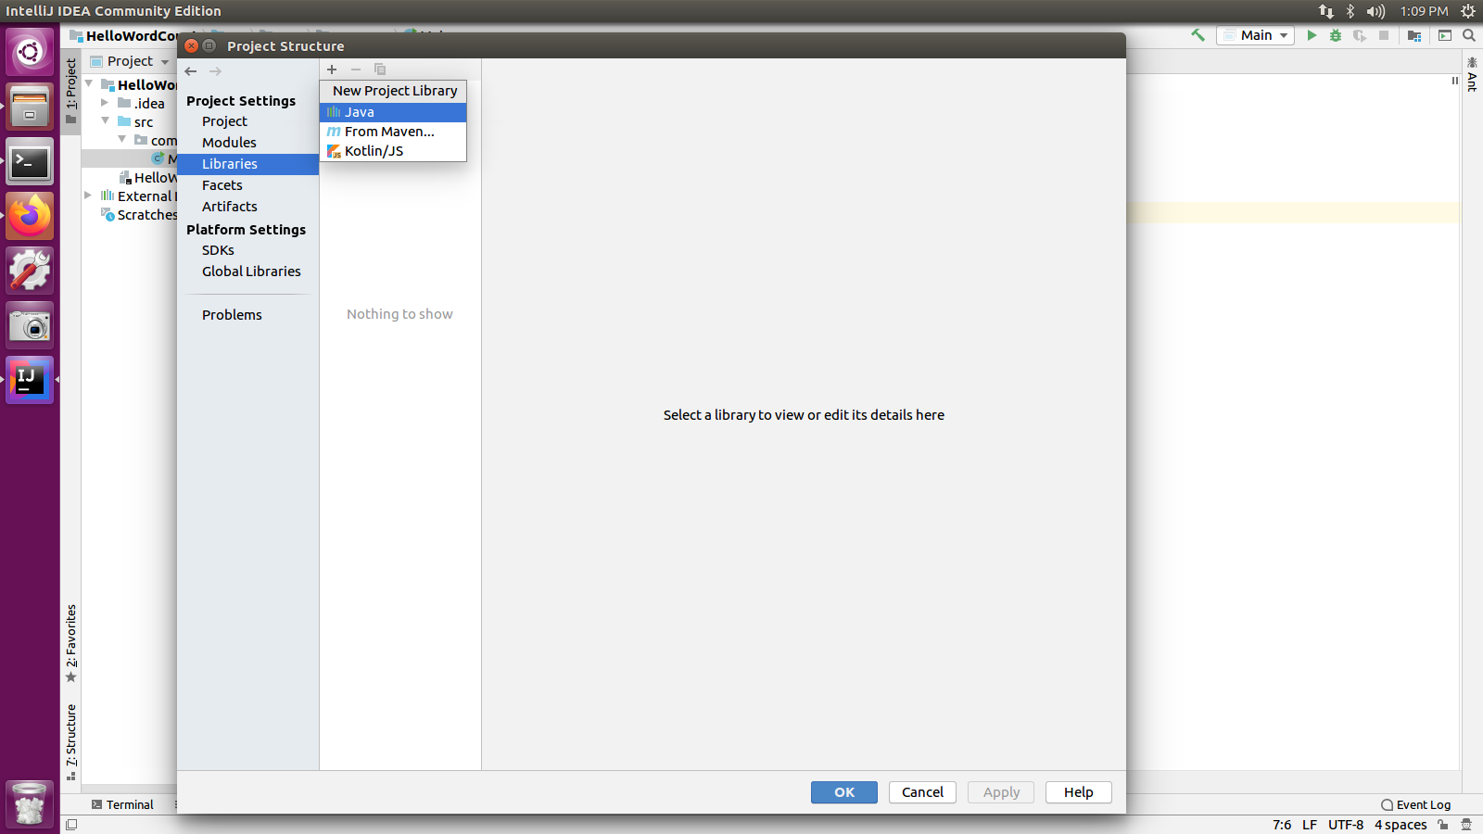

4.Add jars one by one:

|  |
| --- |
| /usr/local/hadoop/share/hadoop/common/hadoop-common-2.7.6.jar |

|  |
| --- |
| /usr/local/hadoop/share/hadoop/mapreduce/hadoop-mapreduce-client-core-2.7.6.jar |

|  |
| --- |
| /usr/local/hadoop/share/hadoop/common/lib/commons-logging-1.1.3.jar |

|  |
| --- |
| /usr/local/hadoop/share/hadoop/common/lib/guava-11.0.2.jar |

|  |
| --- |
| /usr/local/hadoop/share/hadoop/common/lib/commons-collections-3.2.2.jar |

|  |
| --- |
| /usr/local/hadoop/share/hadoop/common/lib/log4j-1.2.17.jar |

/usr/local/hadoop/share/hadoop/common/lib/commons-io.2.4.jar

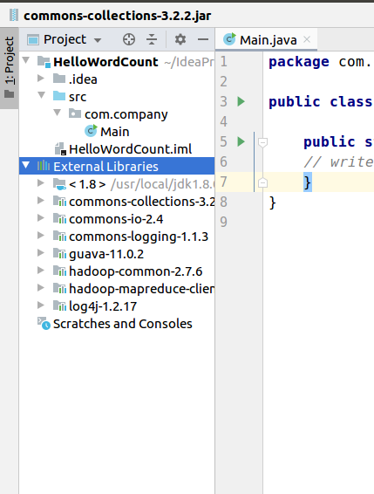

5.Write the code: copy the codes from github page.

<https://github.com/wangfeng1981/hadoop-toycluster/blob/master/HelloWordCount.java>

6.build the Jar.

[File]→[Project Structure]→[Artifact]

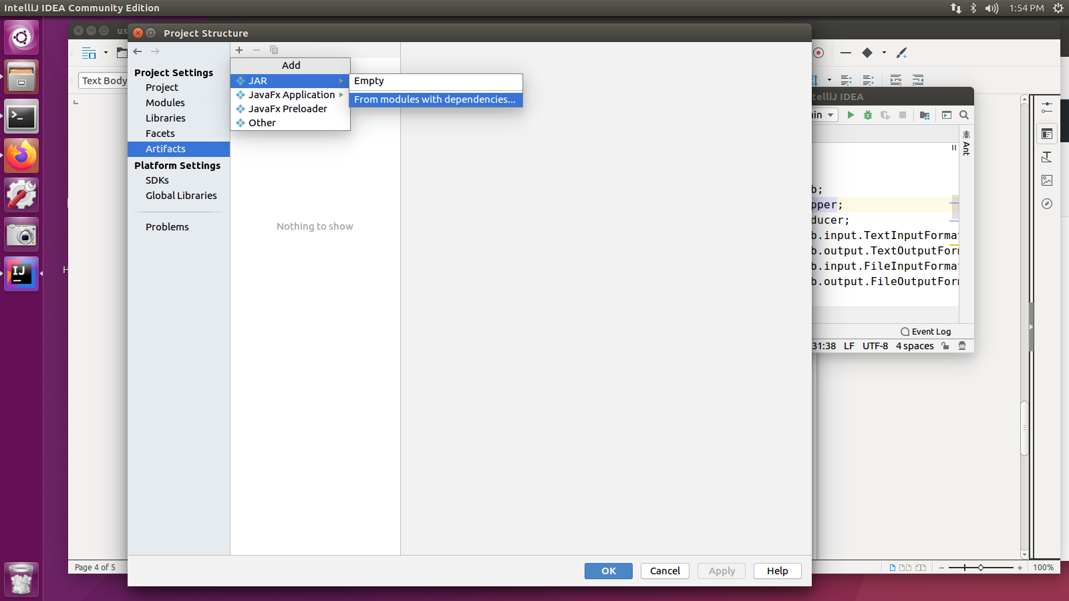

7.Pick Main Class And OK

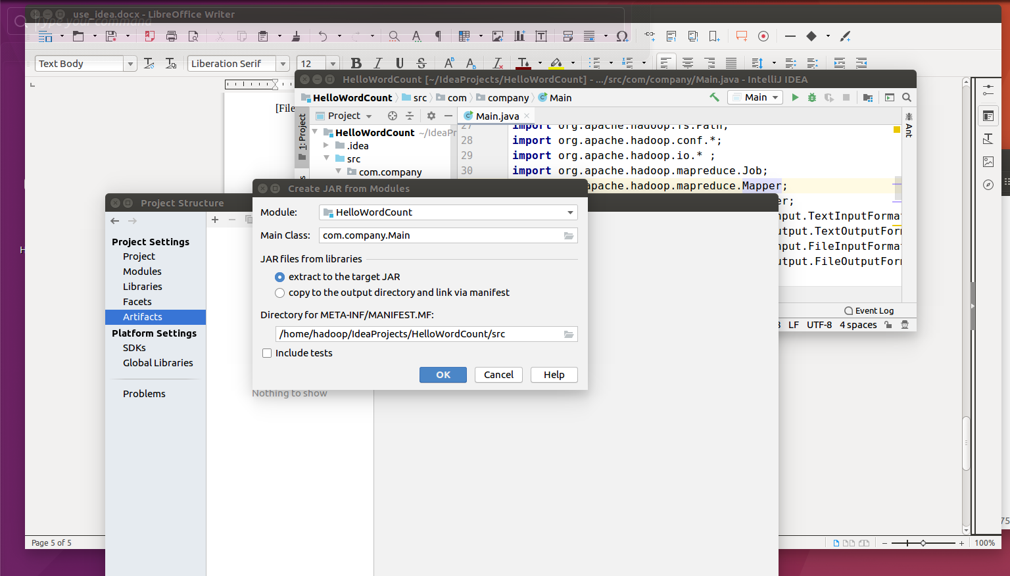8. [Build]→[Build Artifacts]→[HelloWordcount.jar]->[Build]

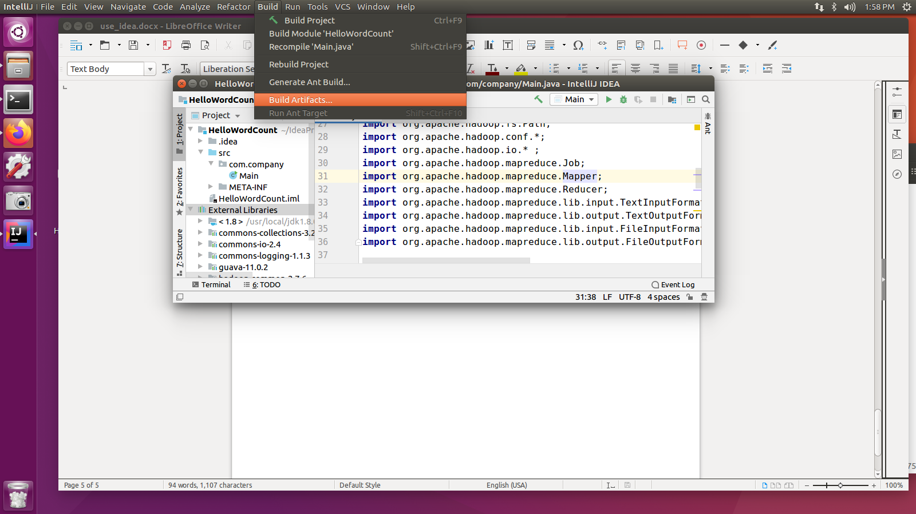

9.build OK

Goto the jar directory. Start a shell to test the jar.

hadoop jar HelloWordCount.jar /testfile.txt /testoutputXXX

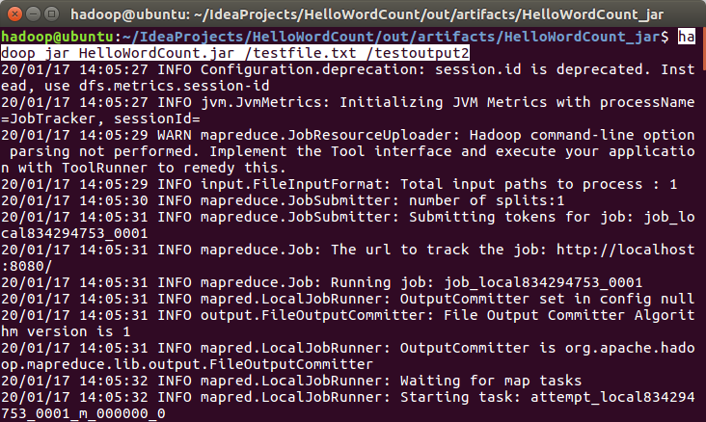

check the results:

hadoop fs -cat /testoutput2/part-r-00000

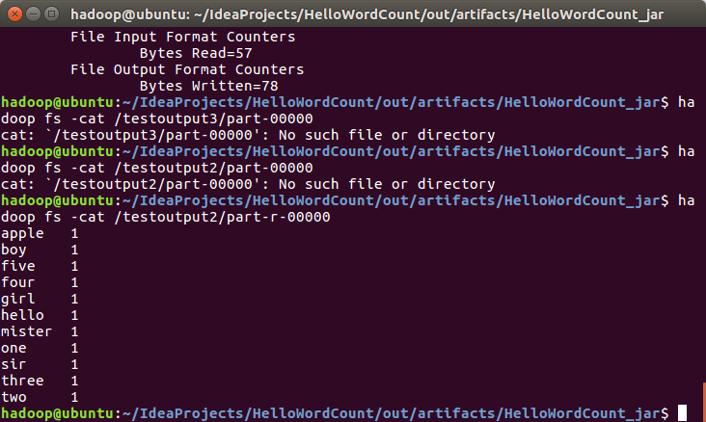

(done)