# Adding a new DID/RID

1. This guide assumes the new arxml extract is already integrated
2. Open DaVinci Developer
3. Go to the target SWC (e.g. external or internal)
4. Go to Port Prototype List Icon
5. Go to Service Ports
6. Click New 🡪 From Port Interface…

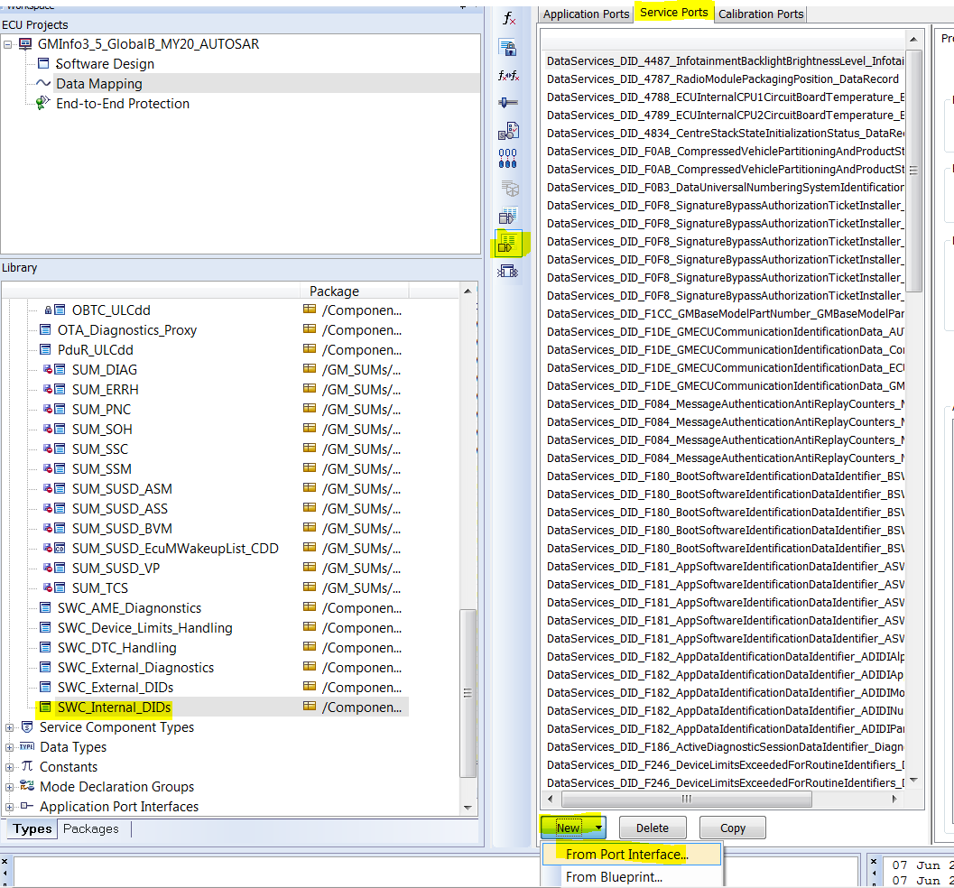

1. Add the needed DID/RID port

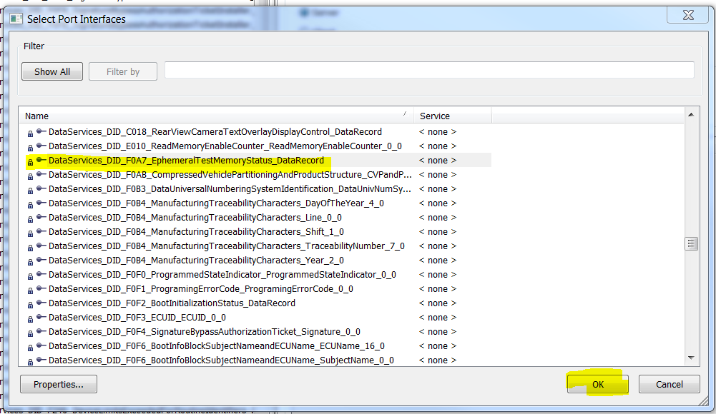

1. Change the Direction to Server under Properties

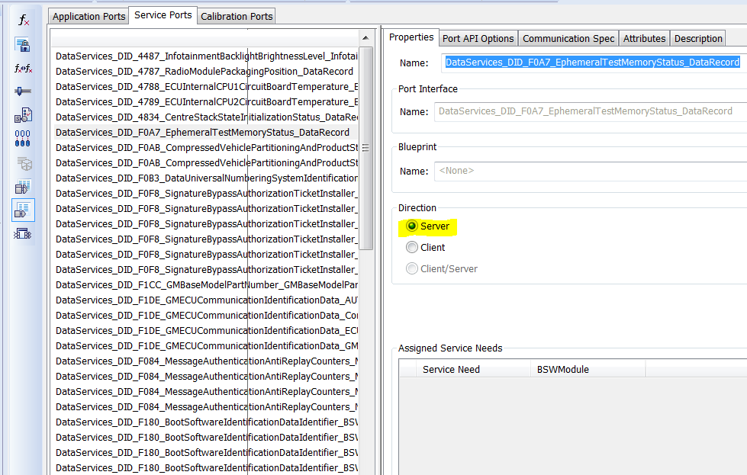

1. Add a Server Runnable

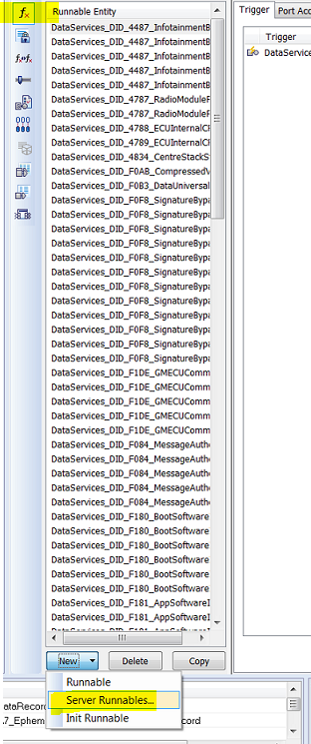

1. Select the DID/RID

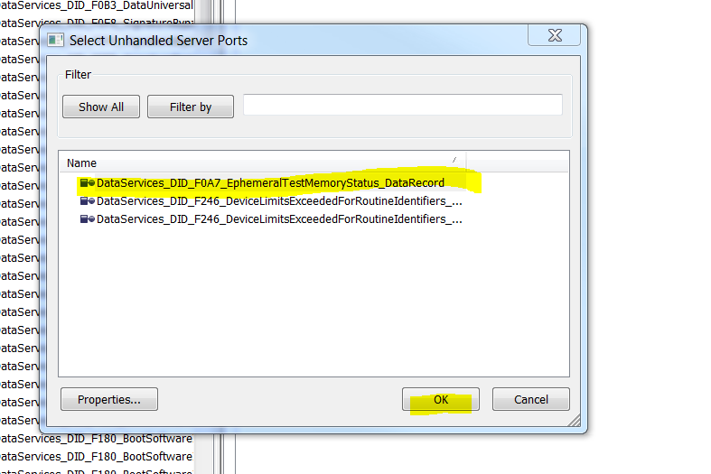

1. Hit ok on Runnable Name Options dialog
2. Go to the Runnable -> Properties and add the Symbol

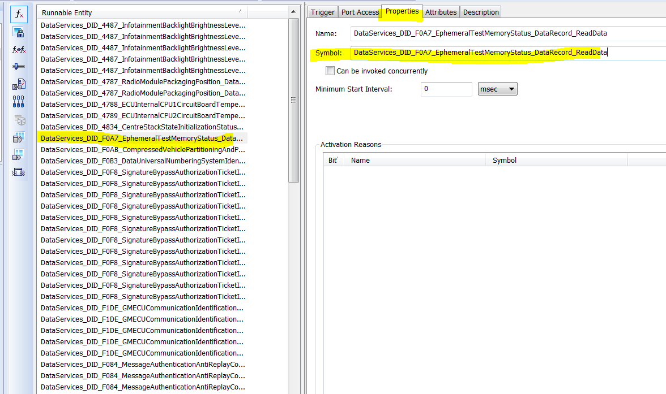

1. Save Developer project
2. Open DaVinci Configurator
3. Go to Runtime System -> ECU Software Components -> Service Components -> Dcm -> Service Connectors
4. Add Connected Component Prototype for the added DID/RID

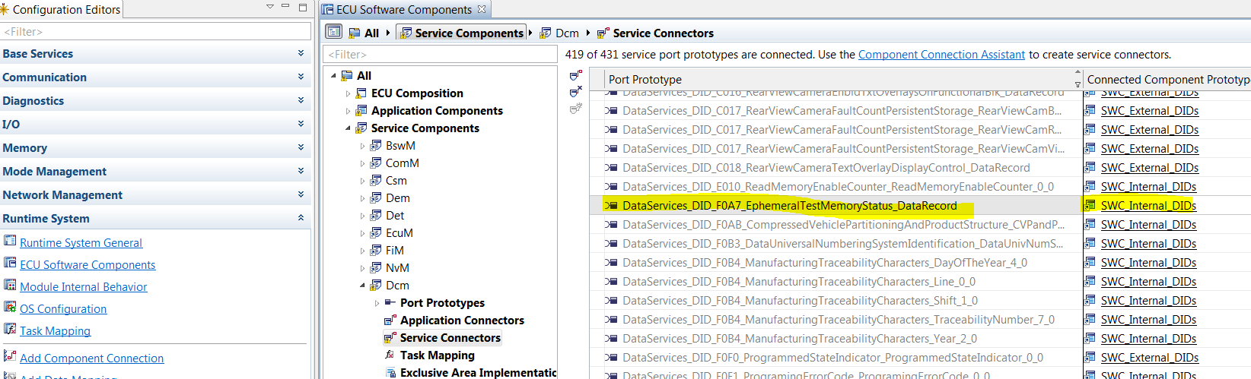

1. Save the Configurator project
2. Generate BSW configuration/Rte code
3. Generate SWC template (Project->Project Settings->SWC Templates and Contract Headers

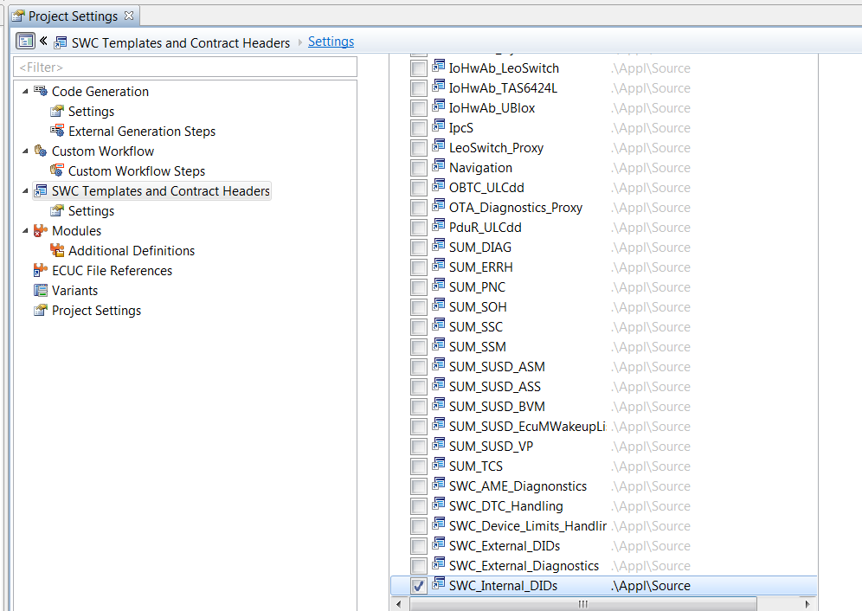

1. SWC source code should have the new DID and implementation can be started