NVM User guide

# Objective

Identify the steps that needed to create new memory blocks. These steps include necessary changes in Davinci Developer and Davinci Configurator.

# Overview

MY21 GB CSM has I2C based EEPROM with size 8 K Bytes. 32 Byte Page Address. For better design, EEPROM layout is designed as different partitions to differentiate sections across VIP Bootloader and VIP Application Software

# Configuration Steps:

## Configuration in EA component

1. Before creating EA block decide on which partition you want to create (ASWOnly Partition or ASWConfig). Always create EEPROM block at the end irrespective of Partition, this way we will protect changes to existing Blocks location.

Example: Here will create EA block in “EaPartitionConfiguration_ASWOnly”

1. Find the last “Block ID” and “Block Number”.

Example: Here Last Block ID for this partition is 112 AND Block Number is 350. Now create new Block with Block ID as 113 and Block Number is 352.

1. Create new EA Block

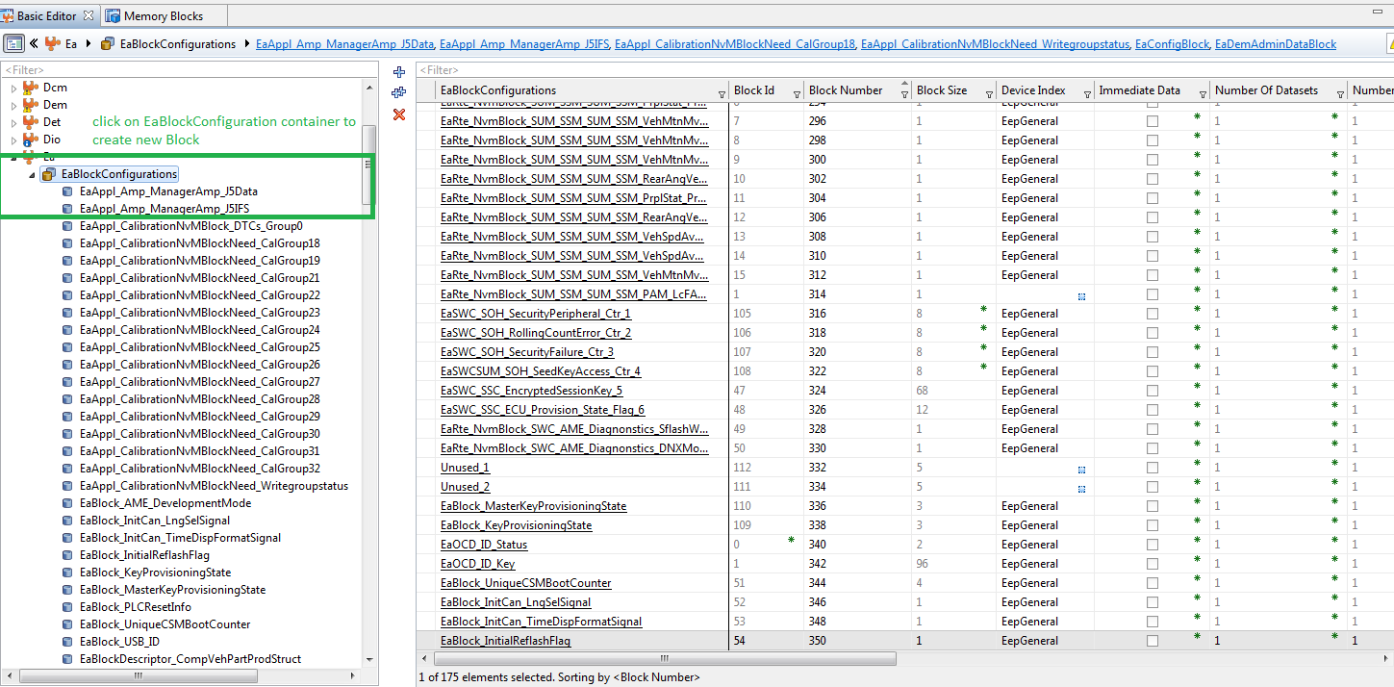

1. Ensure to configure below

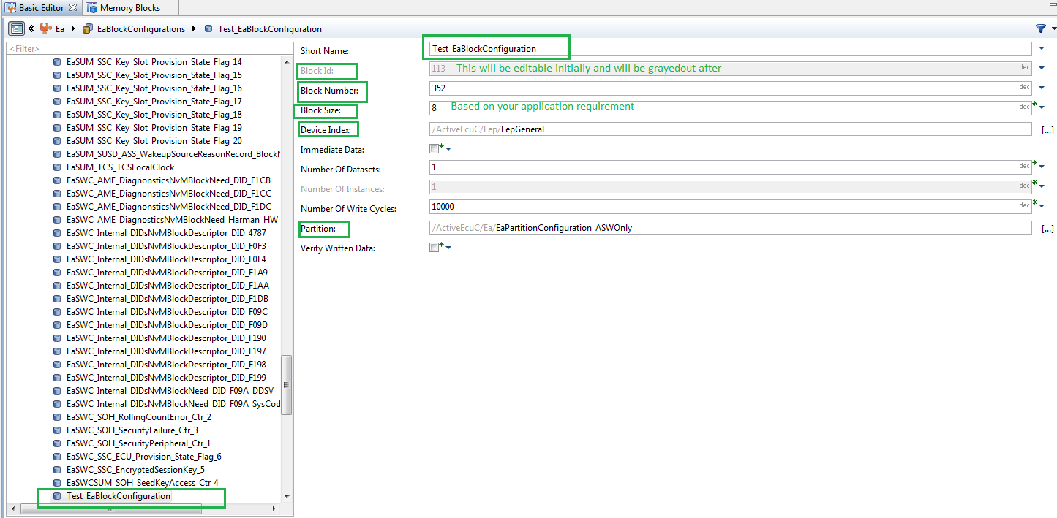

Create new block in EA and assign Block ID as end of the layout, Block Number is Automatic, Define Block Size and map to respective Partition.

## Configuration in NVM component

## Changes in Configurator – Phase 1

1. Create NVM block at the end. To do this find last NVM “Block Identifier” from the configuration. In this example its 153 and now we will create 154.

**NOTE**: Other option is creating duplicate of the existing NVM Block, this way you can reuse configuration of other block and perform necessary changes like “Block Identifier”, Length, Read\Write Mechanism

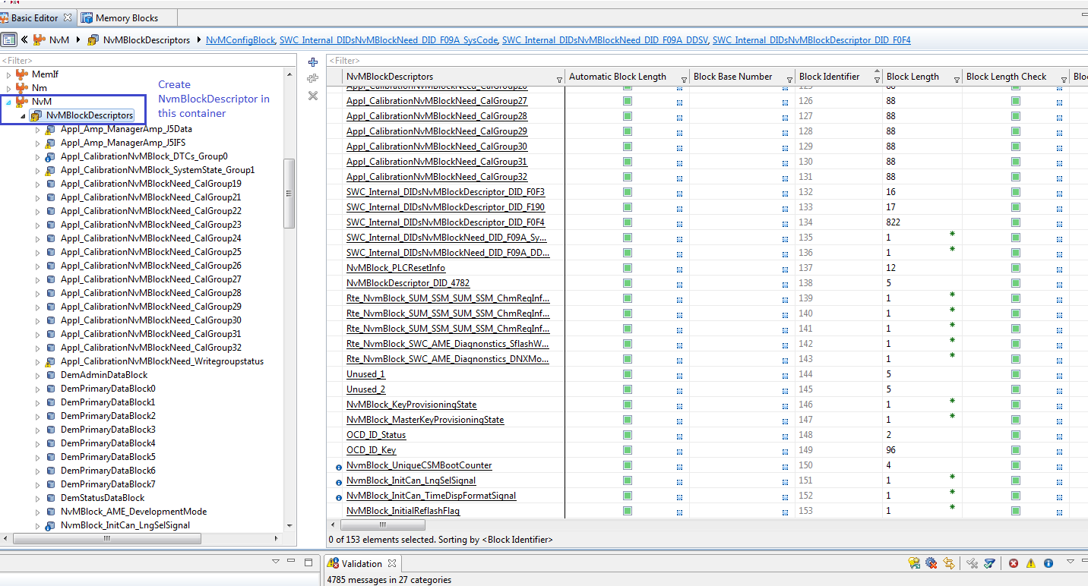

1. You will see below, then elect to perform “Synchronize”.

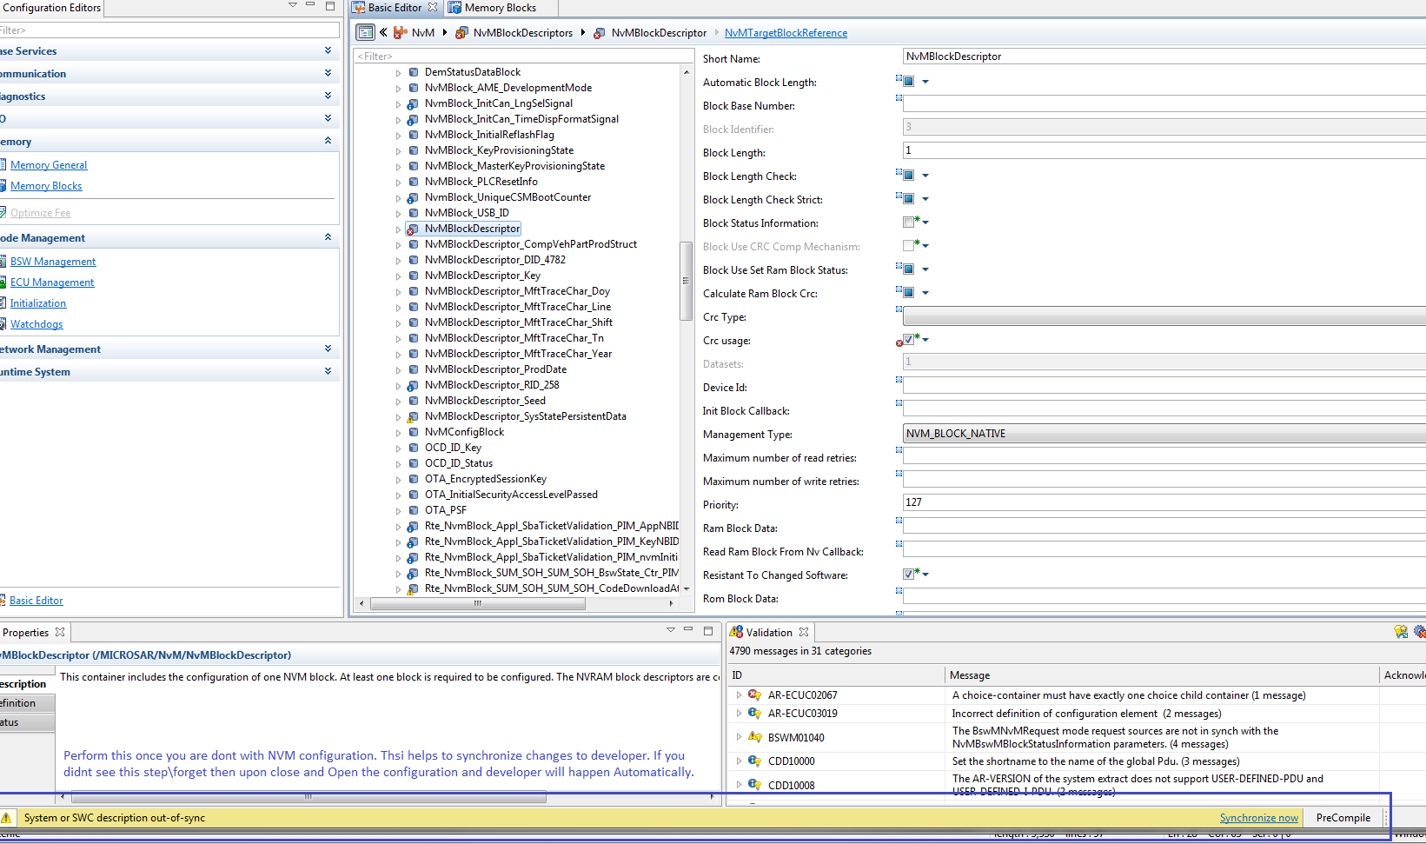

1. Configure all characteristics of NVM Block.

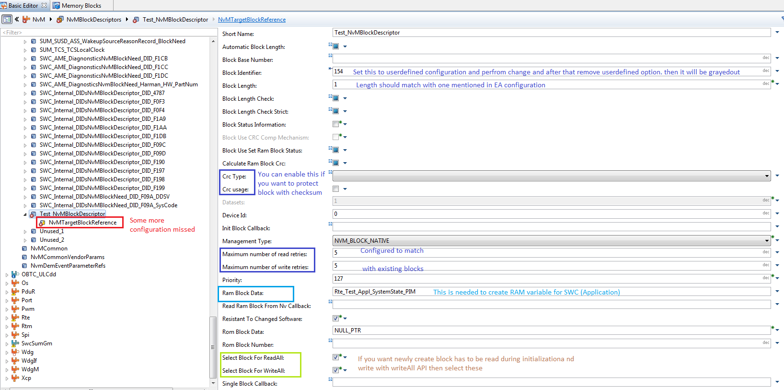

Remaining configuration in NVM 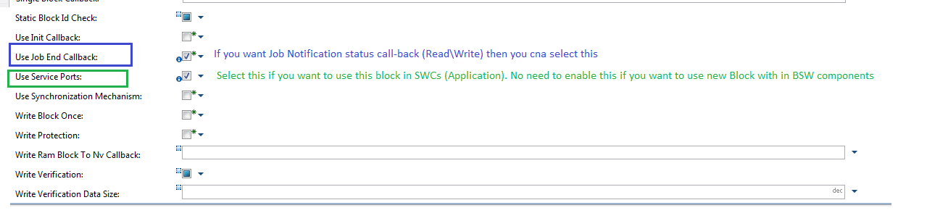

1. Map Ea Block to NVM

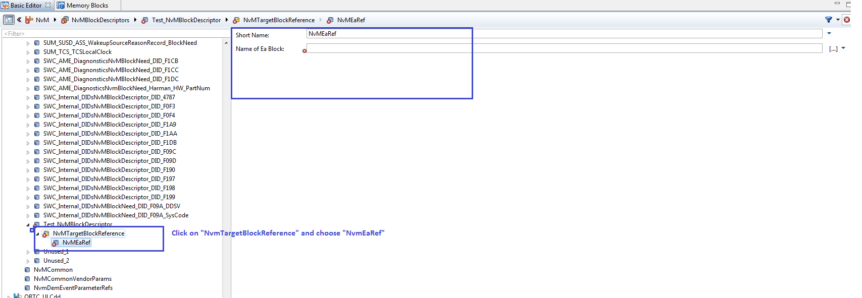

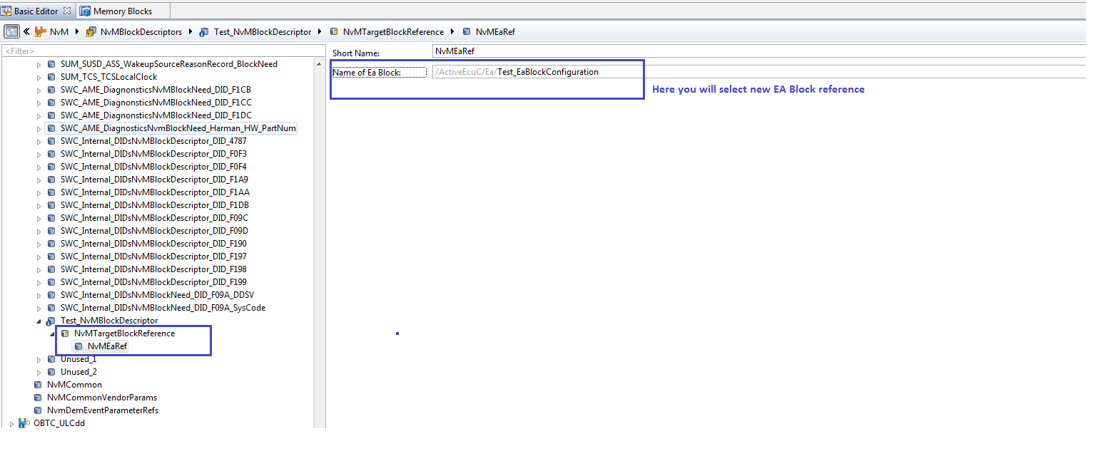

1. Generate code for NVM and EA. You will see new blocks. Ensure in the generated files that these new blocks were created only at the end.

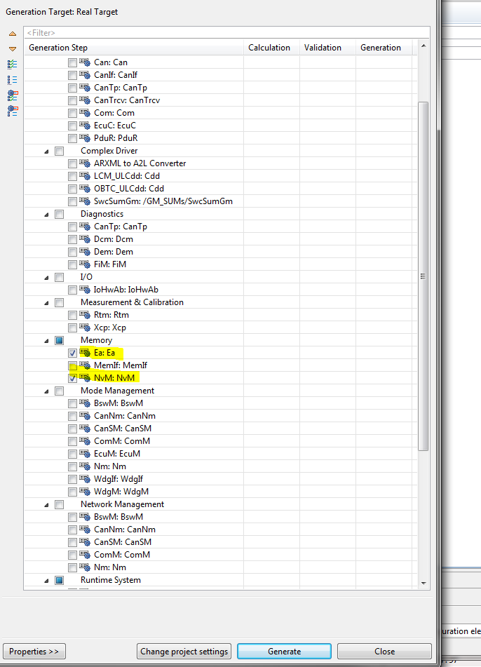

## Configuration in Developer tool

As an example, this newly created block is targeted for System State SWC component. Here will do necessary changes in

1. Create Service Port Prototype in SWC: Service Port, Type is Client for port Interface NvMService_AC3_SRBS". To make it simple we can make copy of existing port.

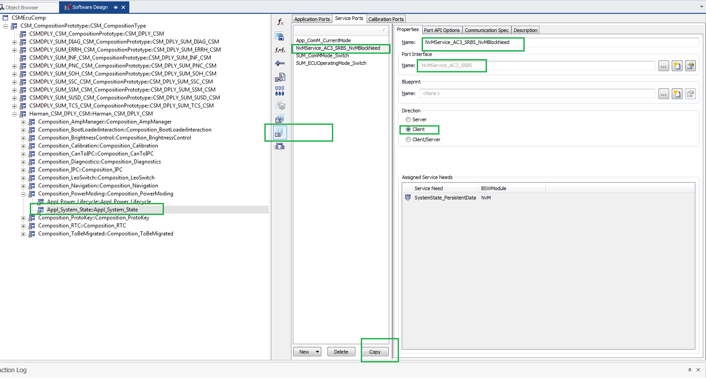

Once you click on copy option then you will see new port.

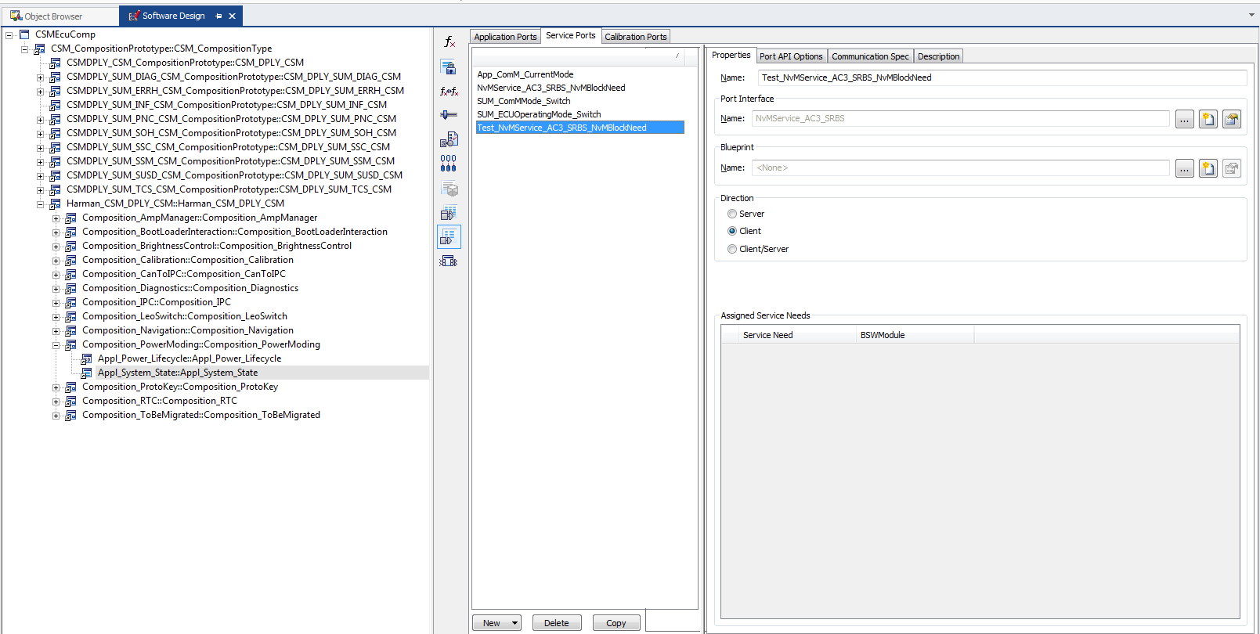

1. Create PIM in the same SWC with the desired Data type.

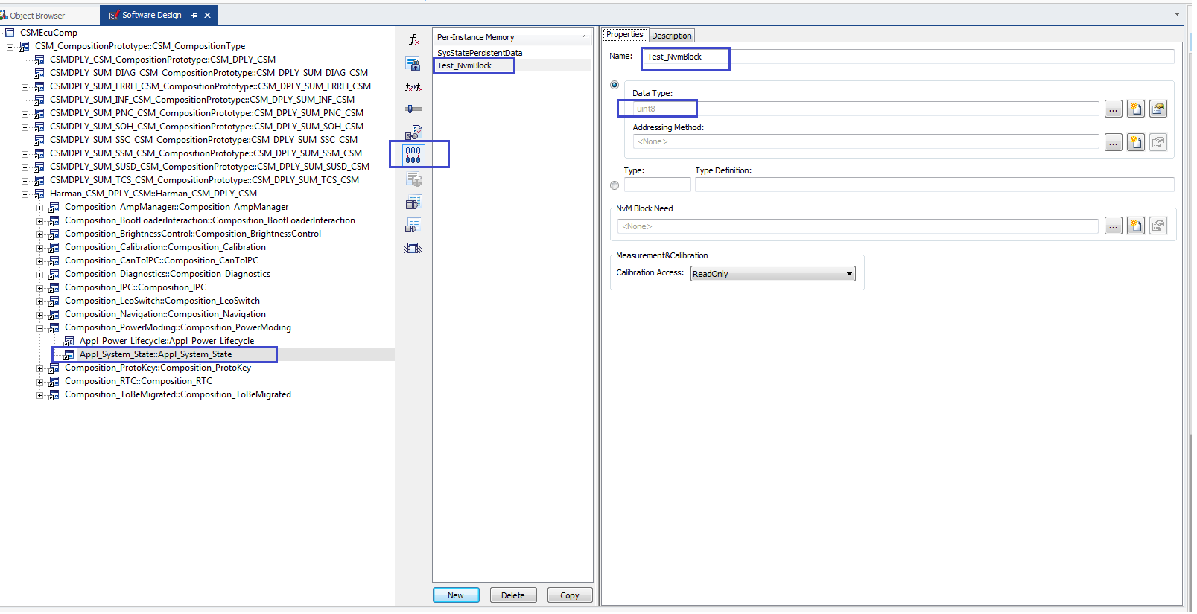

1. Create Service Need of type "NVM Block Needs" - Here you can configure many parameters such that those will be reflected in "BSW modules of Memory ".

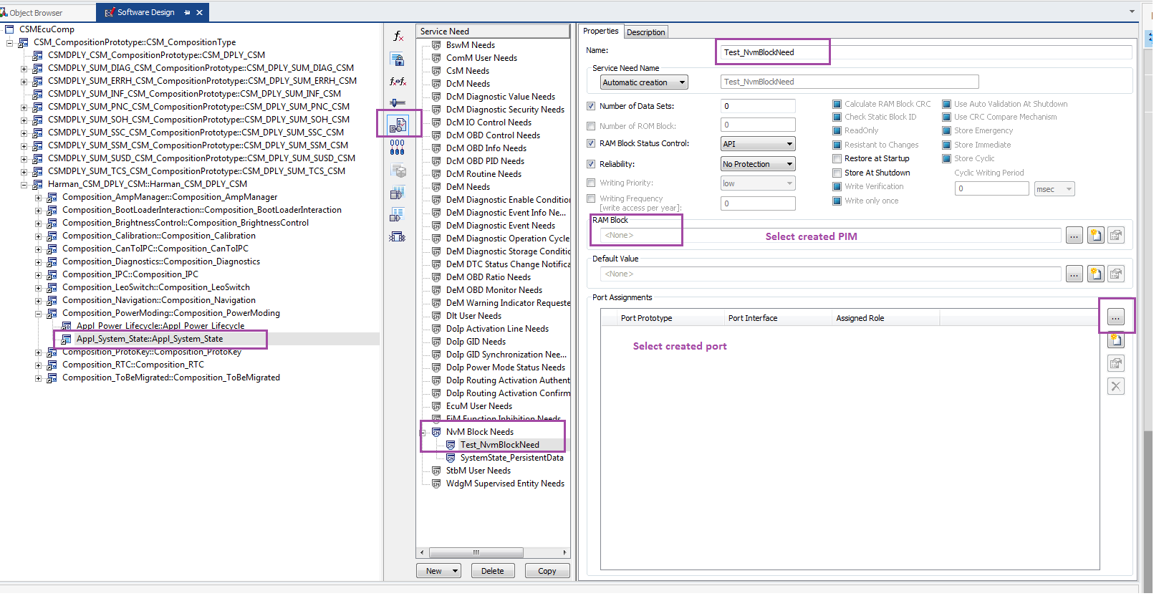

You will see below upon completion of service needs

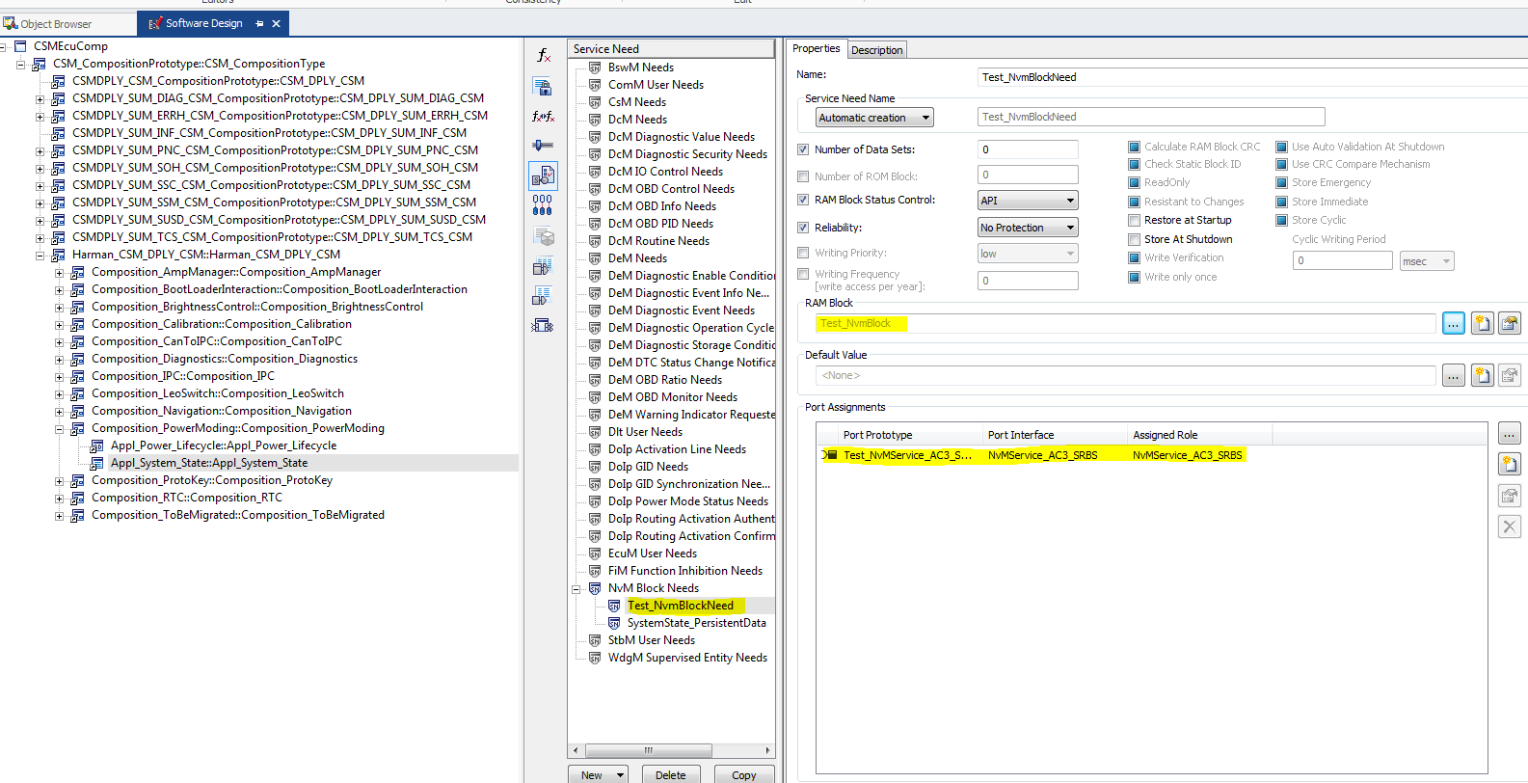

1. Map the created Port to specific runnable for Port Access. Type Invoke Operation with Synchronous call.

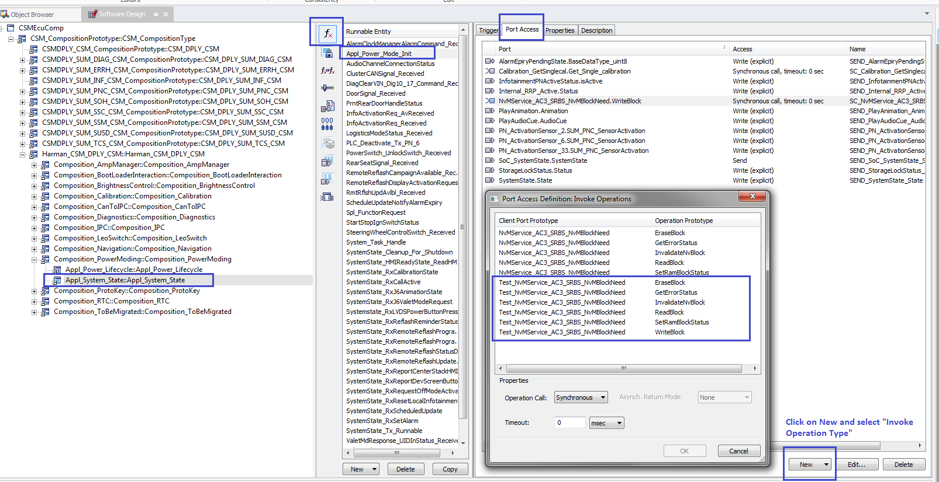

After configuration you will see below

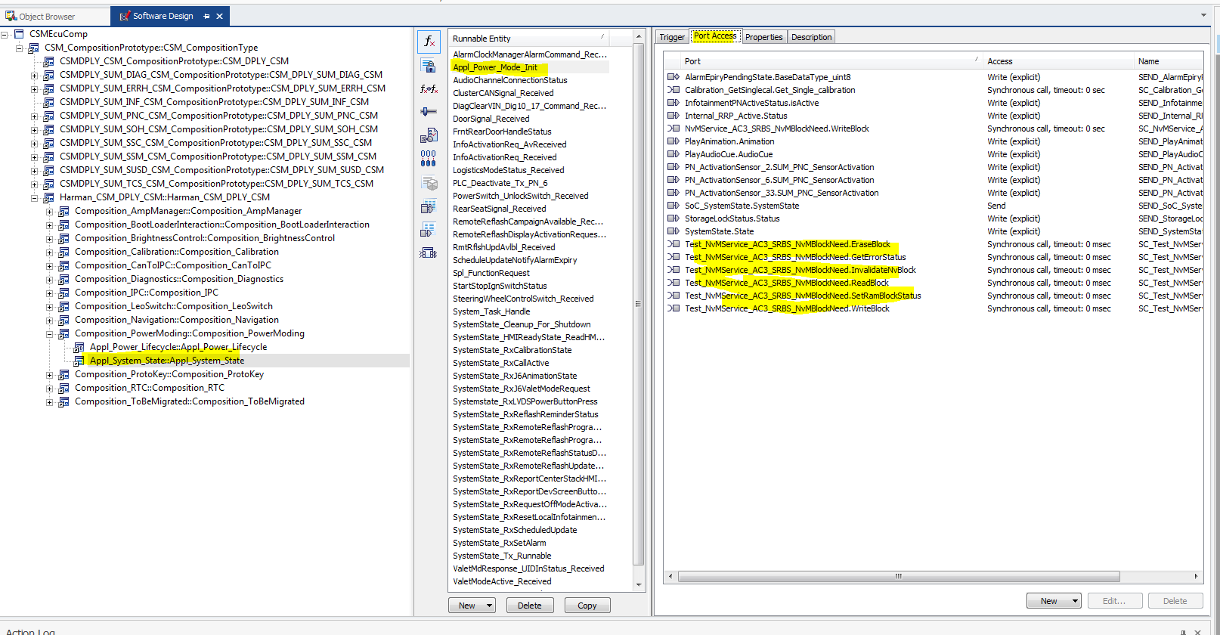

Now with the above changes we are done with necessary changes in developer. After this you can save changes here and synchronize the project in configurator and perform necessary connections and code generation.

You will see below in Configurator

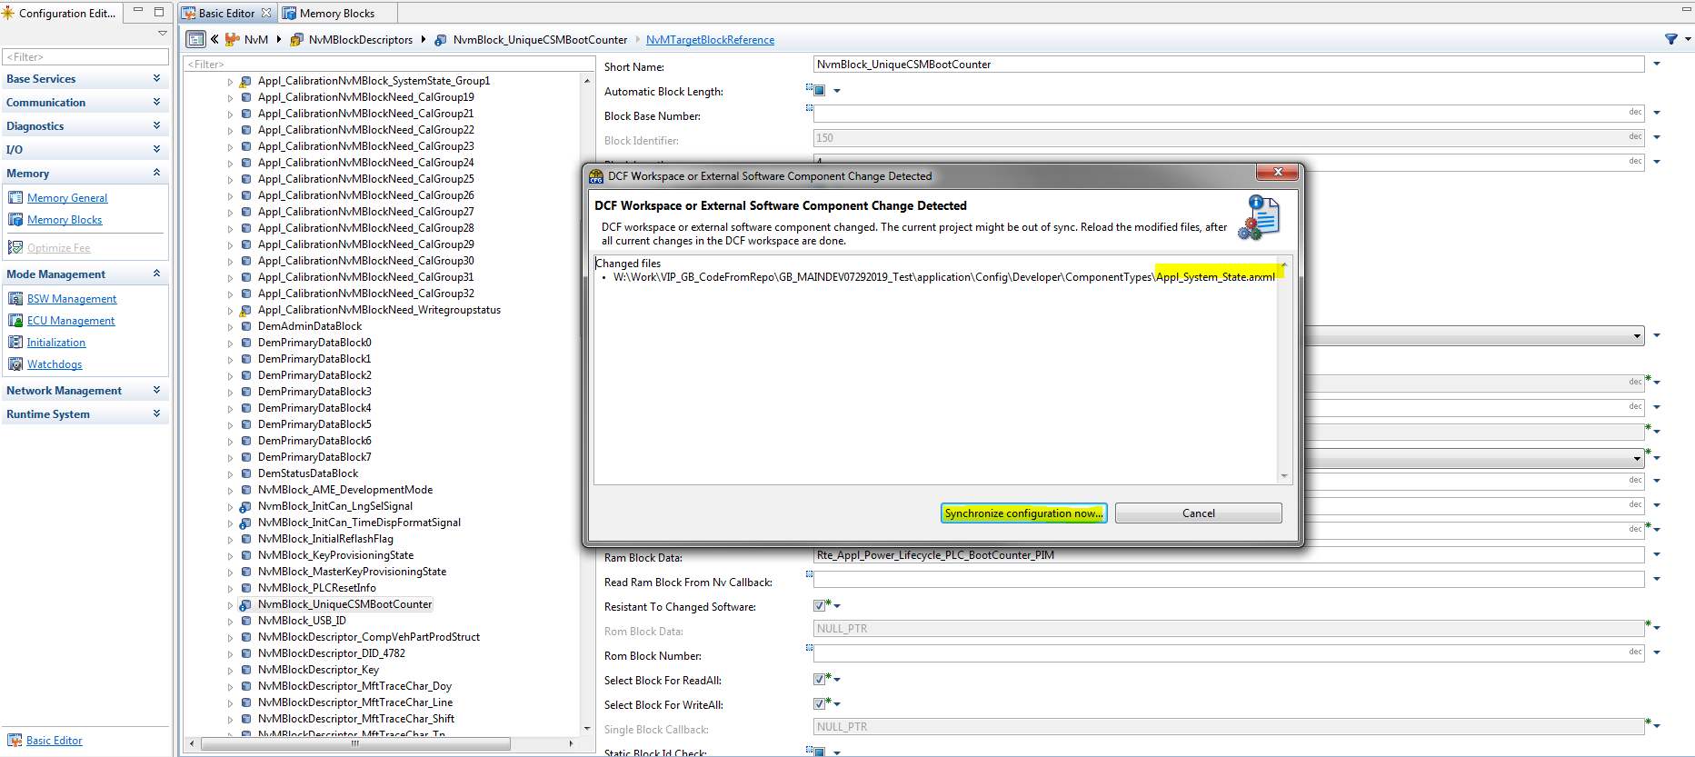

## Changes in Configurator – Phase 2

1. Change in RTE for Memory Block Map. You will see below error. To resolve this error map NVM block to RTE.

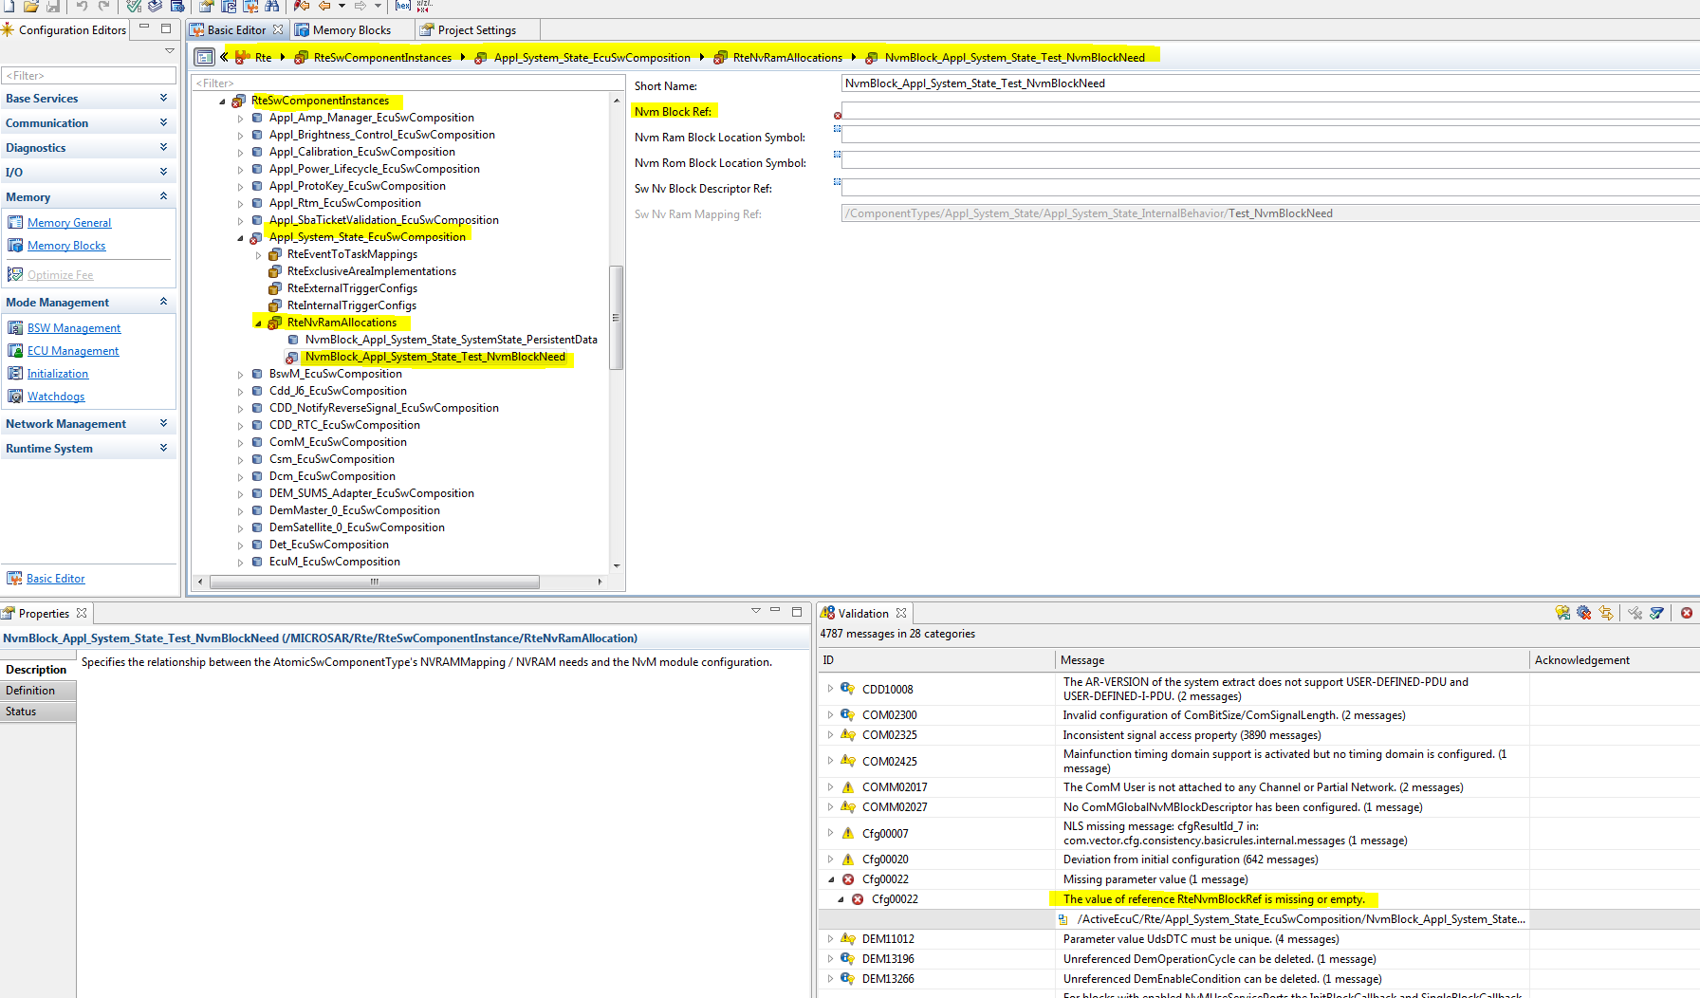

1. Generate code for SWC – Here we did change in System State SWC, so code will be generated for Appl_System_State. Resolve if you get any RTE errors.

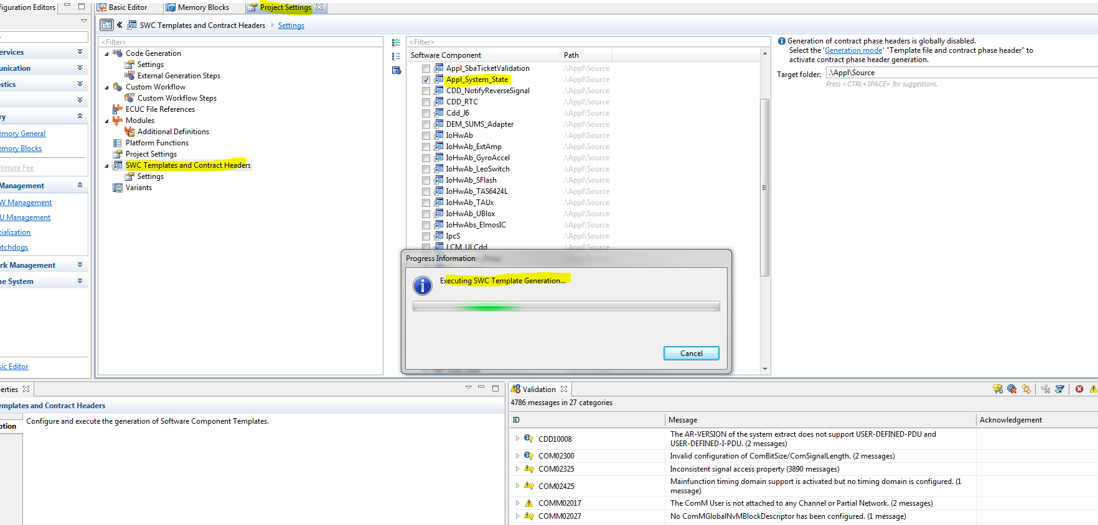

1. Now generate code for RTE. This generated code with new NVM block and you might see unconnected port interfaces as shown below.

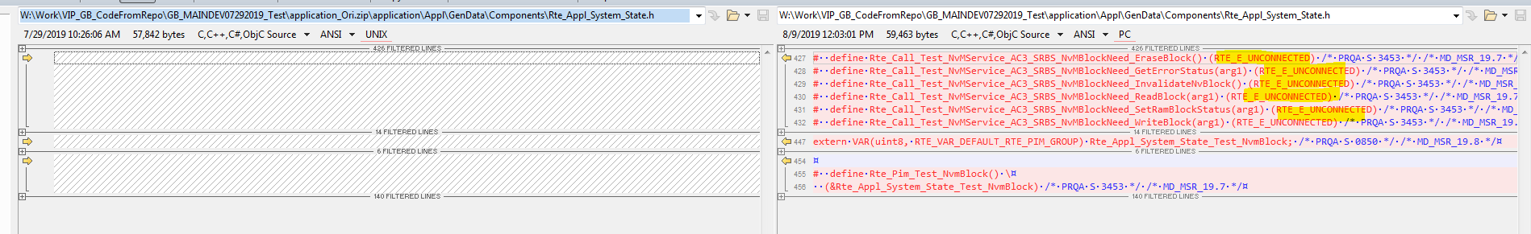

1. Perform necessary Port connections in ECU Software Components

Select below highlighted port and connect with Nvm.

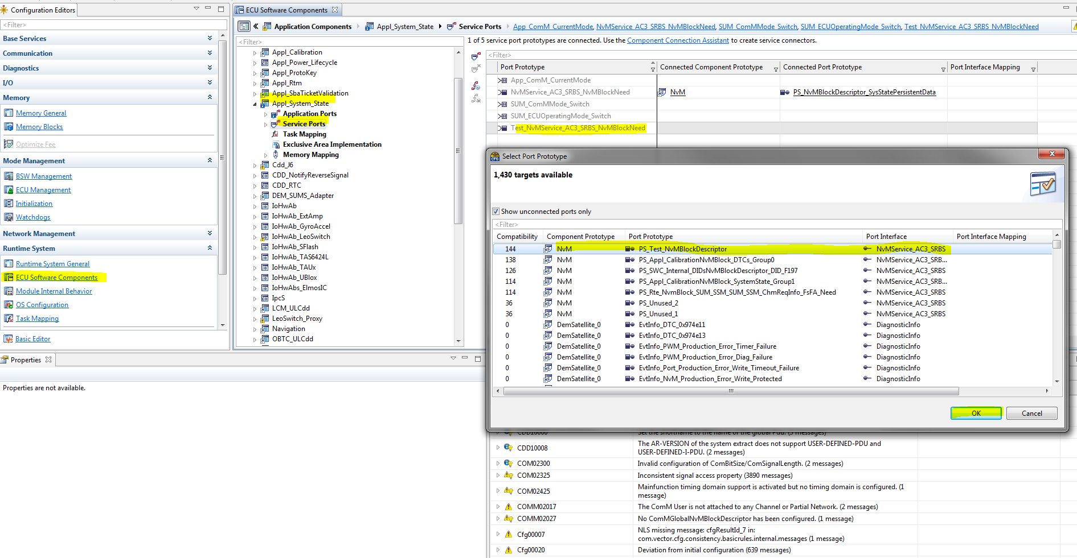

1. Perform port connections in “Service Components”

Generate RTE and SWC code after above change then RTE will have connections with SWC.

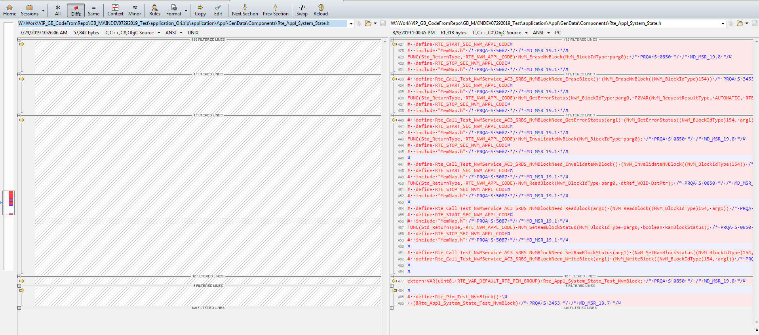

## Create Job End Notification to SWCs

You might see Job End Notification is unconnected in Rte_SystemApplication_OsCORE0.c file

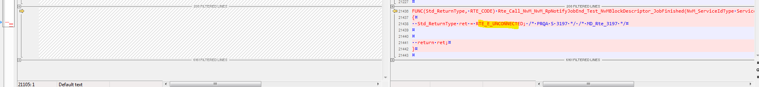

1. If you want to perform connection for Job end notification, then create server port as shown below and map to runnable.

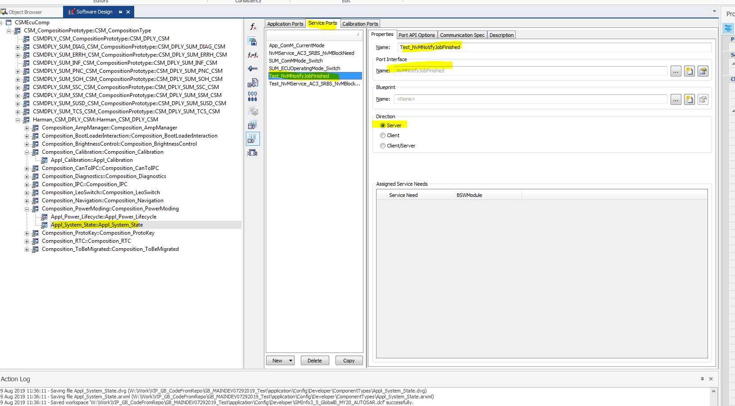

1. Create new runnable and map port access.

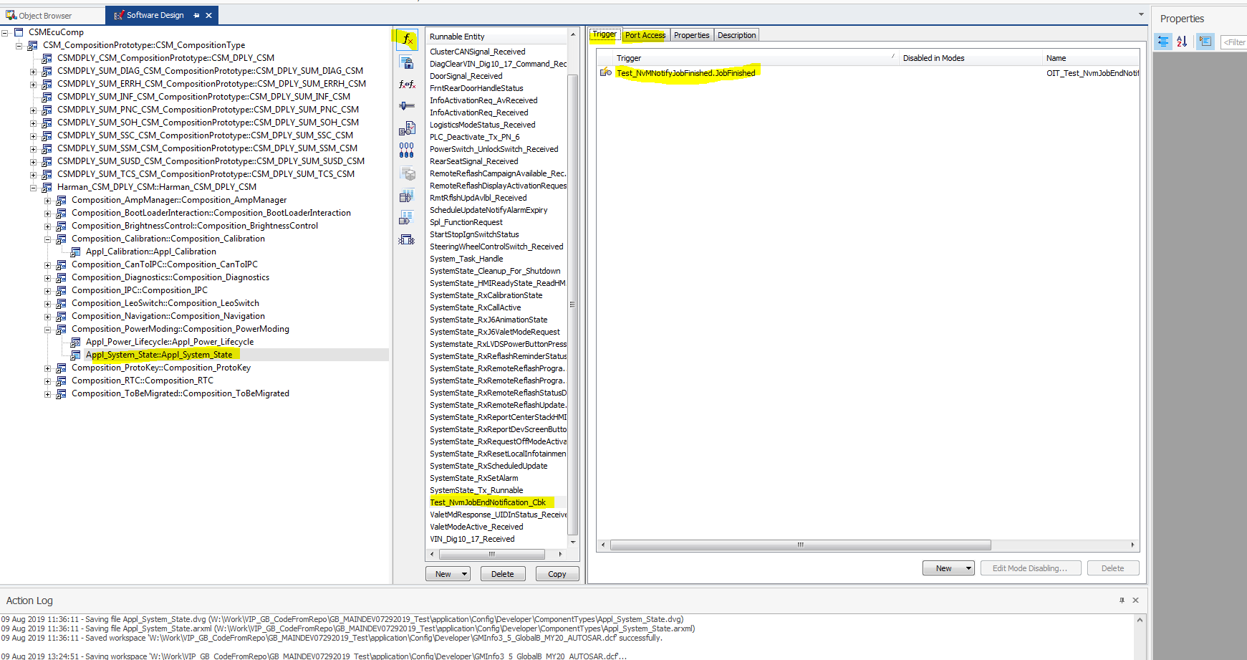

1. Perform RTE connection in Configurator

Default you will see as below.

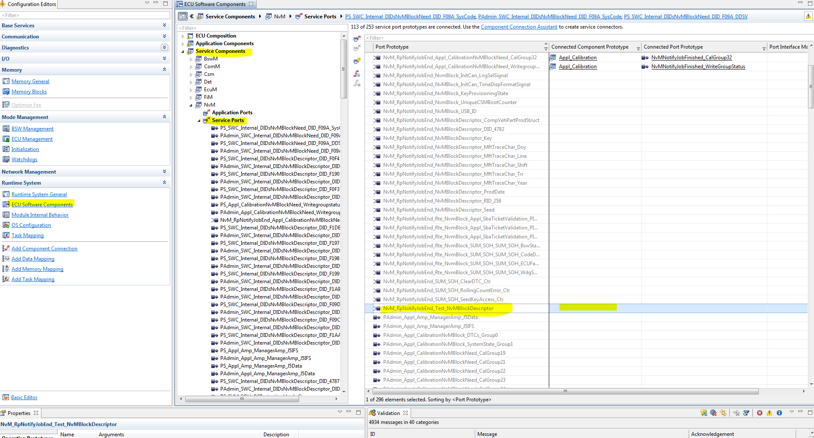

Select as shown below and click OK.

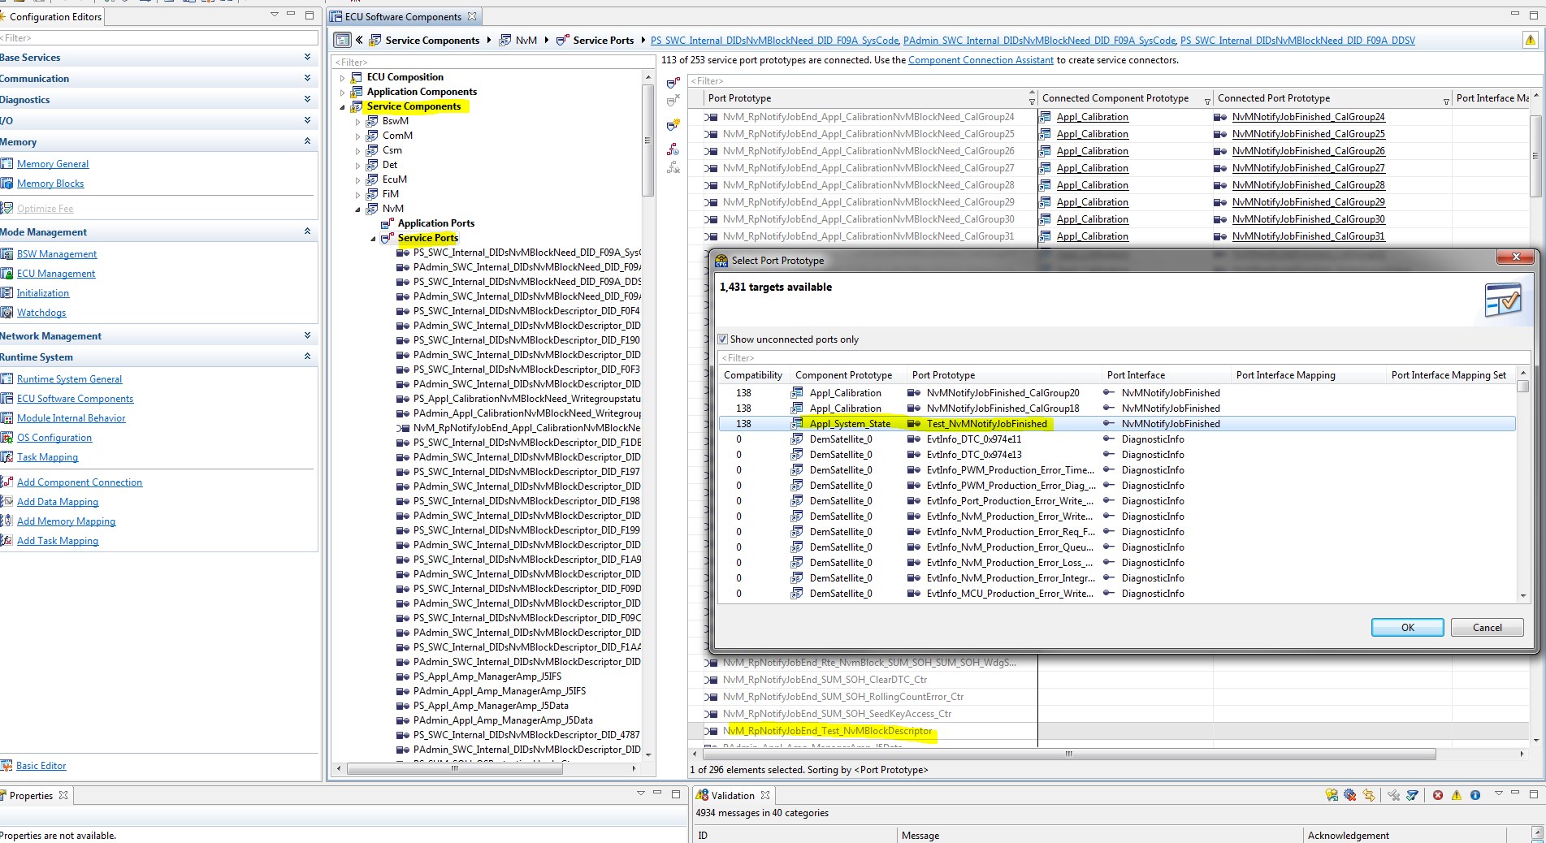

1. Now generate code RTE and SWC after connection. You will see as shown below if coneections are correct.

