# Adding new DTCs

1. Req
2. Design Segregation (SUM_ERRH\SWC_DTCHandling)
3. Internal (SUM_ERRH)
4. External (SWC_DTCHandling) -
   1. Runnable (250\500\150 ms)

**---------------------------------------------------------------Start – Add New SWC_DTC ----------------------------------------**

1. **Presteps In configurator (Dem):**
2. Event Priority
3. Enable Condition Group Ref
4. Operating Cycle\Failure Cycle Ref
5. Various Counter values (Debounce\Threshold and so on)
6. Counter Jump Down\Up
7. Aging Allowed
8. Aging Cycle Counter
9. **Add in SUM_ERRH (SwcSumGM)**

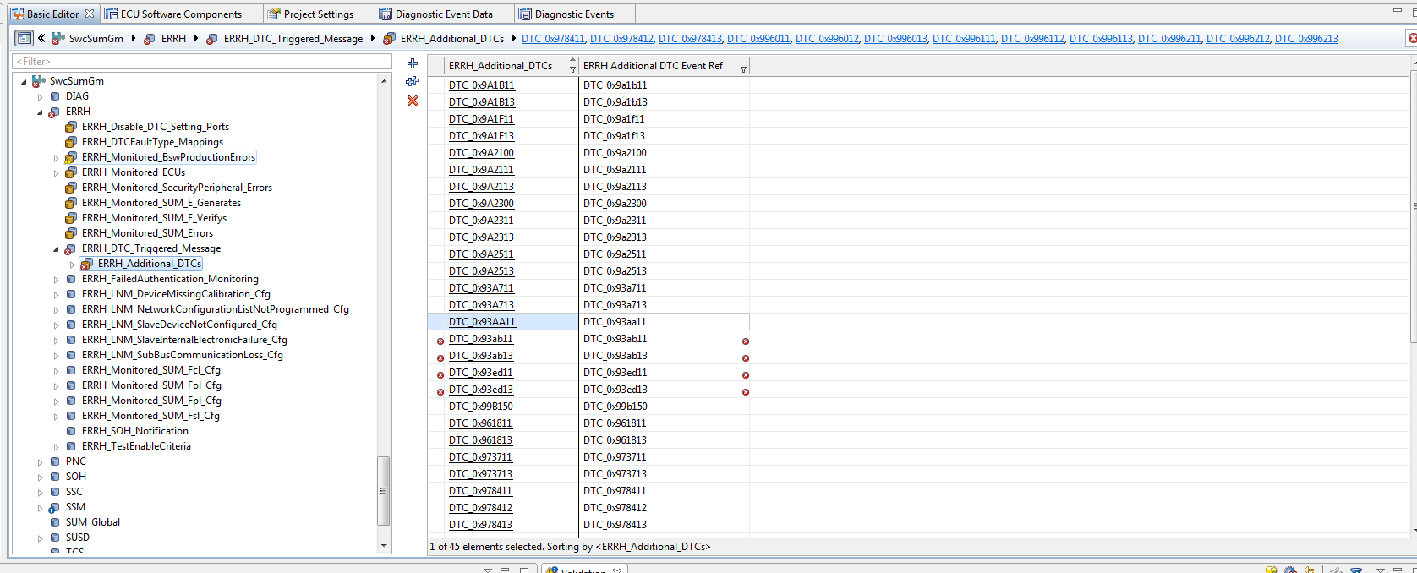

1. **After above step will get below error: This will come if you didn’t configured call-back in DEM. While generating DEM code it will not through error for this.**

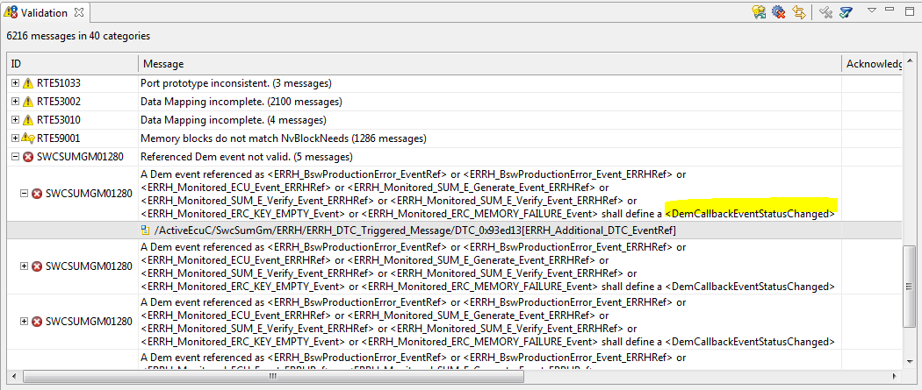

1. **Add Call-back**

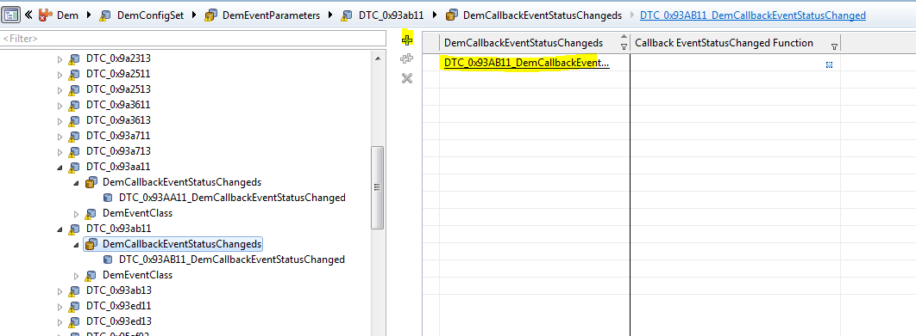

1. **Changes in Developer for Swc_DTC_Handling if need**
2. Create Port Interface of type as shown below

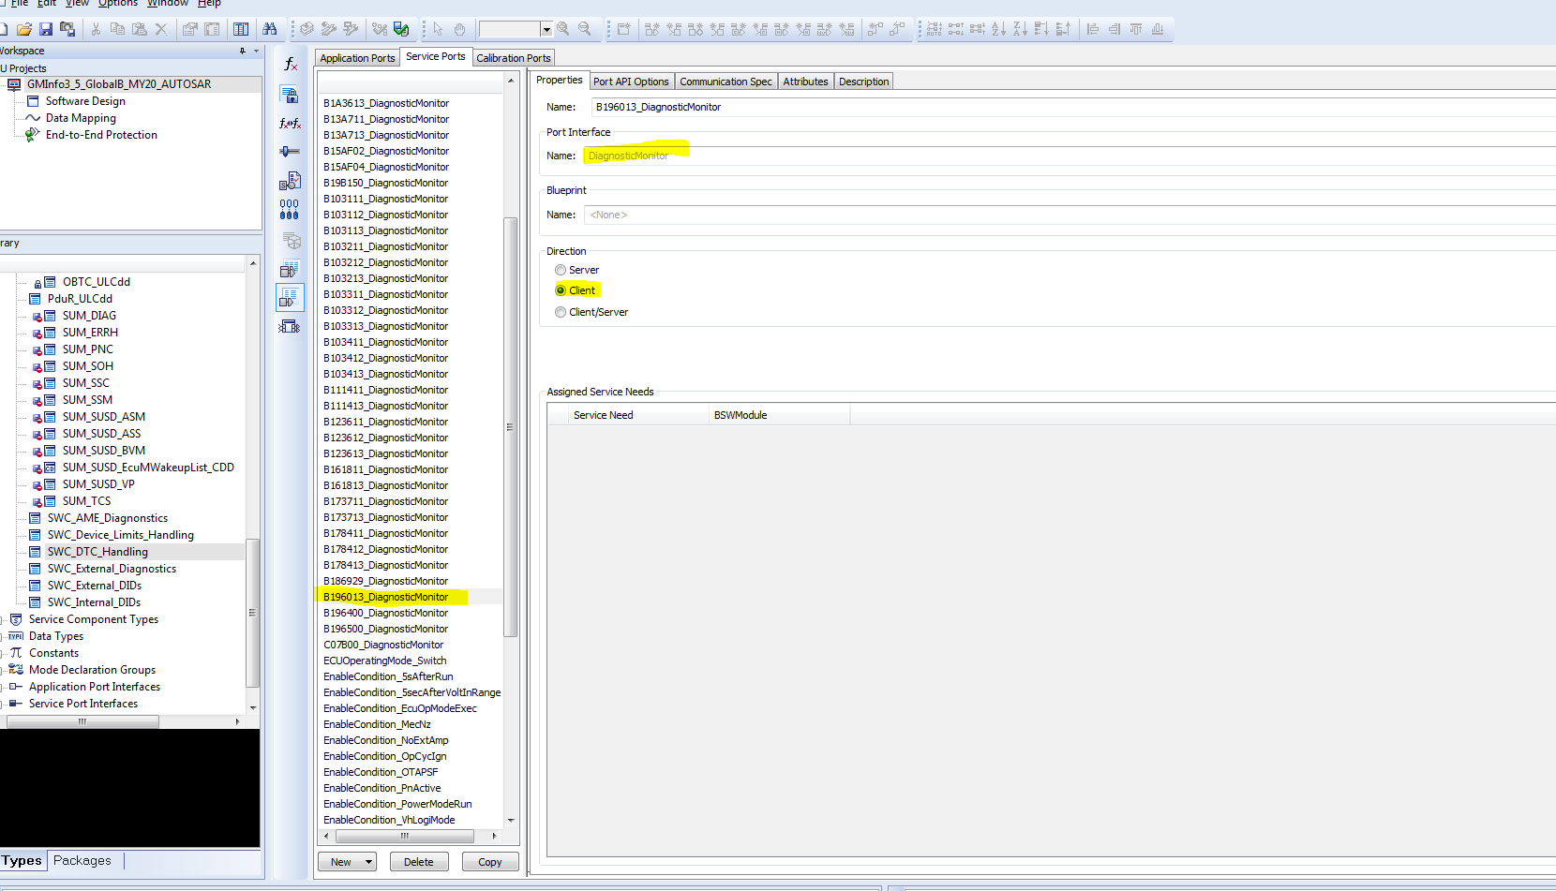

1. Map Port interface to Runnable “Diagnostic_TroubleCode_Monitoring_500ms”

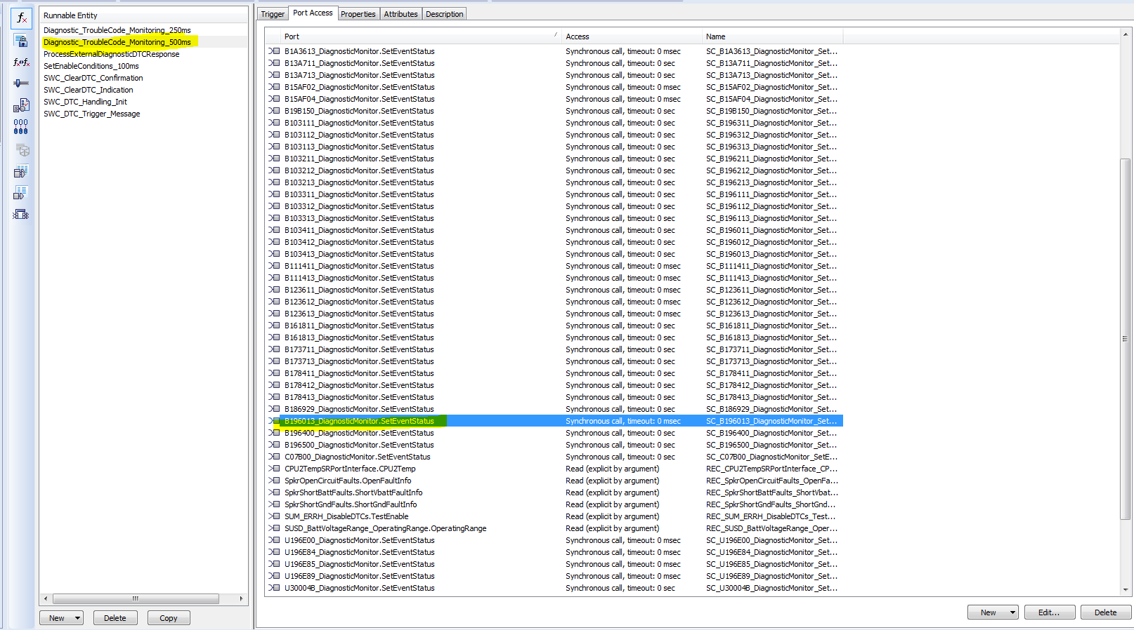

1. Map “Port Interface” to runnable “ProcessExternalDiagnosticDTCResponse” if SoC needs status for this DTC
2. **Perfrom Sevice connectors in “ECU Software components”**
3. **Configure CBStatusEvt_DTC_xyxabc to SUM_ERRH to Set up the link between DEM Call-back with Upper layers**

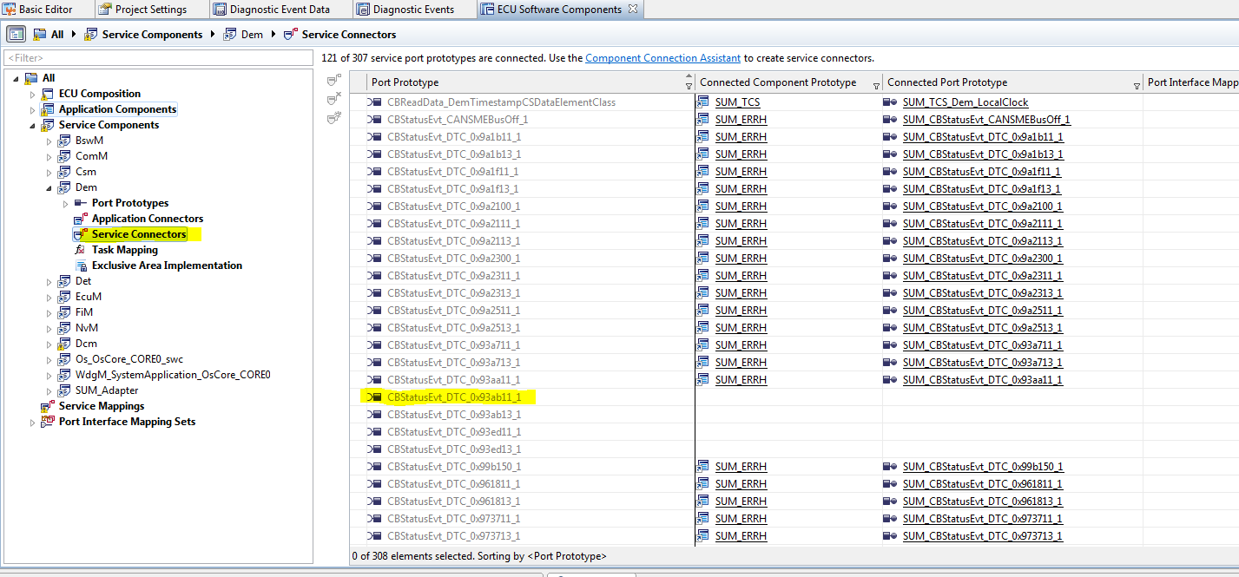

1. **Map “Event_DTC_0x996013” to SWC_DTC_Handling**

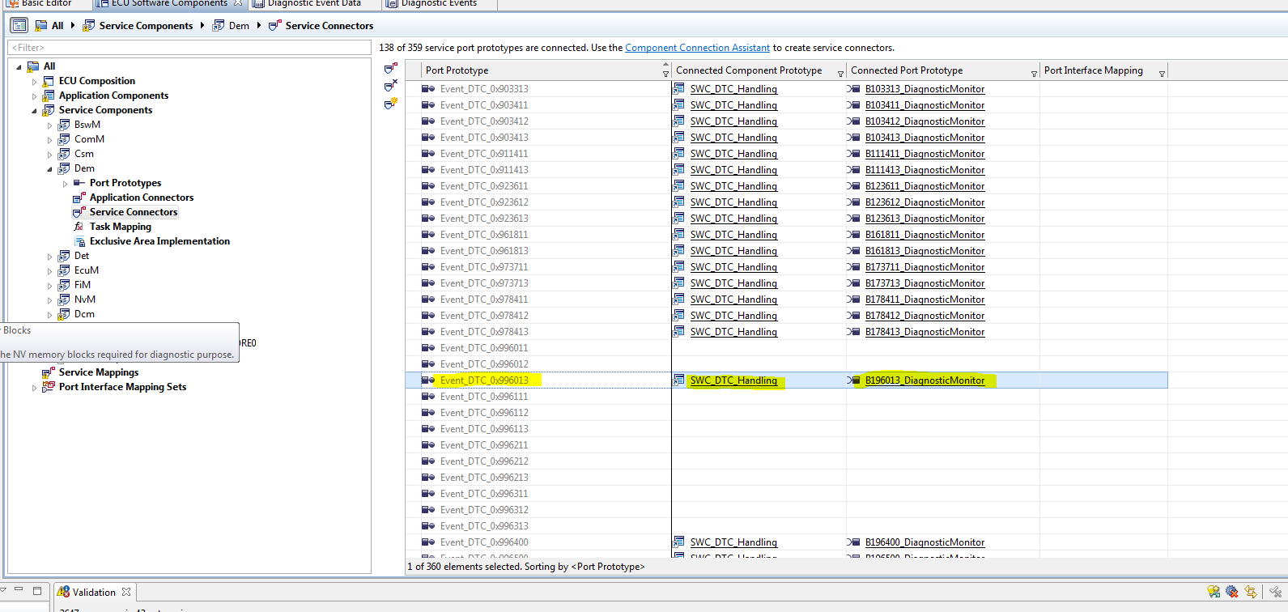

1. **Implement logic in Swc_DTC_Handling.c file**

**----------------------------------------------------------------End – Add New SWC_DTC ----------------------------------------**

**Will see like below**

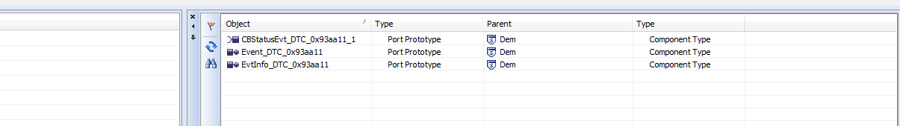

Additional Error With NVM?

Cfg00022 Missing parameter value (1 message)

Cfg00022 The value of reference RteNvmBlockRef is missing or empty.

/ActiveEcuC/Rte/SUM_SSM_EcuSwComposition/NvmBlock_SUM_SSM_SUM_SSM_HVAC_Display_R_LcFA_Need[RteNvmBlockRef]

# Deleted DTC:

1. **Check for NVM Block deletion and other files**
2. **DTC mapping or usage has to be deleted**

**RTE Error**

