Cdd_J6 New Tx Signal Add

User Guide

Introduction
The preconditions are that the new system extract has been imported in DaVinci Configurator and new signal_table.h upon the new system extract has been generated.
前提条件是新的系统提取已经在DaVinci Configurator中导入，并且在生成新的系统提取时，新的signal_table.h已经生成
Take GB System Extract 140 as example.
以GB System Extract 140为例。
According to the diff report diff_analysis_140signals.xlsx, a new frame "CSM_RadioLow_CAN5_MSG04" added in the database, including two signals "OATDispdVal" and "OATDispdVal_DuD".
根据diff报告diff_analysis_140signals.xlsx，在数据库中增加了一个新帧“CSM_RadioLow_CAN5_MSG04”，包括两个信号“OATDispdVal”和“OATDispdVal_DuD”

Scope
This document show how to add CddJ6_TxSignal in Vector Davinci Developer & Configurator.
本文档展示了如何在DaVinci开发器和配置器中添加CddJ6_TxSignal。

Contents

1. Introduction 2
2. Scope 2
3. Contents 2
4. Detail Procedure to make CDDJ6_Tx Signal 3
4.1 Check Application Port in CSMEcuComp 3
4.2 Change port prototype name as naming convention 4
4.3 Verify data element of port prototype 5
4.4 Connect Port from CSMEcuComp to Cdd_J6 5
4.5 Check P-Port in “Cdd_J6” and add port access in ‘Runnable_J6Rx” 7
4.6 Sync with Davinci Configurator & Generate Code 7
4.7 Modify “J6_prv_Can.c” 8
5. ETC 10
6. Revision History 11
Appendix A 12
A-1. When Port already exist in Step 4.4. Connect Port from CSMEcuComp to Cdd_j6 12

Detail Procedure to make CDDJ6_Tx Signal

Check Application Port in CSMEcuComp
4.1检查CSMEcuComp中的应用端口
Open Vector DaVinci Developer project and then navigate to SWC Composition "CSMEcuComp". Check there are "OATDispdVal" and "OATDispdVal_DuD" port prototype as Application port.
打开DaVinci开发项目，然后导航到SWC合成“CSMEcuComp”。检查有“OATDispdVal”和“OATDispdVal_DuD”端口原型作为应用端口
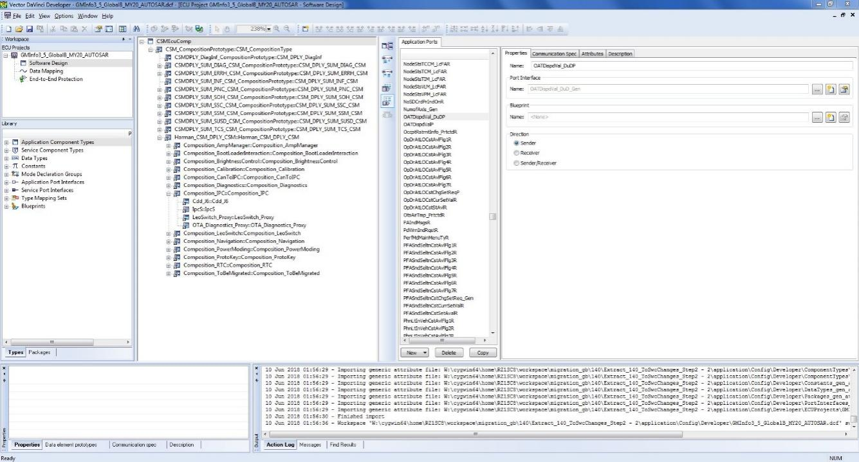
If there is no "OATDispdVal" and "OATDispdVal_DuD"port, generate port prototype in ‘Signal view mode’ in Data Mapping
如果没有“OATDispdVal”和“OATDispdVal_DuD”端口，在数据映射中以“信号视图模式”生成端口原型
Create Port Prototype as default option
创建端口原型作为默认选项

Change port prototype name as naming convention
4.2将端口原型名称更改为命名约定
Change signal name OATDispdVal_DuDP to OATDispdVal_DuD_Gen to follow the same name pattern as Harman did. Take the same action for signal name OATDispdValP
将信号名称OATDispdVal_DuDP更改为OATDispdVal_DuD_Gen，以遵循与Harman相同的名称模式。对信号名称OATDispdValP采取相同的操作

Verify data element of port prototype
4.3验证端口原型数据元素
Verify the data element attached to the port prototype is configured properly, including init value, data type, etc. Please go through Tab "Communication Spec". Check Data Type is proper in Interface Properties tab.
验证连接到端口原型的数据元素配置正确，包括初始化值、数据类型等。请点击“通信规范”。在“接口属性”选项卡中检查“数据类型”是否正确。

Connect Port from CSMEcuComp to Cdd_J6
4.4连接CSMEcuComp端口到Cdd_J6
Go to "CSMEcuComp". Find P-port prototype OATDispdVal_DuD_Gen in Connector Prototype List (R-port View) and create a connector to Harman Composition prototype "CSM_CompositionPrototype" by right click on the broken connector and select "Complete Ports". In poped up window, select "Software Component Ports" and browse in an Objects list and select
去“CSMEcuComp”。在Connector prototype List (R-port View)中找到P-port原型OATDispdVal_DuD_Gen，并通过右键单击损坏的连接器，选择“Complete Ports”，创建一个连接器到Harman Composition原型“CSM_CompositionPrototype”。在弹出的窗口中，选择“Software Component Ports”，在对象列表中浏览并选择

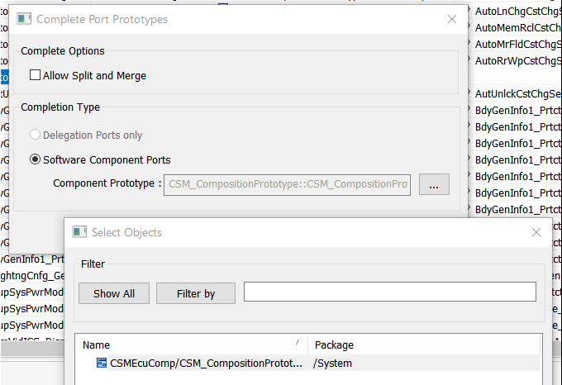

Go down to "CSM_CompositionPrototype". Find P-port prototype OATDispdVal_DuD_Gen in Connector Prototype List (R-port View) and create a connector to Harman Composition prototype "Harman_CSM_DPLY_CSM" by right click on the broken connector and select "Complete Ports". In poped up window, select "Software Component Ports" and browse in an Objects list and select
转到“CSM_CompositionPrototype”。在连接器原型列表(r -端口视图)中找到p -端口原型OATDispdVal_DuD_Gen，并通过右键单击损坏的连接器并选择“完整端口”创建一个到哈曼组合原型“Harman_CSM_DPLY_CSM”的连接器。在弹出的窗口中，选择“Software Component Ports”，在对象列表中浏览并选择
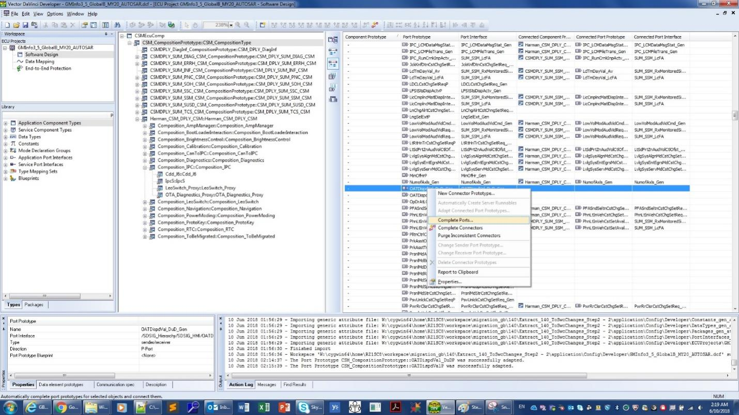
Do the same ‘Complete Ports’ process in Harman_CSM_DPLY and Composition_IPC.
在Harman_CSM_DPLY和Composition_IPC中做相同的' Complete Ports '进程吗

Check P-Port in “Cdd_J6” and add port access in ‘Runnable_J6Rx”
4.54.5检查“Cdd_J6”中的P-Port，在“Runnable_J6Rx”中添加端口访问
Go down to SWC "Cdd_J6". Check if P-ports OATDispdVal_DuD_Gen and OATDispdVal_Gen is existing and the configuration is correct. Then, switch to pane "Runnable Entity List" and add port access to OATDispdVal_Gen in runnable "Runnable_J6Rx" (select New -> Write Data (non-queued) at the bottom of the window)
下到SWC“Cdd_J6”。检查P-ports OATDispdVal_DuD_Gen和OATDispdVal_Gen是否存在，且配置正确。然后，切换到窗格“Runnable Entity List”，并在可运行的“Runnable_J6Rx”中添加端口访问到OATDispdVal_Gen(在窗口底部选择New -> Write Data (non-queued))
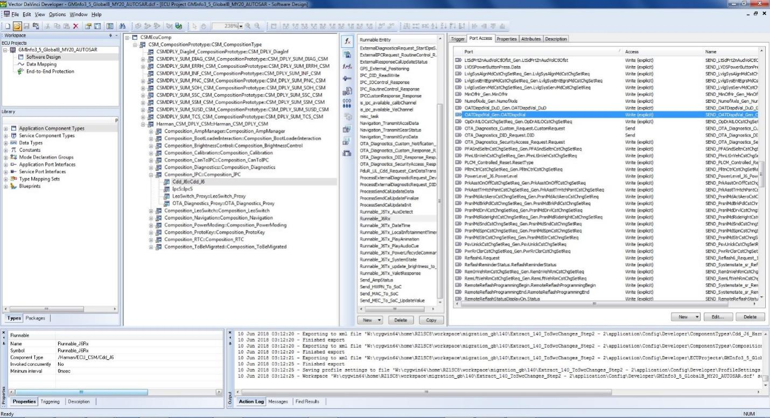

Sync with Davinci Configurator & Generate Code
4.6同步与达芬奇配置器和生成代码
Go back to DaVinci Configurator. Generate code(RTE) and SWC Cdd_J6 (Cdd_J6.c). After generation done, open source file" Cdd_J6.c" and locate the two RTE interfaces generated "Rte_Write_OATDispdVal_Gen_OATDispdVal" and "Rte_Write_OATDispdVal_DuD_Gen_OATDispdVal_DuD". Additionally, you can find the definition and implementation in "Rte_SystemApplication_OsCore_CORE0.c".
回到达芬奇配置器。生成代码(RTE)和SWC Cdd_J6 (Cdd_J6.c)。生成完成后，打开源代码文件“Cdd_J6.c”，找到生成的两个RTE接口“Rte_Write_OATDispdVal_Gen_OATDispdVal”和“rte_write_oatdispdval_dud_gen_oatdispdval_du_gen_oatdispdval_dud”。此外，你可以在“Rte_SystemApplication_OsCore_CORE0.c”中找到定义和实现。
Figure 1 Code Snippet in Cdd_J6.c
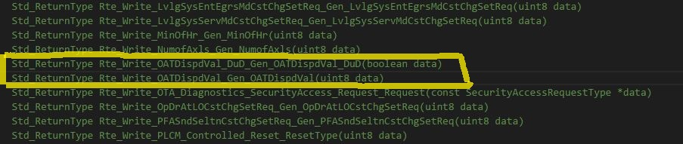
Figure 2 Code Snippet in Rte_SystemApplication_OsCore_CORE0.c
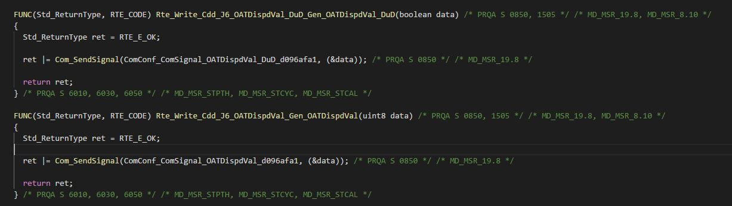

Modify “J6_prv_Can.c”
4.7修改“J6_prv_Can.c”
Open source file "J6_prv_Can.c" (Source\CDD_J6\J6_prv_Can.c). Add the code in function "VIS_Tx_CAN_Signal_VIS_Tx_CAN_Signal" to call the RTE interfaces to send signals "OATDispdVal_Gen" and "OATDispdVal_DuD_Gen" to Can bus. See code snippet below.
打开源代码文件“J6_prv_Can.c”(源代码\CDD_J6\J6_prv_Can.c)。在函数“VIS_Tx_CAN_Signal_VIS_Tx_CAN_Signal”中添加代码，调用RTE接口将信号“OATDispdVal_Gen”和“OATDispdVal_DuD_Gen”发送到Can总线。参见下面的代码片段。
Figure 3 Code Snippet in J6_prv_Can.c
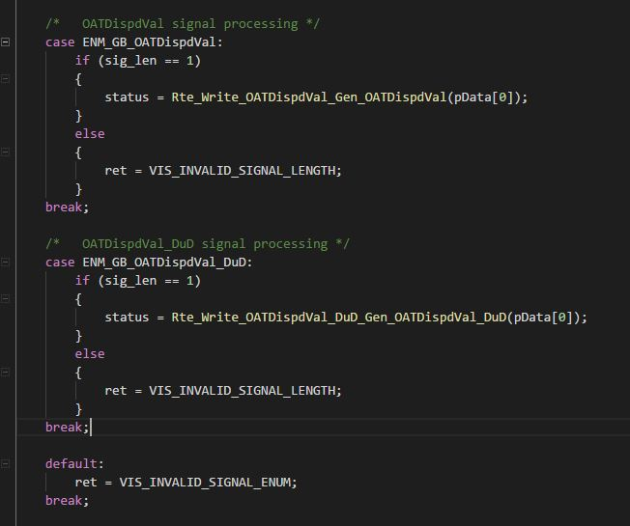
If it's group signal, it should be processed in one case as part of signal group as well as a seperate case for the signal, but only one RTE interface for the signal group is generated and called in group signals process.
如果是群信号，应该在一种情况下作为信号组的一部分进行处理，并单独为信号处理一种情况，但在群信号处理中只生成一个信号组的RTE接口并调用
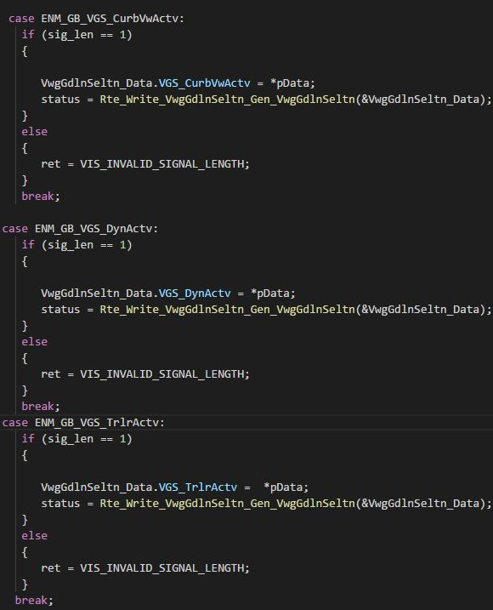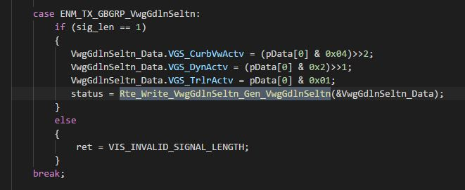

ETC

Revision History
Date | Version | Author | Description
6/15/2018 | 0.1 | Yong Yin | Initial version Release CddJ6_TxSignal_Add_UserGuide.xlsx
8/28/2019 | 0.2 | Chinkyu Kang | Modify to docx format  .

Appendix A

A-1. When Port already exist in Step 4.4. Connect Port from CSMEcuComp to Cdd_j6
Switch to Connector Prototype List (R-port view) and update the connected port prototype "OATDispdVal_DuDP" and interface by right click on the connector and select "Adapt Connected Port Prototypes". In the window poped up, check "Name", "Init Value" and "Attributes", then click "OK". Take the same action for connected port prototype "OATDispdValP"
