Cdd_J6 New Tx Signal Add

User Guide

介绍
前提是在DaVinci Configurator中导入了新的系统解压，并且在生成了新的系统解压后生成了新的signal_table.h.
以GB System Extract 140为例.
根据diff报告diff_analysis_140signals.xlsx，在数据库中添加了一个新的帧“CSM_RadioLow_CAN5_MSG04”，包括两个信号“OATDispdVal”和“OATDispdVal_DuD”.

范围
本文档展示了如何在 Vector Davinci Developer & Configurator 中添加 CddJ6_TxSignal.

内容

1. Introduction 2
2. Scope 2
3. Contents 2
4. Detail Procedure to make CDDJ6_Tx Signal 3
4.1 Check Application Port in CSMEcuComp 3
4.2 Change port prototype name as naming convention 4
4.3 Verify data element of port prototype 5
4.4 Connect Port from CSMEcuComp to Cdd_J6 5
4.5 Check P-Port in “Cdd_J6” and add port access in ‘Runnable_J6Rx” 7
4.6 Sync with Davinci Configurator & Generate Code 7
4.7 Modify “J6_prv_Can.c” 8
5. ETC 10
6. Revision History 11
Appendix A 12
A-1. When Port already exist in Step 4.4. Connect Port from CSMEcuComp to Cdd_j6 12

制作 CDDJ6_Tx 信号的详细过程

检查 CSMEcuComp 中的应用程序端口
打开 Vector DaVinci Developer 项目，然后导航到 SWC Composition "CSMEcuComp"。 检查是否有“OATDispdVal”和“OATDispdVal_DuD”端口原型作为应用程序端口.
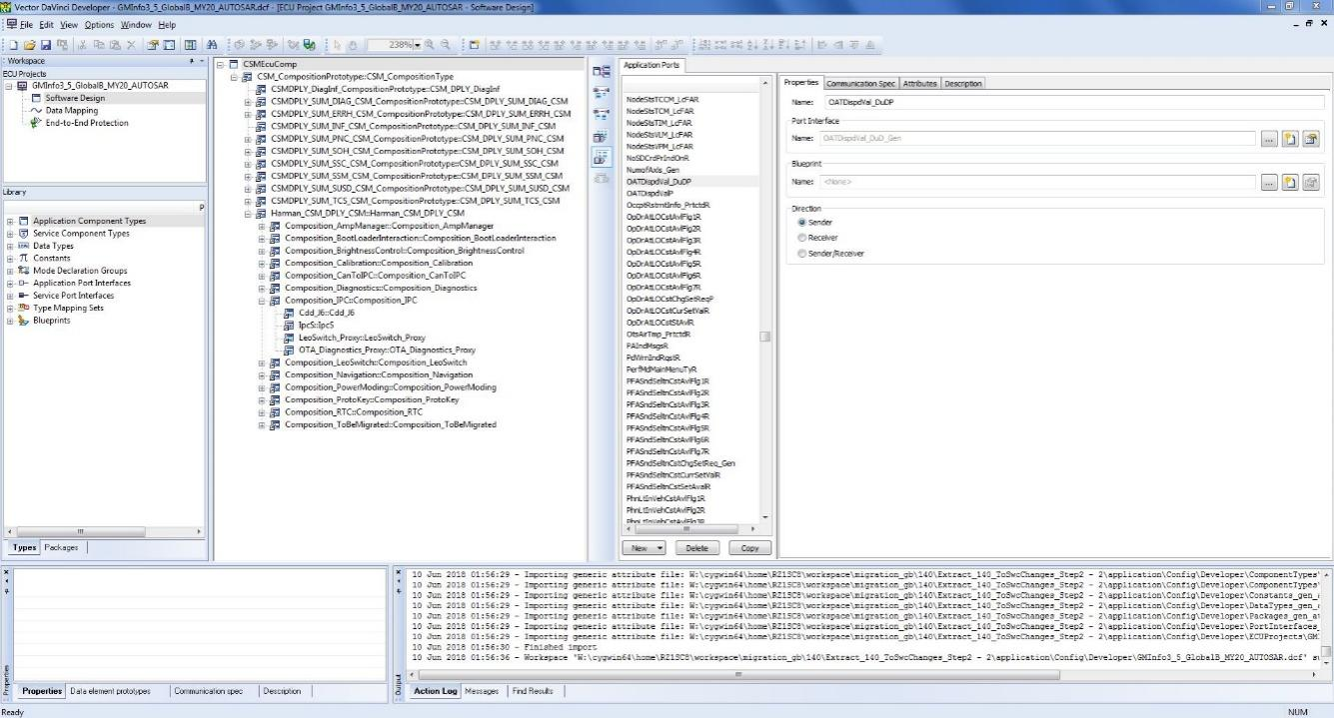
如果没有“OATDispdVal”和“OATDispdVal_DuD”端口，则在Data Mapping中的‘Signal view mode’生成端口原型
创建端口原型作为默认选项

更改端口原型名称作为命名约定
将信号名称 OATDispdVal_DuDP 更改为 OATDispdVal_DuD_Gen 以遵循与 Harman 相同的名称模式。 对信号名称 OATDispdValP 采取相同的操作

验证端口原型的数据元素
验证附加到端口原型的数据元素是否正确配置，包括初始化值、数据类型等。请通过“通信规范”选项卡。 在接口属性选项卡中检查数据类型是否正确.

将 CSMEcuComp 的端口连接到 Cdd_J6
转到“CSMEcuComp”。 在连接器原型列表（R 端口视图）中找到 P 端口原型 OATDispdVal_DuD_Gen，然后通过右键单击损坏的连接器并选择“完整端口”来创建一个到 Harman Composition 原型“CSM_CompositionPrototype”的连接器。 在弹出的窗口中，选择“软件组件端口”并浏览对象列表并选择

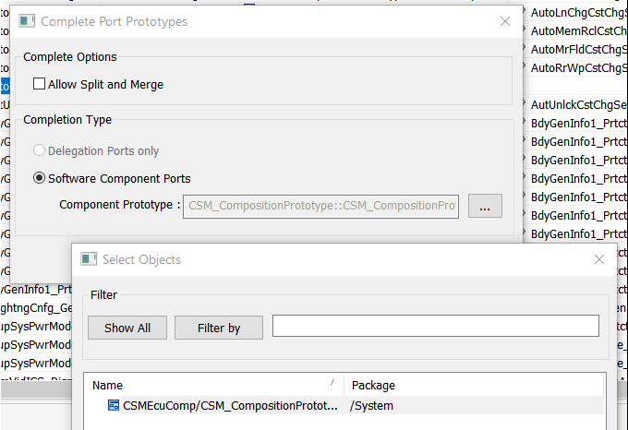

转到“CSM_CompositionPrototype”。 在连接器原型列表（R 端口视图）中找到 P 端口原型 OATDispdVal_DuD_Gen，然后通过右键单击损坏的连接器并选择“完整端口”来创建一个到 Harman Composition 原型“Harman_CSM_DPLY_CSM”的连接器。 在弹出的窗口中，选择“软件组件端口”并浏览对象列表并选择
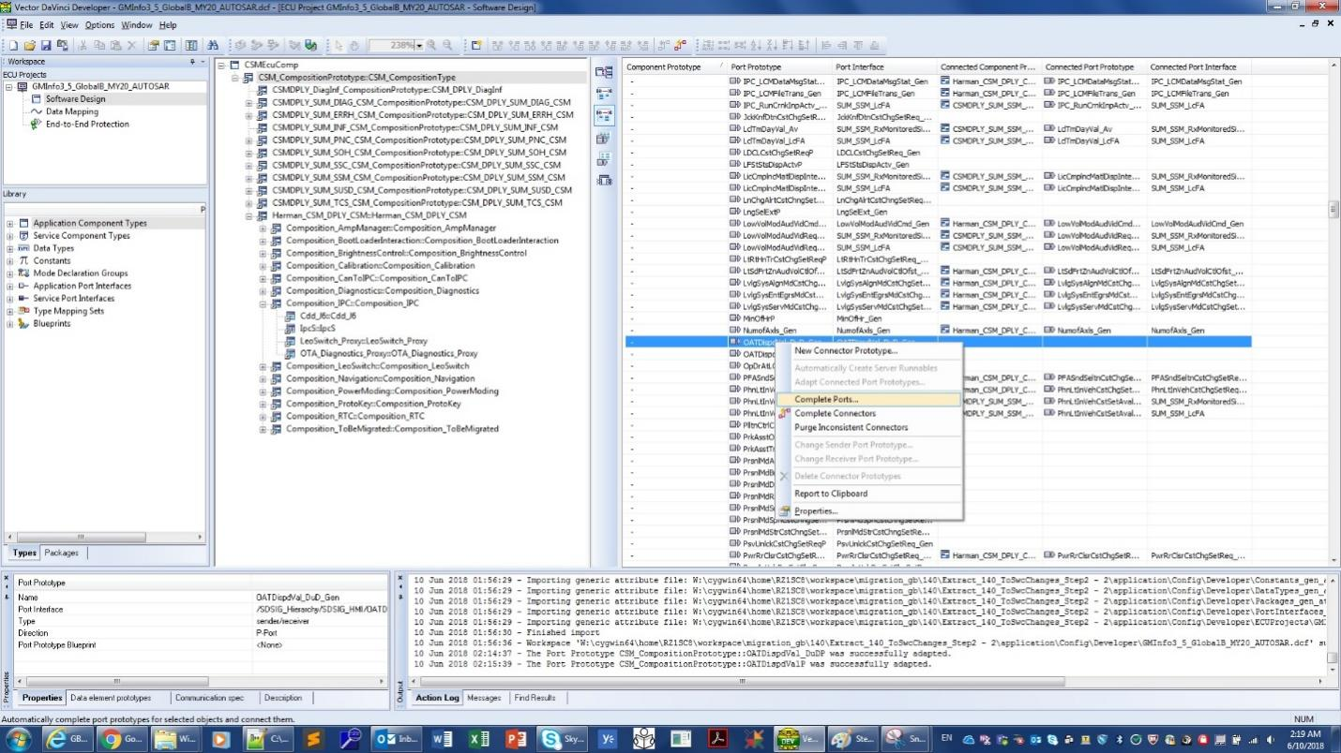
在 Harman_CSM_DPLY 和 Composition_IPC 中执行相同的“完成端口”过程.

Check P-Port in “Cdd_J6” and add port access in ‘Runnable_J6Rx”
Go down to SWC "Cdd_J6". Check if P-ports OATDispdVal_DuD_Gen and OATDispdVal_Gen is existing and the configuration is correct. Then, switch to pane "Runnable Entity List" and add port access to OATDispdVal_Gen in runnable "Runnable_J6Rx" (select New -> Write Data (non-queued) at the bottom of the window)
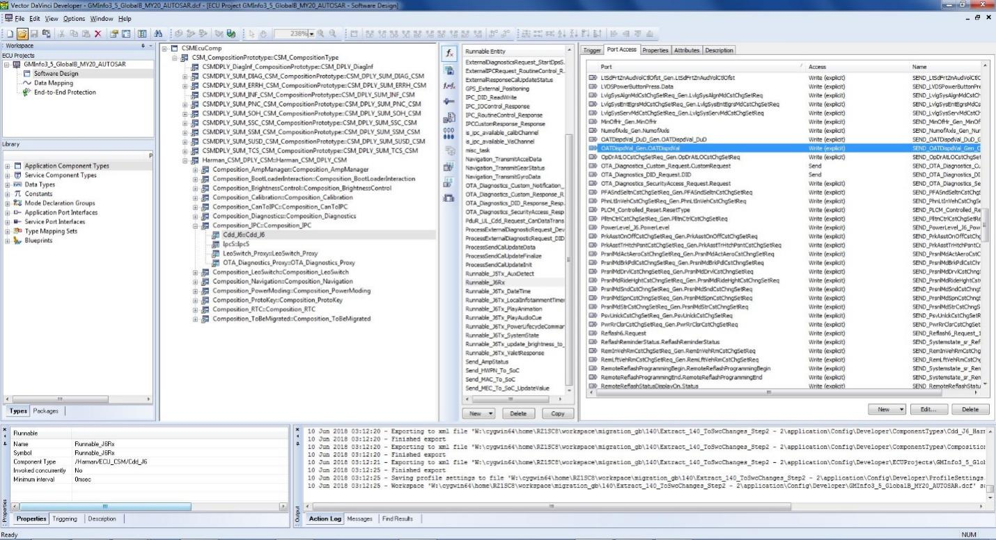

Sync with Davinci Configurator & Generate Code
Go back to DaVinci Configurator. Generate code(RTE) and SWC Cdd_J6 (Cdd_J6.c). After generation done, open source file" Cdd_J6.c" and locate the two RTE interfaces generated "Rte_Write_OATDispdVal_Gen_OATDispdVal" and "Rte_Write_OATDispdVal_DuD_Gen_OATDispdVal_DuD". Additionally, you can find the definition and implementation in "Rte_SystemApplication_OsCore_CORE0.c".
Figure 1 Code Snippet in Cdd_J6.c
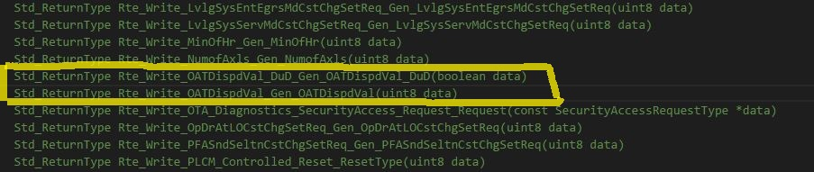
Figure 2 Code Snippet in Rte_SystemApplication_OsCore_CORE0.c
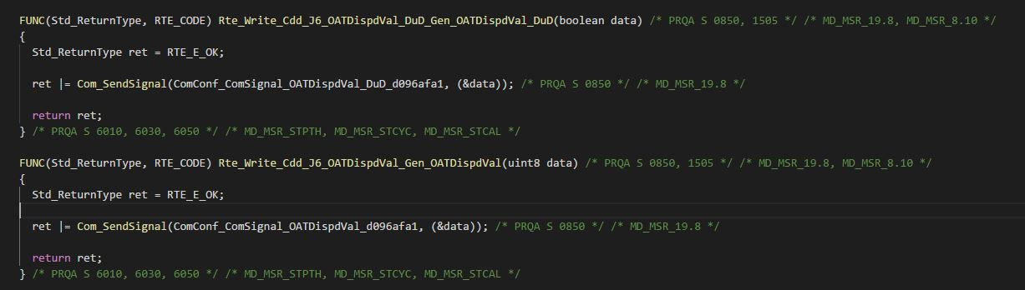

Modify “J6_prv_Can.c”
Open source file "J6_prv_Can.c" (Source\CDD_J6\J6_prv_Can.c). Add the code in function "VIS_Tx_CAN_Signal_VIS_Tx_CAN_Signal" to call the RTE interfaces to send signals "OATDispdVal_Gen" and "OATDispdVal_DuD_Gen" to Can bus. See code snippet below.
Figure 3 Code Snippet in J6_prv_Can.c
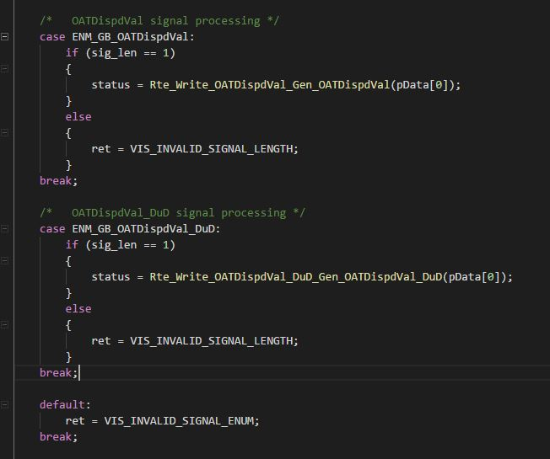
If it's group signal, it should be processed in one case as part of signal group as well as a seperate case for the signal, but only one RTE interface for the signal group is generated and called in group signals process.
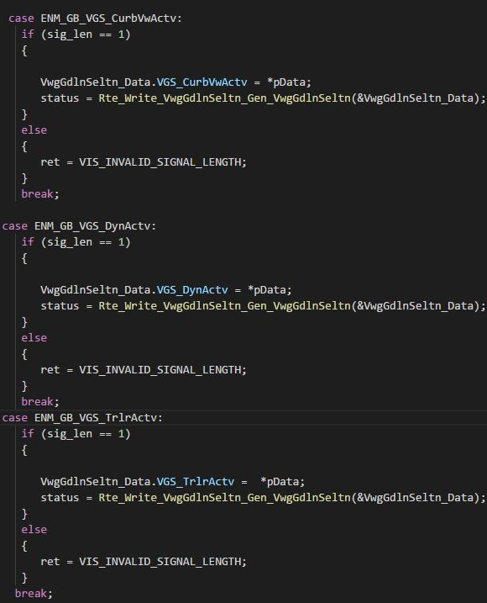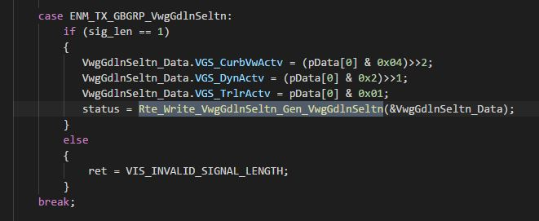

ETC

Revision History
Date | Version | Author | Description
6/15/2018 | 0.1 | Yong Yin | Initial version Release CddJ6_TxSignal_Add_UserGuide.xlsx
8/28/2019 | 0.2 | Chinkyu Kang | Modify to docx format  .

Appendix A

A-1. When Port already exist in Step 4.4. Connect Port from CSMEcuComp to Cdd_j6
Switch to Connector Prototype List (R-port view) and update the connected port prototype "OATDispdVal_DuDP" and interface by right click on the connector and select "Adapt Connected Port Prototypes". In the window poped up, check "Name", "Init Value" and "Attributes", then click "OK". Take the same action for connected port prototype "OATDispdValP"
