## CSS loading image – spin.js

CSS实现Loading加载动画

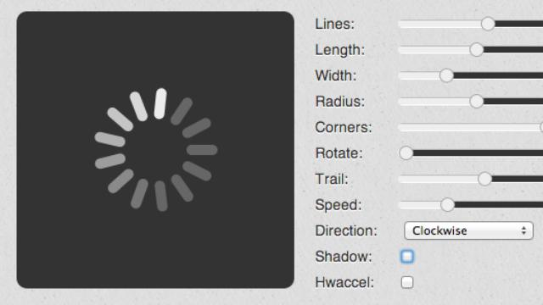

优秀的前端工程师总是优先考虑用CSS替代图片：

效果图如上。这个动画并非GIF，而是纯CSS绘制，通过JavaScript定时器更新动画。

基本思路是创建8个圆形div，绝对定位排列成圆圈，然后，依次通过opacity属性更新透明度，就得到一个loading的效果图。

和GIF相比，CSS实现的好处主要在于，对于不同背景颜色，该动画都是完美的，还可以用CSS轻松实现阴影、发光等特效，而GIF虽然支持透明色，但创建时选择的背景色和实际背景色不一致会导致有明显的毛边，而且GIF不易动态更新，需要重新生成图片。

CSS方式完全可以通过包装成jQuery插件实现非常简单却异常强大的loading动画，缺点是IE不支持border-radius，所以IE下看到的是方块。

如果你不想自己写代码，这里有一个可视化在线生成CSS3 Loading动画的网站，相当强大：

<http://fgnass.github.io/spin.js/>



## Usage

var opts = {

lines: 13 *// The number of lines to draw*

, length: 33 *// The length of each line*

, width: 45 *// The line thickness*

, radius: 42 *// The radius of the inner circle*

, scale: 1 *// Scales overall size of the spinner*

, corners: 1 *// Corner roundness (0..1)*

, color: '#000' *// #rgb or #rrggbb or array of colors*

, opacity: 0.25 *// Opacity of the lines*

, rotate: 0 *// The rotation offset*

, direction: 1 *// 1: clockwise, -1: counterclockwise*

, speed: 1 *// Rounds per second*

, trail: 60 *// Afterglow percentage*

, fps: 20 *// Frames per second when using setTimeout() as a fallback for CSS*

, zIndex: 2e9 *// The z-index (defaults to 2000000000)*

, className: 'spinner' *// The CSS class to assign to the spinner*

, top: '50%' *// Top position relative to parent*

, left: '50%' *// Left position relative to parent*

, shadow: false *// Whether to render a shadow*

, hwaccel: false *// Whether to use hardware acceleration*

, position: 'absolute' *// Element positioning*

}

var target = document.getElementById('foo')

var spinner = new Spinner(opts).spin(target);

The spin() method creates the necessary HTML elements and starts the animation. If a target element is passed as argument, the spinner is added as first child and horizontally and vertically centered.

### Manual insertion

In order to manually insert the spinner into the DOM you can invoke the spin() method without any arguments and use the el property to access the HTML element:

var spinner = new Spinner().spin()

target.appendChild(spinner.el)

### Positioning

Since version 2.0.0 the spinner is absolutely positioned at 50% of its offset parent. You may specify a top and left option to position the spinner manually.

**Note:** The spinner element is a 0×0 pixel DIV that represents the center of the spinner. Hence, if you passed {top:0, left:0} only the lower right quater of the spinner would be inside the target's bounding box.

The spinner element must be surrounded by an element using relative positioning, or the spinner will be outside of the parent element.

### Hiding the spinner

To hide the spinner, invoke the stop() method, which removes the UI elements from the DOM and stops the animation. Stopped spinners may be reused by calling spin() again.

### jQuery plugin

Spin.js does not require jQuery. Anyway, if you want to use jQuery you may use [this plugin](http://fgnass.github.io/spin.js/jquery.spin.js).