Sample output:

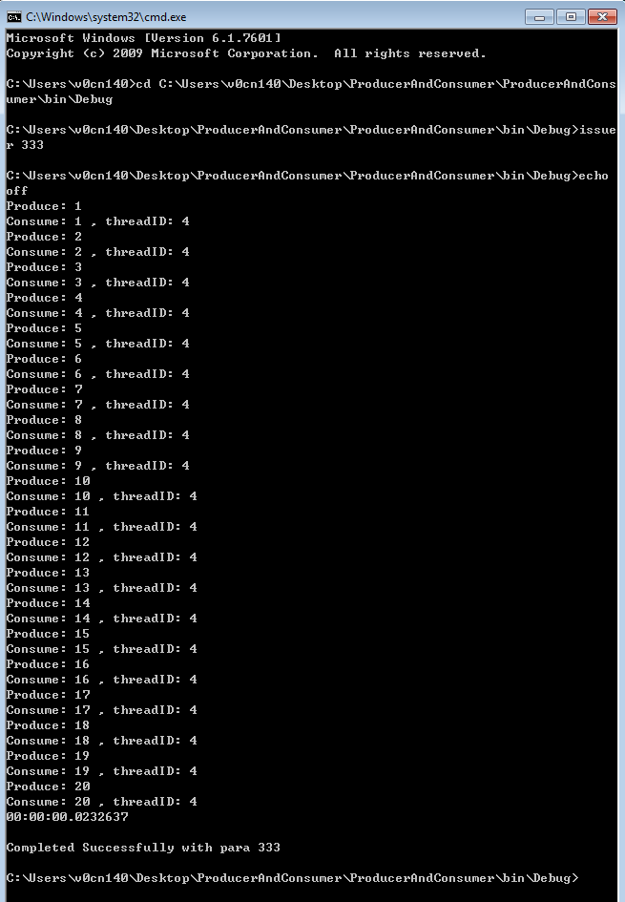

1. Batch script to issue the application via console, indicating the result from exception code.

Usage of such batch file is for deployment of application once developer has no permit to get access, but the issuer will collect and provide the execution result instead.

1. Single consumer and producer using Monitor for synchronization.