## Portfolio Management

Introduction

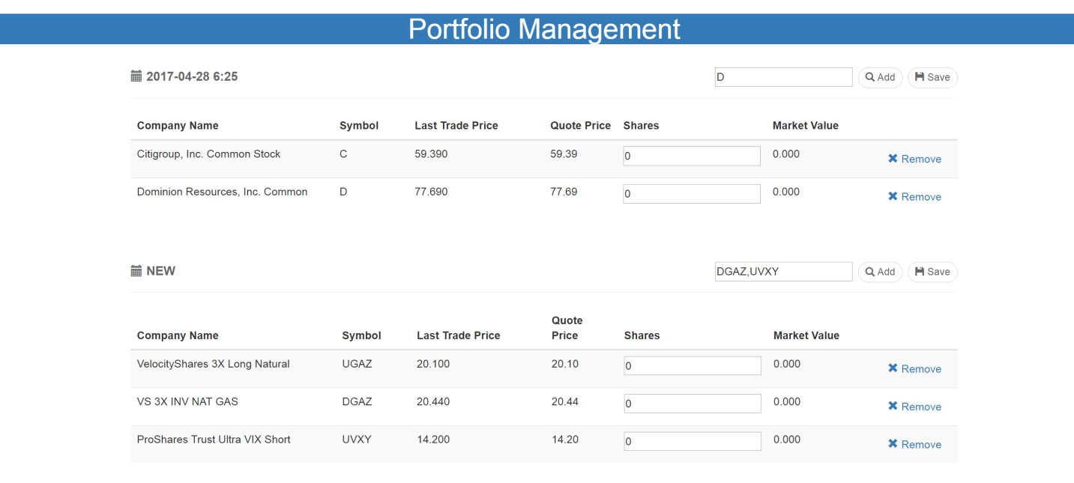

This web application is based on spring boot application responsible for creating and managing multiple portfolios.

Backend stores the portfolio in a RDBMS( default H2 database) using spring JPA repository to accomplish this. It provides several REST APIs .

Frontend is based on Angularjs (Javascript Framework) and Bootstrap (CSS Framework)

### Project Structure

This project is one maven project. You can import this project into your java IDE

The JDK version is 1.8

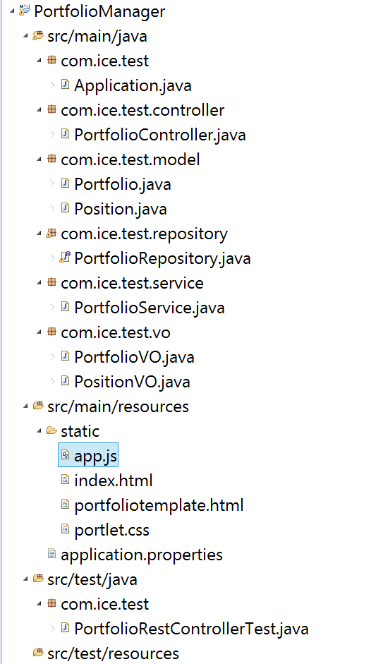

Backend: System use the JPA and restful controller as the backbone

1. Application.java is system running program, this one will start web server
2. PortfolioController.java is restful controller expose some APIs to create portfolio, retrieval portfolios and delete position from one portfolio
3. PortfolioRepository.java is DAO to access domain model, this class just use spring repository without too much definition
4. PortfolioService.java is business logic handler, the restful controller will call service layer. Service layer will call repository and perform converting between domain model and value object
5. The package of com.ice.test.model contain domain models, domain models are POJO with JPA annotation. The relationship of portfolio and position is “one to many”. Portfolio domain model will save portfolio name and portfolio owner information.Position domain model will save ticker of security, number of share of security and quote price.
6. The package of com.ice.test.vo contain value objects, controller will create value object based on API request, then service layer will call domain object.
7. PortfolioRestControllerTest.java is unit test to cover restful controller API.

Frontend: System use Angularjs Javascript framework and bootstrap CSS framework

1. App.js contain the Angularjs components. System define two services: marketDataService, portfolioService. marketDataService take responsibility to retrieval real time market information. portfolioService take responsibility to retrieval portfolio information.
2. Index.html is main entry point of from end. This page will load all portfolios and use Angularjs directive to rendering each portfolio.
3. portfoliotemplate.html is the template layout file for rendering portfolio object, this file will be used in portfolio directive.

## Installation

You can run this application in Eclipse IDE or run Maven command.

For eclipse, just import project into workspace and right click of Application.java , then Run as Java Application.

For maven environment, you need [install maven](https://www.mkyong.com/maven/how-to-install-maven-in-windows/) first, after go to project folder from command line then run command: mvn spring-boot:run

System use H2 memory database as default database, you can change the database vendor in application.properties file. Just remove comment for your designated database.

## Manual

1. Go to <http://localhost:8080/> in your browser.

You can see there is one empty portfolio, the portfolio name is “New”

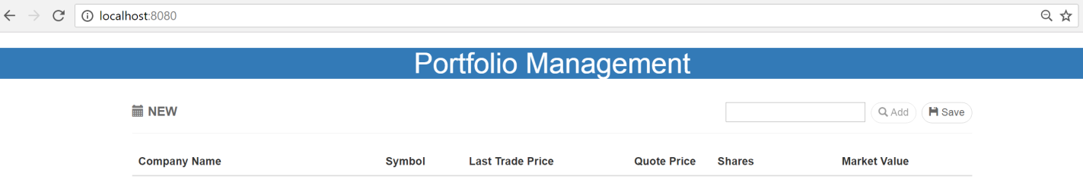

1. Type ticker name in input box besides the Add button, then the Add button will be enabled, click the Add button the valid ticker will be appended in portfolio component

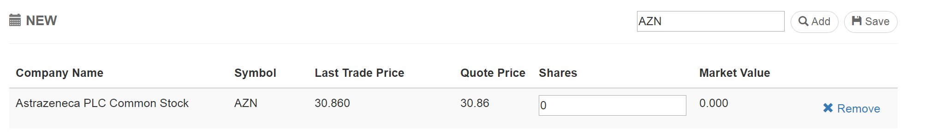

1. You can change the shares number or leave it with default value for tracking
2. You can also add multiple tickers separated with comma and click the Add button.

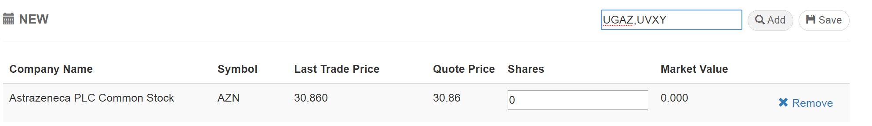

System will add all valid ticker to portfolio component

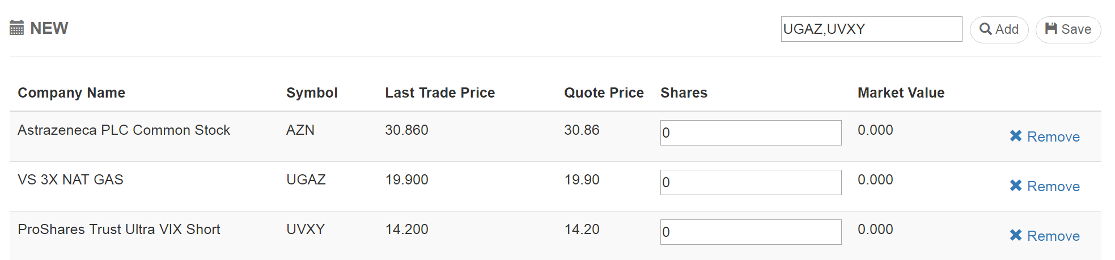

1. Once you add all positions to portfolio and finish the share change in current portfolio, make sure click save button, once save button clicked all portfolio change will be saved into database.

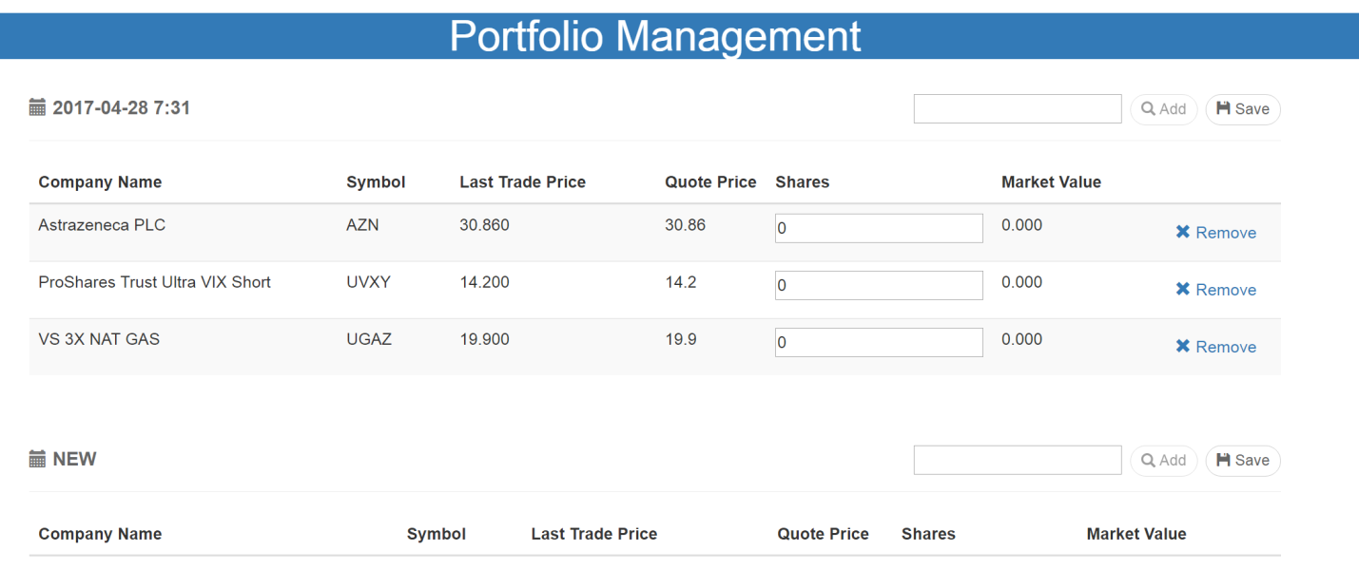

1. After click the save button, your portfolio will be saved into database, the portfolio name is created based on time portfolio create time, the format is “yyyy-MM-dd H:m”. Also new empty portfolio will be appended to the bottom of this page. You can add position to new created portfolio or new empty portfolio.
2. Duplicate security is not allowed in one portfolio, but can be in different portfolio.

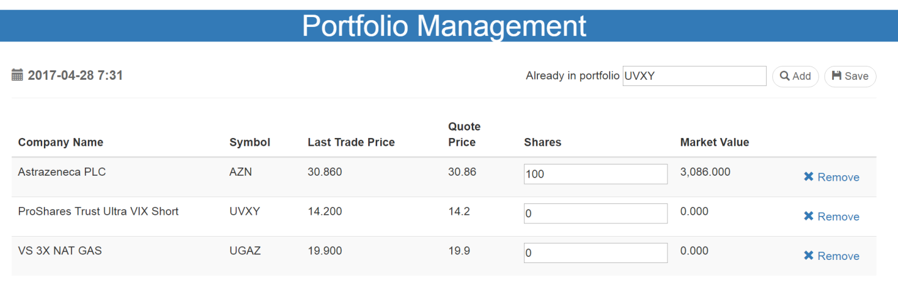

1. Once the positions reach 5, the Add button will be disabled.

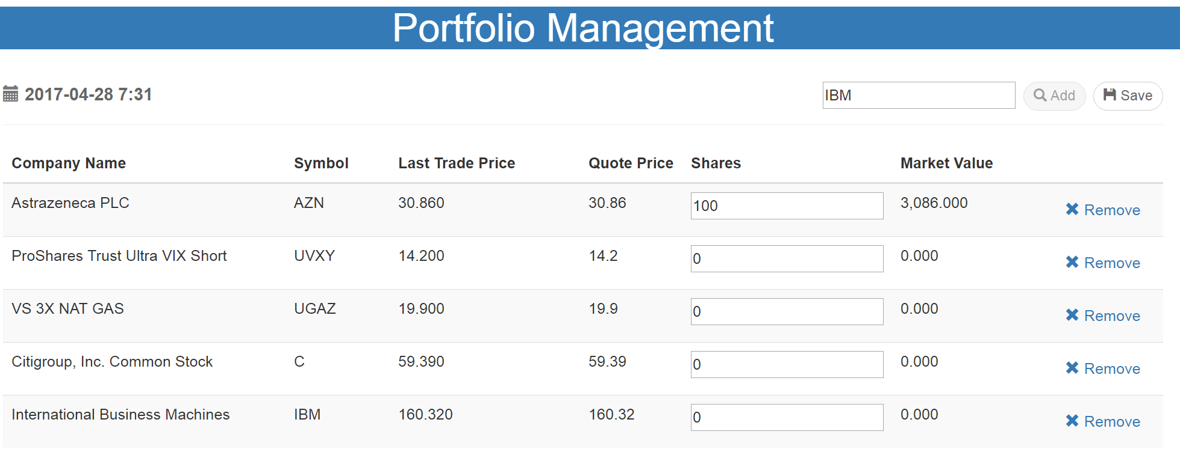

1. The Last Trade Price column background will be changed based on the last quote and last market price.

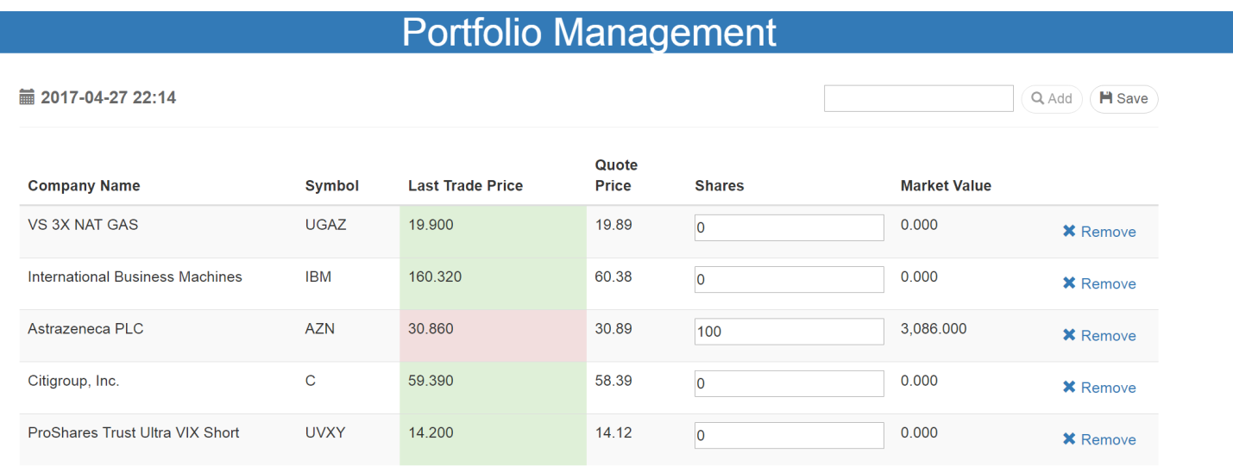

1. You can delete position from portfolio just click the remove button ,delete action will delete the position from database permanently .

