REPORT 2: SYSTEM ANALYSIS & ARCHITECTURAL DESIGN
Design Phase
Restaurant & Table Management System (POS) | Software Engineering 2024–2025

1. System Overview
The Restaurant & Table Management System (POS) is a desktop application designed to digitize end-to-end restaurant operations — from seating guests and taking orders, to kitchen communication, payment processing, inventory tracking, and revenue reporting.
Purpose: Replace manual paper-based order taking and bookkeeping with a centralized, real-time digital system that reduces order errors, speeds up table turnover, and gives management accurate sales and inventory data.
Core functionality: Role-based login; interactive table floor map; menu-driven order entry; real-time kitchen display; cash/transfer checkout with receipt printing; ingredient inventory with automatic deduction; and a sales dashboard with exportable reports.
Intended users: Four roles interact with the system — Admin (full access, configuration, reports), Cashier (tables, orders, payment), Kitchen Staff (order preparation queue), and indirectly, the Restaurant Manager who reviews dashboards and shift summaries.
Target platform: A Windows desktop application (Windows 10/11, 64-bit) built with C# .NET 8 and WPF, connecting to a local or LAN-hosted Microsoft SQL Server instance. The system runs on staff PCs at fixed stations (host stand, cashier counter, kitchen monitor) — no tablet or mobile support in this phase.

2. UML Diagrams

2.1 Use Case Diagram
The use case diagram below identifies four actors and their interactions with the system. The Admin has the widest access, including user and menu management. Cashier and Kitchen roles are scoped to their operational tasks, while the Manager primarily consumes dashboard and report data. The «include» relationship shows that viewing the dashboard always triggers a low-stock check against inventory.
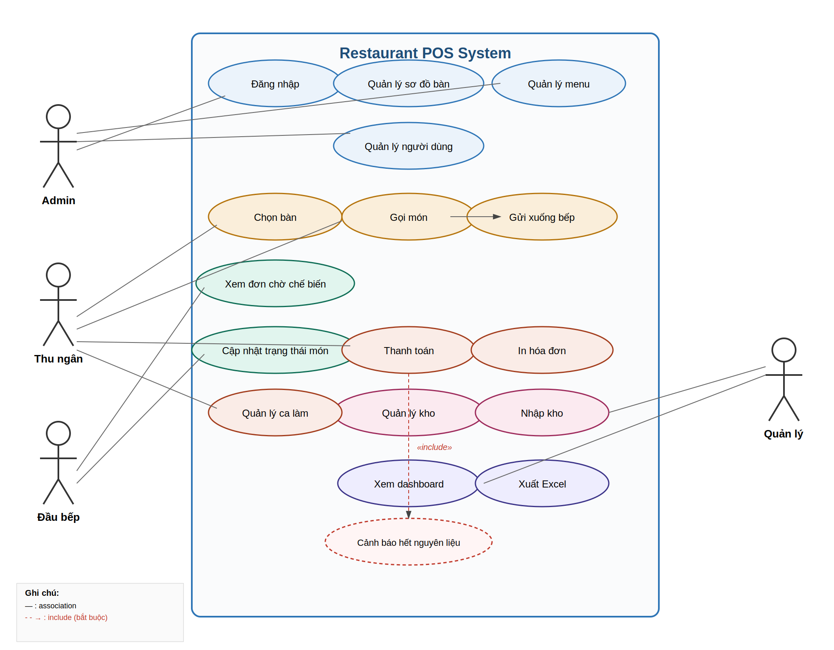
Figure 2.1 — Use Case Diagram of the Restaurant POS System

2.2 Class Diagram
The class diagram models the core domain entities and their relationships, grouped by color to mirror the application's logical modules: Auth/User (blue), Menu (green), Order (orange), Payment/Shift (red), and Inventory (pink). Key design decisions:
- Order owns OrderItem via composition — an OrderItem cannot exist without its parent Order.
- MenuItemIngredient is a many-to-many join entity connecting MenuItem and Ingredient, enabling recipe-based automatic stock deduction.
- TableStatus and OrderStatus are modeled as enumerations to enforce a fixed, valid set of states at the type level rather than via free-text strings.
- Payment has a strict 1-to-0..1 relationship with Order — each order is paid at most once.
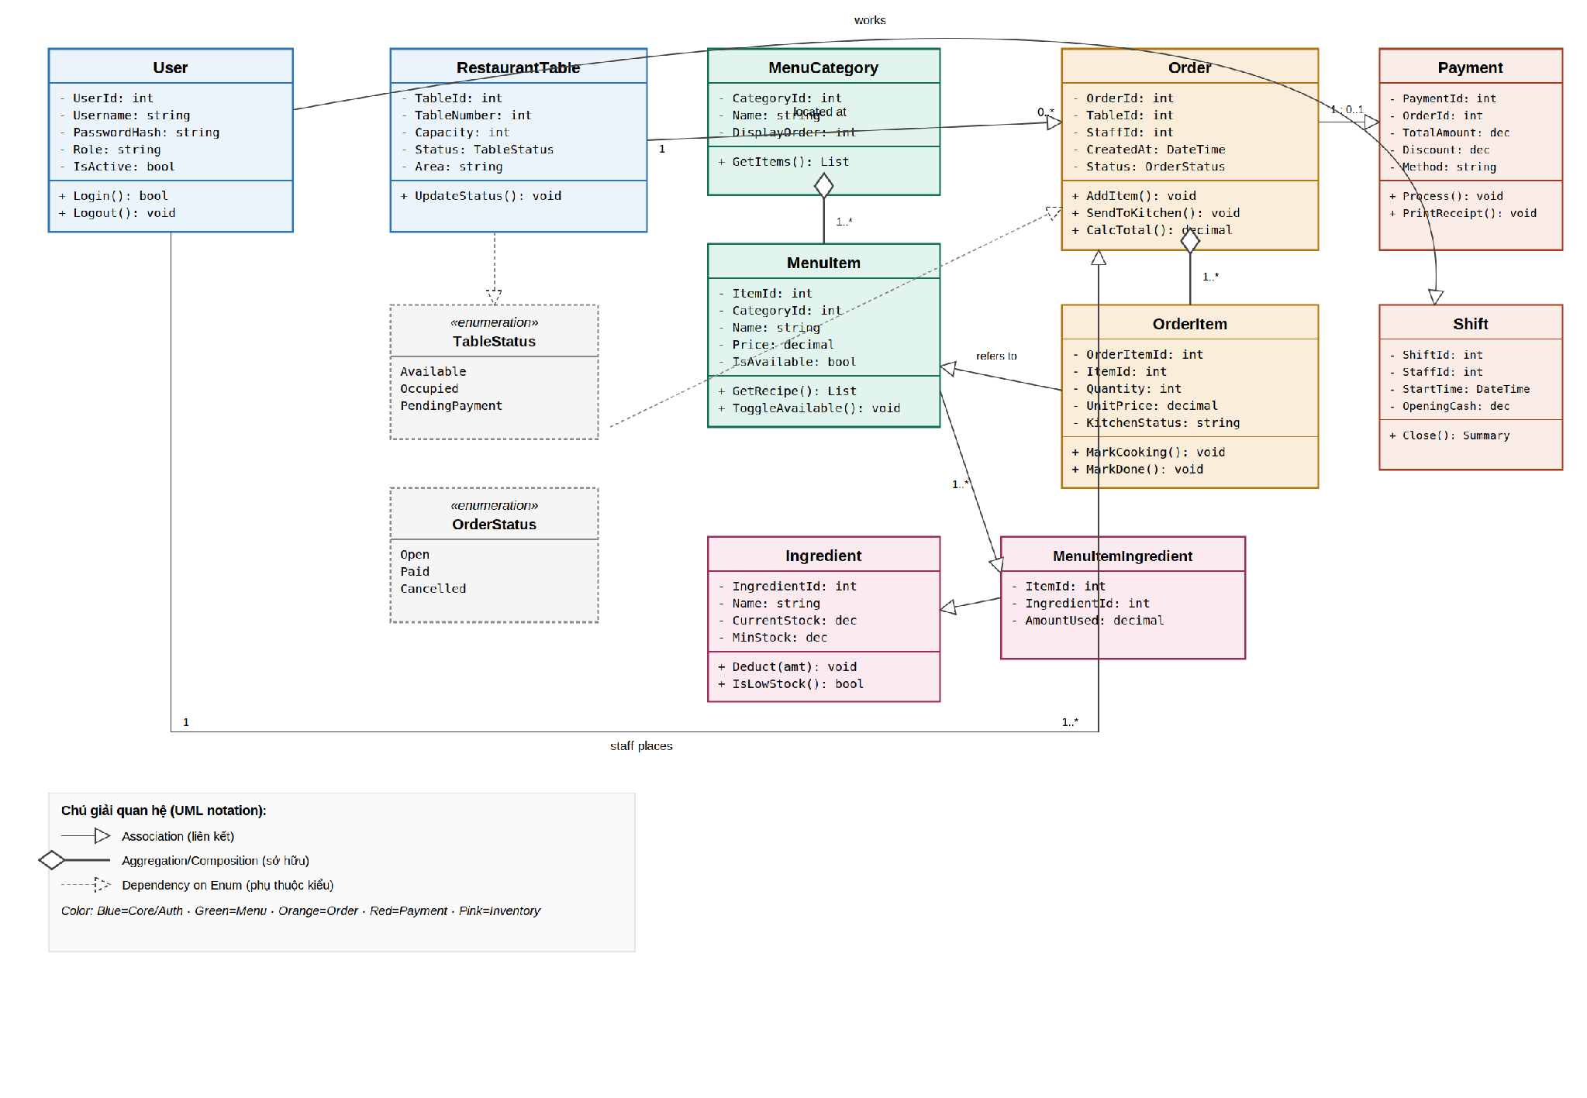
Figure 2.2 — Class Diagram showing core domain entities and relationships

2.3 Sequence Diagram
This sequence diagram traces the system's most critical end-to-end flow: a cashier selects a table, adds items to an order, sends it to the kitchen, the kitchen prepares and marks items done (polled every 10 seconds), and finally the cashier processes payment — closing the order and freeing the table.
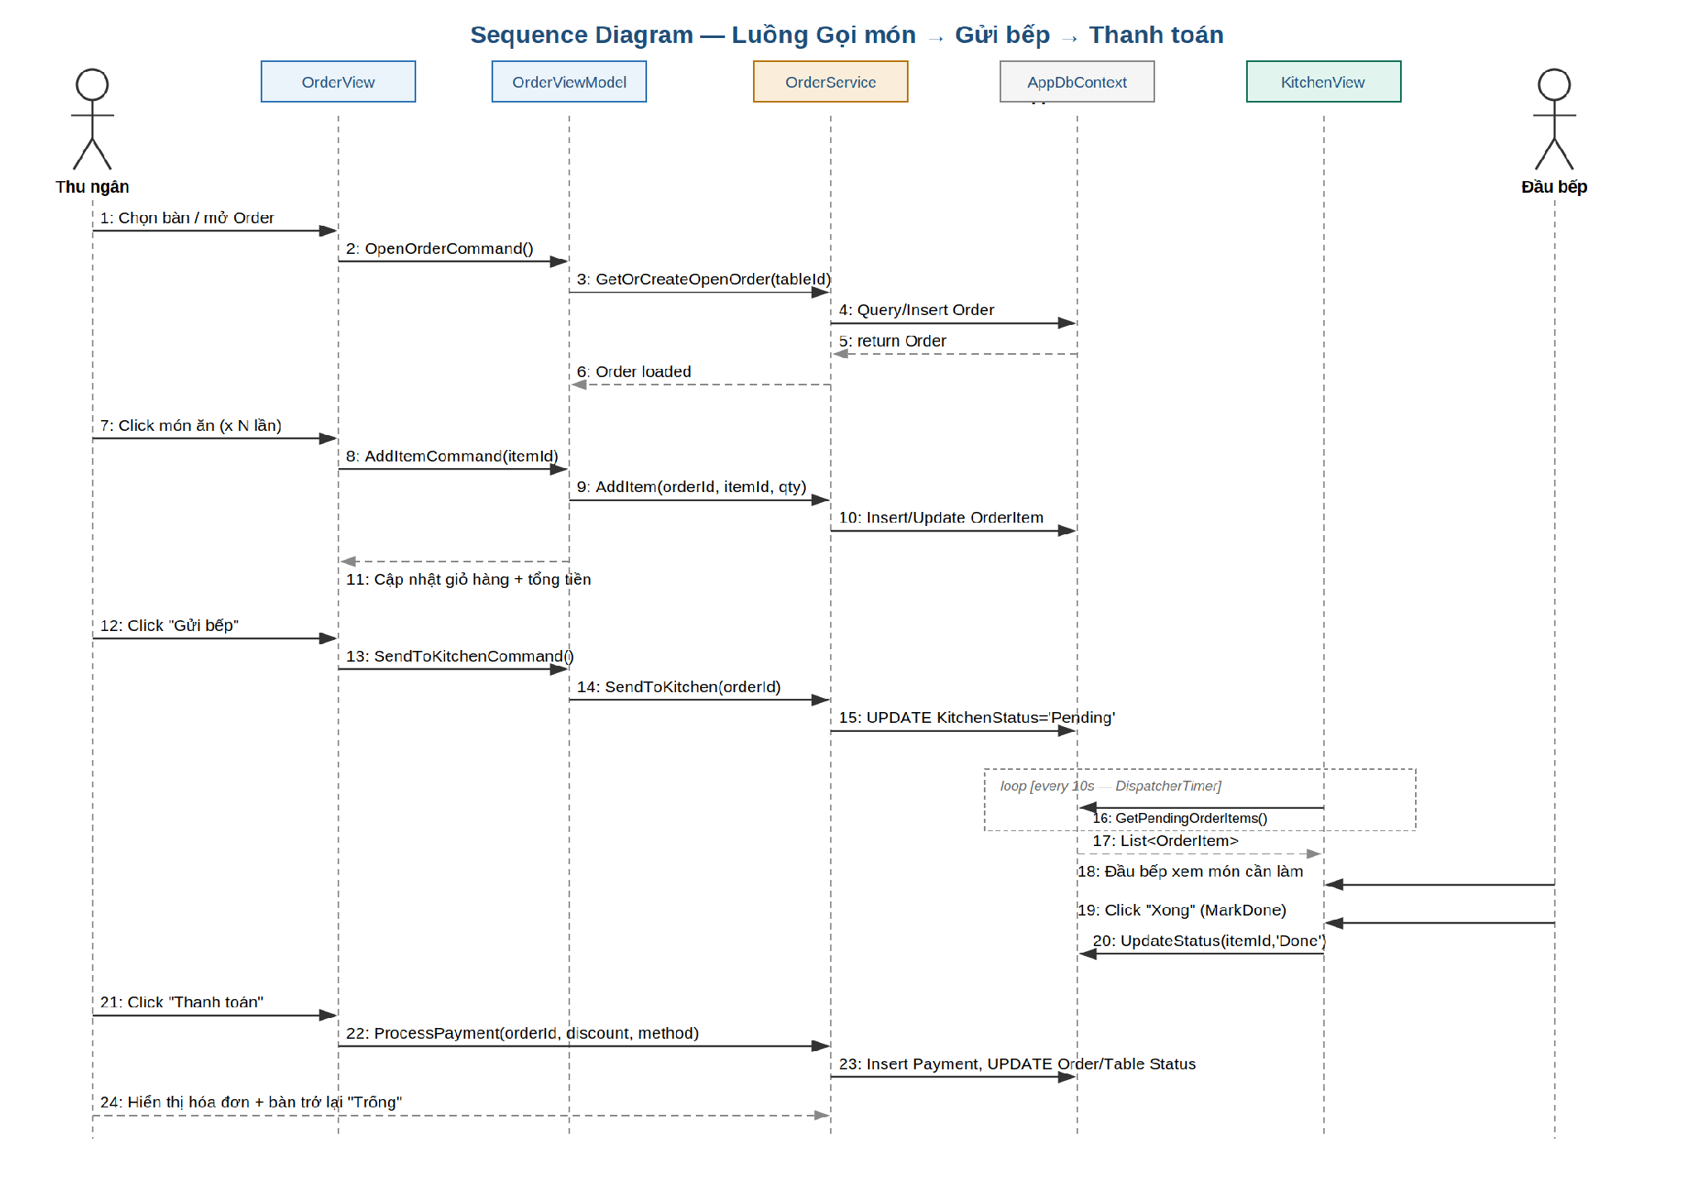
Figure 2.3 — Sequence Diagram: Table Selection → Order → Kitchen → Payment

3. Database Design

3.1 Entity-Relationship Diagram (ERD)
The database is normalized to 3NF and consists of 10 tables grouped into five functional areas. MenuItemIngredients resolves the many-to-many relationship between menu items and raw ingredients, which is what allows automatic stock deduction after each payment.
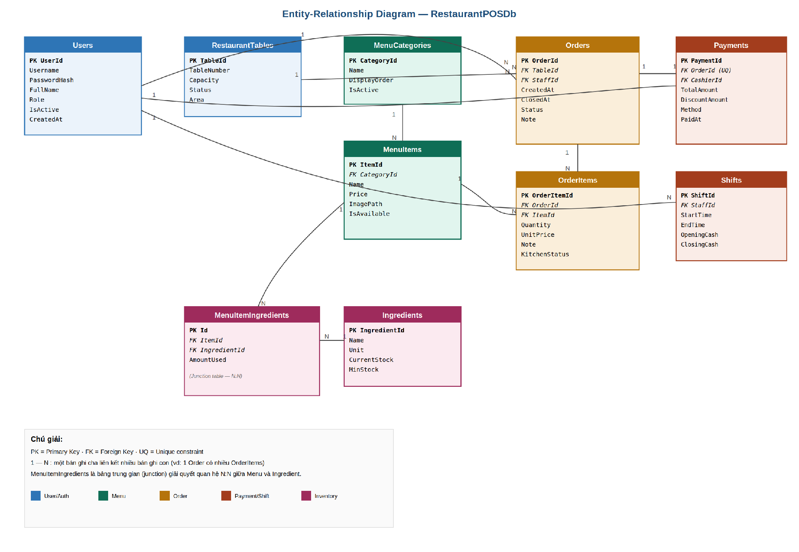
Figure 3.1 — Entity-Relationship Diagram of RestaurantPOSDb

3.2 Table Descriptions
Table | Purpose | Key Relationships
Users | Stores login credentials and role for every staff member. | 1—N Orders, Payments, Shifts
RestaurantTables | Represents each physical table and its current status. | 1—N Orders
MenuCategories | Groups menu items for UI display (tabs). | 1—N MenuItems
MenuItems | Sellable dishes/drinks with price and availability. | 1—N OrderItems, MenuItemIngredients
Orders | One order per dining session at a table. | 1—N OrderItems, 1—0..1 Payment
OrderItems | Line items within an order, tracked through kitchen states. | N—1 Order, N—1 MenuItem
Payments | Final checkout record for a closed order. | 1—1 Order, N—1 Users (cashier)
Ingredients | Raw stock items tracked by quantity and unit. | N—N MenuItems via MenuItemIngredients
MenuItemIngredients | Recipe junction table — how much of each ingredient a dish consumes. | N—1 MenuItem, N—1 Ingredient
Shifts | Tracks a cashier's working session and cash reconciliation. | N—1 Users

4. User Interface (UI) Mockups
Two of the most frequently used screens are mocked up below to validate the user flow before implementation begins.
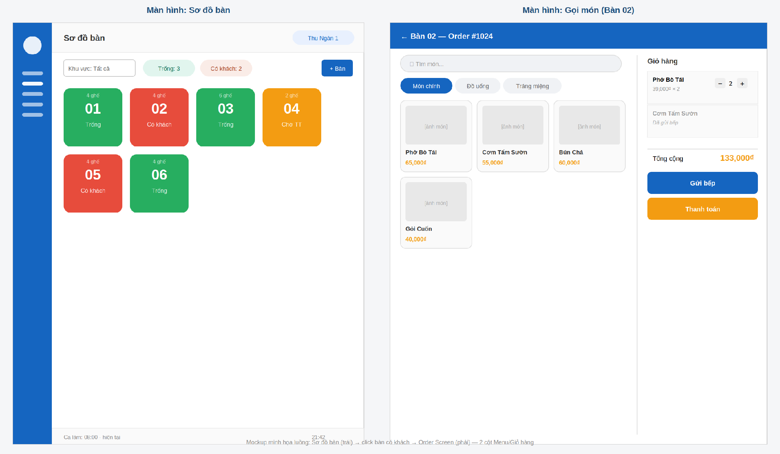
Figure 4.1 — Table Map screen (left) and Order screen (right)

4.1 Design Rationale
Table Map: Uses large, color-coded tiles (green/red/amber) so staff can assess floor status from across the room without reading text. Double-click opens an order immediately — minimizing clicks during peak hours.
Order Screen: A two-column layout keeps the menu (left, 60%) and the running cart (right, 40%) visible simultaneously, so staff never lose sight of the order total while browsing. Items already sent to the kitchen are visually muted to prevent accidental re-sending.
User flow: Sơ đồ bàn → click bàn có khách → Order Screen → thêm món → Gửi bếp → (lặp lại khi khách order thêm) → Thanh toán → quay lại Sơ đồ bàn với trạng thái bàn cập nhật.

5. CI/CD Planning
Continuous Integration is implemented with GitHub Actions to catch build and test failures before code reaches the main branch, which is critical given five developers working on interdependent modules.
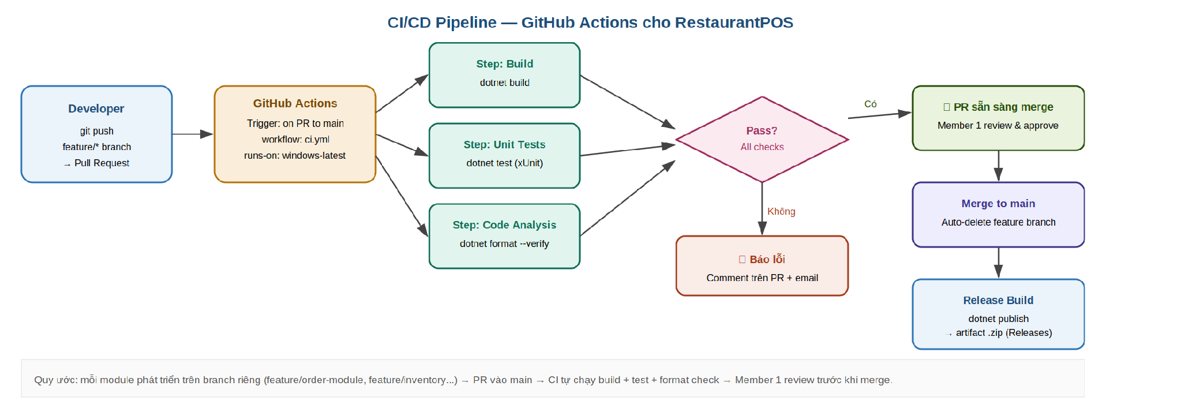
Figure 5.1 — CI/CD Pipeline using GitHub Actions

5.1 Tooling & Approach
Stage | Tool / Approach
Version Control | Git + GitHub, private repository. Branch naming: feature/<module-name> (e.g., feature/order-module).
CI Trigger | GitHub Actions workflow (ci.yml) runs automatically on every Pull Request targeting main.
Build Step | dotnet build on windows-latest runner — WPF requires a Windows build agent.
Test Step | dotnet test executes the xUnit test project (RestaurantPOS.Tests) covering all BLL services.
Code Analysis | dotnet format --verify-no-changes enforces consistent formatting across all 5 contributors.
Review Gate | Member 1 (Team Lead) reviews and approves every PR before merge — no direct pushes to main.
Release | On merge to main, a release workflow runs dotnet publish and uploads a .zip artifact to GitHub Releases for demo/grading.

6. Team Contributions
Design work for this phase was distributed according to each member's assigned module, consistent with Report 1's task assignment:
Member | Role | Design Contributions
Nguyễn Thanh Song | Team Leader | Overall architecture, ERD, Class Diagram, database schema normalization, CI/CD pipeline design.
Nguyễn Cao Mạnh Quân | UI/UX Developer | Table Map and Order Screen UI mockups, user flow design, MaterialDesign visual language.
Tô Thành Trúc | Backend Developer | Sequence diagram (Order → Kitchen → Payment flow), Order/Payment class design.
Đào Đại Sơn | Database & Dashboard Developer | Stored procedure planning for reports, Payment/Shift table design, ERD review.
Nguyễn Anh Khoa | QA & Feature Developer | Use Case Diagram (actor identification), Inventory class design, test scenario planning for this design.

