HW6 Write up

TEAM: Songqi Jing and Che Shize (Write Up by Songqi Jing)

October 14, 2024

Q1.

1.

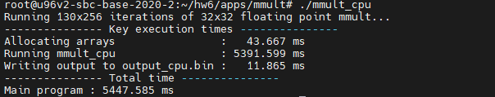Done the latency is 5447.585 ms.

2.

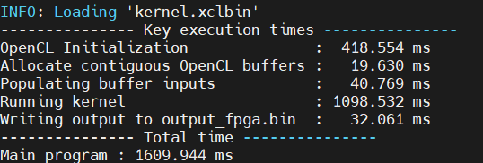The latency is 1609.944ms

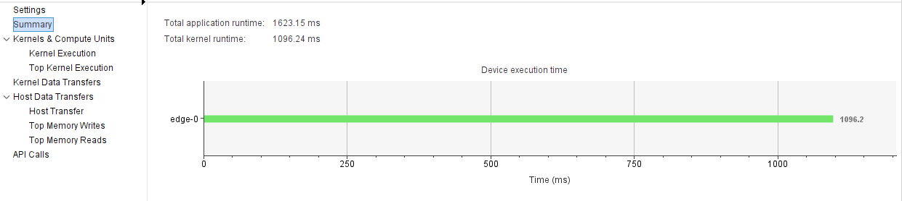

The total application runtime is 1623.15 ms.

The total Kernel runtime is 1096.24 ms.

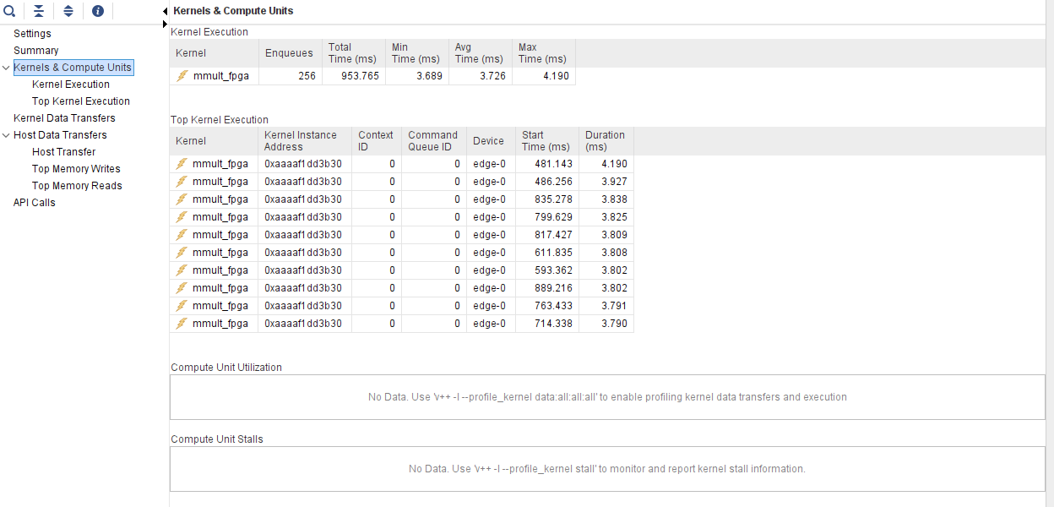

The total time of mmult_fpga is 953.765 ms.

3.

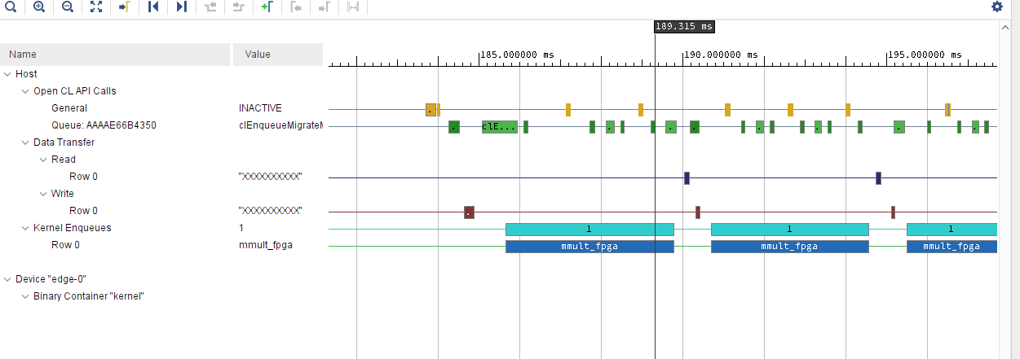

a. We can use multi-cores to do the calculation in pipeline

b. We can unroll the loop if we got enough resources

c. We can use muti ports to transfer the data/

4.

Done

5

5.1

#include "MMult.h"

#include "hls_stream.h"

/**

*

* Design principles to achieve II = 1

* 1. Stream data into local RAM for inputs (multiple access required)

* 2. Partition local RAMs into N/2 sub-arrays for fully parallel access

* (dual-port read)

* 3. Pipeline the dot-product loop, to fully unroll it

* 4. Separate multiply-accumulate in inner loop to force two FP operators

*

*/

void read(const float *A, const float *B,

hls::stream<float> &A_tmp, hls::stream<float> &B_tmp, int itr)

{

// #pragma HLS array_partition variable=A_tmp block factor=16 dim=2

// #pragma HLS array_partition variable=B_tmp block factor=16 dim=1

for (int c = 0; c < itr; c++) {

A_tmp.write(A[c]);

B_tmp.write(B[c]);

}

}

void execution(hls::stream<float> &A_tmp, hls::stream<float> &B_tmp, hls::stream<float> &result)

{

float A_temp1[N][N];

float B_temp1[N][N];

#pragma HLS array_partition variable=A_temp1 block factor=32 dim=2

#pragma HLS array_partition variable=B_temp1 block factor=32 dim=1

for (int c = 0; c < CHUNKS; c++) {

for (int i = 0; i < N; i++) {

for (int j = 0; j < N; j++) {

A_temp1[i][j]=A_tmp.read();

B_temp1[i][j]=B_tmp.read();

}

}

for (int i = 0; i < N; i++) {

for (int j = 0; j < N; j++) {

#pragma HLS PIPELINE II=1

float res = 0;

for (int k = 0; k < N; k++) {

float term = A_temp1[i][k] * B_temp1[k][j];

res += term;

}

result.write(res);

}

}

}

}

void write(hls::stream<float> &result, float *output ,int itr){

for (int i = 0; i < itr; i++) {

output[i] = result.read();

}

}

void mmult_fpga(float A[CHUNKS * N * N], float B[CHUNKS * N * N], float C[CHUNKS * N * N]) {

#pragma HLS INTERFACE m_axi port=A bundle=b0

#pragma HLS INTERFACE m_axi port=B bundle=b1

#pragma HLS INTERFACE m_axi port=C bundle=b2

#pragma HLS INTERFACE ap_ctrl_chain port=return

#pragma HLS DATAFLOW

hls::stream<float> A_tmp;

hls::stream<float> B_tmp;

hls::stream<float> result;

read(A, B, A_tmp, B_tmp, N*N*CHUNKS);

execution(A_tmp, B_tmp, result);

write(result, C, N*N*CHUNKS);

}

5.2

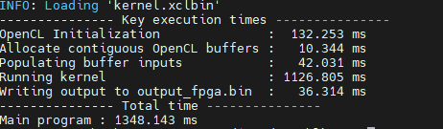

The latency is 1348.143 ms.

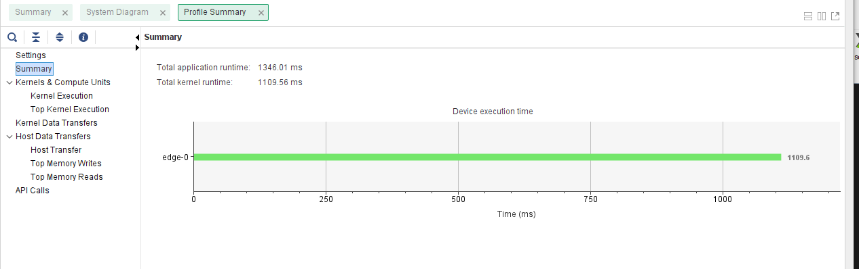The application latency is 1346.01 ms.

The kernel runtime is 1109.56 ms.

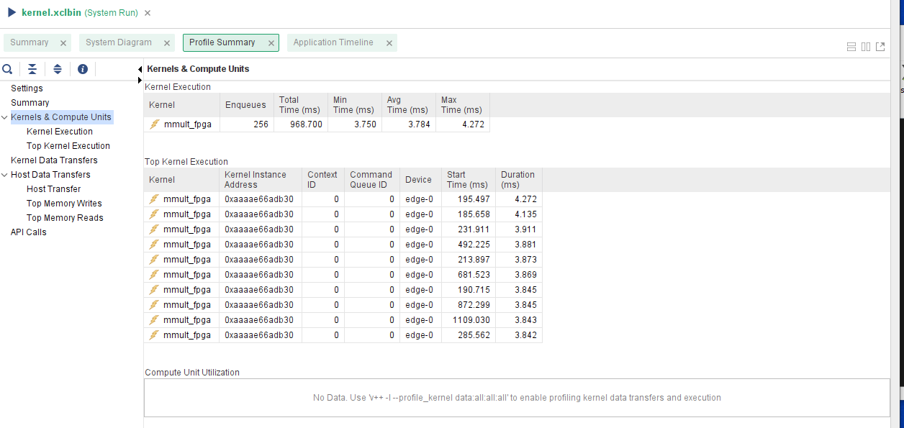The mmult_fpga latency is 968.700 ms.



5.3

#define CL_HPP_CL_1_2_DEFAULT_BUILD

#define CL_HPP_TARGET_OPENCL_VERSION 120

#define CL_HPP_MINIMUM_OPENCL_VERSION 120

#define CL_HPP_ENABLE_PROGRAM_CONSTRUCTION_FROM_ARRAY_COMPATIBILITY 1

#define CL_USE_DEPRECATED_OPENCL_1_2_APIS

#include "EventTimer.h"

#include <CL/cl2.hpp>

#include <cstdint>

#include <cstdlib>

#include <fstream>

#include <iostream>

#include <unistd.h>

#include <vector>

#include "MMult.h"

#include "Utilities.h"

static void init_arrays(float *A[NUM_MAT], float *B[NUM_MAT])

{

for (int m = 0; m < NUM_MAT; m++)

{

for (int c = 0; c < CHUNKS; c++)

{

for (int i = 0; i < N; i++)

{

for (int j = 0; j < N; j++)

{

A[m][ c * N * N + i * N + j] = 1+i*N+j;

B[m][ c * N * N + i * N + j] = rand() % (N * N);

}

}

}

}

}

int main(int argc, char *argv[])

{

EventTimer timer1, timer2;

timer1.add("Main program");

std::cout << "Running " << CHUNKS << "x" <<NUM_TESTS << " iterations of " << N << "x" << N

<< " task pipelined floating point mmult..." << std::endl;

// ------------------------------------------------------------------------------------

// Step 1: Initialize the OpenCL environment

// ------------------------------------------------------------------------------------

timer2.add("OpenCL Initialization");

cl_int err;

std::string binaryFile = argv[1];

unsigned fileBufSize;

std::vector<cl::Device> devices = get_xilinx_devices();

devices.resize(1);

cl::Device device = devices[0];

cl::Context context(device, NULL, NULL, NULL, &err);

char *fileBuf = read_binary_file(binaryFile, fileBufSize);

cl::Program::Binaries bins{{fileBuf, fileBufSize}};

cl::Program program(context, devices, bins, NULL, &err);

cl::CommandQueue q(context, device, CL_QUEUE_PROFILING_ENABLE, &err);

cl::CommandQueue q1(context, device, CL_QUEUE_PROFILING_ENABLE, &err);

cl::CommandQueue q2(context, device, CL_QUEUE_PROFILING_ENABLE, &err);

cl::CommandQueue q3(context, device, CL_QUEUE_PROFILING_ENABLE, &err);

cl::Kernel krnl_mmult(program, "mmult_fpga", &err);

// ------------------------------------------------------------------------------------

// Step 2: Create buffers and initialize test values

// ------------------------------------------------------------------------------------

timer2.add("Allocate contiguous OpenCL buffers");

size_t elements_per_iteration = CHUNKS * N * N;

size_t bytes_per_iteration = elements_per_iteration * sizeof(float);

cl::Buffer a_buf[NUM_MAT];

cl::Buffer b_buf[NUM_MAT];

cl::Buffer c_buf[NUM_MAT];

for(int i = 0; i < NUM_MAT; i++)

{

a_buf[i] = cl::Buffer(context, CL_MEM_READ_ONLY, bytes_per_iteration, NULL, &err);

b_buf[i] = cl::Buffer(context, CL_MEM_READ_ONLY, bytes_per_iteration, NULL, &err);

c_buf[i] = cl::Buffer(context, CL_MEM_WRITE_ONLY, bytes_per_iteration, NULL, &err);

}

float *a[NUM_MAT];

float *b[NUM_MAT];

float *c[NUM_MAT];

for(int i = 0; i < NUM_MAT; i++)

{

a[i] = (float*)q.enqueueMapBuffer(a_buf[i], CL_TRUE, CL_MAP_WRITE, 0, bytes_per_iteration);

b[i] = (float*)q.enqueueMapBuffer(b_buf[i], CL_TRUE, CL_MAP_WRITE, 0, bytes_per_iteration);

c[i] = (float*)q.enqueueMapBuffer(c_buf[i], CL_TRUE, CL_MAP_READ, 0, bytes_per_iteration);

}

timer2.add("Populating buffer inputs");

init_arrays(a, b);

// ------------------------------------------------------------------------------------

// Step 3: Run the kernel

// ------------------------------------------------------------------------------------

timer2.add("Running kernel");

cl::Event w[NUM_TESTS], x[NUM_TESTS], r[NUM_TESTS];

std::vector<cl::Event> w_wl[NUM_TESTS], x_wl[NUM_TESTS], r_wl[NUM_TESTS];

for (int i = 0; i < NUM_TESTS; i+=4) {

krnl_mmult.setArg(0, a_buf[i%NUM_MAT]);

krnl_mmult.setArg(1, b_buf[i%NUM_MAT]);

krnl_mmult.setArg(2, c_buf[i%NUM_MAT]);

if (i == 0) {

q.enqueueMigrateMemObjects({a_buf[i%NUM_MAT], b_buf[i%NUM_MAT]}, 0, NULL, &w[i]);

} else {

q.enqueueMigrateMemObjects({a_buf[i%NUM_MAT], b_buf[i%NUM_MAT]}, 0, &w_wl[i], &w[i]);

}

x_wl[i].push_back(w[i]);

if (i + 1 < NUM_TESTS) {

w_wl[i+1].push_back(w[i]);

}

q.enqueueTask(krnl_mmult, &x_wl[i], &x[i]);

r_wl[i].push_back(x[i]);

krnl_mmult.setArg(0, a_buf[(i+1)%NUM_MAT]);

krnl_mmult.setArg(1, b_buf[(i+1)%NUM_MAT]);

krnl_mmult.setArg(2, c_buf[(i+1)%NUM_MAT]);

q1.enqueueMigrateMemObjects({a_buf[(i+1)%NUM_MAT], b_buf[(i+1)%NUM_MAT]}, 0, &w_wl[i+1], &w[i+1]);

x_wl[i+1].push_back(w[i+1]);

if (i + 2 < NUM_TESTS) {

w_wl[i+2].push_back(w[i+1]);

}

q.enqueueMigrateMemObjects({c_buf[i%NUM_MAT]}, CL_MIGRATE_MEM_OBJECT_HOST, &r_wl[i], &r[i]);

if (i + 4 < NUM_TESTS) {

w_wl[i+4].push_back(r[i]);

}

if (i + 1 < NUM_TESTS) {

r_wl[i+1].push_back(r[i]);

}

q1.enqueueTask(krnl_mmult, &x_wl[i+1], &x[i+1]);

r_wl[i+1].push_back(x[i+1]);

krnl_mmult.setArg(0, a_buf[(i+2)%NUM_MAT]);

krnl_mmult.setArg(1, b_buf[(i+2)%NUM_MAT]);

krnl_mmult.setArg(2, c_buf[(i+2)%NUM_MAT]);

q2.enqueueMigrateMemObjects({a_buf[(i+2)%NUM_MAT], b_buf[(i+2)%NUM_MAT]}, 0, &w_wl[i+2], &w[i+2]);

x_wl[i+2].push_back(w[i+2]);

if (i + 3 < NUM_TESTS) {

w_wl[i+3].push_back(w[i+2]);

}

q1.enqueueMigrateMemObjects({c_buf[(i+1)%NUM_MAT]}, CL_MIGRATE_MEM_OBJECT_HOST, &r_wl[i+1], &r[i+1]);

if (i + 5 < NUM_TESTS) {

w_wl[i+5].push_back(r[i+1]);

}

if (i + 2 < NUM_TESTS) {

r_wl[i+2].push_back(r[i+1]);

}

q2.enqueueTask(krnl_mmult, &x_wl[i+2], &x[i+2]);

r_wl[i+2].push_back(x[i+2]);

krnl_mmult.setArg(0, a_buf[(i+3)%NUM_MAT]);

krnl_mmult.setArg(1, b_buf[(i+3)%NUM_MAT]);

krnl_mmult.setArg(2, c_buf[(i+3)%NUM_MAT]);

q3.enqueueMigrateMemObjects({a_buf[(i+3)%NUM_MAT], b_buf[(i+3)%NUM_MAT]}, 0, &w_wl[i+3], &w[i+3]);

x_wl[i+3].push_back(w[i+3]);

if (i + 4 < NUM_TESTS) {

w_wl[i+4].push_back(w[i+3]);

}

q2.enqueueMigrateMemObjects({c_buf[(i+2)%NUM_MAT]}, CL_MIGRATE_MEM_OBJECT_HOST, &r_wl[i+2], &r[i+2]);

if (i + 6 < NUM_TESTS) {

w_wl[i+6].push_back(r[i+2]);

}

if (i + 3 < NUM_TESTS) {

r_wl[i+3].push_back(r[i+2]);

}

q3.enqueueTask(krnl_mmult, &x_wl[i+3], &x[i+3]);

r_wl[i+3].push_back(x[i+3]);

q3.enqueueMigrateMemObjects({c_buf[(i+3)%NUM_MAT]}, CL_MIGRATE_MEM_OBJECT_HOST, &r_wl[i+3], &r[i+3]);

if (i + 7 < NUM_TESTS) {

w_wl[i+7].push_back(r[i+3]);

}

if (i + 4 < NUM_TESTS) {

r_wl[i+4].push_back(r[i+3]);

}

}

q.finish();

q1.finish();

q2.finish();

q3.finish();

// ------------------------------------------------------------------------------------

// Step 4: Release Allocated Resources

// ------------------------------------------------------------------------------------

timer2.add("Writing output to output_fpga.bin");

FILE *file = fopen("output_fpga.bin", "wb");

for (int i = 0; i < NUM_MAT; i++)

{

fwrite(c[i], 1, bytes_per_iteration, file);

}

fclose(file);

delete[] fileBuf;

timer2.finish();

std::cout << "--------------- Key execution times ---------------"

<< std::endl;

timer2.print();

timer1.finish();

std::cout << "--------------- Total time ---------------"

<< std::endl;

timer1.print();

return 0;

}

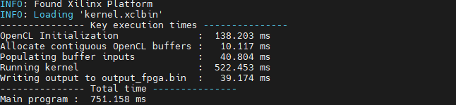The latency is 751.158 ms.

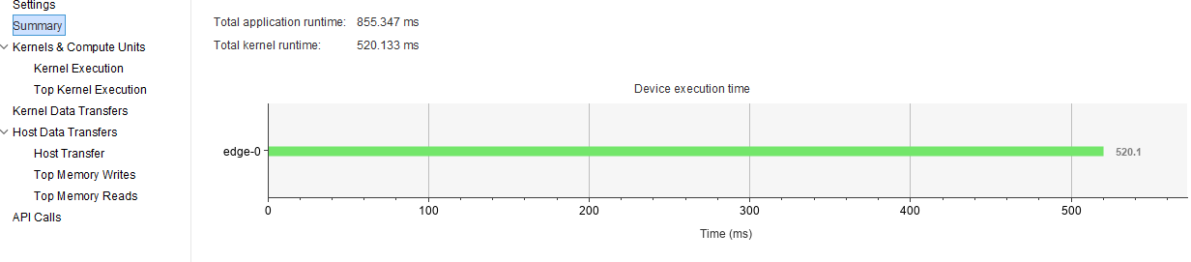The application latency is 855.347 ms.

The kernel runtime is 520.133 ms.

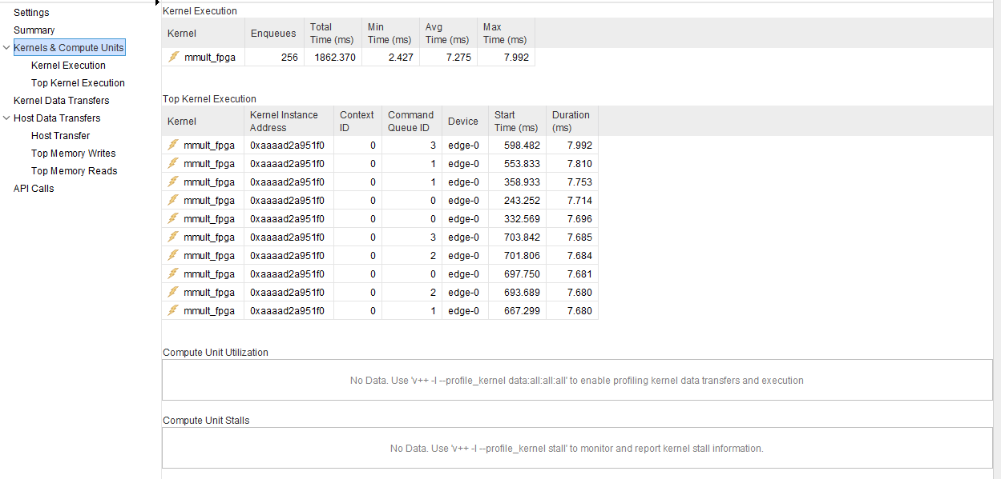The mmult_fpga is 1862.370 ms

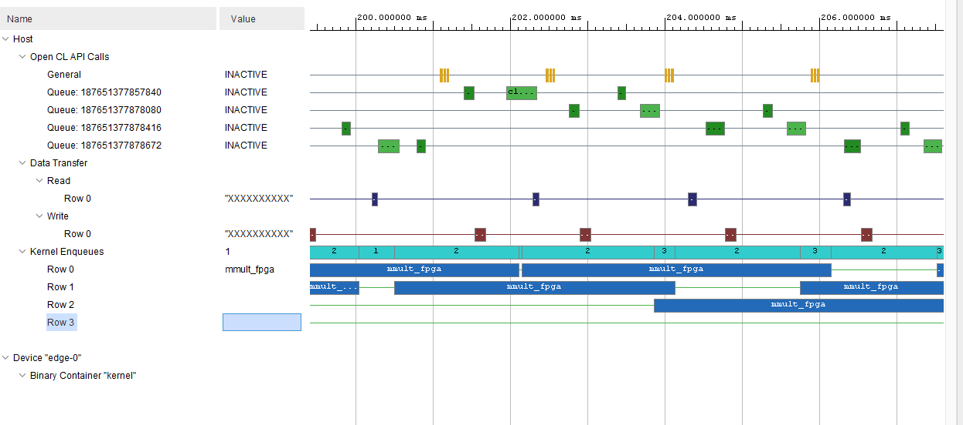

5.4

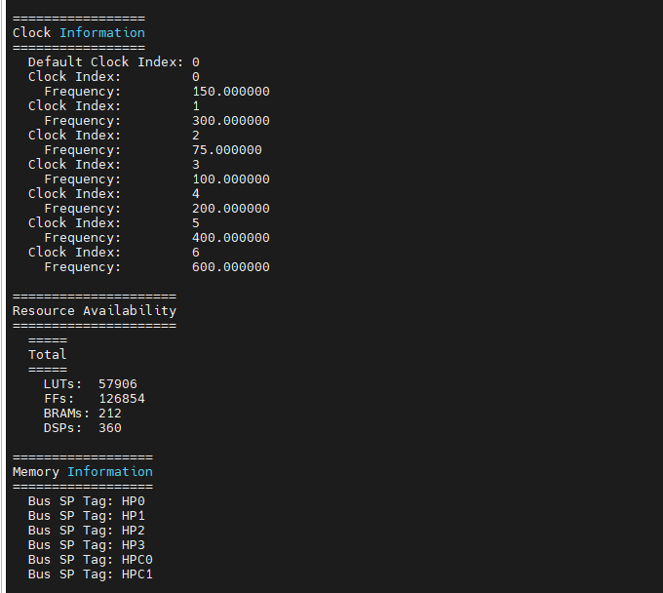

5.5

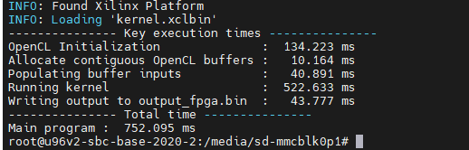

The latency is 752.095 ms.

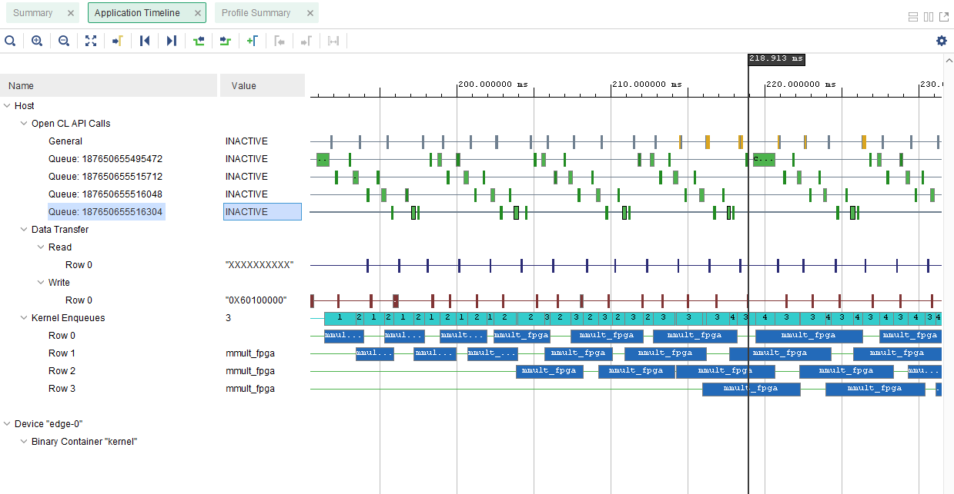

5.6

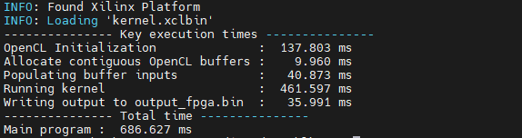The latency is 686.627 ms

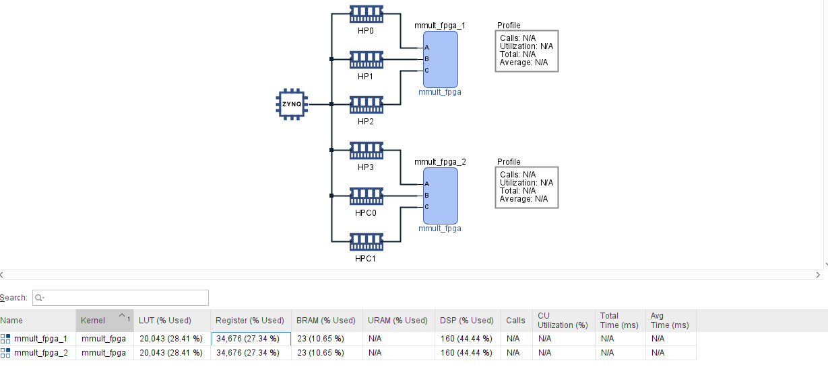

5.7

|  |  |  |  |  |  |
| --- | --- | --- | --- | --- | --- |
|  | Cpu | fpga | Host.cpp | Bank | Multicore |
| Latency | 5447.585 | 1609.944 | 751.158 | 752.095 | 686.627 |
| Speed up | 1 | 3.38 | 7.25 | 7.25 | 7.93 |

Q2

1.

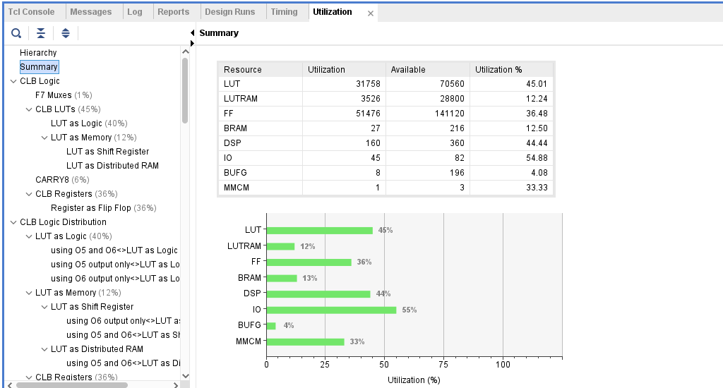

2.

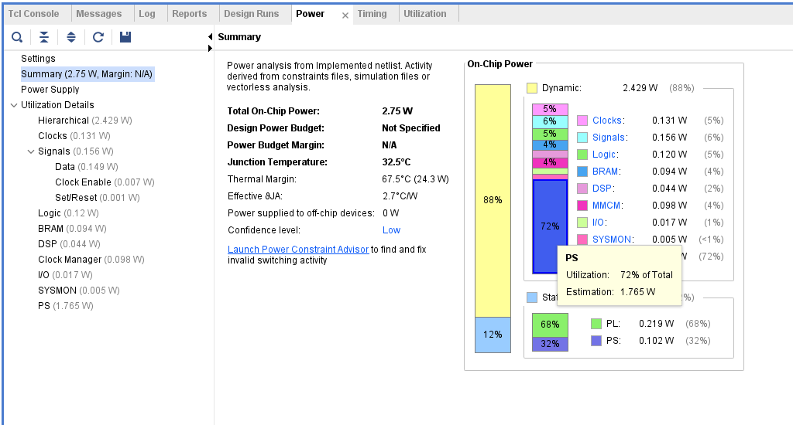

3.

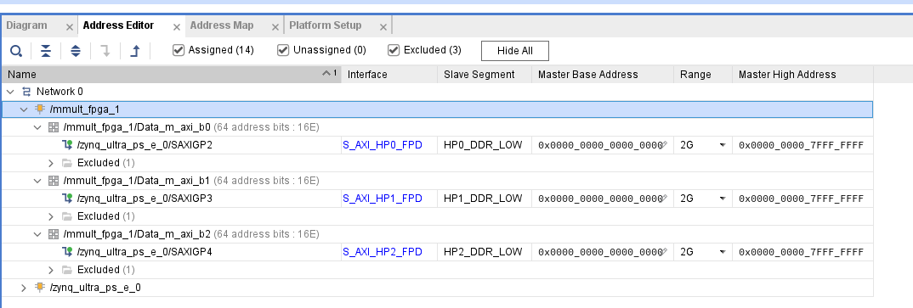memory region is from 0x0000_0000_0000_0000 to 0x0000_0000_7FFF_FFFF

4.

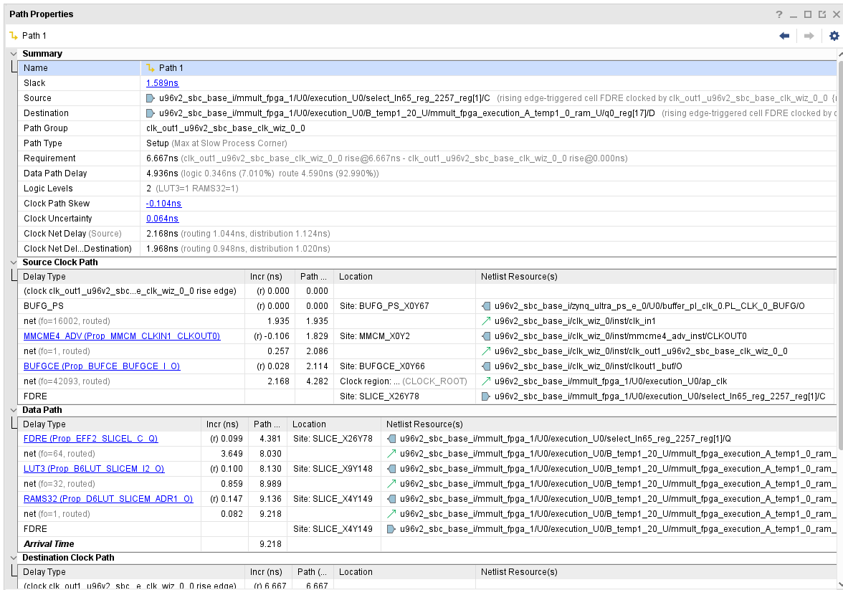

begin is the select_In65_reg2257_reg[1]

end is the q0_reg[17]

5.

6.

