* Coding question: using Angular to create the web application with the following requirements
  + Has a navigation bar on the top. The nav bar should display the application name and link to different parts of the website as shown in the design:
  + 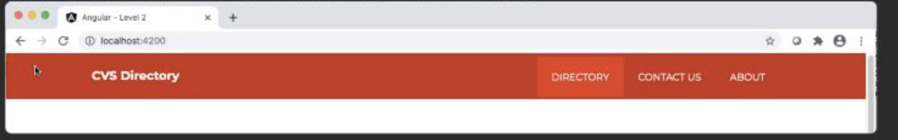
  + Click on the “directory” will bring the user to the directory page which shows a list of employees. This should also be the landing page when you load the website. Each employee entry should be styled as shown below:
  + 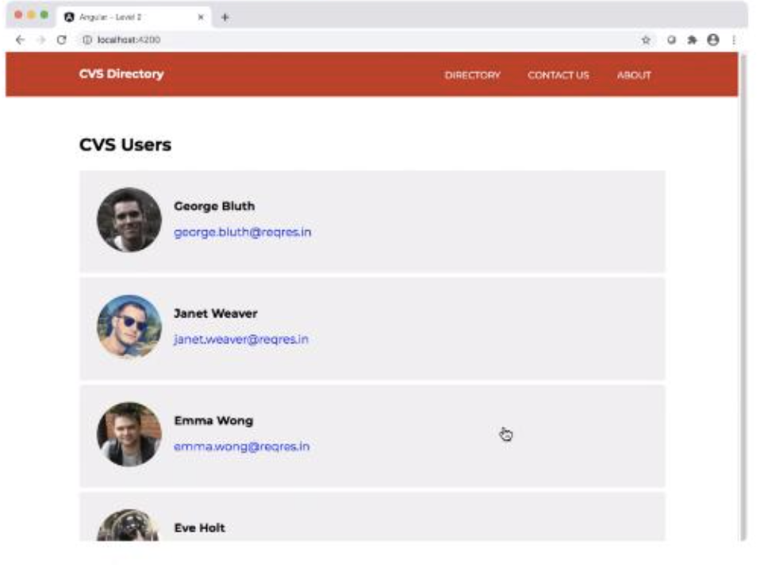
  + Note that clicking on the email addresses will allow user to email that employee
  + Contact Us page should be like this:
  + 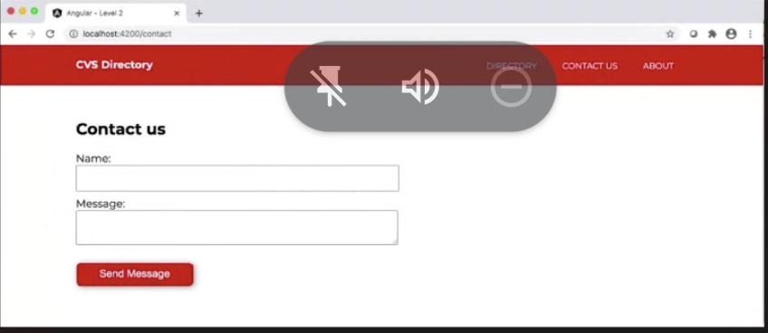
  + The form has some validation rules where both name and message are required. The message should also be at least 10 characters long. If the submitted data does not meet these requirements, it should display error messages for each field accordingly.
  + If the user has satisfied all the input restrictions, it should display a success messages as well as information on what data was submitted

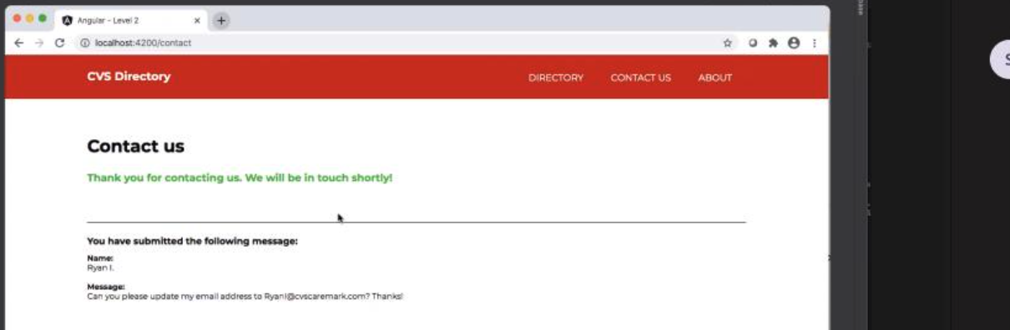

* (Requirements of the coding part)


 