**University of Roehampton Harvard Referencing Style Guide**

**Please note,** from September 2022, Roehampton Harvard will no longer be used as our institutional form of Harvard style referencing. Those students required to use Harvard style referencing should access style guidance through [Cite Them Right](http://sp.sams-sigma.com/Shibboleth.sso/Login?entityID=https://idp.roehampton.ac.uk/shibboleth&target=https://sp.sams-sigma.com/shib?dest=https://www.citethemrightonline.com/SHIBBOLETH?dest=https://www.citethemrightonline.com/).

Only students who began an ongoing piece of work prior to September 2022 should continue to use the Roehampton Harvard style and consult the below style guidance.

If you are unsure of which referencing style to use, see your [Subject Resources guide](https://library.roehampton.ac.uk/subjectresources), module Moodle page, or speak to your module convenor.

**Updated: Sep 2022**

Contents

Introduction: What is referencing? 5

What is referencing? 5

Why reference? 5

Academic Integrity​ 5

Plagiarism 6

Which referencing style do I use? 6

Section 1: In-text citations 7

How to set out in-text citations in your text 7

Conventions for quotations 8

Quotations and Turnitin 8

Example paragraphs with in-text citations: 8

More examples of in-text citations: single author 9

Examples of in-text citations: two authors 👤👤 9

Examples of in-text citations: four or more authors 👤👤👤👤+ 9

Section 2: Bibliography or Reference List 10

Elements of a book reference 10

Elements of a journal article reference 11

Elements of a website reference 12

Formatting your reference list / bibliography 12

Example reference list 13

Section 3: Referencing Examples 14

3.1: Books and eBooks 14

Book with one author 14

Book with two authors 14

Book with three authors 14

Book with four authors or more 14

Chapter in an edited book 15

Edited book as a whole 15

eBook 15

eBook on reader (i.e. Kindle, Kobo, Sony eBook) 15

Dictionaries/encyclopaedias 16

Online Dictionary entry 16

3.2: Literary Works 17

Reprints of Literary Works 17

Poem/play within an anthology 17

Edited play 17

The Classics 17

3.3: Foreign language works 18

Translated work 18

Works in other languages 18

Works in other alphabets non-Roman alphabets 18

3.4: Journals, magazines and newspapers 19

Journal article (from print or online journal without DOI) 19

Journal article from online journal with DOI 19

Article from newspaper or magazine 19

Article from newspaper or magazine – no author (byline) 20

3.5: Theses, conference proceedings, presentations and lecture materials 20

Thesis/Masters Dissertation, online 20

Published Conference Proceedings, individual paper 20

Presentations 20

Online module materials 21

3.6: Webpages and Social Media 21

Website 21

Blog 21

Twitter 22

Facebook 22

3.7: Government publications, Acts, papers and reports 22

UK Statutes (Acts of Parliament) 22

Command Papers (White and Green Papers) 23

Government publications 23

Ofsted reports 23

3.8: Reports from other organisations 24

Publications of international organisations / Research reports 24

Company Annual Report 24

Book Reviews 24

3.9: Archive materials 25

3.10: Visual sources 26

Diagrams, tables and illustrations 26

Paintings/photographs/images online 27

Paintings/drawings/artworks in gallery 28

Photography, online (social media) 28

Photography, personal collection 28

Posters and Leaflets 28

3.11: Audio-visual 29

Television programme 29

Programme or series on a streaming platform 29

Episode from a series on a streaming platform 29

Film, viewed at cinema/DVD 30

Film, viewed via streaming services 30

YouTube 30

Interview, Broadcast 31

Radio programmes 31

Music score 31

Audio download/streamed audio 31

Podcast 32

Computer/Video games 32

3.12: Live performances 32

Play 32

Dance 32

Programme notes 32

3.13: Public Communications 33

Press release 33

Television advertisement 33

3.14: Personal communications 33

Emails/text messages/online messages 33

Interviews, in person 33

Section 4: Frequently Asked Questions 34

When do I use page numbers in my in-text citation? 34

Can I include more than one source in my in-text citation? 34

How do I create an in-text citation for a source with multiple authors? 34

What is the format for multiple authors in the reference list/bibliography? 34

What does ‘*et al.’* mean? 35

When do I use ‘*et al.’*? 35

There is no author in the source I want to use, what do I do? 35

How do I reference multiple sources by the same author? 36

How do I reference multiple pages from the same work? 36

There is no date in the source, what do I do? 36

What do I do if there are no page numbers and I need to quote something? 37

Can I use acronyms in my references? 37

What is a DOI? 37

There are too many dates to choose from (reprint, copyright or published date), which one do I use? 38

Which bit of information should I use about a book? Published, printed, or produced by? 38

The book has been published in multiple locations, which one do I choose? 38

How do I reference confidential material? 38

How do I cite a source that quotes another source? Secondary referencing 39

# Introduction: What is referencing?

What is referencing?

Referencing is used to acknowledge the use of other people’s work and ideas in your own work. It consists of two parts:

1. **In-text citation:** quoting or paraphrasing sources in the body of your text. It usually provides brief information e.g. author, date and page numbers. See Section 1 for more information.
2. **Reference list/Bibliography**: an alphabetical list of the sources used in your work. Full details of the sources are given. See Section 2 for more information.

## Why reference?

Referencing is used to:

* acknowledge the words and ideas of others in your work.
* show the breadth and depth of your research – referring to a wide range of sources can improve your marks.
* enable your reader to locate and retrieve the information you have cited in your work.

You are expected to read widely and reference a range of sources, but remember that these should support, not replace your own ideas. Every time you reference, remember to show how this contributes to your own answer to the question.

## Academic Integrity​

Academic integrity consists of five core values essential for learning at university level:

* **Accuracy** – ensuring your work is free from errors, e.g. when transcribing details from a source.
* **Honesty** – about which ideas are your own and which are derived from others.
* **Fairness** – not trying to gain an advantage by unfair means (e.g. contract cheating) and not taking credit for other people’s work or ideas.
* **Responsibility** – taking an active role in your learning, seeking out information that you need in order to perform a task (e.g. finding out the original author of an image you got from Google).
* **Respect** – for the work of other people, including your peers, tutors and other scholars.

Academic integrity and honesty are fundamental to the academic work you produce at the University of Roehampton. ​You are expected to complete coursework which is your own and which is referenced appropriately. The university has in place measures to detect academic dishonesty in all its forms. If you are found to be cheating or attempting to gain an unfair advantage over other students in any way, this is considered academic misconduct and you will be penalised accordingly. ​​

## Plagiarism

There are many forms in which plagiarism can occur. Some forms are deliberate while others have more to do with study habits, e.g. poor note-taking skills that may lead you to confuse your notes with other people’s original ideas (especially when you leave referencing to the last minute before submission deadline). Make sure you record the details needed for a reference list entry for each source that you intend to use in your coursework.

When you include the arguments, ideas, or theories of someone else without referencing them, or use the exact words they have used and present them as your own argument, it is plagiarism. Whether you do this deliberately or by mistake, it may be interpreted as attempting to present another person’s work as your own. The University of Roehampton takes plagiarism very seriously. A lack of awareness of the rules of referencing is not an acceptable excuse for plagiarism.

To find out more, visit the [Online Study Tool Kit](https://library.roehampton.ac.uk/referencing#s-lg-box-14993182).

## Which referencing style do I use?

It is good practice to **check your module handbook** before you start your assignment or speak with your tutor if you are unclear about which style you should use. Only students who began an ongoing piece of work prior to September 2022 should use the Roehampton Harvard style covered by this guide.

# Section 1: In-text citations

**In-text citation**: used when **quoting, paraphrasing or summarising sources** in the body of your text. This will normally include:

* Author
* Year of Publication
* Page number (when you are quoting directly)

## How to set out in-text citations in your text

**Example:** (**Author Surname, Date)**

(Krutkowski, 2017)

If you are quoting, you include the page number.

Example when using a direct quote: **(Author Surname, Date: Page)**

(Krutkowski, 2017: 235).

|  |
| --- |
| **Quoting** – this is when you cite an author word for word. Use direct quotations sparingly.  **Paraphrasing** – this is when you put a small section of the original source into your own words.    **Summarising** – this is the shortest form, when you briefly describe and highlight the main points of the whole source in your own words. |

## Conventions for quotations

* Keep quotations **brief**.
* If **quoting short text** word-for-word within a sentence, enclose the quotation in ‘single inverted commas’ e.g.:

Lorde (1984: 36) stated that ‘….….’

The author states that ‘………’ (Lorde, 1984: 36)

* If **quoting longer text** (50 words or more) word for word, set out the quotation in a new paragraph with no quotation marks. Indent the quote on the left-hand side and use single spacing between the lines, e.g.:

As we learn to bear the intimacy of scrutiny and to flourish within it, as we learn to use the products of that scrutiny for power within our living, those fears which rule our lives and form our silences begin to lose their control over us.

(Lorde, 1984: 36)

* The **full stop must always be placed on the outside** of the last bracket, e.g.:

|  |
| --- |
| **Correct:** Lau (1984: 23) argues that ‘it is essential to punctuate your sentences correctly’.  **Incorrect:** Lau (1984: 23) argues that ‘it is essential to punctuate your sentences correctly.’ |

The citation can come at the beginning or at the end of the sentence containing the quotation or paraphrase. For readability, there is no need to repeat the author’s name if you have already mentioned it in the sentence, you can just cite the date and the page number(s) in brackets.

## Quotations and Turnitin

Most courses at the university now require you to submit your work via Turnitin.

Turnitin does not recognise quotes in inverted commas or indented text for longer quotations; these will be highlighted by the Turnitin system. Provided you have referenced quotes correctly, your marker will be able to identify these as legitimate.

## Example paragraphs with in-text citations:

Williams (1992: 34) notes that white men teachers experience a ‘glass escalator’, elevated into higher positions such as administration. The same does not hold true for black men, who experience a ‘glass barrier’ in feminised occupations and are often met with hostility and racism from patients and co-workers (Wingfield, 2009).

## More examples of in-text citations: single author

|  |  |
| --- | --- |
| Short quotation without author’s name in sentence | Play is ‘essentially impossible for a child under three’  (Vygotsky, 1980: 96). |
| Short quotation with author’s name in sentence | Vygotsky argued against the definition of play as ‘an activity that gives pleasure to the child’ (1980: 92).  Vygotsky (1980: 92) argued against the definition of play as ‘an activity that gives pleasure to the child’. |
| Long quotation | Play helps children to transition to the stage where perception - what they directly see - can be separated from meaning:  The child cannot yet detach thought from object. The child’s weakness is that in order to imagine a horse, he need to define his action by means of using ‘the-horse-in-the-stick’ as the pivot.  (Vygotsky, 1980: 97-98) |
| Paraphrase without author’s name in sentence | Play should not be defined as an activity that gives children pleasure, but as one that meets a child’s developmental needs (Vygotsky, 1980). |
| Paraphrase with author’s name in sentence | Vygotsky (1980) believed that play should not be defined as an activity that gives children pleasure, but as one that meets a child’s developmental needs. |

## Examples of in-text citations: two authors 👤👤

Display the surnames and initials of both authors in your text, e.g.:

**(Pears and Shields, 2019)** or **Pears and Shields (2019)**

## Examples of in-text citations: four or more authors 👤👤👤👤+

You only need to list the surname of the first author followed by the words **‘*et al*.’**, e.g. (Mabey *et al*.*,* 1998: 50).

**Note:** italics and punctuation are a part of the referencing style, pay attention to when they are used in the guide.

# Section 2: Bibliography or Reference List

Every source you use should have an in-text citation. Every in-text citation **must have a corresponding entry** in your bibliography or reference list.

A bibliography or reference list provides full details of each source you have used in your assignment **in alphabetical order**.

The details you provide will depend on the source type, but it will generally have these basic elements:

* Author
* Year of publication
* Title
* Where it is published
* Who published it

## Elements of a book reference

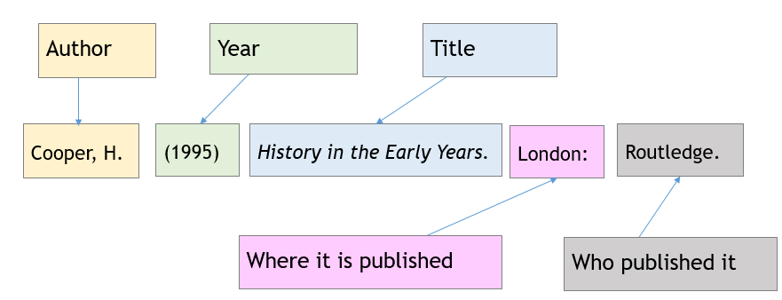

## Elements of a journal article reference

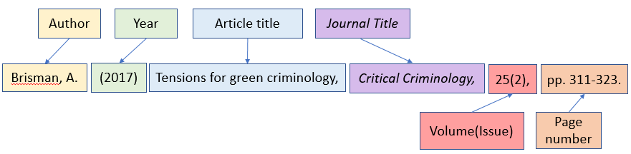



Online journal articles may include a DOI addresses. If there if a DOI include this at the end of the reference. See Section 4: FAQs for details.

**Example of online article with DOI:**

Brisman, A. (2017) Tensions in green criminology, *Critical Criminology*, 25(2), pp. 311-323. doi:10.1007/s10612-017-9365-8

Other sources may require you to include elements such as:

* URL (full web address)
* access date
* date of performance or broadcast.

## Elements of a website reference

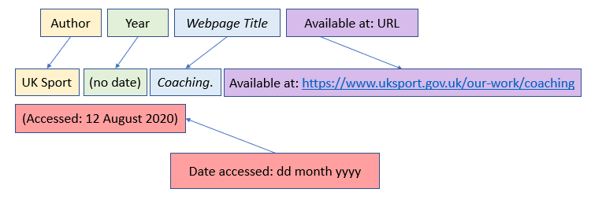

## Formatting your reference list / bibliography

Aside from the use italics and punctuation, you should also pay attention to:

* Sentence case – only the first word and proper nouns are capitalised.
* Title Case – every word aside from articles and prepositions are capitalised.

**Sentence case example:**  Dance movement as a way to help children affected by war.

**Title case example:**  Skills for Success: Personal Development and Employability.

Some tutors will ask you to produce a **bibliography**, while other tutors will ask for a **reference list**. The difference is:

* **Bibliography:** a list of all of the sources you have looked at to help you compile the essay even if you have not made direct mention to them in the text. This can include sources you have read or consulted but not actually quoted from or paraphrased in your work.
* **Reference list:**  a list that only includes sources you have directly quoted or paraphrased in your work.

It is more common to have reference lists than bibliographies, laid out in alphabetical order. If you are unsure which type of list your tutor is expecting, double check with your tutor.

## Example reference list

British Dyslexia Association (no date) *Train the Trainer: Teaching for Neurodiversity*. Available at: <https://www.bdadyslexia.org.uk/about/projects/dyslexia-spld-support-project-2016-17> (Accessed: 24 September 2018).

Cottrell, S. (2015) *Skills for Success: Personal Development and Employability*. 3rd edn. Basingstoke: Palgrave Macmillan.

Levy, F.J., Ranjbar, A. and Dean, C.H. (2006) Dance movement as a way to help children affected by war, *Journal of Physical Education, Recreation and Dance,*77(5), pp. 6-12. doi: 10.1080/07303084.2006.10597870

Linton, S. *et al*. (2017) Harnessing the power of film to combat mental health stigma: a University College London psychiatry society event, *Psychiatria Danubina,* 29(s3), pp. 300-306.

Tan, A. (2018) WhatsApp conversation with Andrew Wong, 1 June.

TED (2012) *Susan Cain: The Power of Introverts* [YouTube]. Available at: https://www.youtube.com/watch?v=c0KYU2j0TM4 (Accessed: 7 June 2014).

**Note**: where there is no author/editor/name of organisation or company etc. the entry is listed by title of the work and ordered alphabetically within the list.

# Section 3: Referencing Examples

# 3.1: Books and eBooks

**Note:** To find out more about how to use *et al.* with multiple authors, go to the FAQs section at the end of this document, and see the examples below.

## Book with one author

Author (Year) *Title of Book*. Edition - if not first edition. Place of Publication: Publisher.

Example: Cottrell, S. (2015) *Skills for Success: Personal Development and Employability*. 3rd edn. Basingstoke: Palgrave Macmillan.

**In-text citation:** (Cottrell, 2015)

## Book with two authors

Author and Author (Year) *Title of Book*. Edition - if not first edition. Place of Publication: Publisher.

Example: Johal, P. and Vickerstaff, B. (2012) *Financial Accounting*. London: Hodder Education.

**In-text citation:** (Johal and Vickerstaff, 2012)

## Book with three authors

Author, Author and Author (Year) *Title of Book.* Edition - if not first edition. Place of Publication: Publisher.

Example: Goepel, J., Childerhouse, H. and Sharpe, S. (2015) *Inclusive Primary Teaching: A Critical Approach to Equality and Special Educational Needs.* 2nd edn. St Albans: Critical Publishing.

**In-text citation:** (Goepel, Childerhouse and Sharpe, 2015)

## Book with four authors or more

Author, *et al.* (Year) *Title of Book.* Edition - if not first edition. Place of Publication: Publisher.

**Example:** Timbury, M.C. *et al.* (2002) *Notes on Medical Microbiology*. Edinburgh: Churchill Livingstone.

**In-text citation:** (Timbury *et al.*, 2002)

## Chapter in an edited book

Author (Year) Title of chapter, in Editor (ed.) *Title of Book*. Edition - if not first edition. Place of Publication: Publisher, Pages.

Example: Hall, J., Peat, J. and Craig, S. (2014) Journeys to success: an appreciative inquiry into the academic attainment of black and minority ethnic students at a post-1992 London university, in Race, R. and Lander, V. (eds.) *Advancing Race and Ethnicity in Education.* London: Palgrave Macmillan, pp. 82-92.

In-text citation: **Author(s)** of the **chapter**, e.g. (Hall, Peat and Craig, 2014)

## Edited book as a whole

Editor (ed.) (Year) *Title of Book.* Edition – if not first edition. Place of Publication: Publisher.

Example: Race, R. and Lander, V. (eds.) (2014) *Advancing Race and Ethnicity in Education*. London: Palgrave Macmillan.

In-text citation: (Race and Lander, 2014)

**Note:** you are more likely to reference a specific chapter in an edited book rather than an edited book as a whole.

## eBook

When an eBook looks like a print books with publication details and page numbers, you should reference as a print book. More examples above.

Author (Year) *Title of Book.* Edition - if not first edition. Place of Publication:

Publisher.

Example: Mitra, R. (2015) *Akram Khan: Dancing New Interculturalism*. Basingstoke: Palgrave Macmillan.

**In-text citation:** (Mitra, 2015)

## eBook on reader (i.e. Kindle, Kobo, Sony eBook)

Author (Year of eBook publication) *Title of Book*. Edition - if not first edition. [Name of eBook reader] Place of publication: Publisher.

Example: Hooks, B. (2015) *Ain't I a Woman: Black Women and Feminism.* 2nd edn.[Kindle edition] Abingdon: Routledge.

**In-text citation:** Page numbering on eBooks may vary from the hard copy or be absent altogether. Instead, use section numbers or section titles, where available, to indicate the location of any quotations, e.g. (Hooks, 2015: Section 1.1)

## Dictionaries/encyclopaedias

**Note:** You may see spelling variations: encyclopedia and encyclopaedia. Go with the spelling used in the source.

**Entry with editor but no author**

Title of entry (Year) in Editor name(s) (ed.) *Publication Title*. Place of Publication: Publisher.

Example:Satori (2006) in Doniger, W. (ed.) *Encyclopedia of World Religions*. Chicago: Encyclopaedia Britannica Inc. p.1023.

In-text citation: use entry title (Satori, 2015)

**Entry with author**

Author (Year) Title of entry, in Editor (ed.) *Title of the Book*. (Volume). Place of publication: Publisher.

Example:Summer, M. (2013) Reparation, in McLaughlin, K. and Muncie, J. (eds.) *The Sage Dictionary of Criminology*. 2nd edn. London: Sage, pp. 470-477.

In-text citation: use the author of entry, e.g. (Summer, 2015)

Example:Hernik, M. and Shamsudheen, R. (2017)Learning theories, in Linkenauger, S., Hopkins, B., and Geangu, E. (eds*.) The Cambridge Encyclopedia of Child Development.* 2nd edn. Cambridge: Cambridge University Press, pp. 50–59. doi: [10.1017/9781316216491.008](https://doi.org/10.1017/9781316216491.008)

In-text citation: use the author of entry, e.g. (Hernik and Shamsudheen, 2017)

## Online Dictionary entry

Author/Name of organisation or company (Year) *Title of Entry/Webpage.* Available at: URL (Accessed: dd Month yyyy).

Example:Oxford English Dictionary Online (2004) *Orwellian, adj. and n*. Available at: [www.oed.com/view/Entry/132902](http://www.oed.com/view/Entry/132902) (Accessed: 25 September 2018).

In-text citation: (Oxford English Dictionary Online, 2004)

Example 2: Oxford Dictionaries (2018) *Orwellian.* Available at: <https://en.oxforddictionaries.com/definition/orwellian> (Accessed: 25 September 2018).

In-text citation: (Oxford Dictionaries, 2018)

# 3.2: Literary Works

**Note:** For literary works, italicise the name of the work when referring to it in-text,

e.g. *Exit West* by Hamid is a novel that deals with the impact of…

## Reprints of Literary Works

Author (Date of reprint). *Title of Work*. Place of publication: Publisher.

Example: Austen, J. (1975) *Pride and Prejudice*. London: Folio.

In-text citation: If you did not read the original edition, then you may refer to the original year of publication in your own text, e.g.

*Pride and Prejudice* (Austen, 1975), published 1813, is a thought-provoking novel.

## Poem/play within an anthology

Author (Year) Title of individual play/short story/poem, in Editor (ed.) *Title of Anthology* Edition -if not first edition. Place of Publication: Publisher.

Example: Wong, E. (1993) Letters to a student revolutionary, in Lamont, R.C. (ed.) *Women on the Verge: 7 Avant-garde American Plays*. New York: Applause Theatre Books, pp. 277-324.

**In-text citation:** Use the **author** of **poem/play**, e.g. (Wong, 1993)

## Edited play

Author (Year of edited text) *Title of Play.* Edited by Editor. Place of Publication: Publisher.

Example: Shakespeare, W. (1967) *All’s Well that Ends Well*. Edited by Edwards, P. London: Routledge.

In-text citation:Use the **author** of **play**, e.g. (Shakespeare, 1967)

## The Classics

Author, *Title of Work in English*. Translated from the [original language] by Translator. (Date of Translation) Place of publication: Publisher.

Example:Homer, *The Odyssey*. Translated from the Greek by E. Wilson (2017) London: W. W. Norton & Company.

**In-text citation:** Use the **original author**, e.g. (Homer, 2017)

# 3.3: Foreign language works

## Translated work

Author (Year of translated version [Year of original work]) *Title of Book.* Translated by Translator. Place of Publication: Publisher.

**Example 1:** Piaget, J. (2001 [1926]) *The Language and Thought of the Child.* Translated from the French by M. Gabain and R. Gabain. London: Routledge Classics.

**Example 2:** Cixous, H. (2004 [1976]) *Portrait of Dora*. Translated from the French by A. Liddle, in Prenowitz, E. (ed.) *Selected Plays of Hélène Cixous*. Abingdon: Routledge. pp. 35-59.

In-text citation: (Cixous, 2004)

## Works in other languages

Author (Year) *Title in Original Language* [English translation of title, if required]. Place of publication: Publisher.

Example: Esquivel, L. (2003) *Como agua para chocolate* [Like Water for Chocolate]. Barcelona: Debolsillo.

In-text citation: (Esquivel, 2003)

**Note:** for works is in a foreign language, give the title as exactly shown. For the above example, as the work is in Spanish, we follow the original title, which is in sentence case ‘Como agua para chocolate’, rather than use title case.

## Works in other alphabets non-Roman alphabets

You may need to reference sources that are not in Roman script. We recommend you provide a translation of the title in brackets. **Check with your tutor** if you are unsure what is required.

Example: Cao, X. (1994) 红楼梦 [Dream of Red Mansions]. Beijing: Huayan jiaoxue chubanshe.

In-text citation: (Cao, 1994)

You may be asked to transliterate the title into the English alphabet.

Example: Cao, X. (1994) *Hong Lou Meng* [Dream of Red Mansions]. Beijing: Huayan jiaoxue chubanshe.

# 3.4: Journals, magazines and newspapers

**Note:** To find out more about how to use *et al.* with multiple authors, go to the FAQs section at the end of this document, and see the examples below.

## Journal article (from print or online journal without DOI)

Author (Year) Title of article, *Title of Journal,* Volume(Issue), Pages.

Example: Ciulla, J. *et al.* (2018) Philosophical contributions to leadership ethics, *Business Ethics Quarterly,* 28(1), pp. 1-14.

In-text citation: (Ciulla *et al*., 2018)

Example: Linton, S. *et al*. (2017) Harnessing the power of film to combat mental health stigma: a University College London Psychiatry Society event, *Psychiatria Danubina,* 29(s3), pp. 300-306.

In-text citation: (Linton *et al*., 2017)

## Journal article from online journal with DOI

Author (Year) Title of article, *Title of Journal,* Volume(Issue), Pages. DOI

Example: Brisman, A. (2017) Tensions in green criminology, *Critical Criminology*, 25(2), pp. 311-323. doi:10.1007/s10612-017-9365-8

In-text citation: (Brisman, 2017)

## Article from newspaper or magazine

Author (Year) Title of article. *Title of Newspaper or Magazine,* Date of publication, Page range if available. Available at: URL (Accessed: dd Month yyyy).

Example:Else, H. (2016) Success rates data may mask gender bias. *Times Higher Education,* 20 October, pp. 6-7.

In-text citation: (Else, 2016)

Example:Chakrabortty, A. (2016) This NHS crisis is not economic. It’s political. *The Guardian,* 8 February. Available at: <https://www.theguardian.com/society/2016/feb/08/this-nhs-crisis-is-not-economic-its-political> (Accessed: 3 May 2018).

In-text citation: (Chakrabortty, 2016)

## Article from newspaper or magazine – no author (byline)

Example: *The Guardian* (2014) The NHS: money matters, 4 June. Available at: <https://www.theguardian.com/commentisfree/2014/jun/04/nhs-money-matters-editorial> (Accessed: 30 July 2019).

In-text citation: (*The Guardian*, 2016)

# 3.5: Theses, conference proceedings, presentations and lecture materials

## Thesis/Masters Dissertation, online

Author (Year of submission) *Title of Thesis/Dissertation*. Type of Degree. Degree-awarding body. Available at: URL (Accessed: dd Month yyyy) or DOI.

Example: Bramwell, R. (2011) *The Aesthetics and Ethics of London Based Rap: A Sociology of UK Hip-hop and Grime.* PhD Thesis. The London School of Economics and Political Science (LSE). Available at: <http://etheses.lse.ac.uk/189/> (Accessed: 4 September 2018).

**In-text citation:** (Bramwell, 2011)

## Published Conference Proceedings, individual paper

Author (Year) Title of paper. *Title of Conference.* Dates of Conference. Place of Publication: Publisher, pages. Available at: URL (Accessed: dd Month yyyy).

Example: McKie, A. (2008) Mapping the territory. *Making Connections – Bringing Together Research on e-Learning.* 15-17 November. London: University of Middlesex, pp. 10-14.

**In-text citation:** (McKie, 2008)

## Presentations

Author (Year) *Title of Presentation.* Presented at: Name of conference, Location of conference. Available at: URL (Accessed: dd Month yyyy).

Example: Hayes, D. (2009) *From Flagellation to Therapy: What are Students Learning Today?* Presented at: ALDinHE Conference, Bournemouth University.

**In-text citation**: *(*Hayes, 2009*)*

## Online module materials

Author/Tutor (Year) Title of online presentation/handout/resource [Item type] *Module code: Module Title*. Institution. Available at: URL of VLE (Accessed: dd Month yyyy).

Example: Riley, M. (2013) Surveillance and Social Control [PowerPoint] *PHT020C105A: Surveillance and Society.* University of Roehampton. Available at: <https://moodle.roehampton.ac.uk> (Accessed: 3 June 2014)

**In-text citation:** (Riley, 2013)

**Note:** It is possible to reference module materials, but it is good academic practice to read the original text your lecturer or tutor refers to, if you are citing it in your work.

# 3.6: Webpages and Social Media

## Website

Author/Name of organisation or company (Year) *Title of Webpage.* Available at: URL (Accessed: dd Month yyyy).

**Example:** Royal College of Nursing (2009) *Patient Focus*. Available at: <https://www.rcn.org.uk/clinical-topics/clinical-governance/patient-focus> (Accessed: 1 May 2017).

**In-text citation:** (Royal College of Nursing, 2009)

**In-text citation - direct quotes:** (Royal College of Nursing, 2009: para. 4)

**Example:** British Dyslexia Association (no date) *Train the Trainer: Teaching for Neurodiversity*. Available at: <https://www.bdadyslexia.org.uk/about/projects/dyslexia-spld-support-project-2016-17> (Accessed: 24 September 2018).

**In-text citation: (**British Dyslexia Association, no date)

## Blog

Author (Year last updated) Title of post. *Title of Website*. Day Month posted. Available at: URL (Accessed: dd Month yyyy).

Example: Coates, T. (2016) Wakanda and the Black Aesthetic. *Notes: First Drafts, Conversations, Stories in Progress.* 7 June. Available at: <http://www.theatlantic.com/notes/2016/06/wakanda-and-the-black-aesthetic/489290/> (Accessed: 20 June 2018).

**In-text citation: (**Coates, 2016)

## Twitter

Author name [Twitter handle] (Year) [Twitter]. Day Month of tweet. Available at: URL (Accessed: dd Month yyyy).

Example: Roehampton Business [@roehamptonbiz] (2018) [Twitter]. 4 May. Available at: <https://twitter.com/roehamptonbiz/status/992320027998212096> (Accessed: 7 May 2018).

**In-text citation:** (Roehampton Business, 2018)

## Facebook

Author (Year) *Title of Page* [Facebook]*.* Day Month posted. Available at: URL (Accessed: dd Month yyyy).

Example: University of Roehampton (2013) *Roehampton Postgraduate* [Facebook]. 19 August. Available at: <https://www.facebook.com/RoehamptonPostgraduate> (Accessed: 20 August 2018).

**In-text citation:** (University of Roehampton, 2013)

# 3.7: Government publications, Acts, papers and reports

Note: Government departments often have a well-known acronym. If you wish to refer to a department by an acronym, you must first introduce the acronym along with the full title of the department. Once the name has been established, you can use the acronym for any further references to the same source or department.

First citation: (Department for Education [DfE], 2009)

Subsequent citations: (DfE, 2009)

You should always use the full name for the bibliography.

## UK Statutes (Acts of Parliament)

*Title of Act including year and chapter number.* Country or jurisdiction if referencing more than one country’s legislation. Available at: URL (Accessed: dd Month yyyy)

**Example:** *The Equality Act 2010, c. 15.* Available at: <https://www.legislation.gov.uk/ukpga/2010/15/contents> (Accessed: 31 August 2018).

**In-text citation:** (*The Equality Act 2010*)

## Command Papers (White and Green Papers)

Government Department (Year) *Title of Report or Consultation Paper* (Command paper number). Place of Publication: Publisher *or* Available at: URL (Accessed: dd Month yyyy).

**Example:** Department for Business, Innovation & Skills (2016) *Success as a Knowledge Economy: Teaching Excellence, Social Mobility and Student Choice* (Cm 9258). Available at: <https://www.gov.uk/government/publications/higher-education-success-as-a-knowledge-economy-white-paper> (Accessed: 31 August 2018).

**In-text citation:** (Department for Business, Innovation & Skills, 2016)

## Government publications

Government Department (Year) *Title of Report*. Place of Publication: Publisher *or* Available at: URL (Accessed: dd Month yyyy).

**Example:** Office for National Statistics (2018) *Children’s Well-being and Social Relationships, UK: 2018*. Available at: <https://www.ons.gov.uk/peoplepopulationandcommunity/wellbeing/articles/measuringnationalwellbeing/march2018/pdf> (Accessed: 31 August 2018).

**In-text citation:** (Office for National Statistics, 2018)

## Ofsted reports

Author/Name of organisation or company (Year) *Title of Document and Dates Inspection Took Place.* Place of Publication: Publisher. *or* Available at: URL (Accessed: dd Month yyyy).

**Example:** Ofsted (2018*) Inspection Report: Oak Academy 1-2 November 2018*. Available at: <https://files.api.ofsted.gov.uk/v1/file/50041070> (Accessed: 16 August 2012).

**In-text citation:** (Ofsted, 2018)

# 3.8: Reports from other organisations

## Publications of international organisations / Research reports

Author/Name of organisation or company (Year) *Title of Report*. Place of Publication: Publisher *or* Available at: URL (Accessed: dd Month yyyy).

**Example:** United Nations (2015) *Human Development Report 2015*. New York: United Nations Development Programme.

**In-text citation:** (United Nations, 2015)

**Example:** Kalathil, J. (2011) *Recovery and Resilience: African, African-Caribbean and South Asian Women’s Narratives of Recovering from Mental Distress*. Available at: <https://www.mentalhealth.org.uk/file/1154> (Accessed: 31 August 2018).

**In-text citation:** (Kalathil, 2011)

## Company Annual Report

Author/Name of organisation or company (Year) *Title of Annual Report.* Place of Publication: Publisher *or* Available at: URL (Accessed: dd Month yyyy).

Example: Nationwide Building Society (2018) *Annual Report and Accounts 2018*. Swindon: Nationwide Building Society.

**In-text citation:** (Nationwide Building Society, 2018)

Example: BBC (2018) *BBC Annual Report and Accounts* *2017-18*. Available at: <https://www.bbc.co.uk/aboutthebbc/insidethebbc/howwework/reports/ara> (Accessed: 3 September 2018)

**In-text citation:** (BBC, 2018)

## Book Reviews

Reviewer (Year*) Title of the Book Being Reviewed*. By Author of book. Reviewed in: *Title of journal*. Volume(Issue) Page range if available. Available at: URL (Accessed: dd Month yyyy).

Example: Publisher’s Weekly (2003) *Beegu.* By Deacon, A. Reviewed in: *Publisher’s Weekly.* 250(36), pp. 74-75.

In-text citation: use the **reviewer** (Publisher’s Weekly, 2003)

Online example: Sandhu, S. (2017) *Exit West.* By Hamid, M. Reviewed in: *The Guardian.* 12 March. Available at: <https://www.theguardian.com/books/2017/mar/12/exit-west-mohsin-hamid-review-refugee-crisis> (Accessed: 30 August 2018).

In-text citation: use the **reviewer** (Sandhu, 2017)

# 3.9: Archive materials

The majority of materials found in archives refers unpublished items, such as hand-written or typed letters or scripts, photographs, a pair of glasses, etc. They are usually housed in a container, such as a box or folder and within the container the material is kept separated in files. Each file has its own unique identifier, called a reference number. Archival references should include the following information (where available):

Creator/Author. Date. *Title or Description of Material.* Page/Section/Volume. Reference Number. Name of Collection. Name of Repository. Name of Institution.

Examples:

Collingwood, M. (c. 1949). *Margot Fonteyn scrapbook*. No.1. MC 1/3.

Monica Collingwood Collection. Archives and Special Collections. University of

Roehampton.

Froebel Educational Institute. (1901). *E. Monteith coursework*. FACS/9/1/67. Froebel Archive for Childhood Studies. Archives and Special Collections. University of Roehampton.

Ann Hutchinson Guest and the Language of Dance Centre, London. (Late 20th century). *Research notes and documentation compiled during the creation of an Advanced Labanotation textbook about validity rules within Labanotation*. AHG/2/2/1/8. Ann Hutchinson Guest Collection. Archives and Special Collections. University of Roehampton.

# 3.10: Visual sources

## Diagrams, tables and illustrations

Author (Year) *Title of Book*. Place of Publication: Publisher. Page reference of item [type of item e.g. illus./fig./table].

Example: Wisker, G. (2008) The Postgraduate Research Handbook. 2nd edn. London: Palgrave Macmillan. [Diagram].

In-text citation:

* replicate the whole diagram/table/illus.
* add a caption and citation below the diagram/table/illus.

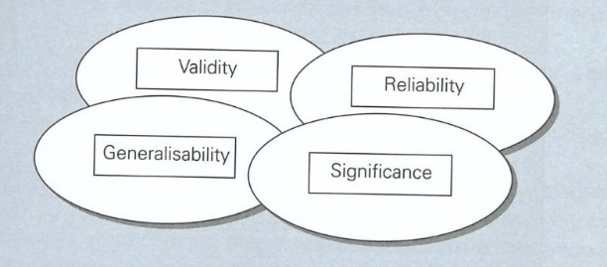

Diagram for the four elements of research conclusions (Wisker, 2008: 323)

**Note:** if the diagram/table/illus. is from **different source** than the book that you found it in, treat the citation as a secondary reference. See example on the next page.

Secondary Reference Example: Sloman, J., Garrett, D. and Hunt, A.(2013) *Economics for Business*. 6th edn. Harlow: Pearson. [Diagram].

In-text citation:

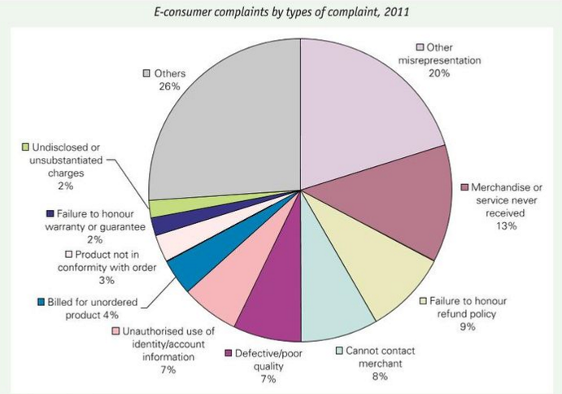

(Econsumer.gov, 2011 cited in Sloman, Garrett and Hunt, 2013: 91)

**Note:** If the author created the diagram/table/illustration just cite the author, year and page number.

## Paintings/photographs/images online

Artist (Year) *Title of Work of Art*. Available at: URL (Accessed: dd Month yyyy).

Example: Basquiat, J. M. (1982) *Jawbone of an Ass*. Available at: <https://library.artstor.org/asset/AWSS35953_35953_33681007> (Accessed: 30 May 2018).

In-text citation:(Basquiat, 1982)

**Note**: you may want to include further contextual information about the medium of work of art in your assignment e.g. Basquiat’s iconic painting, *Jawbone of an Ass* (1982)...

**Alternative example**

In-text citation:

* replicate the image/photo **and** include a caption that explains what is happening in the image and add an in-text citation at the end.

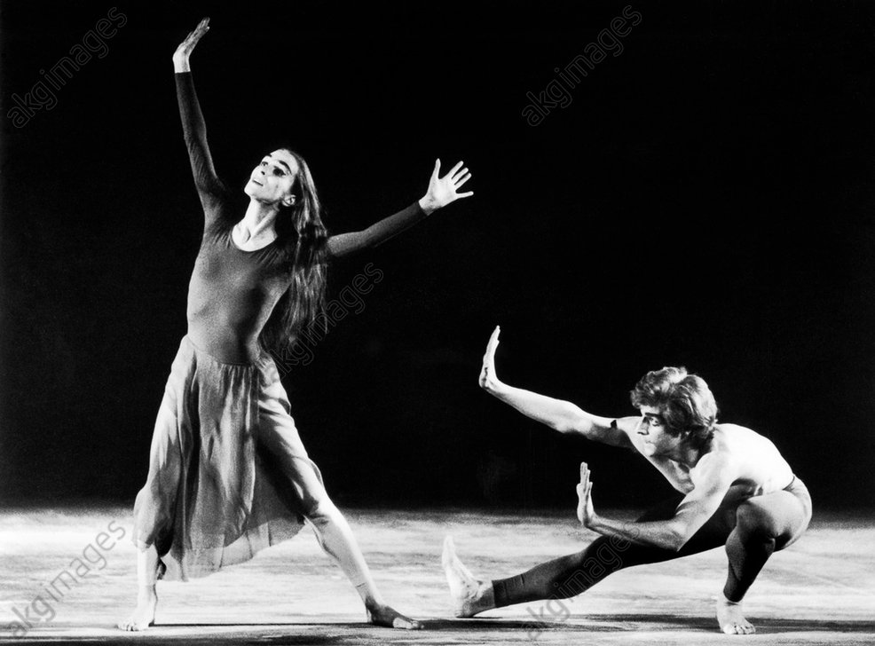

**Fig. 1:** Pina Bausch and Iwan Neumann in a performance of “Poeme Dance” by Folkwang Ballet from Essen (Bender, 1971)

Note: if there is no named author, look for the name of the agency that holds the image copyright (this may be a watermark on the actual image).

Reference list / bibliography entry:

Bender, L. (1971) *Pina Bausch a. Iwan Neumann / Poeme Dance*. Available at: <https://www.akg-images.co.uk/CS.aspx?VP3=SearchResult&VBID=2UMESQ5XTTETET&SMLS=1&RW=1680&RH=907&POPUPPN=47&POPUPIID=2UMDHUFT8IHG&XXXFEP=1> (Accessed: 04 July 2019).

## Paintings/drawings/artworks in gallery

Artist (Year) *Title of Work of Art* [Type of Work]. Gallery or museum name, City where gallery or museum is located (Viewed: dd Month yyyy).

**If viewed online**

Artist (Year) *Title of Work of Art* [Type of Work]. Gallery or museum name, City where gallery or museum is located. Available at: URL (Accessed: dd Month yyyy)

Example: Himid, L. (1985) *The Carrot Piece* [Painting]. Tate Britain, London. Available at: <https://www.tate.org.uk/art/artworks/himid-the-carrot-piece-t14192> (Accessed: 3 August 2019).

In-text citation:use name of Artist, e.g. (Himid, 1985)

## Photography, online (social media)

Photographer/Username (Year) *Title of Photo*. Available at: URL (Accessed: dd Month yyyy).

Example: Chuan, A. (2017) *Richmond Park*. Available at: <https://www.flickr.com/photos/yevon/38021144386> (Accessed: 30 August 2018).

In-text citation:use name of **Photographer/Username**, e.g. (Chuan, 2017)

## Photography, personal collection

Photographer (Year) *Title of Photo* [Photograph]. Unpublished Personal Photograph.

Example: Stowar, J. (2012) *London Parks* [Photograph]. Unpublished Personal Photograph.

In-text citation:use name of Photographer, e.g. (Stowar, 2012)

**Note:** if the photograph does not have a title, use [*Untitled*] in place of *Title of Photo*.

## Posters and Leaflets

Name of organisation or company (Year) *Title of Poster or Leaflet* [Poster/Leaflet]. Place of Publication: Publisher.

Example: University of Roehampton (no date) *Your Library: A Place to Study* [Leaflet]. London: University of Roehampton.

In-text citation:use name of organisation or company, e.g. (University of Roehampton, no date)

# **3.11: Audio-visual**

## Television programme

*Title of Programme/Series* (Year of transmission) Transmission channel. Date and time of transmission if available.

Example: *Horizon* (2014) BBC Two. 20 October, 21:00.

In-text citation:(*Horizon*, 2014)

## Programme or series on a streaming platform

Some programmes may have been broadcast on terrestrial channels first and some may have only been broadcast on a streaming platform. The information you give will have variations depending on which type you are referring to.

*Title of Programme/Series* (Year of broadcast) Production company. Available at: Name of streaming service or URL if known (Accessed: dd Month yyyy).

Example: *Orange is the New Black* (2013) Netflix. Available at: <https://www.netflix.com/gb/title/70242311> (Accessed: 1 May 2018).

In-text citation: **(***Orange is the New Black*, 2013)

Example of programme first shown on a terrestrial channel.

*Title of Programme/Series* (Year of original broadcast) Original transmission channel. Date and time of transmission if available. Available at: Name of streaming service or URL (Accessed: dd Month yyyy).

Example: *Moominland Tales: The Life of Tove Jansson* (2017) 1 December. BBC Four. Available at: Rob Roehampton (Accessed: 1 May 2018).

In-text citation: **(***Moominland Tales*, 2017)

## Episode from a series on a streaming platform

Title/number of episode (Year of broadcast) *Title of Series*. Series, episode. Production company/date, time and channel of transmission. Available at: Name of streaming service or URL

Example: Chapter Six: The Spy (2017) *Stranger Things.* Series 2, episode 6. Netflix. Available at: <https://www.netflix.com/gb/title/800572815> (Accessed: 3 August 2018).

In-text citation:use title/number of **Episode**, e.g. (Episode 5, 2017)

## Film, viewed at cinema/DVD

*Title of Film* (Year of distribution) Directed by Name of Director. [Feature film or DVD]. Place of Production: Production Company.

Cinema Example: *Black Panther* (2018) Directed by R. Coogler. [Feature film]. Burbank, CA: Walt Disney Studios Motion Pictures.

In-text citation: use title of **Film**, e.g.(Black Panther, 2018)

## Film, viewed via streaming services

*Title of Film* (Year of distribution) Directed by Name of Director. DOI or Available at: Name of service (Accessed: dd Month yyyy).

Example: Black Panther (2018) Directed by R. Coogler. Available at: Netflix (Accessed: 10 May 2019).

In-text citation: use title of **Film**, e.g.(Black Panther, 2018)

## YouTube

How you reference a YouTube video may depend on the content of the video

**The common way of citing a YouTube video:**

Name of person posting video (Year video posted) *Title of Video*. Date uploaded (if available). Available at: URL (Accessed: dd Month yyyy).

Example: TED (2012) *Susan Cain: The Power of Introverts.* 2 March. Available at: <https://www.youtube.com/watch?v=c0KYU2j0TM4> (Accessed: 7 June 2014).

In-text citation:use name of person/user posting the video, e.g. (TED, 2012)

Sometimes the username and title of the YouTube video might not give enough information about the content or speaker. In this case, be sure to contextualise the in-text citation, for example by crediting the speaker in the video if they are not named in the title.

**Example:** Susan Cain gave a rousing talk on the *Power of Introverts* (TED, 2012)…

You may also wish to emphasise the choreographer in a dance, or the interviewee. In such case, treat it as if you were citing a dance, or an interview, and include information about how to access the content online.

**Example:** Hale-Christofi, J. (2015) *Take Me to Church.* Composed by Hozier. Performed by S. Polunin. Available at: <https://youtu.be/c-tW0CkvdDI> (Accessed: 20April 2018).

In-text citation: (Hale-Christofi, 2015)

## Interview, Broadcast

Name of person being interviewed (Year) Interviewed by Name of Interviewer for *Title of Programme,* TV channel, date of broadcast. Available at: URL (Accessed: dd Month yyyy)

Example:Yousafzai, M. (2014) Interviewed by Stephen Sackur for *HARDTalk,* BBC2, 11 December. Available at: <https://rob.roehampton.ac.uk/View.aspx?id=27717~5l~EokYm6Sfrh> (Accessed: 20 August 2018).

In-text citation:use interviewee, e.g. (Yousafzai, 2014)

**Note:** If you wish to include quotes from an interview you conducted as part of your research, check with your tutor for the preferred way of referring to this in your work. There is no standard format for this.

## Radio programmes

*Title of Programme* (Year of broadcast) Name of Radio station. Broadcast: Day Month Time. Available at: URL (Accessed: dd Month yyyy).

Radio example: *Woman’s Hour* (2011) BBC Radio 4. Broadcast: 20 June 10:00.

In-text citation:use title of Programme, e.g. (*Woman’s Hour*, 2011)

Online radio example: *Big Drum on Little Carriacou* (2018) BBC Radio 4. Broadcast: 5 June. Available at: <https://www.bbc.co.uk/programmes/b0b50kx5> (Accessed: 27 August 2018).

In-text citation:(*Big Drum on Little Carriacou*, 2018)

## Music score

Composer (Year) *Full Title of Score*. Place of Publication: Publisher.

Example: Debussy, C. (1968) *Images, 2e Série: Piano Solo*. London: Wise Publications Ltd.

In-text citation:(Debussy, 1968)

## Audio download/streamed audio

Artist (Year of Production) *Title of Album*. Available at: Name of Streaming Service (date Accessed: dd Month yyyy).

Example: IU (2017) *Palette*. Available at: Spotify (Accessed: 20 June 2019).

In-text citation:(IU, 2017)

## Podcast

Name of Author/Presenter (Year published/last updated) *Title of Podcast* [Podcast]. Available at: URL (Accessed: dd Month yyyy).

Example: Noble, S. U. (2018) *Algorithms of Oppression* [Podcast] Available at: https://listen.datasociety.net/algorithms-of-oppression (Accessed: 2 June 2018).

In-text citation: (Noble, 2018)

## Computer/Video games

Company/individual developer (Release year) Title of Game [Video game]. Publisher. Available at: URL (Accessed: dd Month yyyy).

Example: Riot Games (2009*) League of Legends* [Video Game]. Riot Games. Available at: <https://play.euw.leagueoflegends.com/en_GB> (Accessed: 8 June 2020).

In-text citation: (Riot Games, 2009)

# 3.12: Live performances

Play

*Title* by Author (Year of performance) Directed by Name of Director. Performed by Company Name/Actor [Venue, Location. Date seen].

Example: *A Midsummer Night’s Dream* by W. Shakespeare (2011) Directed by M. Leipacher. Performed by Faction Theatre Company [Brockwell Park, London. 30 June].

In-text citation: (*A Midsummer Night’s Dream*, 2011)

## Dance

Choreographer(Year of first performance) *Title of Dance*. Composed by Name of Composer. Performed by Name of Dance Company [Venue, Location. Date seen].

Example: Makarova, N. (1993) *Swan Lake.* Composed by P. Tchaikovsky. Performed by London Festival Ballet [Royal Festival Hall, London. 2 January].

In-text citation:use name of Choreographer, e.g. (Makarova, 1993)

## Programme notes

Author (Year) *Title of Performance* [Programme notes]. Location: Venue. Day Month of performance. Available at: URL (Accessed: dd Month yy).

Example: Decouflé, P. (2012) *Panorama* [Programme notes]. London: Sadler’s Wells Theatre. 2-4 November.

In-text citation:(Decouflé, 2012)

# 3.13: Public Communications

## Press release

Author/organisation (Year) *Title of Press Release* [Press release]. Day Month of publication. Available at: URL (Accessed: dd Month yy).

Example: TFL Press Office (2011) *Oyster Pay as You Go Confirmed as the Ticket of Choice for Millions of National Rail Commuters in London*. [Press release]. 5 June.

In-text citation:(TFL Press Office, 2011)

**Online example:** TSB (2017) *TSB launches Face ID for mobile banking*. [Press release]. 10 November. Available at: <https://www.tsb.co.uk/news-releases/tsb-launches-face-id-for-mobile-banking/> (Accessed: 13 September 2018).

In-text citation: The development of mobile banking has moved towards use of biometrics (TSB, 2018)...

## Television advertisement

Name of Company/Product (Year produced) *Title/Description of Advert* [Advertisement on Name of Television Channel]. Date Month when viewed/accessed.

Example: Cadbury Schweppes (2007) *Gorilla* [Advertisement on Channel 4]. 7 November.

In-text citation:use name of Company/Product, e.g. (Cadbury Schweppes, 2007)

# 3.14: Personal communications

## Emails/text messages/online messages

The communications would reference the **sender** of the communications, not the receiver.

Sender (Year) Medium of communication to recipient, Day Month sent.

Examples:

Tan, A. (2018) Whatsapp conversation with Andrew Wong, 1 June.

Tan, A. (2018) Email to Andrew Wong, 5 June.

Tan, A (2018) Skype conversation with Andrew Wong, 5 June.

In-text citation: Tan agreed with these views in her email (2018).

## Interviews, in person

Name of person being interviewed (Year) Interviewed by Interviewer. Day Month of interview.

Example: Ahmed, R. (2018) Interviewed by S. Jones, 5 July.

In-text citation: use the name of the person being interviewed, e.g. (Ahmed, 2018)

# Section 4: Frequently Asked Questions

### When do I use page numbers in my in-text citation?

You include page numbers in your in-text citation only when you have directly quoted from the text. See Conventions for Quotations.

### Can I include more than one source in my in-text citation?

You may refer to multiple sources in one citation. Use semi-colons to separate the sources and put them in the order of publication, the earliest first. If more than one work is published in the same year, list them alphabetically by author/editor.

**Example:** A number of studies (Spivak, 1988; Butler, 1990; Haraway, 1991)…

### How do I create an in-text citation for a source with multiple authors?

**👤 One author**

**Example:**In an important theory on the subject by Ranganathan (1985)…

**👤👤 Two authors**

**Example**: Recent research in this field (Holmes and Watson, 2015)...

**👤👤👤+ Three authors**

**Example:  …**as demonstrated in the work (Levy, Ranjibar and Dean, 2018)

**👤👤👤👤+ Four authors and more**- cite the first name listed in the source followed by ***et al.***written in italics**.**

**Example:** … as shown by the research (Ciualla *et al*., 2018)

### What is the format for multiple authors in the reference list/bibliography?

Write out the names of the authors in the following format:

**👤 1 author** Surname, Initial. (Year) …

**👤👤** **2 authors** Surname, Initial. and Surname, Initial. (Year) …

**👤👤👤 3 authors** Surname, Initial., Surname, Initial. and Surname, Initial. (Year) …

**👤👤👤👤+ 4 authors and more** Surname, Initial. *et al*. (Year) …

### What does ‘*et al.’* mean?

‘Et al.’ is the abbreviate of the Latin phrase ‘et alia’ which means ‘and others’. It is commonly used in referencing to shorten a list of authors.

### When do I use ‘*et al.’*?

If you have a reference that has **four authors or more** (**👤👤👤👤+**), you would use ‘*et a****l****’* in the in-text citation **AND** the bibliography.

In-text example: (Ciulla *et al.*, 2018: 11)

**Bibliography example**: Ciulla, J. *et al.* (2018) Philosophical Contributions to Leadership Ethics. *Business Ethics Quarterly.*28(1) pp. 1-14.

### There is no author in the source I want to use, what do I do?

Some sources do not have a clear author. Sometimes these sources will have a corporate author, e.g. company/government name, which you can use as the author of the source.

Example: United Nations (2015) *Human Development Report 2015*. New York: United Nations Development Programme.

If there is no author or corporate author, you must **always question whether the source is reliable enough to use, especially for academic work**. Why does no one want to claim this work as their own? You might want to find the information from another source instead.

If you do want to reference a source without a clear author, replace the author with the *Title of the Work*, followed by the (Year).

Example: *How to be a Famous Author* (2011). Available at: www.howtobefamous.com (Accessed: 1 April 2014).

### How do I reference multiple sources by the same author?

When using different sources by the same author arrange the references by the year of publication, beginning with the oldest. If some of the sources are published in the same year, use letters after the publication year to distinguish between them

##### Bibliography example:

Crystal, D. (2007a) [*By Hook or by Crook: a Journey in Search of English*](http://capitadiscovery.co.uk/roehampton/items/502921?query=david+crystal&resultsUri=items%3Fquery%3Ddavid%2Bcrystal%26target%3Dcatalogue%26facet%255B0%255D%3Dfulltext%253Ayes&facet%5B0%5D=fulltext%3Ayes&target=catalogue). London: HarperPress.

Crystal, D. (2007b)*How Language Works: how babies babble, words change meaning, and languages live or die***.** New York: HarperPress.

Crystal, D. (2009) [*The*](http://capitadiscovery.co.uk/roehampton/items/502921?query=david+crystal&resultsUri=items%3Fquery%3Ddavid%2Bcrystal%26target%3Dcatalogue%26facet%255B0%255D%3Dfulltext%253Ayes&facet%5B0%5D=fulltext%3Ayes&target=catalogue) *future of Language*. London: Routledge.

In-text citation example:

(Crystal 2007a; 2007b)

### How do I reference multiple pages from the same work?

When referring to different pages from the same text in your work, just change the page numbers in your citations accordingly. You only need to list the text in your reference list once, no matter how many times you have referred to it.

In-text citation example:

‘75 percent of English spelling is regular but 25 percent is complicated’ (Crystal, 2007: 85)…. ‘Texting is far more immediate, direct and personal than alternative methods of electronic communications’ (Crystal, 2007: 42).

### There is no date in the source, what do I do?

If no date of publication, or last updated, date exists, use (no date) instead.

Book example: Smith, J. (no date) *What Year is it? – A Guide for the Confused*. London:

Penguin.

Online example: Royal Dutch Shell (no date) *More and Cleaner Energy.* Available at: <http://www.shell.com/energy-and-innovation/the-energy-future/more-and-cleaner-energy.html> (Accessed: 14 April 2016).

In-text citation example: (Royal Dutch Shell, no date)

### What do I do if there are no page numbers and I need to quote something?

If you are referring to a blog post or a website, there might not be page numbers. In this case, you can number the paragraphs and make a paragraph location reference.

(Royal College of Nursing, 2009: para. 4)

If the information on the page is in sections, you may include section details

(Health and Care Professions Council, 2013: section 3.2)

### Can I use acronyms in my references?

If you are referring to an organisation that uses an acronym, the first time you refer to source you must give the full title and include the acronym in square brackets.

Once you have established the full name and acronym, you can use the acronym for any further references

**First citation:** (Royal College of Nursing [RCN], 2009)

**Subsequent citation:** (RCN, 2009)

Write the full name for the reference list

**Example:**   
Royal College of Nursing (2009) *Patient Focus*. Available at: <https://www.rcn.org.uk/clinical-topics/clinical-governance/patient-focus> (Accessed: 1 May 2017).

### What is a DOI?

DOI stands for **direct object identifier**. It is a persistent link for a source, meaning that it never changes and should always lead you back to the source (whereas URL web links might change or lead to an error page). Because of this, you do not need to add an access date when including a DOI.

### There are too many dates to choose from (reprint, copyright or published date), which one do I use?

Some books will list several dates within the book. Unless you need to specify that the work is a reprint, *see ‘**Reprints of Literary works’*, always use the most recent date in your reference. If this is absent, use the last copyright date.

### Which bit of information should I use about a book? Published, printed, or produced by?

Many books will have details of the publisher and the printer/producer of the book. Always include the name of the publisher in your reference list.

### The book has been published in multiple locations, which one do I choose?

Popular books may be published in several locations, e.g. Paris, New York, London. Choose the location most local to you.

### How do I reference confidential material?

If you need to reference confidential material and need to protect the identity of a person, organisation, publication, etc. you must anonymise the relevant information. Use square brackets to identify anonymised information.

In-text citation example:

Discussions of the report highlighted a lack of policy [School X, 2015]

##### Bibliography example:

[Anonymised author] (Year) *Title* [Use square brackets for any part of the title that is anonymised]. Location: [Anonymised publisher].

[School X] (2015) *Safeguarding in the EYFS: [School X].* London: [School X].

**How do I anonymise sensitive details from my own research e.g. placements, interviews or action research?**

Each department may have requirements, contact your tutor for advice.

### How do I cite a source that quotes another source? Secondary referencing

|  |  |  |
| --- | --- | --- |
| **Secondary referencing 👤 📙-----> 👤**  Secondary referencing – is **citing a source within a source**. It is whenever you cite a work you ***haven’t read* *the original*** version of, and you have only seen **quoted** in a source you ***have read.***  Avoid secondary referencing where possible. Reading the original source is recommended. | | |
|  | **In-text citation** | **Reference list/bibliography** |
| **Book** | (Surname of person you are quoting, Year, cited in Surname of author of the book/article you have read, Year: Page)  (Burt, 1975, cited in Pringle, 1986: 96) | Surname, Initial of Author of the book you read (Year) *Title of Book in Title Case and Italics*. Number edn. - if not first edition Place of Publication: Publisher.  Pringle, M.K. (1986) *The Needs of Children.* 3rd edn. London: Routledge. |