Wifi Position Convertor
NOTE: This software is only available for Windows users.
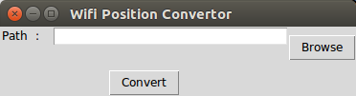

A software to convert multiple MAC addresses into coordinate location data using Mylnikov Geo-location API (https://www.mylnikov.org/).

Instruction (Windows)
Step1: Open wps_convert >> dist >> wps_convert >> wps_convert.exe.
Step2: Click "Browse" button to choose the meta folder that contains .wscan.json files. (e.g. H2_Day 1)
Step3: Click "Convert" Button and wait for few seconds. Corresponding CSV file will be generated inside output folder succesfully.
Warning: Do not change any folder location.

