Shortpitch: The idea of this project is to design a website for “Floris Cattery” to sell British Shorthair kittens and communicate with customers using images and videos.

Longpitch: The principle of the website should be to familiarize and interest the customers with the cats and kittens of the cattery. There should be attractive images and videos of cats and kittens on the main page to grab the attention of the visitors. The website will also include a page to introduce the dams and sires of the cattery as well as the kittens and the availability. Contacts page will be included in order to receive sales inquiries; customers should be able to directly email the seller from the contacts page. Additionally, there will be hyperlinks to social media pages of the cattery. Previous litter page as well as testimonials of previous customers will be added to showcase the quality of the cattery and assure the customers that the website is legitimate.

Personas:

Michelle- A single working mother of 2 children in her 40s who is looking for a family friendly pet but cannot afford to spend a tremendous time taking care of it. Experienced with online navigation and does not have any problem contacting via online platforms. She needs a courier/cargo service to get her cat delivered. Friendly, warm, and courteous.

Liang shi- An international student with a lack of English skills but well versed in uses of electronic devices. Prefers to use wechat, tiktok, or other Chinese communication apps and social media. She attends MSU and she can pick up locally. Straight-forward, interested, and curious

Joel- A grandfather in his 70s whose british shorthair has died of old age and is looking for a new companion for him and his wife. Not very familiar with navigating online webs but can make simple texts and emails. Confused, complicated, and indifferent

Competitors

Loretta British Cattery

<https://www.britishcattery.com/>

British Glory Cattery

[https://www.britishcatusa.com](https://www.britishcatusa.com/available-kittens)/

Email subscription idea: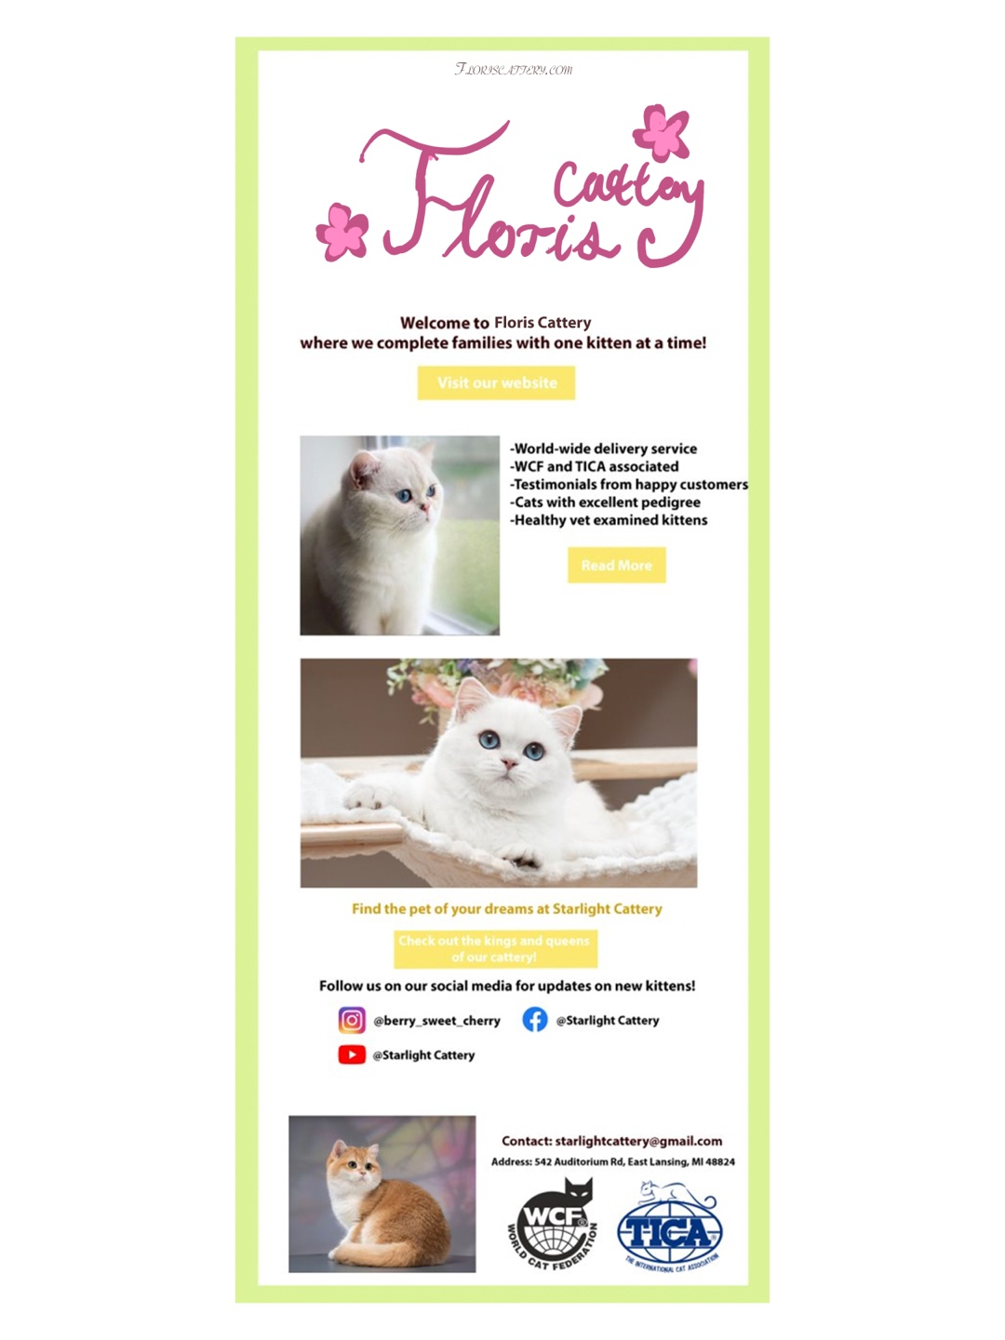

Homepage:

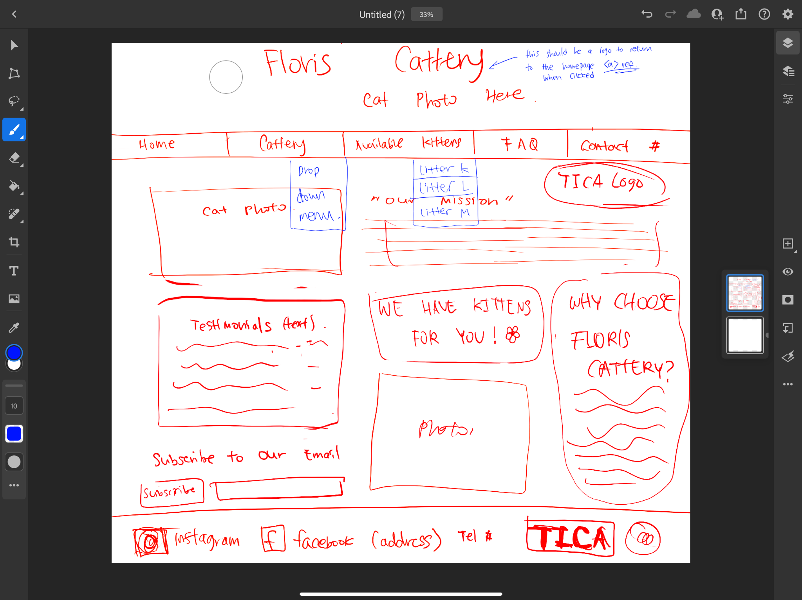

Contact Me page:

