SODA 501 Problem Set 1
Songtao Duan
Jan 18, 2026

1. GitHub Account
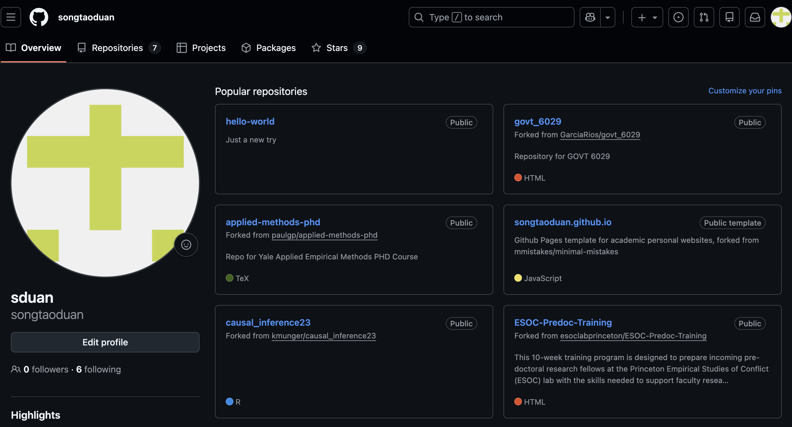

2. Git installed (git –version)

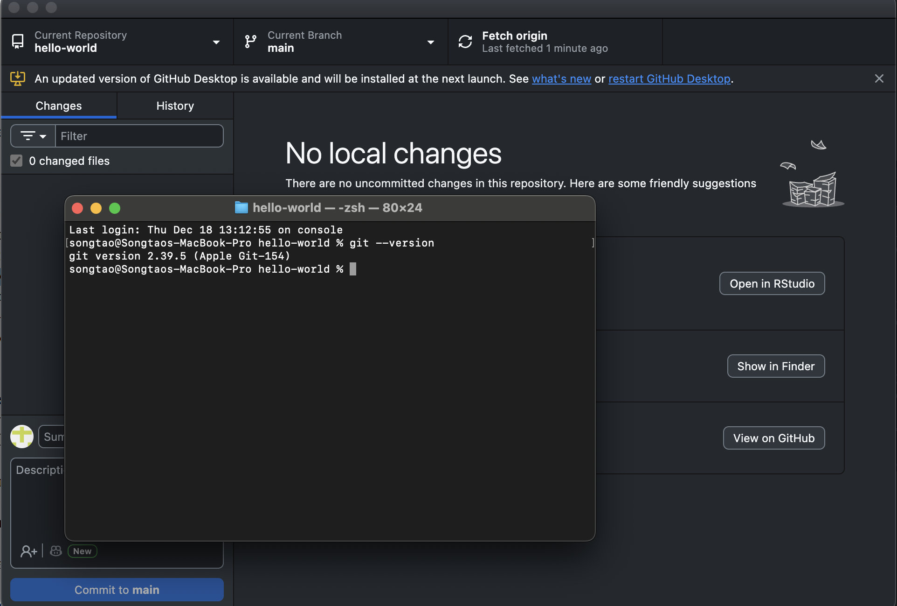

3. Python Installed
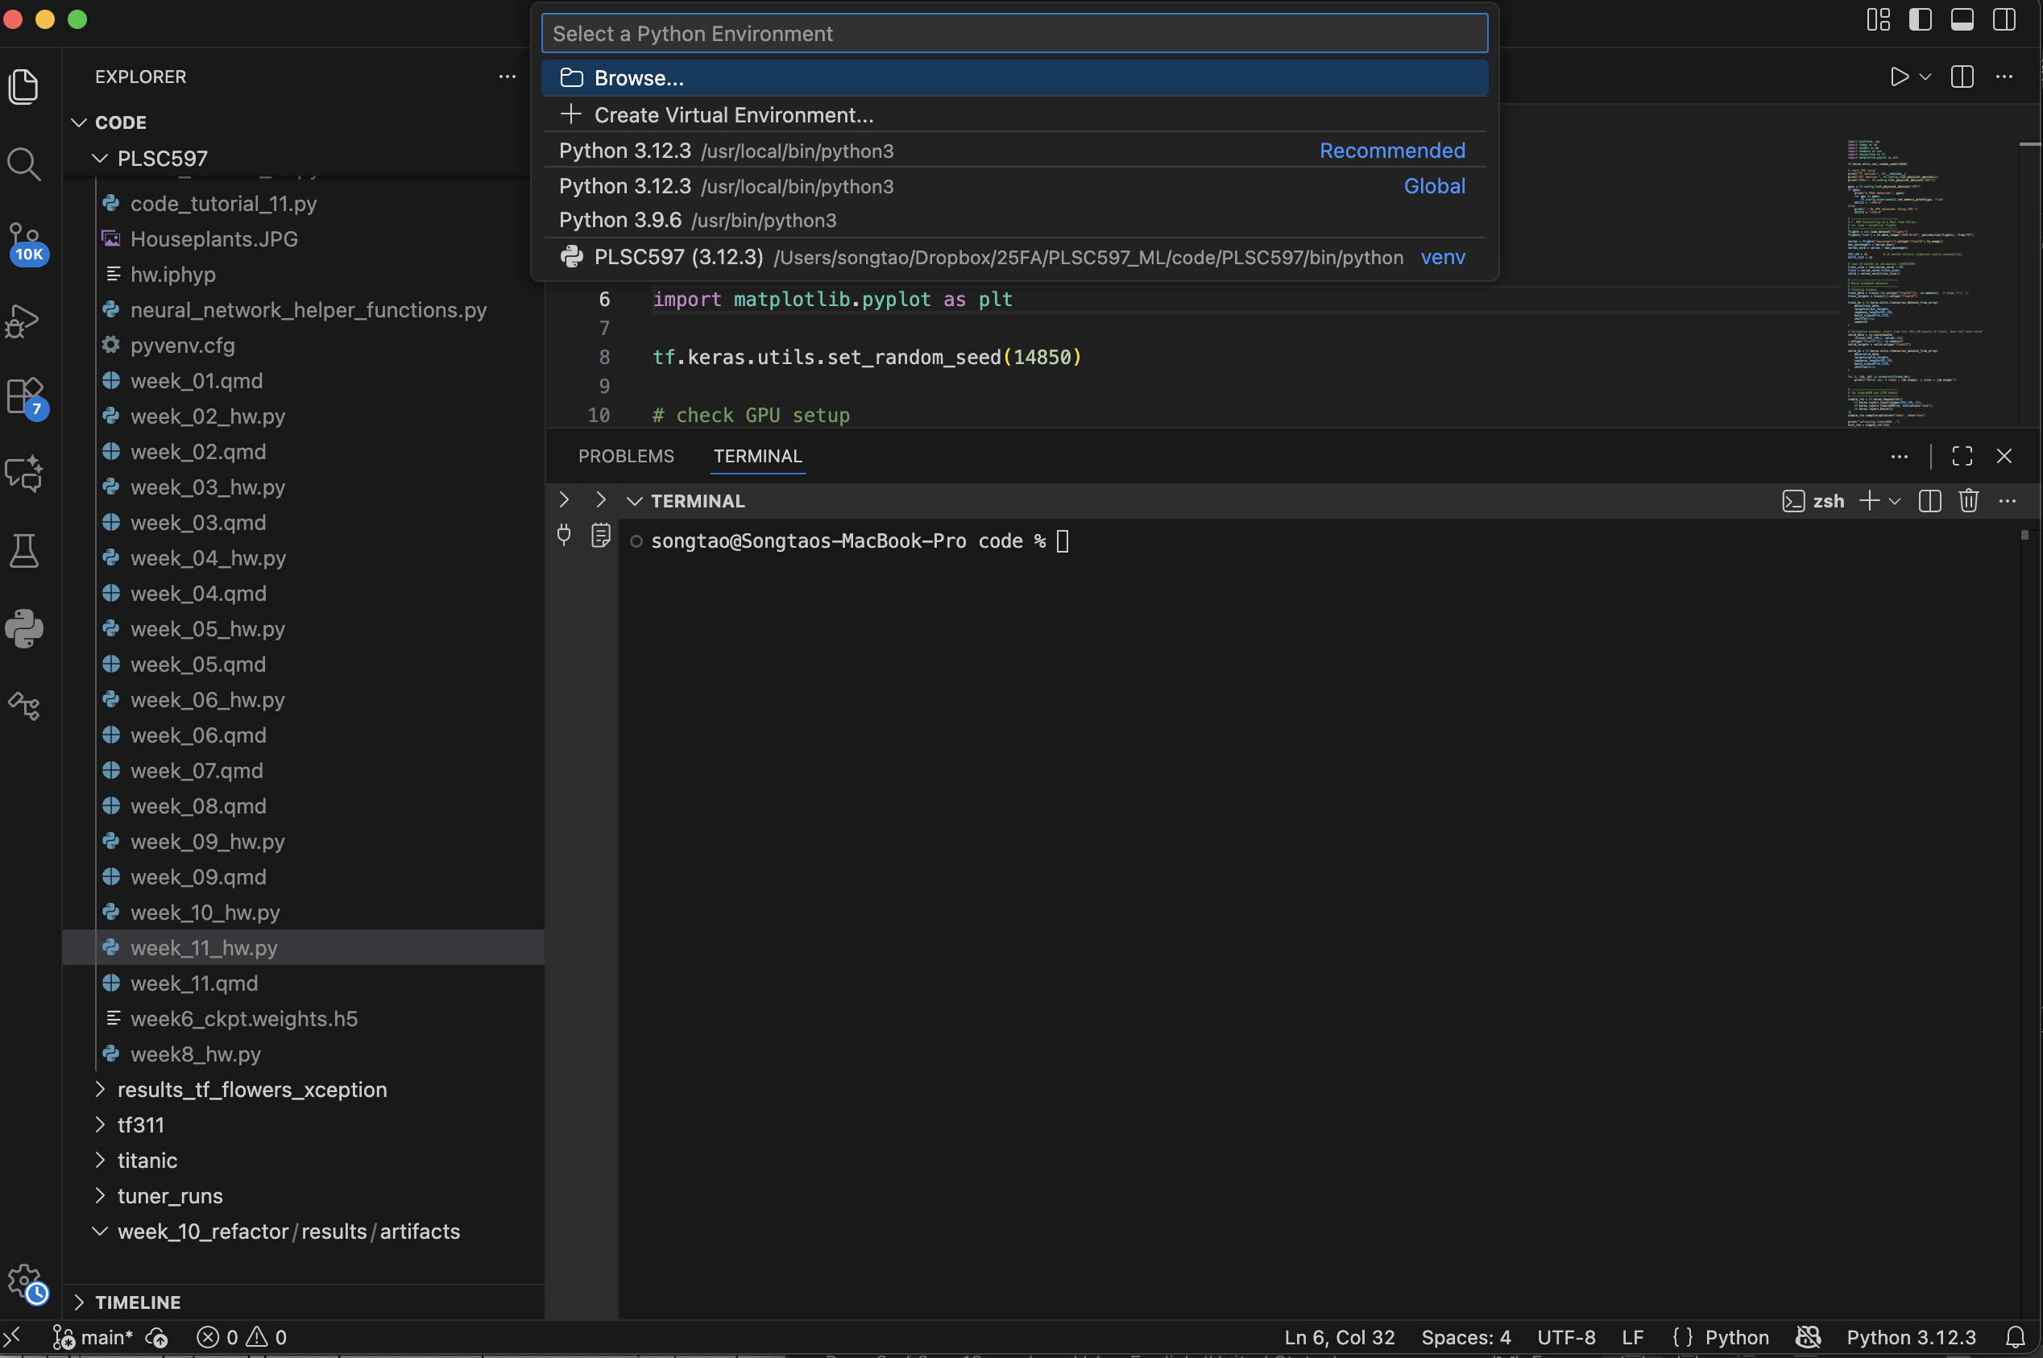

4. R installed (version 4.5.1)

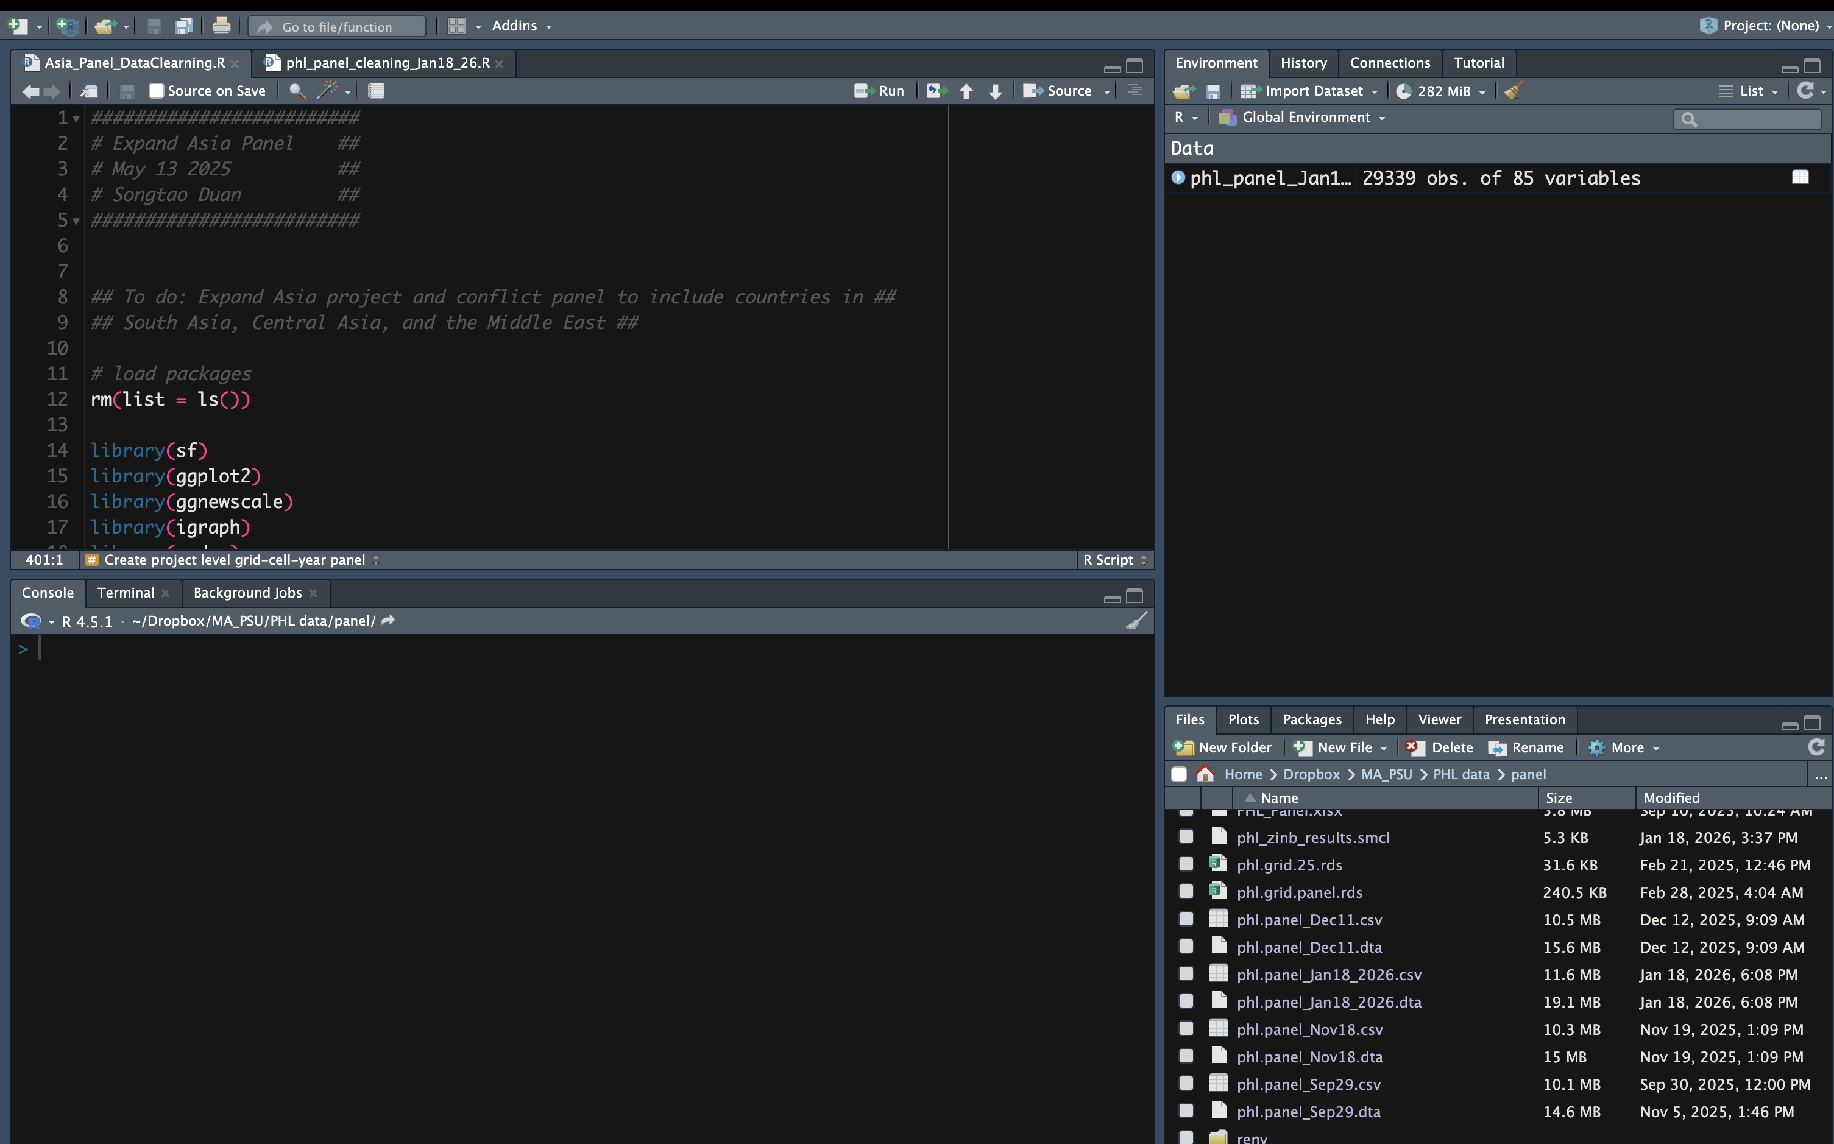

5. IDE installed
- see RStudio and VS Code page above.

6. Cloud-synced course folder (Dropbox: SODA501)
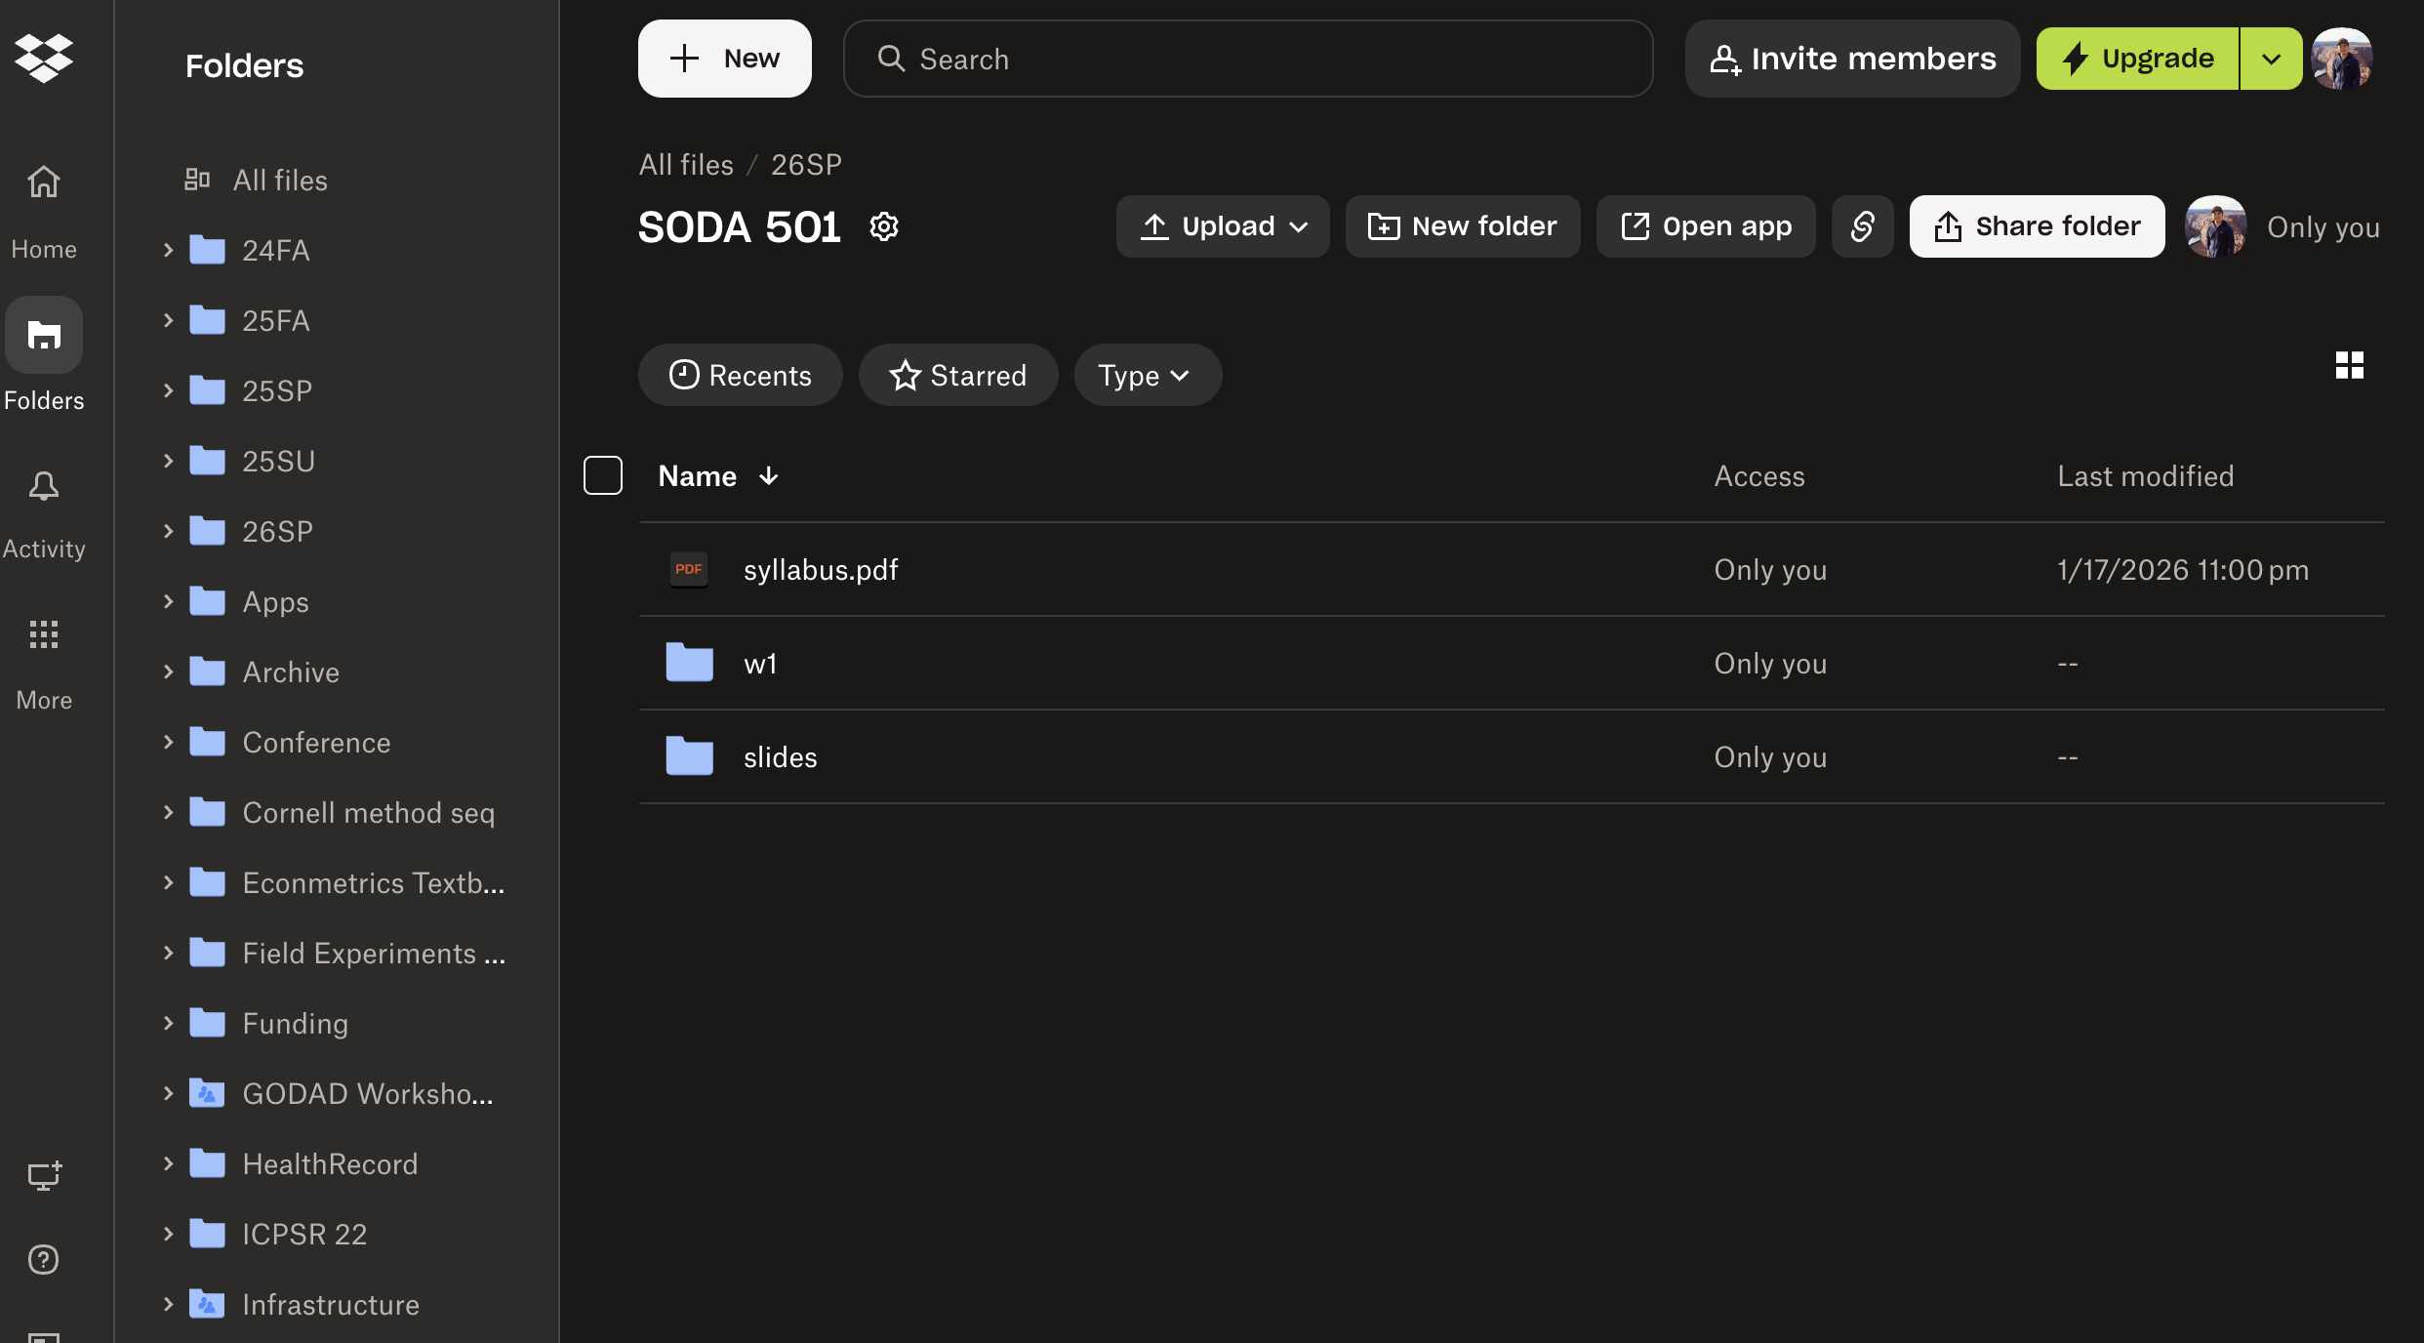

7. Compression utility
- Unarchiver installed
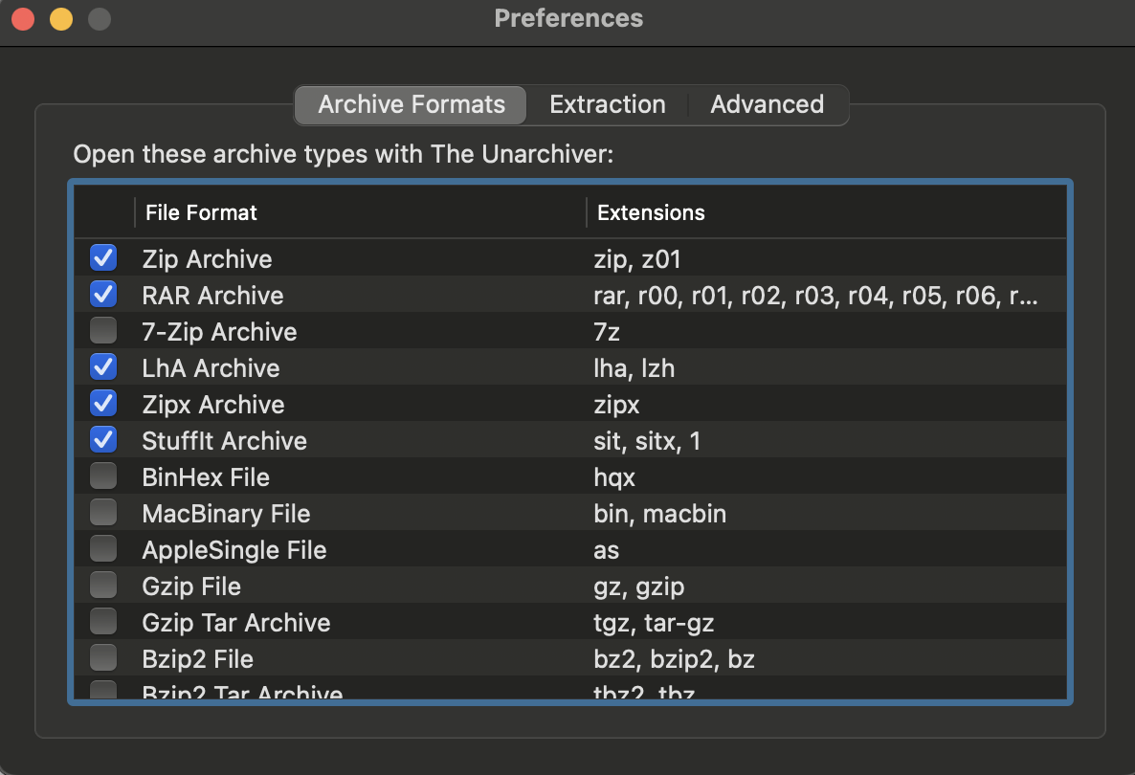

8. Jupyter installed (within vscode)

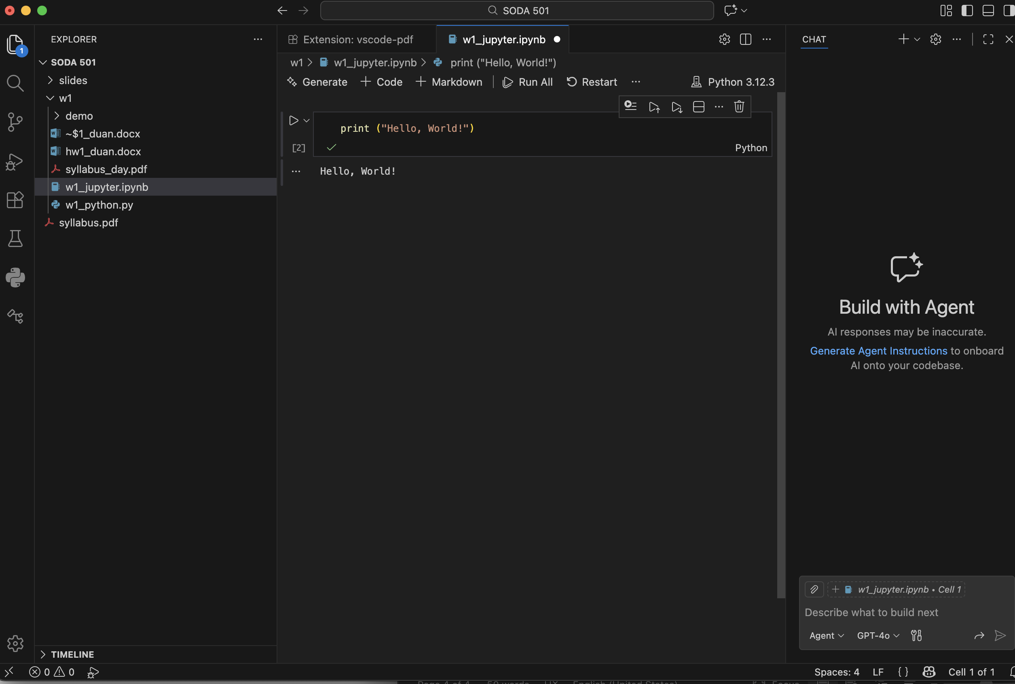

9. SQLite tools installed

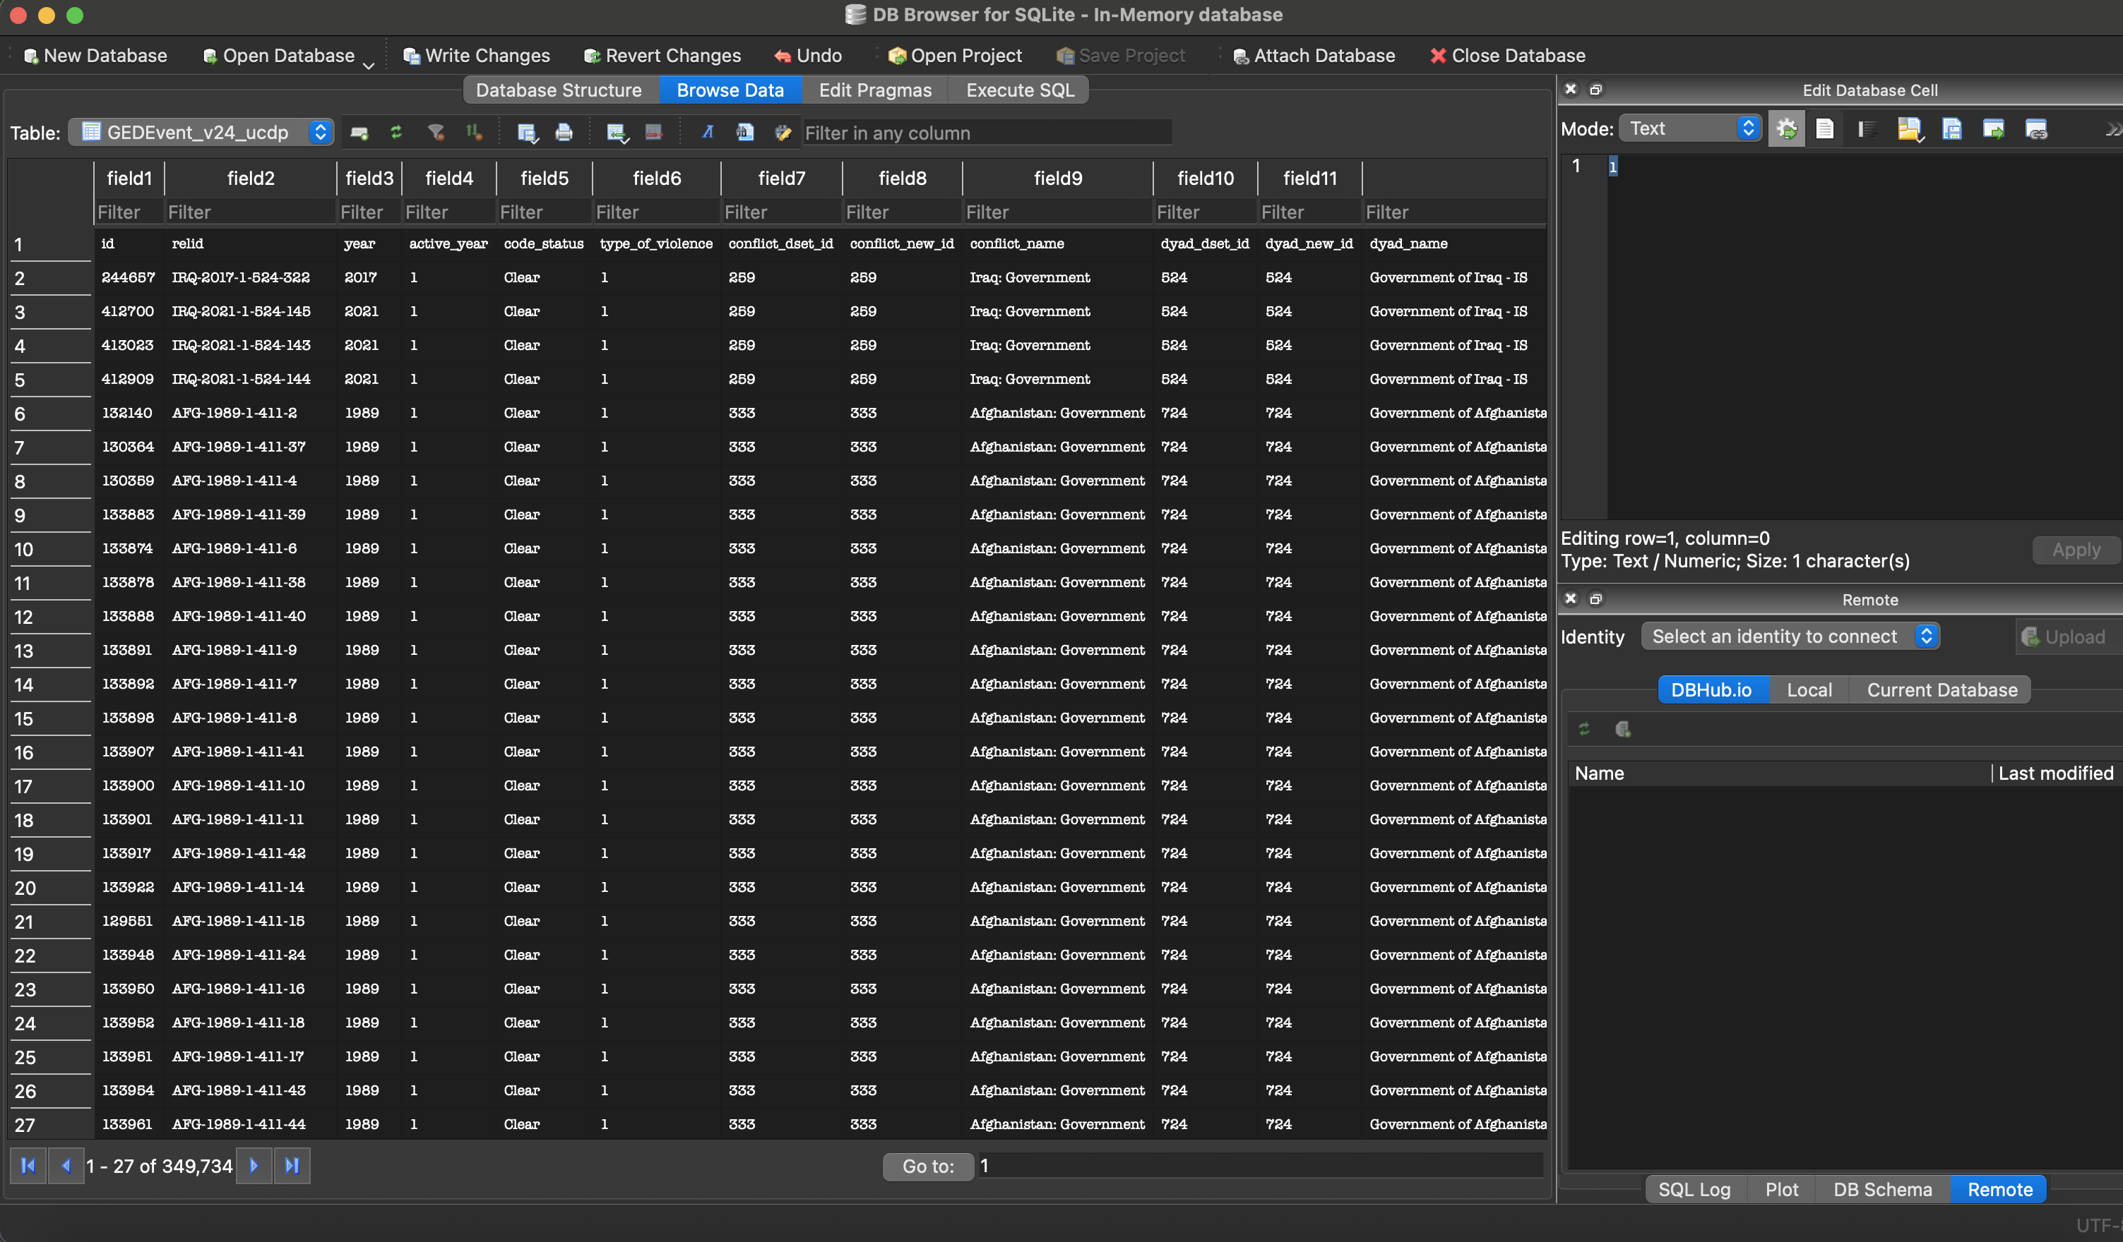

10. IRB
