DRRS implemented by http(jax-ws)

Data Structure:

A hashmap to record the room info with structure:

HashMap<String,ArrayList<HashMap<Integer,ArrayList<String>>>>

A class to record the booking info with variable:

String RecordID; String ID; String campus; String date; int roomnum; String timeslots;

Project Structure:

There a DRRS.idl which give the interface include abstract method and a DRRSImpl which implement them. Three Server which are DVL, WST, and KKL campus, two Client which are Admin and Student.

The Client provide the operation for user, after user input the data on Client , the Client connects to Server and Server connects to DRRS and complete the user’s requirements on DRRS.

Description:

I used jax-ws to implement the HTTP, After I completed, I test Server on the address I support”<http://localhos:8080/DRRS>”. And we need to add “?wsdl” in the end. Which is “<http://localhos:8080/DRRS>?wsdl”.

Important part:

In this project, people can log in with two kind of identity: Admin and Student. If the Client is Admin, then the program will transfer to AdminClient; otherwise, go StudentClient. It is checked by login ID.

As you can see, then there are different operation for them.

For Admin: they can create room and delete room

For Student: they can book a room or cancel a book, and check the available time slot

Both Admin and Student can work concurrency

**Create room by Admin**

There are three different campuses, after they chose, the client will connect to the server belong to the campus.

Now there are two room are created and student check available room on 2021-09-27,

**Booking room by Student:**

For book room of student, if a student has three booking record, then he cannot book anymore and if he cancel a booking then he can book room until he has three record again.

If the room does not exist, program will output the result and mention student to choose another one

However, I always suggest to get Available time slots before reserve.

In last two line it shows no more booking is available.

**Delete room by admin:**

For delete room of Admin, if the room is already booked by a student, then it should cancel the book firstly.

AdminClient

The reservation RR10002 which is created by a student is canceled.

StdentClient:

And we cannot find this booking ID anymore.

**Cancel room by Student:**

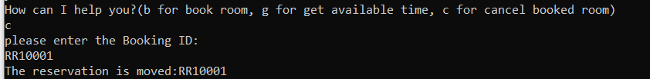

Students can cancel their reservation, then the record is removed and we cannot find it by bookingId again

It will release the booking ID, and then we can use it in the new recording next time

**Change reservation by student**

Student can change their reservation, the new reservation still hold the old bookingID.

The difficult point is to replace the data in the recording,

I need to find the recording address and the reinput the data, meanwhile make sure it will not create a new recording with the same ID.

**Get Available timeslots by stdent**

**Students can check the available time slots before they book, this function is very useful,**

**The program will output the available timeslots for each campus, and if the timeslots was booked, then student cannot find them on the output**

**Students can get the available time slots by enter the date.**