1. Set up Framework

* Install Eclipse Ide and create environment variable for Java: JAVA_HOME
* Install TestNG & Maven Dependencies: and create environment variable for Maven: MAVEN_HOME
* Import existing Maven project TestAutomatonFW
* Update Maven Project to download all dependencies. Please see the below screenshot

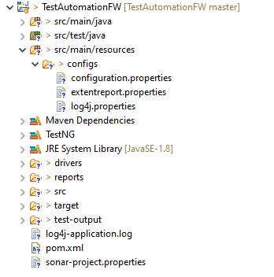

1. Config proxy for WebDriverManager in DriverFactory.java

Edit with your proxy and account

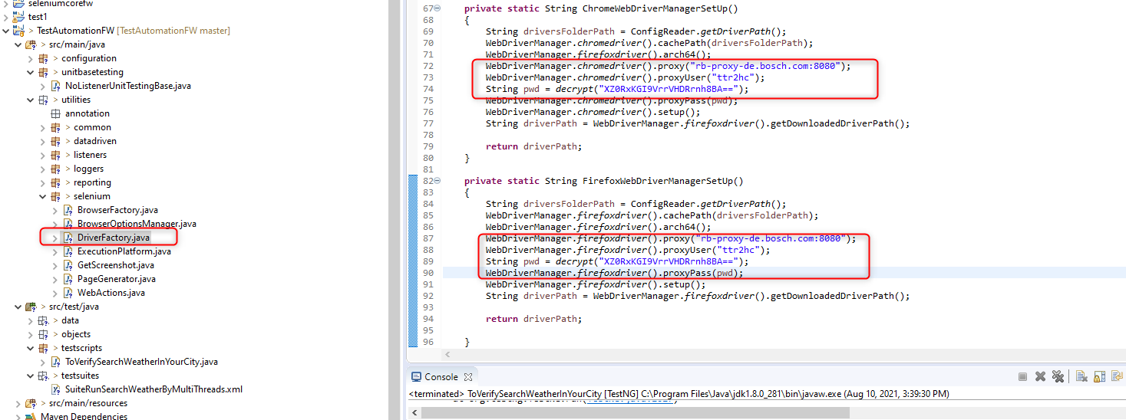

1. Config browser if need to run Test script individual

Open configuration.properties

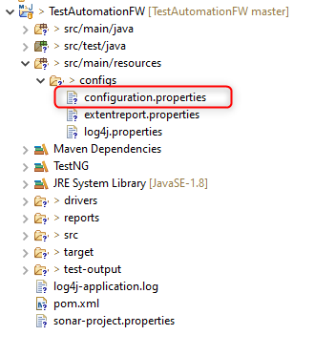

Change defaultBrowserType=firefox if run with “firefox” browser and “chrome” if run with Chrome browser

1. Test Data is stored at /data/TestData.json

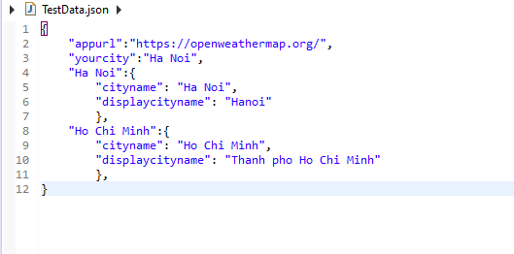

1. Run Test Script by Test NG

Testscripts/ToVerifySearchWeatherInYourCity

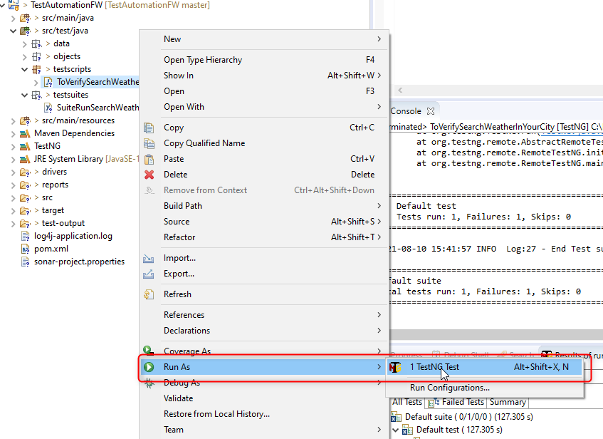

1. Run test suite by TestNG

Testsuites/SuiteRunSearchWeatherByMultiThreads.xml

Testsuite is configured to run with multiple threads (one firefox and one chrome)

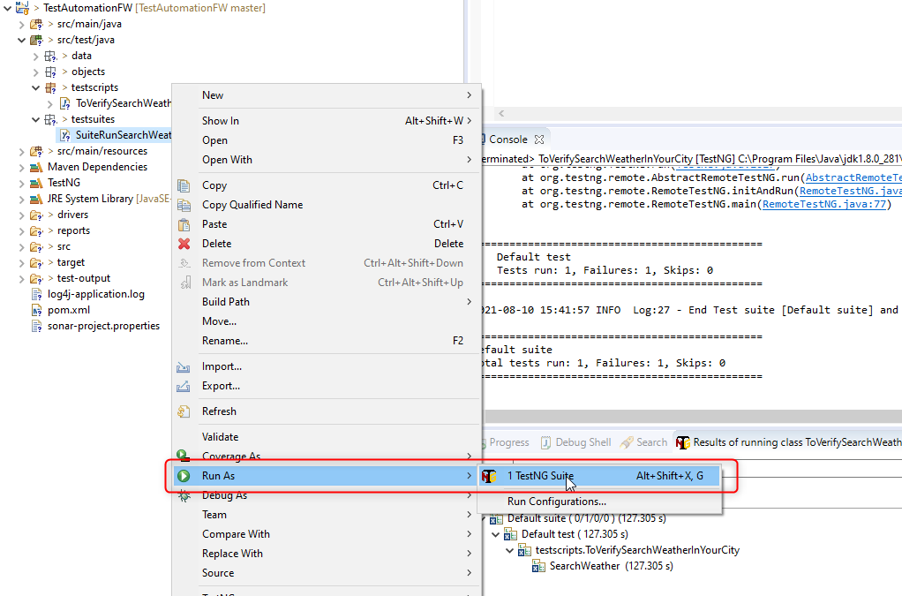

Html Reports is stored at TestAutomationFW\reports

Below are html report of test suite running with multi thread (one on firefox and one on chrome)

