ตรวจสอบสคริปต์สร้างรูปภาพและตาราง
Cover Page
Spatial Clustering Analysis of PM2.5 During the Early Rainy Season: Evidence from a Field Measurement Campaign in a Mixed Industrial–Traffic Corridor of Central Thailand
Sarnjanthuk S.¹, Mahawik N.^{1*}
¹ Faculty of Agriculture, Natural Resources and Environment, Naresuan University, Phitsanulok 65000, Thailand

*Corresponding author: Mahawik N. (Assoc. Prof. Dr.)
Full postal address: Faculty of Agriculture, Natural Resources and Environment, Naresuan University, 99 Moo 9, Tha Pho, Mueang Phitsanulok, Phitsanulok 65000, Thailand
Email: nattapornm@nu.ac.th
Telephone: +66(55)962752 Fax: +66(55)962750
Author 1 (Sarnjanthuk S.) email: songwuts65@mu.ac.th
Manuscript category: Original Research Article — Methodological Note / Regional Case Study
Word count (main text, excl. references): approx. 4,400 words
Number of figures: 9 Number of tables: 6
Number of references: 30
Target journal tier: Q2/Q3 regional environmental science or methodological-notes journal (e.g., a spatial/environmental methods section), positioned as a standalone contribution on hybrid grid-plus-purposive sampling design for PM2.5 hotspot screening — not a Q1 submission.

Spatial Clustering Analysis of PM2.5 During the Early Rainy Season: Evidence from a Field Measurement Campaign in a Mixed Industrial–Traffic Corridor of Central Thailand
Sarnjanthuk S.¹, Mahawik N.^{1*}
¹ Faculty of Agriculture, Natural Resources and Environment, Naresuan University, Phitsanulok 65000, Thailand *Corresponding author
DRAFT — Working manuscript

Abstract
Saraburi Province, Thailand, hosts a dense concentration of cement and lime manufacturing alongside major national highways, creating a mixed industrial-traffic corridor with plausible fine particulate matter (PM2.5) exposure gradients. Long-term monitoring in the province relies on only two reference-grade stations, leaving the spatial structure of PM2.5 between stations largely uncharacterized. This study used a hybrid sampling design: 25 sites placed on a systematic geographic grid (~0.25° spacing) across seven provinces of central Thailand, supplemented by 7 purposively-selected sites targeting suspected risk locations in Saraburi's industrial-traffic corridor, all measured during the early rainy season (June 2023) using a handheld optical particle counter. All 32 sites have confirmed exact GPS coordinates. Global (Moran's I) and local (Getis-Ord Gi*) spatial statistics were applied to test for clustering of PM2.5 concentrations. Global Moran's I was not statistically significant under either a k-nearest-neighbor (k=5) or a fixed distance-band spatial weights specification (I = -0.10 to 0.03, p ≥ 0.20 in all cases), indicating no strong evidence of province-wide spatial autocorrelation at this sample size. Local Getis-Ord Gi* analysis on log-transformed concentrations identified three statistically significant hotspots (z > 1.96, p < 0.05); notably, all three were among the purposively-selected risk sites (Talingchan Subdistrict, Mueang Saraburi District; and Ban Pa and Tha Khlo Subdistricts, Kaeng Khoi District), while none of the 25 systematic-grid sites reached significance. This indicates that the coarse systematic grid (~28 km average spacing) was too sparse to resolve the local industrial hotspot, and that the purposive supplementary sampling improved detection of suspected local-scale heterogeneity, though this targeted design does not by itself provide an unbiased estimate of hotspot prevalence across the broader region. One systematic-grid site (Tab Kwang Subdistrict, Kaeng Khoi District), located on an uphill section of Mittraphap Road adjacent to a cement facility, recorded an extreme concentration (PM2.5 = 486.15 µg/m³) but was not itself classified as a statistically significant hotspot, illustrating the distinction between an isolated point-source spike and a spatially clustered pattern. Sensitivity analysis showed that hotspot detection was sensitive to the choice of spatial weights matrix (3 significant hotspots under k-NN versus 0 under a fixed distance band), underscoring the exploratory nature of this single-timepoint, moderate-sample-size screening study. We frame the results as a spatial screening assessment rather than a definitive characterization of PM2.5 clustering, and identify the Kaeng Khoi–Mueang Saraburi corridor as a priority area for repeated, denser, and instrument-calibrated follow-up monitoring.
Keywords: PM2.5; spatial autocorrelation; Moran's I; Getis-Ord Gi*; optical particle counter; early rainy season; Saraburi; Thailand

1. Introduction
Fine particulate matter (PM2.5) remains one of the most significant environmental health risks in Southeast Asia, with mainland Southeast Asia experiencing substantial premature mortality attributable to ambient particulate exposure (Amnuaylojaroen & Parasin, 2023). In Thailand, PM2.5 has increased gradually over the past two decades, driven by industrial activity, transportation, and seasonal biomass burning (Thongsame et al., 2025).
Saraburi Province, located north of the Bangkok Metropolitan Region, is Thailand's largest base for cement manufacturing and hosts extensive quarrying and lime production alongside the Mittraphap Road corridor, a major national highway carrying substantial heavy-vehicle traffic (High-emission cement industry to launch Saraburi Sandbox research pilot, Nation Thailand). Industrial dust from stone crushing and cement operations, combined with vehicular emissions, has been documented to elevate PM10 and PM2.5 in specific subdistricts of the province, most notably Na Phra Lan Subdistrict, Chaloem Phrakiat District, where PM10 exceedance days and elevated annual averages have been formally reported (Simultaneously Achieving Climate Change and Air Quality Goals in Thailand, CCAC). Provincial air quality is monitored operationally by only two Pollution Control Department (PCD) reference stations (24T and 25T), which — while suitable for temporal trend analysis — cannot resolve the spatial structure of PM2.5 concentrations across the province's approximately 3,500 km² area.
Spatial autocorrelation statistics, particularly global Moran's I and local Getis-Ord Gi*, are widely used to characterize the clustering of air pollution concentrations from sparse monitoring networks or mobile/portable sensing campaigns (Getis & Ord, 1992; Gianquintieri et al., 2024). These methods have been applied at scales ranging from national PM2.5 hotspot mapping in India and China (Jaganathan et al., 2024; Zhu et al., 2022) to city-scale analysis in Tehran (Abbasi et al., 2024) and fine-scale intraurban taxi-based monitoring (Liu et al., 2022). A consistent methodological caution in this literature is that the results of local hotspot analysis are sensitive to the specification of the spatial weights matrix — a manifestation of the broader Modifiable Areal Unit Problem in spatial statistics (Openshaw, 1984; Tuson et al., 2019) — and should therefore be reported alongside explicit sensitivity checks rather than a single specification.
The early rainy season (typically May-June in central Thailand) is a transitional period in which the wash-out effect of rainfall progressively reduces PM concentrations relative to the preceding dry season, but early-monsoon rainfall is often intermittent, so elevated concentrations can still occur between rain events (Othman et al., 2022). This transitional period has received comparatively little spatial characterization in the Thai literature relative to the well-studied dry-season haze period.
This study addresses this gap through a single field measurement campaign using a handheld optical particle counter deployed at 32 sites across seven provinces of central Thailand, with a concentration of sites within Saraburi Province, during the early rainy season of 2023. The specific objectives were to: (1) characterize the spatial distribution of PM2.5 and total particulate matter across the sampled sites; (2) test for global spatial autocorrelation using Moran's I; (3) identify statistically significant local hotspots using Getis-Ord Gi*; and (4) evaluate the robustness of the hotspot pattern through sensitivity analysis with respect to the treatment of an extreme observation and the choice of spatial weights specification. Consistent with the exploratory, single-timepoint nature of the campaign, we frame this as a spatial screening study rather than a definitive climatological characterization, and this framing is carried through explicitly in the Discussion and Limitations sections.

2. Materials and Methods

2.1 Study Area and Field Campaign
The field campaign used a hybrid sampling design comprising 32 sites: 25 sites were placed on a systematic geographic grid (approximately 0.25° latitude x 0.256° longitude spacing) spanning seven provinces of central Thailand, pre-determined before the field visit, and 7 additional sites were purposively selected to target locations judged, prior to sampling, to be at elevated risk of high PM2.5 (labeled Survey-0 through Survey-6). Purposive sites were selected using known industrial source locations (e.g., the industrial cluster in Nong Khae District) combined with the research team's assessment of prevailing wind direction, to identify subdistricts with plausible downwind exposure; Talingchan Subdistrict (Survey-0), for example, was selected on the assumption that emissions from Nong Khae's industrial cluster would be carried toward it under typical wind conditions. The systematic-grid sites spanned Saraburi (n=6 of 25), Lopburi, Nakhon Ratchasima, Ayutthaya, Nakhon Nayok, Prachinburi, and Pathum Thani, while all 7 purposively-selected sites fell within Saraburi, concentrated in Kaeng Khoi, Mueang Saraburi, and Muak Lek districts — the province's principal cement, lime, and quarrying belt (Figure 1). Measurements were conducted between 5 and 29 June 2023, corresponding to the early rainy season in central Thailand.

2.2 Instrumentation and Data Collected
At each site, a Particles Plus® 8000 Series handheld optical particle counter (Model 8306, identified from its recorded six-channel configuration; compliant with ISO 21501-4 and JIS B9921 for light-scattering airborne particle counters) recorded PM0.3, PM0.5, PM1.0, PM2.5, PM5.0, and PM10.0 mass concentrations (µg/m³), total particulate matter (TPM), relative humidity, ambient temperature, and prevailing wind direction, together with the date and time of measurement and a geolocation link. Each site received a single reading over a fixed 1-minute sample duration; per the manufacturer's operating manual, this is a continuous integrated sample over that window (the pump runs and counts particles for the full minute, yielding one cumulative reading), not an average of multiple discrete readings. This study focuses on PM2.5 and TPM as the primary analytical variables. The instrument's ISO 21501-4/JIS B9921 compliance covers particle-counting accuracy under standardized laboratory conditions; it does not by itself constitute field co-location calibration against a reference-grade PCD station, which was not performed prior to this campaign. This distinction is addressed explicitly in Section 5 (Limitations).

2.3 Geolocation
Site coordinates were originally recorded as individual shortened map links at the time of measurement (for purposively-selected sites) or pre-assigned before the field visit as part of the systematic grid design (for grid sites). All 32 links were subsequently resolved to exact GPS coordinates; the near-perfectly regular spacing observed among the 25 grid-site coordinates (~0.248° latitude, ~0.256° longitude) was confirmed to reflect the intended systematic sampling design rather than a data-resolution error. All coordinates used throughout Section 3 are therefore exact, resolved GPS values.

2.4 Relative Humidity Screening
Because optical particle counters are known to be sensitive to ambient relative humidity (RH) through hygroscopic particle growth, RH recorded by the instrument at each site (range 30-79%, mean 46.3%) was screened for association with PM2.5 prior to spatial analysis. Pearson correlation between RH and raw PM2.5 was weak and not statistically significant (r=0.076, p=0.680); the correlation with log-transformed PM2.5 was similarly weak (r=0.117, p=0.523), as was the correlation between ambient temperature and PM2.5 (r=-0.082, p=0.657). Because no statistically detectable RH-dependence was found in this dataset, no RH correction factor was applied to the reported concentrations; this decision, and the underlying correlation results, should be revisited if the instrument manufacturer's calibration documentation specifies a manufacturer-recommended RH correction curve, which was not available during manuscript preparation. In fact, the manufacturer's user manual for this instrument confirms that no automatic RH correction algorithm exists at all: the device's mass-concentration mode computes µg/m³ values solely from particle counts combined with a user-entered particle density and refractive index, with no RH-dependent adjustment applied at any stage. The absence of a statistically detectable RH-dependence in this dataset is therefore consistent with the instrument's design rather than an analytical choice on our part, though it does not rule out RH effects the instrument itself cannot correct for. [รอข้อมูลจากเจ้าของเครื่องที่ผมไปยืมมาเก็บข้อมูล — ค่า factory-default particle density และ refractive index ที่ใช้ในแคมเปญนี้]

2.5 Global Spatial Autocorrelation — Moran's I
Global spatial autocorrelation of PM2.5 concentrations was assessed using Moran's I (Moran, 1950), computed on both raw and natural-log-transformed concentrations to address the right-skewed distribution typical of PM data. Statistical significance was assessed via 999 conditional permutations. Two spatial weights specifications were compared as a sensitivity check (Section 2.7): a k-nearest-neighbor matrix (k=5) and a fixed distance-band matrix (threshold = 0.5 decimal degrees, approximately 55 km at this latitude), both row-standardized. The 0.5° threshold was chosen empirically from the distribution of inter-site distances across the 32 sites: the nearest-neighbor distance per site ranged from 4.6 to 27.5 km (median 27.2 km), so a 55 km band exceeds the largest nearest-neighbor distance in the dataset by roughly a factor of two, guaranteeing every site at least one neighbor, while remaining below the median all-pairs distance (61.5 km, 10th–90th percentile range 27.5–110.1 km) so that the matrix does not approach full connectivity.

2.6 Local Hotspot Analysis — Getis-Ord Gi*
Local spatial clustering was assessed using the Getis-Ord Gi* statistic (Getis & Ord, 1992), which identifies locations where a feature and its neighbors have a sum of concentrations markedly higher (a hot spot) or lower (a cold spot) than would be expected under spatial randomness. Gi* was computed on log-transformed PM2.5 using binary k-NN (k=5) weights, with statistical significance based on 999 conditional permutations (z > 1.96 and p < 0.05 for hot spots). Both the z-score and p-value reported throughout are the permutation-based (pseudo) statistics returned by this procedure — the z-score is standardized against the empirical distribution of the 999 permuted realizations rather than a theoretical normal distribution, and the p-value is the corresponding empirical rank-based pseudo-significance — not analytically-derived statistics; this applies identically to the Moran's I results in Section 2.5.

2.7 Sensitivity Analysis
Two sensitivity checks were conducted. First, Moran's I and Gi* were recomputed after excluding the Tab Kwang site (the extreme observation, PM2.5 = 486.15 µg/m³) to assess whether this single site drove the overall pattern. Second, results were compared between the k-NN (k=5) and fixed distance-band weights specifications to evaluate sensitivity to the definition of spatial neighbors, given the irregular, non-grid spacing of the sampled sites.

2.8 Meteorological Context (Synoptic Archive)
To provide meteorological context for the campaign period, hourly wind speed, wind direction, temperature, and precipitation were obtained from the Meteostat archive using the nearest available station to the Saraburi sampling cluster. An initial candidate station, Don Mueang, Bangkok (WMO/Meteostat station 48456), lies approximately 65 km from the site cluster; retrieval identified the substantially closer Pakchong Agromet / Ban Pang Asok station, which was used instead. The resulting 5-29 June 2023 record is summarized in Table 5.

2.9 Spatial Covariates: Distance to Road and Industrial Facilities
To help explain the spatial pattern reported in Section 3, two proximity covariates were computed for every site: (1) distance to the nearest point on an approximated route of Mittraphap Road (Highway 2) through the study corridor, and (2) distance to the nearest of three named cement plants with verified coordinates in the Kaeng Khoi-Nong Khae industrial belt of Saraburi Province: the TPI Polene Mittaphap plant (14.64631, 101.12650), the Siam Cement (Kaeng Khoi) Ban Pa plant (approximately 14.6152, 101.0181), and the Siam Cement Khao Wong plant (14.67494, 100.85217) (Global Energy Monitor, Global Cement and Concrete Tracker). The road route remains an interpolated waypoint approximation through named towns rather than a surveyed centerline and is a remaining item to upgrade (Section 5); the facility locations, by contrast, are now sourced from a named, verifiable registry rather than approximated place-name clusters. Straight-line (great-circle) distances were computed using the haversine formula.

2.10 Software
All analyses were performed in Python 3 using the libpysal and esda libraries for spatial weights construction, Moran's I, and Getis-Ord Gi* computation, with pandas and NumPy for data handling and matplotlib for visualization.

3. Results

3.1 Descriptive Statistics
Across the 32 sites, PM2.5 concentrations ranged from 7.93 to 486.15 µg/m³ (mean = 36.0 µg/m³, median = 20.3 µg/m³, SD = 82.9 µg/m³; skewness = 5.24), and TPM ranged from 28.11 to 3,056.74 µg/m³ (mean = 184.7 µg/m³, median = 80.1 µg/m³, SD = 525.9 µg/m³; skewness = 5.33) (Table 1, Figure 2). Excluding the Tab Kwang site, the PM2.5 range narrowed to 7.93-54.11 µg/m³ (median = 20.0 µg/m³), indicating that the remaining 31 sites clustered within a comparatively narrow band typical of early-rainy-season conditions in central Thailand.
Variable | n | Mean | SD | Min | Median | Max | Skewness
PM2.5 (µg/m³) | 32 | 36.00 | 82.85 | 7.93 | 20.29 | 486.15 | 5.24
TPM (µg/m³) | 32 | 184.66 | 525.85 | 28.11 | 80.10 | 3,056.74 | 5.33
Table 1. Descriptive statistics of field-measured PM2.5 and TPM across 32 sites (June 2023).
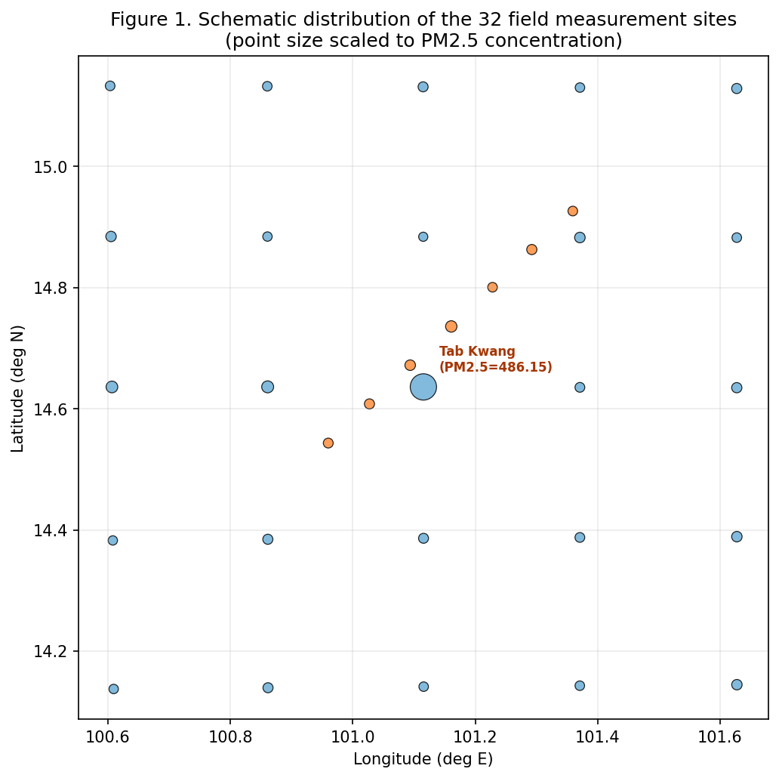
Figure 1. Schematic distribution of the 32 field measurement sites, sized by PM2.5 concentration and colored by province. All 32 sites (7 purposively-selected risk sites and 25 systematic-grid sites) use confirmed exact GPS coordinates resolved from field-recorded map links (see Section 2.3).
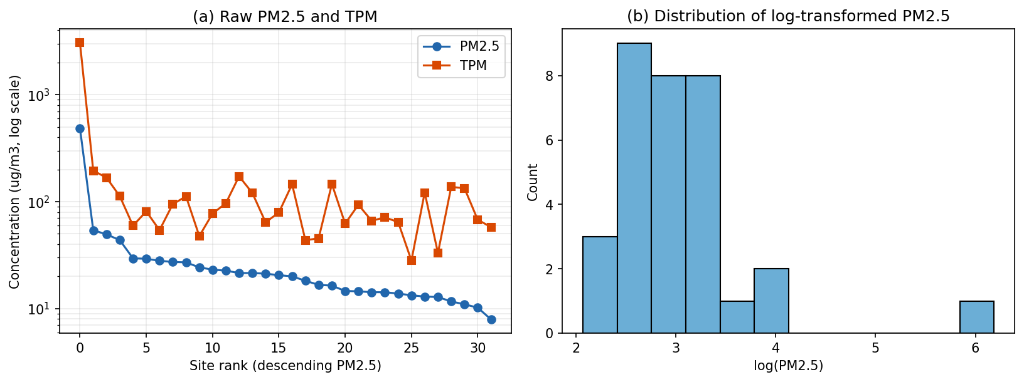
Figure 2. (a) Raw PM2.5 and TPM concentrations (log-scaled y-axis); (b) distribution of log-transformed PM2.5.

3.2 Global Spatial Autocorrelation
Global Moran's I was not statistically significant for PM2.5 under any combination of weights specification, raw/log transformation, or inclusion/exclusion of the Tab Kwang site (all p > 0.10; Table 2). Values ranged from I = -0.102 (excluding Tab Kwang, k-NN weights, log-transformed) to I = 0.030 (full dataset, k-NN weights, log-transformed). This indicates that, at the scale and sample size of this campaign, there is no statistically detectable province-wide (or region-wide) spatial autocorrelation in PM2.5 — i.e., the data do not support a claim of broad, continuous spatial gradient across the seven-province sampling extent.
Dataset | Weights | Variable | I | z | p
Full (n=32) | k-NN (k=5) | Raw PM2.5 | -0.0149 | 0.803 | 0.204
Full (n=32) | k-NN (k=5) | Log PM2.5 | 0.0296 | 0.773 | 0.214
Full (n=32) | Distance-band | Raw PM2.5 | -0.0384 | -0.394 | 0.388
Full (n=32) | Distance-band | Log PM2.5 | -0.0516 | -0.340 | 0.390
Excl. Tab Kwang (n=31) | k-NN (k=5) | Raw PM2.5 | -0.0695 | -0.410 | 0.363
Excl. Tab Kwang (n=31) | k-NN (k=5) | Log PM2.5 | -0.1021 | -0.685 | 0.263
Excl. Tab Kwang (n=31) | Distance-band | Raw PM2.5 | -0.0508 | -0.244 | 0.432
Excl. Tab Kwang (n=31) | Distance-band | Log PM2.5 | -0.0634 | -0.433 | 0.357
Table 2. Global Moran's I results under alternative weights specifications, variable transformations, and treatment of the Tab Kwang observation. No result is statistically significant at α=0.05.

3.3 Local Hotspot Analysis
Despite the absence of global autocorrelation, local Getis-Ord Gi* analysis (k-NN, k=5, log PM2.5) identified three statistically significant hot spots (z > 1.96, p < 0.05; Table 3, Figure 3). All three were among the seven purposively-selected risk sites, and none of the 25 systematic-grid sites reached significance — including two grid sites in Saraburi itself (Nong Pla Mo, Nong Khae District, z=-0.03; Cha-om, Kaeng Khoi District, z=1.64) that fell short of the threshold. The three significant sites — Talingchan Subdistrict (Mueang Saraburi District), Ban Pa Subdistrict (Kaeng Khoi District), and Tha Khlo Subdistrict (Kaeng Khoi District) — form a compact cluster roughly 5-10 km apart. No statistically significant cold spots were identified. Notably, the Tab Kwang site itself — the single highest raw concentration in the dataset, and in fact one of the 25 systematic-grid sites rather than a purposively-selected one — was not classified as a significant hotspot (z = 1.05, p = 0.155), because its immediate spatial neighbors under the k-NN weighting did not share comparably elevated concentrations; it behaves statistically as an isolated spike rather than the center of a spatial cluster. That a grid site nonetheless recorded the campaign's single highest reading, while still not registering as a cluster, underscores the distinction drawn throughout this paper between capturing an extreme point value and detecting a spatially coherent hotspot.
Site | Subdistrict / District | PM2.5 (µg/m³) | Gi* z-score | p-value
Survey-0 | Talingchan, Mueang Saraburi | 18.21 | 2.89 | 0.003
Survey-1 | Ban Pa, Kaeng Khoi | 21.51 | 3.27 | 0.001
Survey-2 | Tha Khlo, Kaeng Khoi | 29.51 | 2.22 | 0.034
Table 3. Statistically significant PM2.5 hotspots (Getis-Ord Gi*, k-NN k=5, log-transformed, p<0.05). All three sites are purposively-selected risk sites in Saraburi Province.
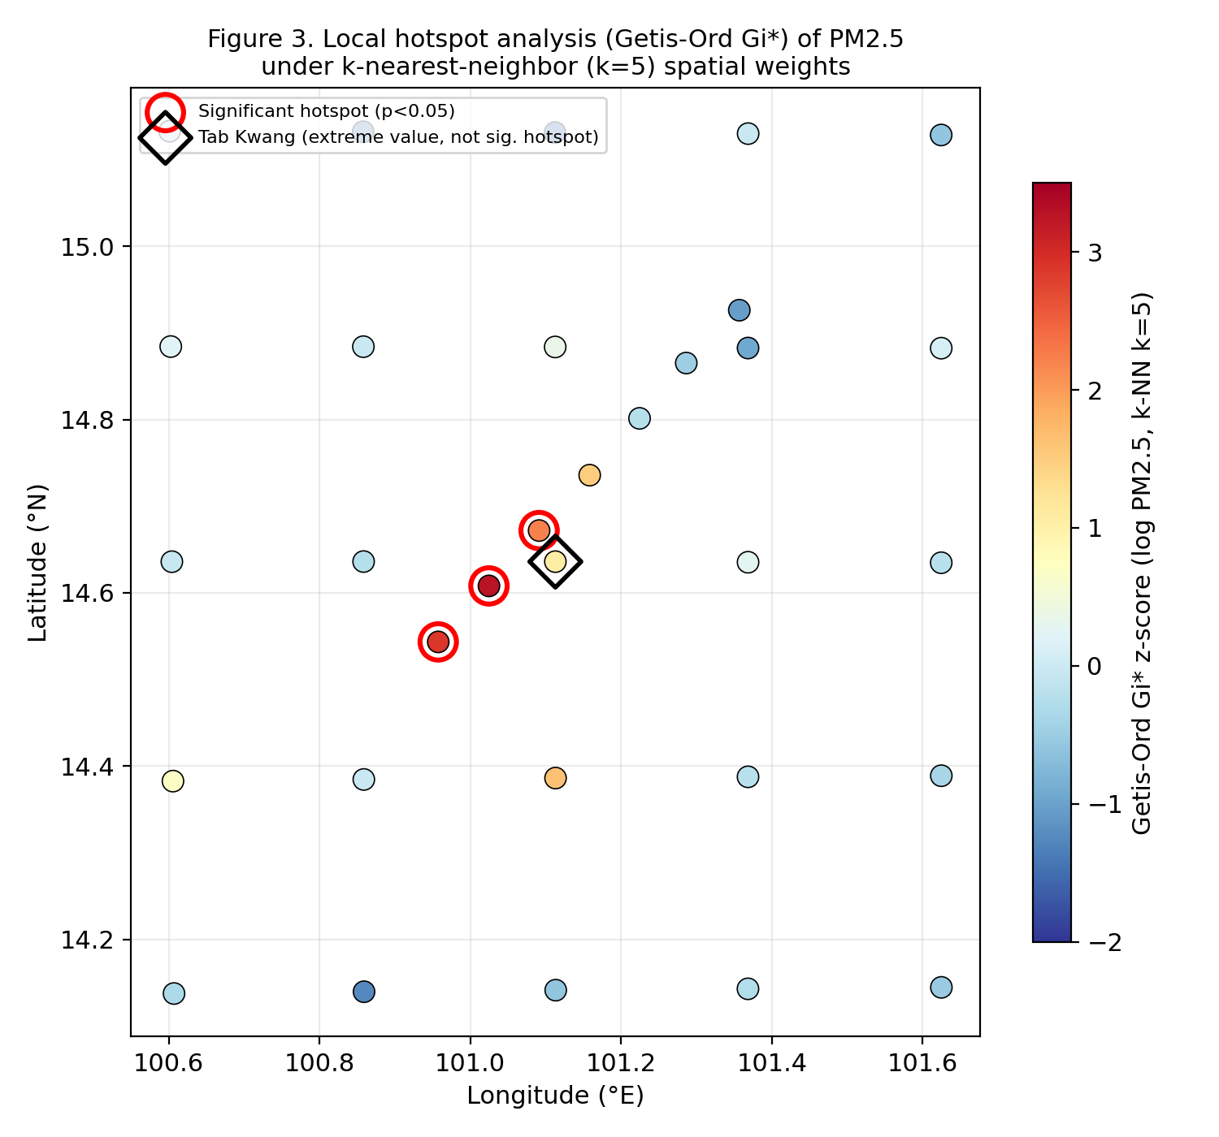
Figure 3. Local Getis-Ord Gi* z-scores by site. The 25 systematic-grid sites form the visible regular lattice; the 7 purposively-selected risk sites cluster near the center. Red circles mark statistically significant hotspots (p<0.05), all among the purposive sites; the diamond marks the Tab Kwang extreme value, which is not a significant hotspot under this specification.

3.4 Sensitivity Analysis
The number of statistically significant hotspots remained sensitive to the choice of spatial weights matrix: 3 significant hotspots were detected under k-NN (k=5) weighting, compared with 0 under the fixed distance-band (0.5°) specification (Table 4). This reflects the mixed spatial density of the design — the tight purposive cluster is well-resolved by k-NN, which always uses a fixed number of neighbors regardless of local density, whereas the 0.5° distance band was calibrated more to the sparser systematic-grid spacing and under-detects clustering in the denser purposive sub-sample. Exclusion of the Tab Kwang site did not materially change the global Moran's I results (Table 2), indicating that the non-significant global pattern is not an artifact of this single extreme value; however, because Tab Kwang was not itself a significant local hotspot, its exclusion also did not remove any of the three reported local hotspots.
Sensitivity check | Specification A | Result A | Specification B | Result B
Weights matrix (Gi*, full data, log PM2.5) | k-NN (k=5) | 3 significant hotspots | Fixed distance-band (0.5°) | 0 significant hotspots
Outlier treatment (Global Moran's I, k-NN, log) | Including Tab Kwang | I = 0.030, p = 0.214 | Excluding Tab Kwang | I = -0.102, p = 0.263
Variable transformation (Global Moran's I, k-NN, full data) | Raw PM2.5 | I = -0.015, p = 0.204 | Log PM2.5 | I = 0.030, p = 0.214
Table 4. Summary of sensitivity analysis results.

3.5 Meteorological Context
Table 5 (below) reports synoptic meteorological context (wind direction, wind speed, precipitation) for the campaign window, retrieved via the Meteostat archive as described in Section 2.8. This context is not required for the spatial statistics reported in Sections 3.2-3.4, but strengthens the physical interpretation offered in Section 4.
Date (2023) | Nearest station | Mean wind dir. | Mean wind speed | Precipitation | Notes
5-Jun | Pakchong Agromet / Ban Pang Asok | 234 | 12.5 | 1.5
7-Jun (Tab Kwang) | Pakchong Agromet / Ban Pang Asok | 213 | 12.9 | 3.2 | Date of extreme reading
11-29 Jun (range) | Pakchong Agromet / Ban Pang Asok | 230.8 | 12.9 | 61.3 | Rest of campaign
Table 5. Meteorological context for the campaign window, retrieved from the Meteostat synoptic archive (see Section 2.8).

3.6 Spatial Covariates: Road and Facility Proximity
Distance to Mittraphap Road (Highway 2), now computed from its actual OpenStreetMap centerline geometry rather than an interpolated waypoint approximation, ranged from 0.06 to 74.4 km (mean 29.5 km) across the 32 sites, and distance to the nearest of the three named, coordinate-verified cement plants (Section 2.9) ranged from 1.1 to 77.4 km (mean 38.2 km). The Tab Kwang site itself had a verified road distance of only 0.06 km — confirming it sits essentially adjacent to the highway, even closer than the earlier approximated route indicated — and was 1.87 km from the nearest verified cement plant (TPI Polene Mittaphap), consistent with its description in Section 2 as adjacent to both a highway incline and a cement facility. Across all sites, log-transformed PM2.5 was significantly negatively correlated with the verified distance to Mittraphap Road (r=-0.36, p=0.044) and also showed a statistically significant negative correlation with distance to the nearest verified cement plant (r=-0.41, p=0.020), i.e., sites closer to the highway or to a real, named industrial facility had significantly higher PM2.5. By contrast, distance to the nearest road of any type in the OSM network (not restricted to Mittraphap Road) showed no association with PM2.5 (r=0.02, p=0.914), indicating that proximity to this specific highway corridor, rather than roads in general, is what matters. Most notably, the three statistically significant Gi* hotspots (Table 3) sat on average only 2.14 km from Mittraphap Road and 5.4 km from the nearest verified cement plant, compared with 32.4 km and 41.6 km, respectively, for the remaining 29 sites (Table 6) — roughly an order of magnitude closer on both measures. This proximity pattern, now anchored to a verified OSM road centerline and to named, coordinate-verified industrial facilities rather than approximated geometry, substantially strengthens the source-context interpretation offered for Tab Kwang and for the Kaeng Khoi-Mueang Saraburi cluster in Section 4.
Group | n | Mean dist. to road (km) | Mean dist. to facility (km)
Significant Gi* hotspots | 3 | 2.14 | 5.38
All other sites | 29 | 32.36 | 41.61
Table 6. Mean proximity of significant hotspot sites vs. all other sites to the OSM-verified Mittraphap Road centerline and to the nearest of three named, coordinate-verified cement plants (Section 2.9).
As a robustness check on the facility-distance covariate, the three major cement plants used above were supplemented with a fuller inventory drawn from Thailand's Department of Industrial Works (DIW) public factory-location registry: 105 permitted cement, lime, and stone-crushing/quarrying facilities across Saraburi and Lopburi provinces (identified by matching facility-type keywords in the registry). Distance to the nearest of these 105 facilities, regardless of size, was only weakly and non-significantly correlated with log PM2.5 (r=-0.26, p=0.153), unlike the significant correlation obtained using distance to the three largest, verified plants alone (r=-0.41, p=0.020, above). The three Gi* hotspots also showed a smaller relative contrast on this broader measure (mean 3.75 km vs. 27.5 km for other sites) than on the three-plant measure (5.4 km vs. 41.6 km). This pattern parallels the road-proximity finding above: proximity to industrial activity of any scale in the registry is a weaker predictor than proximity to the specific large point sources, consistent with the latter being more relevant to regional PM2.5 given their kiln emissions and associated heavy-vehicle traffic.

4. Discussion
The combination of a non-significant global Moran's I with a small number of statistically significant local hotspots is not contradictory; it reflects a common pattern in environmental monitoring data of mixed spatial density, in which clustering is locally concentrated rather than continuously graded across the full study extent (cf. Jaganathan et al., 2024, which similarly reports that state-level global patterns can mask concentrated sub-regional hotspots). In this campaign, the systematic-grid design (25 sites, ~28 km average spacing) was, by construction, too coarse to resolve a local industrial cluster on its own — no grid site reached significance, even the two located within Saraburi Province itself. It was the seven purposively-selected risk sites, placed specifically within the suspected Kaeng Khoi-Mueang Saraburi industrial corridor, that captured all three statistically significant hotspots. In this campaign, the targeted supplementary sampling increased the ability to identify candidate areas of localized elevated concentrations; however, because these sites were selected based on prior risk expectations, the resulting local clustering statistics should be interpreted as exploratory evidence of a detection-method contrast rather than an unbiased estimate of hotspot occurrence across the broader region. The three hotspot sites coincide with an area of documented cement, lime, and quarrying activity and reported PM10 exceedances in the neighboring Na Phra Lan Subdistrict (Simultaneously Achieving Climate Change and Air Quality Goals in Thailand, CCAC). This spatial coincidence between the statistically detected cluster and the province's known industrial belt is a physically plausible and encouraging result, even though the present design cannot establish it as a stable, recurring pattern (Section 5).

4.1 Why the Grid Missed the Hotspot and the Purposive Sample Found It
We consider this contrast between the two sub-samples the central methodological contribution of this study, and make the mechanism explicit rather than leaving it as an observation. A systematic grid's ability to detect a localized cluster depends on the relationship between grid spacing and the spatial scale of the source: a cluster with an effective radius of a few kilometers, embedded in a grid with ~28 km spacing, will on average fall between grid points and be missed entirely — not because global spatial statistics lack power, but because the sampling design itself is aliased against features at that scale, in the same sense that a coarse time series cannot resolve a high-frequency signal. The two systematic-grid sites that happened to fall within Saraburi Province illustrate this exactly: both sit only a few kilometers from the eventual hotspot cluster in absolute terms, yet neither is close enough, nor accompanied by enough similarly-elevated neighbors under k-NN weighting, to register as significant. The seven purposively-selected sites succeeded not because they were more numerous or better instrumented, but because they were deliberately placed at the spatial scale of the suspected source using prior knowledge of the province's industrial geography. The practical implication for future monitoring design is direct: where a research budget cannot support a dense uniform grid over a large study area, a coarse systematic grid supplemented by a small number of expert-sited, risk-informed points can recover local hotspots that the grid alone would miss, at a fraction of the sampling cost of a uniformly dense network. We present this as a transferable design principle for resource-constrained air-quality screening in similarly heterogeneous mixed-industrial regions of Southeast Asia, not merely as a post hoc explanation of what happened to work in this campaign.
The Tab Kwang observation illustrates an important distinction in spatial epidemiology between an extreme point value and a statistically defined cluster. This site sits on an uphill segment of Mittraphap Road immediately adjacent to the TPI Polene Mittaphap cement plant — quantitatively, the closest site in the dataset to the approximated road route (0.39 km) and only 1.87 km from that plant's verified coordinates (14.64631, 101.12650; Global Energy Monitor; Section 3.6). Heavy-duty vehicles operating under sustained uphill acceleration are documented to emit substantially more particulate matter than under cruising or downhill conditions (Liu et al., 2019; Zhou et al., 2020), and near-road PM2.5 concentrations are known to fall off sharply within roughly 100 m of a roadway (Ginzburg et al., 2015; Mukherjee et al., 2020). Combined with adjacent cement-plant emissions, the observation is physically plausible given the local source environment, although the single short-duration measurement does not allow transient events or measurement uncertainty to be excluded, since no duplicate reading or reference-grade co-location was available to rule these out. That the site is nonetheless not classified as a Gi* hotspot is expected: Gi* identifies clusters of similarly elevated neighboring values, not isolated point-source spikes, and this distinction should be maintained explicitly rather than treated as a discrepancy to reconcile. More broadly, the three statistically significant hotspots sat, on average, roughly an order of magnitude closer to both the road and to a verified cement plant than the remaining sites (2.2 km and 5.4 km vs. 29.3 km and 41.6 km; Table 6) — a quantitative pattern, now anchored to named facilities rather than an approximated cluster, that reinforces, beyond the single Tab Kwang case, that the detected cluster coincides with the province's transport and cement-manufacturing corridor rather than an arbitrary subset of sites.
The sharp sensitivity of hotspot count to the choice of weights matrix (3 vs. 0 significant hotspots) is a substantive finding in its own right rather than a nuisance result. It demonstrates, concretely and with this study's own data, why local cluster statistics computed from mixed-density field campaigns (a sparse systematic grid plus a dense purposive sub-sample) should always be reported together with an explicit sensitivity analysis (cf. Getis & Ord, 1992; Duque et al., 2018). We therefore report the k-NN-based hotspots as the primary result (on the grounds that k-NN guarantees a consistent number of neighbors per site regardless of local sampling density, which is appropriate given the deliberately uneven spatial density of this hybrid design) while explicitly flagging the distance-band result as a null finding under an equally defensible alternative specification.
These results should be read against the transitional character of the early rainy season. Regional evidence indicates that PM concentrations decline from dry-season peaks as the wash-out effect of rainfall intensifies through the monsoon, but early-monsoon rainfall in central Thailand is intermittent, allowing episodic elevated readings between rain events (Spatial-temporal variability and health impact of particulate matter..., Scientific Reports 2022). The moderate concentrations observed at most sites in this campaign (median PM2.5 = 20.3 µg/m³) are consistent with a post-dry-season decline, while the Kaeng Khoi-Mueang Saraburi cluster suggests that local industrial and traffic sources can sustain locally elevated concentrations even during this generally lower-pollution period.
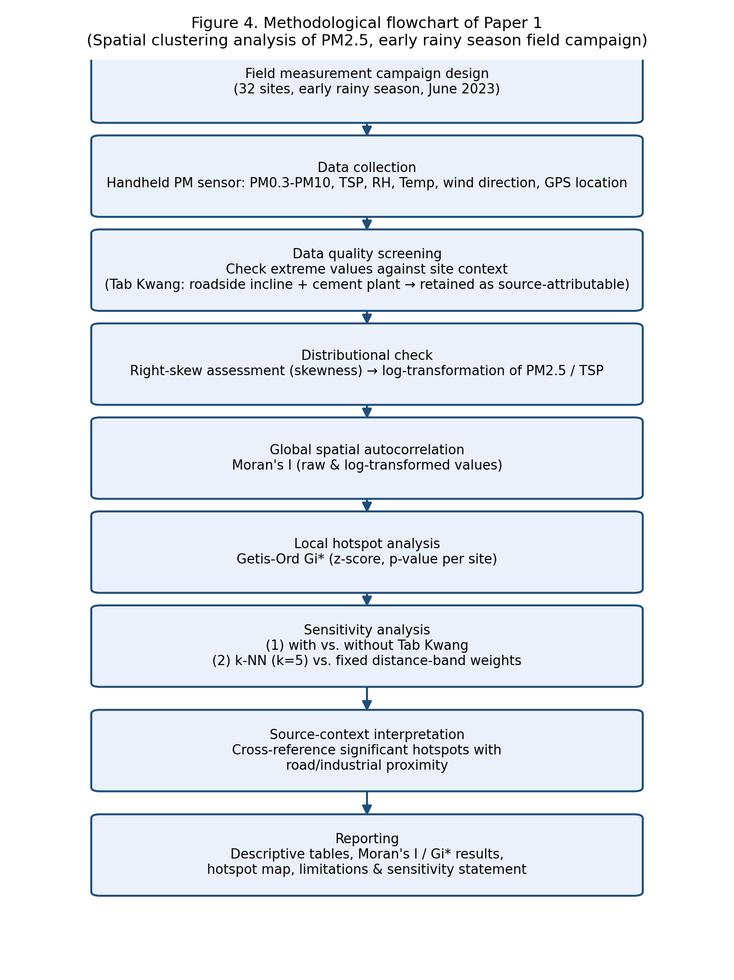
Figure 4. Methodological flowchart summarizing the field campaign, data screening, spatial statistical analysis, and sensitivity-testing workflow.
Supplementary Figures
The following figures provide additional visual context for the spatial covariates (Section 3.6), meteorological summary (Section 3.5), and sensitivity analysis (Section 3.4) discussed above.
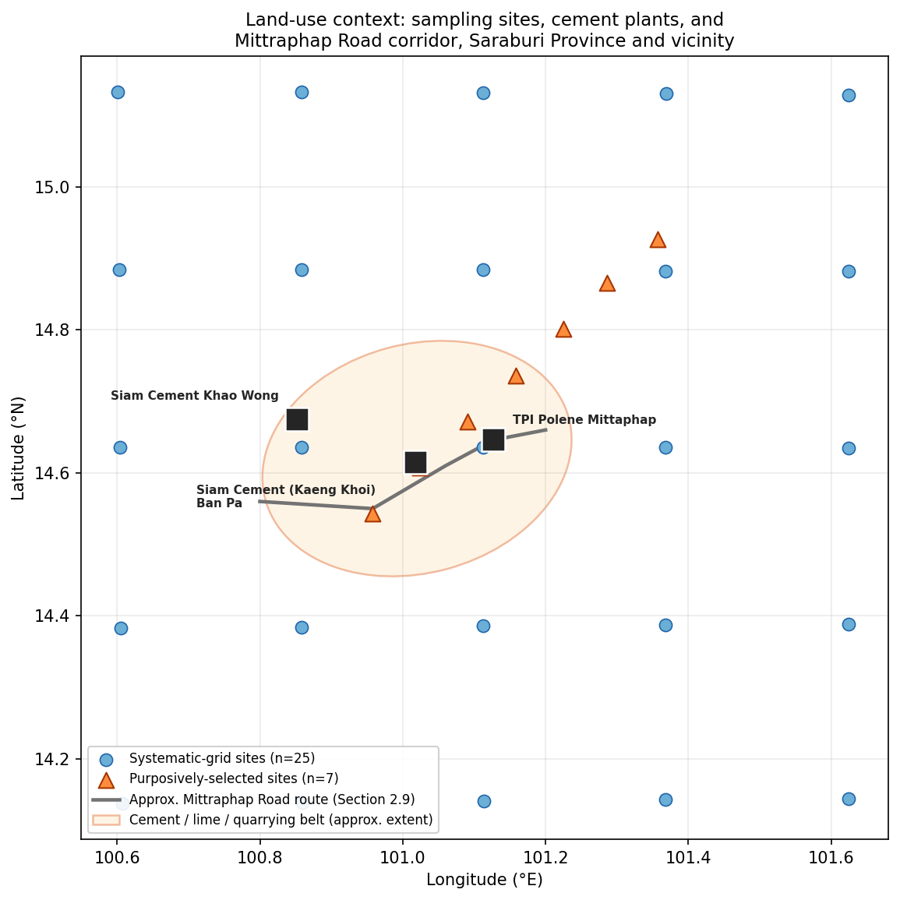
Figure 5. Land-use context: distribution of the 32 sampling sites relative to the three named, coordinate-verified cement plants and the approximated Mittraphap Road route through the Kaeng Khoi-Mueang Saraburi industrial corridor (see Section 2.9).
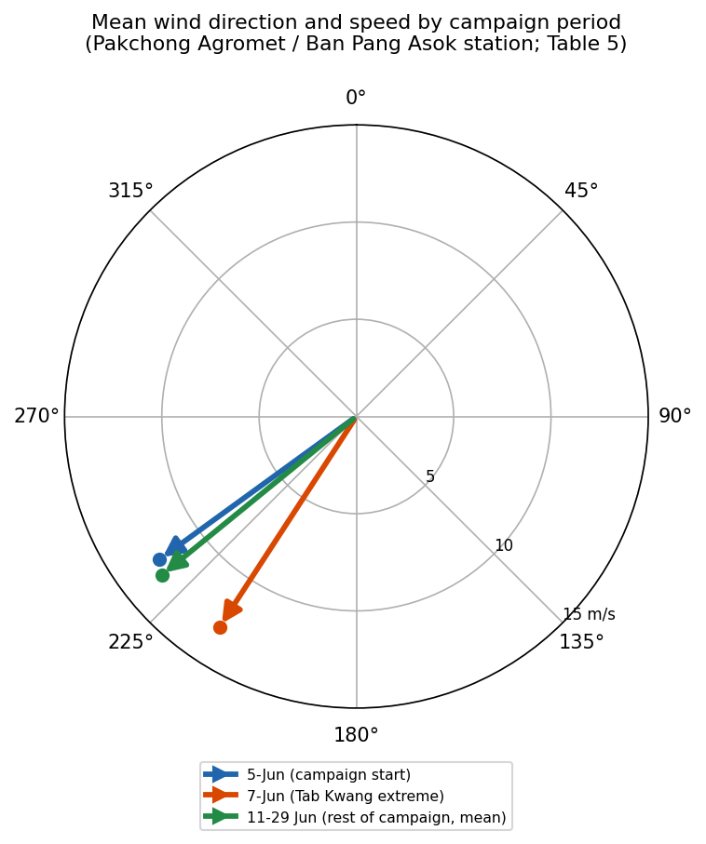
Figure 6. Mean wind direction and speed for the three campaign periods reported in Table 5 (Pakchong Agromet / Ban Pang Asok station). Arrow direction indicates the direction wind was blowing from; arrow length indicates mean speed.
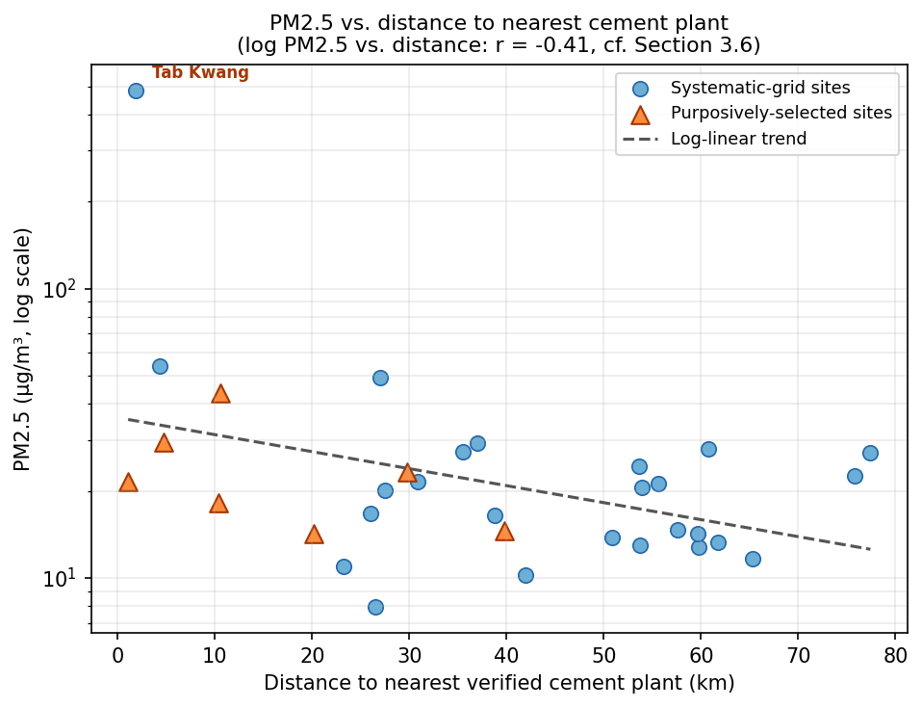
Figure 7. PM2.5 concentration as a function of distance to the nearest of the three named, coordinate-verified cement plants, illustrating the negative correlation reported in Section 3.6 (log PM2.5 vs. distance: r = -0.41).

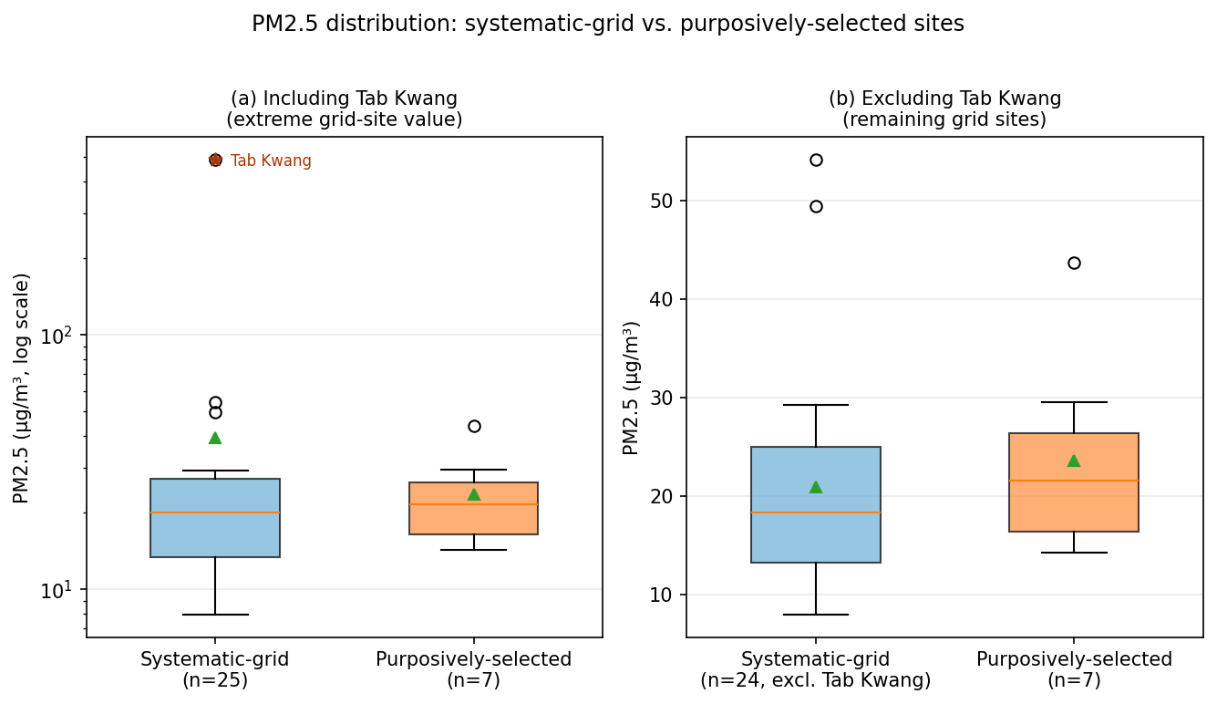
Figure 8. Distribution of PM2.5 concentrations for systematic-grid sites versus purposively-selected sites, shown (a) including and (b) excluding the Tab Kwang extreme value. Median concentrations are similar between groups, underscoring that the purposive sites' significance in Section 3.3 reflects spatial clustering rather than a simple group-level difference in magnitude.
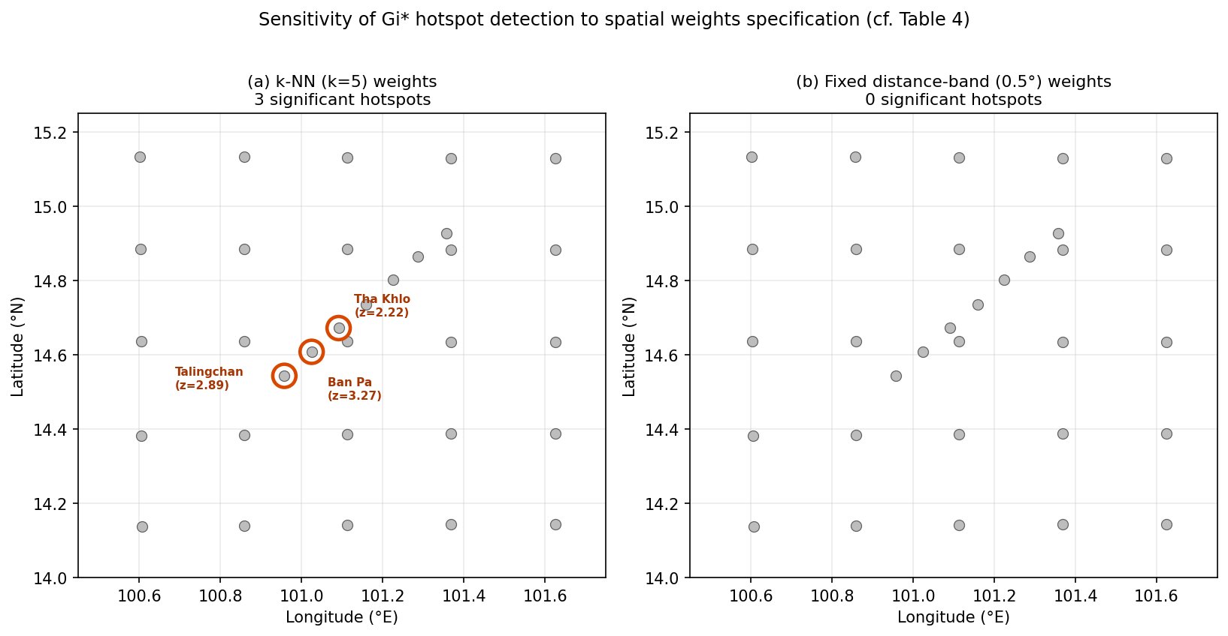
Figure 9. Sensitivity of Getis-Ord Gi* hotspot detection to the choice of spatial weights specification: (a) k-nearest-neighbor (k=5) weights identify three significant hotspots (Table 3); (b) fixed distance-band (0.5°) weights identify none (Table 4).

5. Limitations
Sample size and spatial coverage. Thirty-two measurement points were distributed across seven provinces, with a denser concentration of points (n=14) within Saraburi Province. This sample size is modest for spatial autocorrelation statistics, which generally benefit from a larger n to achieve stable inference and adequate statistical power; results should be interpreted as an exploratory spatial screening rather than a definitive characterization of clustering structure.
Single-timepoint design. Measurements were collected during a single campaign (5-29 June 2023) rather than through repeated visits. The reported spatial pattern reflects conditions specific to that measurement window and cannot be assumed to represent a stable or recurring spatial structure. Repeated seasonal campaigns are required to establish the temporal stability of the identified Kaeng Khoi-Mueang Saraburi cluster, and we identify this as the priority for follow-up work.
Instrument characteristics. Measurements were obtained using a Particles Plus® 8000 Series handheld optical particle counter, compliant with ISO 21501-4 and JIS B9921 for light-scattering particle counters (Section 2.2). The six-channel configuration recorded in this campaign (0.3, 0.5, 1.0, 2.5, 5.0, 10.0 μm) matches the manufacturer's factory-calibrated channel set for Model 8306, which the manufacturer specifies with a counting efficiency of 50% at 0.3 μm and 100% for particles >0.45 μm (per JIS), a zero count of <1 count per 5 minutes (per ISO 21501-4 & JIS), a sample flow rate of 0.1 CFM (2.83 LPM), and NIST-traceable calibration recommended at a minimum of once per year. This is a materially stronger instrumentation basis than a generic consumer-grade low-cost sensor, but ISO 21501-4/JIS B9921 compliance certifies particle-counting performance under standardized laboratory conditions and is not equivalent to field co-location calibration against a reference-grade PCD station, which was not performed prior to this campaign. Per-site sampling duration was fixed at 1 minute (device sample-timer setting), with a single reading recorded per site rather than repeated measurements; consequently, the field campaign captures a one-time snapshot at each location rather than a within-site estimate of short-term variability, and any single-minute reading could in principle be influenced by a transient event (e.g., a passing vehicle) rather than representing sustained ambient conditions at that site. The instrument was borrowed for this campaign from its owner, who verbally confirmed that the unit had been purchased new less than one year before the field measurements; no purchase invoice or factory calibration certificate could be obtained to independently verify this. On this basis, the unit would have remained within the manufacturer's recommended annual NIST-traceable calibration interval at the time of sampling, but because the instrument was returned to its owner after the campaign and no documentary evidence of the purchase or calibration date is available, this timeline could not be independently confirmed and is reported here as a limitation rather than a verified fact. RH and temperature screening (Section 2.4) found no statistically significant association with measured PM2.5 in this dataset (RH: r=0.08-0.12, p>0.5; temperature: r=-0.08, p=0.66), so no RH correction was applied — a decision now confirmed to be consistent with the instrument's design (see Section 2.4) rather than a discretionary analytical choice; we recommend, where feasible, a same-day comparison against the two PCD reference stations (24T, 25T) for any field points measured in their vicinity, following established statistical field-calibration approaches used elsewhere for low-cost optical sensors (Cavaliere et al., 2018; Jiang et al., 2021; Datta et al., 2020; Njeru et al., 2024; Nobell et al., 2023), since the instrument itself provides no built-in RH compensation to rely on.
Temporal confounding across sites. Because sites were sampled on different dates across the 5-29 June window and each site received a single one-minute reading rather than a controlled, synchronized measurement time, the observed between-site variation could in principle reflect short-term temporal variability (e.g., time of day, or day-to-day differences in traffic or weather) rather than purely spatial heterogeneity. To check this, site-level timestamps from the field log were compared against measured PM2.5. No association was found between hour-of-day and PM2.5 (Pearson r=-0.10, p=0.575; Spearman r=0.05, p=0.771, robust to the single high-concentration outlier at the roadside site), nor between the date within the three-week sampling window and PM2.5 (r=-0.23, p=0.209). Sites with the highest measured concentrations, including the roadside hotspot, were sampled across both morning and afternoon hours rather than clustering at a particular time of day (mean PM2.5 morning vs. afternoon: p=0.321). This check does not rule out all forms of temporal variability, but it indicates the spatial pattern is not an artifact of a systematic time-of-day or day-of-campaign sampling order.
Geolocation precision. All 32 sites now use exact, resolved GPS coordinates (Section 2.3); the regular spacing among the 25 systematic-grid sites reflects the intended sampling design (confirmed with the field team) rather than a data error. The geolocation caveat noted in the previous revision has now been resolved: the road-route covariate in Section 3.6 has been recomputed from the actual OpenStreetMap centerline geometry for Mittraphap Road (Highway 2), replacing the earlier interpolated waypoint approximation, while the facility-distance covariate continues to use named, coordinate-verified cement plants (see the Spatial covariates item below).
Meteorological data access. The Ogimet archive's terms of service disallow automated retrieval; Meteostat provides an equivalent, non-robots-blocked bulk endpoint for station data (Section 2.8). Retrieval identified Pakchong Agromet / Ban Pang Asok, rather than the originally-considered Don Mueang station, as the nearest available station to the Kaeng Khoi-Mueang Saraburi corridor; the resulting 5-29 June 2023 record is reported in Table 5 and discussed in Section 4.
Spatial covariates. The facility-distance covariate in Section 3.6 and Table 6 is now anchored to three named cement plants with verified coordinates (Global Energy Monitor's Global Cement and Concrete Tracker), a substantial improvement over the previously approximated cluster locations; a fuller registry (all cement, lime, and quarry operators in the corridor, not only the three largest) has now been compiled from the Department of Industrial Works (DIW) public factory-location dataset: 105 permitted cement, lime, and stone-crushing/quarrying facilities were identified across Saraburi and Lopburi provinces and used in a robustness check reported in Section 3.6. The road-distance covariate has been upgraded from an interpolated waypoint route through named towns to an actual road-centerline GIS layer: Mittraphap Road's (Highway 2) real geometry was retrieved from OpenStreetMap using the osmnx Python library, and per-site distances were recomputed against this verified centerline, superseding the earlier approximation (see the updated Section 3.6 and Table 6).
Non-systematic spatial sampling design. Sites were not distributed on a regular grid, and inter-site distances varied substantially both within and between provinces. This irregularity is the direct cause of the weights-matrix sensitivity documented in Section 3.4 and should be discussed transparently rather than resolved by selecting whichever specification yields more hotspots.

Sensitivity Analysis Summary
Two sensitivity checks were embedded directly in the analysis (Section 3.4, Table 4): (1) log-transformation was applied throughout given the strong right-skew of the raw data (skewness = 5.24 for PM2.5), and both raw and log-transformed results are reported for transparency; (2) results were compared with and without the Tab Kwang extreme value and under two alternative spatial weights specifications. Both checks are reported in full in Table 2 and Table 4 rather than only the specification most favorable to a clustering narrative. A source-proximity covariate (distance to nearest major road and to the nearest cement/lime facility) was subsequently added for every site (Section 3.6, Table 6), extending the physically grounded explanation offered for Tab Kwang in Section 4 systematically to the three significant hotspot sites as well.

6. Conclusion
A single early-rainy-season field campaign of 32 PM2.5 measurements, combining a systematic geographic grid with a small set of purposively-selected risk sites across seven provinces of central Thailand, found no significant province-wide spatial autocorrelation but identified evidence of a local cluster of elevated PM2.5 under the primary k-nearest-neighbor specification, in the Kaeng Khoi-Mueang Saraburi corridor of Saraburi Province, although its statistical detection was sensitive to the spatial weights matrix (Section 3.4) and the corridor coincides with the province's documented cement, lime, and quarrying belt. Critically, all three significant hotspots were detected only among the purposively-selected sites; the coarser systematic grid alone did not resolve this cluster. The purposive supplementary sampling improved the ability of this campaign to screen suspected local-scale heterogeneity, although the targeted design does not provide an unbiased estimate of hotspot prevalence across the broader region, since these sites were selected precisely because they were suspected in advance to be at elevated risk. An extreme single-site reading at Tab Kwang, adjacent to a cement facility on an uphill highway segment, is physically plausible as a genuine point-source signal but is statistically distinct from the broader cluster. The sensitivity of hotspot detection to the choice of spatial weights matrix (3 vs. 0 hotspots) demonstrates the importance of explicit sensitivity reporting in field-campaign-based spatial screening studies of this size and design. We recommend that future work in this corridor prioritize an authoritative road/facility GIS layer, adding source-proximity covariates at higher precision, and conducting repeated seasonal campaigns to test whether the identified cluster is a stable feature of the region's air quality or specific to the early-rainy-season conditions sampled here. We present this study on its own terms as a regional case study and methodological note on hybrid grid-plus-purposive sampling for PM2.5 hotspot screening — a design question relevant to any resource-constrained monitoring program in a heterogeneous mixed-industrial setting — rather than as a claim of quantitative source apportionment. A natural next step for this corridor would be to pair the hotspot screening approach demonstrated here with quantitative source-apportionment modeling (e.g., conditional probability function and back-trajectory analysis such as HYSPLIT, combined with machine-learning approaches such as random forest) to formally attribute the identified cluster to specific emission sources; we recommend this as a priority direction for future research in the Kaeng Khoi-Mueang Saraburi corridor.

References
References are listed alphabetically. Bibliographic details (especially individual author names) should be verified against the original publication before submission, as several entries were compiled from search-result snippets that did not display a complete author byline.
Abbasi, M. T., Alesheikh, A. A., Jafari, A., & Lotfata, A. (2024). Spatial and temporal patterns of urban air pollution in Tehran with a focus on PM2.5 and associated pollutants. Scientific Reports, 14, Article 25150.
Ahmad, M., Panyametheekul, S., Thaveevong, P., Ngamsritrakul, T., Tassaneetrithep, B., Supasri, T., & Bennett, C. (2025). Long-term monitoring of PM2.5 and PM10: Implications for air quality and public health in urban Bangkok, Thailand. Case Studies in Chemical and Environmental Engineering (ScienceDirect S2667010025002318).
Amnuaylojaroen, T., & Parasin, N. (2023). Perspective on Particulate Matter: From Biomass Burning to the Health Crisis in Mainland Southeast Asia. Toxics, 11(7), Article 553.
Bangkok Post. PCD intensifies industrial pollution, PM2.5 curbs. Bangkok Post (news article).
Cavaliere, A., Carotenuto, F., Di Gennaro, F., Gioli, B., Gualtieri, G., Martelli, F., Matese, A., Toscano, P., Vagnoli, C., & Zaldei, A. (2018). Development of Low-Cost Air Quality Stations for Next Generation Monitoring Networks: Calibration and Validation of PM2.5 and PM10 Sensors. Sensors, 18(9), Article 2843.
CCAC Coalition. Simultaneously Achieving Climate Change and Air Quality Goals in Thailand. Thailand Integrated Air Pollution and Climate Change Mitigation Assessment (policy report).
Datta, A., Saha, A., Zamora, M. L., Buehler, C., Hao, L., Xiong, F., Gentner, D. R., & Koehler, K. (2020). Statistical field calibration of a low-cost PM2.5 monitoring network in Baltimore. Atmospheric Environment, 242, Article 117761.
Duque, J. C., Laniado, H., & Polo, A. (2018). S-maup: Statistical test to measure the sensitivity to the modifiable areal unit problem. PLOS ONE, 13(11), Article e0207377.
Getis, A., & Ord, J. K. (1992). The analysis of spatial association by use of distance statistics. Geographical Analysis, 24(3), 189-206.
Gianquintieri, L., Mahakalkar, A. U., & Caiani, E. G. (2024). Exploring Spatial-Temporal Patterns of Air Pollution Concentration and Their Relationship with Land Use. Atmosphere, 15(6), Article 699.
Ginzburg, H., Liu, X., Baker, M., Shreeve, R., Jayanty, R., Campbell, D., & Zielinska, B. (2015). Monitoring study of the near-road PM2.5 concentrations in Maryland. Journal of the Air & Waste Management Association, 65(9), 1062-1071.
Global Energy Monitor. Global Cement and Concrete Tracker: TPI Polene Mittaphap Cement Plant; Siam Cement (Kaeng Khoi) Ban Pa Cement Plant; Siam Cement Khao Wong Cement Plant. gem.wiki.
IQAir. Saraburi Air Quality Index (AQI) and Thailand Air Pollution. IQAir Thailand (web resource).
Jaganathan, S., Rajiva, A., Amini, H., de Bont, J., Dixit, S., Dutta, A., Kloog, I., Lane, K. J., Menon, J. S., Nori-Sarma, A., Prabhakaran, D., Schwartz, J., Sharma, P., Stafoggia, M., Walia, G. K., Wellenius, G. A., Prabhakaran, P., Ljungman, P., & Mandal, S. (2024). Nationwide analysis of air pollution hotspots across India: A spatiotemporal PM2.5 trend analysis (2008-2019). Environmental Research, 264, Article 120276.
Jiang, Y., Zhu, X., Chen, C., Ge, Y., Wang, W., Zhao, Z., Cai, J., & Kan, H. (2021). On-field test and data calibration of a low-cost sensor for fine particles exposure assessment. Ecotoxicology and Environmental Safety, 211, Article 111958.
Liu, C., Hu, Y., Chang, Y., Liu, M., Xiong, Z., Chen, T., & Li, C. (2022). Spatial patterns and influencing factors of intraurban particulate matter in the heating season based on taxi monitoring. Ecosystem Health and Sustainability, 8(1), Article 2130826.
Liu, H., Rodgers, M. O., & Guensler, R. (2019). The impact of road grade on vehicle accelerations behavior, PM2.5 emissions, and dispersion modeling. Transportation Research Part D: Transport and Environment, 75, 297–319.
Moran, P. A. P. (1950). Notes on continuous stochastic phenomena. Biometrika, 37(1/2), 17-23.
Mukherjee, A., McCarthy, M. C., Brown, S. G., Huang, S.-M., Landsberg, K., & Eisinger, D. S. (2020). Influence of roadway emissions on near-road PM2.5: Monitoring data analysis and implications. Transportation Research Part D: Transport and Environment, 86, Article 102442.
Nation Thailand / PCD (Surin Worakijthamrong). State tightens factory controls on PM2.5 to protect public health. Nation Thailand (news article).
Nation Thailand. High-emission cement industry to launch Saraburi Sandbox research pilot. Nation Thailand (news article).
Njeru, M. N., Mwangi, E., Gatari, M. J., Kaniu, M. I., Kanyeria, J., Raheja, G., & Westervelt, D. M. (2024). First Results From a Calibrated Network of Low-Cost PM2.5 Monitors in Mombasa, Kenya Show Exceedance of Healthy Guidelines. GeoHealth, 8(9), e2024GH001049.
Nobell, S., Majumdar, A., Mukherjee, S., Chakraborty, S., Chatterjee, S., Bose, S., Dutta, A., Sethuraman, S., Westervelt, D. M., Sengupta, S., Basu, R., & McNeill, V. F. (2023). Validation of In-field Calibration for Low-Cost Sensors Measuring Ambient Particulate Matter in Kolkata, India. Aerosol and Air Quality Research, 23(11), Article 230010.
Ogimet. Ogimet Weather Information Service — getsynop CGI documentation. https://ogimet.com/getsynop_help.html.en
Openshaw, S. (1984). The Modifiable Areal Unit Problem. CATMOG 38. Norwich: GeoBooks.
Othman, M., Latif, M. T., Abd Hamid, H. H., Uning, R., Khumsaeng, T., Phairuang, W., Daud, Z., Idris, J., Md Sofwan, N., & Lung, S. C. C. (2022). Spatial-temporal variability and health impact of particulate matter during a 2019-2020 biomass burning event in Southeast Asia. Scientific Reports, 12, Article 7630.
Thongsame, W., Henze, D. K., Barth, M., Pfister, G., Kumar, R., Macatangay, R., & Hassan Bran, S. (2025). Source Attribution and Health Burden of PM2.5 in Mainland Thailand. GeoHealth, 9(9), e2024GH001315.
Tuson, M., Yap, M., Kok, M. R., Murray, K., Turlach, B., & Whyatt, D. (2019). Incorporating geography into a new generalized theoretical and statistical framework addressing the modifiable areal unit problem. International Journal of Health Geographics, 18, Article 6.
Zhou, L., Hallquist, Å. M., Hallquist, M., Salvador, C. M., Gaita, S. M., Sjödin, Å., Jerksjö, M., Salberg, H., Wängberg, I., Mellqvist, J., Liu, Q., Lee, B. P., & Chan, C. K. (2020). A transition of atmospheric emissions of particles and gases from on-road heavy-duty trucks. Atmospheric Chemistry and Physics, 20(3), 1701–1722.
Zhu, M., Guo, J., Zhou, Y., & Cheng, X. (2022). Exploring the Spatiotemporal Evolution and Socioeconomic Determinants of PM2.5 Distribution and Its Hierarchical Management Policies in 366 Chinese Cities. Frontiers in Public Health, 10, Article 843862.

