A Group Consensus Method for Interval-Valued Fuzzy Preferences
Based on Context Encoding and Social Attention
Yang Song², Mingshuo Cao¹, Jian Wu¹, Francisco Chiclana³
(1. School of Economics and Management, Shanghai Maritime University, Shanghai 201306, China; 2. School of Information Engineering, Shanghai Maritime University, Shanghai 201306, China; 3. Institute of Artificial Intelligence, Faculty of Computing, Engineering and Media, De Montfort University, Leicester, UK)
Abstract: Interval-valued preferences retain acceptable ranges but make consensus control sensitive to endpoint dispersion, hidden response differences, and variable group size. This study extends continuous-control Meta-GDM with interval translation, a Transformer context encoder, a variational response code, and permutation-invariant social attention. Consensus and boundary risk are computed from both endpoints; the reward combines consensus gain, nonlinear adjustment cost, cost fairness, outlier distance, and violations. The model is trained for 5,000 episodes only at N=10 and then frozen for 50-scenario tests at N=10, 40, and 100. In static settings, deterministic rules and the proposed model all reach a 1.00 success rate, so no general rule advantage is claimed. Under hidden response heterogeneity, the model reaches 0.98, 1.00, and 1.00 success, versus 0.80, 0.64, and 0.36 for the strongest rule, while reducing termination time by 21.92, 45.28, and 72.84 rounds. At N=40, PPO, DDPG, and conventional SAC fail within 120 rounds, whereas the proposed model reaches 1.00 success in 16.72 rounds. Masking the ten-round history lowers success by 14, 22, and 44 percentage points. Interval translation leaves the mean half-width change at zero and limits the Hausdorff-center discrepancy to 1.11e-16. The evidence supports history-conditioned adaptation, cross-scale reuse, and preservation of interval uncertainty, while higher adjustment cost under heterogeneity and single-seed training remain limitations.
Keywords: interval-valued fuzzy preference; group consensus; context encoder; social attention; meta-reinforcement learning; adjustment cost

1 Introduction
Group consensus models must reconcile heterogeneous opinions without treating uncertainty as noise. Fuzzy preferences and soft-consensus methods provide the basic representation and feedback mechanisms ^{[1,3,6]}, while interval-valued formulations retain both an opinion center and an admissible range ^{[7,8]}. Opinion-dynamics and personalized-feedback models explain convergence ^{[9,10]} and negotiated adjustment ^{[12,13]}, but a point-valued state can conceal endpoint violations or create apparent consensus by suppressing uncertainty. ^{[2,4,5]}
Consensus quality also depends on adjustment cost and burden allocation. Minimum-cost and fairness-aware models show that identical terminal consensus may arise from very different negotiation paths ^{[14,15,16]}. Variable costs, trust constraints, and behavioral preferences further imply that members need not realize the same fraction of a recommendation ^{[18,20,21]}. Hidden acceptance tendencies and inertia are therefore identifiable only through repeated suggestions and realized movements. ^{[11,17,19]}
Reinforcement learning can optimize continuous coordination paths ^{[22,23,29]}, but flattened group states bind the policy to a fixed group size. The proposed model combines temporal attention ^{[24,28]}, permutation-invariant set aggregation ^{[26,27]}, and soft actor-critic optimization ^{[30,33]}. Its context-conditioned latent code follows the meta-reinforcement-learning principle of inferring task-relevant behavior from interaction history ^{[34,35,37]}, although the present implementation does not use a separate MAML outer loop. ^{[25,36,38]}
This study makes three contributions. First, interval centers, half-widths, endpoints, boundaries, and costs are defined consistently, and actions translate rather than shrink intervals. Second, a ten-round context encoder infers response tendencies from suggestions, realized movements, and rewards; social attention then produces member-specific actions with shared parameters. Third, frozen-policy experiments compare static rules, PPO, DDPG, SAC, interval widths, unseen group sizes, hidden heterogeneity, and history masking. This sequence separates basic solvability from the conditions under which context and set structure create an advantage.
2 Problem Formulation
2.1 Interval preference and consensus
For N members, member i reports interval Ii,t at round t. Equations (1)-(2) define its center ci,t, half-width hi,t, and group means. Initial centers are sampled so that every interval lies inside the safe domain; hi,t=0 recovers the point-valued case.
$$I_{i,t}=[l_{i,t},u_{i,t}]=[c_{i,t}-h_{i,t}, c_{i,t}+h_{i,t}]，0≤l_{i,t}≤u_{i,t}≤1。 (1)$$
$${l̄}_{t}=N^{-1}Σ_{i} l_{i,t}，ū_{t}=N^{-1}Σ_{i} u_{i,t}；{c̄}_{t}=N^{-1}Σ_{i} c_{i,t}，{h̄}_{t}=N^{-1}Σ_{i} h_{i,t}。 (2)$$
Endpoint dispersion Dt, safety score St, and consensus Ct are given by Eqs. (3)-(5). The cutoff delta=0.01 prevents numerical decay once dispersion is negligible, kappa controls consensus decay, and C*=0.90 is the termination threshold. Member-level endpoint distance di,t and boundary violation vi,t are defined in Eq. (6).
$$D_{t}=\{½[N^{-1}Σ_{i}(l_{i,t}-{l̄}_{t})^{2}+N^{-1}Σ_{i}(u_{i,t}-ū_{t})^{2}{]\}}^{1/2}。 (3)$$
$$p_{t}^{-}=max\{0,(s_{L}-\min_{i} l_{i,t})/s_{L}\}，p_{t}^{+}=max\{0,(\max_{i} u_{i,t}-s_{U})/(1-s_{U})\}；S_{t}=clip[1-max(p_{t}^{-},p_{t}^{+}),0,1]。 (4)$$
$$F(D_{t})=\{1, D_{t}<δ； exp(-κD_{t}), D_{t}≥δ\}；C_{t}=F(D_{t})S_{t}。 (5)$$
$$d_{i,t}=\{[(l_{i,t}-{l̄}_{t})^{2}+(u_{i,t}-ū_{t})^{2}{]/2\}}^{1/2}，v_{i,t}=max(s_{L}-l_{i,t},0)+max(u_{i,t}-s_{U},0)。 (6)$$
2.2 Response, interval update, and cost
The policy proposes ai,t in [-1,1], but the environment realizes movement mi,t according to stubbornness omega_i and response type fi. Equation (8) covers linear, threshold, smooth-threshold, and inertial responses; zeta=10, lambda=0.35, and Delta=0.1 in the reported experiments. Hidden response parameters affect execution but are not exposed to the policy.
$$m_{i,t}=clip[(1-ω_{i})Δ f_{i}(a_{i,t},a_{i,t-1};θ_{i}),-Δ,Δ]。 (7)$$
$$f_{0}=a_{i,t}； f_{1}=a_{i,t}·1(|a_{i,t}|≥θ_{i})； f_{2}=a_{i,t}σ[ζ(|a_{i,t}|-θ_{i})]；f_{3}=λa_{i,t}+(1-λ)a_{i,t-1}。 (8)$$
$$c_{i,t+1}=clip[c_{i,t}+m_{i,t},h_{i,t},1-h_{i,t}]，h_{i,t+1}=h_{i,t}。 (9)$$
Equation (9) translates the center and holds the half-width fixed, so both endpoints move equally and remain within [0,1]. Adjustment cost is nonlinear with eta=75 and p=2. Equation (11) computes a shifted cost Gini; lower values indicate a more even burden.
$$J_{i,t}=q_{i}ηΔ(|m_{i,t}{|/Δ)}^{p}，p>1。 (10)$$
$${J̃}_{i,t}=J_{i,t}-\min_{j} J_{j,t}；g_{t}=\{0, Σ_{i} {J̃}_{i,t}=0；2Σ_{i} i·{J̃}_{(i),t}/[NΣ_{i} {J̃}_{i,t}]-(N+1)/N, otherwise\}。 (11)$$
3 Interval Meta-GDM
3.1 Architecture and context encoding
The closed loop alternates policy suggestions, hidden member responses, interval updates, and reward feedback. Training uses a replay buffer and twin SAC critics; testing freezes every parameter. Figure 1 separates the interaction loop from the off-policy update loop.

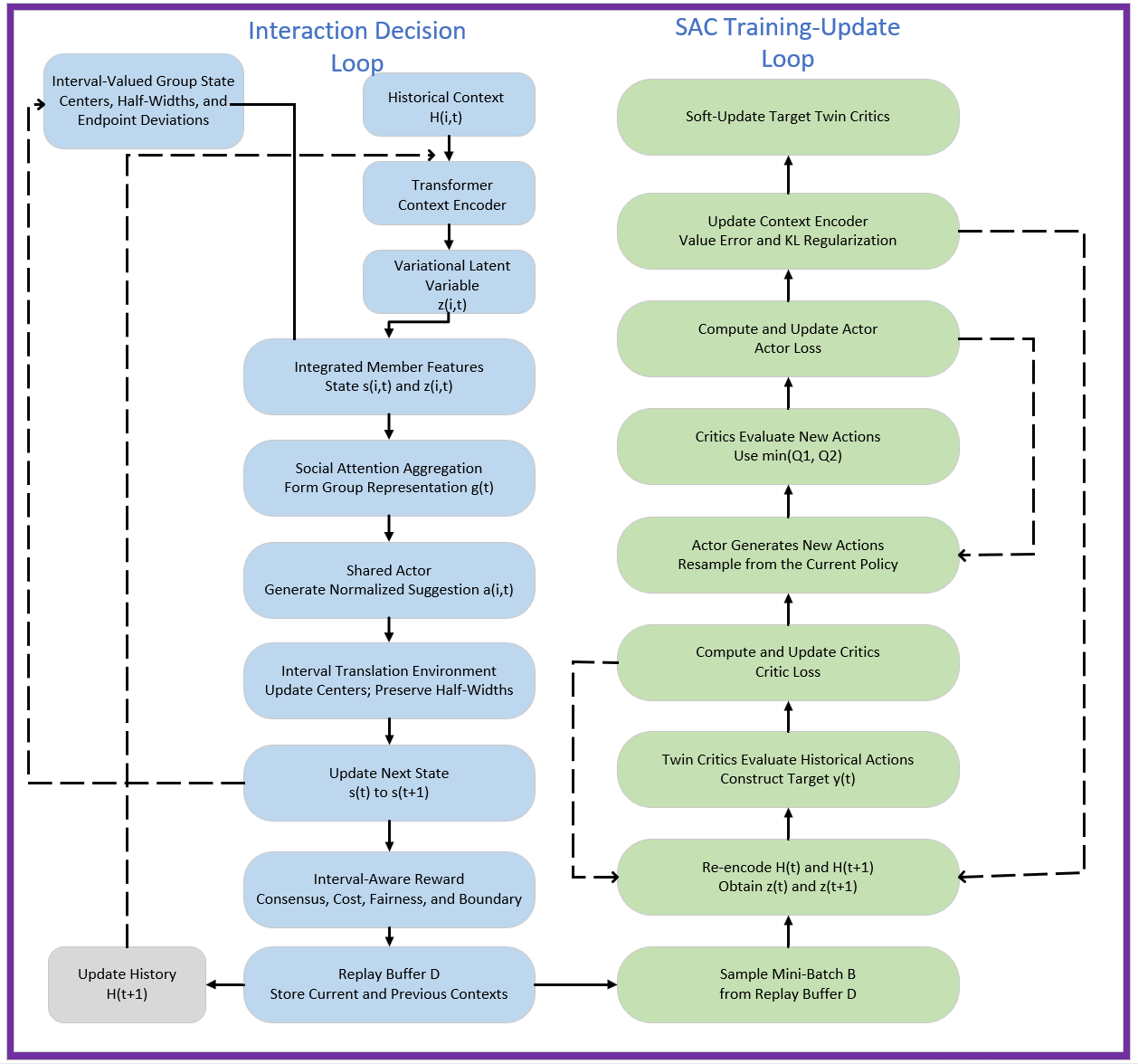
Fig. 1 Interaction and SAC Update Loops of Interval Meta-GDM

Each member state contains the center, half-width, their deviations from group means, and the remaining-horizon ratio (12). The latest L=10 tuples of proposed action, realized movement, and normalized local reward form the history (13). A Transformer parameterizes the Gaussian response code (14), and the reparameterization and KL term are defined in (15). At test time the latent mean is used, making inference deterministic.
$$s_{i,t}=[c_{i,t},h_{i,t},c_{i,t}-{c̄}_{t},h_{i,t}-{h̄}_{t},(H-t)/H]∈R^{5}。 (12)$$
$$x_{i,t}=[a_{i,t},m_{i,t},r_{i,t}/ν]，H_{i,t}=(x_{i,t-L},…,x_{i,t-1})∈R^{L×3}。 (13)$$
$$q_{φ}(z_{i,t}|H_{i,t})=N(μ_{φ}(H_{i,t}),diag[σ_{φ}^{2}(H_{i,t})])。 (14)$$
$$z_{i,t}=μ_{i,t}+σ_{i,t}⊙ε，ε∼N(0,I)；χ_{i,t}=½Σ_{k}(μ_{i,k}^{2}+σ_{i,k}^{2}-logσ_{i,k}^{2}-1), at test time z_{i,t}=μ_{i,t}。 (15)$$
3.2 Social attention and shared policy
A shared feature layer maps each state-code pair to ui,t. Four-head attention compares each member with the pooled group representation; Eqs. (16)-(18) are invariant to member order and accept any N. The shared Actor generates one squashed Gaussian action per member, with the corrected log density in (20). Twin Critics receive the member representations, group context, and joint action.
$$u_{i,t}=ReLU(W_{x}[s_{i,t};z_{i,t}]+b_{x})，ū_{t}=N^{-1}Σ_{i} u_{i,t}。 (16)$$
$$q_{h,t}=W_{q,h}ū_{t}+b_{q,h}，k_{i,h,t}=W_{k,h}u_{i,t}，v_{i,h,t}=W_{v,h}u_{i,t}；α_{i,h,t}={softmax}_{i}[q_{h,t}^{T}k_{i,h,t}/√d_{h}]。 (17)$$
$$o_{t}=W_{o}·LN({Concat}_{h}[Σ_{i}α_{i,h,t}v_{i,h,t}+ū_{t}])。 (18)$$
$$({μ̂}_{i,t},log{σ̂}_{i,t})=f_{θ}(s_{i,t},z_{i,t},o_{t})，ξ_{i,t}={μ̂}_{i,t}+{σ̂}_{i,t}ε_{i}，a_{i,t}=tanh(ξ_{i,t})。 (19)$$
$$logπ_{θ}(a_{i,t}|s_{i,t},z_{i,t},o_{t})=logN(ξ_{i,t};{μ̂}_{i,t},{σ̂}_{i,t}^{2})-log(1-a_{i,t}^{2}+ε_{0})。 (20)$$
3.3 Reward and optimization
The local reward (21) combines consensus gain, the terminal bonus, cost fairness, time, endpoint distance, boundary violations, and individual cost. The reported weights are wC=50, b=10, wF=1, tau=0.1, wD=2, and wB=20; clipping to [-20,20] limits outliers. The replay transition stores both current and next histories (22).
$$r_{i,t}=clip[w_{C}(C_{t+1}-C_{t})+b·1(C_{t+1}≥C^{*})-w_{F}g_{t}-τ-w_{D}d_{i,t}-w_{B}v_{i,t}-J_{i,t},-R,R]。 (21)$$
$${r̄}_{t}=N^{-1}Σ_{i} r_{i,t}，(s_{t},H_{t},a_{t},{r̄}_{t},s_{t+1},H_{t+1},d_{t})→D。 (22)$$
Equations (23)-(27) give the SAC target, twin-Critic loss, Actor loss, context-encoder objective, and soft target update. Training uses gamma=0.95, alpha=0.1, tauq=0.01, beta_z=0.05, and learning rate 3e-4. Each episode samples intervals and hidden responses, executes at most H=120 rounds, records transitions, and updates the encoder, Actor, and Critics from replay batches.
$$y_{t}={r̄}_{t}+γ(1-d_{t})\{\min_{j∈\{1,2\}} {Q̄}_{j}(s_{t+1},z',a')-αlogπ_{θ}(a'|s_{t+1},z')\}。 (23)$$
$$L_{Q}=E_{B}[Σ_{j=1}^{2}(Q_{j}(s_{t},z_{t},a_{t})-y_{t})^{2}]。 (24)$$
$$L_{π}=E_{B}[αlogπ_{θ}(a_{t}|s_{t},z_{t})-\min_{j∈\{1,2\}} Q_{j}(s_{t},z_{t},a_{t})]。 (25)$$
$$L_{z}=L_{Q}+β_{z}·N^{-1}Σ_{i} KL[q_{φ}(z_{i,t}|H_{i,t})||N(0,I)]。 (26)$$
$${ψ̄}_{j}←(1-τ_{q}){ψ̄}_{j}+τ_{q}ψ_{j}，j∈\{1,2\}。 (27)$$
3.4 Training behavior
Figure 2 reports the audited 5,000-episode history. Reward and terminal consensus improve after early exploration and stabilize despite curriculum changes. Actor loss becomes negative as high-value actions dominate the entropy term; it is not expected to decrease monotonically. Critic loss is initially large because targets change with the policy, then declines and fluctuates around a bounded level. Taken together, the curves show policy improvement rather than a divergent objective.

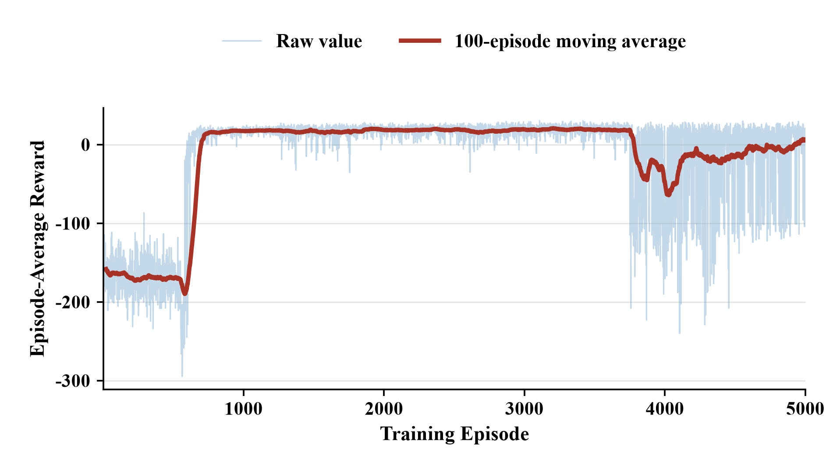  (a) | 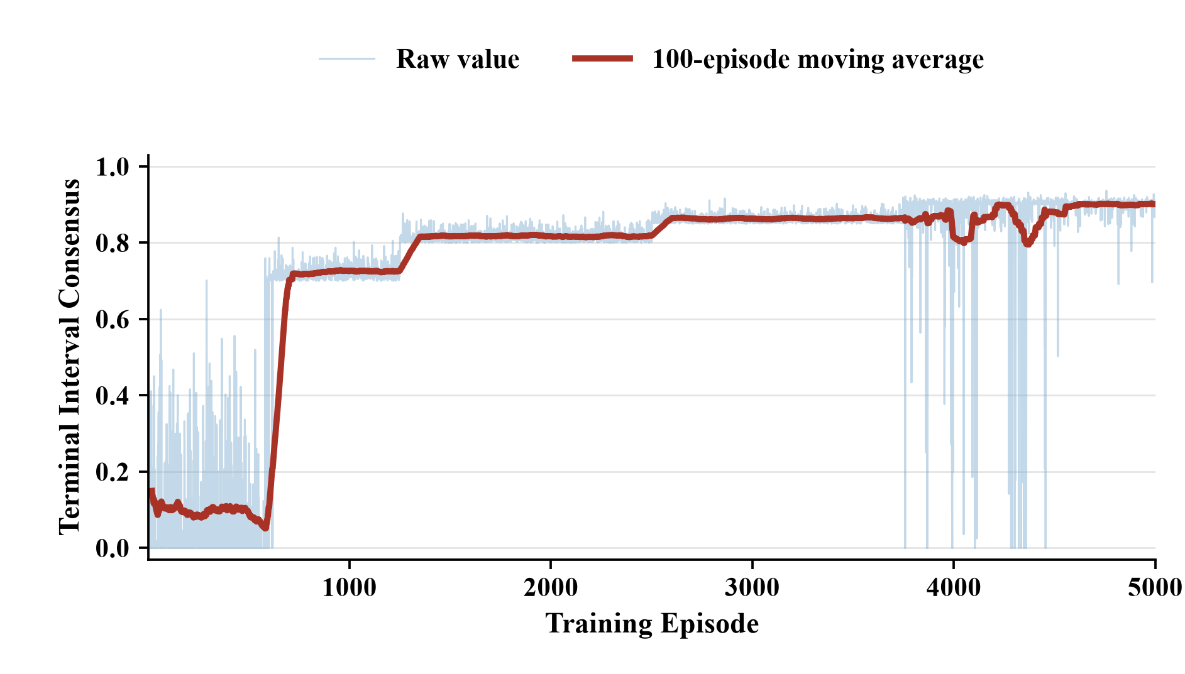  (b)
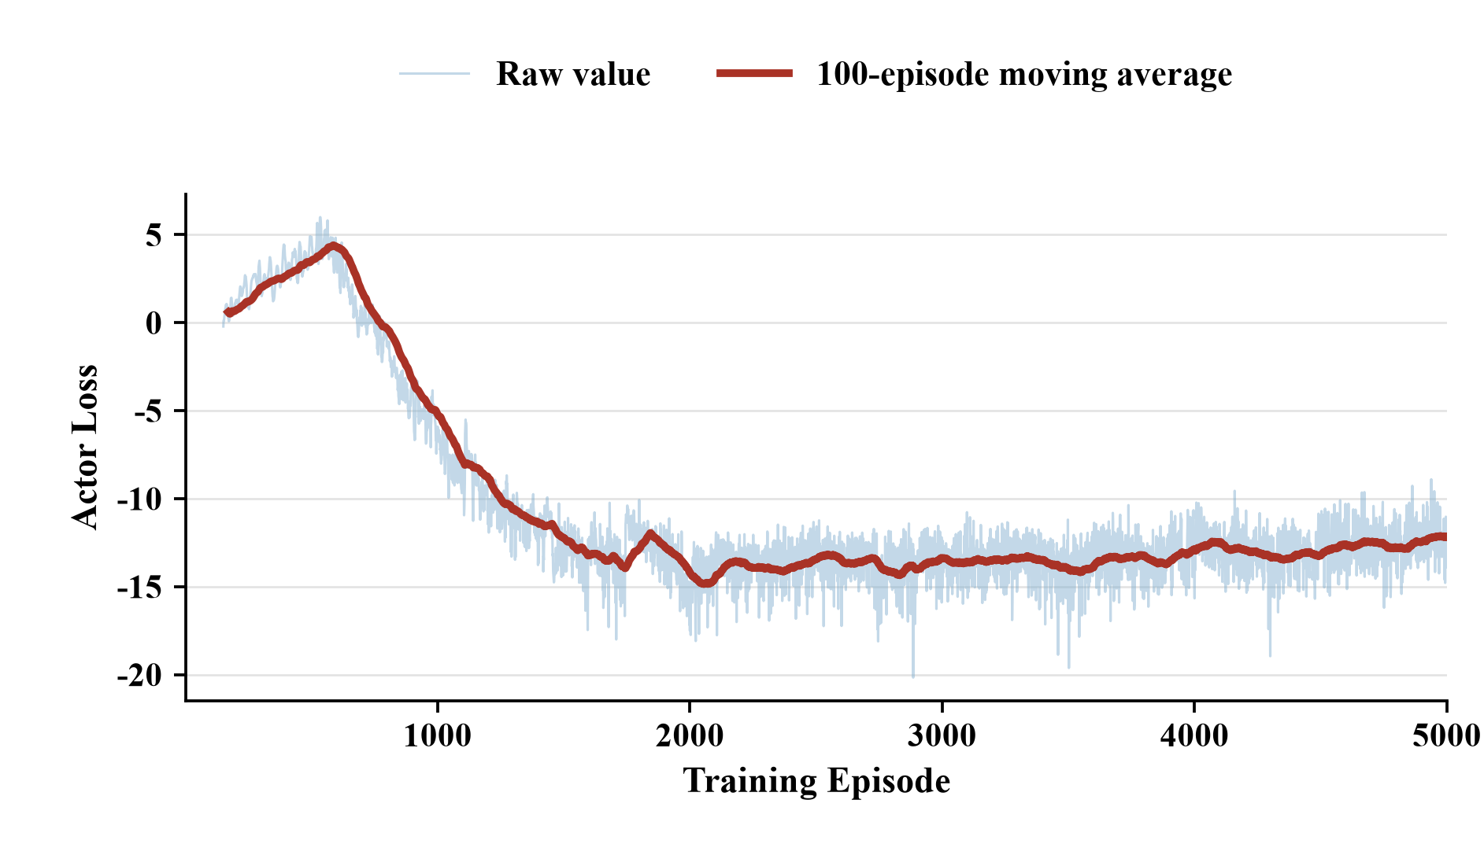  (c) | 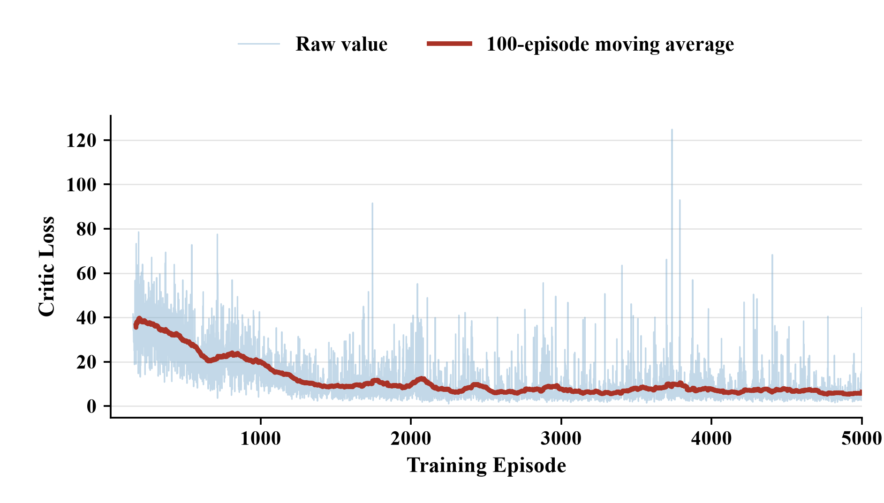  (d)
Fig. 2 Training Diagnostics: (a) Reward; (b) Terminal Consensus; (c) Actor Loss; (d) Critic Loss

4 Experiments
4.1 Protocol and metrics
The main model uses seed 20260507 and is trained only at N=10 for 5,000 episodes. Frozen evaluation uses 50 paired scenarios per cell at N=10, 40, and 100, with identical initial intervals and hidden parameters across methods. PPO, DDPG, and conventional SAC are trained separately for each tested N. No replay, backpropagation, or target update occurs during testing.

Table 1 Key Experimental and Training Settings
Module | Setting | Symbol | Value
Environment | Training/test scale | N | 10 / 10, 40, 100
Environment | Episodes/scenarios | - | 5,000 / 50 per cell
Environment | Horizon/threshold | H / C* | 120 / 0.90
Intervals | Half-width/cutoff | h / delta | [0.02,0.08] / 0.01
Context | Window/latent size | L / dz | 10 / 8
Network | Attention | dg / heads | 256 / 4
SAC | Learning rate/discount | lr / gamma | 3e-4 / 0.95
SAC | Soft update/entropy | tauq / alpha | 0.01 / 0.10
Cost | Scale/exponent | eta / p | 75 / 2

Equation (28) defines success rate, mean termination time, total cost, mean reward, and violations. Equation (29) combines success and time through success AUC and consensus-trajectory AUC. Paired differences and 95% bootstrap intervals use B=10,000 resamples (30) ^{[39,40]}. Cost is interpreted only alongside success because an inactive failed policy can appear inexpensive.
$$p_{s}=M^{-1}Σ_{e} 1_{e}；T̄=M^{-1}Σ_{e} T_{e}；J̄=M^{-1}Σ_{e}Σ_{t}Σ_{i}J_{i,e,t}；R̄=M^{-1}Σ_{e}Σ_{t}[N^{-1}Σ_{i}r_{i,e,t}]；V̄=M^{-1}Σ_{e}Σ_{t}Σ_{i}1(l_{i,e,t}<s_{L} or u_{i,e,t}>s_{U})。 (28)$$
$$A_{s,e}=1_{e}(H-T_{e}+1)/(H+1)；A_{c,e}=H^{-1}Σ_{t=1}^{H} {C̃}_{e,t}。 (29)$$
$$δ_{e}=m_{1,e}-m_{0,e}，δ̄=M^{-1}Σ_{e}δ_{e}；I_{1-ϑ}=[Q_{ϑ/2}(\{{δ̄}_{b}^{*}\}),Q_{1-ϑ/2}(\{{δ̄}_{b}^{*}\})]，b=1,…,B。 (30)$$
Code, checkpoints, scenario-level data, and sensitivity analyses are available at github.com/songyang531/IntervalFuzzy-MetaGDM (commit 9029bd51; see PAPER_EXPERIMENT_MAP.md).
4.2 Static rules and reinforcement-learning baselines
The deterministic controls are mean convergence, bounded confidence, and observable cost awareness, defined by Eqs. (31)-(33); a random policy is included as a failure control. In the static identically distributed setting, all deterministic rules and Interval Meta-GDM reach 1.00 success at every N. Rules are faster and cheaper at N=10. At N=40 and 100, however, the model obtains mean rewards of 20.41 and 19.65 and cost Gini values of 0.5292 and 0.5326, the best composite reward and burden balance among deterministic methods. Thus, static tests establish competence, not a universal advantage over rules.
$$a_{i,t}^{(1)}=clip[({c̄}_{t}-c_{i,t})/Δ,-1,1]。 (31)$$
$$N_{i,t}=\{j:|c_{j,t}-c_{i,t}|≤ε\}，c_{i,t}^{(2)*}=β/|N_{i,t}|Σ_{j∈N(i,t)}c_{j,t}+(1-β){c̄}_{t}；a_{i,t}^{(2)}=clip[(c_{i,t}^{(2)*}-c_{i,t})/Δ,-1,1]。 (32)$$
$${b̂}_{i,t}={mean}_{k} max(-r_{i,k},0)，{ρ̂}_{i,t}={mean}_{k} |m_{i,k}|/Δ，{q̂}_{i,t}=1+{b̂}_{i,t}/s；w_{i,t}=1/{q̂}_{i,t}，c_{w,t}=Σ_{i}w_{i,t}c_{i,t}/Σ_{i}w_{i,t}，λ_{i,t}=clip[(λ_{0}+{ρ̂}_{i,t})/{q̂}_{i,t},λ_{m},1]；a_{i,t}^{(3)}=clip[λ_{i,t}(c_{w,t}-c_{i,t})/Δ,-1,1]。 (33)$$
Figure 3 compares fixed-dimensional PPO, DDPG, and SAC baselines. At N=10, the proposed model reaches 0.96 success in 15.12 rounds, versus 0.94/20.40 for PPO and 0.82/32.60 and 0.82/34.04 for DDPG and SAC. At N=40, all three baselines fail within 120 rounds, whereas Interval Meta-GDM reaches 1.00 success in 16.72 rounds with no boundary violations. Low cost from a failed baseline is not treated as an advantage. ^{[31,32]}

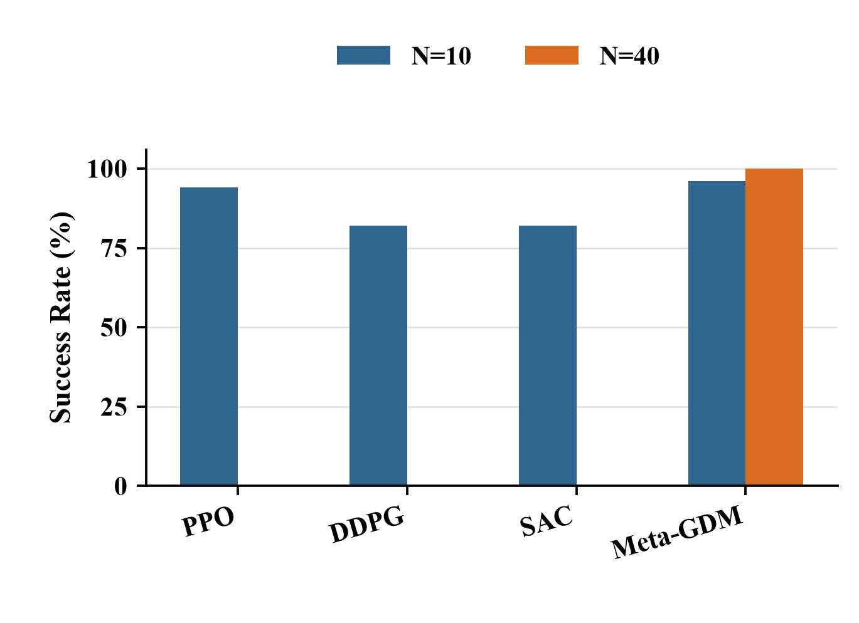  (a) | 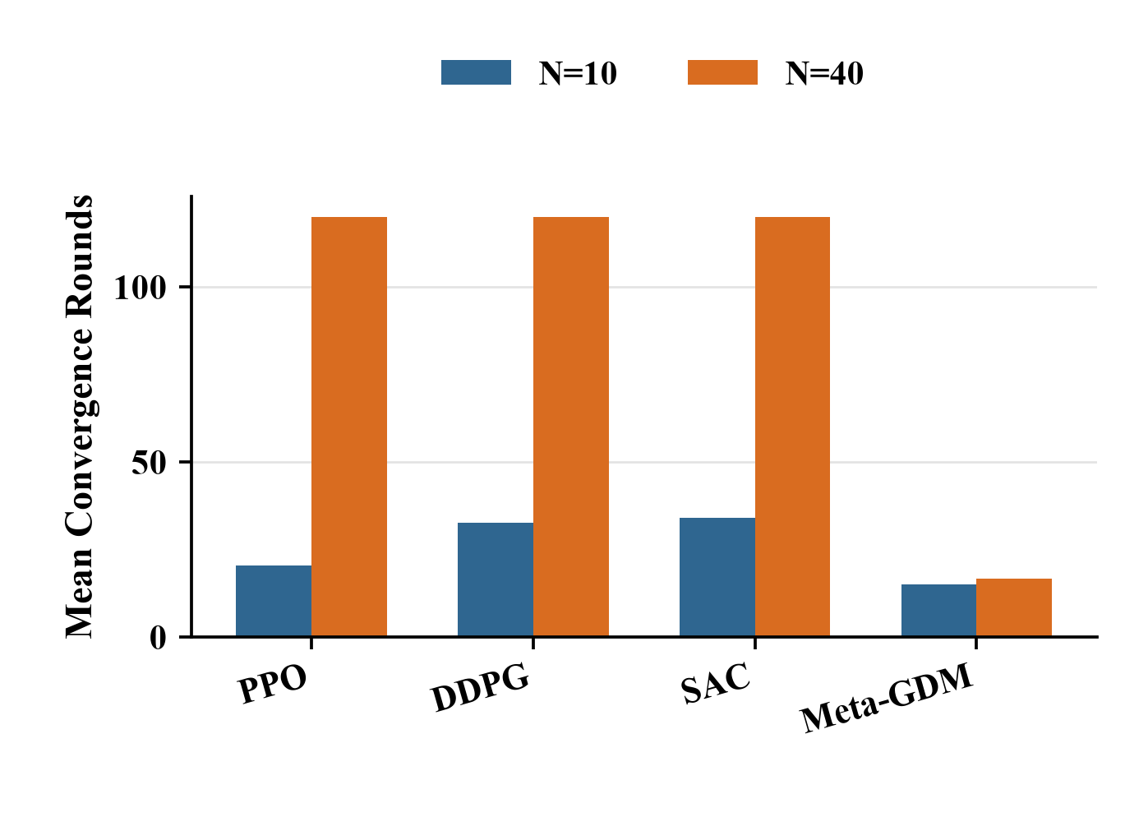  (b)
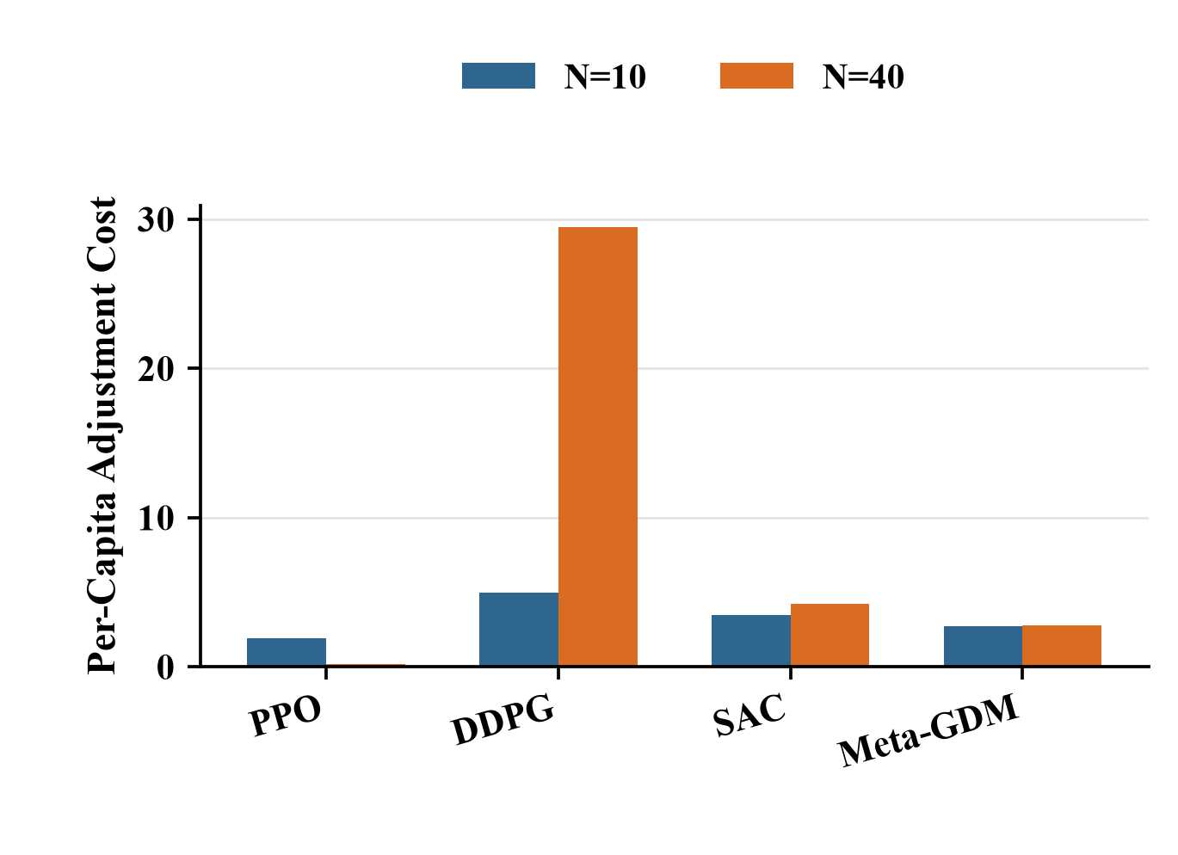  (c) | 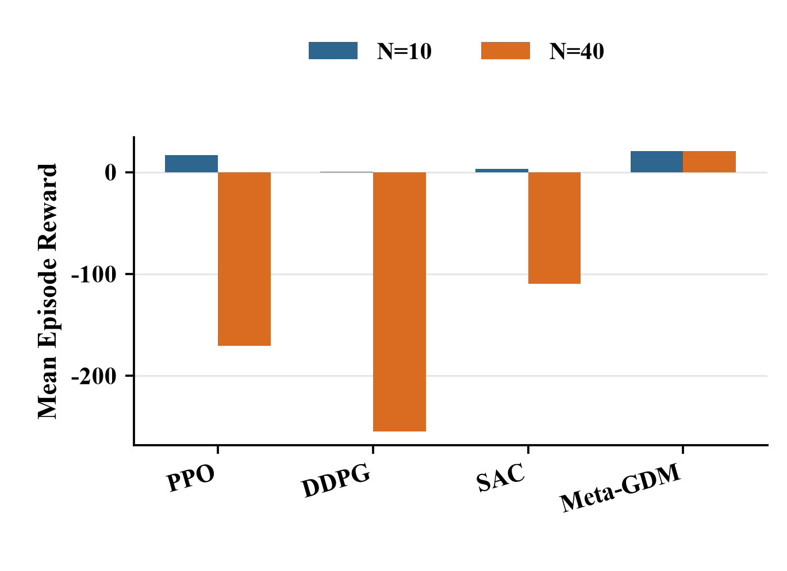  (d)
Fig. 3 Reinforcement-Learning Baselines: (a) Success; (b) Rounds; (c) Cost; (d) Reward

4.3 Interval fuzziness, scale transfer, and hidden heterogeneity
Point-valued [0,0] and narrow-interval [0.01,0.04] tests reach 1.00 success at N=10, 40, and 100, showing compatibility with precise and mildly uncertain preferences. Under the training interval [0.02,0.08], success is 0.96, 1.00, and 1.00; AUC is 0.8698, 0.8392, and 0.8417. The checkpoint trained at N=10 is reused unchanged at N=40 and 100, where it requires 19.46 and 19.16 rounds. The small efficiency loss without retraining supports cross-scale reuse within the tested distributions.
Hidden-heterogeneity tests vary stubbornness, cost sensitivity, and response type while withholding those parameters from every method. Figure 4 shows that Interval Meta-GDM reaches 0.98, 1.00, and 1.00 success, compared with 0.80, 0.64, and 0.36 for the strongest mean rule. It saves 21.92, 45.28, and 72.84 rounds and gains 21.22, 49.00, and 81.41 reward units; paired success intervals lie above zero. Total costs are higher (28.05, 121.14, and 303.62 versus 24.10, 106.71, and 271.00), so the advantage is higher success, speed, reward, and fairness rather than minimum cost.

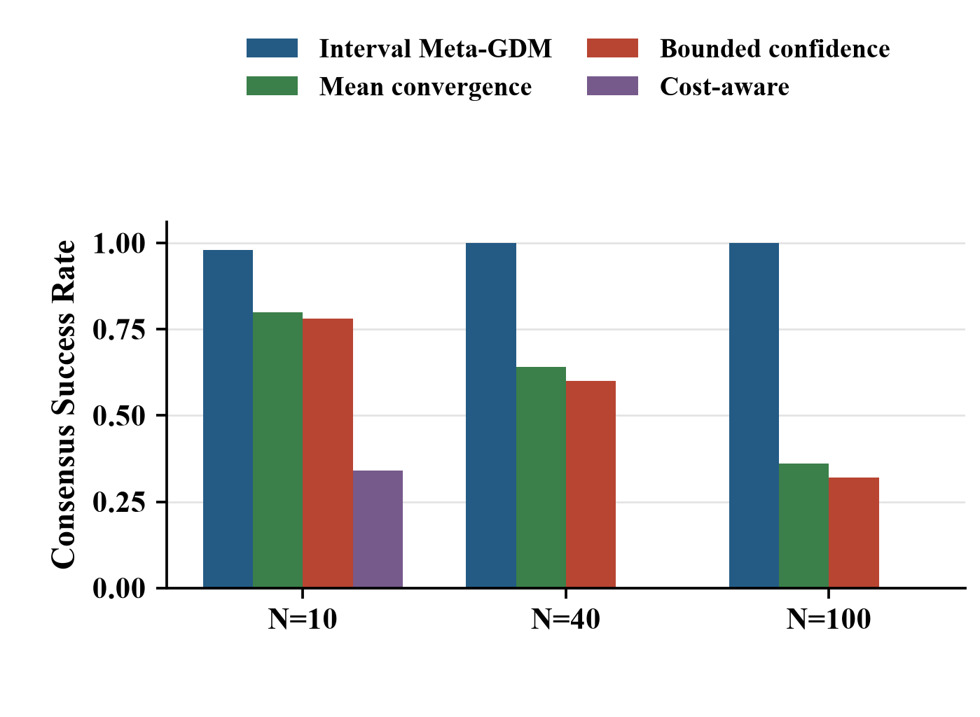  (a) | 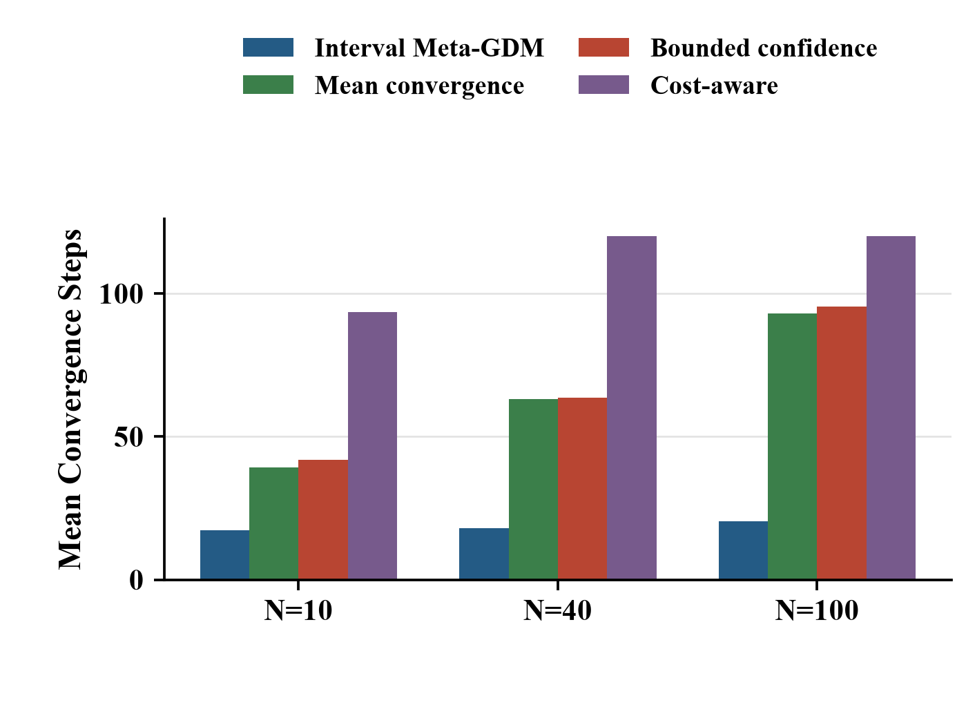  (b)
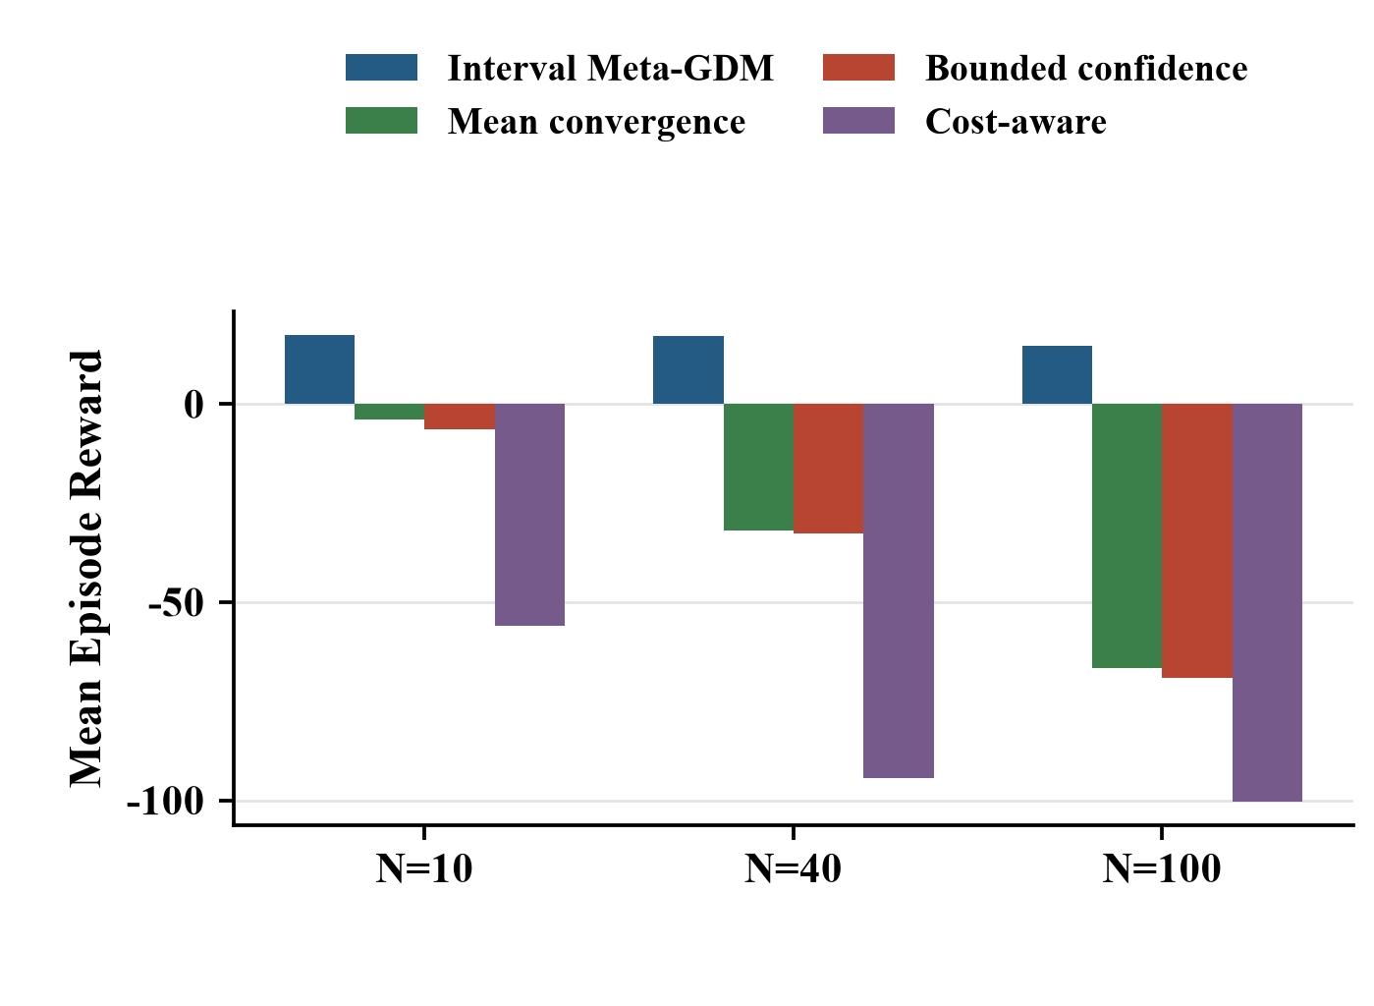  (c) | 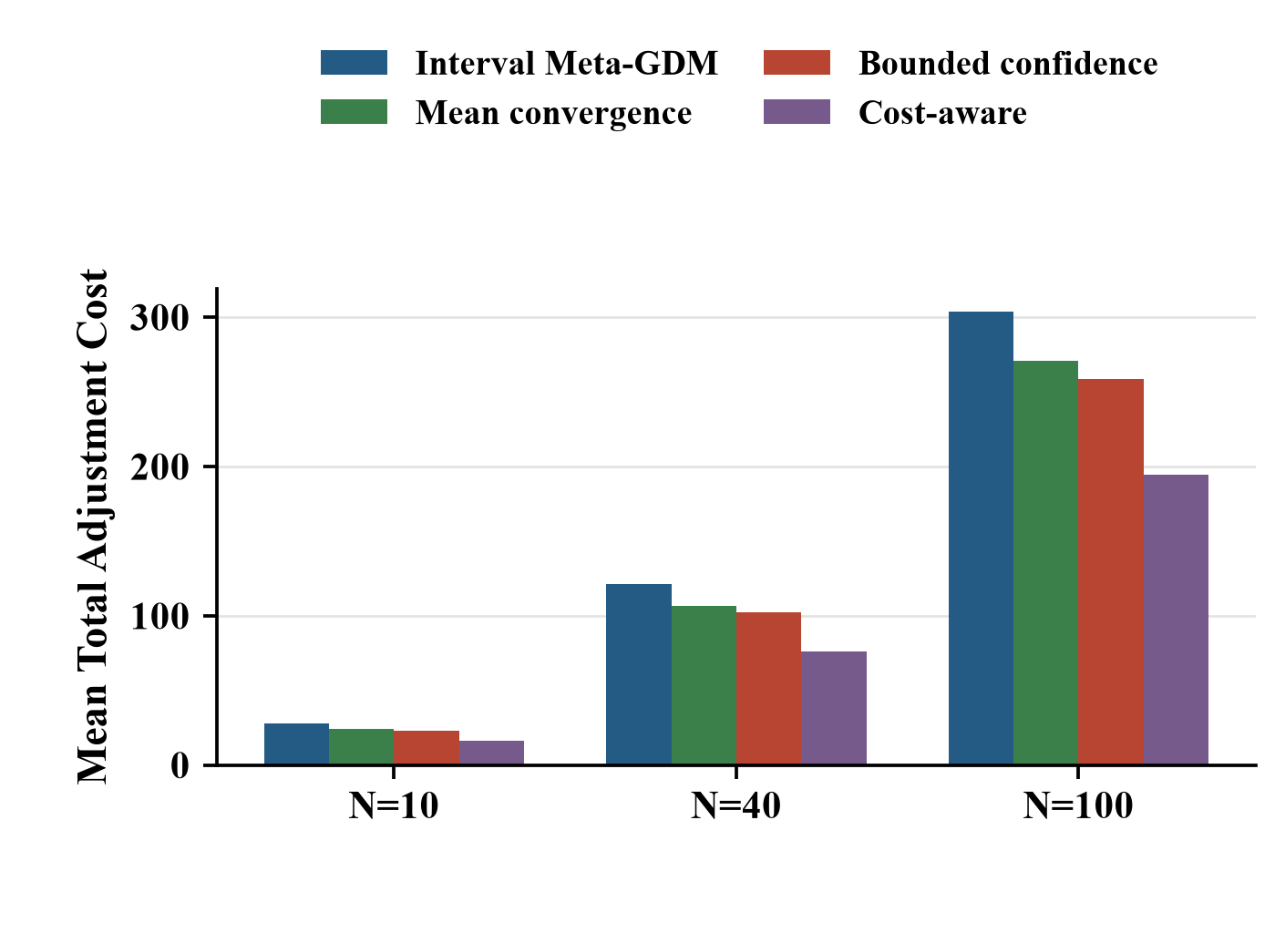  (d)
Fig. 4 Hidden Heterogeneity: (a) Success; (b) Rounds; (c) Reward; (d) Cost

4.4 Context ablation
The zero-history condition masks only the ten-round encoder input while keeping the frozen Actor, attention module, environment, and paired seeds unchanged. Real history raises success by 14, 22, and 44 percentage points at N=10, 40, and 100, with 95% intervals [6,24], [12,34], and [30,58]. AUC gains are 0.0747, 0.0704, and 0.1338. Mean rounds fall from 35.74 to 17.40, 53.06 to 17.90, and 74.74 to 20.32; total cost falls by 7.45, 56.33, and 171.13. The paired design therefore attributes the difference to usable historical information, while a separately retrained context-free network remains a future structural ablation.

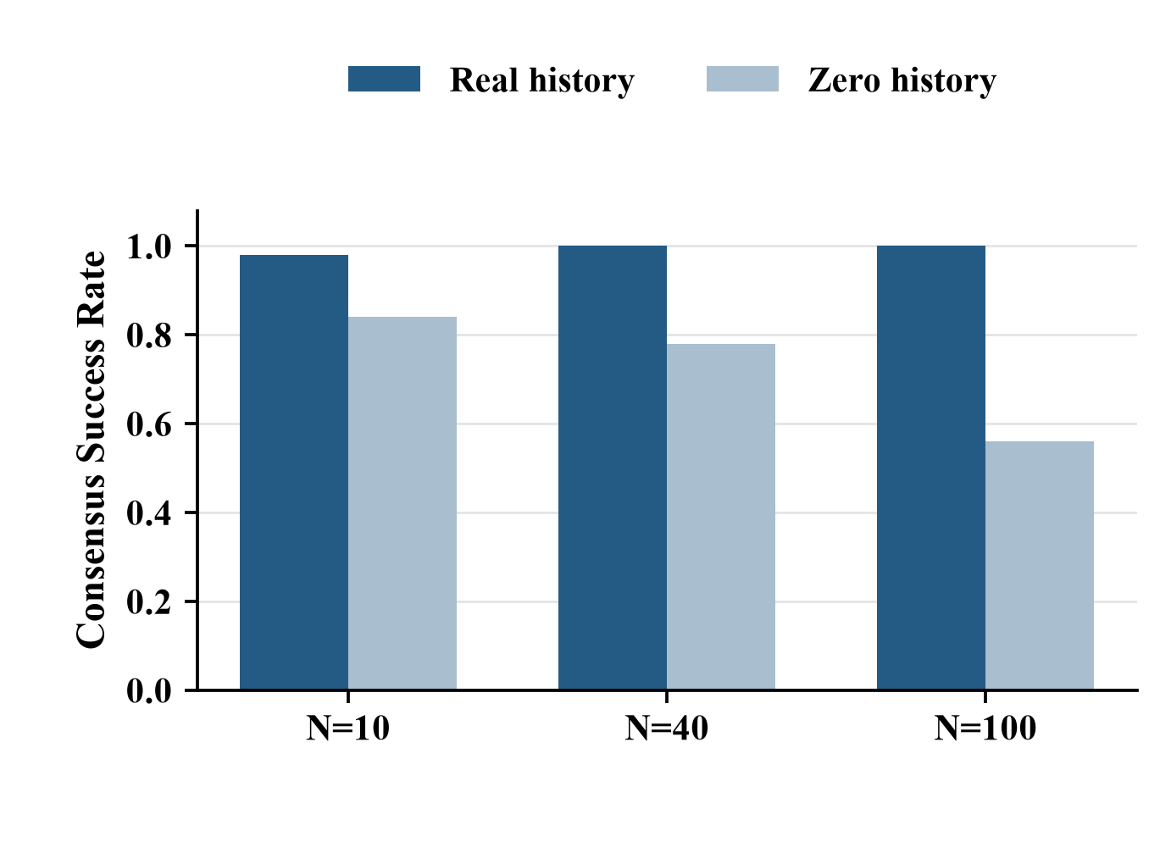  (a) | 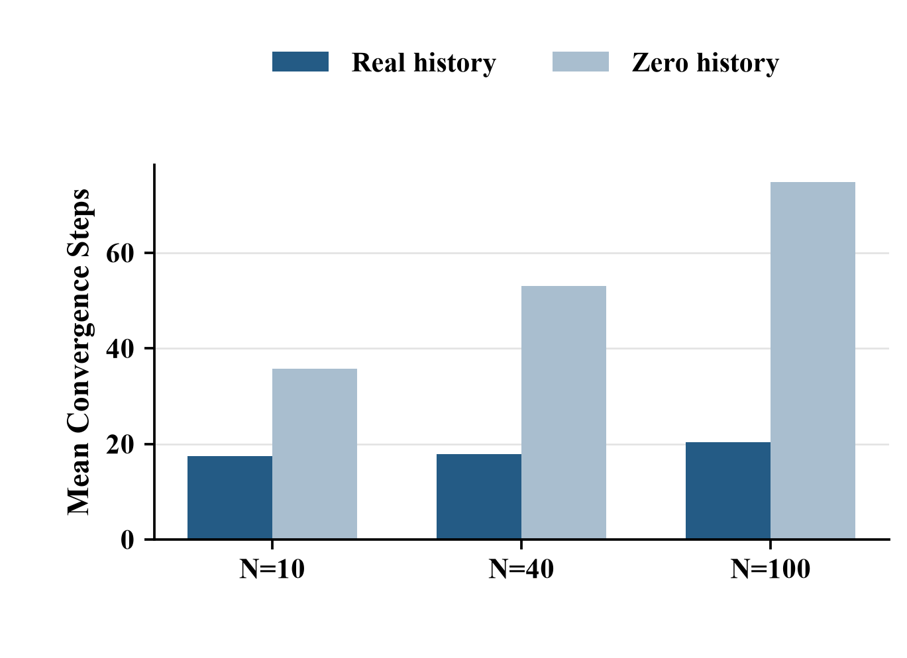  (b)
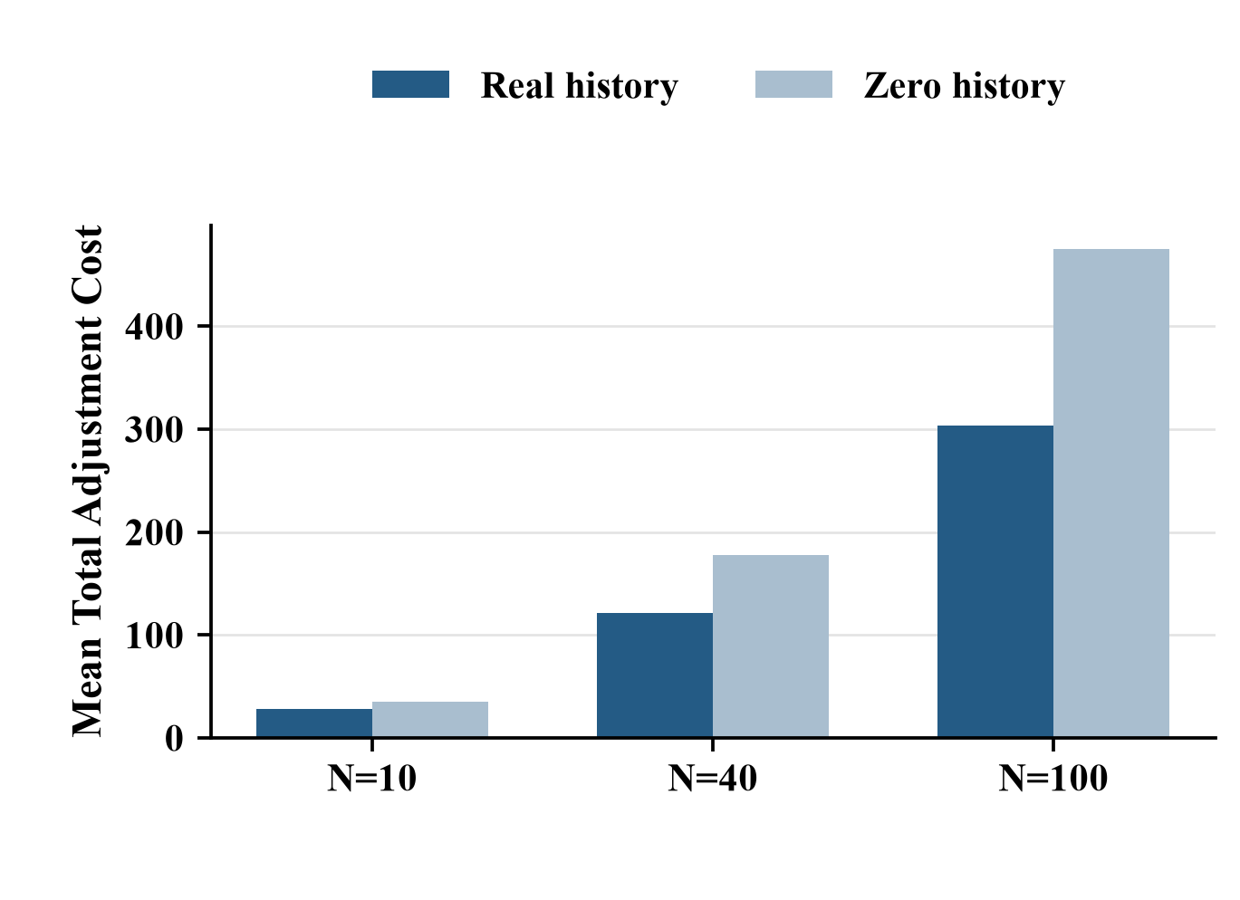  (c) | 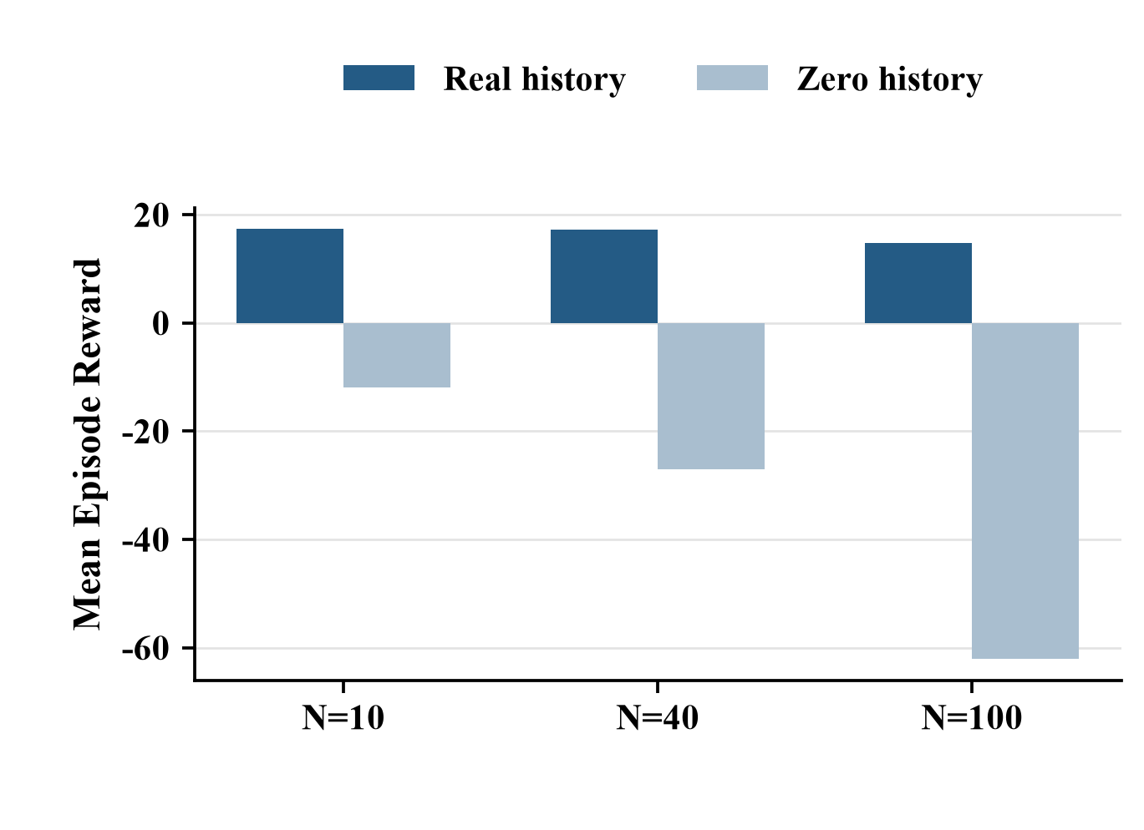  (d)
Fig. 5 Context-History Ablation: (a) Success; (b) Rounds; (c) Cost; (d) Reward

4.5 Interval preservation and scope
Because Eq. (9) translates both endpoints equally, Hausdorff distortion equals center displacement when hi,T=hi,0 (34). Final center consensus is 0.9652, 0.9542, and 0.9482; mean half-width change is zero, and the maximum Hausdorff-center discrepancy is 1.11e-16. Figure 6 confirms that consensus is not obtained by narrowing members' uncertainty ranges.
$$d_{H}(I_{i,T},I_{i,0})=max(|l_{i,T}-l_{i,0}|,|u_{i,T}-u_{i,0}|)=|c_{i,T}-c_{i,0}|（h_{i,T}=h_{i,0}）。 (34)$$

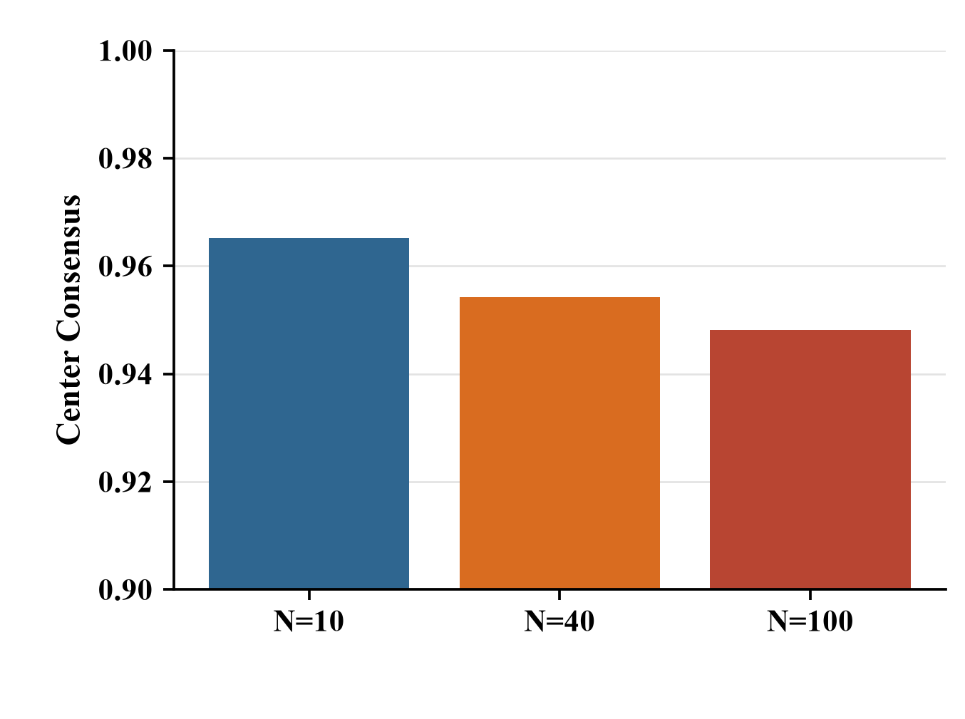  (a) | 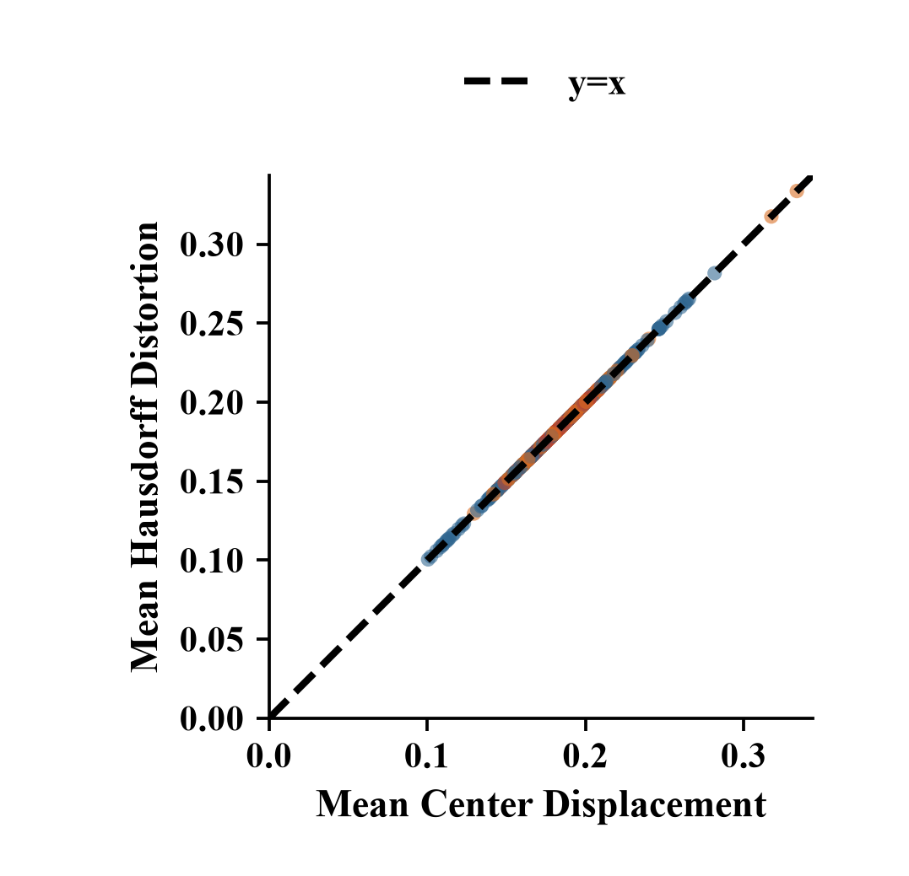  (b)
Fig. 6 Interval Preservation: (a) Final Center Consensus; (b) Hausdorff-Center Consistency
The evidence is limited to one training seed, 50 frozen scenarios per cell, and half-widths up to 0.08. The architecture is context-conditioned meta-RL rather than MAML. Sensitivity tables, noise and missing-feedback stress tests, and negotiation trajectories are retained as repository supplements because they delimit robustness but are not needed to establish the main causal chain. Multiple training seeds and a matched retrained context-free model are the next validation steps.
5 Conclusion
Interval Meta-GDM couples endpoint-consistent consensus control with history-conditioned response inference and set-based action generation. The model does not dominate simple rules in static homogeneous tasks, but it retains their success while offering better composite reward and burden balance at larger scales. Its clearest advantage appears when hidden response differences accumulate: the frozen policy uses observed interaction history to sustain success, reduce repeated probing, and transfer from N=10 to N=40 and N=100 without architectural changes.
The interval extension is structural rather than cosmetic: actions preserve half-widths, boundary checks use both endpoints, and the reward uses endpoint consensus, cost, fairness, and violations. The main remaining issues are higher total cost under heterogeneity, single-seed training, and incomplete structural ablation. Future work should optimize this trade-off, repeat training across seeds, and test task-level adaptation and real negotiation data.

References
[1] Zadeh L A. Fuzzy sets. Information and Control, 1965, 8(3): 338-353.
[2] Atanassov K T. Intuitionistic fuzzy sets. Fuzzy Sets and Systems, 1986, 20(1): 87-96.
[3] Xu Z S. A survey of preference relations. International Journal of General Systems, 2007, 36(2): 179-203.
[4] Torra V. Hesitant fuzzy sets. International Journal of Intelligent Systems, 2010, 25(6): 529-539.
[5] Rodríguez R M, Martínez L, Torra V, et al. Hesitant fuzzy sets: State of the art and future directions. International Journal of Intelligent Systems, 2014, 29(6): 495-524.
[6] Herrera-Viedma E, Cabrerizo F J, Kacprzyk J, Pedrycz W. A review of soft consensus models in a fuzzy environment. Information Fusion, 2014, 17: 4-13.
[7] Mendel J M, John R I, Liu F. Interval type-2 fuzzy logic systems made simple. IEEE Transactions on Fuzzy Systems, 2006, 14(6): 808-821.
[8] Bellman R E, Zadeh L A. Decision-making in a fuzzy environment. Management Science, 1970, 17(4): B141-B164.
[9] DeGroot M H. Reaching a consensus. Journal of the American Statistical Association, 1974, 69(345): 118-121.
[10] Hegselmann R, Krause U. Opinion dynamics and bounded confidence: Models, analysis and simulation. Journal of Artificial Societies and Social Simulation, 2002, 5(3): 2.
[11] Friedkin N E, Johnsen E C. Social influence and opinions. Journal of Mathematical Sociology, 1990, 15(3-4): 193-206.
[12] Kacprzyk J, Fedrizzi M. A soft measure of consensus in the setting of partial (fuzzy) preferences. European Journal of Operational Research, 1988, 34(3): 316-325.
[13] Cao M S, Wu J, Chiclana F, et al. A personalized consensus feedback mechanism based on maximum harmony degree. IEEE Transactions on Systems, Man, and Cybernetics: Systems, 2021, 51(10): 6134-6146.
[14] Ben-Arieh D, Easton T, Evans B. Minimum cost consensus with quadratic cost functions. IEEE Transactions on Systems, Man, and Cybernetics—Part A: Systems and Humans, 2009, 39(1): 210-217.
[15] Du J L, Liu S F, Liu Y. A limited cost consensus approach with fairness concern and its application. European Journal of Operational Research, 2022, 298(1): 261-275.
[16] Gong G C, Li K, Zha Q B. A maximum fairness consensus model with limited cost in group decision making. Computers & Industrial Engineering, 2023, 175: 108891.
[17] Zhang R N, Huang J, Xu Y J, et al. Consensus models with aggregation operators for minimum quadratic cost in group decision making. Applied Intelligence, 2023, 53(2): 1370-1390.
[18] Shen Y F, Ma X L, Xu Z S, et al. A minimum cost and maximum fairness-driven multi-objective optimization consensus model for large-scale group decision-making. Fuzzy Sets and Systems, 2025, 500: 109198.
[19] Liang Y Y, Qin J D, Pedrycz W. Minimum cost consensus model considering dual behavior preference. Computers & Operations Research, 2025, 176: 106961.
[20] Liu X, Shan Y J, Xu Y J, et al. Minimum cost consensus modeling considering opinion-based variable cost and trust-based tolerance constraints. IEEE Transactions on Computational Social Systems, 2025, 12(5): 3023-3036.
[21] Zhang B W, Huang W J, Dong Y C, et al. Utility-driven minimum cost consensus model with preference learning and fairness concerns. IEEE Transactions on Systems, Man, and Cybernetics: Systems, 2025, 55(7): 4641-4655.
[22] Shen Y F, Ma X L, Bao Y K, et al. A consensus method based on reinforcement learning for group decision-making. European Journal of Operational Research, 2026, 330(3): 941-955.
[23] Tu Y, Wang W S, Ma Z, et al. Multi-agent reinforcement learning-based consensus building for large-scale group decision making. Information Fusion, 2026, 126: 103629.
[24] Vaswani A, Shazeer N, Parmar N, et al. Attention is all you need. Advances in Neural Information Processing Systems, 2017, 30: 5998-6008.
[25] Bahdanau D, Cho K, Bengio Y. Neural machine translation by jointly learning to align and translate. International Conference on Learning Representations, 2015.
[26] Zaheer M, Kottur S, Ravanbakhsh S, et al. Deep sets. Advances in Neural Information Processing Systems, 2017, 30: 3391-3401.
[27] Lee J, Lee Y, Kim J, et al. Set Transformer: A framework for attention-based permutation-invariant neural networks. Proceedings of Machine Learning Research, 2019, 97: 3744-3753.
[28] Kingma D P, Welling M. Auto-encoding variational Bayes. International Conference on Learning Representations, 2014.
[29] Sutton R S, Barto A G. Reinforcement Learning: An Introduction. 2nd ed. Cambridge, MA: MIT Press, 2018.
[30] Haarnoja T, Zhou A, Abbeel P, Levine S. Soft actor-critic: Off-policy maximum entropy deep reinforcement learning with a stochastic actor. Proceedings of Machine Learning Research, 2018, 80: 1861-1870.
[31] Lillicrap T P, Hunt J J, Pritzel A, et al. Continuous control with deep reinforcement learning. International Conference on Learning Representations, 2016.
[32] Schulman J, Wolski F, Dhariwal P, et al. Proximal policy optimization algorithms. arXiv:1707.06347, 2017.
[33] Fujimoto S, van Hoof H, Meger D. Addressing function approximation error in actor-critic methods. Proceedings of Machine Learning Research, 2018, 80: 1587-1596.
[34] Finn C, Abbeel P, Levine S. Model-agnostic meta-learning for fast adaptation of deep networks. Proceedings of Machine Learning Research, 2017, 70: 1126-1135.
[35] Duan Y, Schulman J, Chen X, et al. RL²: Fast reinforcement learning via slow reinforcement learning. arXiv:1611.02779, 2016.
[36] Wang J X, Kurth-Nelson Z, Tirumala D, et al. Learning to reinforcement learn. Proceedings of the 39th Annual Conference of the Cognitive Science Society, 2017: 1331-1338.
[37] Rakelly K, Zhou A, Finn C, et al. Efficient off-policy meta-reinforcement learning via probabilistic context variables. Proceedings of Machine Learning Research, 2019, 97: 5331-5340.
[38] Zintgraf L M, Shiarlis K, Igl M, et al. VariBAD: A very good method for Bayes-adaptive deep RL via meta-learning. International Conference on Learning Representations, 2020.
[39] Efron B, Tibshirani R J. An Introduction to the Bootstrap. New York: Chapman & Hall, 1993.
[40] Davison A C, Hinkley D V. Bootstrap Methods and Their Application. Cambridge: Cambridge University Press, 1997.

Funding: National Natural Science Foundation of China (72471137); Shanghai Magnolia Talent Program Pujiang Project (24PJC042); Shanghai Philosophy and Social Sciences Planning Project (2025EZH002) Author biography: Corresponding author: Jian Wu (born 1977), male, Han nationality, from Wuxi, Jiangsu Province; Distinguished Professor under the 'Voyage Program' of Shanghai Maritime University and doctoral supervisor. Research interests: group decision-making and social network analysis. E-mail: jyajian@163.com

