
编 号：
版 本 号： V1.0

安徽省农村信用社联合社信息技术中心
Redis安装规范

文档编号： | 密 级：
起草人： | 修改人：
审核人： | 批准人：

文档历史信息
版本号 | 修订日期 | 修订人 | 变更内容 | 备注
V1.0 | 2026/4/09 |  |  | 编写文档

目录
一、 概述 4
（一） 文档目的 4
（二） 适用范围 4
（三） 使用对象 4
二、 环境准备 4
（一） 环境要求 4
（二） 环境信息定义 4
三、 安装步骤 5
（一） 环境准备 5
1． 修改系统参数 5
2． 修改ulimit参数 5
3． 解压安装redis 5
（二） Redis单机模式配置 6
1． 修改系统参数 6
2． 启动redis服务 7
3． 测试redis 8
4． 停止redis 8
5． 添加开机自启 9
（三） Redis哨兵集群配置 9
1． 创建redis配置文件 10
2． 创建哨兵配置文件 14
3． 启动redis进程 14
4． 启动哨兵进程 14
5． 查看状态 14
6． 添加开机自启 15
（四） Redis Cluster集群配置 16
1． 创建配置文件 17
2． 启动所有redis节点 19
3． 以3个主节点组建集群 19
4． 从节点加入集群 19
5． 查看集群节点信息 20
6． 添加开机自启 21

概述

文档目的
本文档为安装Redis中间件提供规范指引与参考，建议按照本规范安装部署Redis。

适用范围
本文档适用范围为安徽省农村信用社联合社信息技术中心。

使用对象
本文档基于Kylin v10操作系统撰写，对象为该环境下安装使用Redis的开发、测试、运维及相关人员，在其他操作系统上安装Redis可参考本文档。

环境准备

环境要求
操作系统要求 | 64位Linux
CPU配置要求 | 4 vCPU
内存配置要求 | 8GB起

环境信息定义
安装操作系统 | Kylin V10
安装版本 | redis-7.4.2
安装包 | redis-7.4.2.tar.gz
安装目录 | /opt/redis
配置目录 | /opt/redis/conf
数据目录 | /opt/redis/data (注意：数据统一挂载此目录)
日志目录 | /opt/redis/logs
运行用户 | redis

安装步骤

环境准备

修改系统参数
sudo vi /etc/sysctl.conf
vm.overcommit_memory=1
net.core.somaxconn=65535
sudo sysctl -p
vm.overcommit_memory=1，表示内核允许分配所有的物理内存，而不管当前的内存状态如何；
net.core.somaxconn参数与redis配置文件的tcp-backlog参数有关，控制连接等待队列的深度。

修改ulimit参数
sudo vi /etc/security/limits.conf
redis soft nofile 65535
redis hard nofile 65535
redis soft nproc 65535
redis hard nproc 65535

解压安装redis
sudo mkdir -p /opt/redis/{data,logs,conf,pid,bin}
#上传安装包到/tmp/目录下
sudo tar xf redis-7.4.2.tar.gz
cd redis-7.4.2
sudo make && sudo make PREFIX=/opt/redis install
#修改目录权限
sudo chown -R redis.redis /opt/redis

Redis单机模式配置
IP地址 | 192.168.200.10
服务端口 | 6379
配置文件目录 | /opt/redis/conf
配置文件 | redis-6379.conf
aof文件名称 | appendonly-6379.aof
rdb文件名称 | dump-6379.rdb
日志文件名称 | redis-6379.log

修改系统参数
创建redis配置文件/opt/redis/conf/redis-6379.conf（说明：ip地址、密码及Memory配置大小，根据实际需要进行修改）：
# Network
bind 127.0.0.1 192.168.200.10
protected-mode yes
port 6379
tcp-backlog 511
timeout 0
tcp-keepalive 300
# Process
daemonize no
supervised no
pidfile /opt/redis/pid/redis-6379.pid
# Logging
loglevel notice
logfile "/opt/redis/logs/redis-6379.log"
always-show-logo no
# General
databases 16
dir /opt/redis/data
dbfilename dump-6379.rdb
# Snapshots (RDB)
save 900 1
save 300 10
save 60 10000
stop-writes-on-bgsave-error yes
rdbcompression yes
rdbchecksum yes
rdb-save-incremental-fsync yes
# AOF
appendonly yes
appendfilename "appendonly-6379.aof"
appendfsync everysec
no-appendfsync-on-rewrite no
auto-aof-rewrite-percentage 100
auto-aof-rewrite-min-size 64mb
aof-load-truncated yes
aof-use-rdb-preamble yes
aof-rewrite-incremental-fsync yes
# Memory
maxmemory 1024mb
maxmemory-policy allkeys-lru
lazyfree-lazy-eviction no
lazyfree-lazy-expire no
lazyfree-lazy-server-del no
# Security
requirepass {password}
rename-command FLUSHDB ""
rename-command FLUSHALL ""
rename-command KEYS ""
# Slow Log / Latency
slowlog-log-slower-than 10000
slowlog-max-len 128
latency-monitor-threshold 0
# Clients
client-output-buffer-limit normal 0 0 0
client-output-buffer-limit pubsub 32mb 8mb 60
# Runtime
lua-time-limit 5000
activerehashing yes
hz 10
dynamic-hz yes
disable-thp yes
jemalloc-bg-thread yes
# ACL / Events
acllog-max-len 128
notify-keyspace-events ""

启动redis服务
nohup /opt/redis/bin/redis-server /opt/redis/conf/redis-6379.conf &
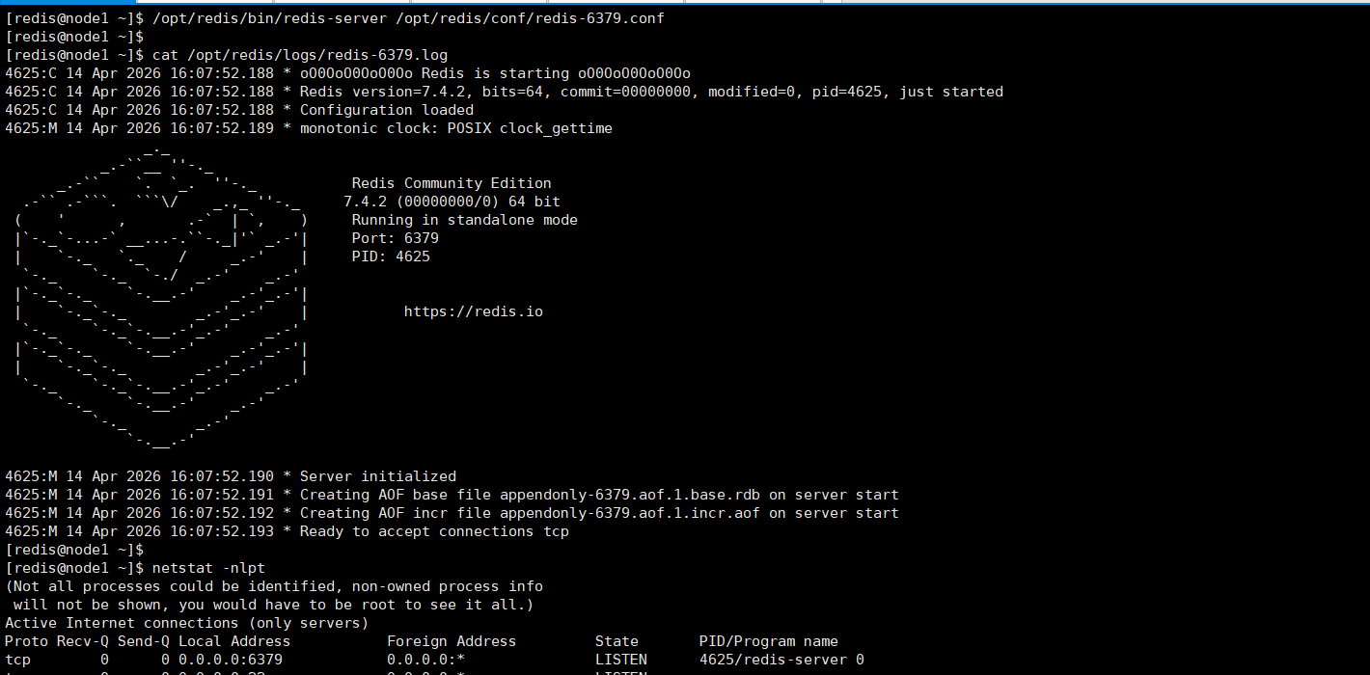

测试redis
/opt/redis/bin/redis-cli -h 192.168.200.10 -p 6379 --askpass
#交互输入密码
info memory
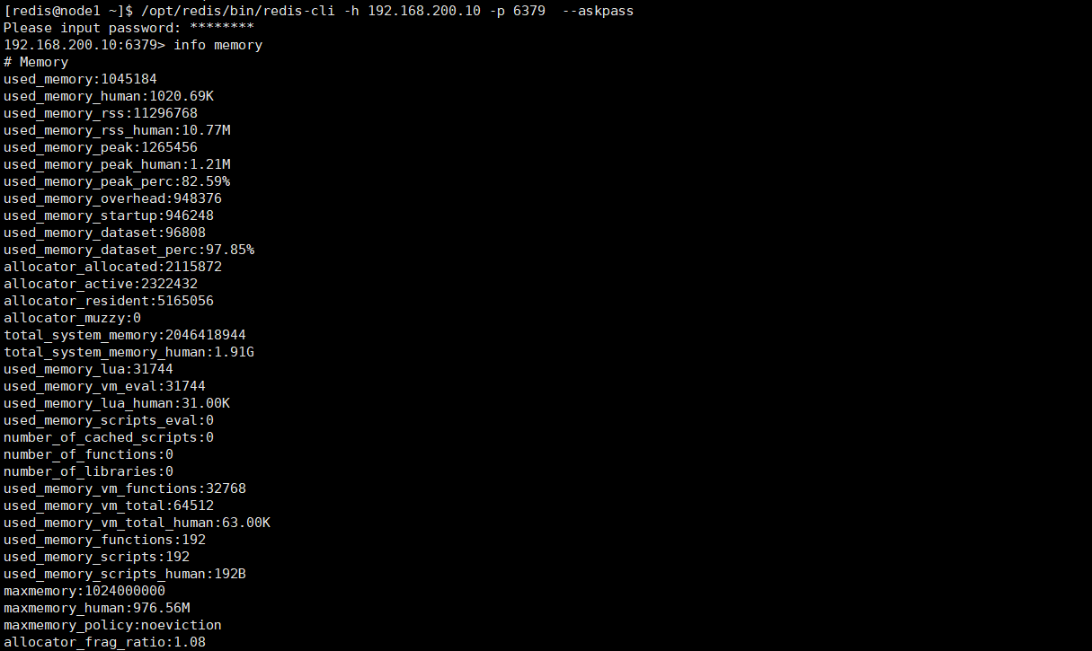

停止redis
/opt/redis/bin/redis-cli -h 192.168.200.10 -p 6379 --askpass
#交互输入密码
shutdown


添加开机自启
#使用sudo权限账号执行
sudo vi /etc/systemd/system/redis.service
[Unit]
Description=Redis 6379
After=network.target

[Service]
Type=simple
User=redis
Group=redis
ExecStart=/opt/redis/bin/redis-server /opt/redis/conf/redis-6379.conf
ExecStop=/opt/redis/bin/redis-cli -h 127.0.0.1 -a {password} -p 6379 shutdown
Restart=always
RestartSec=3
LimitNOFILE=65535

[Install]
WantedBy=multi-user.target
重载配置、添加开机启动:
#使用sudo权限账号执行
sudo systemctl daemon-reload
sudo systemctl enable redis

Redis哨兵集群配置
主节点IP | 192.168.200.10
主节点端口 | 16379
主节点配置文件路径 | /opt/redis/conf/redis-16379.conf
从节点1:IP | 192.168.200.20
从节点1端口 | 16379
从节点1配置文件路径 | /opt/redis/conf/redis-16379.conf
从节点2:IP | 192.168.200.30
从节点2端口 | 16379
从节点2配置文件路径 | /opt/redis/conf/redis-16379.conf
哨兵节点1:IP | 192.168.200.10
哨兵节点1端口 | 26379
哨兵节点1配置文件路径 | /opt/redis/conf/sentinel-26379.conf
哨兵节点2:IP | 192.168.200.20
哨兵节点2端口 | 26379
哨兵节点2配置文件路径 | /opt/redis/conf/sentinel-26379.conf
哨兵节点3:IP | 192.168.200.30
哨兵节点3端口 | 26379
哨兵节点3配置文件路径 | /opt/redis/conf/sentinel-26379.conf
redis-server,redis-cli,redis-sentinel命令路径 | /opt/redis/bin
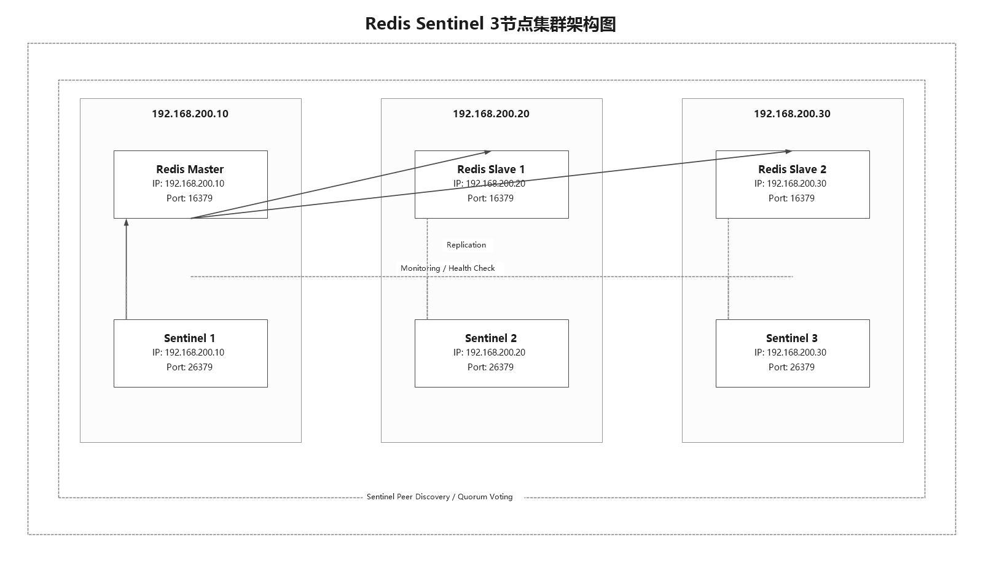

创建redis配置文件
主节点创建redis配置文件/opt/redis/conf/redis-16379.conf（注意ip地址、Memory配置大小、密码，根据实际情况进行修改）:
# Network
bind 127.0.0.1 192.168.200.10
protected-mode yes
port 16379
tcp-backlog 511
timeout 0
tcp-keepalive 300
# Process
daemonize no
supervised no
pidfile /opt/redis/pid/redis-16379.pid
# Logging
loglevel notice
logfile "/opt/redis/logs/redis-16379.log"
always-show-logo no
# General
databases 16
dir /opt/redis/data
dbfilename dump-16379.rdb
# RDB
save 900 1
save 300 10
save 60 10000
stop-writes-on-bgsave-error yes
rdbcompression yes
rdbchecksum yes
rdb-save-incremental-fsync yes
# AOF
appendonly yes
appendfilename "appendonly-16379.aof"
appendfsync everysec
no-appendfsync-on-rewrite no
auto-aof-rewrite-percentage 100
auto-aof-rewrite-min-size 64mb
aof-load-truncated yes
aof-use-rdb-preamble yes
aof-rewrite-incremental-fsync yes
# Replication
masterauth {password}
replica-serve-stale-data yes
replica-read-only yes
repl-diskless-sync no
repl-diskless-sync-delay 5
repl-disable-tcp-nodelay no
replica-priority 100
# Memory
maxmemory 1024mb
maxmemory-policy allkeys-lru
lazyfree-lazy-eviction no
lazyfree-lazy-expire no
lazyfree-lazy-server-del no
# Security
requirepass {password}
rename-command FLUSHDB ""
rename-command FLUSHALL ""
rename-command KEYS ""
# Slow Log / Latency
slowlog-log-slower-than 10000
slowlog-max-len 128
latency-monitor-threshold 0
# Clients
client-output-buffer-limit normal 0 0 0
client-output-buffer-limit replica 256mb 64mb 60
client-output-buffer-limit pubsub 32mb 8mb 60
# Runtime
lua-time-limit 5000
activerehashing yes
hz 10
dynamic-hz yes
disable-thp yes
jemalloc-bg-thread yes
# ACL / Events
acllog-max-len 128
notify-keyspace-events ""
从节点1配置如下，创建redis配置文件/opt/redis/conf/redis-16379.conf，注意ip地址、Memory配置大小、密码，根据实际情况进行修改）。从节点2配置一样，需要替换ip地址：
# Network
bind 127.0.0.1 192.168.200.20
protected-mode yes
port 16379
tcp-backlog 511
timeout 0
tcp-keepalive 300
# Process
daemonize no
supervised no
pidfile /opt/redis/pid/redis-16379.pid
# Logging
loglevel notice
logfile "/opt/redis/logs/redis-16379.log"
always-show-logo no
# General
databases 16
dir /opt/redis/data
dbfilename dump-16379.rdb
# RDB
save 900 1
save 300 10
save 60 10000
stop-writes-on-bgsave-error yes
rdbcompression yes
rdbchecksum yes
rdb-save-incremental-fsync yes
# AOF
appendonly yes
appendfilename "appendonly-16379.aof"
appendfsync everysec
no-appendfsync-on-rewrite no
auto-aof-rewrite-percentage 100
auto-aof-rewrite-min-size 64mb
aof-load-truncated yes
aof-use-rdb-preamble yes
aof-rewrite-incremental-fsync yes
# Replication
replicaof 192.168.200.10 16379
masterauth {password}
replica-serve-stale-data yes
replica-read-only yes
repl-diskless-sync no
repl-diskless-sync-delay 5
repl-disable-tcp-nodelay no
replica-priority 100
# Memory
maxmemory 1024mb
maxmemory-policy allkeys-lru
lazyfree-lazy-eviction no
lazyfree-lazy-expire no
lazyfree-lazy-server-del no
# Security
requirepass {password}
rename-command FLUSHDB ""
rename-command FLUSHALL ""
rename-command KEYS ""
# Slow Log / Latency
slowlog-log-slower-than 10000
slowlog-max-len 128
latency-monitor-threshold 0
# Clients
client-output-buffer-limit normal 0 0 0
client-output-buffer-limit replica 256mb 64mb 60
client-output-buffer-limit pubsub 32mb 8mb 60
# Runtime
lua-time-limit 5000
activerehashing yes
hz 10
dynamic-hz yes
disable-thp yes
jemalloc-bg-thread yes
# ACL / Events
acllog-max-len 128
notify-keyspace-events ""

创建哨兵配置文件
3台哨兵配置（注意标记为红色部分的内容,根据实际情况进行修改）
配置文件保存路径：/opt/redis/conf/sentinel-26379.conf
bind 127.0.0.1 192.168.200.10
protected-mode yes
port 26379
tcp-keepalive 300
daemonize no
pidfile "/opt/redis/pid/sentinel-26379.pid"
dir "/opt/redis/data"
logfile "/opt/redis/logs/sentinel-26379.log"
loglevel notice
requirepass {password}

sentinel monitor redisMaster 192.168.200.10 16379 2
sentinel auth-pass redisMaster {password}
sentinel down-after-milliseconds redisMaster 10000
sentinel failover-timeout redisMaster 60000
sentinel parallel-syncs redisMaster 1

启动redis进程
nohup /opt/redis/bin/redis-server /opt/redis/conf/redis-16379.conf &

启动哨兵进程
nohup /opt/redis/bin/redis-sentinel /opt/redis/conf/sentinel-26379.conf &

查看状态
查看主从复制信息
/opt/redis/bin/redis-cli -h <主节点ip地址> -p 16379 -a <password> info Replication
说明：显示如下类似信息，表示安装成功
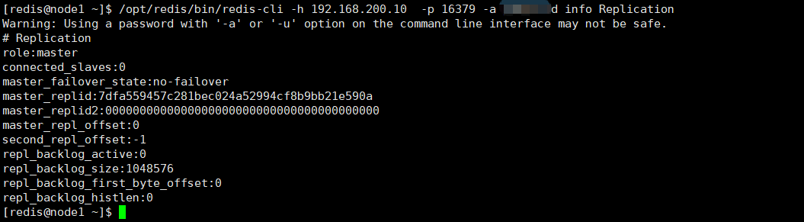
查看哨兵集群状态
/opt/redis/bin/redis-cli -h <ip地址> -p 26379 -a <password> info sentinel
说明：显示如下类似信息，表示安装成功
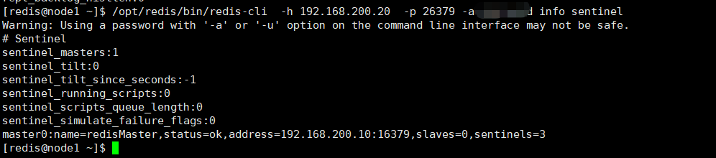

添加开机自启
#使用sudo权限账号执行
sudo vi /etc/systemd/system/redis.service
[Unit]
Description=Redis 16379
After=network.target

[Service]
Type=simple
User=redis
Group=redis
ExecStart=/opt/redis/bin/redis-server /opt/redis/conf/redis-16379.conf
ExecStop=/opt/redis/bin/redis-cli -h 127.0.0.1 -a {password} -p 16379 shutdown
Restart=always
RestartSec=3
LimitNOFILE=65535

[Install]
WantedBy=multi-user.target
redis-sentinel:
#使用sudo权限账号执行
sudo vi /etc/systemd/system/redis-sentinel.service
[Unit]
Description=Redis Sentinel 26379
After=network.target redis-16379.service
Requires=redis-16379.service

[Service]
Type=simple
User=redis
Group=redis
ExecStart=/opt/redis/bin/redis-sentinel /opt/redis/conf/sentinel-26379.conf
ExecStop=/bin/kill -s TERM $MAINPID
Restart=always
RestartSec=3
LimitNOFILE=65535

[Install]
WantedBy=multi-user.target
重载配置、添加开机启动:
#使用sudo权限账号执行
sudo systemctl daemon-reload
sudo systemctl enable redis
sudo systemctl enable redis-sentinel

Redis Cluster集群配置
三主三从配置说明：
cluster节点1:IP | 192.168.200.10
cluster节点1端口 | 7000
cluster节点1配置文件路径 | /opt/redis/conf/redis-7000.conf
cluster节点2:IP | 192.168.200.20
cluster节点2端口 | 7000
cluster节点2配置文件路径 | /opt/redis/conf/redis-7000.conf
cluster节点3:IP | 192.168.200.30
cluster节点3端口 | 7000
cluster节点3配置文件路径 | /opt/redis/conf/redis-7000.conf
cluster节点4:IP | 192.168.200.40
cluster节点4端口 | 7000
cluster节点4配置文件路径 | /opt/redis/conf/redis-7000.conf
cluster节点5:IP | 192.168.200.50
cluster节点5端口 | 7000
cluster节点5配置文件路径 | /opt/redis/conf/redis-7000.conf
cluster节点6:IP | 192.168.200.60
cluster节点6端口 | 7000
cluster节点6配置文件路径 | /opt/redis/conf/redis-7000.conf
redis-server,redis-cli,redis-sentinel | /opt/redis/bin
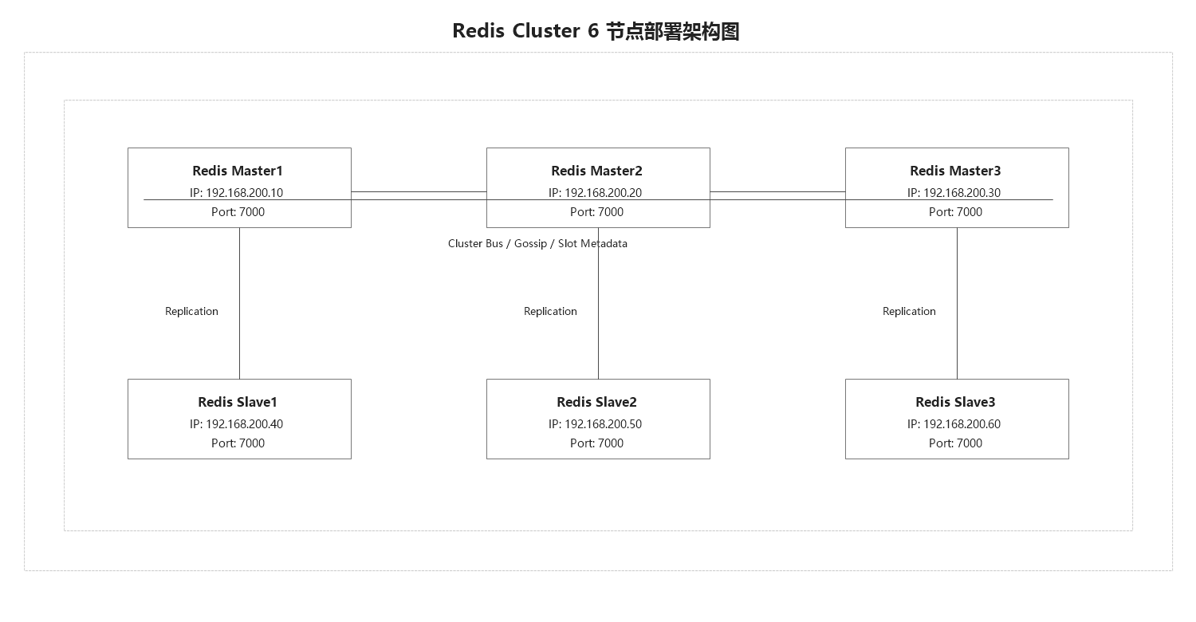

创建配置文件
redis集群节点配置如下，主从节点基本相同（注意ip地址、密码、Memory配置大小，根据实际情况进行修改），以节点1为例，创建配置文件/opt/redis/conf/redis-7000.conf：
# Network
bind 127.0.0.1 192.168.200.10
protected-mode yes
port 7000
tcp-backlog 511
timeout 0
tcp-keepalive 300
# Process
daemonize no
supervised no
pidfile /opt/redis/pid/redis-7000.pid
# Logging
loglevel notice
logfile "/opt/redis/logs/redis-7000.log"
always-show-logo no
# Persistence
dir /opt/redis/data
dbfilename dump-7000.rdb
save 900 1
save 300 10
save 60 10000
stop-writes-on-bgsave-error yes
rdbcompression yes
rdbchecksum yes
rdb-save-incremental-fsync yes
appendonly yes
appendfilename "appendonly-7000.aof"
appendfsync everysec
no-appendfsync-on-rewrite no
auto-aof-rewrite-percentage 100
auto-aof-rewrite-min-size 64mb
aof-load-truncated yes
aof-use-rdb-preamble yes
aof-rewrite-incremental-fsync yes
# Security
requirepass {password}
masterauth {password}
rename-command FLUSHDB ""
rename-command FLUSHALL ""
rename-command KEYS ""
# Memory
maxmemory 1024mb
maxmemory-policy allkeys-lru
lazyfree-lazy-eviction no
lazyfree-lazy-expire no
lazyfree-lazy-server-del no
# Cluster
cluster-enabled yes
cluster-config-file nodes-7000.conf
cluster-node-timeout 15000
# Replication
replica-serve-stale-data yes
replica-read-only yes
repl-diskless-sync no
repl-diskless-sync-delay 5
repl-disable-tcp-nodelay no
replica-priority 100
# Slow Log / Monitoring
slowlog-log-slower-than 10000
slowlog-max-len 128
latency-monitor-threshold 0
notify-keyspace-events ""
# Client / Runtime
client-output-buffer-limit normal 0 0 0
client-output-buffer-limit replica 1024mb 512mb 300
client-output-buffer-limit pubsub 32mb 8mb 60
lua-time-limit 5000
activerehashing yes
hz 10
dynamic-hz yes

启动所有redis节点
nohup /opt/redis/bin/redis-server /opt/redis/conf/redis-7000.conf &

以3个主节点组建集群
/opt/redis/bin/redis-cli -h <主节点ip地址> --cluster create 192.168.200.10:7000 192.168.200.20:7000 192.168.200.30:7000 -a 密码
#输入yes
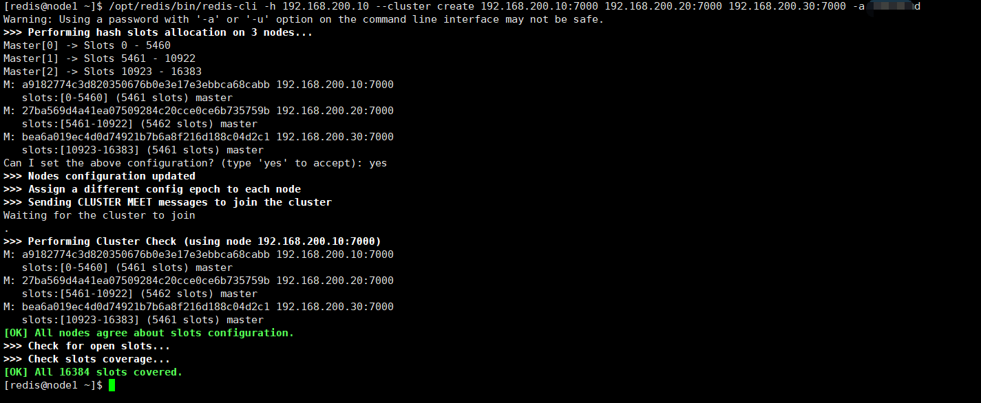

从节点加入集群
加入方式：/opt/redis/bin/redis-cli -h <主节点ip地址> -a 密码 --cluster add-node --cluster-slave --cluster-master-id master节点的id 从ip:从端口 主ip:主端口
/opt/redis/bin/redis-cli -h <主节点ip地址> -a 密码--cluster add-node --cluster-slave --cluster-master-id a9182774c3d820350676b0e3e17e3ebbca68cabb 192.168.200.40:7000 192.168.200.10:7000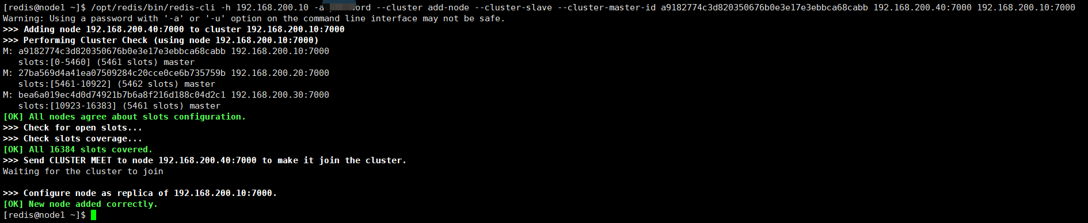
/opt/redis/bin/redis-cli -h <主节点ip地址> -a 密码--cluster add-node --cluster-slave --cluster-master-id 27ba569d4a41ea07509284c20cce0ce6b735759b 192.168.200.50:7000 192.168.200.20:7000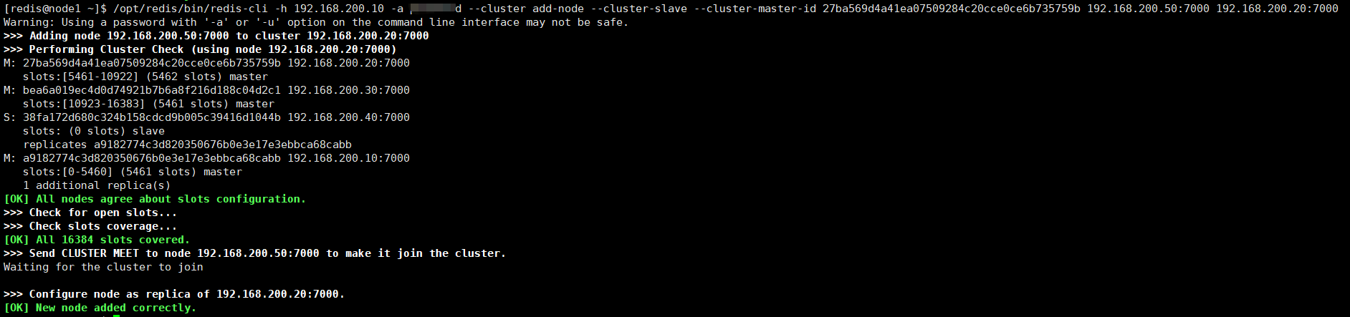
/opt/redis/bin/redis-cli -h <主节点ip地址> -a 密码--cluster add-node --cluster-slave --cluster-master-id bea6a019ec4d0d74921b7b6a8f216d188c04d2c1 192.168.200.60:7000 192.168.200.30:7000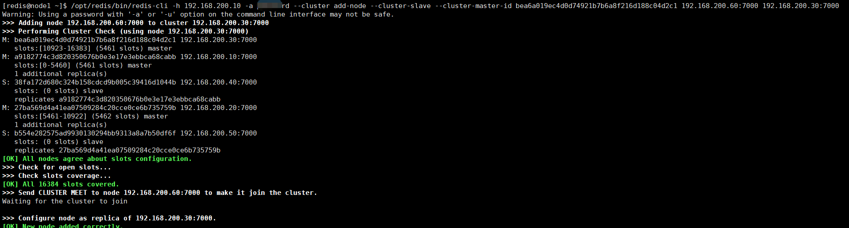

查看集群节点信息
/opt/redis/bin/redis-cli -h <主节点ip地址> -p 7000 -a 密码cluster nodes
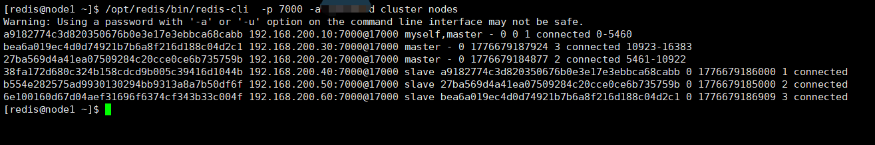
/opt/redis/bin/redis-cli -p 7000 -a 密码 -c cluster slots | xargs -n8 | awk '{print $3":"$4"->"$6":"$7}' | sort -nk2 -t ':' | uniq

添加开机自启
#使用sudo权限账号执行
sudo vi /etc/systemd/system/redis.service
[Unit]
Description=Redis 7000
After=network.target

[Service]
Type=simple
User=redis
Group=redis
ExecStart=/opt/redis/bin/redis-server /opt/redis/conf/redis-7000.conf
ExecStop=/opt/redis/bin/redis-cli -h 127.0.0.1 -a {password} -p 7000 shutdown
Restart=always
RestartSec=3
LimitNOFILE=65535

[Install]
WantedBy=multi-user.target
重载配置、添加开机启动:
#使用sudo权限账号执行
sudo systemctl daemon-reload
sudo systemctl enable redis

