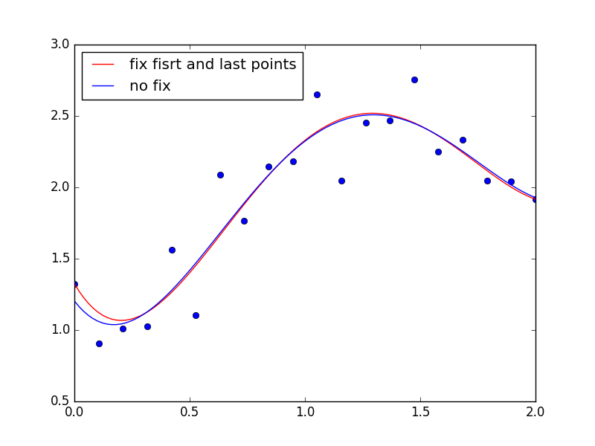
1. Frist Method (Least-Squares of different weight):

Gaps between true postions and estimated positions:
[-1.70151737e-09 2.13200659e-01 5.82894199e-02 1.01063834e-01
-3.01783237e-01 3.49270969e-01 -4.24853965e-01 1.16438435e-01
-6.42954705e-02 7.30313001e-02 -2.61367118e-01 4.33974843e-01
6.18798111e-02 3.85966324e-02 -3.04436898e-01 1.08990259e-01
-9.08017694e-02 7.06520371e-02 -3.98460040e-02 3.21449978e-10]

We can give the first and the last point a very little weight to make them infinitely close to the true value, but it’s not certainly to be exact. It depends on the tolerance we can have.

2. Second Method ( Lagrange Multipliers with equation constraint )

In theory, the equation is strictly solved. However, in computer science, it’s rarely true.
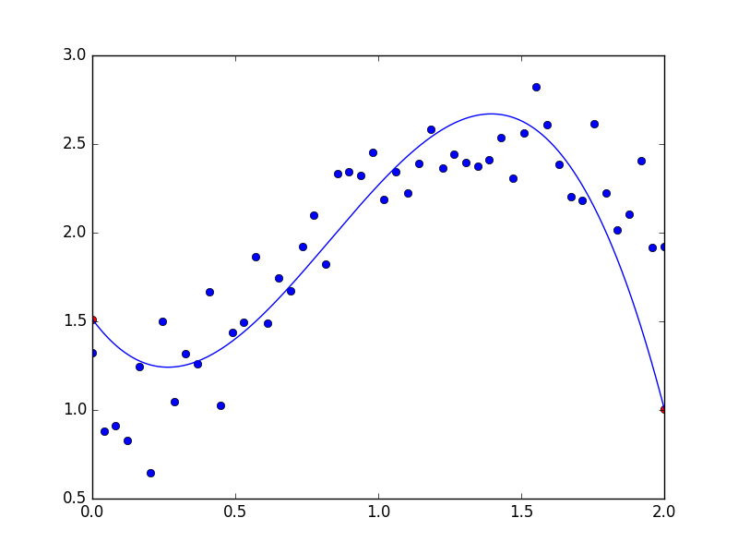
Gaps between true postions and estimated positions(first and last):
(-1.3322676295501878e-15, 3.7747582837255322e-15)
This method is not until well implemented.

