USER_LOGIN_EXP参考文档
需要文件：
/express/user_login_exp.class.php
/services/i_user_login.class.php
/exp.php
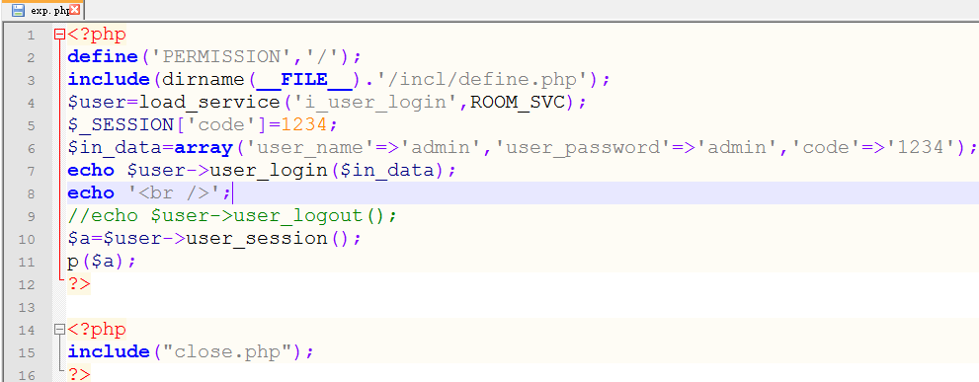
调用方法如上图
代码：
user_login_exp.class.php
<?php
/*
CREATE TABLE IF NOT EXISTS `yi_user` (
`id` int(10) unsigned NOT NULL auto_increment,
`user_name` varchar(20) NOT NULL,
`user_password` char(32) NOT NULL,
`email` varchar(50) NOT NULL,
`tag` tinyint(3) unsigned NOT NULL,
`reg_time` int(10) unsigned NOT NULL,
`login_time` int(10) unsigned NOT NULL,
`login_ip` char(15) NOT NULL,
`times` int(10) unsigned NOT NULL,
`allow_del` tinyint(3) unsigned NOT NULL default '0',
`myhash` char(32) NOT NULL default '',
PRIMARY KEY (`id`)
) ENGINE=MyISAM DEFAULT CHARSET=utf8 AUTO_INCREMENT=1 ;
*/
abstract class user_login_exp extends service{
//传入的数据
protected $in_data=null;
//用户数据
protected $user_data=null;
//初始化session MY code
protected function init_session(){
$_SESSION['MY']=array();
}
protected function fill_session(){
$_SESSION['MY']['ISLOGIN']=1;
$_SESSION['MY']['ID']=$this->user_data['id'];
$_SESSION['MY']['USER_NAME']=$this->user_data['user_name'];
$_SESSION['MY']['LOGIN_IP']=$this->user_data['login_ip'];
$_SESSION['MY']['LOGIN_TIME']=$this->user_data['login_time'];
$_SESSION['MY']['TIMES']=$this->user_data['times'];
}
//结束session MY code
protected function finish_session(){
$_SESSION=array();
if(isset($_COOKIE[session_name()])){
setcookie(session_name(),'',time()-3600,'/');
}
session_destroy();
return true;
}
//判断所有表单项是否填写
protected function check_blank(){
if($this->in_data['user_name']=='' or $this->in_data['user_password']=='' or $this->in_data['code']==''){
return false;
}
return true;
}
//判断验证码是否正确
protected function check_authcode(){
return strtoupper($this->in_data['code'])==$_SESSION['code'];
}
//判断用户是否存在
protected function check_user_exist(){
if(empty($this->user_data) or $this->user_data['id']==''){
return false;
}
return true;
}
//判断密码是否正确
protected function check_user_password(){
return md5password($this->in_data['user_password'])==$this->user_data['user_password'];
}
//读取一条用户信息
protected function get_user(){
$user_name=$this->in_data['user_name'];
$query="select `id`,`user_name`,`user_password`,`login_time`,`login_ip`,`times` from `{$this->prefix}user` where `user_name`='{$user_name}' and `tag`='1' limit 1";
$info=$this->sql_func->select($query);
$this->user_data=is_array($info)?$info:array();
return $info;
}
//更新 login_time,login_ip,times
protected function update_user(){
$id=$this->user_data['id'];
$login_time=time();
$login_ip=$_SERVER['REMOTE_ADDR'];
$query="update `{$this->prefix}user` set `login_time`='{$login_time}',`login_ip`='{$login_ip}',`times`=`times`+1 where `id`='{$id}' limit 1";
$this->sql_func->query($query);
}
//示例用户登陆程序
protected function example_user_login($in_data){
$this->in_data=$in_data;
if($this->check_blank()==false){
return -1;//信息未填写完全
}
if(!$this->check_authcode()){
return -2;//验证码不正确
}
$this->get_user();
if(!$this->check_user_exist()){
return -3;//用户不存在
}
if(!$this->check_user_password()){
return -4;//密码不正确
}
$this->update_user();
$this->init_session();
$this->fill_session();
return 1;//登陆成功
}
abstract public function user_login($in_data);
//示例用户登出程序
protected function example_user_logout(){
$this->finish_session();
return true;
}
abstract public function user_logout();
//示例获取用户session信息
protected function example_user_session($name=''){
$name=strtoupper($name);
return ($name=='')?$_SESSION['MY']:$_SESSION['MY'][$name];
}
abstract public function user_session($name='');
}
i_user_login.class.php
<?php
class i_user_login extends user_login_exp{

public function user_login($in_data){
return $this->example_user_login($in_data);
}
public function user_logout(){
return $this->example_user_logout();
}
public function user_session($name=''){
return $this->example_user_session($name);
}
}

