form_hash组件
/services/form_hash.class.php
使用示例：
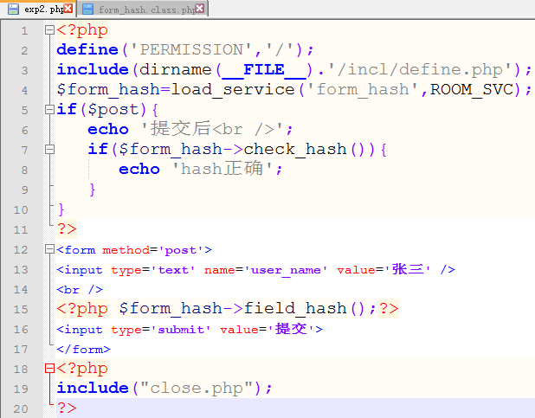
代码：
form_hash.class.php
<?php
class form_hash {
//生成一个hash
public function create_hash(){
$_SESSION['HASH']=md5(rand());
return $_SESSION['HASH'];
}
//删除hash
public function delete_hash(){
unset($_SESSION['HASH']);
}
public function get_hash(){
return $_SESSION['HASH'];
}
//检查hash是否正确
public function check_hash(){
if($_SESSION['HASH']!=$_POST['ihash_2013']){
exit('hash error!');
}
$this->delete_hash();
return true;
}
//生成一个表单隐藏字段
public function field_hash(){
if(!isset($_SESSION['HASH'])){
$this->create_hash();
}
$value=$_SESSION['HASH'];
echo "<input type='hidden' name='ihash_2013' value='{$value}' />\n";
}
}

