How to check a variable’s type?

* Open VS code
* Press: “Ctrl + ~” to enter Terminal
* In the Terminal, type: “python” to enter immediate mode
* Type the syntax: Type (Values) and Python return the class of the values

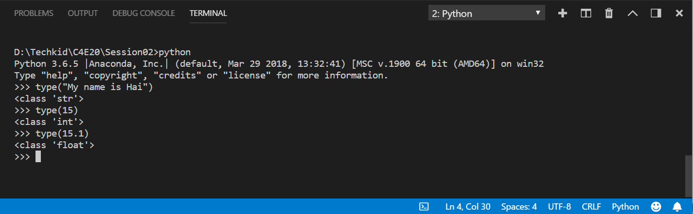

In what cases, you will get ***SyntaxError*** from the compiler telling you that some of your variables have **invalid names**? Can you give 3 different examples of **invalid names**?

The compiler return “SyntaxError” when

* Name of variables contains illegal character like: $,%,*
* Name of variable not begin with a letter or underscore.
* Name of variable is one of **Python keyword**

**Python keyword** include:

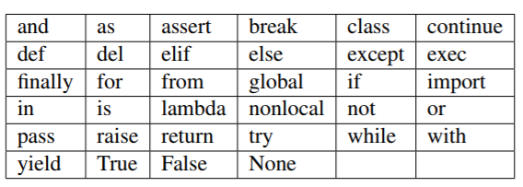

Examples:

* 123hello_world = 1
* hello_world* = 1
* import = 1

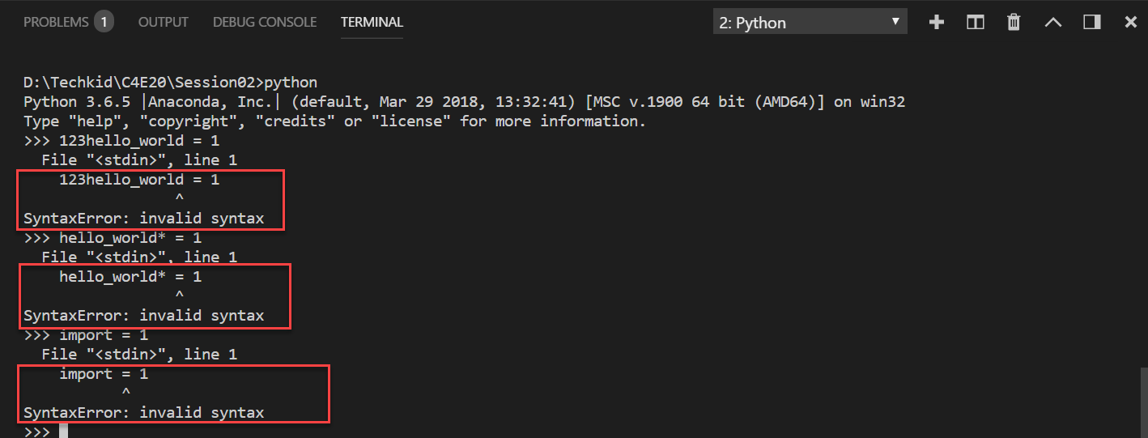

Account github: https://github.com/sonhaidang1995