Exercise 1:

* What is nested list? Can a list store both intergers and string in it?

Nested list is a list within another list. A list can contain string, float, intergers and another list.

Example:

nested_list = [“book”, “game”, 1, 2, [“code”,”music”]

Exercise 2:

* How to delete an item in a list?

Example 01: Way 1 delete an item in a list

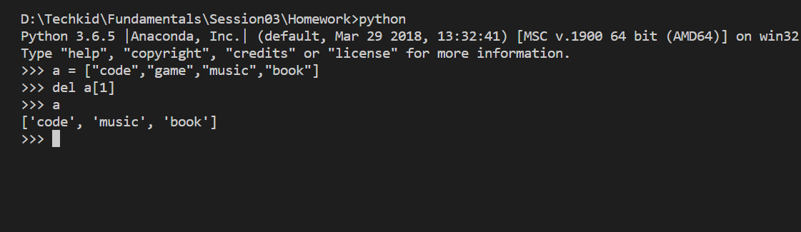

Example 02: Way 2 to delete an item in a list

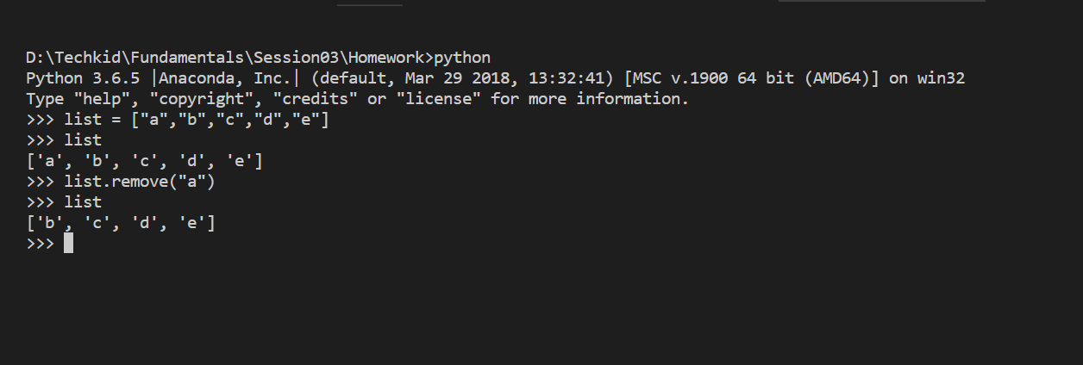

Example 03: Way 1 to delete a slide in a list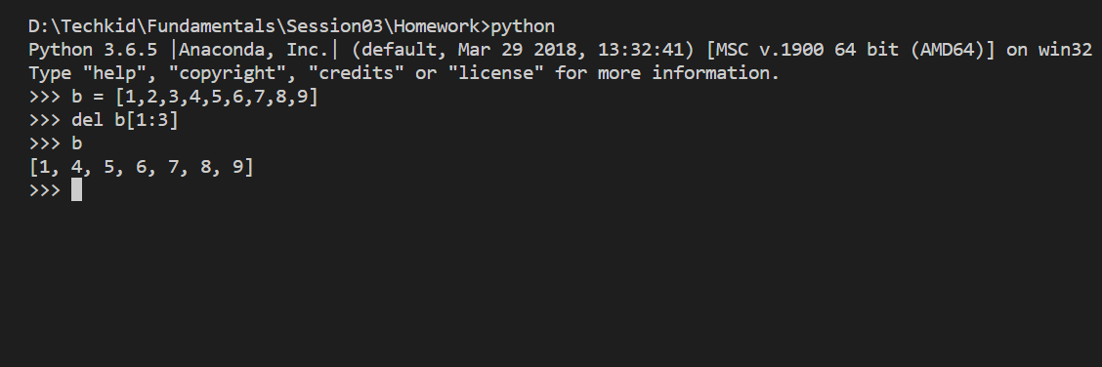

Example 03: Way 2 to delete a slide in a list

