Bài 1:

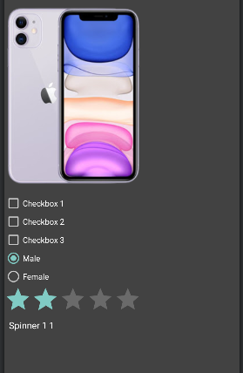

| <LinearLayout xmlns:android="http://schemas.android.com/apk/res/android"  android:layout_width="match_parent"  android:layout_height="match_parent"  android:background="@color/cardview_dark_background"  >  <ScrollView  android:layout_width="match_parent"  android:layout_height="wrap_content">  <LinearLayout  android:orientation="vertical"  android:layout_width="match_parent"  android:layout_height="wrap_content">  <ImageView  android:layout_width="wrap_content"  android:layout_height="wrap_content"  android:src="@drawable/iphone_11" />  <CheckBox  android:layout_width="wrap_content"  android:layout_height="wrap_content"  android:text="Checkbox 1" />  <CheckBox  android:layout_width="wrap_content"  android:layout_height="wrap_content"  android:text="Checkbox 2" />  <CheckBox  android:layout_width="wrap_content"  android:layout_height="wrap_content"  android:text="Checkbox 3" />  <RadioGroup  android:layout_width="wrap_content"  android:layout_height="wrap_content">  <RadioButton  android:id="@+id/ex_2_2_gender_male"  android:layout_width="wrap_content"  android:layout_height="wrap_content"  android:checked="true"  android:text="Male" />  <RadioButton  android:id="@+id/ex_2_2_gender_female"  android:layout_width="wrap_content"  android:layout_height="wrap_content"  android:text="Female" />  </RadioGroup>  <RatingBar  android:layout_width="wrap_content"  android:layout_height="wrap_content"  android:numStars="5"  android:rating="2"  android:stepSize="1" />  <Spinner  android:id="@+id/ex_2_2_spinner_1"  android:layout_width="wrap_content"  android:entries="@array/spinner_1"  android:layout_height="wrap_content" />  <Spinner  android:id="@+id/ex_2_2_spinner_2"  android:layout_width="wrap_content"  android:layout_height="wrap_content" />  </LinearLayout>  </ScrollView>  </LinearLayout> |
| --- |

Bài 2:

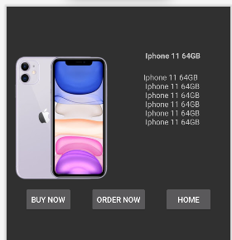

| <androidx.constraintlayout.widget.ConstraintLayout xmlns:android="http://schemas.android.com/apk/res/android"  xmlns:app="http://schemas.android.com/apk/res-auto"  android:layout_width="match_parent"  android:layout_height="match_parent">  <ImageView  android:id="@+id/ex_2_img"  android:layout_width="200dp"  android:layout_height="250dp"  android:layout_marginTop="80dp"  android:src="@drawable/iphone_11"  app:layout_constraintLeft_toLeftOf="parent"  app:layout_constraintTop_toTopOf="parent" />  <TextView  android:id="@+id/ex_2_title"  android:layout_width="wrap_content"  android:layout_height="wrap_content"  android:text="Iphone 11 64GB"  android:textStyle="bold"  app:layout_constraintLeft_toRightOf="@+id/ex_2_img"  app:layout_constraintRight_toRightOf="parent"  app:layout_constraintTop_toTopOf="@+id/ex_2_img" />  <TextView  android:id="@+id/ex_2_desc"  android:layout_width="wrap_content"  android:layout_height="wrap_content"  android:layout_marginTop="20dp"  app:layout_constraintRight_toRightOf="parent"  app:layout_constraintTop_toBottomOf="@+id/ex_2_title"  app:layout_constraintLeft_toRightOf="@+id/ex_2_img"  android:text="Iphone 11 64GB\n Iphone 11 64GB\n Iphone 11 64GB\n Iphone 11 64GB\n Iphone 11 64GB\n Iphone 11 64GB"  />  <Button  android:id="@+id/ex_2_btn_buy"  android:layout_width="wrap_content"  android:layout_height="wrap_content"  android:text="BUY NOW"  app:layout_constraintEnd_toStartOf="@+id/ex_2_btn_order"  app:layout_constraintHorizontal_bias="0.5"  app:layout_constraintHorizontal_chainStyle="spread"  app:layout_constraintStart_toStartOf="parent"  app:layout_constraintTop_toBottomOf="@+id/ex_2_img" />  <Button  android:id="@+id/ex_2_btn_order"  android:layout_width="wrap_content"  android:layout_height="wrap_content"  android:text="ORDER NOW"  app:layout_constraintEnd_toStartOf="@+id/ex_2_btn_home"  app:layout_constraintHorizontal_bias="0.5"  app:layout_constraintHorizontal_chainStyle="spread"  app:layout_constraintStart_toEndOf="@+id/ex_2_btn_buy"  app:layout_constraintTop_toBottomOf="@+id/ex_2_img" />  <Button  android:id="@+id/ex_2_btn_home"  android:layout_width="wrap_content"  android:layout_height="wrap_content"  android:text="HOME"  app:layout_constraintEnd_toEndOf="parent"  app:layout_constraintHorizontal_bias="0.5"  app:layout_constraintHorizontal_chainStyle="spread"  app:layout_constraintStart_toEndOf="@+id/ex_2_btn_order"  app:layout_constraintTop_toBottomOf="@+id/ex_2_img" />  </androidx.constraintlayout.widget.ConstraintLayout> |
| --- |

Bài 3:

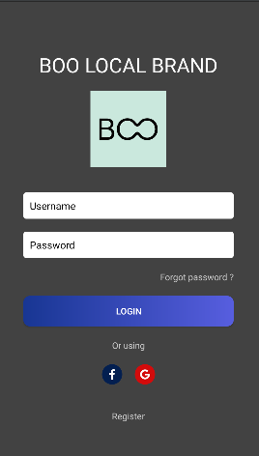

| <LinearLayout xmlns:android="http://schemas.android.com/apk/res/android"  xmlns:app="http://schemas.android.com/apk/res-auto"  android:layout_width="match_parent"  android:layout_height="match_parent"  android:background="@color/white"  android:backgroundTint="@color/cardview_dark_background">  <ScrollView  android:layout_width="match_parent"  android:layout_height="match_parent"  android:fillViewport="true">  <LinearLayout  android:layout_width="match_parent"  android:layout_height="match_parent"  android:gravity="center"  android:orientation="vertical"  android:paddingLeft="40dp"  android:paddingTop="20dp"  android:paddingRight="40dp"  android:paddingBottom="20dp">  <TextView  android:layout_width="wrap_content"  android:layout_height="wrap_content"  android:text="BOO LOCAL BRAND"  android:textColor="@color/white"  android:layout_marginTop="40dp"  android:textSize="32sp" />  <ImageView  android:layout_width="120dp"  android:layout_height="120dp"  android:layout_marginTop="20dp"  android:layout_marginBottom="40dp"  android:src="@drawable/boo" />  <EditText  android:layout_width="match_parent"  android:layout_height="wrap_content"  android:layout_marginBottom="20dp"  android:background="@drawable/bg_white_corner_4"  android:hint="Username"  android:padding="10dp"  android:textColor="@color/black"  android:textColorHint="@color/black"  android:textSize="16dp" />  <EditText  android:layout_width="match_parent"  android:layout_height="wrap_content"  android:layout_marginBottom="20dp"  android:background="@drawable/bg_white_corner_4"  android:hint="Password"  android:inputType="textPassword"  android:padding="10dp"  android:textColor="@color/black"  android:textColorHint="@color/black"  android:textSize="16dp" />  <RelativeLayout  android:layout_width="match_parent"  android:layout_height="wrap_content">  <TextView  android:layout_width="wrap_content"  android:layout_height="wrap_content"  android:layout_alignParentRight="true"  android:text="Forgot password ?" />  </RelativeLayout>  <Button  android:layout_width="match_parent"  android:layout_height="wrap_content"  android:layout_marginTop="20dp"  android:background="@drawable/bg_linear_blue_corner_4"  android:text="Login" />  <TextView  android:layout_width="wrap_content"  android:layout_height="wrap_content"  android:layout_marginTop="20dp"  android:text="Or using" />  <LinearLayout  android:layout_width="wrap_content"  android:layout_height="wrap_content"  android:background="@drawable/bg_blue_corner_16"></LinearLayout>  <LinearLayout  android:layout_marginTop="20dp"  android:layout_width="match_parent"  android:layout_height="wrap_content"  android:gravity="center_horizontal">  <LinearLayout  android:layout_marginLeft="10dp"  android:layout_marginRight="10dp"  android:layout_width="32dp"  android:layout_height="32dp"  android:background="@drawable/bg_blue_corner_16"  android:gravity="center">  <ImageView  android:layout_width="16dp"  android:layout_height="16dp"  android:src="@drawable/ic_facebook" />  </LinearLayout>  <LinearLayout  android:layout_marginLeft="10dp"  android:layout_marginRight="10dp"  android:layout_width="32dp"  android:layout_height="32dp"  android:background="@drawable/bg_red_corner_16"  android:gravity="center">  <ImageView  android:layout_width="16dp"  android:layout_height="16dp"  android:src="@drawable/ic_google" />  </LinearLayout>  </LinearLayout>  <TextView  android:layout_width="wrap_content"  android:layout_height="wrap_content"  android:text="Register"  android:layout_marginTop="40dp"  />  </LinearLayout>  </ScrollView>  </LinearLayout> |
| --- |

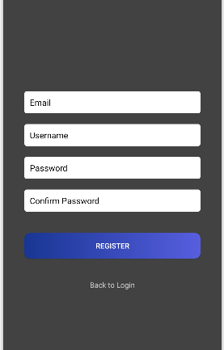

| <LinearLayout xmlns:android="http://schemas.android.com/apk/res/android"  xmlns:app="http://schemas.android.com/apk/res-auto"  android:layout_width="match_parent"  android:layout_height="match_parent"  android:background="@color/white"  android:backgroundTint="@color/cardview_dark_background">  <ScrollView  android:layout_width="match_parent"  android:layout_height="match_parent"  android:fillViewport="true">  <LinearLayout  android:layout_width="match_parent"  android:layout_height="match_parent"  android:gravity="center"  android:orientation="vertical"  android:paddingLeft="40dp"  android:paddingTop="20dp"  android:paddingRight="40dp"  android:paddingBottom="20dp">  <EditText  android:layout_width="match_parent"  android:layout_height="wrap_content"  android:layout_marginBottom="20dp"  android:background="@drawable/bg_white_corner_4"  android:hint="Email"  android:padding="10dp"  android:textColor="@color/black"  android:textColorHint="@color/black"  android:textSize="16dp" />  <EditText  android:layout_width="match_parent"  android:layout_height="wrap_content"  android:layout_marginBottom="20dp"  android:background="@drawable/bg_white_corner_4"  android:hint="Username"  android:padding="10dp"  android:textColor="@color/black"  android:textColorHint="@color/black"  android:textSize="16dp" />  <EditText  android:layout_width="match_parent"  android:layout_height="wrap_content"  android:layout_marginBottom="20dp"  android:background="@drawable/bg_white_corner_4"  android:hint="Password"  android:inputType="textPassword"  android:padding="10dp"  android:textColor="@color/black"  android:textColorHint="@color/black"  android:textSize="16dp" />  <EditText  android:layout_width="match_parent"  android:layout_height="wrap_content"  android:layout_marginBottom="20dp"  android:background="@drawable/bg_white_corner_4"  android:hint="Confirm Password"  android:inputType="textPassword"  android:padding="10dp"  android:textColor="@color/black"  android:textColorHint="@color/black"  android:textSize="16dp" />  <Button  android:layout_width="match_parent"  android:layout_height="wrap_content"  android:layout_marginTop="20dp"  android:background="@drawable/bg_linear_blue_corner_4"  android:text="Register" />  <LinearLayout  android:layout_width="wrap_content"  android:layout_height="wrap_content"  android:background="@drawable/bg_blue_corner_16"></LinearLayout>  <TextView  android:layout_width="wrap_content"  android:layout_height="wrap_content"  android:text="Back to Login"  android:layout_marginTop="40dp"  />  </LinearLayout>  </ScrollView>  </LinearLayout> |
| --- |