**RESEARCH PROJECT**

**AN ANALYSIS OF FINANCIAL PERFORMANCE AND TRENDS IN THE INDIAN AUTOMOBILE INDUSTRY.**

**PREPARED BY**

**DINKAL PARASBHAI BHADIYADRA**

**0021017**

**BBA SEM-6 (FINANCE)**

**GUIDED BY**

**ASSISTANT PROFESSOR**

**Ms. KHUSHALI OZA**

**ACADEMIC YEAR**

**2023-24**

**SUBMITTED BY**

**SHREE SWAMINARAYAN COLLEGE OF**

**COMMERCE & MANAGEMENT,**

**BHAVNAGAR**

**AFFILIATED TO**

**MAHARAJA KRISHNAKUMARSINHJI BHAVNAGAR UNIVERSITY**

**BHAVNAGAR, GUJARAT**

**INDEX**

|  |  |  |
| --- | --- | --- |
| **NO.** | **PARTICULARS** | **Page**  **No.** |
| **1.** | **Acknowledgement** |  |
| **2.** | **Declaration** |  |
| **3.** | **Abstract** |  |
| **4.** | **Chapter 1** |  |
|  | * **Introduction** |  |
|  |  |  |
|  |  |  |
| **5.** | **Chapter 2: LITERATURE REVIEW** |  |
| **6.** | **Chapter 3: RESEARCH METHODOLOGY** |  |
|  | * **Introduction** |  |
|  | * **Problem Identification** |  |
|  | * **Problem Statement** |  |
|  | * **Research Approach** |  |
|  | * **Research Design** |  |
|  | * **Objective of study** |  |
|  |  |  |
|  |  |  |
|  |  |  |
|  |  |  |
|  |  |  |
|  |  |  |
|  |  |  |
| **7.** | **Chapter 4: Data Analysis** |  |
| **8.** | **Chapter 5: Findings & Recommendations** |  |
| **9.** | **Bibliography** |  |

**ACKNOWLEDGEMENT**

Feeling gratitude and not expressing it is like wrapping a present and not giving it.

* **William Arthur Ward**

I would maintain that thanks are the highest form of thought; and that gratitude is happiness doubled by wonder

**-G.K. Chesterton**

These two quotes inspired me to come up with an acknowledgement of all those persons who have contributed significantly to the compilation of this piece of work or those who played a crucial role by encouraging me during thesis preparation.

At the start, my deepest gratitude to “**The Almighty**” who bestowed upon me his best bunch of blessings so that I could keep self-concentrated towards my aspirations all the time.

I would also like to take the opportunity to pay my deepest gratitude to the person who had been mentoring my research work, Professor **KHUSHALI OZA–** for providing his valuableguidance throughout my research work and sharing his vast knowledge during this course which was of great assistance in compiling my research.

The list of gratitude would not end unless the names of the person who made unconditional efforts in providing me with all the required study material for my research project, thus thanks for all.

# LIST OF TABLES

|  |  |  |
| --- | --- | --- |
| **SL NO** | **Title** | **Page No** |
| **5.1** | Current Ratio | **34** |
| **5.2** | Liquid Ratio | **35** |
| **5.3** | Absolute Liquid Ratio | **36** |
| **5.4** | Debt Equity Ratio | **37** |
| **5.5** | Total Asset Ratio | **38** |
| **5.6** | Proprietary Ratio | **39** |
|  |  |  |
|  |  |  |
| **5.7** | Interest Coverage Ratio | **41** |
| **5.8** | Stock Turnover Ratio | **42** |
| **5.9** | Debtors Turnover Ratio | **43** |
| **5.10** | Creditors Turnover Ratio | **45** |
| **5.11** | Working Capital Turnover Ratio | **46** |
| **5.12** | Gross Profit Ratio | **47** |
| **5.13** | Operating Ratio | **48** |
| **5.14** | Operating Profit Ratio | **49** |
| **5.15** | Net Profit Ratio | **50** |
| **5.16** | Return on Total Asset Ratio | **51** |
| **5.17** | Comparative Balance Sheet as of 2016 & 2017 | **54** |
| **5.18** | Comparative Income Statement as of 2016&2017 | **55** |
| **5.19** | Comparative Balance Sheet as of 2017 & 2018 | **56** |
| **5.20** | Comparative Income Statement as of 2017 & 2018 | **57** |
| **5.21** | Comparative Balance Sheet as of 2018 & 2019 | **58** |
| **5.22** | Comparative Income Statement as of 2018 & 2019 | **59** |
| **5.23** | Comparative Balance Sheet as of 2019 & 2020 | **60** |
| **5.24** | Comparative Income Statement as of 2019 & 2020 | **61** |
|  | Comparative Income Statement as of 2020 & 2021 |  |

**LIST OF FIGURES**

|  |  |  |
| --- | --- | --- |
| **SL No** | **Title** | **Page No** |
| **5.1** | Current Ratio | **34** |
| **5.2** | Liquid Ratio | **35** |
| **5.3** | Absolute Liquid Ratio | **36** |
| **5.4** | Debt Equity Ratio | **38** |
| **5.5** | Total Asset Ratio | **39** |
| **5.6** | Proprietary Ratio | **40** |
| **5.7** | Interest Coverage Ratio | **41** |
| **5.8** | Stock Turnover Ratio | **43** |
| **5.9** | Debtors Turver Ratio | **44** |
| **5.10** | Creditors Turnover Ratio | **45** |
| **5.11** | Working Capital Turnover Ratio | **46** |
| **5.12** | Gross Profit Ratio | **48** |
| **5.13** | Operating Ratio | **49** |
| **5.14** | Operating Profit Ratio | **50** |
| **5.15** | Net Profit Ratio | **51** |
| **5.16** | Return on Total Asset | **52** |

# ABBREVIATIONS

# 1. GDP: GROSS DOMESTIC PRODUCT

1. P&L: Profit and Loss

## HIP: Human Information Program

## DEA: Data Envelopment Analysis

## GM: General Motors

1. FY: Financial Year

Feeling gratitude and not expressing it is like wrapping a present and not giving it.

I would maintain that thanks are the highest form of thought; and that gratitude is happiness doubled by wonder**.**

These two quotes inspired me to come up with an acknowledgement of all those persons who have contributed significantly to the compilation of this piece of work or those who played a crucial role by encouraging me during thesis preparation.

At the start, my deepest gratitude to “**The Almighty**” who bestowed upon me his best bunch of blessings so that I could keep self-concentrated towards my aspirations all the time.

I would also like to take the opportunity to pay my deepest gratitude to the person who had been mentoring my research work, Professor Ms **KHUSHALI OZA** and our head Mr **Harin Bhatt–** for providing his valuableguidance throughout my research work and sharing his vast knowledge during this course which was of great assistance in compiling my research.

The list of gratitude would not end unless the names of the person who made unconditional efforts in providing me with all the required study material for my research project, thus thanks for all.

**DECLARATION**

I undersigned **Ms Dinkal P. Bhadiyadra** at this moment, declare that the work embodied in this project work titled, “An Analysis of Financial Performance and Trends in the Indian Automobile Industry.” forms my contribution to the research work carried out under the guidance of “ASSISTANT PROFESSOR KHUSHALI OZA” and our head Mr Harin has not been previously submitted to any other University for any other Degree/Diploma to this or any other University. Wherever reference has been made to previous works of others, it has been indicated as such and included in the bibliography.

I, here further declare that all information in this document has been obtained and presented under academic rules and ethical conduct.

Name and Signature of Learner

DINKAL P. BHADIYADRA

Certified by

ASS. PRO. KHUSHALI OZA

DATE:

PLACE

**CHAPTER 1**

## **OVERVIEW**

India is the world’s third-largest automobile market, the largest manufacturer of passenger vehicles and tractors, and the second-largest manufacturer of two-wheelers.

The Indian automobile industry is one of the largest in the world, with a wide range of vehicles being manufactured and sold in the country. The industry includes manufacturers of cars, motorcycles, commercial vehicles, and electric vehicles.

The industry has seen significant growth over the past few decades, driven by factors such as rising disposable incomes, urbanisation, and government initiatives to promote manufacturing in the country. India is now one of the largest markets for automobiles globally, with both domestic and international manufacturers operating in the country. Meeting increasing demand, thanks to his investment in automation. by implementing new equipment, and software, and In the first quarter of 2023-24, the total production of passenger vehicles, commercial vehicles, three-wheelers, two-wheelers, and quadricycles was 6.01 million units.

Hero Moto Corp the Principal activities of the Company are manufacturing and marketing of motorcycles and spare parts. The Company is a joint venture between Hero Group, India. The Motorcycles of the Company features facilities such as four-stroke technology, phenomenal fuel economy and low exhaust pollution levels. The major brands of the Company include Splendor, Joy and Passion.

The two manufacturing facilities of the Company are located in Haryana. Motorcycles accounted for 95% of fiscal 2009 gross revenues and spare parts, 5%. Grows over 500% in five years For 2010-11, volume was up by 38 per cents; net profit soared by 88 per cent; total turnover was up by 42 per cent Achieves a high 48 per cent motorcycle market share; and 33 per cent two-wheeler market share Announces 350 per cent final dividend and 250 per cent celebration dividend (over and above special interim dividend of 250%) Over the last five years, the company's total turnover has grown by a whopping 580% PAT by 919% New Delhi, April 13, 2011: Hero Moto Corp Co.., the newly crowned World No. 1 two-wheeler companies, declared outstanding financial results for the year 2010-11.

Profit after tax (PAT) is Rs. 462.93 crores, a growth of 88 per cent. The company's total turnover (sales plus other income, net of excise) grew to Rs. 4539.49 crore, a growth of 42 per cent. In a landmark run, the company achieved a 48 per cent market share in the motorcycle category during the

## BACKGROUND OF THE STUDY

Financial statement analysis is an important part of the overall financial analysis. It is based on the financial statements, i.e., Balance Sheet and Statements of Profit and Loss, which are the end products of the accounting process. Analysis of Financial Statements is a systematic process of critical examination of the financial information contained in the financial statements to understand and make decisions regarding the operations of the enterprise. The analysis of financial statements is a study of relationships among various financial figures as set out in the financial statements, i.e., Balance Sheet and Statement of Profit and Loss. The complex data given in these financial statements is divided or broken into simple and valuable elements and relationships are established between the elements of the same statement or different financial statements. The project is undertaken to understand the company HERO MOTORCORP and to study the financial structure, to interpret and analyze the financial statement which will help to forecast its activities for future earnings. The main objective is to analyze the financial statement based on ratio analysis and comparative statements.

## STATEMENT OF THE PROBLEM

Finance in our present-day economy is defined as the provision of money at the time when it is required. Every enterprise whether big medium or small needs funds to carry on its day-to-day operations and to achieve its targets. Finance is so dispensable today that it is said that finance is the “Life Blood of an Enterprise”. Without finance, no enterprise can accomplish its goals and objectives.

Financial management is a managerial process that is concerned with the planning and control of financial resources. It has recently originated as a separate discipline. Proper handling of finance makes an organization profitable. In this present scenario, financial management is not only the collection of funds but also their proper utilization.

The money-related perfection makes an association effective in achieving its goals. Association convey their budgetary data through money-related reports and explanations. By dissecting the monetary presentation, we can comprehend whether the association is under sound money-related conditions. Financial smoothness makes an organization successful in accomplishing its objectives. The organization communicates their financial information through financial reports and statements. By analyzing the financial performance, we can understand whether the organization is in sound financial condition.

## RELEVANCE & SCOPE OF THE STUDY

* The project is undertaken to analyse and understand the financial statement of HERO MOTORCORP which allows using theoretical knowledge practically.
* To know how the company manages its managerial efficiency.
* To have a sound knowledge regarding various ratios and comparative statements and how they impact the organization
* To find out the relationship between the various variables and their impact on the functioning of the organization.

## OBJECTIVE OF THE STUDY

* The project is undertaken to analyse and understand the financial statement of HERO MOTORCORP which allows using theoretical knowledge practically.
* To know how the company manages its managerial efficiency.
* To have a sound knowledge regarding various ratios and comparative statements and how they impact the organization
* To find out the relationship between the various variables and their impact on the functioning of the organization.

**Hero Motors Company (HMC)**

Hero Motors Company (HMC)is a multinational business conglomerate based in India and is controlled by Pankaj M Munjal. The HMC family includes various organisations such as Hero Cycles, Avocet Sports (UK), BSH (Sri Lanka), Firefox, Spur, HGD, Hero Motors, Munjal Hospitality, Munjal Kiriu, ZF Hero, and OMA. It is a Delhi-based former moped and scooter manufacturer and is now a part of Hero Motors Company. This multinational corporation also owns Hero Moto-Corp (formerly Hero Honda) and Hero Cycles.

Due to tightening emission regulations and poor sales, Hero Motors has transferred the manufacture of all gasoline-powered vehicles to Hero Moto-Corp and transformed itself into an electric two-wheeler and auto parts manufacturer.

Hero MotoCorp Limited was incorporated on January 19th, 1984 under the name Hero Honda Motors Ltd. The Company was established as a Joint Venture Company between Honda Motor Company of Japan and Hero Group. In the year 1983, they signed a Joint Collaboration Agreement and formed the Company.

Brands: Hero Motors (also known as Hero Motors’ Gear & Transmissions) – produces gearboxes, ATV-sub transmissions, primary drive assemblies for motorcycles, transmission gear assemblies for motorcycles, balance shaft assemblies for marine and snowmobile engines, and starter gear and oil pump gear assemblies for the automotive industry.

Hero MotoCorp – New Delhi-based motorcycle, ATV, moped and scooter manufacturer.

Hero Cycles – The Largest manufacturer of bicycles in India. In addition to Hero branded bicycles, Hero also produces the following "premium brands": Hero Sprint (mountain bikes), Octane (mountain bikes), Disney (children's bikes), Miss India (women's bikes), UT and Firefox bikes

1st Two-Wheeler Manufacturer in the World- We are empowering millions around the globe through our portfolio of innovative and sustainable products. Powered by technology-driven excellence, we are shaping the future of mobility.

The Indian Two-Wheeler Industry-

The Indian two-wheeler sector contributes the largest volumes among all the segments in the automobile Industry. Though the segment can be broadly categorized into 3 sub-segments viz; scooters, motorcycles and mopeds; some categories introduced in the market are a combination of two or more segments e.g. scooters and stepthru's. The market primarily comprises five players in the two-wheeler segment with most of the companies having foreign collaborations with well-known Japanese firms earlier. But with most of the companies now planning 100% subsidiaries in India.

In the last four to five years, the two-wheeler market has witnessed a marked shift towards motorcycles at the expense of scooters. In rural areas, consumers have come to prefer sturdier bikes to withstand bad road conditions. In the process the share of the motorcycle segment has grown from 48% to 58%, the share of scooters declined drastically from 33% to 25%, while that of mopeds declined by 2% from 19% to 17% during the year 2009-10. All new vehicles are now being replaced by 4 stock motorcycles. Reduced excise duties and fierce competition have led to a fall in the prices of certain models.

Hero, a name synonymous with two-wheelers in India, began its journey around four decades ago. Starting as a manufacturer of by-cycle components, the Hero has today grown into a multi-unit, multi-product, geographically diversified group of companies.

The hero group began with a simple philosophy: to provide excellent transportation to the common man, at a price he could easily afford. Even today the dream of providing total satisfaction is all its sphere of activity. To consumers, excellent products at an affordable price; a thorough understanding of the fast-changing consumer understanding the fast-changing consumer behaviour, new market segments and opportunities, and a marketing mix sensitive to changing customer needs from the core of Hero's marketing strategy and philosophy.

Hero Moto Corp. is one of the leading companies in the two-wheeler Industry. At present. it is segmented with around 47% of the market share during the financial year. 2000-01. The company has as emerged one of the most successful players, much ahead of its competitors by its superior and reliable product quality complemented by excellent marketing techniques.

Hero Moto Corp has been an early entrant in the 4-stroke segment of the two-wheeler industry. With the right mix of product styling and pricing, the company has grabbed the 4-stoke market as compared to Bajaj Auto and TVS.

Mmmm TVS Motors Ltd has been the largest manufacturer of mopeds which are prevalent as a low-cost transportation and provide tremendous potential in all parts of India. However, the company is likely to face the threat of Bajaj Auto Ltd (BAL) which continued its price-based competition with Hero Moto Corp cycle and Scooter Ltd. a new entrant in the 2-wheeler market.

The company has achieved the industry growth rates by a huge margin. From April to December 2008 while the motorcycle industry sales were up to 38.68% TVS Motor's sales surged by a whopping 73.6% more importantly it is the success of its model Victor. Baja Auto has continued with its impressive performance witnessing significant growth in the motorcycle and three-wheeler segments. Based on the performance fill data one can expect the company to meet its excellence by FY09. Hero Moto Corp is the largest player in the motorcycle segment. Focused on contemporary design and style, the company has a compare leucine ranges bikes viz;

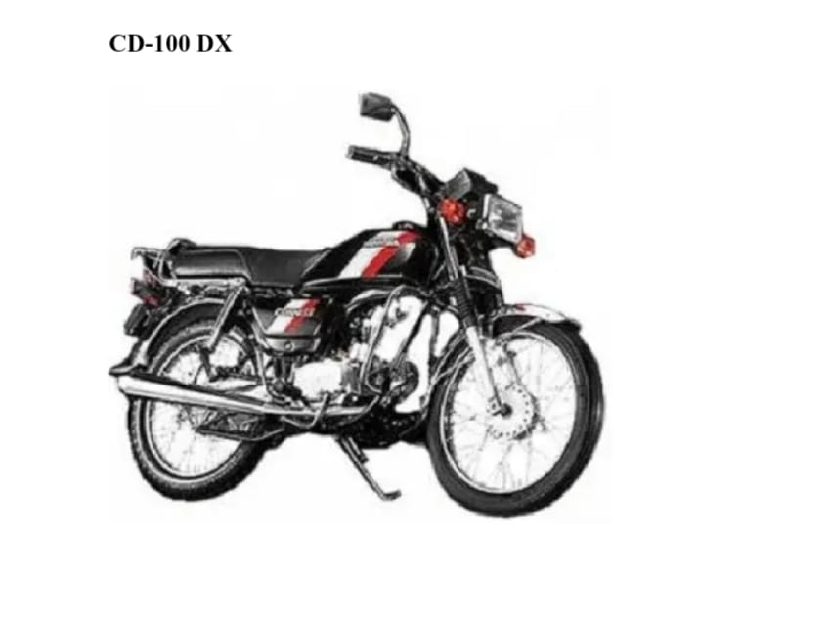

Its splendour model is urban-centric with its fuel efficiency which accounts for over 60-70% of its sales. The passion launched in mid-Jan. 2001 has a resending success contributing to 26% of its sales.

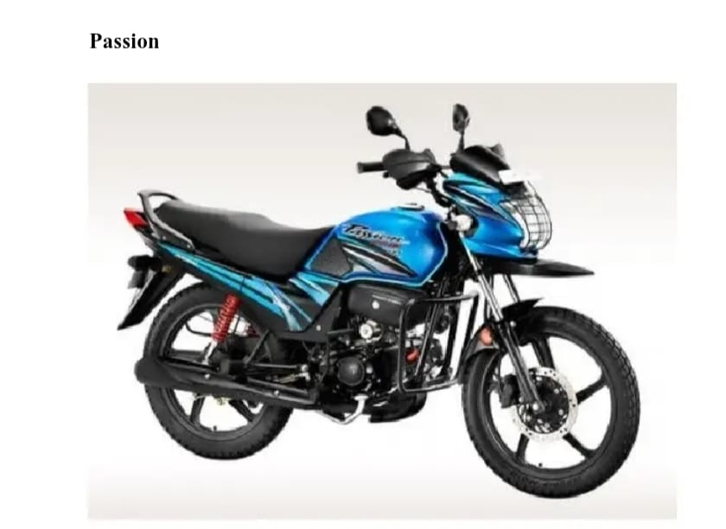

TVS offers a wide range of two-wheeler motorcycles- Victor/Fiero/Max100/max100R/Max DL.

Scooterette-TVS scotty

Moped- chap/ XL/ XL super/ XL supper HD/ sports.

TVS plans to launch 4 new models in the coming 15 months. A 4-stroke version of India's best-selling scooter; TVS-Scooty and a 4-stroke version of the existing moped line will be launched this year.

Bajaj Auto Ltd: Offer product service to the customers to satisfy their needs. It has a 4-stroke single-cylinder natural air to cool the displacement of the engine is 111.6 CC having the engine power is 7-7 bhp at 7000 spm. The bike has a hydrometric disc brake in the front wheel. "Flash" is an added future in the bike.

In 1993 BAL manufactured 12 different models 5-5 scooter model, 3- motorcycle model, moped model, 3-three-wheeler model.

But in recent years Bajaj developed various models in the motorcycle segment which provide good riding conditions in urban roads as well as rater roads. Scooter- cub/super/super FE/chetak/stride/Msl Priya, Moped- Bajaj Sunny.

Motorcycle- M-80/Kawasaki RTZ/Kawasaki45 by 1993 and latest model are. Eliminator/Pulsor 180/Pulsor 150/Boxer/Caliber Crowa/Caliber Sales performance of the player:

Hero Moto Corp repeated a y-o-y growth of 6.3% in its motorcycle sales for Jan 2006 at 1,45,708 units. Exports during the month have surged almost 64% y-o-y. On a month-on-month basis, the sales growth has been even higher up 16.5%.

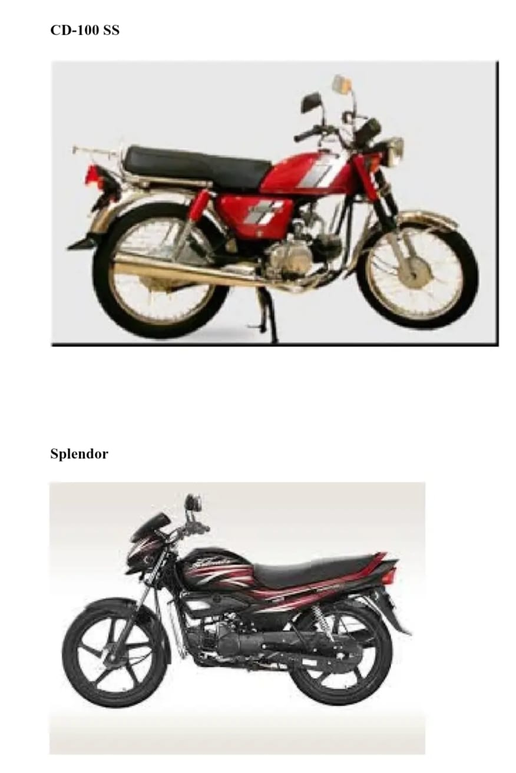

In 2023, Honda unveiled its Digital Fact Book, offering a comprehensive overview of its worldwide operations, sales, manufacturing, and research and development endeavours. Emphasizing proximity to consumers, Honda operates 18 major manufacturing facilities in North America and collaborates with nearly 800 suppliers in the region. The company's environmental consciousness is evident through the introduction of new electric and hybrid vehicles, with aspirations to unveil over 10 electric motorcycle models globally by 2025. Honda is also dedicated to fortifying its business framework, focusing on five pivotal elements for mobility advancement: carbon neutrality, energy management, resource circulation, AD/ADAS (Advanced Driver-Assistance Systems), and IoT/Connected technologies. With a continuous enhancement in its earnings structure, Honda targets a return on sales (ROS) of 7% by 2026.

In the realm of electrification, Honda aims to elevate the proportion of electric vehicle (EV) and fuel cell electric vehicle (FCEV) sales to 100% globally by 2040. To achieve this, the comny plans to manufacture over 2 million EVs annually by 2030 and has forged strategic partnerships to ensure consistent progress in electrification efforts.

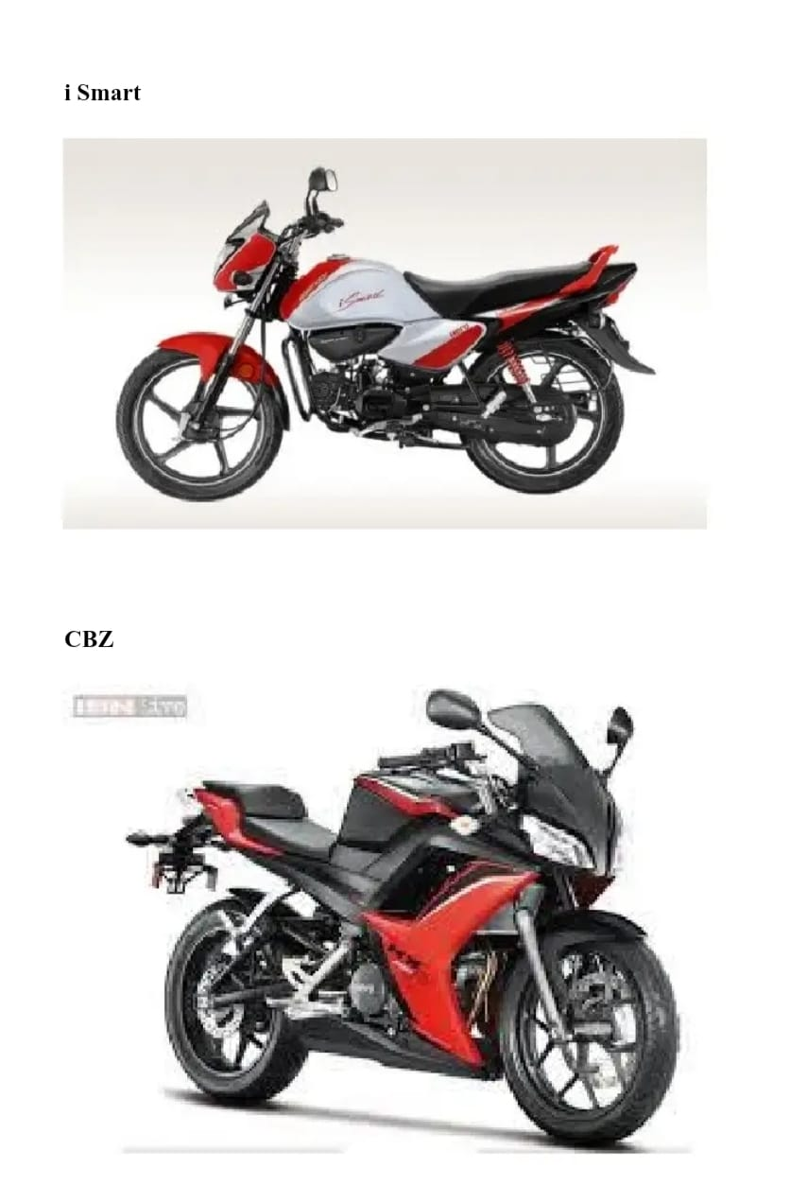

The mission is to create: Value for our customers by manufacturing affordable new-age mobility solutions. Thus, empowering them to move ahead in their lives riding the wave of development and innovation.

Collaborate-embracing: With co-workers and partners by drawing energy and inspiration to excel at everything, directed towards building a better world.

Inspire- A whole new generation of social and environmental heroes by developing a worry-free ecosystem conducive to sustainable mobility. Thus, paving the way to a greener, safer and equitable future.

VALUES-

Passion: Be bold. I love what you do. Deliver your best.

Integrity: Be ethical and do the right thing, even when no one’s watching.

Respect: Be confident, but humble. Appreciate and acknowledge everyone. Celebrate diversity.

Courage: Take risks and question the status quo. Dare to be different.

Responsible: Be caring and accountable to your team, your organisation, society and environment.

47- add red icon Country Presence, 115-M add red icon- Happy Customers, 9000 add red icon- Customer Touch-Points Worldwide, 40Years of Trust and Tech leadership.

**History of Hero MotoCorp**

Hero MotoCorp Limited is the world's largest manufacturer of two-wheelers, with an annual production capacity of over 9.50 million units across eight manufacturing facilities in India, Bangladesh, and Colombia. From the CD Dawn to the Xtreme 200 S, Hero MotoCorp Limited offers a wide range of bikes for every taste and budget. The company has a long and successful history since its establishment in 1984 as a joint venture between the Hero Group and Honda Motor Company of Japan. Hero MotoCorp has maintained its position as a market leader in the Indian two-wheeler industry by introducing innovative products and continuously improving its manufacturing processes.

Hero MotoCorp's success is evident in its impressive sales figures, having sold over 78.21 lakh vehicles during the financial year 2018-19, which is the highest by any two-wheeler company in the world. Additionally, the company has expanded its global footprint to 47 markets in FY 2022-23, with the launch of the Harley-Davidson X440 motorcycle, Hero Sure - Powered by Wheels of Trust platform, and nine new models.

With its commitment to innovation and excellence, Hero MotoCorp Limited is a leading player in the global two-wheeler industry. As a company that has consistently delivered high-quality products and services, it is no wonder that Hero MotoCorp is a trusted name among customers worldwide. Join the millions of satisfied customers who have put their trust in Hero MotoCorp Limited, and experience the thrill of riding a Hero bike today.

Hero MotoCorp Limited is the world’s largest manufacturer of two-wheelers. The Company is engaged in the manufacturing and selling of motorised two-wheelers, spare parts and related services. The Company has over 9.50 million annual production capacity across 8 manufacturing facilities i.e., 6 in India and one each in Colombia and Bangladesh. The Company offers a range of bikes from CD Dawn, CD Deluxe, Splendor-Plus, Splendor-NXG, Passion and Passion Pro.

The 125 cubic centimetres segment offers Glamour, Super Splendor and Glamour F1. It has an offering called Achiever in a 135 cubic centimetre segment. In the 150 cubic centi-meter and above the company offers brands like Hunk, CBZ x-treme, Karizma and the Karizma ZMR. It also offers a 100 cubic centimetre scooter, Pleasure. Hero MotoCorp Limited was incorporated on January 19th, 1984 under the name Hero Honda Motors Ltd.

In 1983, Hero Group and Honda Motor Company established a Joint Venture Company that became the world's largest two-wheeler company. They introduced their first motorcycle, the CD 100, in 1985 and launched new models, such as the Splendor, CBZ, and Karizma, over the years. In 1997, the Company inaugurated its second manufacturing facility at Gurgaon.

They refreshed Glamour and Glamour FI. They introduced the New Hunk, Super Splendor and Splendor Pro. The company launched the new upgraded versions of CBZ Xtreme and Karizma. Also, they breached the landmark 5 million figure cumulative sales in a single year. During the year, the Indian Promoter Group of the company, which comprised Hero Investments Pvt Ltd (HIPL), Bahadur Chand Investment Pvt Ltd (BCIPL) and Hero Cycles Limited (Hero Cycles) re-aligned the shareholding in the company, following a family agreement. As a result, Hero Cycles transferred its shareholding in the company to HIPL on May 28, 2010. As a result of these transactions, the Indian Promoter Group of the company now comprises HIPL and BCIPL owned and controlled entirely by the Munjal Family headed by Brijmohan Lall Munjal. Also, during the year, the Indian Promoter Group and Honda Motor Co Ltd, Japan (Honda) entered into a Share Transfer Agreement (the Agreement) on January 22, 2011.

As per their agreement, Honda agreed to transfer its entire 26% shareholding in the company to the Indian Promoter Group, thus ending the joint venture between the two promoter groups. The transfer was completed on March 22, 2011, and Honda's shares were successfully transferred to its Indian joint venture partner. Furthermore, Honda and the Indian Promoter Group entered into a License Agreement on January 1, 2011, granting the company the right and license to manufacture, assemble, sell, and distribute certain products and their service parts using Honda's Intellectual Property Rights. Later, in July 2011, the company changed from Hero Honda Motors Ltd to Hero MotoCorp Ltd. In February 2012, Hero MotoCorp formed a strategic partnership with Erik Buell Racing (EBR) of the USA to introduce modern technology and design inputs and launch high-end bikes for both domestic and international markets. Finally, in 2013, Hero MotoCorp began constructing its new plant and Global Parts Centre.

Hero MotoCorp has recently launched successful products such as the Splendor I Smart 110, Limited Edition Achiever 150, and the Dawn 125 motorcycle. They have expanded their reach by adding new markets and manufacturing facilities, investing in Ather Energy Private Limited, and becoming the distributor of Harley-Davidson in India. They have entered the Mexican market and currently operate in 41 markets outside of India. Hero MotoCorp celebrated producing 100 million two-wheelers by announcing a special dividend of Rs 10 per share in February 2021. Due to the surge of COVID-19 cases in India, they have temporarily suspended operations at all manufacturing facilities.

During FY 2021, Hero MotoCorp also entered into a strategic partnership with Gogoro Inc. to accelerate the shift from fuel-based mobility to sustainable electric mobility in India. During FY 2020-21, the company entered into the Mexican market, expanding its footprint to 41 markets outside India. On 04 February 2021, the company declared a special dividend of Rs 10 per share to mark the achievement of the historic milestone of producing 100 million cumulative two-wheelers.

The company proactively paused its operations temporarily during the second wave at all of its manufacturing facilities across the country, including its Global Parts Centre (GPC) in Neemrana and its R&D facility - the Centre of Innovation and Technology (CIT), Jaipur due to the escalation of Covid-19 cases across the country. The company gradually resumed its operations on 17 May 2021 by starting single-shift production at three of its plants - Gurugram and Dharuhera in Haryana and Haridwar in the northern hill state of Uttarakhand. The company resumed production at all its manufacturing plants in India on 24 May 2021.

During the second quarter of FY2022, Hero MotoCorp achieved two consecutive recognitions from the Guinness World Record for creating the Largest Motorcycle Logo in August 2021 and for creating the Largest Online Photo Album of People Planting Plants in September 2021. During the third quarter of FY2022, the company inaugurated a flagship dealership in Dubai to expand its presence in the Gulf market to 10 customer touchpoints in 5 countries. Also, Hero partnered with Gilera Motors in Argentina to expand its presence in the country and inaugurated a flagship dealership in Buenos Aires under the partnership.

As of March 31, 2022, the company has 6 subsidiaries, including step-down subsidiaries, and 2 associate companies. During FY 2021-22, Hero MotoCorp commenced retail sales in Mexico and introduced an extensive portfolio of products. It relaunched the Hero brand in markets like Argentina, Kenya, Honduras, and Nicaragua. The company strengthened its presence in the Gulf region by expanding its network of touchpoints, including dealerships, service centres, and spare parts outlets, and entered into another exclusive dealership in Dubai. It reinvigorated its strategy for the Nigerian market, leading to a 978% dispatch growth, and launched a new motorcycle, Hunter, developed especially for the market.

In March 2022, Hero MotoCorp launched a new brand Vida-Powered by Hero, an in-house electric vehicle brand. It forayed into the pre-owned two-wheeler business under the brand Hero Sure - Powered by Wheels of Trust. It expanded the network by adding super stockists, authorized representatives of dealers, Hero Sure network, and HGPD. It launched the X-pulse 200 4V in October 2021 and the new Stealth variant, Xtreme 160R, a fast-pick-bike. During the year 2022, 45 new outlets were added, which increased their footprint to 43 markets outside India. It launched the official Hero merchandise business in August 2021.

During the year 2023, Hero MotoCorp launched VIDA V1- India's first fully integrated electric scooter in Delhi, Jaipur, and Bengaluru. It commenced the expansion plan of reaching eight more cities in FY 2022-23. The company launched nine new models and expanded its global presence to 47 in FY 2022-23. It launched the Harley-Davidson X440 motorcycle and thereafter, launched the Hero Sure - Powered by Wheels of Trust platform. X440 motorcycle and thereafter launched the Hero Sure - Powered by Wheels of Trust platform.

**SWOT ANALYSIS OF HERO MOTO CORP**

SWOT Analysis of Hero MotoCorp focuses on Strengths, weaknesses, opportunities, and threats. Strength and Weakness are the internal factors and Opportunities and Threats are the external factors that influence the SWOT Analysis of Hero MotoCorp.

Strengths are defined as the best thing every company does in its range of activities that can give it a hold on its competitors. Weaknesses are used in areas in which improvement of the business or brand is necessary. Opportunities are the environmental avenues around the enterprise that can be used to increase its income. Threats are environmental factors that can adversely affect business growth.

Hero MotoCorp Ltd., formerly known as Hero Honda, is an Indian manufacturer of scooters and motorbikes. The company’s headquarters are in New Delhi, India. Hero MotoCorp is now the world’s biggest maker of two-wheelers. It has a 46 per cent market share in the two-wheeler segment. Hero Moto Corp has recently launched Hero Electric two-wheelers. These vehicles are launched due to increasing fuel prices. People are showing great interest in these electric vehicles.

Hero Moto Corp has a production capacity of 7587130 units with an operating income of 530 million dollars and total assets of US 2.5 billion dollars.

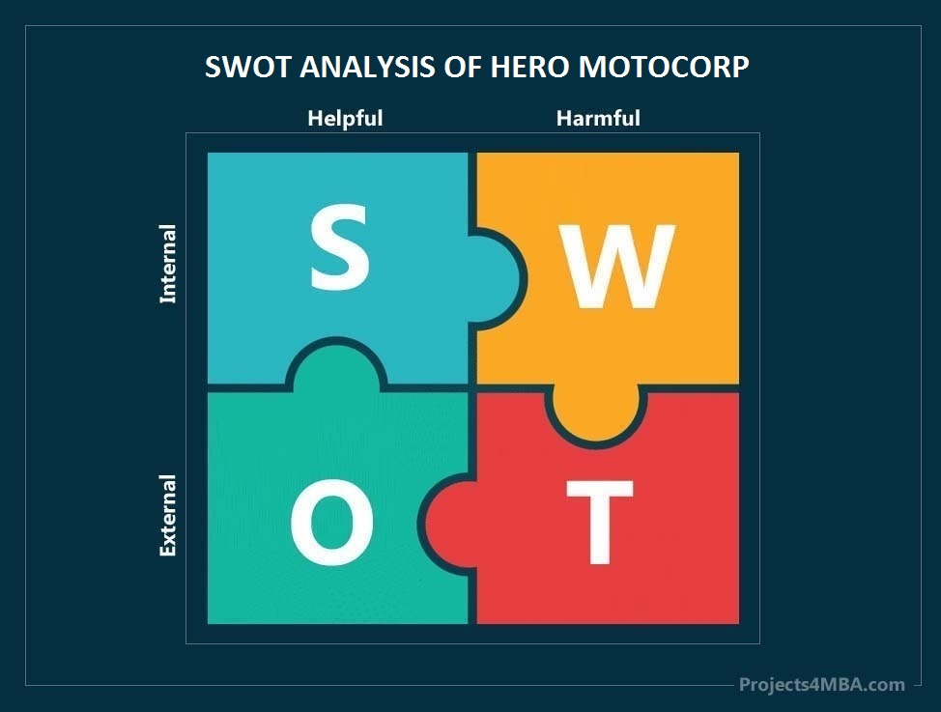

## Strength in the SWOT Analysis of Hero MotoCorp – Hero MotoCorp SWOT Analysis

The aspects of a businessman’s strengths that assist it in expanding further and maintaining its dominant position above all. Hero MotoCorp’s strengths are as follows:

* **Brand Equity:** Hero MotoCorp has a lot of brand equity, which is one of its main assets. This corporation is one of the most important companies in the two-wheeler sector. A company can only flourish if its brand name is well-known. Hero MotoCorp is one of the firms that can compete on the popularity front.
* **Strong Distribution Network:** Hero MotoCorp has more than 3000 dealerships and service facilities, making it the market leader.
* **Wide Range of Products:** The more products a firm successfully launches, the more popular it gets. As a result, Hero Moto-crop is the market’s true hero. Hero Moto Corp has recently launched Hero Electric two-wheelers. These vehicles are launched due to increasing fuel prices. People are showing great interest in these electric vehicles.
* **Recognitions and Awards:** When a brand is recognized with prizes and awards, customers may put their trust in it. Hero Moto-Corp has garnered several awards throughout the years.
* **Sponsoring Events:** Sports and racing events contribute sponsorships to the firm, which has made it the most popular of all its rivals.
* **Superb Performance in New Markets:** Hero Moto-Corp has built expertise in entering new markets and making a success of them. The expansion has helped the organization to build a new revenue stream and diversify the economic cycle risk in the markets it operates.
* **Mergers and Acquisition:**Successful track record of integrating complimentary firms through mergers & acquisitions. It has successfully integrated several companies in the past few years to streamline its operations and expand its footprint & business.
* **Strong Brand Portfolio:**Over the years Hero MotoCorp has invested in building a strong brand portfolio. The SWOT analysis of Hero MotoCorp just underlines this fact. This brand portfolio can be extremely useful if the organisation wants to expand into new product categories.
* **Good Returns on Capital Expenditure:** Hero MotoCorp is relatively successful at the execution of new projects and generated good returns on capital expenditure by building new revenue streams.
* **Skilled Workforce:**Highly skilled workforce through successful training and learning programs. Hero MotoCorp is investing huge resources in the training and development of its employees resulting in a workforce that is not only highly skilled but also motivated to achieve more.

Weaknesses in the SWOT Analysis of Hero MotoCorp:

Weaknesses are areas where the company has fallen behind competitors. There are opportunities to overcome these obstacles and get back on track. Hero Moto-Corp’s weaknesses are as follows:

1. **Intense Competition**: Hero MotoCorp faces fierce competition from both domestic and international firms in the crowded market. This high level of competition poses challenges in maintaining market share and profitability.

2. **Lack of Innovation**: The majority of Hero MotoCorp's products exhibit similar characteristics in terms of both appearance and functionality, indicating a lack of significant innovation. This can result in difficulty in differentiating its offerings from competitors, potentially leading to stagnant growth.

3. **High Attrition Rate**: Hero MotoCorp experiences a higher attrition rate compared to its industry counterparts, necessitating increased spending on employee training and development. This can impact operational efficiency and increase recruitment costs.

## 4. **Investment in New Technology**: Hero MotoCorp needs to enhance its investment in new technologies to align with its expansion plans across different geographies. The current level of investment may not be sufficient to integrate processes effectively, hindering the company's ability to adapt to evolving market trends and consumer preferences.

## Opportunities in the SWOT Analysis of Hero MotoCorp:

Opportunities are the areas in which the firm can defeat its rivals. The following are the areas:

1. **Diversification**: Hero MotoCorp has the opportunity to diversify its product portfolio to cater to evolving consumer needs and preferences. This could involve expanding into new segments such as electric vehicles or introducing innovative features in existing products.

2. **Emerging Markets**: Hero MotoCorp can capitalize on growth opportunities in emerging markets by expanding its presence and distribution network. This includes tapping into regions with rising disposable incomes and increasing demand for motorcycles and scooters.

3. **Strategic Partnerships**: Collaborating with technology partners or forging alliances with other industry players can enhance Hero MotoCorp's capabilities in innovation and technology adoption. This can facilitate access to new markets, expertise, and resources.

4. **Sustainable Practices**: With an increasing focus on sustainability, Hero MotoCorp can leverage opportunities in developing eco-friendly vehicles and promoting environmentally conscious practices. This aligns with consumer preferences and regulatory trends, fostering brand loyalty and market competitiveness.

## Threats in the SWOT Analysis of Hero MotoCorp – Hero MotoCorp SWOT Analysis

Threats are the areas in which the firm lags behind its rivals. The following are the areas:

**Intense Competition:** Several other firms are fast rising and pose a significant threat to the company.

**Alternative Transportation:** As alternative forms of transportation have grown in popularity; the usage of two-wheelers has declined.

**Government Regulations:**Government regulations can also affect the production and sales of the company.

**New Entrants:**New Entrants can also be a major threat.

ADVANTAGE INDIA

GROWING DEMAND

Rising middle-class income and a huge youth population will result in strong demand.

In November 2023, the total production of passenger vehicles", three-wheelers, two-wheelers, and quadricycles were 2.22 million units.

The global EV market was estimated at approximately US$ 250 billion in 2021 and by 2028, it is projected to grow by 5 times to US$ 1,318 billion.

Growth in Quarterly Net Profit with increasing Profit Margin

Company with Low Debt

Increasing Revenue every Quarter for the past 4 Quarters

Increasing profits every quarter for the past 2 quarters

Book Value per share has improved for the last 2 years

Company with Zero Promoter Pledge

FII/FPI or Institutions increasing their shareholding.

Strategy: Hero Moto Corp's key strategies are to build a robust product portfolio across categories, explore growth opportunities globally, continuously improve its operational efficiency, aggressively expand its reach to customers, continue to invest in brand-building activities and ensure customer and shareholder delight.

OPPORTUNITIES

India could be a leader in shared mobility by 2030, providing opportunities for electric and autonomous vehicles.

The focus is shifting to electric vehicles to reduce emissions.

By 2030, the Indian government has committed that 30% of the new vehicle sales in India will be electric.

RISING INVESTMENT

The automobile sector received a cumulative equity FDI inflow of about US$ 35.40 billion between April 2000 - September 2023.

India is on track to become the largest EV market by 2030, with a total investment opportunity of more than US$ 200 billion over the next 8-10 years.

Threat

• Promoter decreasing their shareholding

• Increasing Trend in Non-Core Income

## **INTRODUCTION**

The Indian automobile industry has historically been a good indicator of how well the economy is doing, as the automobile sector plays a key role in both macroeconomic expansion and technological advancement. The two-wheeler segment dominates the market in terms of volume, owing to a growing middle class and a huge percentage of India’s population being young. Moreover, the growing interest of companies in exploring the rural markets further aided the growth of the sector. The rising logistics and passenger transportation industries are driving up demand for commercial vehicles. Future market growth is anticipated to be fuelled by new trends including the electrification of vehicles, particularly three-wheelers and small passenger automobiles.

India enjoys a strong position in the global heavy vehicles market as it is the largest tractor producer, second-largest bus manufacturer, and third-largest heavy truck manufacturer in the world. India’s annual production of automobiles in FY22 was 22.93 million vehicles. India has a strong market in terms of domestic demand and exports. In November 2023, total passenger vehicle sales reached 3,34,130*. Sales of Passenger Vehicles in November 2023 have been the highest, with a marginal growth of 3.7%, compared to November 2022. In FY23, total automobile exports from India stood at 47,61,487. This sector's share of the national GDP increased from 2.77% in 1992-1993 to around 7.1% presently. It employs about 19 million people directly and indirectly.

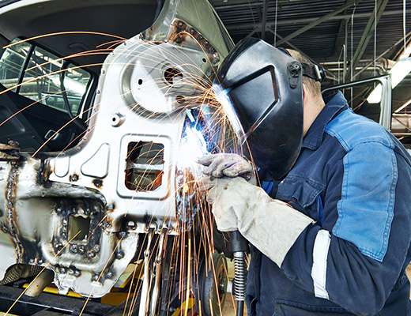

India is also a prominent auto exporter and has strong export growth expectations for the near future. In addition, several initiatives by the Government of India such as the Automotive Mission Plan 2026, scrappage policy, and production-linked incentive scheme in the Indian market are expected to make India one of the global leaders in the two-wheeler and four-wheeler market by 2022.

## MARKET SIZE

The Indian passenger car market was valued at US$ 32.70 billion in 2021, and it is expected to reach a value of US$ 54.84 billion by 2027 while registering a CAGR of over 9% between 2022 and 27. The global EV market was estimated at approximately US$ 250 billion in 2021 and by 2028, it is projected to grow by 5 times to US$ 1,318 billion.

In November 2023, the total production of passenger vehicles, three-wheelers, two-wheelers, and quadricycles was 2.22 million units. In (April-November) 2023-24, the total production of passenger vehicles, commercial vehicles, three-wheelers, two-wheelers, and quadricycles was 15.56 million units. In the first quarter of 2023-24, the total production of passenger vehicles, commercial vehicles, three-wheelers, two-wheelers, and quadricycles was 6.01 million units. India accomplished a significant milestone, with the sale of 8,32,434 EVs in 2023-24 (till August 2023).

The electric vehicle (EV) market is estimated to reach Rs. 50,000 crore (US$ 7.09 billion) in India by 2025. A study by the CEEW Centre for Energy Finance recognized a US$ 206 billion opportunity for electric vehicles in India by 2030. This will necessitate a US$ 180 billion investment in vehicle manufacturing and charging infrastructure.

According to NITI Aayog and the Rocky Mountain Institute (RMI), India's EV finance industry is likely to reach Rs. 3.7 lakh crore (US$ 50 billion) by 2030. A report by the India Energy Storage Alliance estimated that the EV market in India is likely to increase at a CAGR of 36% until 2026. In addition, the projection for the EV battery market is expected to expand at a CAGR of 30% during the same period.

Indian automotive industry is targeting to increase the export of vehicles by five times during 2016-26. In FY23, total automobile exports from India stood at 47,61,487. Indian automobile exports of two-wheelers stood at 36,52,122 in FY23. Honda Motor Co., Ltd. is a leading Japanese manufacturer of automobiles, motorcycles, and power equipment. The company has been in operation for over 70 years and has established a strong presence in the global automotive industry.

MOTORCYCLE APRIL TO DEC 2010 APRIL TO DEC 2009 % CHANGE

INDUSTRY SALE: 2897842, 2089637, 38.68 and

INDUSTRY SALES: 1281342, 1026102, 24.85

MARKET SHARE: 44.21 49.11

Bajaj Auto: Bajaj Auto has reported y-o-y growth of 19.8% in motorcycle sales for Jan 2006 at 75059 units. On a month-on-month basis, the growth is 8.8%. The export performance continues to be impressive with 10,089 two and three-wheelers exported in Jan 2006, a growth of 98.6% year on year.

Two-wheeler sales for the current year are up 6.8%. The growth is driven sharply by motorcycle sales up to 37% in the two-wheeler segment, the share of motorcycles has jumped from 52.8% to 67.8% during the current year. this sharp growth in the motorcycle can be attributed to the positive response received by its needed products and the encouraging performance of select existing models.

SALES (UNITS) JAN 10 JAN 09

% CHANGE

APR-JAN 10

APR-JAN 09

% CHANGE: 8.73, 18

SCOOTERS (GEARED): 20211 30233 -33.15

2023: 235829, 348700-32.37

SCOOTER-UNGEARED 4349 4333 0.37, 56072 57686, 2.80

STEPTHRU'S: 4563 5810, -21.46 47636, 59576 -20.04

MOTORCYCLE: 75059 62640 19.83 717397 523508 37.04

% CHANGE

APR-JAN 10

APR-JAN 09

% CHANGE: 8.73,18

SCOOTERS (GEARED): 20211 30233 -33.15, 235829, 348700-32.37

SCOOTER-UNGEARED: 4349, 4333, 0.37, 56072, 57686, 2.80

STEPTHRU'S: 4563 5810, -21.46 47636, 59576 -20.04

MOTORCYCLE: 75059, 62640, 19.83, 717397, 523508, 37.04

TOTAL 2-WHEELER: 104182 103016 1.13, 1056934, 989470 6.82

THREE WHEELERS: 17426, 14405, 20.97, 163359, 132864, 22.95

TOTAL: 121608, 117421, 3.57, 1220293, 1122334

Overall, Honda is committed to realizing the joy and freedom of mobility for people around the world with zero environmental impact and zero traffic collision fatalities involving Honda motorcycles and automobiles. The company is continuously working on improving its operations and introducing new technologies to achieve its goals.

In 2023, Honda released its Digital Fact Book, which provides an overview of its global operations, sales, manufacturing, and R&D activities. The report highlights Honda's commitment to building products close to the customer, with 18 major manufacturing plants in North America and nearly 800 suppliers in the region. The company has also been focusing on reducing its environmental impact by introducing new electric and hybrid vehicles, with plans to introduce 10 or more electric motorcycle models globally by 2025. Honda has also been working on strengthening its business structure and focusing on five key factors for the advancement of mobility, including carbon neutrality, energy management, resource circulation, AD/ADAS, and IoT/Connected. The company has made a steady improvement in its earnings structure and aims to achieve a return on sales (ROS) of 7% by 2026.

In terms of electrification, Honda has set a goal to increase the ratio of EV and FCEV sales to 100% globally by 2040. The company is planning to produce more than 2 million EVs annually by 2030 and has entered into various strategic partnerships to ensure steady progress in electrification—financial performance.

* What are the key financial indicators used to measure the performance of the Indian automobile industry?

The financial health of any industry can be measured using certain key indicators, such as ratio analysis. In a study conducted over five years from 2012 to 2016, the financial performance of major selected automobile companies in India was measured using ratio analysis.

This study aimed to compare the financial statements of leading automobile companies and determine their relative financial performance.

By analysing key financial ratios, such as liquidity ratios, profitability ratios, and debt ratios, the performance of the Indian automobile industry can be assessed. These ratios provide insight into the industry's ability to meet short-term and long-term obligations, generate profits, and manage debt. Additionally, other factors such as sales growth, market share, and return on investment can also be used to evaluate the performance of the Indian automobile industry. By analysing these financial indicators, investors and stakeholders can make informed decisions about investing in the Indian automobile industry.

* How has the revenue trend of the Indian automobile industry been over the past decade?

The Indian automobile industry has been on a growth trajectory over the last decade. According to the Automobile Mission Plan 2016-2026, the Indian automobile market is projected to be the fourth largest in the world. The Compound Annual Growth Rate (CAGR) of the Indian automotive industry's sales between the financial year 2009 and 2020 stood at around 8%. A comparative study of Maruti Suzuki and Tata Motors reveals that the financial performance of Indian automobile companies after liberalization has been positive. Researchers have analysed the growth and financial performance of selected automobile companies in India by studying trends in their financial statements over five years from 2012-2016. The objectives of the study were to analyse the profitability and solvency position of select automobile companies in India using ratio analysis.

The results of the study indicate that the select automobile companies analysed showed a positive trend in their financial performance during the period analysed. In addition, India's automobile industry includes the manufacture of trucks, buses, passenger cars, defence vehicles, two-wheelers, etc., and can be broadly divided into commercial and non-commercial vehicle segments. Finally, to further understand the financial performance of the Indian automobile industry, data for the period of five years from 2011 to 2015 of 25 Indian automobile companies. The results indicate that these companies have shown significant growth over the years.

* What are the key factors influencing the financial performance of the Indian automobile industry?

The Indian automobile industry has seen significant fluctuations in its financial performance. The industry has been facing a slowdown trend even before the COVID-19 lockdown was imposed, with a sharp decline in the domestic sale of passenger vehicles by 51% during the lockdown period. However, it is projected to be the third-largest automobile market in the world, contributing 12% to the GDP. The demand for vehicles in India has increased significantly over the years. After the announcement of phase-wise unlocking, the Indian automobile industry experienced a sharp rise in demand. The industry has proliferated post-reforms. Researchers have analysed the growth and financial performance of selected Indian automobile companies by calculating and comparing selected ratios. They have also identified and discussed the reasons for the growth and financial performance of the Indian automobile industry. Furthermore, the trend in growth quarterly sales, revenue, and market cap have been studied to gain insights into the factors that influence the financial performance of the Indian automobile industry.

The analysis of financial performance and trends in the Indian automobile industry conducted in this study using ratio analysis has yielded valuable insights. The study found that the Indian automobile industry has been on a growth trajectory over the last decade, with significant fluctuations in its financial performance. The researchers identified key financial ratios, such as liquidity ratios, profitability ratios, and debt ratios, to assess the performance of the selected Indian automobile companies. The study also compared the financial statements of leading automobile companies to determine their relative financial performance. The results indicated that the Indian automobile industry experienced a sharp rise in demand after the announcement of phase-wise unlocking.

The reasons for the growth and financial performance of the Indian automobile industry were also discussed. However, it is important to note that this study has some limitations, such as the use of only five years of data and the selection of a limited number of companies. Future research could expand on these limitations by including a larger sample size and a longer time frame. Overall, this study contributes to the ongoing advancement of knowledge in the field and provides valuable insights for policymakers and investors in the Indian automobile industry.

After years of snail-paced progress, a deal between the Indian government and American EV maker, Tesla, seems to be finally taking shape. It has been reported that the government has encouraged Tesla to set up a manufacturing plant in the country with a production capacity of 5 lakh vehicles per annum. The EV maker will reportedly focus on affordable electric models that could be priced around the USD 25,000 or Rs 20.5 lakh mark. If the Elon Musk-led company does achieve that price point, then a Tesla EV would be in direct competition against homegrown electric cars such as the Tata Nexon EV Max and the Mahindra XUV400. Considering Tesla’s worldwide success, could the development be a headache for affordable EV-selling manufacturers such as Tata Motors, Mahindra, and even perhaps MG India? Here are a few standpoints to consider.

* Why Indian OEMs should be alert?

To gauge the expected market response to EVs in India, we can refer to Volkswagen’s INDIA 2.0 strategy, where the German automaker developed four vehicle models based on the made-for-India MQB-A0 platform between the VW and Skoda brands. The ‘Made-in India’ Volkswagen Virtus, TaigḤun, and the Skoda Slavia, Kushaq have seen tremendous success, to the point where Skoda is gearing up to export its two cars to Vietnam from India. For the case study, VW’s strategy proves that when international brands introduce India-specific models at an affordable price point and with a high percentage of homologation, the Indian car buyer invests their trust more readily.

Apart from having a high aspirational value, an affordable EV would also be an offering built to be electric from the ground up, this would lead to better space inside the cabin, better driving dynamic, and presumably close-to-claimed, real-world range. However, if what happened in China is anything to go by, then maybe homegrown EV makers have more to worry about than just architectural differences.

The automobile industry is a significant sector that involves the design, development, production, and sale of motor vehicles. This industry includes various vehicles, such as self-powered vehicles, domestic and commercial vehicles, passenger cars, and trucks. Malaysia is a notable player in this industry, being a major manufacturer and exporter of vehicle parts and components. In 2007, the country produced 441,678 vehicles; by 2015, the number had doubled to 614,664 vehicles (MAA, 2015).

Working in the automotive industry, particularly in automotive repair shops, can be physically demanding and may expose workers to various health and safety risks. These risks may include occupational injuries due to the use of heavy machinery and equipment. Employers are responsible for ensuring the safety of their workers by providing a safe working environment, implementing safety measures, and ensuring the use of personal protective equipment.

Regarding safety regulations, the Occupational Safety Health Act provides guidelines that businesses must follow to ensure the safety and health of their workers. Employers are required to maintain a safe working environment, provide appropriate safety equipment, and ensure that employees are trained in proper safety procedures.

Automotive repair shops must follow specific safety regulations, such as the Personal Protective Equipment at Work Regulations, which require employees to wear appropriate protective equipment when performing maintenance tasks. Additionally, the Workplace (Health, Safety, and Welfare) Regulation 1992 requires employers to provide adequate lighting, temperature control, and washing facilities.

In conclusion, the automobile industry is an essential sector that requires strict safety measures to protect workers. Employers must follow safety regulations to ensure the safety and health of their employees. Personal protective equipment, safety training, and a safe working environment are essential to prevent accidents and injuries.

**REVIEW OF LITERATURE**

**M P Singh:** Time management has probably become the most important aspect in the 21st century, with the automobile sector being no exception. The intricacies related to scheduled maintenance of vehicles have not made the job of providing the best service any easier. The behavioural aspects associated with the overall process also provide numerous challenges. Furthermore, the lack of adequate knowledge and the unavailability of specific literature was the main precursor of this study. This review was carried out to assess the past research efforts and their validity for possible application and formulation of novel approaches for sustainable growth of service quality in the industry in general and the automobile sector in particular. The literature was reviewed by following the standard methods of content analysis and the results are presented under appropriate subsections.

Impact of Growth of Automobile Industry on Air Pollution in India

**Dr Bipin Namdev Bandekar:** The average growth rate of India’s GDP was between 2.5 to 3 % from 1947 to 1991. It was due to the protectionism policy of Govt. of India. The Liberalization policy of 1991 boosted the industrial sector including the automobile industry and India’s average growth rate reached to the level of 6 to 8 %. In 2019, India was the seventh-largest manufacturer of commercial vehicles. Today, India is the world’s fifth largest automobile market in terms of sales, after Germany, selling about 3.49 million units in passenger and commercial categories and a total of 26.28 million units. India has the largest and fastest-growing automobile industry with a turnover of 120 billion US $ which is more than 4 % of India’s GDP. Employment-wise, more than 1.7 million people are employed in the auto sector. The automobile industry also contributes a large extent towards the growth of the Indian economy.

On the other hand, a rise in the number of vehicles leads to an increase in air pollution, which creates environmental problems. Air pollution causes many health issues especially related to respiration. The study is based on secondary data collected from multiple sources. The data on the automobile industry in India is collected from the Society of Indian Automobile Manufacturers and the data on air pollution levels is collected from the International Energy Agency. The period of the study is from 2006 to 2020. The graphical presentation explains the growth of the automobile industry in India.

**Mohit Agarwal**: Descriptive statistics and a Linear Correlation Matrix are used to test the relation between the growth of the automobile industry and air pollution levels. The regression technique is used to test the impact of automobile industry growth on air pollution. The empirical analysis inferred that the highest production of all vehicles together was 309.1 lakh in 2019, the highest sales were 262.66 lakh in 2019, and the record export was 47.66 lakh in 2020. It is also confirmed that the two-wheeler segment contributes to a majority of production, sales and export. The growth of the automobile industry is restricted in 2019- 20, which may be due to the COVID-19 pandemic. India’s maximum air pollution is from the Electricity and Heat Producers sector 51.13 % and 3 % from the other energy industry. Air pollution level shows an increasing trend every year. The Regression OLS model confirmed that the sales of automobile vehicles have a significant impact on air pollution in India.

**Home and Wachowicz (2000)** Working capital is an important tool for growth and profitability for corporations. If the levels of working capital are not enough, it could lead to shortages and problems with the day-to-day operations.

**Lazard and Tryfonidis (2006)** investigated the relationship between corporate profitability and working capital management for firms listed on the Athens Stock Exchange. They reported that there is a statistically significant relationship between profitability measured by gross operating profit And the Cash Conversion Cycle. Furthermore, Managers can create profit by correctly handling the individual components of working capital to an optimal level.

**Shah and Sana (2006)** used Avery's small sample of 7 oil and gas sector firms to investigate this relationship for the period 2001-2005. The results suggested that managers can generate positive returns for the shareholders by effectively managing working capital.

**Ganesan (2007)** selected the telecommunication equipment industry to study the effectiveness of working capital management. The sample included for his research paper included 443 annual financial statements of 349telecommunication equipment companies covering the period 2001 to 2007. The statistical tests used included correlation, regression analyses and Analysis of variance (ANOVA). The results showed those days of the working capital negatively affected the profitability of these firms but in reality, it did not affect the transportability of firms in the telecommunication equipment industry.

**Sen. M (2009)** examined the ISE (Istanbul Stock Exchange) listed firms and checked out the relationship with the working capital. According to them, there is a negative 23 relationship among variables. His research uncovered the importance of the finance directors who act as moderators or catalysts to increase the productivity of the firm in other words they positively affect the firm's performance.

Pre- and post-privatization financial and operating performance of 85 companies from 28 industrialized countries that were privatized through public share offerings for the period from 1990 through 1996. The significant increases in profitability, output, operating efficiency, dividend payments and significant decreases in leverage ratios for the full sample of firms after privatization were noticed. Capital expenditures increase significantly in absolute terms, but not relative to sales. Employment declines, but insignificantly. The findings of the study strongly suggest that privatization yields significant performance improvements.

**Rupa Rege Nitsure and Mathew Joseph (1999)** in their study entitled, "Liberalisation and the Behaviour of Indian Industry (A Corporate Sector Analysis based on Capacity Utilisation) examined the impact of economic reform on productive capacity creation and utilisation across various Motors in the nineties. The results suggest that although substantial achievements occurred initially in the creation and utilization of capacities in the various Motors, there is significant room for further improvement in utilization. It analysed the determinants of capacity use such as credit flows, import liberalization, fiscal consolidation and demand conditions, using pane data for 802 firms for the period 1993-98 to suggest an optimum combination of policies that is critical for realizing the unused capacity.

**Rajeswari (2000)** studied the Liquidity Management of Tamil Nadu Cement Corporation Ltd. Alangulam-A Case Study. It can be concluded from the analysis, that the liquidity position of TANCEM is not stable. Regarding liquidity ratios, there was too much liquidity in the first two years of the study period. A very high degree of liquidity is also bad as idle assets earn nothing and affect profitability. It can be concluded that the liquidity management of TANCEM is poor and is not satisfactory.

**Dabasish Sur, Joydeep Biswas and Prasenjit Ganguly (2001**) studied Liquidity Management in Indian Private Sector Enterprises A case study of the Indian Primary Aluminium industry. From the analysis, it may be summarized that the overall performance regarding liquidity management at INDAL was better in terms of efficient utilization of short-term funds, whereas HINDALCO was unable to do so. A very high degree of positive correlation between liquidity and profitability in the case of both companies was a notable feature, reflecting the favourable effect of liquidity on profitability.

**Aggarwal and Singla (2001)** in their study developed a single index of financial performance through the technique of Multiple Discriminant Analysis (MDA), They attempted to identify from among the 11 ratios, used as inputs, those ratios, that are relevant in distinguishing between profit-making units and loss-making units in Indian paper industry. The study indicates that the model has correctly classified 82.14 per cent of units selected as profit-making and loss-marking. The study also shows that inventory turnover ratio, interest coverage ratio, net profit to total assets and earnings per share are the most important indicators of financial performance. The study also suggests that the results of MDA can be used as a predictor of future profitability/sickness.

**Joanne Loundes (2001)** in the study, the Financial Performance of Australian Government Trading Enterprises Pre-and Post-Reform" revealed that during the 1990s there were several measures introduced to improve the efficiency and financial performance of government trading enterprises in Australia. The purpose of this study was to discover whether there had been any change in the financial performance of government trading enterprises operating in electricity, gas, water, railways and ports Motors as a result of these changes. The study reveals that it does not appear to have been a noticeable enhancement in the financial performance of most of this business, although railways have improved slightly, from a low base.

**Mark Rogers (2001)** in his research on the effect of diversification on firm performance analyses the association between diversification and firm performance in a sample of up to 1449 large Australian firms (1994 to 1997). Firm performance is measured by profitability and, for quoted firms, market value. Results from the full sample show that more focused firms have higher profitability. This result controls for firm-specific effects and other determinants of profitability. However, this association is not found in sub-sample regressions for listed firms. This is true when either profitability or market value is used as a performance measure. The results may indicate that listed firms may be under closer scrutiny and competitive pressures that ensure, on average, that these firms are at their optimal degree of diversification.

**Mansur A. Mulla (2002)** in the use of Z" score analysis for evaluation of financial health of textile mills - A case study" has made an insight into the financial health of Shri Venkatesh Co-operative Textile Mills Ltd., Arunageri of Dharwad District. The „Z" score analysis has been applied to evaluate the general trend in the financial health of a firm over a period by using many accounting ratios. From the study, it was concluded that the textile mill under study was just on the verge of financial collapse. On the one hand, current assets declined because of the negative profitability performance, whereas on the other hand, the current liabilities were on the increase because of the poor liquidity performance of the mill.

**Sudarsana Reddy (2003)** studied the Financial Performance of the Paper industry in AP. The main objectives set for the study are to evaluate the financing methods and practices to analyse the investment pattern and utilization of fixed assets, to ascertain the working capital condition, to review the profitability performance and to suggest measures to improve the profitability. The data collected have been examined through ratios, trends, common size, comparative financial statement analysis and statistical tests have been applied in appropriate context. The main findings of the study are that the A.P. paper industry needs the introduction of additional funds along with restructuring of finances and modernization of technology for better operating performance.

**RBI Corporate Studies Division (2003)** has attempted to study the performance of the corporate business sector during the first half of 2002-2003. The results of 146 private companies of various sectors were analysed on the various parameters of performance. Aggregation and comparison of the results of the first two quarters were done on these performance parameters. It was concluded that the performance of the private sector was better when compared with the first half of the previous year.

**S. K. Srivastava (2007)** 34 in his study Role of Organizational Management and Managerial Effectiveness in promoting performance and production. Management is a universal Phenomenon. It is present in virtually all walks of life. Management is not confined merely to a factory or an office. Skilful management is needed in clubs, families, Schools, Sports, teams and social functions like marriages, picnic parties and so on—lack of proper management invariable results in chaos, and wastage of time, money and effort. Although management is needed in various activities, it is special.

**Chandrasekaran (1993)** 42 in Determinants of profitability in Cement Industry" has studied the determinants of profitability in cement industry. The objective of this study was to examine determinants of profitability in the cement industry. The study aims to draw inferences on the impact of policy measures that led to changes in price and distribution policies relevant to the cement industry. Determinants of profitability are analysed using the technique of ordinary least squares. Based on existing theories and relevant econometric empirical works, variables are selected. The study concluded that efficiency in inventory management and efficient management of current assets were important to improve profitability.

## UNIQUENESS OF RESEARCH STUDY

* + The study is entirely based on online data.
  + Data collected from reliable sources.
  + The tools used for analysis are updated as well as have advanced techniques.

**CHAPTER 4 METHODOLOGY OF THE STUDY**

## RESEARCH APPROACH AND DESIGN

Research methodology is a way of systematically solving the problem. Methodology is the science of studying how research is done scientifically. In other words, all these methods that the researcher used during studying his/her research are termed as methodology.

### Analytical Research

The study is primarily based on the internal records and the annual records of the company. Besides, information is gathered through discussions held with the officers of the company.

**Research design**

The research design used in this project is the nature of the procedure, in which the researcher has to use facts or information already available and analyse these to make a critical evaluation of the performance.

## SOURCES OF ONLINE DATA

1. Estimated cash flows and P&L account for 12 years
2. Website
3. records and Articles
4. Annual reports
5. Books

## DATA ANALYSIS TOOLS

The data collected were classified and analyzed with the help of percentages, averages, accounting rates and comparative financial statements.

## 

## LIMITATIONS OF THE STUDY

* + The entire study is done on the data provided by the company that is based on various assumptions.
  + An in-depth analysis of the functional activities of various departments was not possible.
  + Study is restricted to a single project of HERO MOTO CORP
  + Since data used for analysis are financial reports and published information, the quality of the study largely depends on the quality of the data.
  + Change in price level affects the comparability of the ratios. However, price level changes are not considered in accounting variables from which ratios are computed.
  + Ratios are calculated from the financial statements, so the reliability of the ratio and its analysis is dependent upon the correctness of the financial statements.
  + Since information utilized for examination are budgetary reports and distributed data, the nature of the investigation generally relies upon the nature of the information.
  + Change in value level influences the similarity of the proportions. Yet, value level changes are not considered in bookkeeping factors from which proportions are registered.
  + Ratios are determined from the fiscal reports, so the dependability of the proportion and its investigation is reliant upon the rightness of the budget summaries.

**CHAPTER 5**

**RATIOATIO ANALYSIS, INTERPRETATION & INFERENCE**

### LIQUIDITY RATIOS

* 1. **Current ratio : $\frac{Current assets}{current liabilites}$**

|  |  |  |  |
| --- | --- | --- | --- |
| **Year** | **Current asset** | **Current liabilities** | **Current ratio** |
| 2020 | 8,649.20 | 4,279.06 | 2.02 |
| 2019 | 8,413.21 | 4,409.18 | 1.91 |
| 2018 | 9,002.23 | 4,481.36 | 2.01 |
| 2017 | 7,570.51 | 4,176.69 | 1.81 |
| 2016 | 6,303.33 | 3,571.52 | 1.76 |

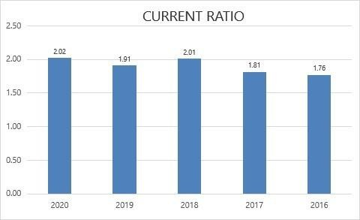

The company is more capable of paying its obligations because it has a larger proportion of [short-term asset](https://www.investopedia.com/terms/c/currentassets.asp) value relative to the value of its short-term liabilities and has consistently maintained this liquidity over the five years. However, the company should also make sure that this ratio doesn’t increase further as it will indicate an inefficient way of utilizing the current assets.

### **b.) Liquid Ratio:**

It is calculated as: Liquid Assets

Current liabilities

|  |  |  |  |
| --- | --- | --- | --- |
| Year | Liquid asset | Current liabilities | Current ratio |
| 2020 | 7938.76 | 4,279.06 | 1.86 |
| 2019 | 7472.42 | 4,409.18 | 1.69 |
| 2018 | 8218.34 | 4,481.36 | 1.83 |
| 2017 | 6999.78 | 4,176.69 | 1.68 |
| 2016 | 5694.72 | 3,571.52 | 1.59 |

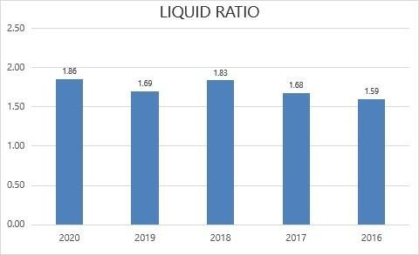

The company has consistently maintained high cash and liquid assets over the short-term liabilities and in the 5 years, the short-term assets held by the company have always been more than 1.5 times the current liabilities indicating the cash richness and high cash reserves of the company as well as the very high liquidity.

### c.) Absolute Liquid Ratio:

It is calculated as: Cash + Marketable Securities

Current liabilities

|  |  |  |  |
| --- | --- | --- | --- |
| Year | Cash and Marketable Securities (Cr.) | Current Liabilities (Cr.) | Liquid Ratio |
| 2020 | 1272.45 | 4,279.06 | 0.28 |
| 2019 | 1247.09 | 4,409.18 | 0.26 |
| 2018 | 992.96 | 4,481.36 | 0.20 |
| 2017 | 864.27 | 4,176.69 | 0.19 |
| 2016 | 834.68 | 3,571.52 | 0.19 |

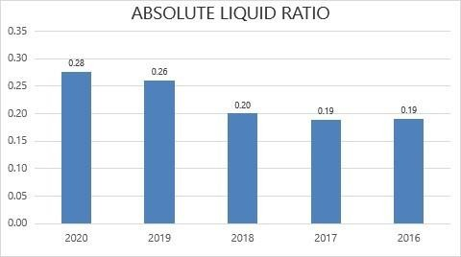

Similar to the liquid ratio, the absolute liquid ratio is also maintained consistently over the 5 years and has increased during the latest years indicating the high reserves of cash and cash equivalent assets by the company. The cash and cash equivalent assets alone have covered over 25% of the current liabilities of the company which also indicates the high liquidity of the company.

### II.) SOLVENCY RATIO

**a.) Debt- Equity Ratio**

It is calculated as: Debt (short-term debt + long-term debt + other fixed payments) Equity (Shareholder’s fund)

|  |  |  |  |
| --- | --- | --- | --- |
| Year | Debt | Equity | Debt equity ratio |
| 2020 | 4,371.01 | 14,406.29 | 0.30 |
| 2019 | 4,474.31 | 13,120.41 | 0.34 |
| 2018 | 4,570.70 | 11,971.46 | 0.38 |
| 2017 | 4,342.02 | 10,315.51 | 0.42 |
| 2016 | 3,687.70 | 8,834.11 | 0.42 |

--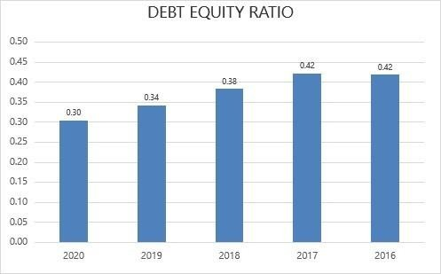

The company doesn’t have much exposure towards both long and short-term debt and has shown a declining trend in the ratio over the 5 years indicating that the company has linearly decreased the amount of debts held. The current debts of the company are very low as compared to the equity of the company and this is also in line with the liquidity ratios as the company already has very strong cash equivalent assets.

### **b.) Total assets Ratio:**

It is calculated as: Total Assets

Long-Term Debts

|  |  |  |  |
| --- | --- | --- | --- |
| Year | Total asset | Total debt | Total asset ratio |
| 2020 | 19,674.07 | 4,371.01 | 4.50 |
| 2019 | 18,504.36 | 4,474.31 | 4.14 |
| 2018 | 17,396.73 | 4,570.70 | 3.81 |
| 2017 | 15,312.00 | 4,342.02 | 3.53 |
| 2016 | 12,895.81 | 3,687.70 | 3.50 |

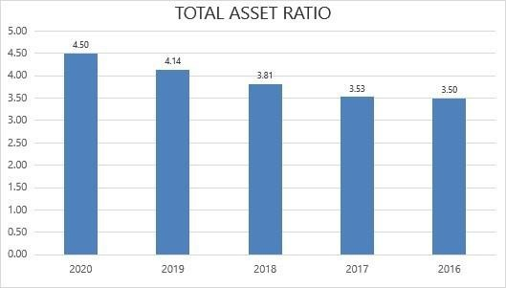

There is a linear increase in the total asset ratio of the company which is not only due to the increase in the assets held by the company but also is attributable to the gradual decrease in the debts of the company over the 5 years. The total asset ratio shows a linear increase and the debt-equity ratio has shown a linear decrease indicating the reduction in the debts held and the corresponding buildup of assets over the years.

### **c.) Proprietary Ratio:**

It is calculated as: a shareholder’s fund or Proprietary funds

Total Assets

|  |  |  |  |
| --- | --- | --- | --- |
| Year | Shareholders fund | Total asset | Proprietary ratio |
| 2020 | 14,406.29 | 19,674.07 | 0.73 |
| 2019 | 13,120.41 | 18,504.36 | 0.71 |
| 2018 | 11,971.46 | 17,396.73 | 0.69 |
| ---  2017 | 10,315.51 | 15,312.00 | 0.67 |
| 2016 | 8,834.11 | 12,895.81 | 0.69 |

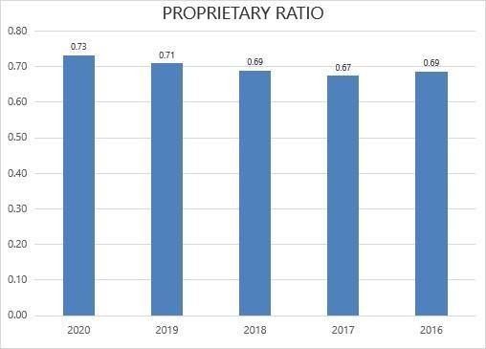

The proprietary ratio has always been maintained at high levels indicating that the company has a sufficient amount of [equity](https://www.accountingtools.com/articles/2017/5/6/equity) to support the functions of the business, and probably has room in its [financial structure](https://www.accountingtools.com/articles/2018/1/15/financial-structure) to take on additional [debt](https://www.accountingtools.com/articles/2017/5/6/debt), if necessary as it indicates a strong financial position of the company and greater security for creditors.

### d.) Interest Coverage Ratio:

It is calculated as: Earnings before Interest and Tax

Interest

|  |  |  |  |
| --- | --- | --- | --- |
| Year | Earnings before  interest and tax | Interest | Interest coverage  Ratio |
| 2020 | 3,852.44 | 46.64 | 82.60 |
| 2019 | 5,006.36 | 37.18 | 134.65 |
| 2018 | 5,211.64 | 30.8 | 169.21 |
| 2017 | 4,541.11 | 27.28 | 166.46 |
| 2016 | 4,338.06 | 14.61 | 296.92 |

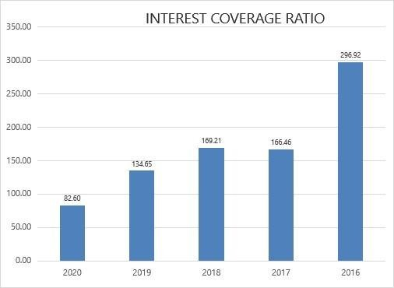

As seen above in the other ratios the Debts both long- and short-term debts held by the company are significantly less compared to the assets and equity of the company. Moving over the current Debt of the company is significantly contributed by the trade’s payables and interest payable and the financial cost of the company is much less. However, the interest coverage ratio has a declining trend over the years which indicates that the interest expenses have increased more proportionally than the earnings of the company. Since the financial cost of the company is still significantly less compared to the assets and equity this decline is an indication of a significant increase in financial cost but a higher growth rate as compared to the rate at which the earnings have increased.

1. **ACTIVITY RATIOS/ TURNOVER RATIOS**

**a.) Stock Turnover Ratio:**

It is calculated as the cost of goods sold

Average Stock

|  |  |  |  |
| --- | --- | --- | --- |
| Year | Cost of goods sold | Average inventory | Stock turnover ratio |
| 2020 | 20,004.29 | 1265.93 | 15.80 |
| 2019 | 23,503.46 | 1106.11 | 21.25 |
| 2018 | 21,995.94 | 835.63 | 26.32 |
| 2017 | 19,019.34 | 735.28 | 25.87 |
| 2016 | 19,357.96 | 811.69 | 23.85 |

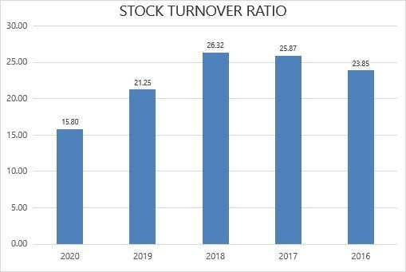

There is a significant reduction in the inventory turnover ratio over the 5 years indicating the decline in sales and possibly excess inventory or overstocking by the company. This also could lead to an increase in the storage cost and other related costs of the company due to overstocking.

### b.) Debt Turnover Ratio:

It is calculated as Net Credit Sales Avg Trade Receivables

|  |  |  |  |
| --- | --- | --- | --- |
| Year | Net credit sales | Avg trade  receivables | Debt turnover ratio |
| 2020 | 29,253.97 | 2128.51 | 13.74 |
| 2019 | 33,970.82 | 2086.04 | 16.28 |
| 2018 | 32,458.37 | 1489.36 | 21.79 |
| 2017 | 28,610.43 | 1416.91 | 20.19 |
| 2016 | 30,715.33 | 1326.95 | 23.15 |

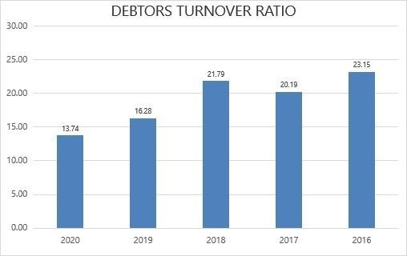

The Debtors turnover ratio is on the lower side and has shown a declining trend over the years indicating the inefficiency in collecting the receivables by the company. The declining trend and the low ratio an indicators of poor collection processes, bad credit policies, or customers that are not financially viable or creditworthy. This needs to be monitored and improved so that the credit collection process becomes more efficient and this can improve the liquidity of the company as well as reduce chances of bad debt. The company should reassess its credit policies to ensure the timely collection of its receivables and also better utilization of such cash inflows should be looked into.

### b.) Creditors’ Turnover Ratio:

It is calculated as: Net Credit Purchases

Average Trade Payable

|  |  |  |  |
| --- | --- | --- | --- |
| Year | Net credit purchase | Average trade payable | Creditors turnover ratio |
| 2020 | 20,037.08 | 3282.93 | 6.10 |
| 2019 | 25,715.67 | 3406.75 | 7.55 |
| 2018 | 22,250.04 | 3320.73 | 6.70 |
| 2017 | 18,965.93 | 2970.77 | 6.38 |
| 2016 | 19,258.56 | 2765.13 | 6.96 |

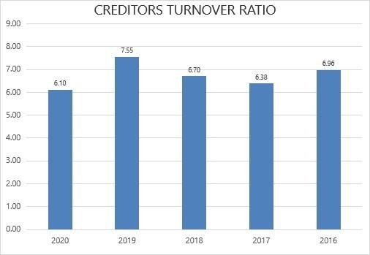

The company has maintained a low creditor turnover ratio indicating the slow payment to suppliers for purchases on credit. This may be due to favorable credit terms provided by the suppliers and not due to any financial or liquidity issues as there is high current asset holding and high liquidity. This low ratio is favorable to the company in terms of holding more cash, providing more liquidity and also benefits in terms of opportunity cost as cash outflows flows are delayed.

### d.) Working Capital Turnover Ratio:

It is calculated as the Cost of Goods sold (Cost of Revenue from Operations)

Net Working Capital

|  |  |  |  |
| --- | --- | --- | --- |
| **Year** | **Cost of goods sold** | **Net working capital** | **Creditors turnover ratio** |
| 2020 | 20,004.29 | 4,370.14 | 4.58 |
| 2019 | 23,503.46 | 4,004.03 | 5.87 |
| 2018 | 21,995.94 | 4,520.87 | 4.87 |
| 2017 | 19,019.34 | 3,393.82 | 5.60 |
| 2016 | 19,357.96 | 2,731.81 | 7.09 |

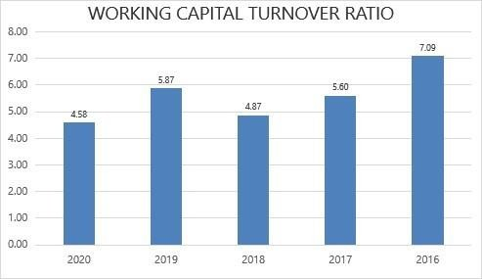

Here the working capital turnover ratio has always been on the higher side indicating that the management is efficiently utilizing the company’s short-term assets and liabilities to generate sales. There is a high return generated through sales in terms of cash outflows of the company in the form of current liabilities.

1. **PROFITABILITY RATIOS:**

**a.) Gross Profit Ratio:**

It is calculated as: Gross Profit X 100

Net Sales

|  |  |  |  |
| --- | --- | --- | --- |
| **Year** | **gross profit** | **net sales** | **gross profit ratio** |
| 2020 | 8,808.29 | 29,253.97 | 0.30 |
| 2019 | 9,926.49 | 33,970.82 | 0.29 |
| 2018 | 9,809.84 | 32,458.37 | 0.30 |
| 2017 | 9,262.06 | 28,610.43 | 0.32 |
| 2016 | 8,860.94 | 30,715.33 | 0.29 |

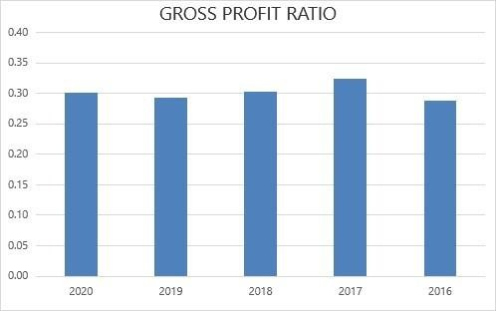

The gross profit ratio is showing an almost constant ratio for the past 5 years. The ratio means that the company may reduce the selling price by 30 % without incurring any loss. There has been a slight improvement in the gross profit ratios which indicates a constant improvement.

### b.) Operating Ratio:

It is calculated as: Cost of Goods Sold + Operating Expenses X 100

Net Sales

|  |  |  |  |
| --- | --- | --- | --- |
| **Year** | **COGS+**  **Operating expense** | **Net sales** | **Gross profit ratio** |
| 2020 | 34,893.74 | 29,253.97 | 1.19 |
| 2019 | 39,540.50 | 33,970.82 | 1.16 |
| 2018 | 37,548.94 | 32,458.37 | 1.16 |
| 2017 | 33,826.05 | 28,610.43 | 1.18 |
| 2016 | 33,378.22 | 30,715.33 | 1.09 |

From the above operating ratios, we can conclude that the company has a desirable operating ratio.

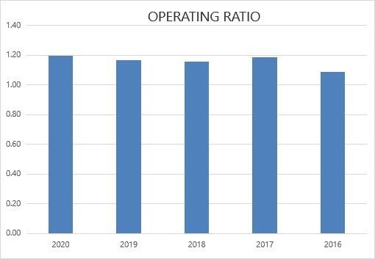

### c.) Operating Profit Ratio:

It is calculated as: Operating Profit X 100 Sales (Revenue from Operation)

|  |  |  |  |
| --- | --- | --- | --- |
| **Year** | **Operating profit** | **Net sales** | **Operating profit ratio** |
| 2020 | 4,060.92 | 29,253.97 | 0.14 |
| 2019 | 5,018.43 | 33,970.82 | 0.15 |
| 2018 | 5,325.05 | 32,458.37 | 0.16 |
| 2017 | 4,575.97 | 28,610.43 | 0.16 |
| 2016 | 6,655.91 | 30,715.33 | 0.22 |

The company has having higher operating profit ratio which enables the organization to recoup non-operating expenses out of operating profits and provide a reasonable return.

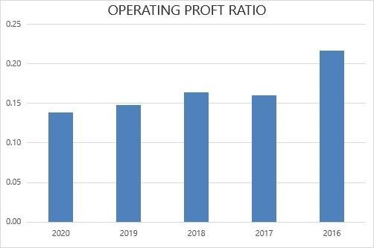

### d.) Net Profit Ratio:

It is calculated as: Net Profit X 100

Sales (revenue from operations)

|  |  |  |  |
| --- | --- | --- | --- |
| Year | Net profit | Net sales | Net profit ratio |
| 2020 | 3,638.11 | 29,253.97 | 0.12 |
| 2019 | 3,444.09 | 33,970.82 | 0.10 |
| 2018 | 3,720.40 | 32,458.37 | 0.11 |
| 2017 | 3,584.27 | 28,610.43 | 0.13 |
| 2016 | 3,141.98 | 30,715.33 | 0.10 |

The company has a good net profit ratio. It means that its current business practices allow it to sell its products at a higher price than the cost of manufacture and distribution.

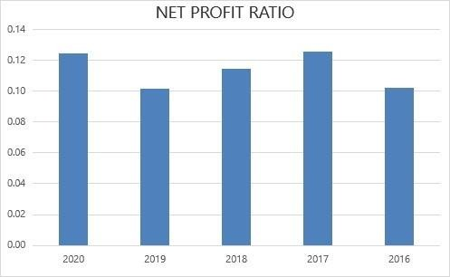

**Return on total assets:**

It is calculated as: Net Profit after Tax X 100

Total Assets

|  |  |  |  |
| --- | --- | --- | --- |
| Year | Total assets | Net profit after tax | Ratio |
| 2020 | 19,674.07 | 3,624.78 | 5.43 |
| 2019 | 18,504.36 | 3,405.59 | 5.43 |
| 2018 | 17,396.73 | 3,672.51 | 4.74 |
| 2017 | 15,312.00 | 3,229.29 | 4.74 |
| 2016 | 12,895.81 | 3,077.96 | 4.19 |

The company has a higher return on total asset ratio. A higher ratio is more favorable to investors because it shows the company is more effectively managing its assets to produce a greater amount of net income. It shows an upward profit trend.

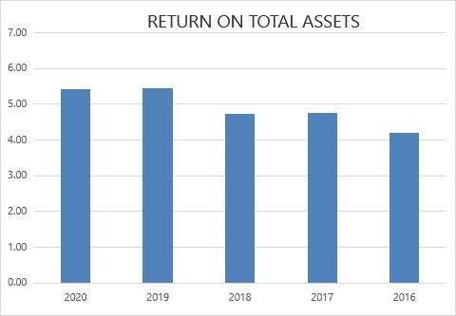

|  |  |  |  |  |
| --- | --- | --- | --- | --- |
| **COMPARATIVE BALANCE SHEET AS OF 2016 AND 2017** | | | | |
| Particulars | 2016 | 2017 | Absolute  change | Percentage  Change |
| EQUITIES AND LIABILITIES |  |  |  |  |
| SHAREHOLDER'S FUNDS |  |  |  |  |
| Equity Share Capital | 39.94 | 39.94 | 0 | 0% |
| Total Share Capital | 39.94 | 39.94 | 0 | 0% |
| Reserves and Surplus | 8,794.17 | 10,275.57 | 1481.4 | 17% |
| Total Reserves and Surplus | 8,794.17 | 10,275.57 | 1481.4 | 17% |
| Employees Stock Options | 0 | 0 | 0 |  |
| Total Shareholders’ Funds | 8,834.11 | 10,315.51 | 1481.4 | 17% |
| Minority Interest | 54.63 | 67.38 | 12.75 | 23% |
| NON-CURRENT LIABILITIES |  |  |  |  |
| Long Term Borrowings | 145.98 | 207.9 | 61.92 | 42% |
| Deferred Tax Liabilities [Net] | 221.77 | 468.9 | 247.13 | 111% |
| Other Long-Term Liabilities | 0 | 0 | 0 | 0% |
| Long Term Provisions | 67.8 | 75.62 | 7.82 | 12% |
| Total Non-Current Liabilities | 435.55 | 752.42 | 316.87 | 73% |
| CURRENT LIABILITIES |  |  |  |  |
| Short Term Borrowings | 84.06 | 40.08 | -43.98 | -52% |
| Trade Payables | 2,675.34 | 3,266.20 | 590.86 | 22% |
| Other Current Liabilities | 782.32 | 827.84 | 45.52 | 6% |
| Short Term Provisions | 29.8 | 42.57 | 12.77 | 43% |
| Total Current Liabilities | 3,571.52 | 4,176.69 | 605.17 | 17% |
| Total Capital and Liabilities | 12,895.81 | 15,312.00 | 2416.19 | 19% |
| ASSETS |  |  |  |  |
| NON-CURRENT ASSETS |  |  |  |  |
| Tangible Assets | 3,654.64 | 4,495.03 | 840.39 | 23% |
| Intangible Assets | 129.07 | 103.82 | -25.25 | -20% |
| Capital Work-In-Progress | 325.23 | 386.5 | 61.27 | 19% |
| Intangible Assets Under Development | 328.14 | 194.46 | -133.68 | -41% |
| Fixed Assets | 4,437.08 | 5,179.81 | 742.73 | 17% |
| Non-Current Investments | 1,029.51 | 1,522.31 | 492.8 | 48% |
| Long-Term Loans and Advances | 26.7 | 48.52 | 21.82 | 82% |
| Other Non-Current Assets | 1,099.19 | 990.85 | -108.34 | -10% |
| Total Non-Current Assets | 6,592.48 | 7,741.49 | 1149.01 | 17% |
| CURRENT ASSETS |  |  |  |  |
| Current Investments | 3,471.57 | 4,544.06 | 1072.49 | 31% |
| Inventories | 761.99 | 708.58 | -53.41 | -7% |
| Trade Receivables | 1,282.07 | 1,551.75 | 269.68 | 21% |
| Cash And Cash Equivalents | 179.09 | 195.39 | 16.3 | 9% |
| Short-Term Loans and Advances | 23.21 | 24.93 | 1.72 | 7% |
| Other Current Assets | 585.4 | 545.8 | -39.6 | -7% |
| Total Current Assets | 6,303.33 | 7,570.51 | 1267.18 | 20% |
| Total Assets | 12,895.81 | 15,312.00 | 2416.19 | 19% |

|  |  |  |  |  |
| --- | --- | --- | --- | --- |
| COMPARATIVE INCOME STATEMENT AS OF 2016 AND 2017 | | | | |
| PARTICULARS | 2016 | 2017 | ABSOLUTE CHANGE | PER CENT GE CHANGE |
| Revenue From  Operations [Gross] | 30,477.11 | 30,654.63 | 177.52 | 1% |
| Less: Excise/Service  Tax/Other Levies | 2,258.21 | 2,373.23 | 115.02 | 5% |
| Revenue From  Operations [Net] | 28,218.90 | 28,281.40 | 62.50 | 0% |
| Other Operating  Revenues | 238.22 | 329.03 | 90.81 | 38% |
| Total Operating  Revenues | 28,457.12 | 28,610.43 | 153.31 | 1% |
| Other Income | 412.83 | 521.95 | 109.12 | 26% |
| Total Revenue | 28,869.95 | 29,132.38 | 262.43 | 1% |
| EXPENSES |  |  |  |  |
| Cost Of Materials  Consumed | 19,357.96 | 19,019.34 | -338.62 | -2% |
| Changes In Inventories Of  FG, WIP And Stock-In  Trade | -49.86 | 96.74 | 146.60 | -294% |
| Employee Benefit  Expenses | 1,339.46 | 1,432.49 | 93.03 | 7% |
| Finance Costs | 14.61 | 27.28 | 12.67 | 87% |
| Depreciation And Amortization  Expenses | 443.25 | 502.25 | 59.00 | 13% |
| Other Expenses | 3,411.86 | 3,485.89 | 74.03 | 2% |
| Total Expenses | 24,517.28 | 24,563.99 | 46.71 | 0% |
| Profit/Loss Before Exceptional, Extraordinary Items  And Tax | 4,352.67 | 4,568.39 | 215.72 | 5% |
| Exceptional Items | 0 | 0 | 0.00 | 0% |
| Profit/Loss Before Tax | 4,352.67 | 4,568.39 | 215.72 | 5% |
| Tax Expenses- Continued  Operations |  |  |  |  |
| Current Tax | 960.91 | 1,082.24 | 121.33 | 13% |
| Deferred Tax | 313.8 | 256.86 | -56.94 | -18% |
| Total Tax Expenses | 1,274.71 | 1,339.10 | 64.39 | 5% |
| Profit/Loss After Tax and Before Extraordinary Items | 3,077.96 | 3,229.29 | 151.33 | 5% |
| Profit/Loss From  Continuing Operations | 3,077.96 | 3,229.29 | 151.33 | 5% |
| Profit/Loss for The  Period | 3,077.96 | 3,229.29 | 151.33 | 5% |

54

**Tools for analysis of financial statements:**

Financial statements when analysed in isolation are not of much meaning and use. They are thus analysed by comparing them with financial statements of previous years or with those of other enterprises of similar nature and size operating in similar business environments or with industry standards. The tools used for carrying out the analysis are:

1. Comparative Statements

2. Common – size Statements

3. Ratio Analysis

4. Cash Flow Statement

5. Trend Analysis

6. Fund flow statement

COMPARATIVE STATEMENTS

Comparative statements or comparative Financial Statements mean a study of components or elements or items of financial statements (Balance sheet and Statement of Profit and Loss) for two years or with that of other enterprises. As a first step, each component element or item of financial statements of two or more financial years is placed alongside each other. After that, the difference between the two amounts is determined. And lastly, the percentage change in the amount is ascertained. The statement so prepared is known as the Comparative statement.

COMPARATIVE BALANCE SHEET

“Comparative Balance Sheet analysis is the study of the trend of the same items, group of items and computed items in two or more balance sheets of the same business enterprise on different dates”. The comparative balance sheet of an enterprise on two or more dates is used for comparing assets, liabilities and capital and ascertaining increases and decreases in those items. Such analysis often yields considerable information that is of value in forming the opinion regarding the process of an enterprise.

COMPARATIVE STATEMENT OF PROFIT AND LOSS OR INCOME STATEMENT:

Statement of Profit and Loss or Income Statement shows net profit earned or net loss incurred for the year. A comparative Income Statement shows the operating results for several accounting periods so that changes in data in terms of absolute amount and percentage from one period to another may be known.

RATIO ANALYSIS:

Ratio analysis is a technique of Financial Statements Analysis and is the most widely used tool to interpret the quantitative relationship between two variables of the financial statements. ‘Ratio’ is an arithmetical expression of the relationship between two related or interdependent items. Ratios, when calculated based on accounting information, are called Accounting Ratios. The accounting ratio is, thus, an arithmetical relationship between two accounting variables. “The term accounting ratio is used to describe significant relationships which exist between figures shown in a balance sheet, in a Statement of Profit and Loss, in a budgetary control system or any part of the accounting organisation.” Accounting ratios can be expressed in any of the following forms:

1. Pure: It is expressed as a quotient. For example, the Current Ratio expresses the relationship between current assets and current liabilities.

2. Percentage: It is expressed in percentage. For example, the net Profit Ratio which relates net profit to net sales.

3. Times: It is expressed in the number of times a particular figure is when compared to another figure. For example, Creditors’ or Trade Payables Turnover Ratio, which studies the relationship between Net Credit Purchases and Average Payables.

4. Fraction: It is expressed in fractions. For example, the ratio of fixed assets to share capital.

CLASSIFICATION OF RATIOS:

Ratios as a tool of analysis may be classified into the following four categories:

1. Liquidity ratios: These ratios show the ability of the enterprise to meet its short-term financial obligations. The important Liquidity Ratios are:

1. Current ratio
2. Quick ratio

2. Solvency ratios: These ratios show the ability of the enterprise to meet its long–term financial position of the business. Solvency means a firm’s ability to meet its long–term liabilities. The important liquidity ratios are:

1. Debt-to-equity ratio
2. Total assets to Debt ratio
3. Proprietary ratio
4. Interest coverage ratio

3. Activity Ratios or Turnover Ratios: These ratios show how efficiently a company is using its assets to generate sales. The important Activity Ratios are:

1. Stock turnover Ratio
2. Debtors’ Turnover Ratio
3. Creditors’ Turnover Ratio
4. Working Capital Turnover

4. Profitability Ratios: The profitability of Affirm can be measured by its profitability ratios. The important Profitability Ratios are:

1. Gross profit ratio
2. Operating ratio
3. Operating profit ratio
4. Net profit ratio
5. Return on investment

### Liquidity Ratio

1. Current Ratio

The current ratio is a relationship of current assets to current liabilities and is computed to assess the short-term financial position of the enterprise. It means the current ratio is an indicator of the enterprise's ability to meet its short-term obligations. It is an accepted norm that current assets should be two times the current liabilities. If the current ratio is 2:1 only, then realization from current assets is adequate to pay current liabilities in time and enable the enterprise to meet other day-to-day expenses.

1. Quick Ratio/ Liquid Ratio

The liquidity ratio is the relationship of liquid assets with current liabilities and is computed to assess the short-term liquidity of the enterprise. Liquid assets put against the current liabilities give the liquid ratio. The quick ratio of 1:1 is an accepted standard, since for every rupee of current liabilities; there is a rupee of quick assets. Absolute liquid ratio

This ratio is obtained by dividing cash and marketable securities by current liabilities. It is also known as the cash position ratio. A ratio of 0.75:1 is recommended to ensure liquidity. This test is a vigorous measure of a firm’s liquidity position. This ratio gains much significance only when it is used in function with the current and liquid ratios. A standard 1.2:2 absolute liquidity is considered the standard norm. However, this ratio is not much in use.

### 

1. Debt – Equity Ratio

Debt-equity Ratio is computed to assess the long-term financial soundness of the enterprise. The ratio expresses the relationship between external equities and internal equities (i.e., Shareholders’ funds) of the enterprise. Debt The equity ratio indicates the relative proportion of shareholders’ funds and debt, i.e., capital contributed by long-term lenders and shareholders, used to finance company assets. The ideal debt-equity ratio depends on the nature of the business. Normally, a Debt- Debt-equity ratio of 2:1 is considered an appropriate ratio.

1. Total assets to debt ratio

Total Assets to Debt Ratio establishes a relationship between total assets and total long-term debts. The objective of computing the ratio is to establish the relationship between total assets and long-term debts of the business. It measures the safety margin available to the providers of long-term debts. In other words, it measures the safety margin available to the providers of long-term debts.

1. Proprietary ratio

The proprietary ratio establishes a relationship between proprietors’ funds and total assets. Proprietors’ fund is a sum of share capital, reserves and surplus, money received against share warrants and share application money pending allotment but deducting there from Deferred Tax assets(net) and fictitious assets such as Unamortized Loss on the issue of debentures which may be shown as Other Non – Current asset and/or Other current assets of the business. Total assets include all the assets less fictitious assets. The objective of computing this ratio is to measure the proportion of total assets financed by the proprietor’s funds. The ratio is important for creditors.

1. Interest Coverage Ratio

The ratio establishes a relationship between net profit before interest and tax and interest payable on long-term debts. Interest is a charge on profit therefore; net profit before interest and tax is taken to calculate the ratio. The ratio is very meaningful to debenture holders and lenders of long-term funds. The objective of calculating the ratio is to ascertain the amount of profit available to cover the interest.

### Activity Ratio

1. Stock or inventory Turnover ratio

Inventory Turnover Ratio establishes a relationship between the cost of goods sold, i.e., Cost of Revenue from Operations and the average amount of inventory carried during that period. Inventory ratio is an activity as well as efficiency ratio and it measures how many times per period a business sells and replaces its inventory.

1. Debtors’ turnover ratio or Trade Receivables turnover ratio

The debtors’ Turnover ratio establishes the relationship between net credit sales and average trade receivables, i.e., debtors and bill receivable of the year. This ratio indicates the number of times the receivables are turned over in a year about sales. It shows how quickly receivables are converted into cash and thus, shows the efficiency in the collection of amounts due from debtors.

1. Creditors’ turnover ratio
2. Working Capital Turnover Ratio:

The Working Capital Turnover Ratio establishes the relationship between working capital and revenue from operations or sales. It shows the number of times a unit of rupee invested in working capital produces sales. The ratio indicates whether the working capital has been effectively utilized or not. In fact, in the short- -run, it is the current assets and current liabilities that play a major role.

### Profitability ratio

1. Gross Profit Ratio

The gross profit ratio establishes the relationship between gross profit and Net sales, i.e., Net Revenue from Operations of an enterprise. The ratio is calculated and presented in percentages.

1. Operating Ratio

Operating Ratio is computed to establish a relationship between Operating Costs and Revenue from operations, i.e., Sales. The ratio shows the proportion of cost of goods sold and operating expenses. The operating Ratio is the test of the operational efficiency of the business. It shows the percentage of Revenue from Operations, i.e., sales that are absorbed by the cost of sales and operating Expenses.

1. Operating Profit Ratio

The operating ratio measures the relationship between Operating Profit and Net sales. It is computed by dividing the operating profit by the net sales and is expressed as a percentage. The objective of computing this ratio is to determine the operational efficiency of the management.

1. Net Profit Ratio

Net Profit Ratio establishes the relationship between Net Profit and Net Sales. It shows the percentage of Net Profit earned on Revenue from Operations. It is an indicator of the overall efficiency of the business.

1. return on Investment (ROI) or Return on Capital Employed Ratio

Return on Capital Employed Ratio shows the relationship of profit (profit means profit before interest and tax) with Capital Employed. The net result of the operation of a business is either profit or loss. The sources, i.e., funds used by the business to earn this (profit or loss) are proprietors’ (shareholders’) funds and loans. The objective is to assess the overall performance of the enterprise. It measures how efficiently the sources entrusted to the business are used.

### Total Assets Turnover Ratio

Total assets turnover Ratio shows the relationship between Total Assets, i.e., fixed assets and current assets and revenue from operations. Fictitious assets, if any, are excluded. The objective of computing the ratio is to determine how efficiently assets have been utilized and in turn, it shows the promise of profitability and efficiency of management.

### Return on Shareholders’ Funds

This ratio measures the relationship between net profit after interest and tax, and shareholders, funds. The objective of computing this ratio is to find out how efficiently the funds supplied by the shareholders have been used. This ratio indicates the firm’s ability to generate profit per rupee of shareholders’ funds.

### Return on Total Assets.

This ratio shows the relationship between the net profit and total assets. The ratio is computed by dividing net profit after tax by total assets. It is expressed as a percentage. The ratio is computed to ascertain whether the investments in assets have generated adequate net profit. It also reflects on the efficiency of the management.

### Earnings per Share (EPS)

It is the earnings of a company attributable to the Equity shareholders divided by the number of Equity Shares. In other words, this ratio measures the earnings available to equity shareholders on a per basis. This ratio helps in evaluating the prevailing market price of share in the light of profit-earning capacity. The higher the earnings per share, the better the performance and prospects of the company.

**CHAPTER 7**

**FINDINGS, SUGGESTION AND CONCLUSION:**

FINDINGS:

In 2022, the company's tangible assets decreased by Rs. 190.17 or 3.33% compared to 2021. The non-tangible assets increased by Rs. 8.24 or 2.83%

compared to 2021. The capital work in progress decreased by Rs. 90.54 or 50.9% compared to 2021.

The company has a stable financial position with strong current and quick ratios, indicating that it has enough current and liquid assets to cover its short-term obligations. The proprietary ratio also shows that the company has a strong financial position relative to its tangible assets. However, it is important

to consider other financial ratios and metrics to get a complete picture of the company's financial health.

The tables suggest that the company's profitability has been somewhat unstable over the years, with fluctuations in gross profit, net profit, and operating

profit ratios. The decline in profitability in 2022 may warrant further investigation to identify the cause and potential solutions.

The company appears to have used its fixed assets and total assets relatively efficiently over the five-year period, although there was some fluctuation in

the ratios. The company also appears to have improved its inventory turnover ratio over the period, indicating that it was able to sell its inventory more

quickly.

SUGGESTIONS:

Hero Moto Corp should continue to innovate and develop new products to meet changing customer needs and preferences. This could involve investing

in research and development, collaborating with technology companies, and exploring new markets and customer segments.

Hero MotoCorp should look for ways to expand its distribution channels and reach new customers. This could involve partnering with dealerships, online

platforms, and other businesses that can help to expand the company's reach and brand awareness.

As concerns about the environment and sustainability grow, automotive companies like Hero MotoCorp must prioritize sustainability and reduce them

environmental impact. This could involve investing in clean energy, reducing waste and emissions, and promoting sustain

**CHAPTER 7**

**CONCLUSIONS**

The project “A STUDY ON ANALYSIS AND COMPARISON OF FINANCIAL STATEMENTS

USING FINANCIAL ANALYSIS TOOLS” was a good learning experience both theoretically

and in practice. It gave me a greater insight into various concepts of financial statement analysis

and the practical use of the same during the project. It also helped me to think beyond bookish

knowledge and understand the relative worth of the project. I find myself privileged to do a study

on the financial statements of HERO MOTO CORP.

From the financial analysis, the company is shown in a good and financially sound position. The

way different departments uniquely contribute to the overall functioning of the organization

reveals their unanimous efforts toward the overall objective of the company. As a nation, one can be

proud of the contributions made by the company towards its economy and its GDP.

In terms of asset management, the company has maintained a relatively high fixed asset turnover ratio, which suggests efficient utilization of its fixed assets. However, there has been a decline in this ratio over the years, indicating a need for the company to focus on optimizing the use of its fixed assets to maintain profitability.

Hero MotoCorp appears to be a stable and profitable company, but there is room for improvement in terms of asset management and inventory control to maintain long-term profitability

**BIBLIOGRAPHY**

**BOOK**:

Research Methodology

Method And Techniques

(Second Revised Edition)

C.R. Kothari

New Age Interpretation publication

**WEBSITES**:

• Company site www.heromotocorp.com

• Accounting text by S. P. Jain and k. Narang

• Annual reports of the company

• www.moneymarket.com

• www.yahoofinance.com

|  |  |  |  |  |
| --- | --- | --- | --- | --- |
| PARTICULARS | 2021 | 2022 | INCREASE OR DECREASE IN RS | INCREASE OR DECREASE IN % |
| Equities and Liabilities |  |  |  |  |
| Equity share capital | 39.96 | 39.96 | - | - |
| Reserves and Surplus | 15139.43 | 15718.51 | +579.08 | +3.82 |
| Employee Stock Option | 19.04 | 24.45 | +5.41 | +28.41 |
| Deferred Tax Liability | 404.09 | 388.29 | -15.8 | -3.91 |
| Long-term Liability | 275.85 | 297.36 | +21.51 | +7.79 |
| Long term Provision | 172.46 | 178.07 | +5.61 | +3.25 |
| Trade Payables | 5204.61 | 4260.34 | -944.27 | -18.14 |
| Current Liabilities | 745.24 | 651.62 | -93.62 | -12.56 |
| Short Term Provisions | 160.37 | 160.42 | +0.05 | +0.03 |
| Total Liabilities | 22161.05 | 21714.02 | -447.03 | -2.01 |
| ASSETS |  |  |  |  |
| Tangible Assets | 5698.15 | 5507.98 | -190.17 | -3.33 |
| Non-Tangible Assets | 290.26 | 298.50 | +8.24 | +2.83 |
|  |  |  |  |  |
|  |  |  |  |  |
|  |  |  |  |  |
|  |  |  |  |  |
|  |  |  |  |  |