**API**

APIs are mechanisms that enable two software components to communicate with each other using a set of definitions and protocols.

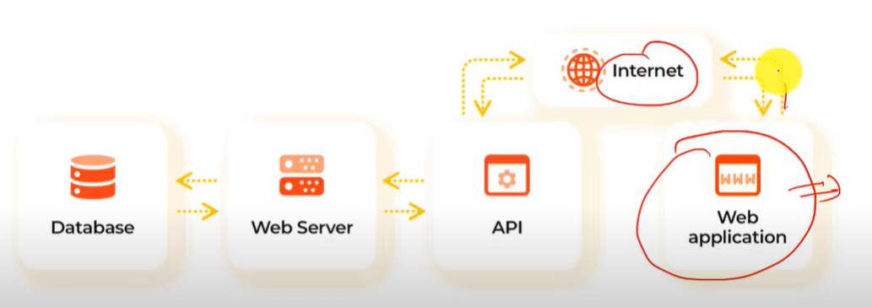

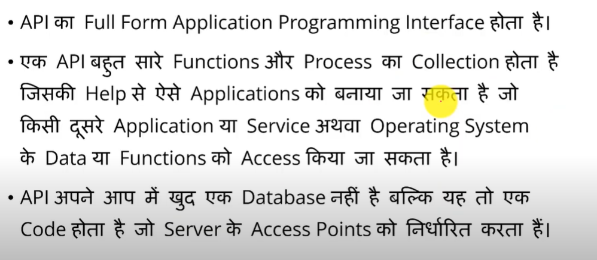

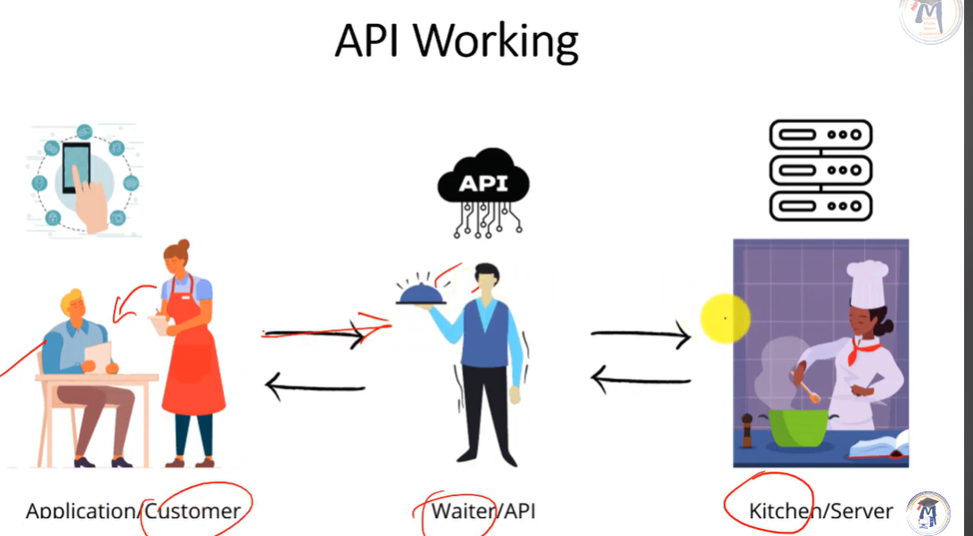

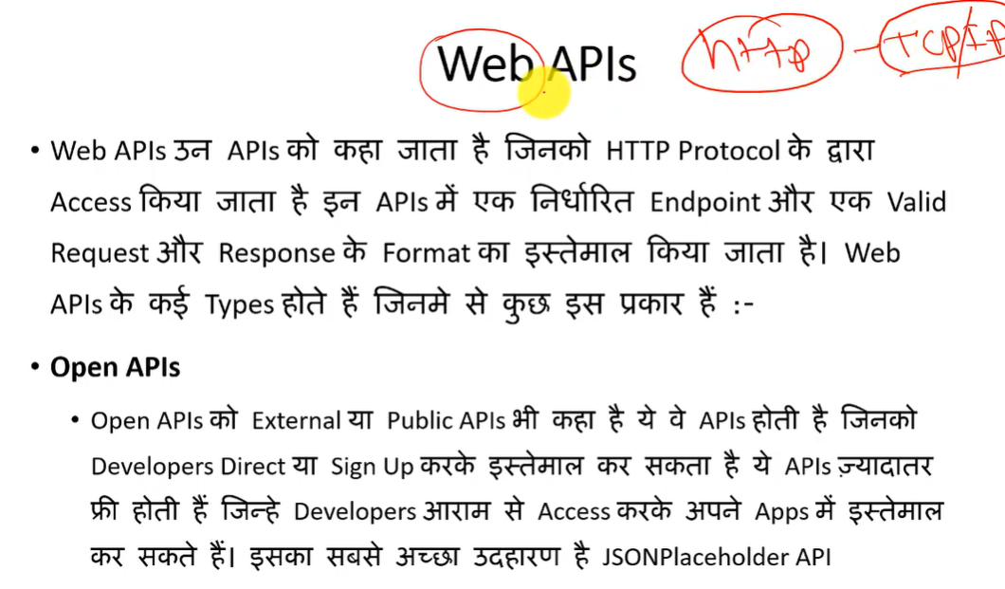

<https://scrolltest.com/2018/12/15/api-testing-tutorial/>

# What is an API?

API stands for the Application Programming Interface,

They are basically a collection of functions and procedures which allows us to communicate two applications or libraries.

In short, It is like a **connector** between two services as shown in the picture.

**Postman vs CURL**

Postman is an [API platform](https://www.postman.com/api-platform/) for building and using APIs. Postman simplifies each step of the API lifecycle and streamlines collaboration so you can create better APIs—faster.

**CURL— [Client url]**

**1. What is curl?**

curl is used in command lines or scripts to transfer data. curl is also used in cars, television sets, routers, printers, audio equipment, mobile phones.

**2. What is GET Request?**

The HTTP GET method is used to **\*read\*** (or retrieve) a representation of a resource. In the “happy” (or non-error) path, GET returns a representation in XML or JSON and an HTTP response code of 200 (OK).

**3. What is POST Request?**

The POST verb is most-often utilized to **\*create\*** new resources. In particular, it's used to create subordinate resources. That is, subordinate to some other (e.g. parent) resource. In other words, when creating a new resource, POST to the parent and the service takes care of associating the new resource with the parent, assigning an ID (new resource URI), etc.

**4. What is PATCH Request?**

PATCH is used for **\*modify\*** capabilities. The PATCH request only needs to contain the changes to the resource, not the complete resource.

**5. What is Delete Request?**

DELETE is pretty easy to understand. It is used to **\*delete\*** a resource identified by a URI.

**6. What is PUT Request?**

PUT is most-often utilized for **\*update\*** capabilities, PUT-ing to a known resource URI with the request body containing the newly-updated representation of the original resource.

However, PUT can also be used to create a resource in the case where the resource ID is chosen by the client instead of by the server. In other words, if the PUT is to a URI that contains the value of a non-existent resource ID. Again, the request body contains a resource representation. Many feel this is convoluted and confusing. Consequently, this method of creation should be used sparingly, if at all.

**7. Put VS Patch vs post POST**

creates an item in a collection. PUT replaces an item. PATCH modifies an item.

We are going to learn, HTTP in Hindi, This is Day 3 of the 30 days of the API Testing challenge Series with Rest Assured.

Where will learn the Basics before jumping to API Automation.

**✅ Download notes**:

<https://sdet.live/notes>

**8. What is HTTP?**

HTTP stands for Hyper Text Transfer Protocol WWW is about communication between web clients and servers Communication between client computers and web servers is done by sending HTTP Requests and receiving HTTP Responses

**9. What’s in an HTTP request?**

An HTTP request is the way internet communications platforms such as web browsers ask for the information they need to load a website.

Each HTTP request made across the Internet carries with it a series of encoded data that carries different types of information. A typical HTTP request contains:

* HTTP version type
* a URL
* an HTTP method
* HTTP request headers
* Optional HTTP body.

**10. What is HTTP cookie?**

An HTTP cookie (also called web cookie, Internet cookie, browser cookie, or simply cookie) is a small piece of data sent from a website and stored on the user's computer by the user's web browser while the user is browsing.

**Read more** - <https://www.cloudflare.com/learning/ddos/glossary/hypertext-transfer-protocol-http/>

Curl function –

<?php

curl_init(); 🡪 for initialization

curl_setopt(); 🡪 for data send of curl

curl_exec(); 🡪 for execution

curl_close(); 🡪

?>

For example –

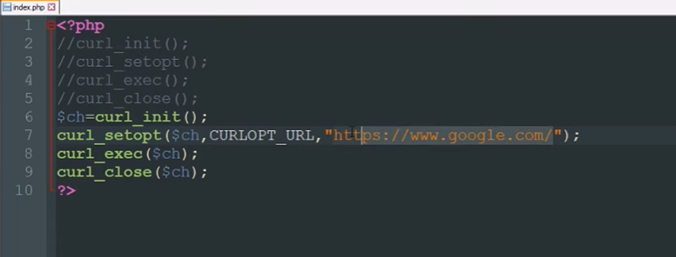

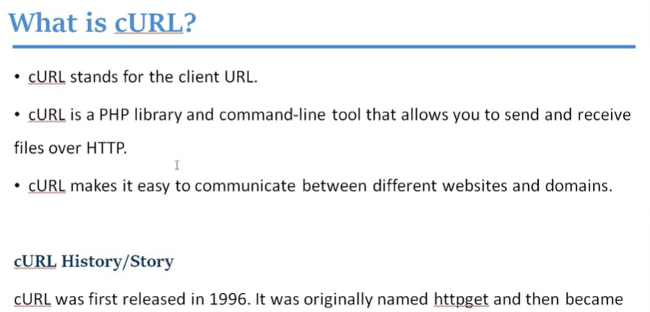

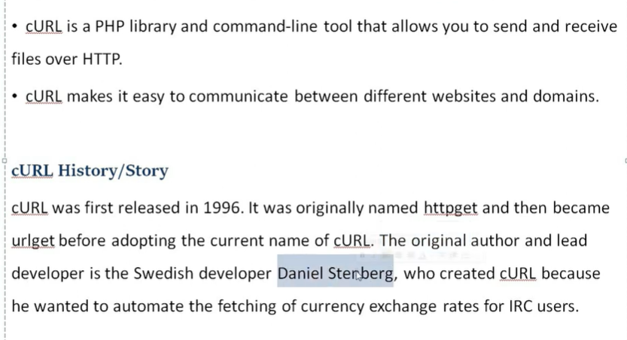

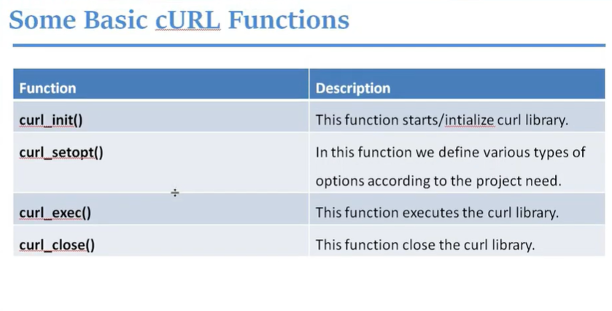

🡪**Exmaple**

