|  |  |
| --- | --- |
|  |  |

**Faculty of Technology and Engineering**

**Chandubhai S. Patel Institute of Technology (CSPIT)**

**Department of Computer Science & Engineering**

Date: / /

**Laboratory Manual**

|  |  |  |  |  |  |
| --- | --- | --- | --- | --- | --- |
| Academic Year | : | 2024-25 | Semester | : | 4 |
| Course code | : | CSE206 | Course name | : | DATABASE MANAGEMENT SYSTEM |

|  |
| --- |
| **Practical - 12** |
| **Aim:** - Your task is to design and implement database functionalities for managing product information in an e-commerce system. The system should allow users to create, retrieve, update, and delete product data, compute discounts on products using a function, and maintain an audit trail for product updates using a trigger. |

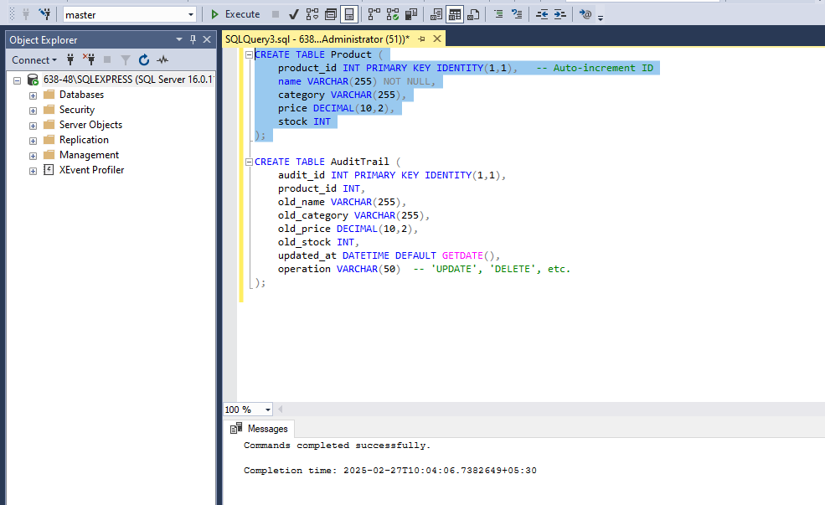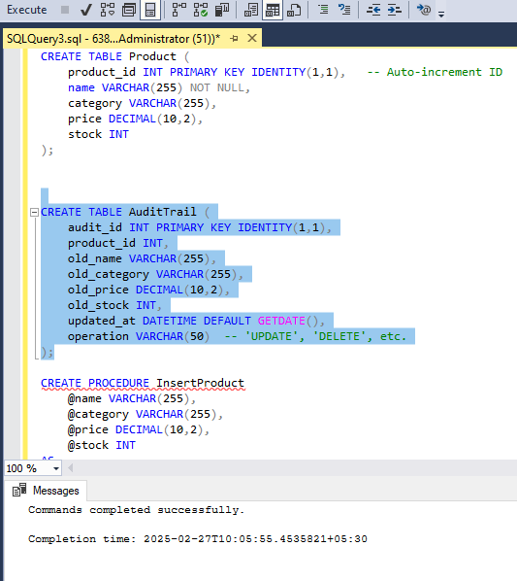

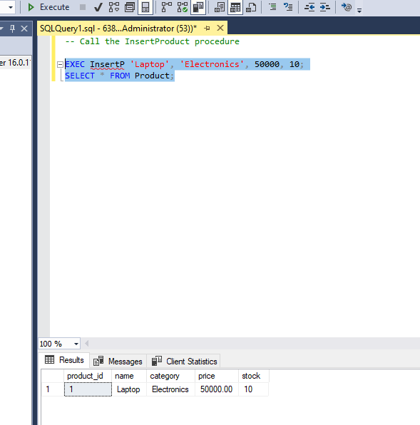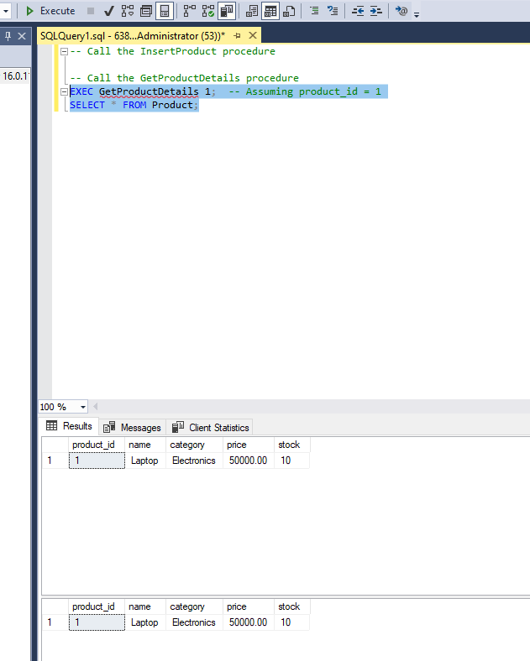



**Task:**

1. Create a stored procedure to insert a new product into the Product table.

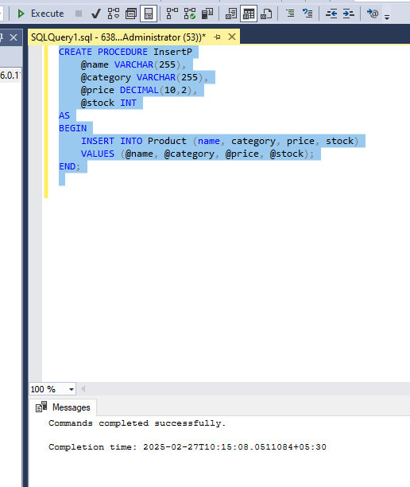

1. Create a stored procedure to retrieve product details by product_id.

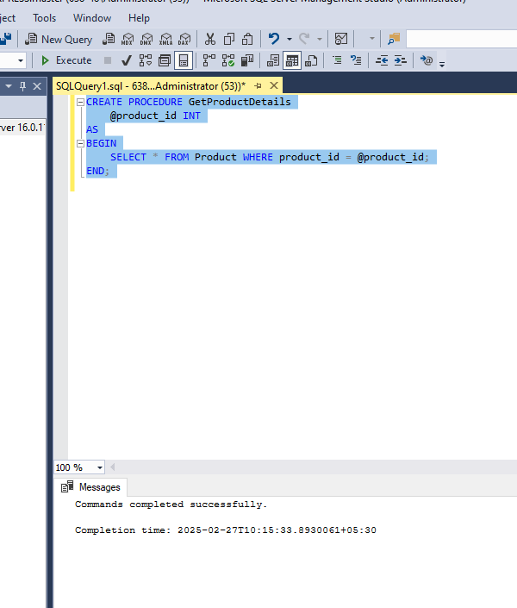

1. Create a stored procedure to update the stock of a product.

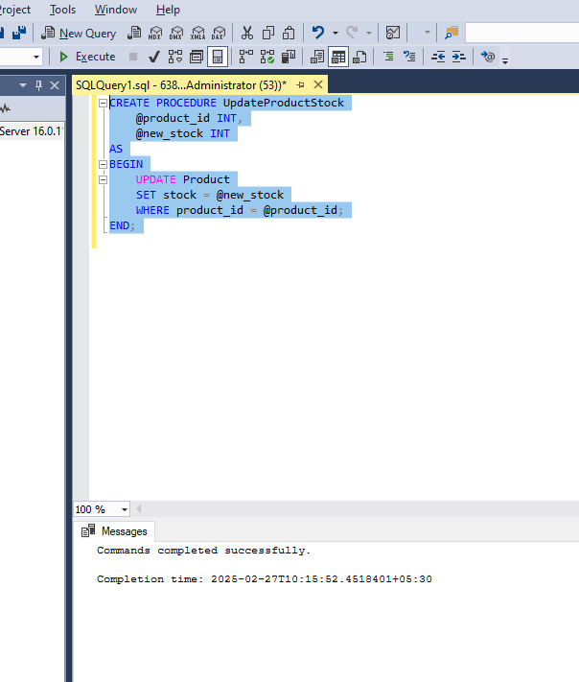

1. Create a stored procedure to delete a product by product_id.

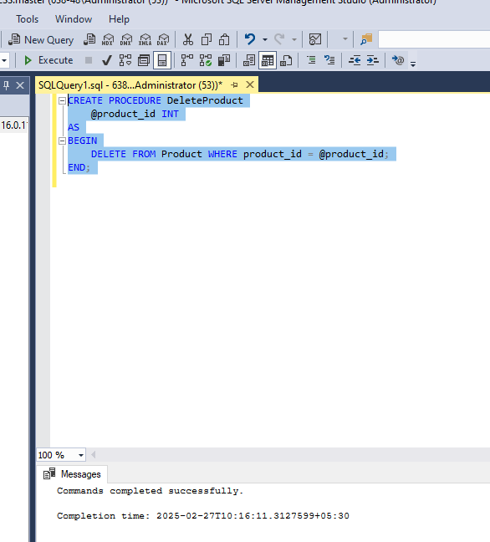

1. Create a function to calculate the discounted price of a product.

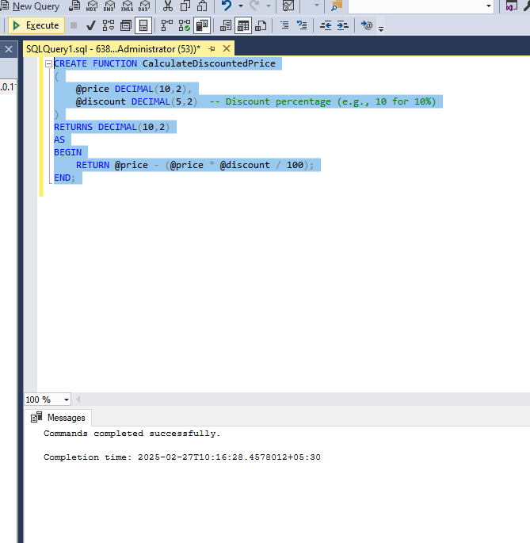

1. Implement a trigger to maintain an audit trail of updates made to the Product table. Before any update, the trigger should insert a record into an AuditTrail table, storing the old product details along with the update timestamp.

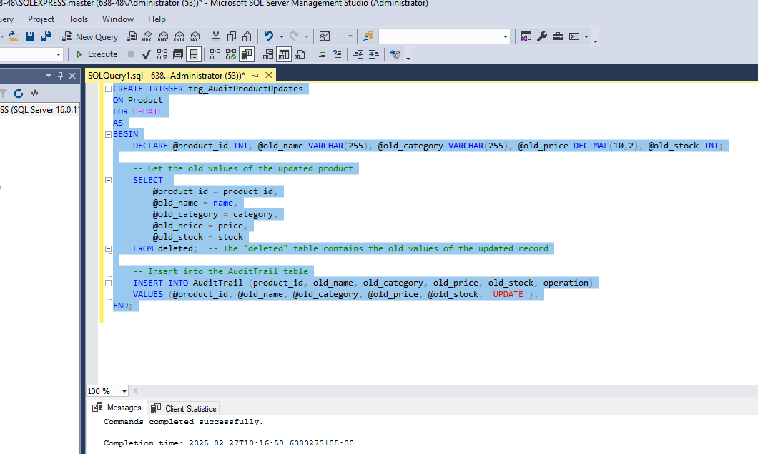

Tasks for test:

