|  |  |
| --- | --- |
|  |  |

**Faculty of Technology and Engineering**

**Chandubhai S. Patel Institute of Technology (CSPIT)**

**Department of Computer Science & Engineering**

Date: / /

**Laboratory Manual**

|  |  |  |  |  |  |
| --- | --- | --- | --- | --- | --- |
| Academic Year | : | 2024-25 | Semester | : | 4 |
| Course code | : | CSE206 | Course name | : | DATABASE MANAGEMENT SYSTEM |

|  |
| --- |
| **Practical - 4** |
| * **Aim: -** You are a database administrator for a multinational bank. The bank requires insights and maintenance of its employee and customer databases to ensure data consistency and retrieval of relevant information for various operations. Your tasks involve applying constraints and writing SQL queries to retrieve specific data based on given conditions. Below are the tasks to be performed:   **The bank maintains the following schemas:**  **Employee Schema**  **•** Emp_ID (Primary Key)  • Emp_Name (Not Null)  • Emp_Salary (Not Null, Check: Greater than zero)  • Job_ID (Unique)  • Other attributes you can add as needed  **Customer Schema**  • Cust_ID (Primary Key)  • Cust_Name (Not Null)  • Branch (Not Null)  • Other attributes you can add as needed  **Constraints –**   * **Not Null Constraints:** Ensure critical fields are not null. * **Unique Constraints:** Ensure data integrity by limiting column values. * **Check Constraints:** Ensure columns have unique values where required. |

**Tasks:-**

The HR team wants to identify specific employees for a new project. Write SQL queries to:

1. Retrieve the details of employees whose names:

* Start with the letter 'A'.
* Have 'a' as the third character.

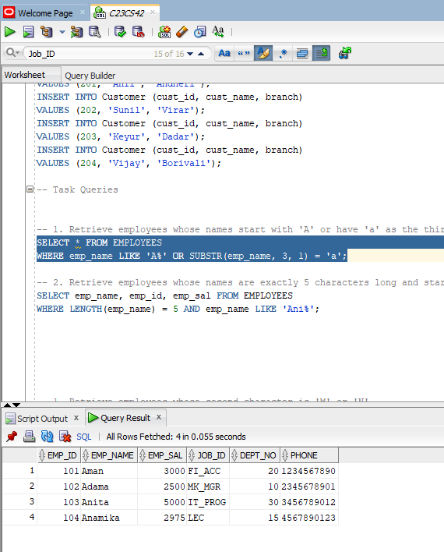

1. Display the names, employee numbers, and salaries of employees whose names:

* Are exactly 5 characters long.
* Start with 'Ani'.

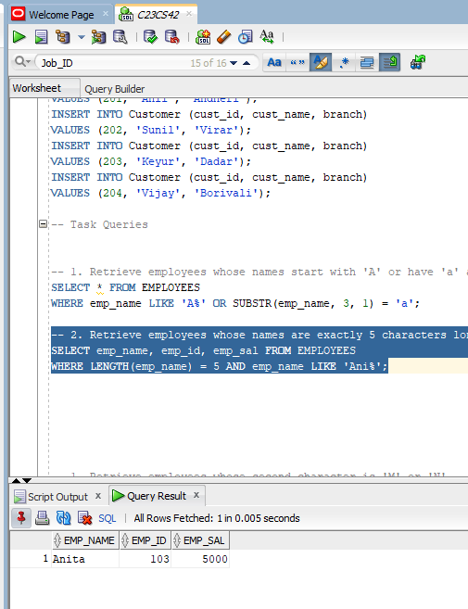

To analyze naming patterns in the employee database, perform the following:

1. Retrieve the details of employees whose second character is either 'M' or 'N'.  
     
   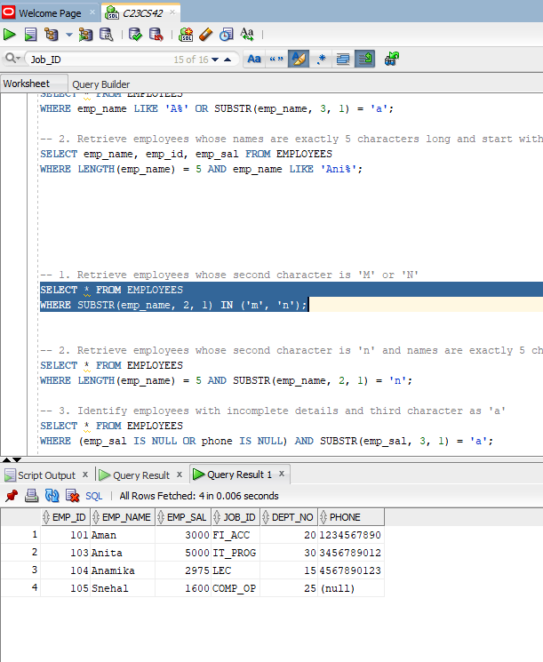
2. Retrieve the details of employees whose second character is 'n', and their names are exactly 5 characters long.

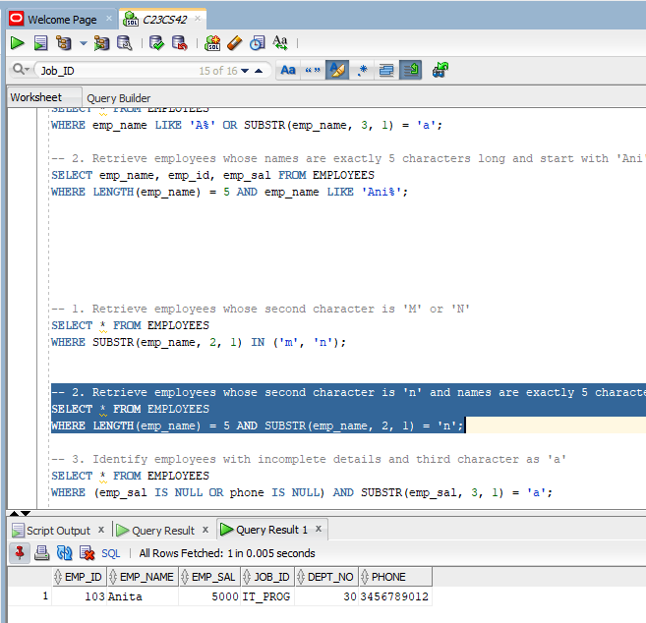

1. Identify employees whose details are partially incomplete (contain null values) and whose third character in their names is 'a'.

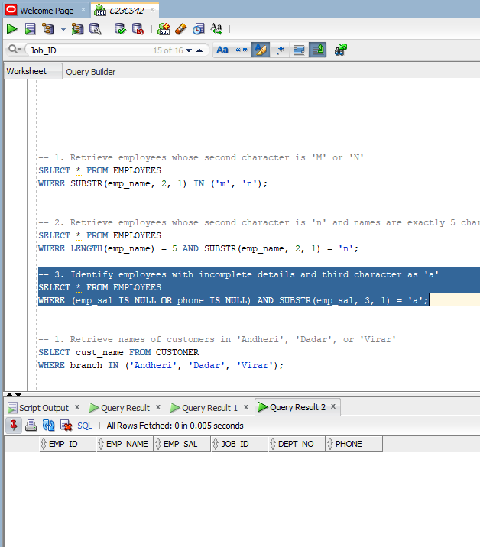

The marketing department plans a special campaign for customers in specific branches. Write a query to:

* Retrieve the names of all customers whose branch is either ‘Andheri’, ‘Dadar’, or ‘Virar’.

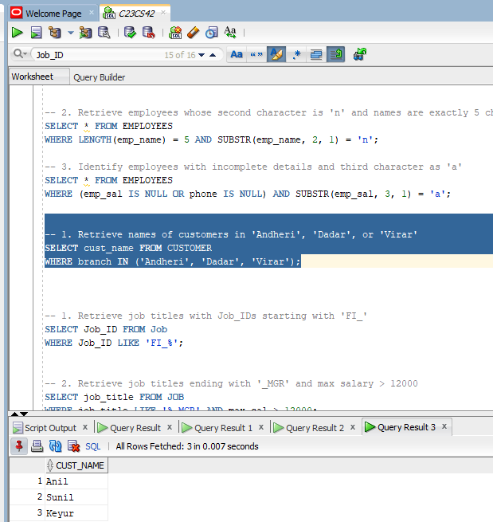

.

To optimize the workforce and their roles, retrieve the following:

1. Job names whose job IDs begin with ‘FI_’.

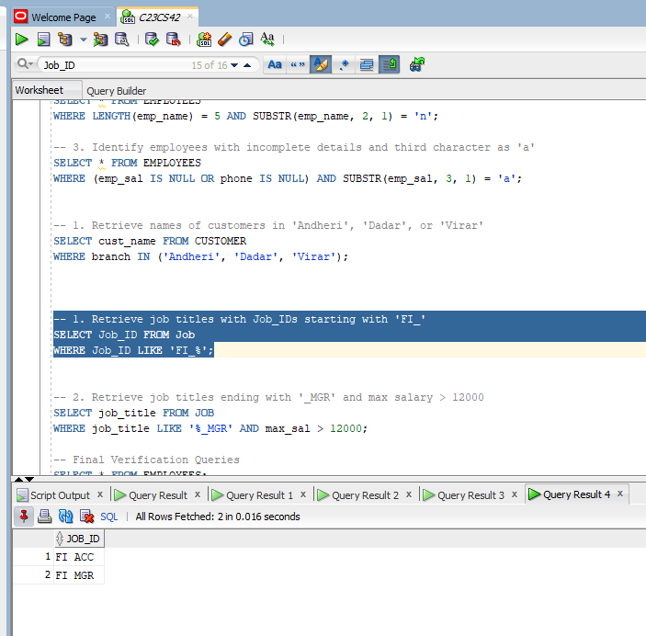

1. Titles of jobs that end with '_MGR' and have a maximum salary greater than ₹12,000.

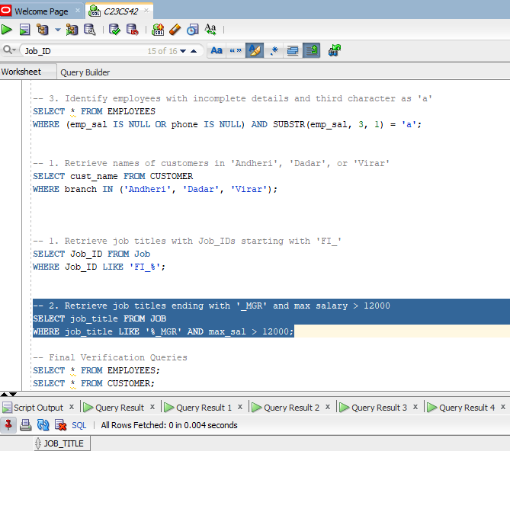

**Final Verification Queries :--**

1. Employee

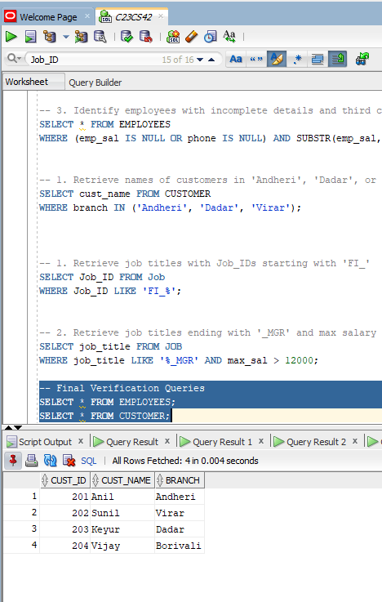

1. Customer

