|  |  |
| --- | --- |
|  |  |

**Faculty of Technology and Engineering**

**Chandubhai S. Patel Institute of Technology (CSPIT)**

**Department of Computer Science & Engineering**

Date: / /

**Laboratory Manual**

|  |  |  |  |  |  |
| --- | --- | --- | --- | --- | --- |
| Academic Year | : | 2024-25 | Semester | : | 4 |
| Course code | : | CSE206 | Course name | : | DATABASE MANAGEMENT SYSTEM |

|  |
| --- |
| **Practical - 6** |
| **Aim:** You are a database administrator for a manufacturing and consulting company. The company maintains two primary tables: Product and Employee Company (emp_company). You are tasked with solving business queries related to order quantities, employee salaries, and company analysis using SQL grouping and aggregate functions. To manipulate and retrieve meaningful insights using grouping and aggregate functions in SQL while adhering to database constraints and integrity rules.**The bank maintains the following schemas:**   1. Product Table: Tracks order details for various products.   • Detorder_no (Primary Key)  • Product_no (Not Null, Unique)  • Qty_order (Not Null, Check: Greater than zero)   1. emp_company Table: Tracks employees, their companies, and salaries.   • ENAME (Not Null, Unique)  • CNAME (Not Null)  • SALARY (Not Null, Check: Greater than zero)  **Constraints –**   * Not Null Constraints: Critical fields such as product numbers, employee names, and salaries must not contain null values. * Unique Constraints: Ensure the integrity of unique fields like Product_no and ENAME. * Check Constraints: Validate that quantities and salaries have valid positive values |

**Tasks:-**

1. Insert Values: o Insert the above data into the Product table. o Test Case: Verify that the values are inserted correctly by displaying all rows.

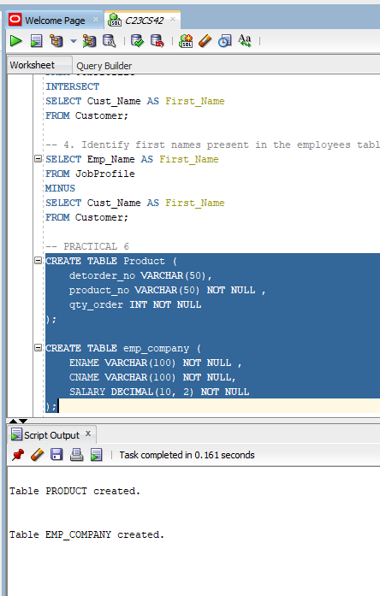

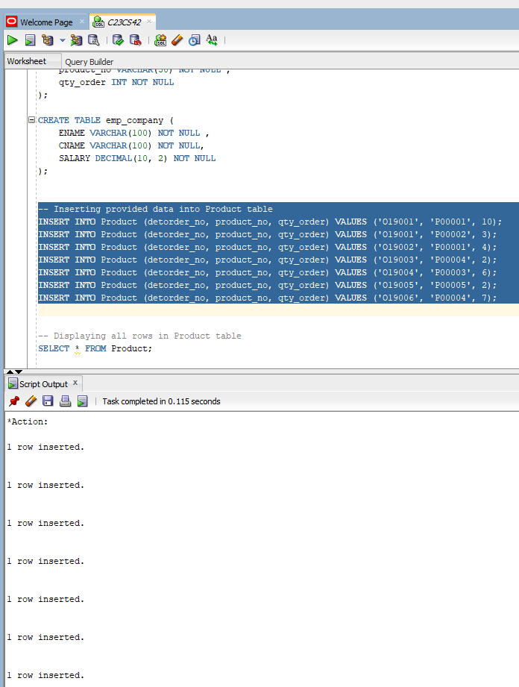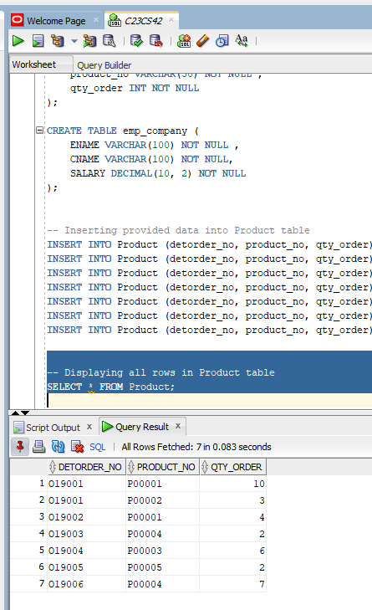

1. Total Quantity per Product: o Retrieve the product numbers and total quantities ordered for each product. o Test Case: Verify that the sum of quantities ordered for each product number is calculated correctly.

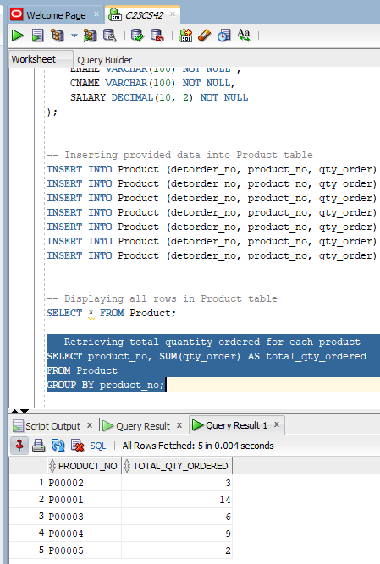

3. Filter Specific Products: o Retrieve the product numbers and total quantities ordered for products P00001 and P00004.o Test Case: Verify that the sum of quantities ordered for product numbers P00001 and P00004 is calculated correctly

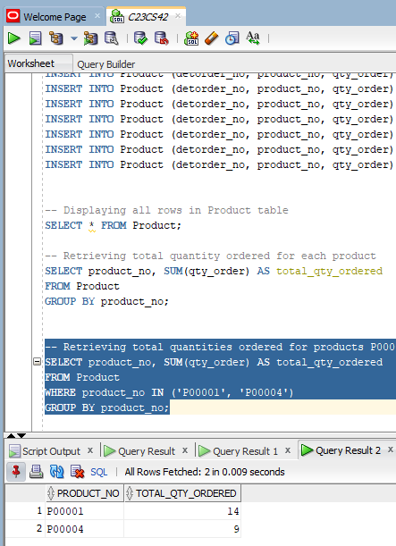

1. Insert Values: o Insert the above data into the emp_company table. o Test Case: Verify that the values are inserted correctly by displaying all rows.

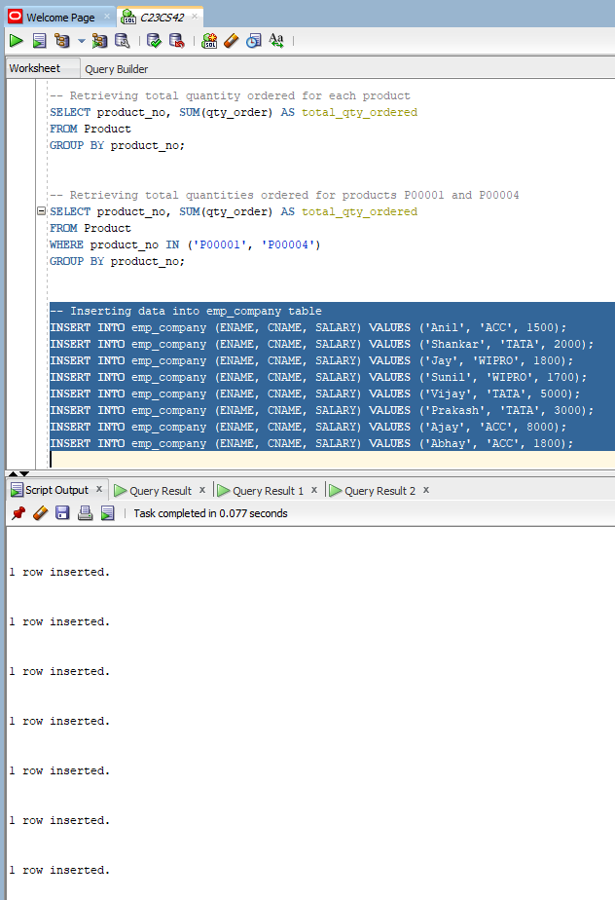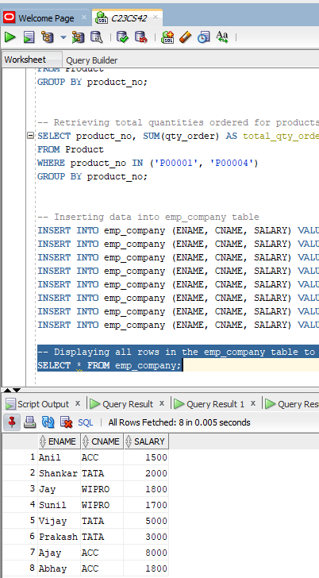

2. Maximum Salary per Company: o List the company names and the maximum salary in each company. o Test Case: Verify that the maximum salary for each company is calculated correctly.

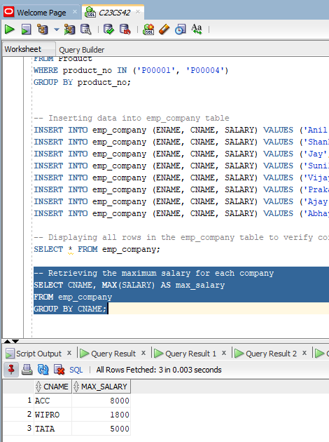

3. Average Salary per Company: o Calculate the average salary for each company. o Test Case: Verify that the average salary for each company is calculated correctly.

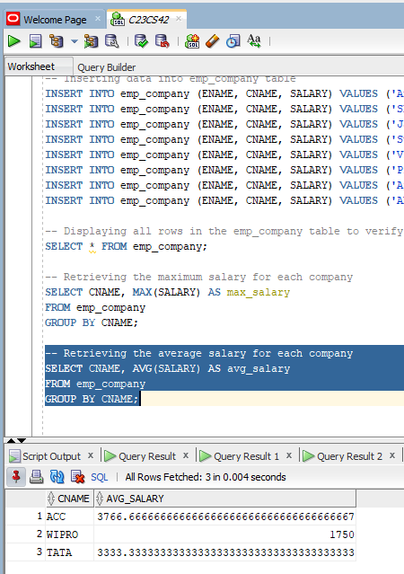

4. Filter Companies by Average Salary: o List the names of companies with an average salary greater than ₹1,500. o Test Case: Verify that the companies with an average salary greater than ₹1,500 are listed correctly.

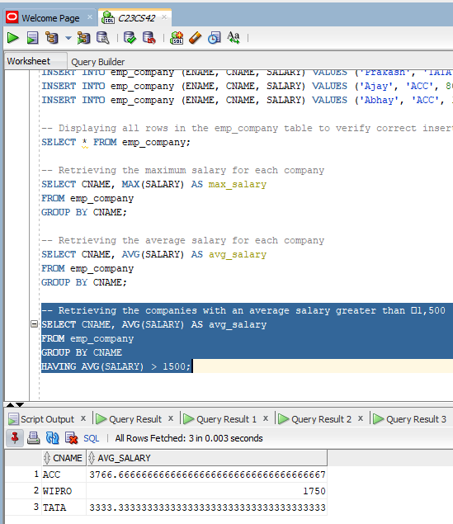

5. Exclude a Specific Company: o Calculate the average salary for each company except ACC. o Test Case: Verify that the average salary for each company, excluding ACC, is calculated correctly.

