|  |  |
| --- | --- |
|  |  |

**Faculty of Technology and Engineering**

**Chandubhai S. Patel Institute of Technology (CSPIT)**

**Department of Computer Science & Engineering**

Date: / /

**Laboratory Manual**

|  |  |  |  |  |  |
| --- | --- | --- | --- | --- | --- |
| Academic Year | : | 2024-25 | Semester | : | 4 |
| Course code | : | CSE206 | Course name | : | DATABASE MANAGEMENT SYSTEM |

|  |
| --- |
| **Practical - 9** |
| **Aim:** You are a database administrator for a company managing sales, customers, and orders. The system must provide robust querying capabilities to retrieve, analyze, and manipulate data based on specific business requirements. Your task is to use SQL JOIN commands and constraints to answer real-world queries about salespeople, customers, and orders. (Refer the attached excel sheet for Database)  1. Salespeople: Contains information about sales staff, including their ID, name, city, and commission rate.  2. Customer: Stores details of customers, their ratings, and the salesperson managing them.  3. Order: Tracks order details, including the order amount, date, and links to customer and salesperson records. |

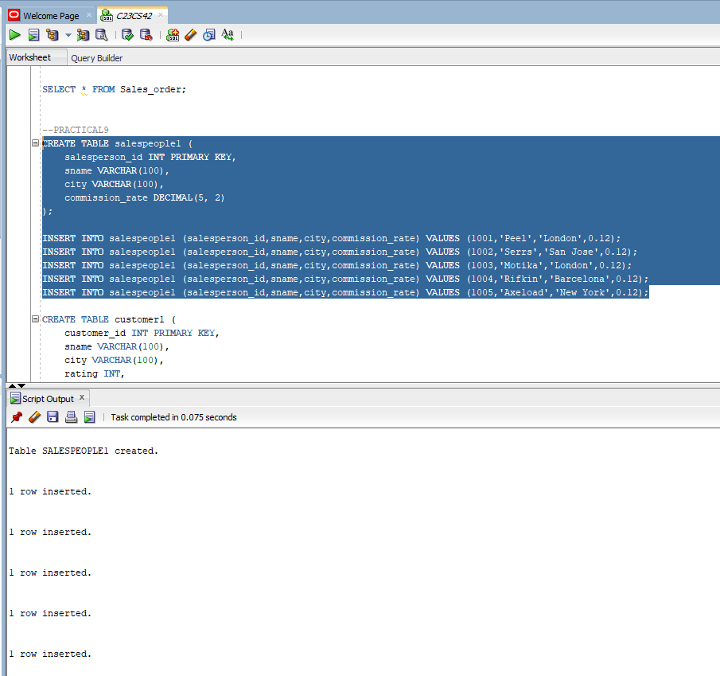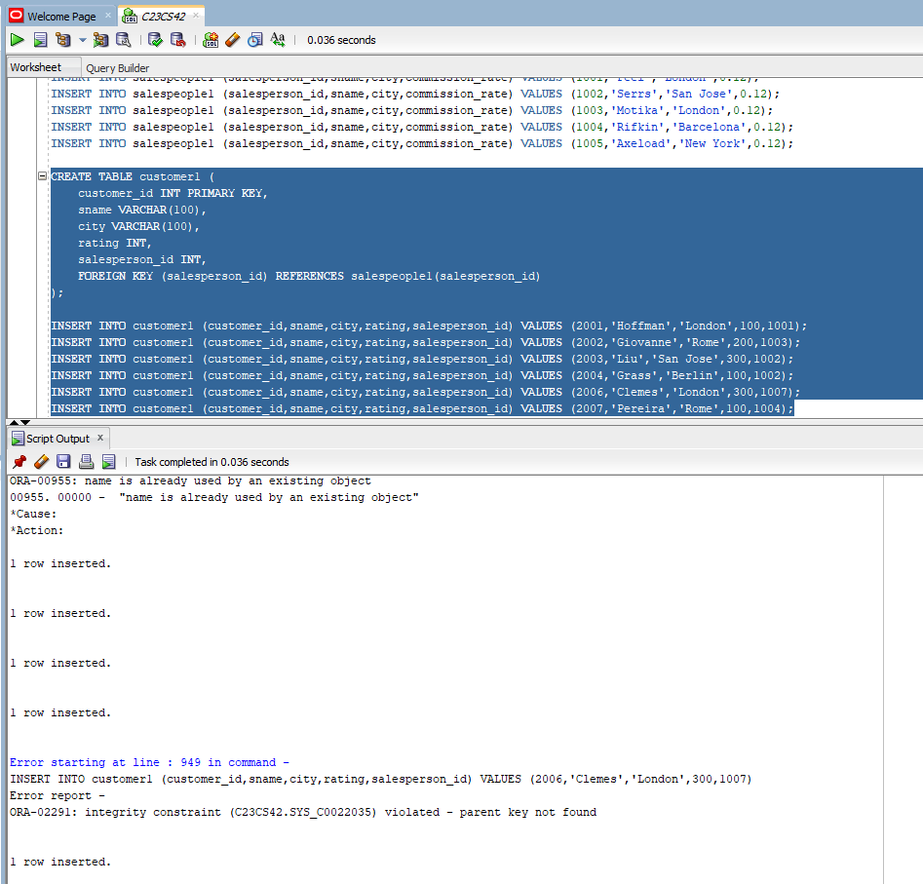

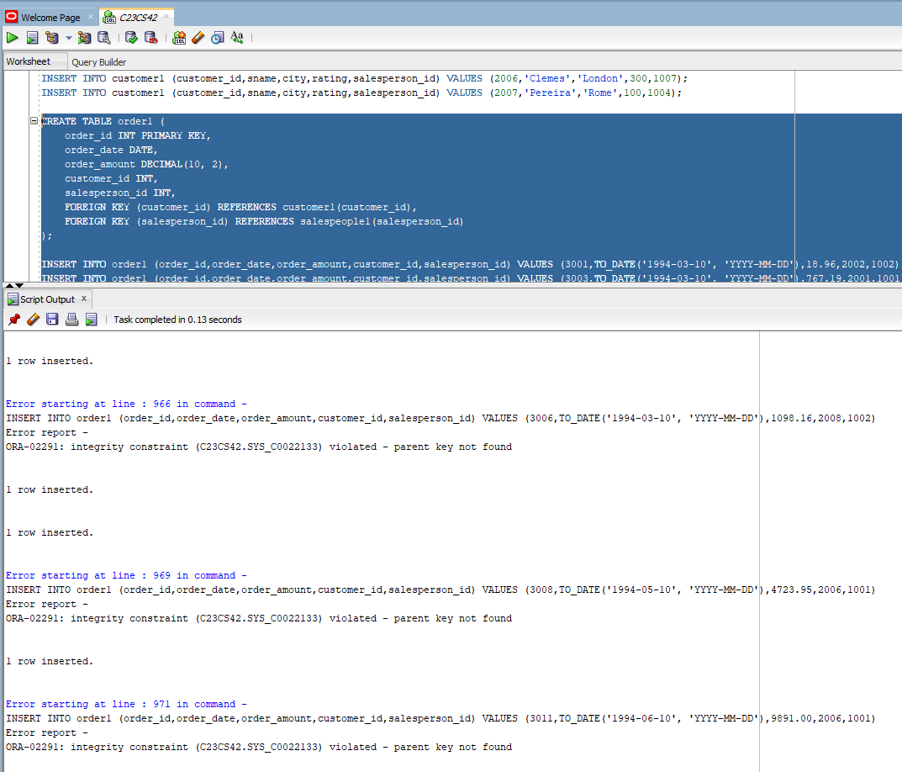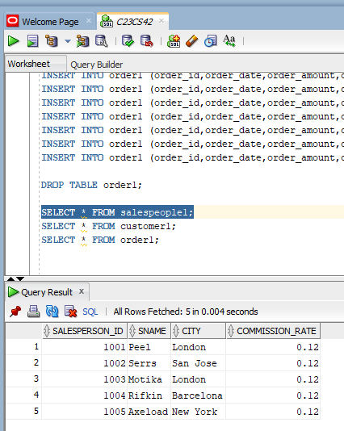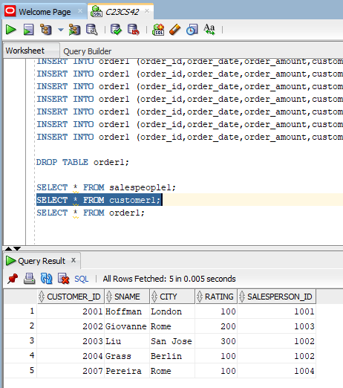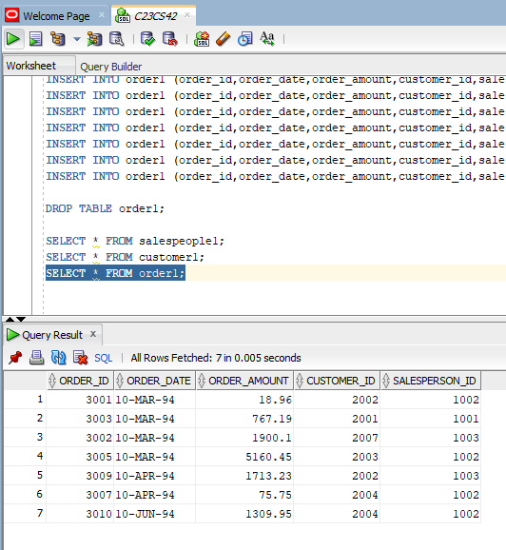

**Tasks:-**

1. The sales manager wants to identify all customers being handled by salespeople named Peel or Motika.

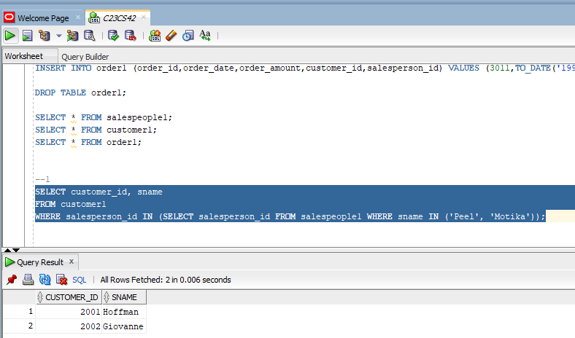

2. The finance team wants to exclude invalid orders where the amount is 0 or missing.

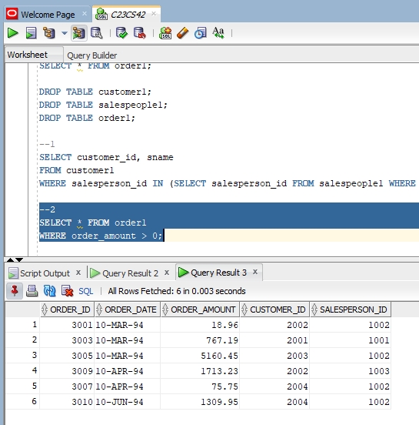

3. The management wants to analyze the highest order values processed by salespeople for orders exceeding $3000.

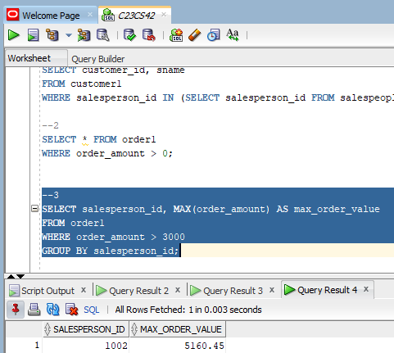

4. The HR department wants to find relationships between salespeople and customers in the same city.

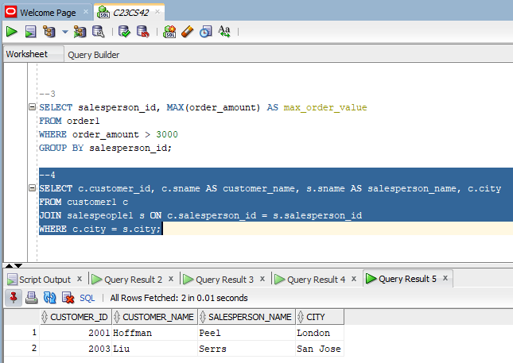

5. The operations team needs a list of orders along with the names of customers who placed them.

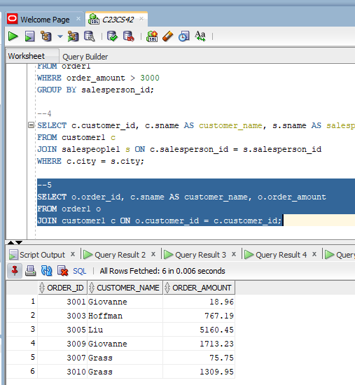

6. Identify customers managed by salespeople earning more than 12% commission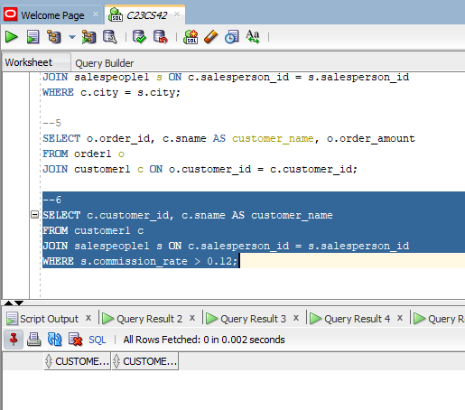

7. Identify customers with a rating identical to Hoffman's.

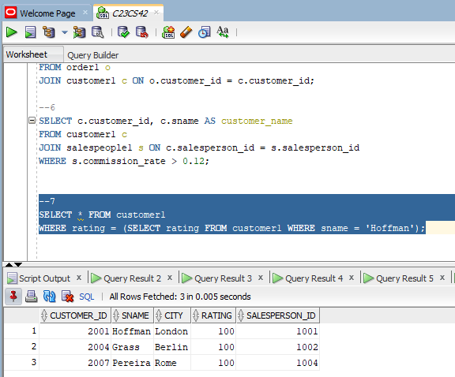

8. The analytics team wants to find the number of customers with ratings exceeding the average rating of customers from San Jose.

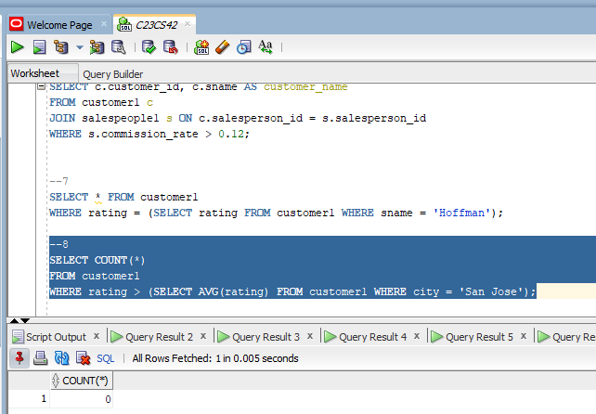

9. Identify salespeople whose total orders exceed the largest single order amount in the system.

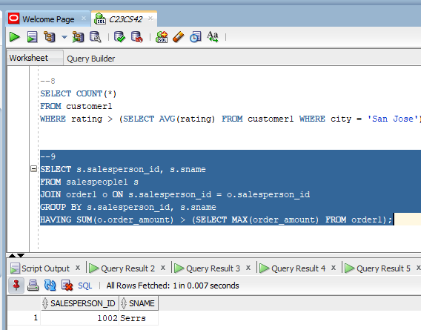

10. Create a categorized listing of customers based on their ratings. Ratings >= 400 should be marked as 'High Rating'; otherwise, 'Low Rating'.

