Question :

Using ALV, display Header details.  
•    When double clicked on document-number display item data corresponding to document number.  
•    Double clicked on payer number in header table. Go to transaction ‘xd03’and skip the first screen and display payer details.  
•    Double clicked on material number in item table. Go to transaction ‘mm03’and display material details.

**Package (zust_180496)**

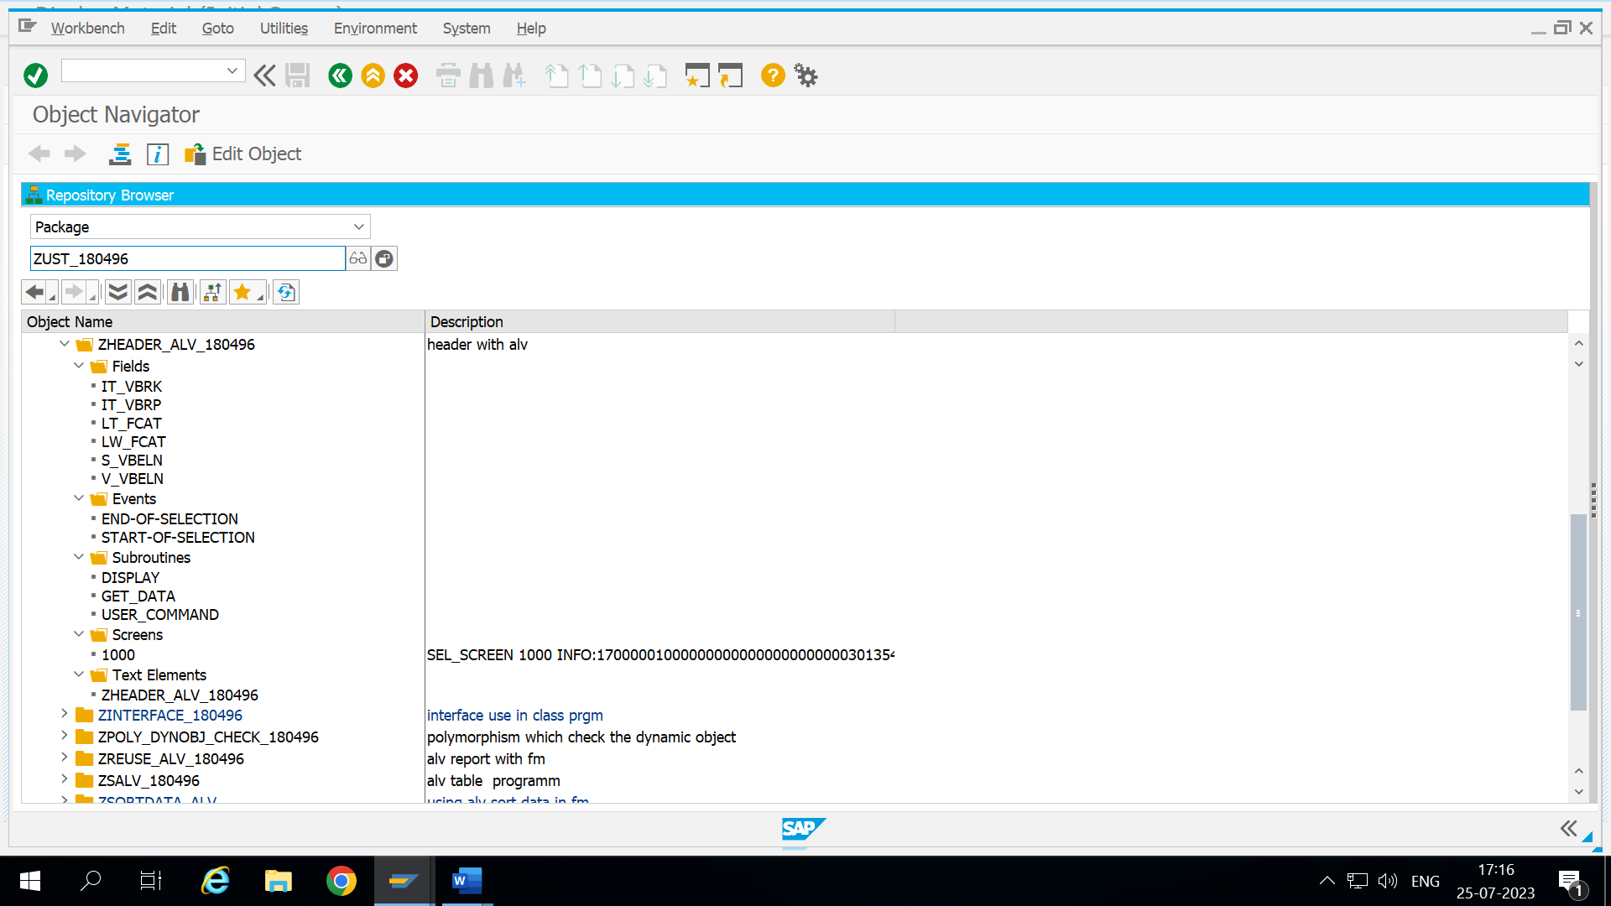

**SE38 - ZHEADER_180496 (code snippet)**

*&---------------------------------------------------------------------*  
*& Report ZHEADER_ALV_180496  
*&---------------------------------------------------------------------*  
*&  
*&---------------------------------------------------------------------*  
REPORT ZHEADER_ALV_180496.

"declaring header and item internal table  
DATA : it_vbrk TYPE STANDARD TABLE OF zvbrk_1,   
         it_vbrp type STANDARD TABLE OF zvbrp_1.  
  
  
"internal table and work area for fieldcat display  
  data: lt_fcat TYPE slis_t_fieldcat_alv,  
         lw_fcat LIKE LINE OF lt_fcat.

"declaring select options  
DATA v_vbeln TYPE vbeln.  
SELECT-OPTIONS s_vbeln FOR v_vbeln.

" start execute the program from next line of start-of-selection  
START-OF-SELECTION.

"calling subroutine for getting header data  
  PERFORM get_data.   
  
"output part  
END-OF-SELECTION.  
  PERFORM display. "calling subroutine for display  
  
*&---------------------------------------------------------------------*  
*& Form get_data  
*&---------------------------------------------------------------------*  
*& text  
*&---------------------------------------------------------------------*  
*& -->  p1        text  
*& <--  p2        text  
*&---------------------------------------------------------------------*  
"subroutine  
FORM get_data .  
"copying data from header table to internal table  
  select * from zvbrk_1 into table it_vbrk where vbeln in s_vbeln.  
  
ENDFORM.  
*&---------------------------------------------------------------------*  
*& Form display  
*&---------------------------------------------------------------------*  
*& text  
*&---------------------------------------------------------------------*  
*& -->  p1        text  
*& <--  p2        text  
*&---------------------------------------------------------------------*

FORM display .  
  
  
  lw_fcat-col_pos = 1.  
  lw_fcat-fieldname = 'VBELN'.  
  lw_fcat-tabname = 'IT_VBRK'.  
  lw_fcat-seltext_m = 'DOCUMENT NO'.  
*  lw_fcat-hotspot = 'X'.  
  lw_fcat-outputlen = 20.  
  APPEND lw_fcat TO lt_fcat.  
  CLEAR LW_FCAT.  
  
  lw_fcat-col_pos = 2.  
  lw_fcat-fieldname = 'KUNRG'.  
  lw_fcat-tabname = 'IT_VBRK'.  
  lw_fcat-seltext_m = 'PAYER NO'.  
  lw_fcat-outputlen = 20.  
  APPEND lw_fcat TO lt_fcat.  
  CLEAR LW_FCAT.  
  
  lw_fcat-col_pos = 3.  
  lw_fcat-fieldname = 'FKDAT'.  
  lw_fcat-tabname = 'IT_VBRK'.  
  lw_fcat-seltext_m = 'DATE'.  
  lw_fcat-outputlen = 20.  
  APPEND lw_fcat TO lt_fcat.  
 CLEAR LW_FCAT.  
  
    lw_fcat-col_pos = 4.  
  lw_fcat-fieldname = 'NETWR'.  
  lw_fcat-tabname = 'IT_VBRK'.  
  lw_fcat-seltext_m = 'NETVALUE'.  
  lw_fcat-outputlen = 20.  
  APPEND lw_fcat TO lt_fcat.  
   CLEAR LW_FCAT.  
  
  
  
  CALL FUNCTION 'REUSE_ALV_GRID_DISPLAY'  
   EXPORTING  
*     I_INTERFACE_CHECK                 = ' '  
*     I_BYPASSING_BUFFER                = ' '  
*     I_BUFFER_ACTIVE                   = ' '  
     I_CALLBACK_PROGRAM                = 'ZHEADER_ALV_180496'  
*     I_CALLBACK_PF_STATUS_SET          = ' '  
     I_CALLBACK_USER_COMMAND           = 'USER_COMMAND '  
*     I_CALLBACK_TOP_OF_PAGE            = ' '  
*     I_CALLBACK_HTML_TOP_OF_PAGE       = ' '  
*     I_CALLBACK_HTML_END_OF_LIST       = ' '  
*     I_STRUCTURE_NAME                  =  
*     I_BACKGROUND_ID                   = ' '  
*     I_GRID_TITLE                      =  
*     I_GRID_SETTINGS                   =  
*     IS_LAYOUT                         =  
     IT_FIELDCAT                       =  lt_fcat  
*     IT_EXCLUDING                      =  
*     IT_SPECIAL_GROUPS                 =  
*     IT_SORT                           =  
*     IT_FILTER                         =  
*     IS_SEL_HIDE                       =  
*     I_DEFAULT                         = 'X'  
*     I_SAVE                            = ' '  
*     IS_VARIANT                        =  
*     IT_EVENTS                         =  
*     IT_EVENT_EXIT                     =  
*     IS_PRINT                          =  
*     IS_REPREP_ID                      =  
*     I_SCREEN_START_COLUMN             = 0  
*     I_SCREEN_START_LINE               = 0  
*     I_SCREEN_END_COLUMN               = 0  
*     I_SCREEN_END_LINE                 = 0  
*     I_HTML_HEIGHT_TOP                 = 0  
*     I_HTML_HEIGHT_END                 = 0  
*     IT_ALV_GRAPHICS                   =  
*     IT_HYPERLINK                      =  
*     IT_ADD_FIELDCAT                   =  
*     IT_EXCEPT_QINFO                   =  
*     IR_SALV_FULLSCREEN_ADAPTER        =  
*     O_PREVIOUS_SRAL_HANDLER           =  
*   IMPORTING  
*     E_EXIT_CAUSED_BY_CALLER           =  
*     ES_EXIT_CAUSED_BY_USER            =  
    TABLES  
      t_outtab                          =  IT_VBRK  
   EXCEPTIONS  
     PROGRAM_ERROR                     = 1  
     OTHERS                            = 2  
            .  
  IF sy-subrc <> 0.  
* Implement suitable error handling here  
  ENDIF.  
  
  ENDFORM.  
  
  
  
  
FORM USER_COMMAND USING r_ucomm LIKE sy-ucomm  
                        rs_selfield TYPE slis_selfield.  
  
  IF r_ucomm EQ '&IC1' AND rs_selfield-fieldname EQ 'KUNRG'.  
    SET PARAMETER ID 'KUN' FIELD rs_selfield-value.  
    CALL TRANSACTION 'XD03' AND SKIP FIRST SCREEN.  
  ENDIF.  
  
IF r_ucomm EQ '&IC1' AND rs_selfield-fieldname EQ 'VBELN'.  
  SELECT * from zvbrp_1 into table it_vbrp where vbeln eq rs_selfield-value.  
  
CLEAR LT_FCAT.  
  lw_fcat-col_pos = 1.  
  lw_fcat-fieldname = 'POSNR'.  
  lw_fcat-tabname = 'IT_VBRP'.  
  lw_fcat-seltext_m = 'ITEM'.  
  lw_fcat-outputlen = 20.  
  APPEND lw_fcat TO lt_fcat.  
   CLEAR LW_FCAT.  
  
  lw_fcat-col_pos = 2.  
  lw_fcat-fieldname = 'MATNR'.  
  lw_fcat-tabname = 'IT_VBRP'.  
  lw_fcat-seltext_m = 'MATERIAL NO'.  
  lw_fcat-outputlen = 20.  
  APPEND lw_fcat TO lt_fcat.  
   CLEAR LW_FCAT.  
  
  lw_fcat-col_pos = 3.  
  lw_fcat-fieldname = 'FKIMG'.  
  lw_fcat-tabname = 'IT_VBRP'.  
  lw_fcat-seltext_m = 'QUAN'.  
  lw_fcat-outputlen = 20.  
  APPEND lw_fcat TO lt_fcat.  
   CLEAR LW_FCAT.  
  
  lw_fcat-col_pos = 4.  
  lw_fcat-fieldname = 'VRKME'.  
  lw_fcat-tabname = 'IT_VBRP'.  
  lw_fcat-seltext_m = 'UOM'.  
  lw_fcat-outputlen = 20.  
  APPEND lw_fcat TO lt_fcat.  
   CLEAR LW_FCAT.  
  
  lw_fcat-col_pos = 5.  
  lw_fcat-fieldname = 'NETWR'.  
  lw_fcat-tabname = 'IT_VBRP'.  
  lw_fcat-seltext_m = 'NETVALUE'.  
  lw_fcat-outputlen = 20.  
  APPEND lw_fcat TO lt_fcat.  
  CLEAR LW_FCAT.  
  
  CALL FUNCTION 'REUSE_ALV_GRID_DISPLAY'  
   EXPORTING  
*     I_INTERFACE_CHECK                 = ' '  
*     I_BYPASSING_BUFFER                = ' '  
*     I_BUFFER_ACTIVE                   = ' '  
     I_CALLBACK_PROGRAM                = 'ZHEADER_ALV_180496'  
*     I_CALLBACK_PF_STATUS_SET          = ' '  
     I_CALLBACK_USER_COMMAND           = 'USER_COMMAND'  
*     I_CALLBACK_TOP_OF_PAGE            = ' '  
*     I_CALLBACK_HTML_TOP_OF_PAGE       = ' '  
*     I_CALLBACK_HTML_END_OF_LIST       = ' '  
*     I_STRUCTURE_NAME                  =  
*     I_BACKGROUND_ID                   = ' '  
*     I_GRID_TITLE                      =  
*     I_GRID_SETTINGS                   =  
*     IS_LAYOUT                         =  
     IT_FIELDCAT                       =  lt_fcat  
*     IT_EXCLUDING                      =  
*     IT_SPECIAL_GROUPS                 =  
*     IT_SORT                           =  
*     IT_FILTER                         =  
*     IS_SEL_HIDE                       =  
*     I_DEFAULT                         = 'X'  
*     I_SAVE                            = ' '  
*     IS_VARIANT                        =  
*     IT_EVENTS                         =  
*     IT_EVENT_EXIT                     =  
*     IS_PRINT                          =  
*     IS_REPREP_ID                      =  
*     I_SCREEN_START_COLUMN             = 0  
*     I_SCREEN_START_LINE               = 0  
*     I_SCREEN_END_COLUMN               = 0  
*     I_SCREEN_END_LINE                 = 0  
*     I_HTML_HEIGHT_TOP                 = 0  
*     I_HTML_HEIGHT_END                 = 0  
*     IT_ALV_GRAPHICS                   =  
*     IT_HYPERLINK                      =  
*     IT_ADD_FIELDCAT                   =  
*     IT_EXCEPT_QINFO                   =  
*     IR_SALV_FULLSCREEN_ADAPTER        =  
*     O_PREVIOUS_SRAL_HANDLER           =  
*   IMPORTING  
*     E_EXIT_CAUSED_BY_CALLER           =  
*     ES_EXIT_CAUSED_BY_USER            =  
    TABLES  
      t_outtab                          = it_vbrp  
   EXCEPTIONS  
     PROGRAM_ERROR                     = 1  
     OTHERS                            = 2  
            .  
  IF sy-subrc <> 0.  
* Implement suitable error handling here  
  ENDIF.  
  
ENDIF.  
  
 IF r_ucomm EQ '&IC1' AND rs_selfield-fieldname EQ 'MATNR'.  
    SET PARAMETER ID 'MAT' FIELD rs_selfield-value.  
    CALL TRANSACTION 'MM03'.  
  ENDIF.  
  
ENDFORM.

**selection screen (from 1000 to 1003)**

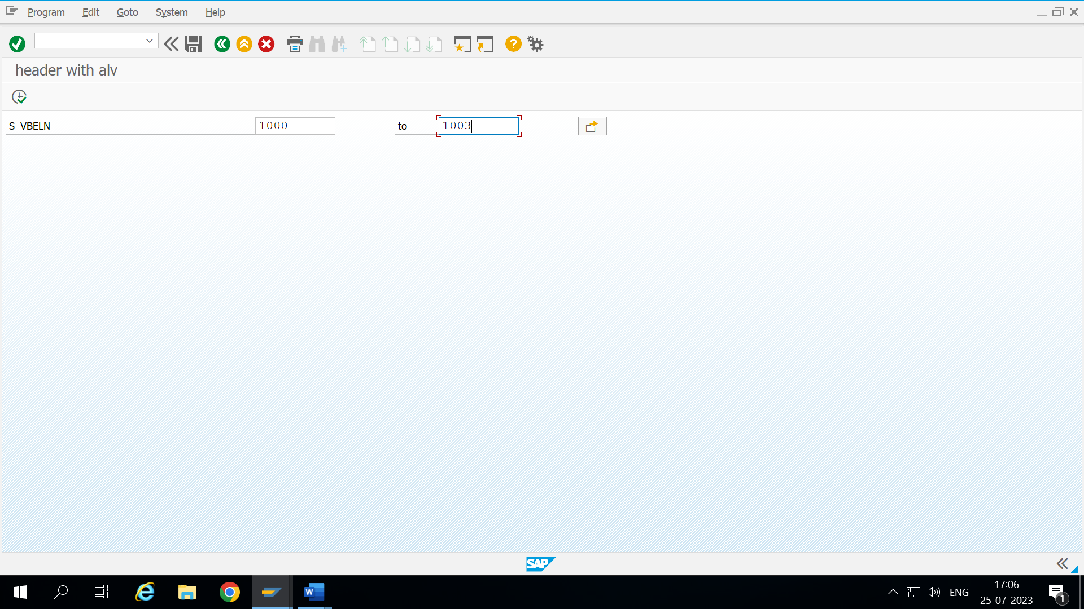

**Header Table Data**

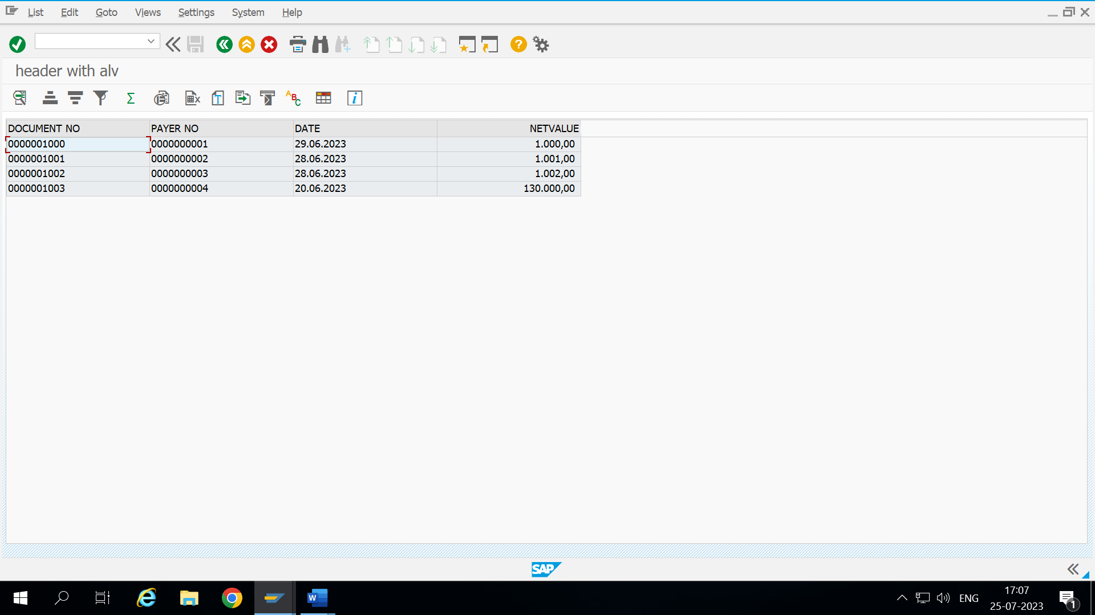

**Double click on Document No. (1000) in header table display item table data**

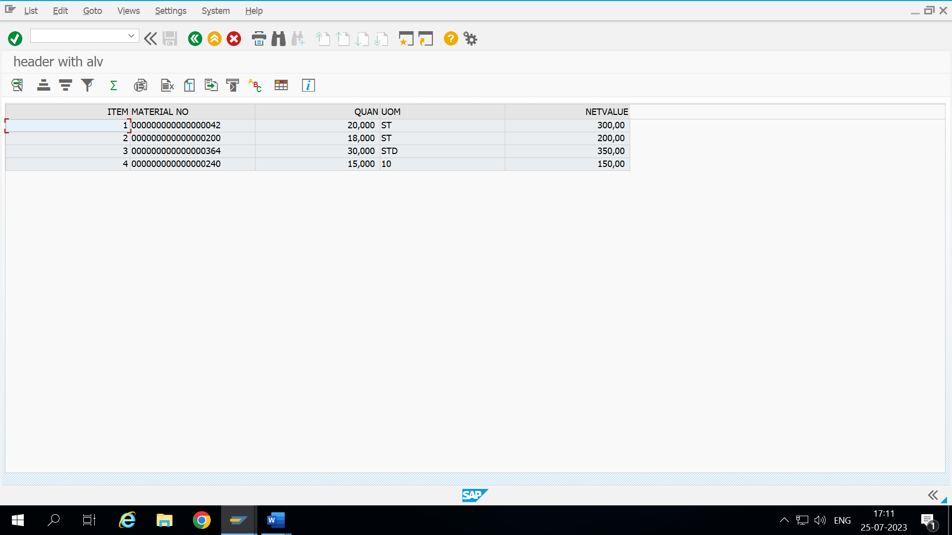

**Double click on Payer no( 1 ) in header table display payer details**

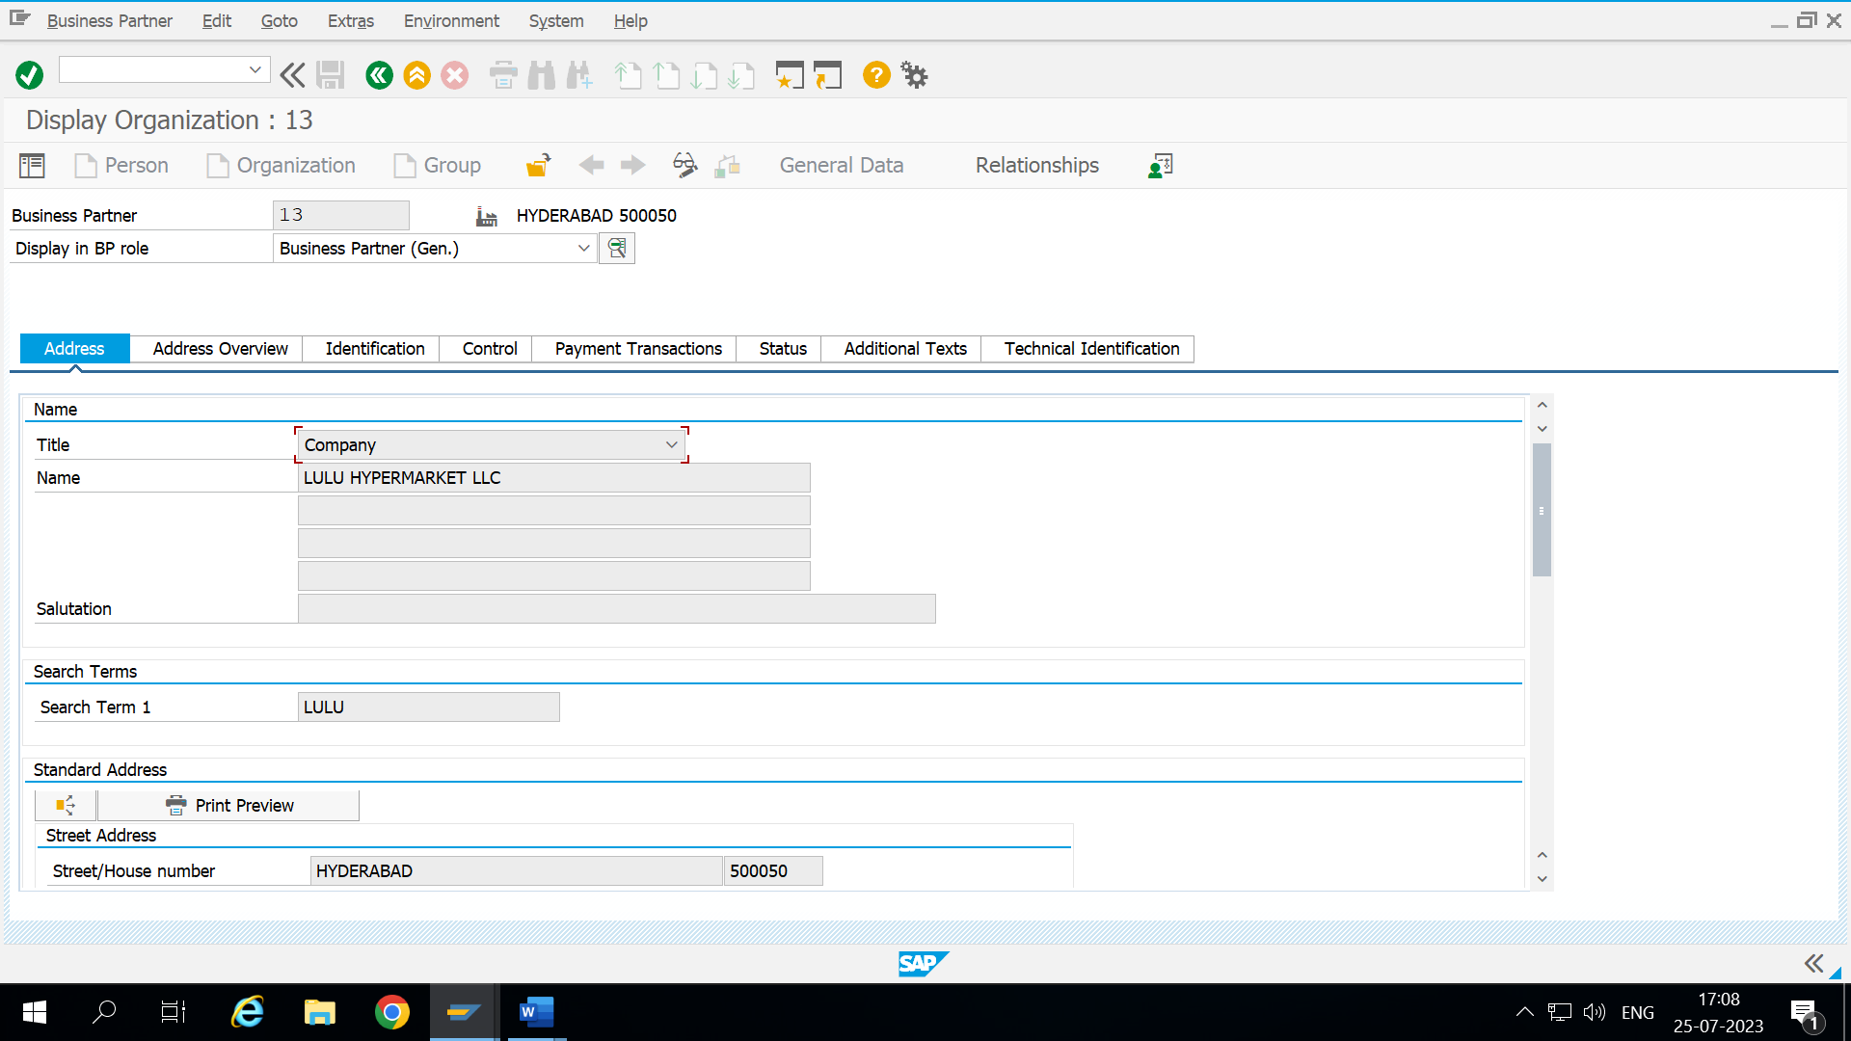

**Double click on material no.( 42 ) in item table display material details**

