- Make sure you have Git installed on your machine. If you are using Mac/Apple/Linux, you already have Git by default. For Windows users, you can get a free download and quick simple install.
http://git-scm.com/install/windows

- Check if Git (Gitbash) is locally installed.
Opening CMD as below and typing in the command,
git --version
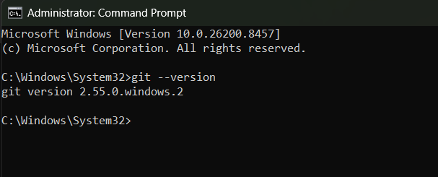

- C

