S3 Bucket Creation: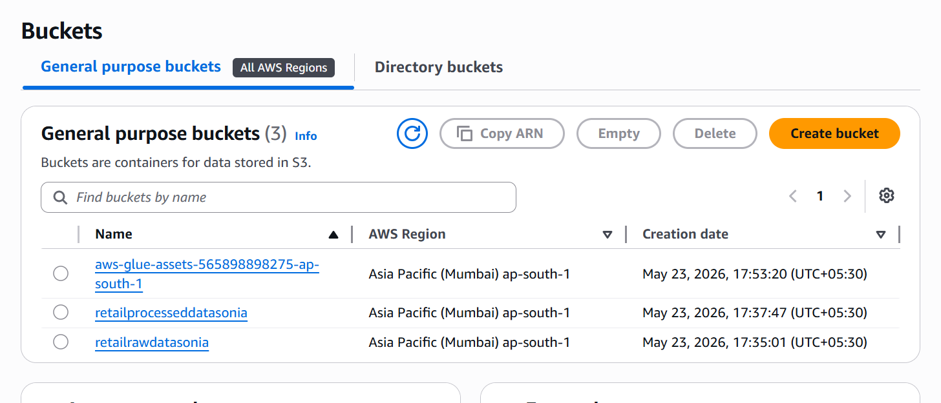

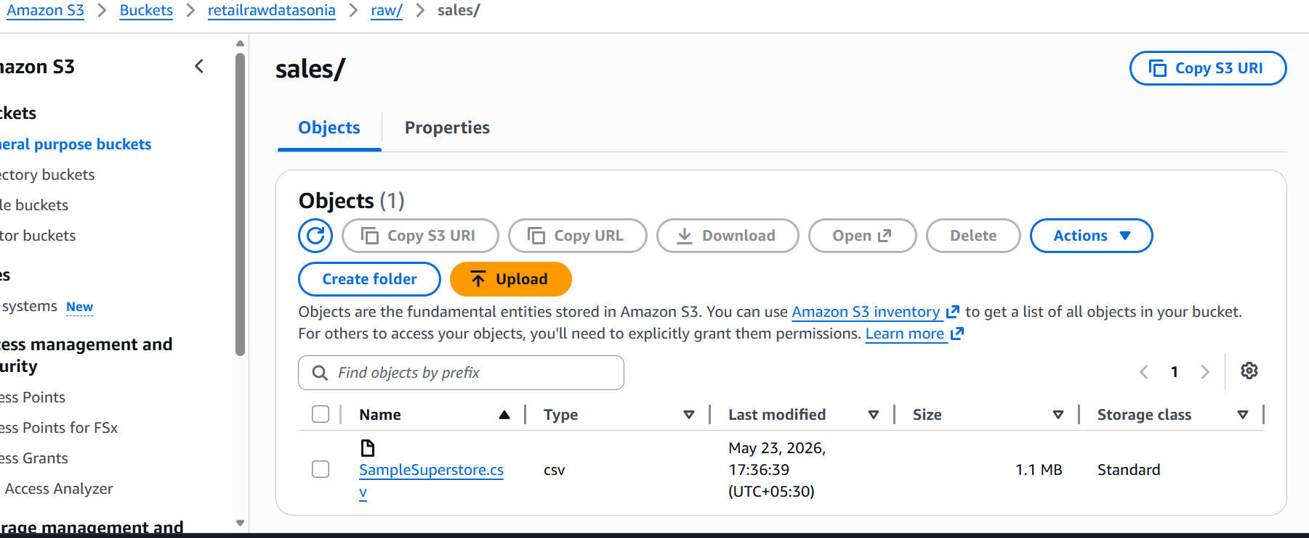
Explanation:
Created an Amazon S3 bucket to store the raw dataset and processed output files used by the data pipeline.

IAM Role Permissions: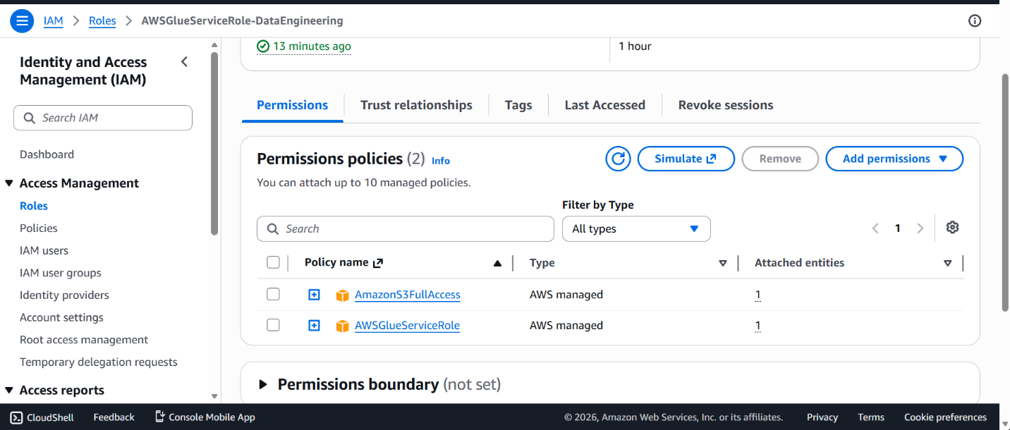
Explanation:
Created an IAM role with the required permissions for AWS Glue to access S3 resources and write logs. This role enables secure execution of the ETL job.

AWS Glue ETL Job
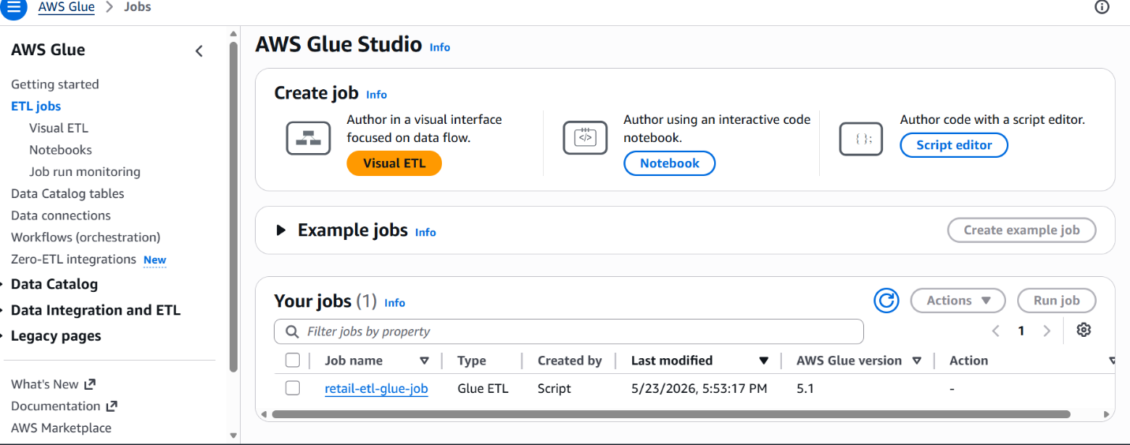

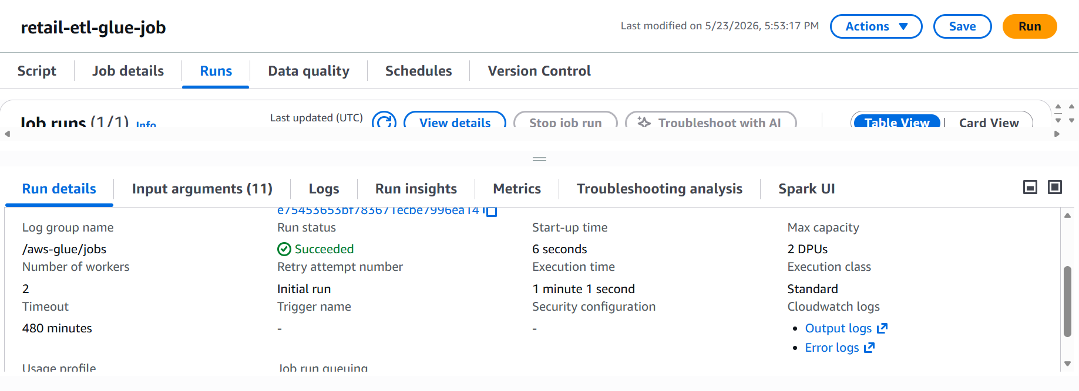

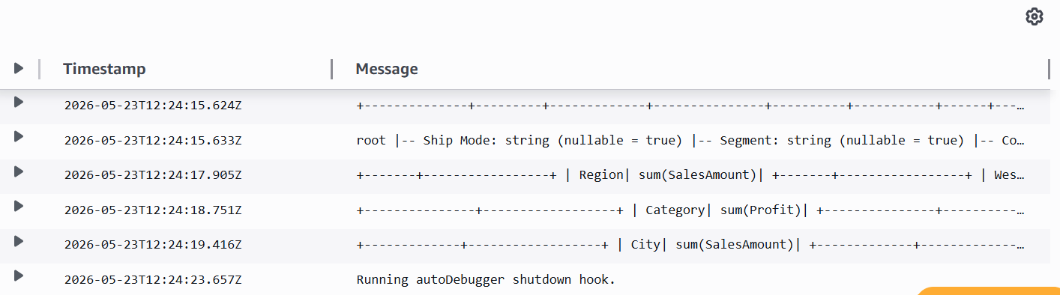

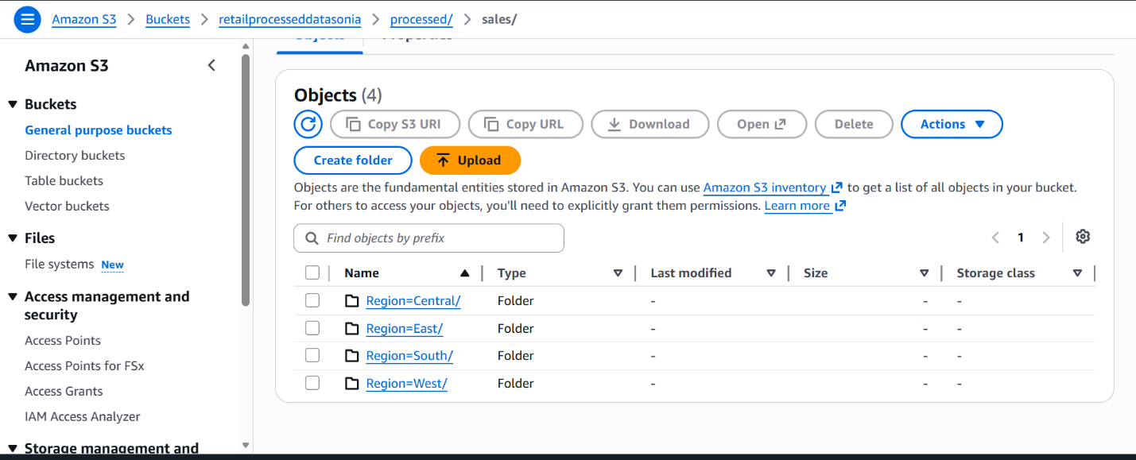
Explanation:
Configured a Glue ETL job using PySpark to transform source data stored in S3 and write processed data back to S3.

Athena Query Screenshot:

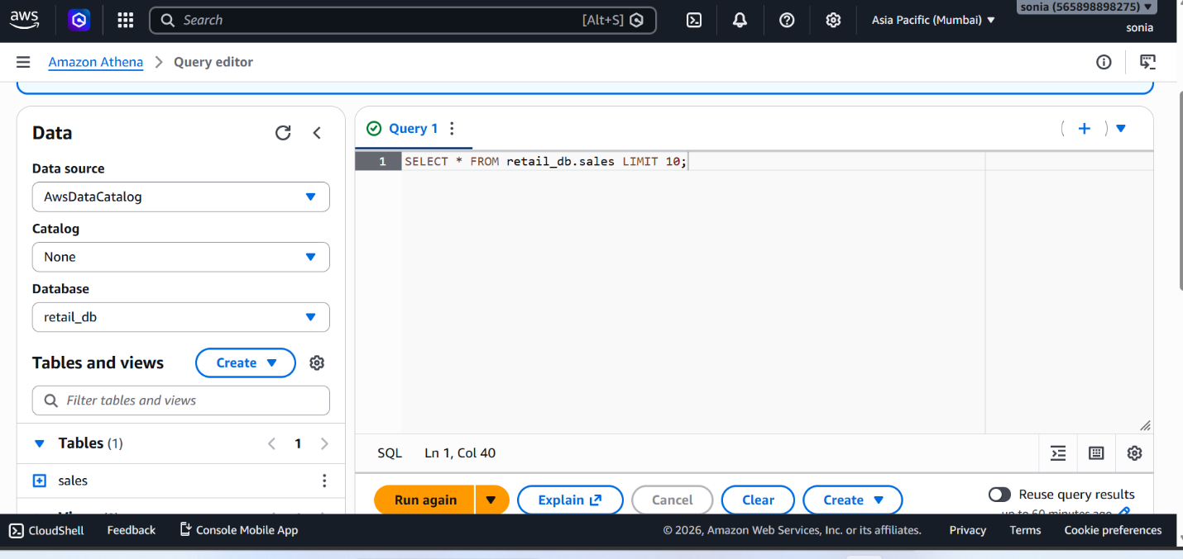
Explanation:
Created Athena queries to analyze the transformed data stored in S3. Athena provides serverless SQL-based querying capabilities.
Athena Results Screenshot:

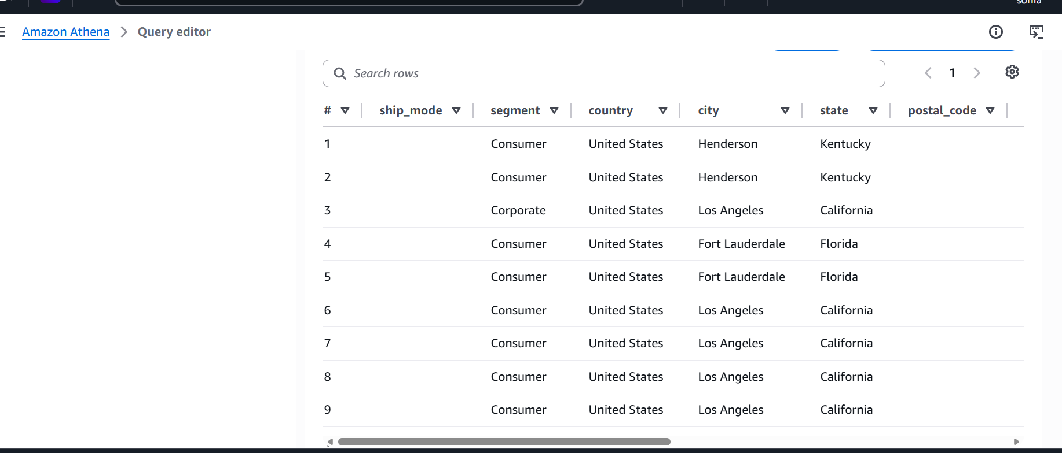

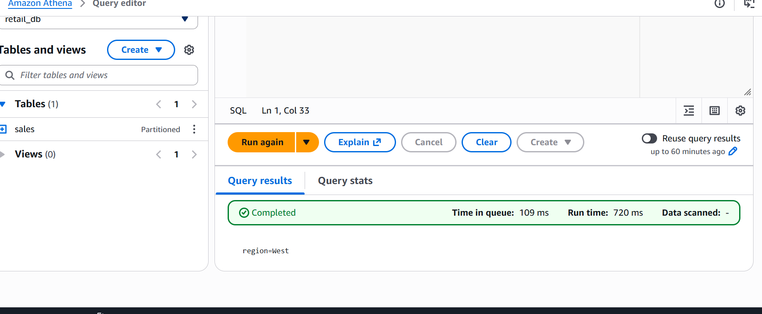

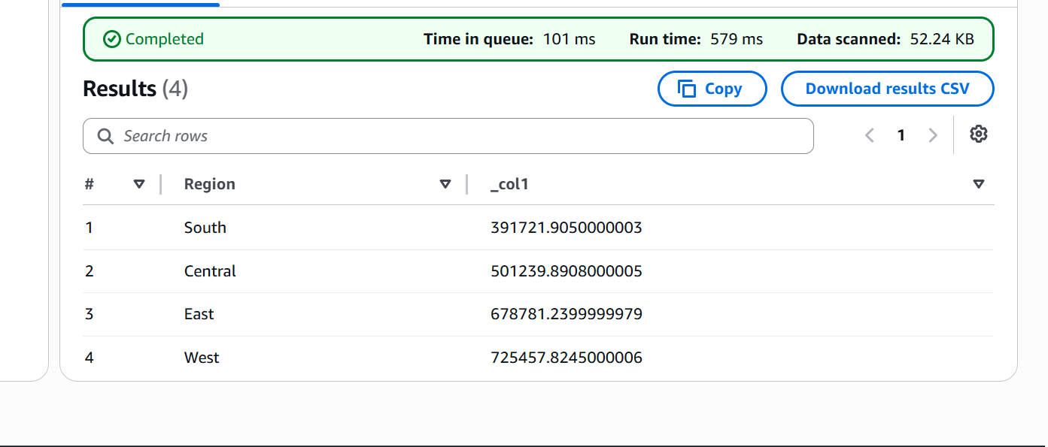

Explanation:
Query results validate that the transformed dataset is available and can be analyzed using SQL queries

Airflow DAG Creation:

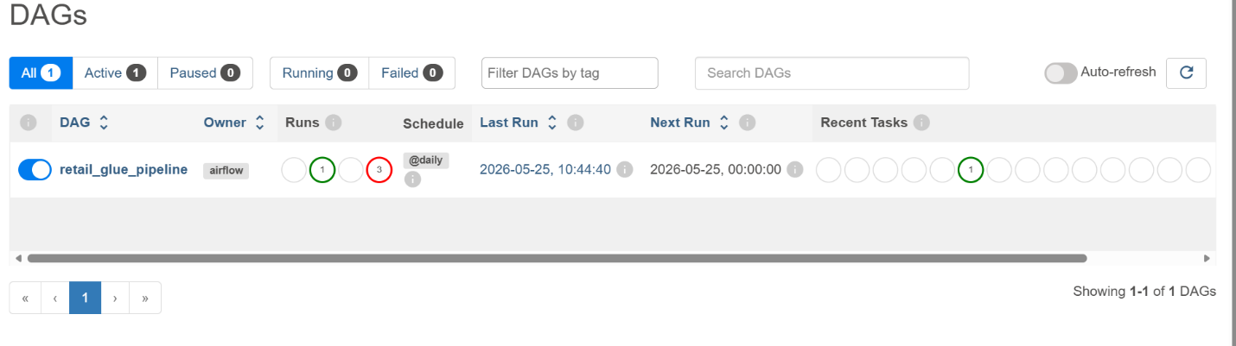

Explanation:
Developed an Apache Airflow DAG to orchestrate the ETL workflow. The DAG automates the execution of the AWS Glue job.

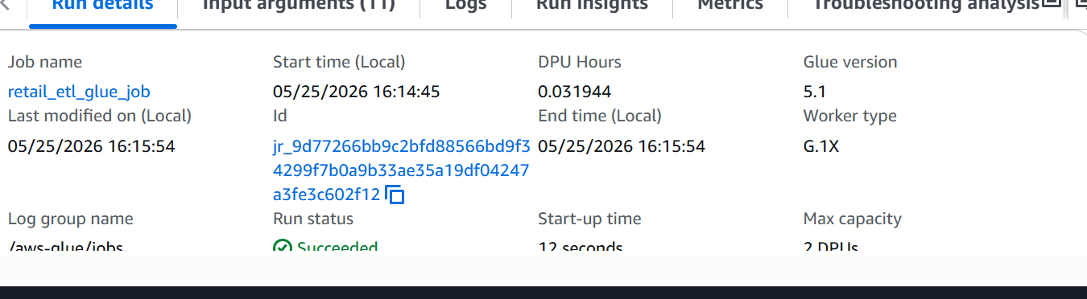

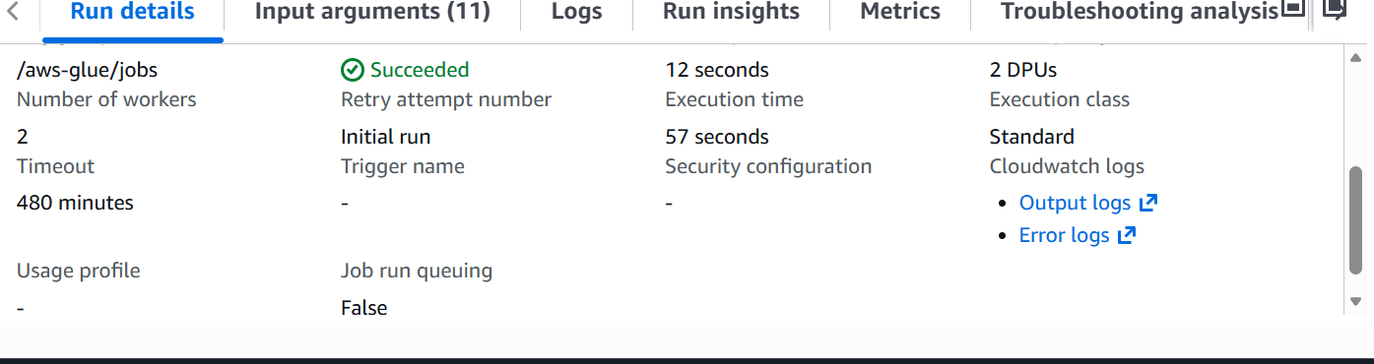

Airflow Success Screenshot: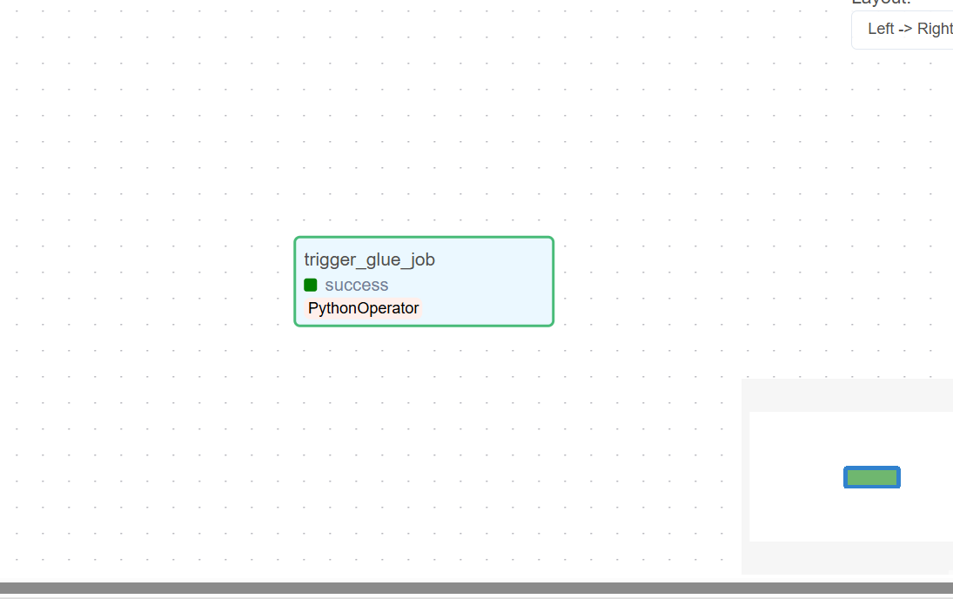

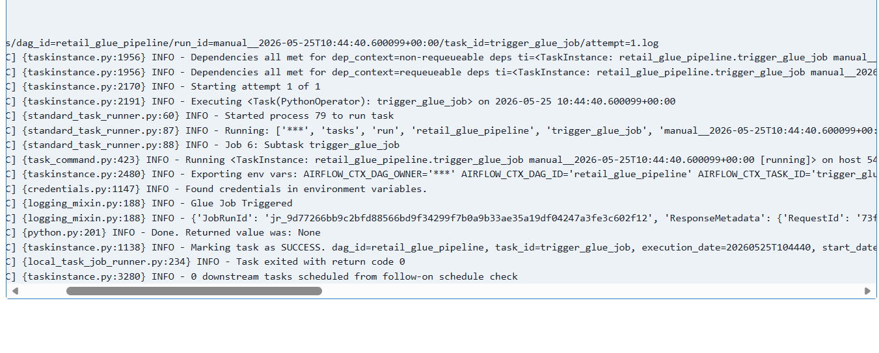
Explanation:
The DAG executed successfully, indicating that the workflow completed without failures and the ETL process was triggered as expected.

