TERRAFORM -01
- . Install Terraform on your PC
Step1:go to browser search for terraform on windows shown in below
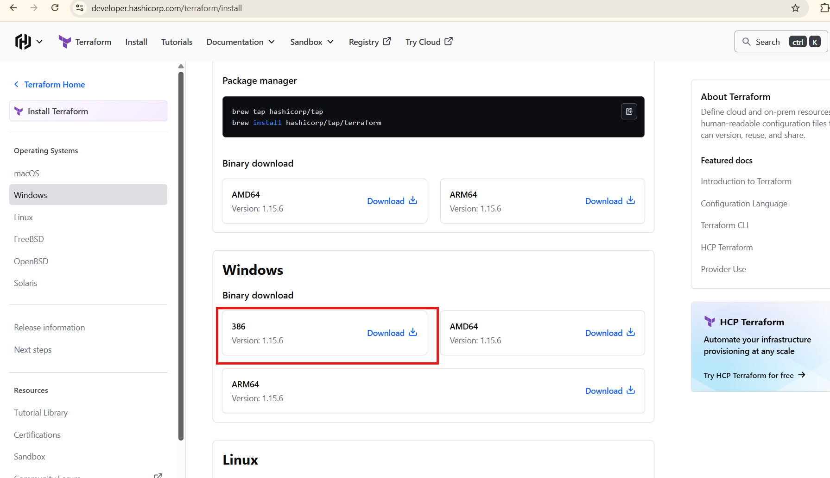
After downloaded we can extract that file in this pc
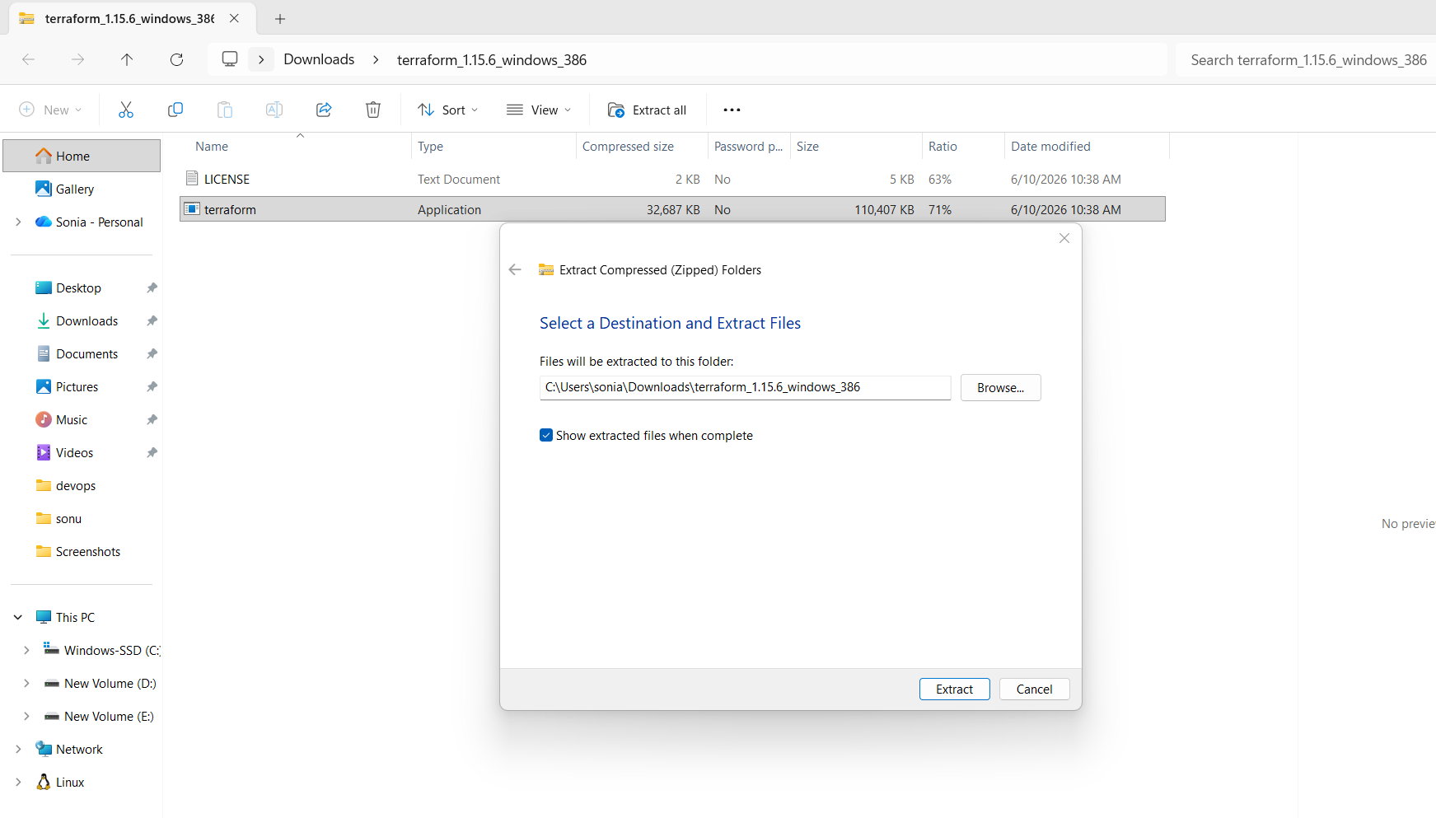
terraform copy to this location-->→go to advanced system settings-->environment variables--system variables-->path-edit-->copy the -->correct path of terraform.-->this is my path

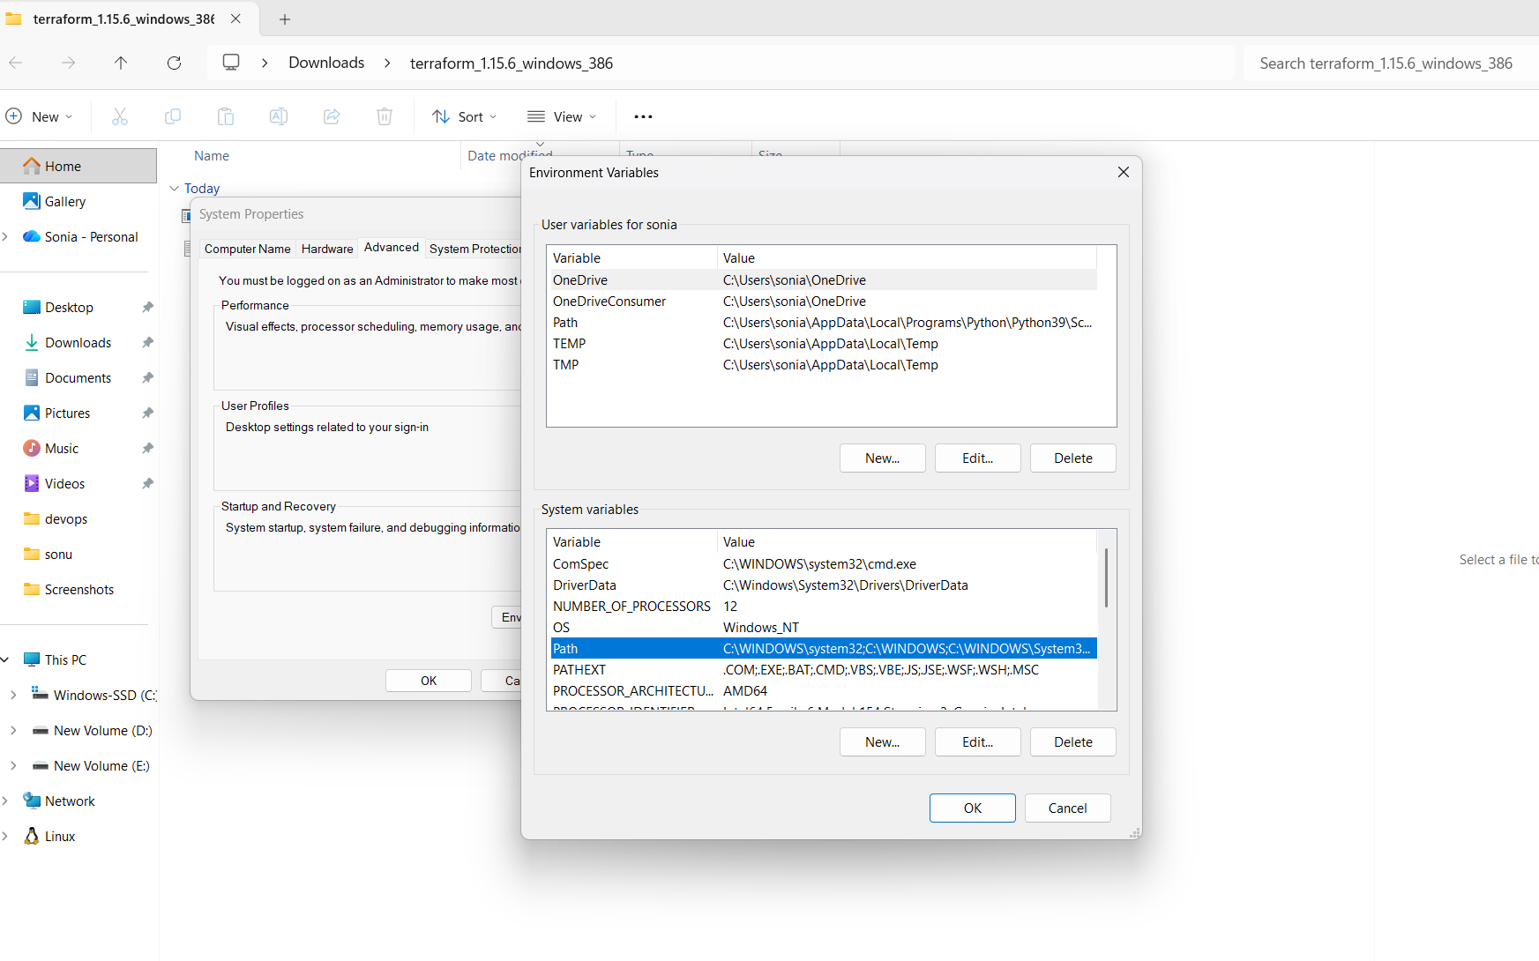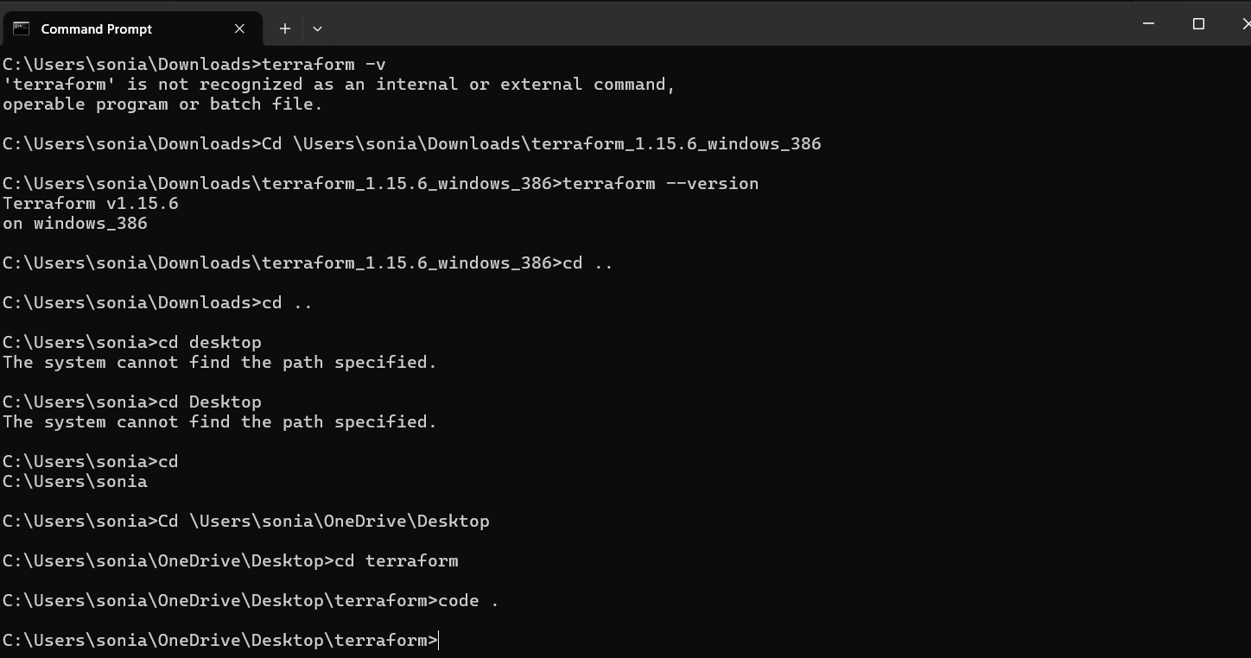
Terraform has been successfully installed and configured on Windows. The executable is available globally through the PATH environment variable and can be accessed from Command Prompt,PowerShell, and Git Bash.

2). Execute all the templates shown in video.
First we can install hashicorp terrafrom
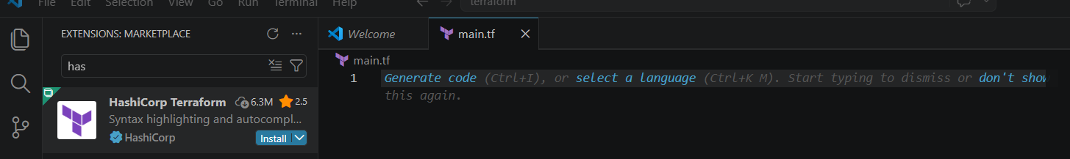
Install the terraform extension in visual studio code
Create file main.tf
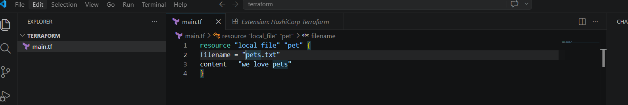
Go to terminal--> new terminal -->terraform init
After that code change and plan
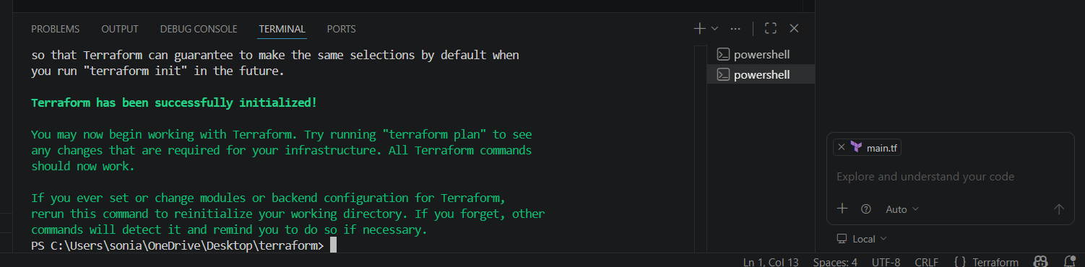
Terraform plan
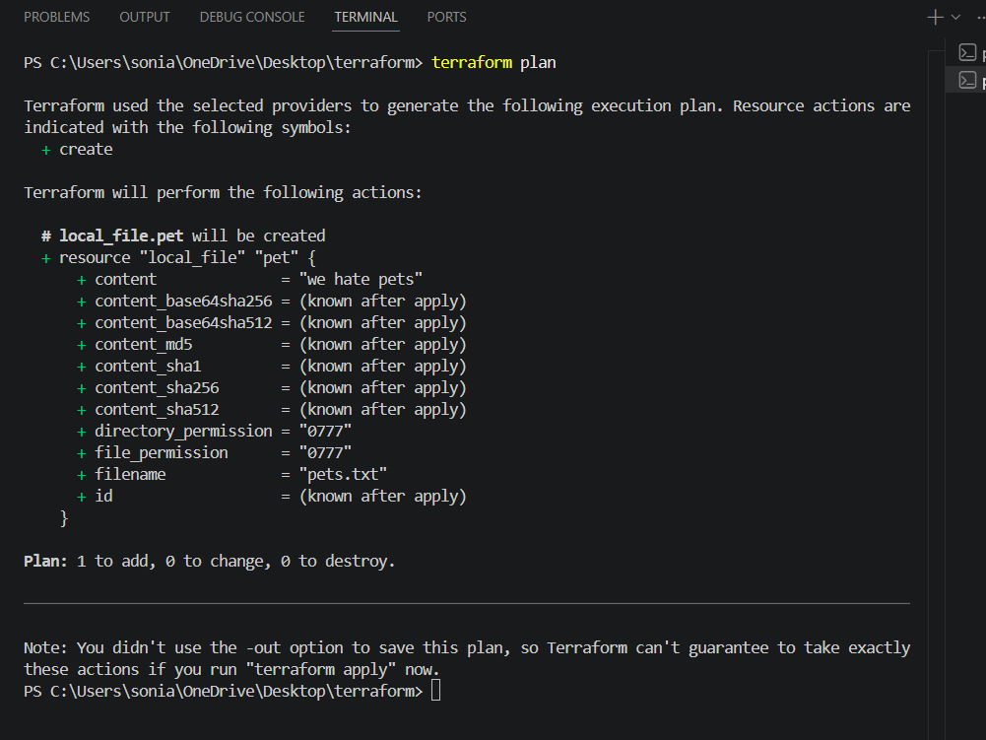
Terraform plan show one thinkg to add
Terraform apply
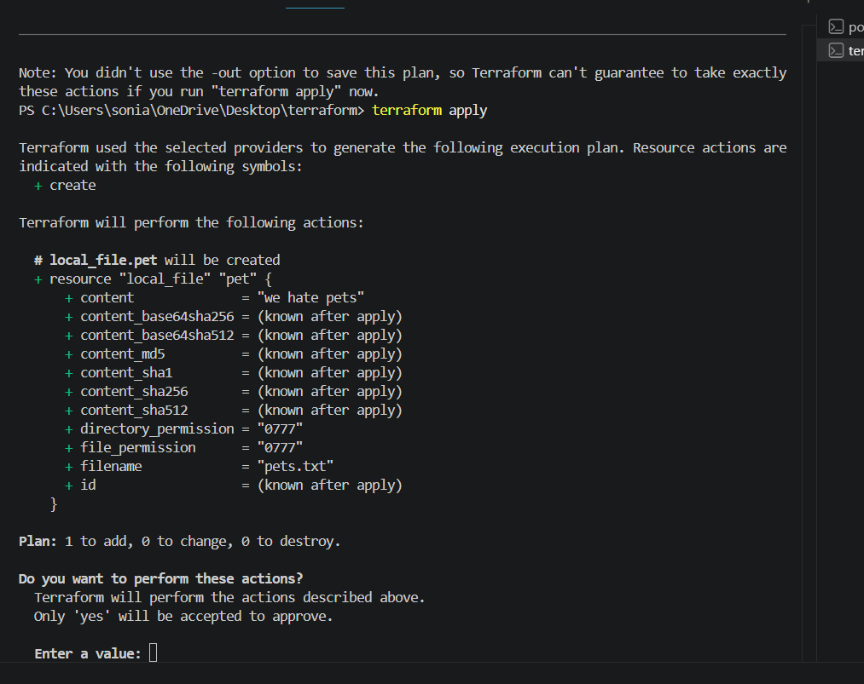
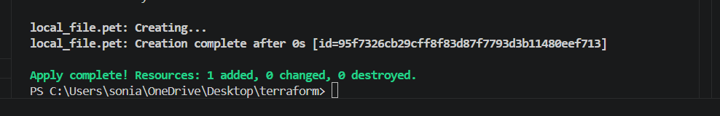
It has created the file
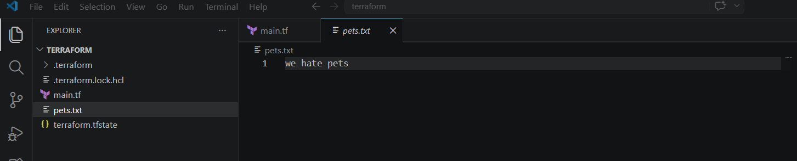
We have all configuration are in added terraform .tfsate file here
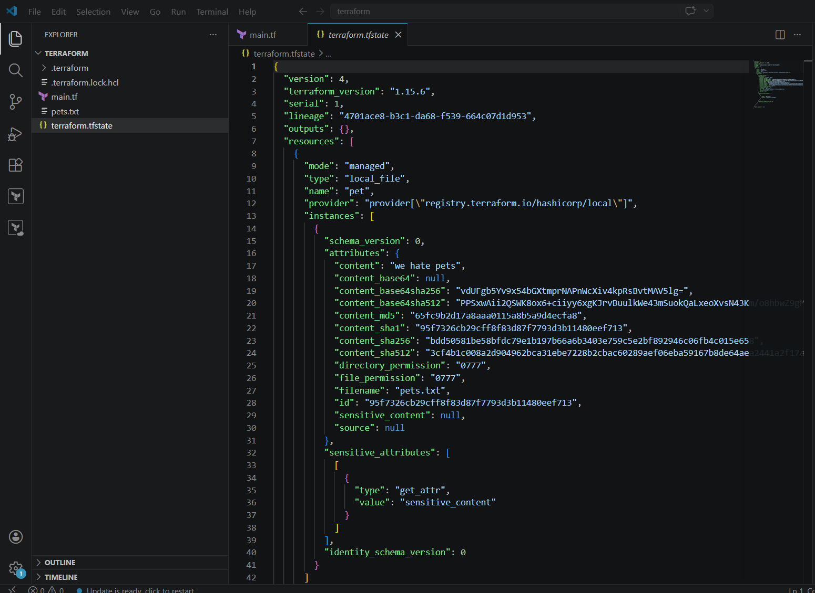

3). Note down below points, Terraform Init Terraform Plan Terraform Apply Terraform Provider.
Terraform init
Purpose:
- Initializes the Terraform working directory.
- Downloads required provider plugins.
- Configures the backend for state storage.
- Downloads referenced modules.
When to Use:
- Before running any Terraform commands in a new project.
- After adding or changing providers/modules.
Terraform plan
Purpose:
- Creates an execution plan.
- Shows what resources will be created, modified, or destroyed.
- Does not make any actual changes.
When to Use:
- Before applying changes to review the impact.
Terraform apply
Purpose:
- Executes the changes defined in the Terraform configuration.
- Creates, updates, or deletes infrastructure resources.
- Updates the Terraform state file.
When to Use:
- After reviewing the execution plan.
Terraform provider : It is a complete package of api calls to communicate with our
resources a Acts as the bridge between Terraform and the target infrastructure
platform.

4). Integrate a sample Terraform template in Jenkins.
Lets check jenkins are running or not
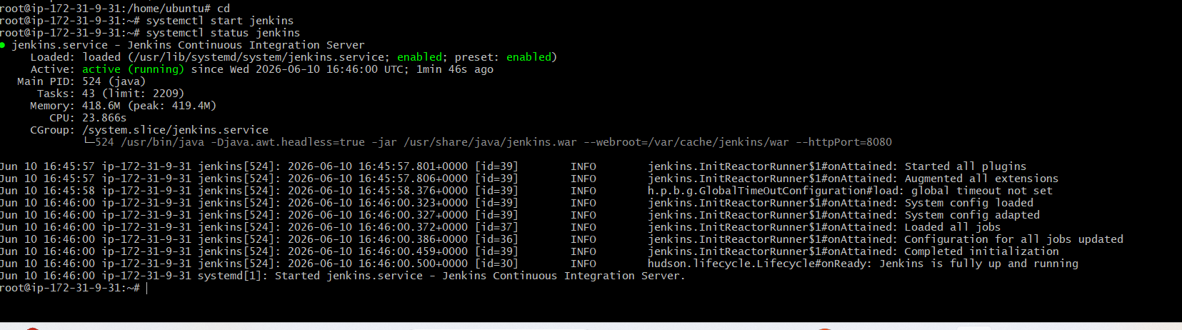
Install Terraform in Jenkins Server
sudo apt update
sudo apt install -y gnupg software-properties-common curl
curl -fsSL https://apt.releases.hashicorp.com/gpg | \
sudo gpg --dearmor -o /usr/share/keyrings/hashicorp-archive-keyring.gpg
echo "deb [signed-by=/usr/share/keyrings/hashicorp-archive-keyring.gpg]
https://apt.releases.hashicorp.com $(lsb_release -cs) main" | \
sudo tee /etc/apt/sources.list.d/hashicorp.list
sudo apt update
sudo apt install -y terraform
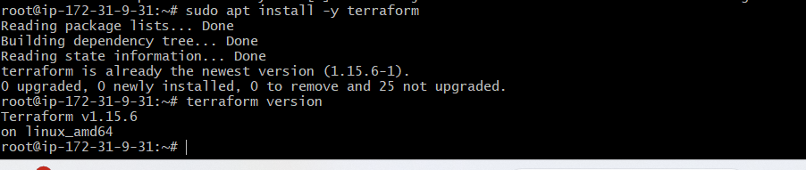
Lets create a new item
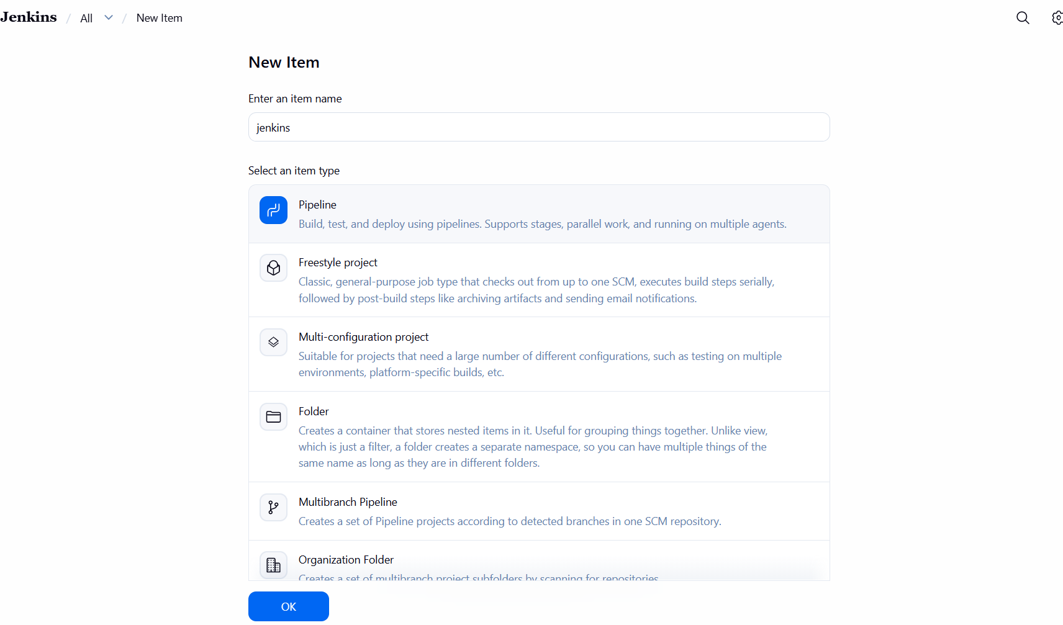
Create vi main.tf for Simple Terraform
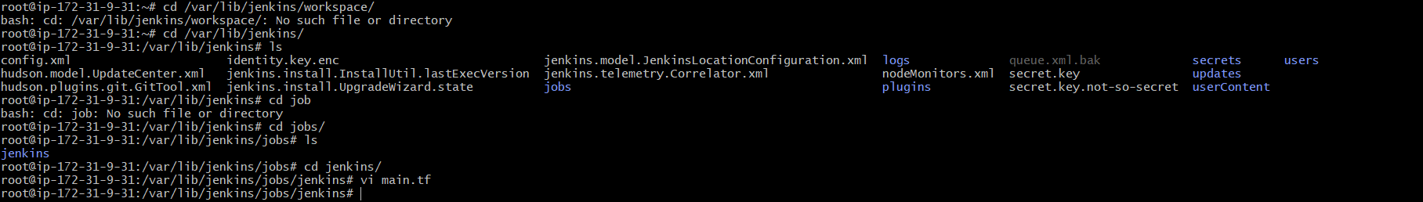
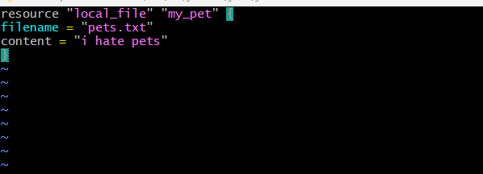
Go to jenkins writte the below script and build now
pipeline {
agent any
stages {

stage('Terraform Init') {
steps {
sh 'terraform init'
}
}

stage('Terraform Validate') {
steps {
sh 'terraform validate'
}
}

stage('Terraform Plan') {
steps {
sh 'terraform plan'
}
}

stage('Terraform Apply') {
steps {
sh 'terraform apply -auto-approve'
}
}
}
}

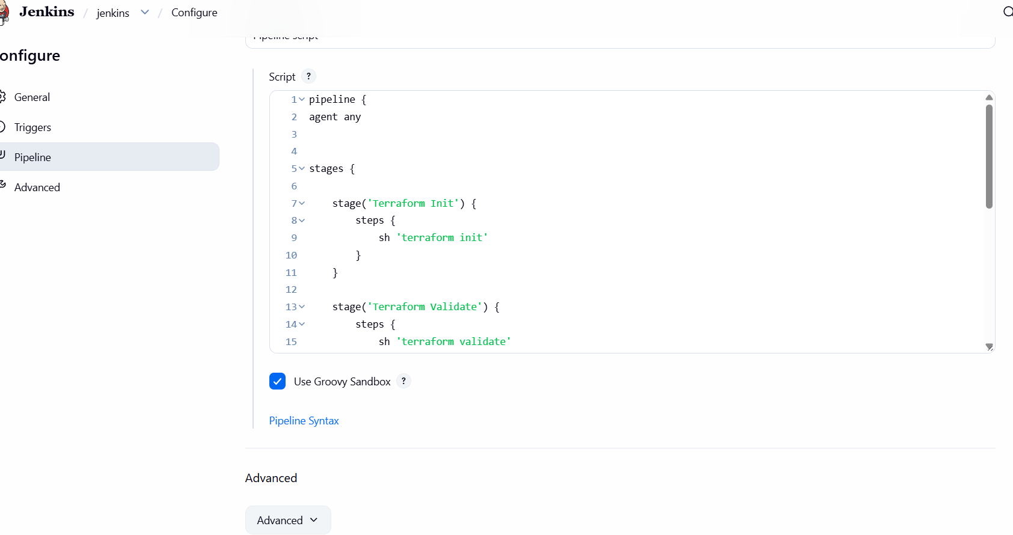

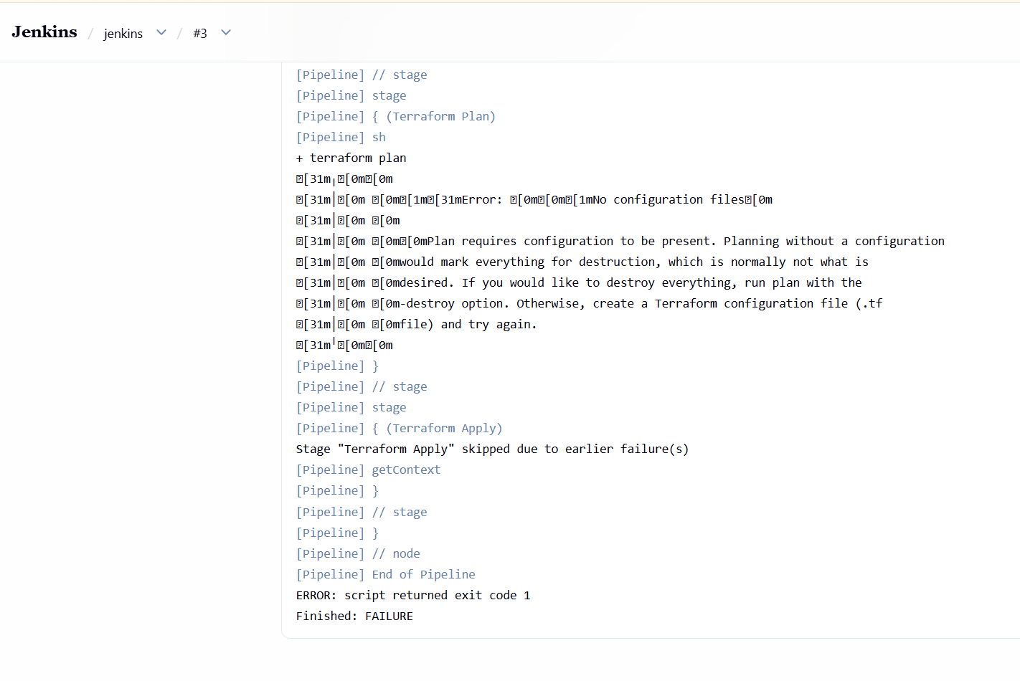
Build is failed because The error is happening because Jenkins is running Terraform in
/var/lib/jenkins/workspace/jenkins
But your main.tf file was created in
/var/lib/jenkins/jobs/jenkins
So Copy the Terraform file to the workspace
sudo cp /var/lib/jenkins/jobs/jenkins/main.tf /var/lib/jenkins/workspace/jenkins/
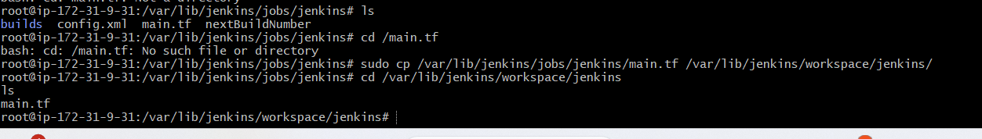
After that successfully run pipeline
