Terraform -02
1).Watch the Terraform-02 video.
2). Execute all the templates shown in the video.
Using two providers in a same configuration file
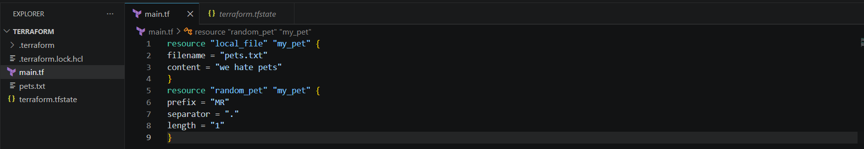
Initializing backend : terraform init
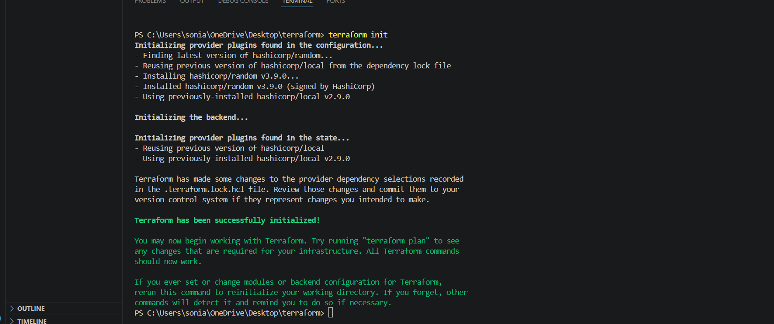
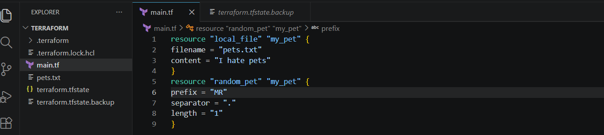
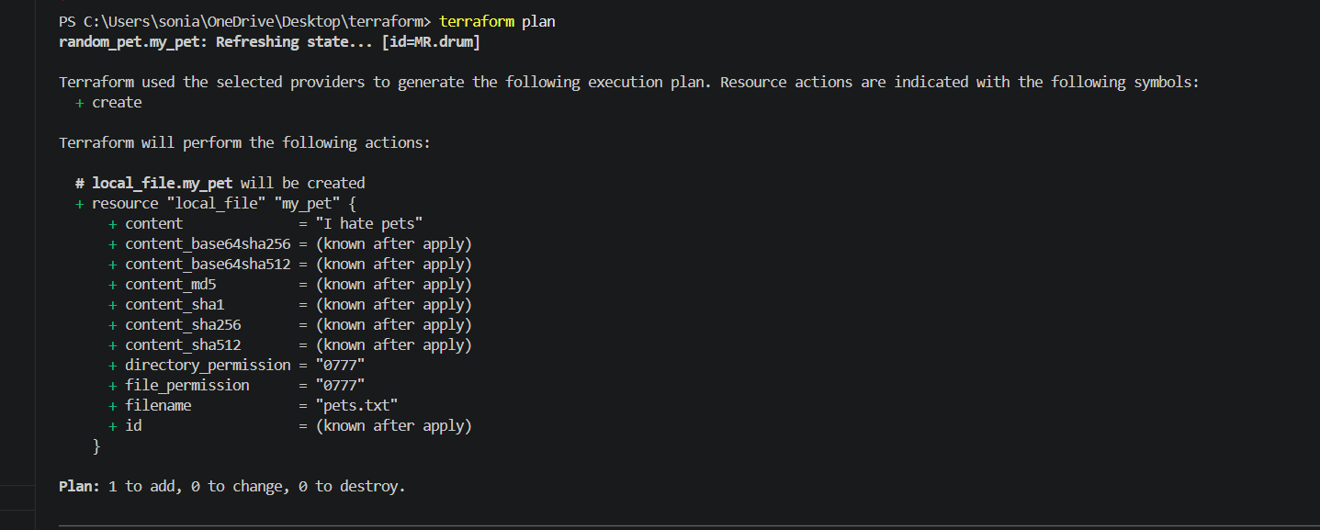
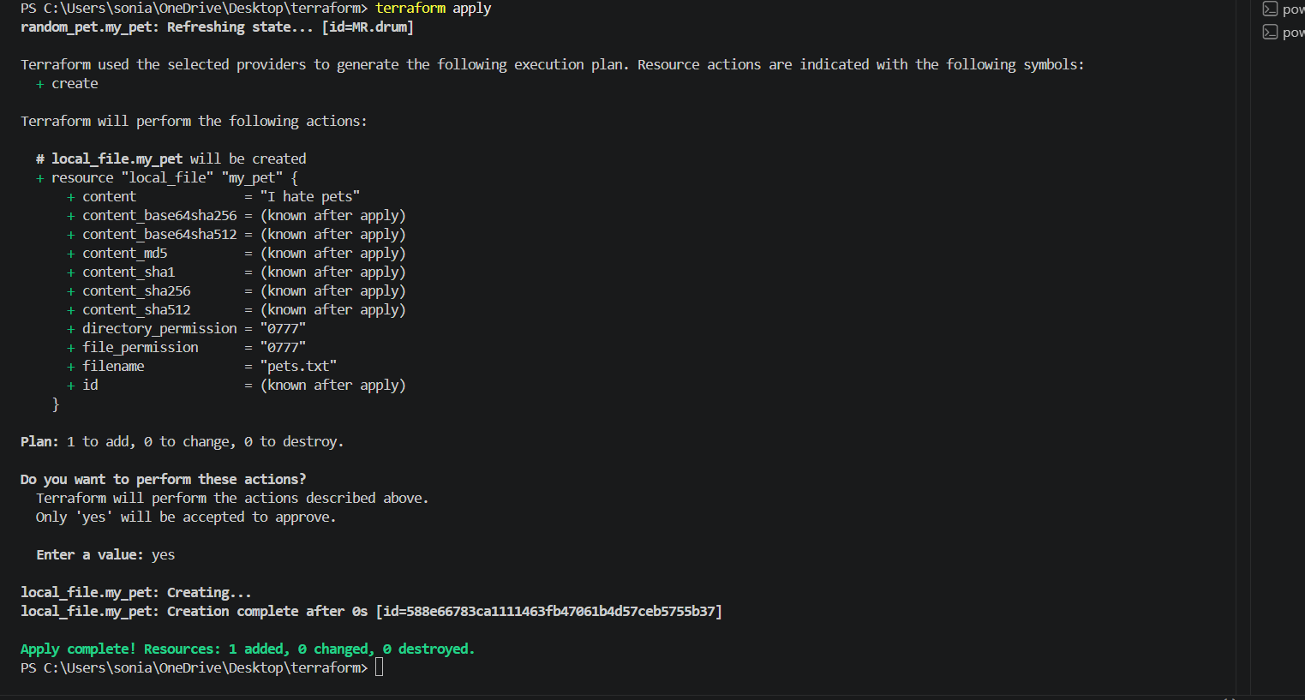
We can see Pets.txt has been created and content inside is we love pets
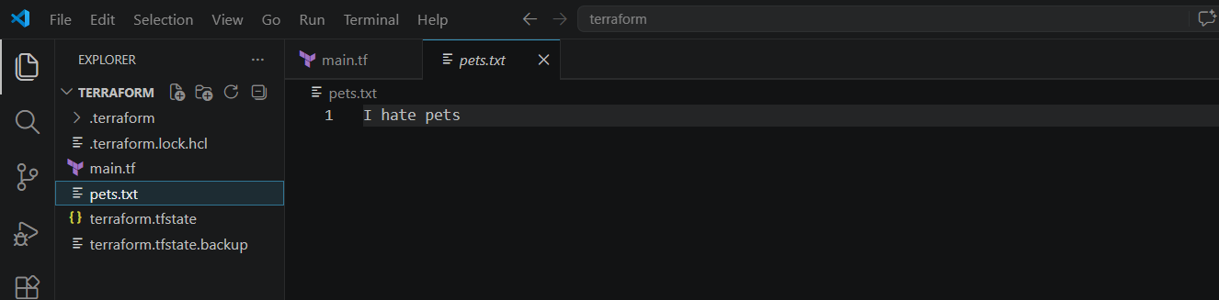

Lets work with the variables
Lets create a variables.tf file
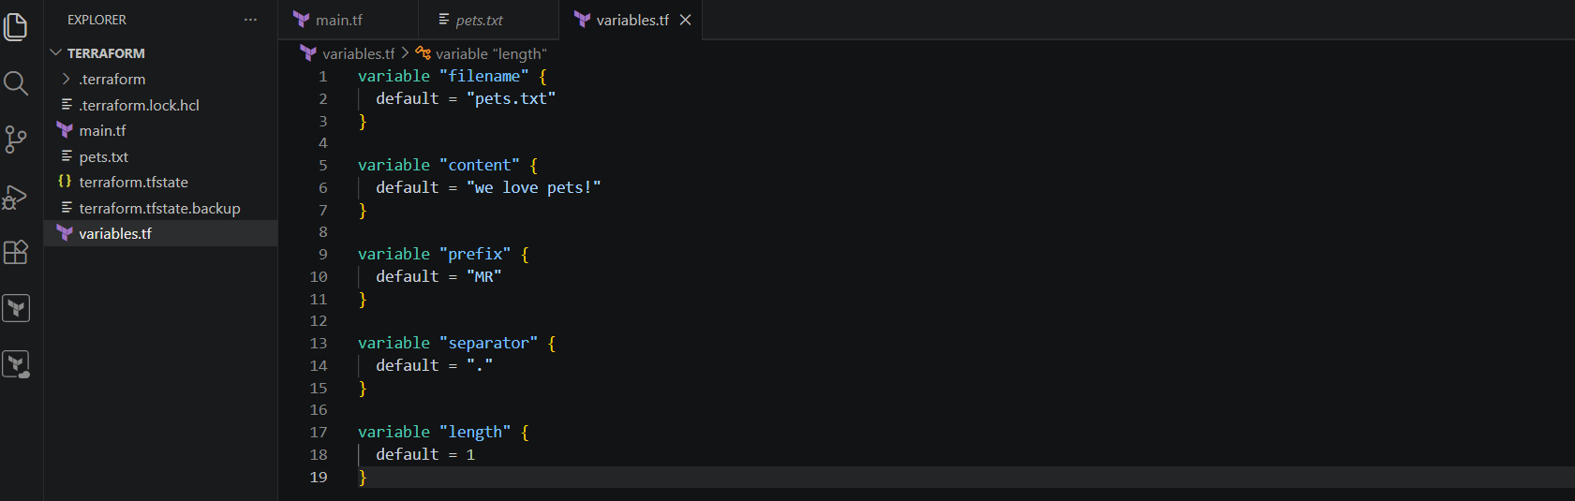
We have created a variables.tf file so instead of hardcoding the values inside our mainconfiguration file we will be referring to this variable.tf file inside main.tf file
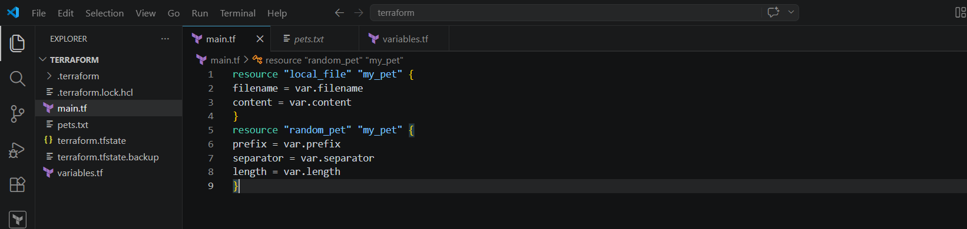
This is our main.tf now
Here we are using the variables var.filename , var.content etc from the variables.tf file
Lets now apply the changes
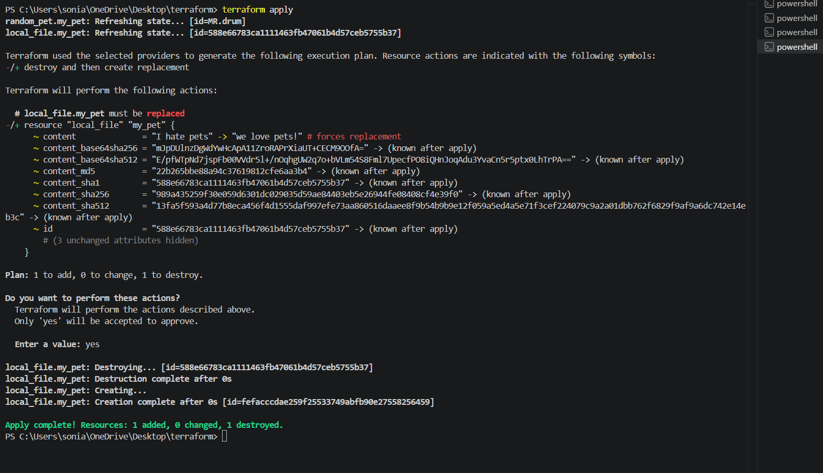
Here we can see replaced the word
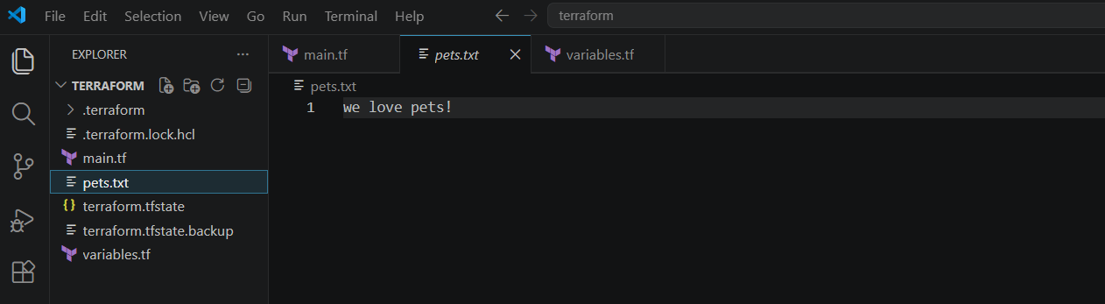
3). Integrate Terraform in Jenkins using the Terraform plugin.
First open jenkins -->manage jenkins-->plugins-->available plugins-->terraform--> install
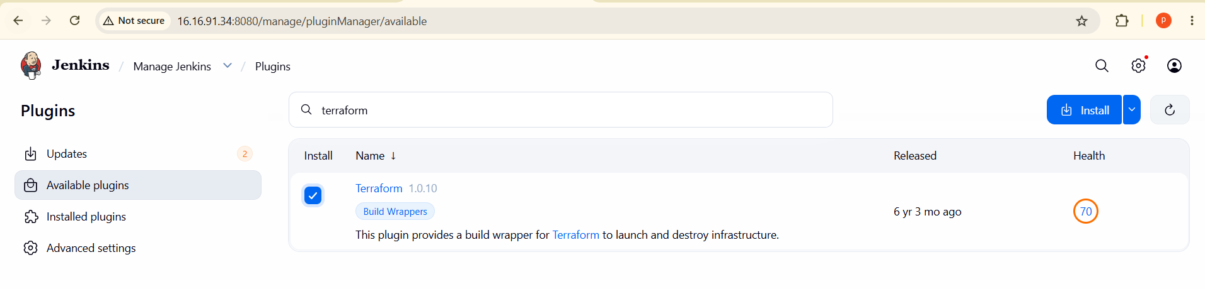
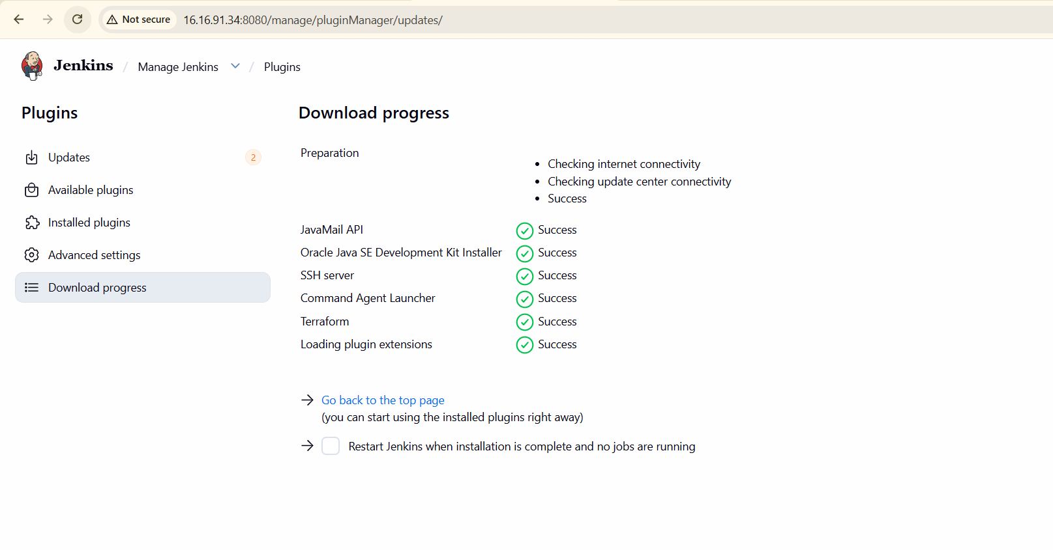
Go to manage jenkins-->tool-->terraform installation-->save
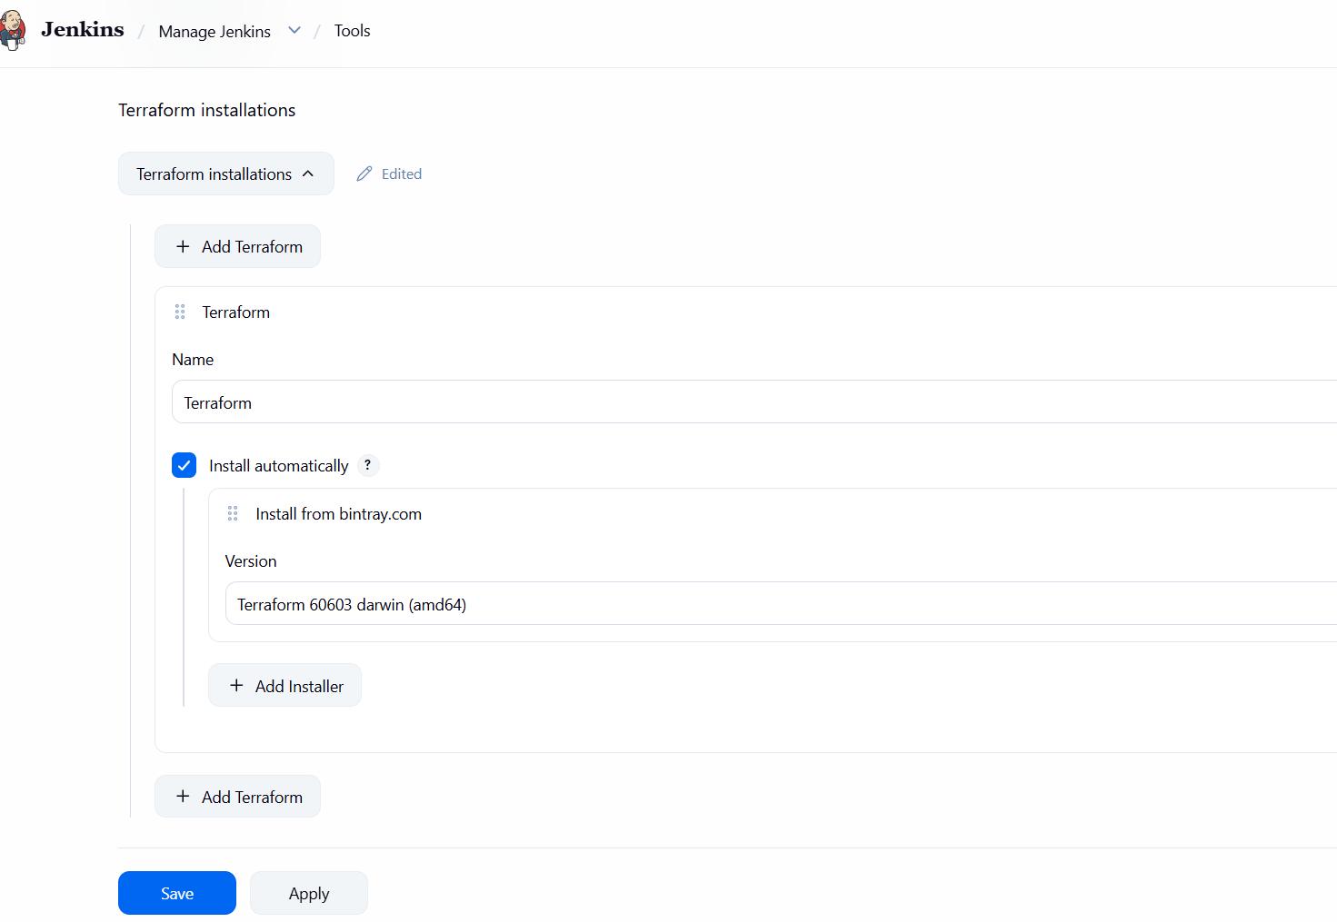
Lets go jenkins dashboard create a new item
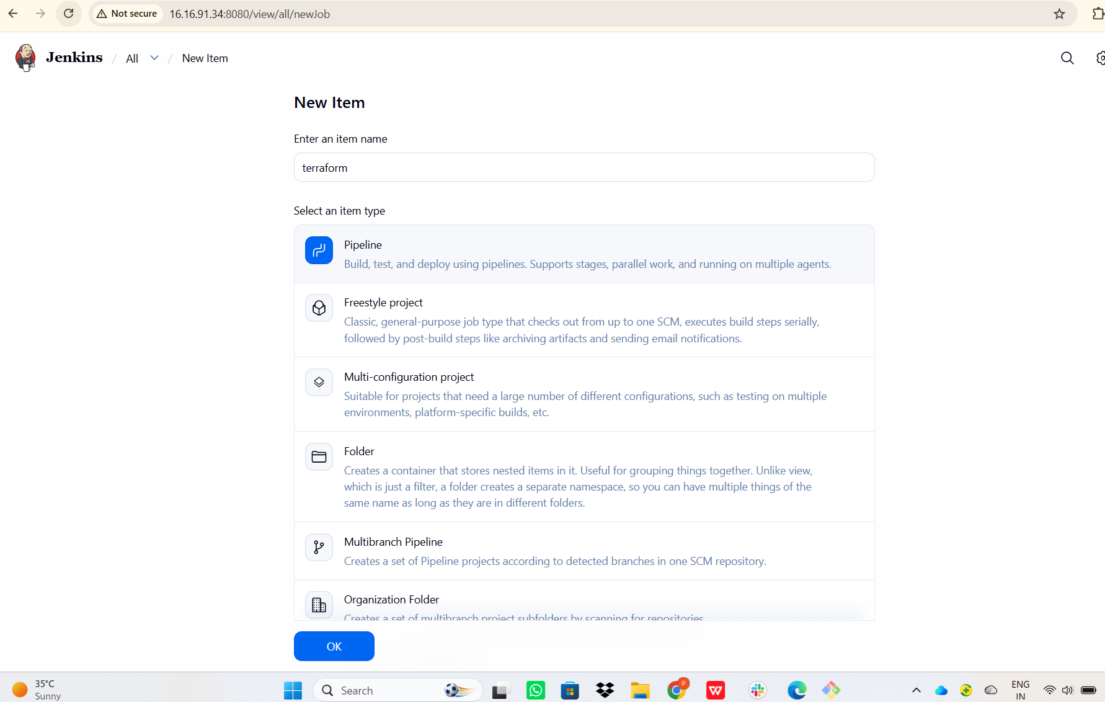
pipeline {
agent any
tools {
terraform 'Terraform'
}
stages {
stage('Terraform Init') {
steps {
sh 'terraform init'
}
}
stage('Terraform Plan') {
steps {
sh 'terraform plan'
}
}
stage('Terraform Apply') {
steps {
sh 'terraform apply -auto-approve'
}
}
}
}
Writte on above script in pipeline and save and build now the build is faild because we can not create a sample file
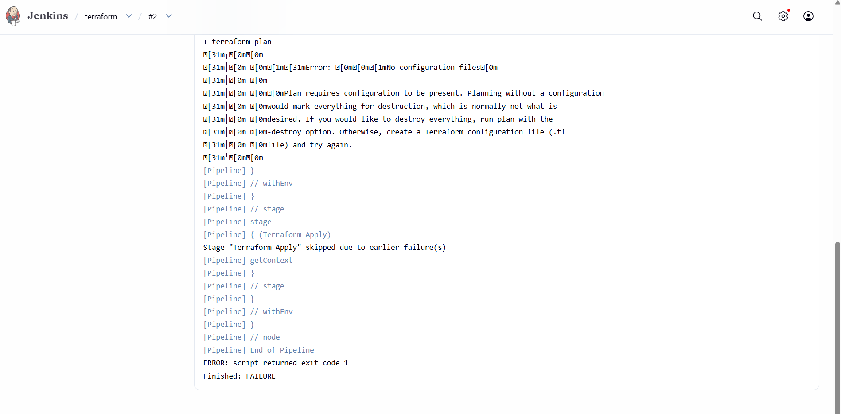

Go to git bash create a vi main.tf
