Terraform -03
- Execute the script shown in the video.
Here we have created both main.tf and variable.tf files
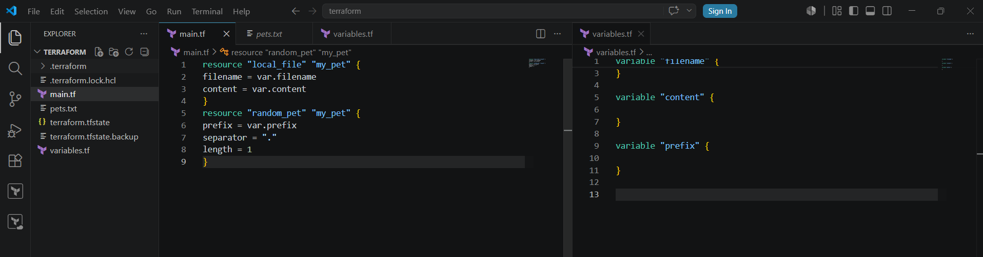
Let give the envinornmental variable
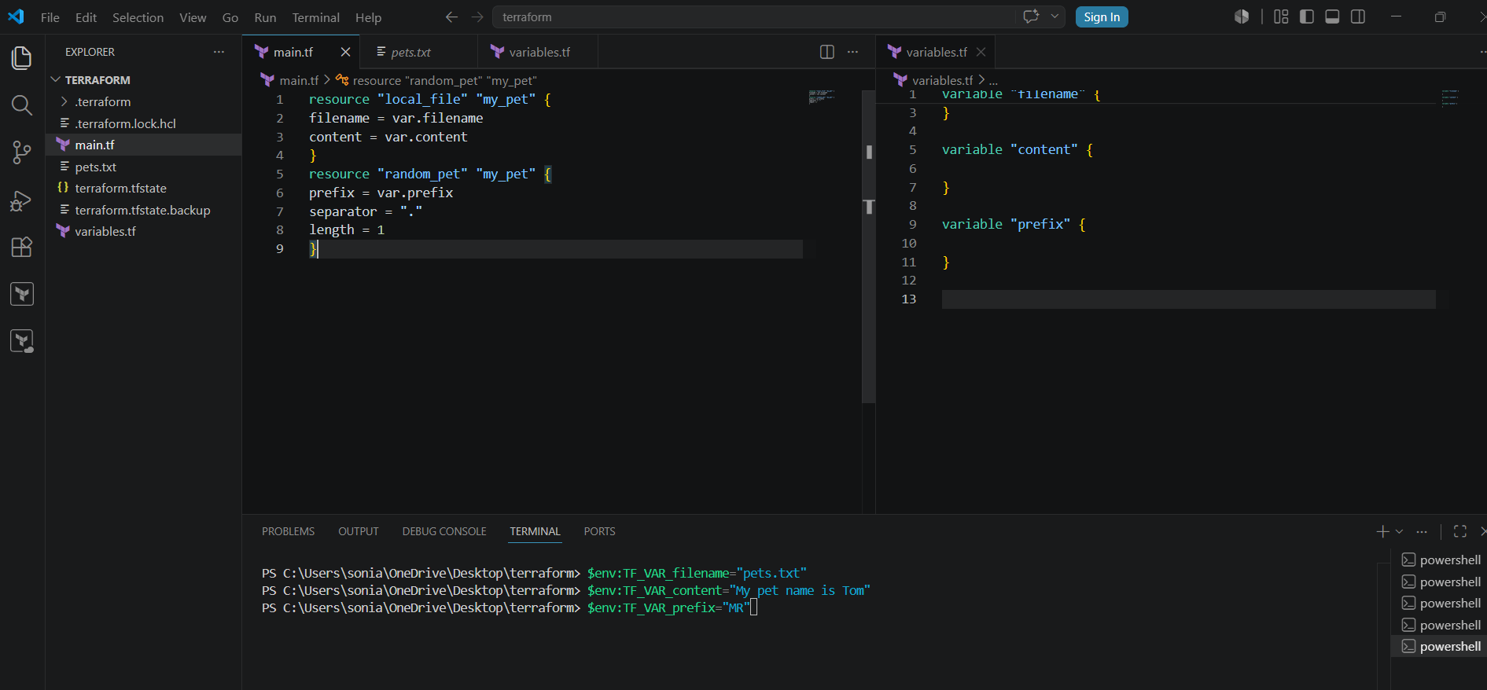
Now lets apply terraform apply

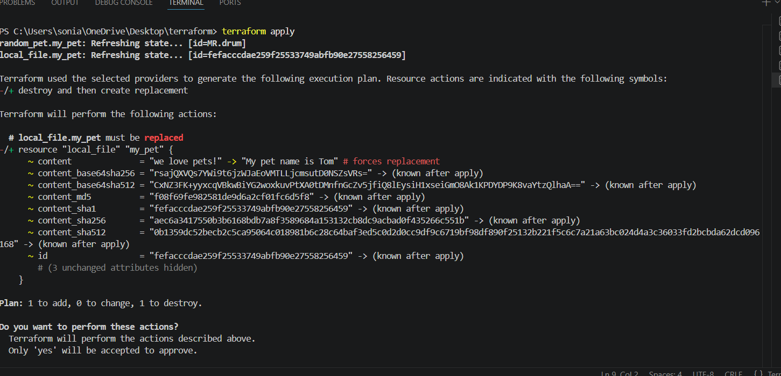
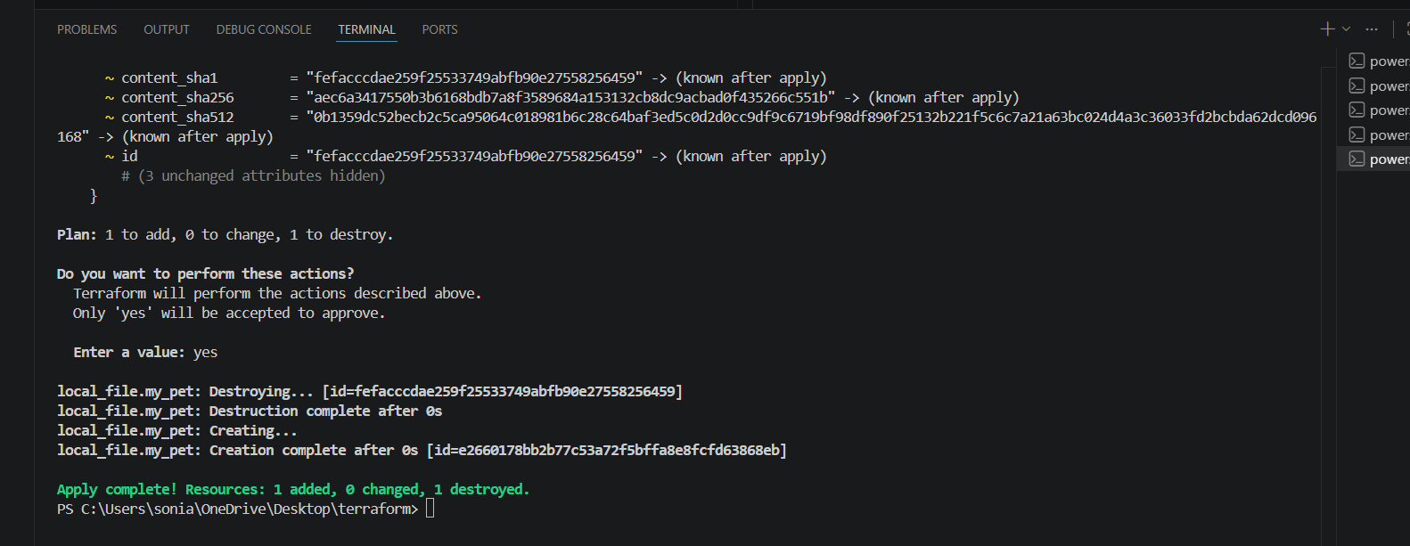
If we can verify the file the content has been replaced
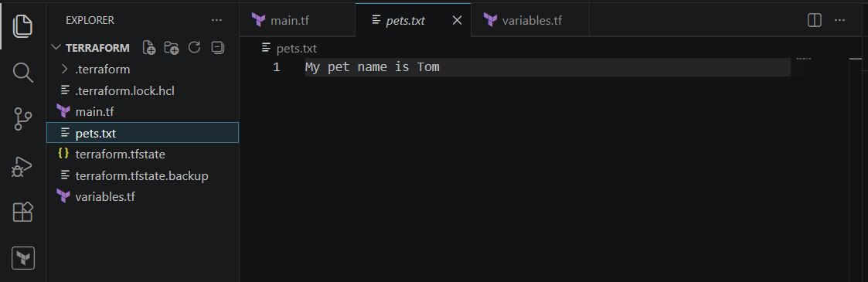
Resource dependency
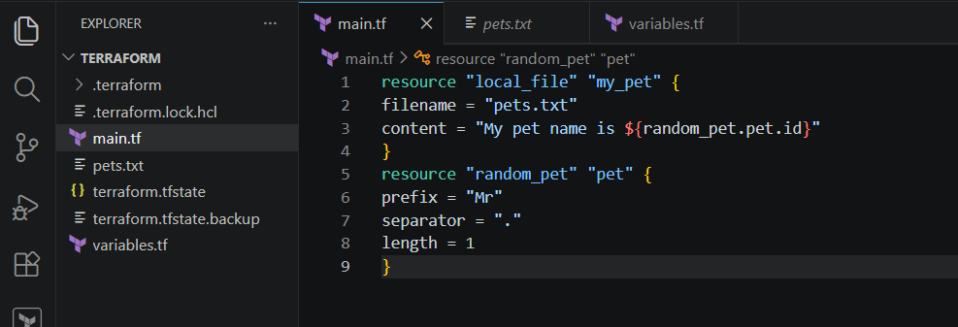
Lets perform terraform apply
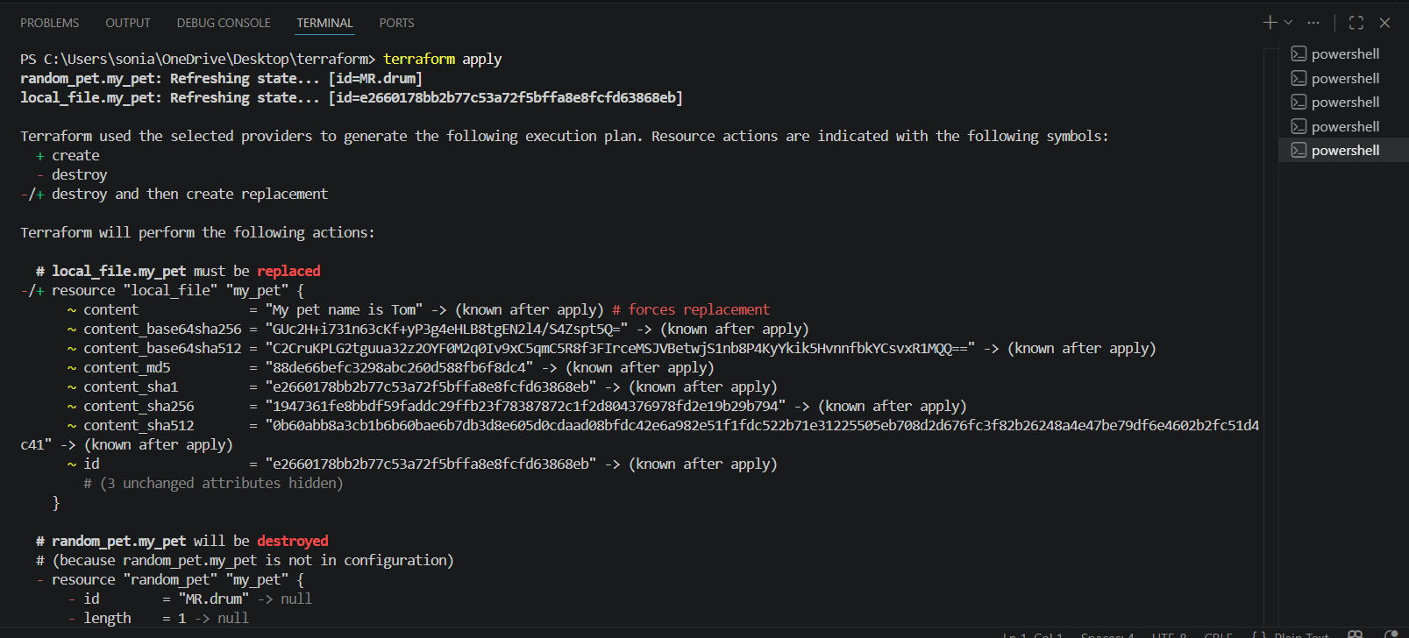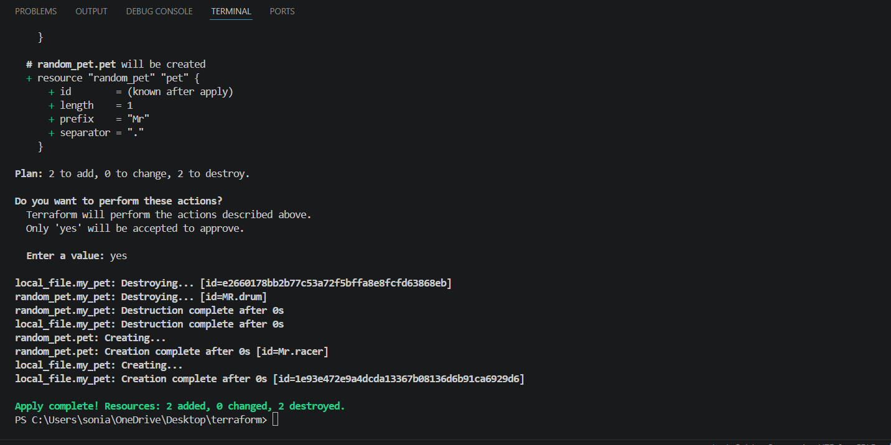
Here the random pet name is created
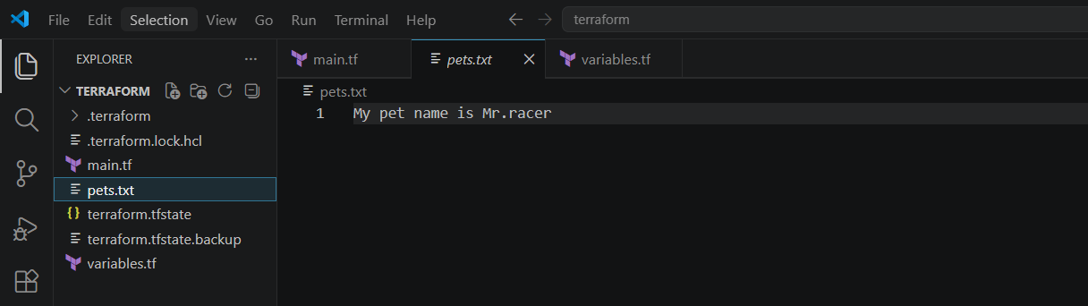
Let use output.tf file
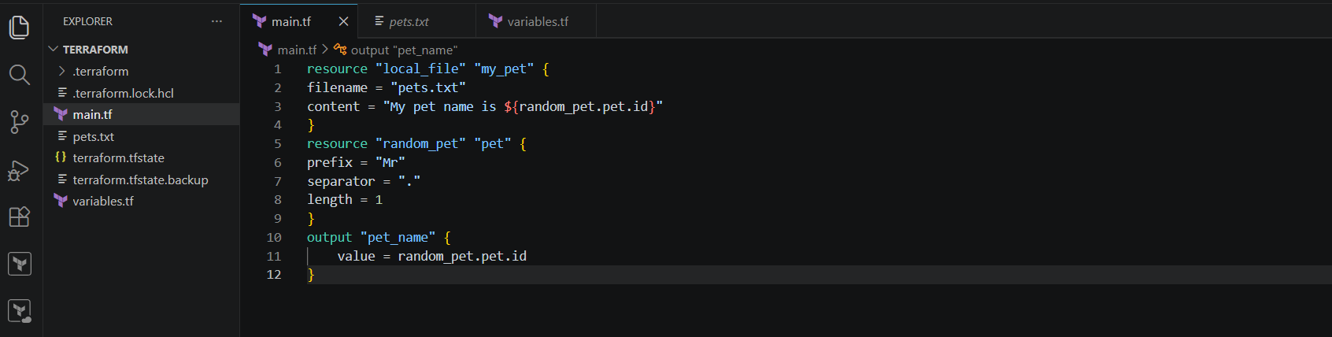
The output is displayed after performing terraform apply
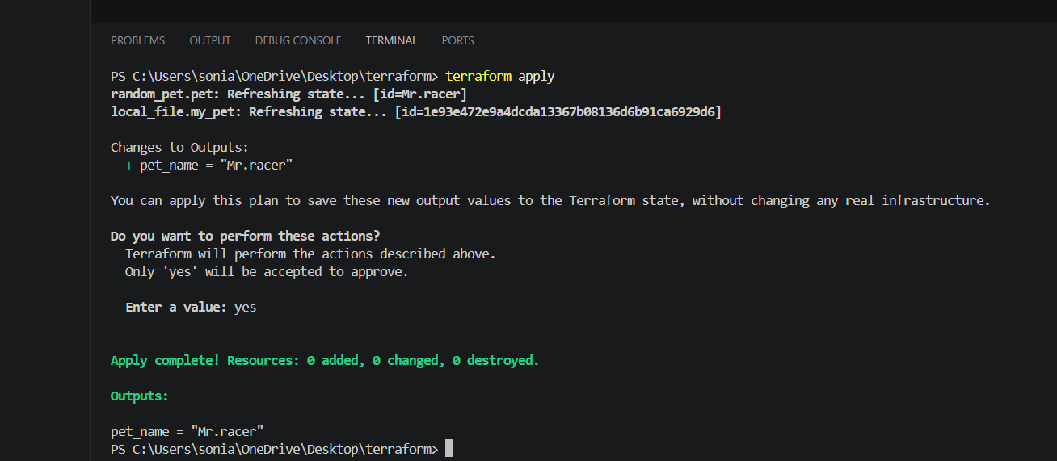
Giving terraform output command it will display the output
Statefile
By performing terraform show command it will show the statefile
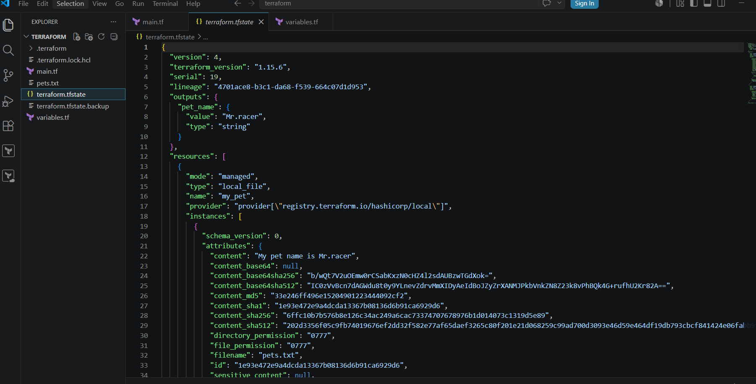
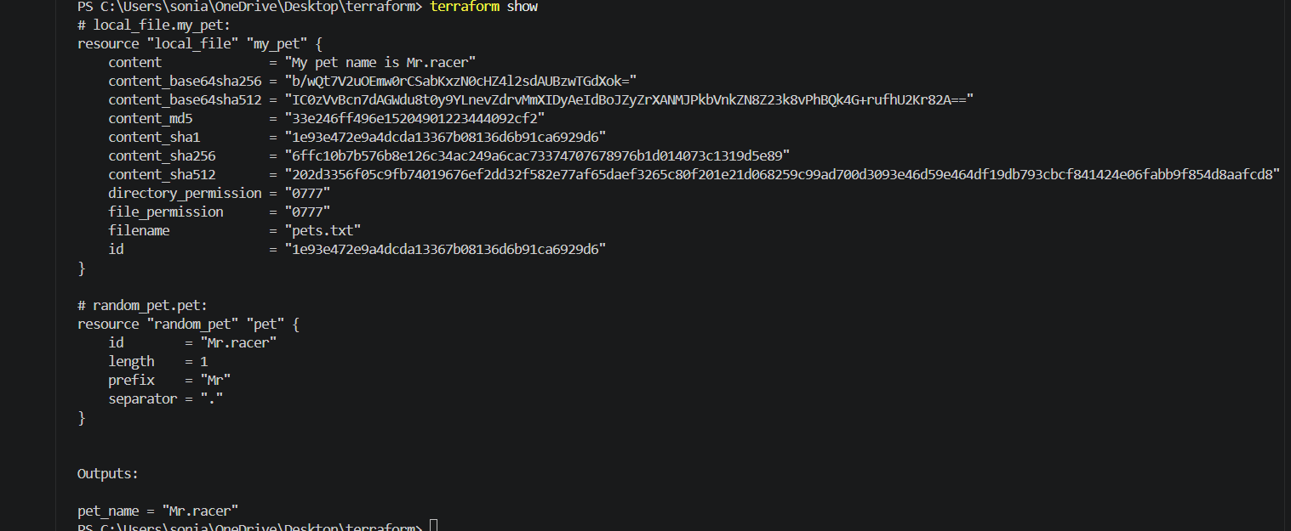
- Integrate Terraform in Jenkins using the Terraform plugin.
Lets create new pipeline job
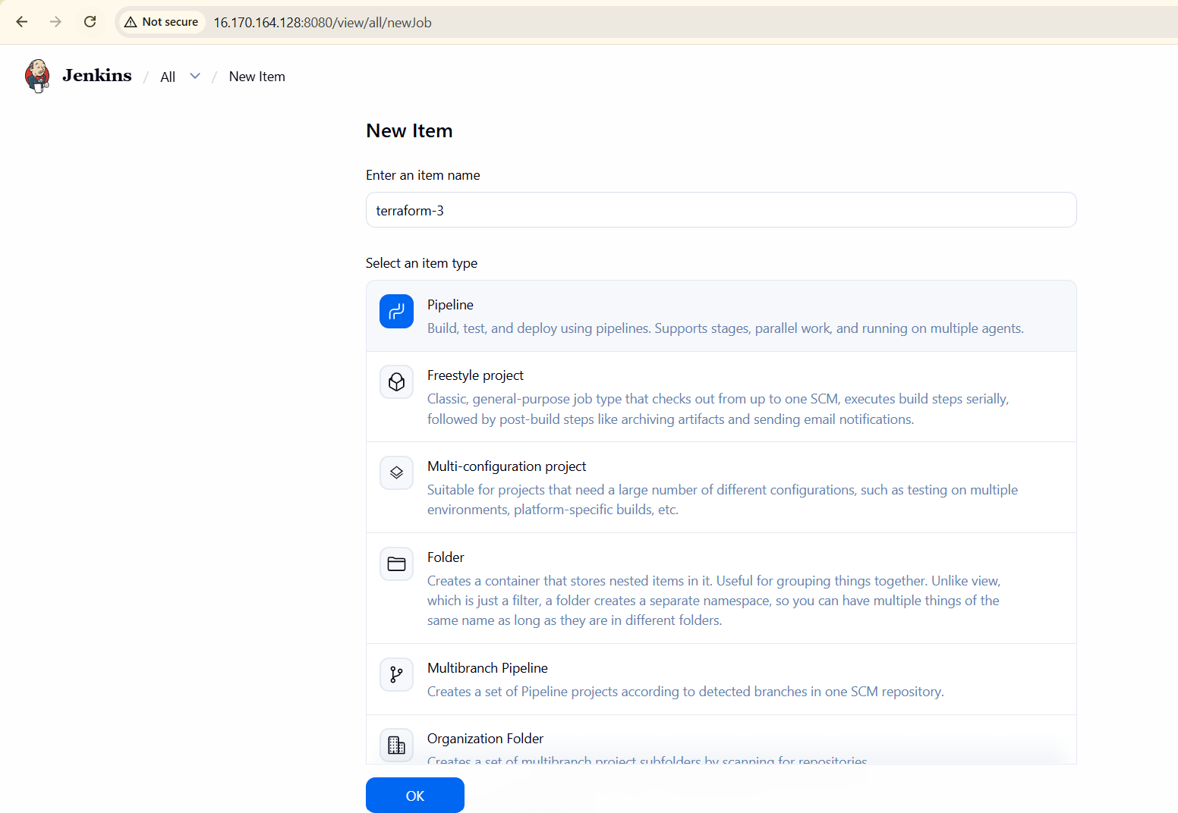
pipeline {
agent any

stages {

stage('Terraform Init') {
steps {
sh 'terraform init'
}
}

stage('Terraform Plan') {
steps {
sh 'terraform plan'
}
}

stage('Terraform Apply') {
steps {
sh 'terraform apply -auto-approve'
}
}
}
}
Write a pipeline script and build now
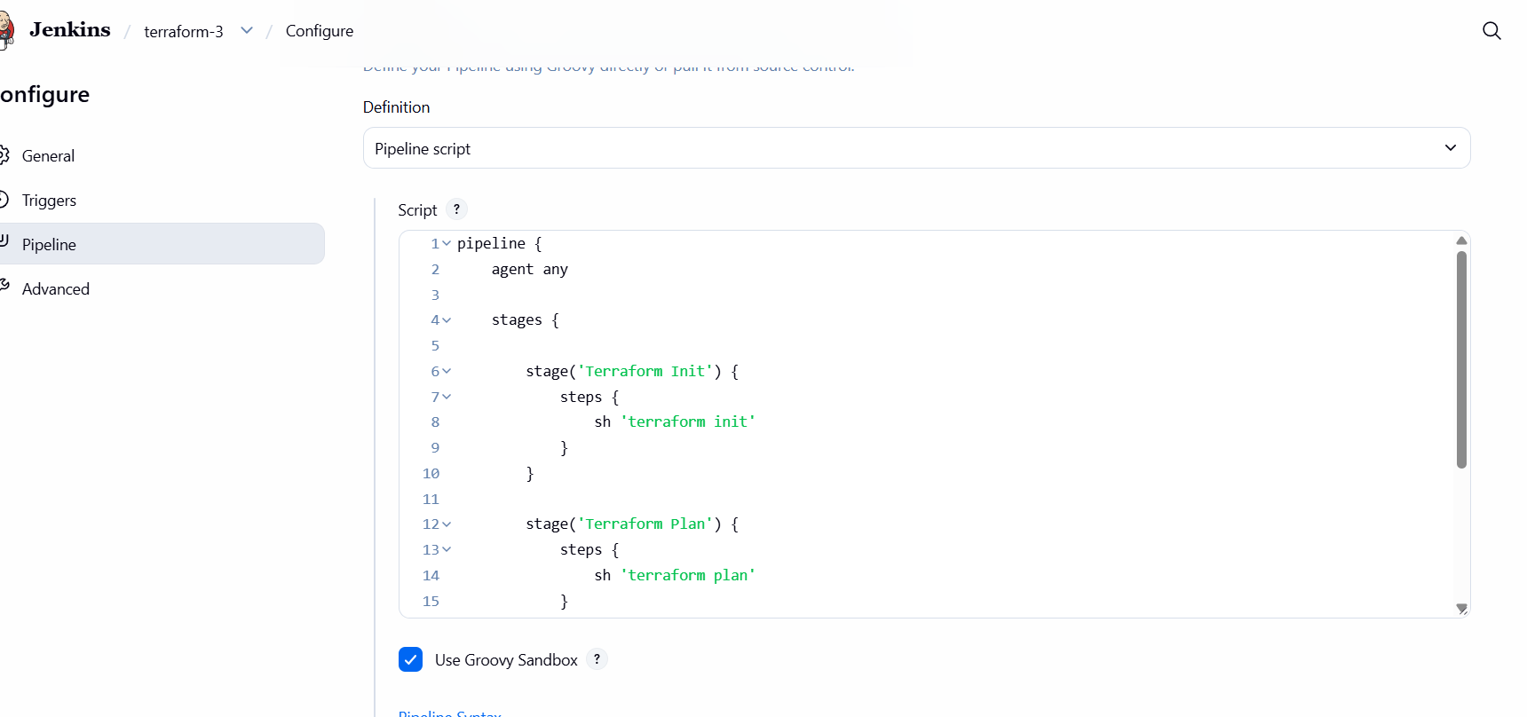
Pipeline will be fail because could not create the sample file
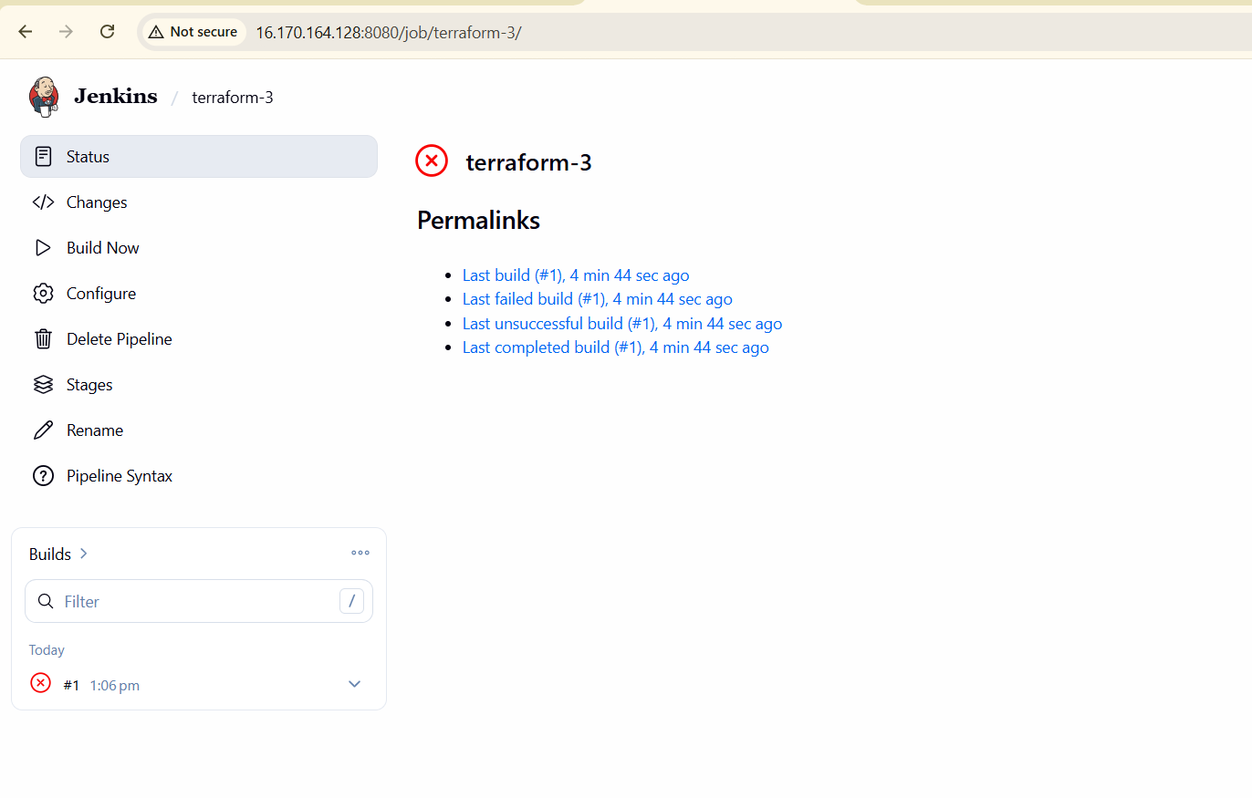
Now we can create the vi main.tf file
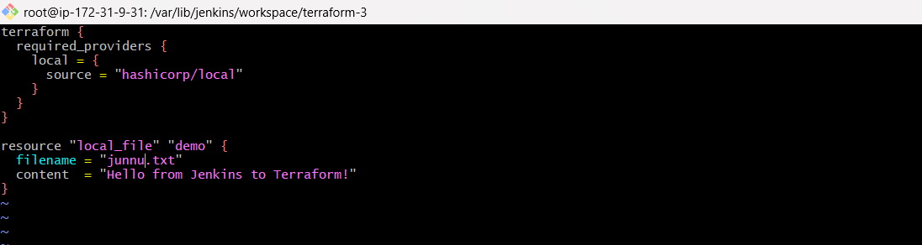
Again pipeline run it eill be successfullt build
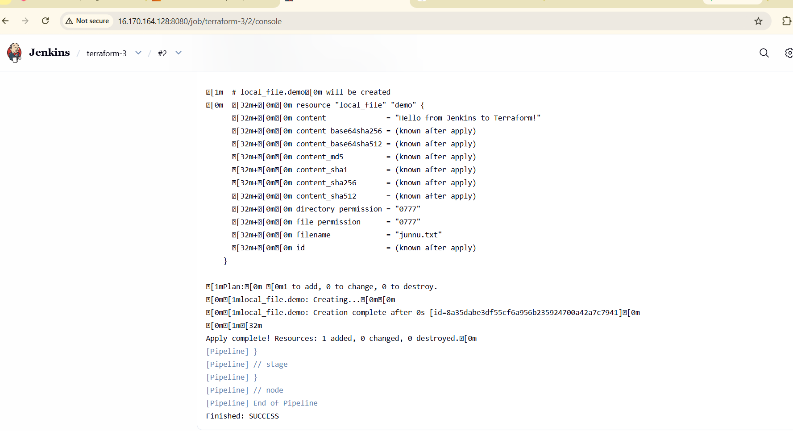
File created successfully

- Create one Jenkins job using Maven Project for the code below with two stages:
  - Stage 1:Git clone
  - Stage 2:Maven CompilationCode:https://github.com/betawins/java-Working-app.git
Lets install mavan integration first
Go to manage Jenkins plugins available plugins search for maven integrationclick on install
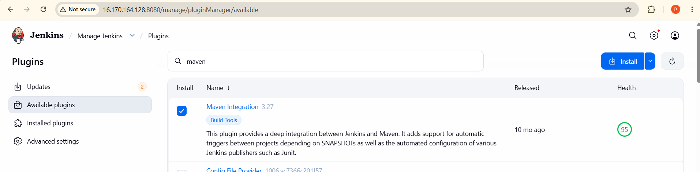
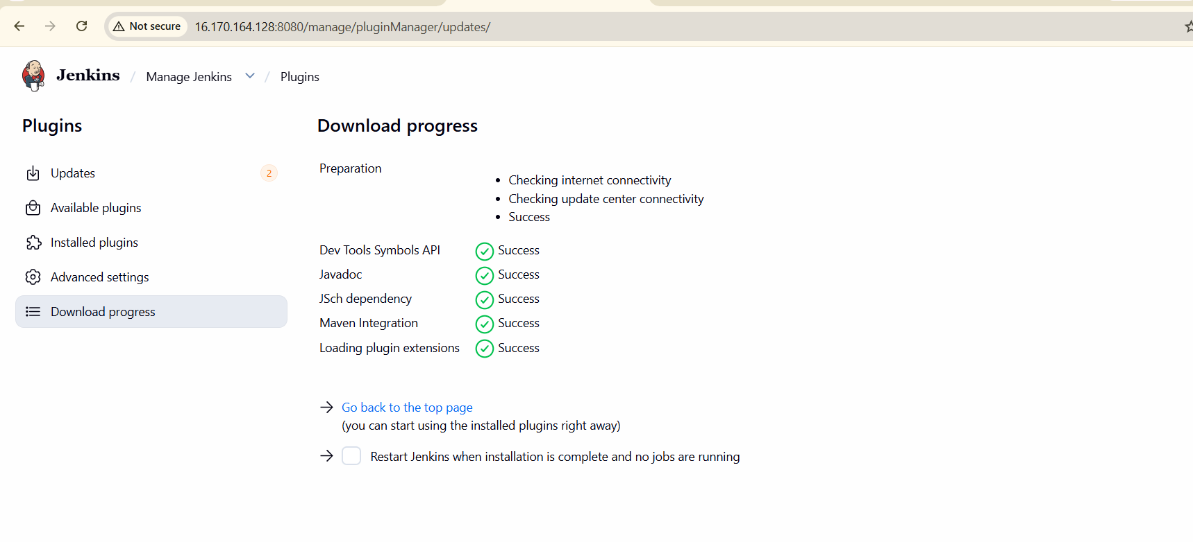
Let add maven integration
Go to manage Jenkins toolclick on maven save
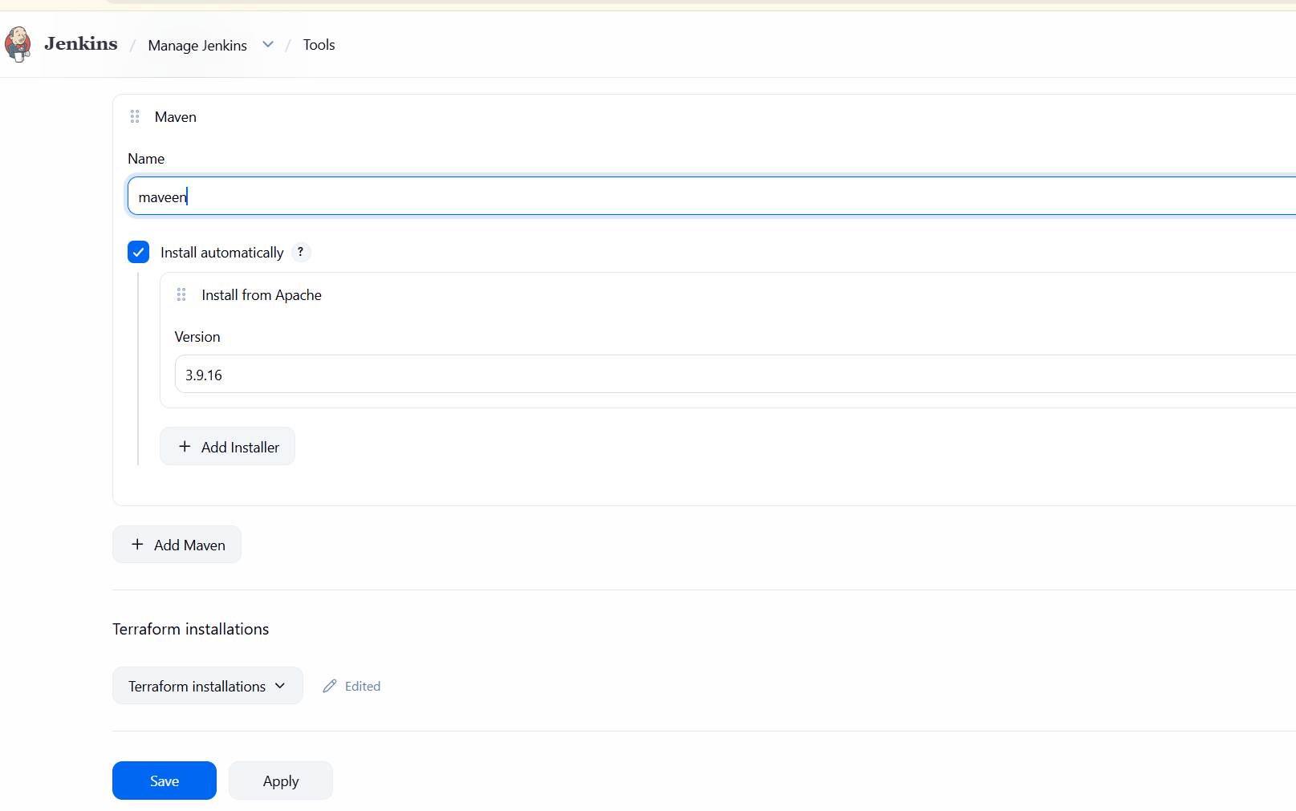
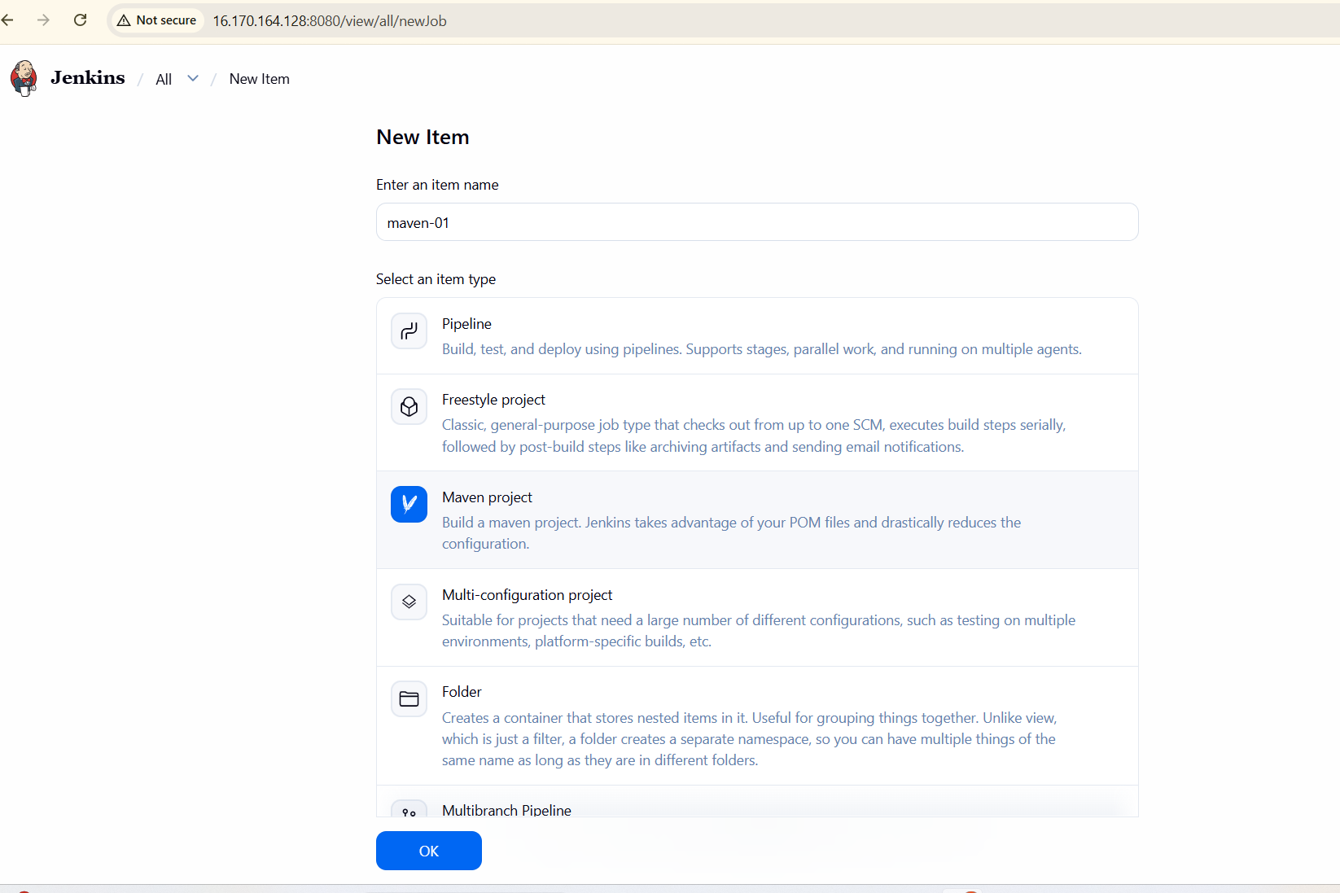
  - Stage 1:Git clone

Now lets select management as git and copy the URL and paste it. Then run job 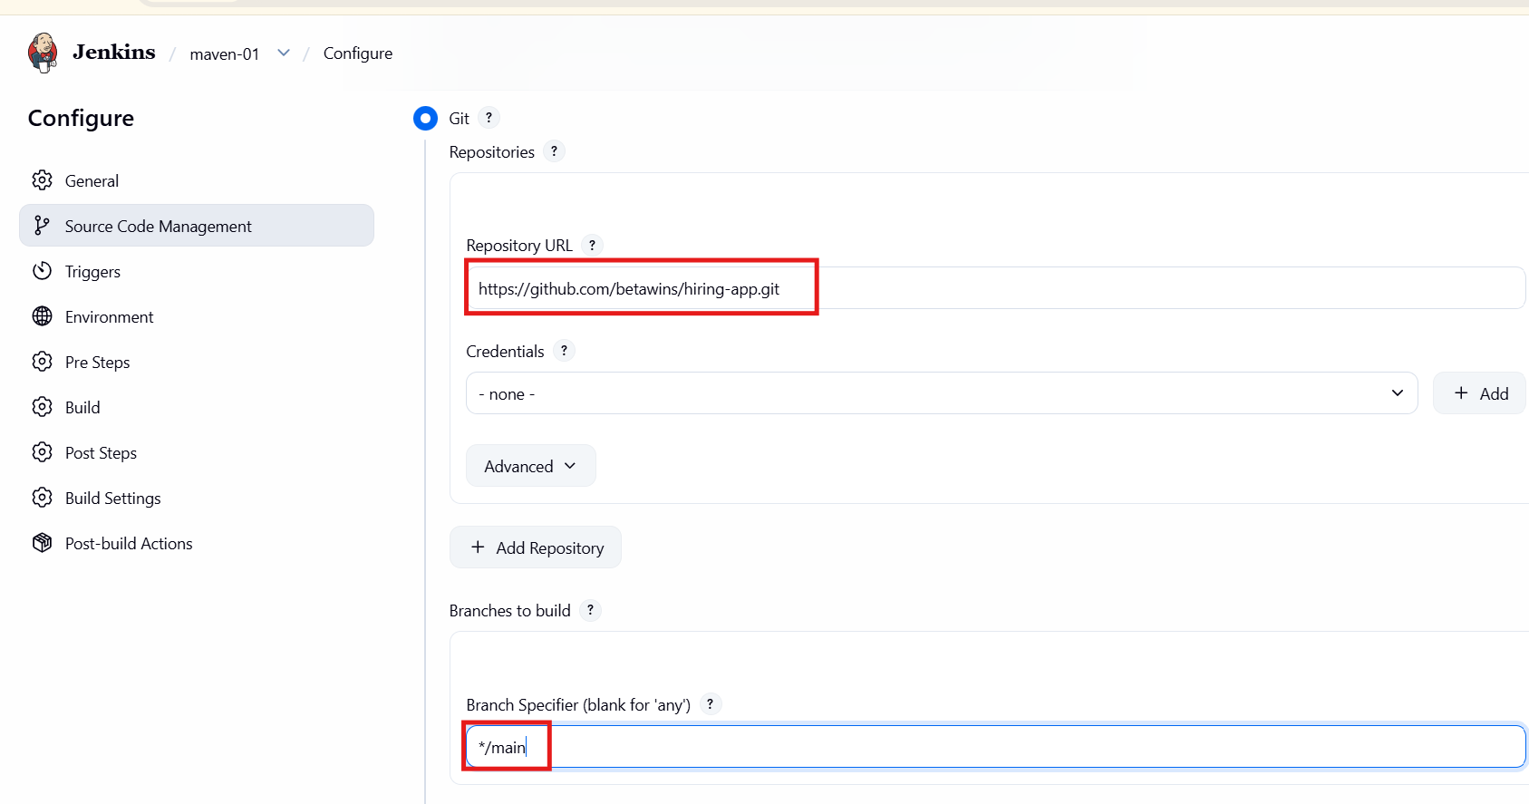
The job was run successfully
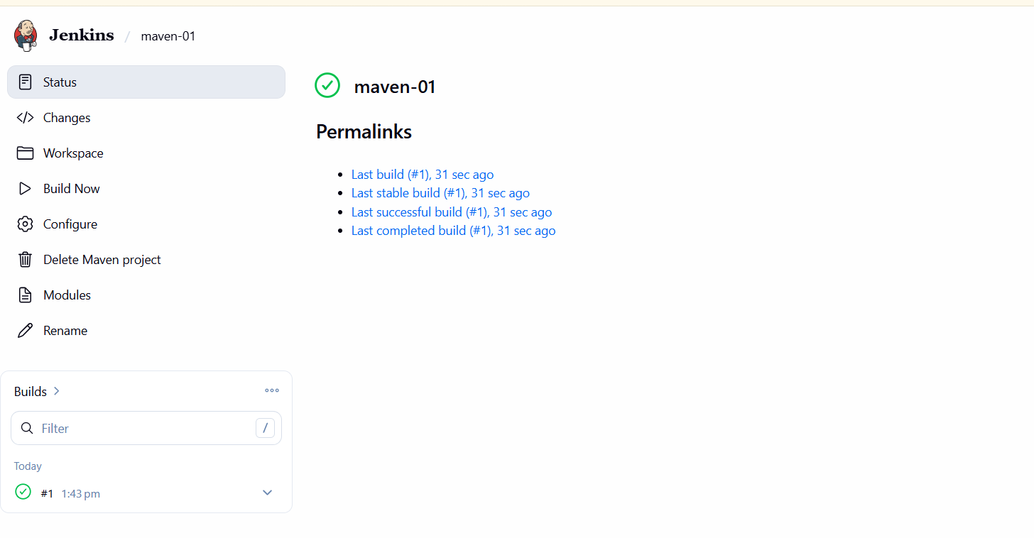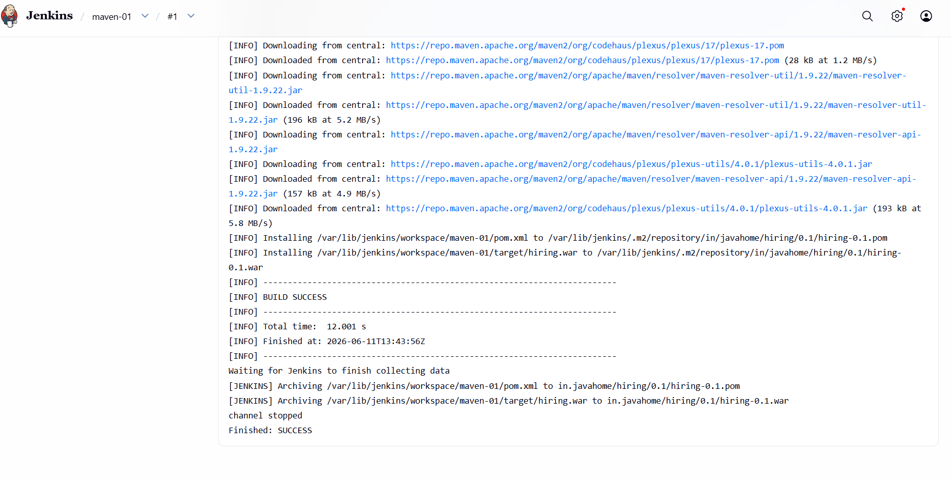
We can see that the jenkins has been successfully build the maven application and geranetaed a war file
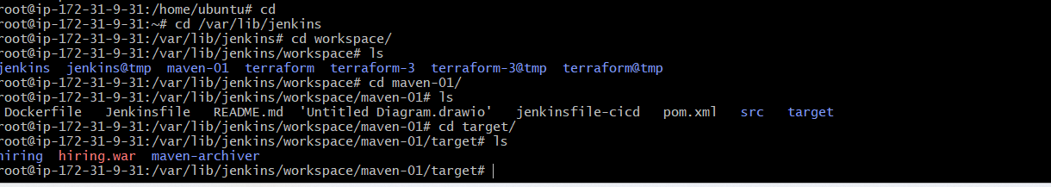

- Use the same code and create a parameterized job in Jenkins with:
  - Stage 1:Git clone
  - Stage 2:Maven CompilationCode:https://github.com/betawins/java-Working-app.git
First create new job
Go to Jenkins dashboard new item give name select pipeline save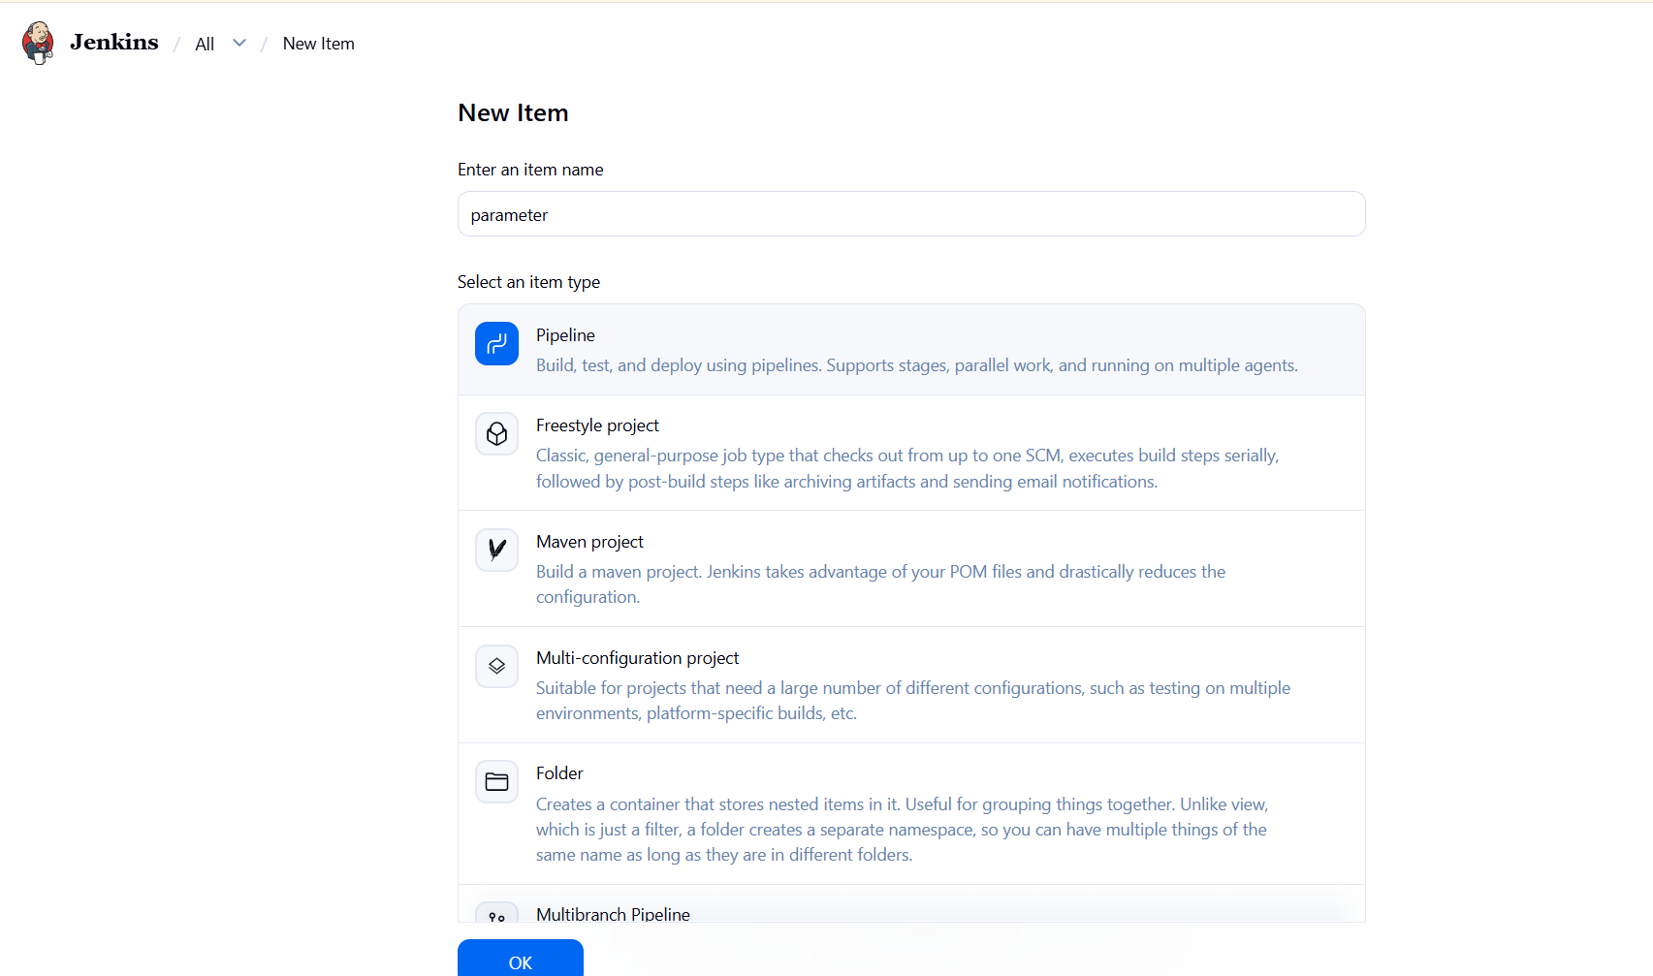
Click on the project is parameterizedclick on add parameterchoose string parametergive name &valuvedescription
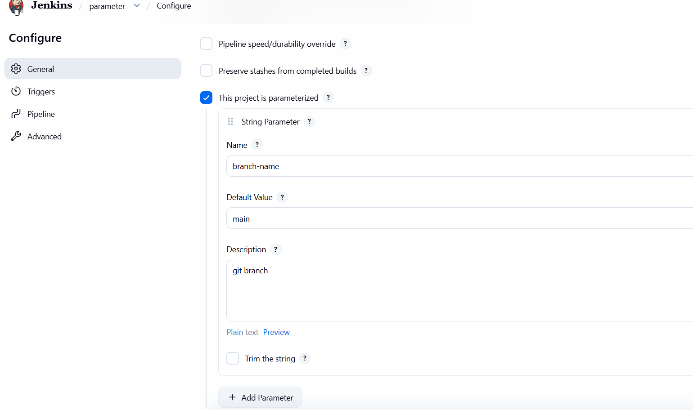
pipeline {
agent any
parameters {
string(
name: 'BRANCH_NAME',
defaultValue: 'main',
description: 'Git Branch Name'
)
}
tools {
maven 'maven'
}
stages {
stage('Git Clone') {
steps {
git branch: "${params.BRANCH_NAME}",
url: 'https://github.com/betawins/java-Working-app.git'
}
}
stage('Maven Compilation') {
steps {
sh 'mvn clean compile'
}
}
}
post {
success {
echo 'Build Successful'
}
failure {
echo 'Build Failed'
}
}
}
Write on below script
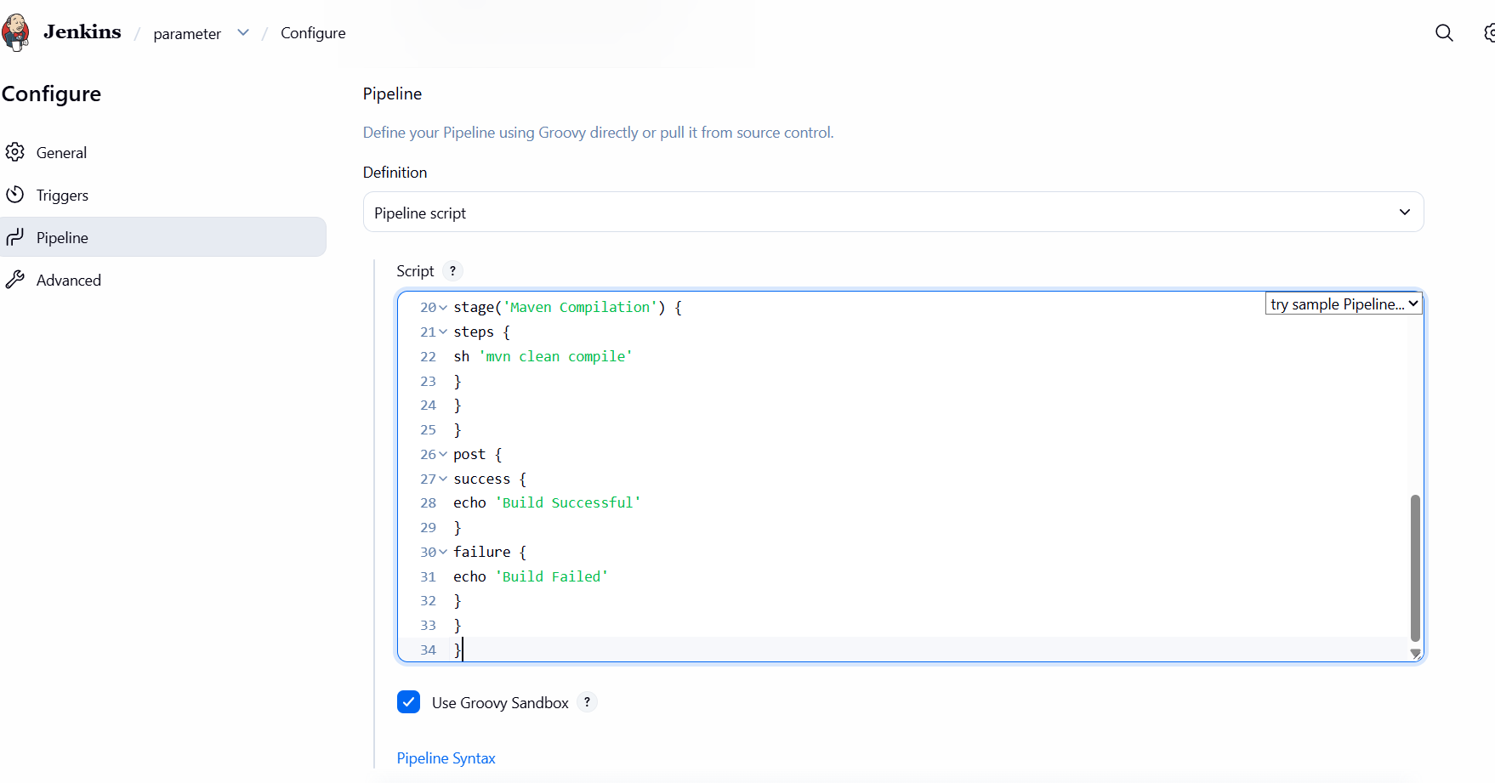
Click on build with parameter and run the job
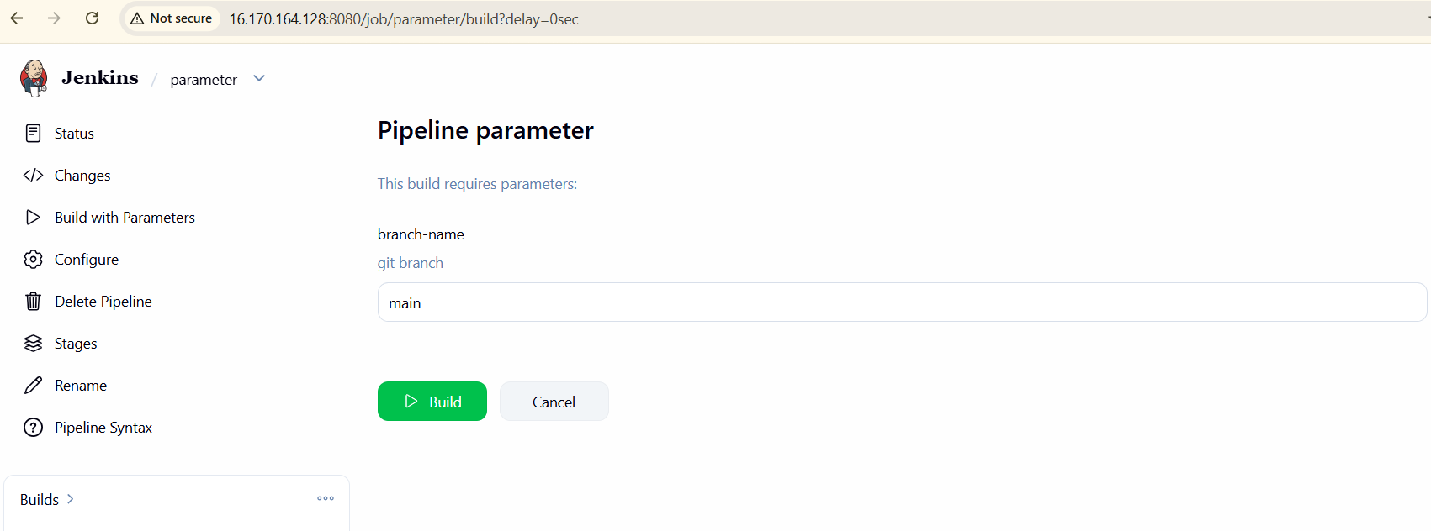
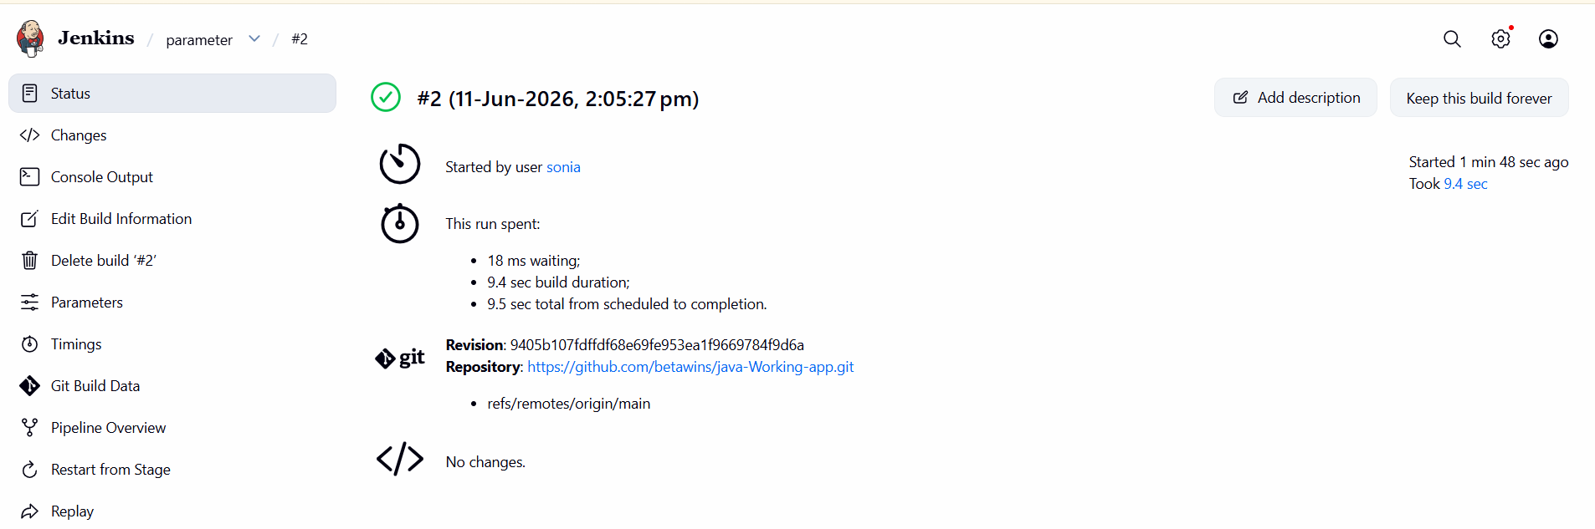
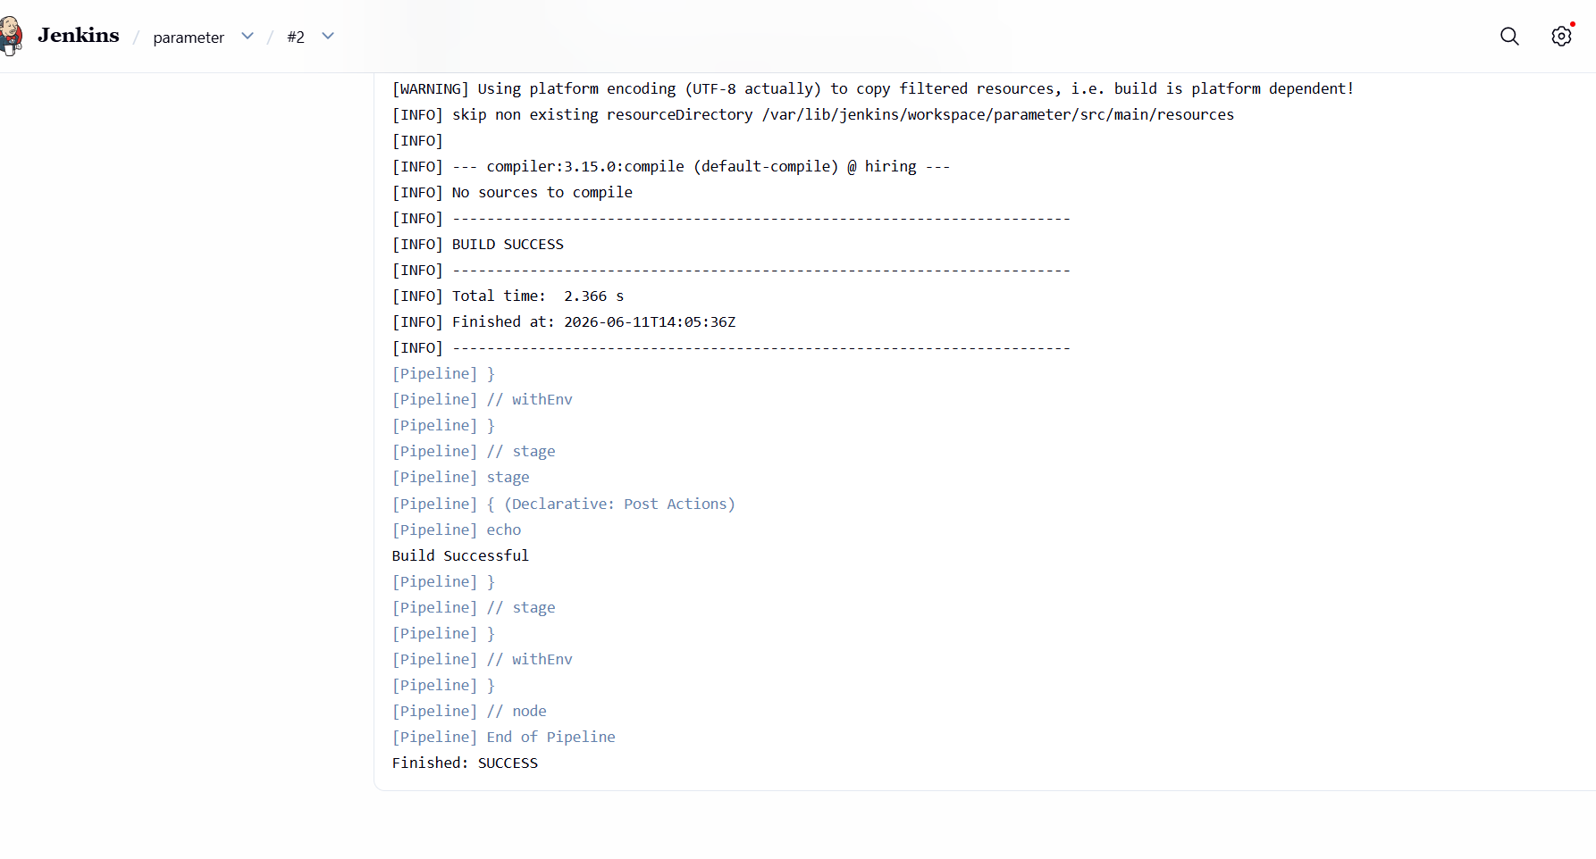
- .What are the global variables in Jenkins?
Jenkins Global Variables
What are Global Variables in Jenkins?
Global variables are predefined variables provided by Jenkins that can be used anywhere in a
pipeline job. They contain useful information about the current build, job, workspace, Git
repository, and Jenkins environment.
These variables help us avoid hardcoding values in scripts and make our pipelines more
flexible and reusable.
Commonly Used Global Variables
Variable Description
BUILD_NUMBER Current build number
BUILD_ID Unique identifier of the build
JOB_NAME Name of the Jenkins job
BUILD_URL URL of the current build
WORKSPACE Path of the Jenkins workspace
JENKINS_URL URL of the Jenkins server
NODE_NAME Name of the Jenkins agent/node
GIT_BRANCH Git branch being built
GIT_COMMIT Commit ID of the source code
GIT_URL Git repository URL
Why Do We Use Global Variables?
- To get build information dynamically.
- To avoid hardcoding values.
- To make pipelines reusable.
- To access job, Git, and workspace details during execution.
Example Pipeline
pipeline {
agent any
stages {
stage('Display Variables') {
steps {
echo "Job Name: ${env.JOB_NAME}"
echo "Build Number: ${env.BUILD_NUMBER}"
echo "Workspace: ${env.WORKSPACE}"
echo "Build URL: ${env.BUILD_URL}"
}
}
}
}

