Terraform-04
2). Execute the script shown in the video.
Version constraints
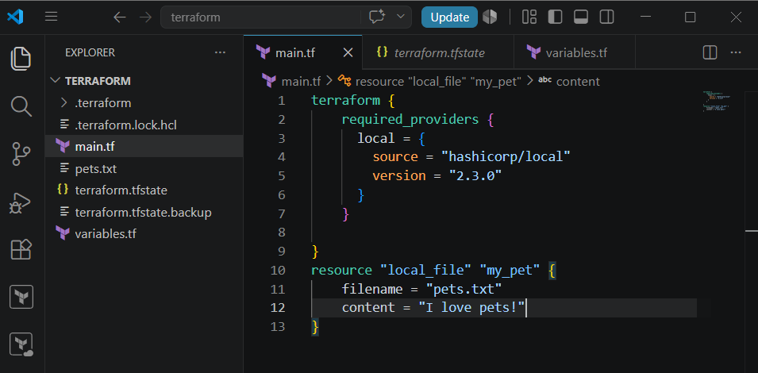
Here we can see that it is downloading the given version from the configuration
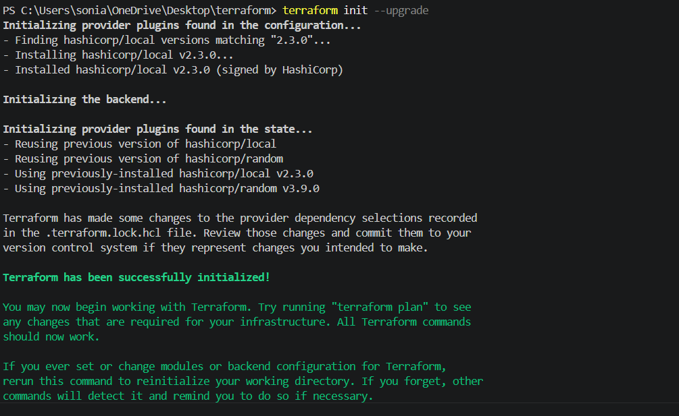
We can see the file has been created
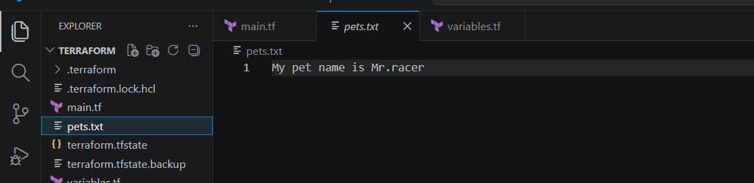
Now lets download different version
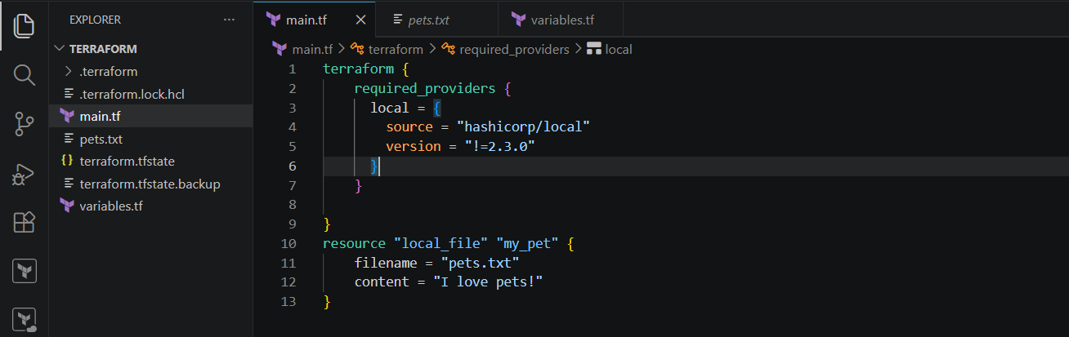
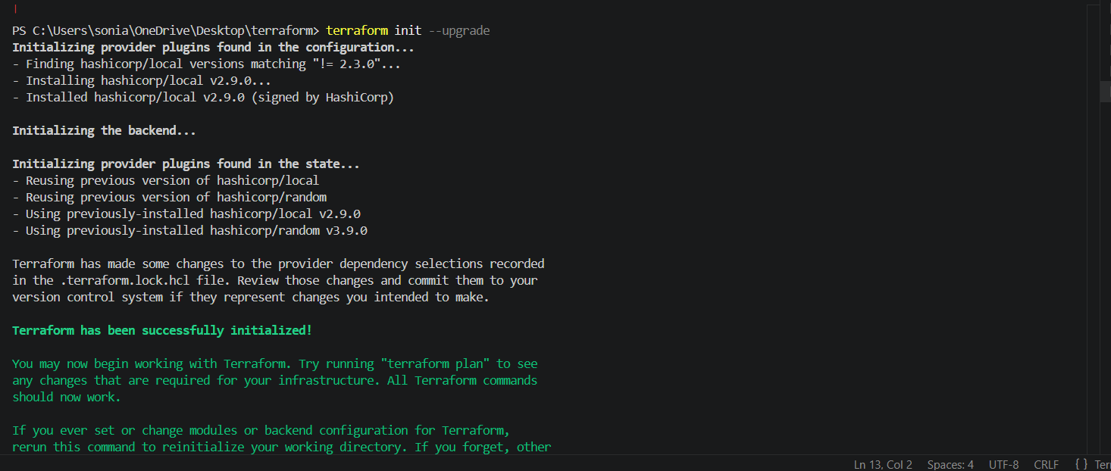
Now lets download for version less than 2.3.0
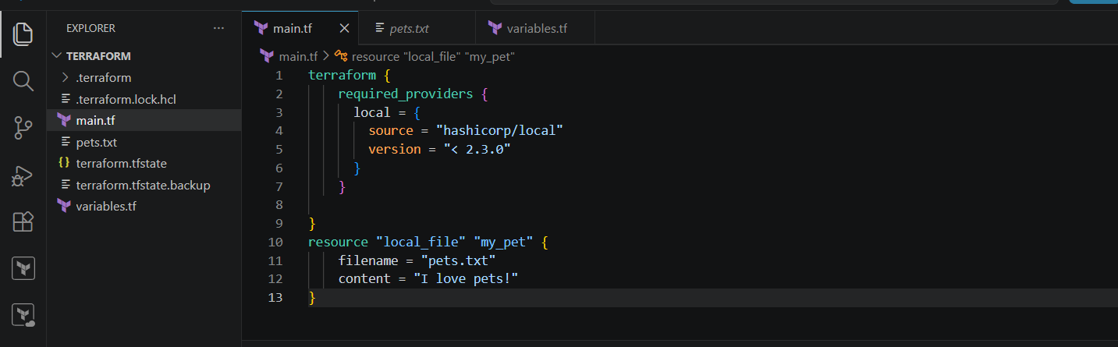
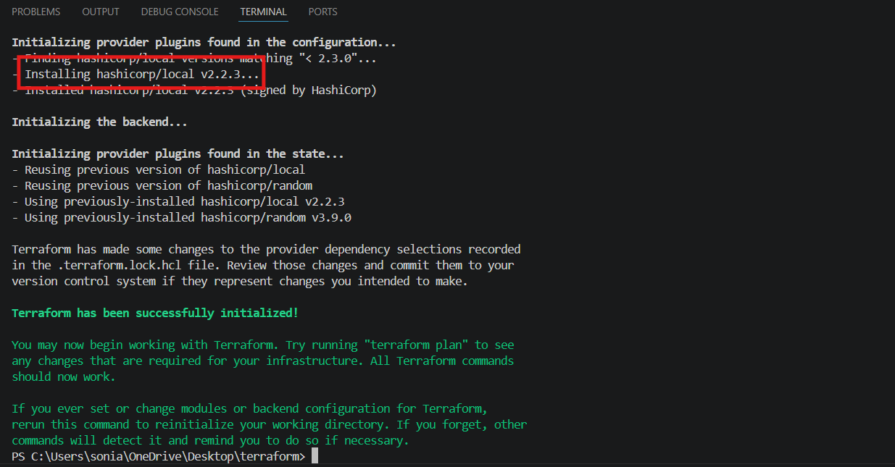
Also lets download the version greater than 2.3.0
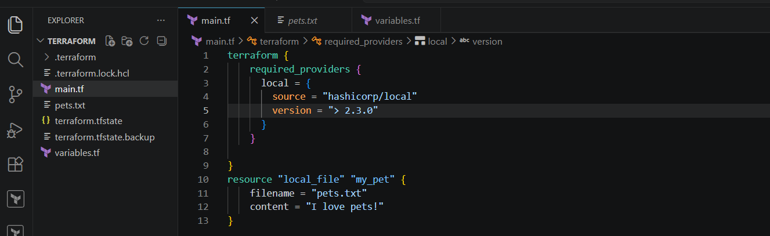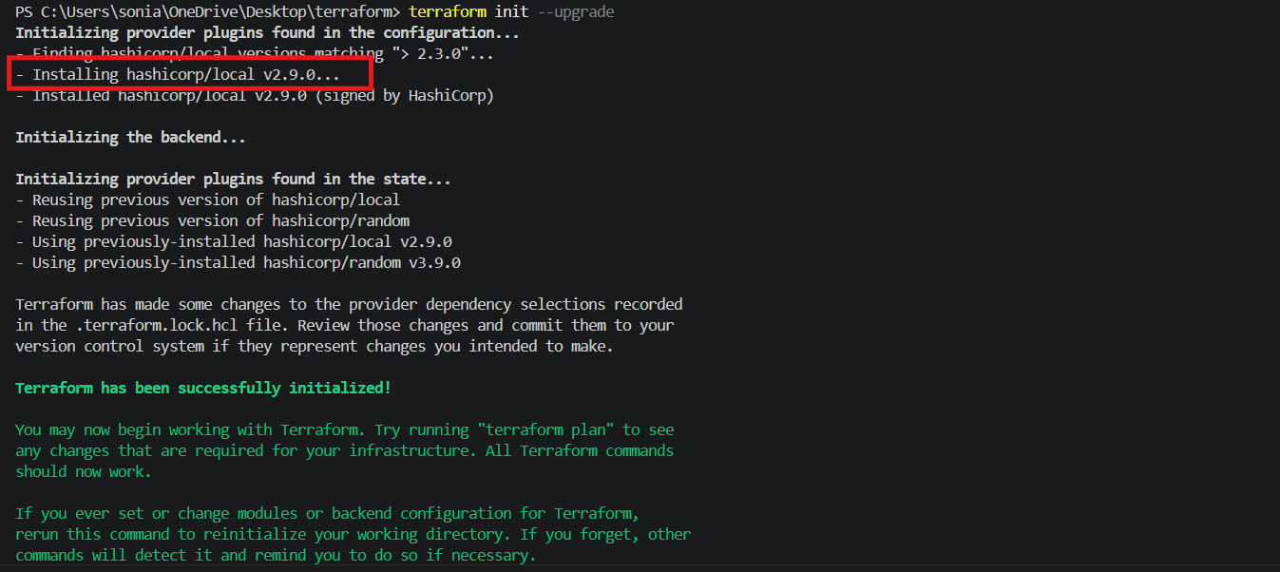
version = "~> 2.3.0" --> specific version or higher version.
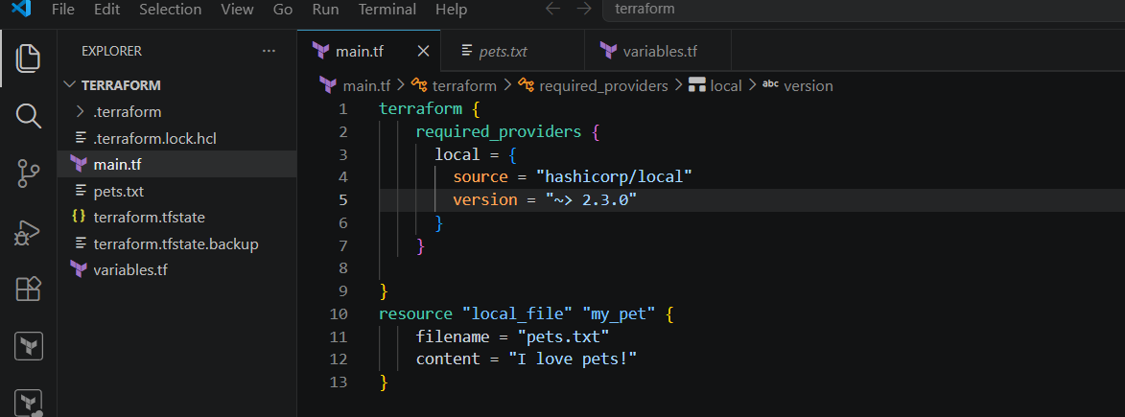
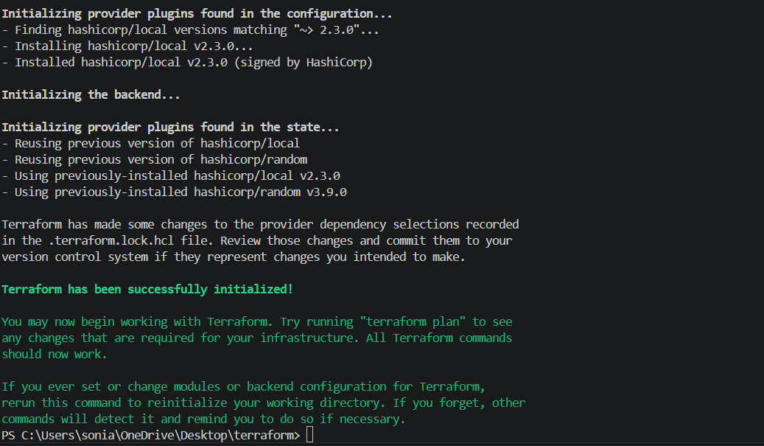
Data source
Data source is used to read the existing infrastructure, it won’t create any files
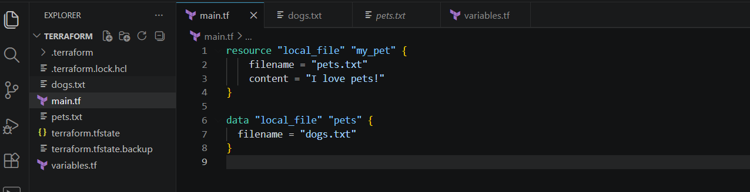
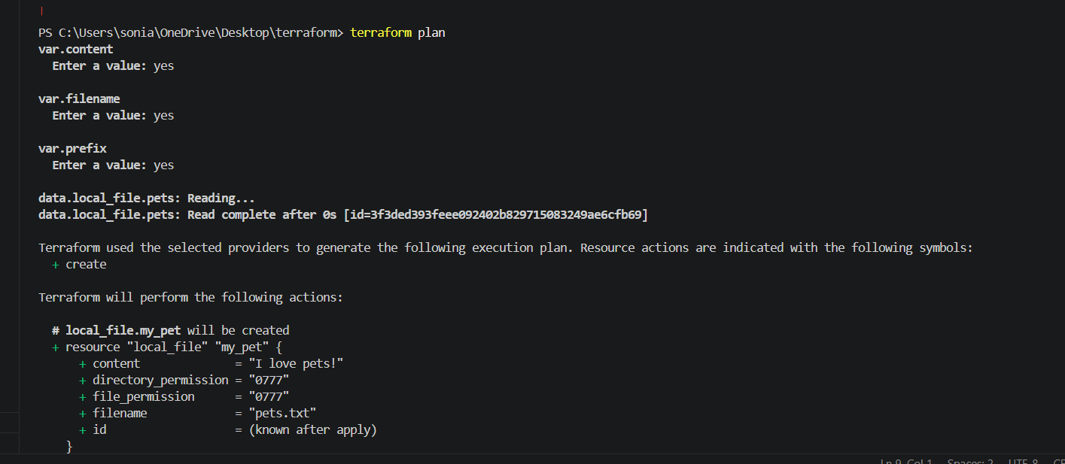
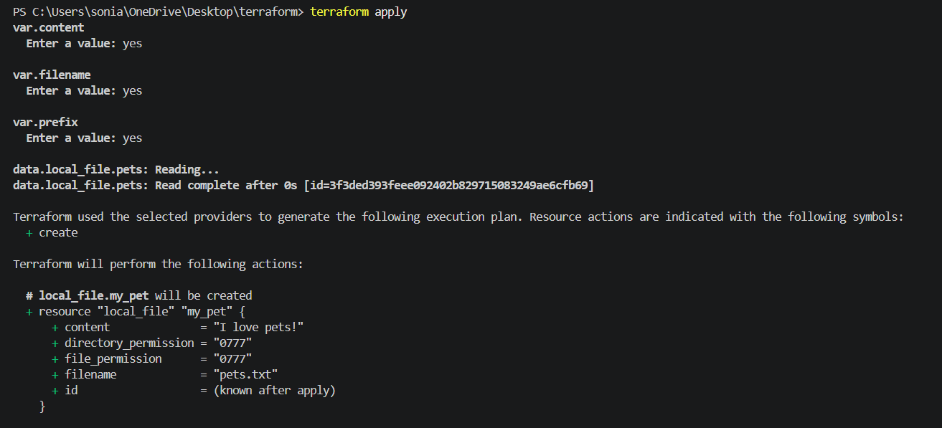
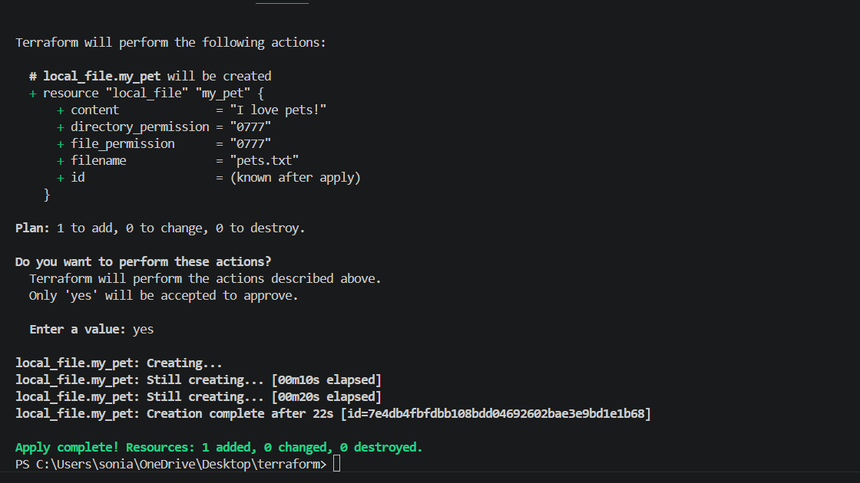
Meta arguments
Count
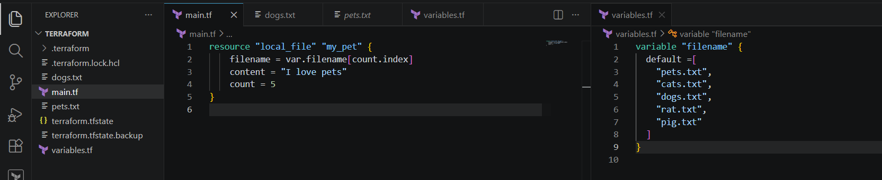
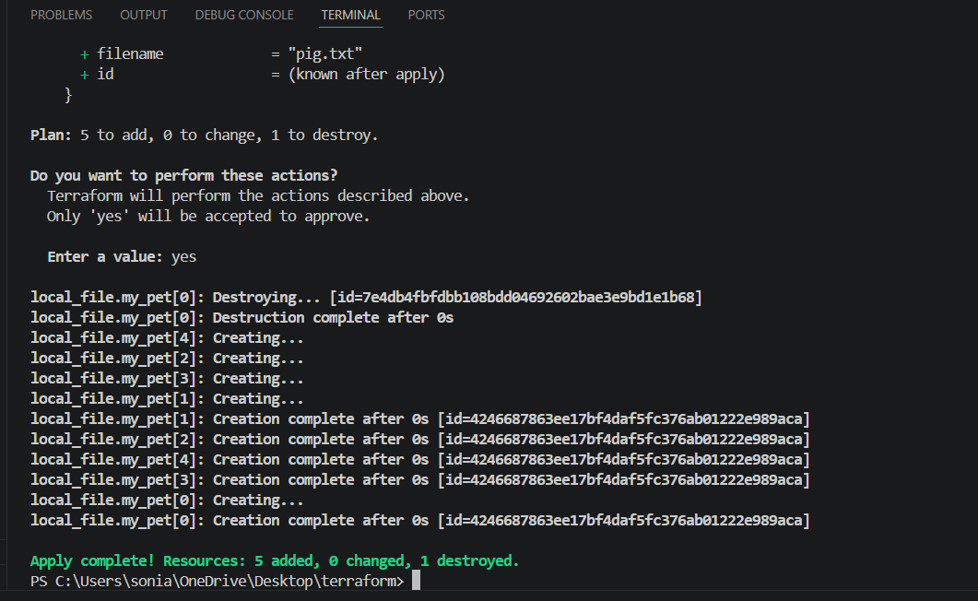
Now created a 5 file
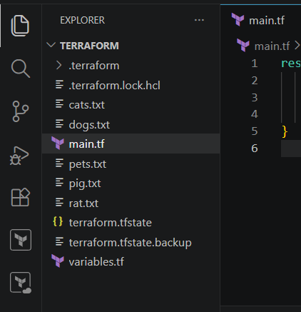
Now destoy two files
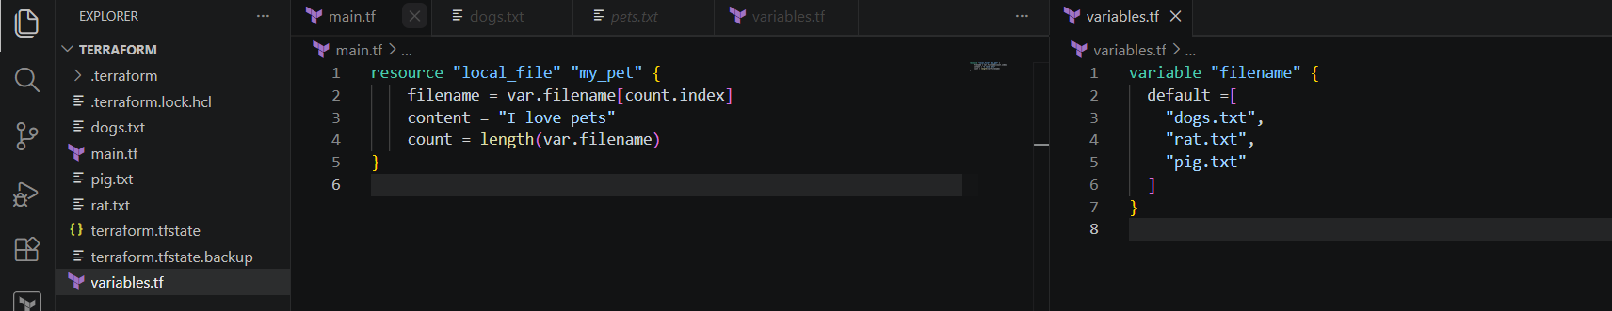
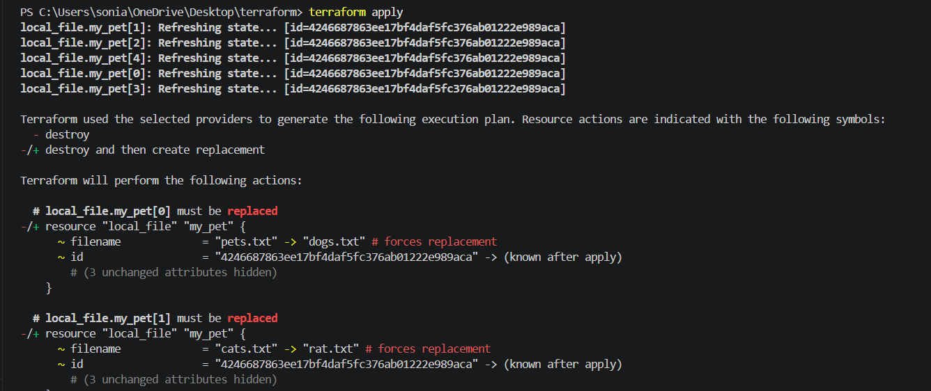
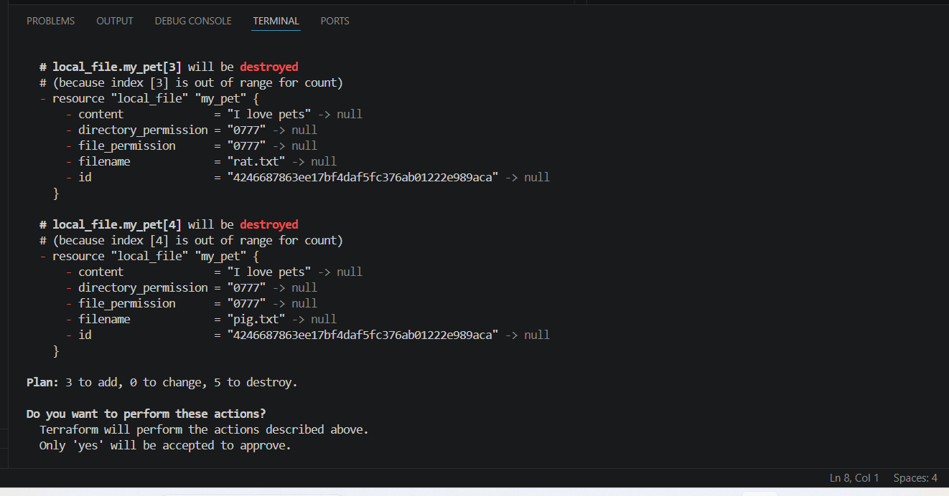
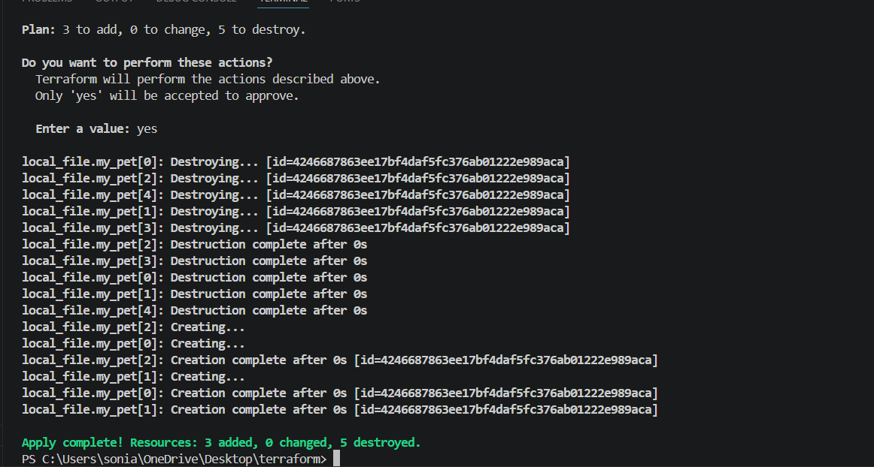
Files was deleted
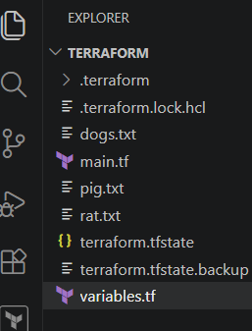
For_each
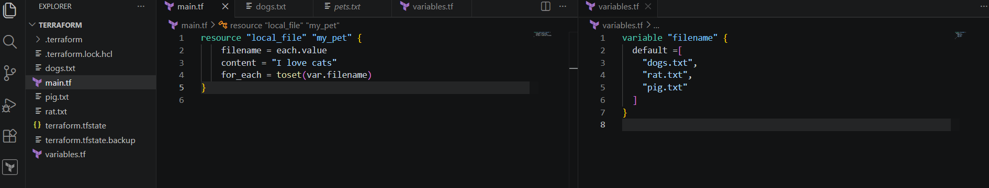
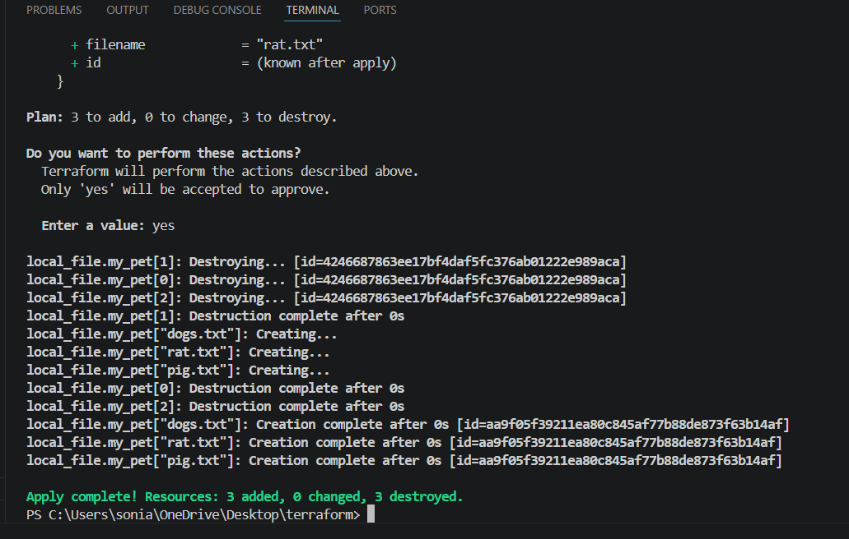
If we don’t want to use the inbuilt function we can include type in variable.tf
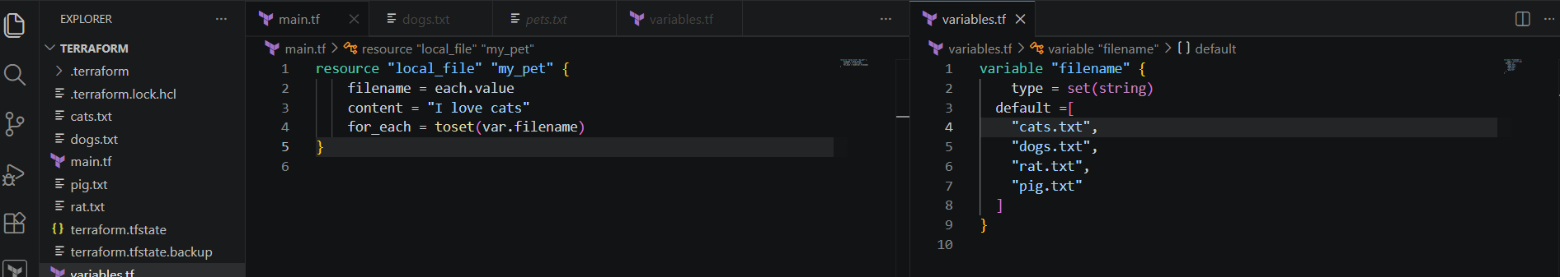
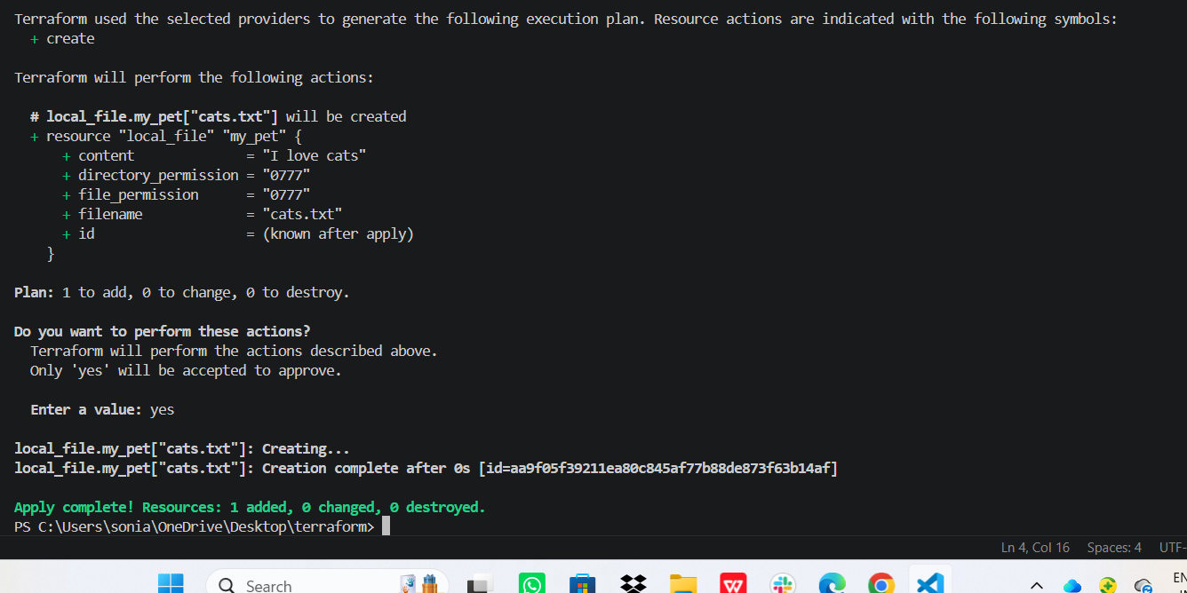
Lets create user and policy
provider "aws" {
region = "eu-north-1"
}
# Create IAM User
resource "aws_iam_user" "dev_user" {
name = "terraform-dev-user"
}
# Create Custom IAM Policy
resource "aws_iam_policy" "custom_policy" {
name = "CustomS3ReadOnlyPolicy"
description = "Allow read-only access to S3 buckets"
policy = jsonencode({
Version = "2012-10-17"
Statement = [
{
EƯect = "Allow"
Action = [
"s3:ListBucket",
"s3:GetObject"
]
Resource = [
"arn:aws:s3:::*",
"arn:aws:s3:::*/*"
]
}
]
})
}
# Attach Policy to User
resource "aws_iam_user_policy_attachment" "attach_policy" {
user = aws_iam_user.dev_user.name
policy_arn = aws_iam_policy.custom_policy.arn
}

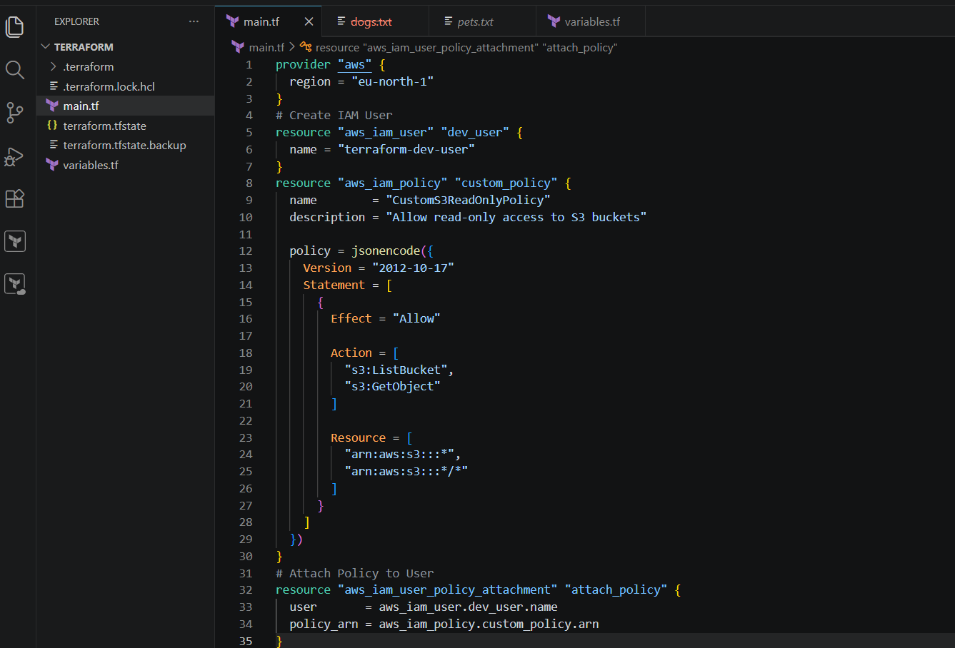

Terraform init
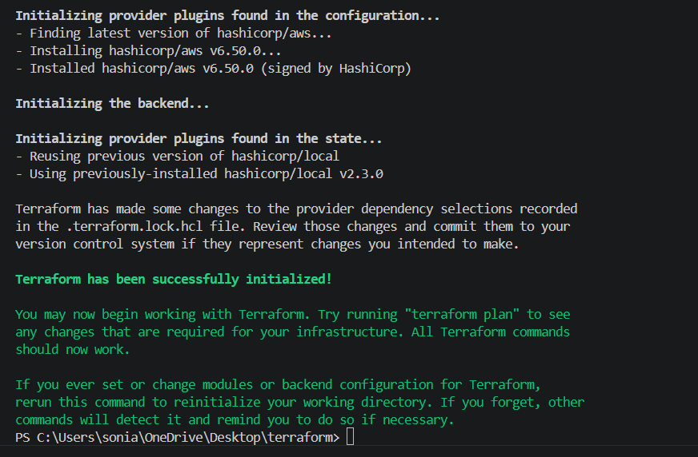
Terraform fmt
Terrraform validate
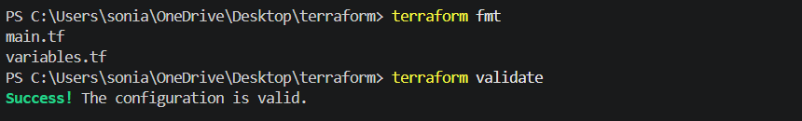
Terraform plan
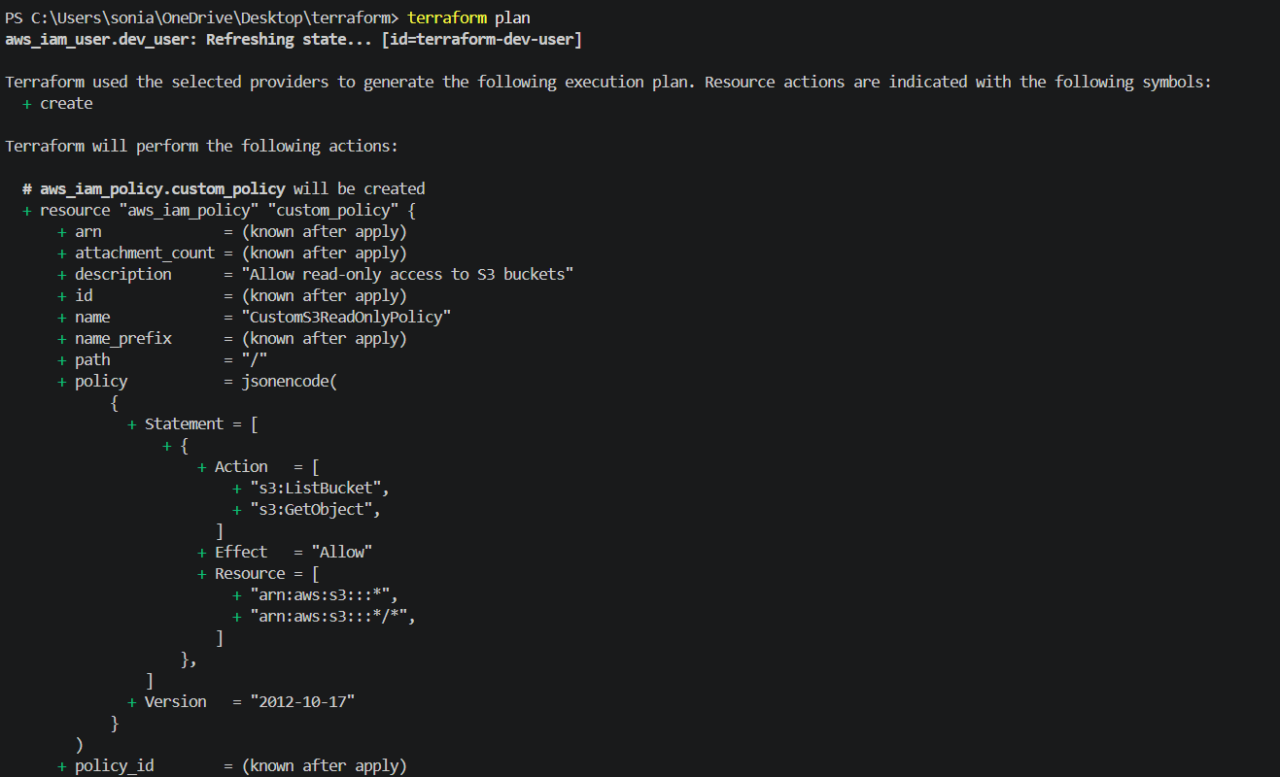
Terraform apply
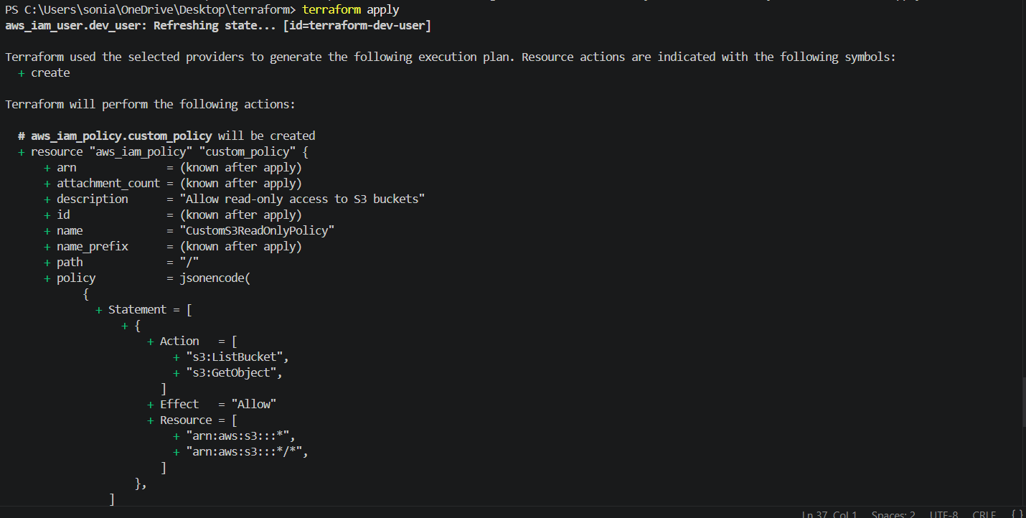
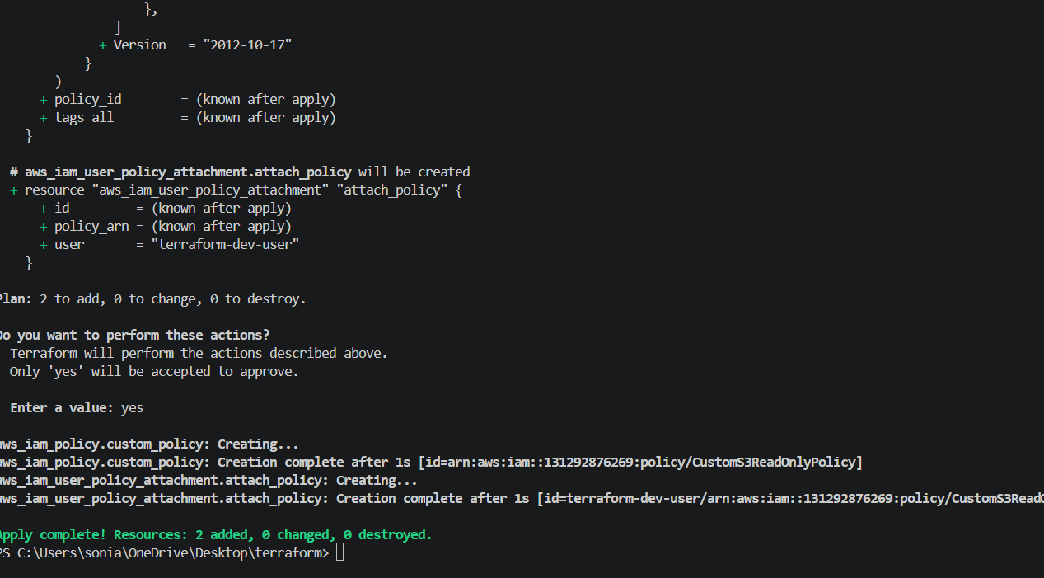
User terraform created successfully
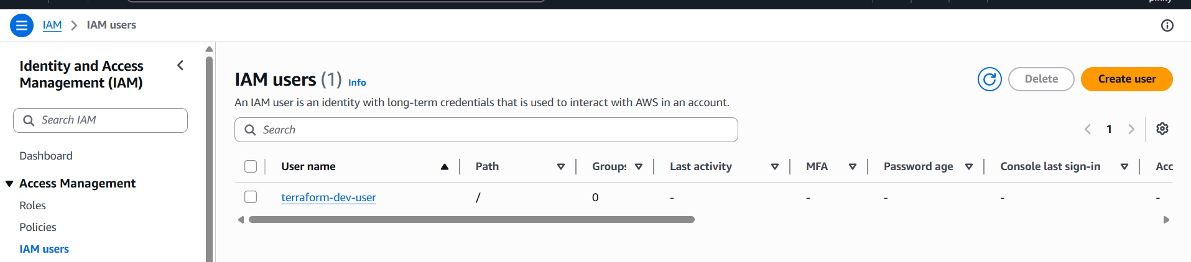
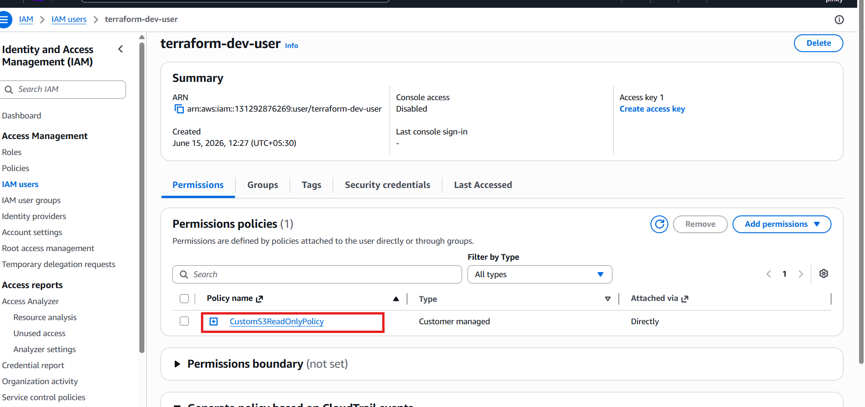

3). Integrate Terraform in Jenkins using the Terraform plugin.
First open jenkins -->manage jenkins-->plugins-->available plugins-->terraform--> install
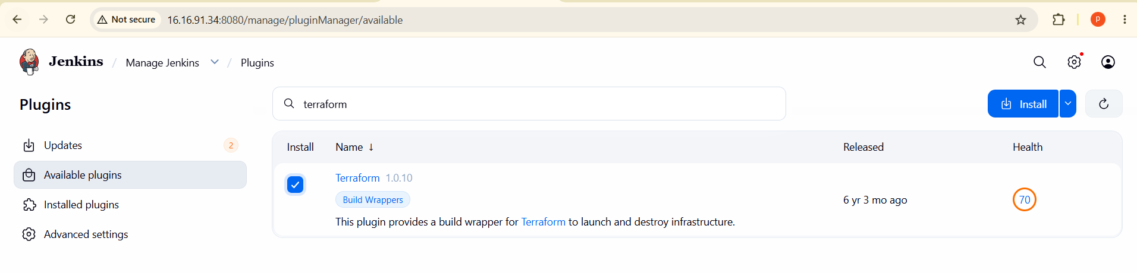
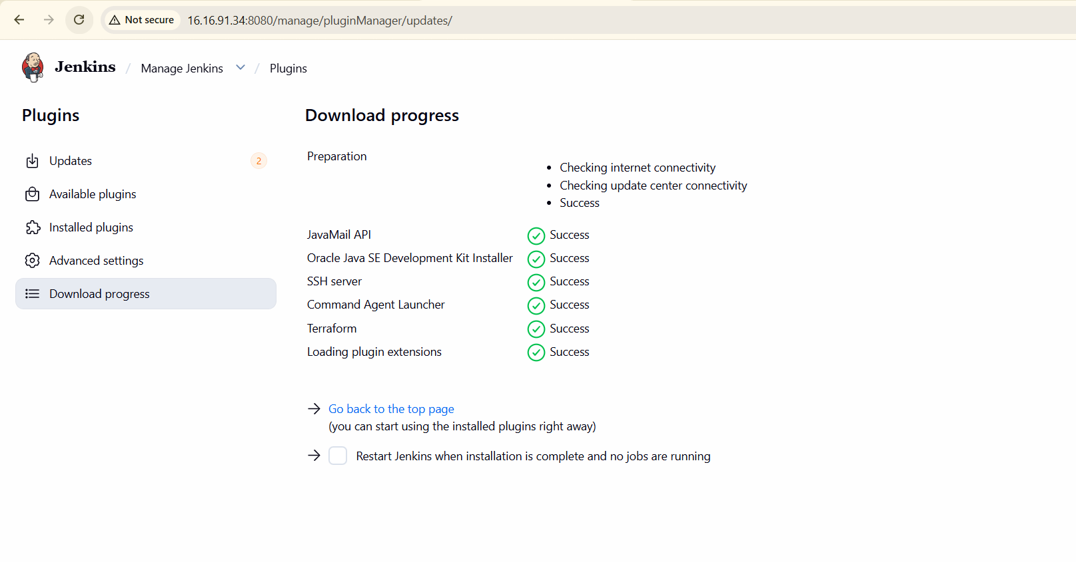Go to manage jenkins-->tool-->terraform installation-->save
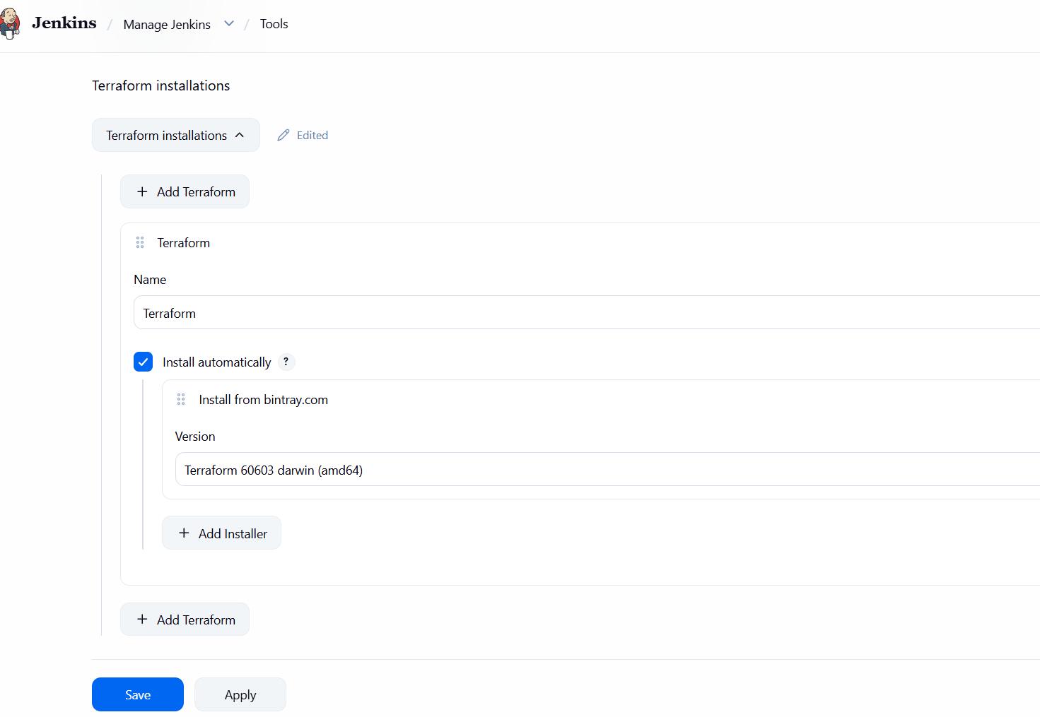Lets go jenkins dashboard create a new item
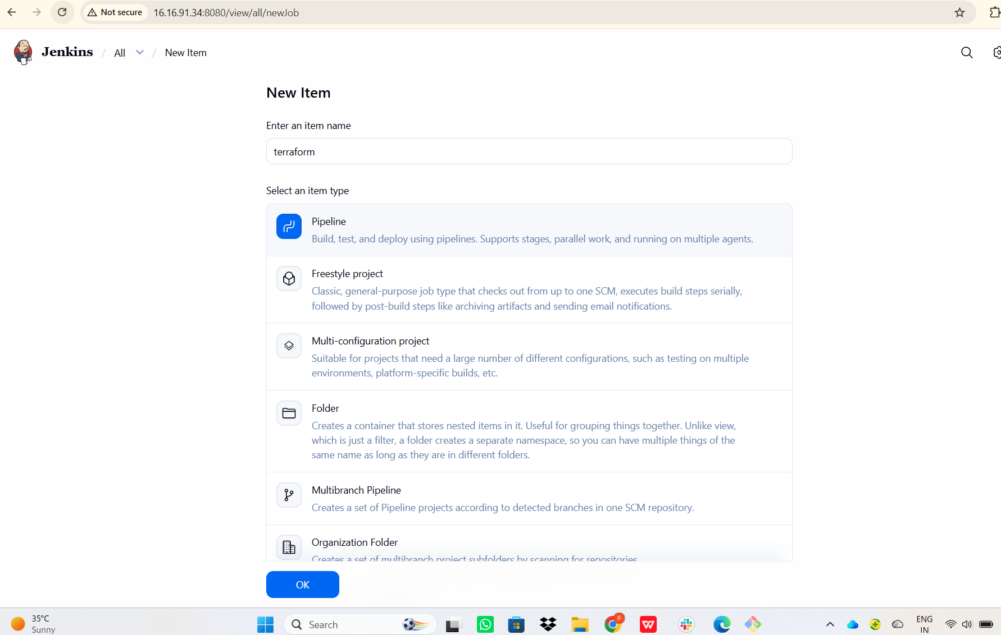pipeline {
agent any
tools {
terraform 'Terraform'
}
stages {
stage('Terraform Init') {
steps {
sh 'terraform init'
}
}
stage('Terraform Plan') {
steps {
sh 'terraform plan'
}
}
stage('Terraform Apply') {
steps {
sh 'terraform apply -auto-approve'
}
}
}
}
Writte on above script in pipeline and save and build now the build is faild because we can not create a sample file
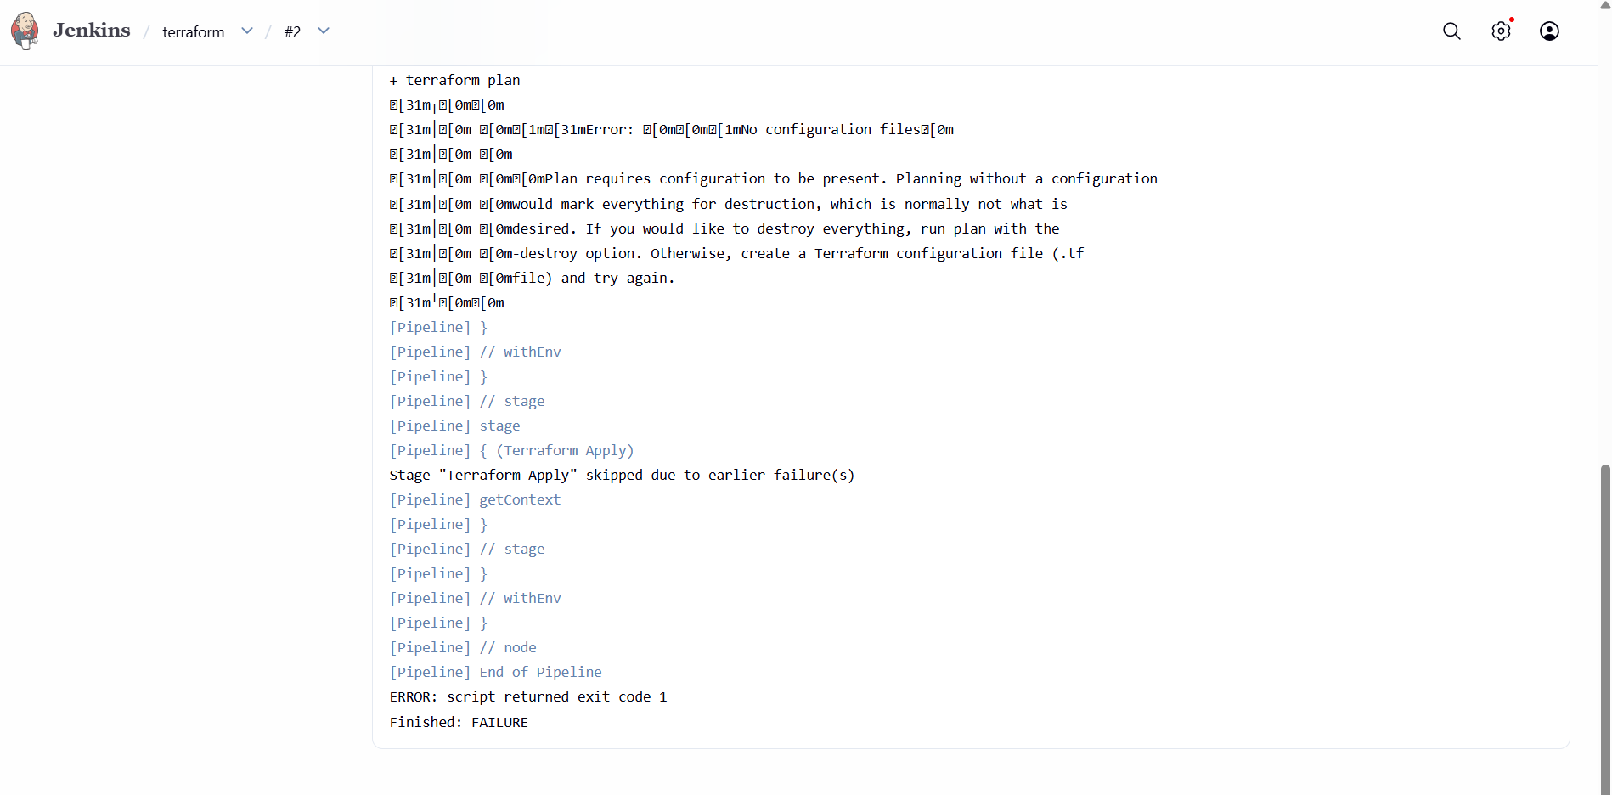Go to git bash create a vi main.tf
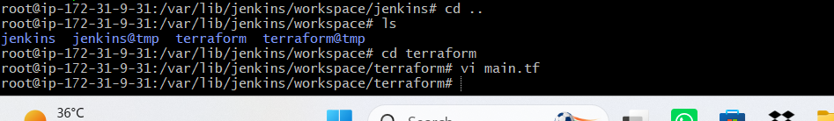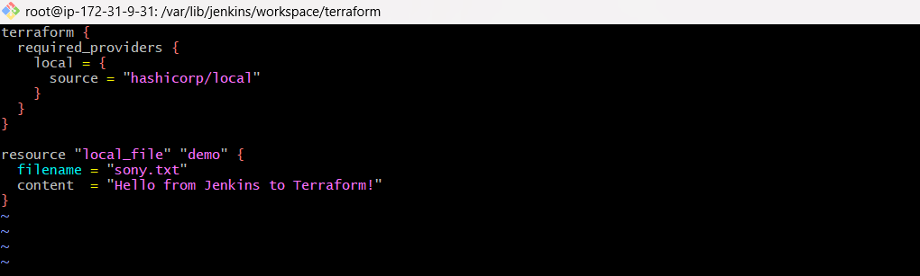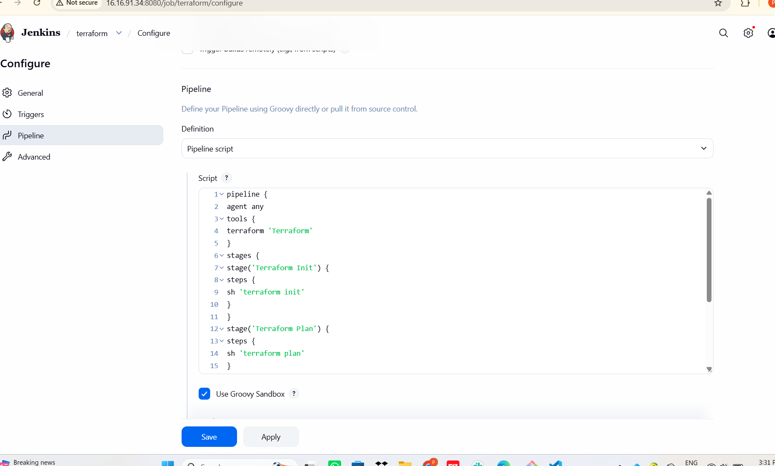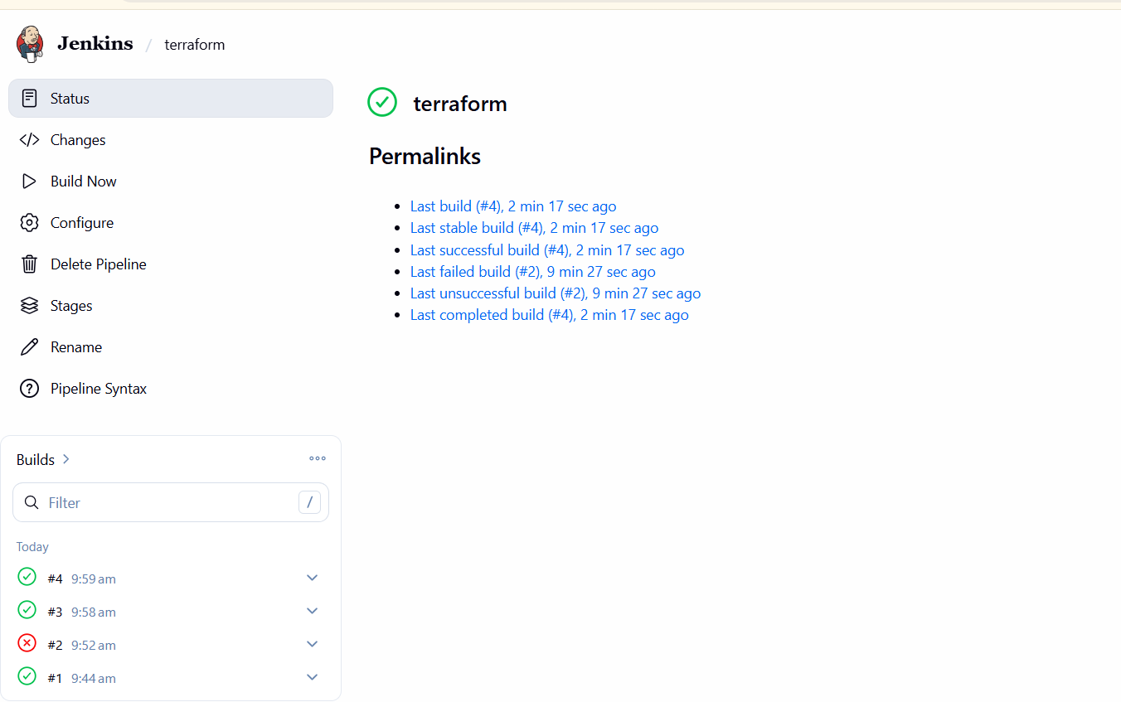
4). Create a CI/CD pipeline for a Nodejs Application: https://github.com/betawins/Trading-UI.git
Frist update package-->apt update
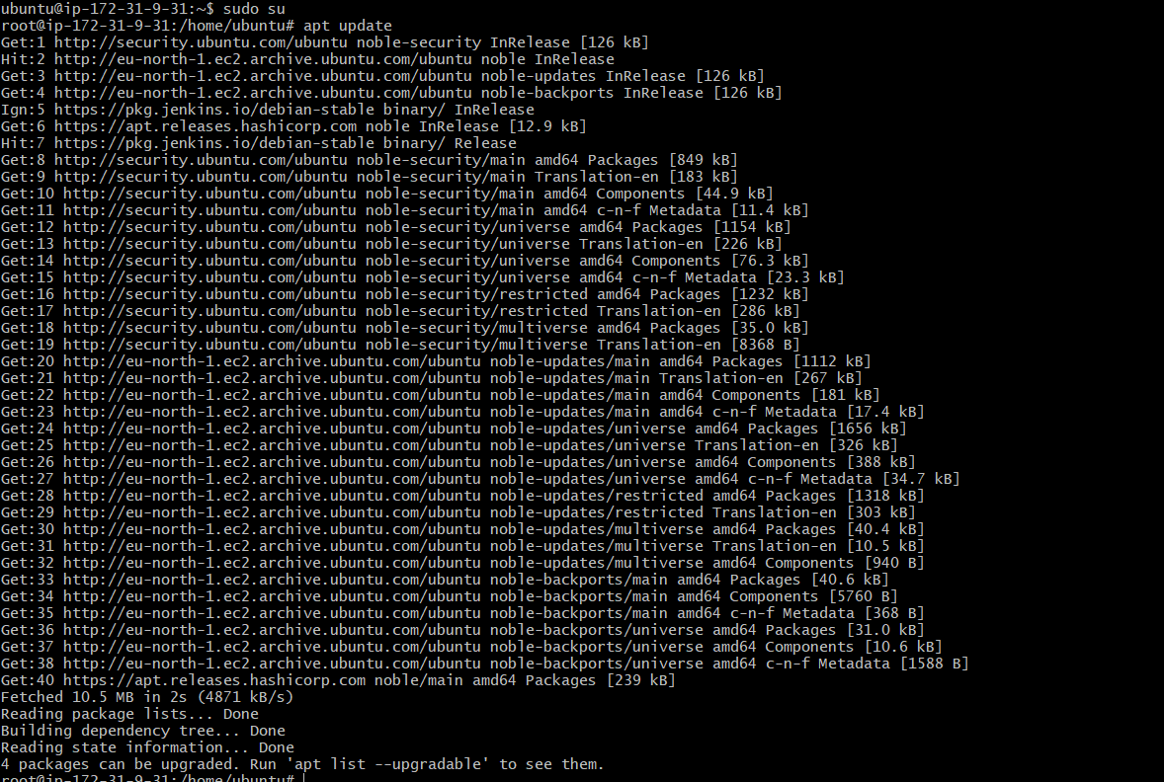
curl -fsSL https://deb.nodesource.com/setup_16.x | sudo -E bash -
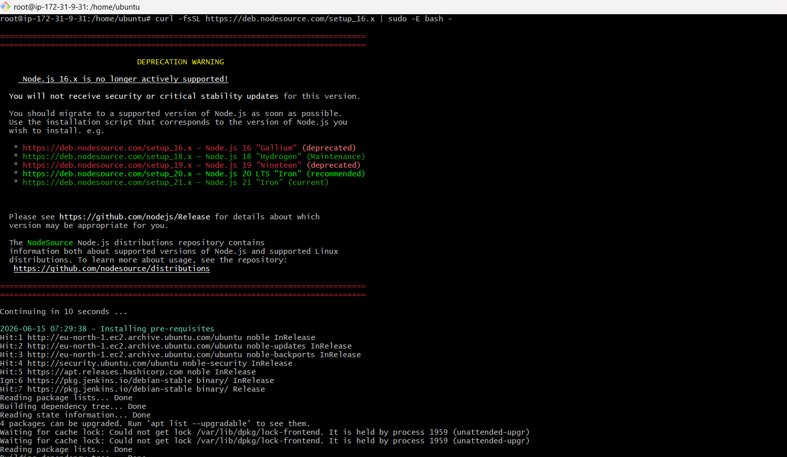
Apt install nodejs -y
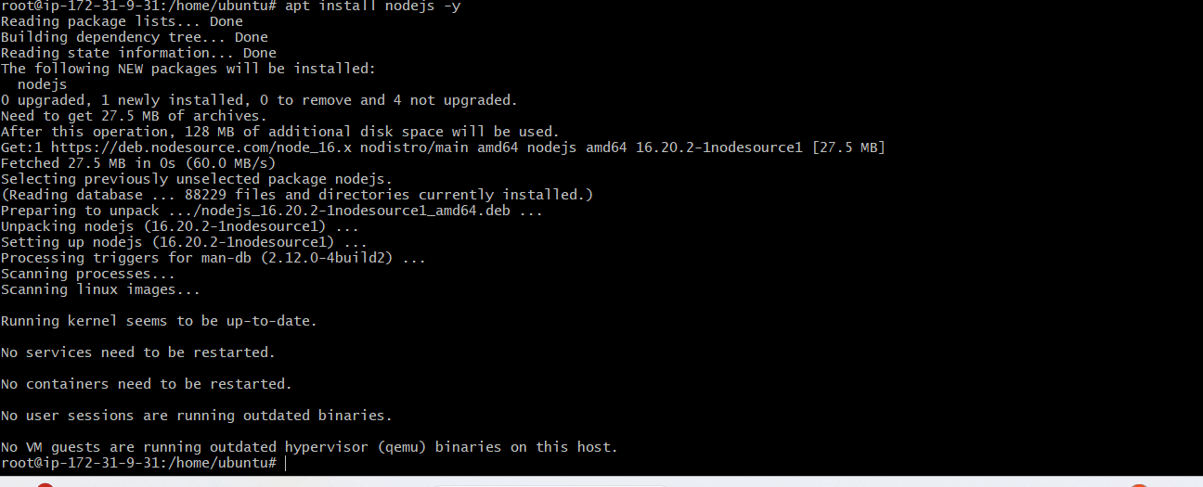
Lets create a pipeline
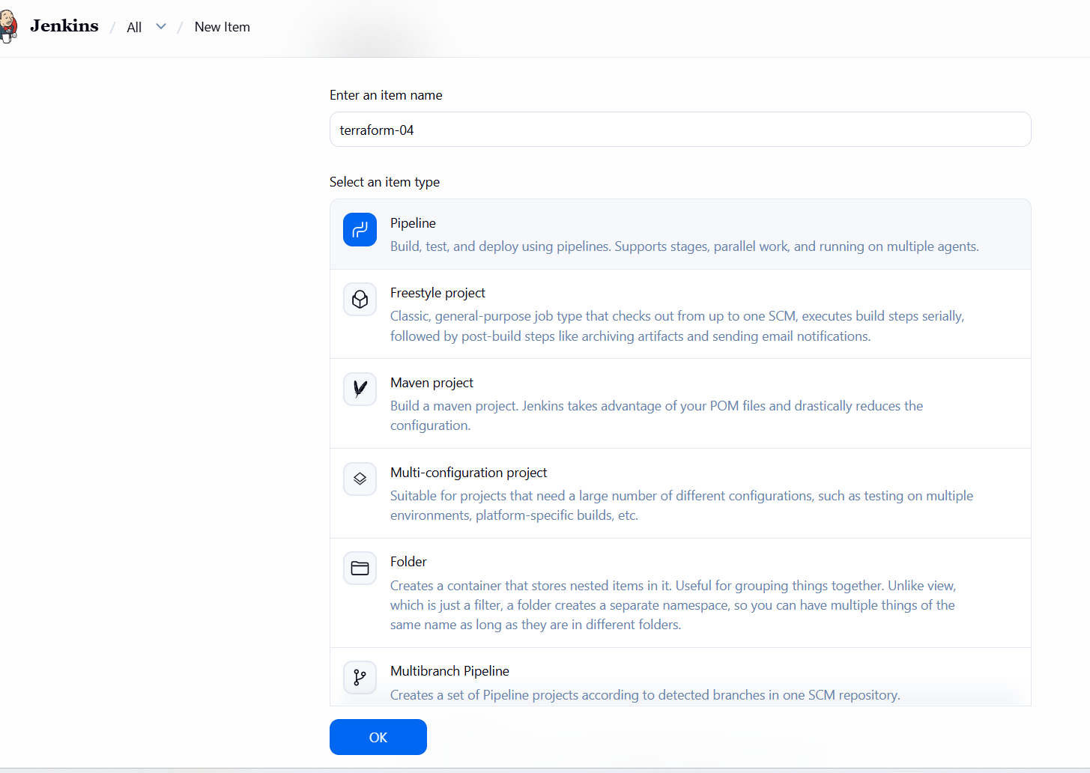
Write the pipeline script
pipeline {
agent any
environment {
CI = 'false'
}
stages {
stage('Git Clone') {
steps {
git branch: 'master',
url: 'https://github.com/betawins/Trading-UI.git'
}
}
stage('Install Dependencies') {
steps {
sh 'npm install'
}
}
stage('Build NodeJS App') {
steps {
sh 'npm run build'
}
}
}
}
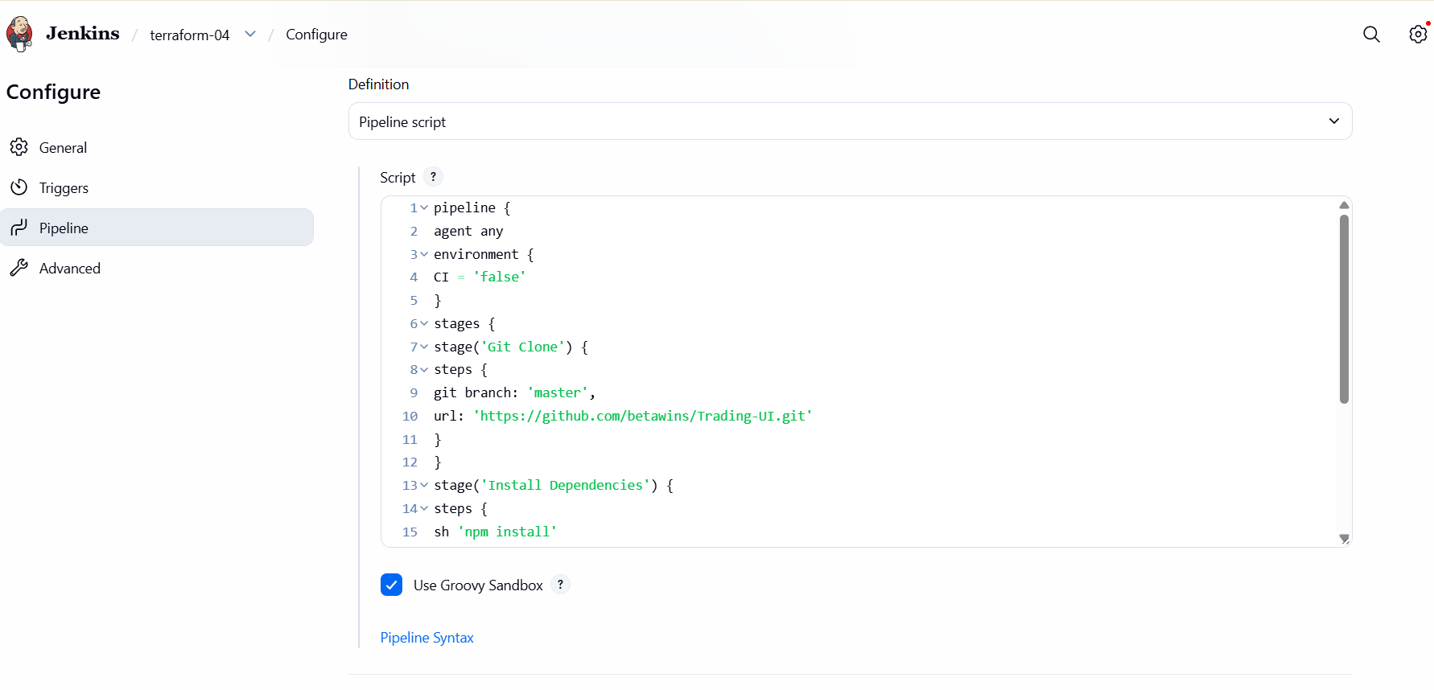
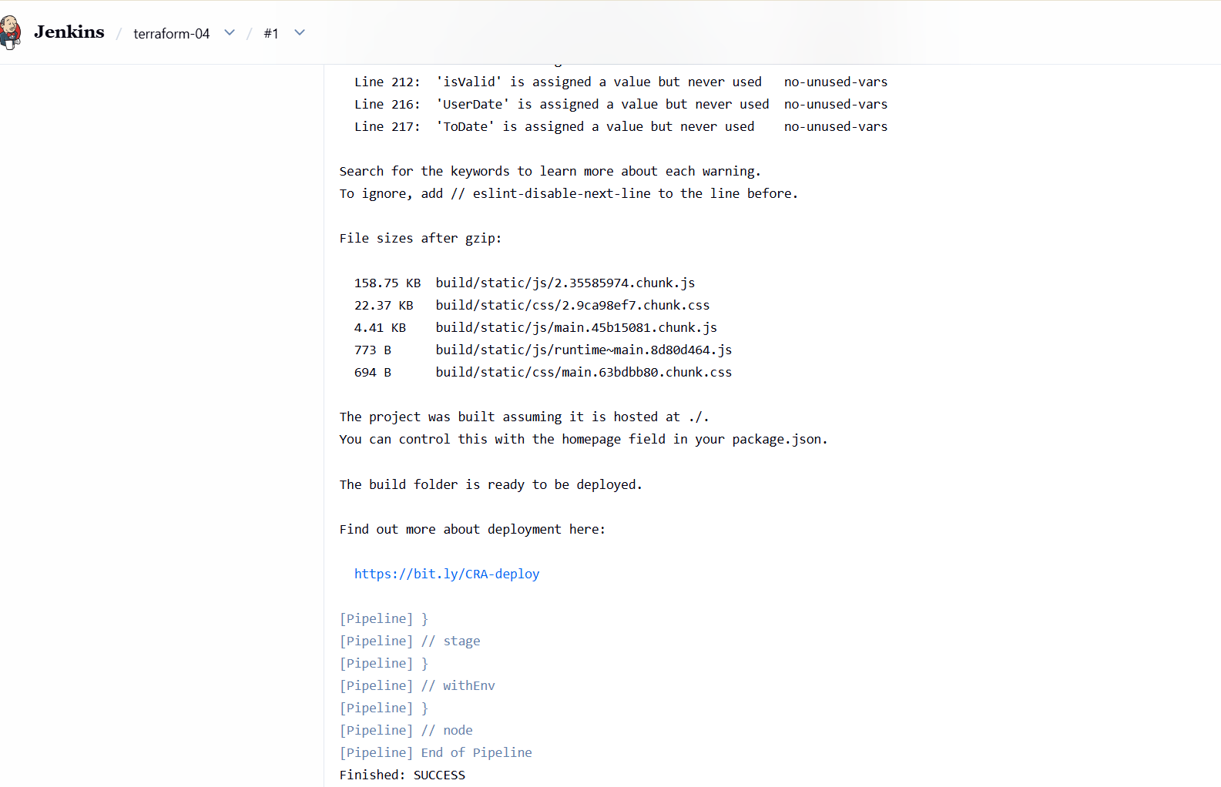
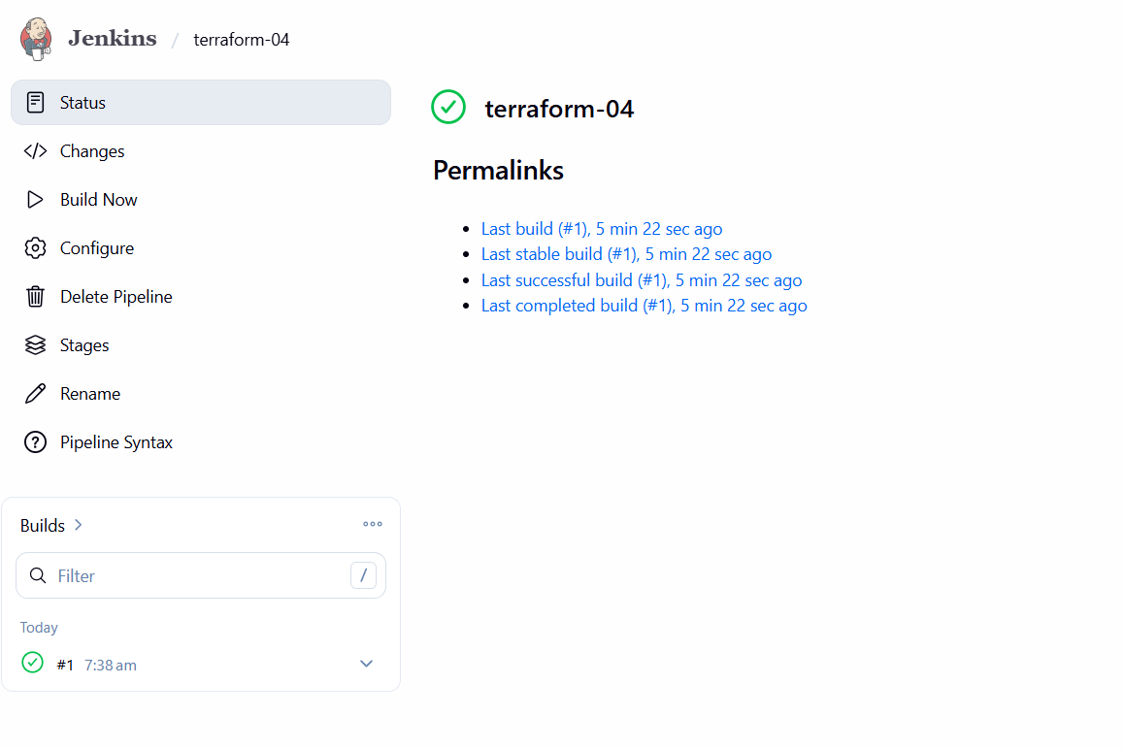
Lets verify the package
5). Explain 10 Maven commands.
Command | Description
mvn compile | Compiles the source code in the project.
mvn test | Runs the test cases written in the project.
mvn package | Compiles, tests, and creates a JAR/WAR file.
mvn install | Installs the packaged artifact into the local Maven repository (.m2).
mvn clean | Deletes the target directory and previous build files.
mvn validate | Validates the project structure and pom.xml.
mvn verify | Runs checks to verify the package is valid and meets quality criteria.
mvn deploy | Deploys the artifact to a remote repository such as Nexus or Artifactory.
mvn dependency:tree | Displays all project dependencies in a tree format.
mvn site | Generates project documentation and reports.

