Terraform-05
1). Watch the Terraform-05 video.
2). Execute the script shown in the video.
Lets create s3 bucket
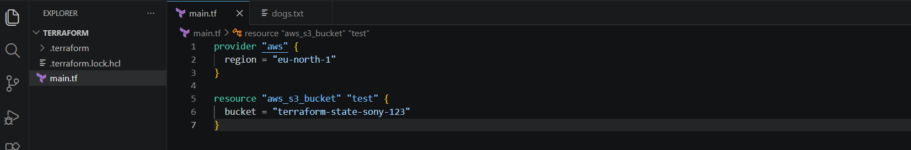
Terraform init
Terraform plan
Terraform apply
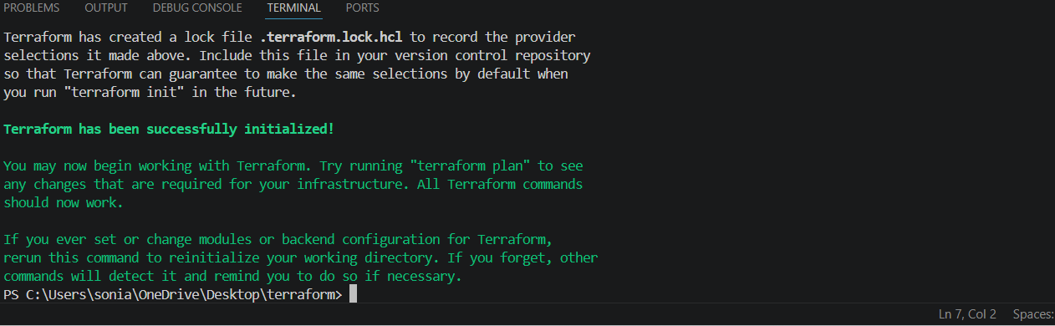
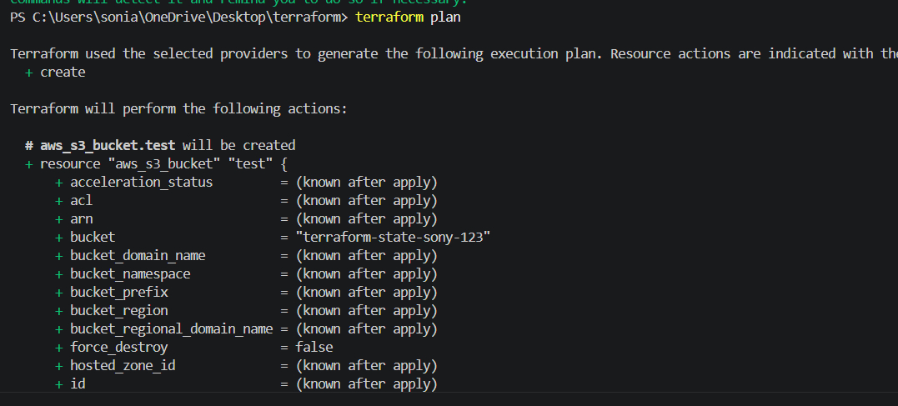
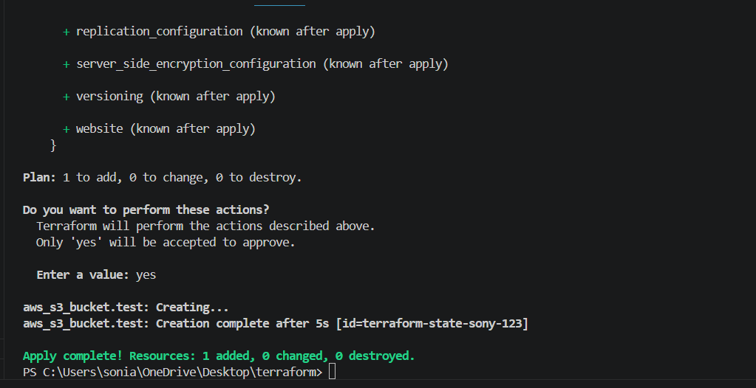
BUCKET WAS CREATED
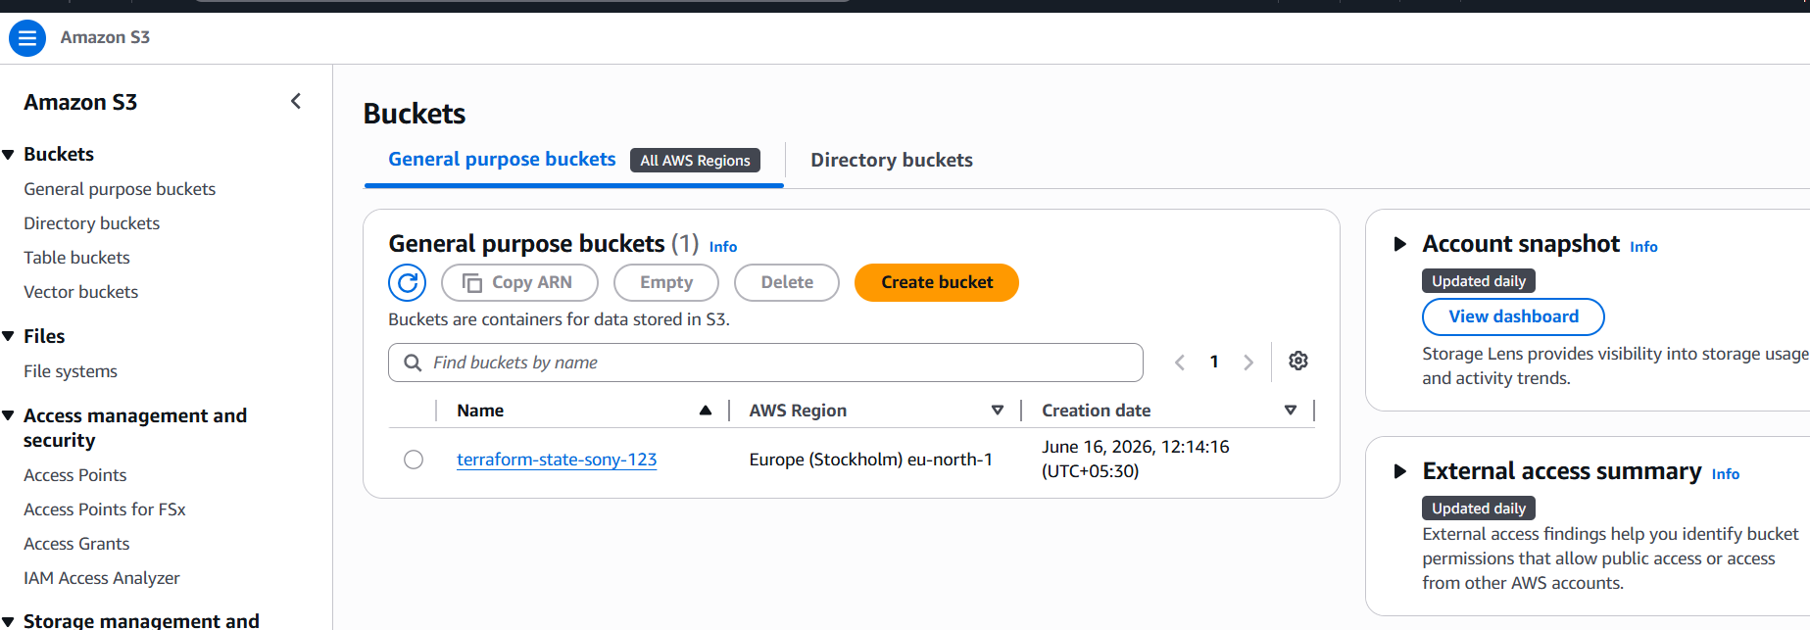
Provisioning
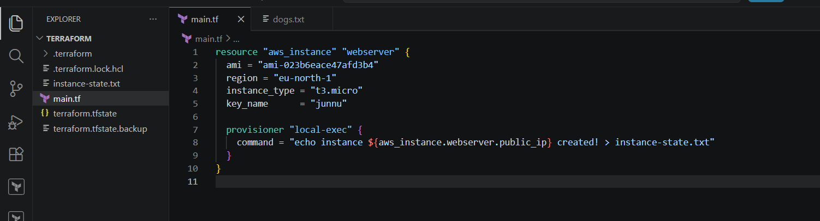
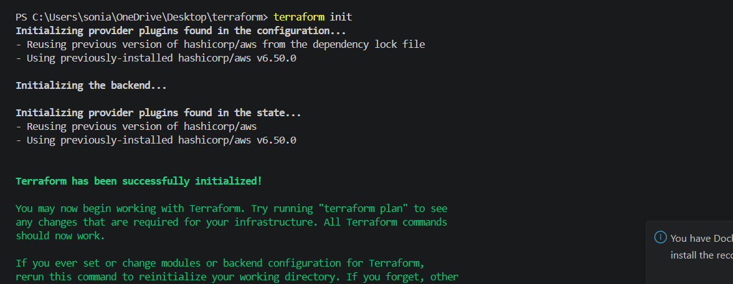
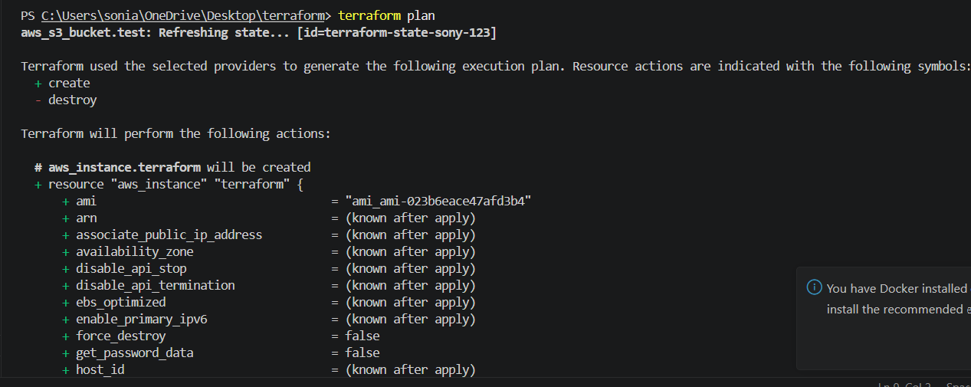
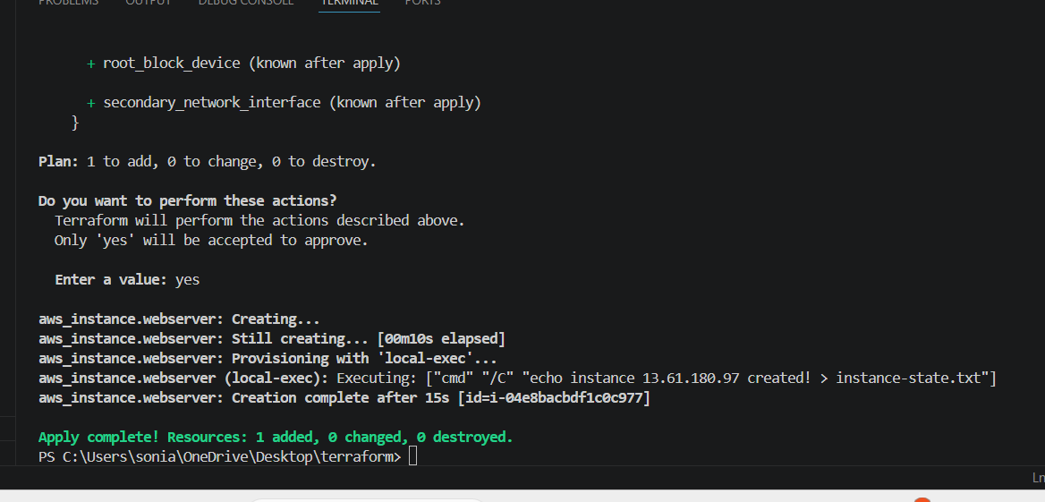
Instance state is created
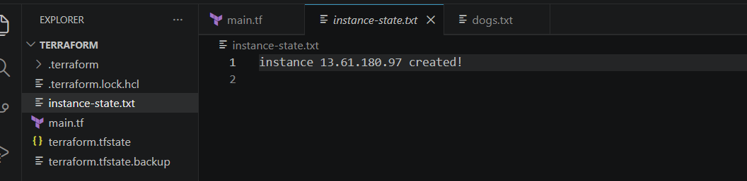
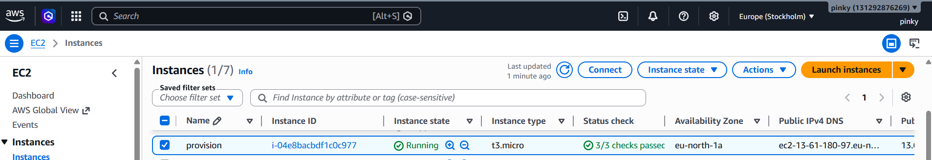
Statelock
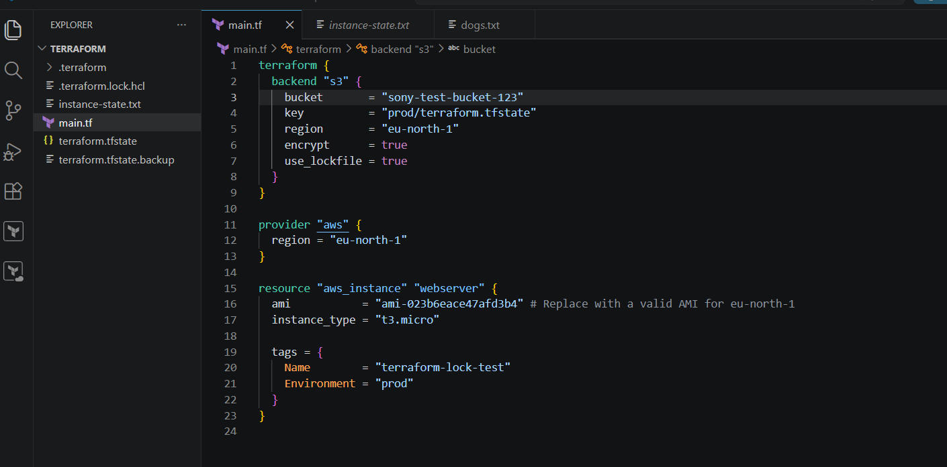
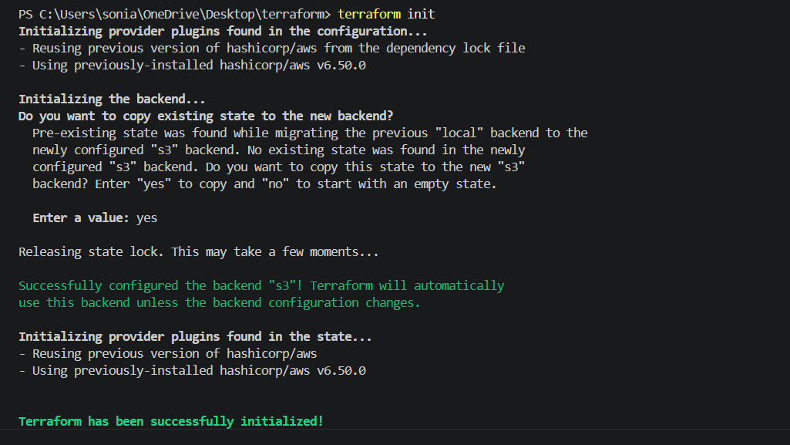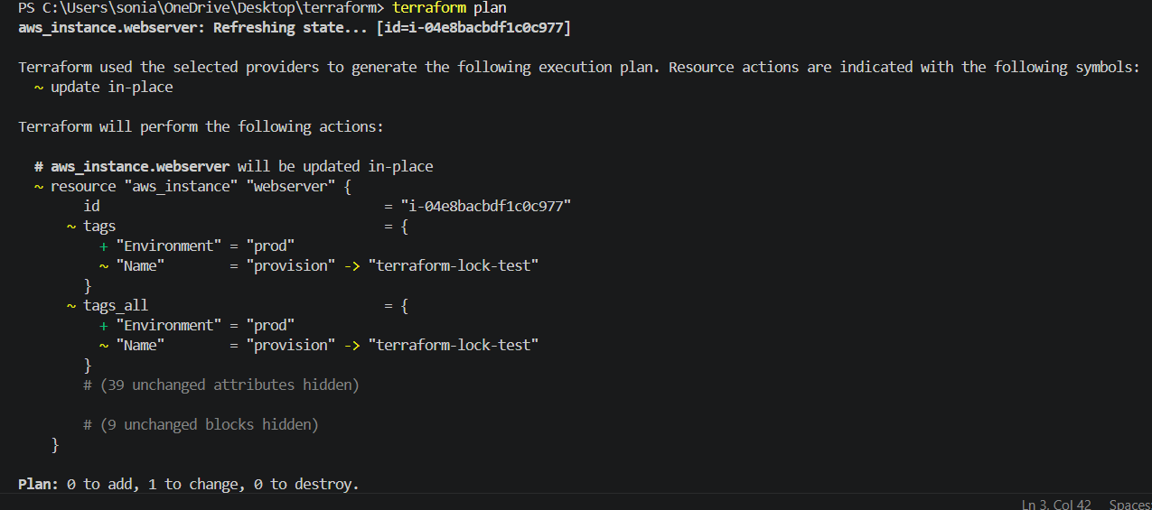
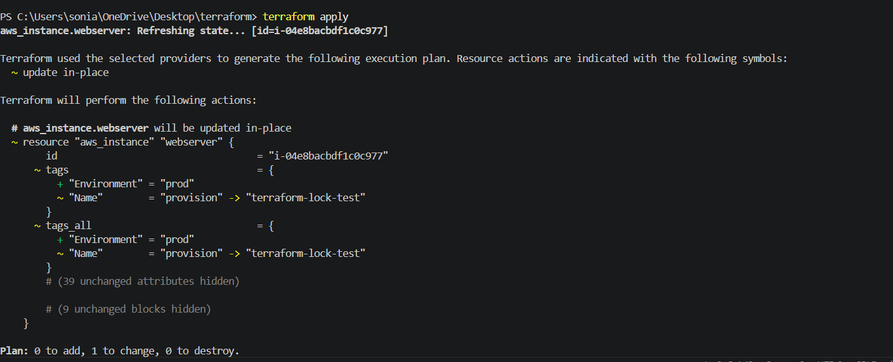

3). Create one EC2 instance with httpd installed using a Terraform script.
provider "aws" {
region = "eu-north-1"
}

data "aws_ami" "amazon_linux" {
most_recent = true

owners = ["amazon"]

filter {
name = "name"
values = ["al2023-ami-*"]
}
}

resource "aws_security_group" "web_sg" {
name = "web-sg"

ingress {
from_port = 80
to_port = 80
protocol = "tcp"
cidr_blocks = ["0.0.0.0/0"]
}

ingress {
from_port = 22
to_port = 22
protocol = "tcp"
cidr_blocks = ["0.0.0.0/0"]
}

egress {
from_port = 0
to_port = 0
protocol = "-1"
cidr_blocks = ["0.0.0.0/0"]
}
}

resource "aws_instance" "webserver" {
ami = data.aws_ami.amazon_linux.id
instance_type = "t3.micro"
key_name = "monikaroyal"
vpc_security_group_ids = [aws_security_group.web_sg.id]

user_data = <<-EOF
#!/bin/bash
dnf update -y
dnf install -y httpd

systemctl start httpd
systemctl enable httpd

echo "<h1>Terraform Web Server</h1>" > /var/www/html/index.html
EOF

tags = {
Name = "Terraform-WebServer"
Environment = "prod"
}
}

output "public_ip" {
value = aws_instance.webserver.public_ip
}
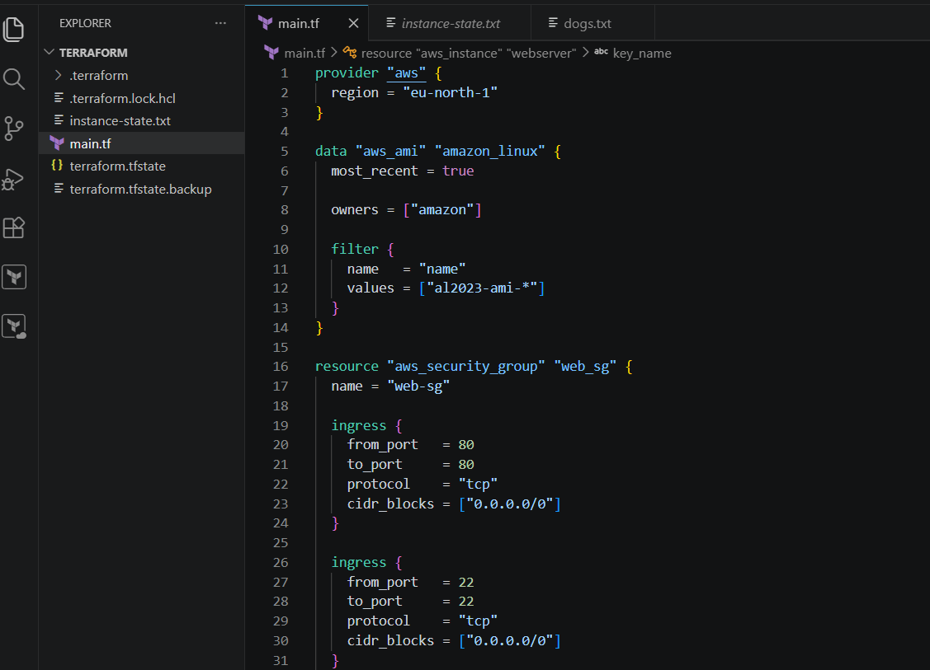
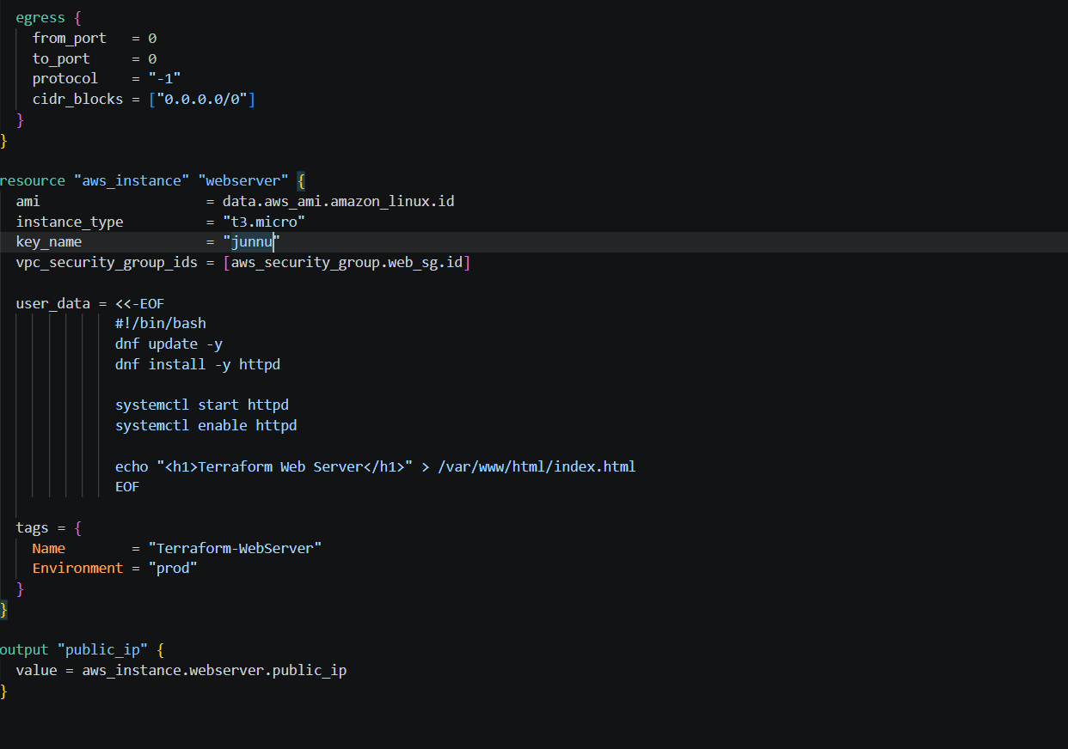
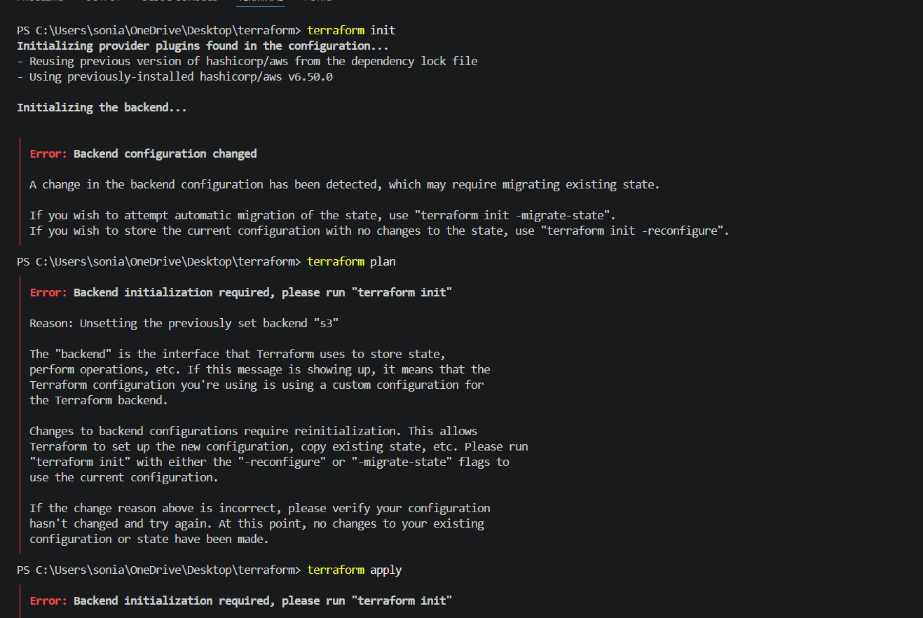
Issue 1: Backend Configuration Changed
Cause:
Previously configured Terraform with an S3 backend and later removed or modified the backend configuration.
--> terraform init -reconfigure
If the issue persisted:
Remove-Item -Recurse -Force .terraform
Remove-Item .terraform.lock.hcl
terraform init -reconfigure
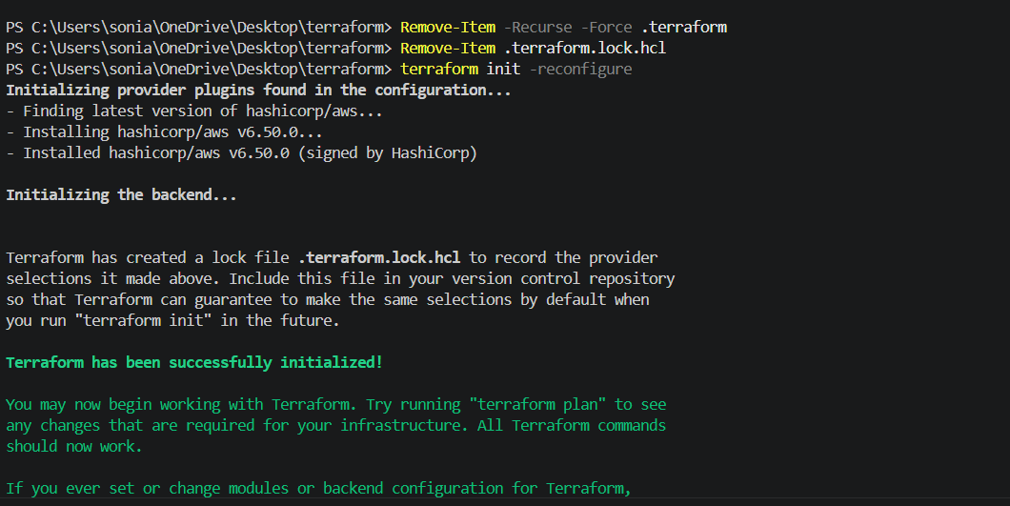
Terraform plan
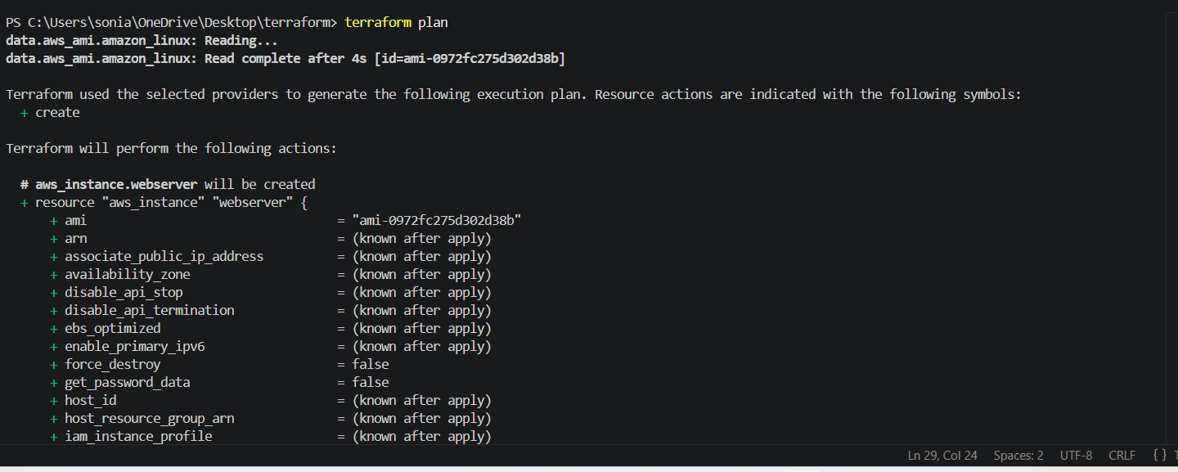
Terraform apply
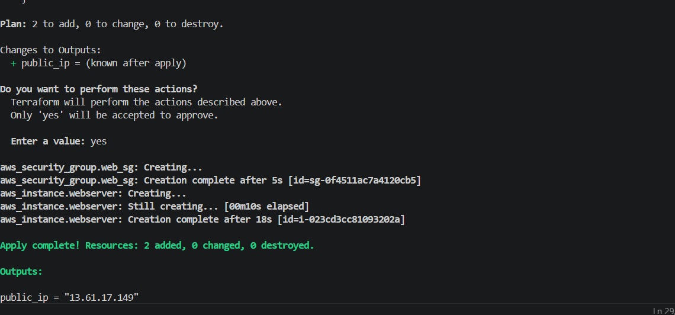
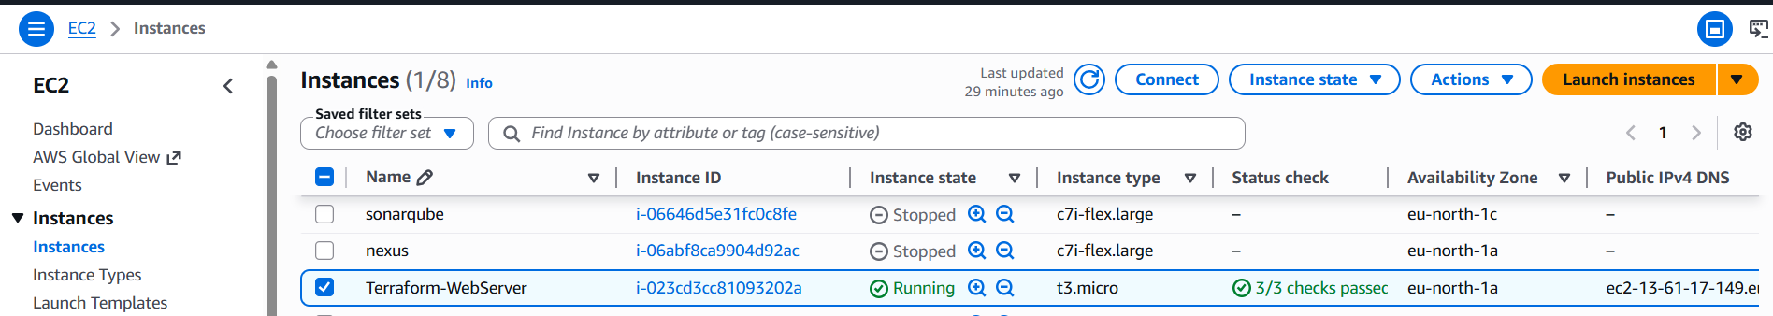
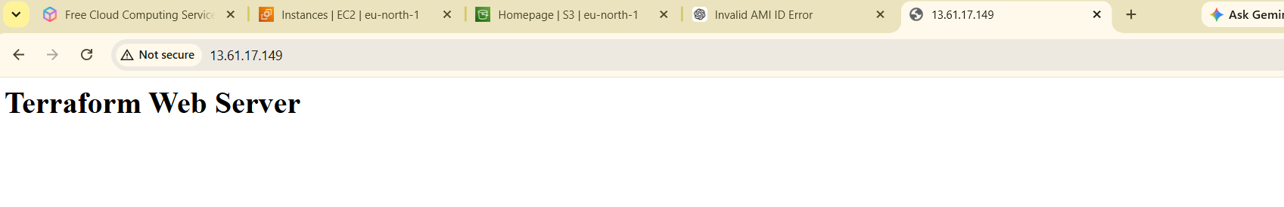
4). Set up S3 as backend for task 3.
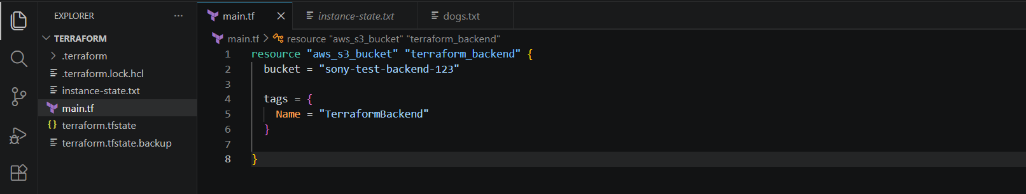
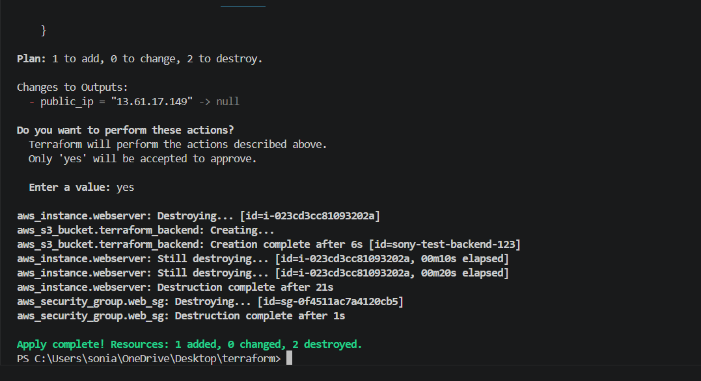
Bucket is created
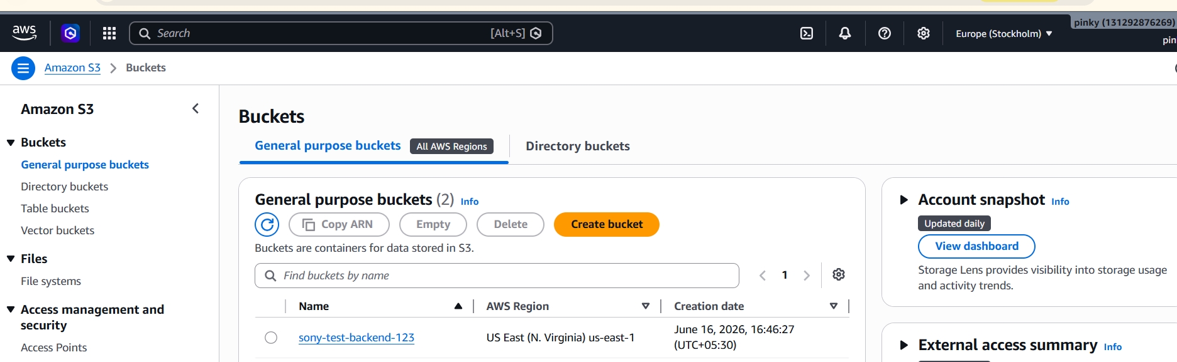
Now created a new file backend.tf
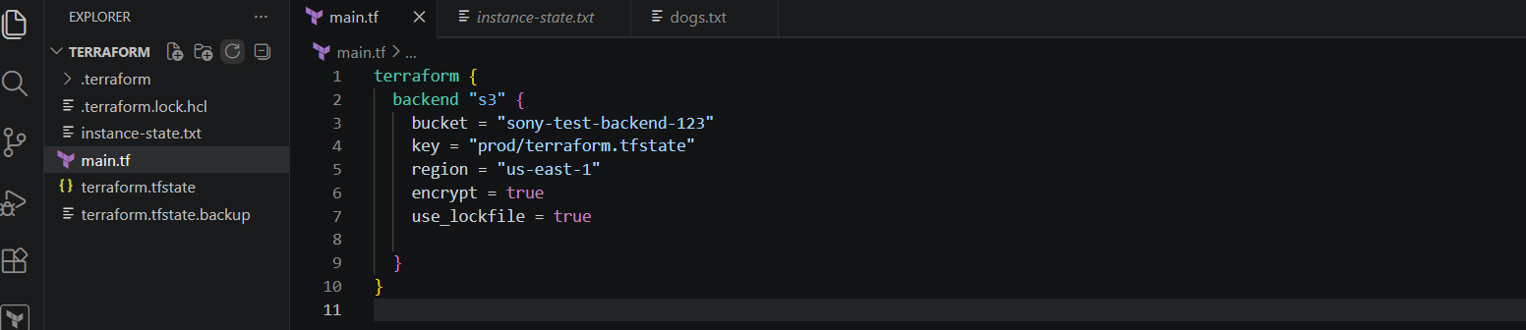
After applying the terraform I got error

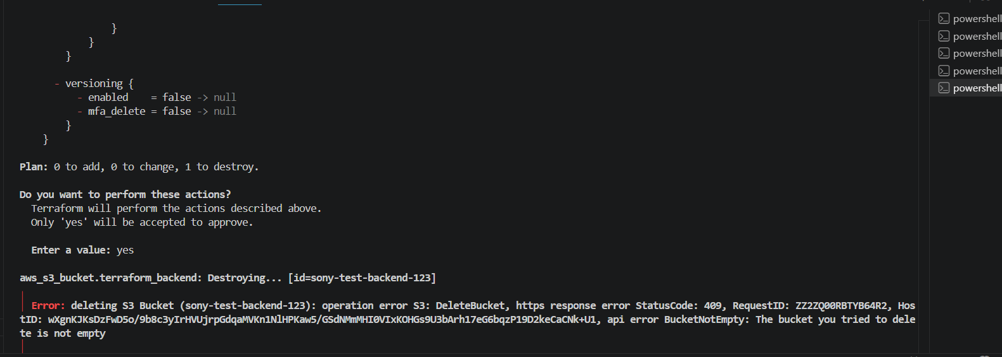
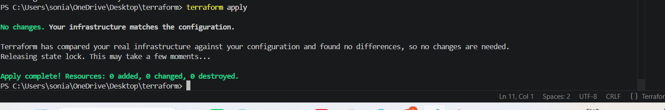
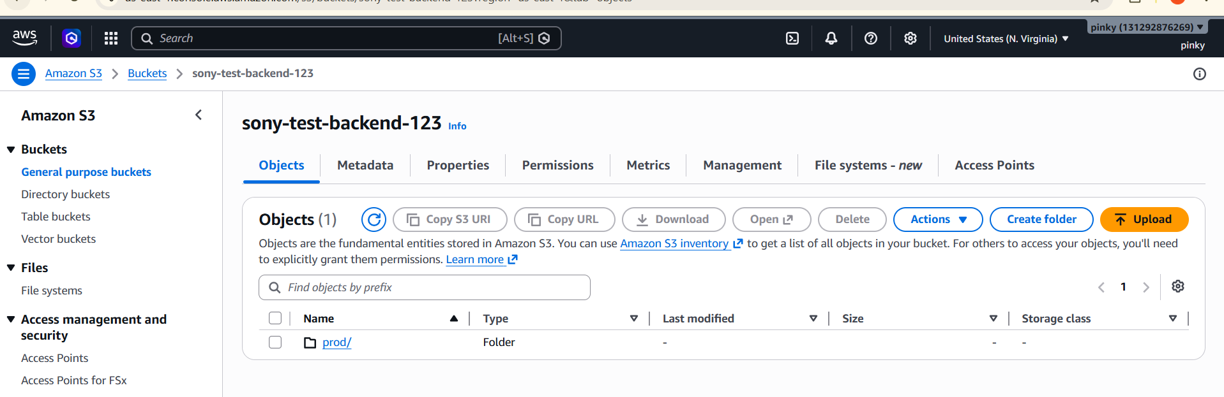
5). Set up DynamoDB locking for task 3.
Create DynamoDB file and written script
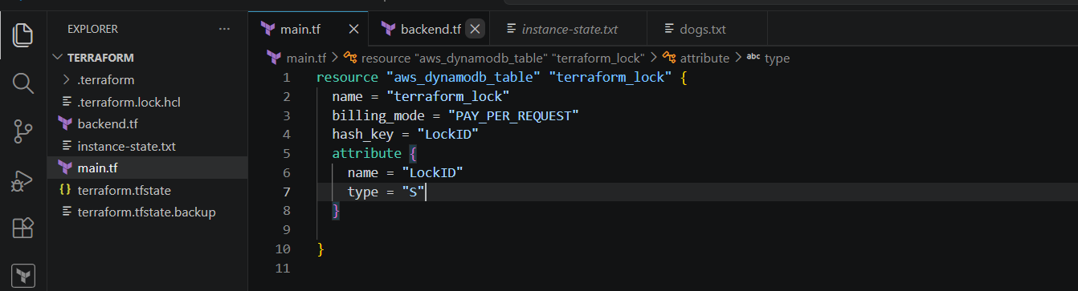
Create one backend file--> and also written backend.tf file for terraform.tf state
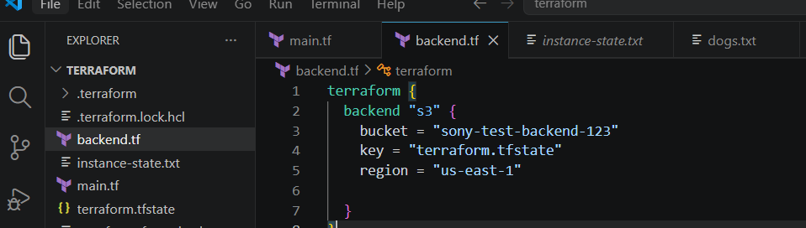
Now terraform init --reconfigure
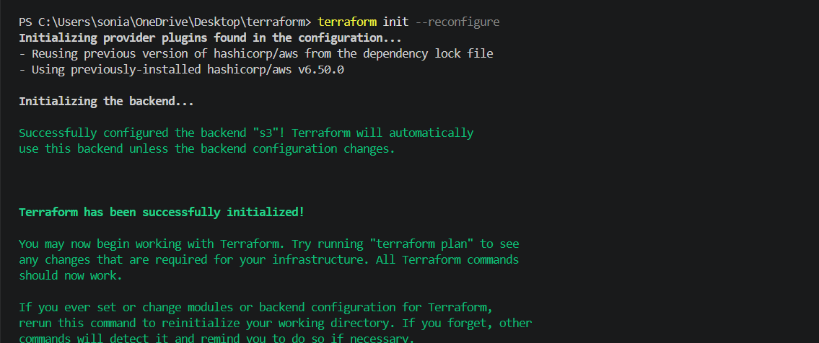
Terraform plan
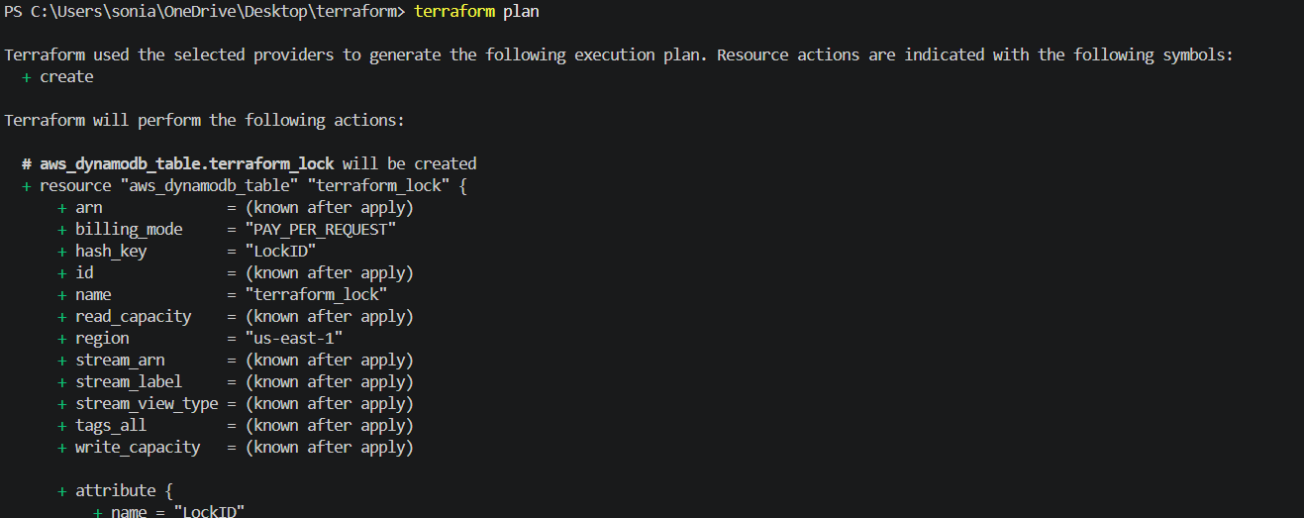
Terraform apply
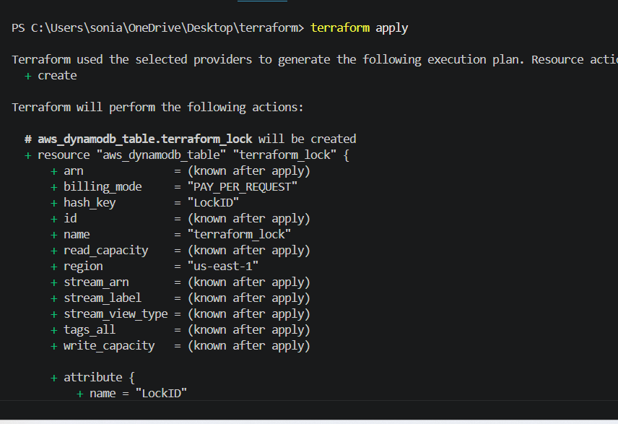
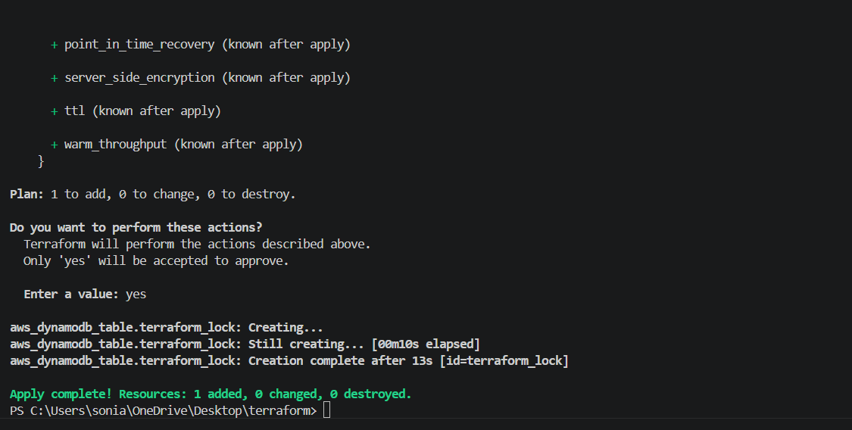
Now check in dynamodb table is created
