Jenkins-02
- Configure 2 slave machines in the Jenkins master.
Launched three EC2 instances:
jenkins-master
slave-01
slave-02

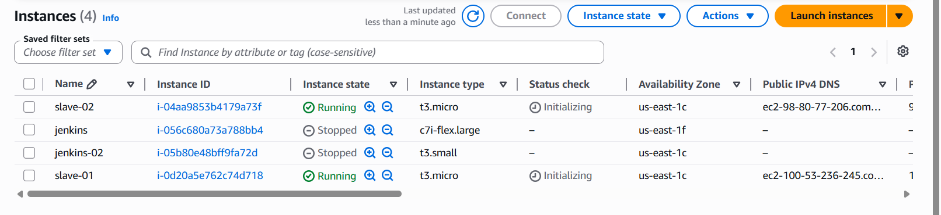
Slave-01 salve-02 OS Configuration
Logged in to slave-01,salve-02 as root.
Installed Java both instance:
yum install java-21-amazon-corretto -y
Verified Java installation completed.
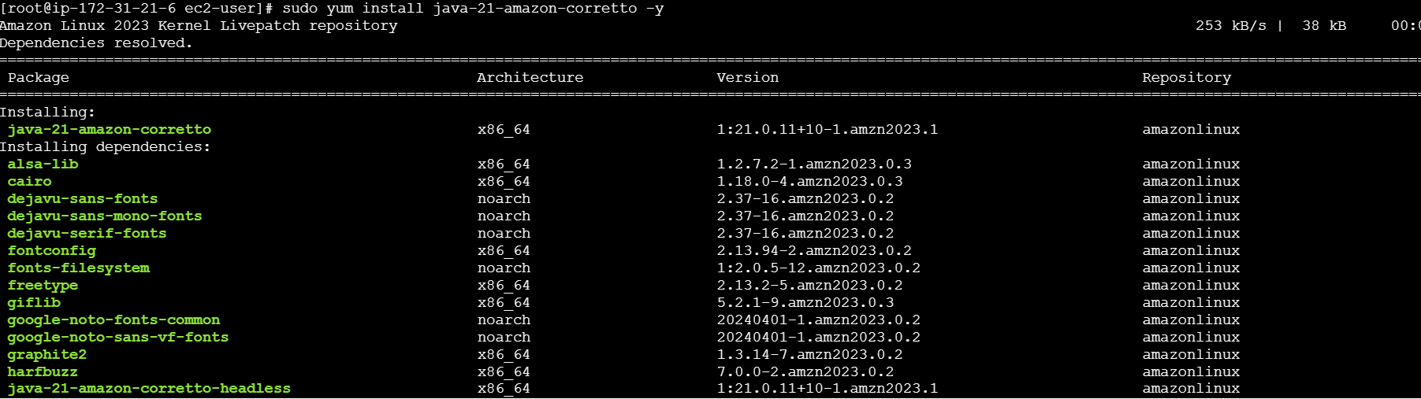
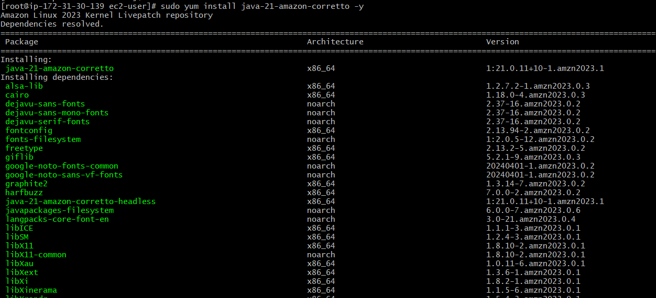

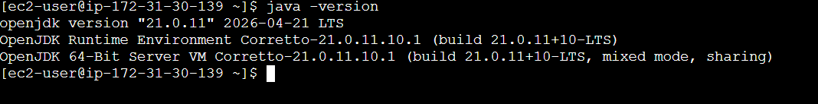
SSH Configuration on Slave-01 ,salve
Generated SSH key pair:
ssh-keygen
Navigated to SSH directory:
cd ~/.ssh
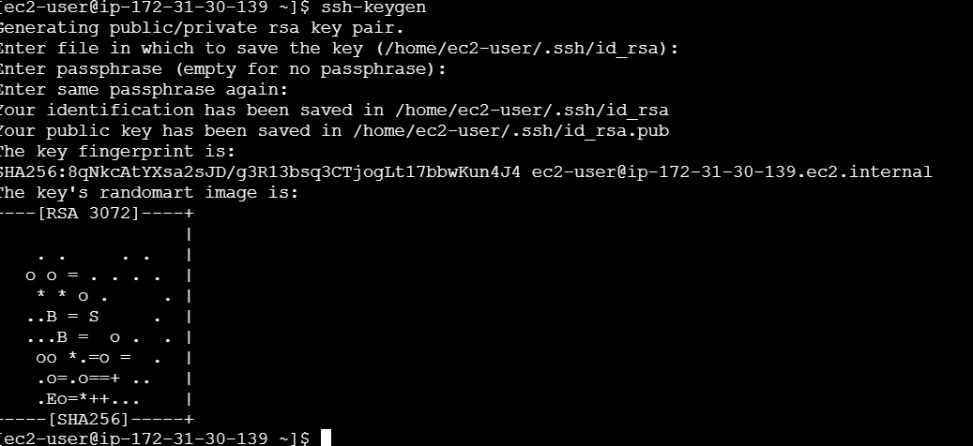
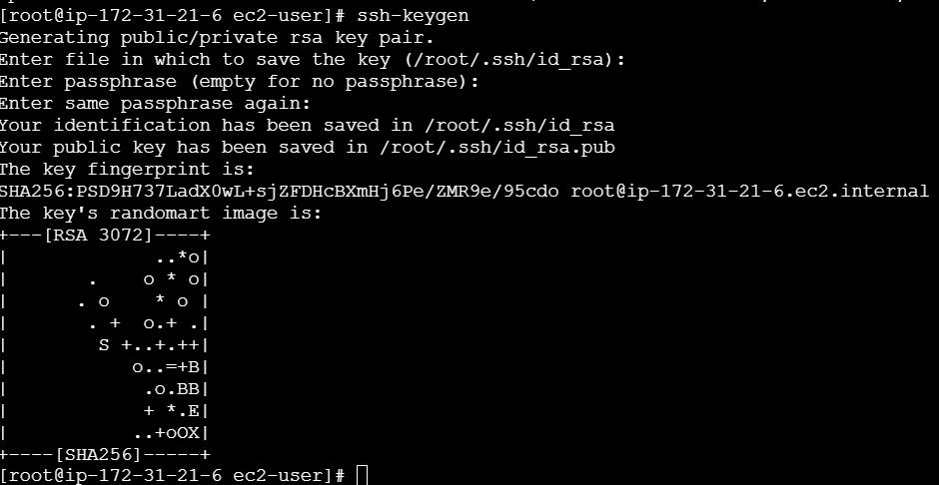
Added public key to authorized keys:
cat id_rsa.pub >> authorized_keys
Fixed permissions:
chmod 700 authorized_keys

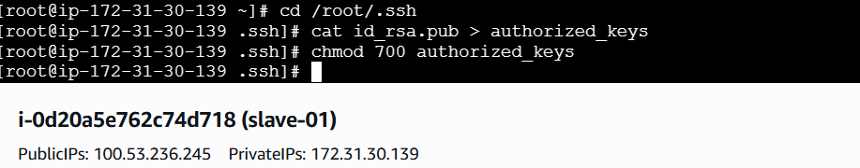
Go to Jenkins Master SSH Trust
Logged in to jenkins-master.
Create one directory path
Added slave host key:
ssh-keyscan -H 13.61.10.105 >> /var/lib/jenkins/.ssh/known_hosts
Set correct permissions:
chown jenkins:jenkins known_host
Chmod 700 known_host
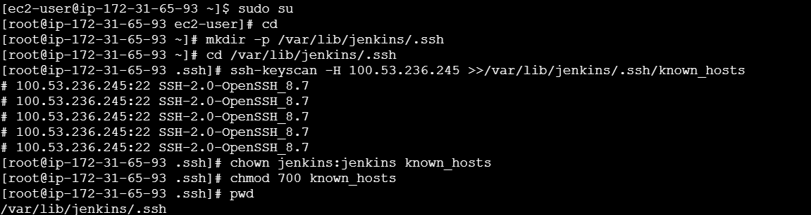
Go to Opened Jenkins dashboard.
Navigated to Manage Jenkins → Nodes.
Clicked New Node.
Entered node name: slave-01.
Selected Permanent Agent and created the node
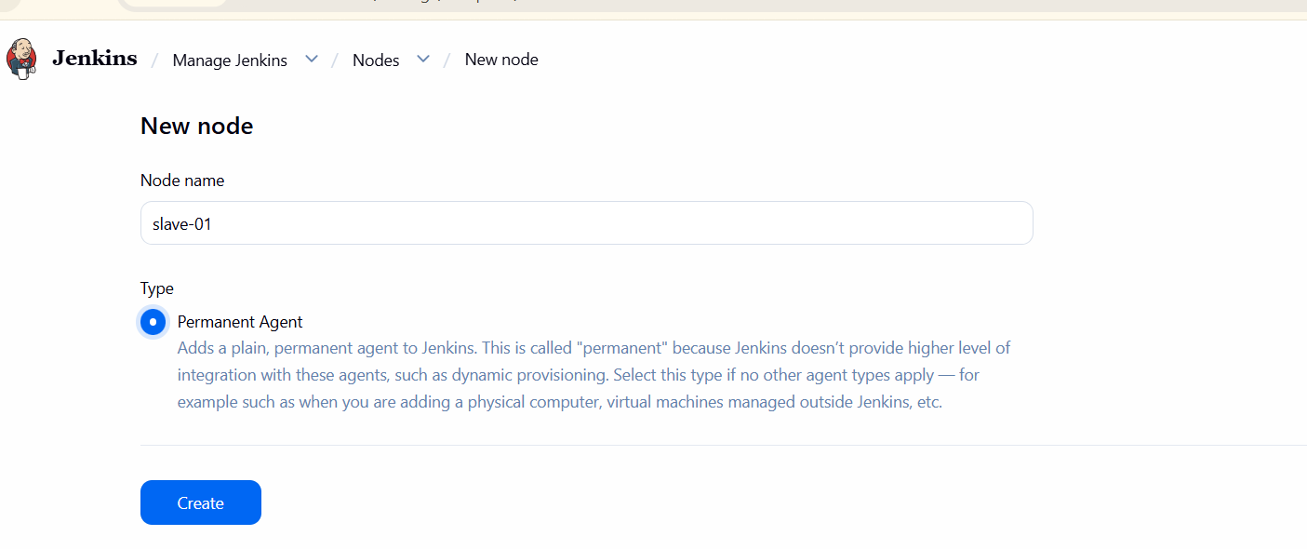
Node Configuration (slave-01):
Set Number of executors to 2.
Give the remote root directory-->lable-->launch method-->ssh-->give host --> host means slave-01 id address-->give the cridential-->node properties-->save

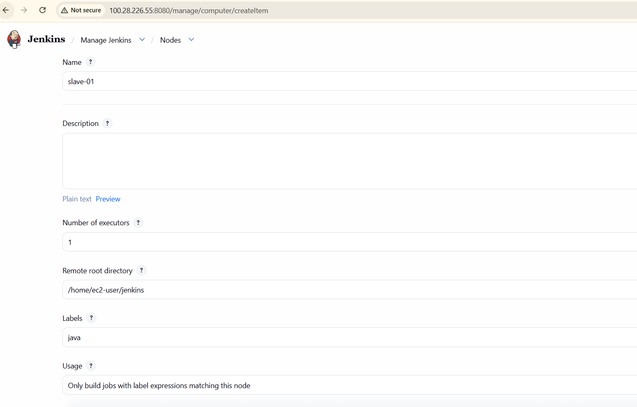
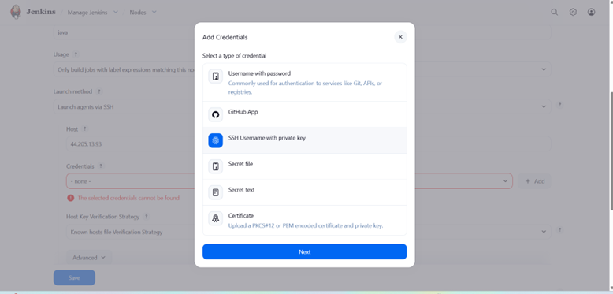
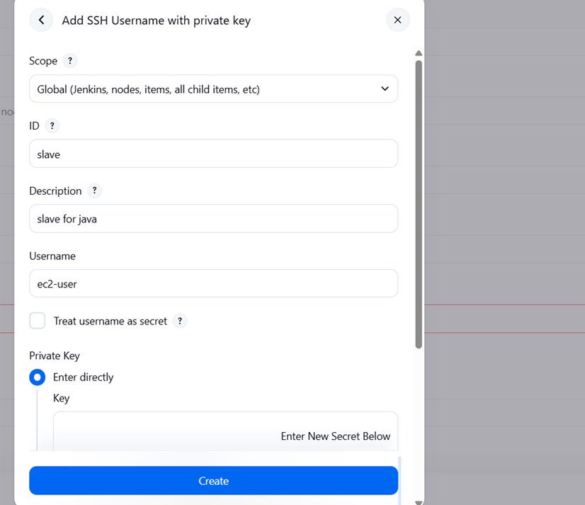
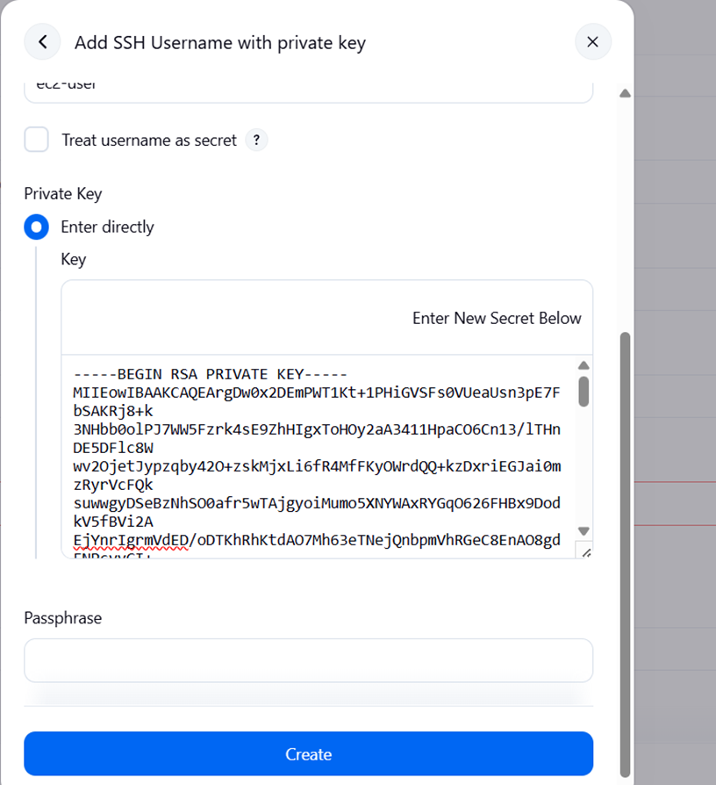
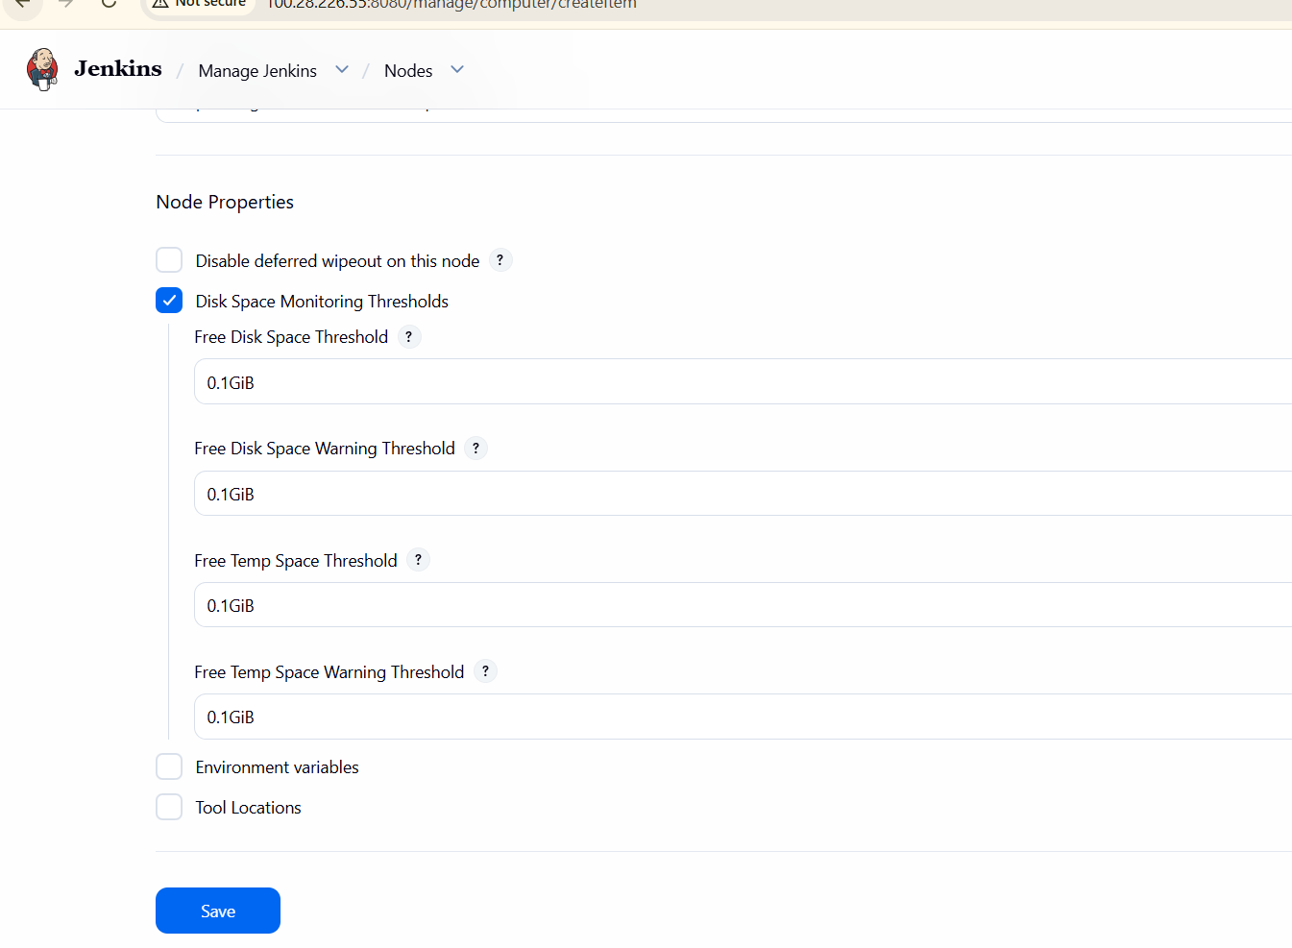
We have created a node
Then go to jankins dash board create a new item--> give item name --> select freestyle project--> ok
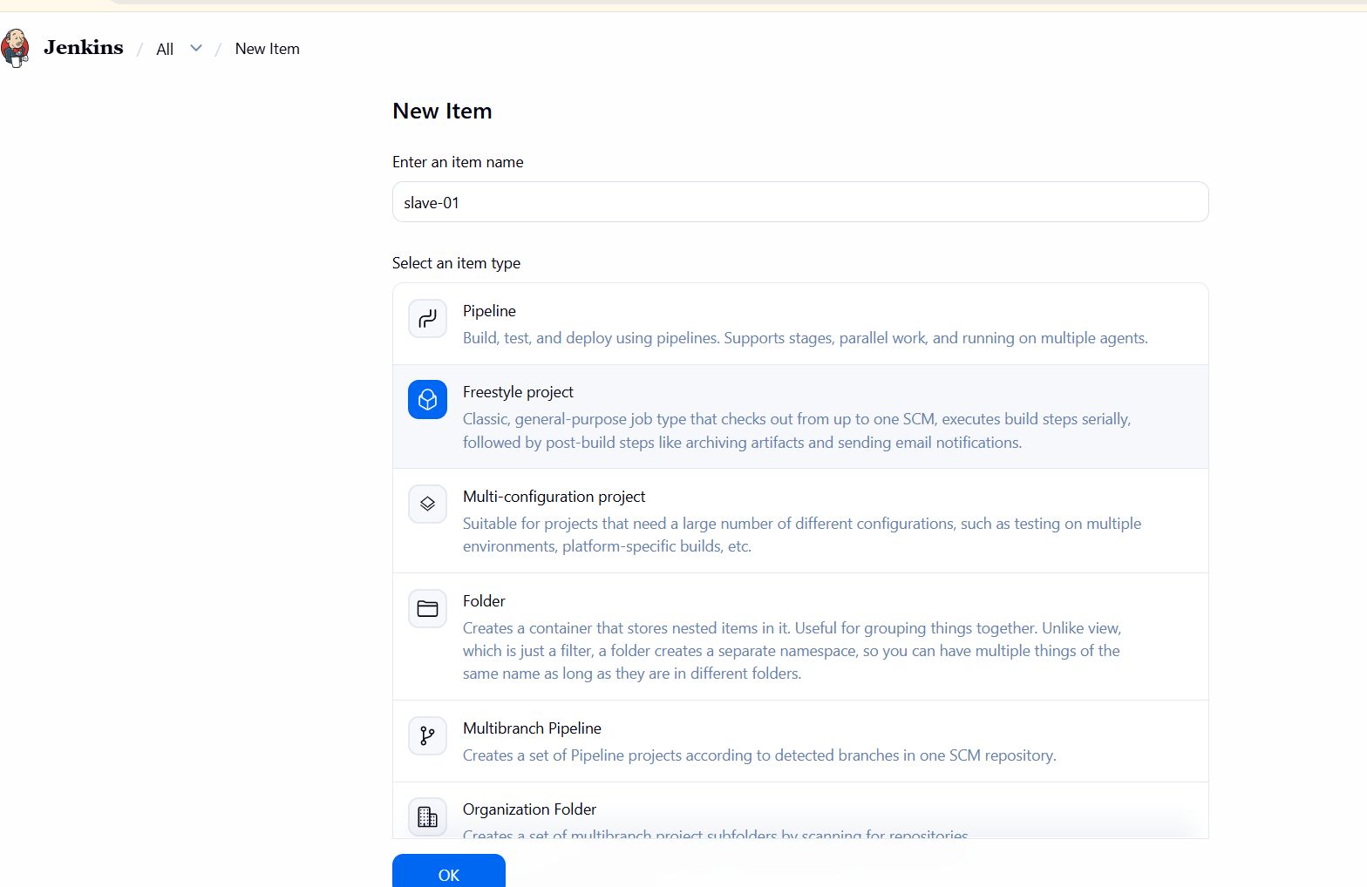

Job Creation & Execution
Clicked New Item.
Entered job name: first_job.
Selected Freestyle project.
Enabled Restrict where this project can be run.
Entered label:
java
Configured Source Code Management → Git.
Entered repository URL:
https://github.com/betawins/Techie_horizon_Login_app.git
Saved the job configuration.
Ran the job.
Verified build executed remotely on slave-01.
Confirmed Git clone successful.
Build finished with SUCCESS.

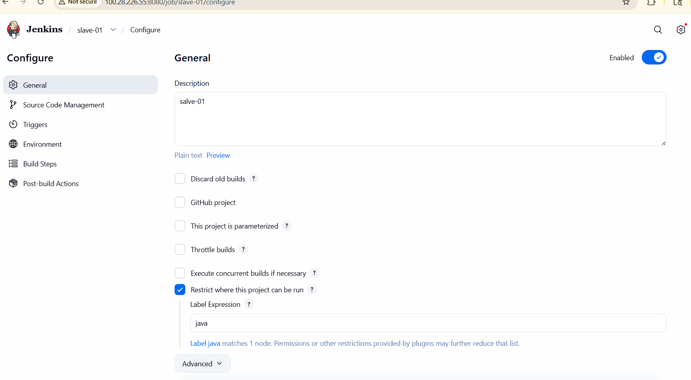

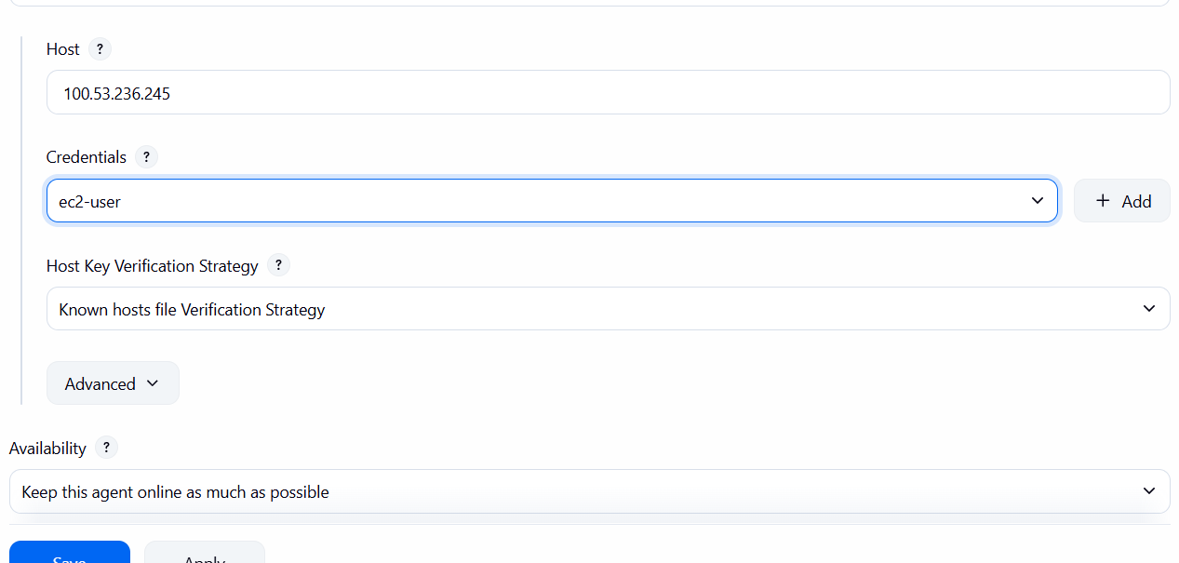
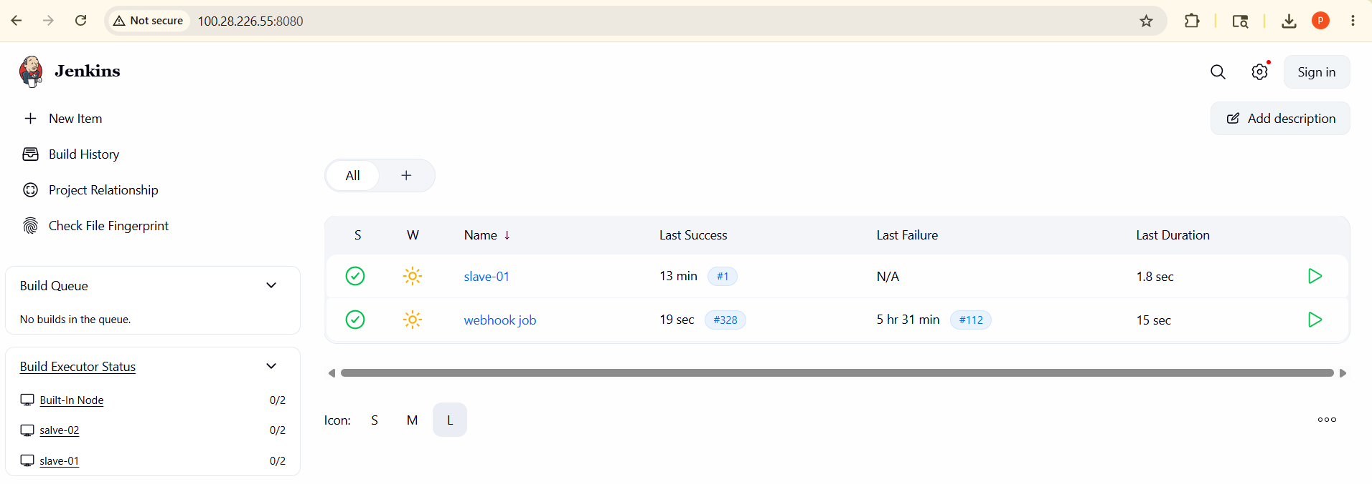
Final Node Verification
Navigated to Manage Jenkins → Nodes.
Verified:
Built-in node → online
slave-01 → online with disk & response metrics visible
Slave-02 Configuration:
Repeated the same configuration steps (Java install, SSH setup, workspace creation, Jenkins node setup) for slave-02.
Added slave-02 successfully to Jenkins.
Verified both slave-01 and slave-02 are online and available for builds
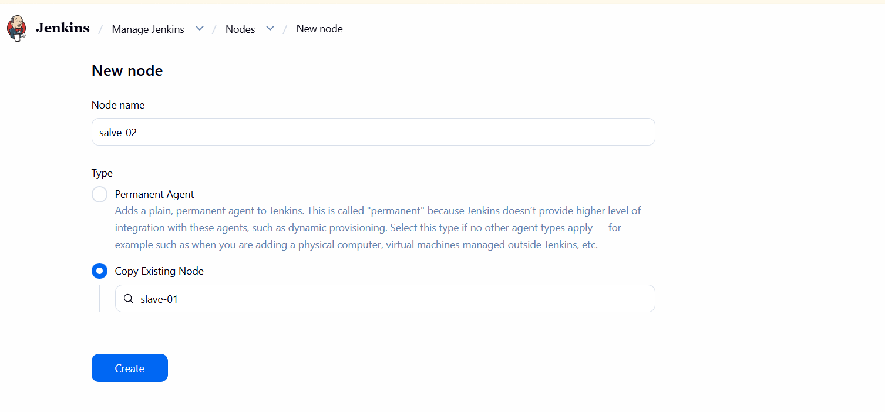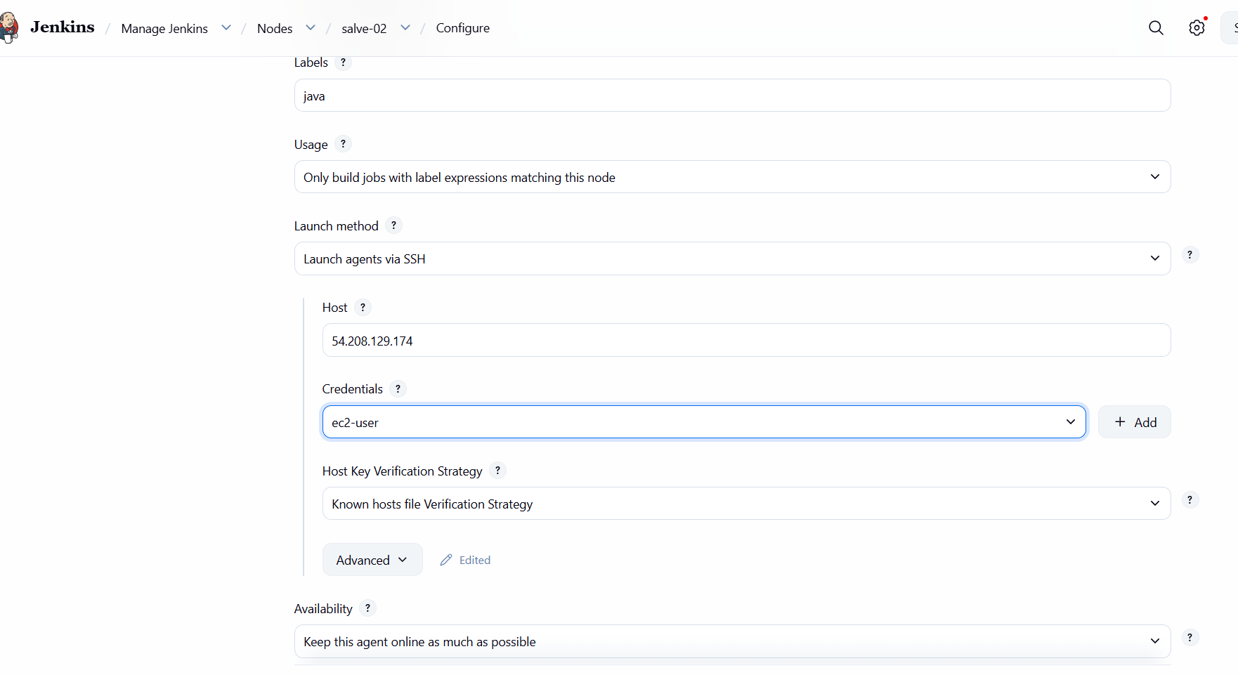
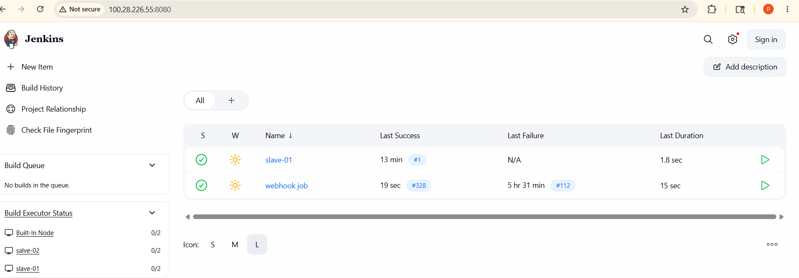
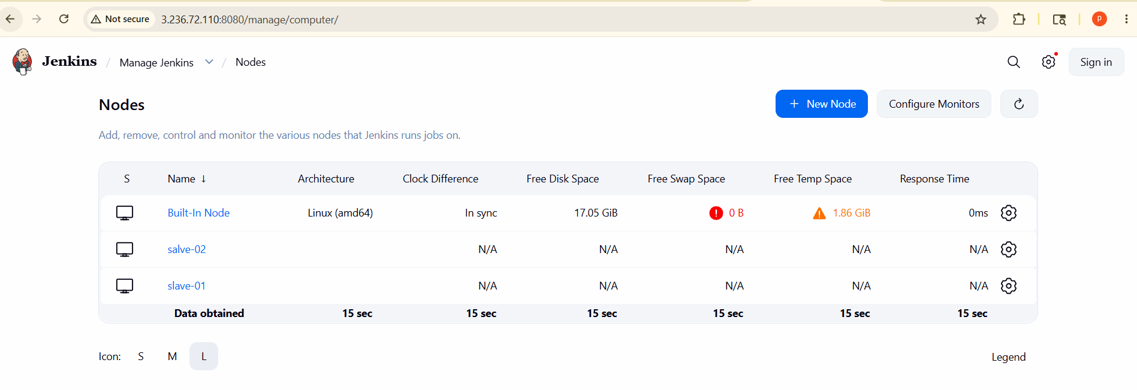

- Configure webhooks to the Jenkins job.
First go to Jenkins create jobnew itemselect freestyle project ok
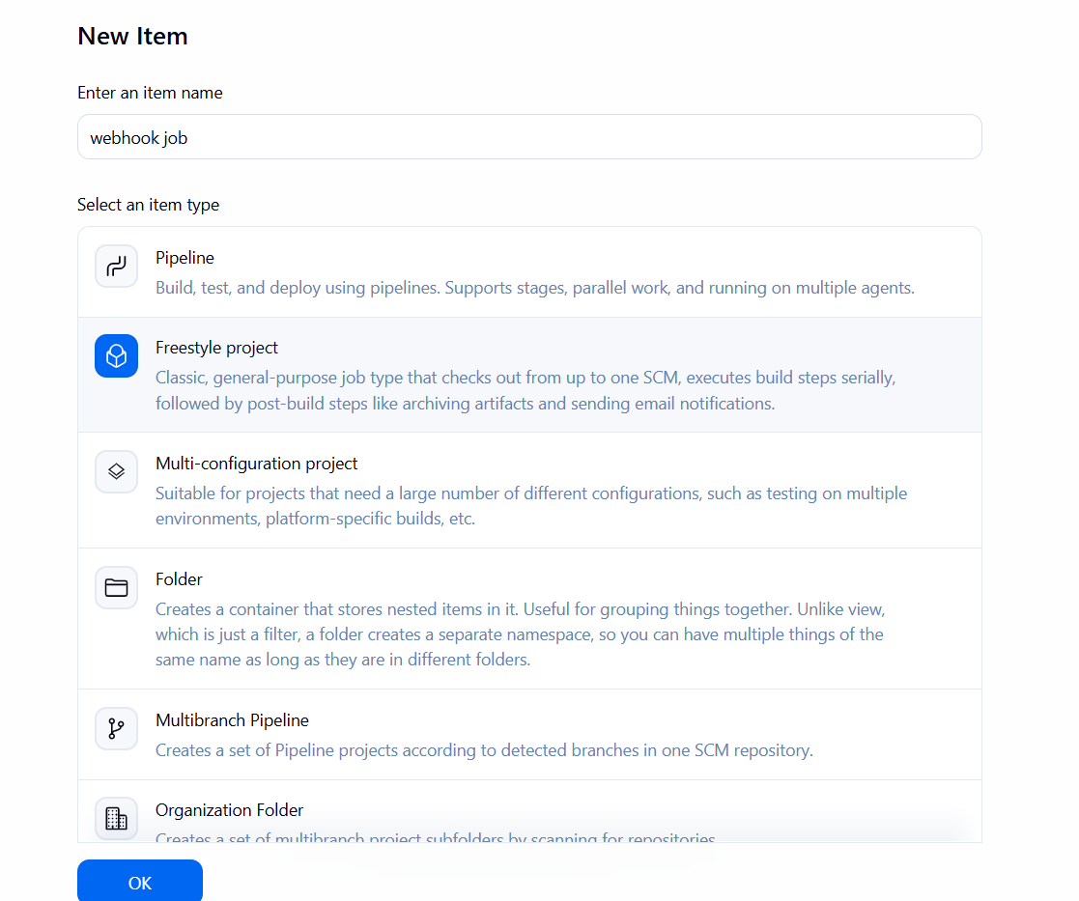
General descriptionsource code managementgive git repository URL
Where ever we have stored our source code github give that URL
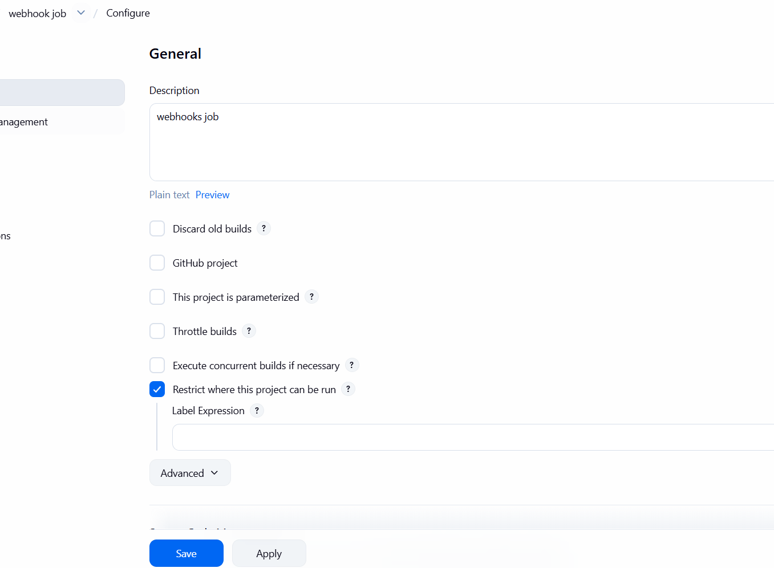
Then select credentialscheck the branch
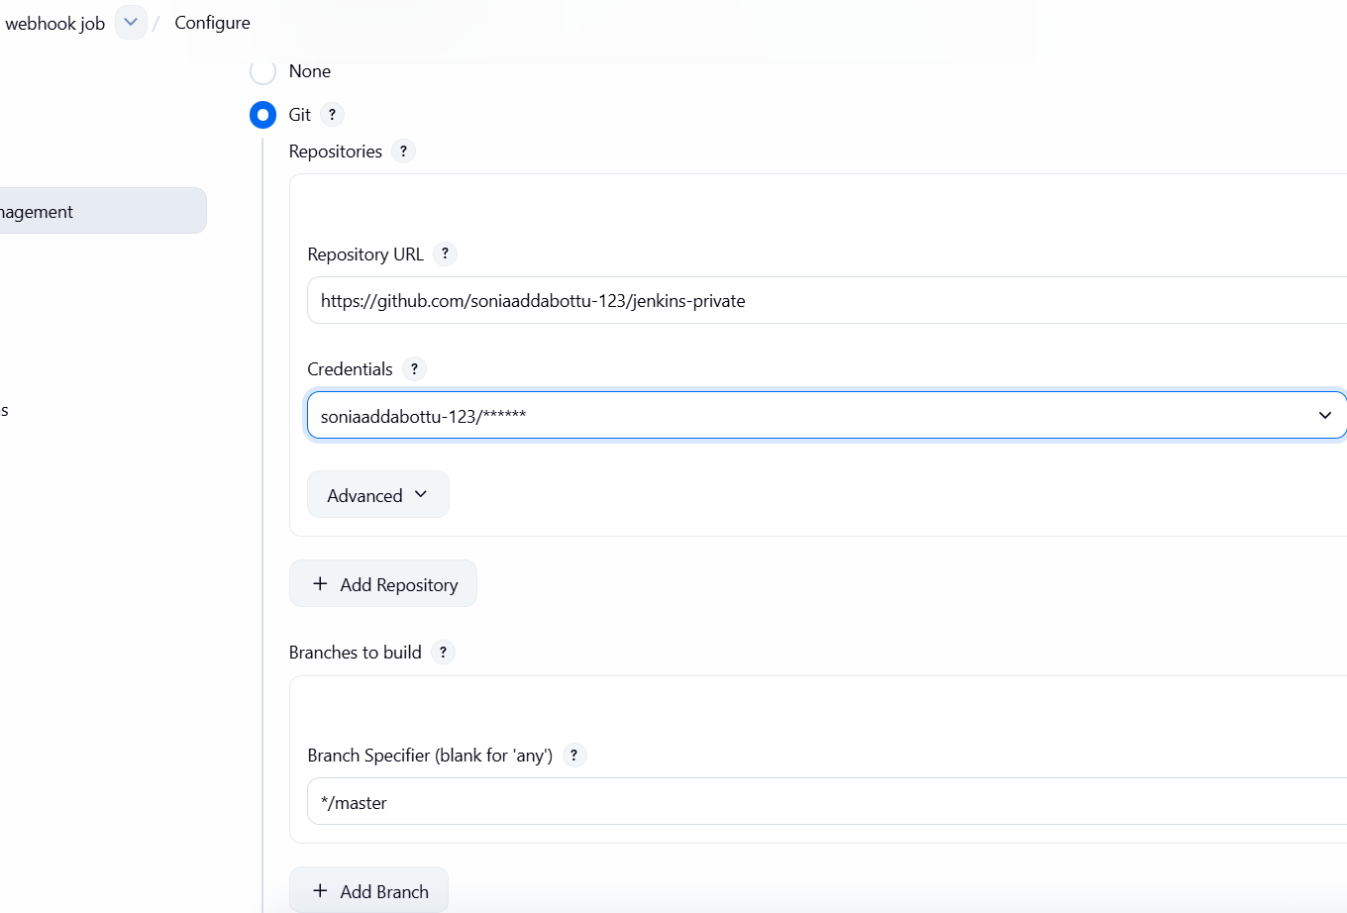
Select the triggers
Enable Github hook trigger for GITScm pollinggive the build step
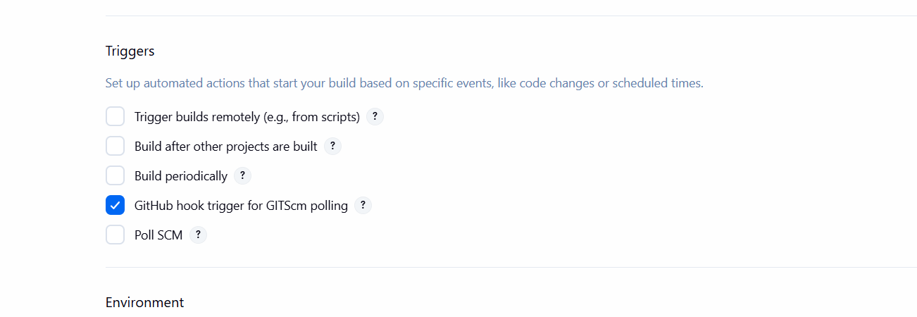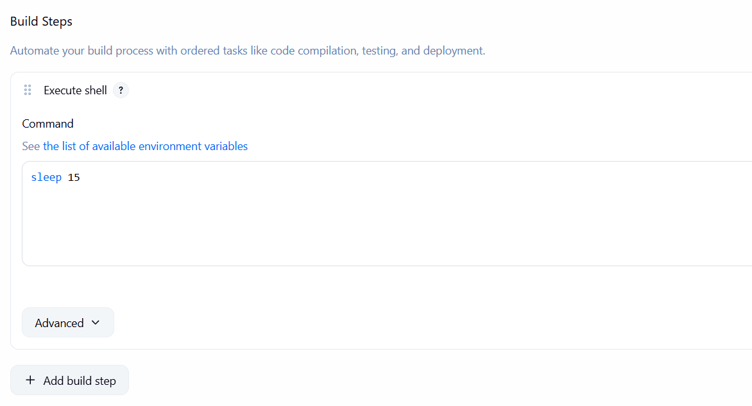
Open GitHub and open private repo and in that got ot settings scroldown click on webhooks and add new.
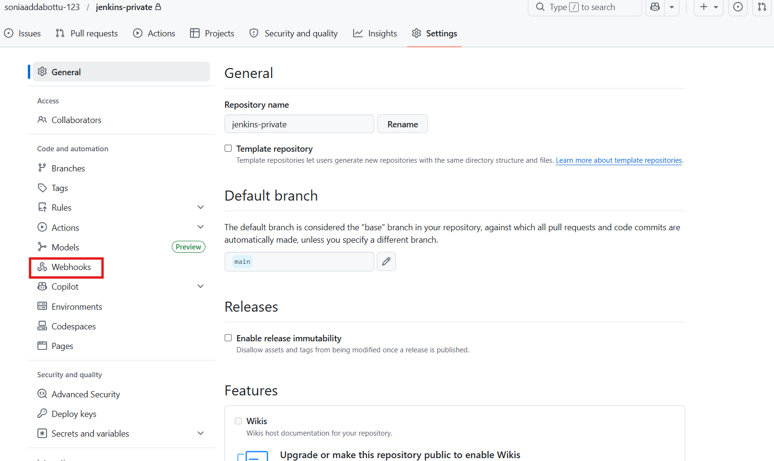
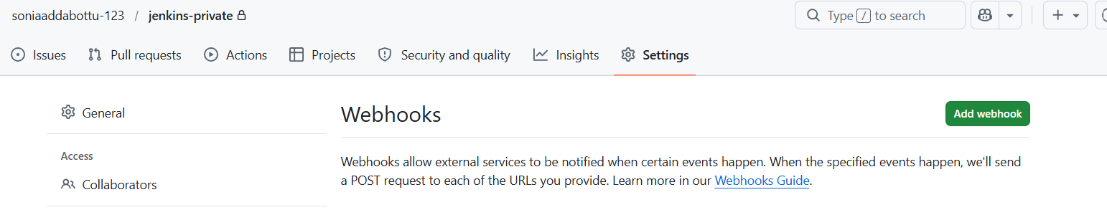
The payload URl means we need to use the Jenkins ip address
Abd github-webhook/
Content typeapplicationand we will take event triggersend me everything add webhook
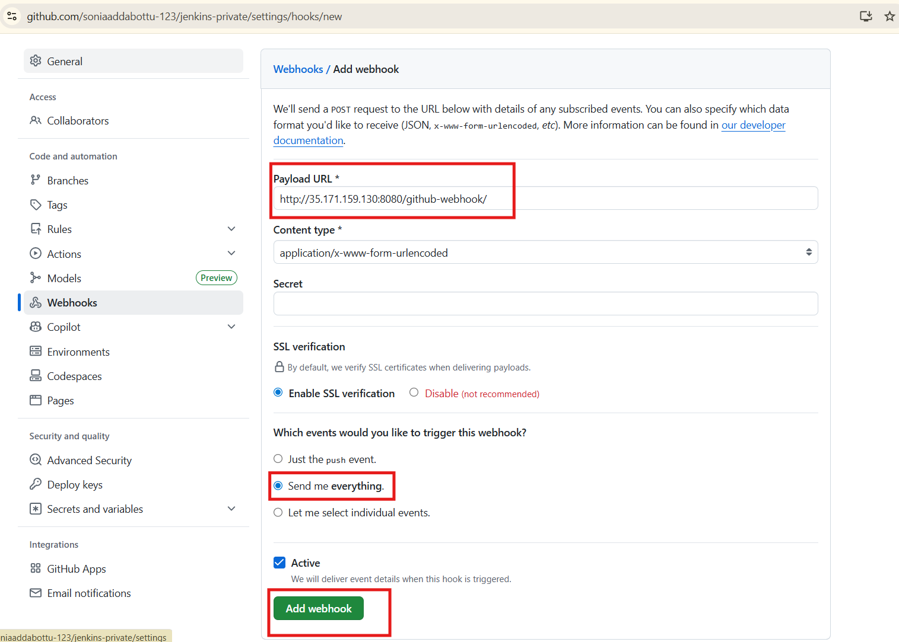
We can see successfully webhook created
Make any commits in repository and check in webhooks it shows
Now we can see automatically build
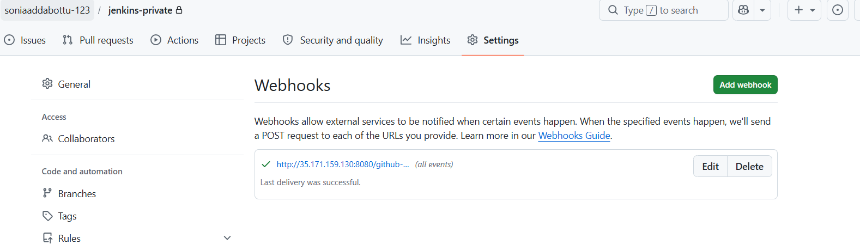
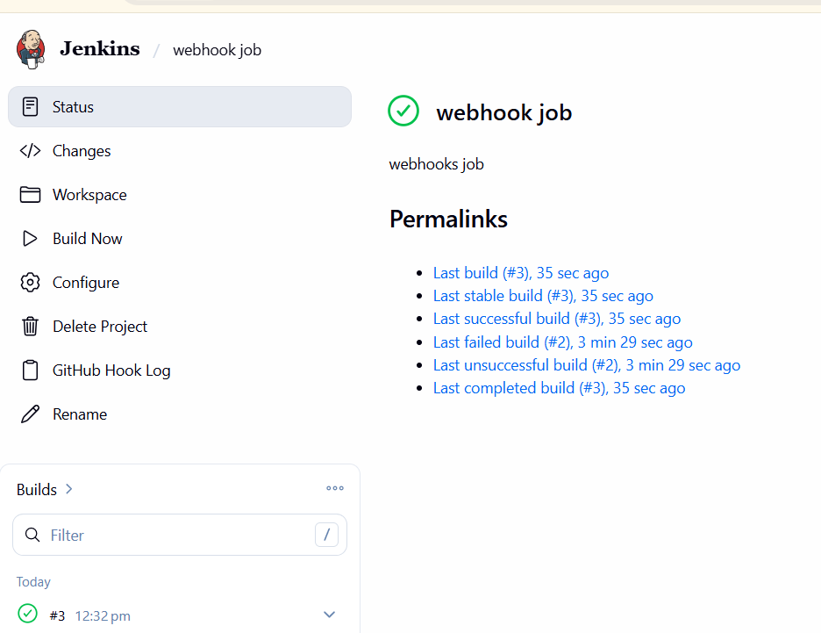

Go to githubprivate repo—>upload new filewe see automatically configure in jenkins
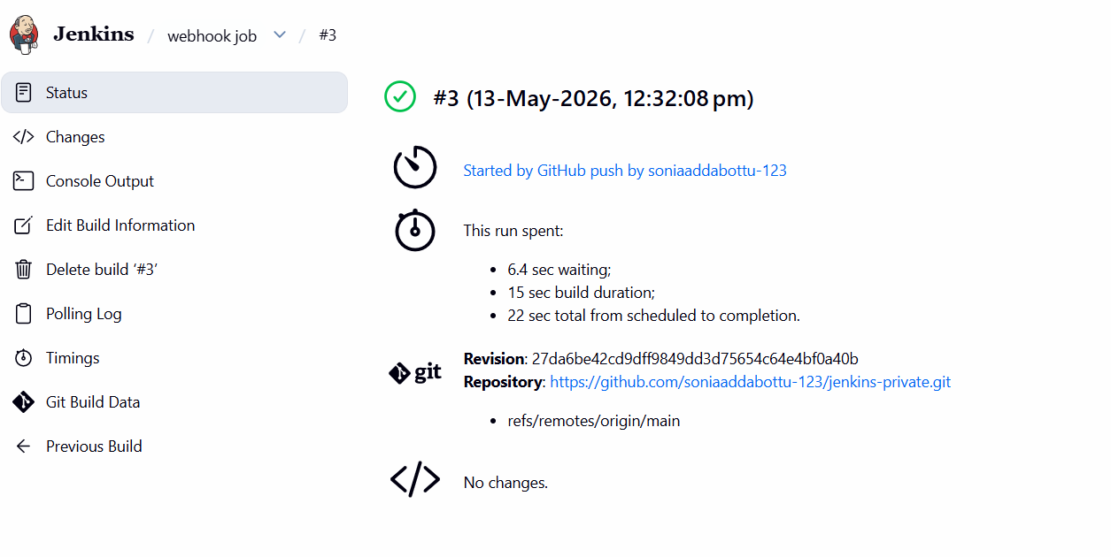

- ConfigurePoll SCMandBuild Periodicallyoptions in the Jenkins job.
Go to Jenkins already we have create one jobclick on thet job and select configure poll SCM : Jenkins → Checks GitHub → Detects Change → Starts Build

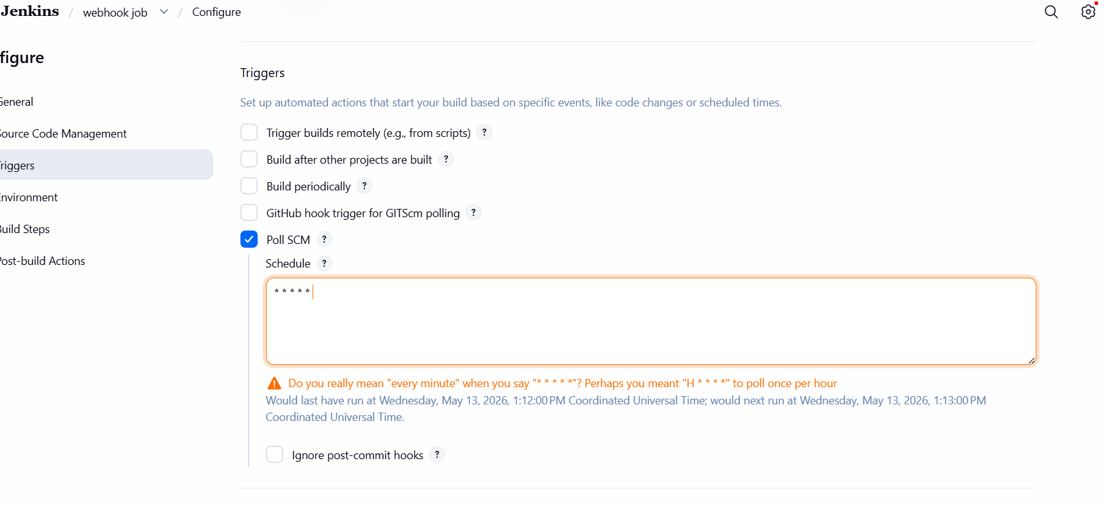
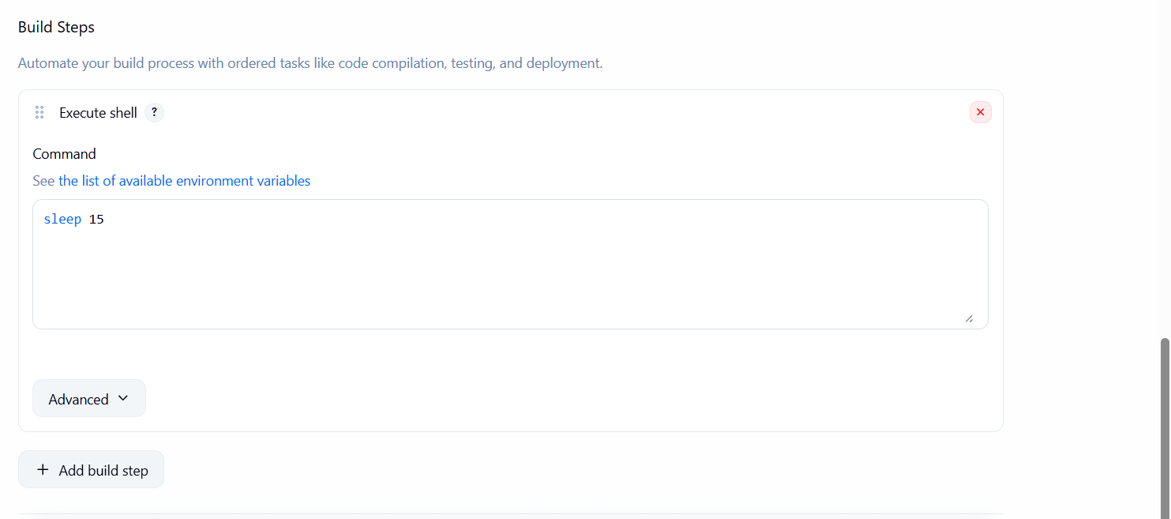
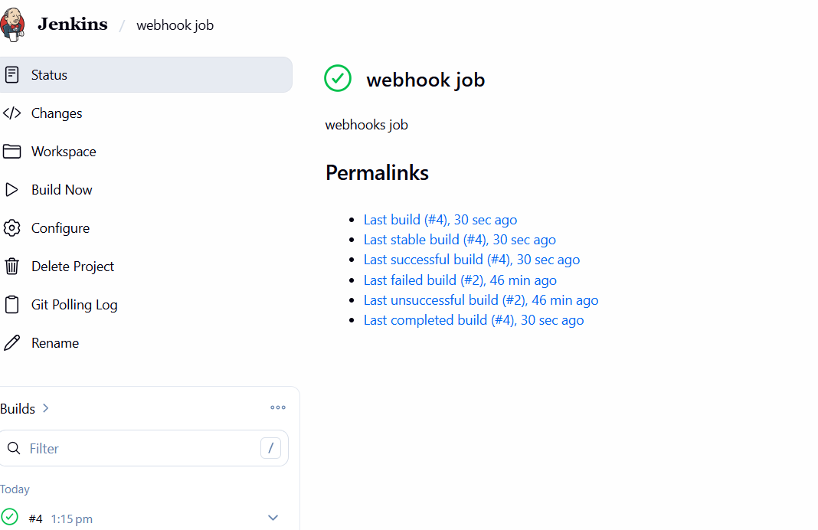
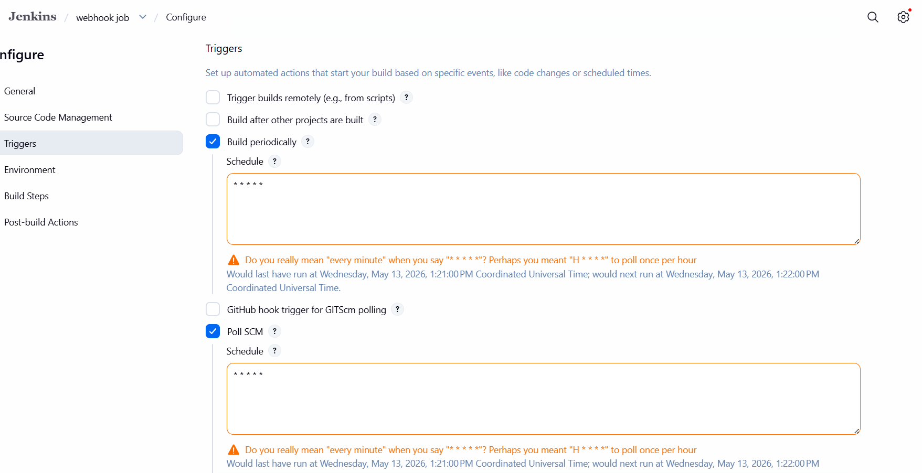
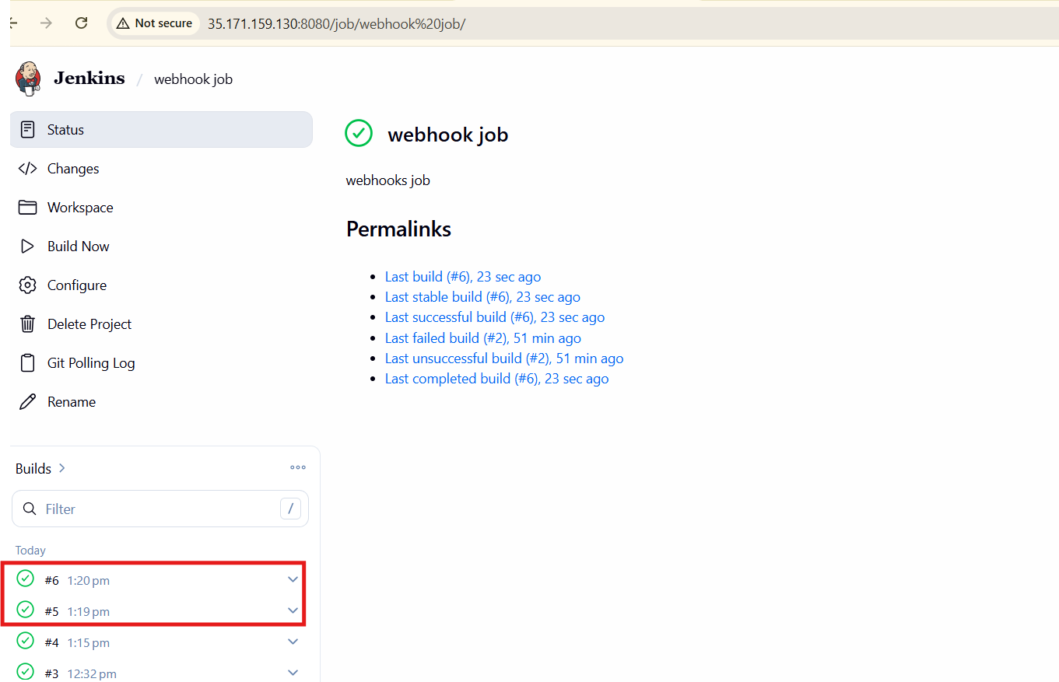

- Take a backup of the Jenkins server using abash-script.

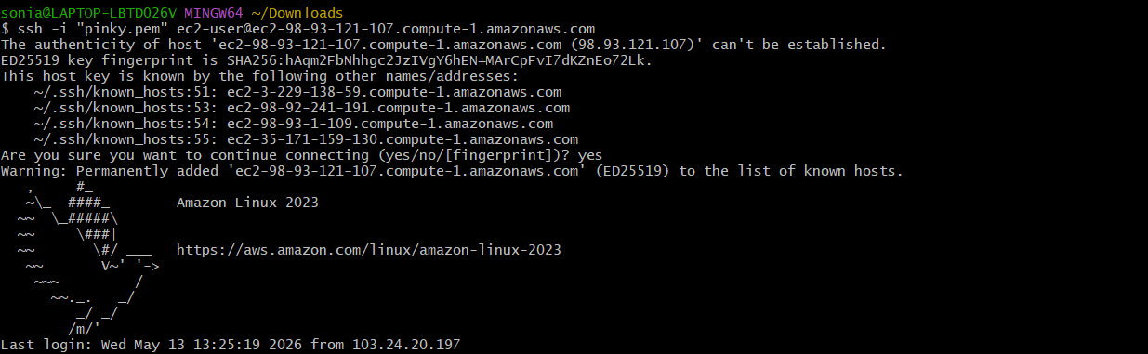
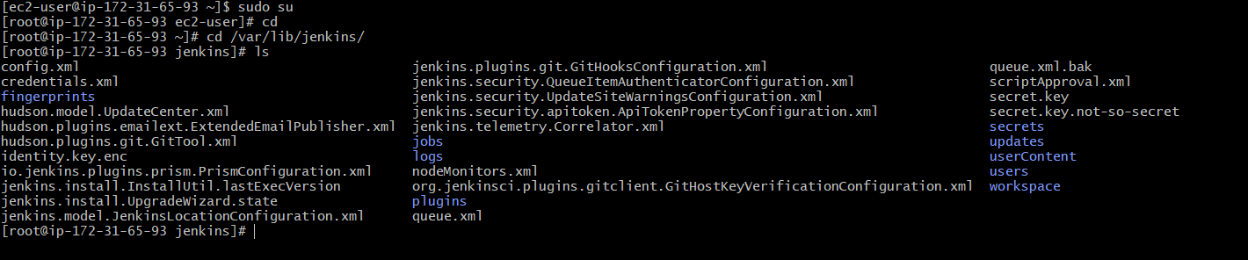
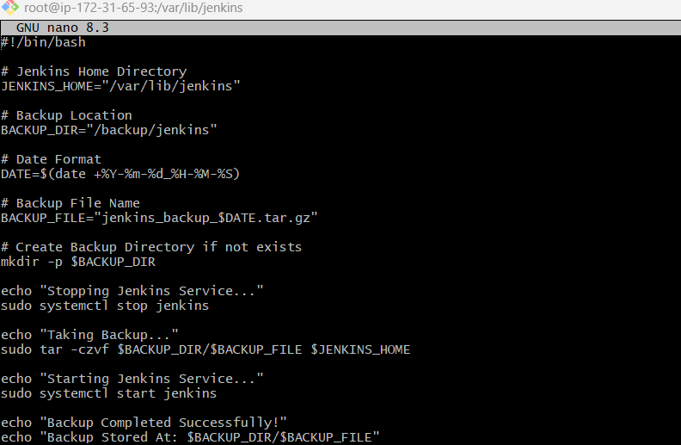
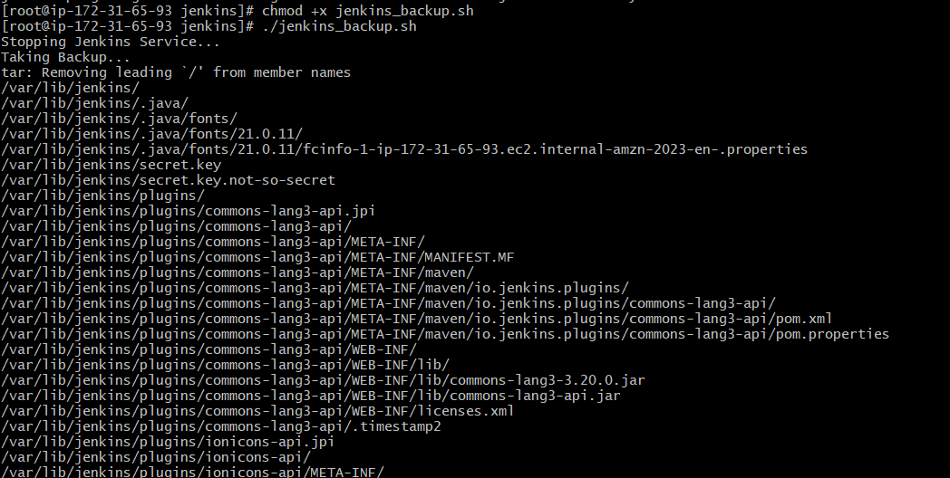
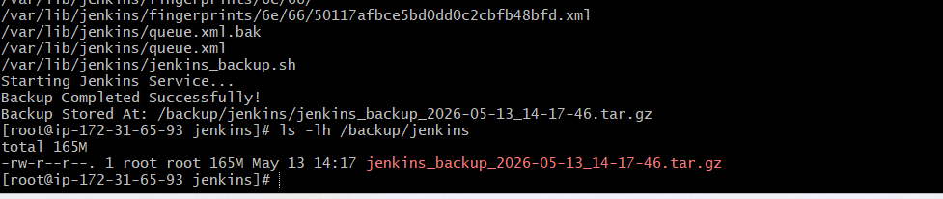

- Take a backup of Jenkins using theThinBackupplugin.

Install ThinBackup Plugin
Go to Manage Jenkins -->Click Plugins -->Open Available Plugins -->Search for ThinBackup -->Select ThinBackup -->Click Install

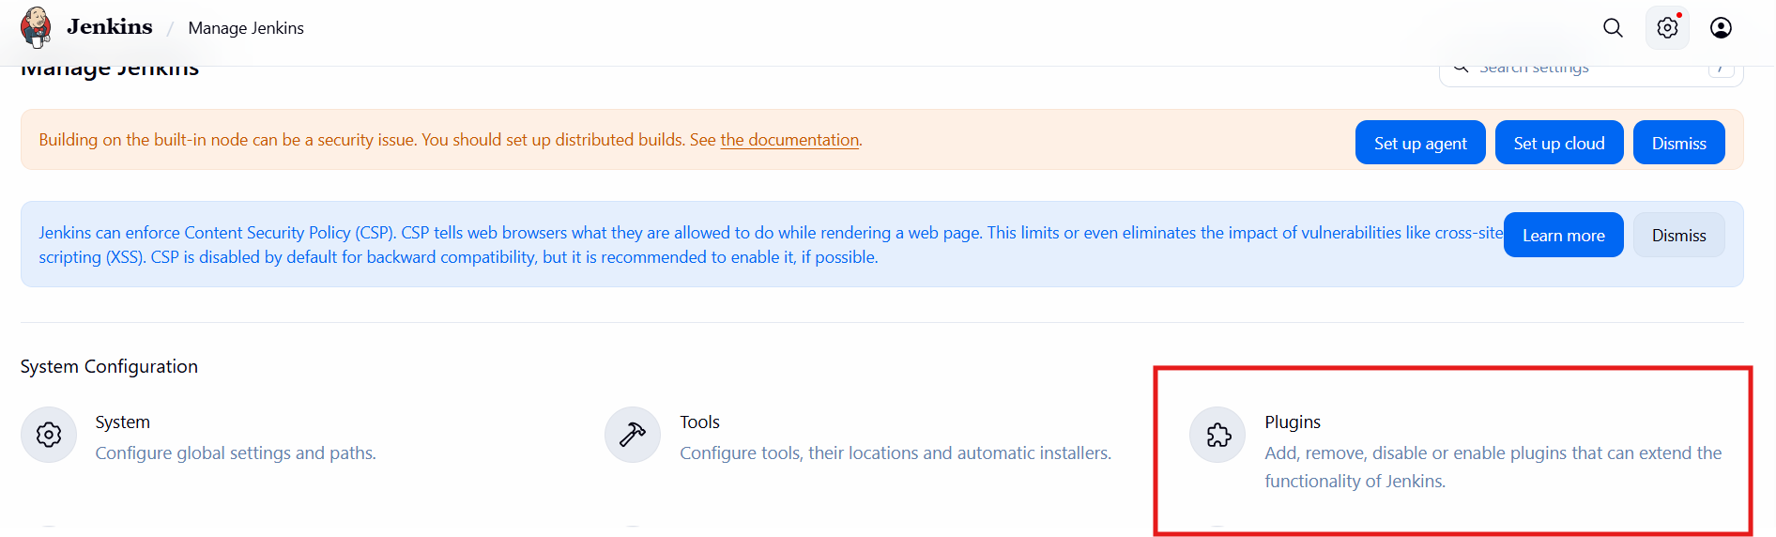
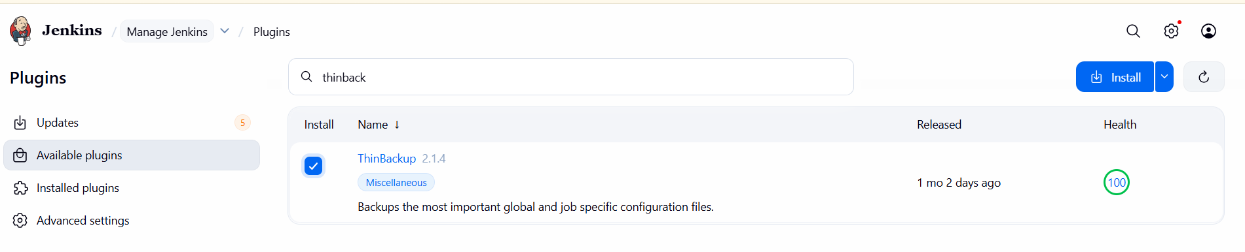
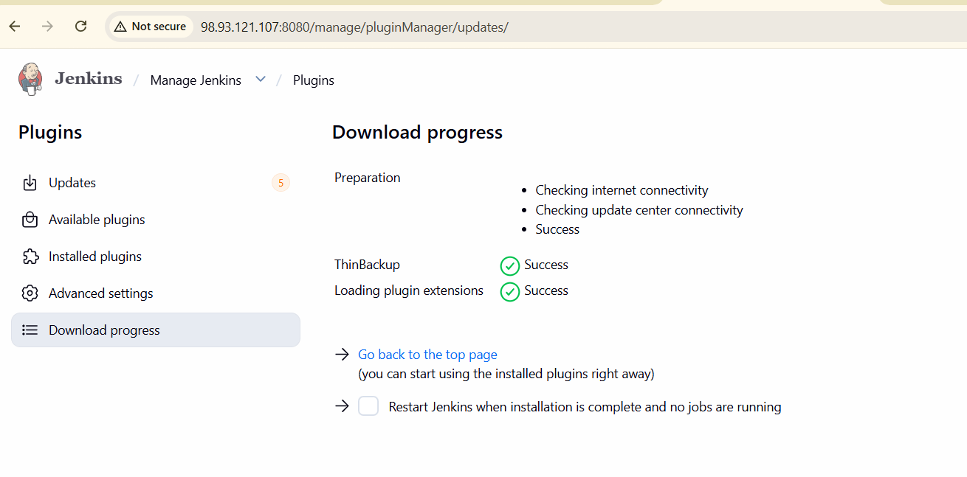
Go to manage jankins-->thinbackup-->backup now-->
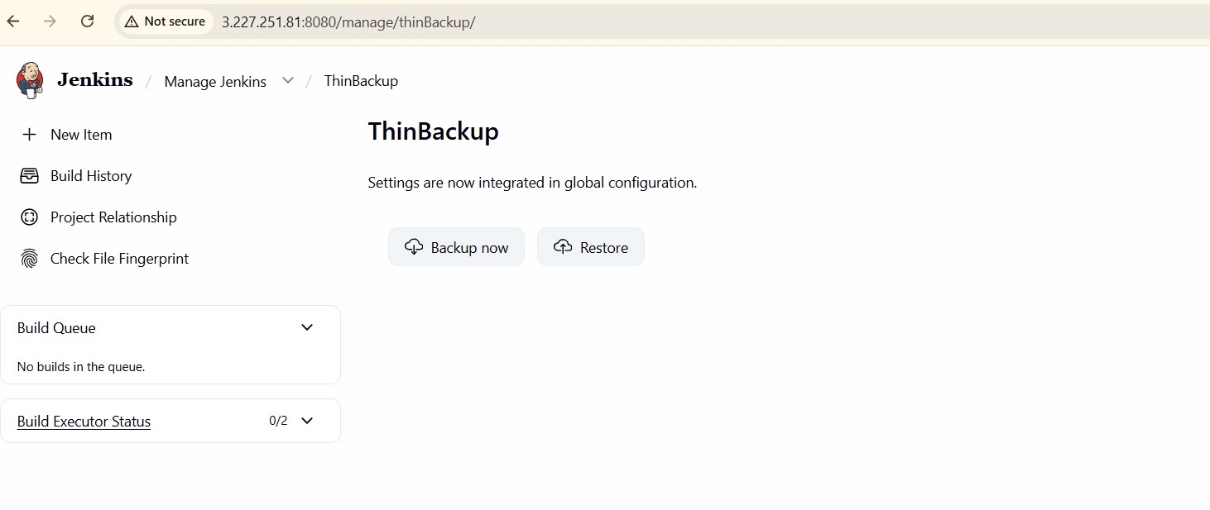
To get the backup we need to configure the details In Manage
Jenkins→System→ThinBackup Configurations→Details(Like Path and schedule and
how many backups u need)→Save
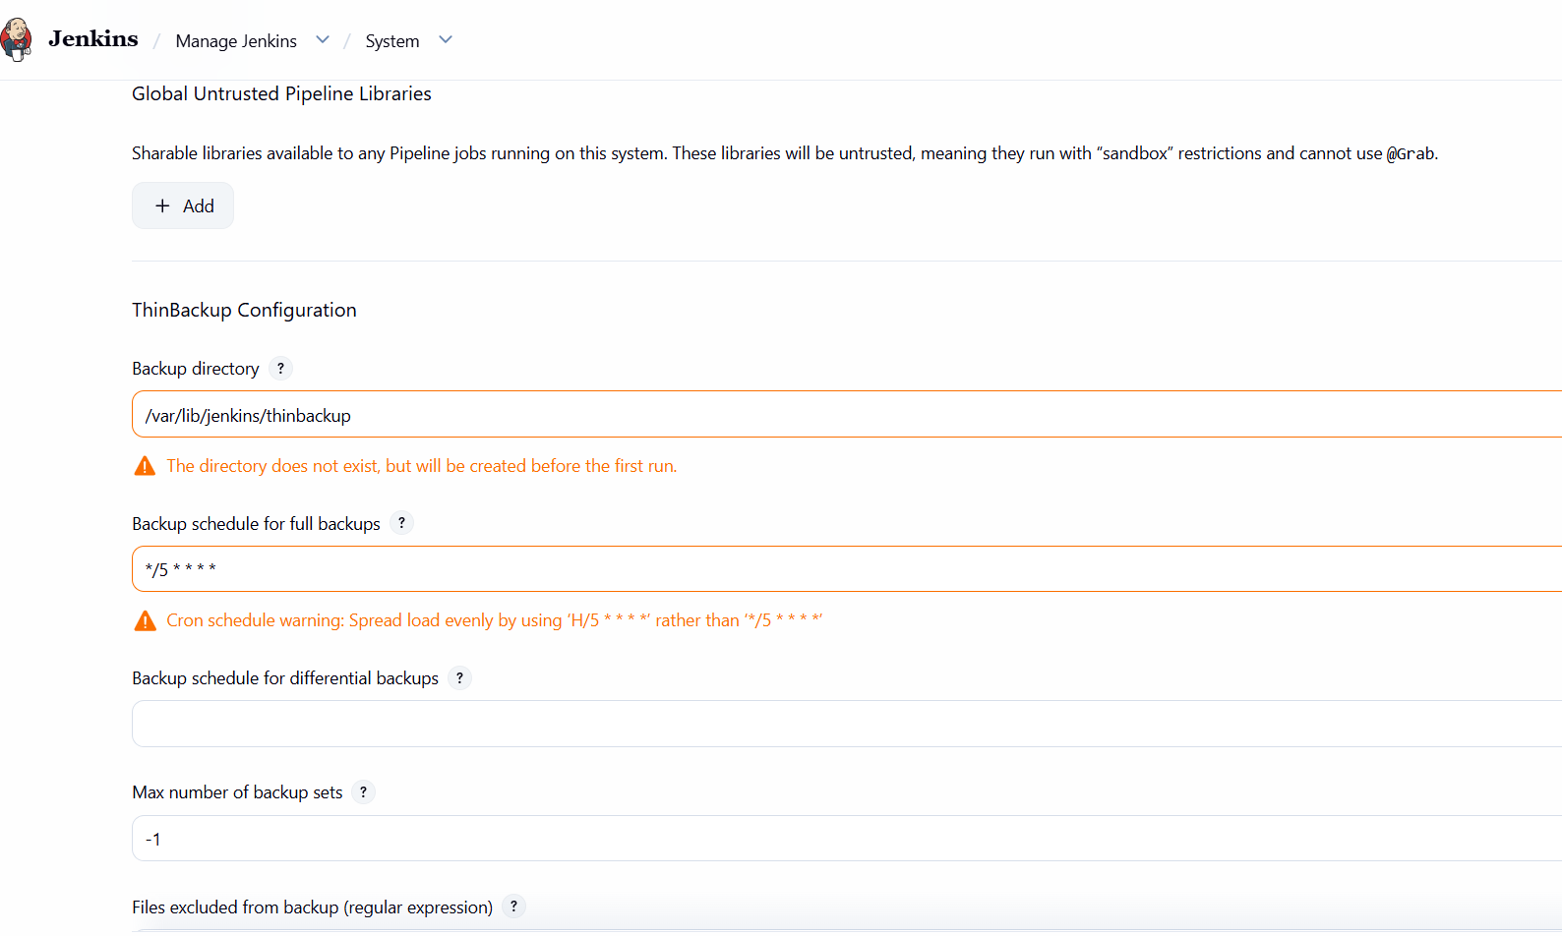

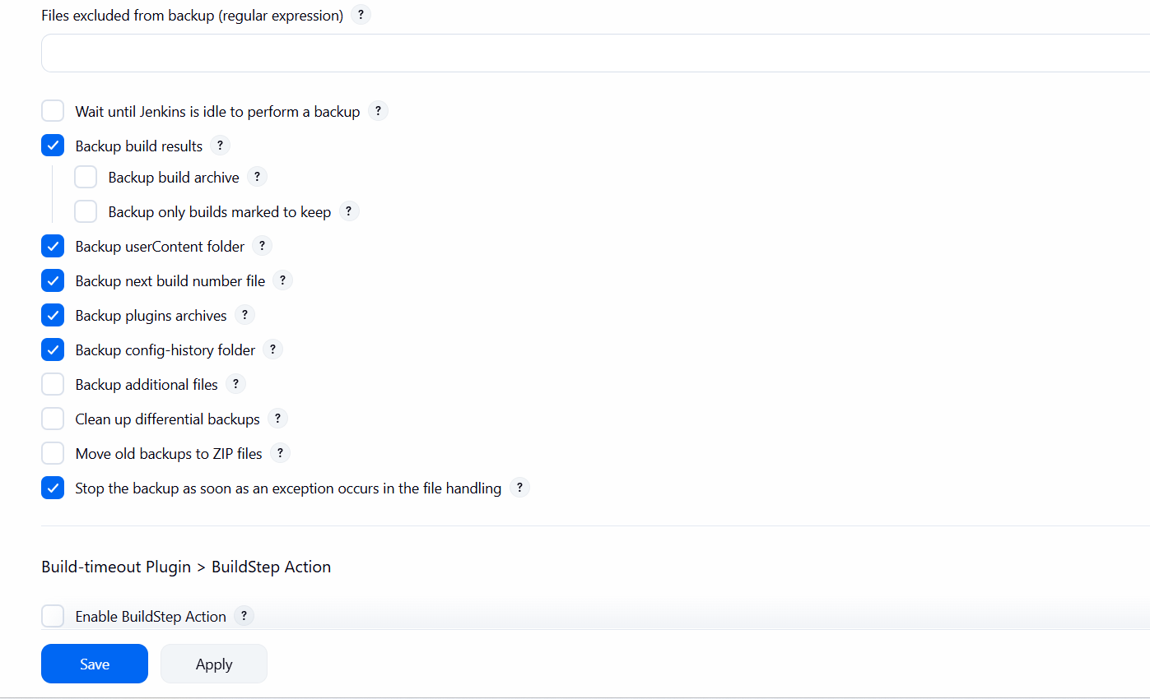
Save the thinbackup configuretions-->and go to back --> manage jenkins-->thinbackup-->backup now
and go to gitbash and check the thinbackup has been created
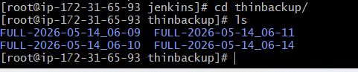
- Set up a new Jenkins server and restore the backup taken in task 4.
First we can lunch one instane-->install jenkins
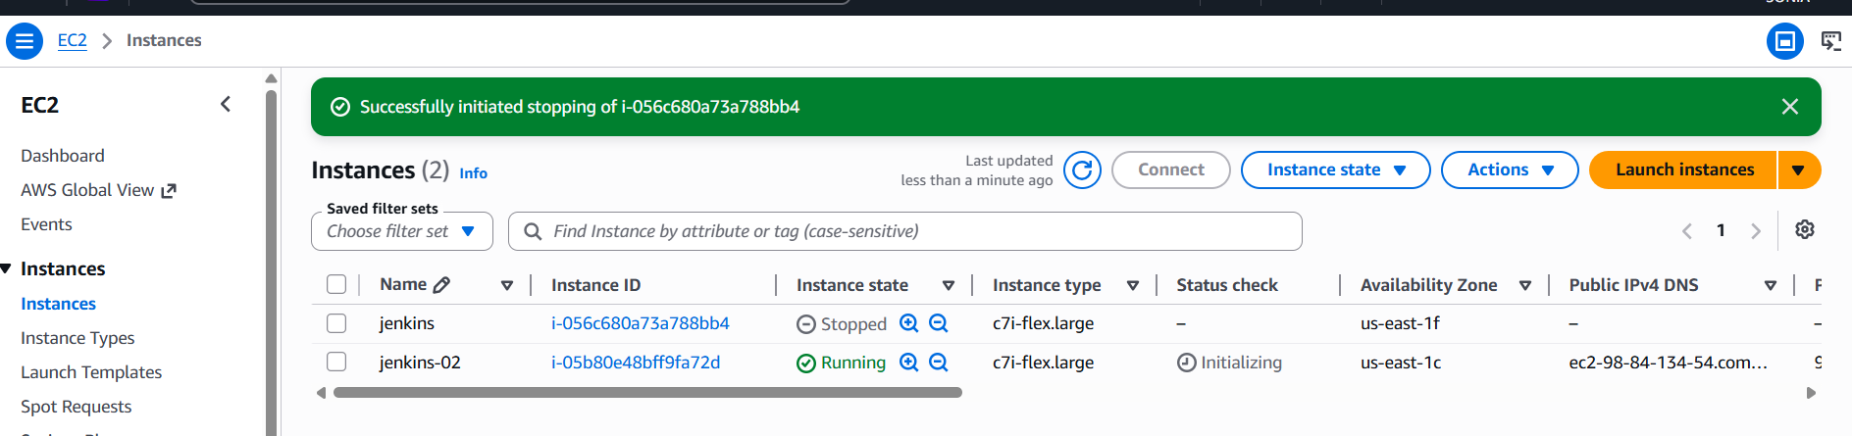
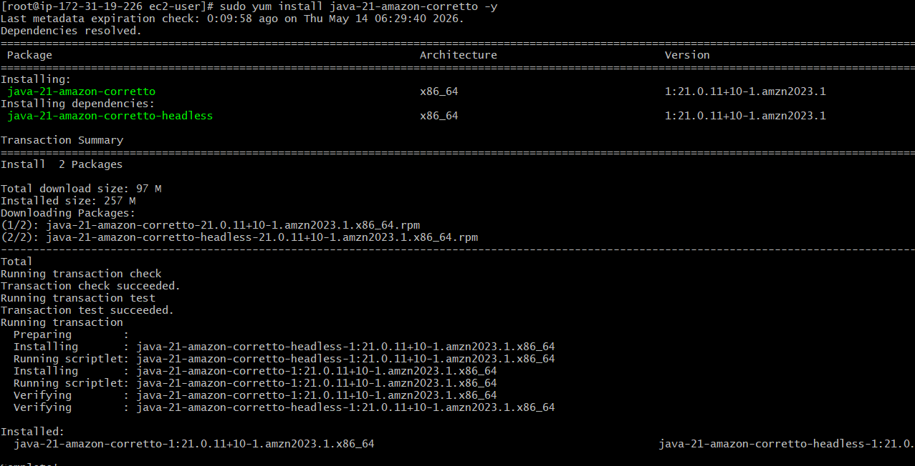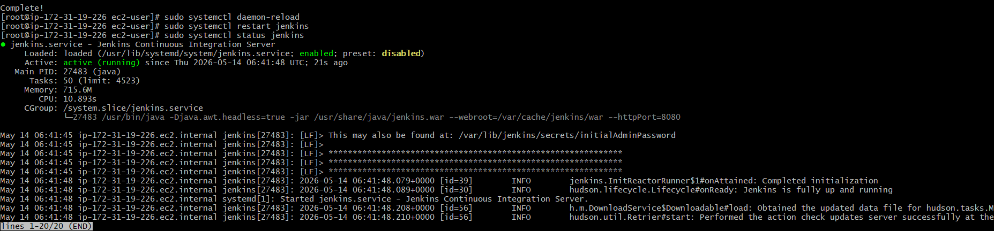
We need to copy the pem key of our new instance on our old instance
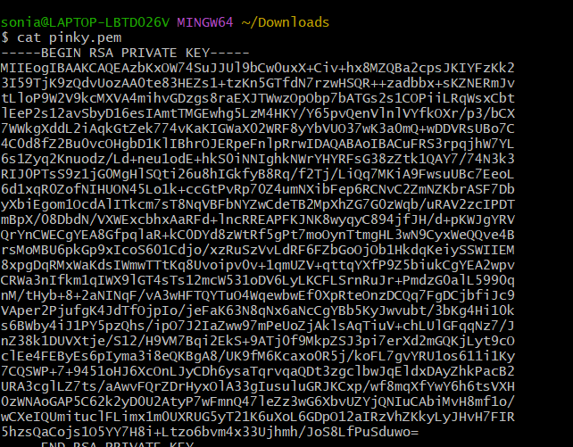
Copy the pem key --> create one file-->give permissions
From our old instance we need to do secure copy our tar file to new
instance using command
scp -i test.pem /backup/jenkins/jenkins-2026-05-13-14-17-46.tar.gz
ec2-user@98.84.134.54:/tmp
By using the command we will securely copy the tar file to our new instance
Go to ec2--> connect new instance
Now we need to untar the file and can find all the contents have been
copied from our old server
