Jenkins-04
Setup Jenkins CICD pipeline using freestyle job using Docker containers using below code.
Source Code: https://github.com/betawins/hiring-app.git
Stages:
- Git Clone
- SonarQube Integration
- Maven Compilation
- Nexus Artifactory
- Slack Notification
- Deploy On tomcat
We have already done with the git and sonarqube integration
Now we can install maven package wget https://…………..
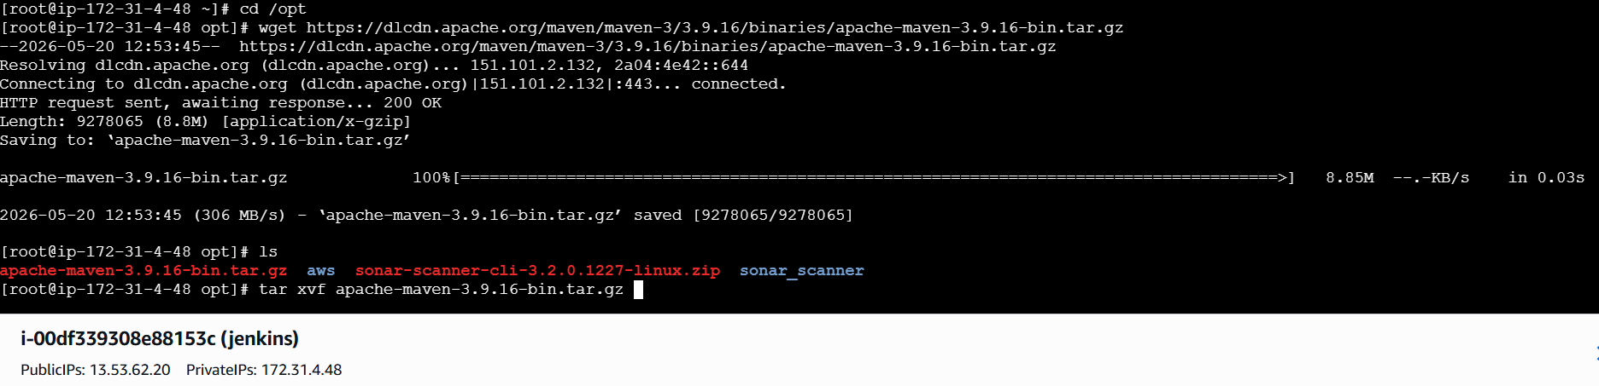
Now we can exstract that maven software package after downloading it in jenkins server
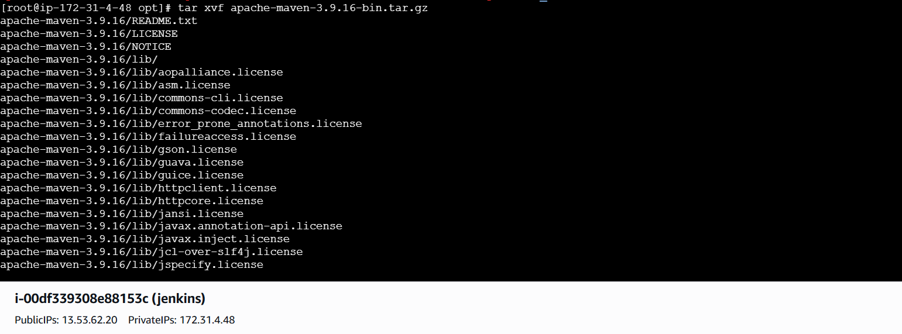
We can display the files and folders give that command ls
Then we enters maven directory and enters binary folder where executablefile are storedhere, you will identify the `mvn` command to verify the installation.
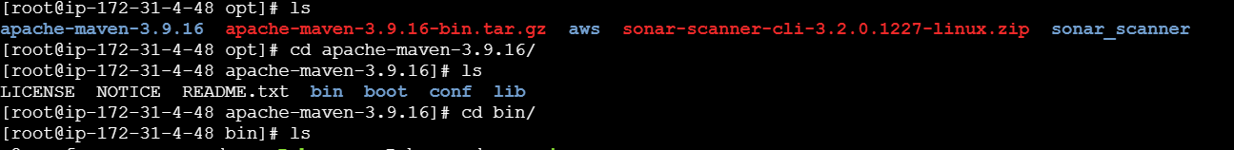
Execute the command `./mvn -version` to confirm that the Maven environment is correctly configured. Following this, you must configure the environment variables by adding the Maven bin directory to your system PATH in the `.
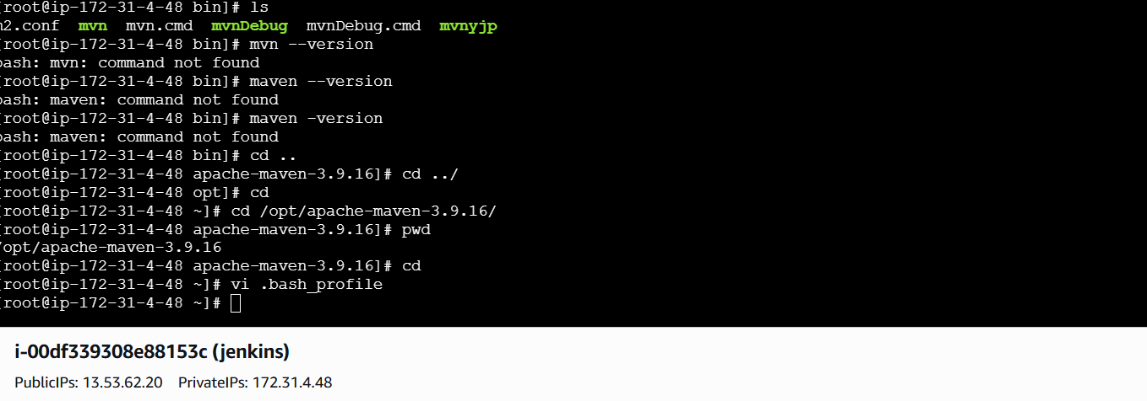
bash_profile` file. Once the path is updated, reload the configuration using `source ~/.bash_profile` to ensure the changes take effect globally. With Maven successfully integrated,
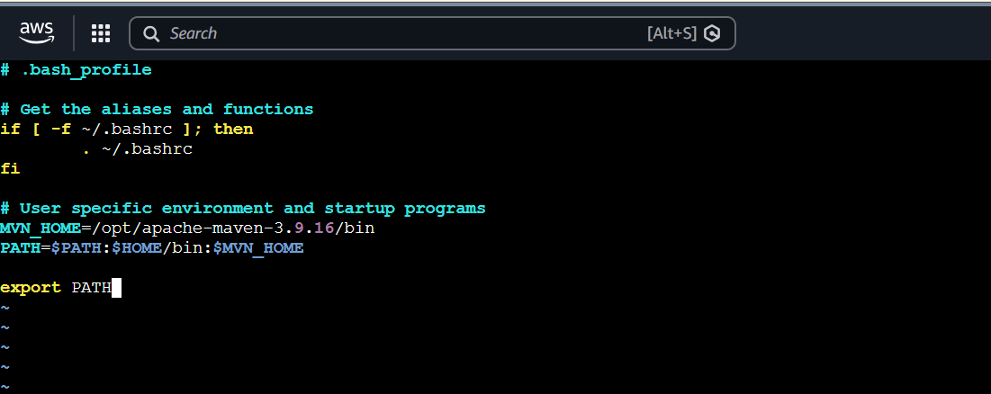

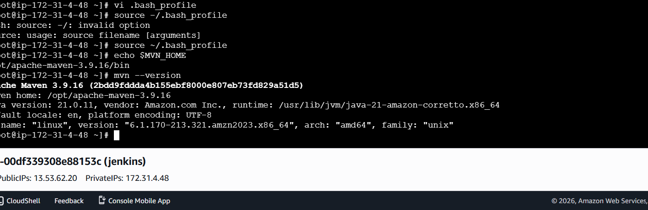
Now go to jenkins -->manage jenkins-->select plugins--> availabele plugins-->search for "Maven Integration" and install the plugin.
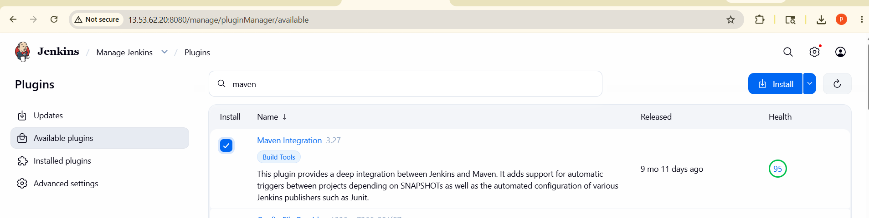
After installation, navigate to Jenkins dashboard, select "Manage Jenkins," then select "Tools," and click on "Maven installations." Here, click "Add Maven" to give the name and maven home like manven path
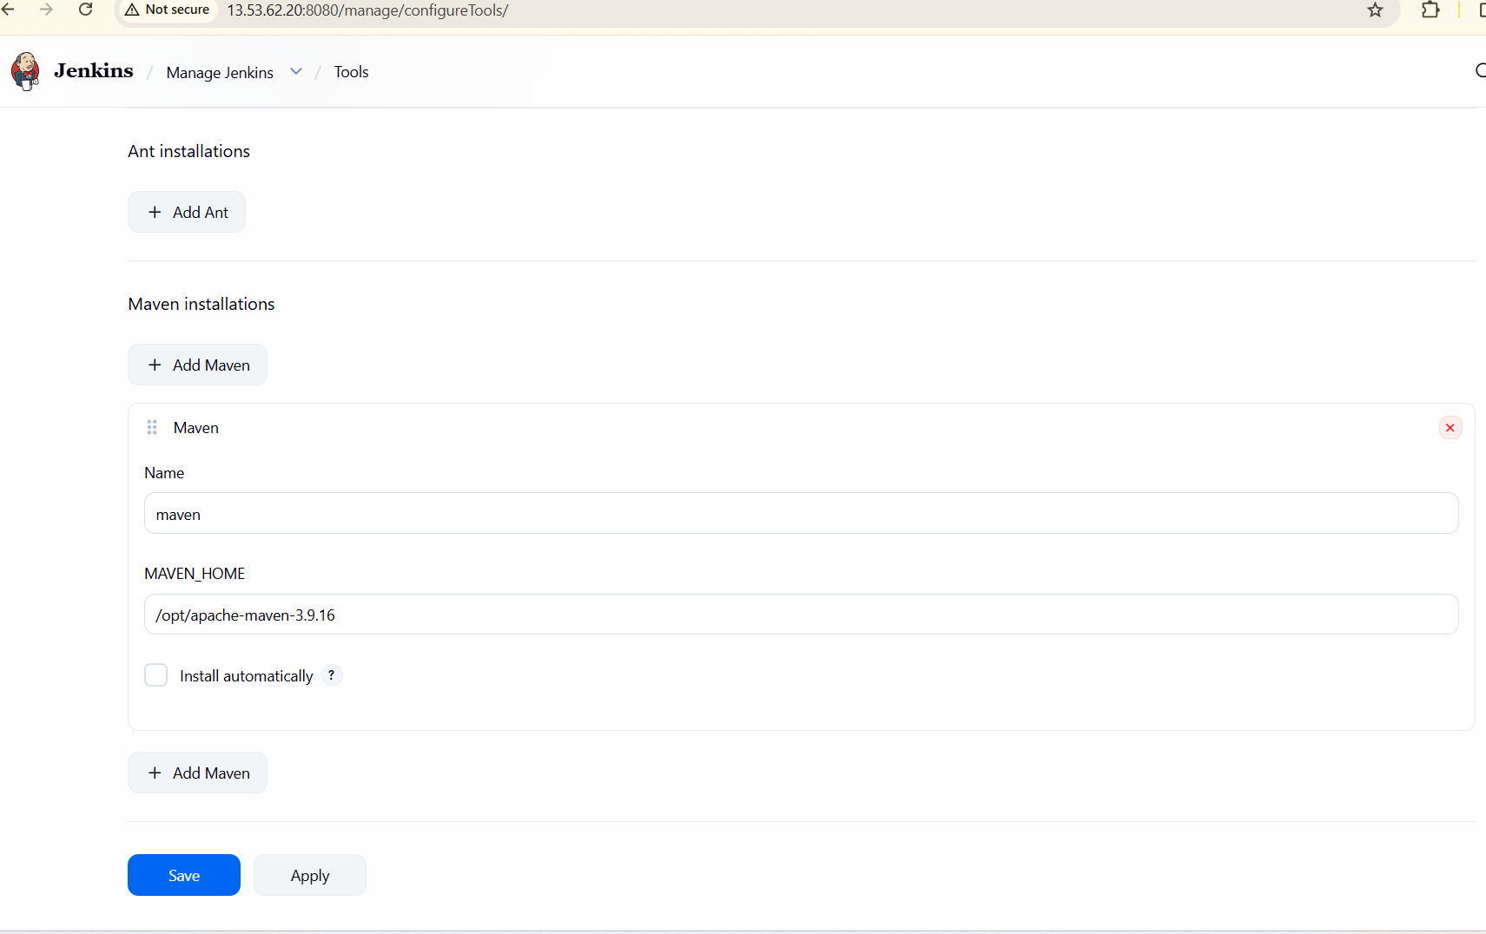
Give the maven version-->goals-->save and apply the changes to finalize the configuration.

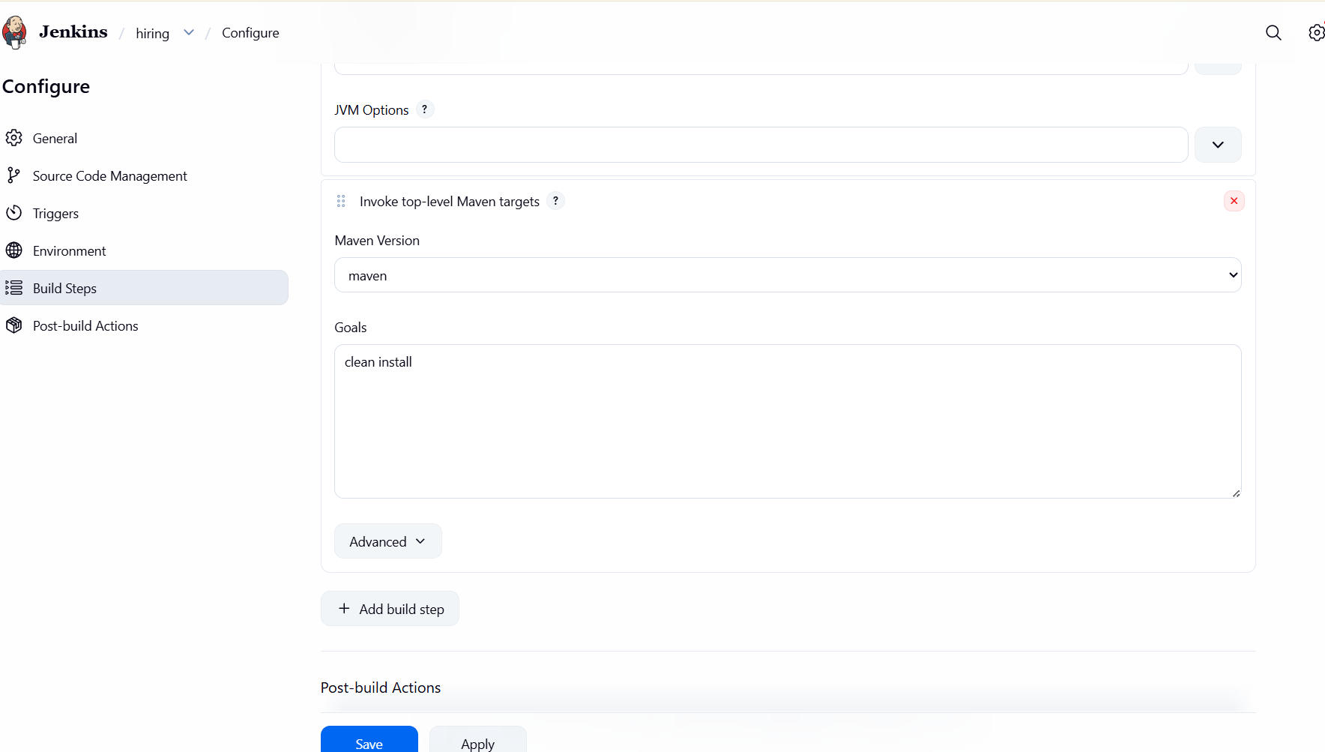after running the maven build I got a sonarqube error .then I run the sonarqube again
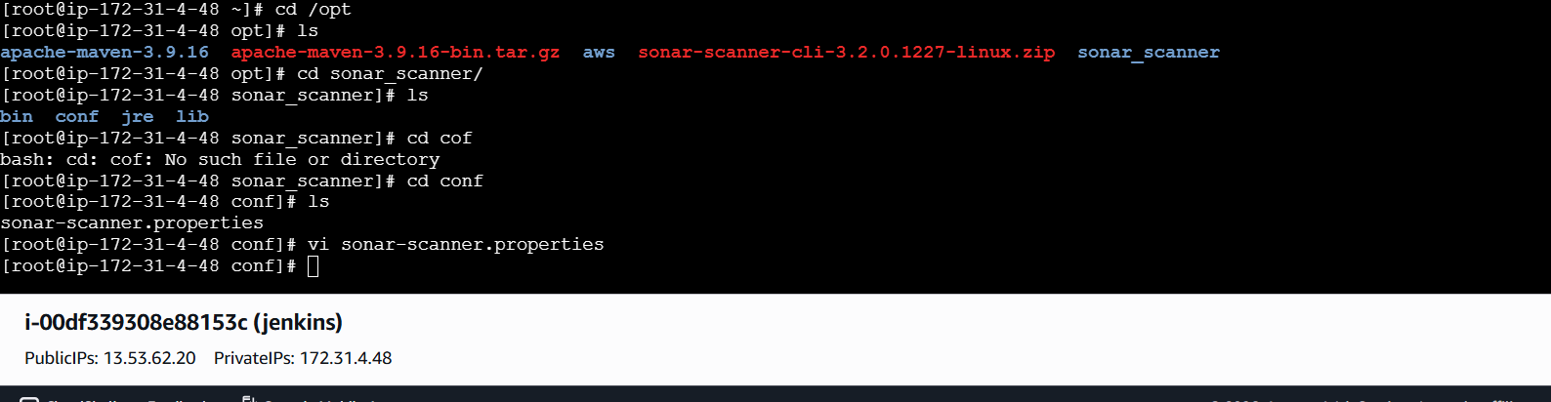
Successfully run sonarqube maven was build
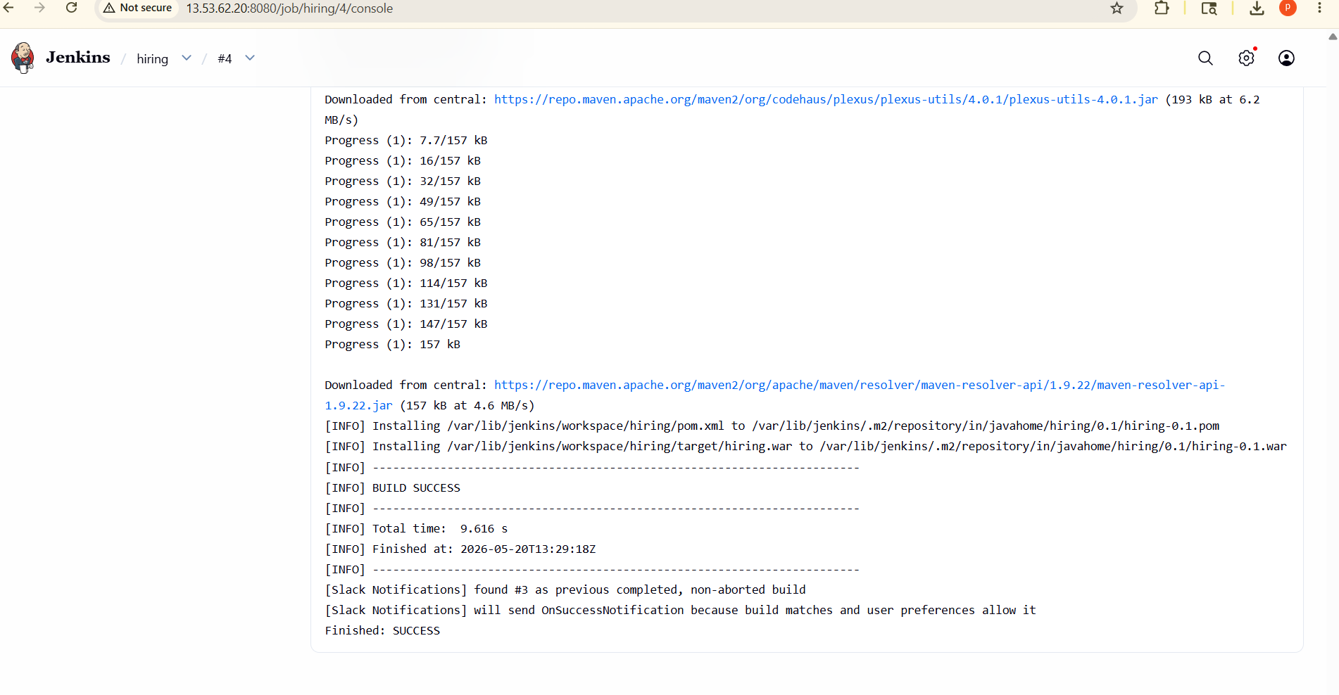
Slack channel received Jenkins notifications:
Build #1 – started
Build #2 – Success
Build #3 – Success
Confirms Slack–Jenkins integration is working correctly
Notifications triggered for both failure and success events

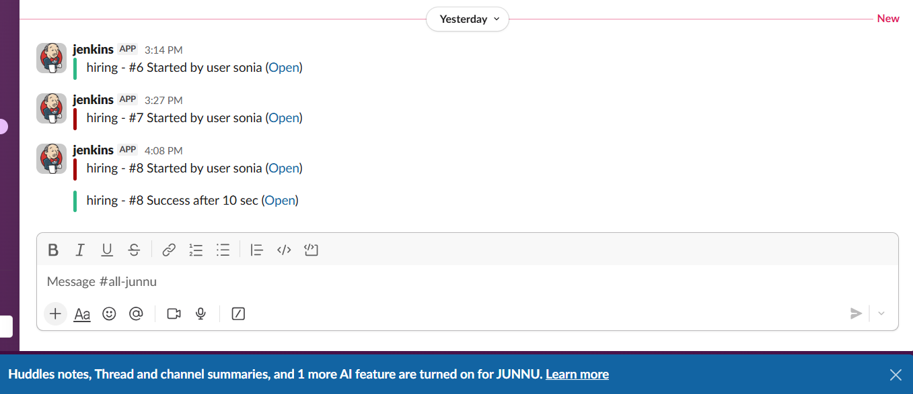

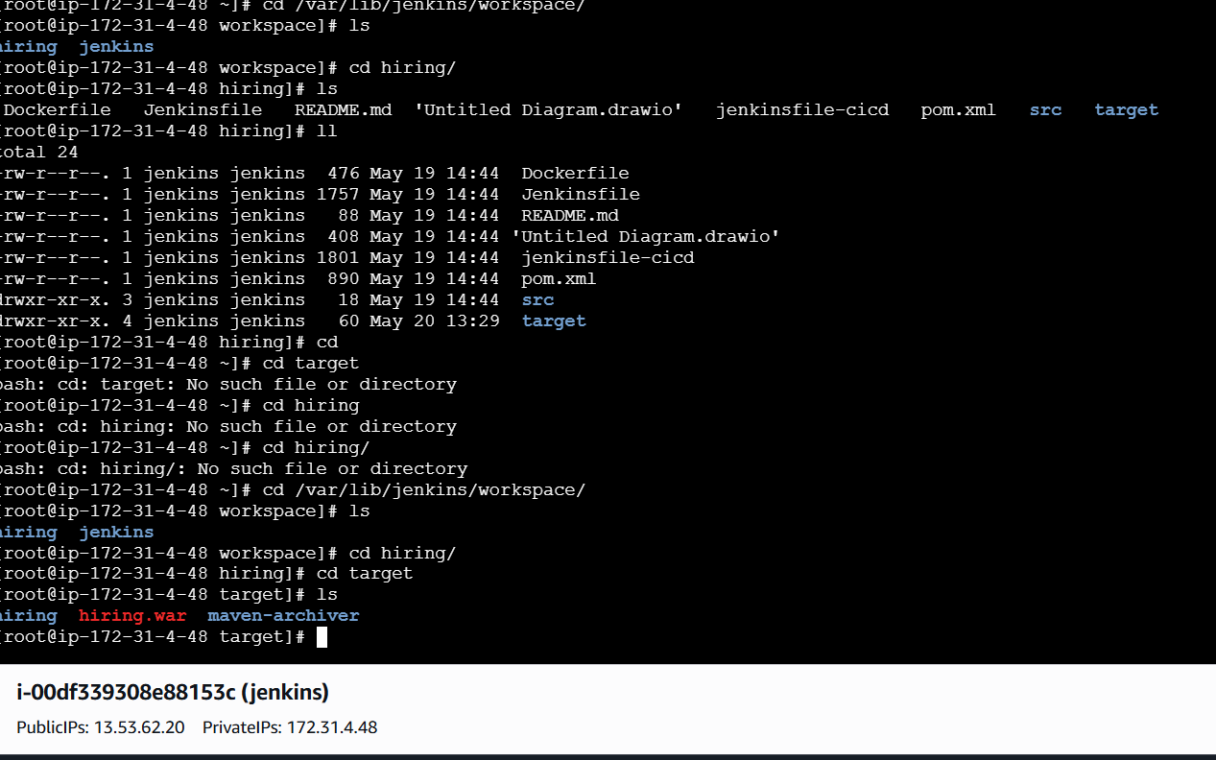
- Nexus Artifactory
We can launch one sever for nexus after that
First We can install java”yum install java-1.8.0-openjdk -y

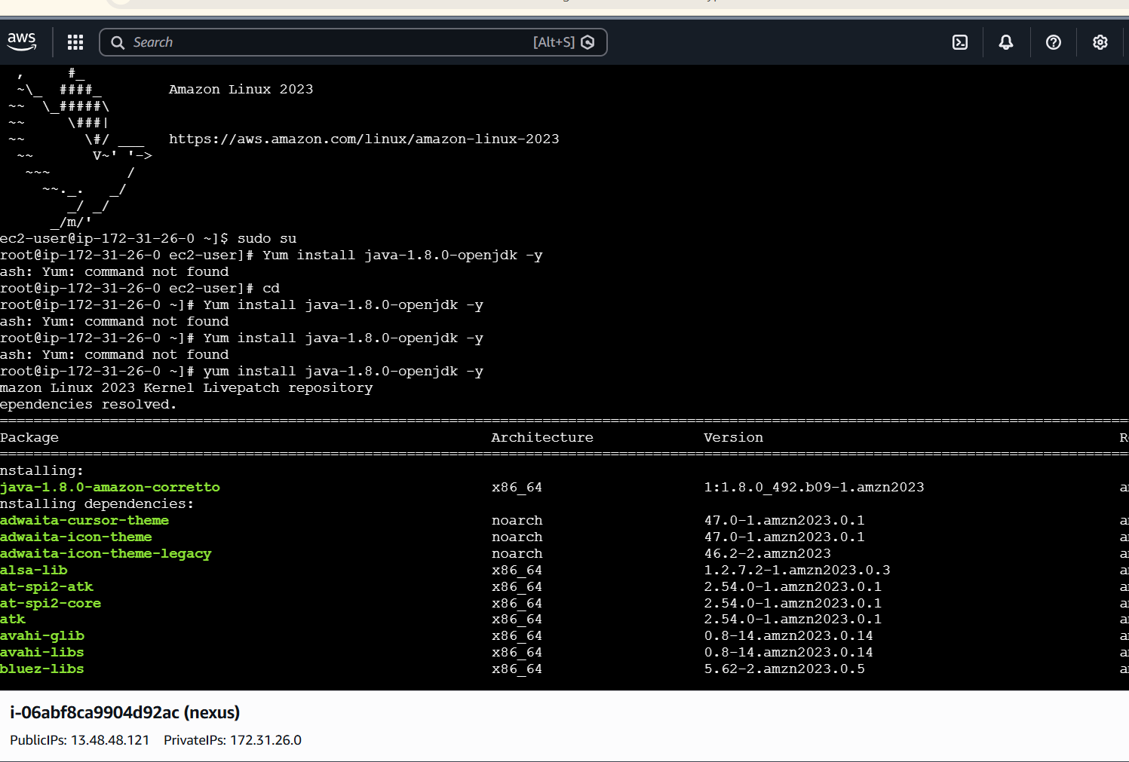
then download the Nexus repository manager tar file from the official website. Extract the archive using the 'tar -xvf' command,

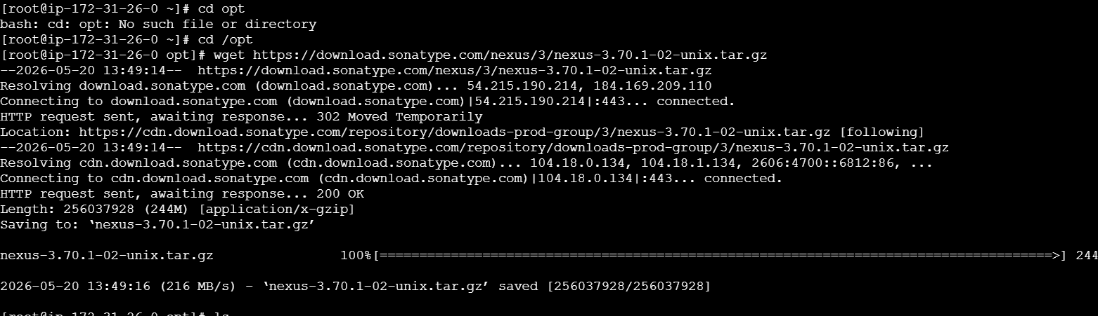
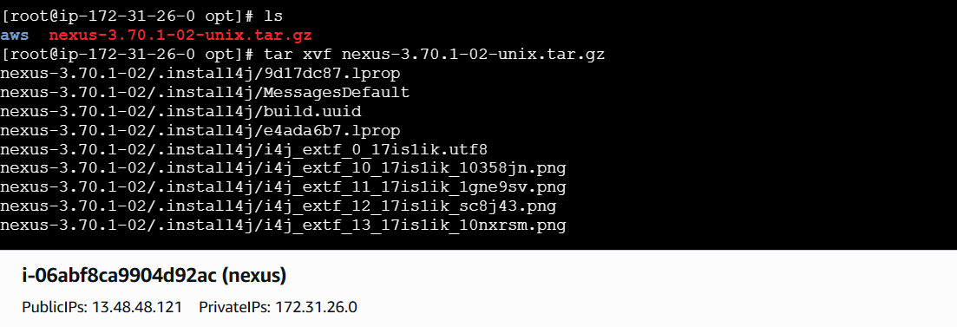
and navigate into the extracted directory. Locate the 'bin' folder to execute
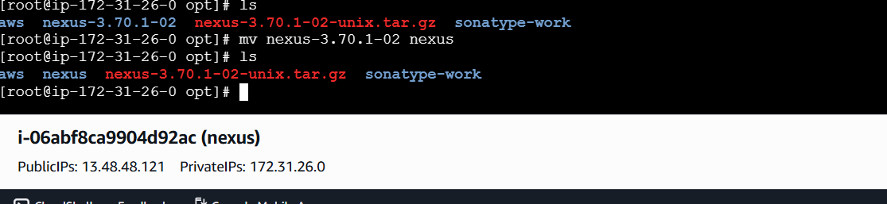
After that we can add user and password to log in to the Nexus web interface. Once logged in, you can configure your repositories, manage user permissions,
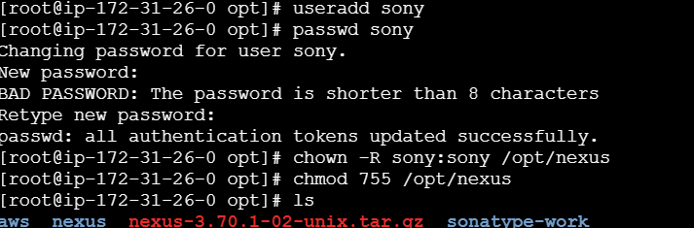

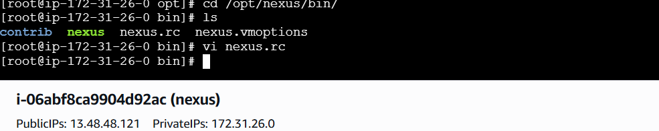

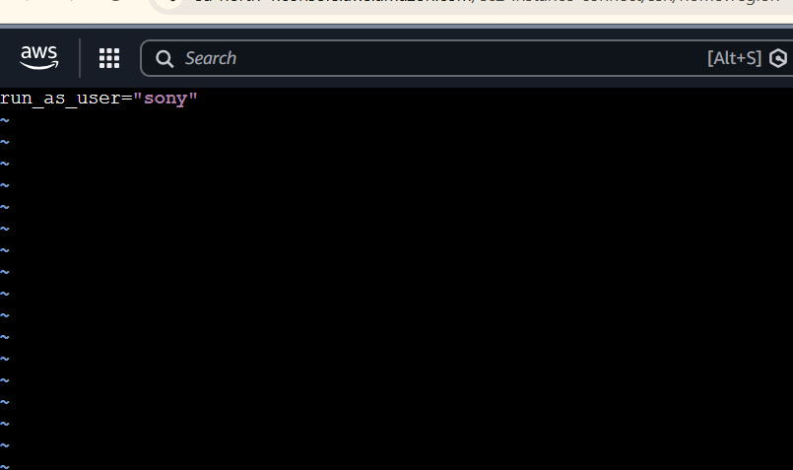

We can give permission to the owership of the Nexus installation directory to a dedicated user to ensure security and stability. By executing the 'chown' command,
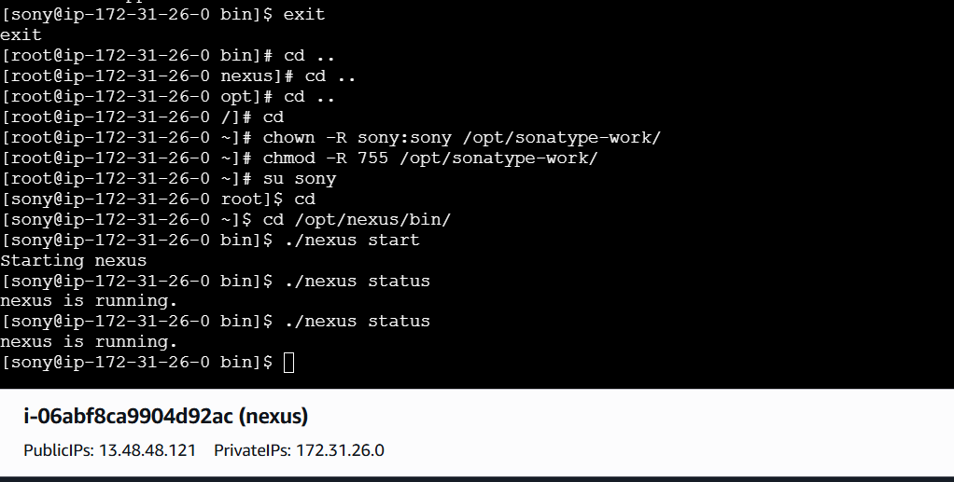
you can restrict access to the application copy the nexus URL and paste it into your browser to access the dashboard
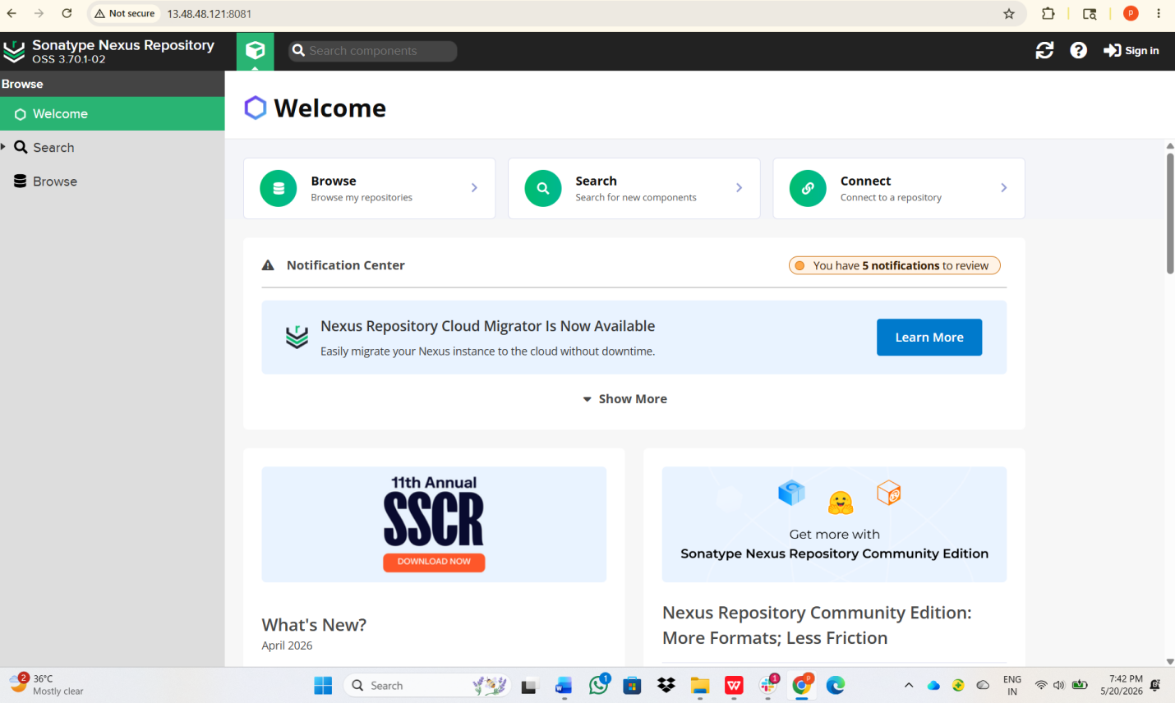
Now we can sign in with the default credentials,go to the nexus server copy the sign in password and see the “cat commaned and /opt/sonatype-work/nexus3/admin.password” file to retrieve the initial authentication string.
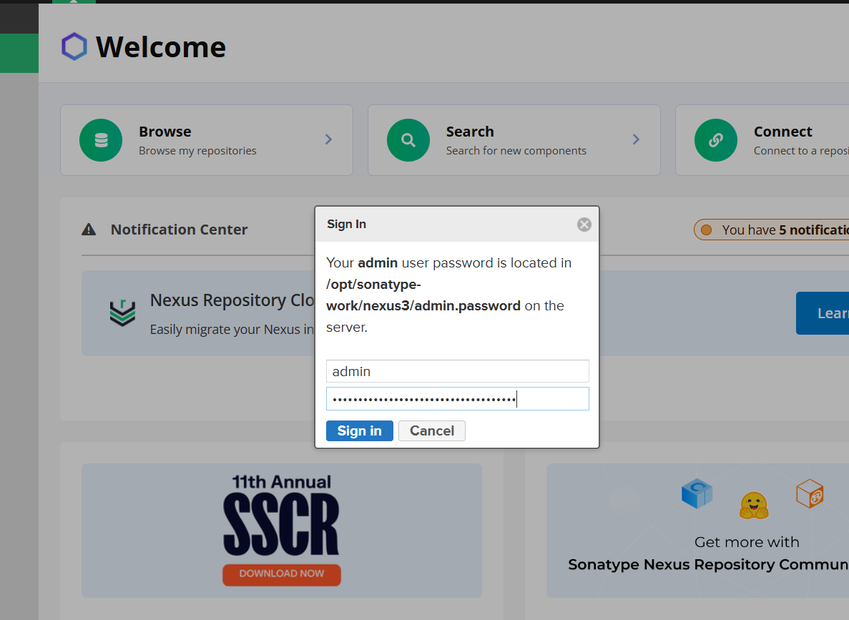
Then we can go to jenkins dashboard -->manage plugins-->available plugins--> search for the "Nexus Artifact Uploader" plugin, -->and install it.
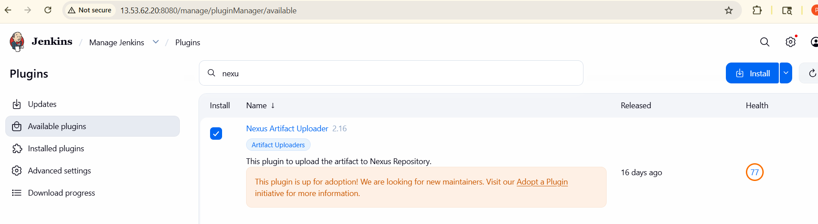
After that go to jenkins-->hiring-->cofigure-->build steps--> give the nexus repository version-->protocol-->nexus URL
Then we can created the credential for the Nexus server by adding the username and password within the Jenkins configuration,
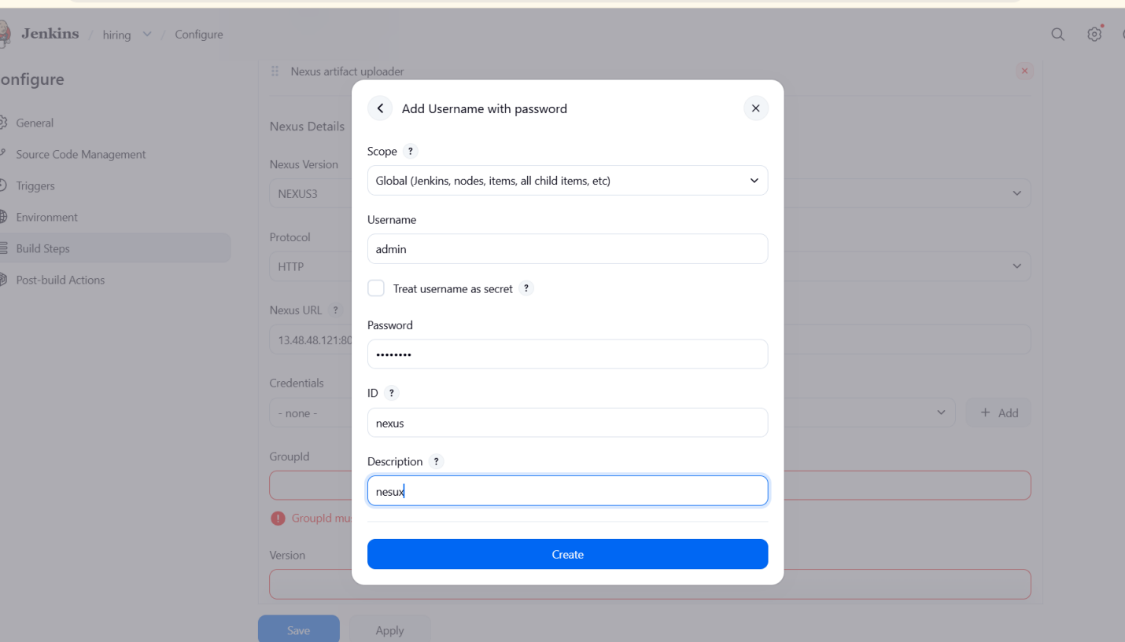
and save the settings. Once the connection is established
And go to nexus repository-->select repository--> maven hosted-->

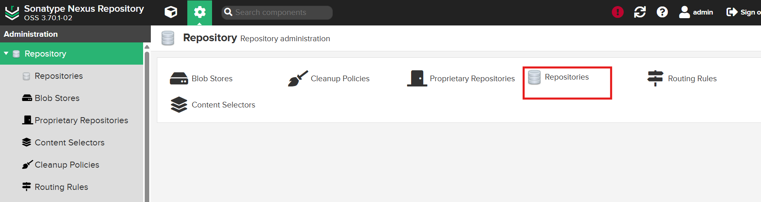
Give the name--> version policy as release, and ensure the deployment policy is set to allow redeploy. Finally, click create repository to finalize the setup,
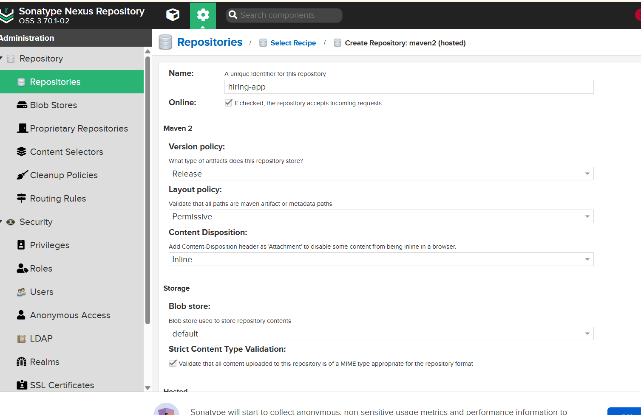
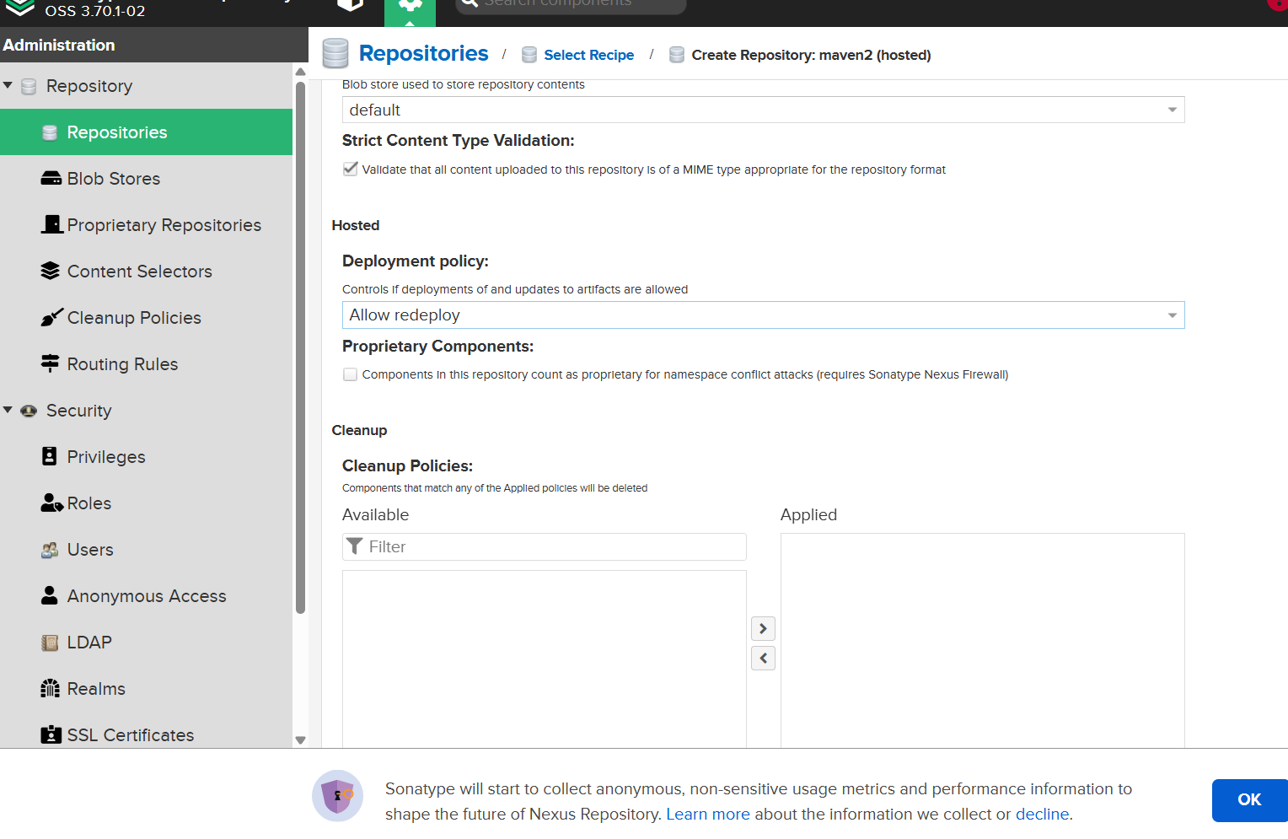
ensuring your artifact storage environment is ready to receive build outputs.
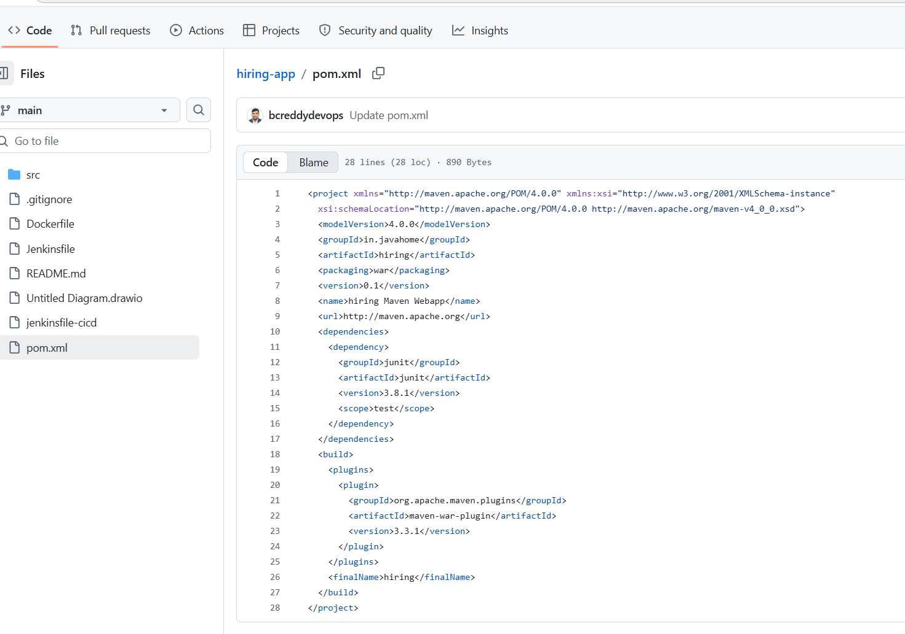and we can give the group ID, artifact ID, and versioning details within the Jenkins build configuration to map your project structure correctly
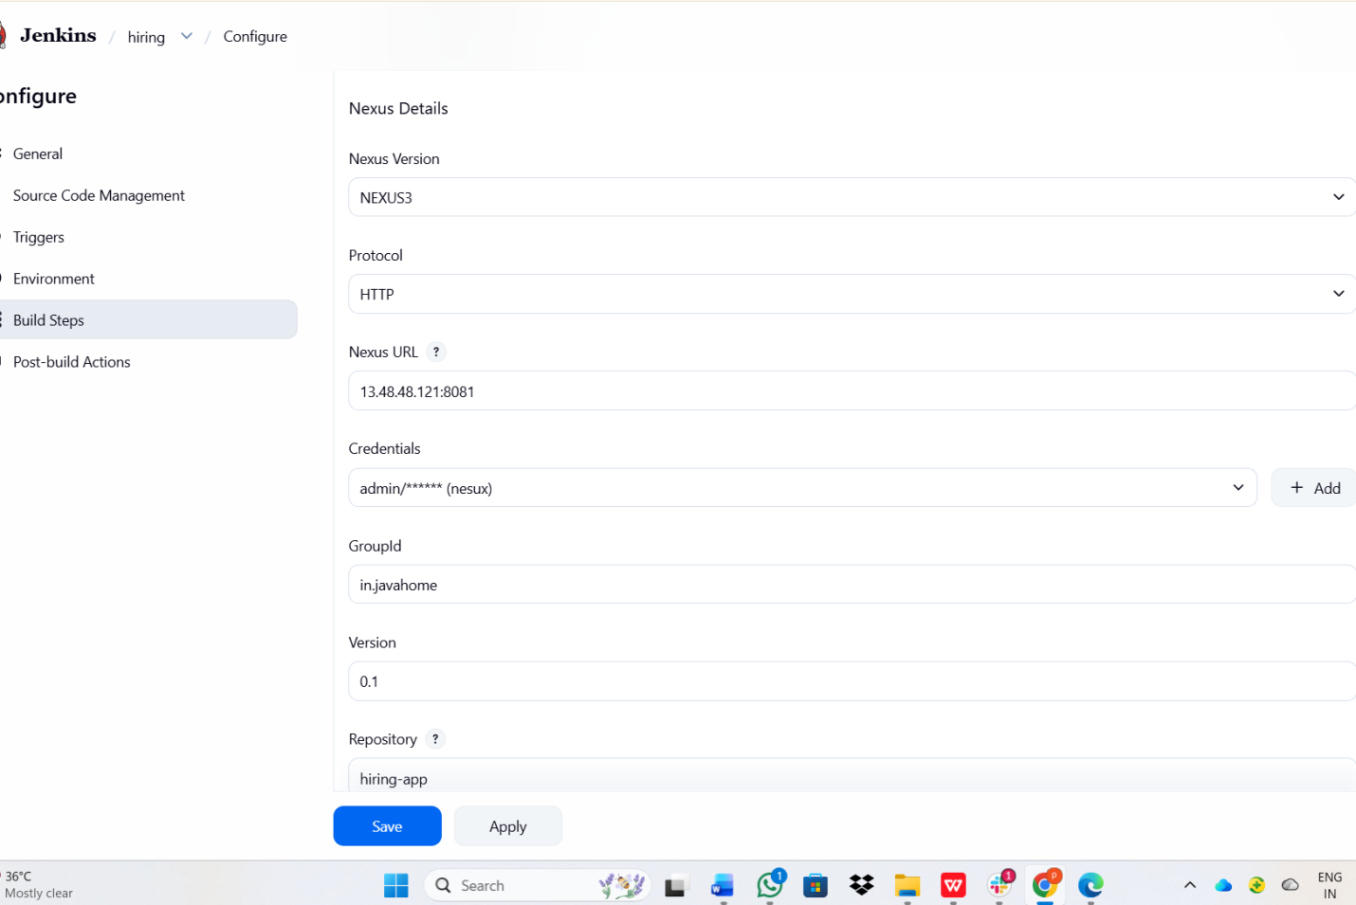
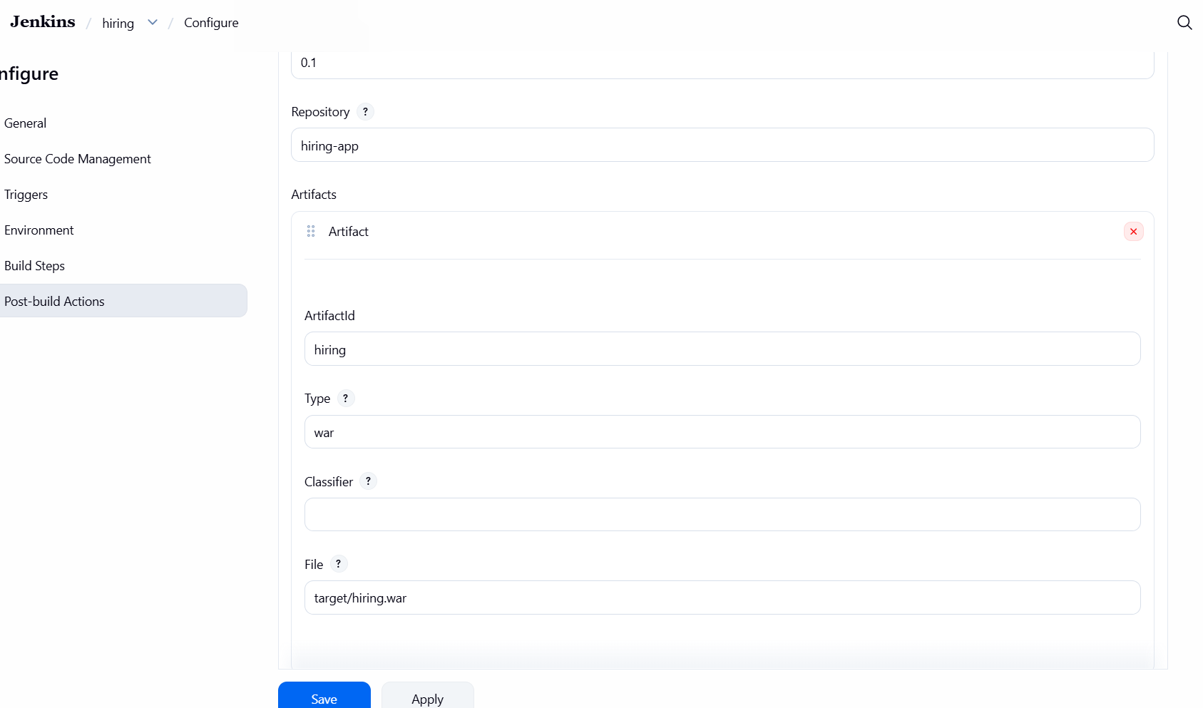
After that you need to configure the build now section to trigger the pipeline,
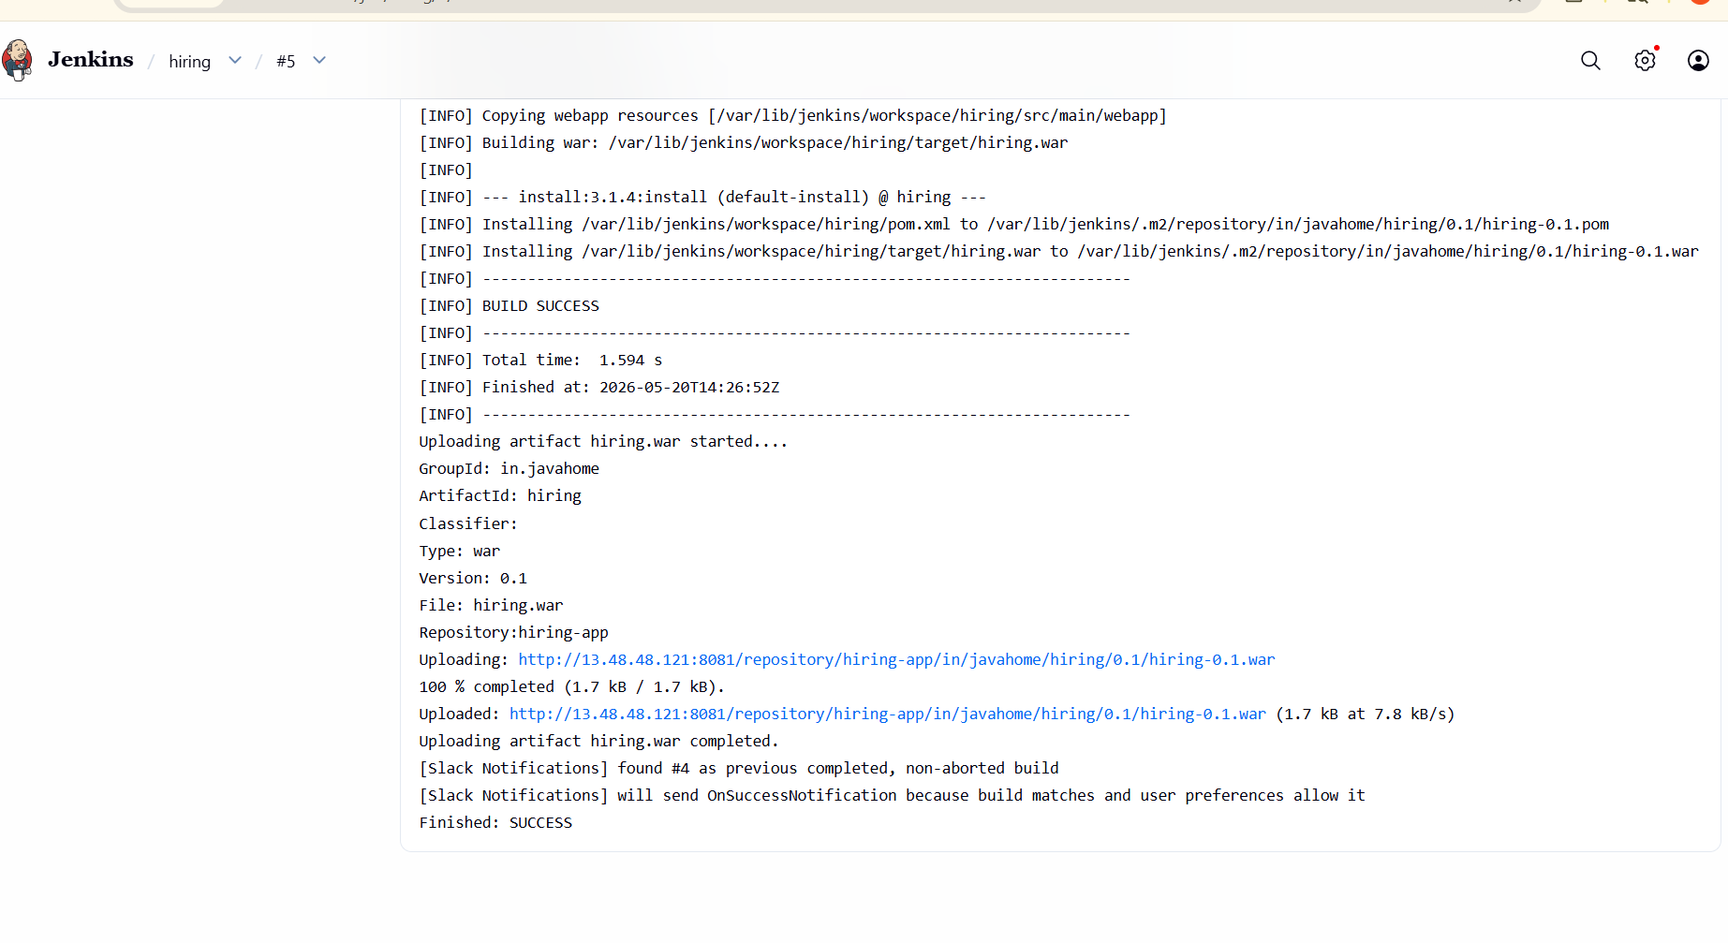
- Deploy On tomcat
We can in install tomcat in nexus sever
Navigated to /opt
Downloaded Tomcat archive:
wget https://dlcdn.apache.org/tomcat/tomcat-9/v9.0.113/bin/apache-tomcat-9.0.113.tar.gz
Extracted the archive:
tar -xvf apache-tomcat-9.0.113.tar.gz
Tomcat directory created successfully
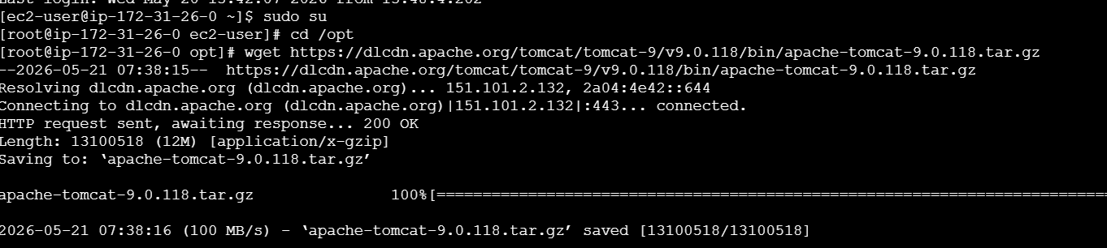
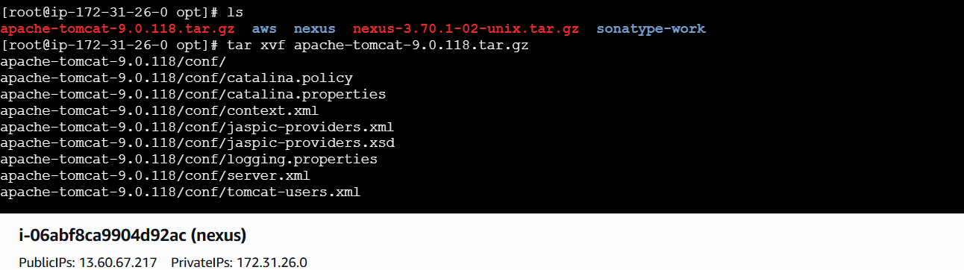
Now we can rename the directory to tomcat
Mv apache-tomcat-9.0.118 tomcat
We see the name give that ls
Change cd bin
Ls
./startup.sh. This command initializes the Tomcat server process. Once initiated,

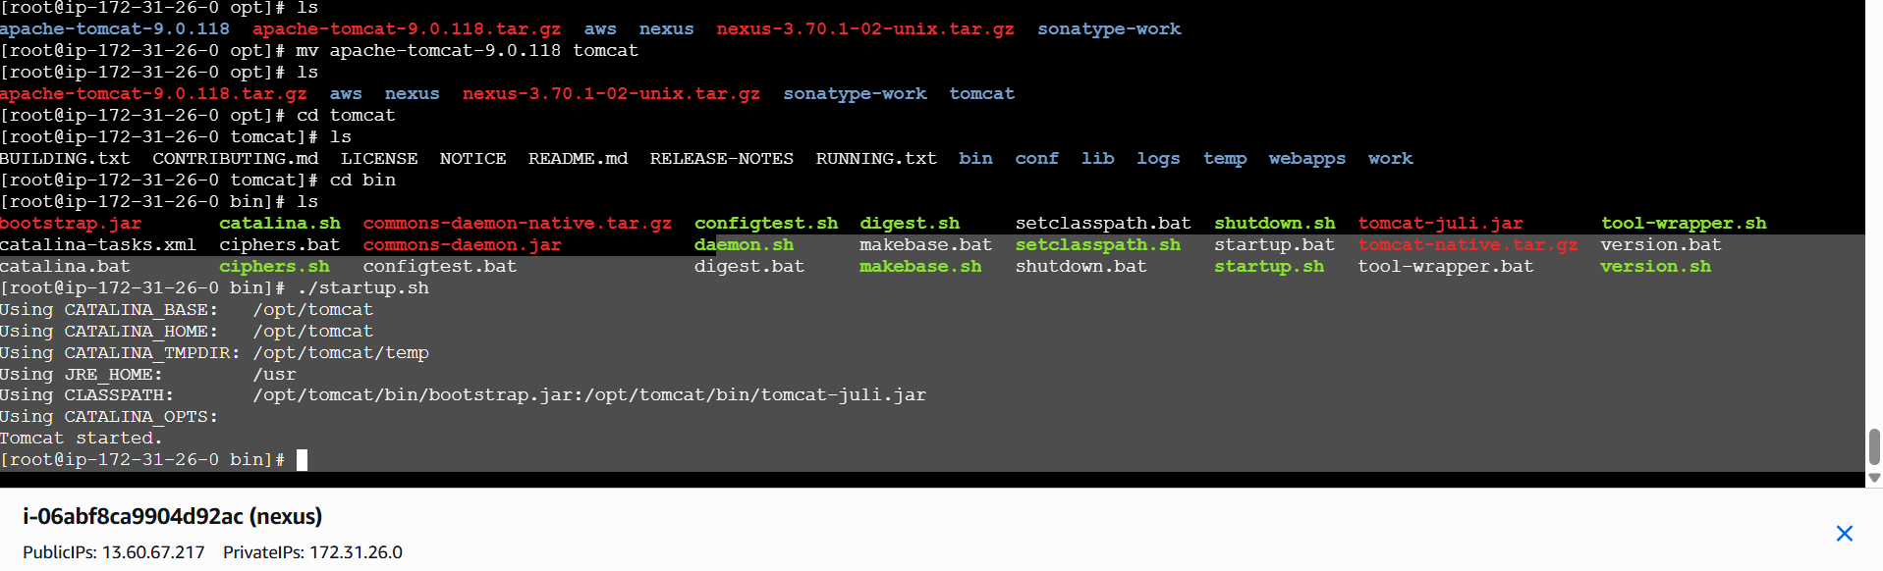
Now we can check the browser by accessing the server's IP address on port 8080 to verify that
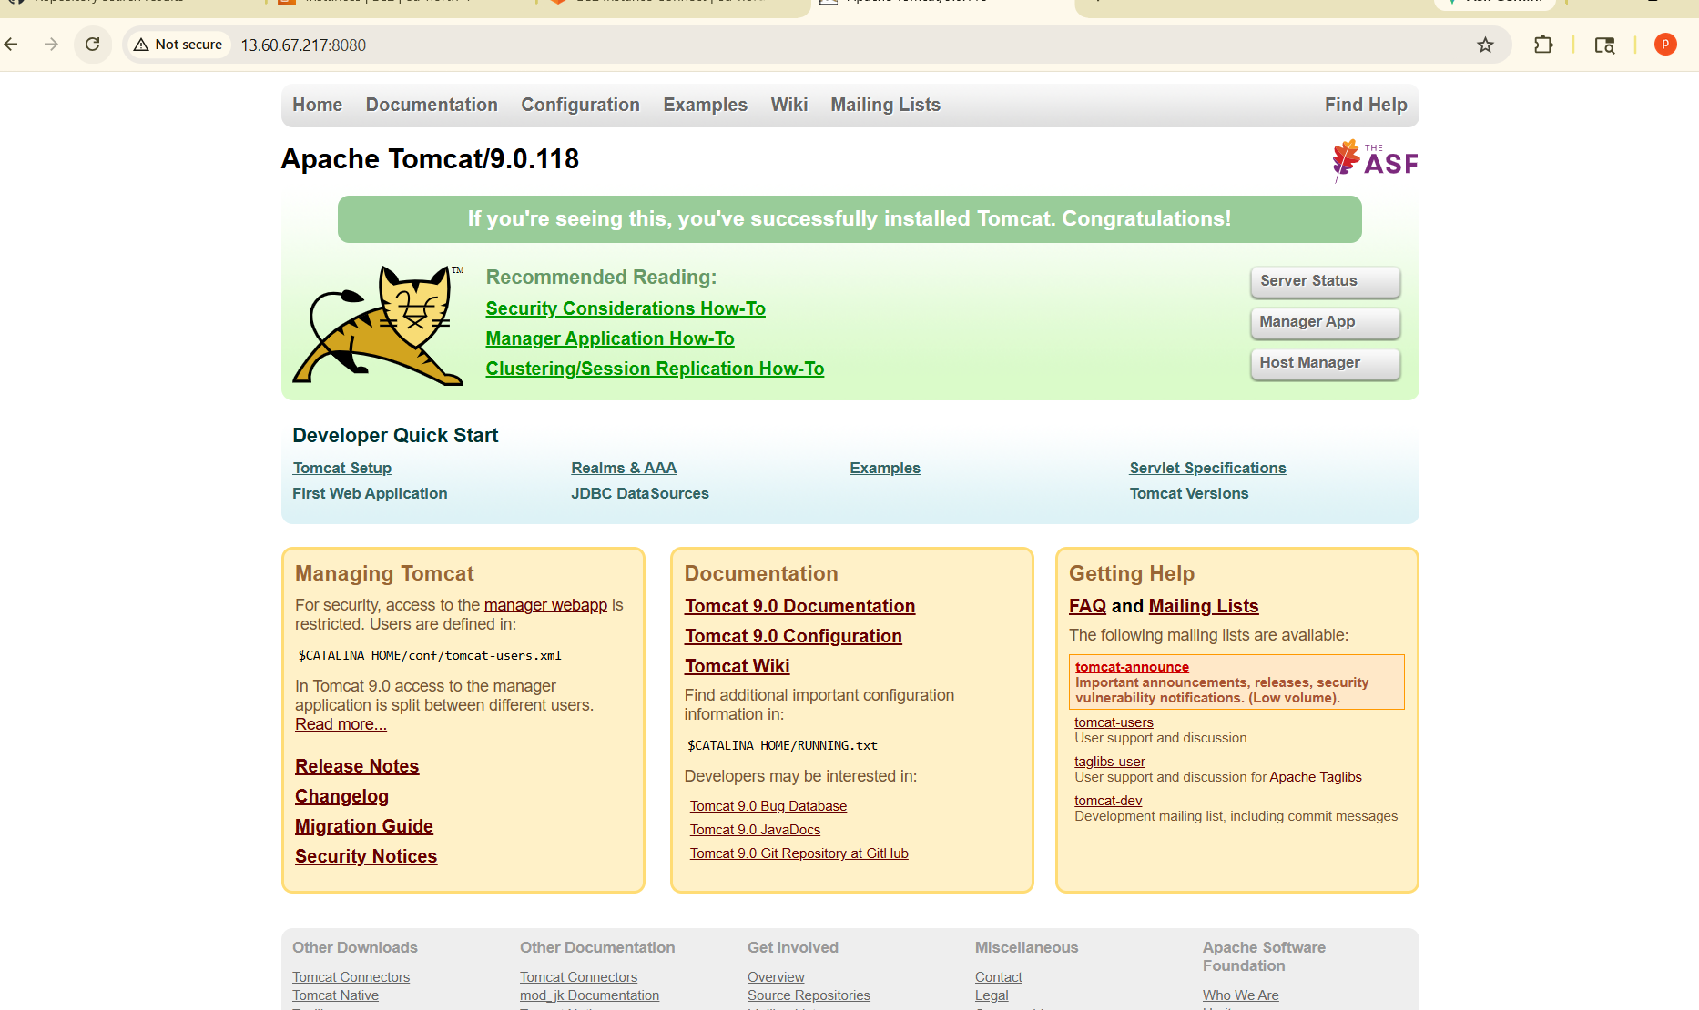

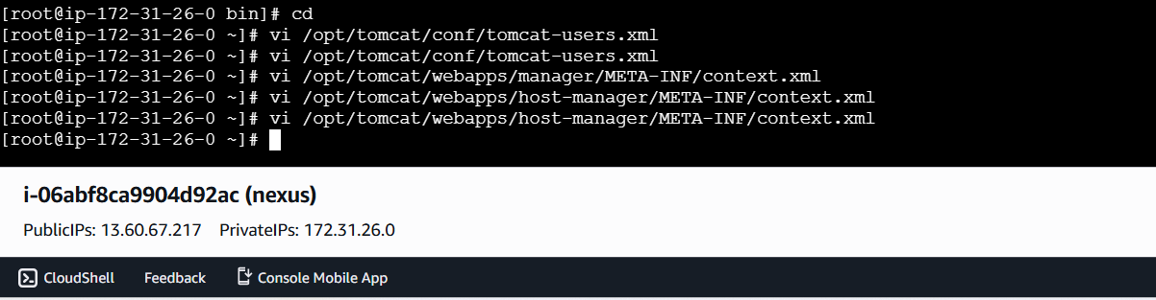
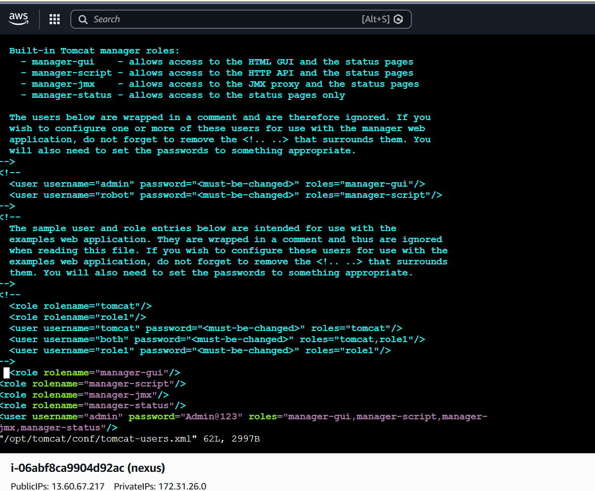
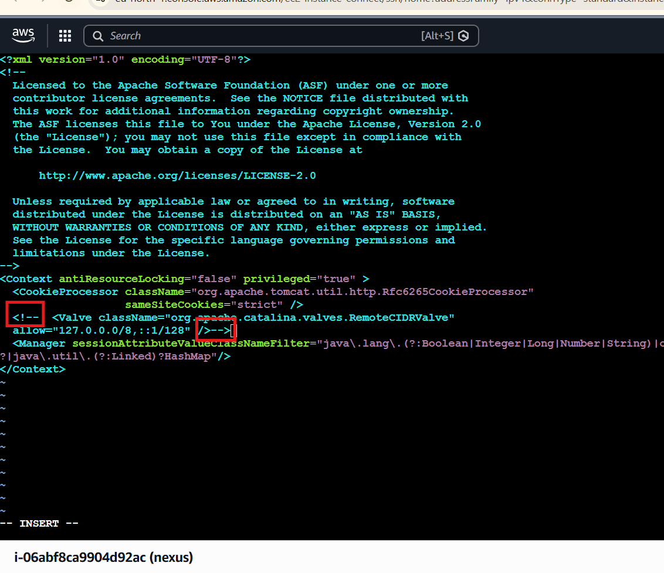
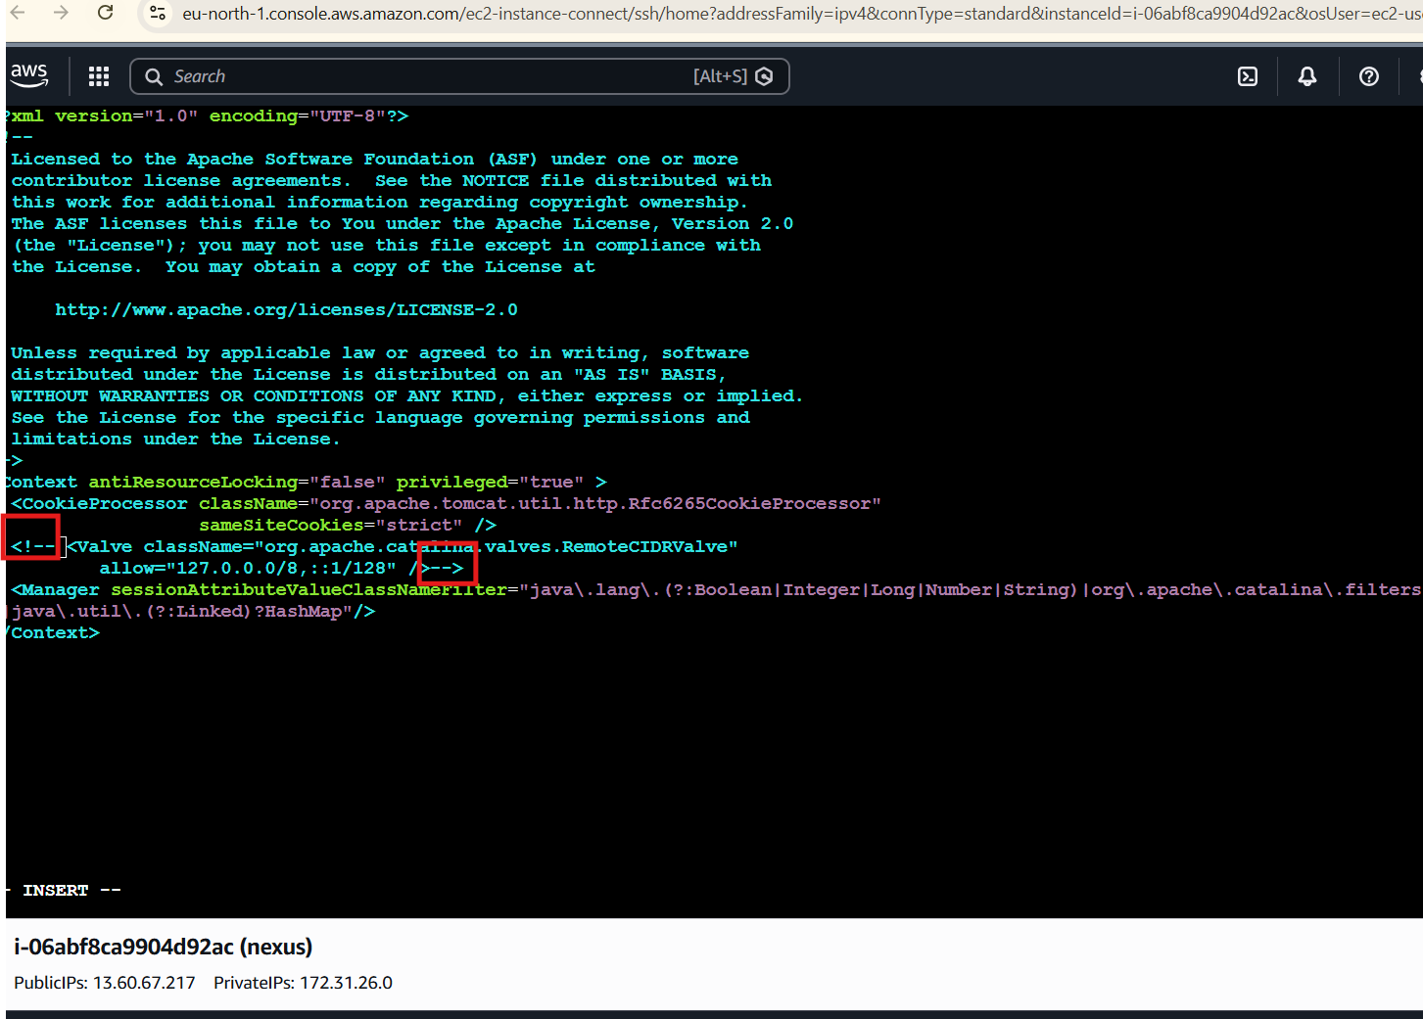
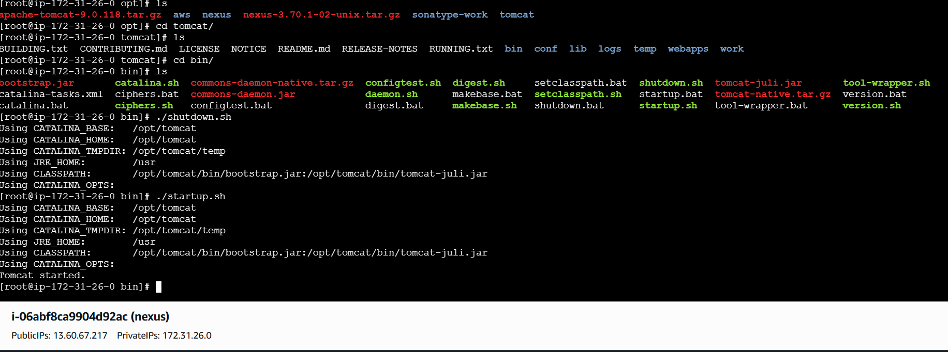
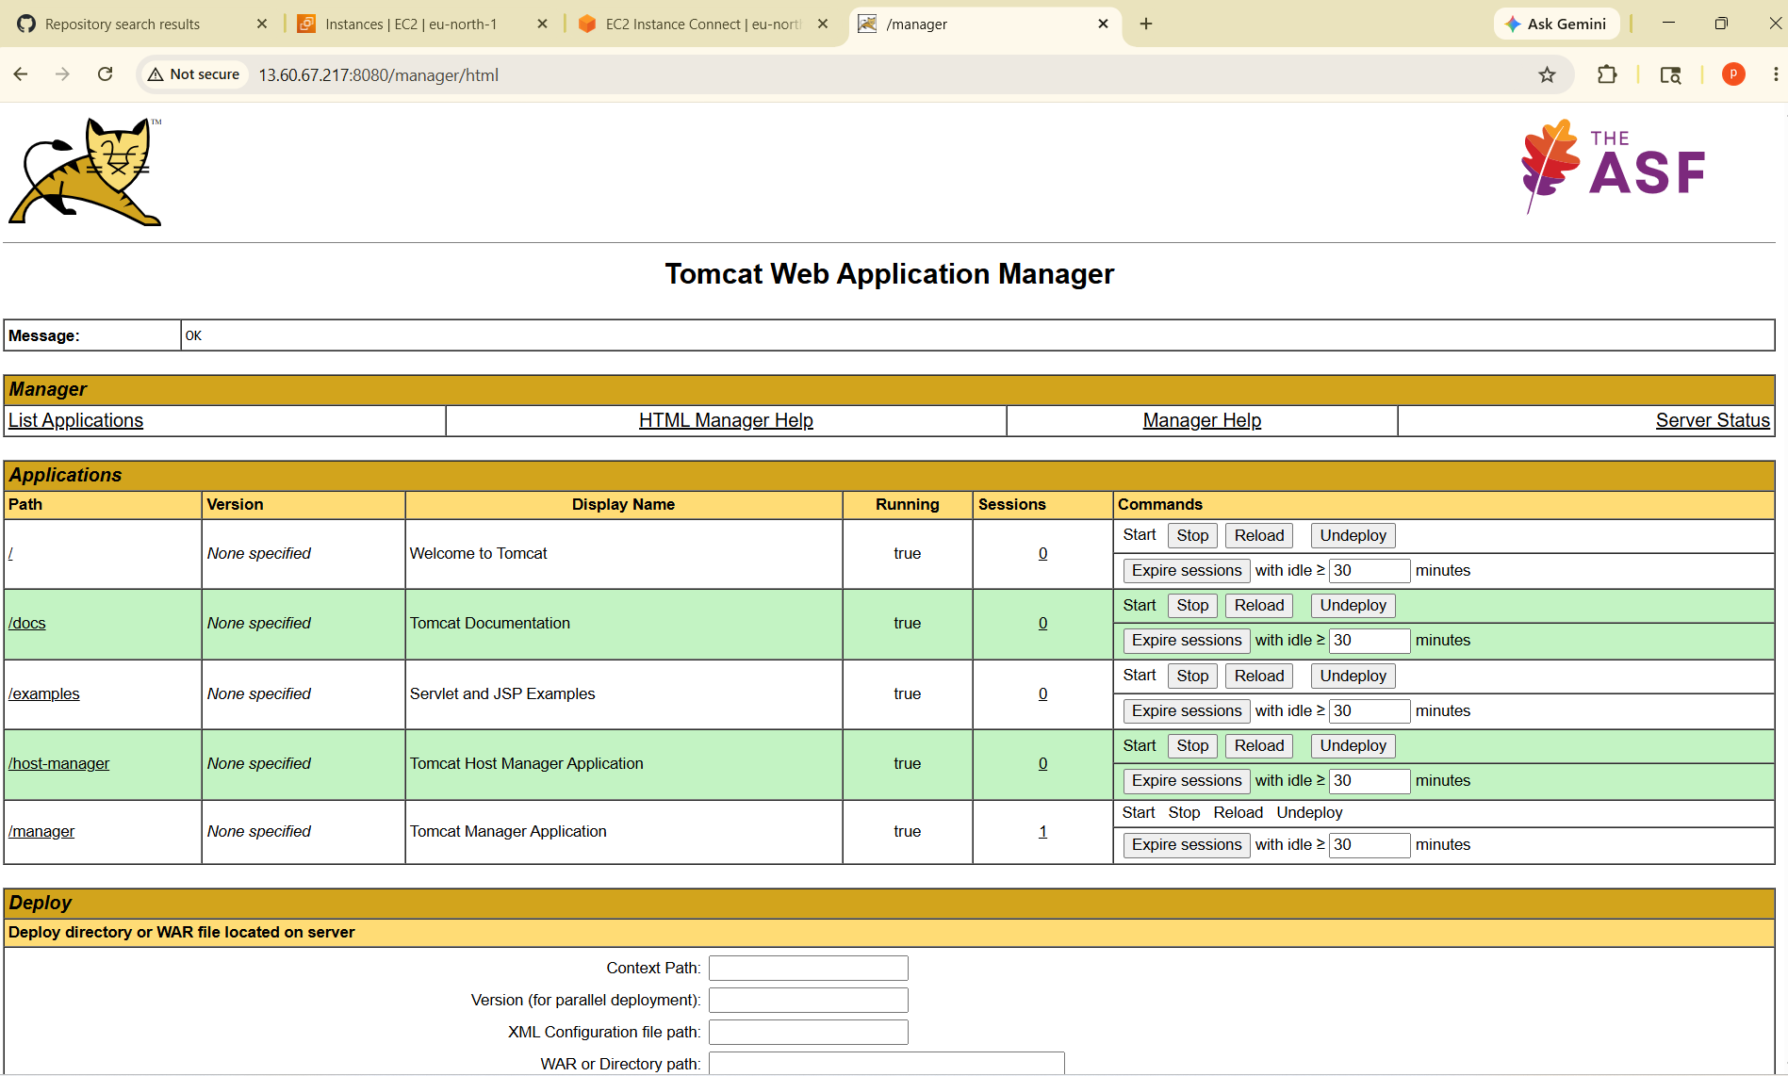
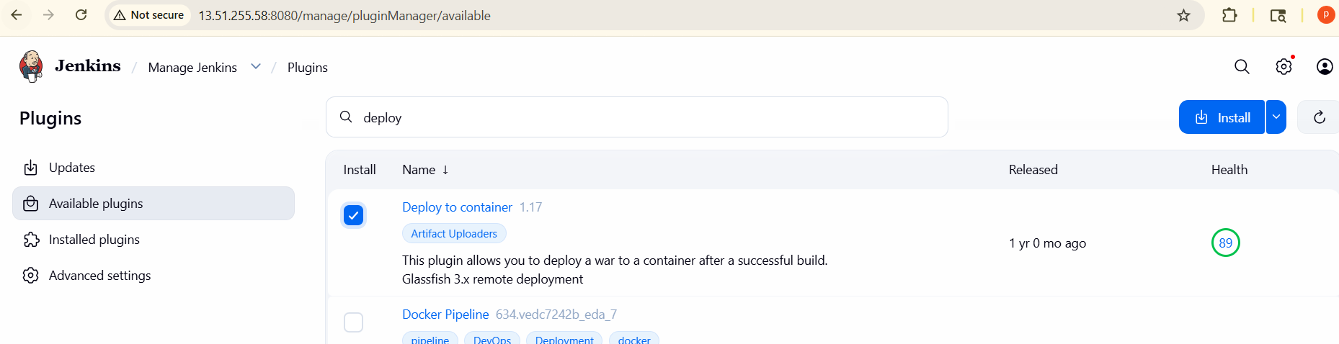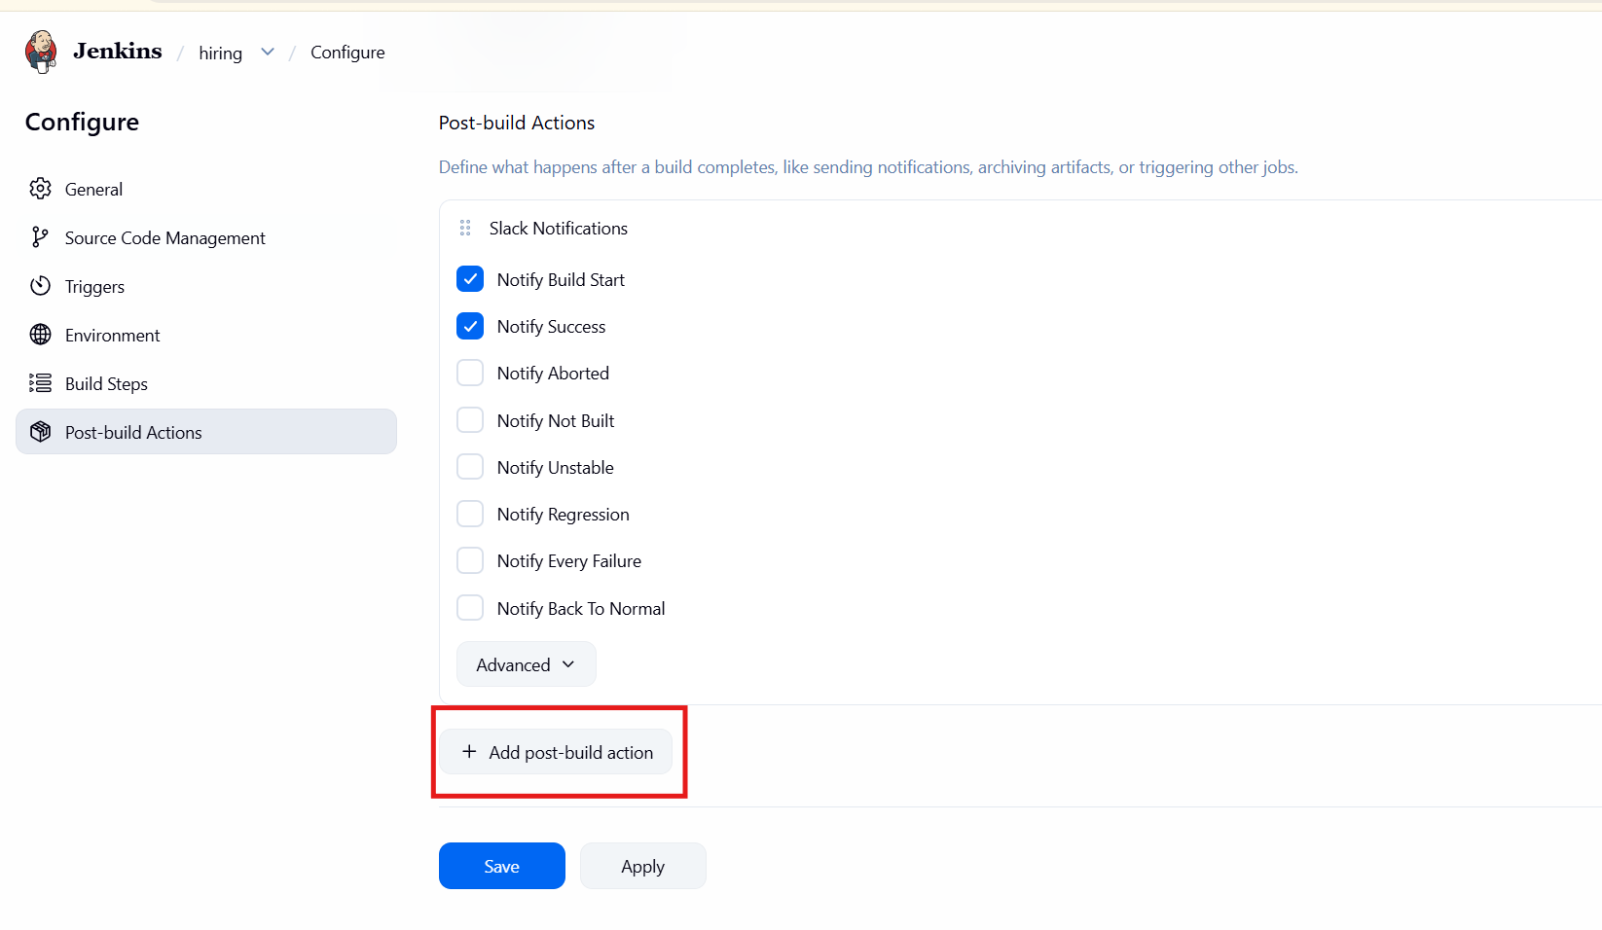
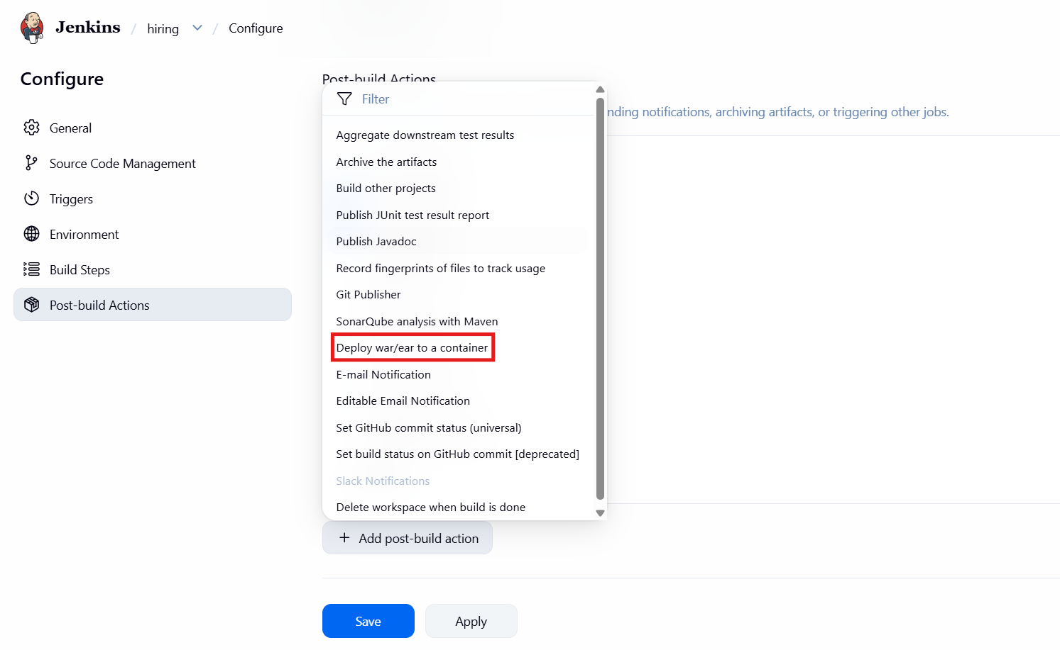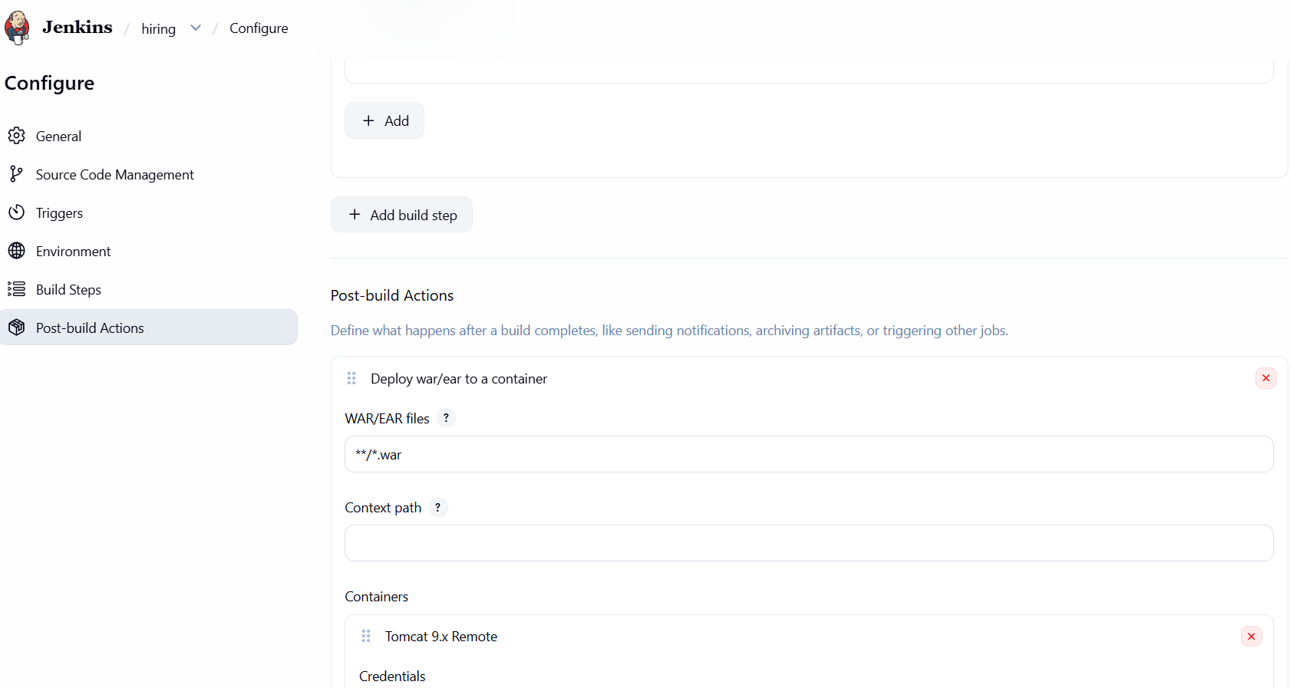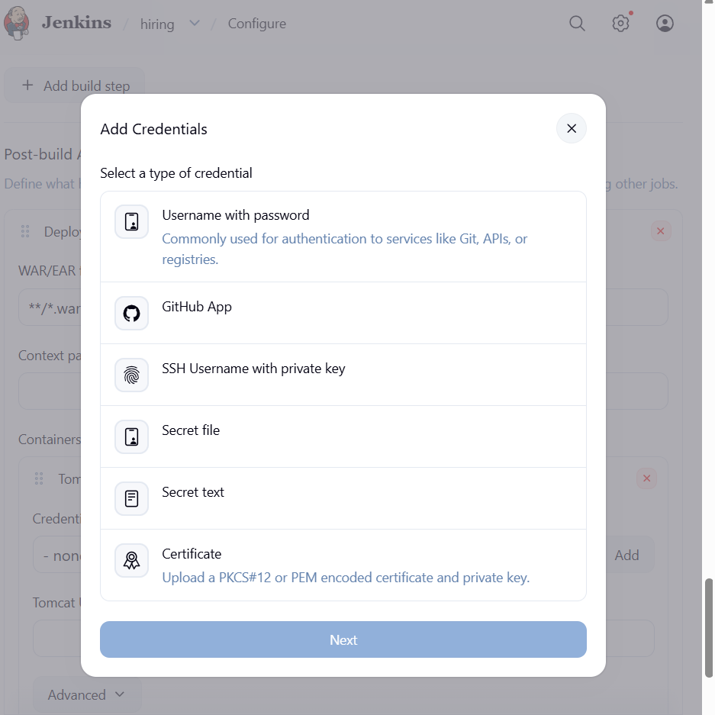
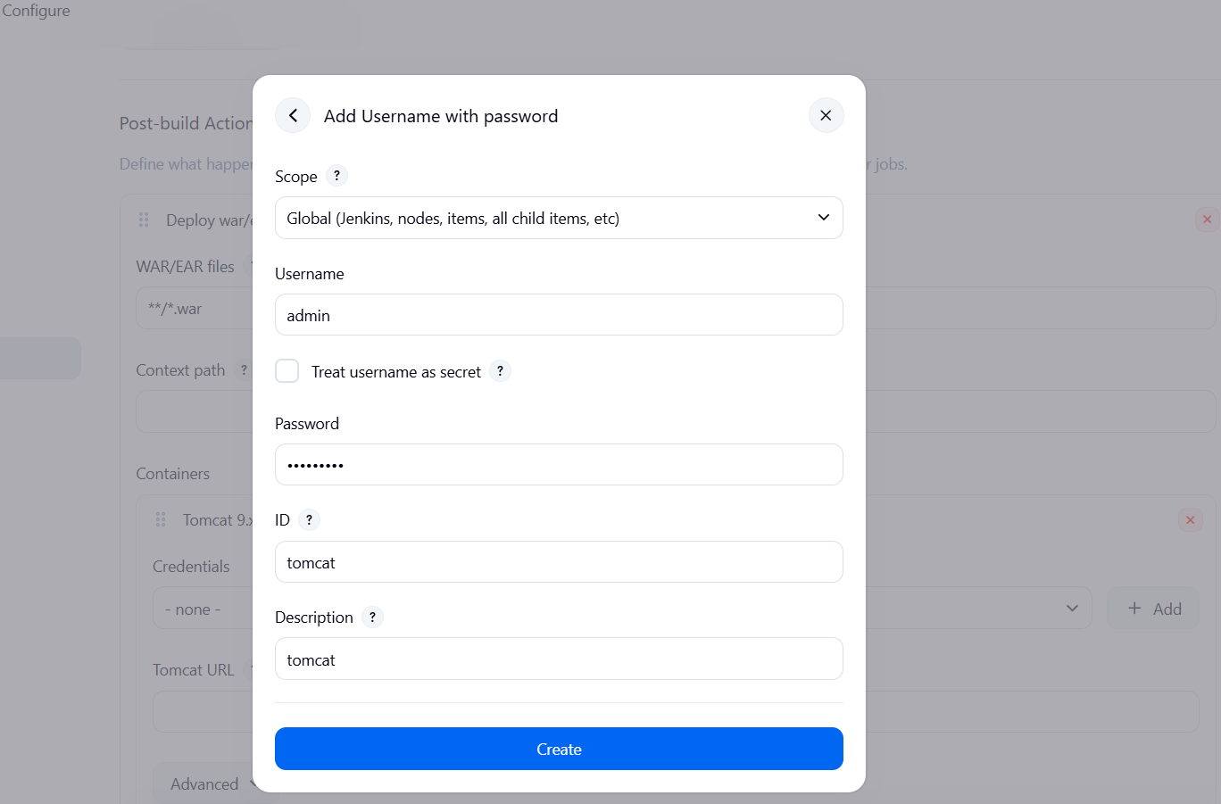
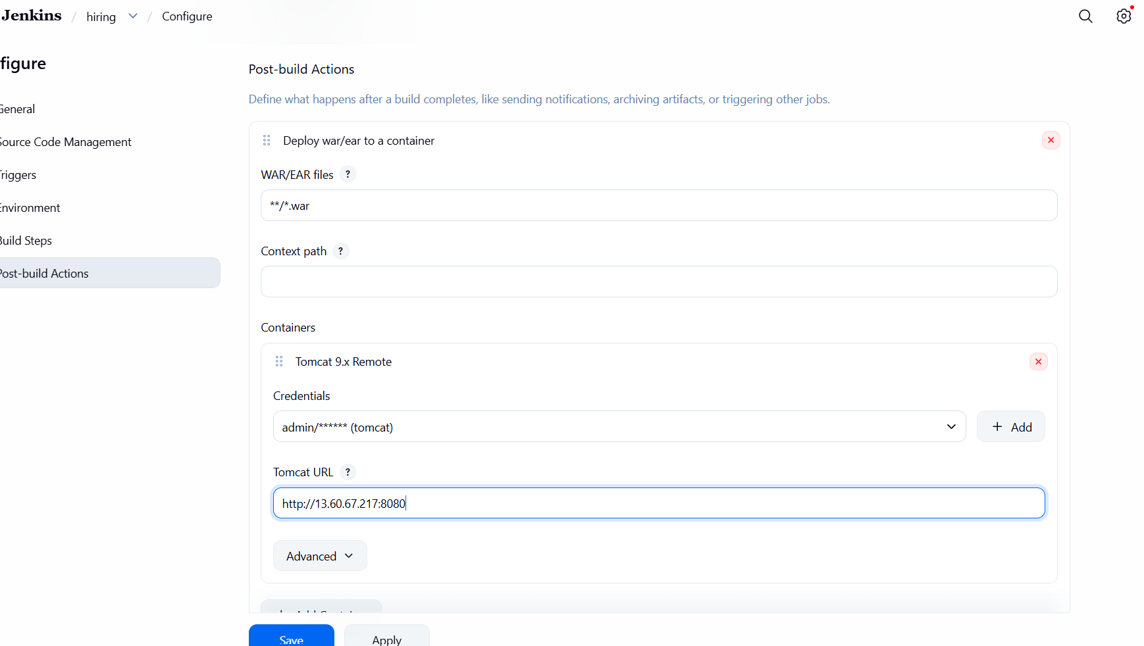

step-01
Now we get console output is error now iam checking first the sonarqube scanner is running or not
I need to run sonarqube where we are install sonarqube scanner go to the server
Swetch to root user-->cd /opt-->ls--> cd sonar-->su pinky-->ls--> cd linux-->./ sonar.sh start-->./sonar.sh status
Step-02: after confirming the sonarqube service is successfully running,
we proceed to configure the jenkins dashboard--> Manage Jenkins--> System--> to integrate the SonarQube server details.
Step-03 :Once the integration is established,
Then go master jenkins server (ec2) cd /opt -->ls--> cd sonar-scanner-->ls-->cd conf-->ls-->vi sonar-scanner.properties. Ensure the sonar.host.url will be changedto point towards your SonarQube server address,
After that we can check nexus is running or not
Step-04 : navigate to the Nexus installation directory, sudo su-->cd /opt-->ls-->cd nexus-->la-->cd/bin--> ./nexus start-->./nexus status

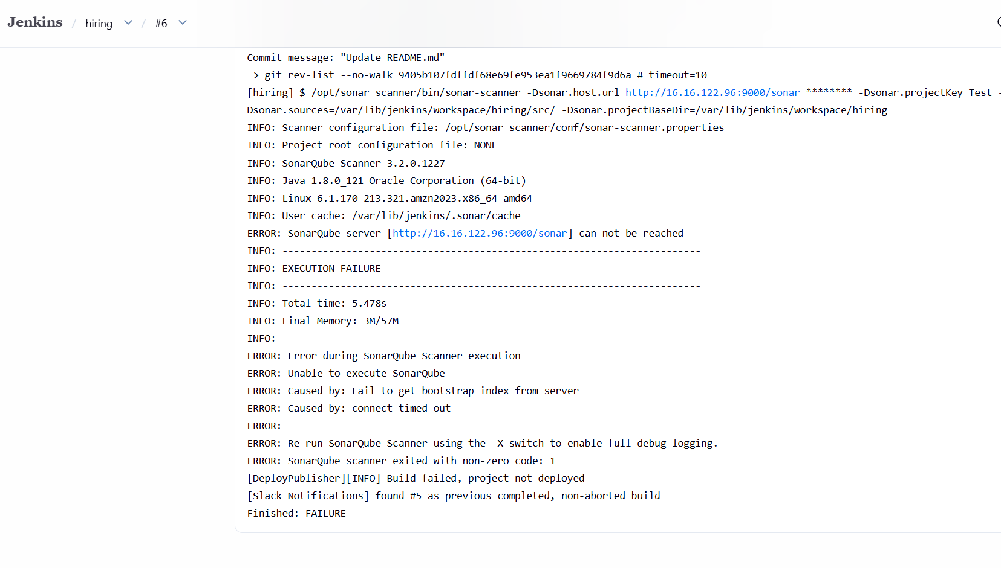

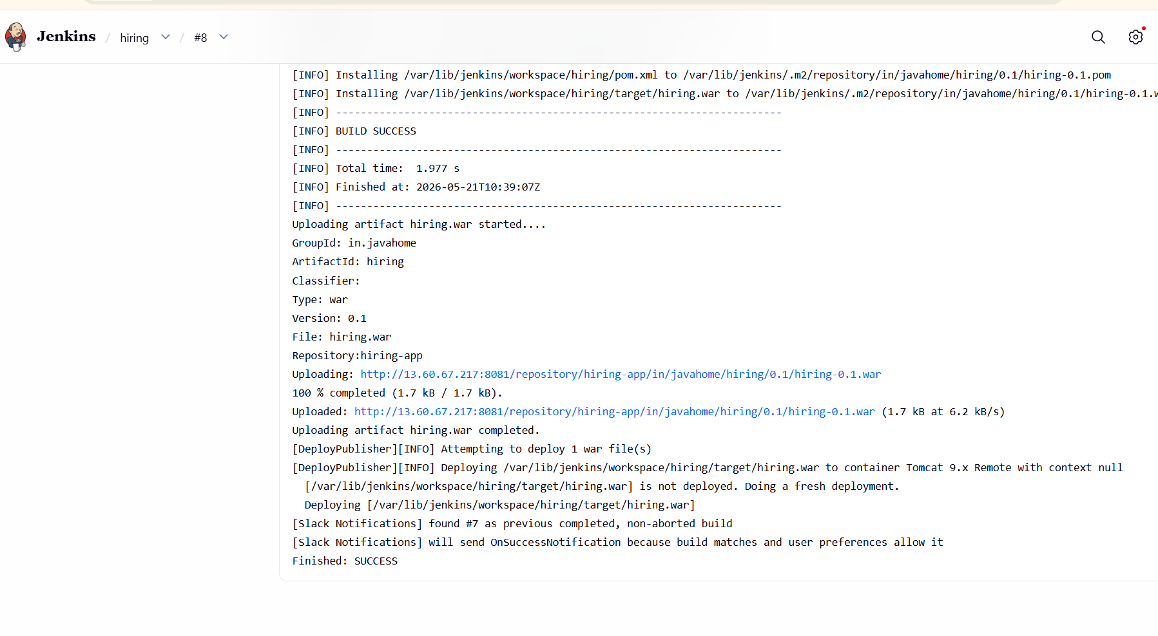
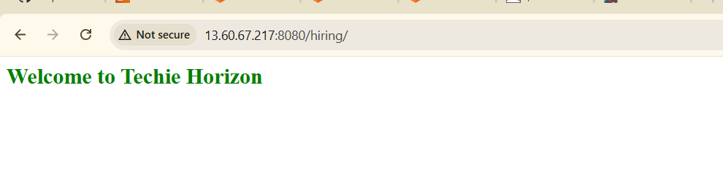
- Setup a Jenkins CICD pipeline using Declarative pipeline using feature-1.1 branch.
Source Code: https://github.com/betawins/sabear_simplecutomerapp/tree/feature-1.1
stages:
Git Clone
SonarQube Integration
Maven Compilation
Nexus Artifactory
Slack Notification
Deploy On tomcat
- First Opened Jenkins dashboard
- Clicked -->New Item
- Entered job name--> SIMPLECUSTOMERAPP
- Selected--> Pipeline as the job type
- Clicked OK

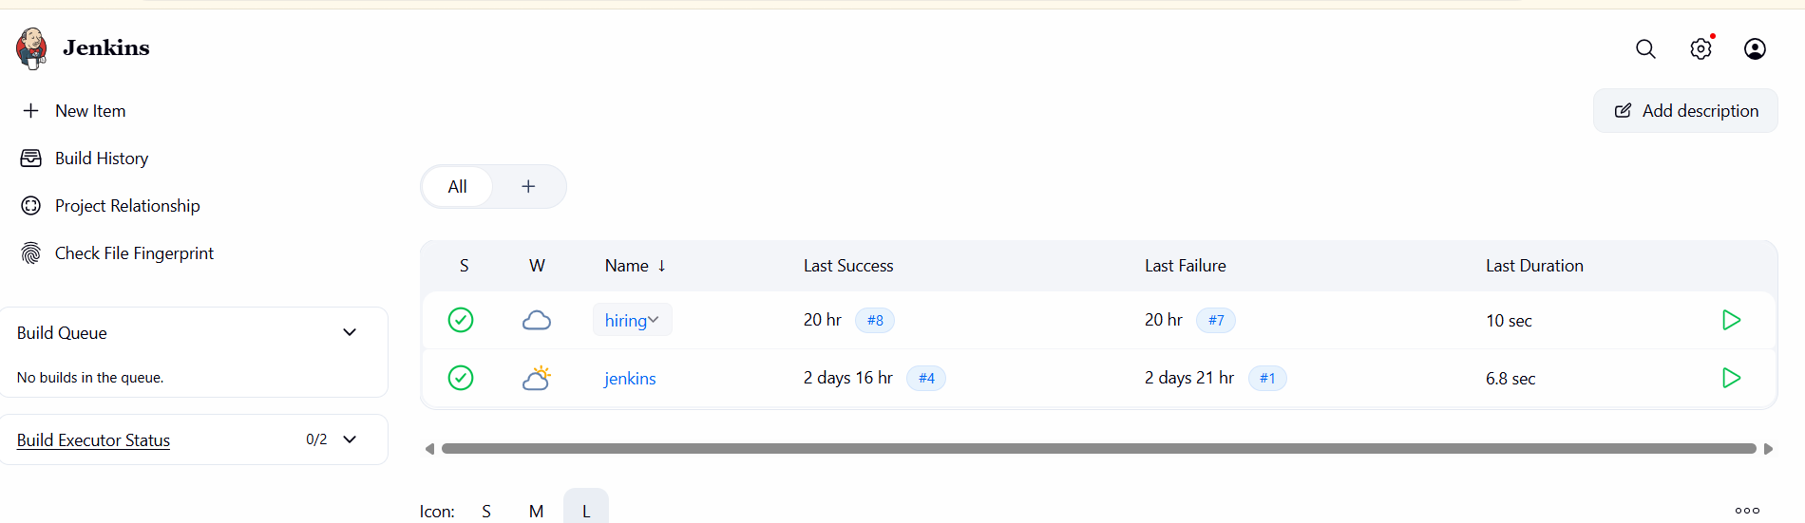
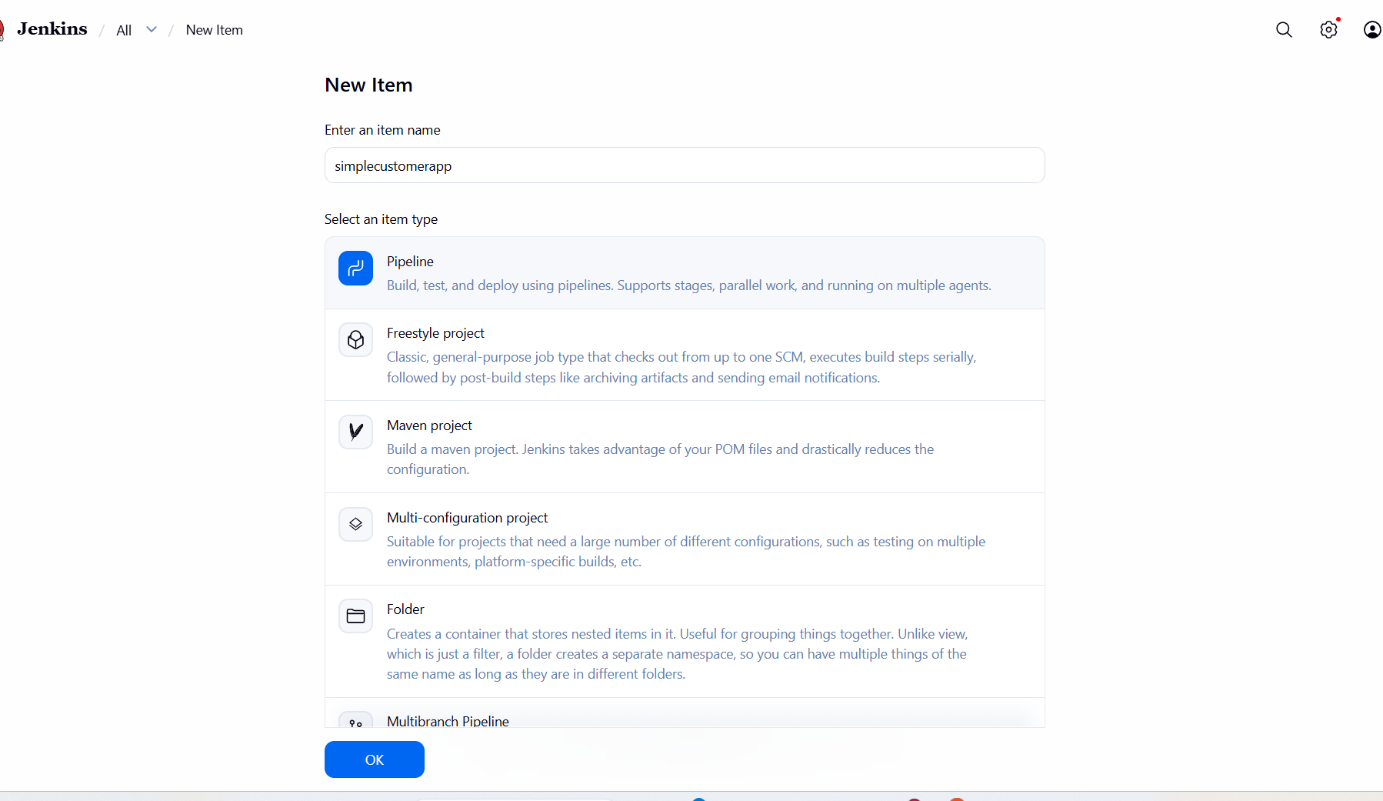
And go to nexus repository settings, newly created repository to verify the deployment path. Return to the Jenkins job configuration page,
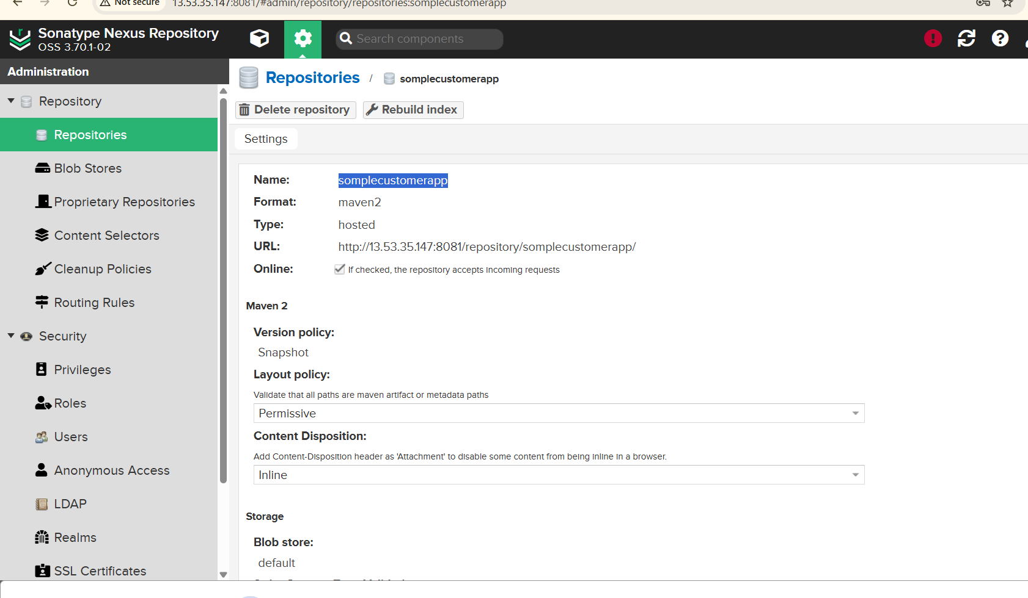
- Opened job Configure
- Navigated to Pipeline section
- Selected Pipeline script
- Added basic pipeline code with:

pipeline {
agent any

tools {
maven 'maven'
}

stages {

stage('Clean Workspace') {
steps {
cleanWs()
}
}

stage('Clone Code') {
steps {
git branch: 'master',
url: 'https://github.com/betawins/sabear_simplecutomerapp.git'
}
}

stage('Build using Maven') {
steps {
sh 'mvn clean install'
}
}

stage('Check Build Files') {
steps {
sh 'ls -ltr target'
}
}

stage('Publish to Nexus') {
steps {
script {

try {

def artifactPath = sh(
script: "ls target/*.war | head -1",
returnStdout: true
).trim()

echo "Uploading Artifact: ${artifactPath}"

nexusArtifactUploader(
nexusVersion: 'nexus3',
protocol: 'http',
nexusUrl: '3.145.186.141:8081',
repository: 'maven-newapp',
groupId: 'com.javatpoint',
version: "${BUILD_NUMBER}-SNAPSHOT",
credentialsId: 'nexus-cred',

artifacts: [
[
artifactId: 'SimpleCustomerApp',
classifier: '',
file: artifactPath,
type: 'war'
]
]
)

} catch (Exception e) {

error "Failed to upload artifact to Nexus: ${e.message}"
}
}
}
}

stage('Deploy On Tomcat') {
steps {
script {

try {

def warFile = sh(
script: "ls target/*.war | head -1",
returnStdout: true
).trim()

echo "Deploying WAR: ${warFile}"

deploy adapters: [
tomcat9(
credentialsId: 'tomcat-creds',
path: '',
url: 'http://3.131.90.248:8080/manager/text'
)
],
contextPath: '/sabaer',
war: warFile

} catch (Exception e) {

error "Deployment to Tomcat failed: ${e.message}"
}
}
}
}
}

post {

success {

echo ":white_check_mark: Pipeline SUCCESS: Job=${env.JOB_NAME} Build=#${env.BUILD_NUMBER}"
}

failure {

echo ":x: Pipeline FAILED: Job=${env.JOB_NAME} Build=#${env.BUILD_NUMBER}"
}
}
}
Give the above script
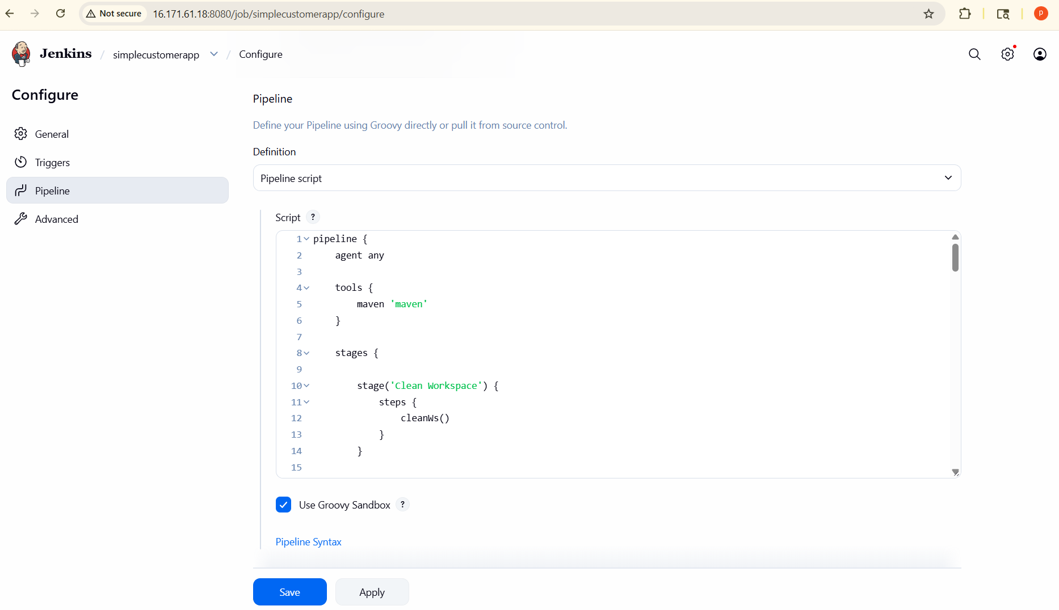
Save and build now
Successfully start the pipeline
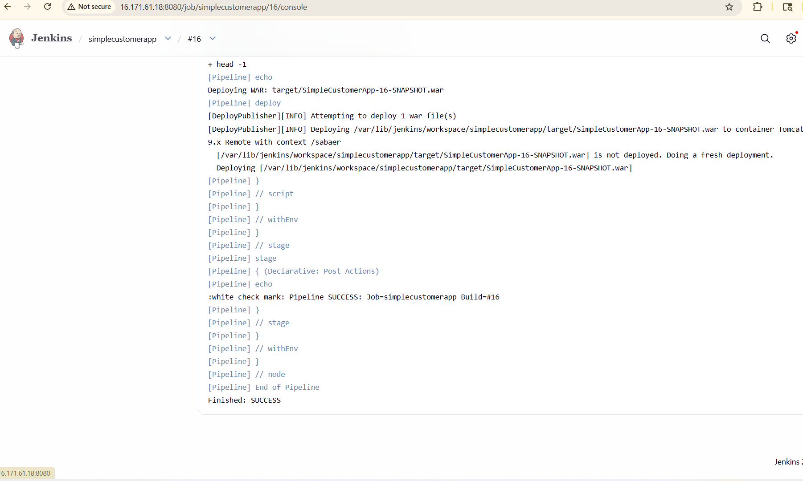
Go to tomcat browser verifiy the application is runnnig
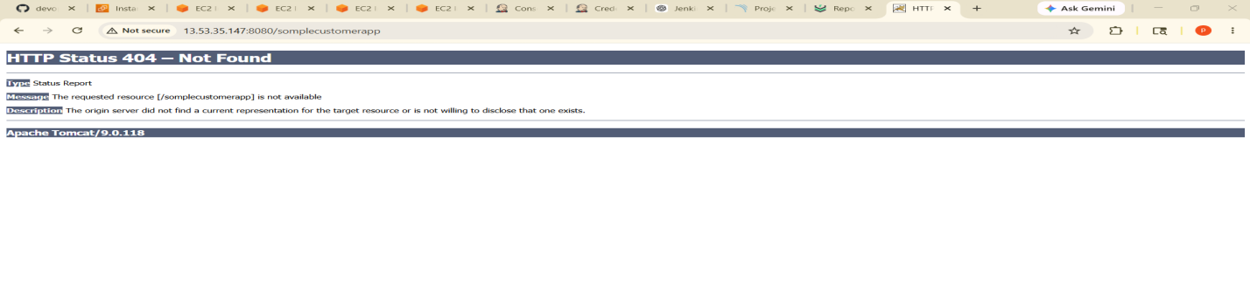3) Setup a Jenkins CICD pipeline using Scripted pipeline using feature-1.1 branch.
Source Code: https://github.com/betawins/sabear_simplecutomerapp/tree/feature-1.1
stages:
Git Clone
SonarQube Integration
Maven Compilation
Nexus Artifactory
Slack Notification
Deploy On tomcat
- First Opened Jenkins dashboard
- Clicked -->New Item
- Entered job name--> SIMPLECUSTOMERAPP
- Selected--> Pipeline as the job type
- Clicked OK

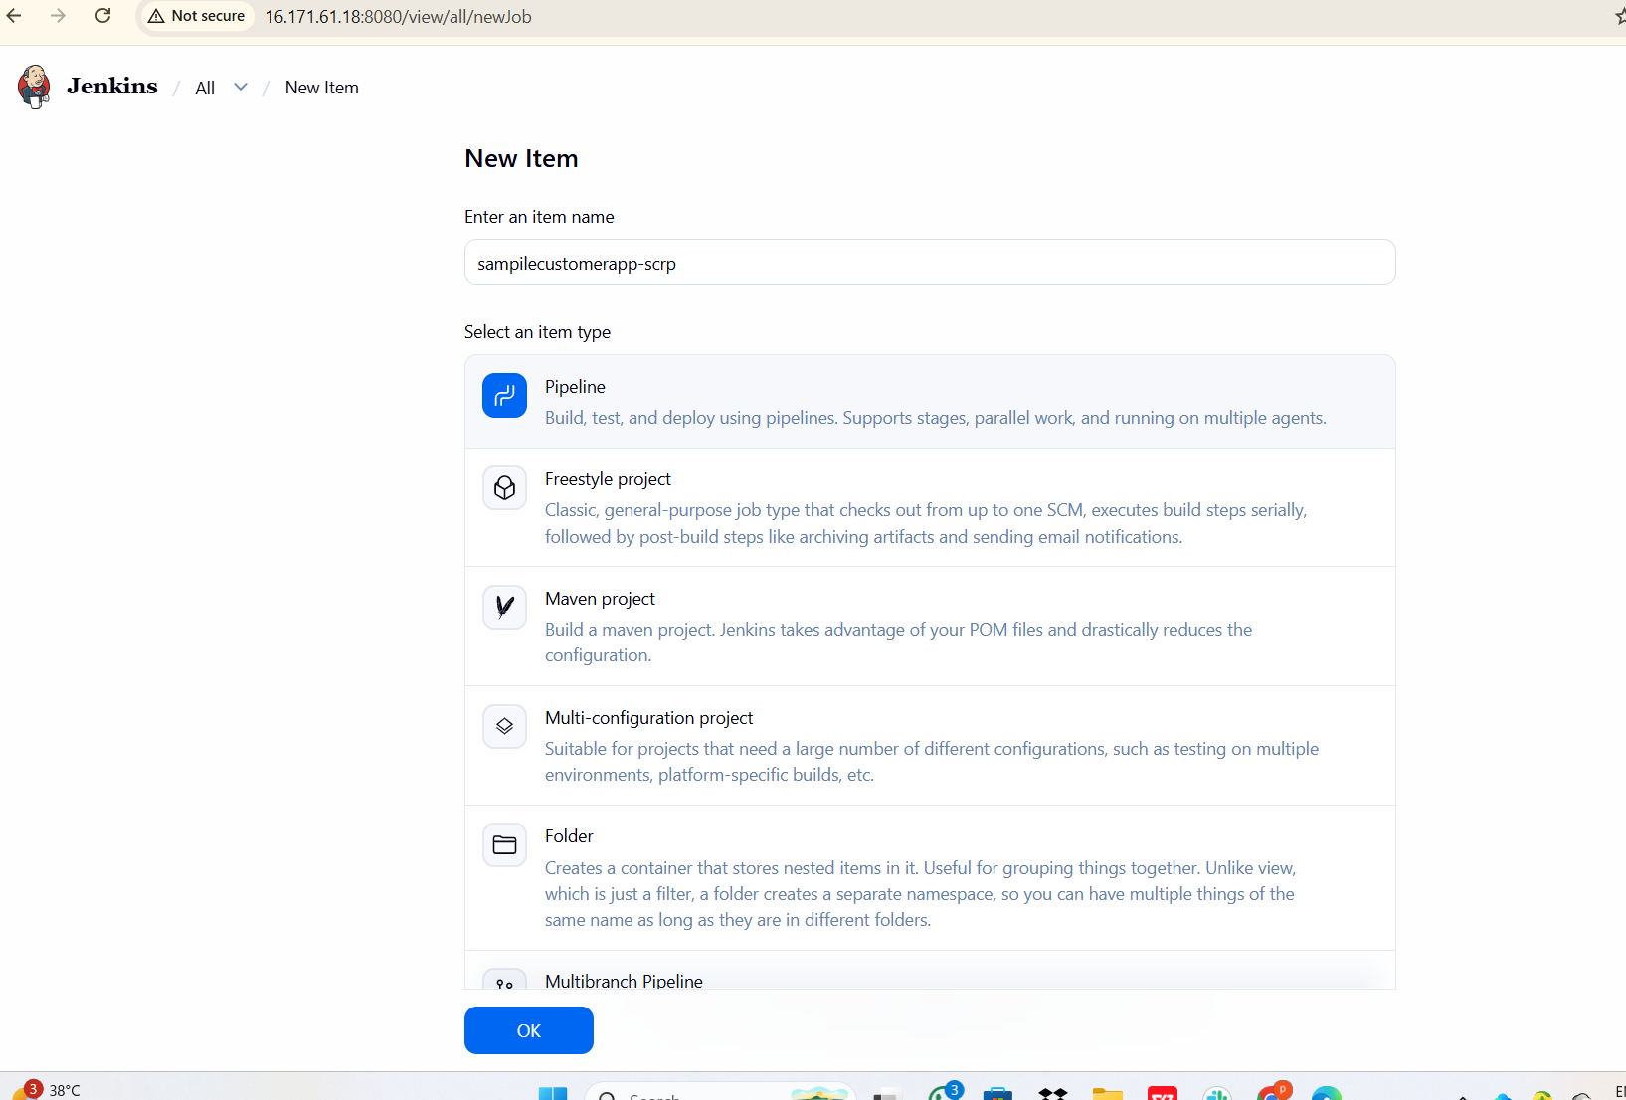
- Opened job Configure
- Navigated to Pipeline section
- Selected Pipeline script
- Added basic pipeline code with:
node {

// Maven Tool Configuration
def mvnHome = tool name: 'maven', type: 'maven'

try {

stage('Clean Workspace') {
cleanWs()
}

stage('Clone Code') {

git branch: 'master',
url: 'https://github.com/betawins/sabear_simplecutomerapp.git'
}

stage('Build using Maven') {

sh "${mvnHome}/bin/mvn clean install"
}

stage('Check Build Files') {

sh 'ls -ltr target'
}

stage('Publish to Nexus') {

try {

def artifactPath = sh(
script: "ls target/*.war | head -1",
returnStdout: true
).trim()

echo "Uploading Artifact: ${artifactPath}"

nexusArtifactUploader(
nexusVersion: 'nexus3',
protocol: 'http',
nexusUrl: '13.53.35.147:8081',
repository: 'somplecustomerapp',
groupId: 'com.javatpoint',
version: "${BUILD_NUMBER}-SNAPSHOT",
credentialsId: 'nexus',

artifacts: [
[
artifactId: 'SimpleCustomerApp',
classifier: '',
file: artifactPath,
type: 'war'
]
]
)

} catch (Exception e) {

error "Failed to upload artifact to Nexus: ${e.message}"
}
}

stage('Deploy On Tomcat') {

try {

def warFile = sh(
script: "ls target/*.war | head -1",
returnStdout: true
).trim()

echo "Deploying WAR: ${warFile}"

deploy adapters: [
tomcat9(
credentialsId: 'tomcat',
path: '',
url: 'http://13.53.35.147:8080/manager/text'
)
],
contextPath: '/sabaer',
war: warFile

} catch (Exception e) {

error "Deployment to Tomcat failed: ${e.message}"
}
}

stage('Pipeline Success') {

echo "Pipeline SUCCESS: Job=${env.JOB_NAME} Build=#${env.BUILD_NUMBER}"
}

} catch (Exception e) {

stage('Pipeline Failure') {

echo "Pipeline FAILED: Job=${env.JOB_NAME} Build=#${env.BUILD_NUMBER}"
}
}
}
- Clicked Save
- Clicked Build Now

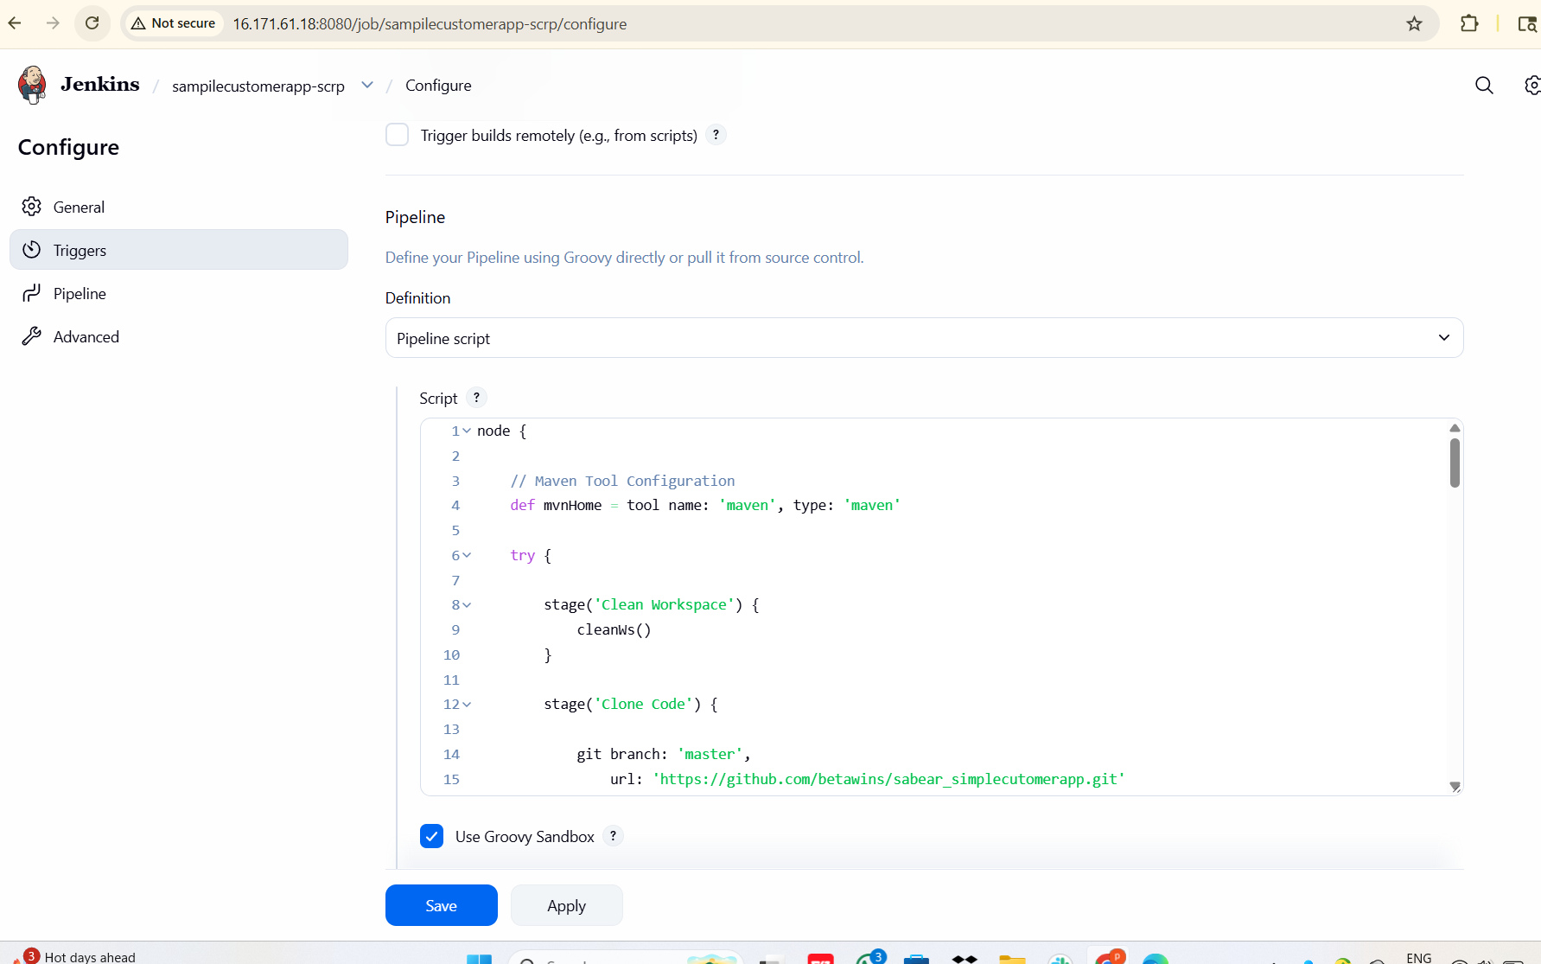
- Pipeline started successfully

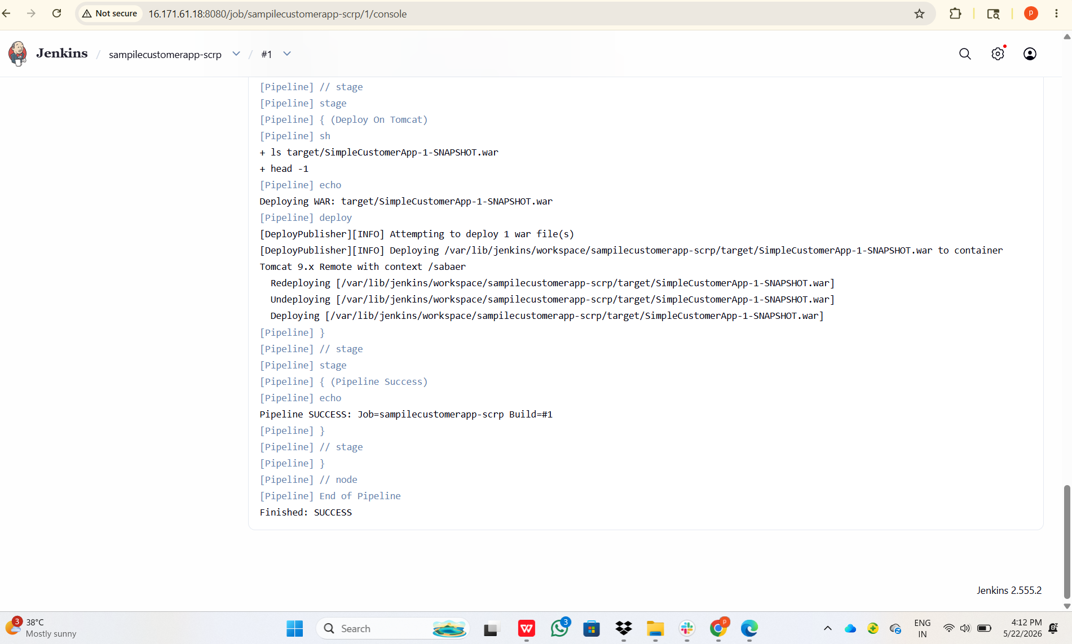

4) Write sample skeleton of pipelines.
pipeline {
agent any

tools {
// Define tools
maven 'maven'
}

environment {
// Environment variables
APP_NAME = "MyApp"
}

stages {

stage('Stage 1 - Clone Code') {
steps {
echo "Cloning source code..."
git 'https://github.com/example/repo.git'
}
}

stage('Stage 2 - Build') {
steps {
echo "Building application..."
sh 'mvn clean package'
}
}

stage('Stage 3 - Test') {
steps {
echo "Running tests..."
sh 'mvn test'
}
}

stage('Stage 4 - Deploy') {
steps {
echo "Deploying application..."
}
}
}

post {

success {
echo "Pipeline executed successfully!"
}

failure {
echo "Pipeline failed!"
}

always {
echo "Pipeline execution completed."
}
}
}

- Create a parameterized job in Jenkins.
Source Code: https://github.com/betawins/spring3-mvc-maven-xml-hello-world-1.git

Step 1: Open Jenkins Dashboard
- Login to Jenkins.
- Click New Item.

Step 2: Create New Job
- Enter Job Name
Example: Parameterized-Job
- Select Freestyle Project
- Click OK

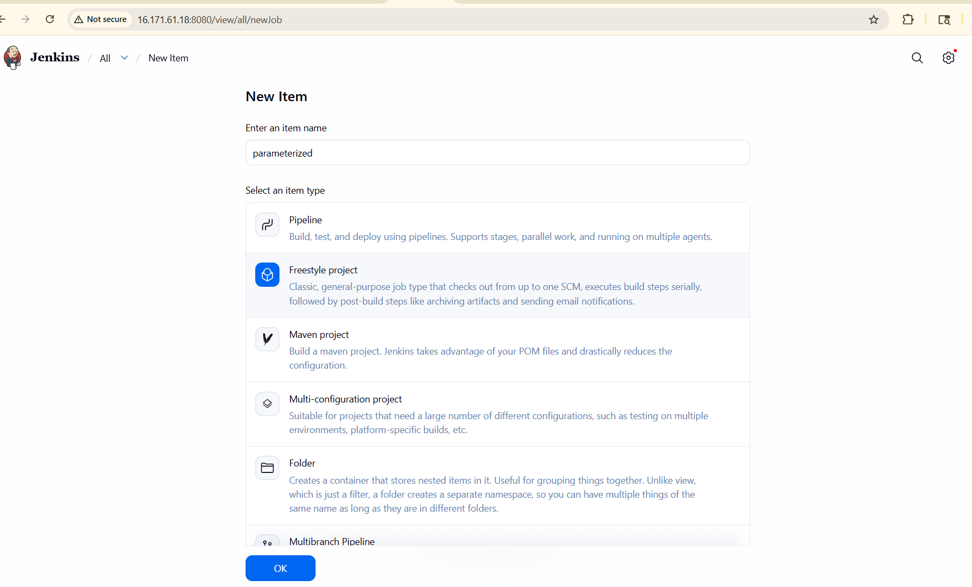

- Opened Configure → General
- Enabled This project is parameterized
- Added Choice Parameter
- Parameter name: ENV
- Choices added:
- dev
- qa
- prod
- Saved parameter configuration

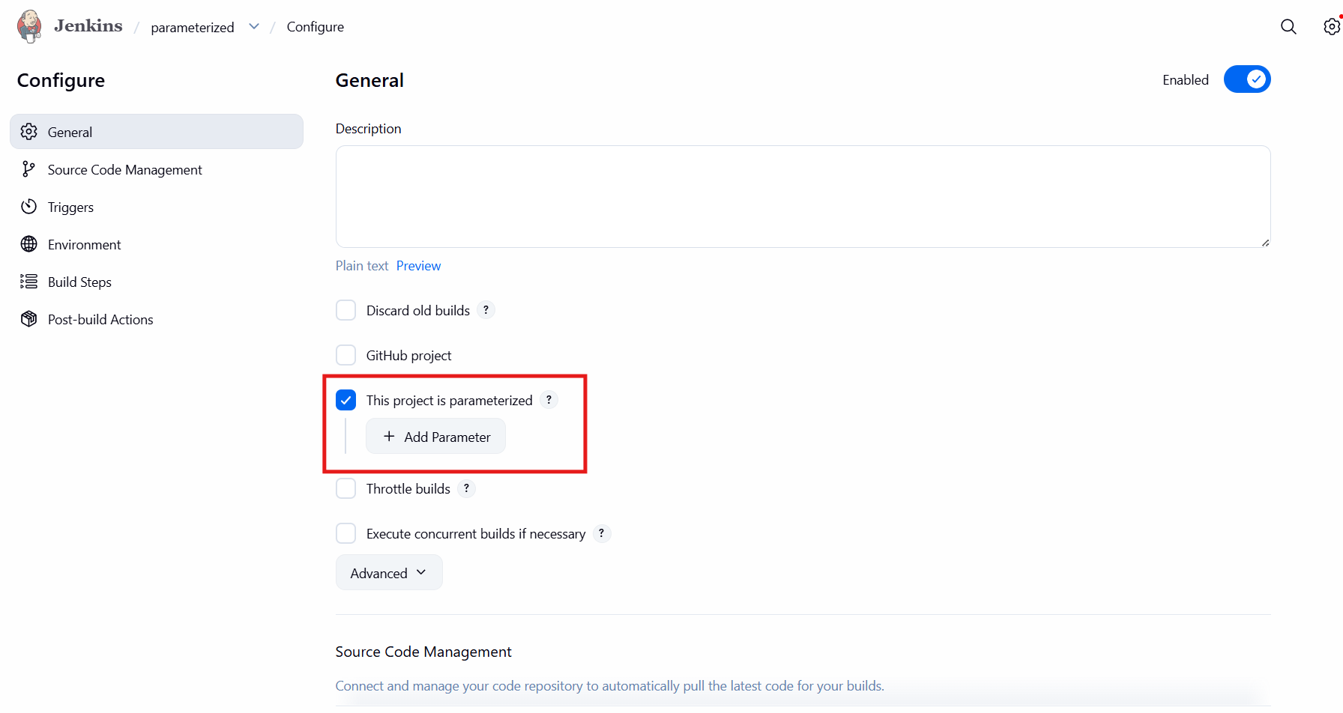
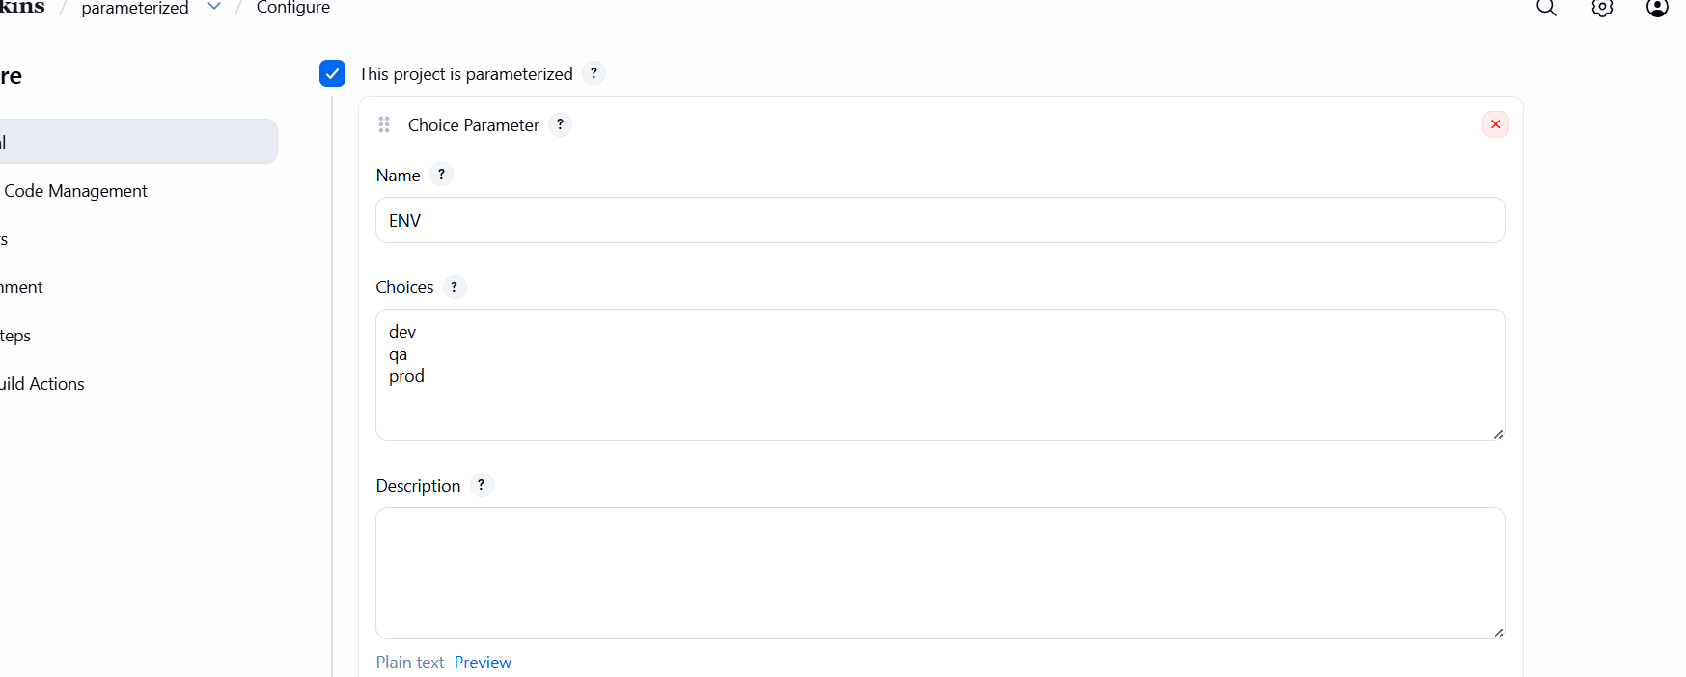

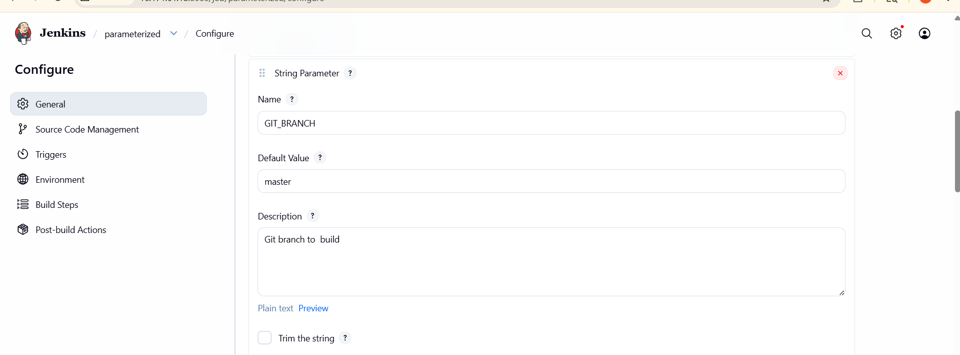
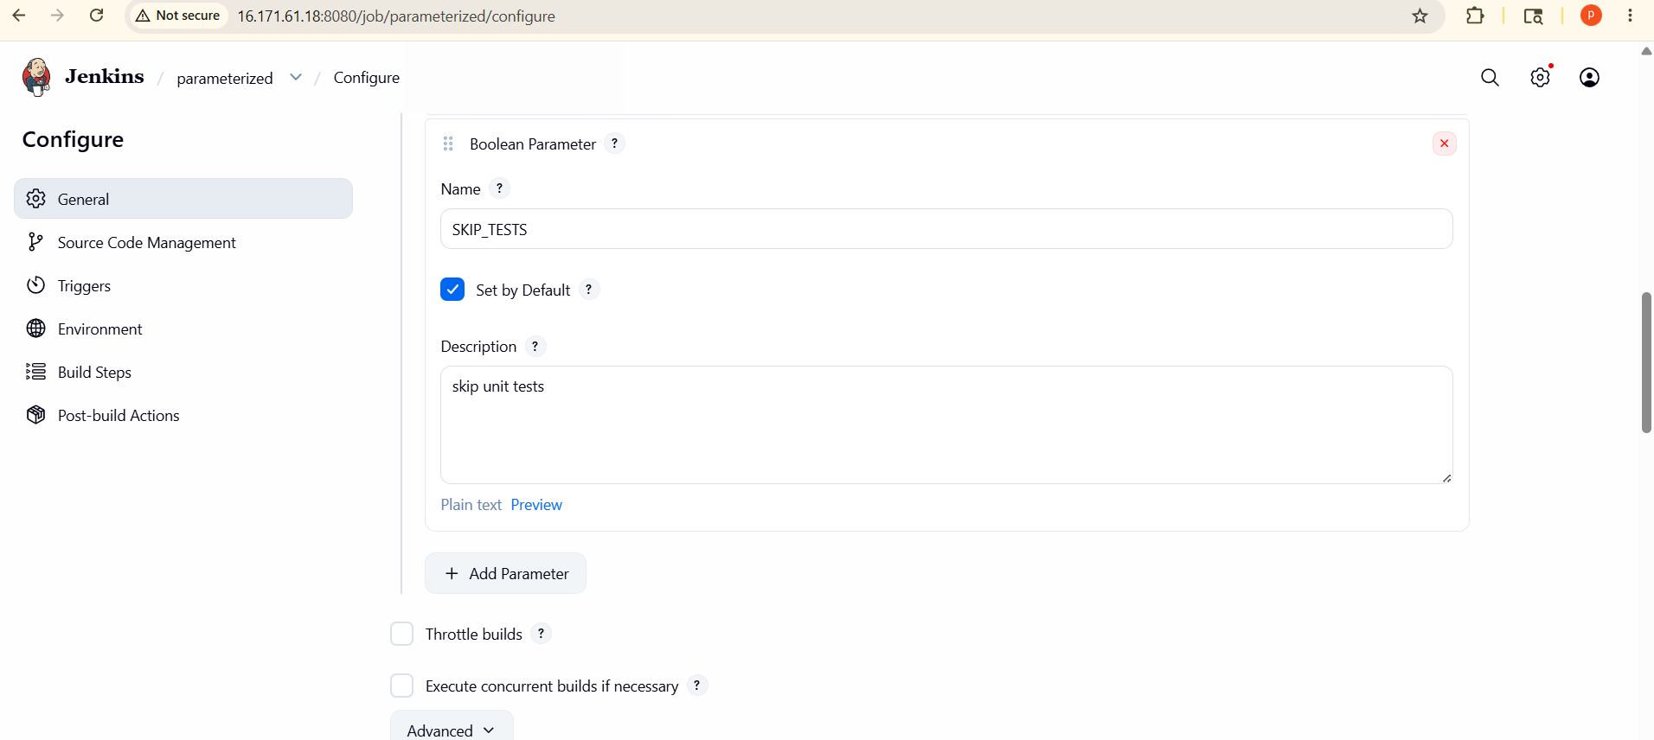
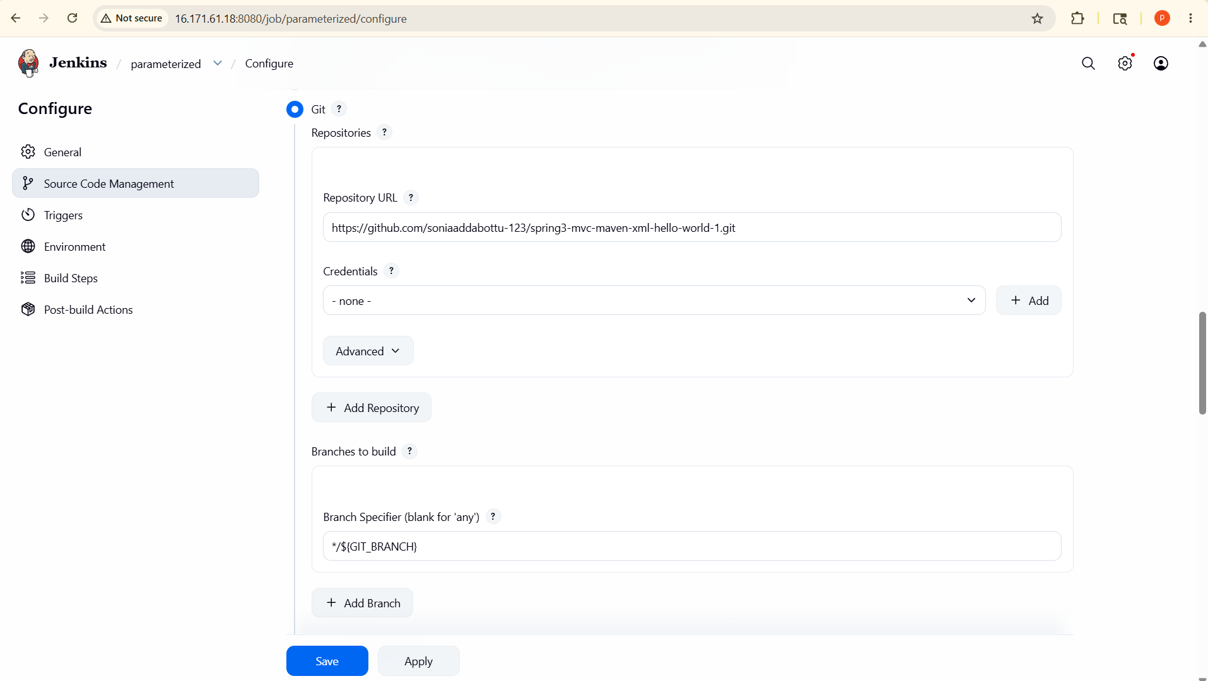
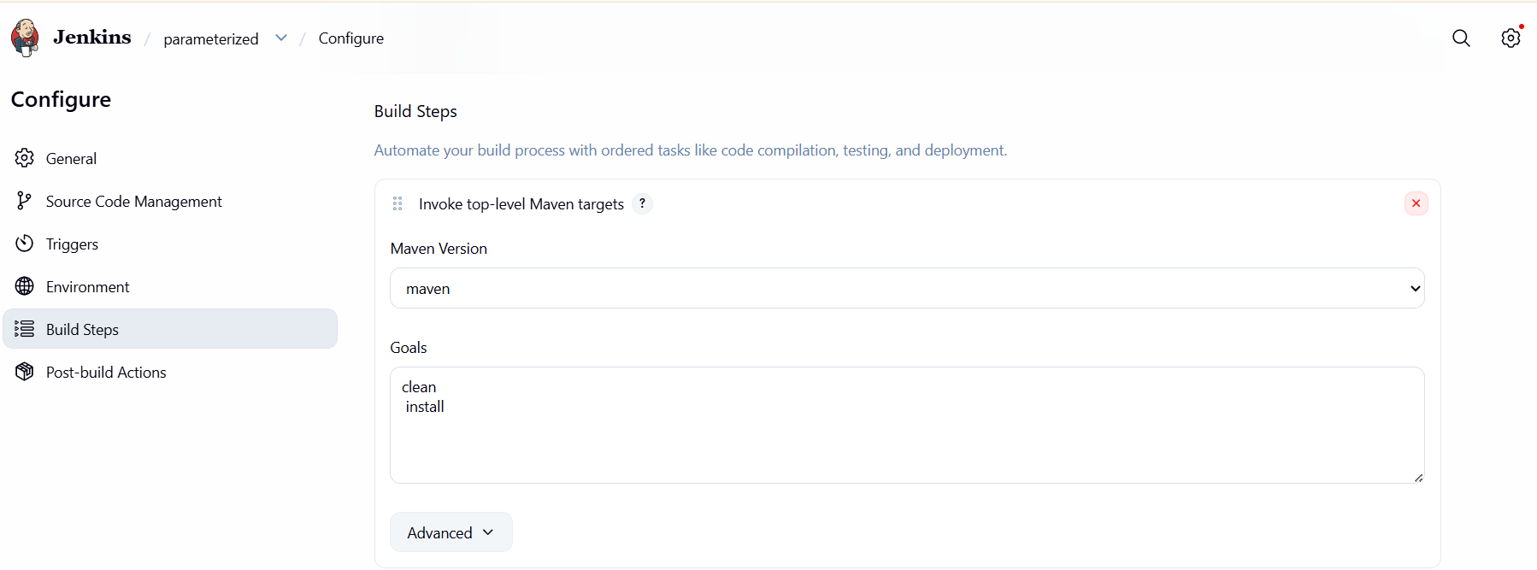

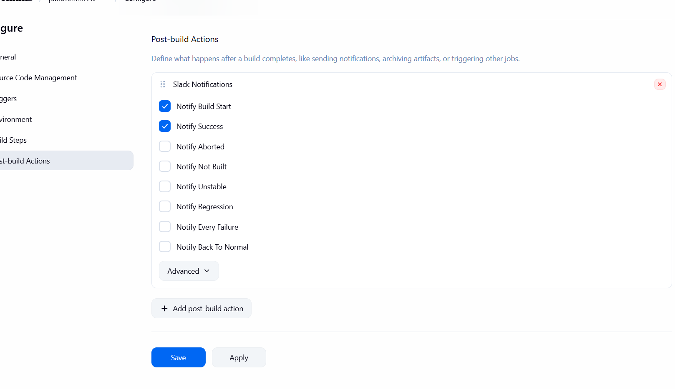
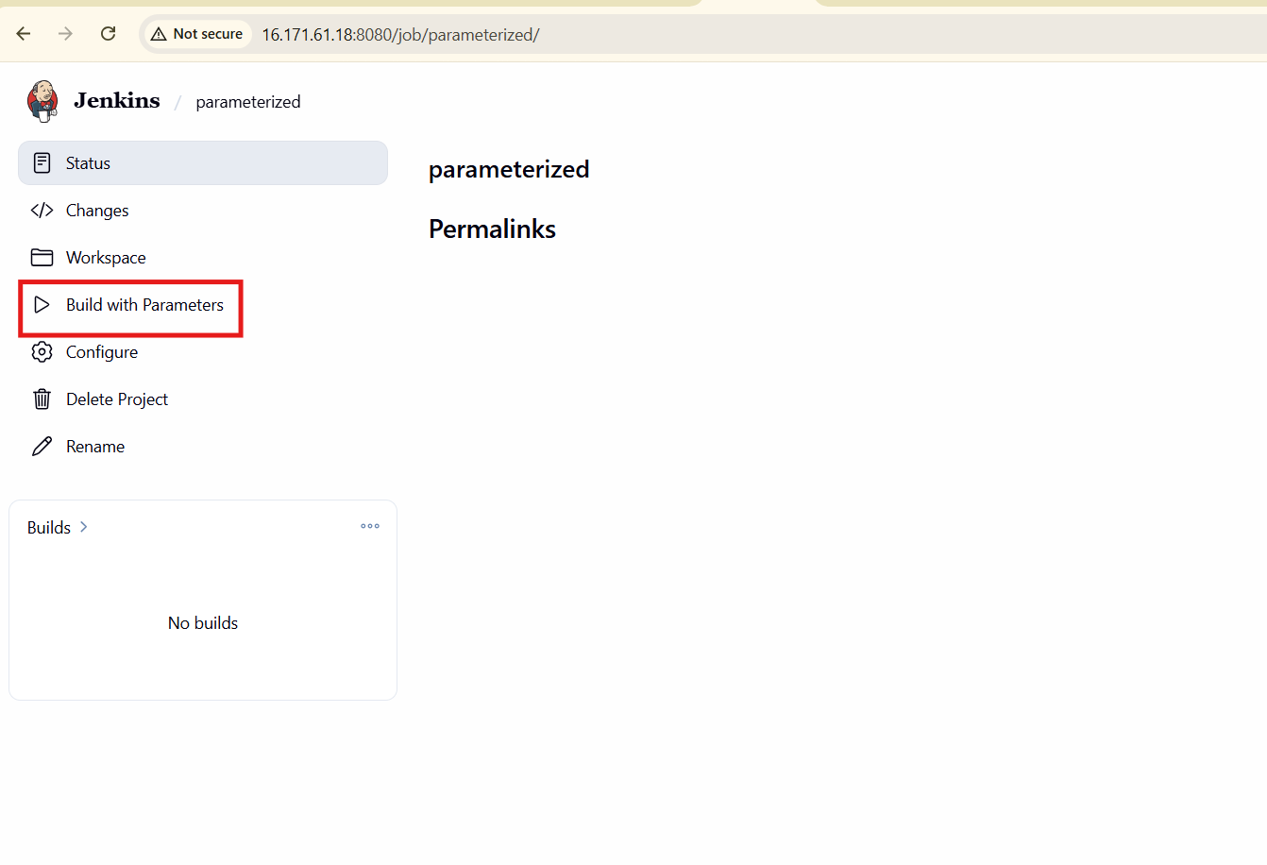
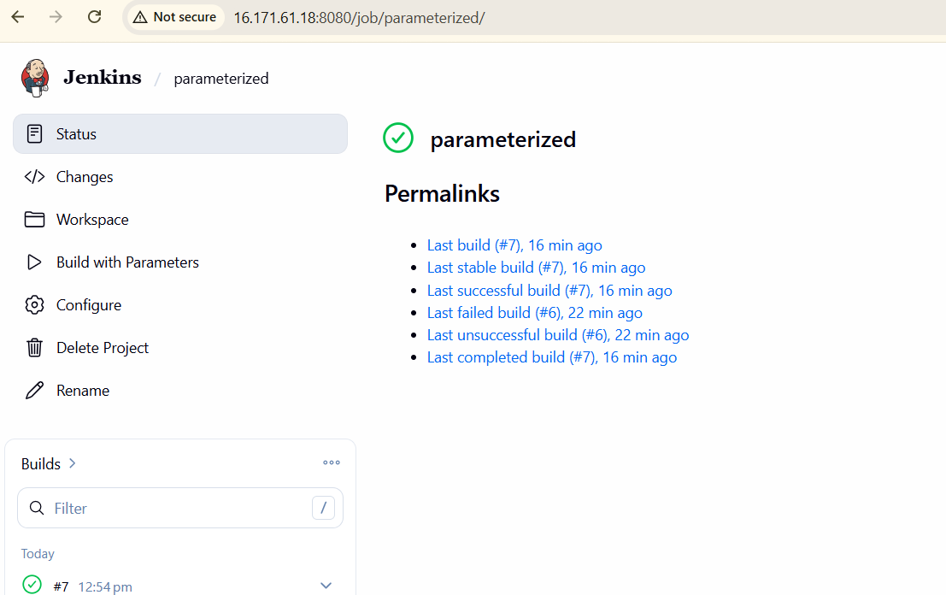

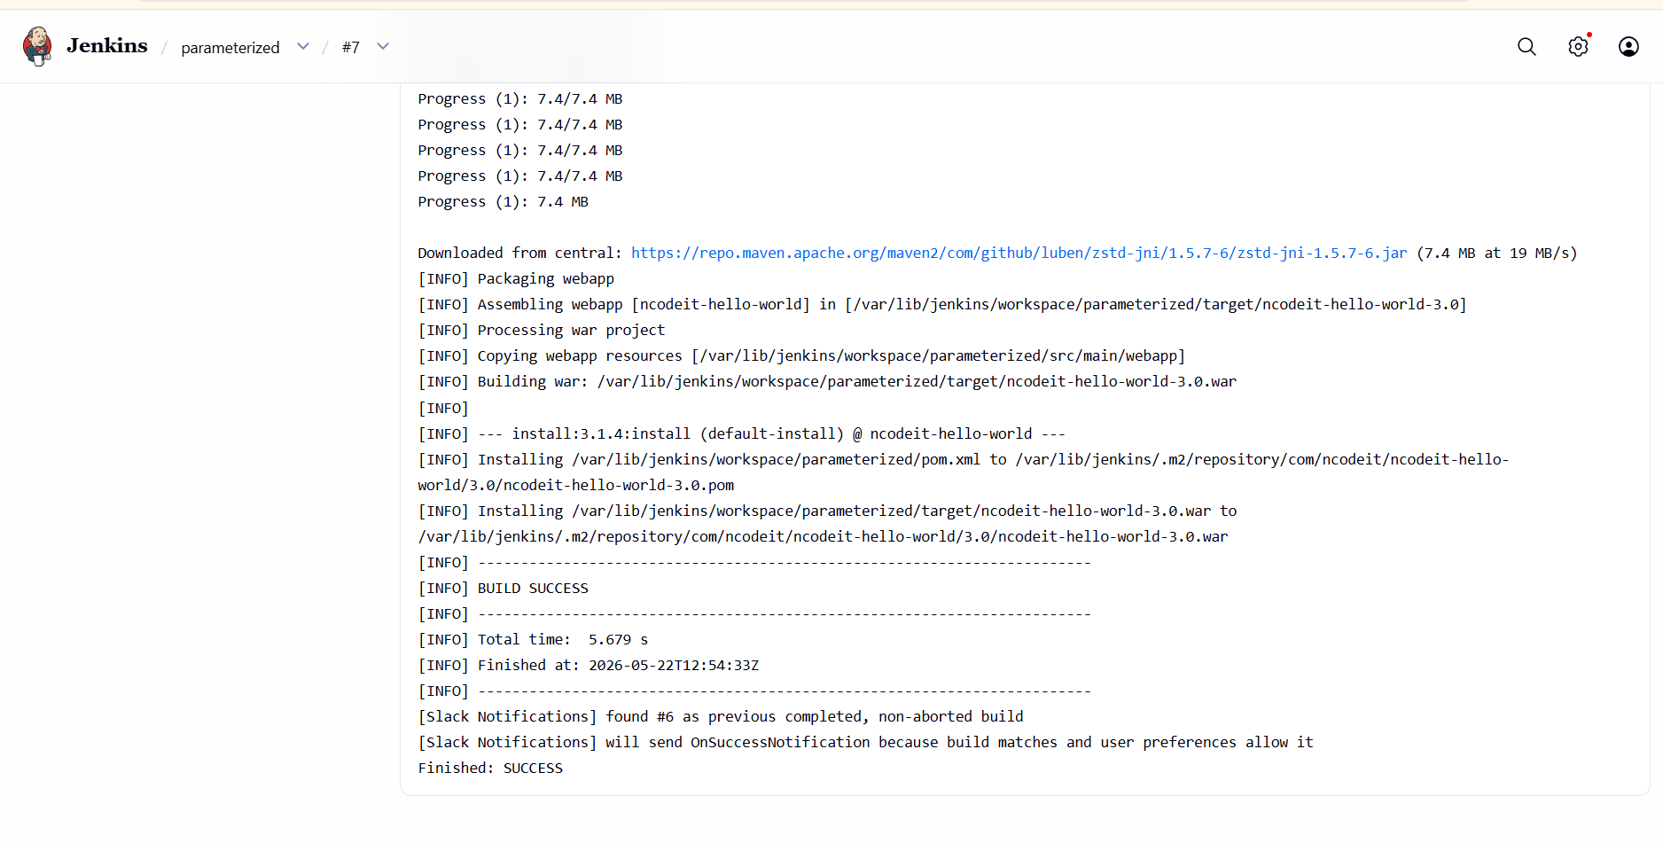
- Setup one slave machine for Jenkins.
First go to aws console create one slave instance
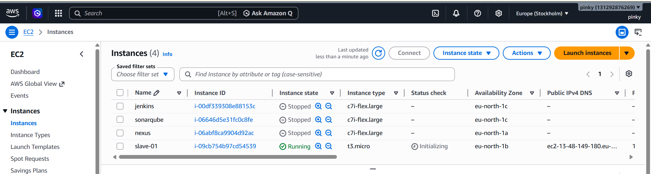
- Connected to slave-01 instance
- Installed Java using command:
- yum install java-21-amazon-corretto -y

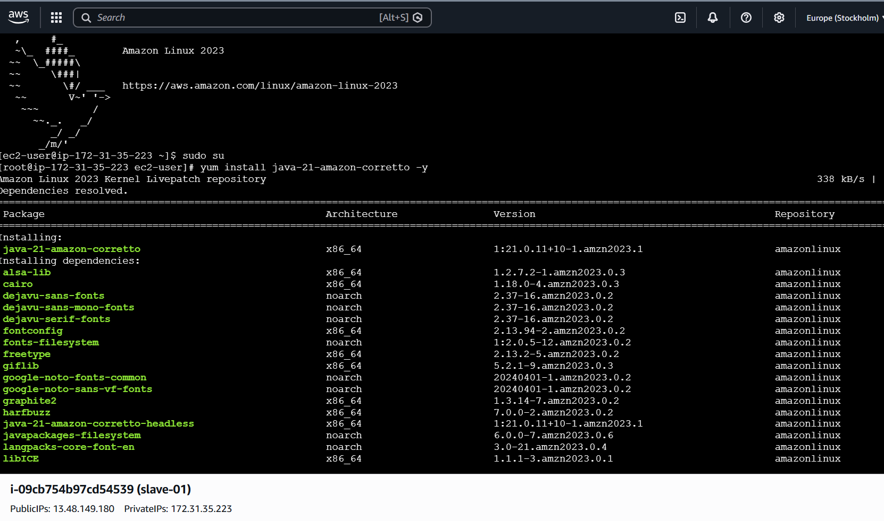
- Verified Java installation
- Confirms Java is available for Jenkins agent execution
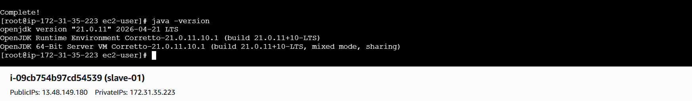
- Ran ssh-keygen on slave-01

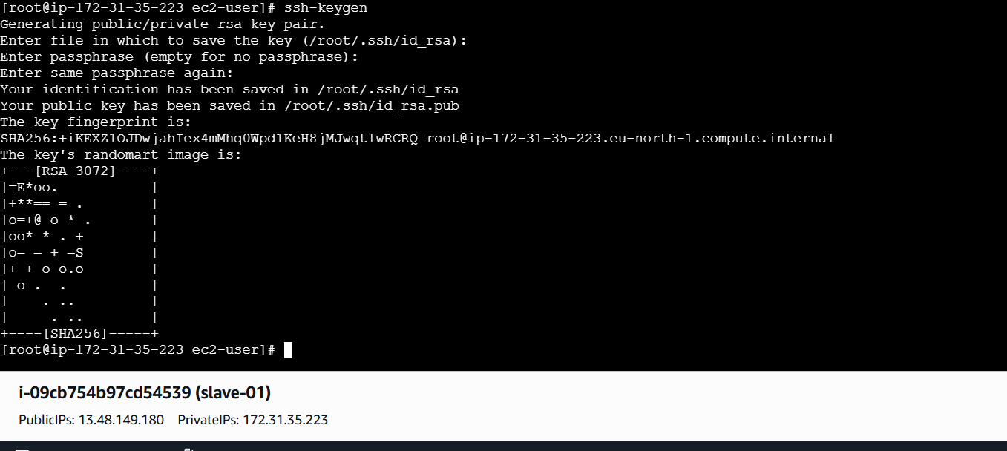
Change the root to ssh
Cd /root/.ssh
Generate the authorized key
Cat id ras.pub>>authorized_key
Give the permissions
Chmod 700 authorized_key

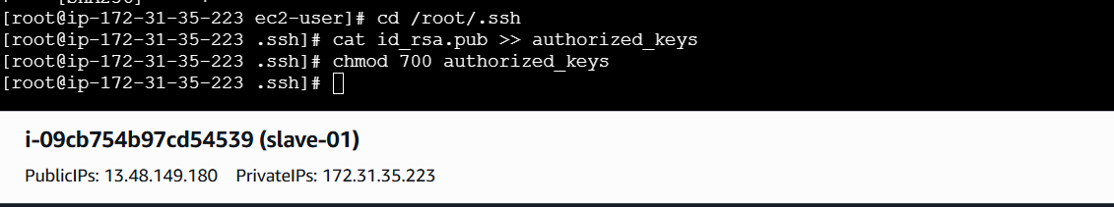
Then go to master jenkins server
Create a one path
Mkdir -p /var/lib/jenkins/.ssh
Change to the ssh
Cd /var/lib/jankins/.ssh
Used ssh-keyscan to avoid SSH prompt
Ssh-keygen -H(slave-01 ip add) 13.48.149.180 >> /var/lib/jenkins/.ssh?known_hosts

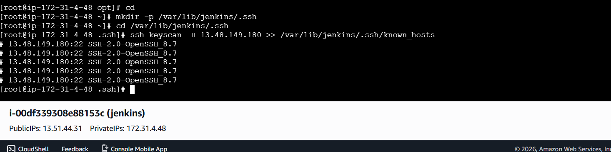
Open jankins-->go to manage jenkins-->select node-->create new node-->for slave-01
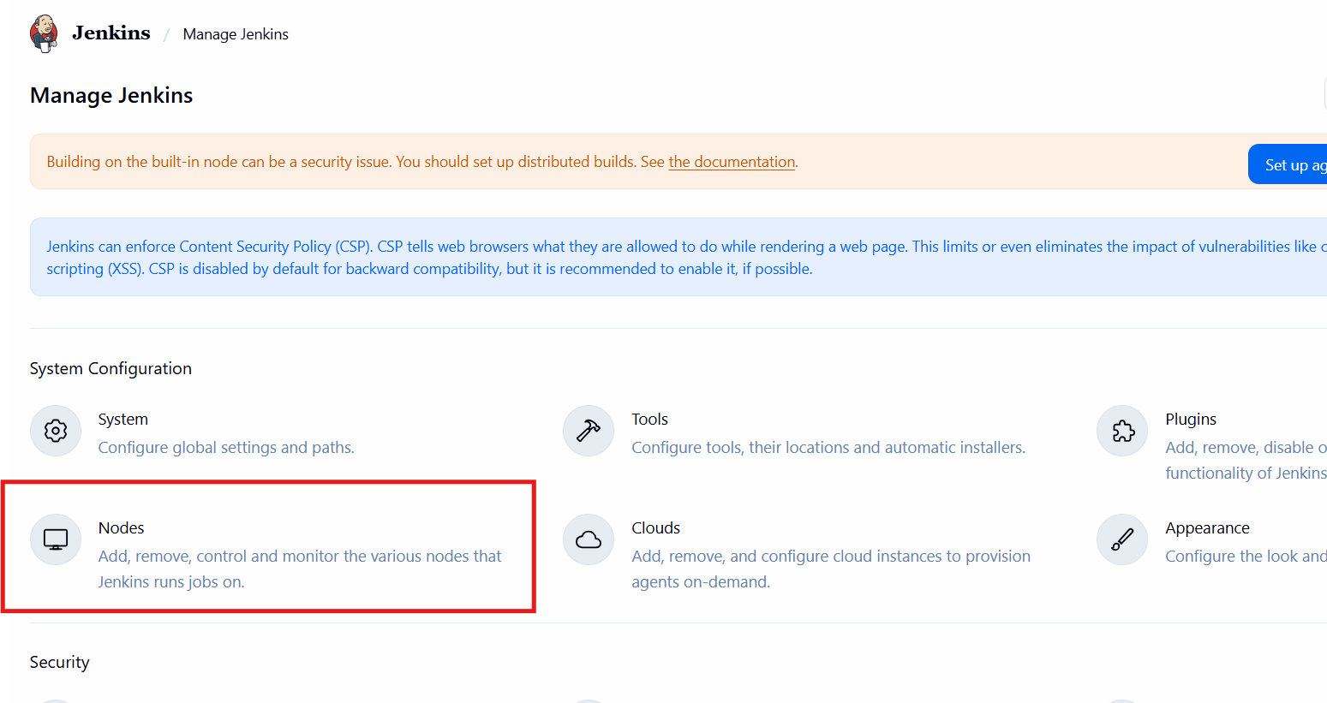
- Entered node name: slave-01-->Selected Permanent Agent-->Clicked Create
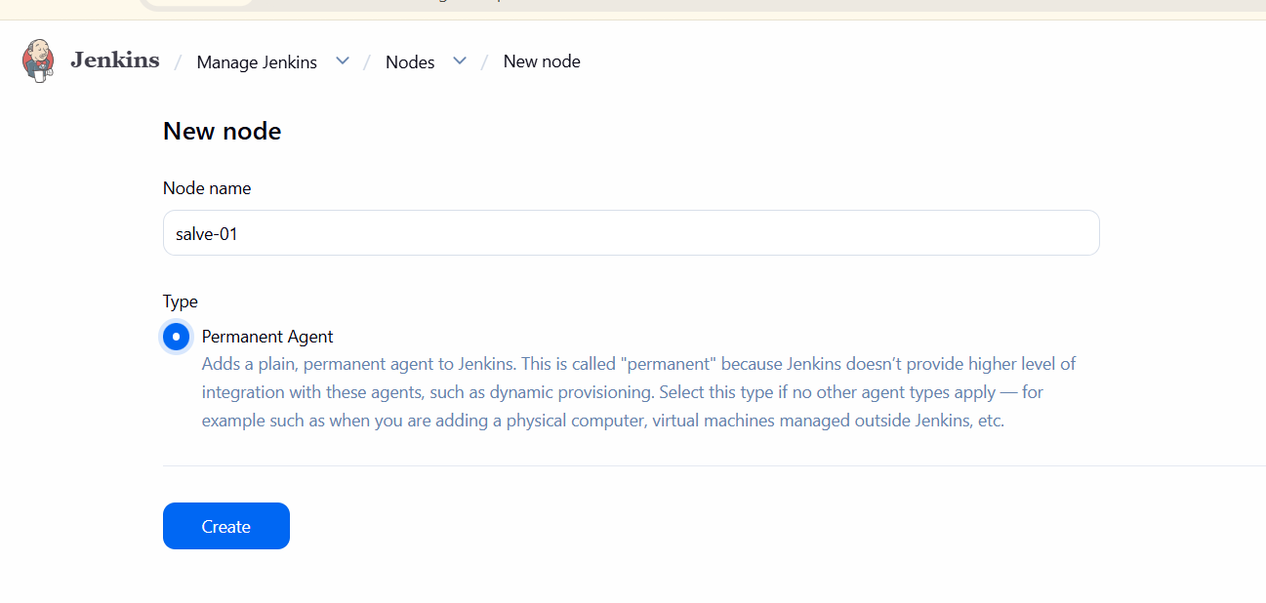
Node name salve01-->number of executors 2-->remote root directory /home/ec2-user/jenkins--> lable-->use stage-->
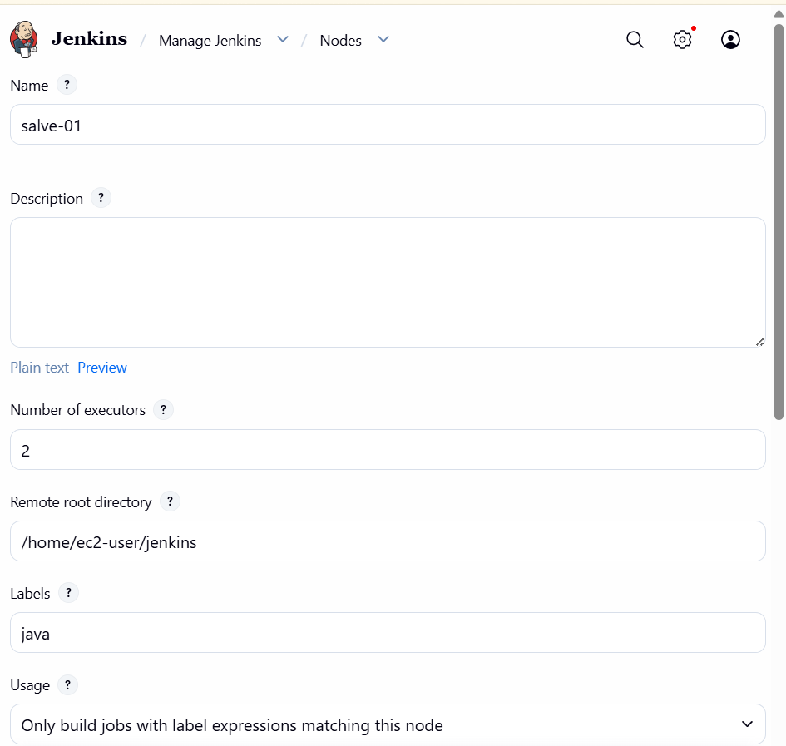
Clik on launch method-->launch agent via ssh
Host mean give slave 01 ip add-->
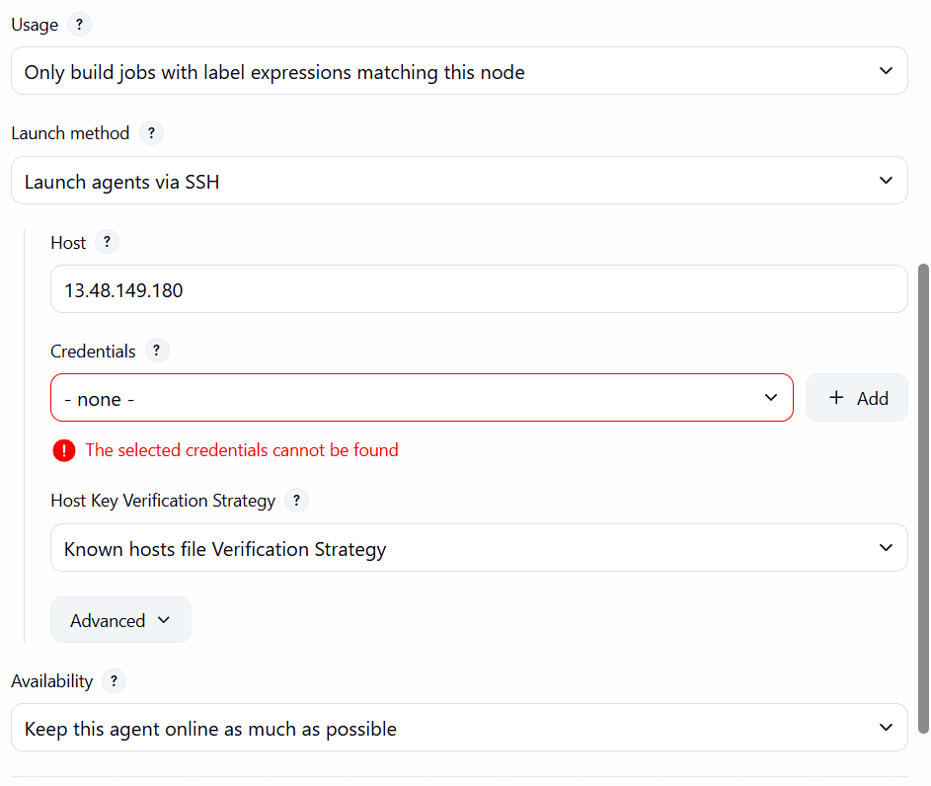
- Clicked Add Credentials
- Selected SSH Username with private key
- Scope: Global
- ID: slave-01
- Username: ec2-user
- Added private key (from slave)
Saved credentials and selected them for node

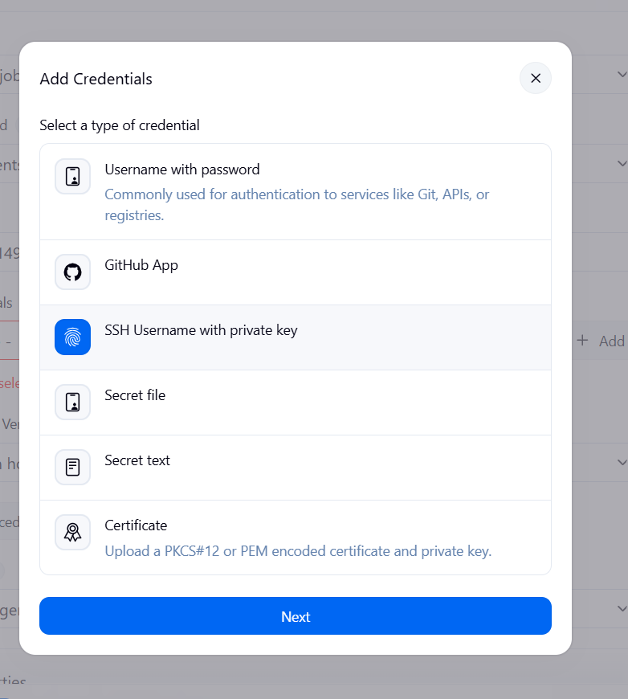
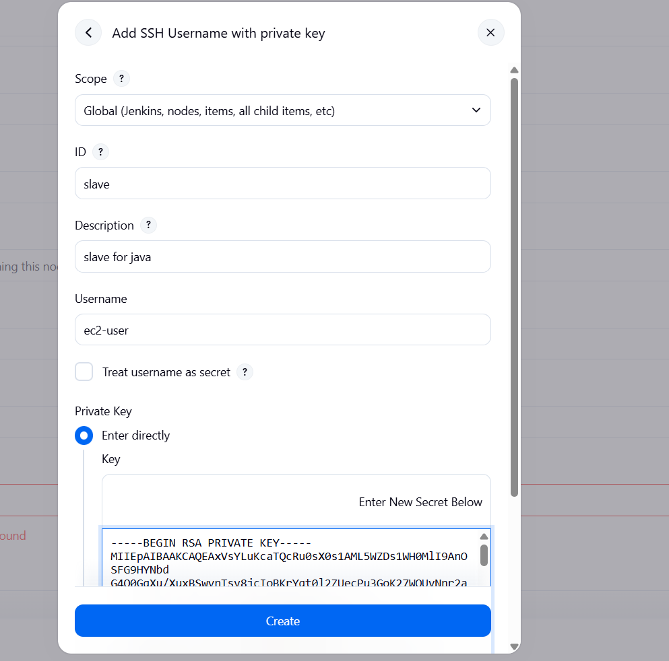
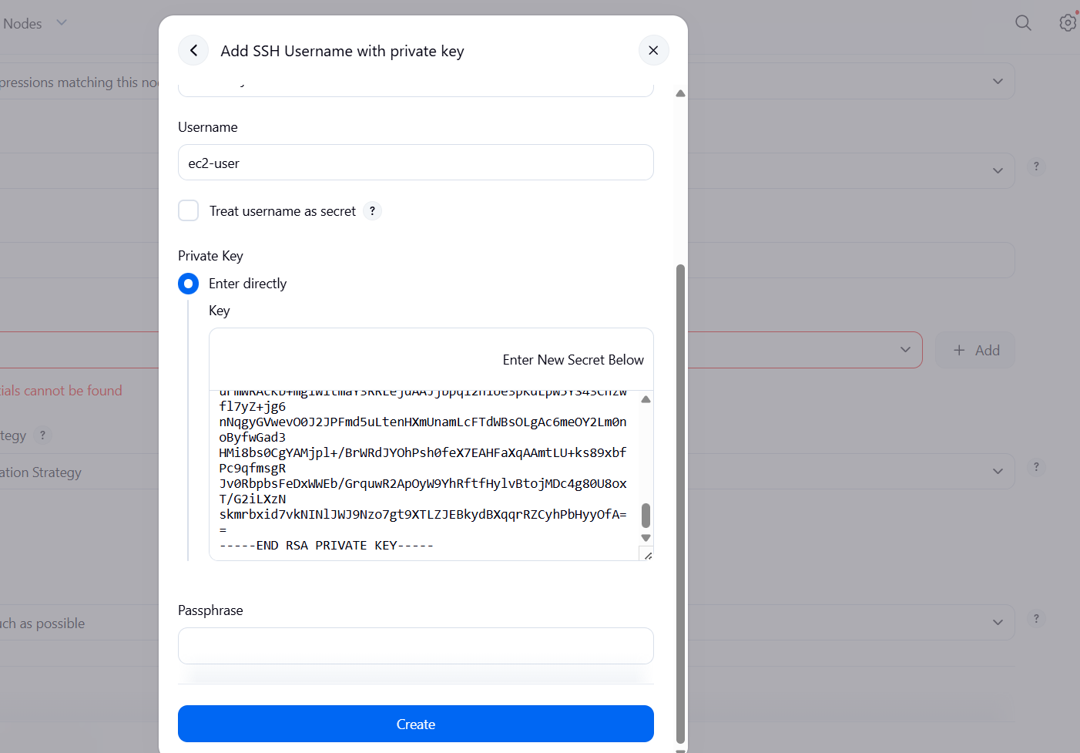

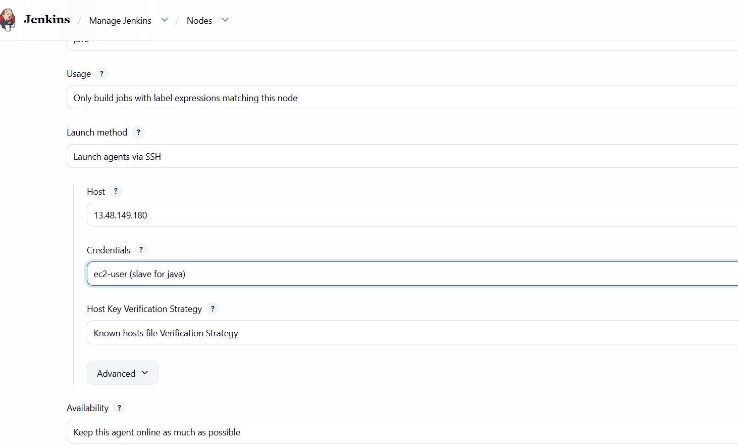
I got error agen is ofline because disk space is below threshold

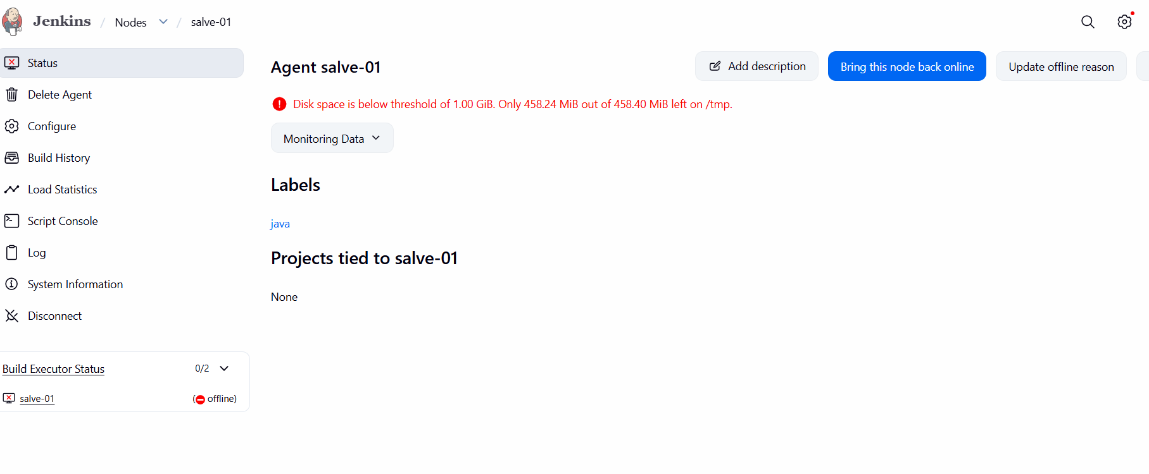
And go to slave 01 check the configure -->give node propertis -->select disk space monitoring thresholds and ensure the disk space threshold is appropriately adjusted to accommodate Jenkins operations.
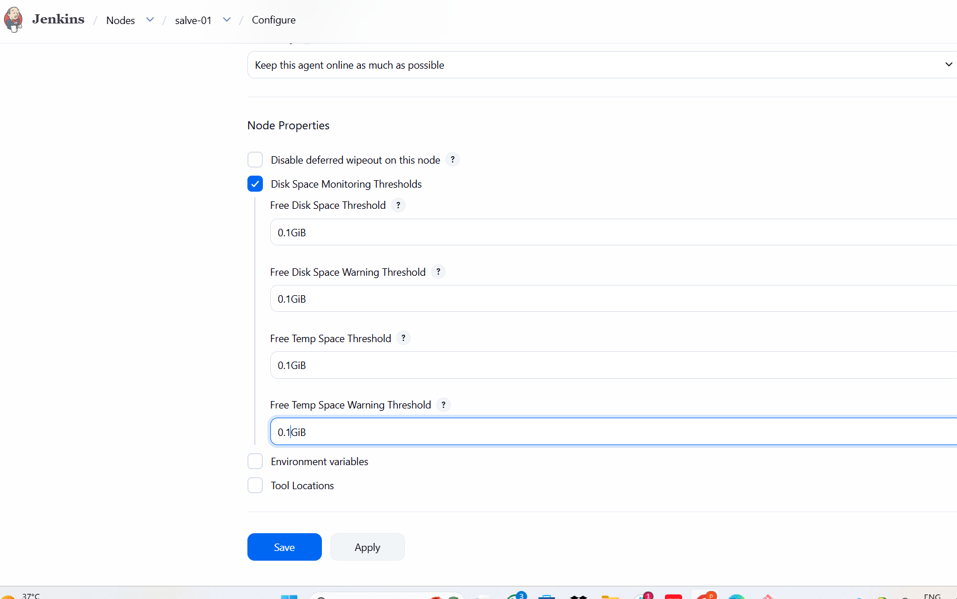
After adjusting the thresholds, navigate back to the node status page and click the "Launch agent" button to initiate the connection. Monitor the logs to verify that the Jenkins controller successfully establishes an SSH connection with the slave-01 node. Once the connection is stabilized, the agent status will transition from offline to online,
