Jenkins-03

Create one Jenkins job using the below code and create three stages.
- stage1: Git clone to download the source code.
- stage2: Sonarqube Integration to check the quality of code.
- stage3: Slack Integration to send the alerts to slack.
Source Code: https://github.com/betawins/VProfile-1.git

stage1: Git clone to download the source code.
First go to jenkins-->create a new job-->

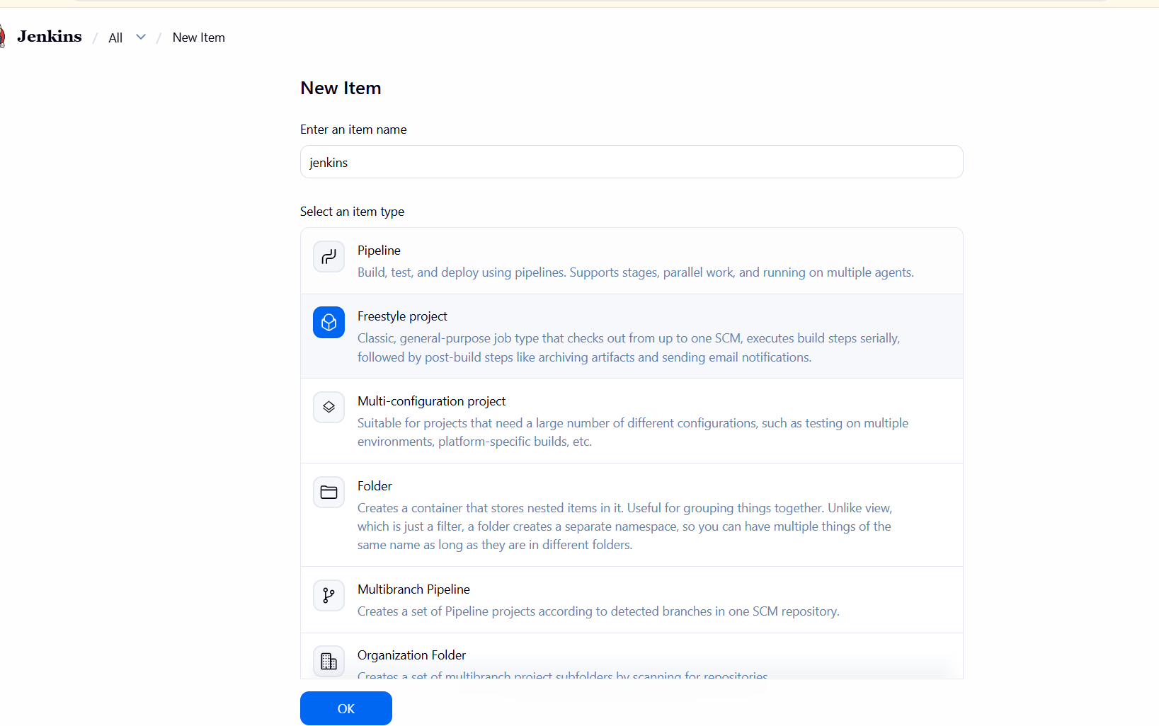

Clone the source code in git repositry
Give repository URL--> save
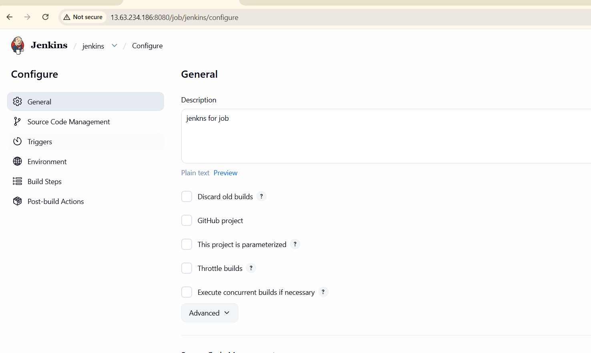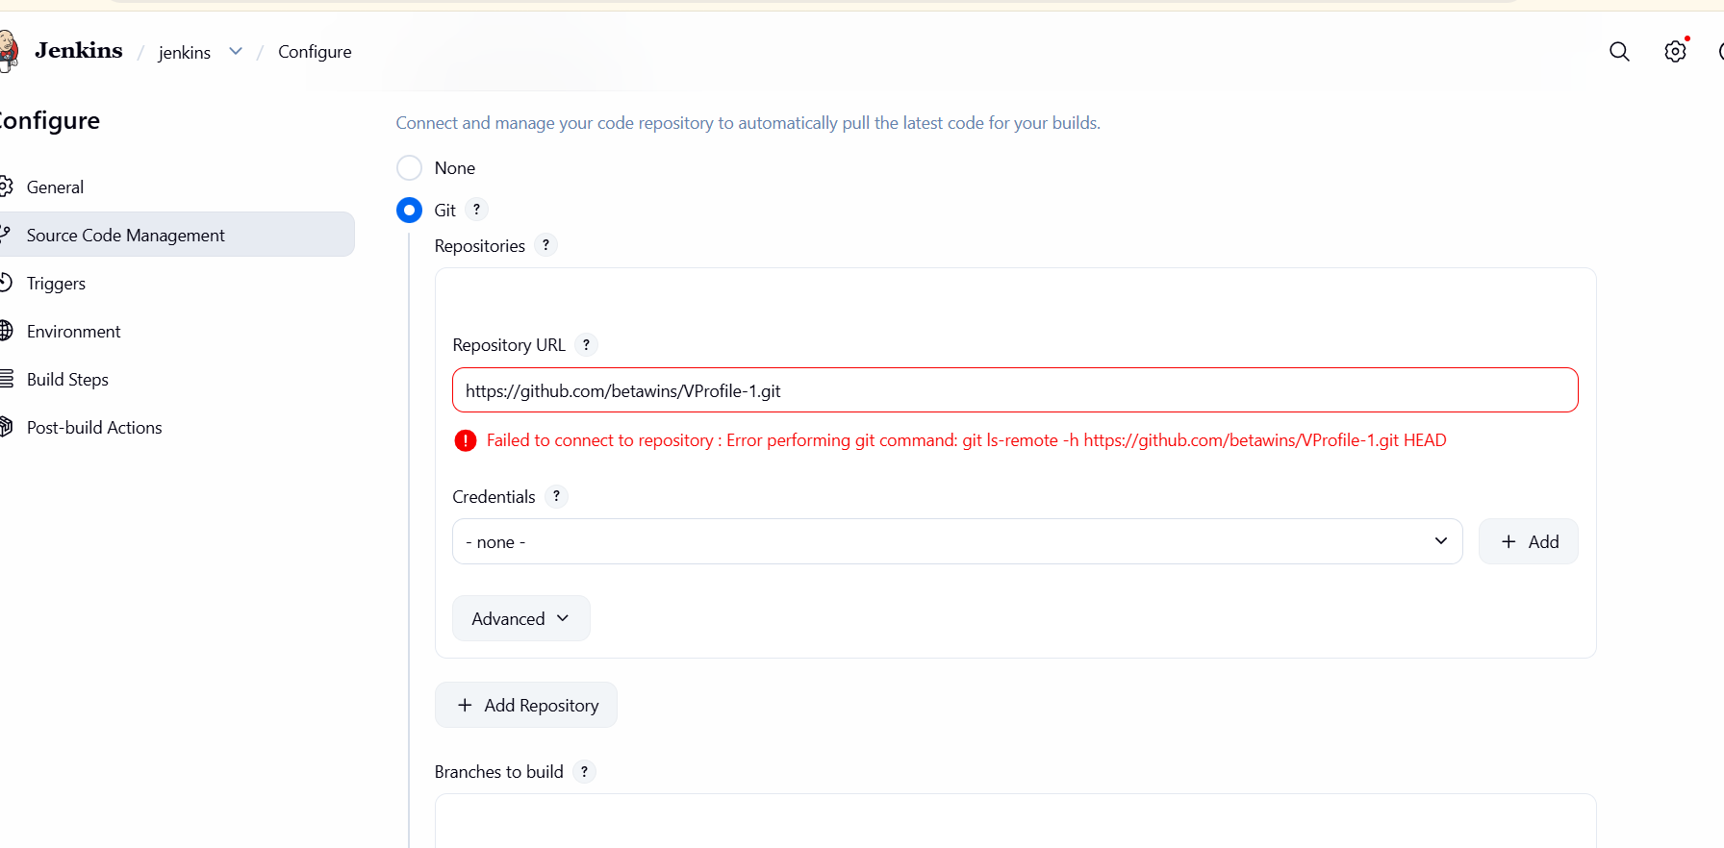

After thet to build the code -->then we see the console output is success

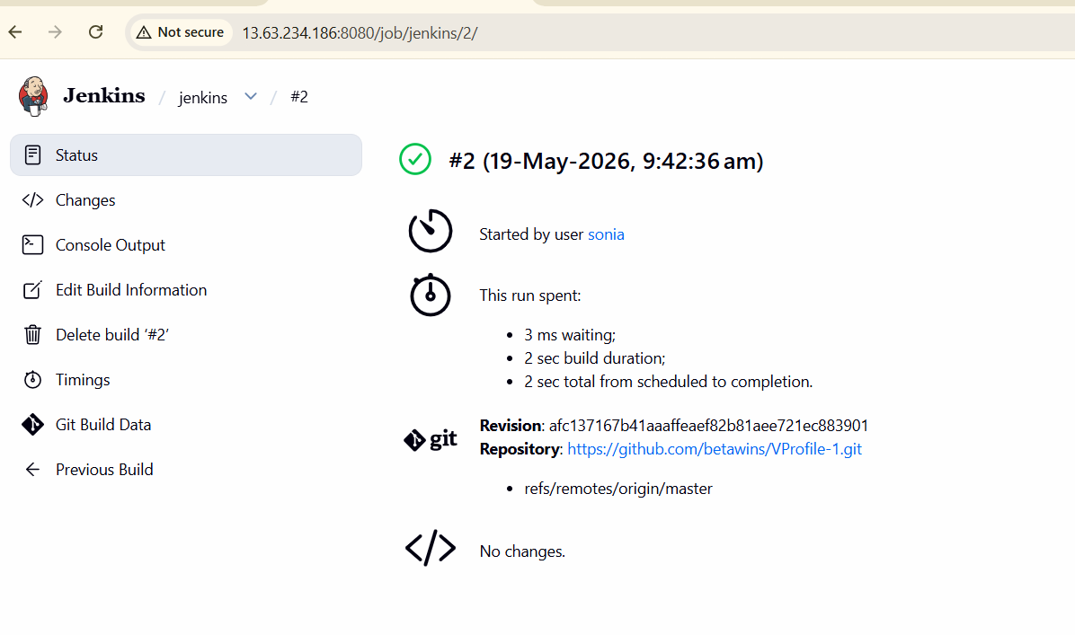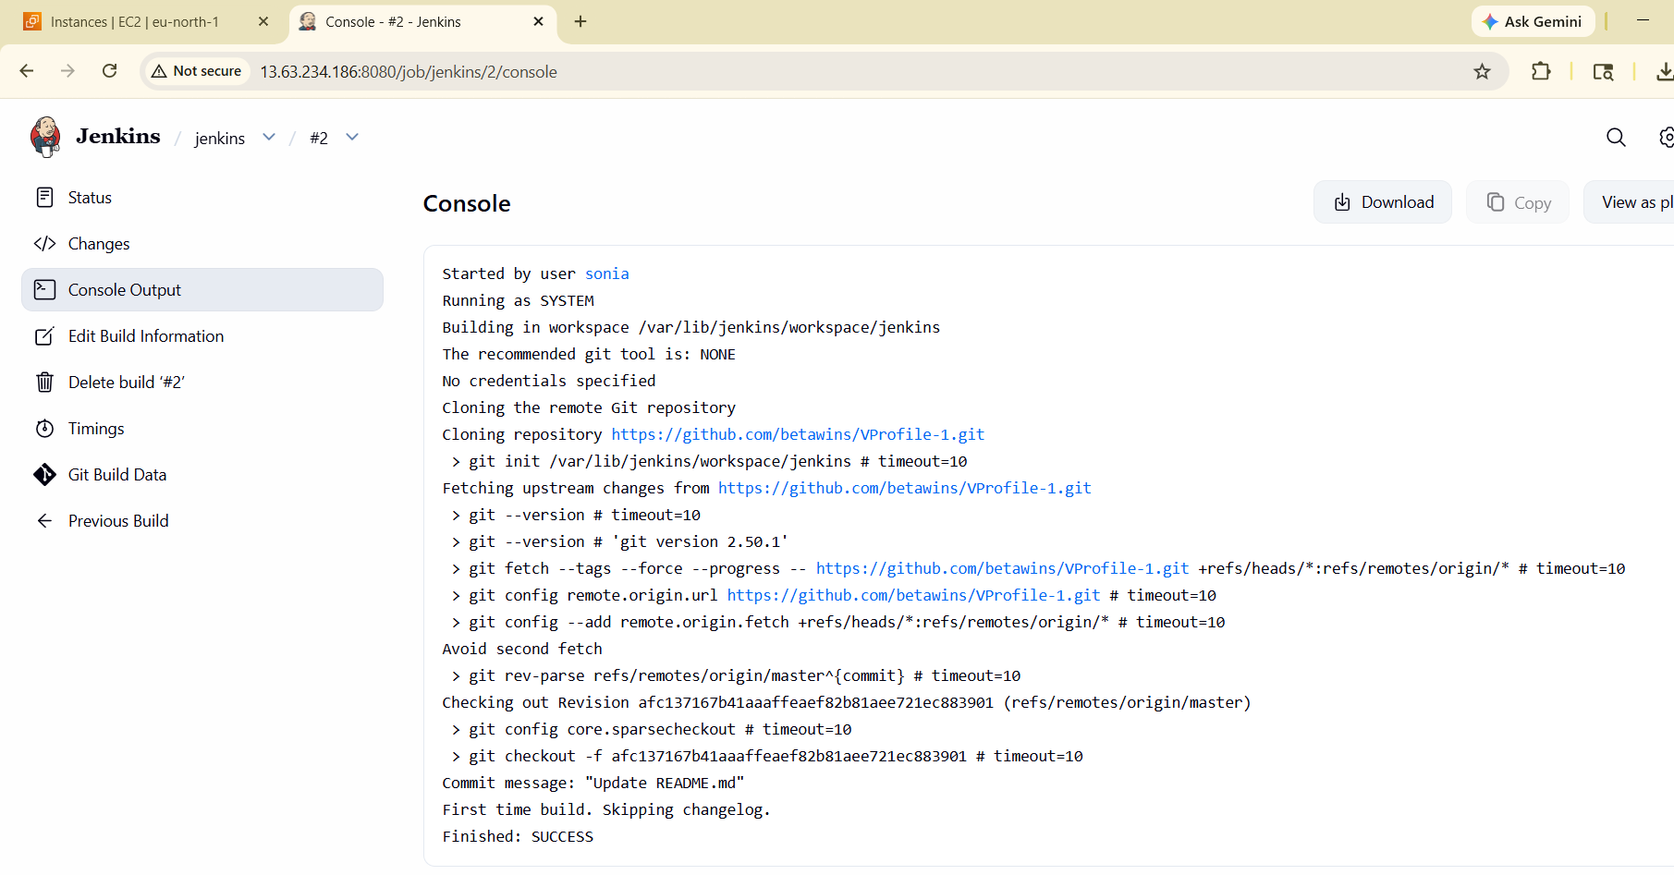

stage2: Sonarqube Integration to check the quality of code.
EC2 Instance Creation for SonarQube Server
launched an EC2 instance to host SonarQube and PostgreSQL.
Explanation
SonarQube needs a Linux server with enough CPU, memory, and disk. EC2 provides a flexible compute environment.

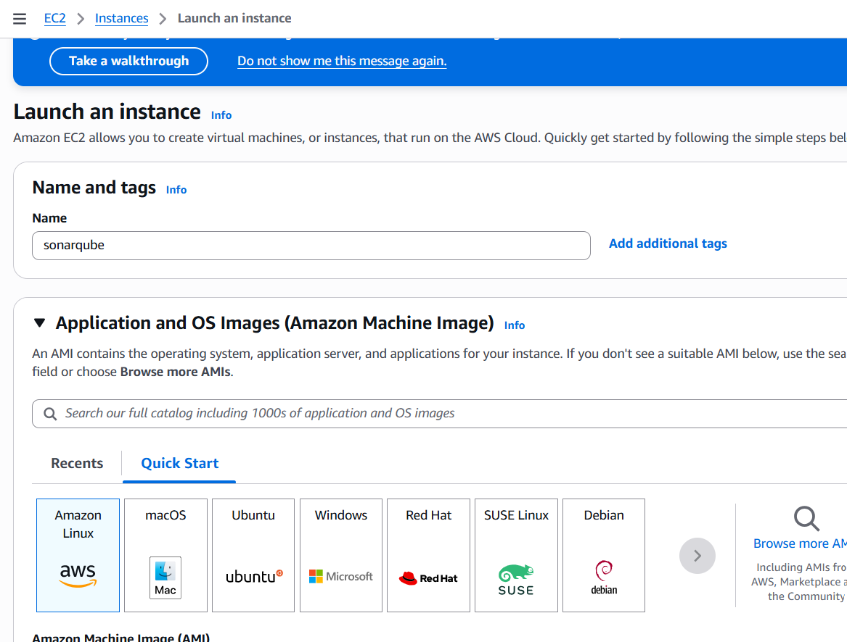
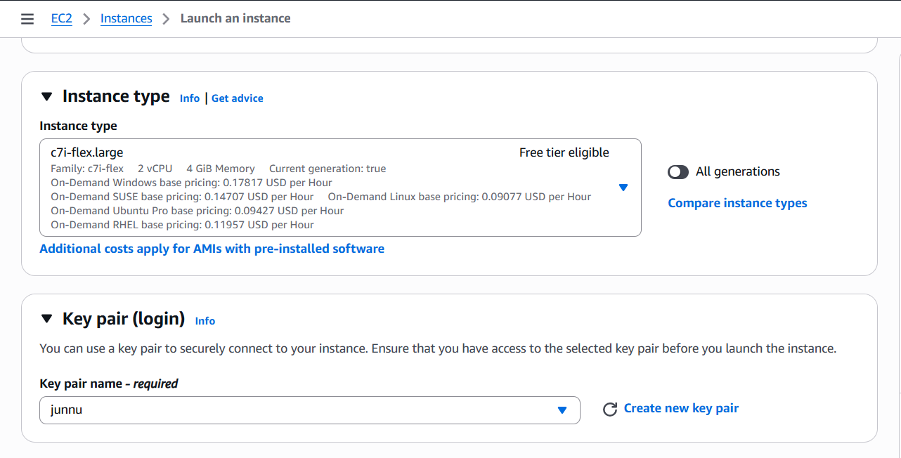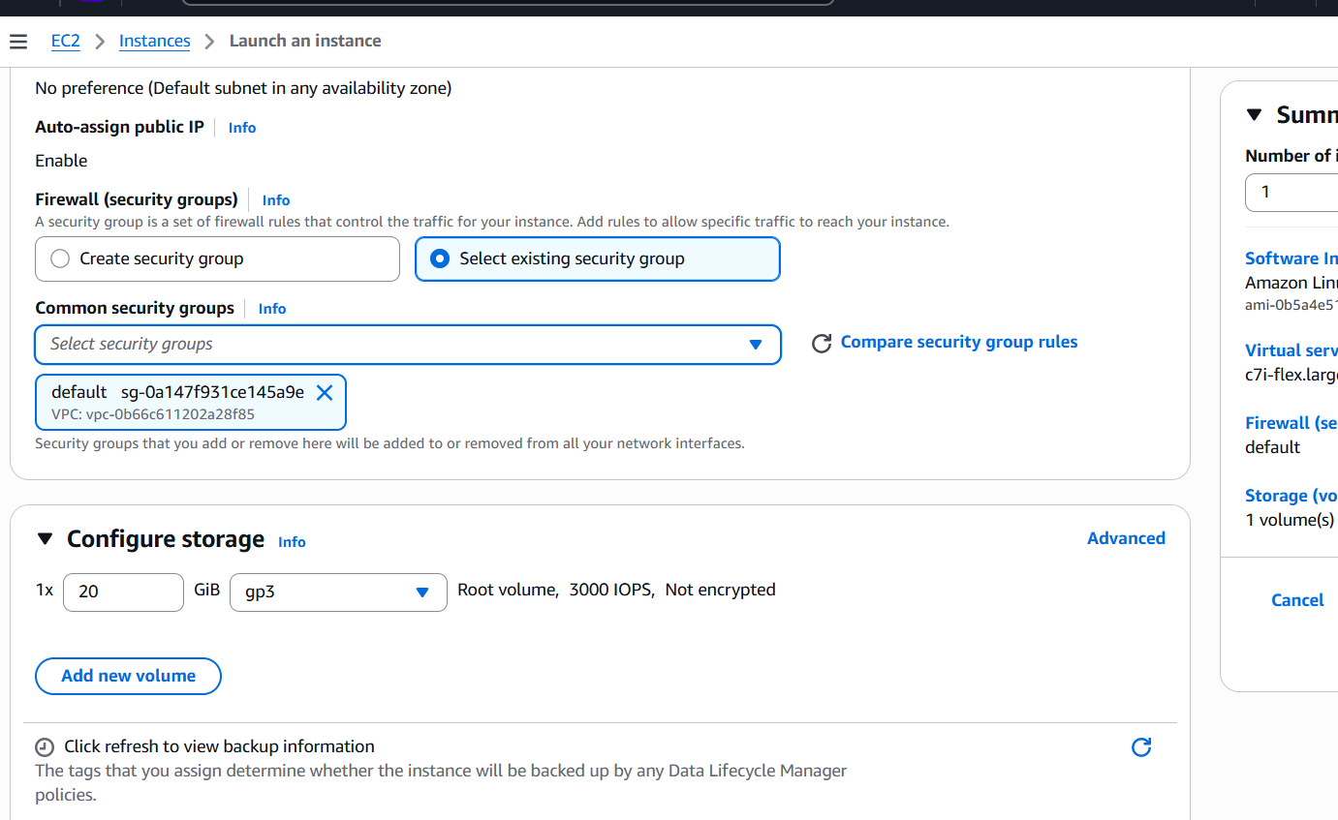
Successfully created one sonarqube instance then
We can install java
Yum install java-1.8.0-openjdk -y

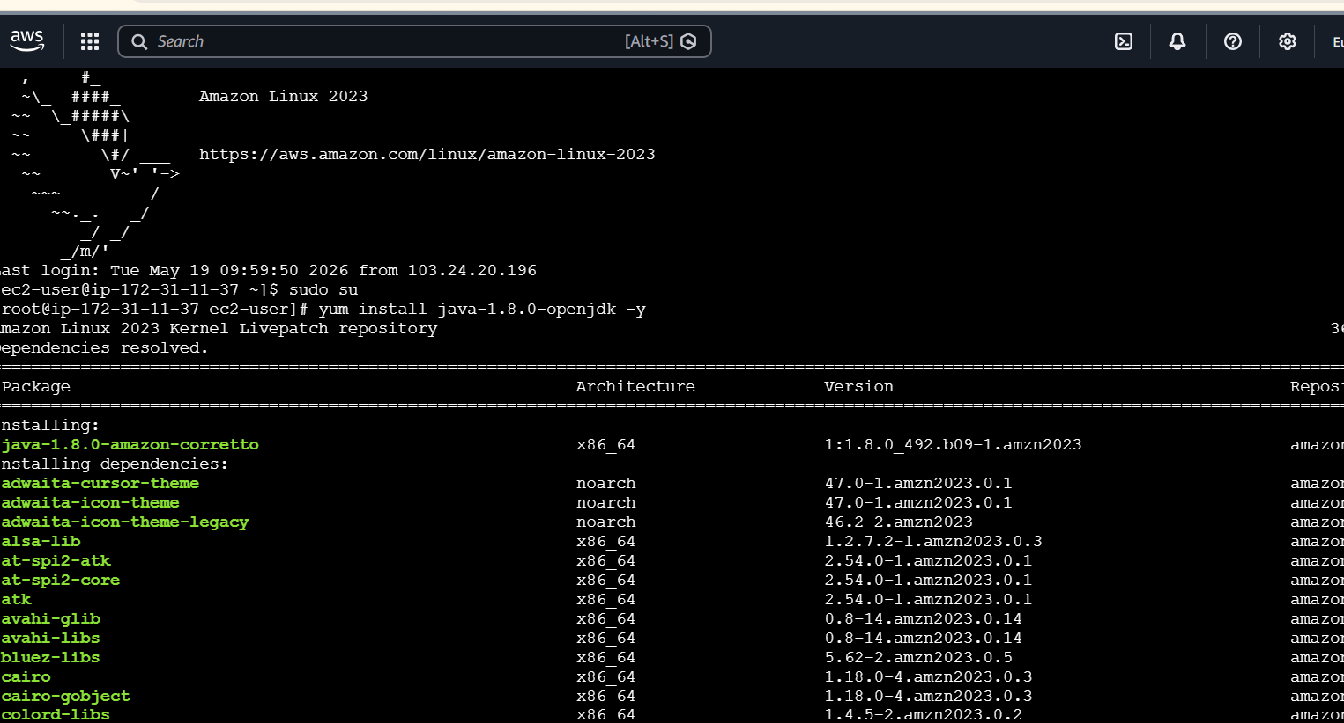
Add mysql rpm Repository
sudo wget https://dev.mysql.com/get/mysql57-community-release-el7-11.noarch.rpm
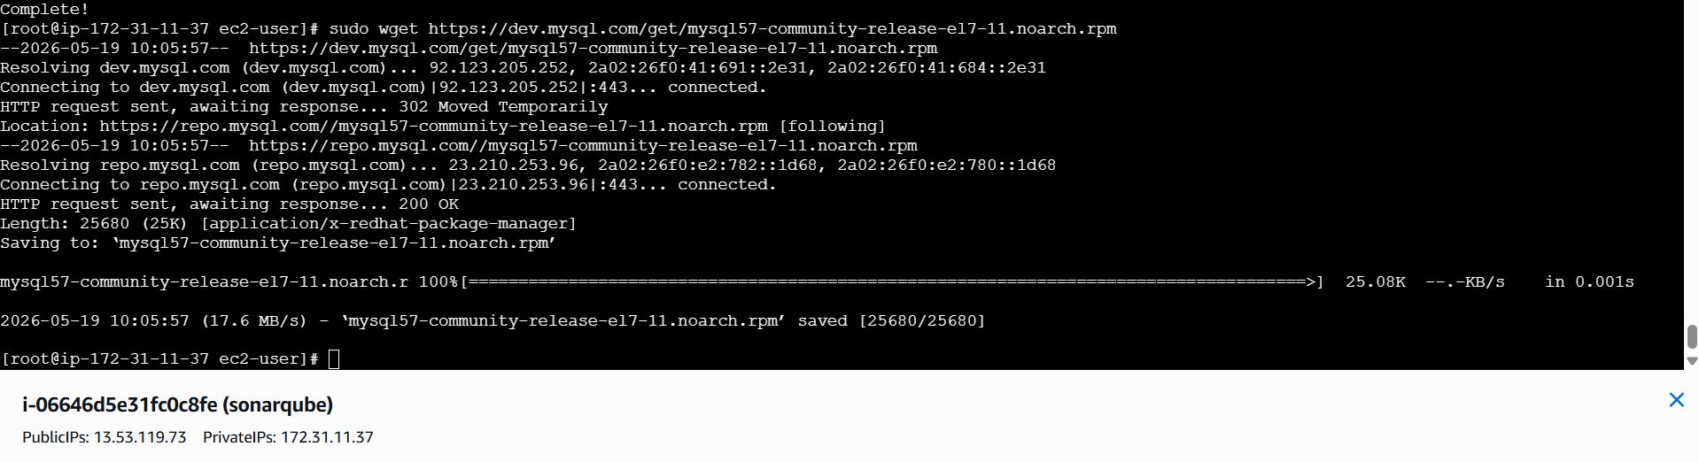

sudo yum localinstall mysql57-community-release-el7-11.noarch.rpm

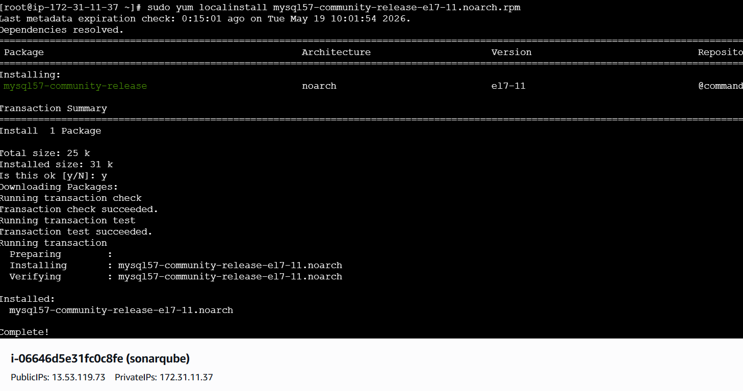
rpm --import https://repo.mysql.com/RPM-GPG-KEY-mysql-2022
sudo yum install mysql-community-server
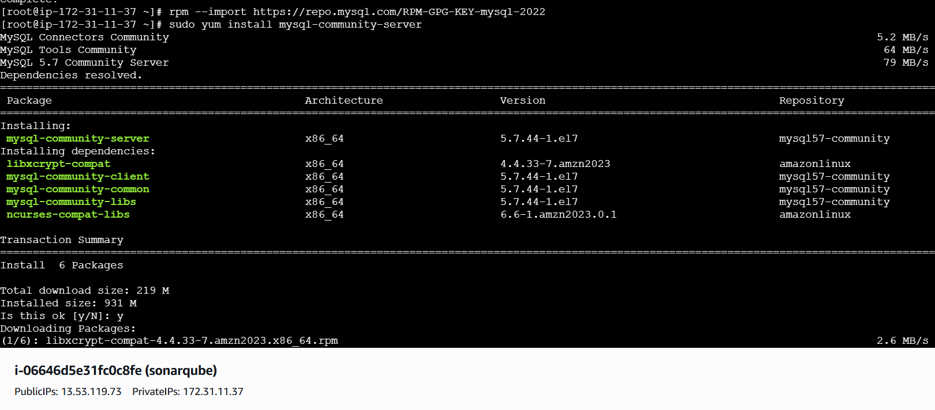
Start MySQL and Enable Start at Boot Time
systemctl start mysqld
systemctl enable mysqld
Check if mysql is running or not I give this command
netstat -na | grep 3306

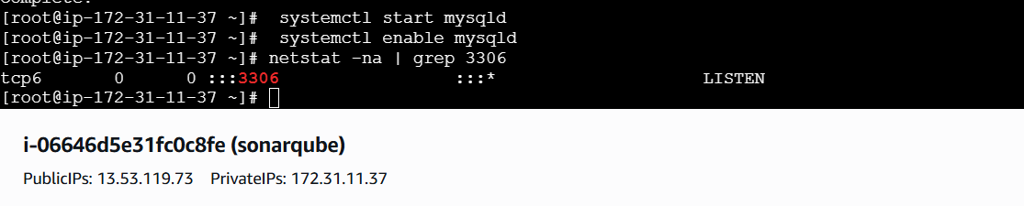
Configure the MySQL Root Password
You will see default MySQL root password
grep 'temporary' /var/log/mysqld.log
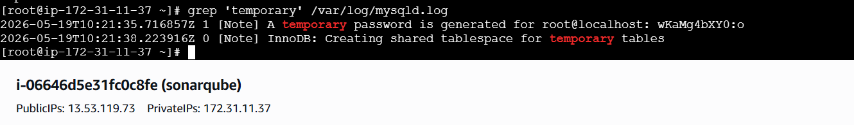
Login to mysql using the default password
mysql -u root -p
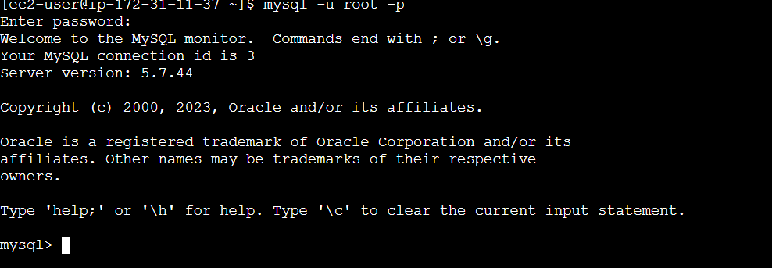
Now replace the default password with a new and strong password
Test Using new password
mysql -u root -p

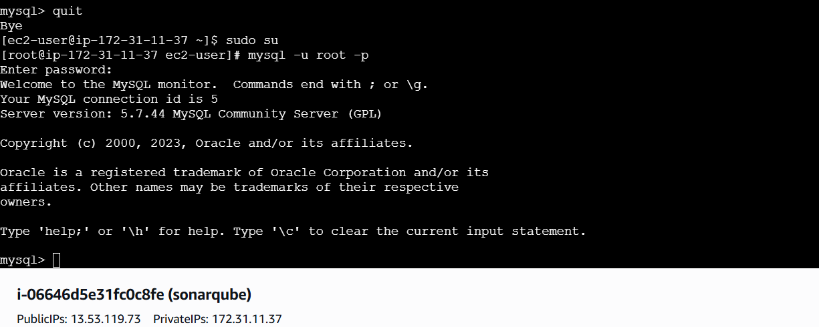
Download stable SonarQube version from below website.
Download & unzip SonarQube 6.0
wget https://binaries.sonarsource.com/Distribution/sonarqube/sonarqube-6.6.zip

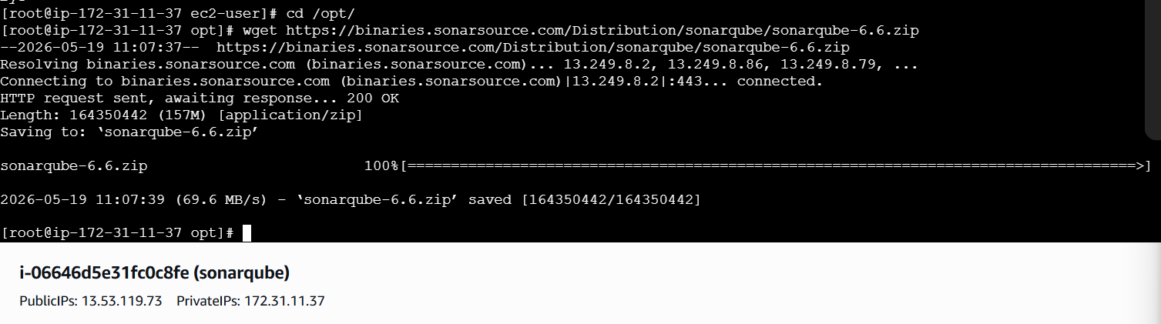
To unzip the tar file
# unzip sonarqube-6.6.zip

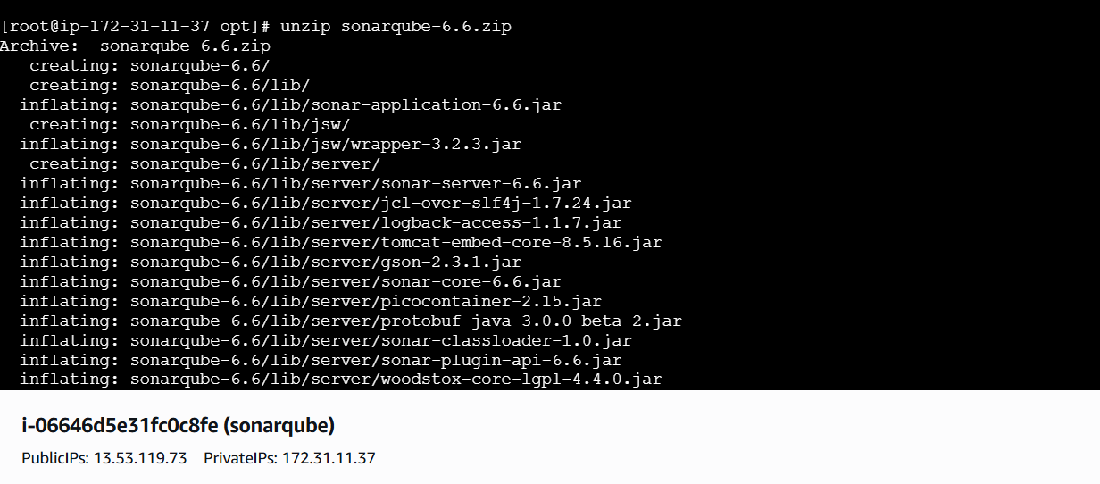
Rename the file
mv /opt/sonarqube-6.6 /opt/sonar
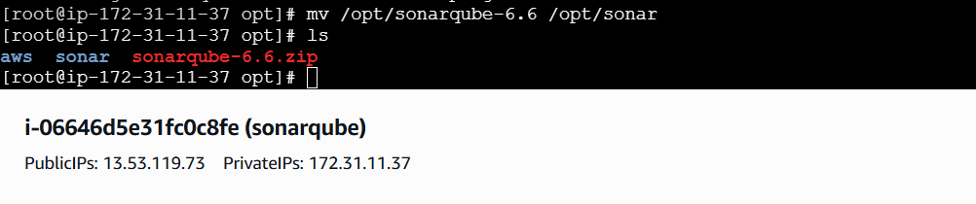
Login to mysql
mysql -u root -p

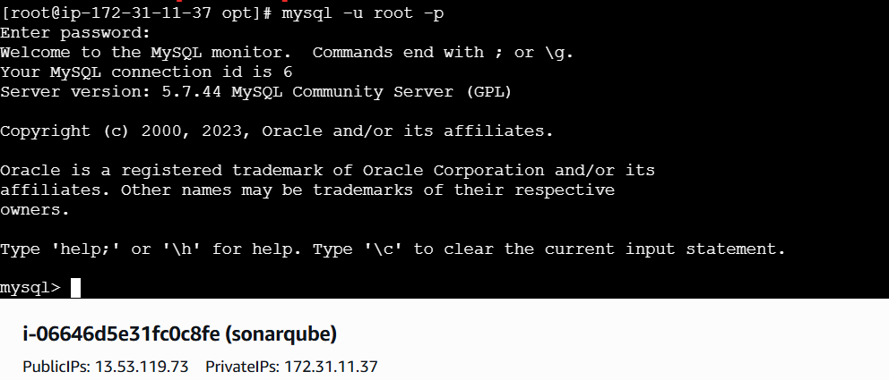
Create a new sonar database
CREATE DATABASE sonar CHARACTER SET utf8 COLLATE utf8_general_ci;

Create a local and a remote user
CREATE USER sonar@localhost IDENTIFIED BY 'Sonar@123';
CREATE USER sonar@'%' IDENTIFIED BY 'Sonar@123';
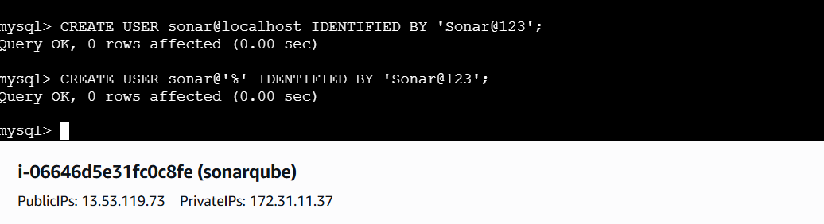
Give the Grant database access permissions to users
GRANT ALL ON sonar.* TO sonar@localhost;
GRANT ALL ON sonar.* TO sonar@'%';
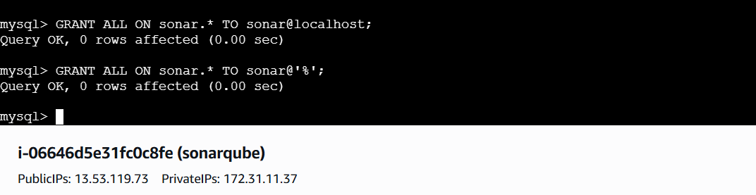
check users and databases
show databases;
SELECT User FROM mysql.user;
FLUSH PRIVILEGES;
QUIT

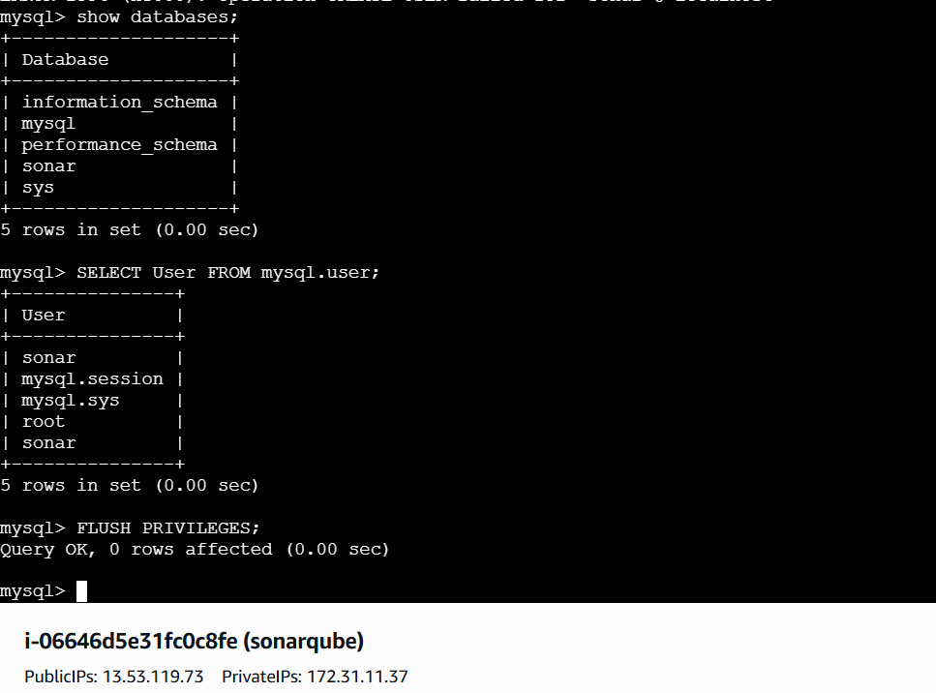
So for you have configured required database information on mysql. Let’s Jump back to your EC2 instance and enable SonarQube properties file to connect his Database.
ON EC2 Instance
Edit sonar properties file to uncomment and provide required information for below properties.
Sudo nano /opt/sonar/conf/sonar.properties
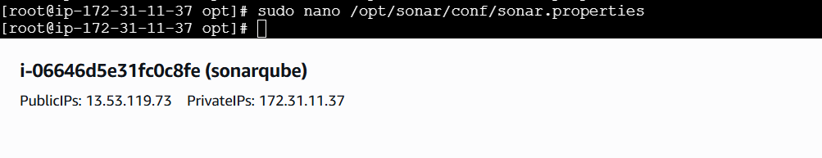
sonar.jdbc.username=`sonar`
- sonar.jdbc.password=`Sonar@123`
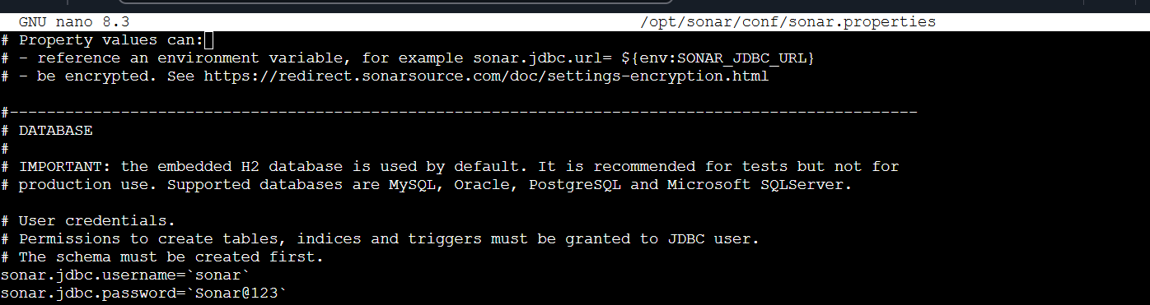
- sonar.web.host=`0.0.0.0`
- sonar.web.context=`/sonar`

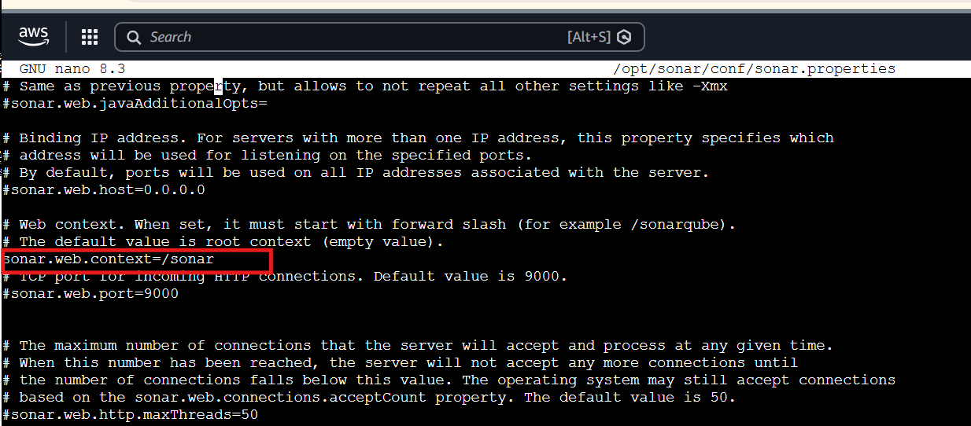
After thet to unzip the sonarqube file
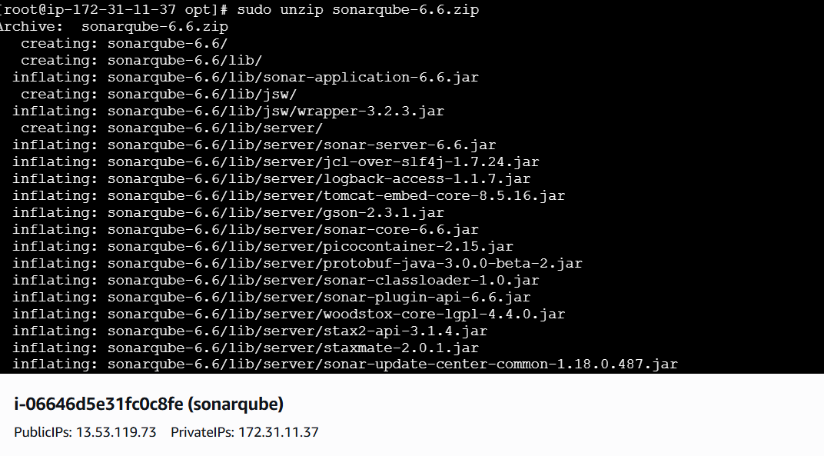
See the sonarqube log files
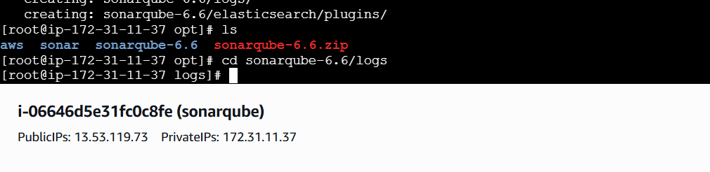
To add user and new groups
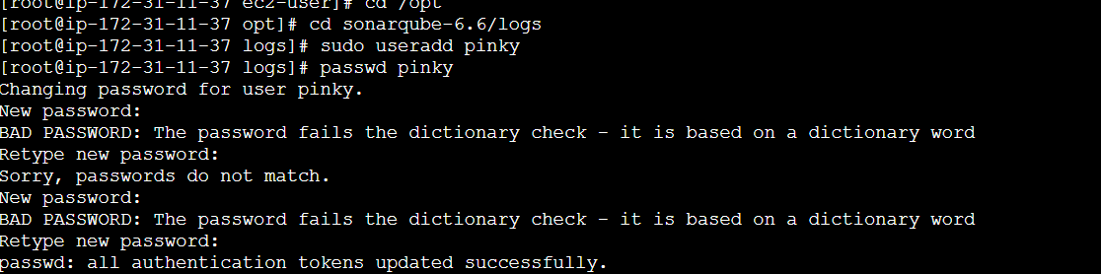
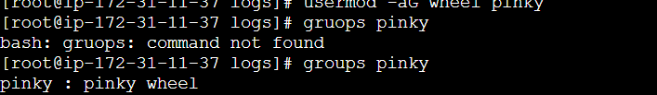
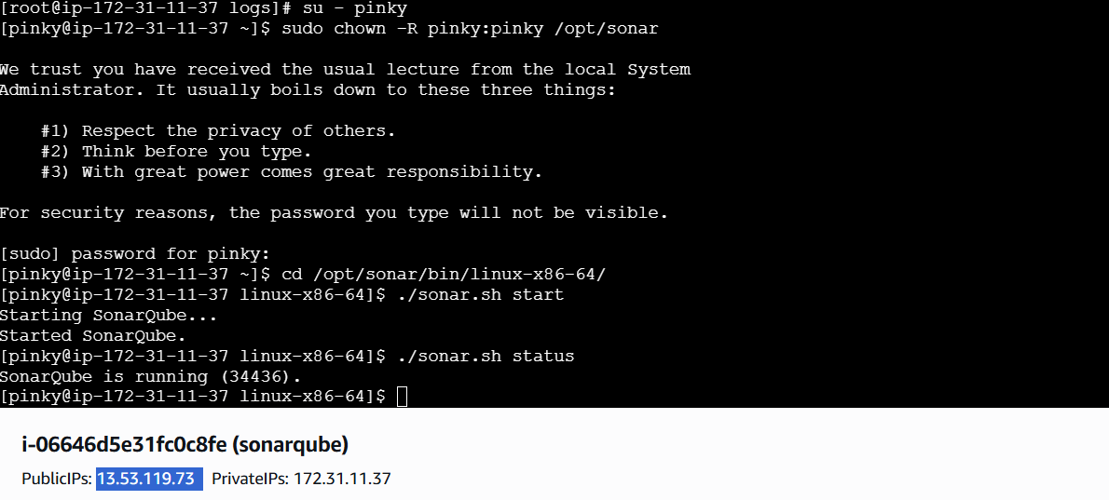
After thet we can Successfully logged into sonarqube server
SonarQube application uses port 9000. access SonarQube from browser

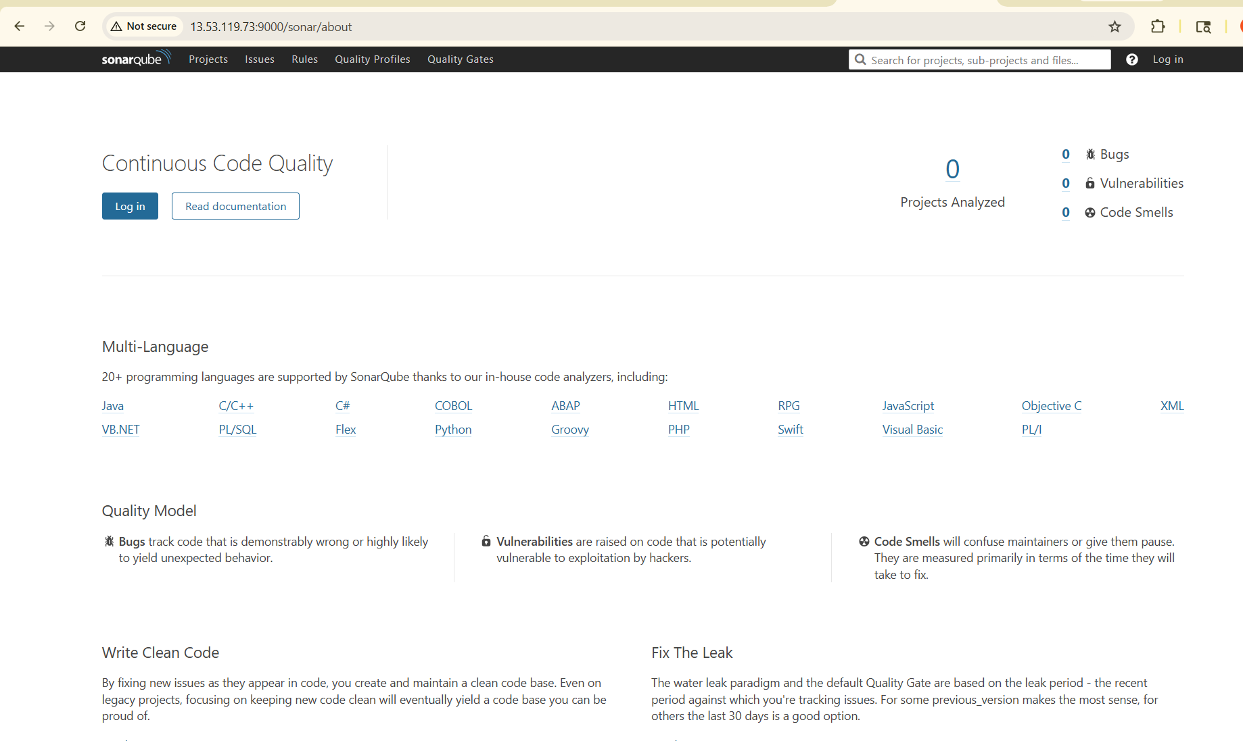
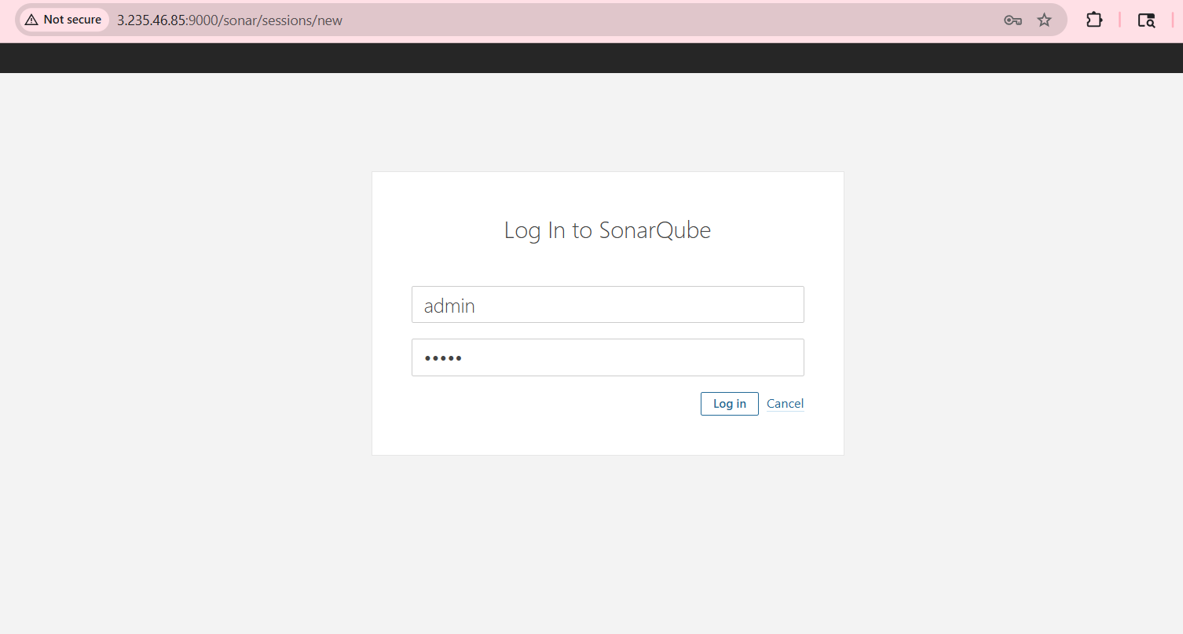

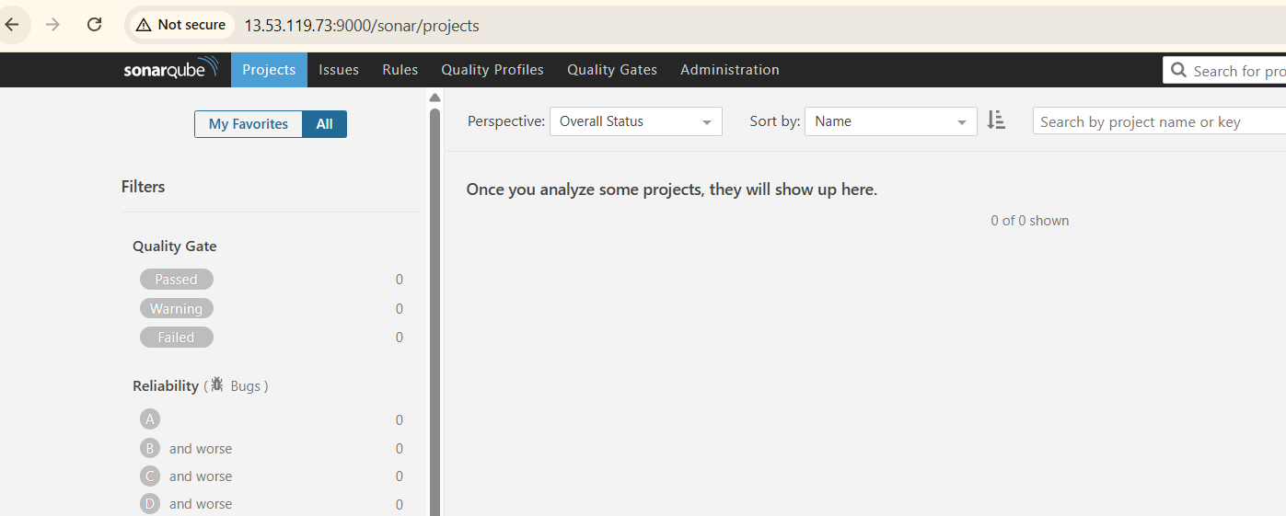
SonarQube Scanner on our Jenkins
Go to Manage Jenkins Plugins search the Sonarcube scanner click on Install

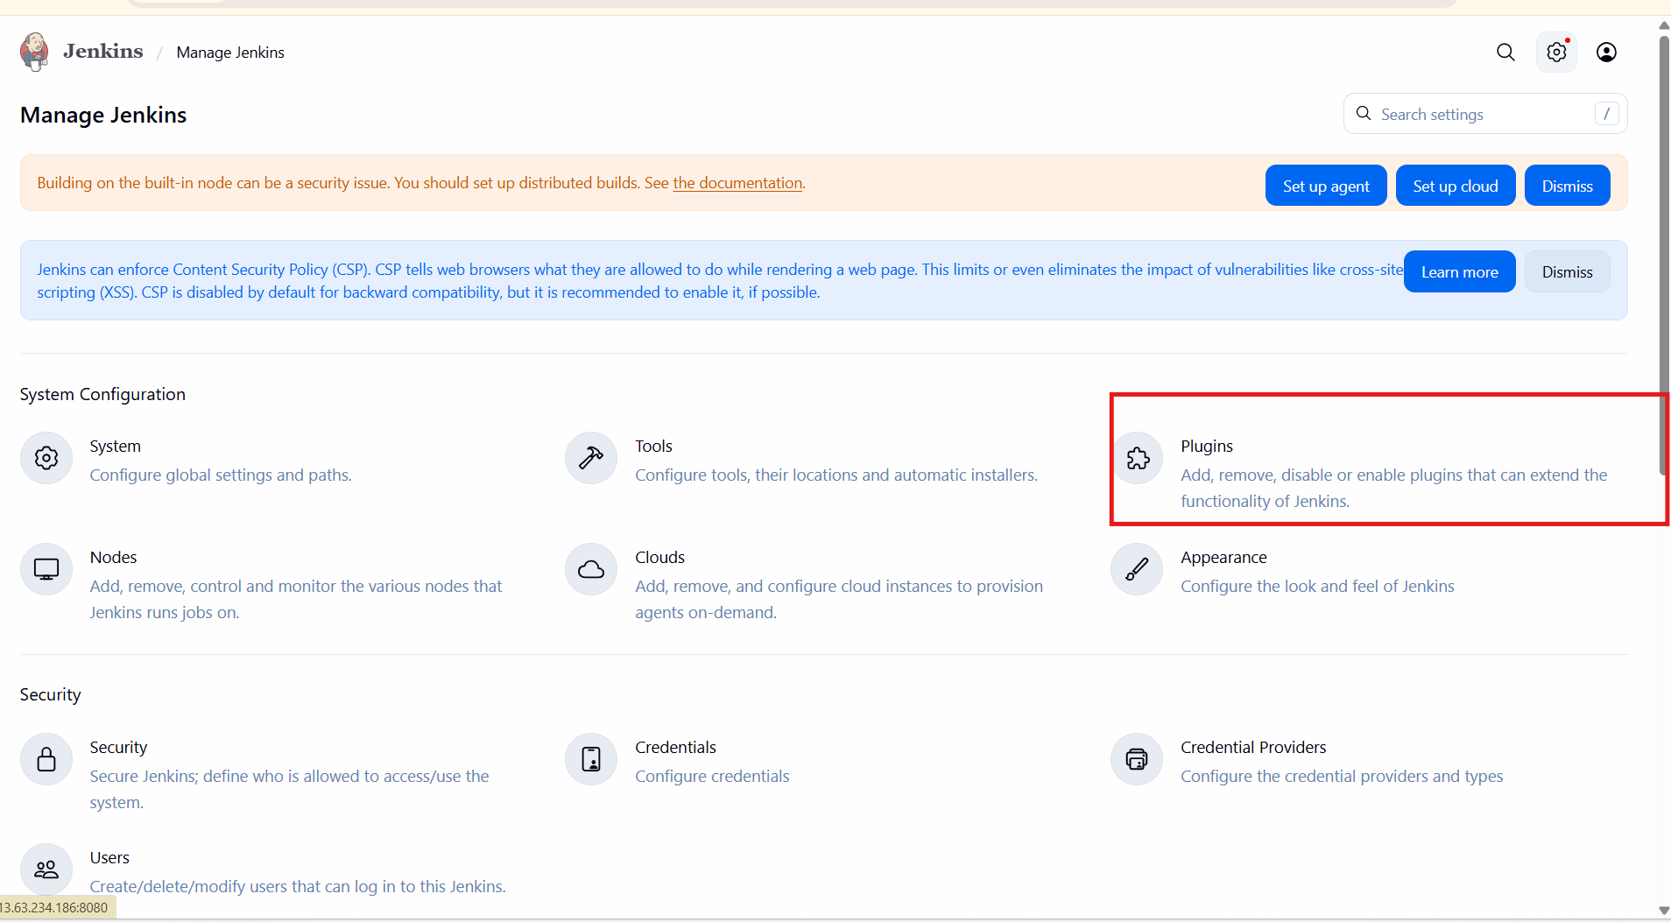
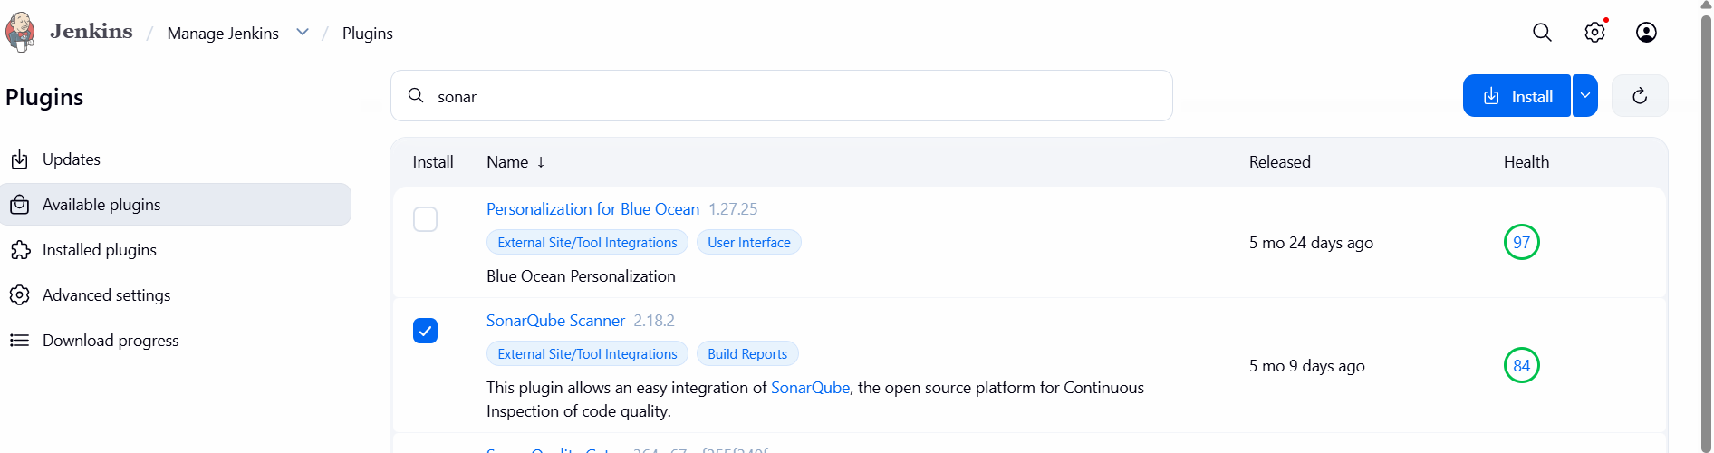
To create
Manage Jenkins - click on system -SonarQube server -give Name - sonarqube Server URL -
Credentials

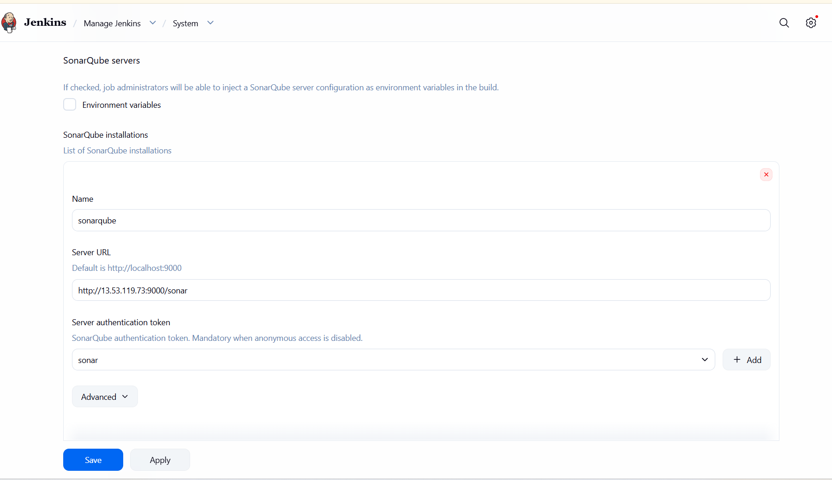
To add the server authentication token,we need to create a token in sonarqube
Go to sonarqube--> click on security--> generate a token-->token well be generated
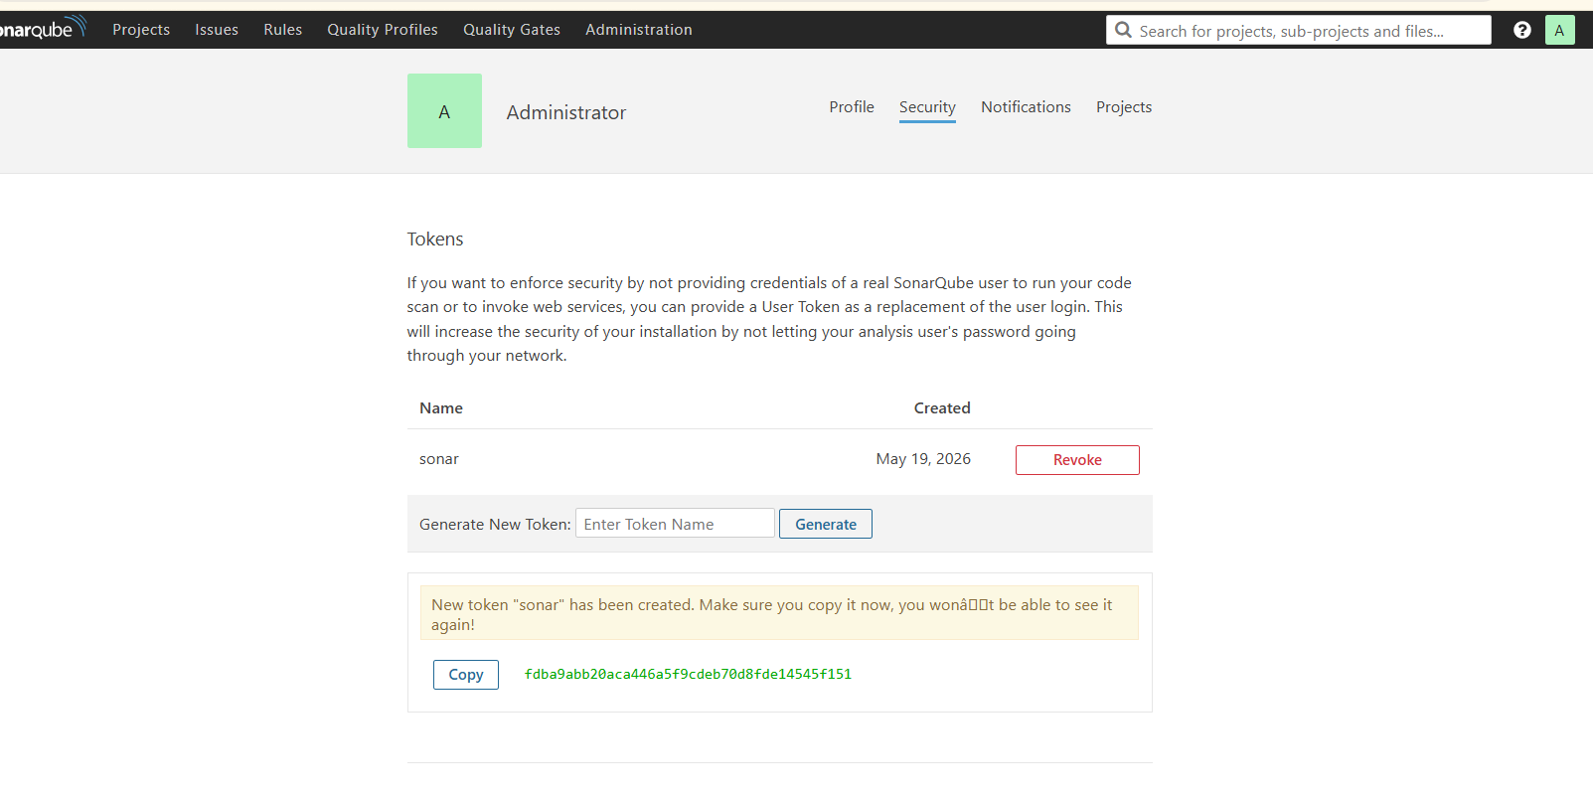
After thet go to jenkins-->add credintial-->select secreat test-->past the token

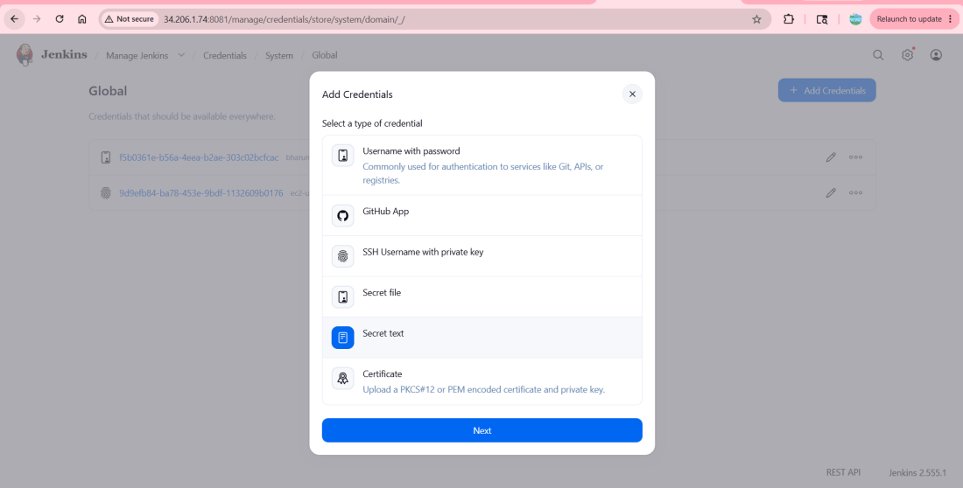
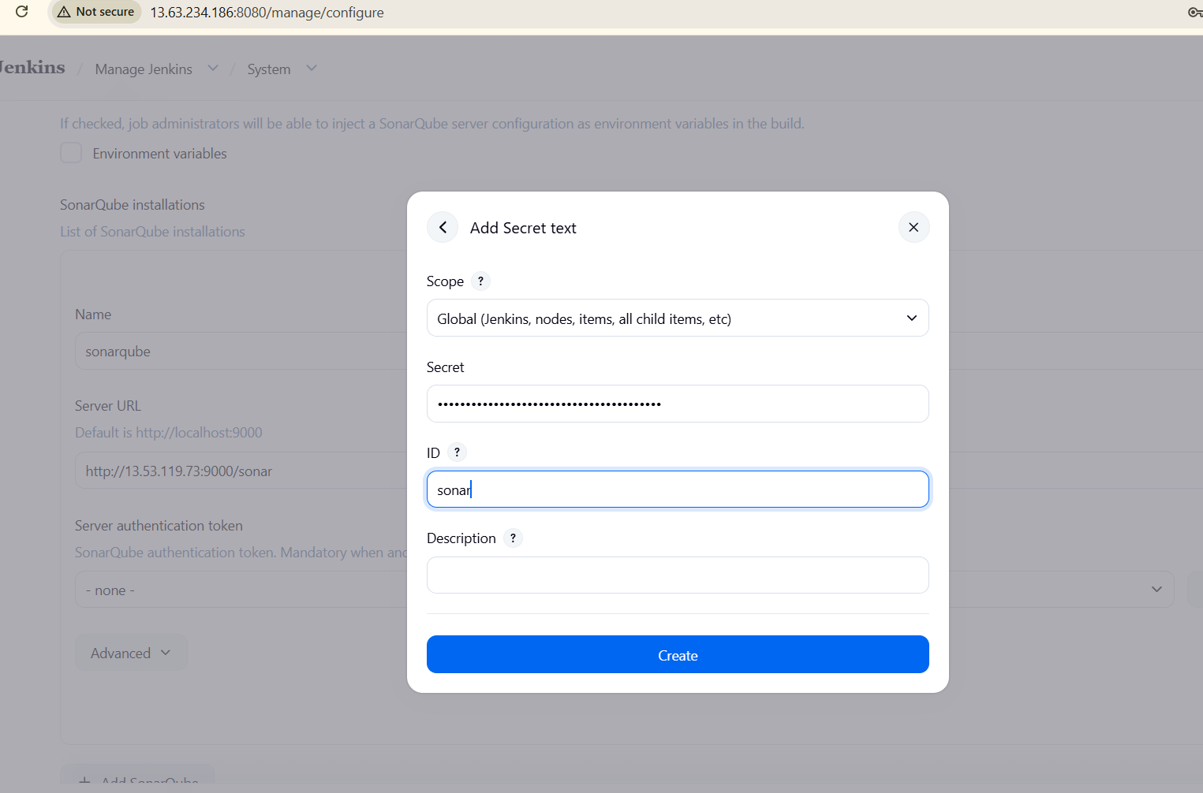

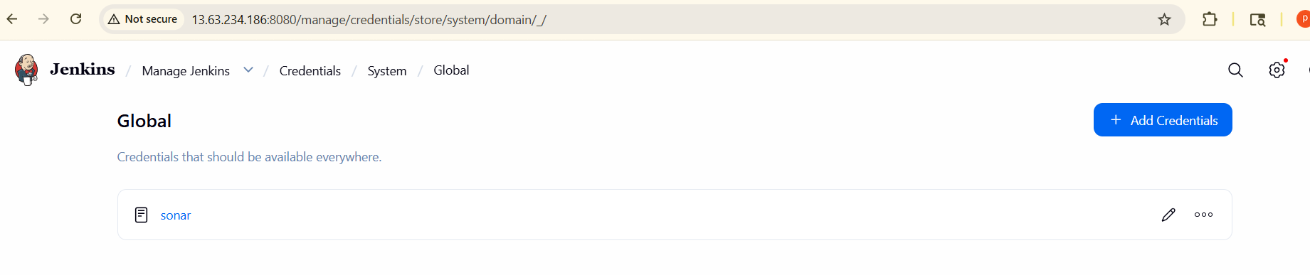
We need to install sonarqube-scanner in Jenkins server
To Download - sudo wget https://binaries.sonarsource.com/Distribution/sonar-scanner-cli/sonar-scanner-cli-3.2.0.1227-linux.zip
- To Unzip - unzip sonar-scanner-cli-3.2.0.1227-linux.zip
- To Rename - mv sonar-scanner-3.2.0.1227-linux /opt/sonar_scanner

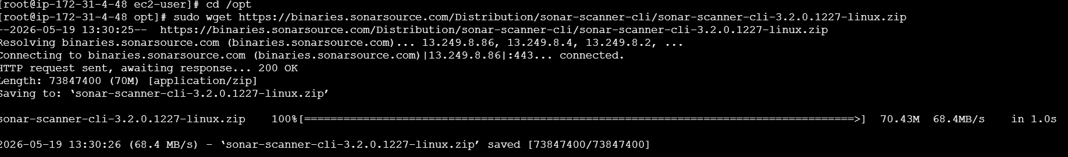
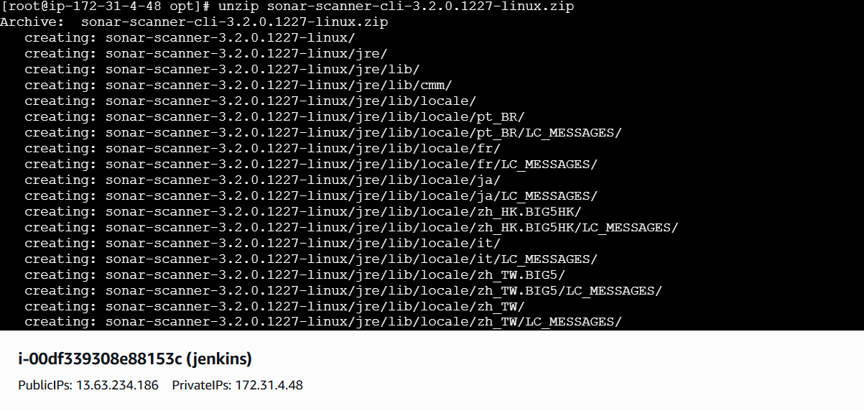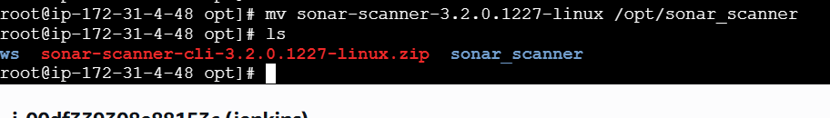
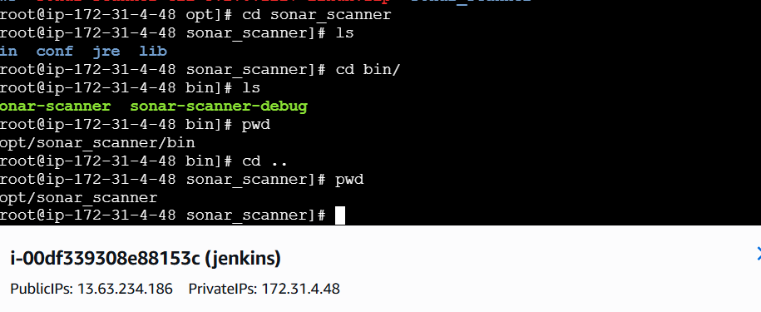
Add the above sonar-scanner path in the Jenkins
Go to manage Jenkinstools sonarQube Scanner Name Path Save

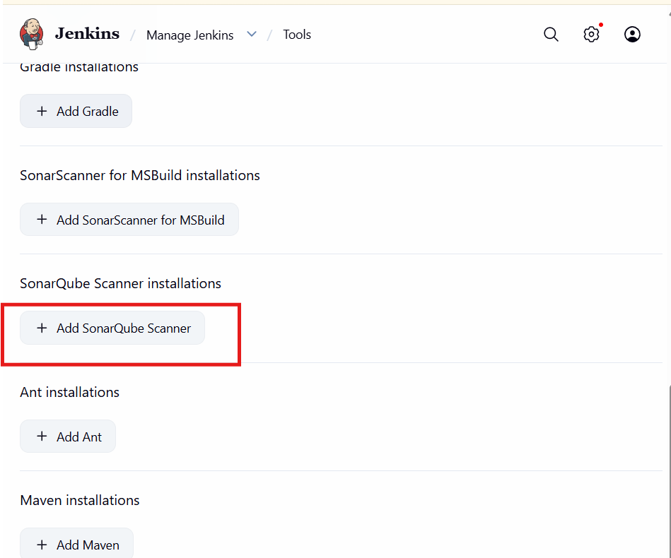
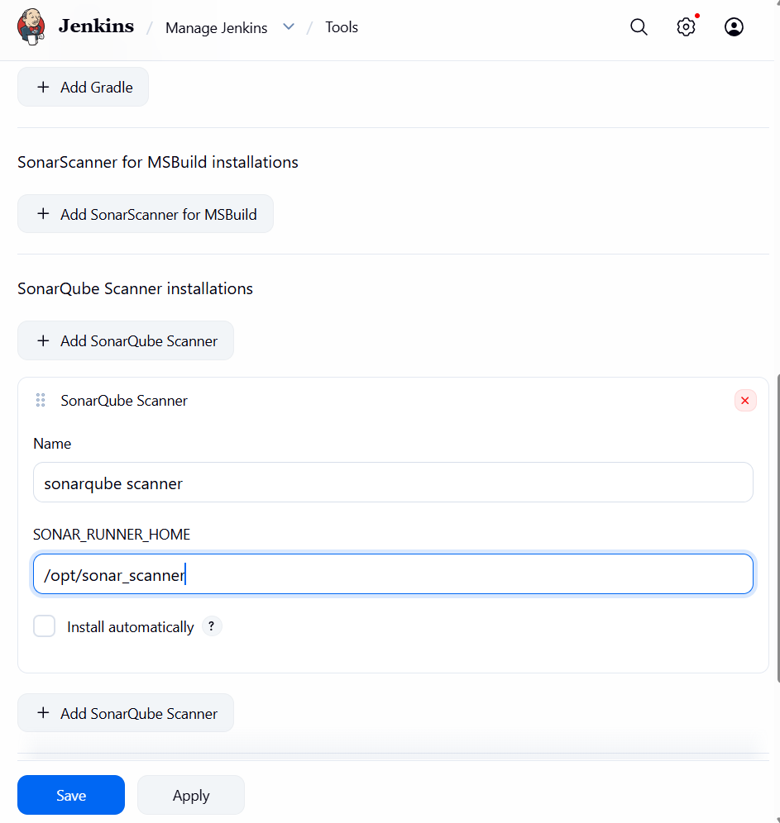
Next We need to give analysis properties of the code to run in the Job we created
Job Configure Build Steps Analysis Properties(we will get it from developers)-Save

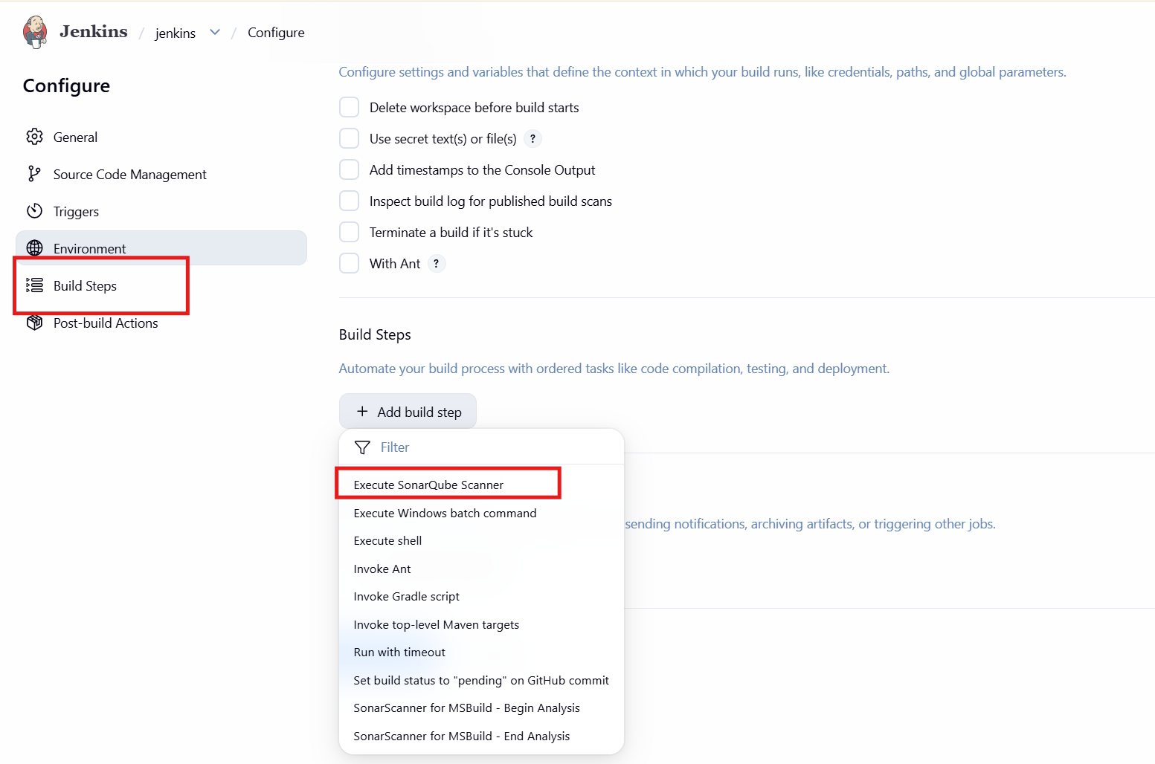
Open the sir given url in chrome go to last line and copy that
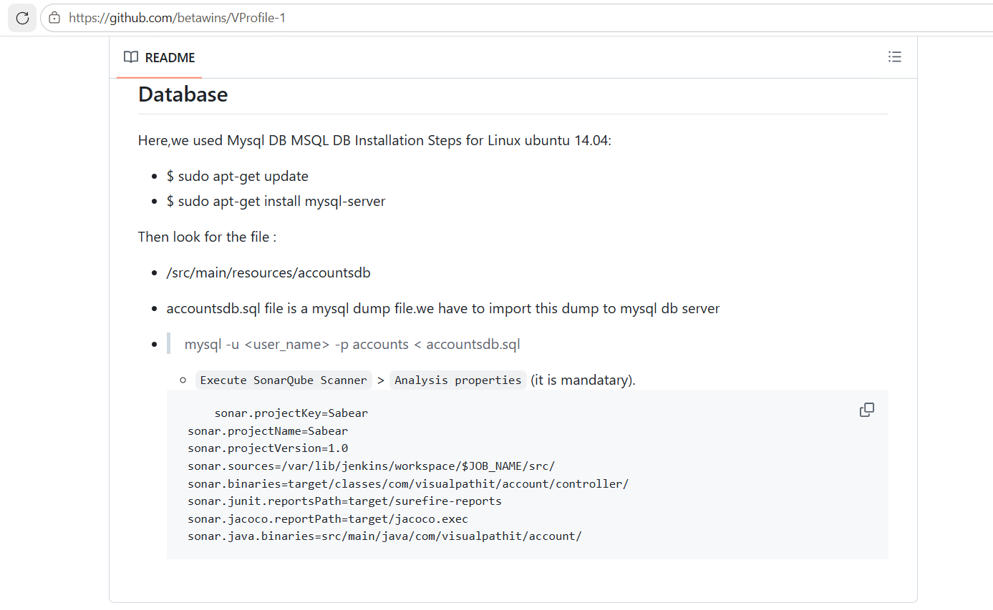
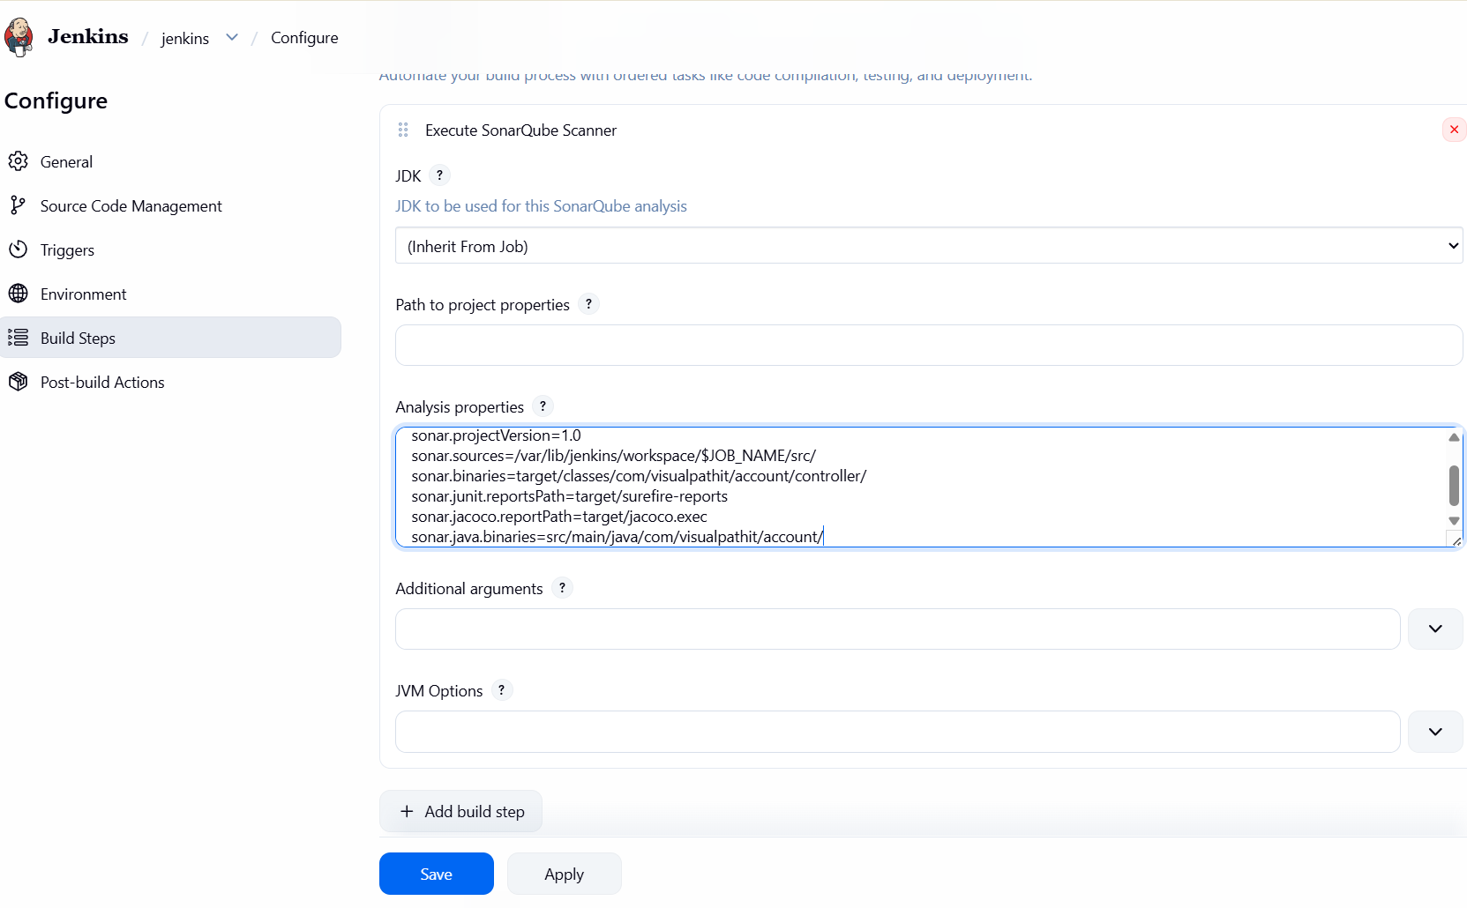
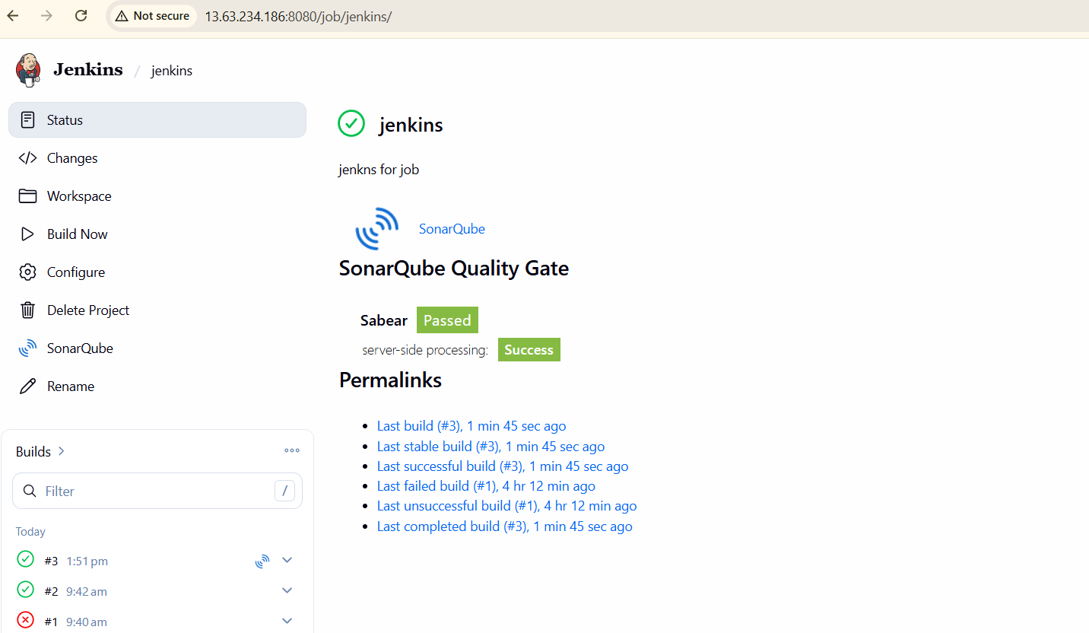

Job ran successfully
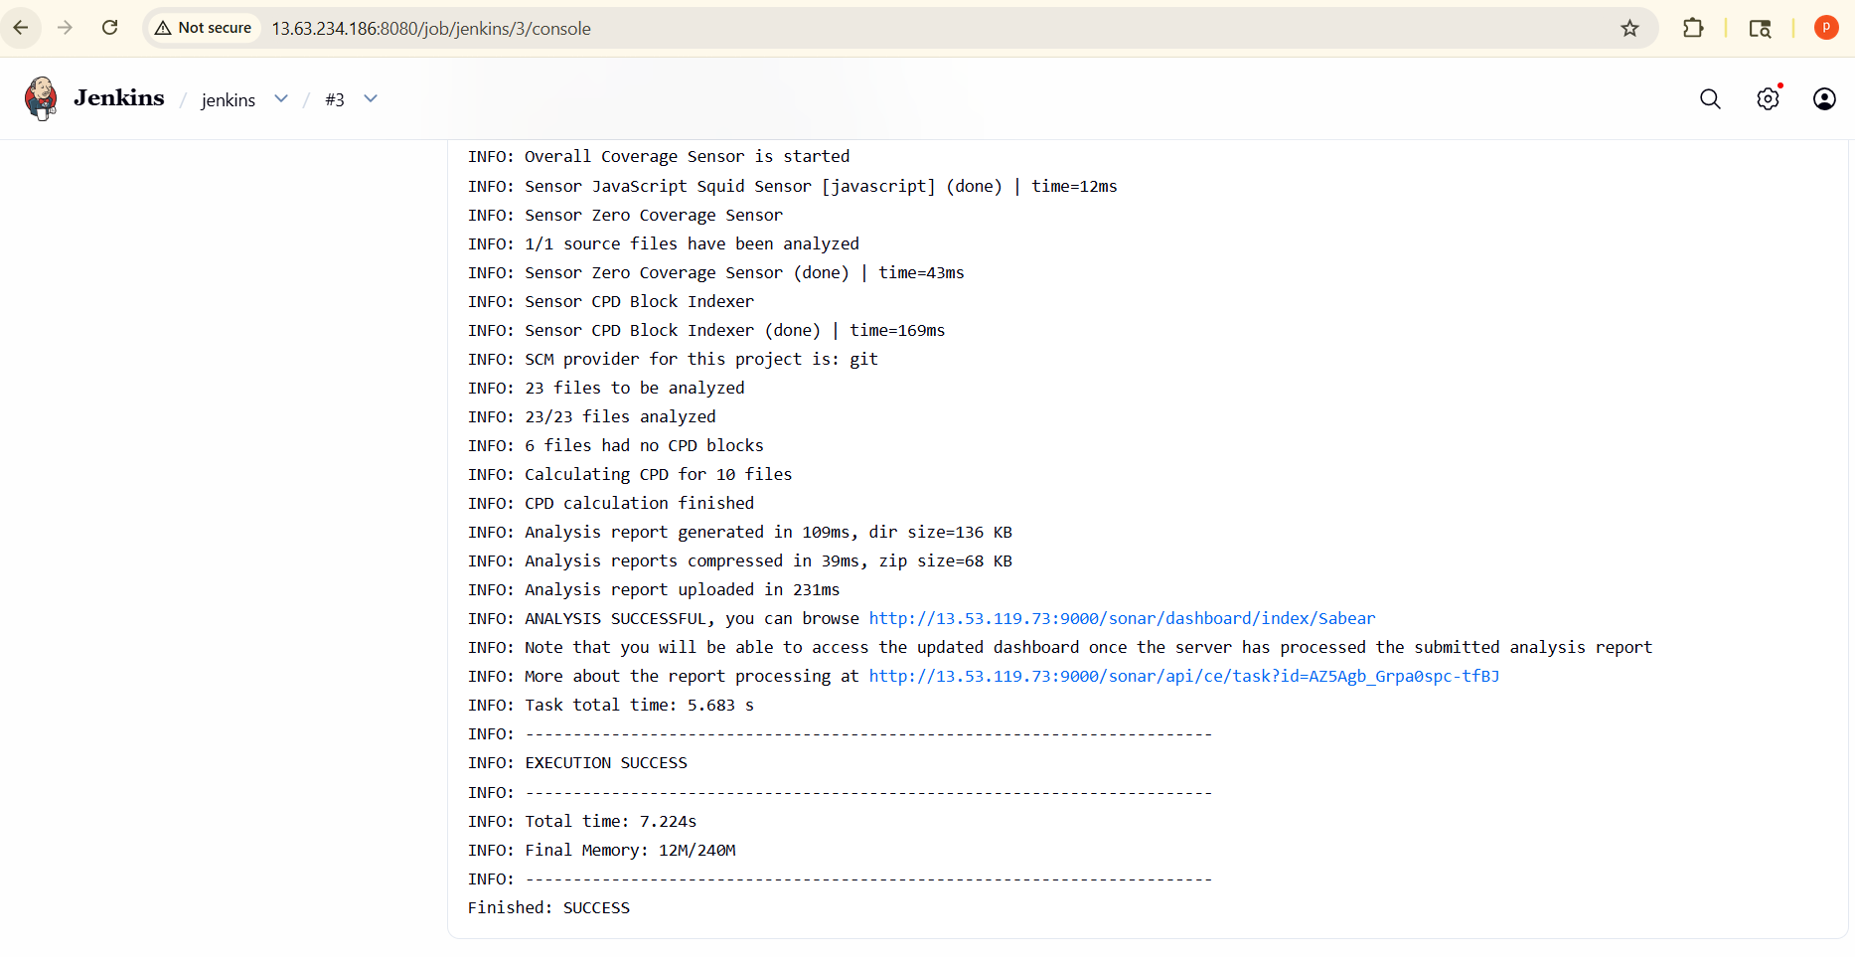
It also passed in sonarqube

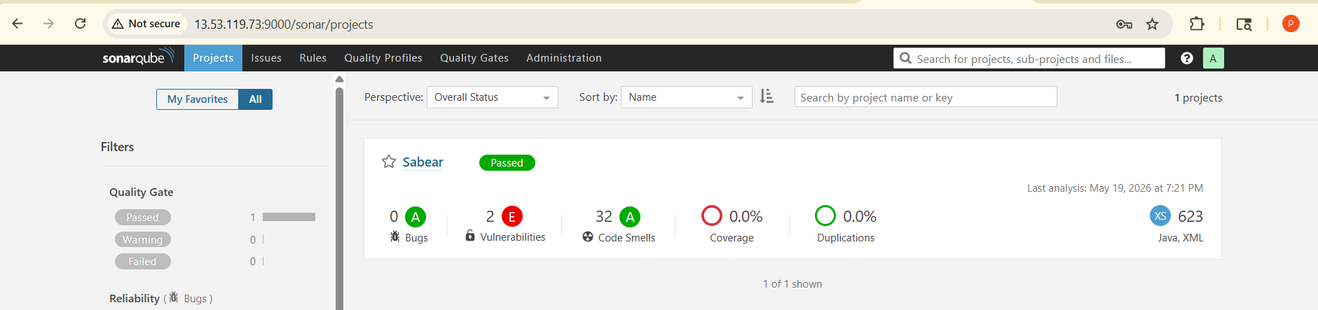
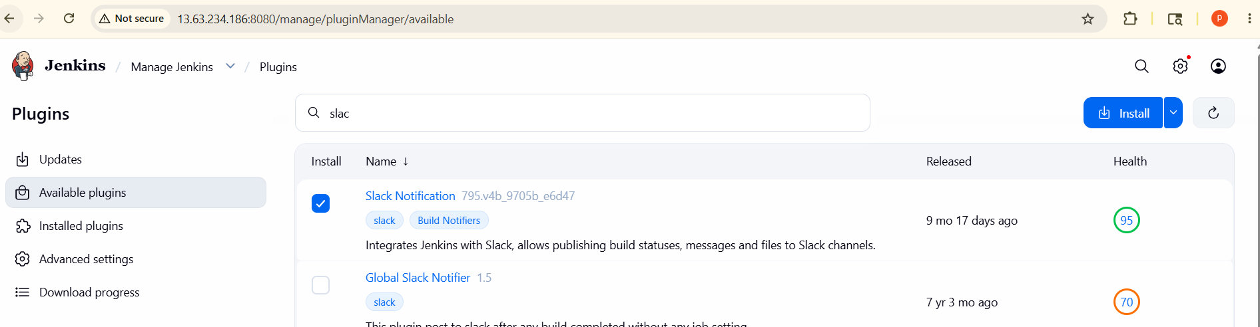
Stage 3 : Slack Integration to send the alerts to slack.
Go to manage Jenkins plugins available plugins - search for slack notification -install
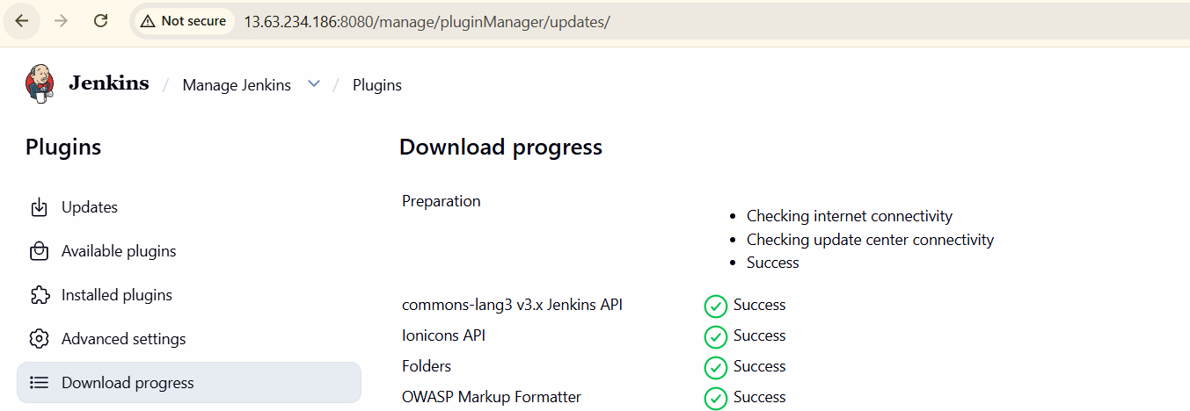
I have created a slack account

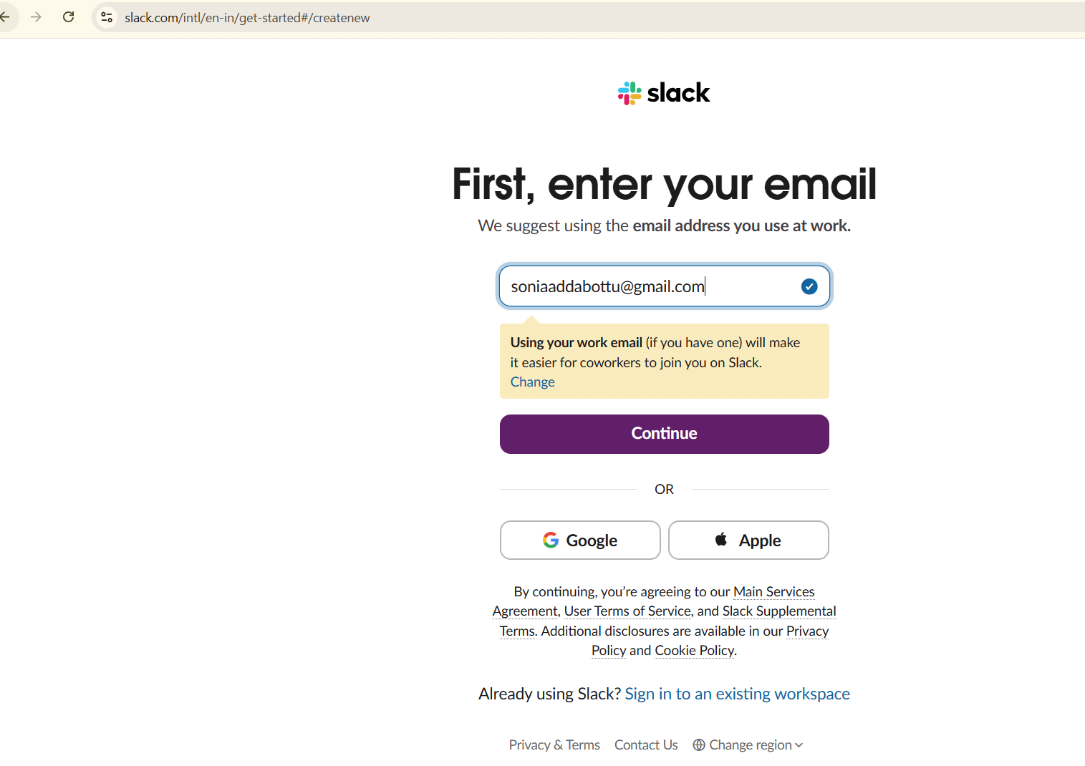
Go to slack app-->
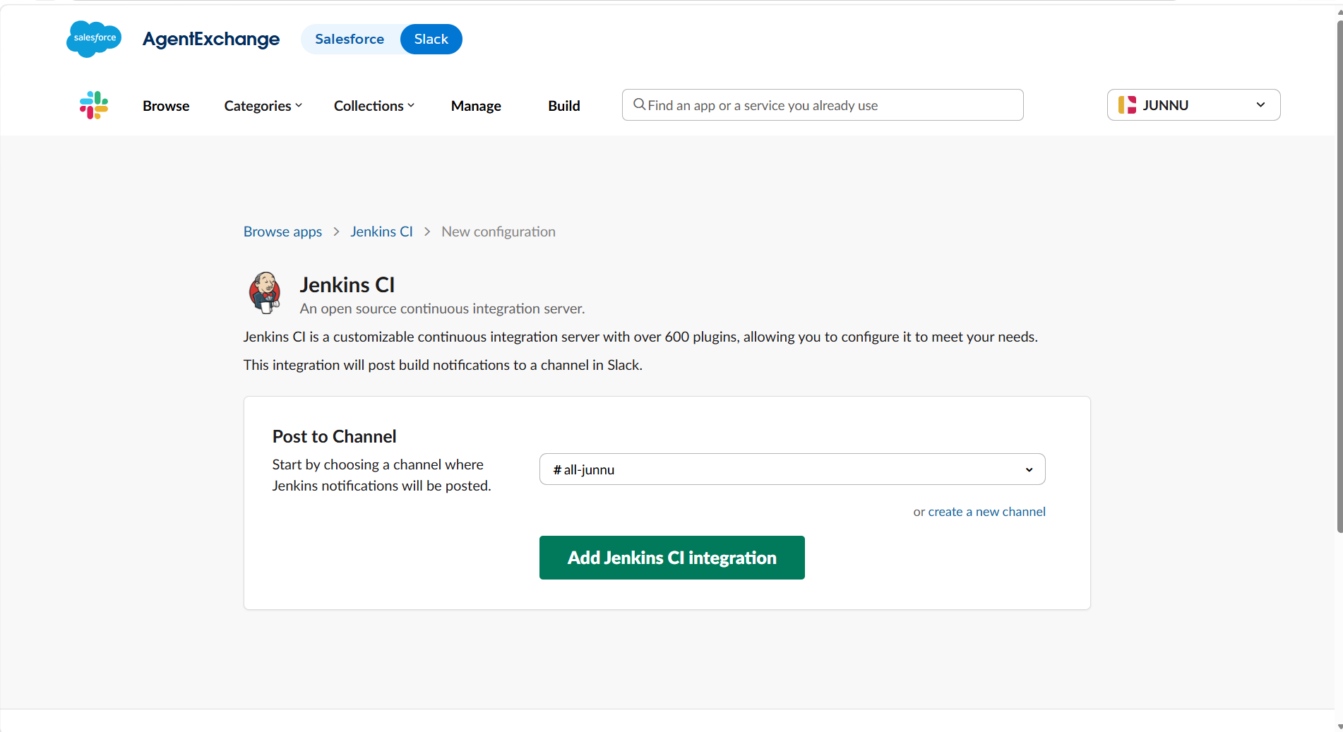
Open Jenkins last go to token copy that
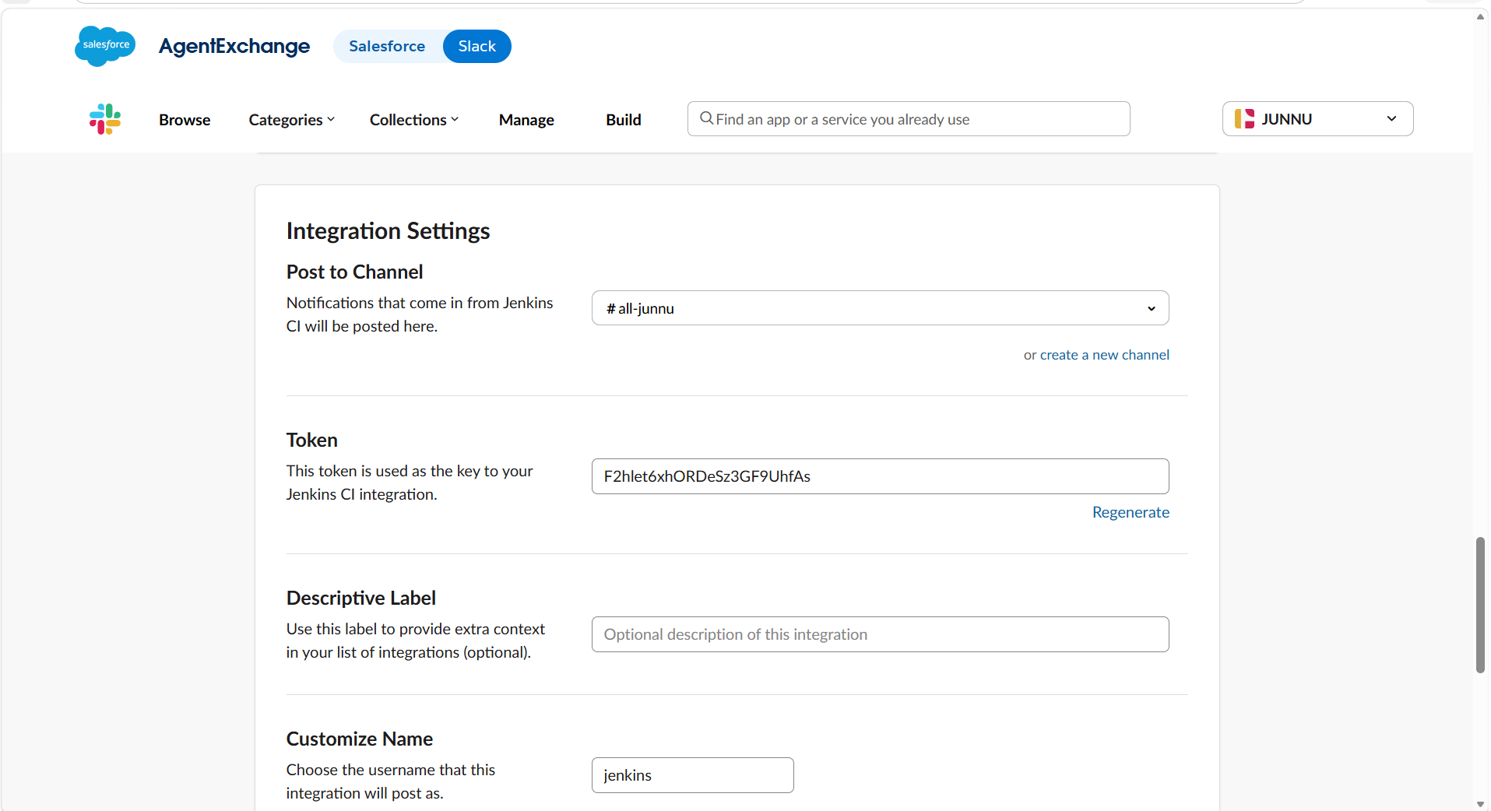
Go to manage Jenkinscredentialsclick on secret textadd the copied token inSecret

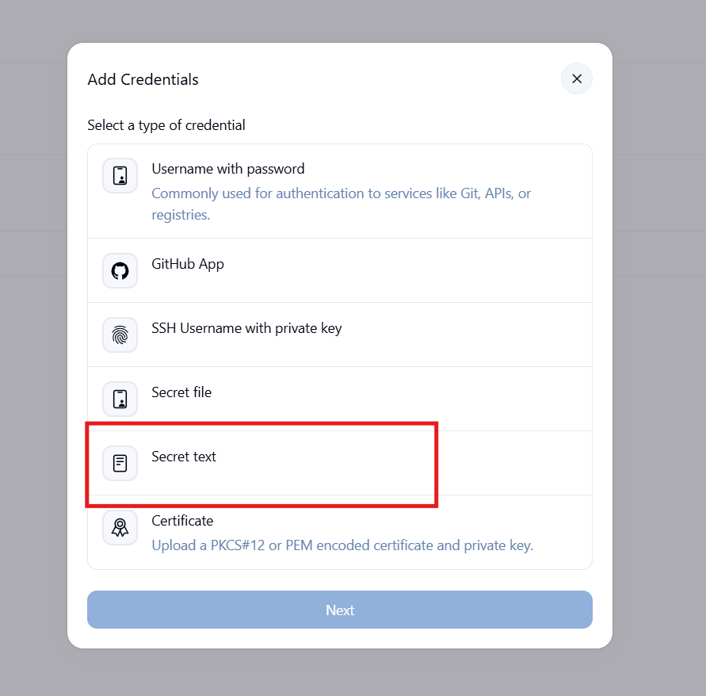
If we open the channel in slack there we will be having channel id, copy that and give in
channel id section

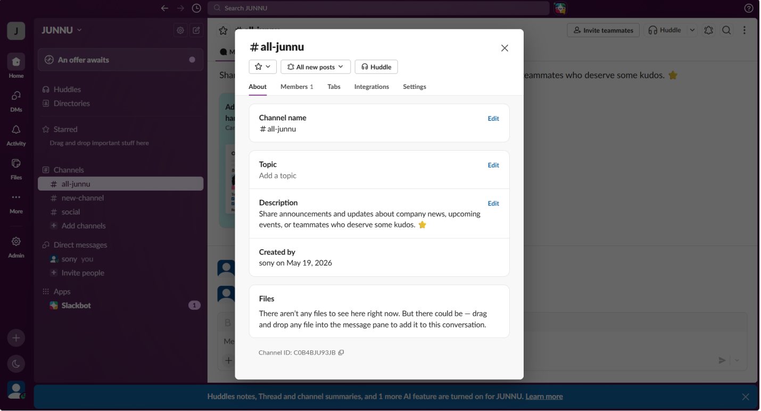
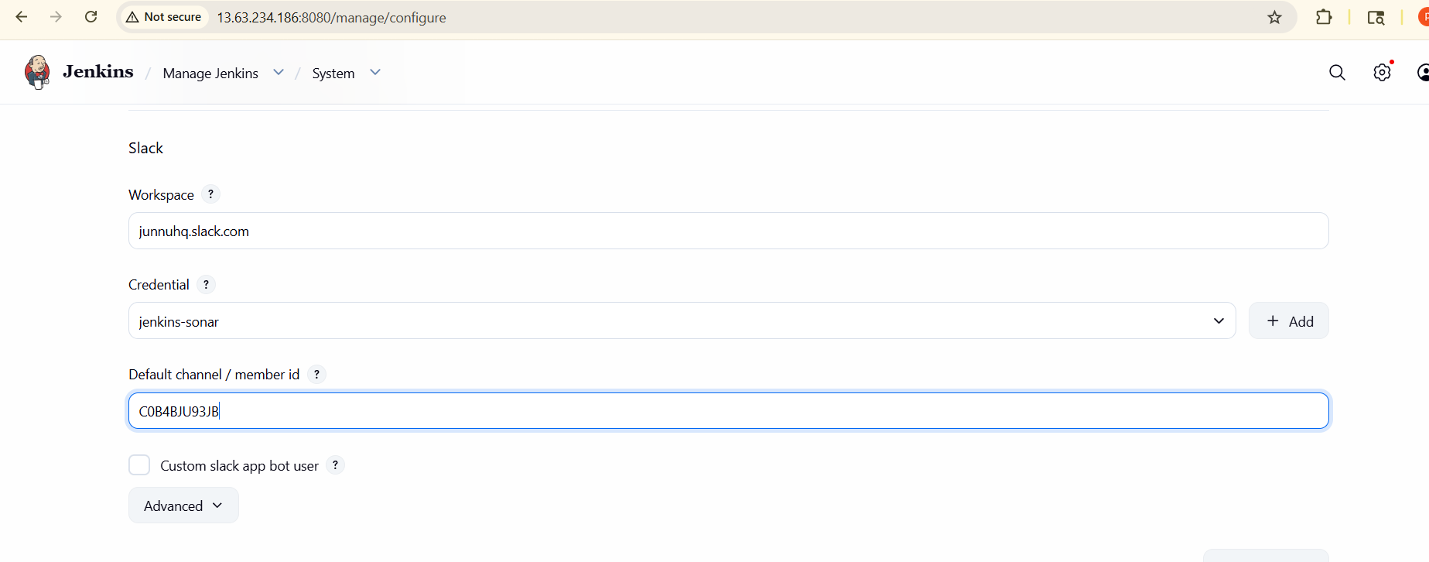
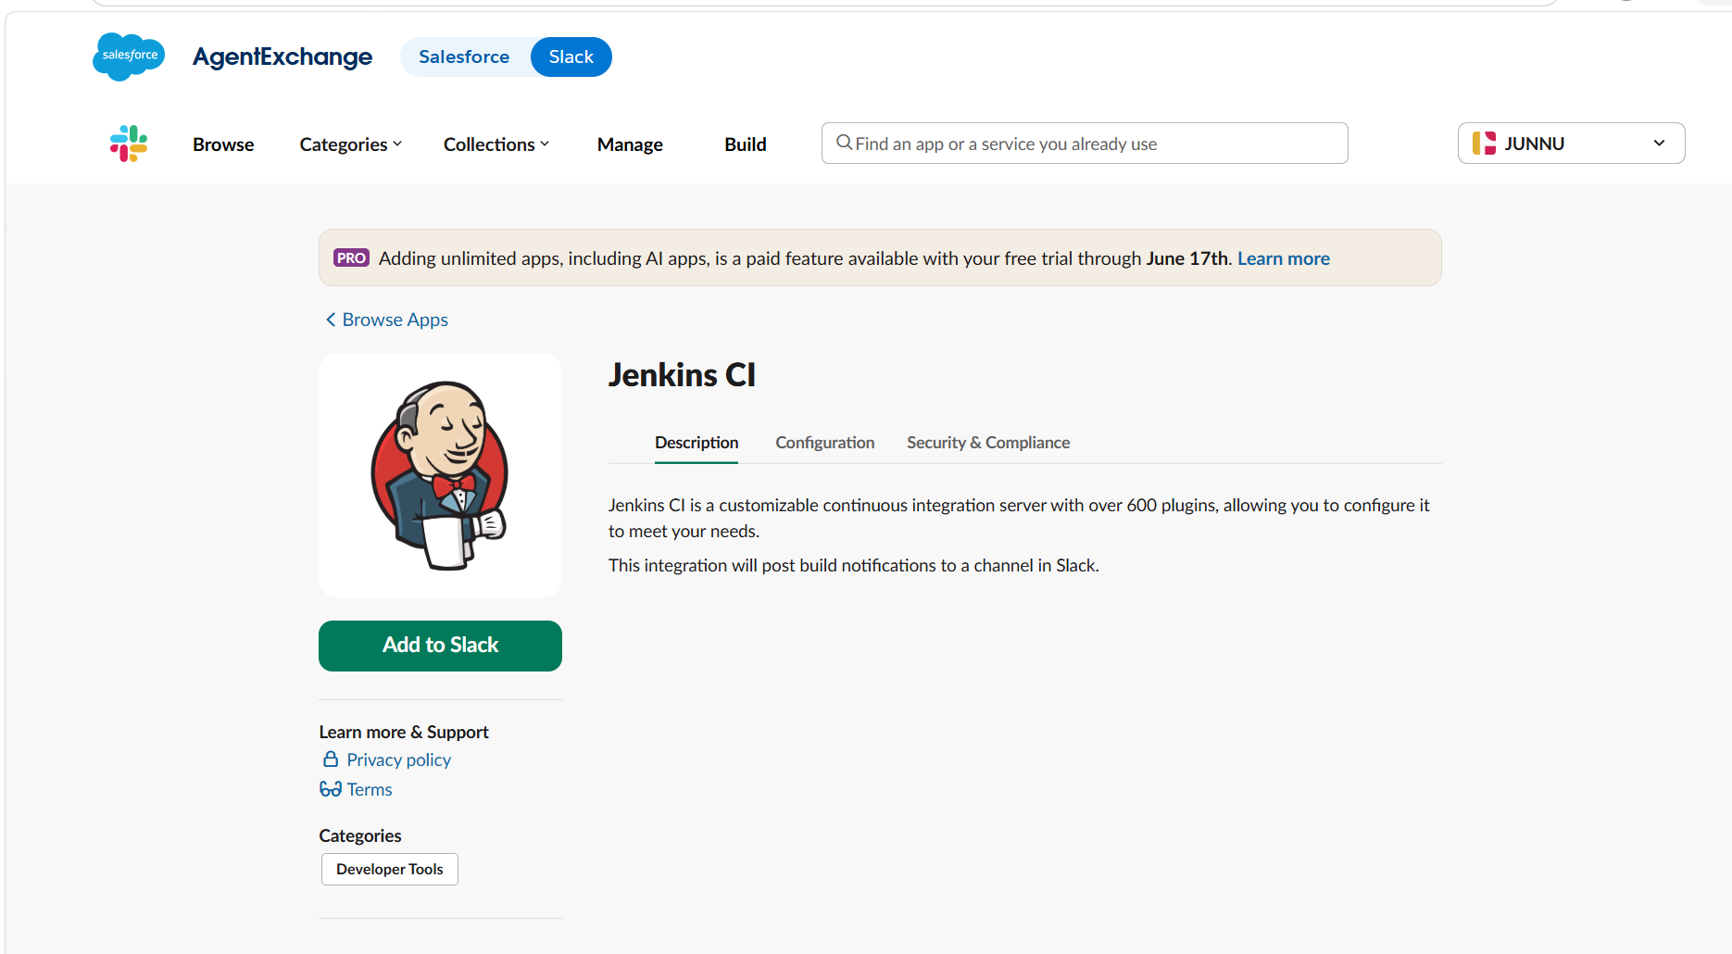
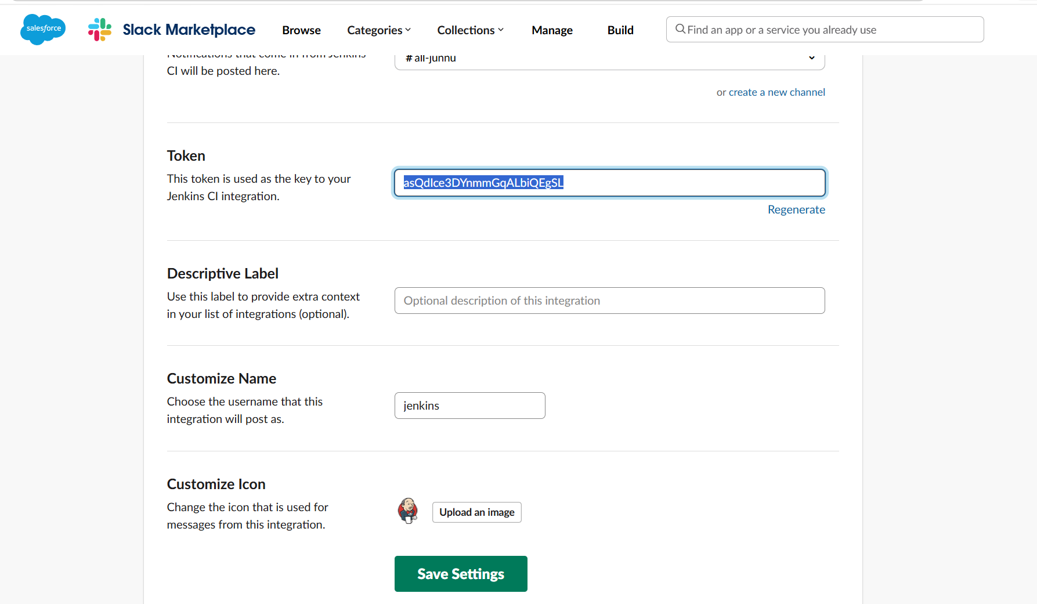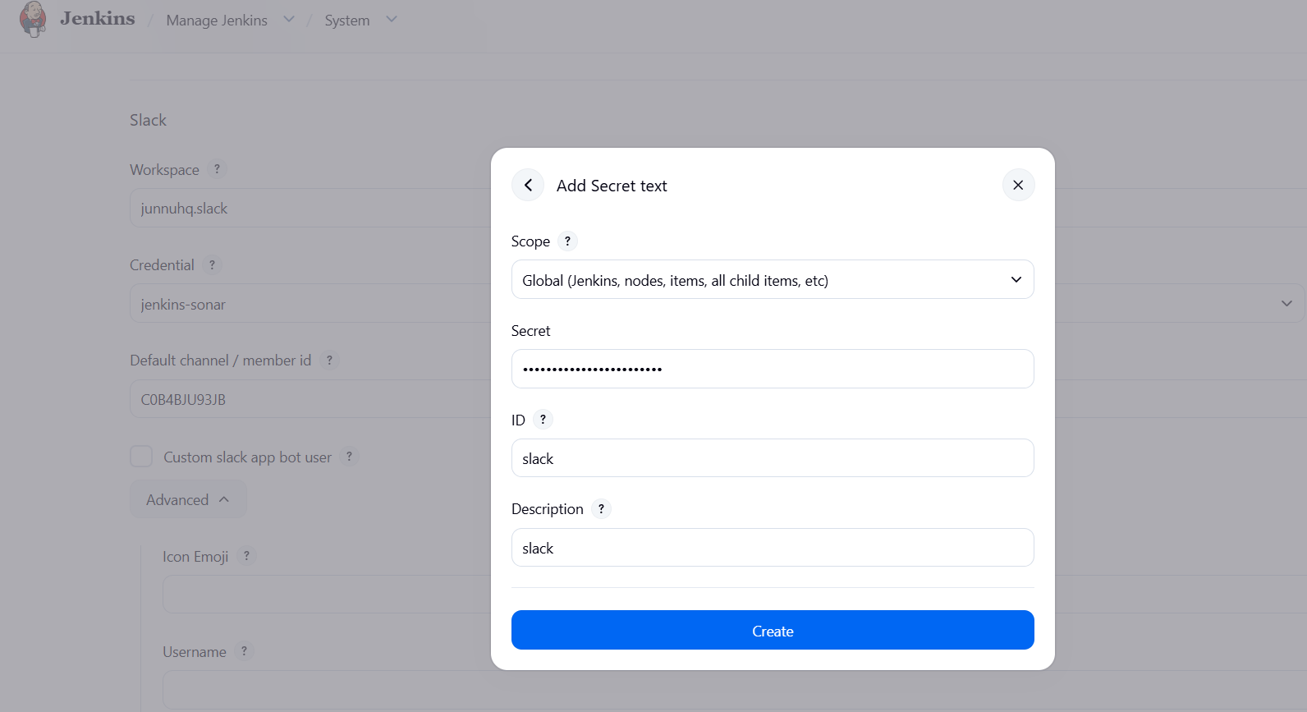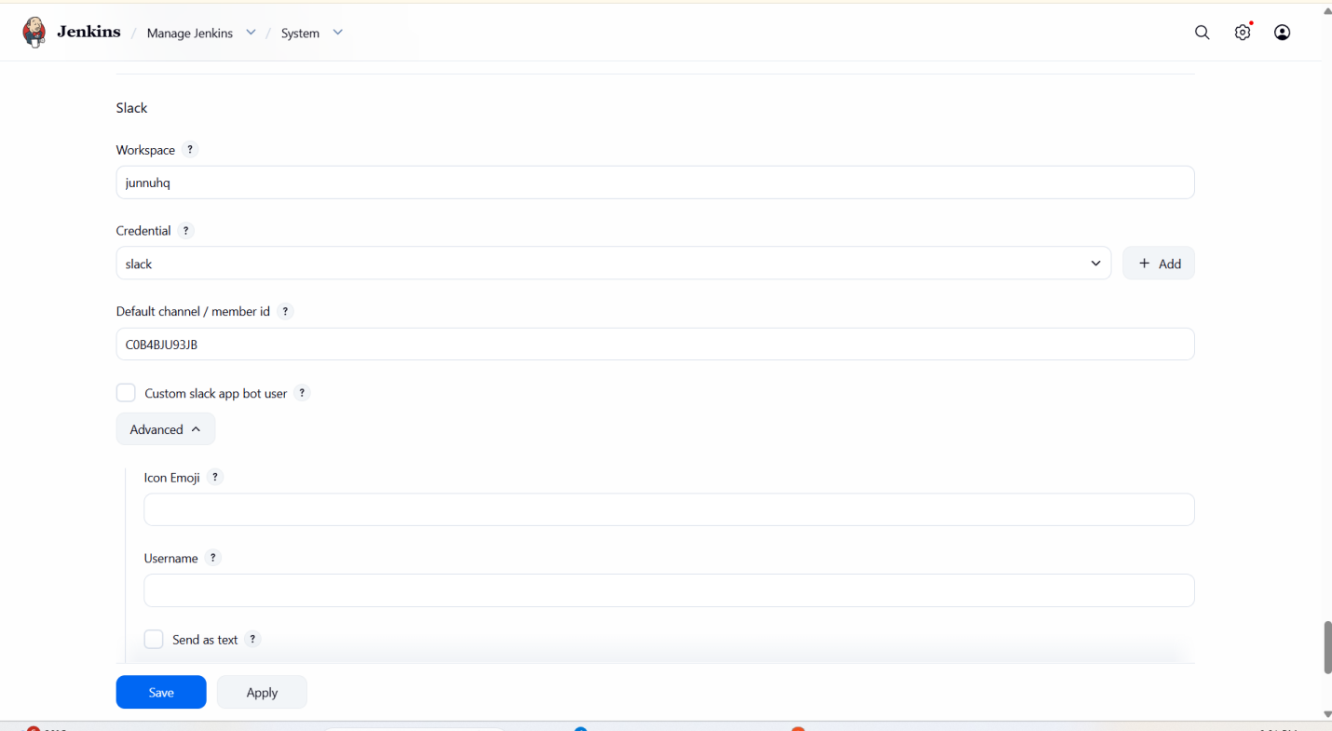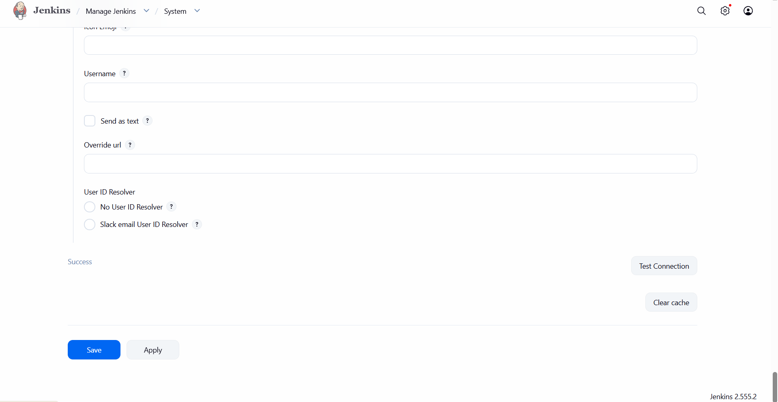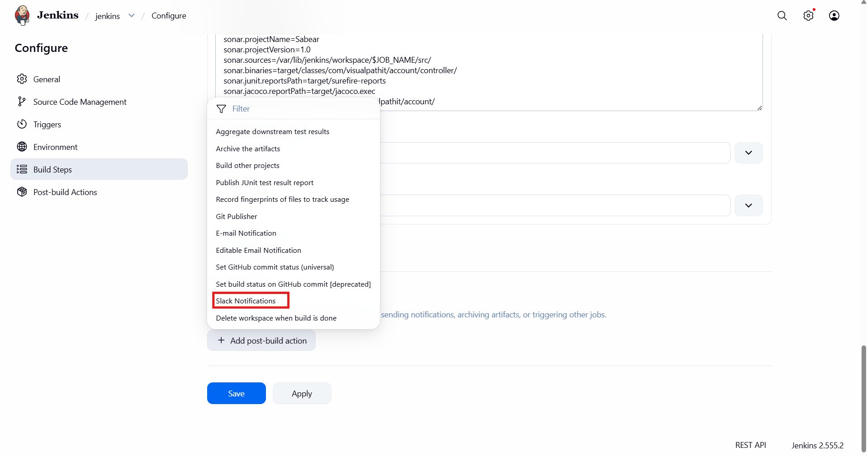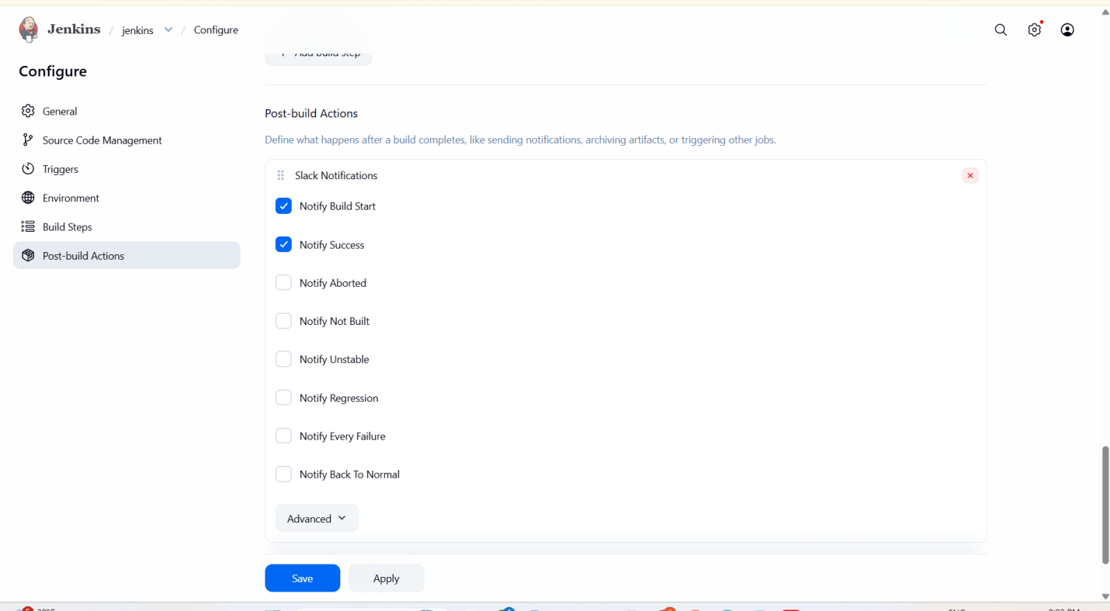
Here we can see connection is successful
•When we click on build it is successfully ran

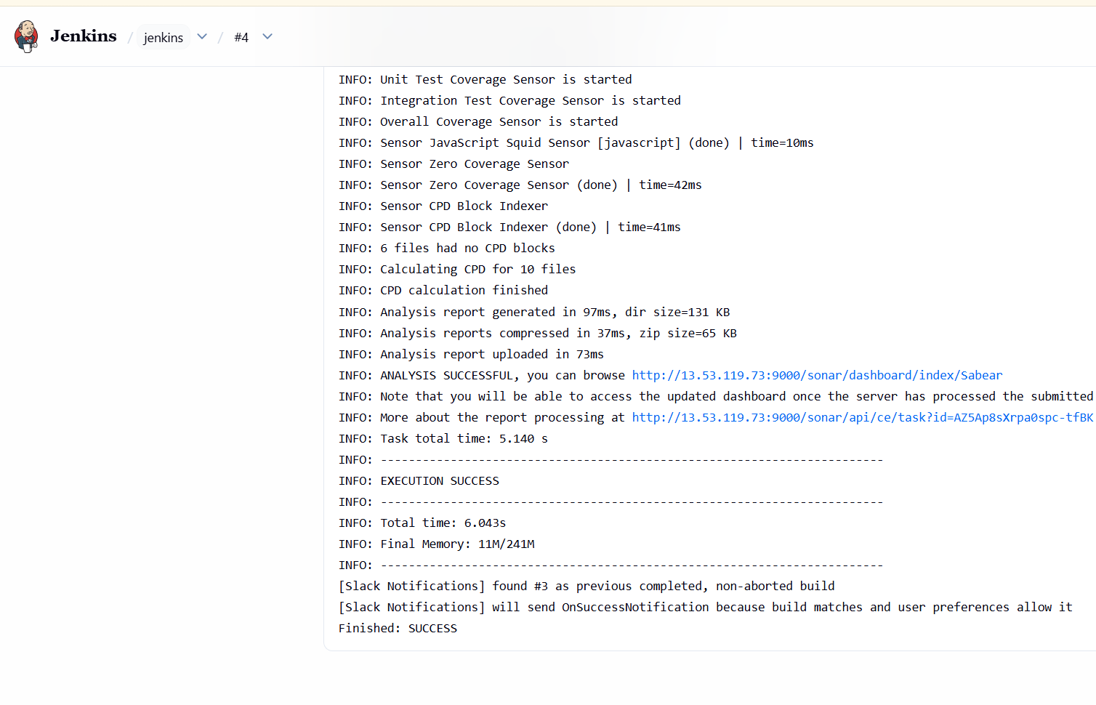
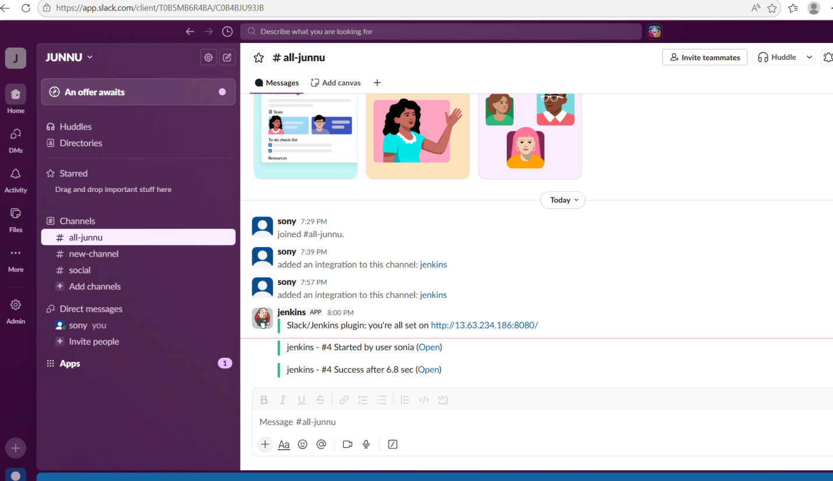

2.Create one Jenkins job using the below code and create three stages.
- stage1: Git clone to download the source code.
- stage2: Sonarqube Integration to check the quality of code.
- stage3: Slack Integration to send the alerts to slack.
Source Code: https://github.com/betawins/hiring-app.git

First we create a new job 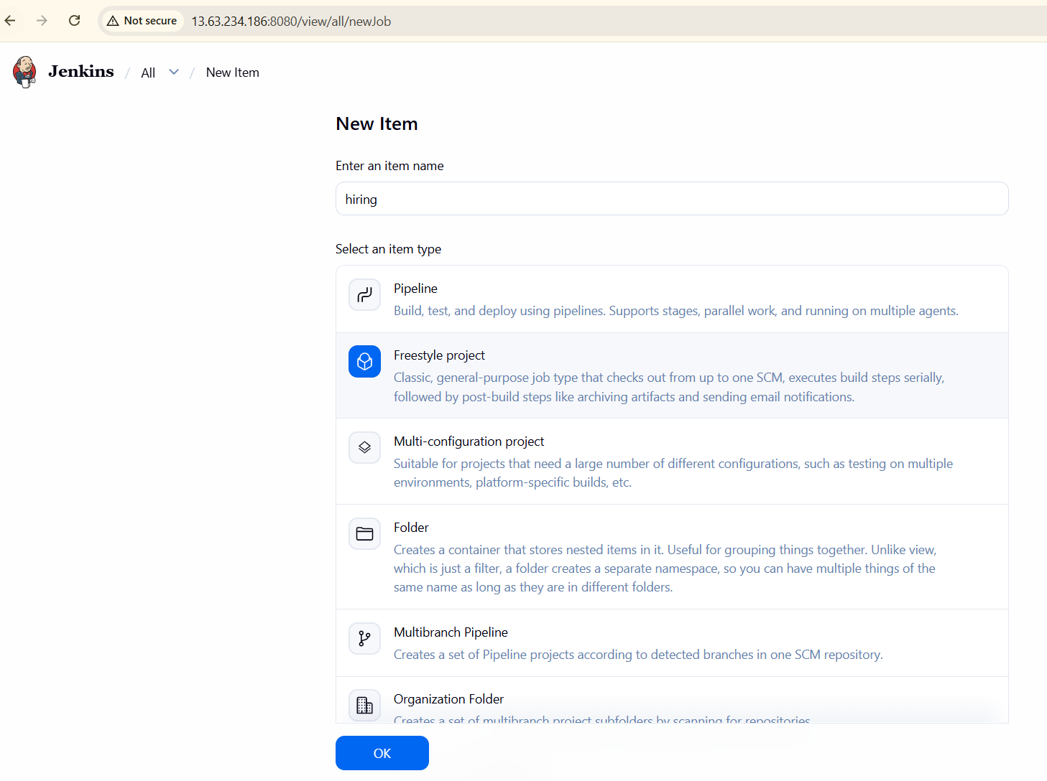
Choose git and provide url

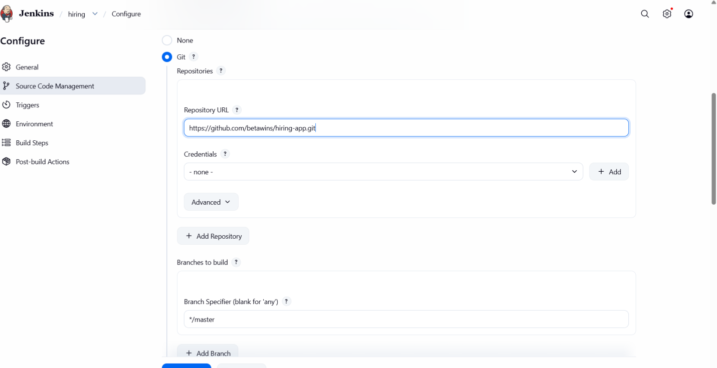
Click on add build step - choose sonarqube scannerAdd code in analysis properties
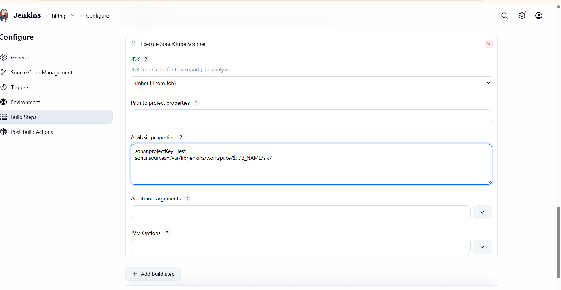
Go to post build actions choose slack notificationselect 2 advanced

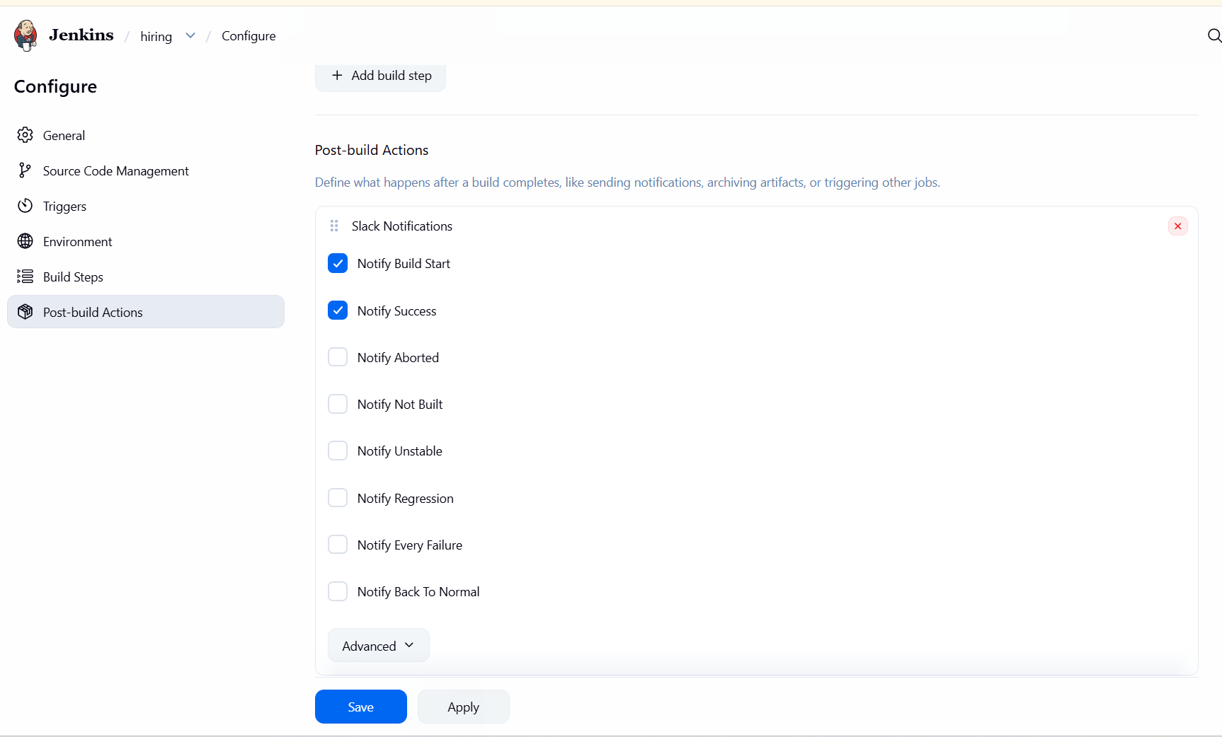
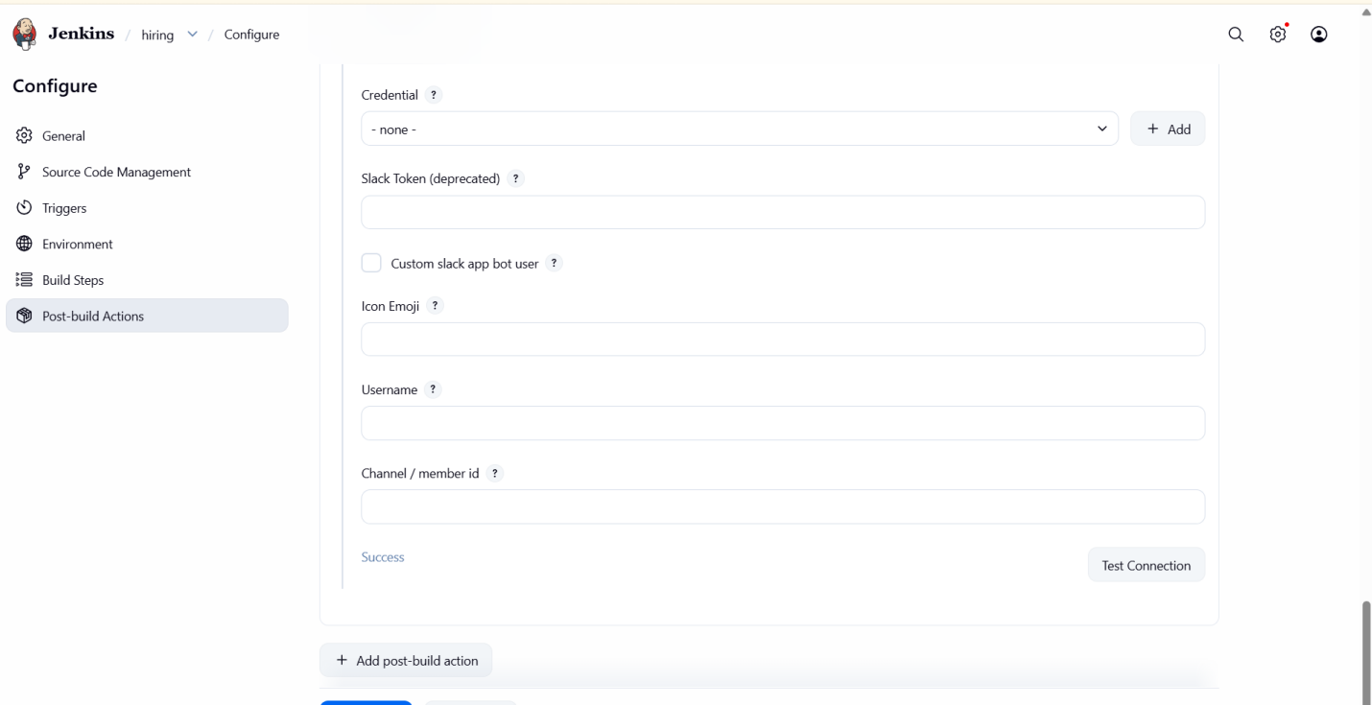

Click on build nowsuccesswe get alerts on slack

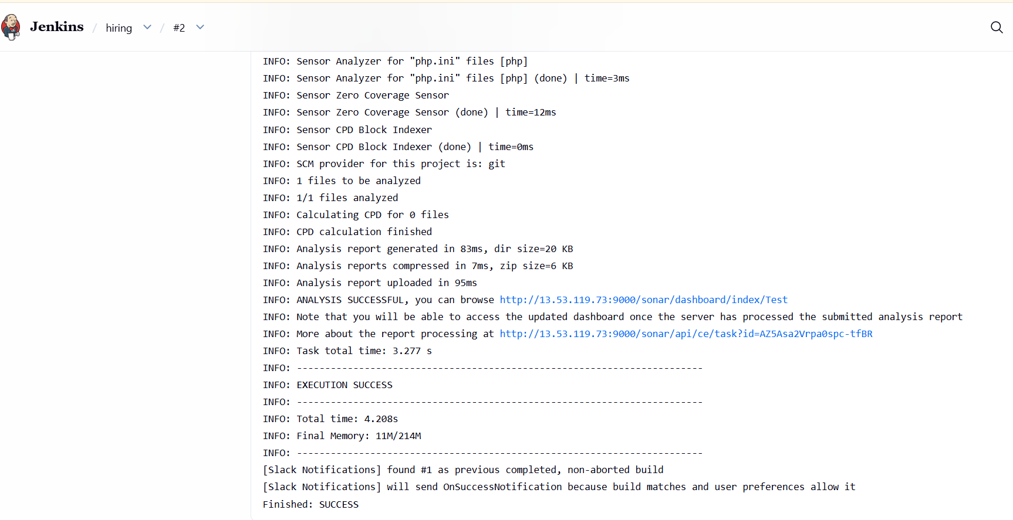
We get alert on slack
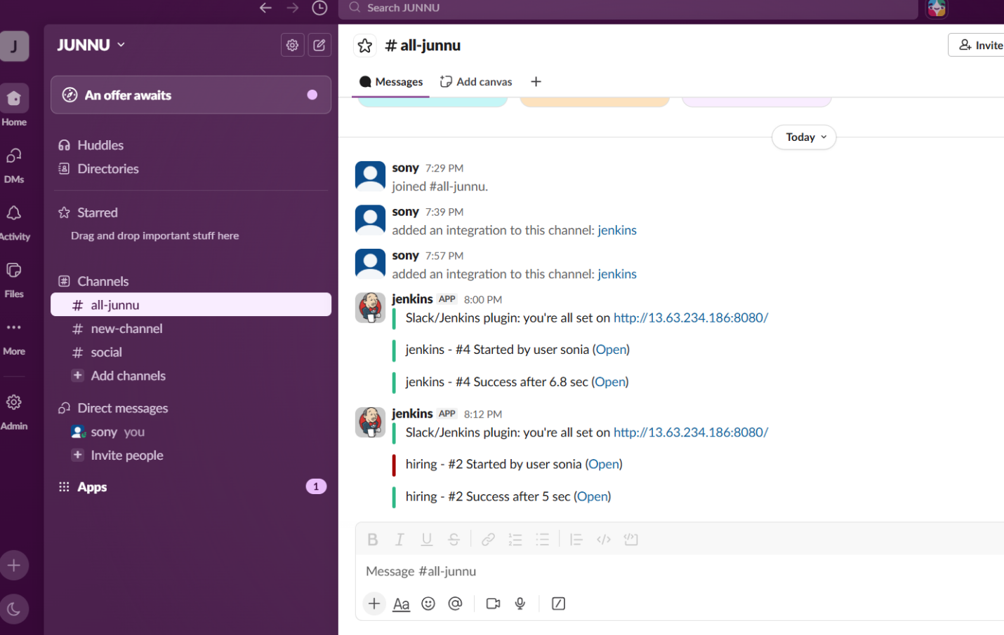
Automatically see the sonarqube
