AMAZON SIMPLE QUEUE SERVICE
Amazon Simple Queue Service (SQS) is a fully managed message queuing service
used to decouple distributed applications.
It acts as a temporary storage area for messages between applications.
Why Do We Use SQS?
SQS helps solve:
application dependency issues
• traffic spikes
• asynchronous processing
• reliability problems
Use Case : An e-commerce website receives thousands of customer orders.
If the backend database becomes slow or overloaded:
- orders may fail
- users may see errors
- system may crash
To avoid this, we use Amazon SQS.
Create SQS Queue
Click create queue --> give queue name →
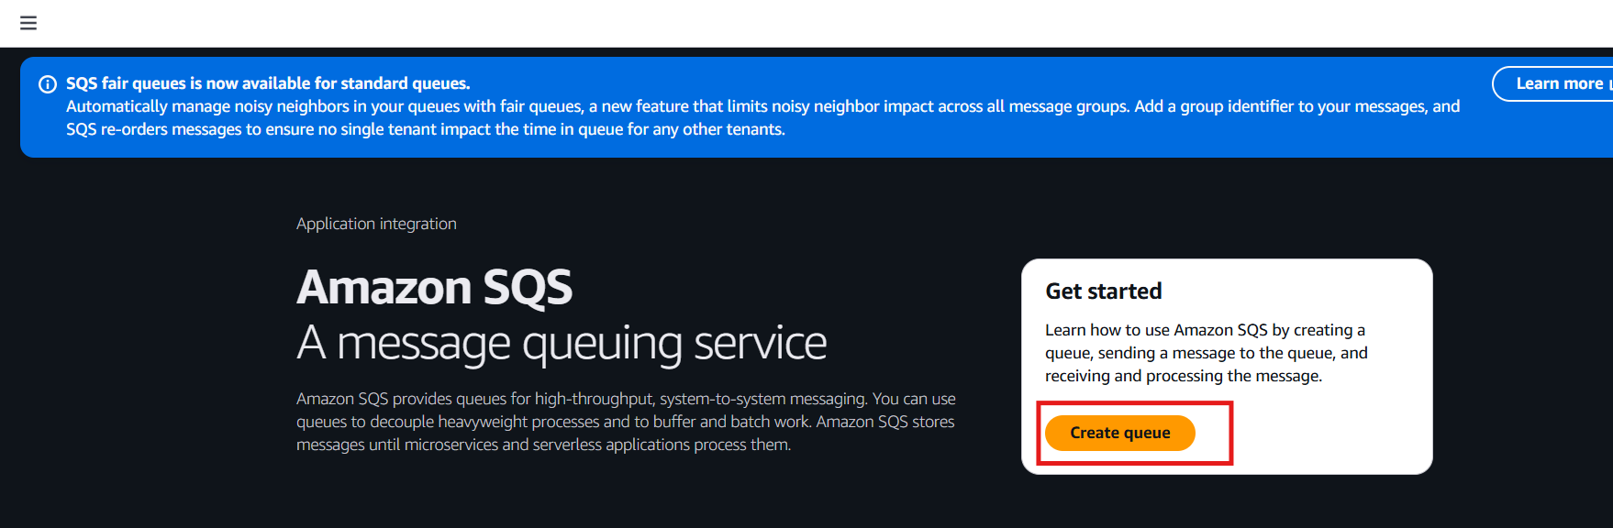

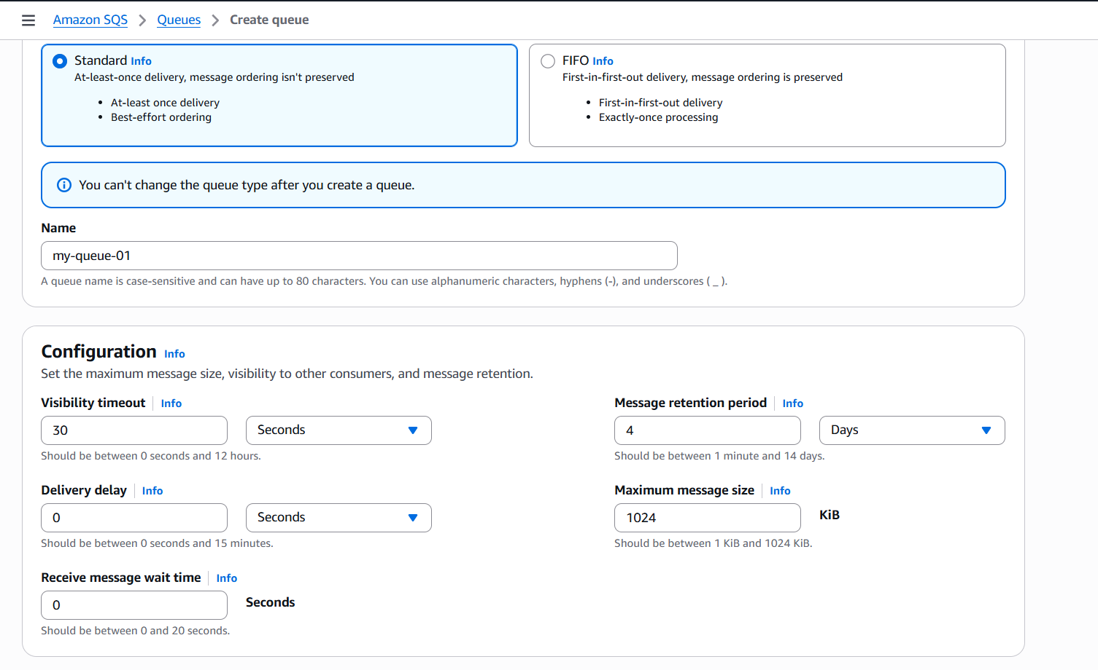
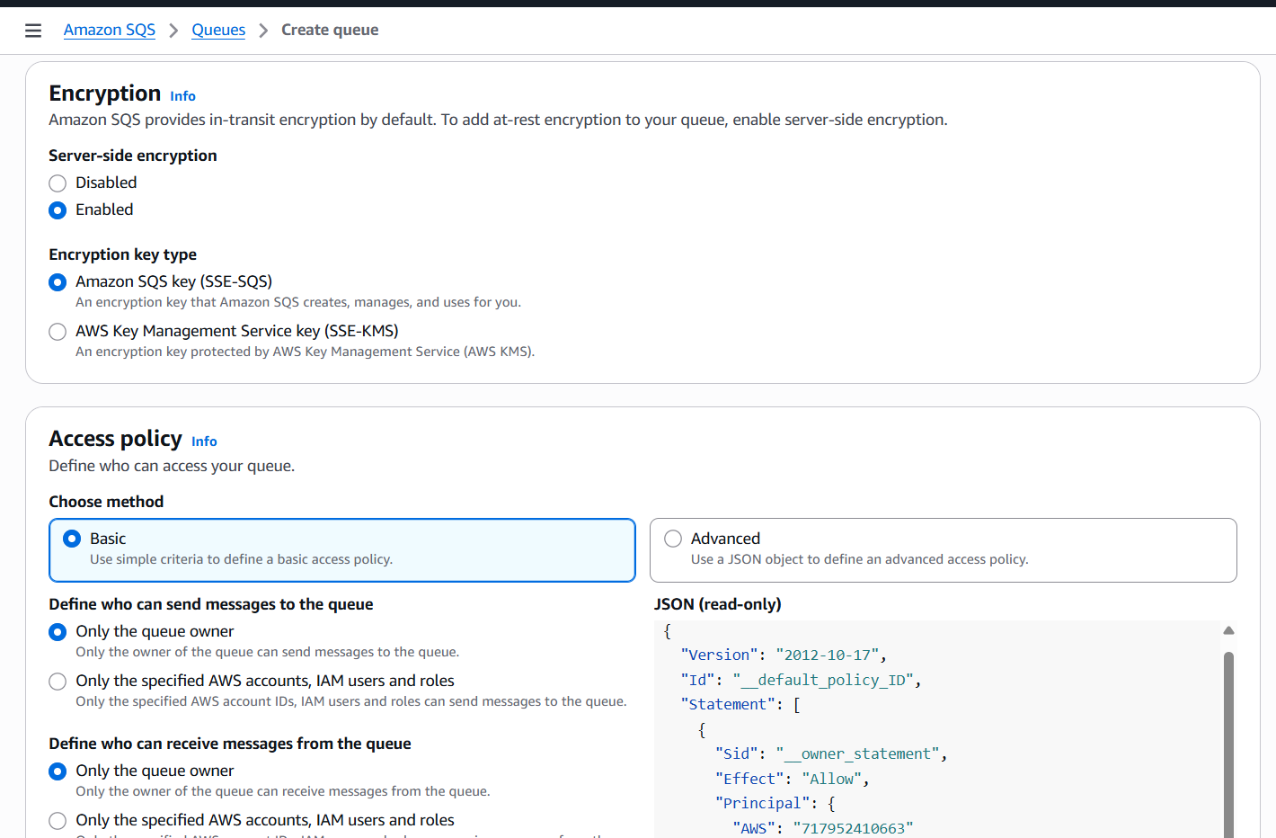
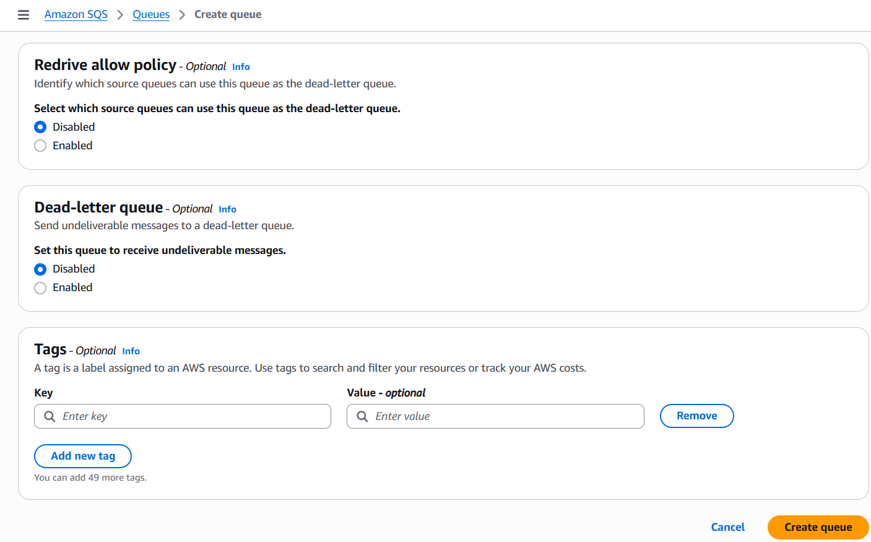
Successfully created queue
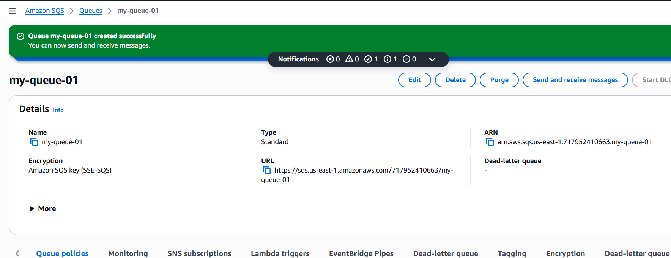
Send Order Message
Click on send and order messages --> write json script in message body-->send
message
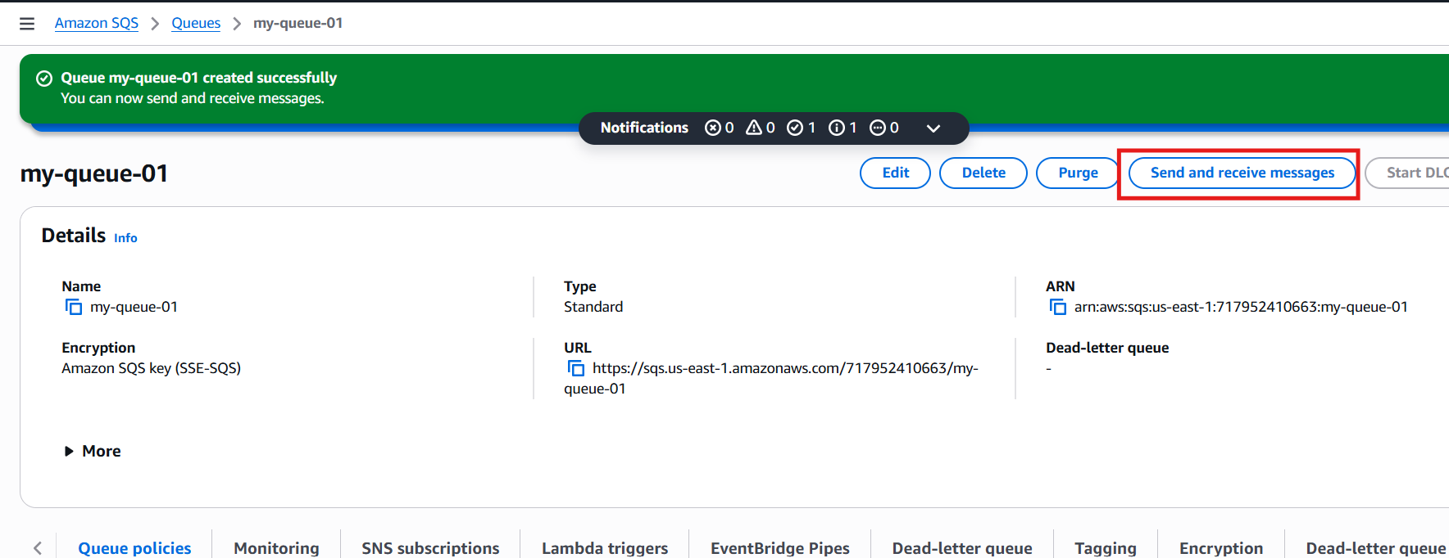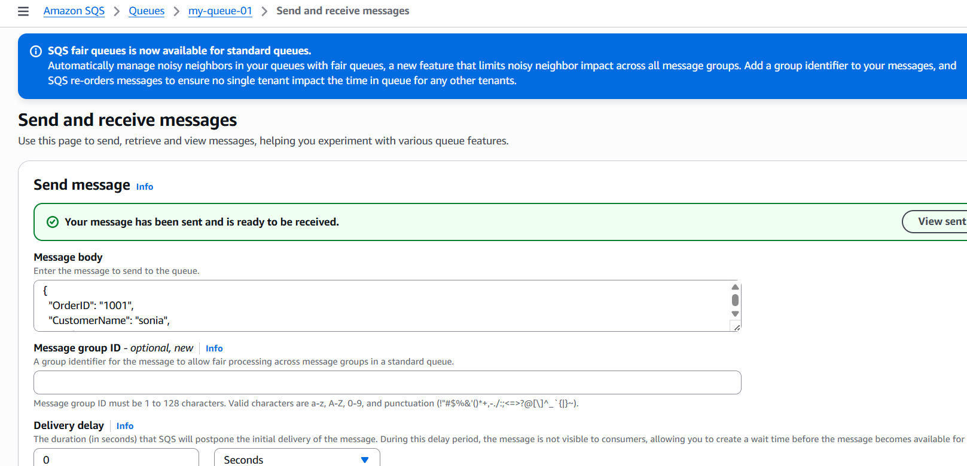
Click on poll for messages
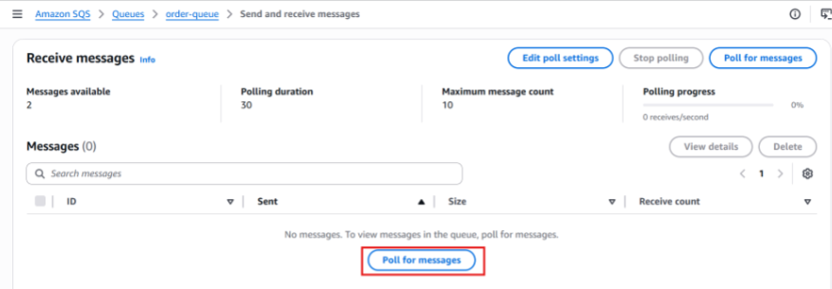
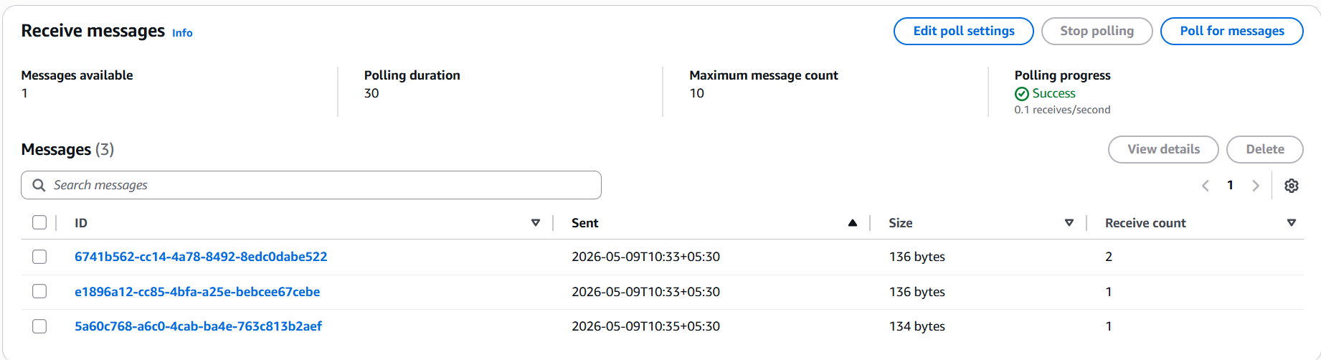
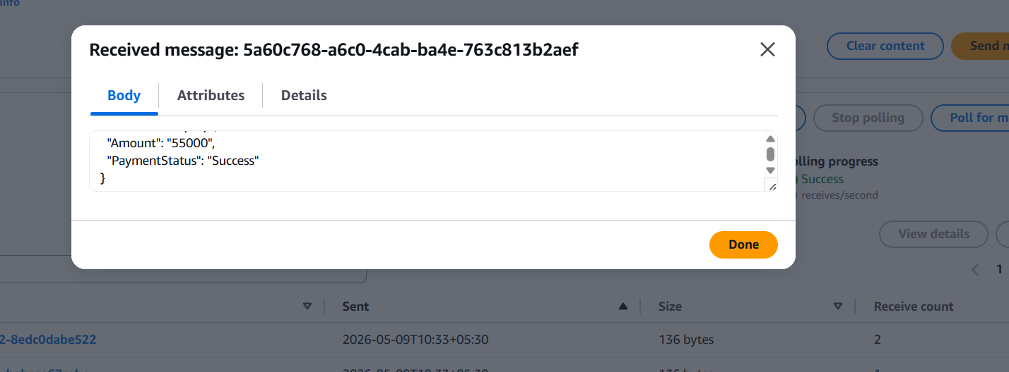
To monitoring logs
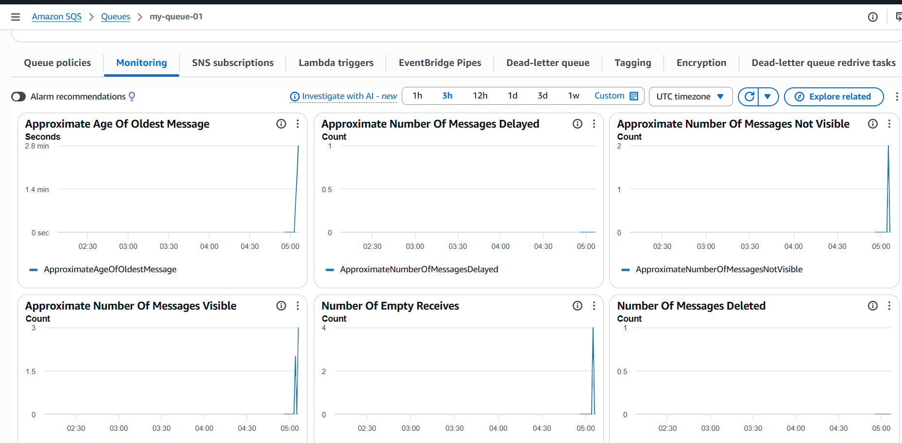

AMAZON MESSAGE QUEUE (Amazon MQ)
Amazon MQ is a managed message broker service provided by Amazon Web Services (AWS).
It helps developers easily create and manage message brokers such as:
- Apache ActiveMQ
- RabbitMQ
in the cloud without managing servers manually.
Amazon MQ is mainly used for application migration.
If a company already has old applications using protocols like:
- JMS (Java Message Service)
- AMQP
- MQTT
- STOMP
they can move to Amazon MQ without changing much code.

Real-Time Scenario (Banking Application)

Scenario
A banking system handles:
- Customer transactions
- Payment requests
- Fraud detection alerts
Different applications must communicate continuously and reliably.
Instead of directly connecting all applications, the bank uses Amazon MQ as a message broker.
Go to aws console
Click on get started
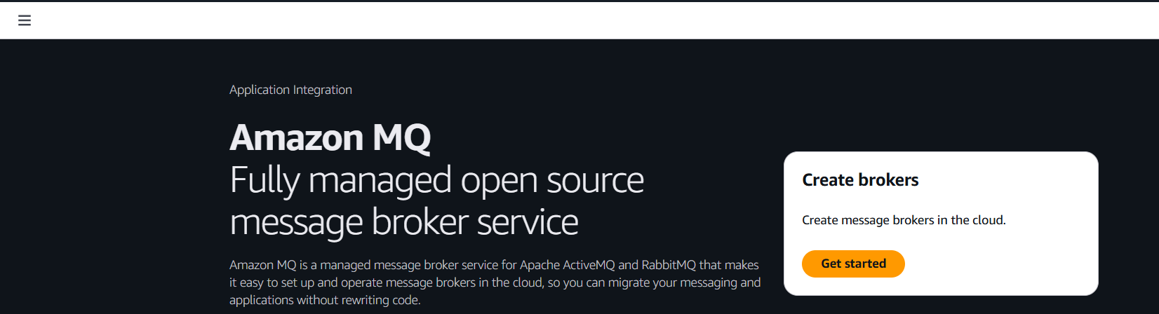
Selected broker engine as ActiveMQ
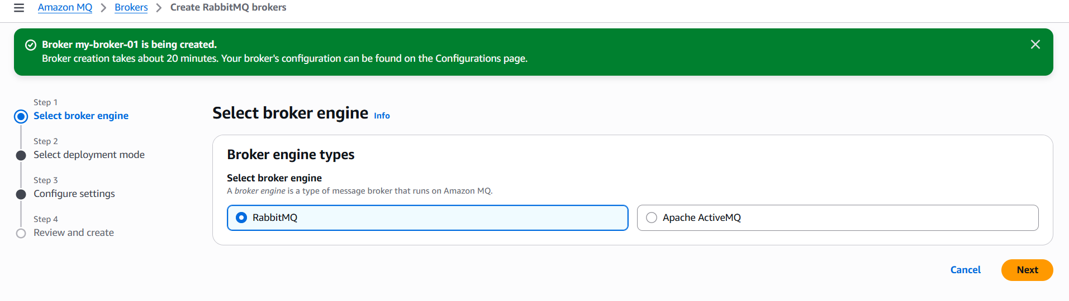
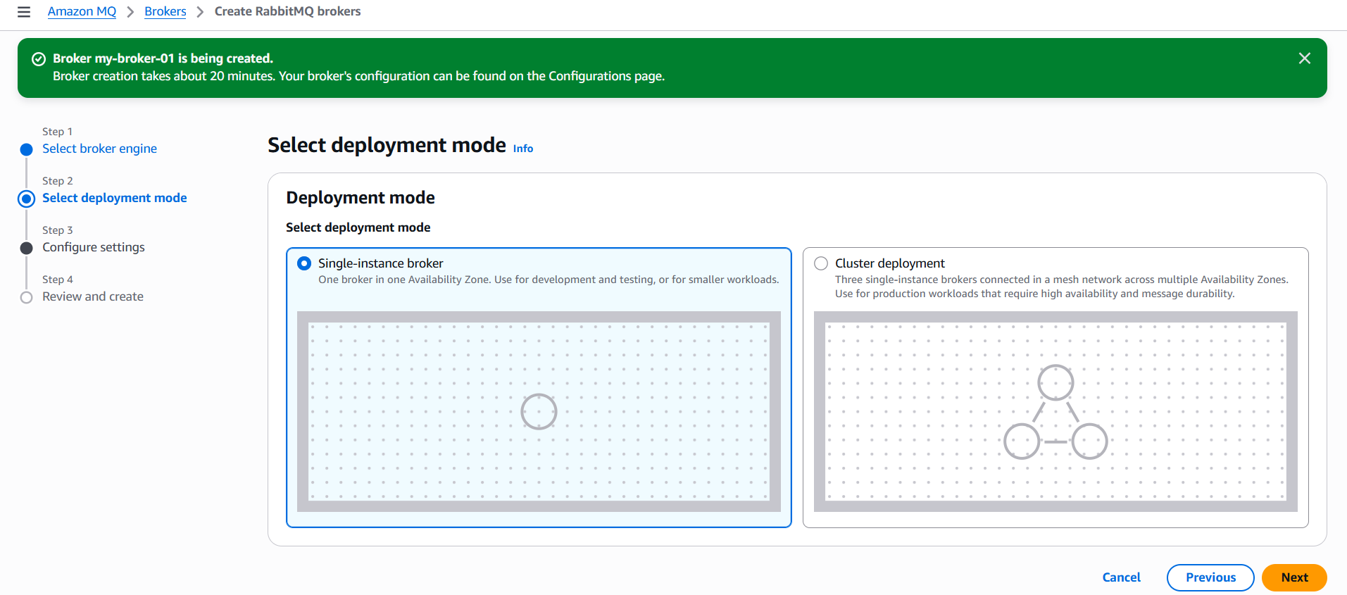
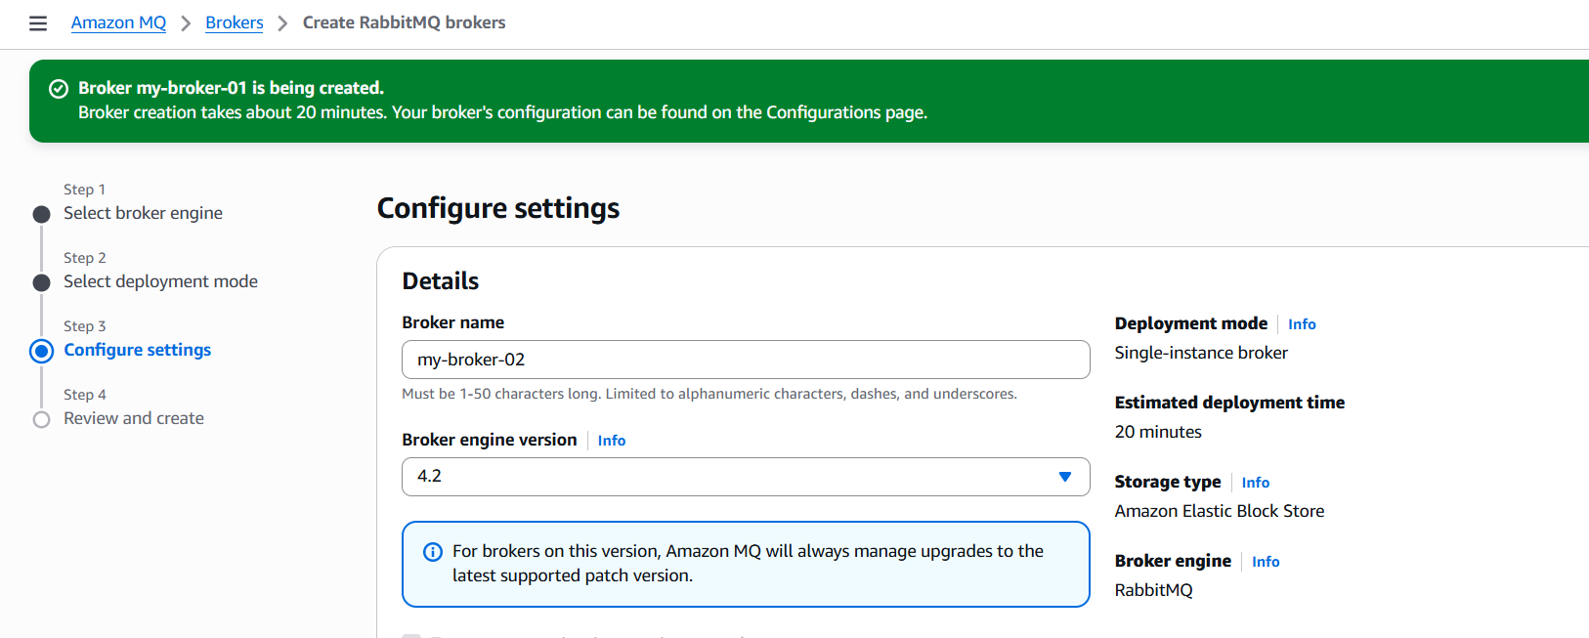
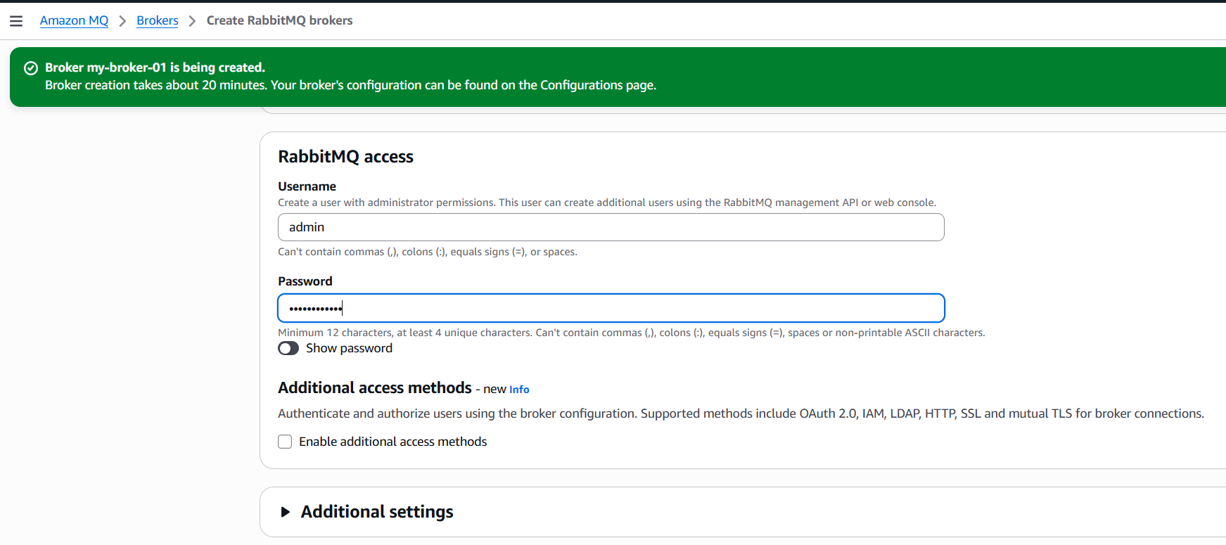
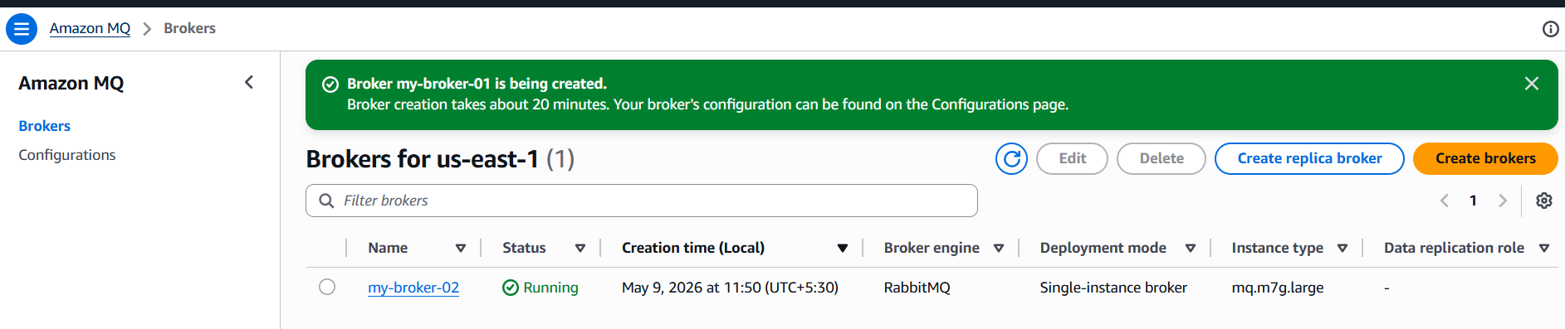
Click on the url
