S3-02
Task on cloudfront and route53
- Configure VPC peering in cross regions.
First we create n.virginia vpc
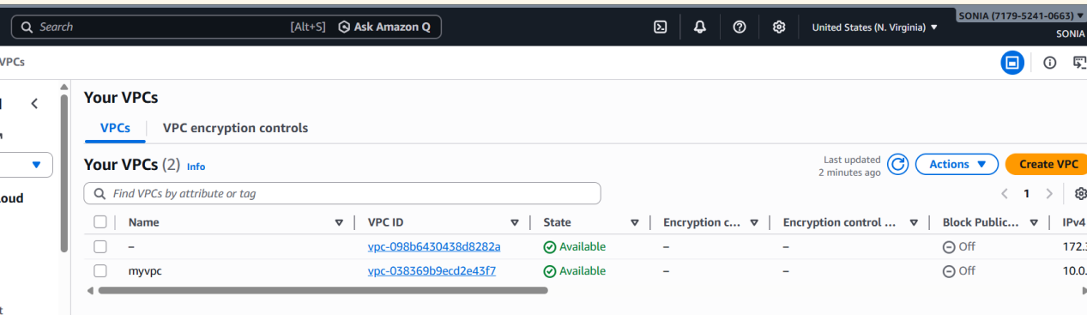
Then we well go to subnet --> create private and public subnets
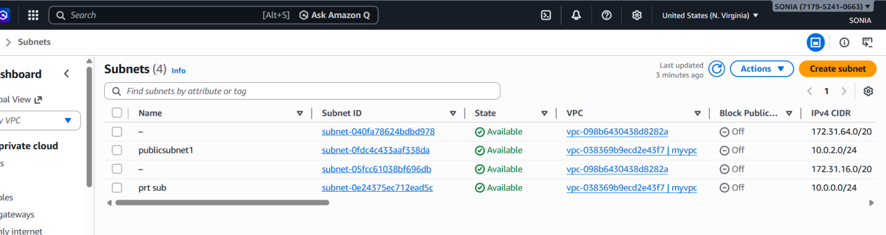
open route tables and create route tables for private and public keys separate
then go to internet gateway create IGW for public keys go to route tables -->open subnet assosiactions save edit routes à select enter integrate way was entered successfully
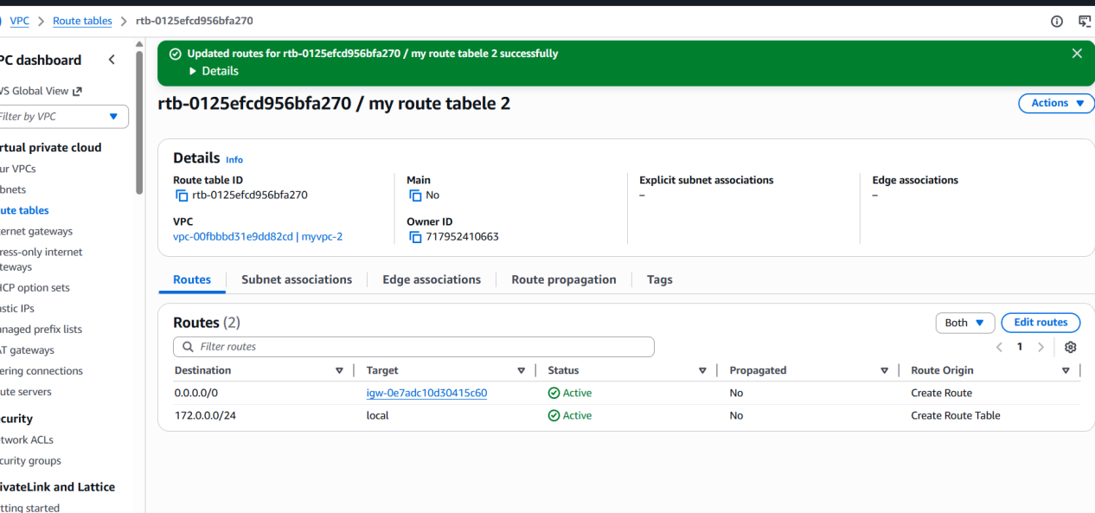
peering connectionàFrom ohio to N.virgina give that regionàconnect the ohio pem to git bash
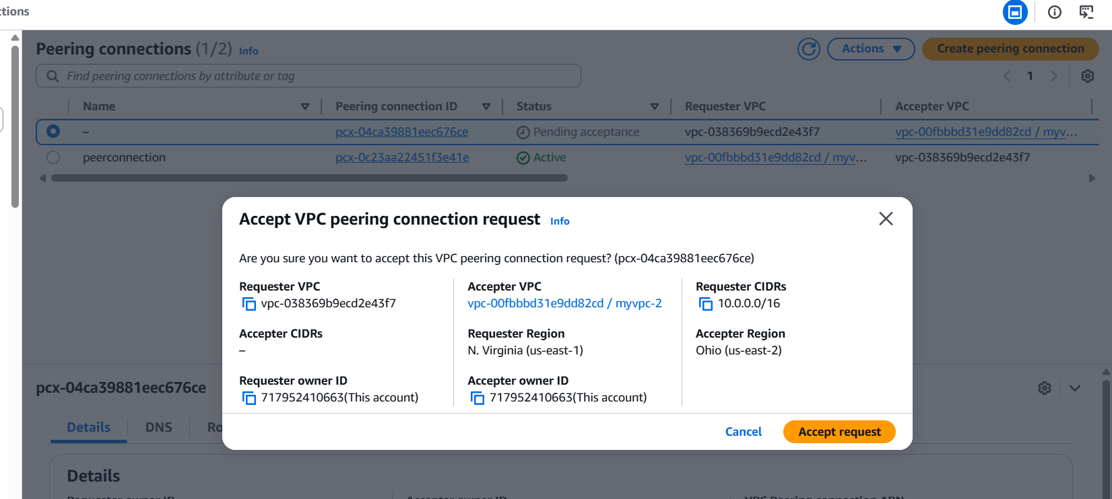
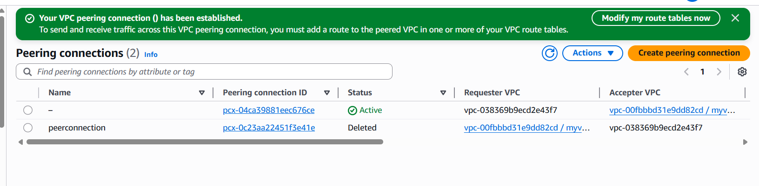
ping ip address of n.virgina we have connection of peering successfully.

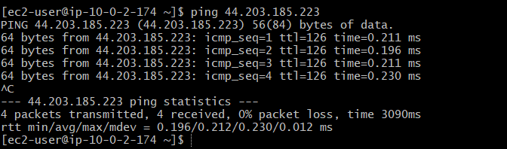

- Purchase one domain from GoDaddy.
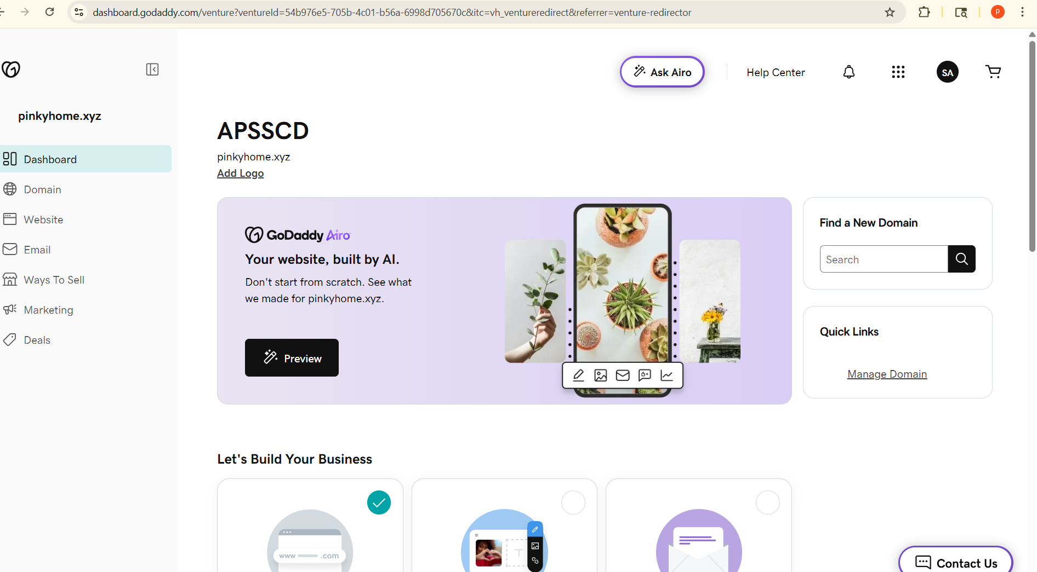
- Deploy static website in S3.
Frist we can create s3 bucketpinkyhome.xyz
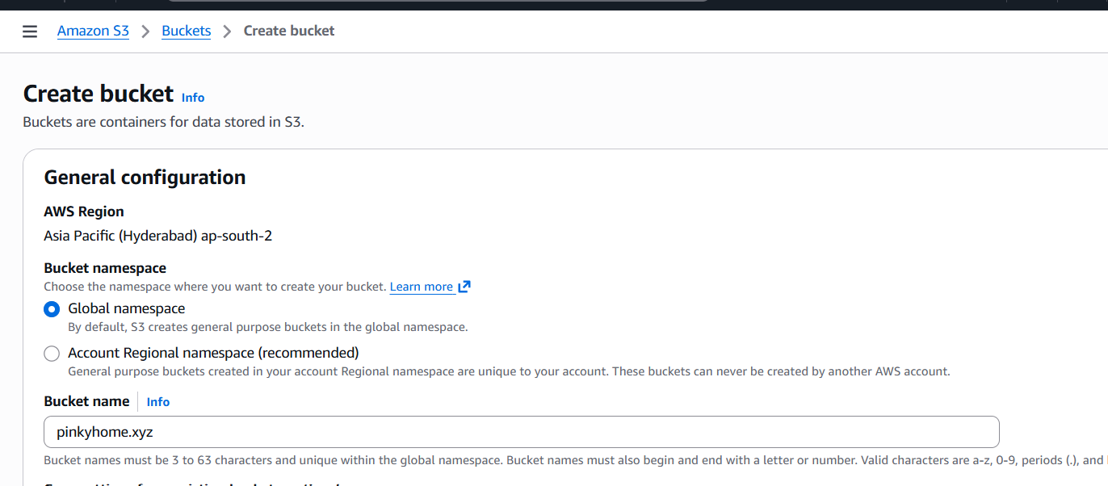
Go to object ownershipacls enabledblock public access off
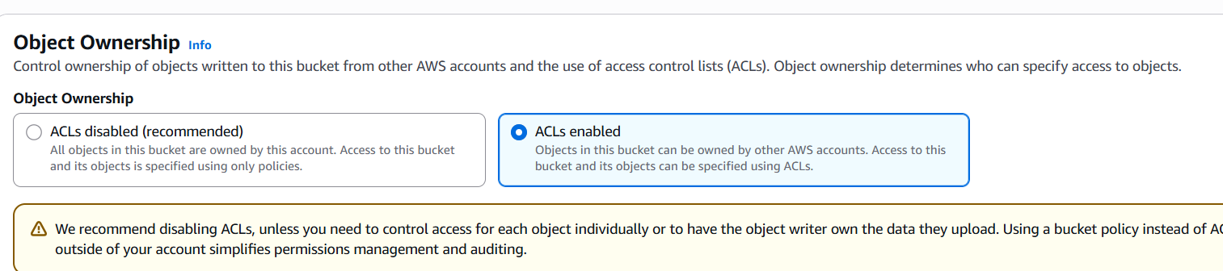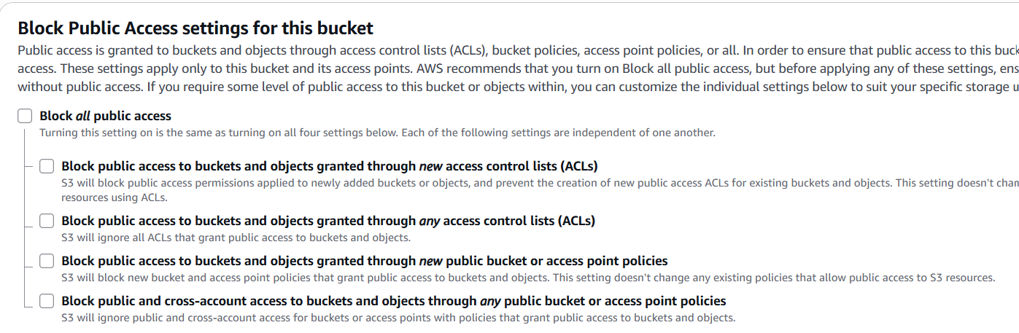
Sucssusfully created bucket
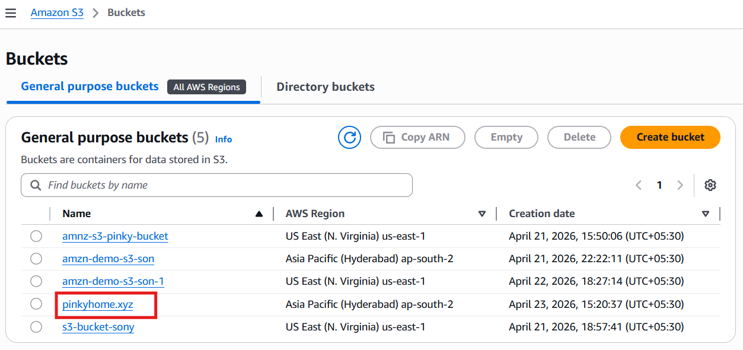
And we create two files index.html ,error.html
Click on bucket and upload the files
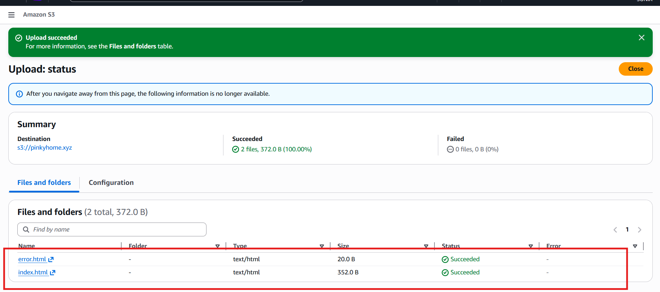
Files are successfully uploaded
And go to propertiesscroll we can see static website hostingenable
Index.html,error.html
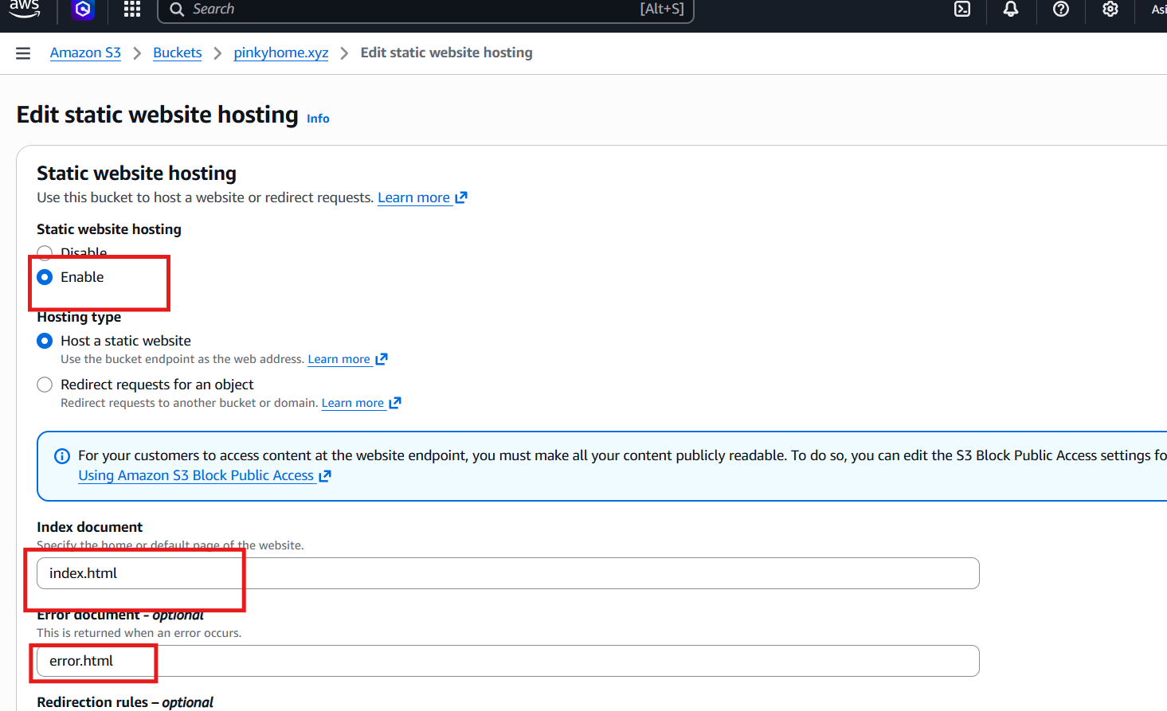
Get the url copy browser we can see our website
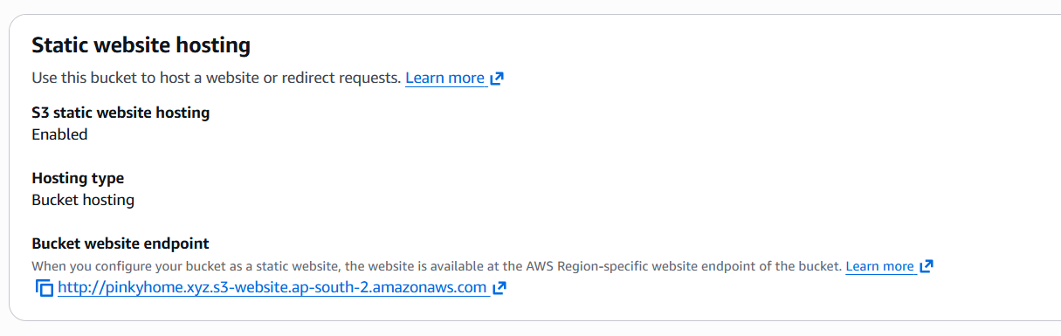
Successfully deploy the static website
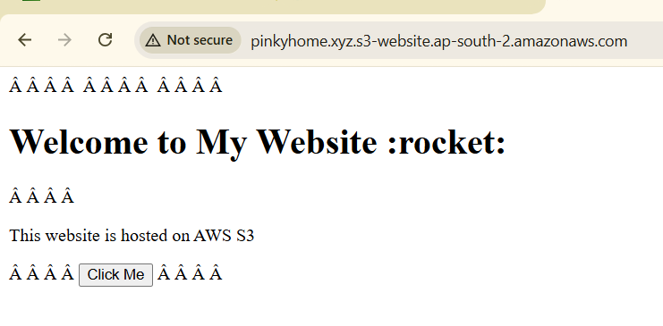
- Create a CDN and attach one SSL certificate.
Fisrt we go to cloudfrontcreate distributionsname
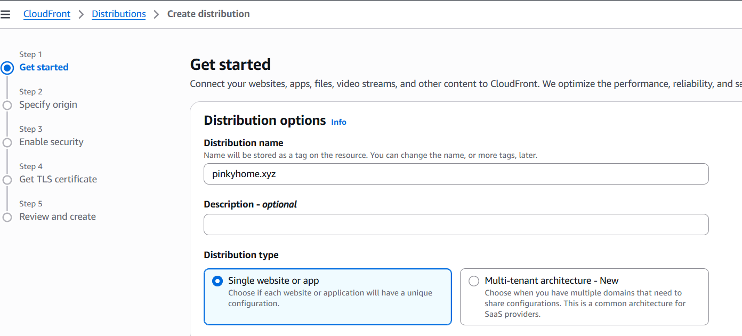
S3 origin give the static website url

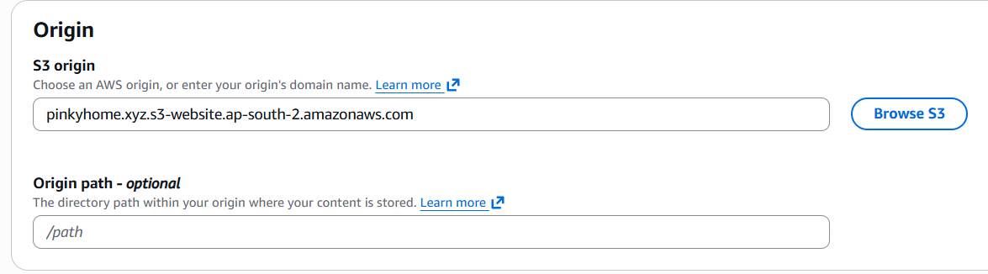

Go to the settings editselect customize origin settingsselect protocolhtml
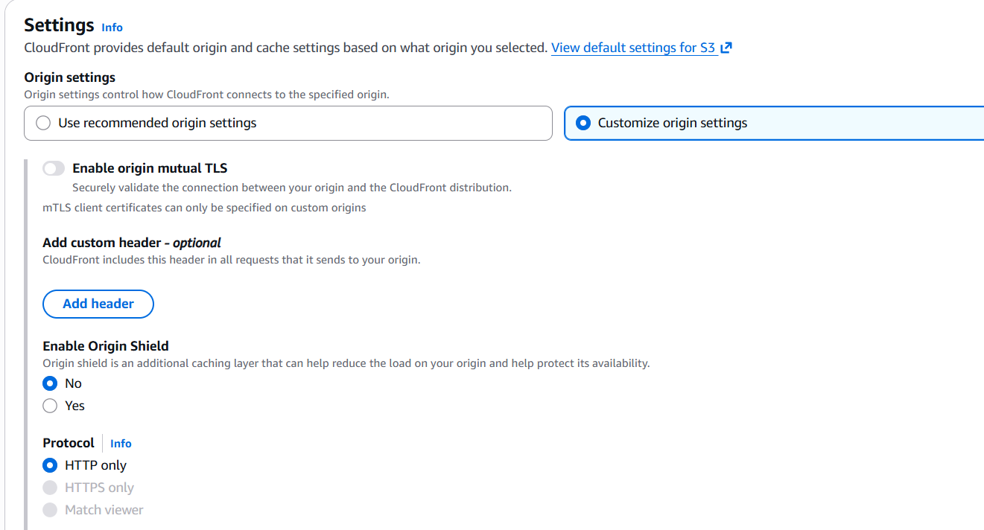
settings CUSTIMIZE CACHE SETTINGS HTTP and HTTPS
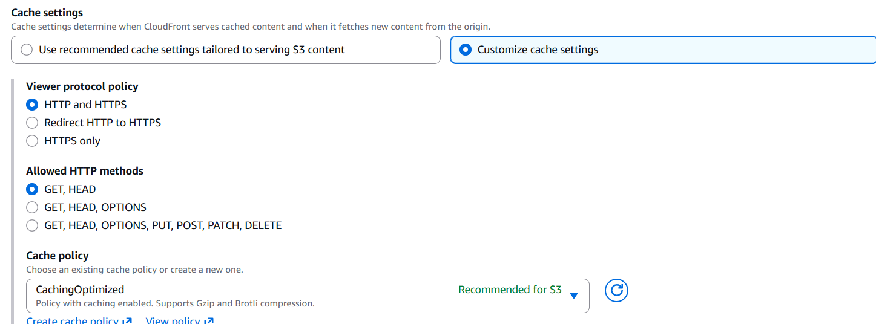
And edit the cache settings

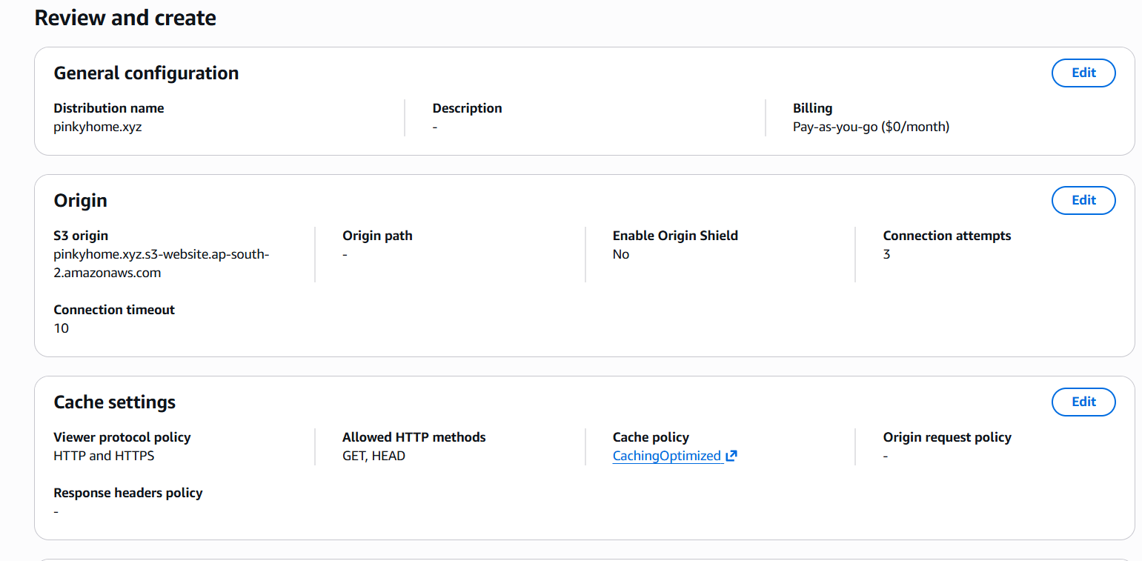
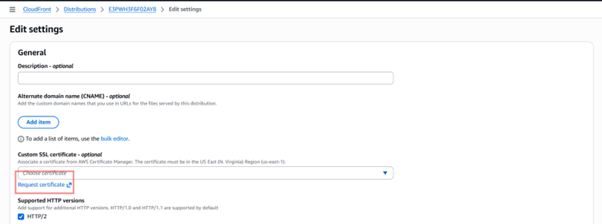
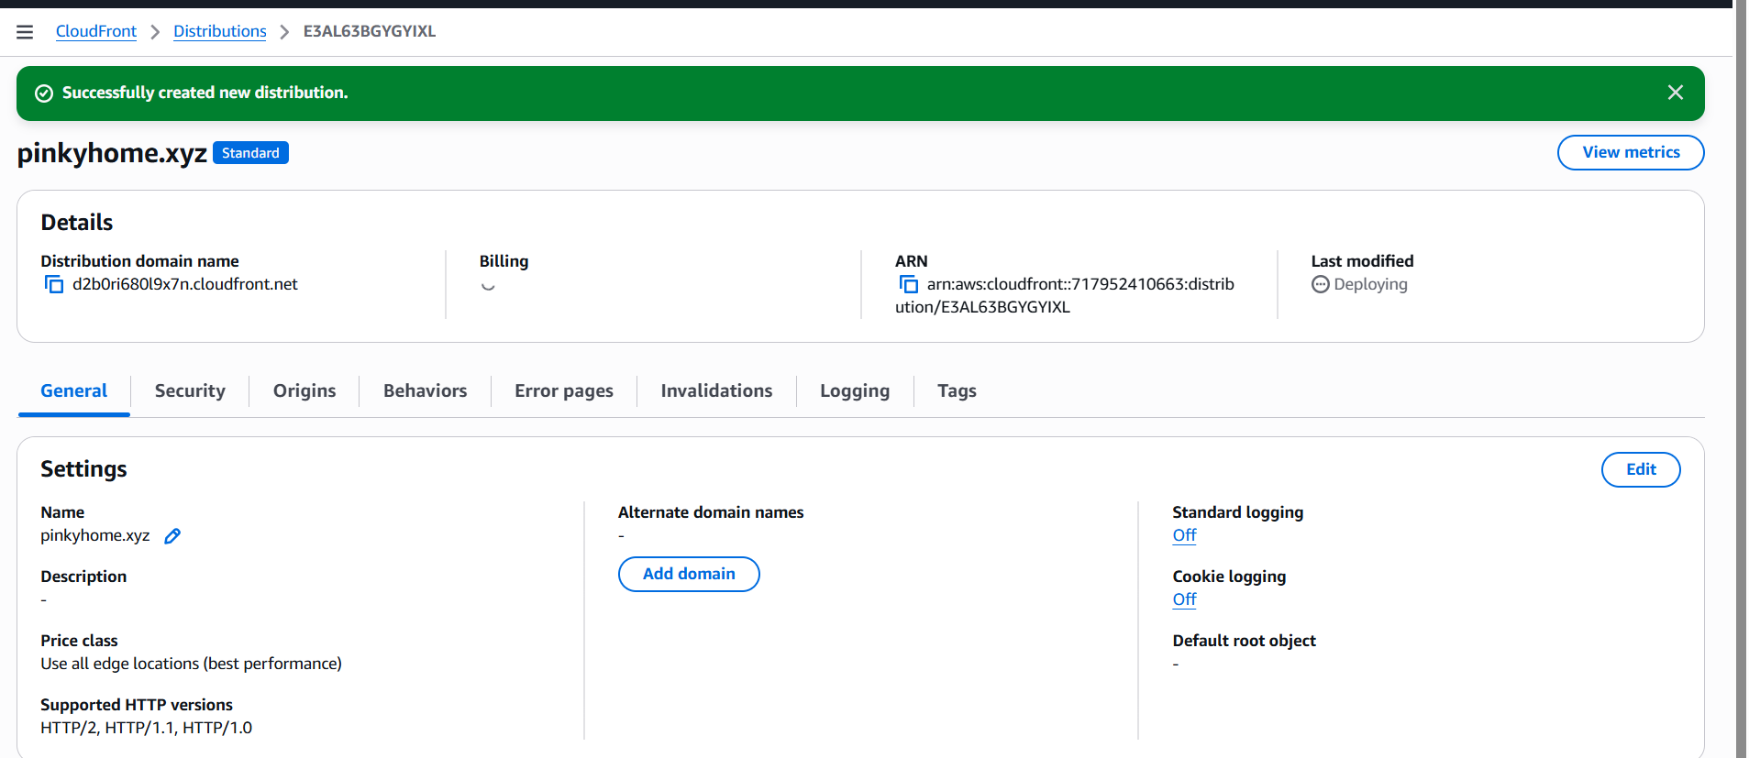

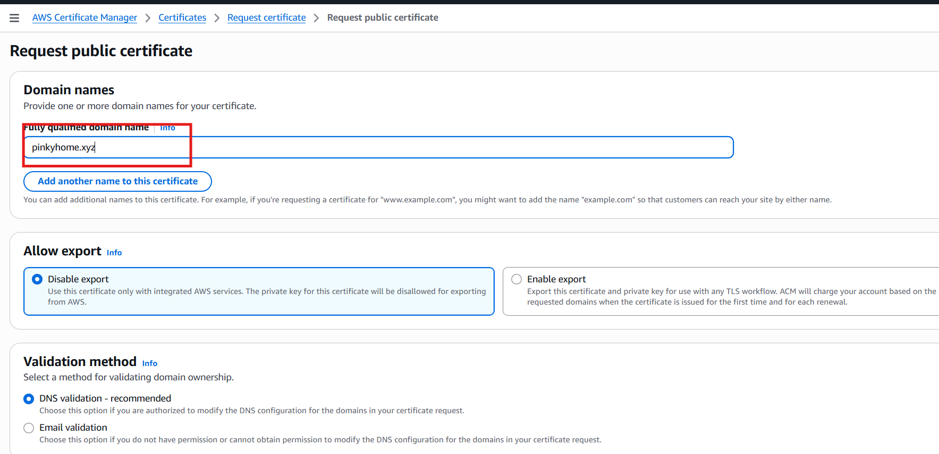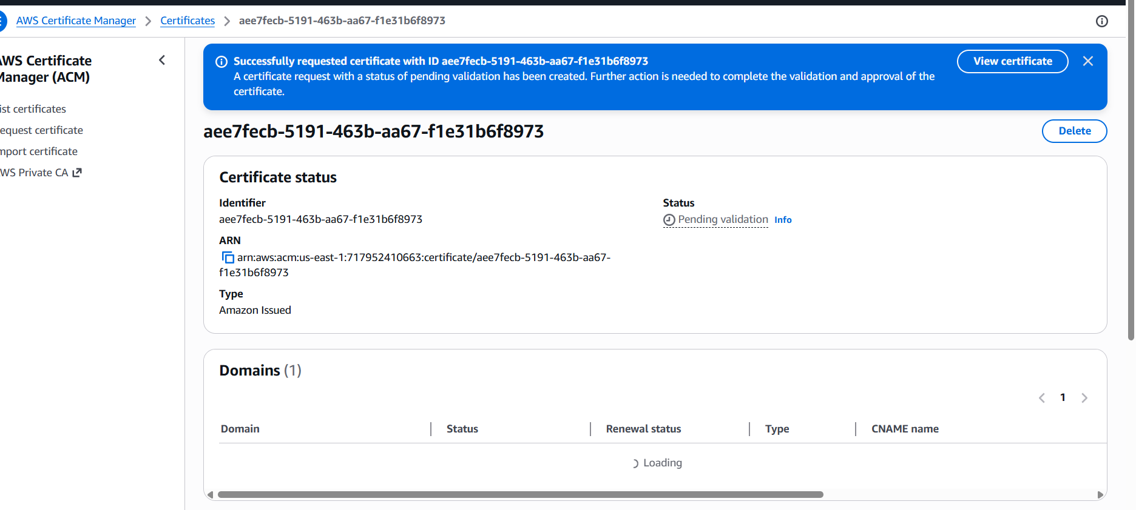

- Create a Route 53 hosted zone and map the domain with the CDN.
Click to routr53
Select create hosted zones

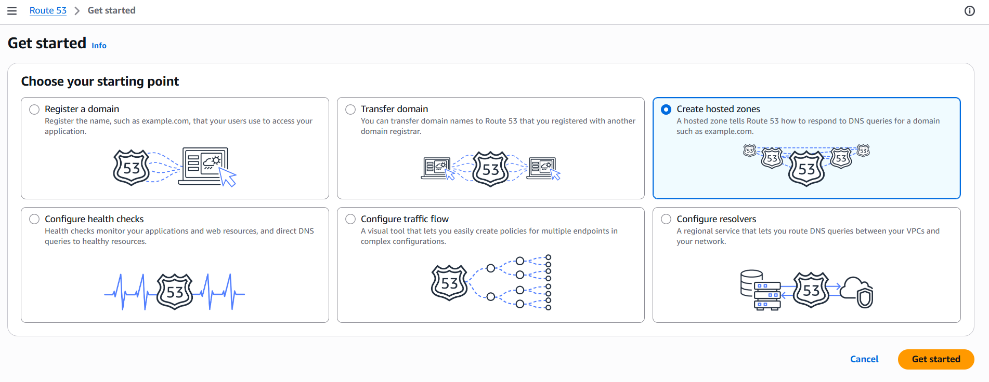
Click hosted zone we give our domain name (godaddy) created hosted zone
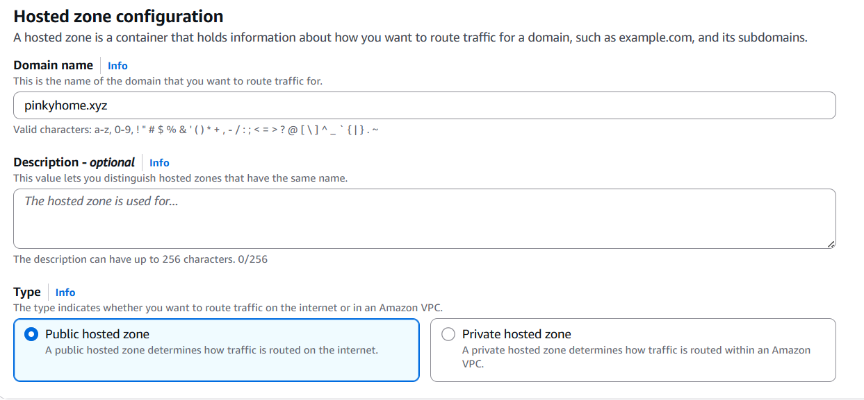
Create record by default we have naming servers
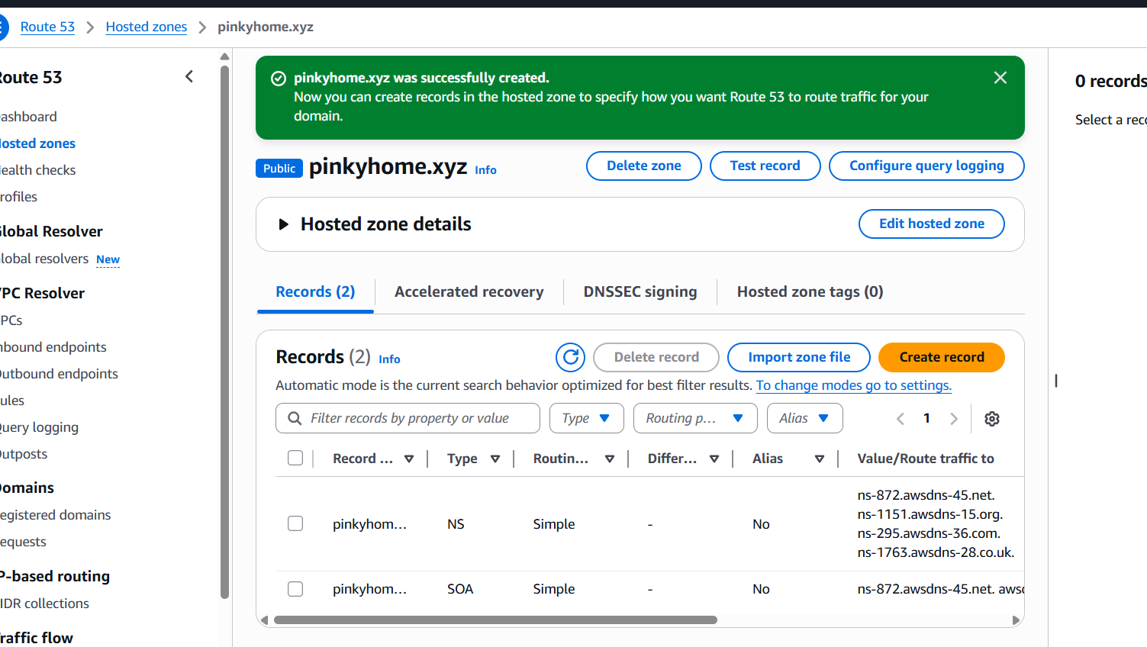
Go to godaddy edit nameserversCopy the nameservers and to the godaddy in the nameservers
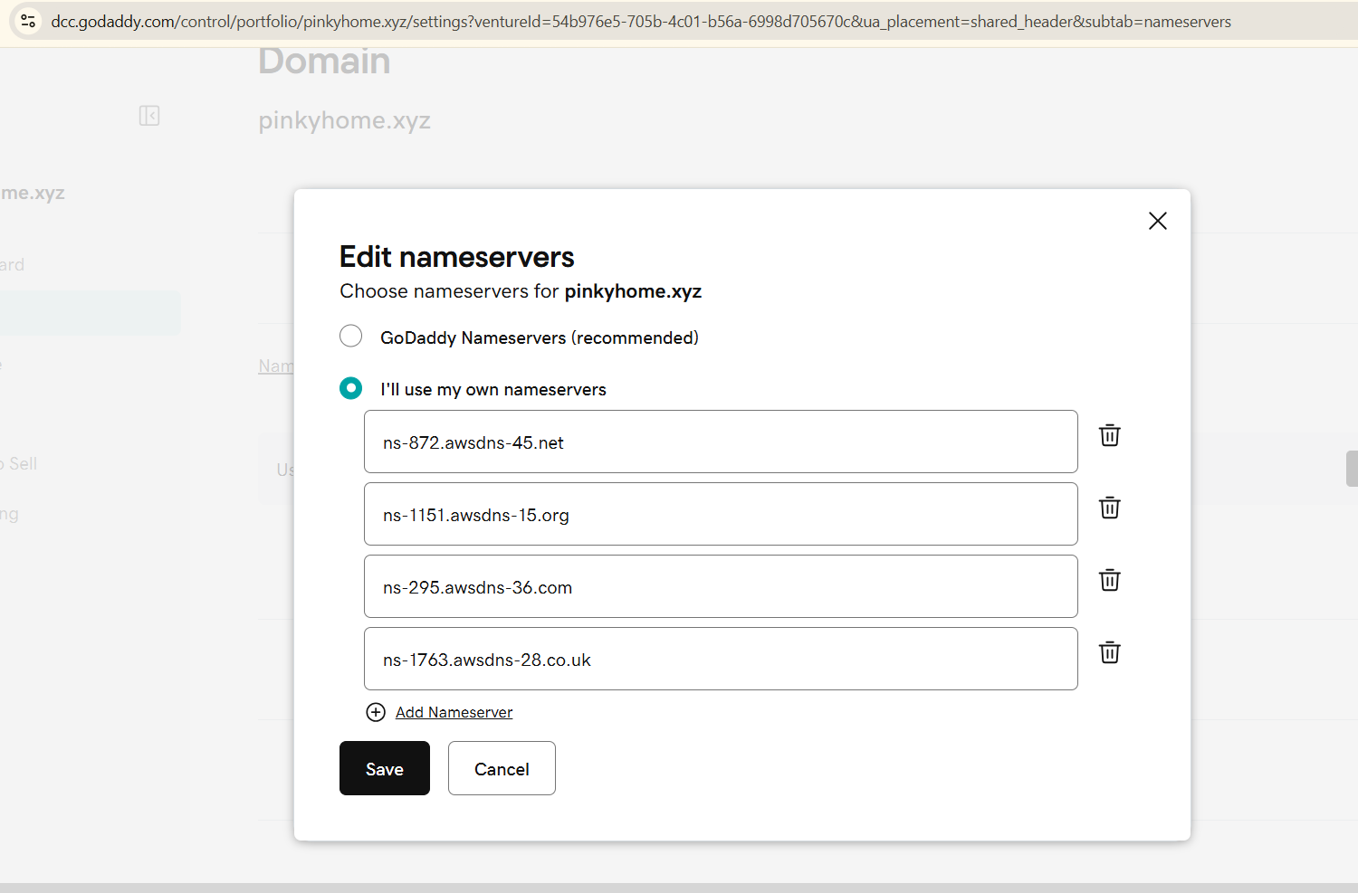
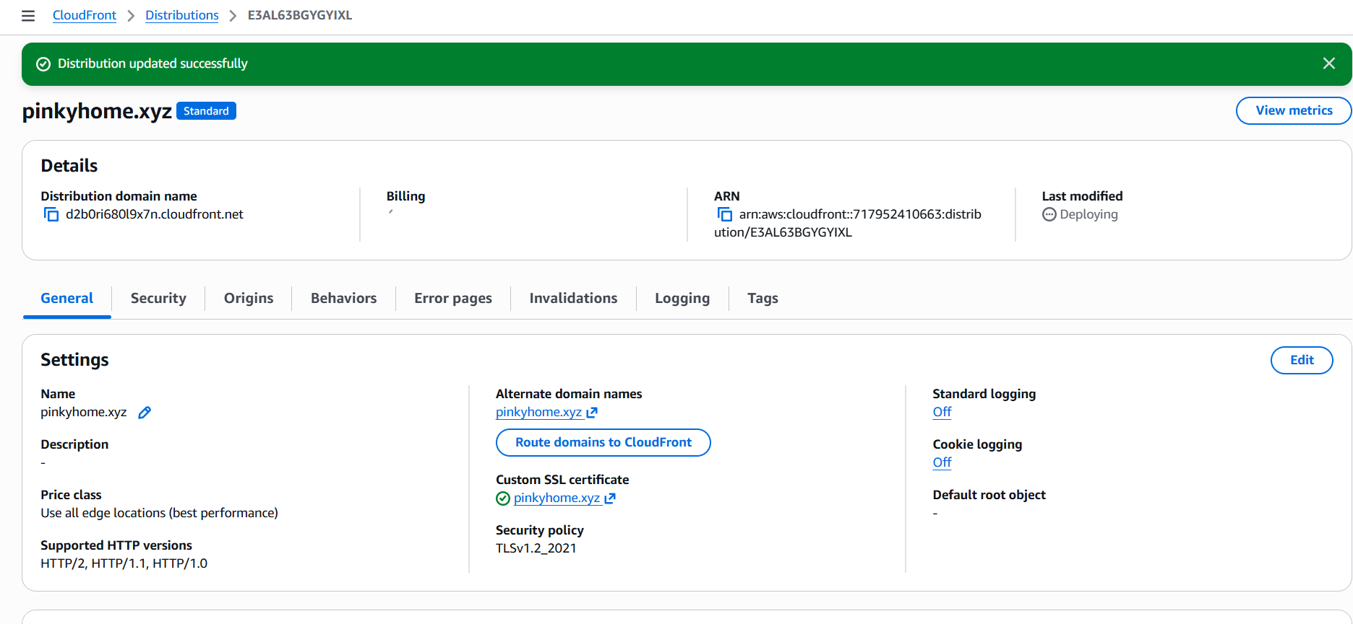
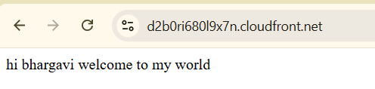

- Update the index.html in the S3 bucket and ensure the updated file is accessible using the domain name.
We can go to gitbash edit the old index.html file and we can copy edit html file url
Copy a browser
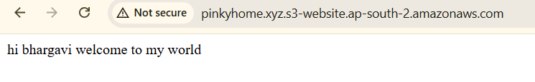
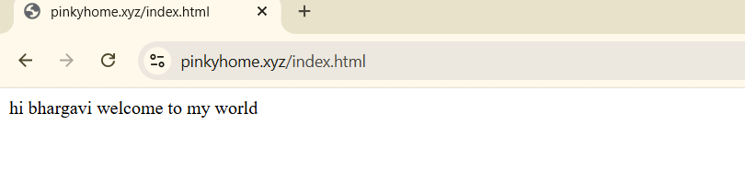

- Share the domain name in Slack to test the connectivity.
Pinkyhome.xyz

