- Install Jenkins and run Jenkins on port number 8081.
First go to aws console go to ec2
Launch one instance
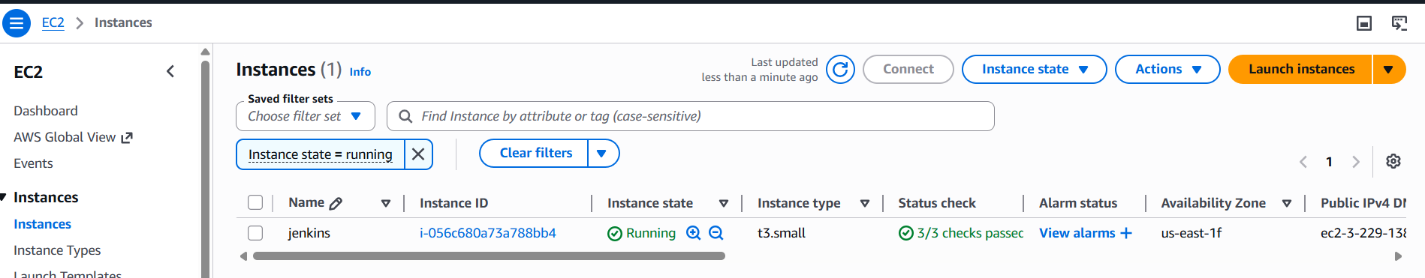
Connect to gitbash trought link
Download jenkins Repo sudo wget -O /etc/yum.repos.d/jenkins.repo https://pkg.jenkins.io/redhat-stable/jenkins.repo
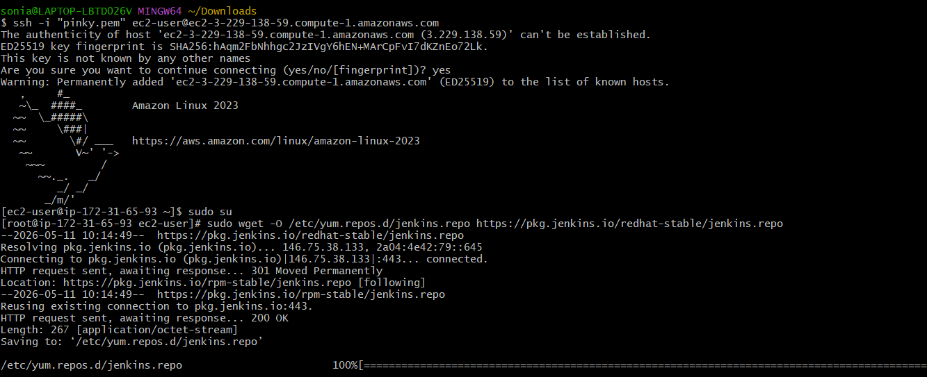
Import the jenkins key sudo rpm --import https://pkg.jenkins.io/redhat-stable/jenkins.io-2023.key
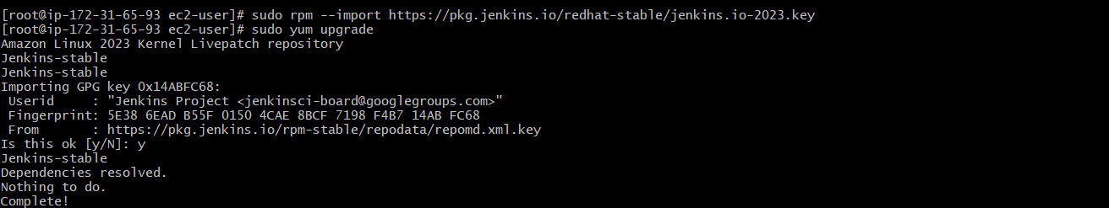
Install the java package sudo yum install java-21-amazon-corretto -y
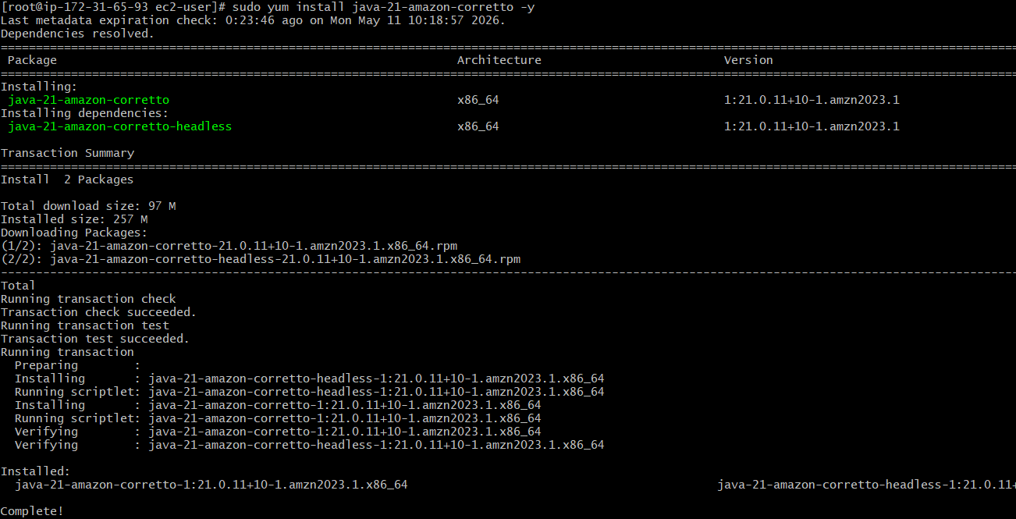
Install Jenkins yum install Jenkins
To check Jenkins are running or not
Systemctl start Jenkins
Systemctl status jenkins
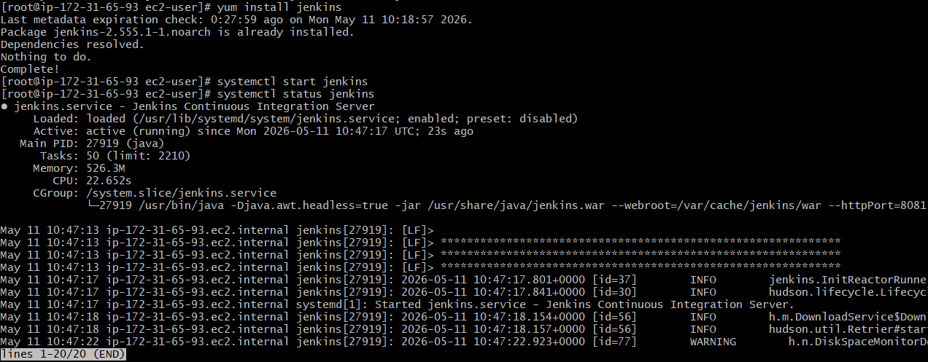
The Jenkins is install completed we change port number use this commend
sudo vi /usr/lib/systemd/system/jenkins.service

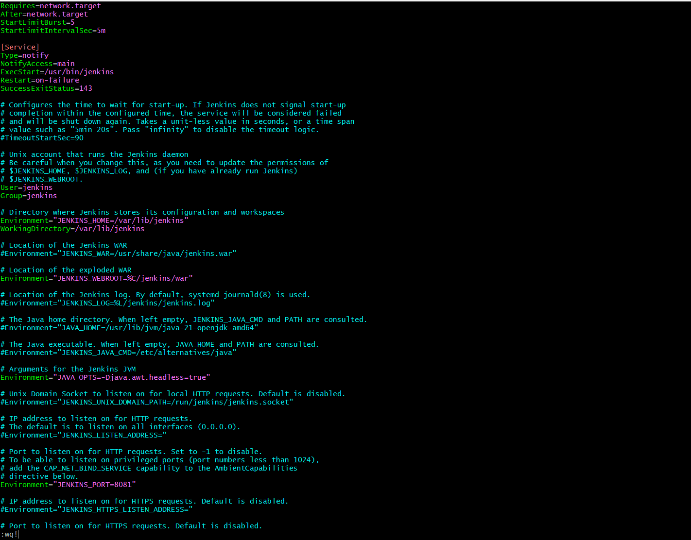
After change the port number we can restart the Jenkins
Systemctl daemon-reload
Systemctl restart Jenkins
Systemctl status jenkins
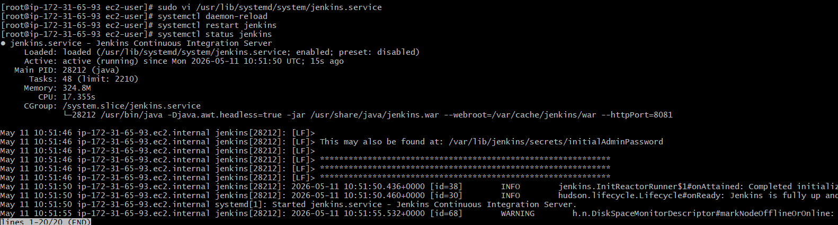
We verify the browser
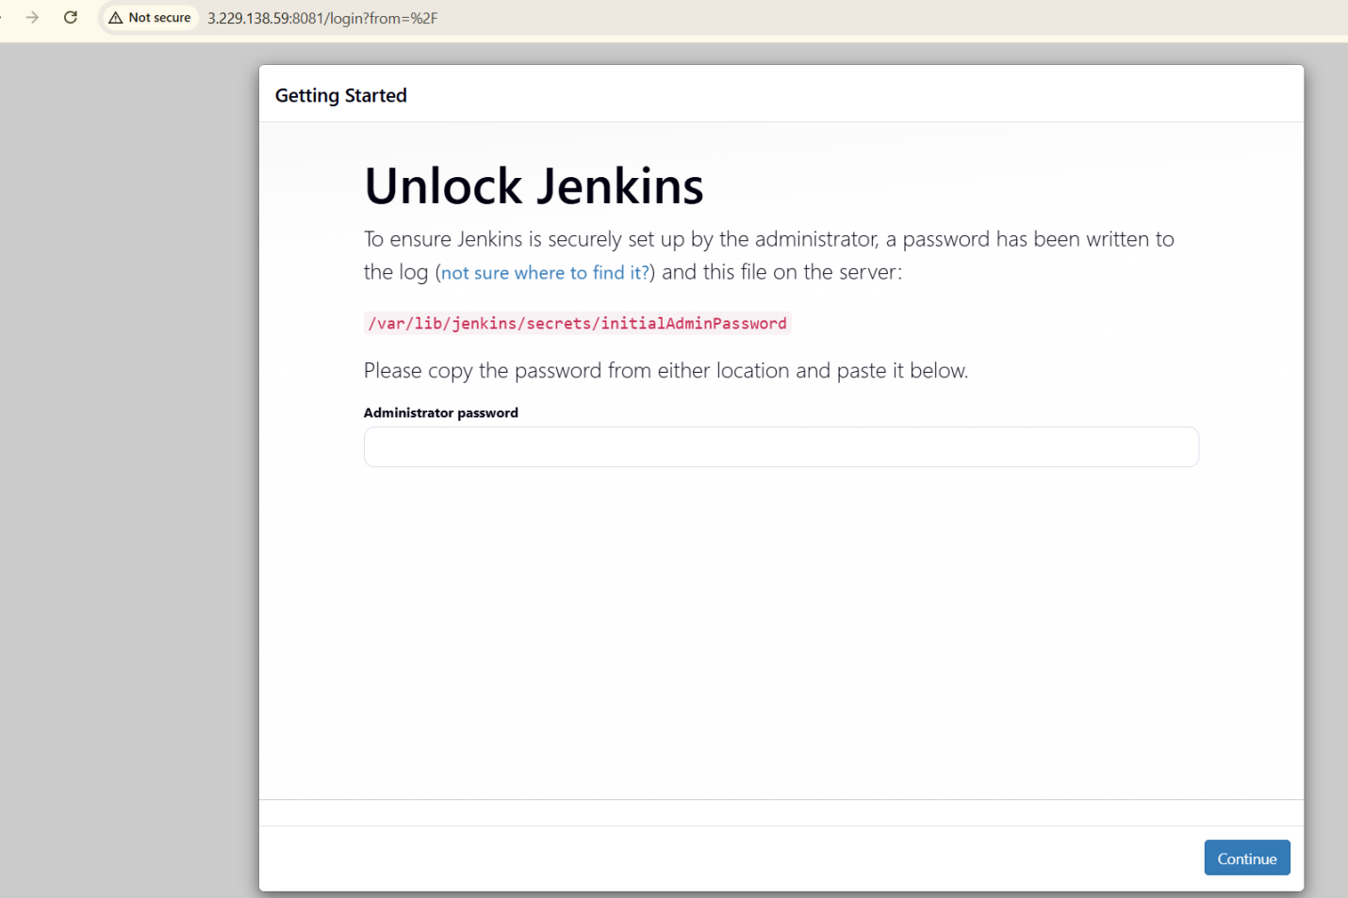

- Secure Jenkins server
First login to Jenkins
Got ot settingsmanage Jenkinsclick on available pluginsearch the role based authorizationstrategyclick on install
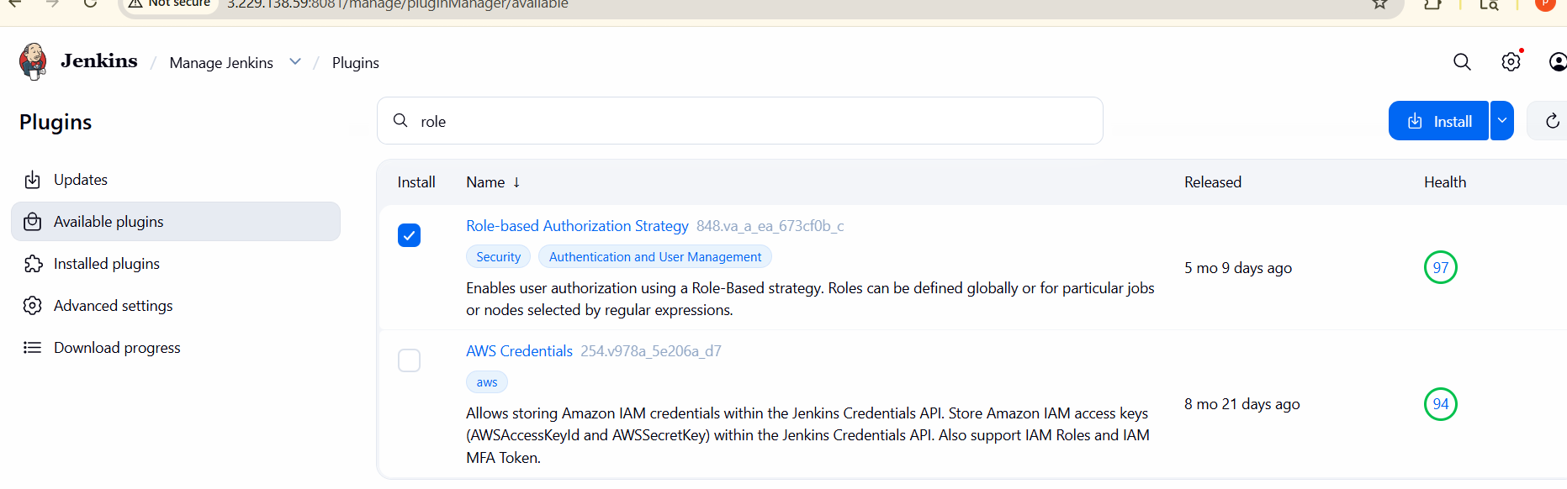
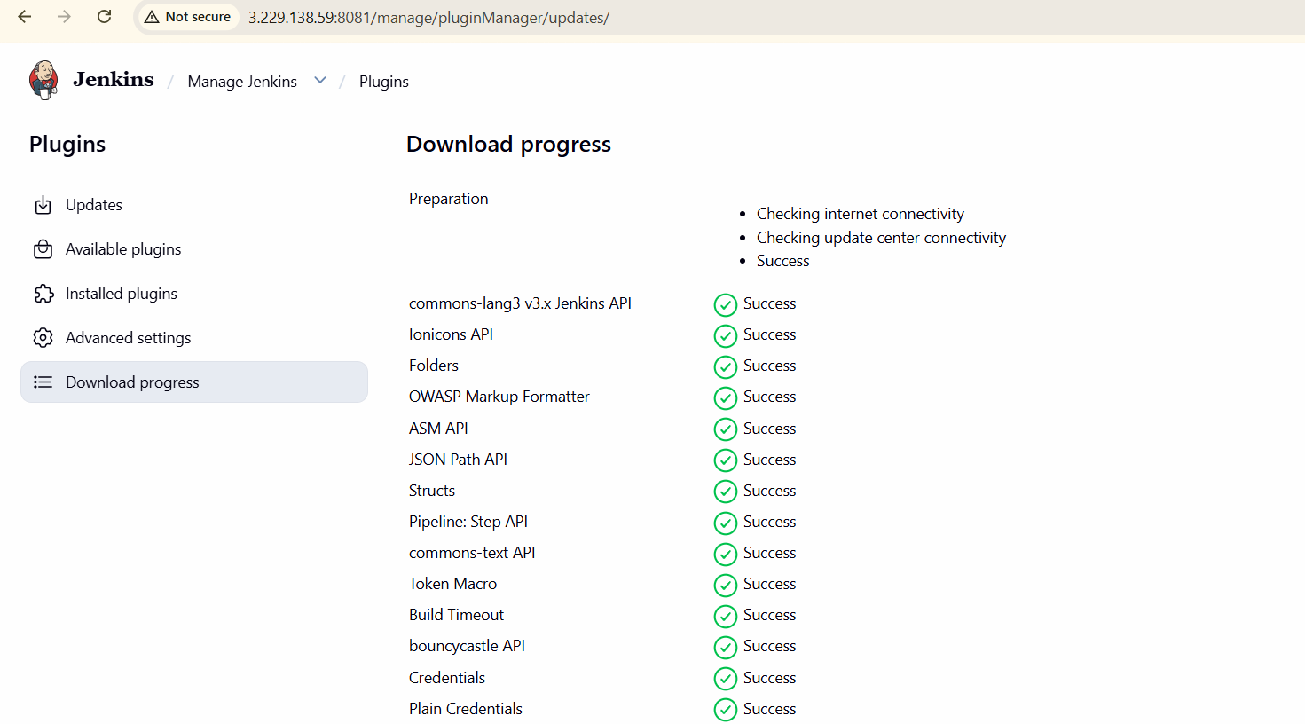
After installation completed we check security authorization
Go to manage Jenkins securityauthorization
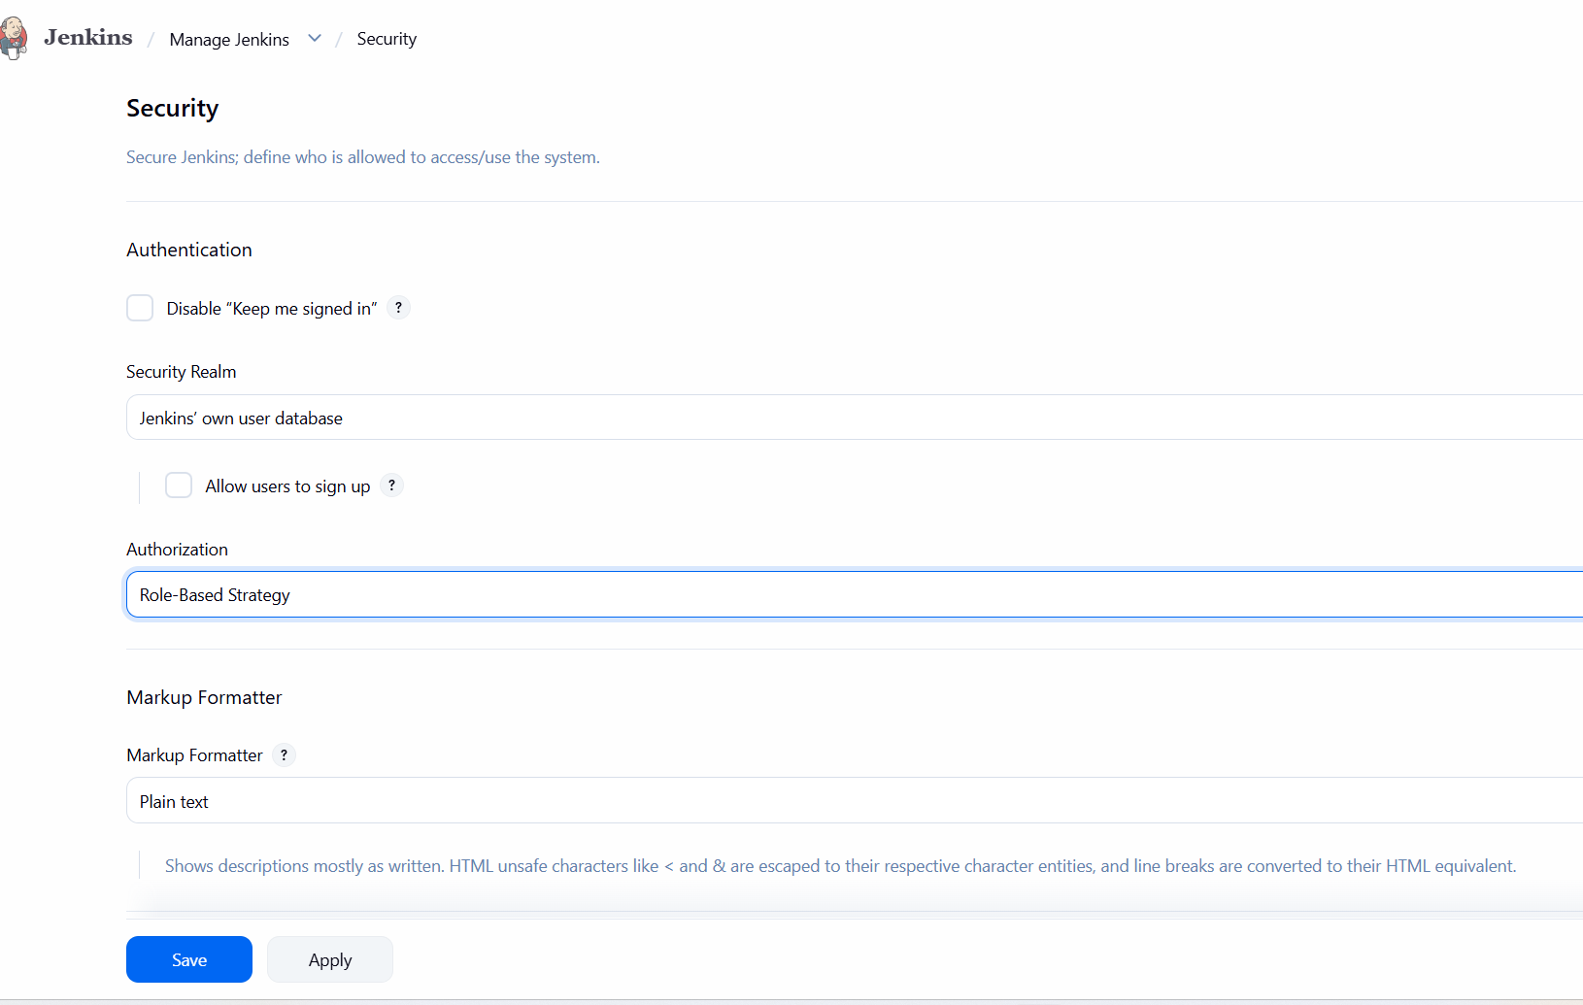

- Create users called DevOps, Testing in Jenkins with Limited access.
Go to manage Jenkins click on usersclick on create user give use names ans password create
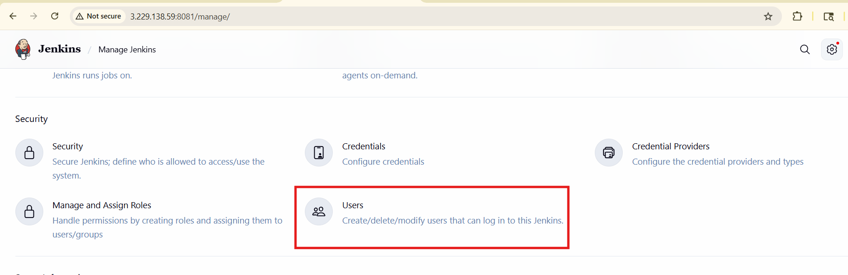
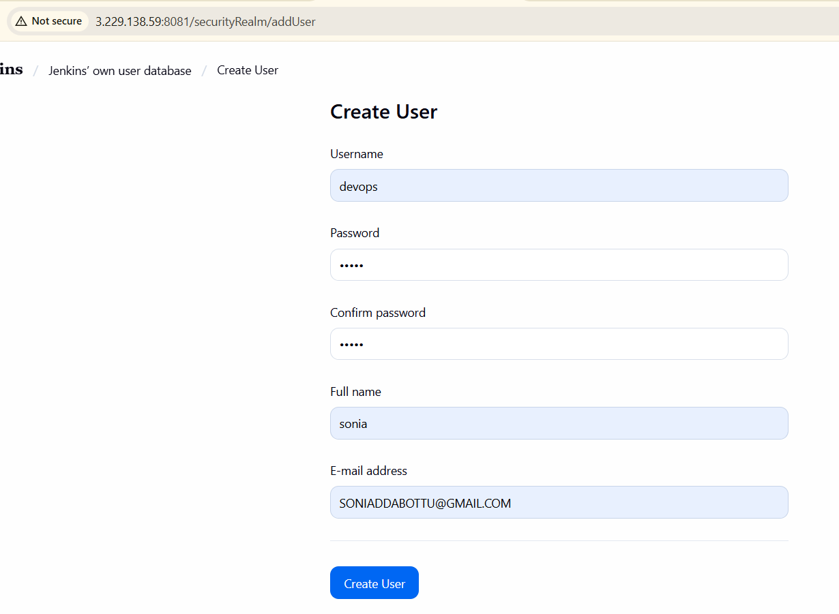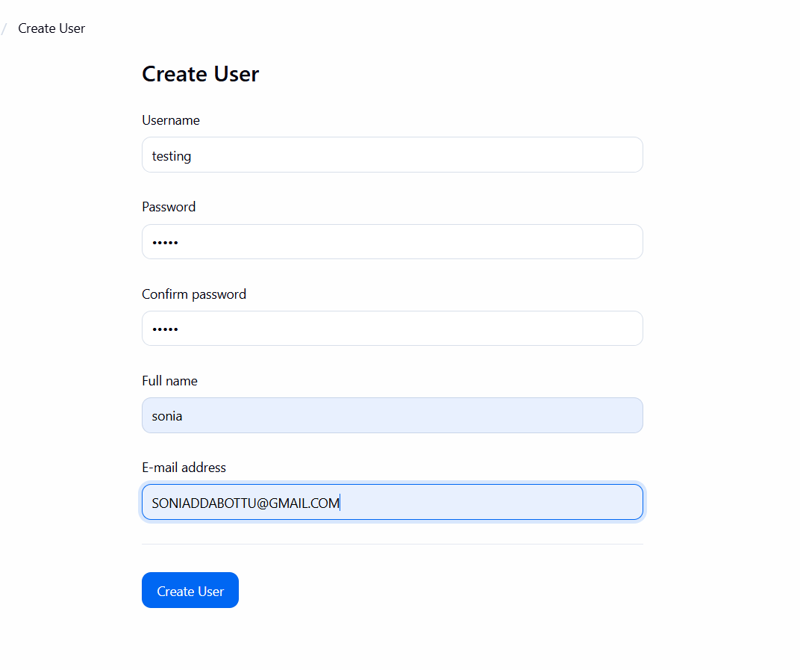

After create user then give the access
Go to manage jenkinsselect manage nd assign rolesadd roleand assinging permissions to user
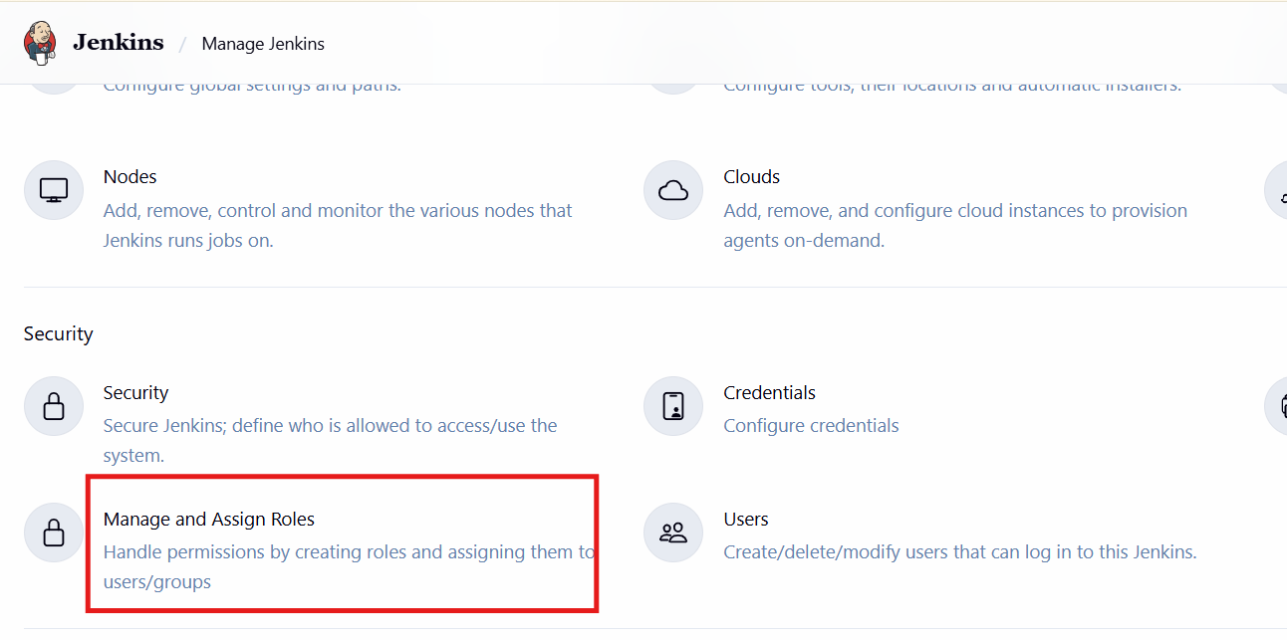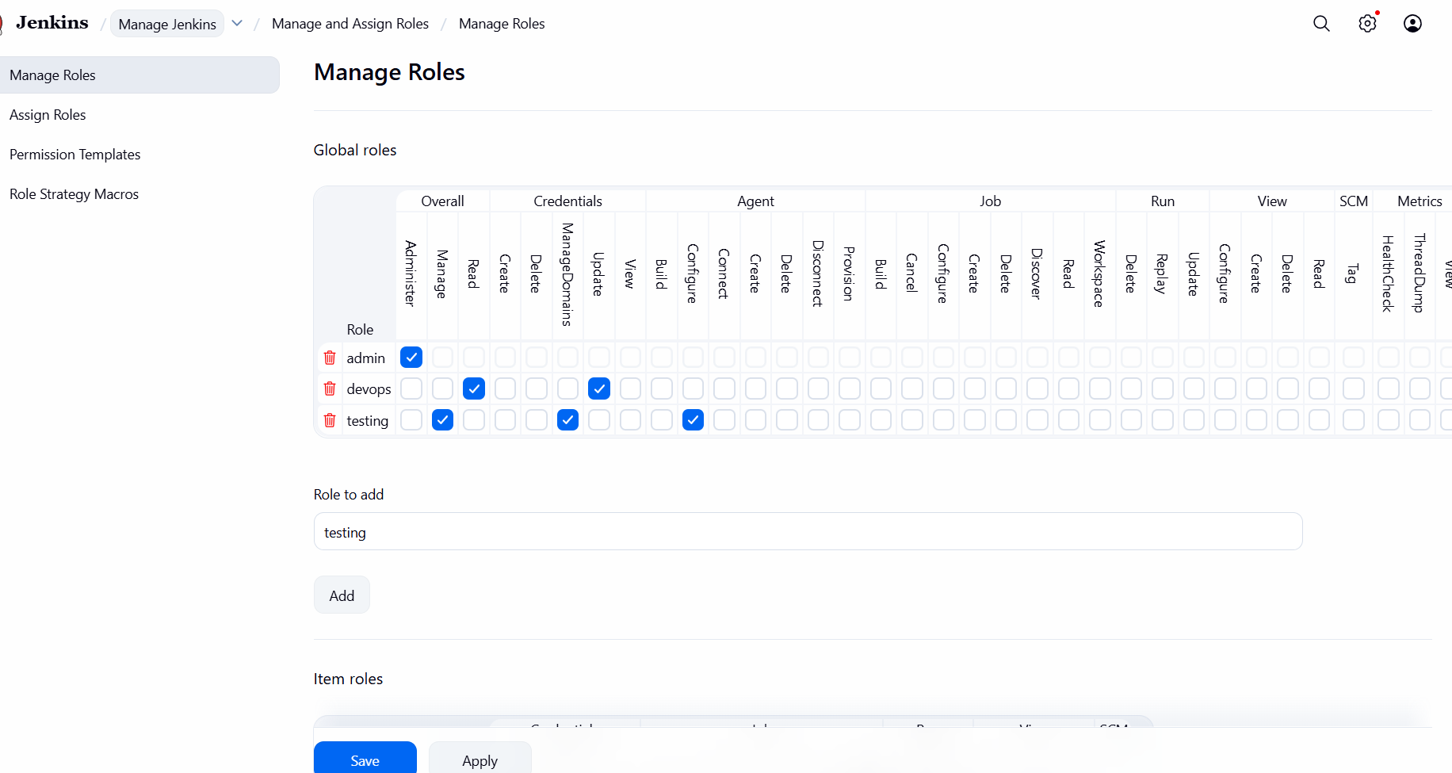
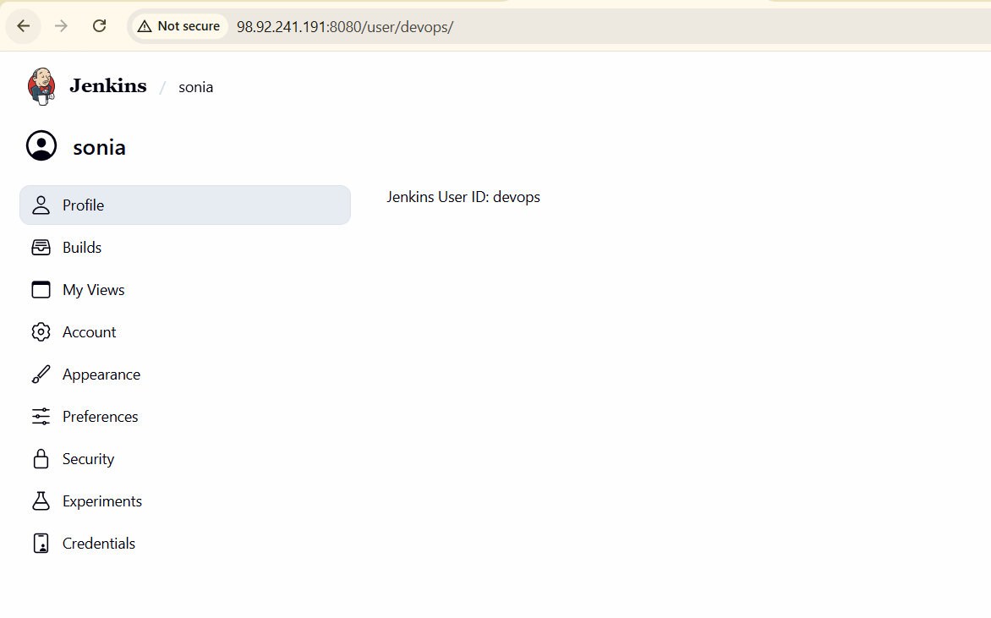
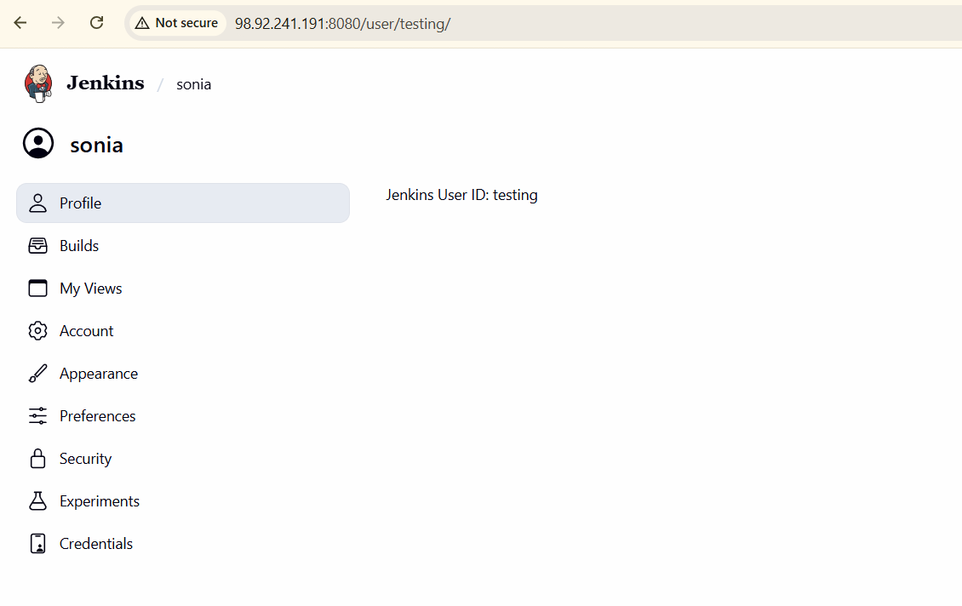

- Configure labels and restrict the jobs to execute based on label only.
Dashboard → Manage Jenkins → Nodes
Select your node

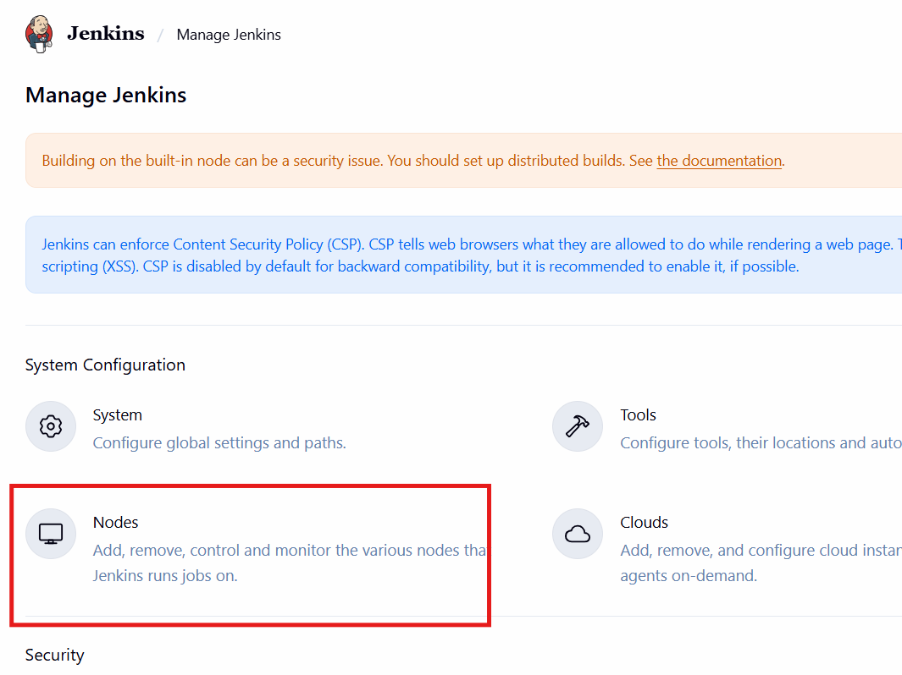
Click the node name → Configure
You can give one or multiple labels separated by spaces.
Click on save
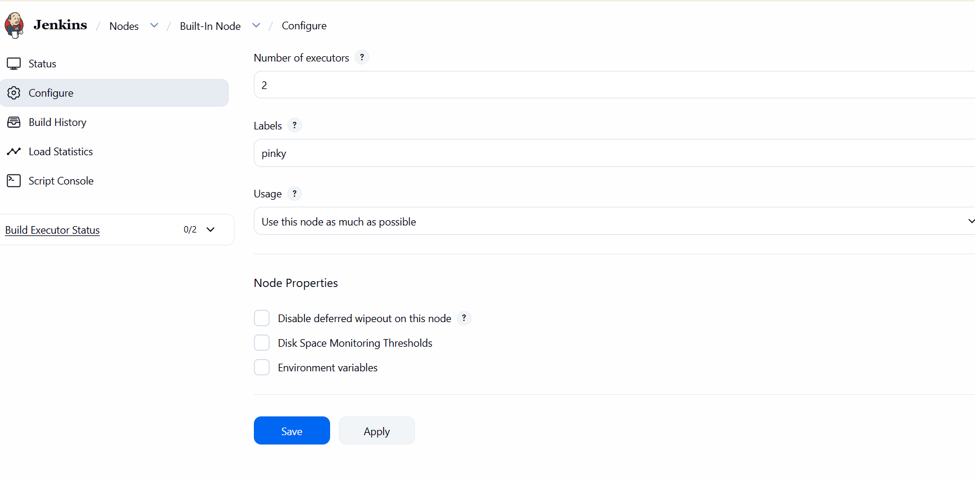

Restrict Job Execution Based on Label

For Freestyle Job
• Open your job
• Click Configure

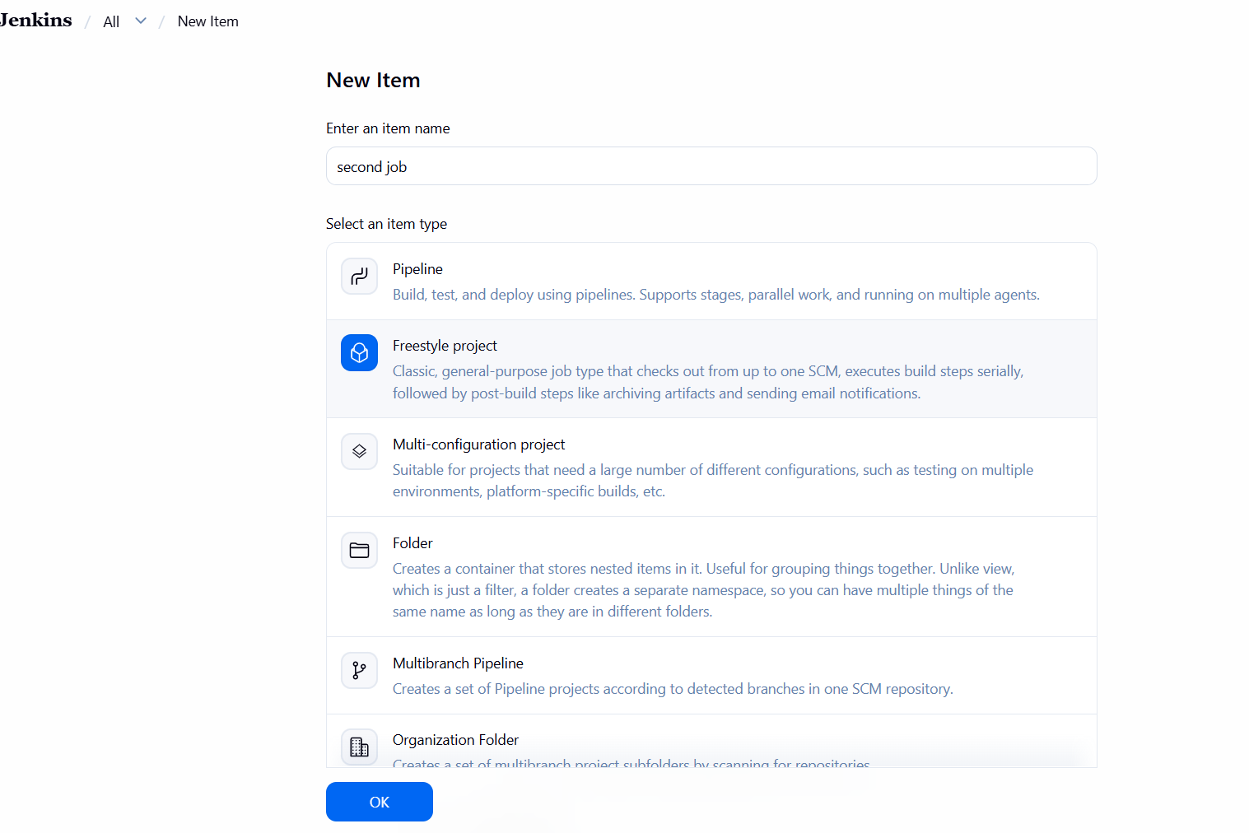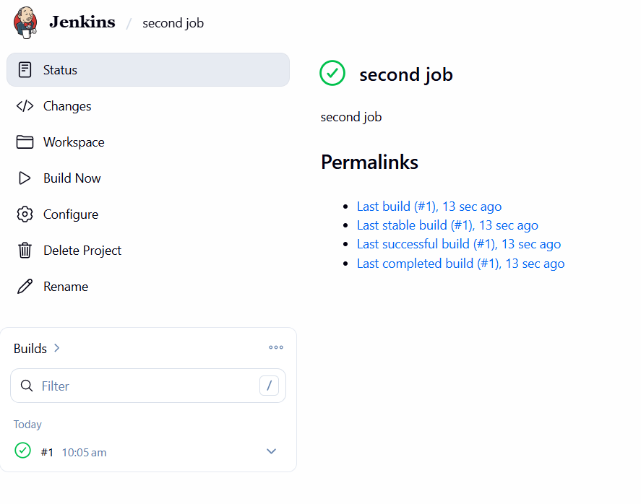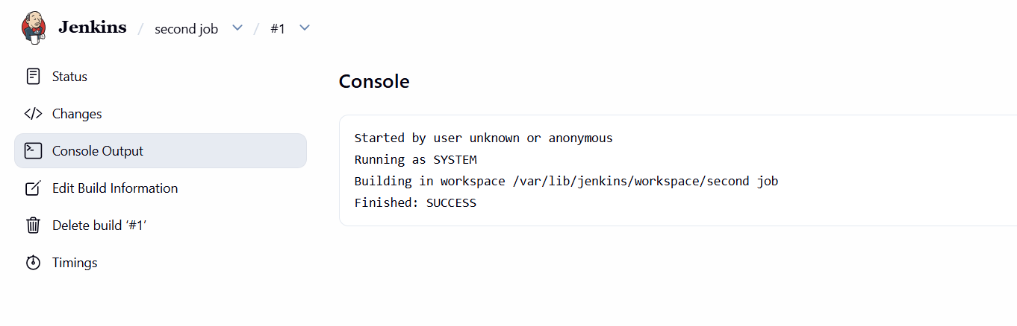
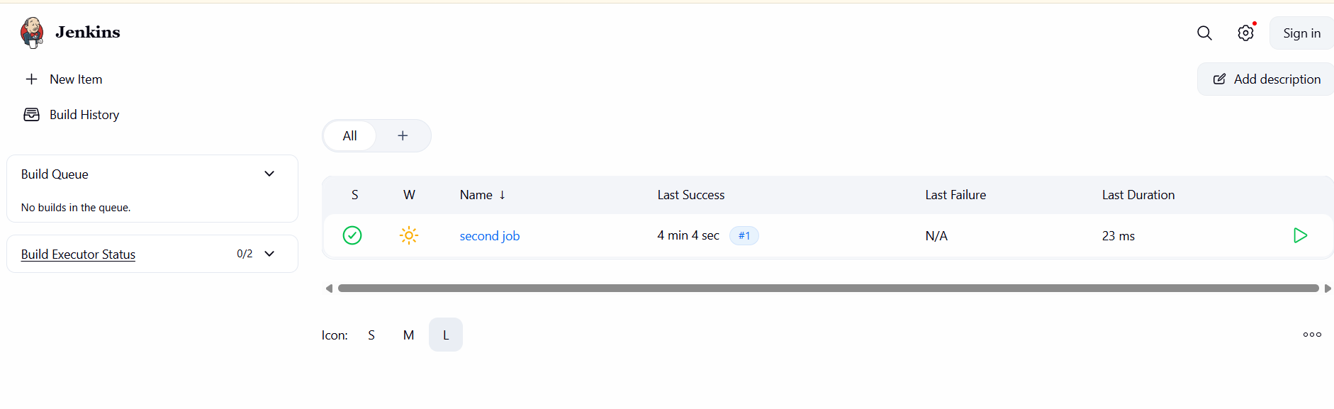

- Create Three sample jobs using the below URL.
Source Code:https://github.com/betawins/Techie_horizon_Login_app.git
first create job more 2
New item-->name-->freestyle project-->estrict where this project can be run-->select git and --> give url-> to check the branch--> give execute shell--> save
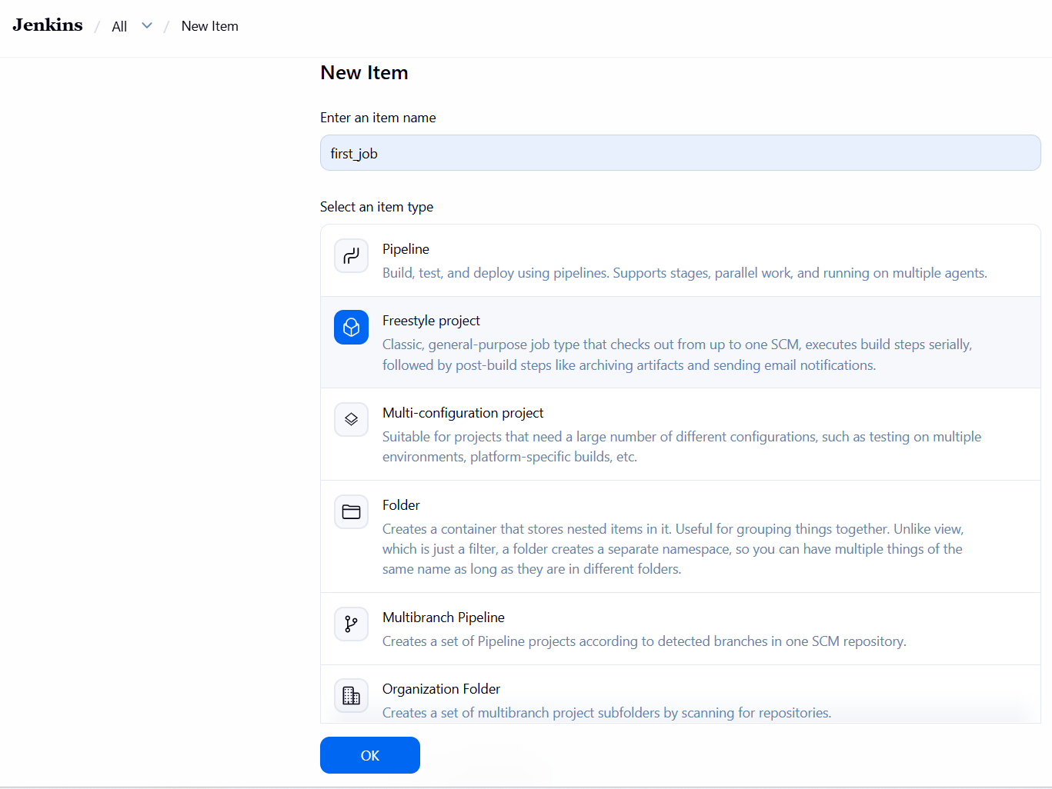
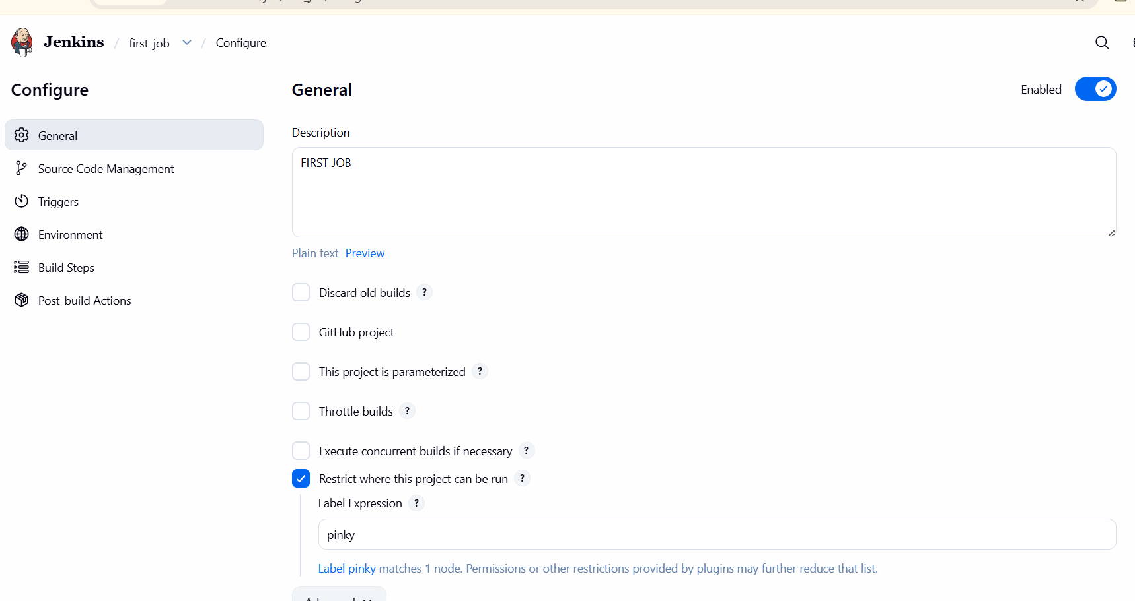
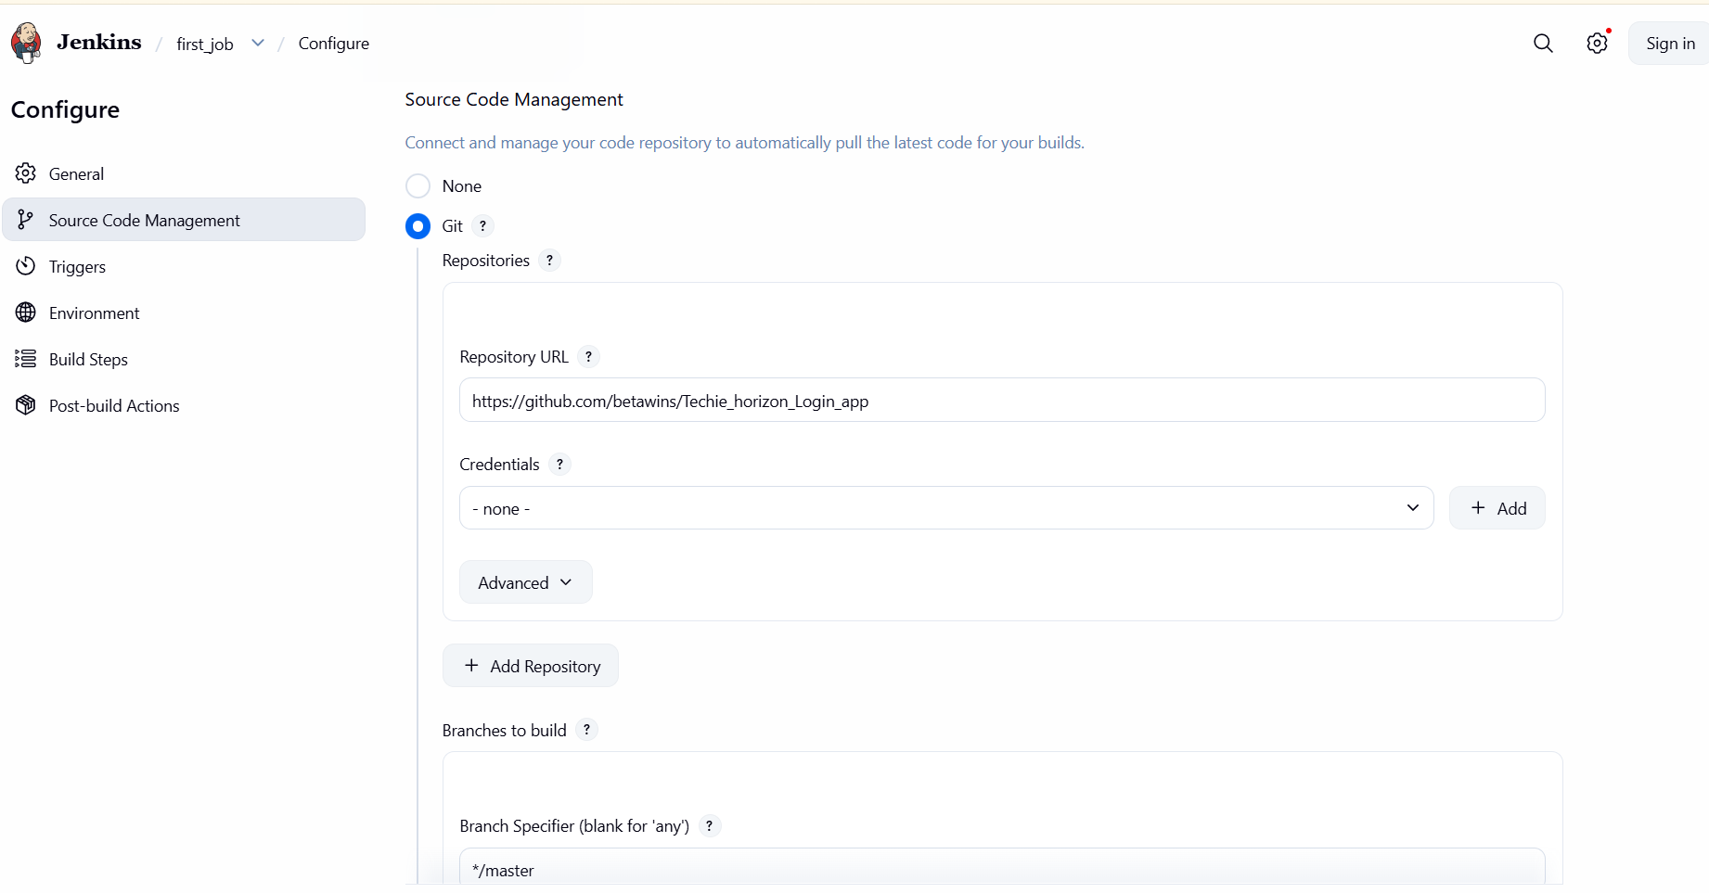
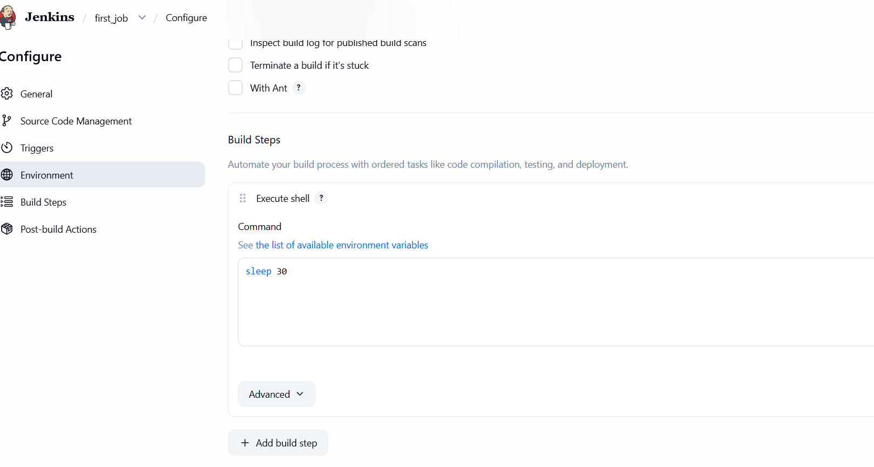
Then we can check status and build now--> console output
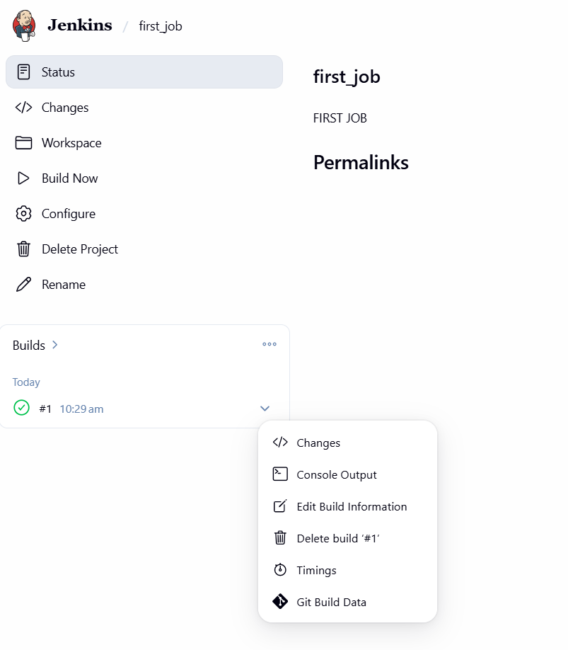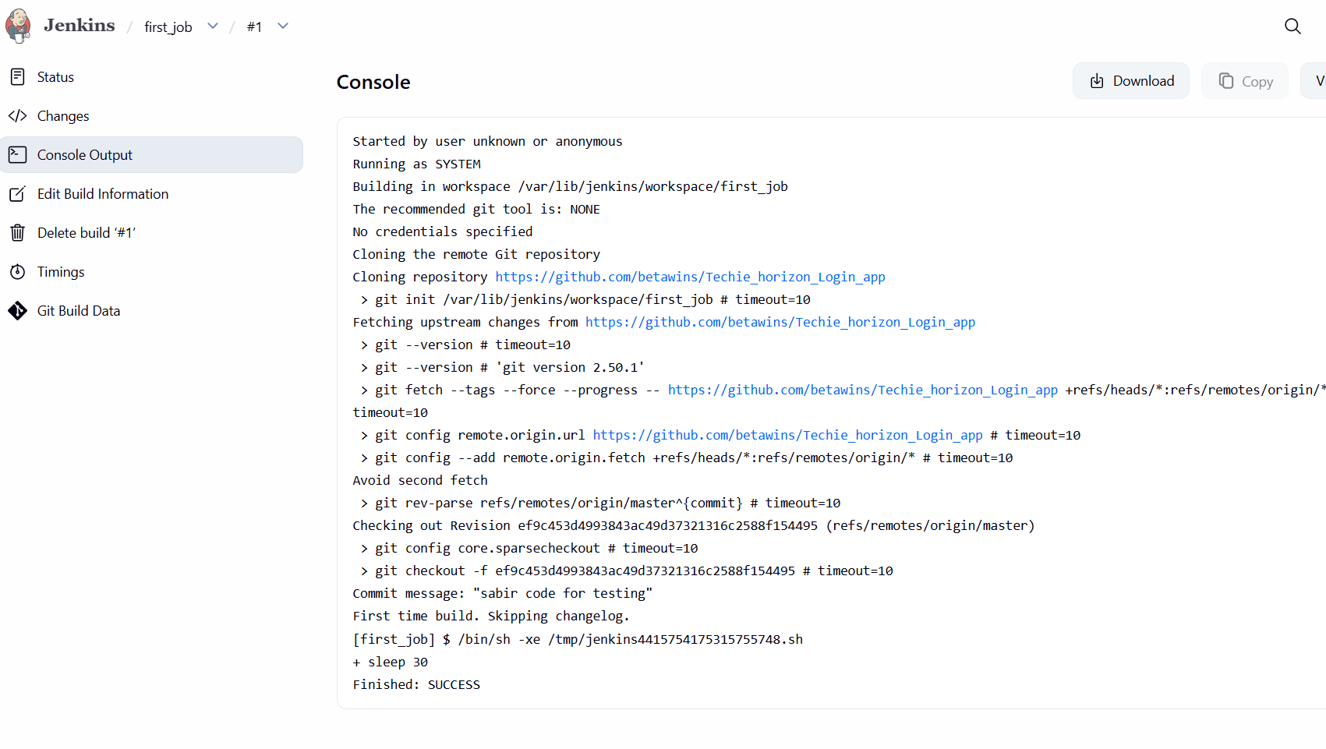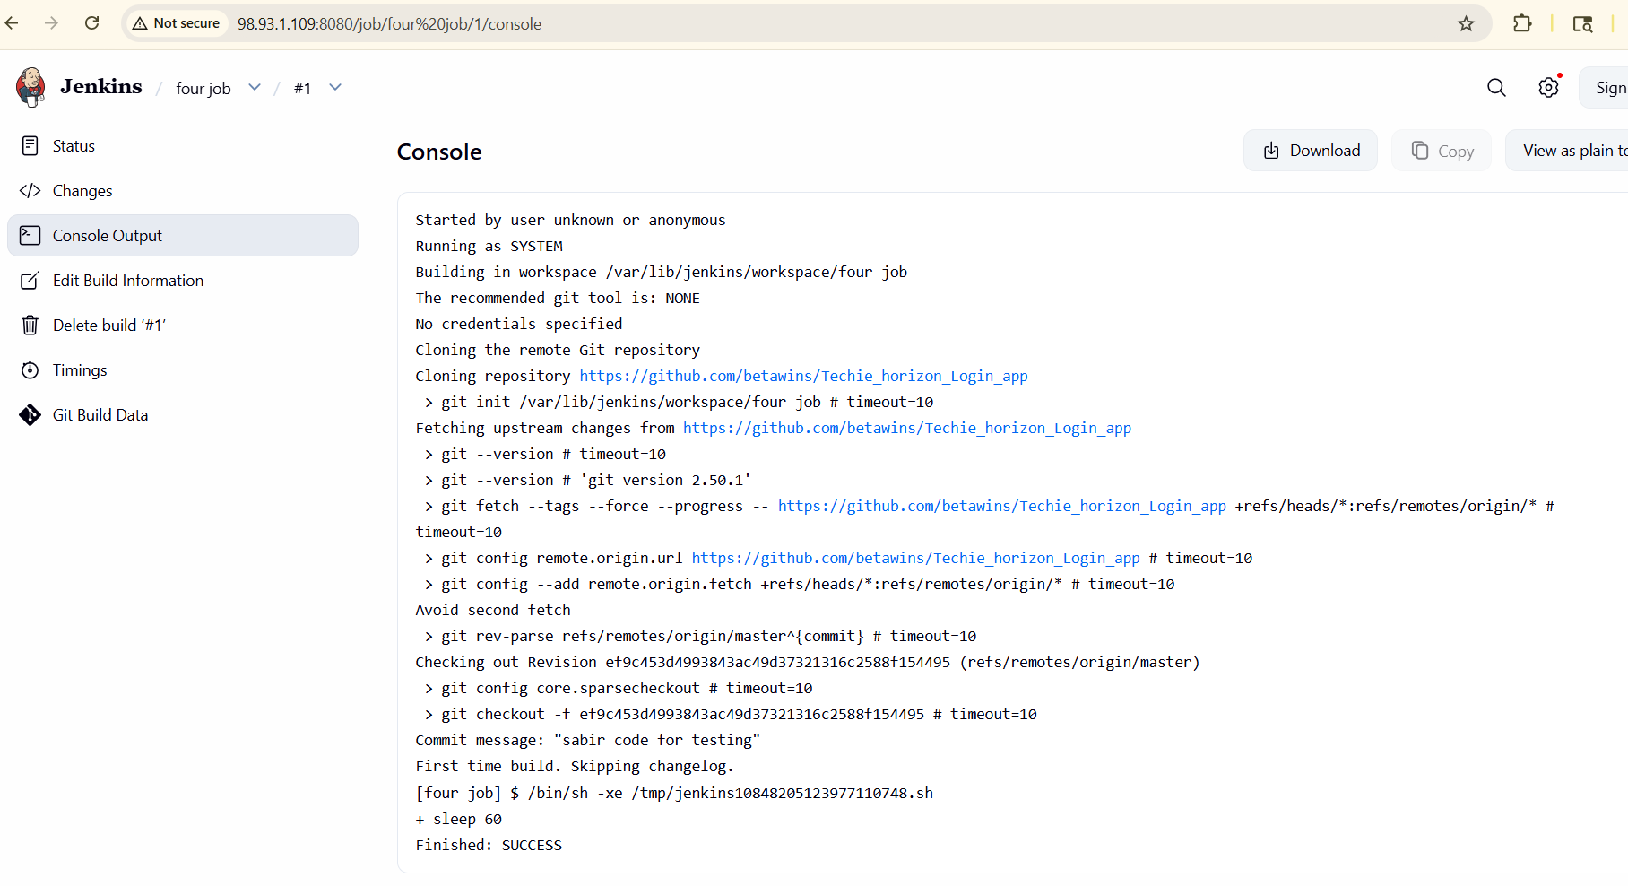
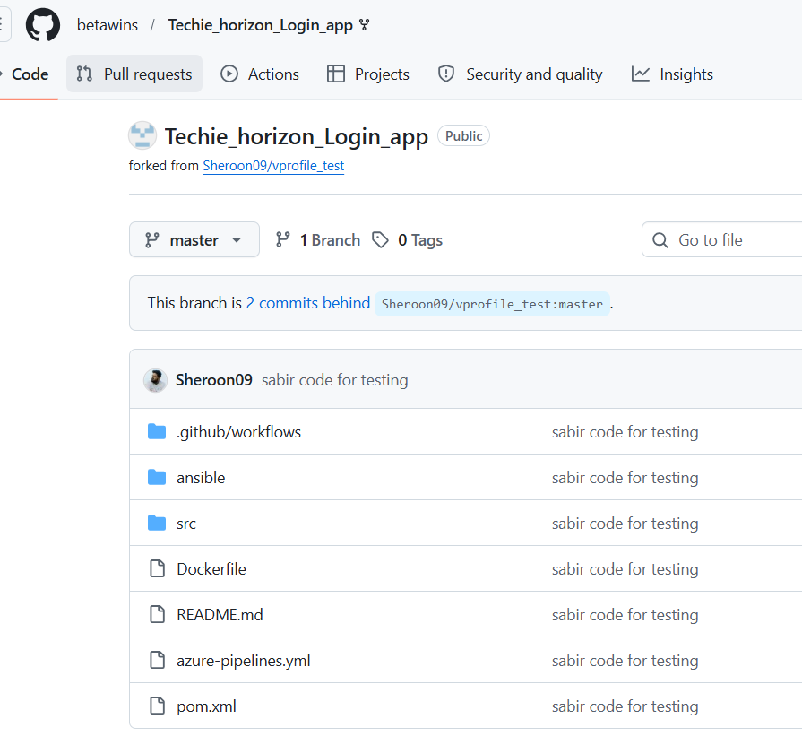
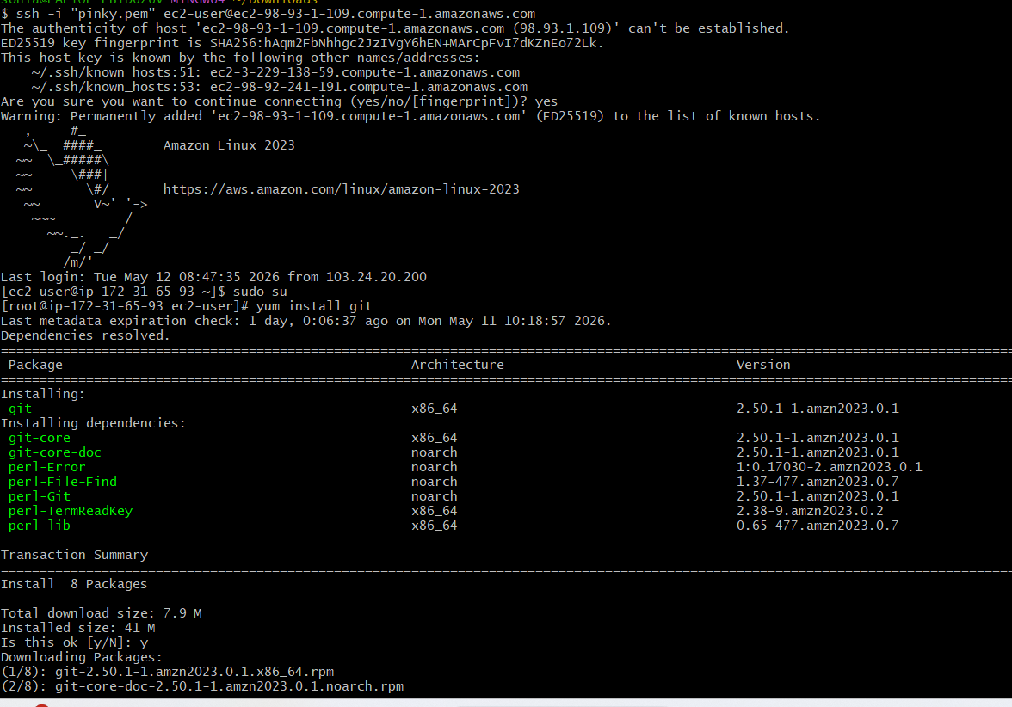
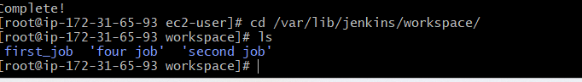

- Create one Jenkins job using GitHub Private repository.
First go to github--> create new repository-->give repository name-->select configuretion -->create repo
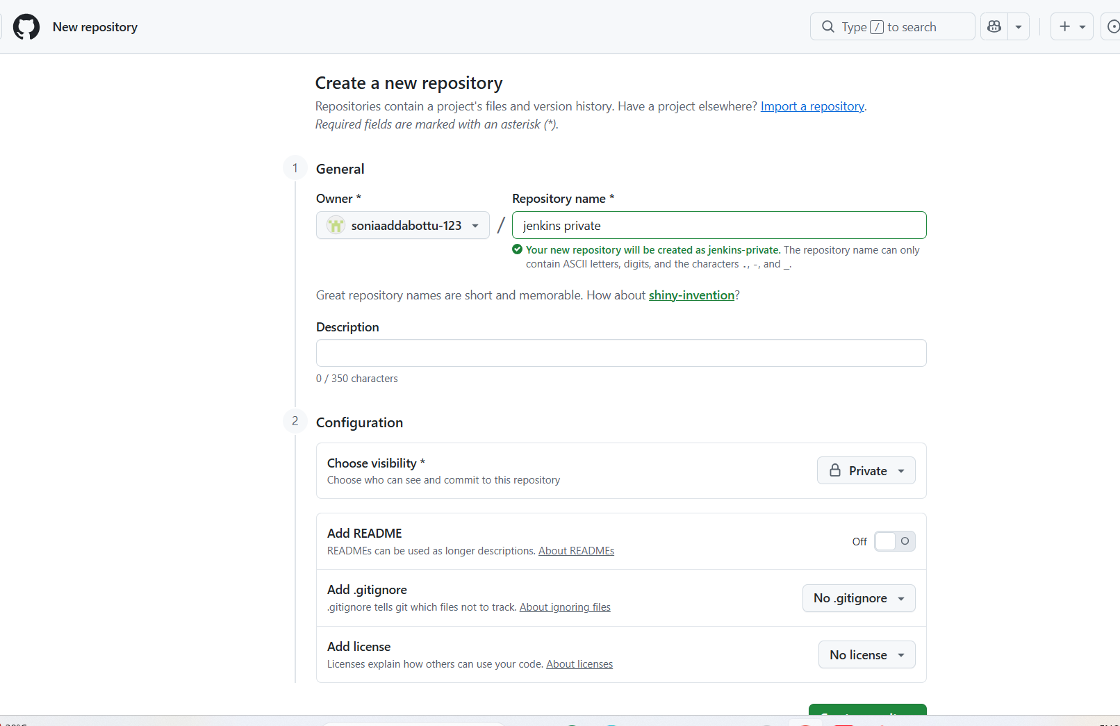
Aftre creaated upload a file--> commit changes -->open
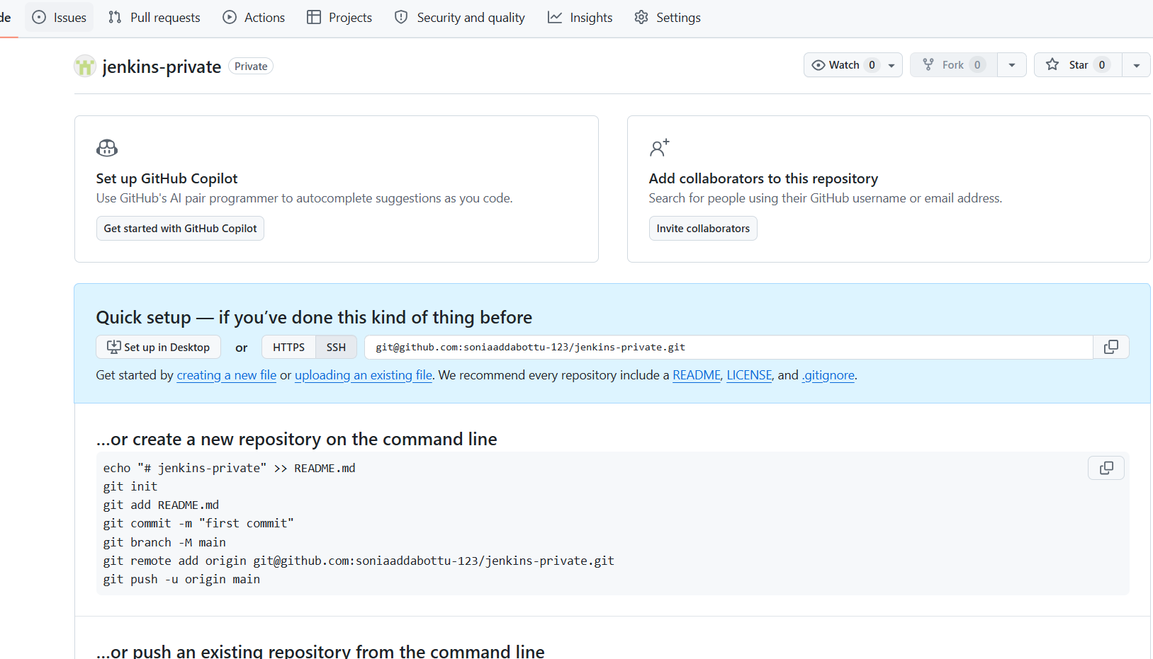
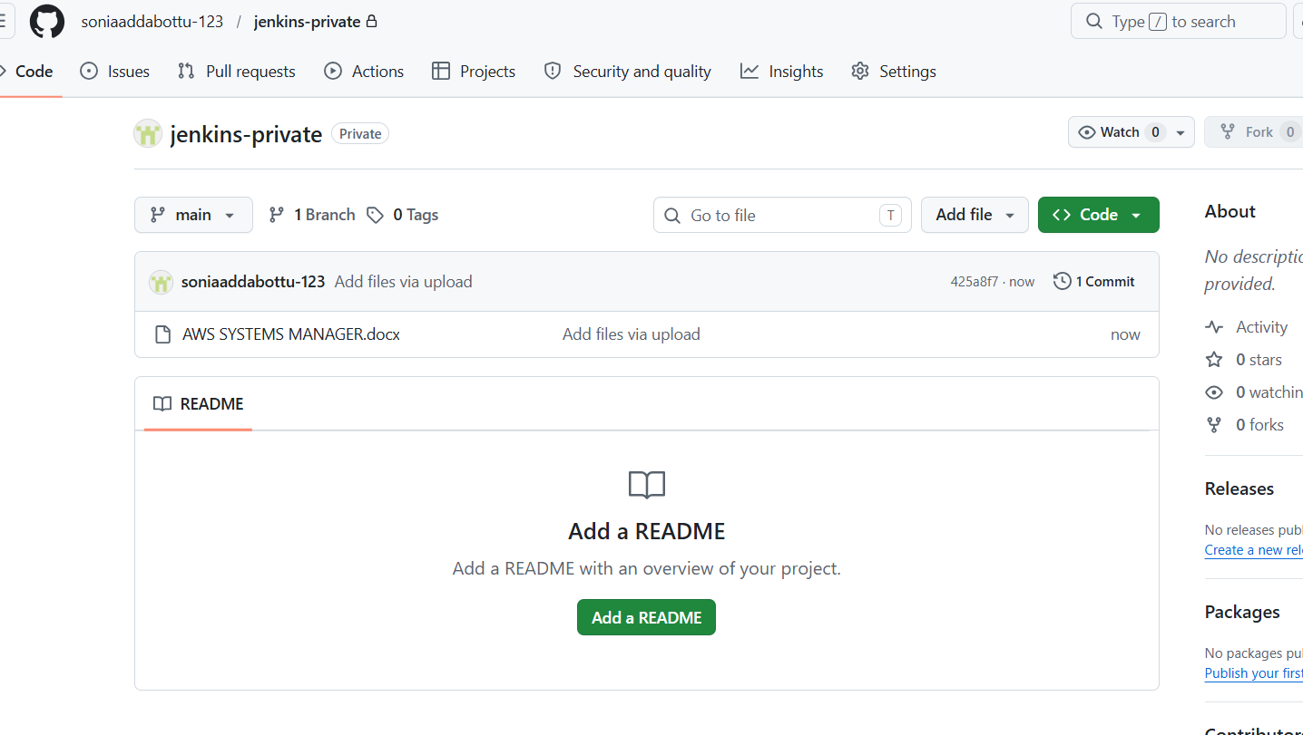
Generate token
Go to settings --> go to developers --> click on personal access token--> token

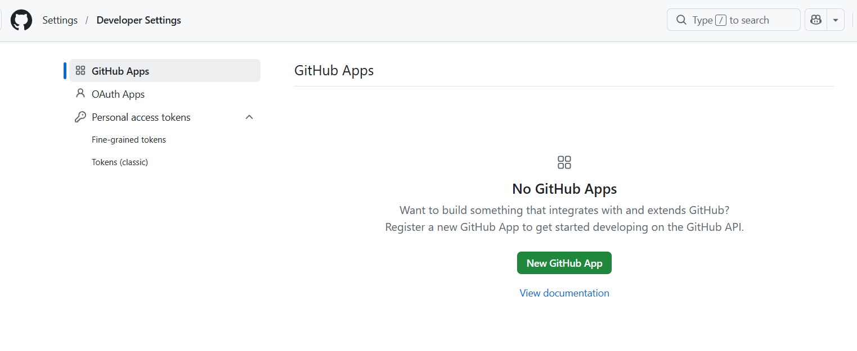
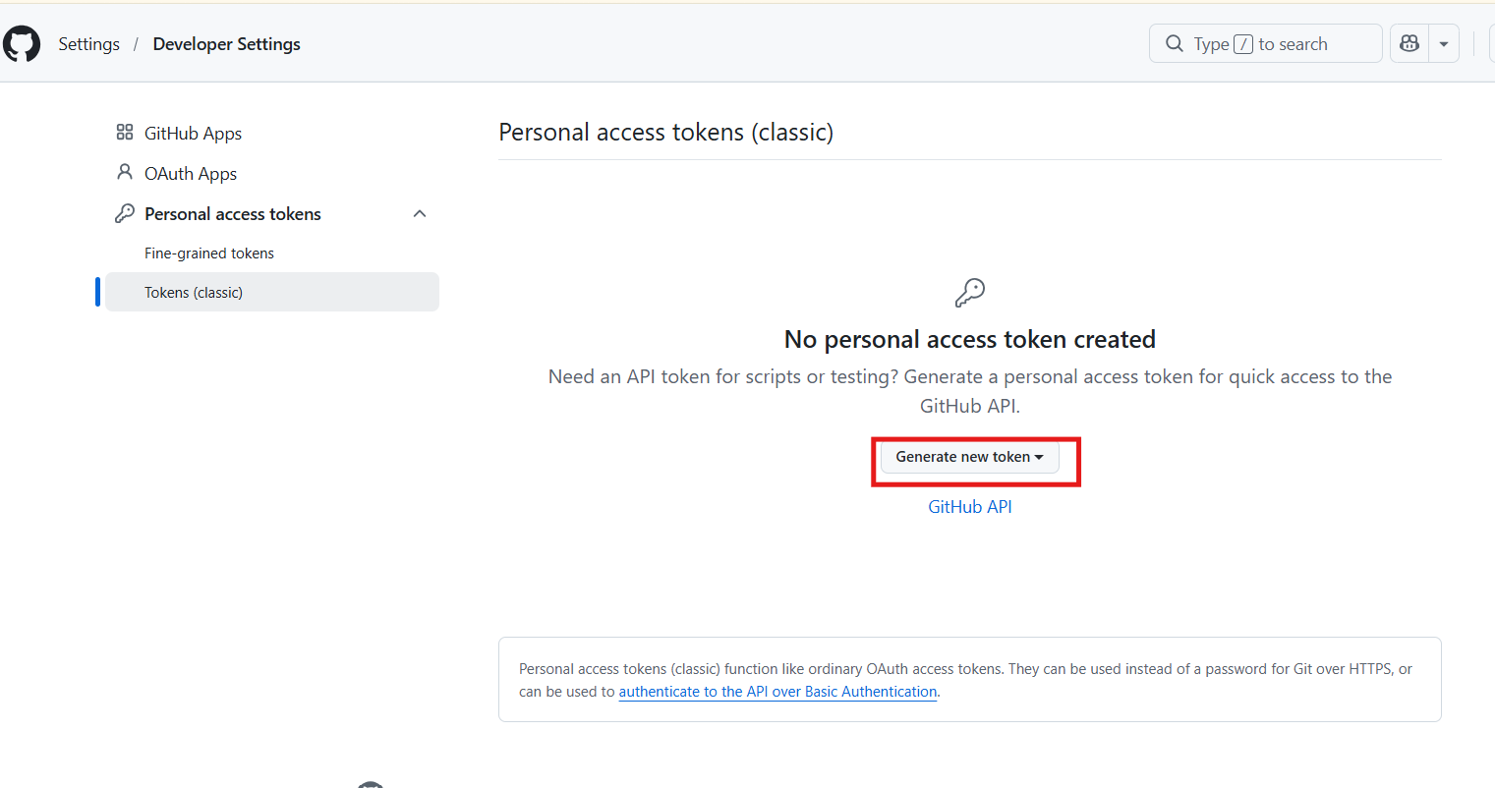

Gererate new token-->note--> give permissions-->select repo--> generate
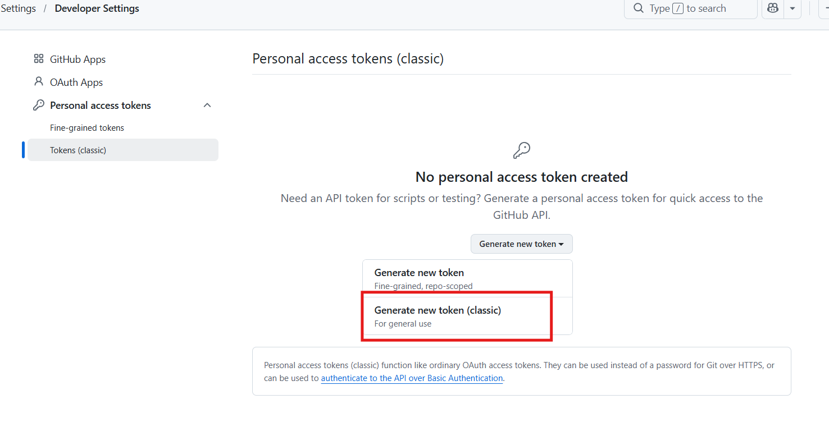
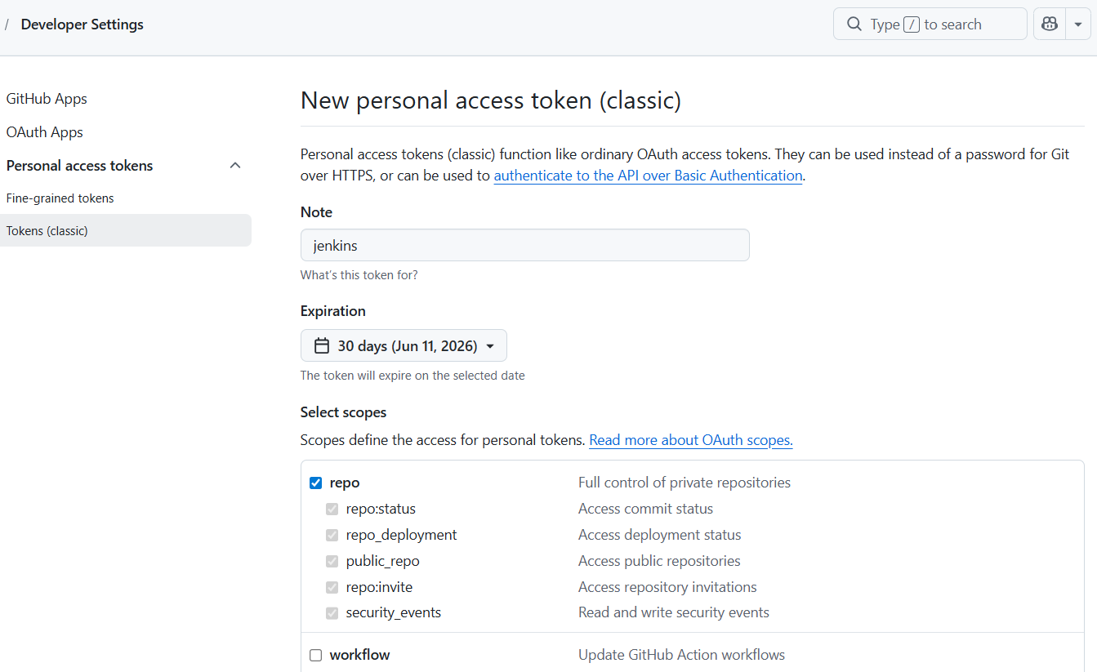

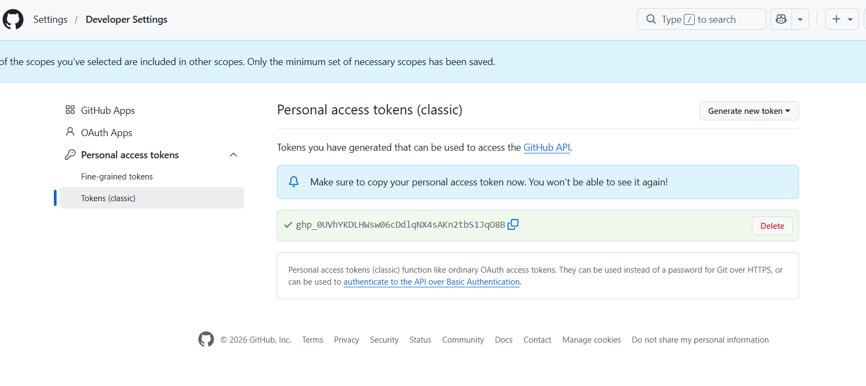
Go to jenkins -->manage jenkins-->select credentials--> user name and password
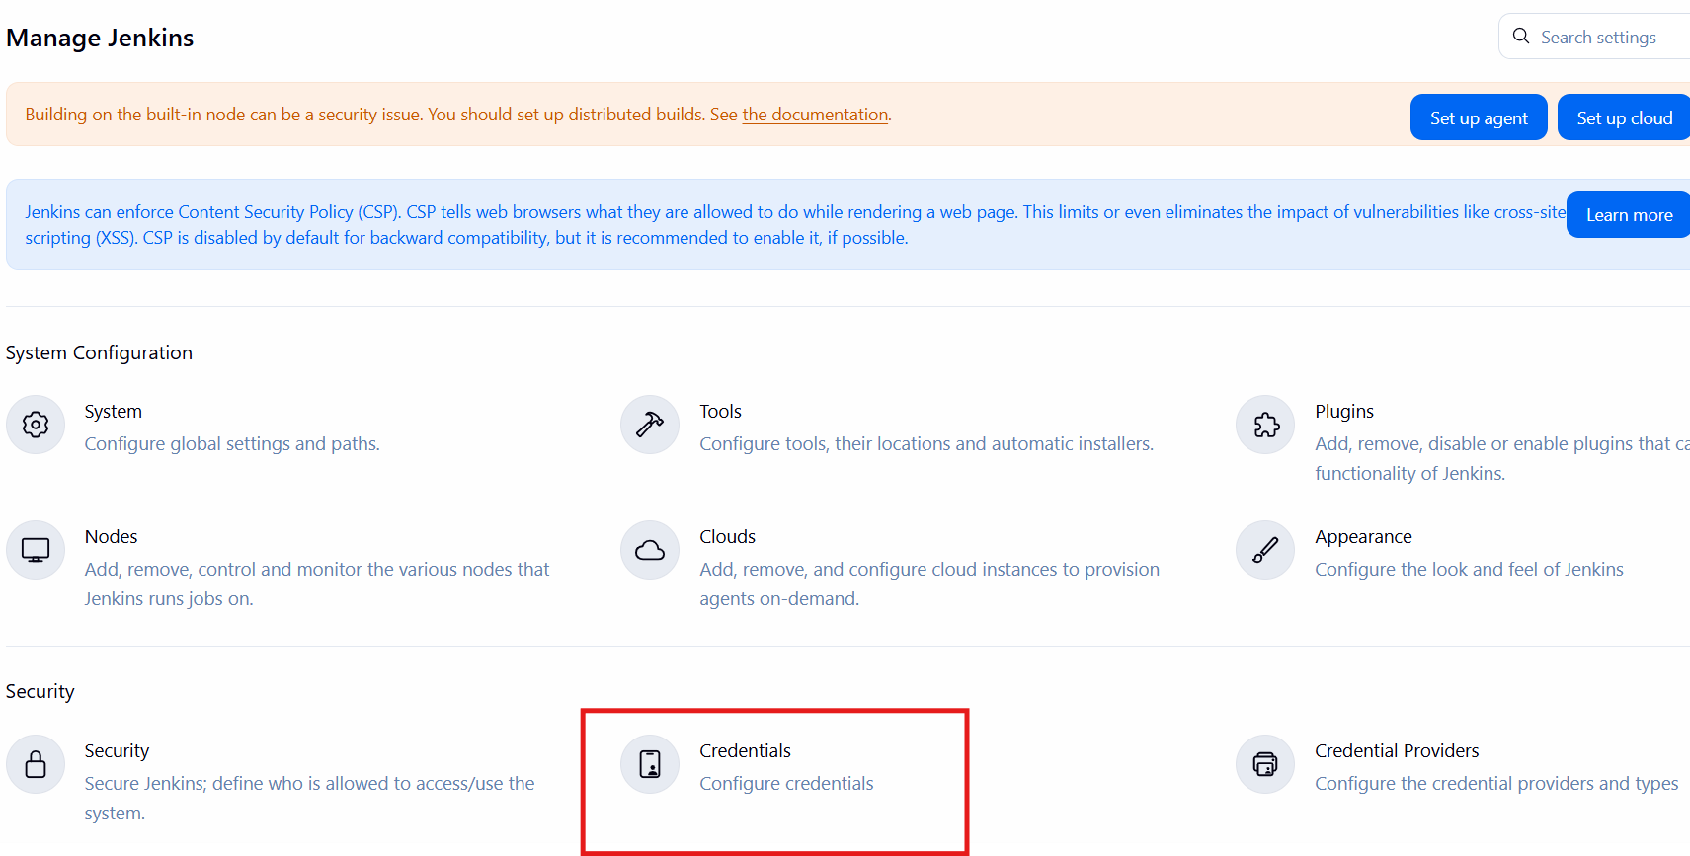

Select Global and Click Add Credentials and select username and password
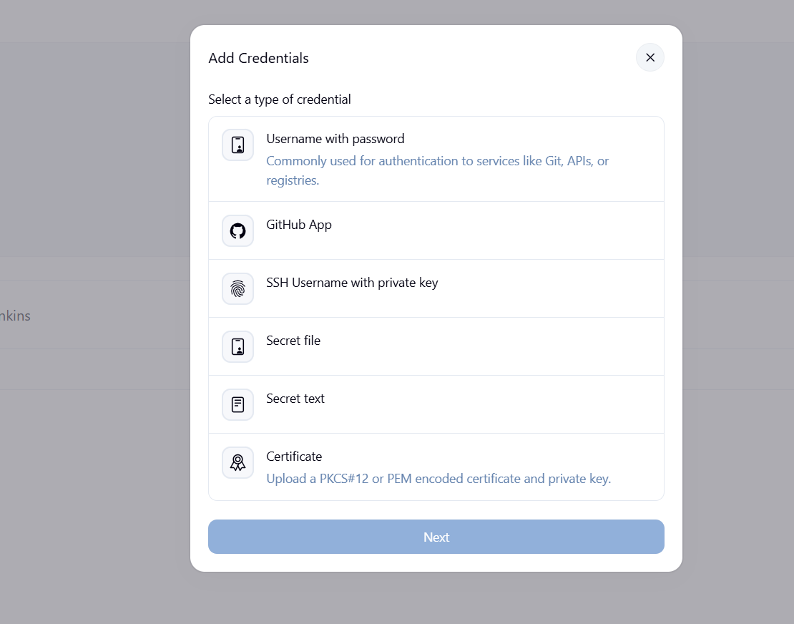
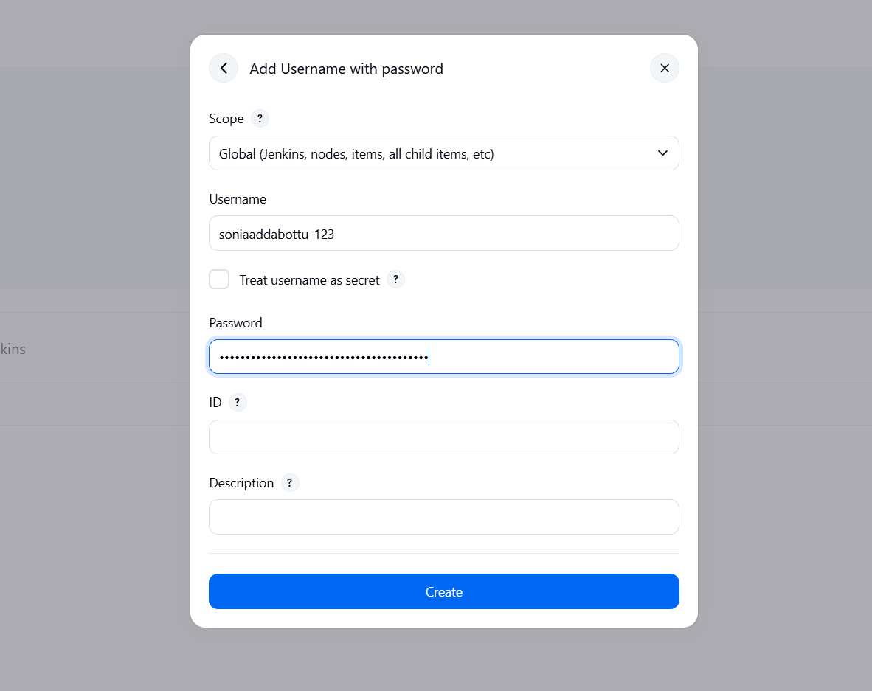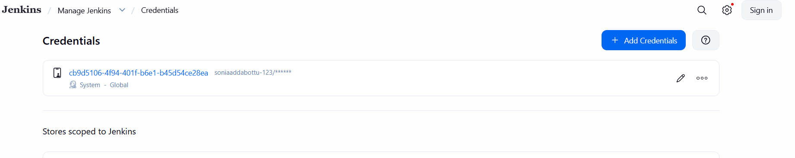
Create a new utem
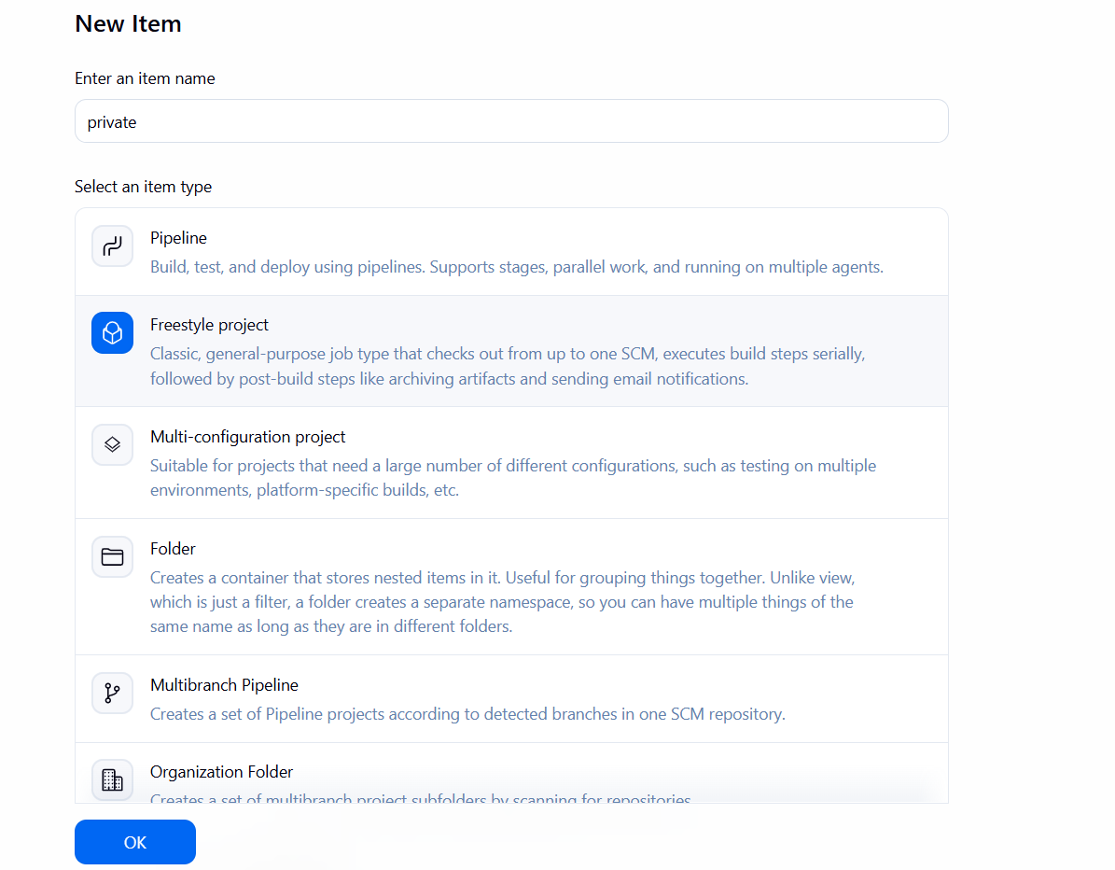

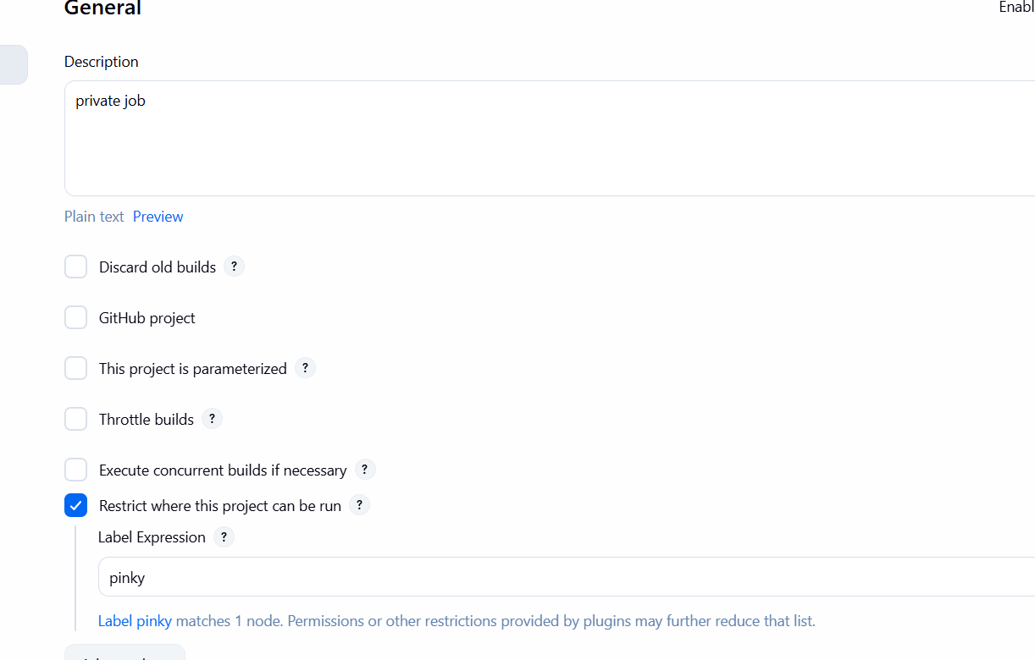
In Source Management change git and added my private git URL
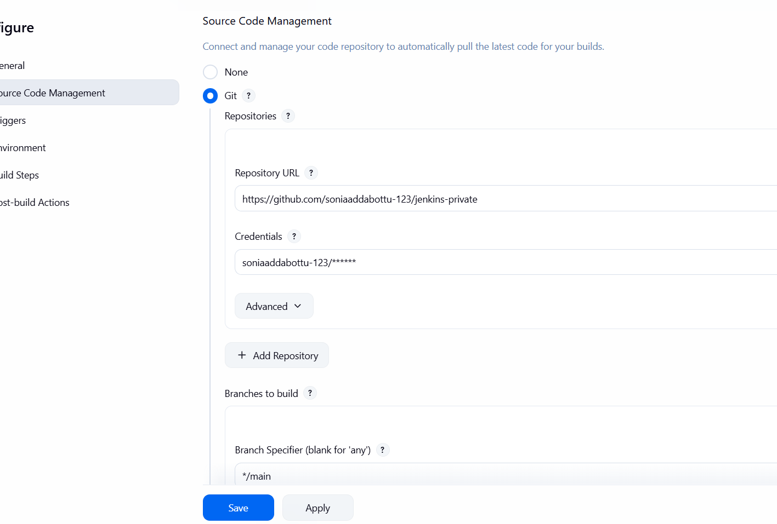
Create build
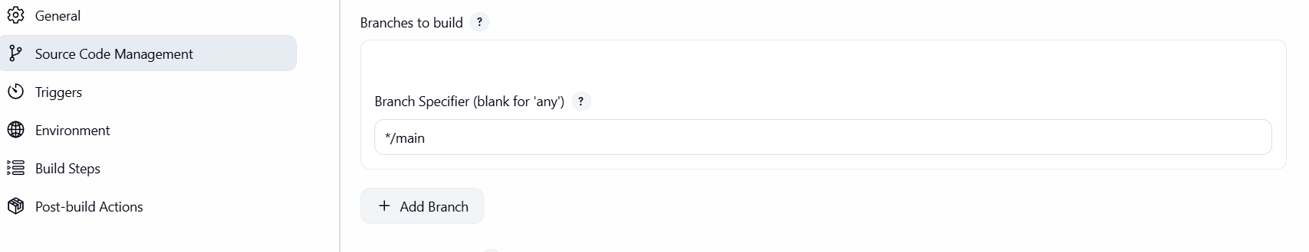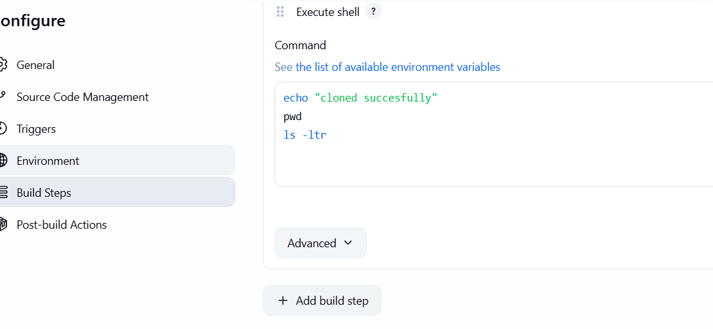
Verify the status
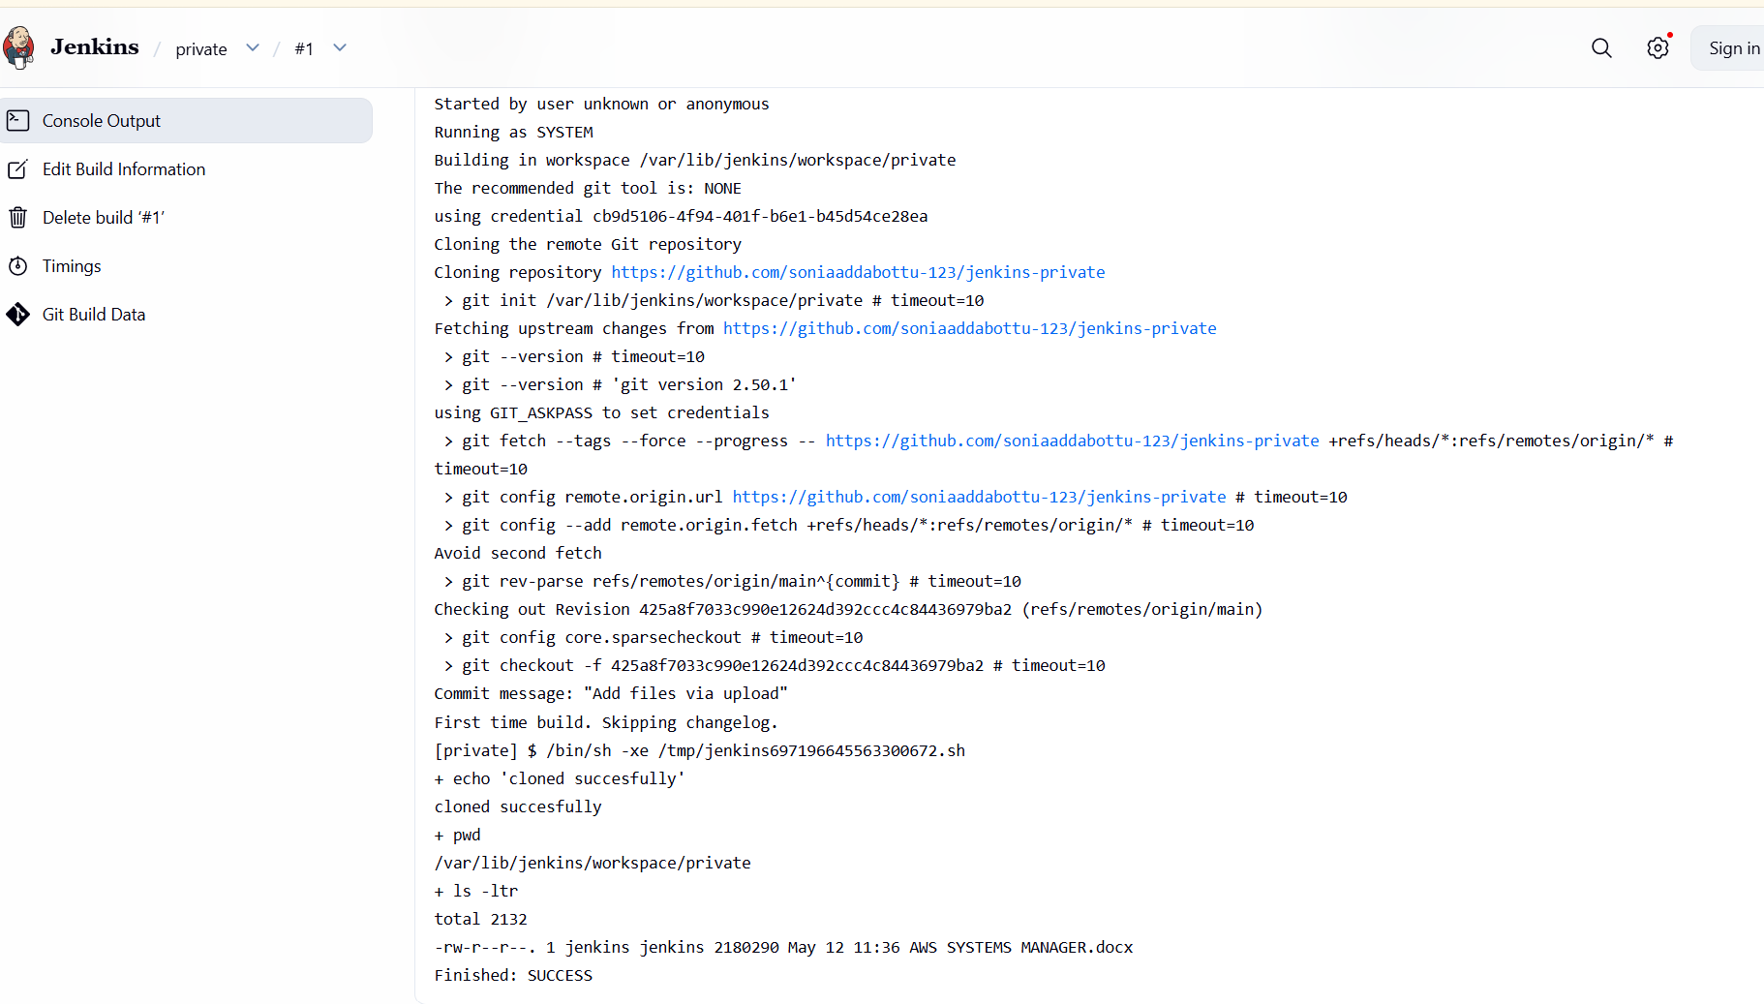
To check the gitbash
