Docker-03
- Create a image from running container.
check if we have any images or not
docker images
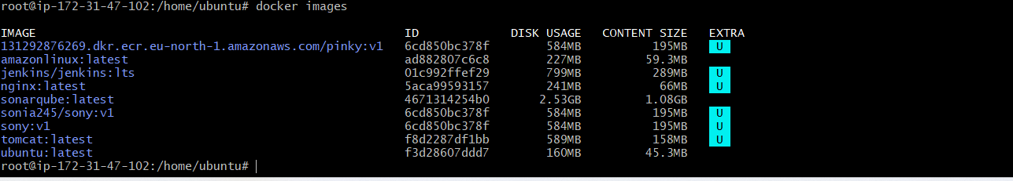
We have running container for that need to start an imag Docker run -itd -p 80:80 nginx:latest
Docker ps
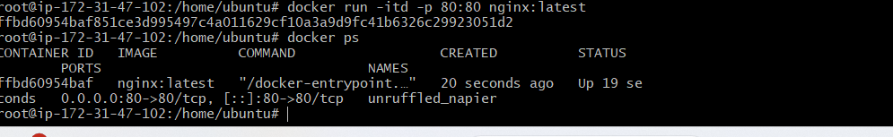
Lets create an image using the running container using command
docker commit <container_id> <image_name>:<tag>
and to check if the images has been created or not use command
docker images

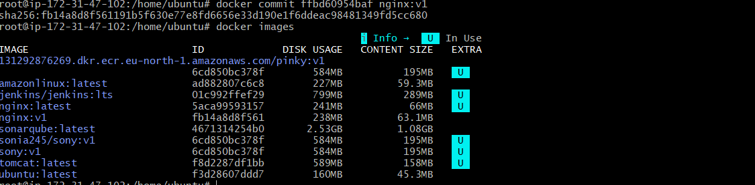
- Copy image from local machine to docker server and load the image.

For this first Install DOcker Desktop in our local machine
Go to google dowload the docker desktop
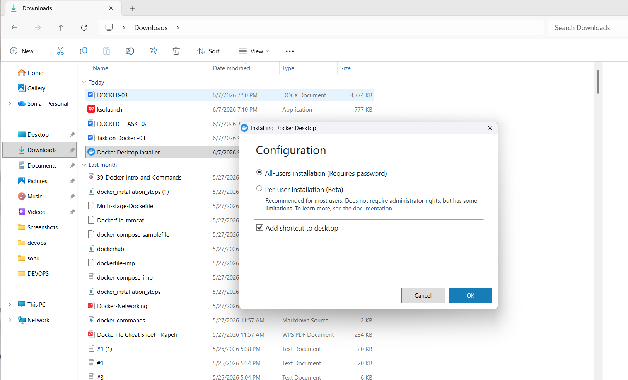
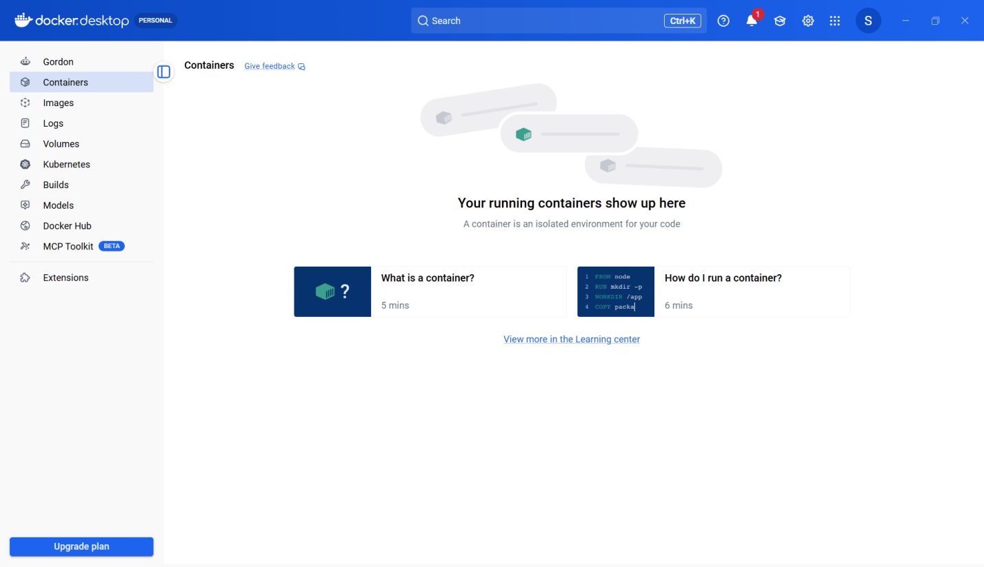
Now check if docker has been installed or not by using
docker –version
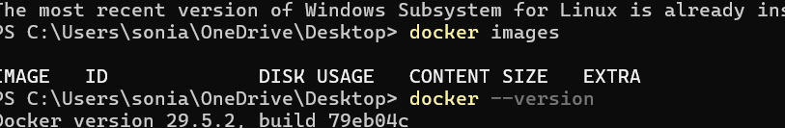
Now lets pull an tomcat image on my local machine
Docker pull tomcat
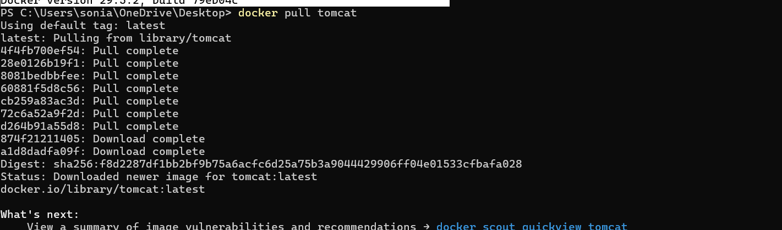
As we cannot copy this image to our server we will be creating a tar file using command
Docker save -o tomcat.tar tomcat:latest
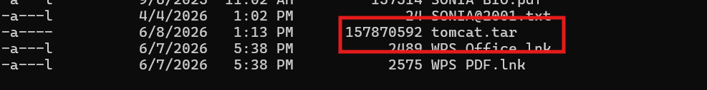
As we can see from above tar file is created now lets move the tar file to our server using command
Scp -i “junnu.pem”tomcat.tar ubuntu@ec2-51-20-185-149.eu-north-1.compute.amazonaws.com:/home/ubuntu/
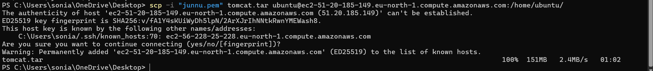
Connect to ec2
Ssh -I “junnu.pem”ubuntu@ec2-51-20-185-149.eu-north-1.compute.amazonaws.com
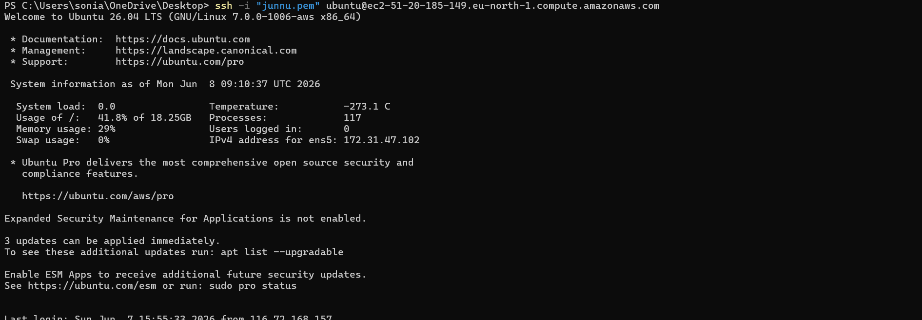
Verify TAR File
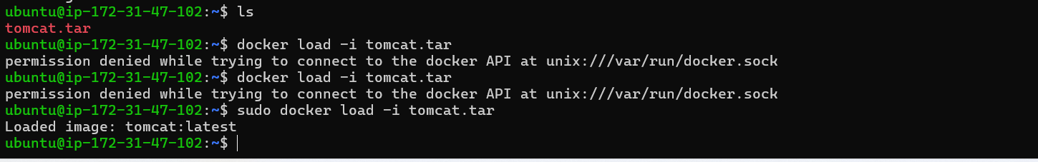
Verify image
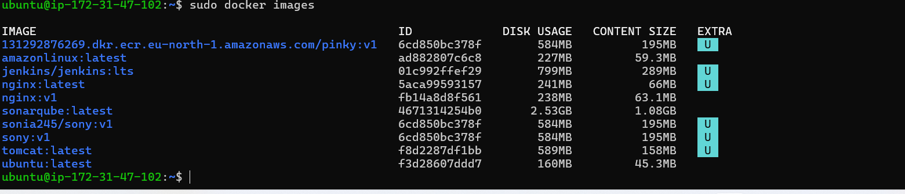
Run the container
Docker Container has been created and working on the given port
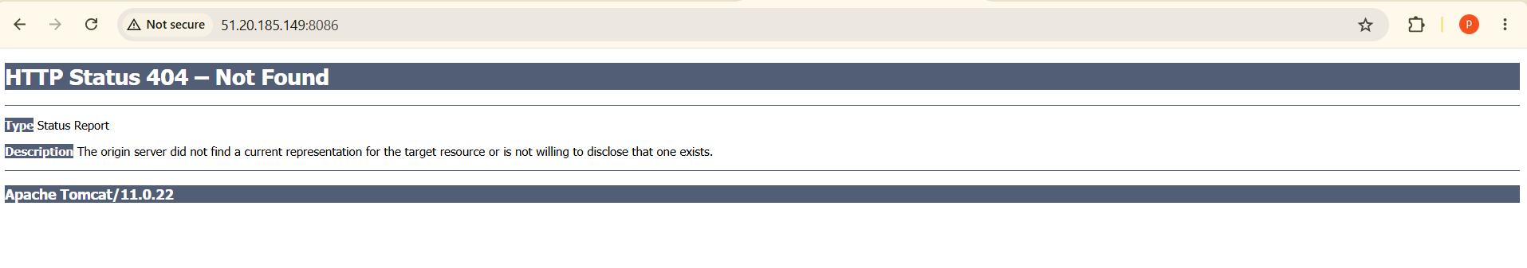

- Create Docker image using alpine and customize with tomcat.
First create one directory
Mkdir alpine-tomcat
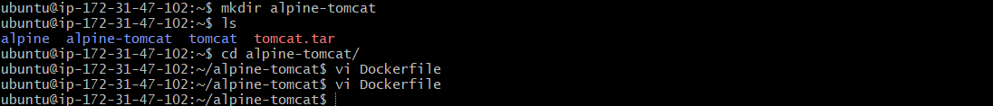
Then create a docker file
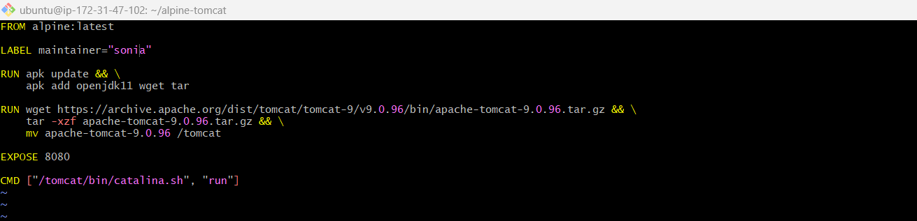
Successfully created docker file
To build the file
Docker build -t alpine-tomcat:v1
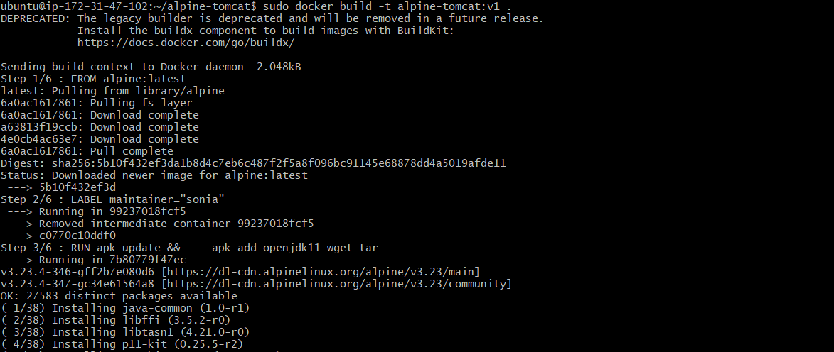
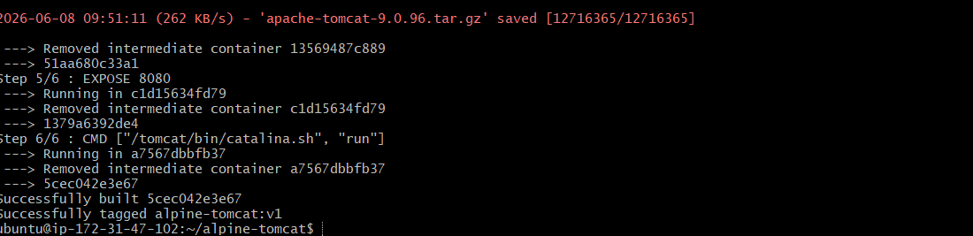
After that check the file as build or not
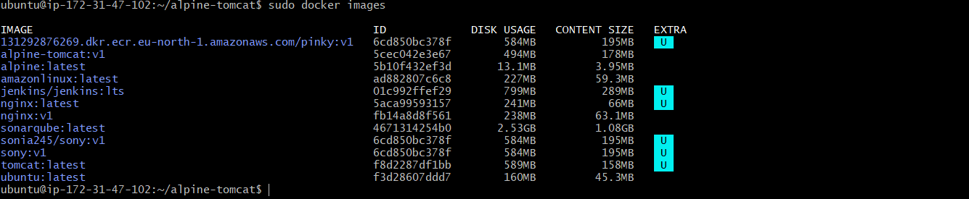
To run the application on port number
Docker run -d --name alpine-tomcat-container -p alpine-tomcat:v1
To check the images
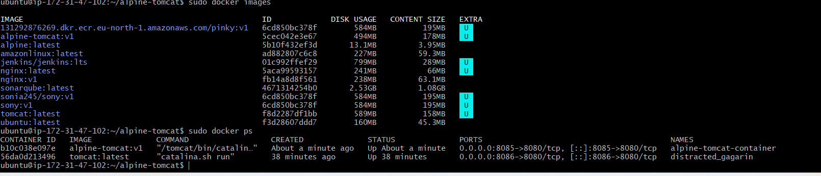
To verify the port number8085
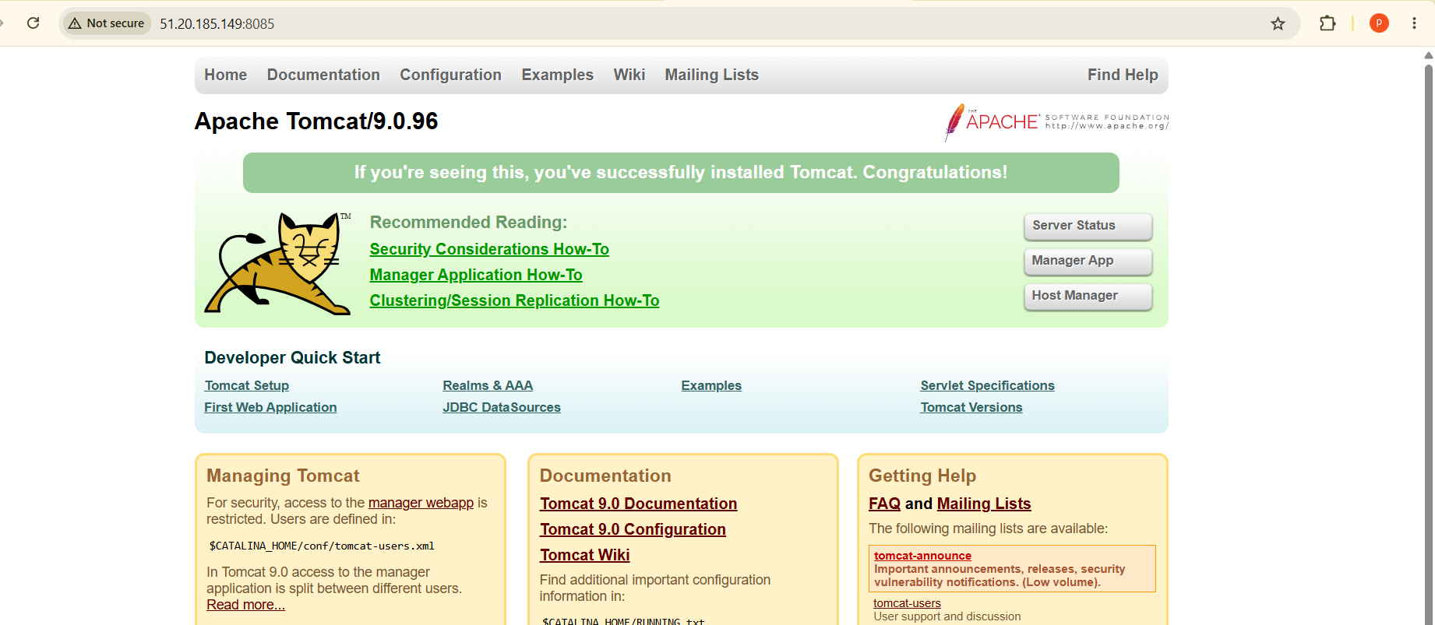

- Create single stage and multi stage docker file using this source code:https://github.com/betawins/multi-stage-example.git
First we have check git install or not
Git -- version
Clone the git repo
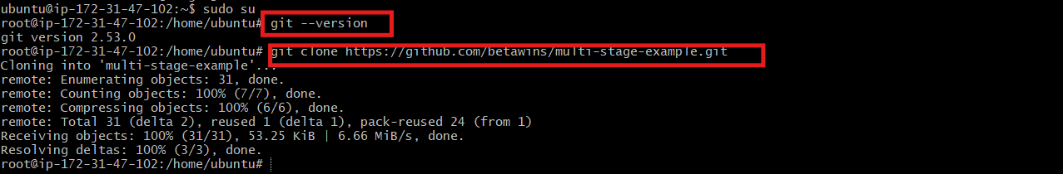
And change the directory
And create single stage docker file
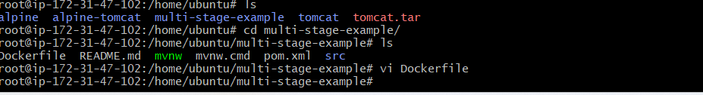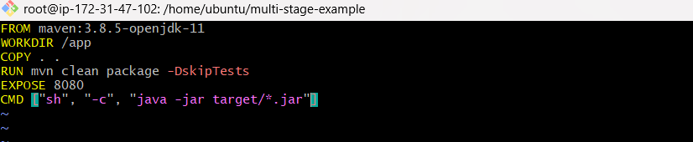
Now build the single stage docker file
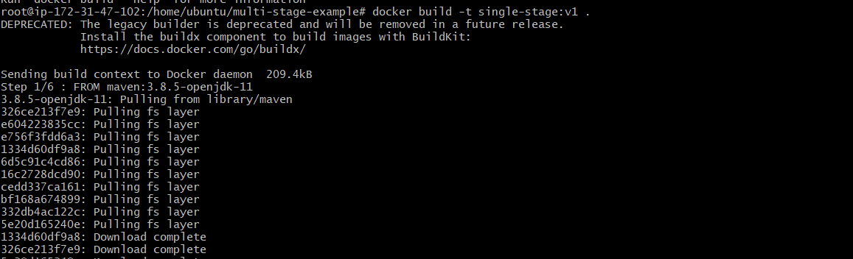
Successfully build
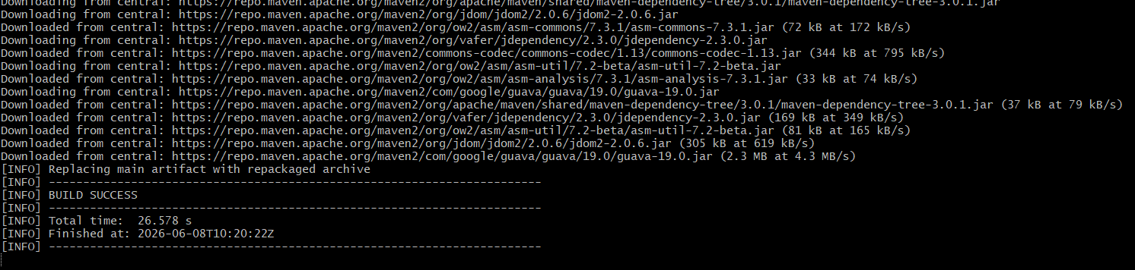
Check with docker images single stage docker exist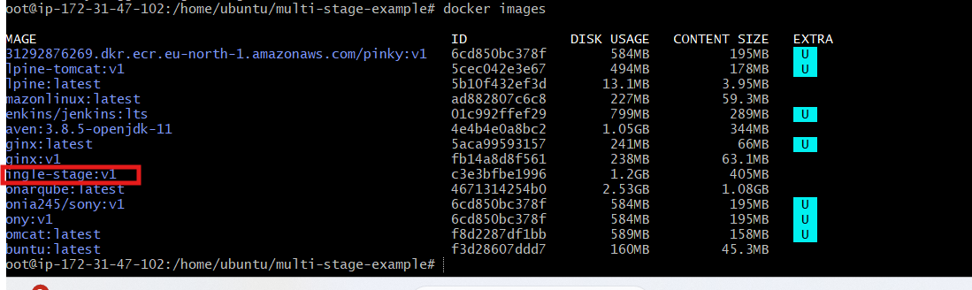
Run container with new port no 8089
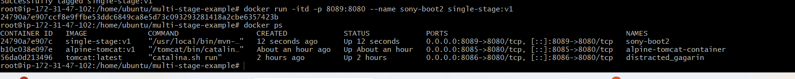
Verify the port number
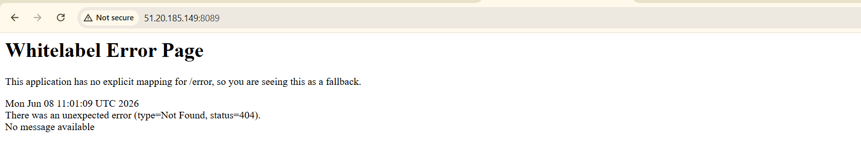
Create multistage docker file
And type the below script
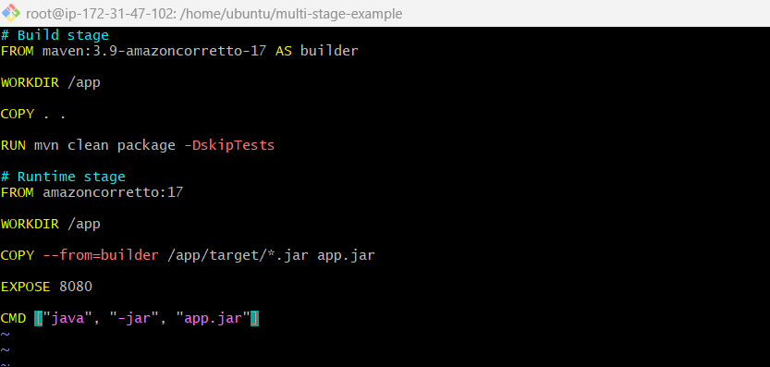
Build it with command
Docker build -t multistage:v1
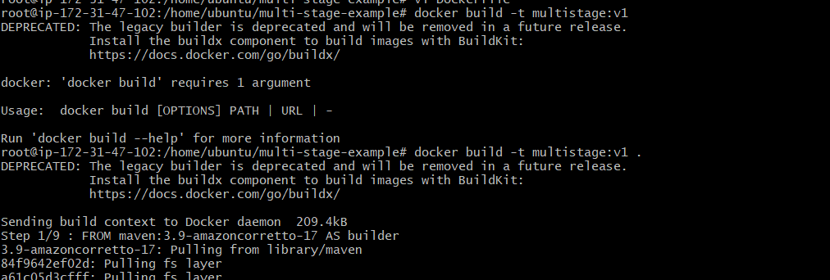
Build successfully
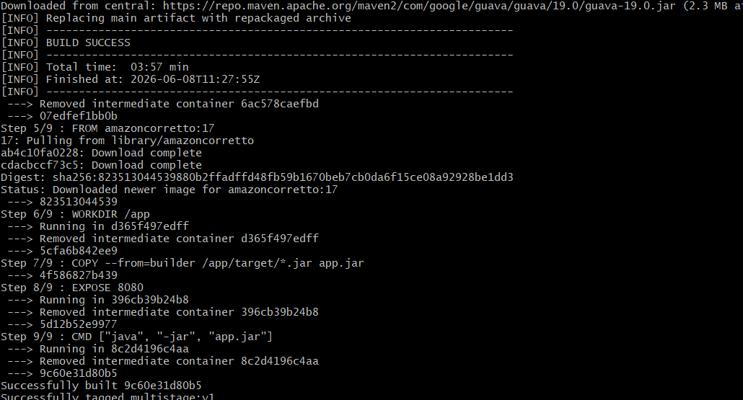
Run the container
Docker run -itd -p 8088:8080 sony:boot multistage:v1
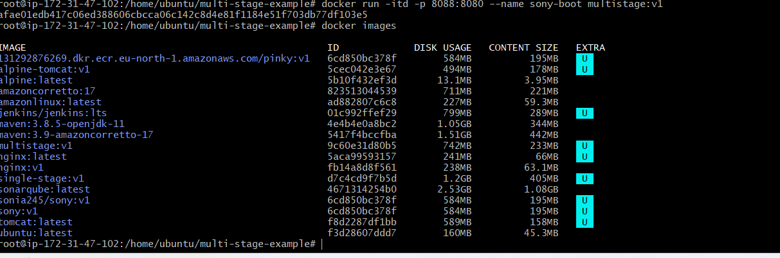
Verify the browser
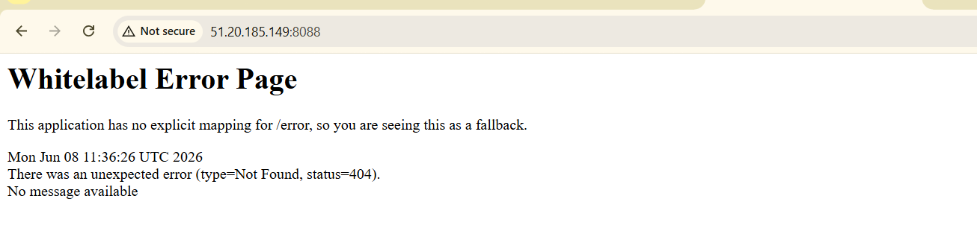

- Install docker compose and execute sample application.
Update Packages apt update
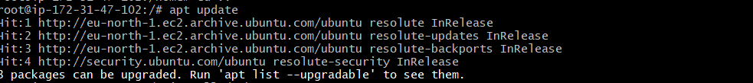
install Docker compose
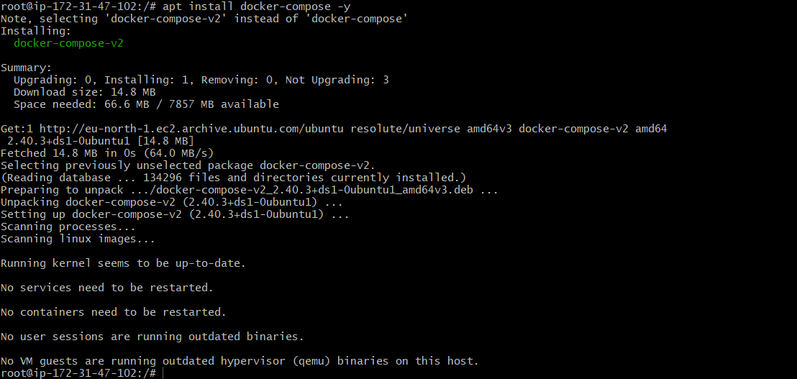
Verify Installation and Create Docker compose project
Create docker-compose.yml and written script
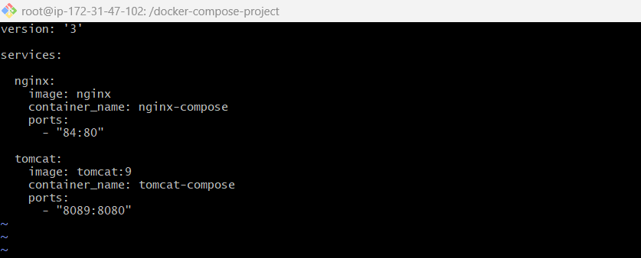
Start Compose
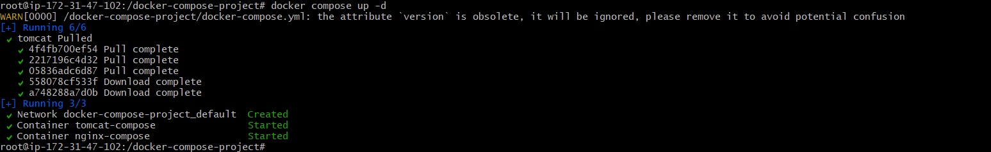
Verify Containers
Verify the nignx is run
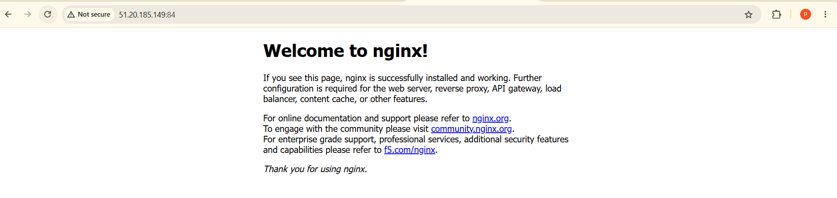
Successfully tomcat run
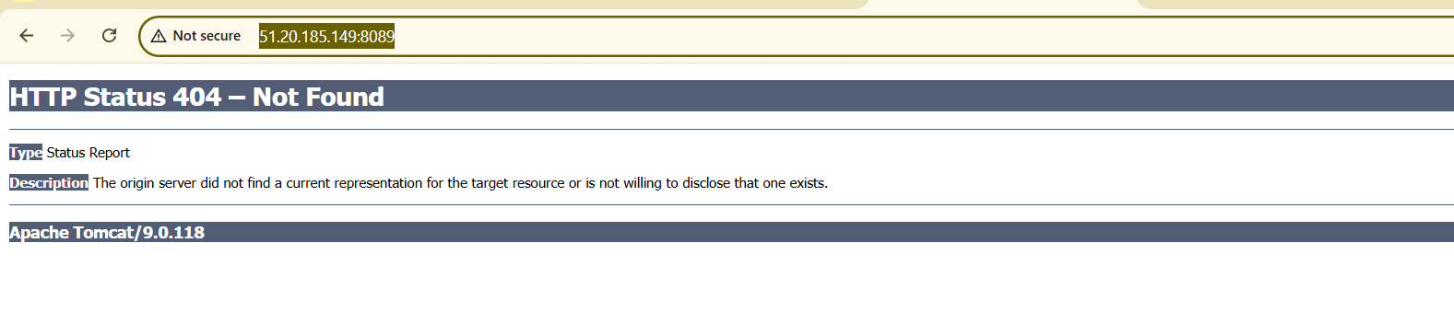

- Implement solution to scan images when pushed to docker registry.
First Ligin in to docke
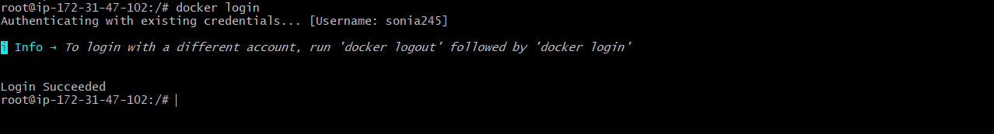
Docker tag sony:v1 sonia245/sony:v1
Docker images | grep sony
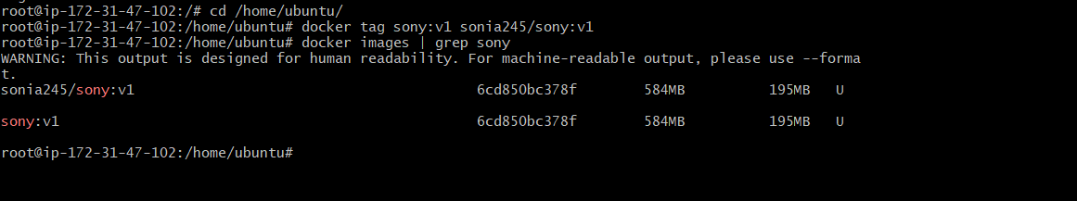
Docker tag sony:v1 sonia245/sony:v2
Docker images | grep sony
To push the image
Docker push sonia245/sony:v2
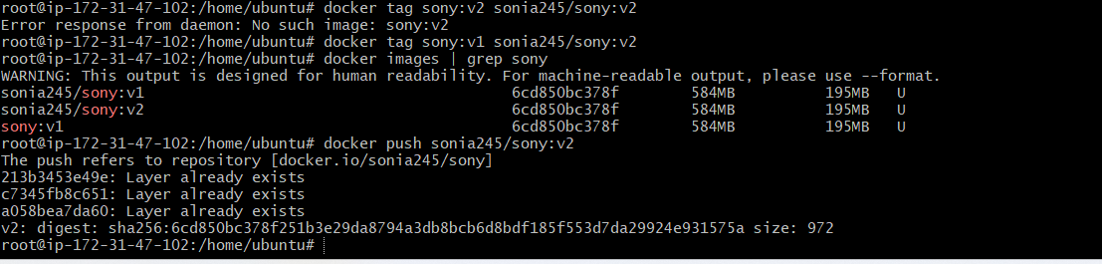
Login to docker hub
Click on sony we can display the pushed images
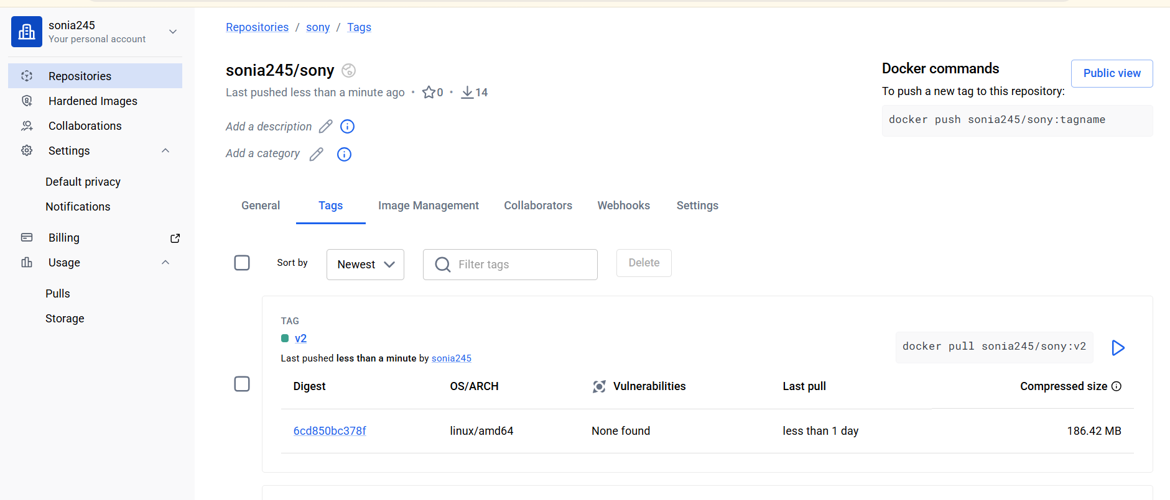

- Implement solution to scan images when pushed to AWS ECR.
First go to ecr -->feature & settings-->click on scannig-->scan on push filter give *-->click add build-->
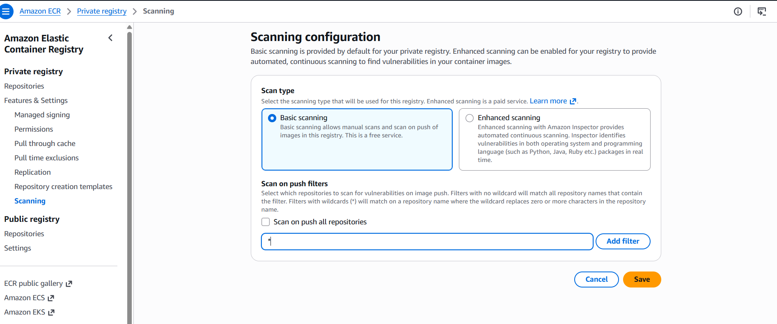
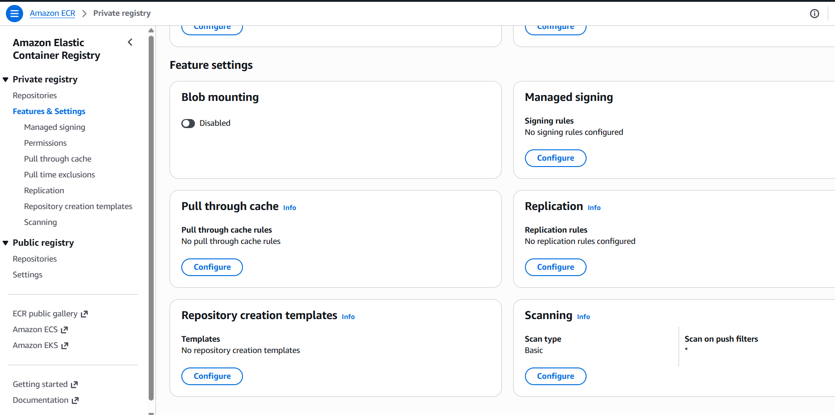
Create a repo
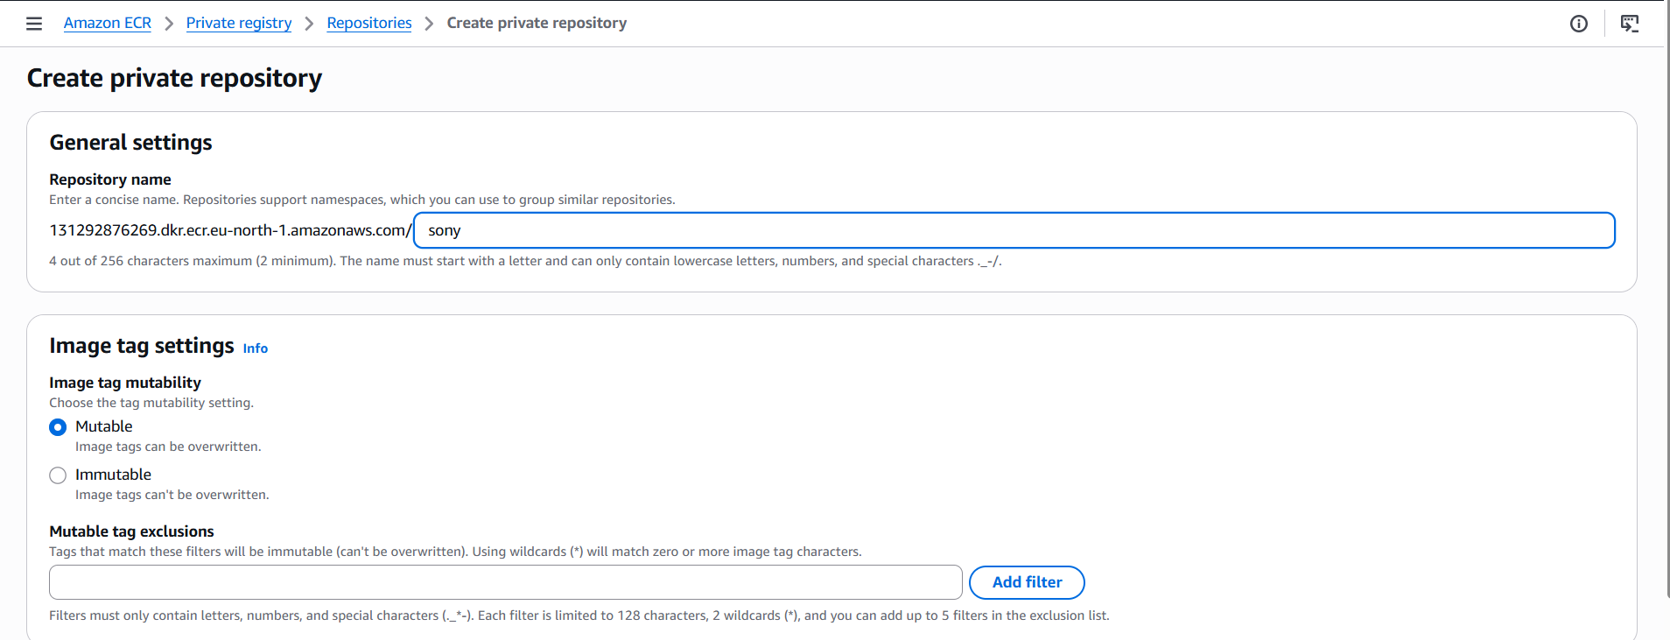
aws ecr get-login-password --region us-east-1 |
docker login --username AWS --password-stdin131292876269.dkr.ecr.eu-north-
1.amazonaws.com/nginx-scan-test
aws ecr describe-repositories --repository-names nginx-scan-test --region eu-north-1
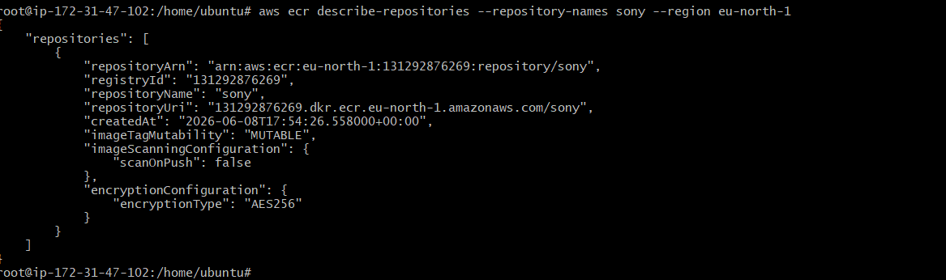
Docker tag sony:v1 131292876269.dkr.ecr.eu-north-1.amazonaws.com/sony:v1
Docker push 131292876269.dkr.ecr.eu-north-1.amazonaws.com/sony:v1

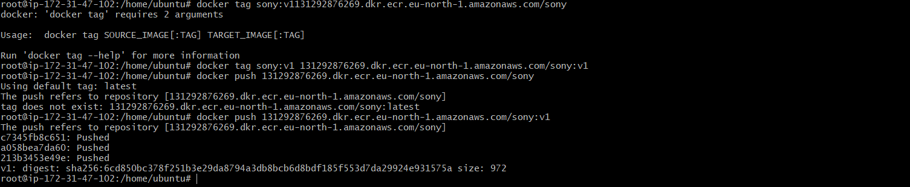
Amazon ECR → Repositories → sony →Images → latest → Scan Findings
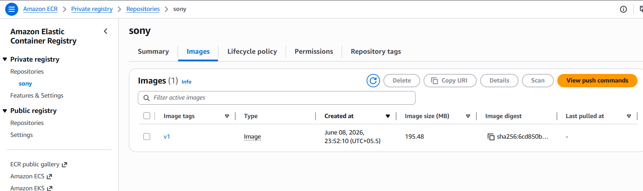
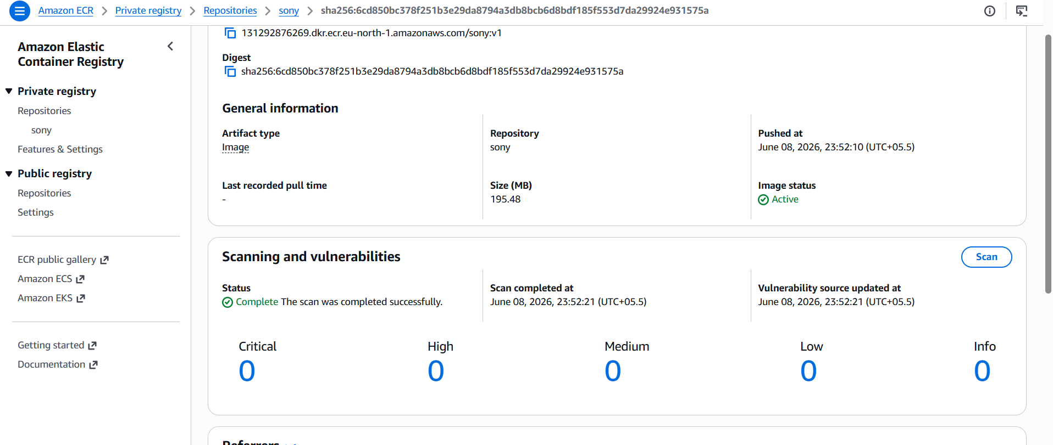
- Create a Jenkins pipeline to create a docker image and push the image to Docker hub.

So First Lets pull jenkins
docker run -d \
--name jenkins-server \
--restart unless-stopped \
-p 9090:8080 \
-p 50000:50000 \
-v jenkins_home:/var/jenkins_home \
-v /var/run/docker.sock:/var/run/docker.sock \
-u root \
jenkins/jenkins:lts
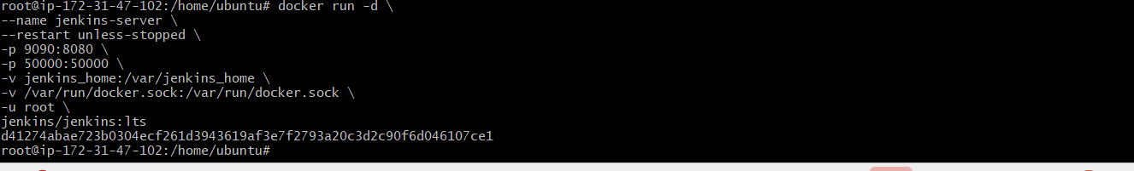
docker start jenkins-server
docker exec -it jenkins-server cat
/var/jenkins_home/secrets/initialAdminPassword
Install both Docker and docker pipeline

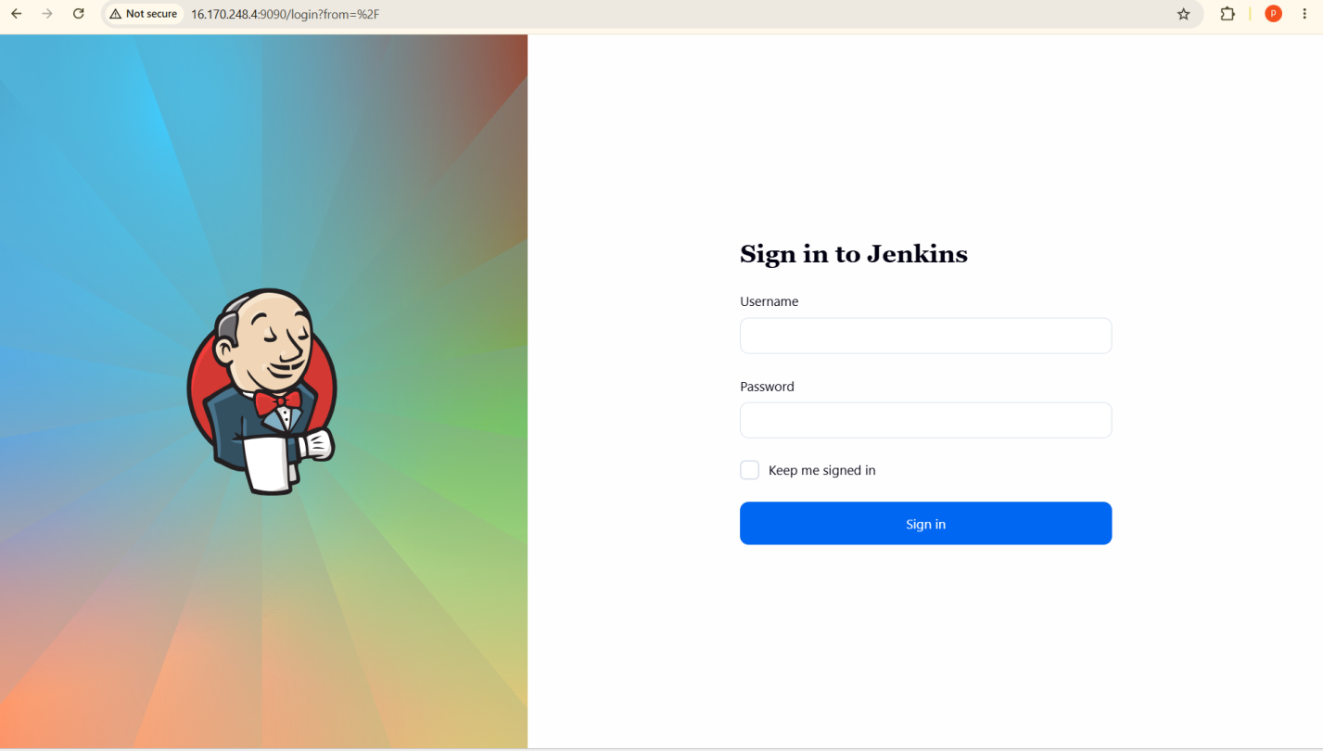
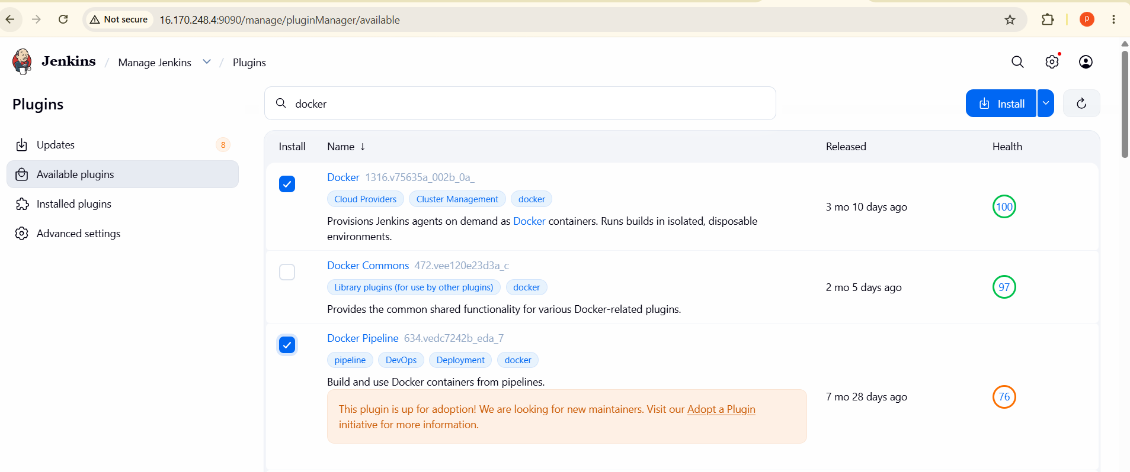
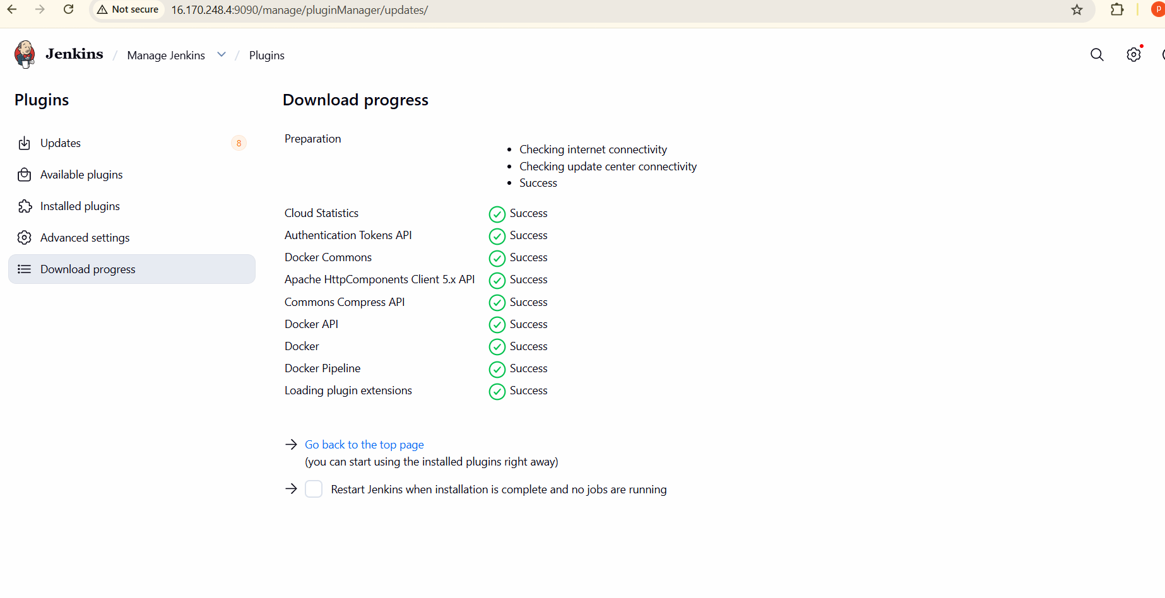
Add Docker Hub Credentials
Manage Jenkins → Credentials → System → Global Credentials → Add
Credentials

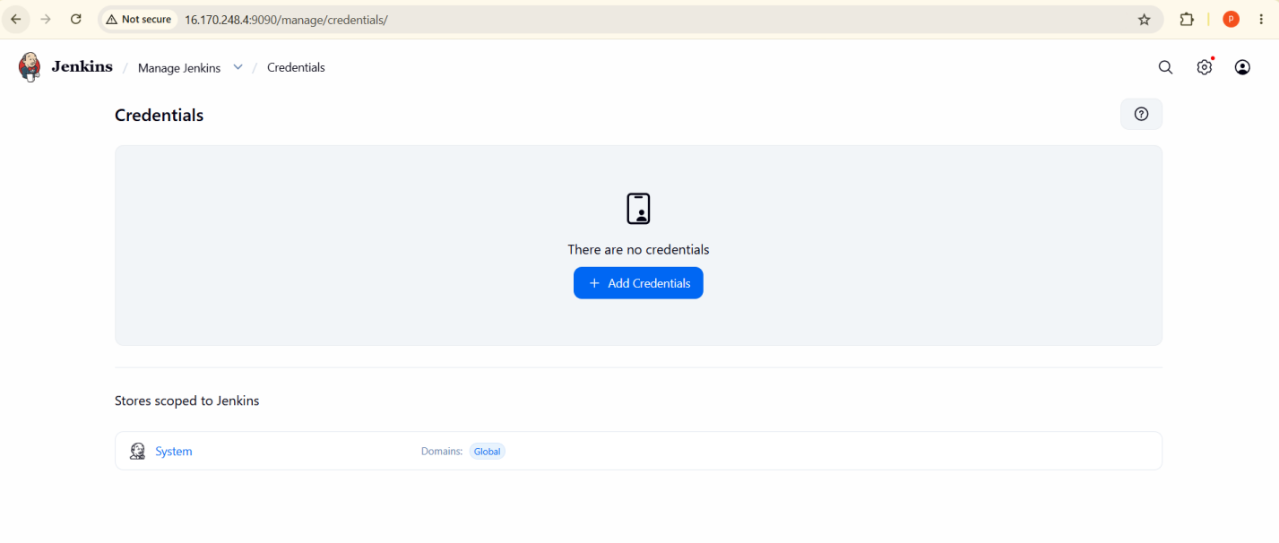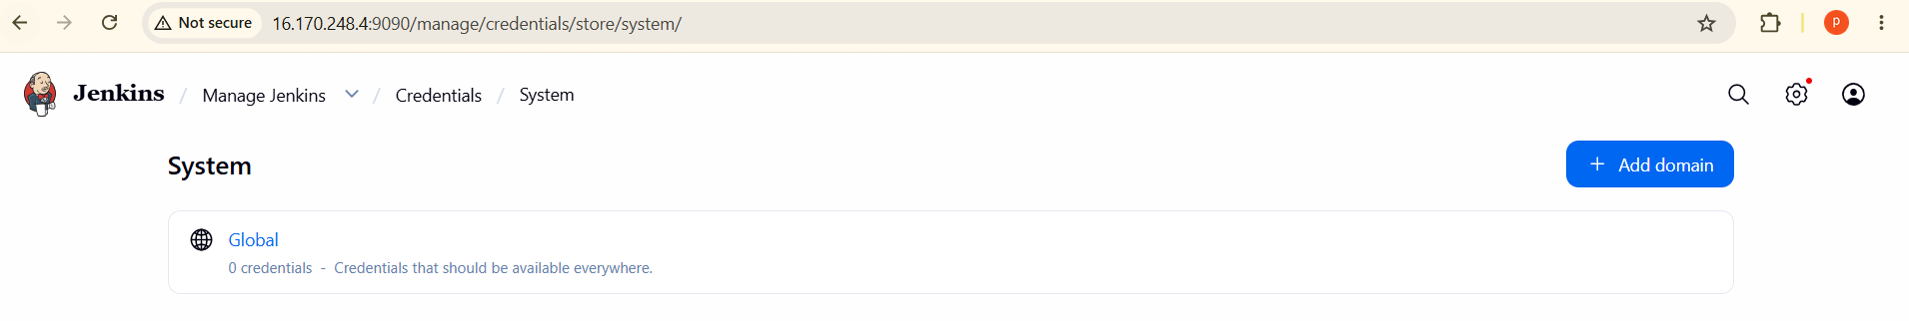
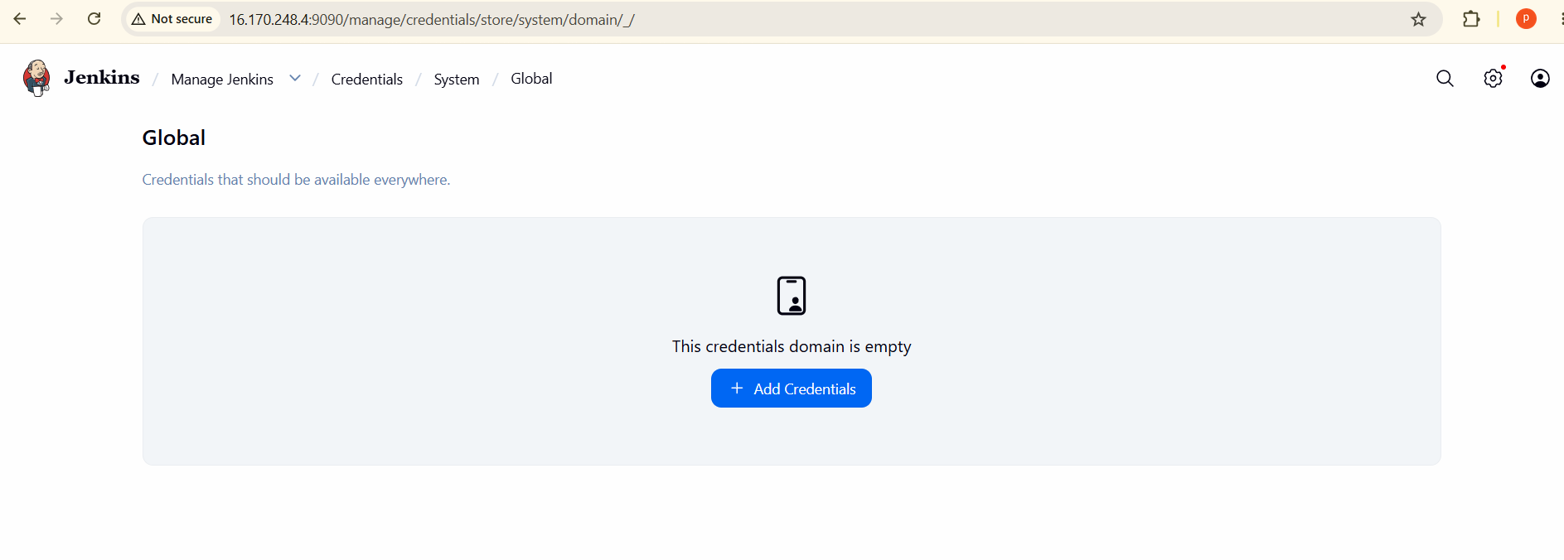
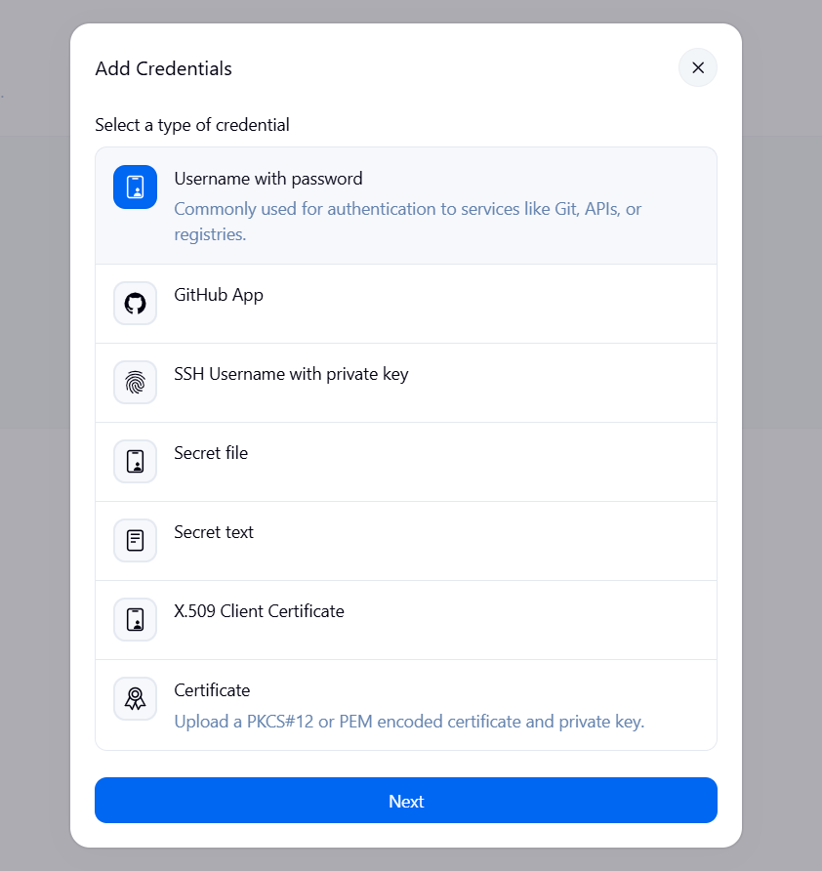
- We have to created in dockerhub personal acces tokens and genearate that token copy that password add that password.
- Go to docker hub -->settings-->personal access token-->give name--> access permission--> read,write,delete-->genarete

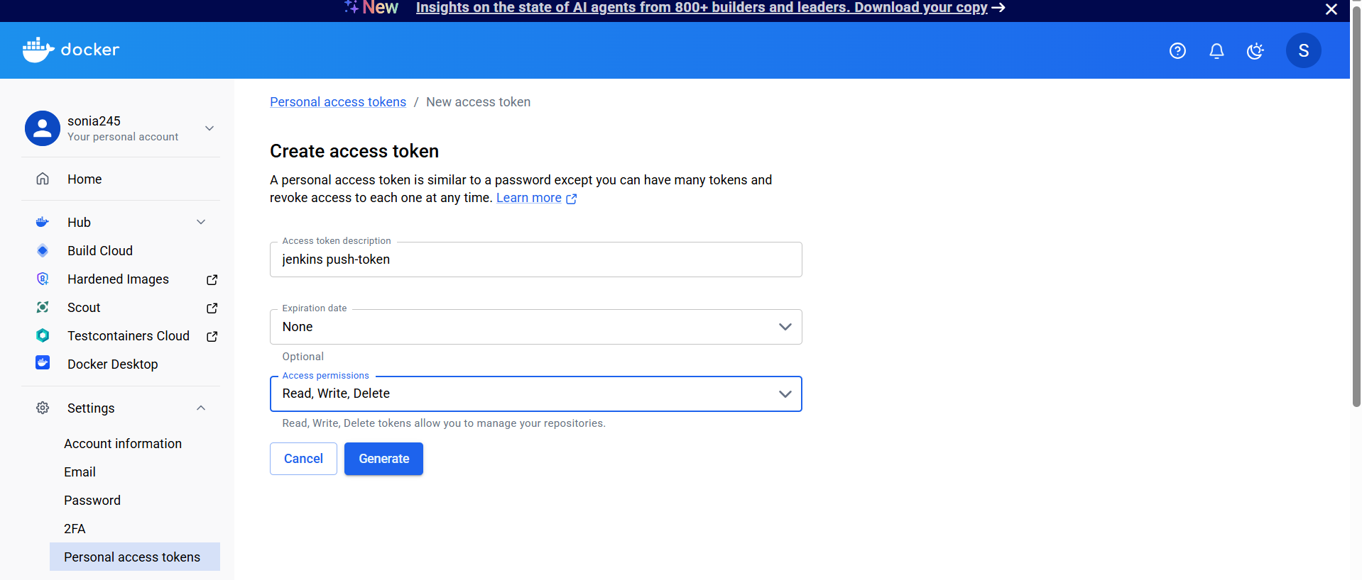
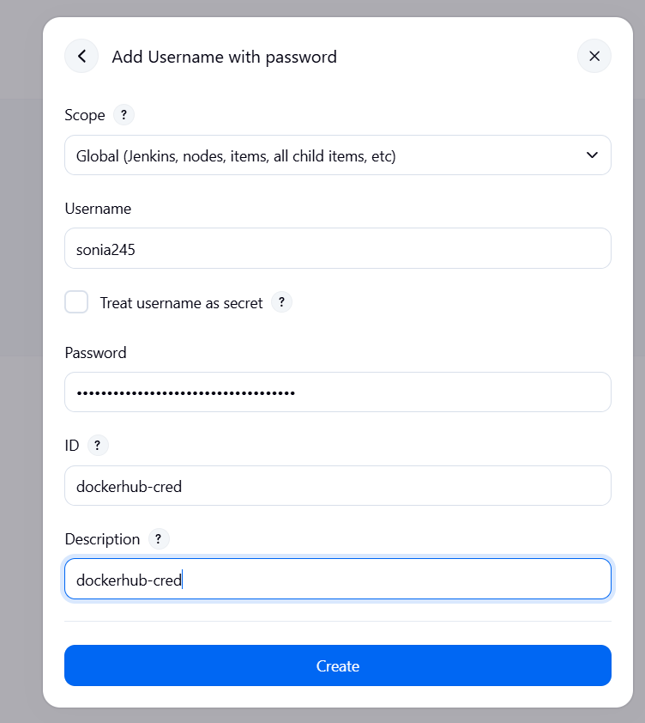
Create Pipeline Job

New Item → Pipeline → Enter Job Name →
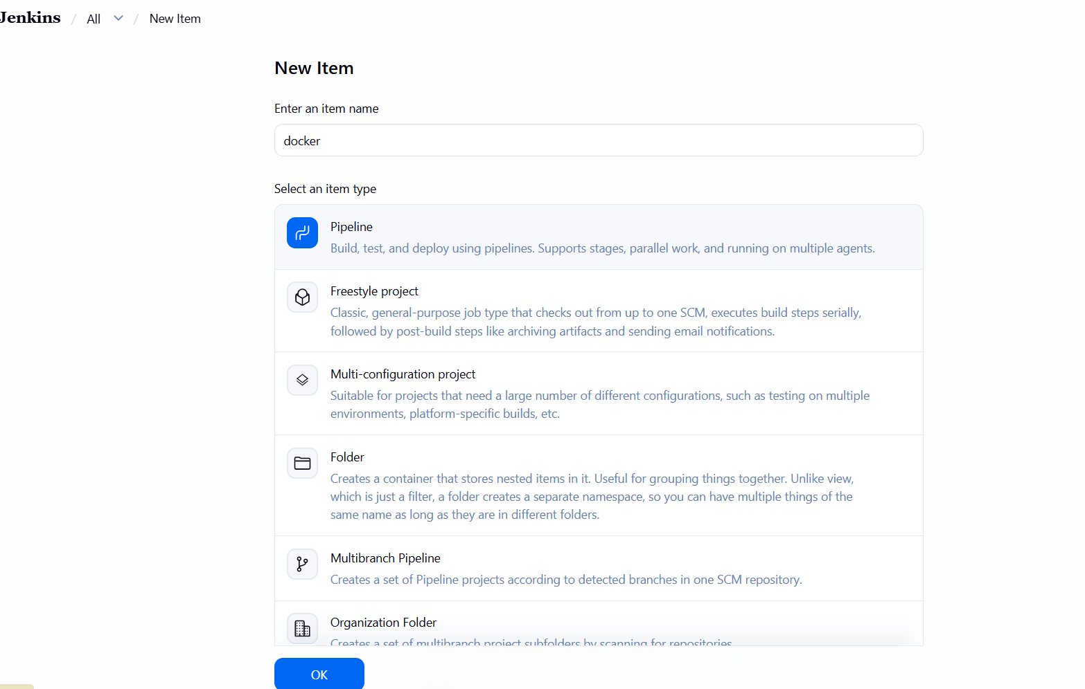
pipeline {
agent any

environment {
DOCKER_IMAGE = "sonia245/sony:v2"
}

stages {

stage('Clone Code') {
steps {
git branch: 'master',
url: 'https://github.com/soniaaddabottu-123/multi-stage-example.git'
}
}

stage('Create Dockerfile') {
steps {
writeFile file: 'Dockerfile', text: '''
FROM maven:3.8.6-openjdk-8 AS builder

WORKDIR /app

COPY . .

RUN mvn clean package

FROM eclipse-temurin:8-jre

WORKDIR /app

COPY --from=builder /app/target/*.jar app.jar

EXPOSE 8080

ENTRYPOINT ["java","-jar","app.jar"]
'''
}
}

stage('Build Docker Image') {
steps {
sh "docker build -t ${DOCKER_IMAGE} ."
}
}

stage('Docker Hub Login') {
steps {
withCredentials([
usernamePassword(
credentialsId: 'dockerhub-cred',
usernameVariable: 'DOCKER_USER',
passwordVariable: 'DOCKER_PASS'
)
]) {
sh '''
echo $DOCKER_PASS | docker login -u $DOCKER_USER --password-stdin
'''
}
}
}

stage('Push Docker Image') {
steps {
sh "docker push ${DOCKER_IMAGE}"
}
}
}
}
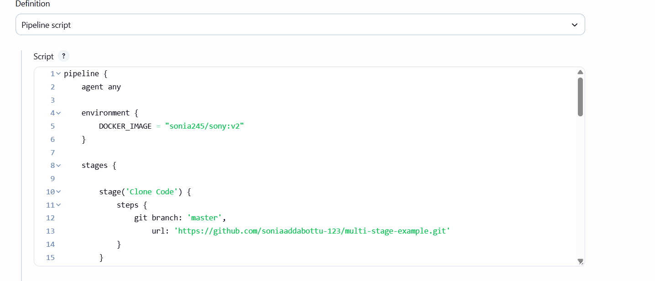
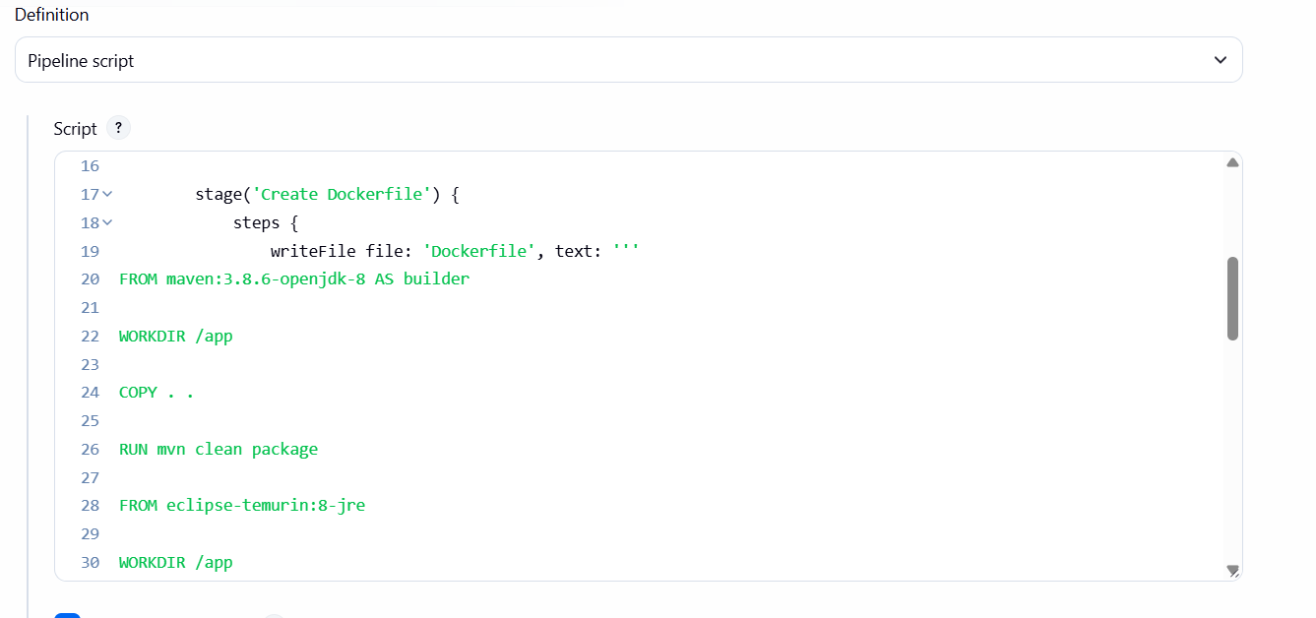
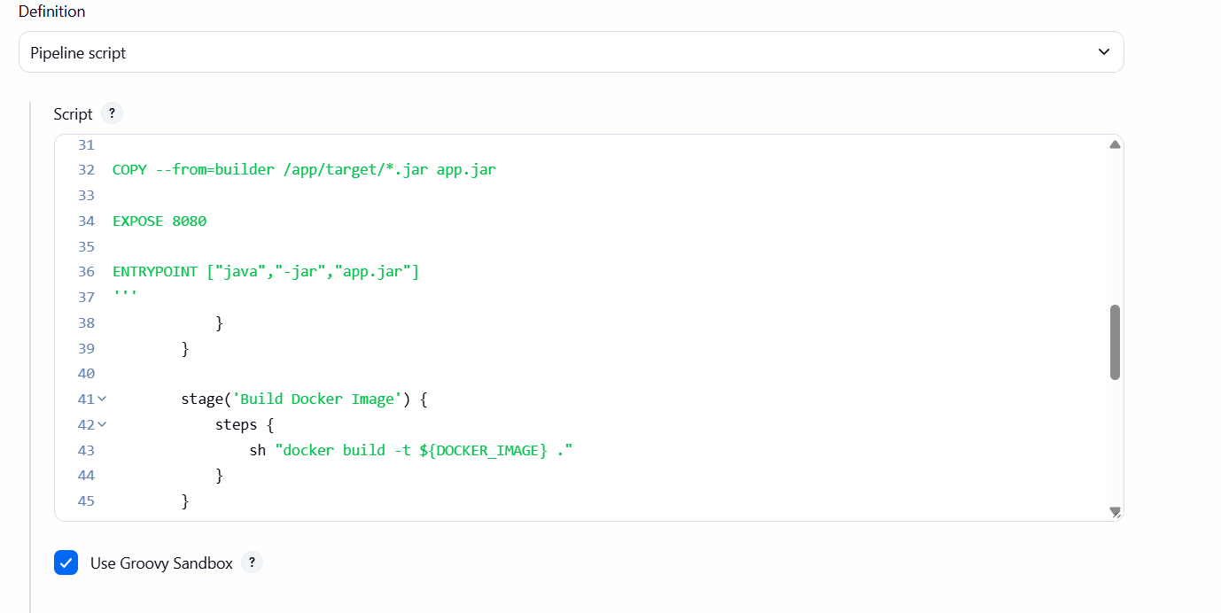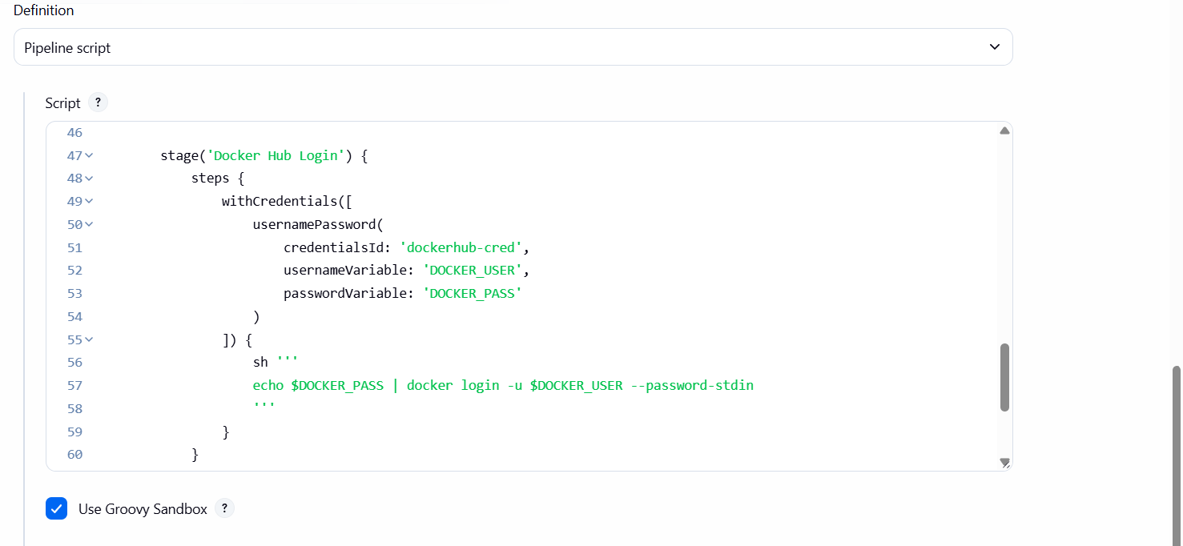
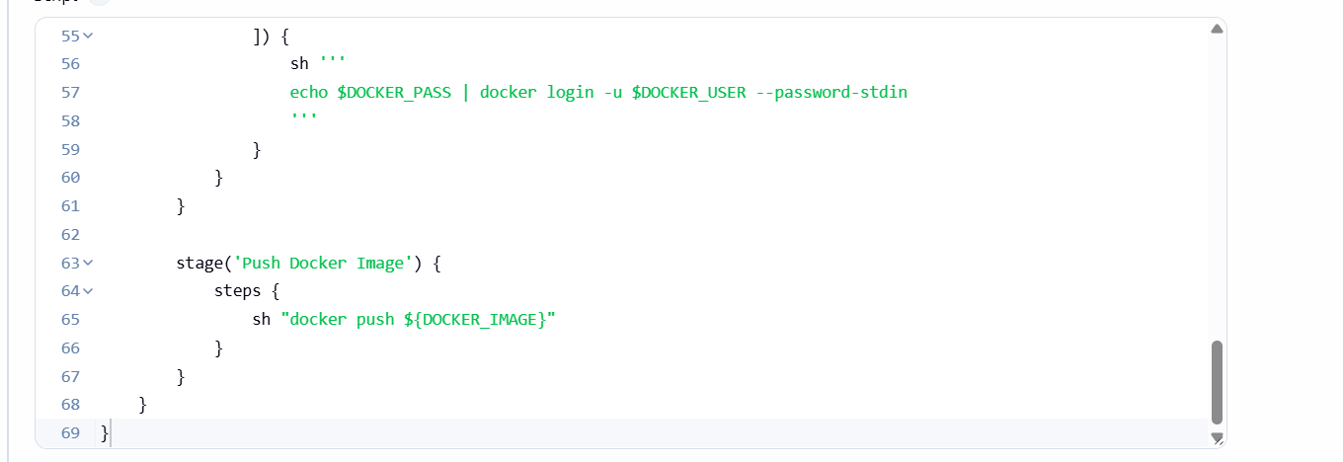
Write the script and save
Click on build now
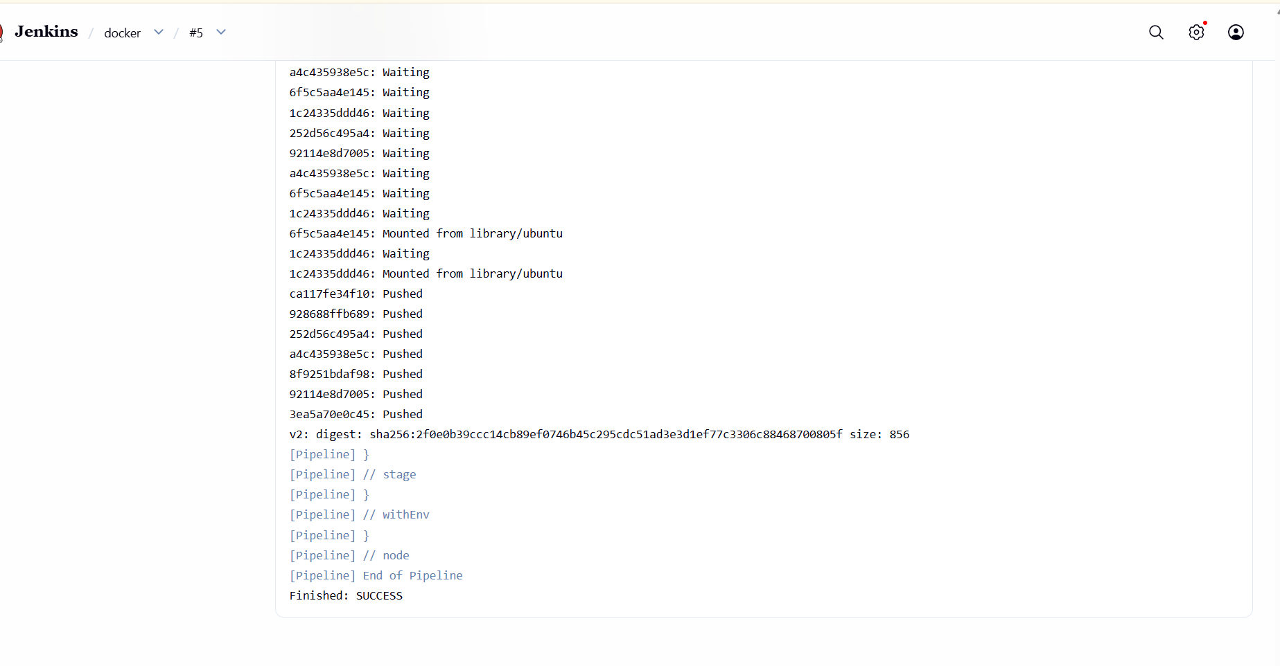
To verify the image go to docker hub and verify
The image was pulled successfully

