DOCKER-01
- Setup a virtual machine using Ubuntu image.
First go to console launch new instance
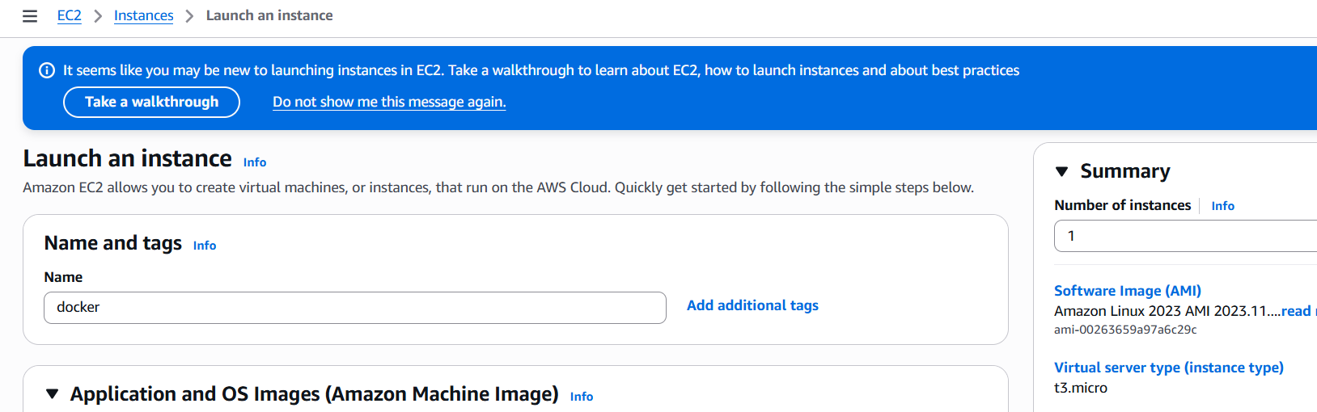
Select AMI as ubuntu
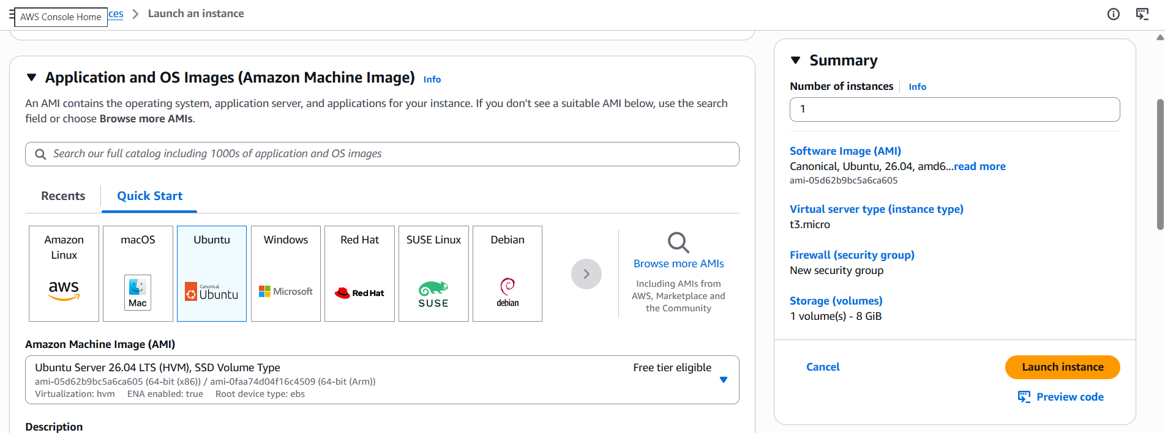
Choose instance type and key pair
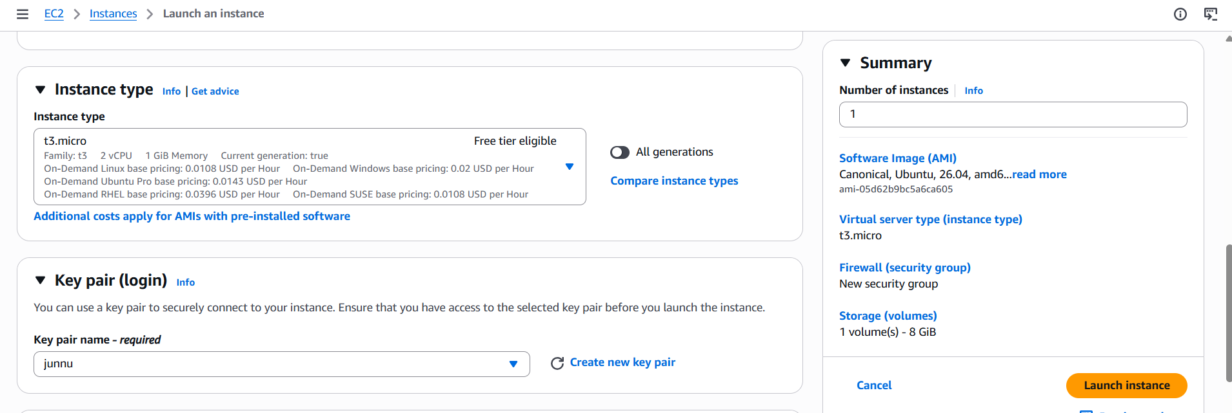
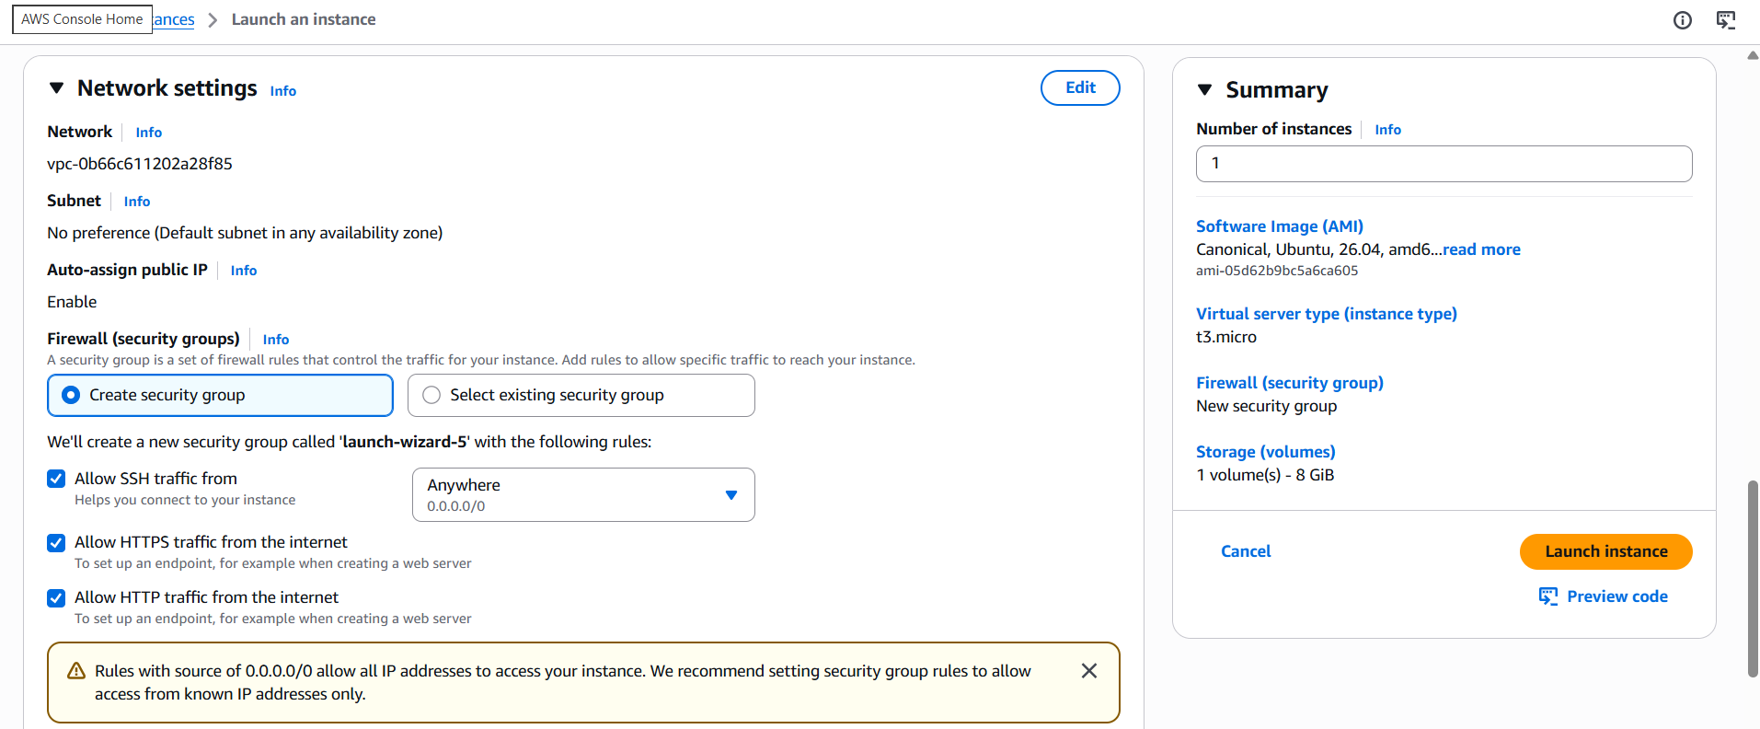
Give configure storage
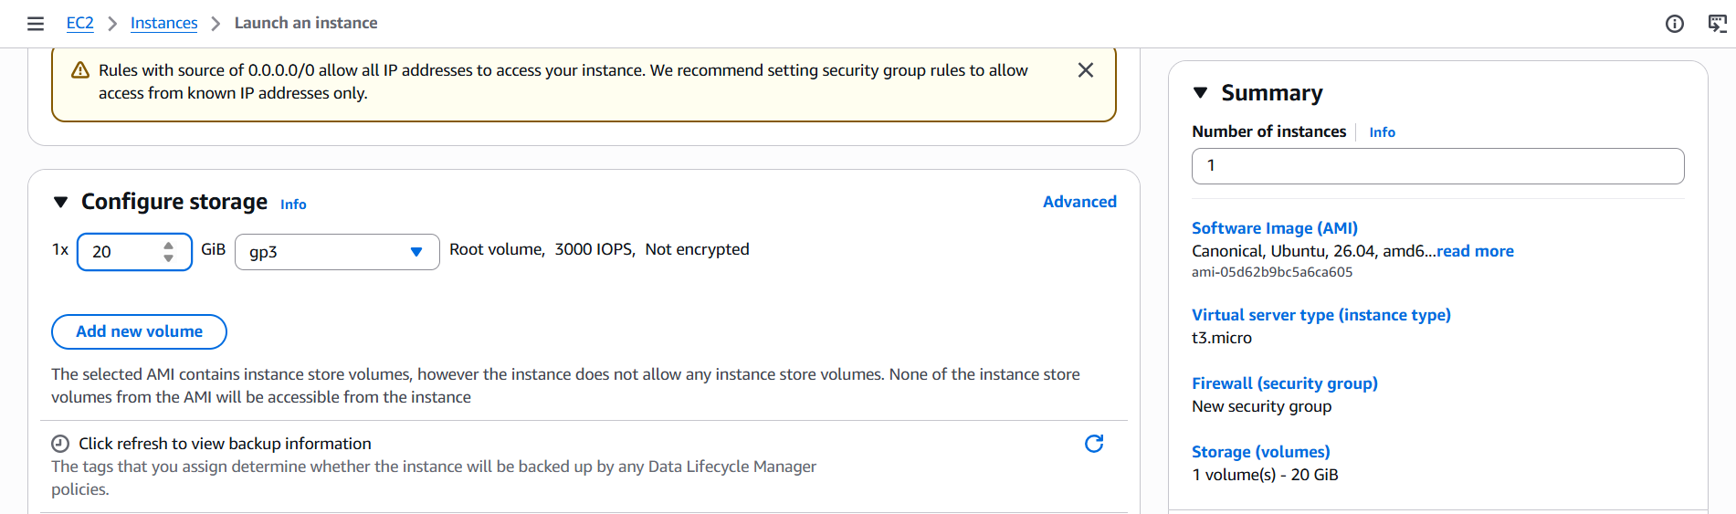
Sucsessfully launch instance
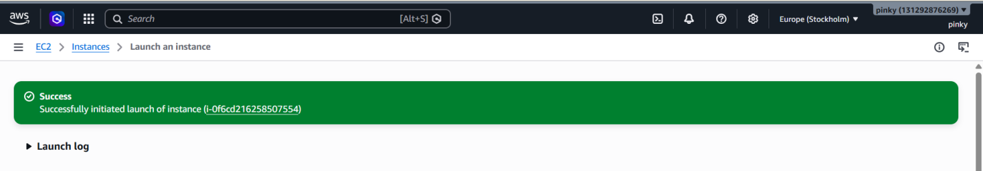
Connect to instance
Sudo apt update -y
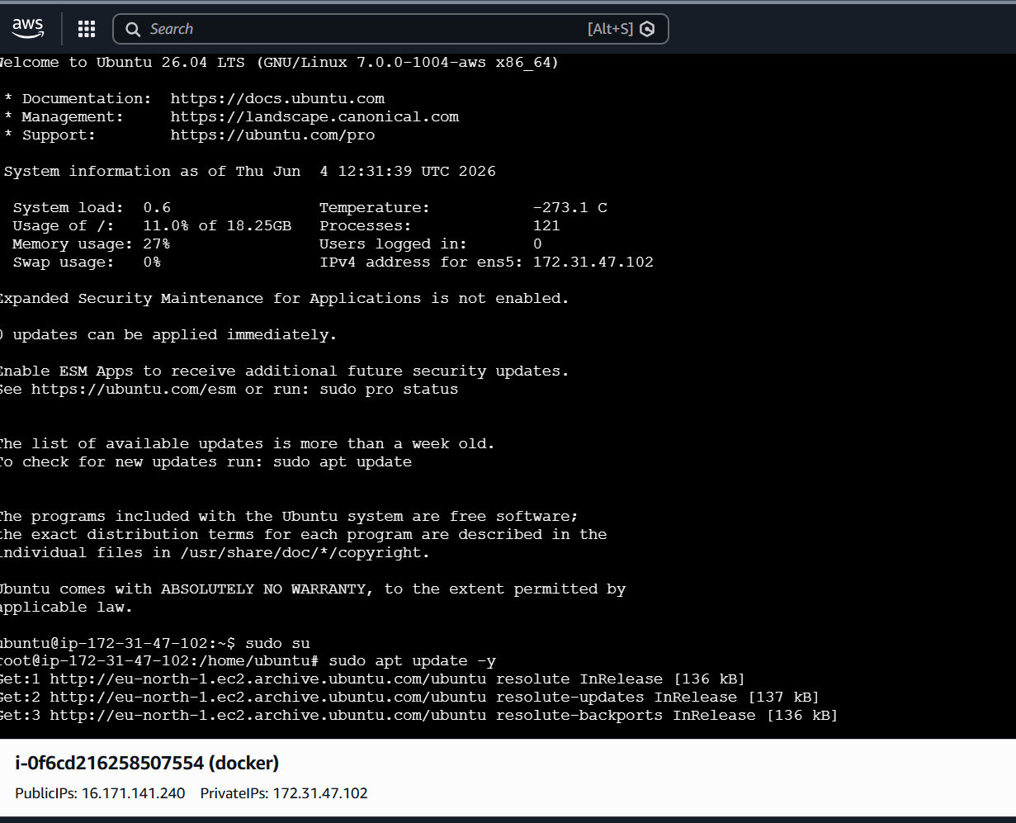
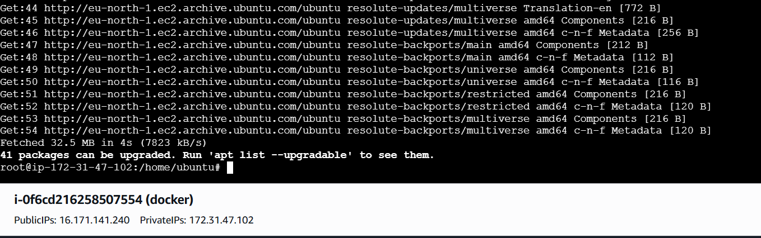
- Install docker on ec2.
Install docker on sever
Sudo pt install docker .io -y
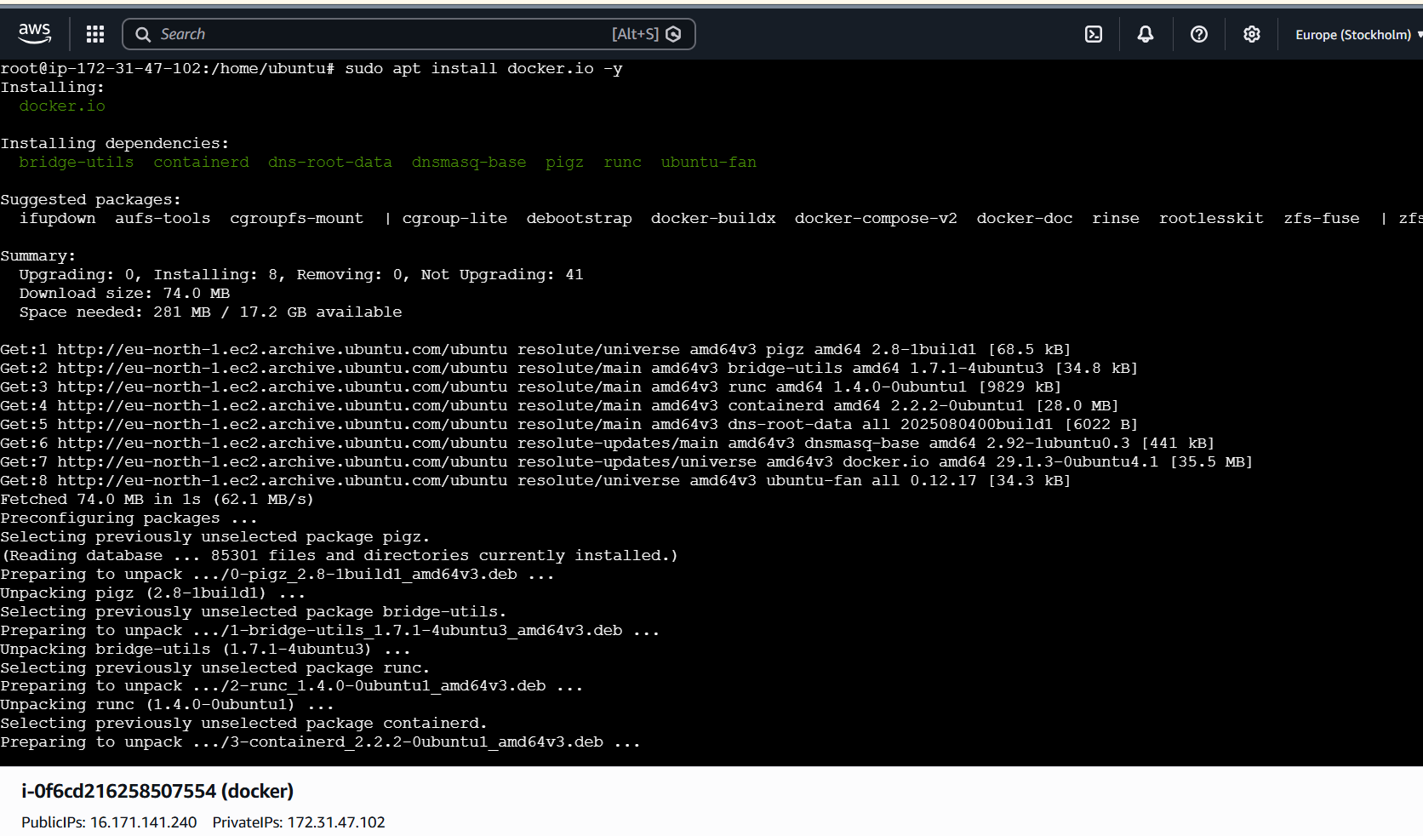
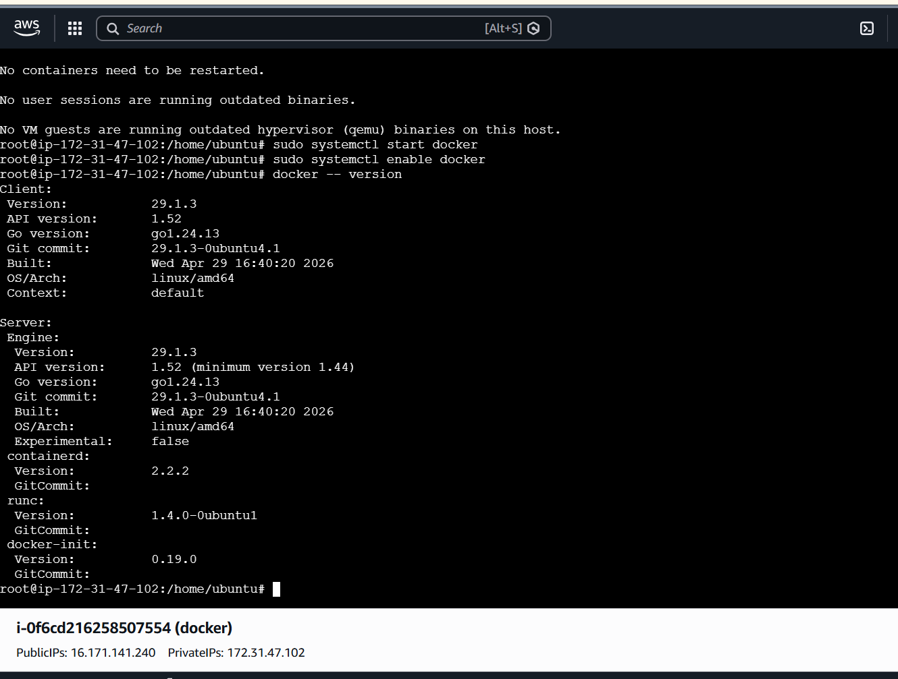

- Pull 5 docker images. (nginx, Apache tomcat, ubuntu, Jenkins, SonarQube)
To pull docker images
For nginx – docker pull nginx
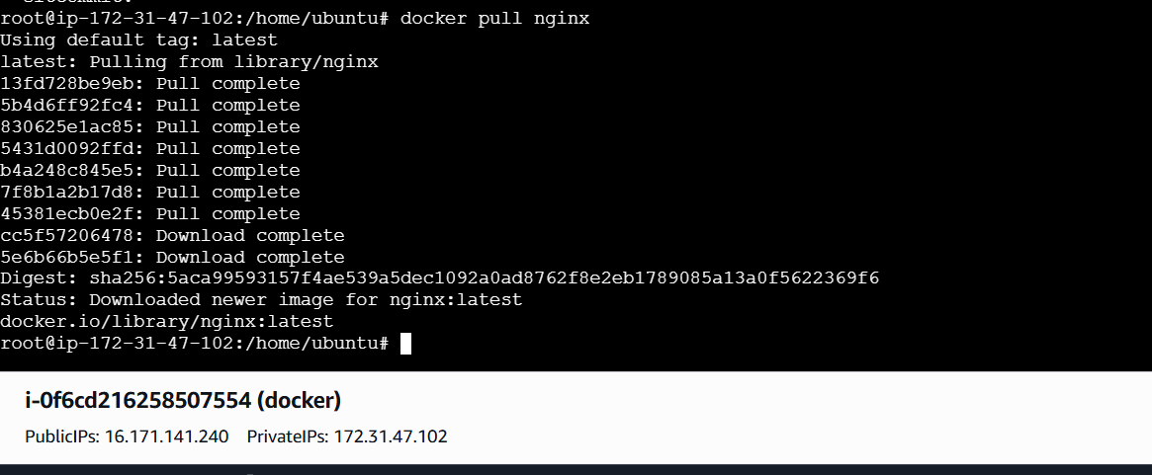
For tomcat – docker pull tomcat
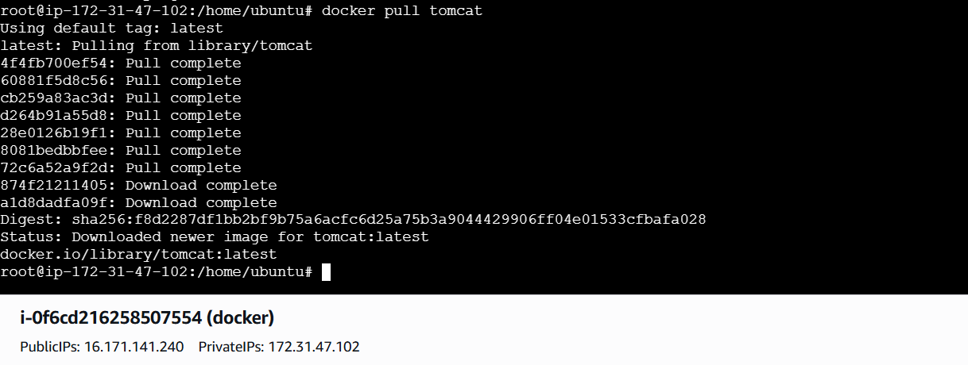
For ubuntu – docker pull ubuntu
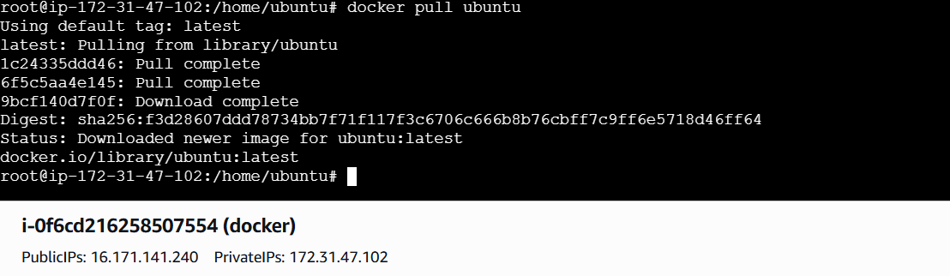
For Jenkins – docker pull jenikns/Jenkins:lts
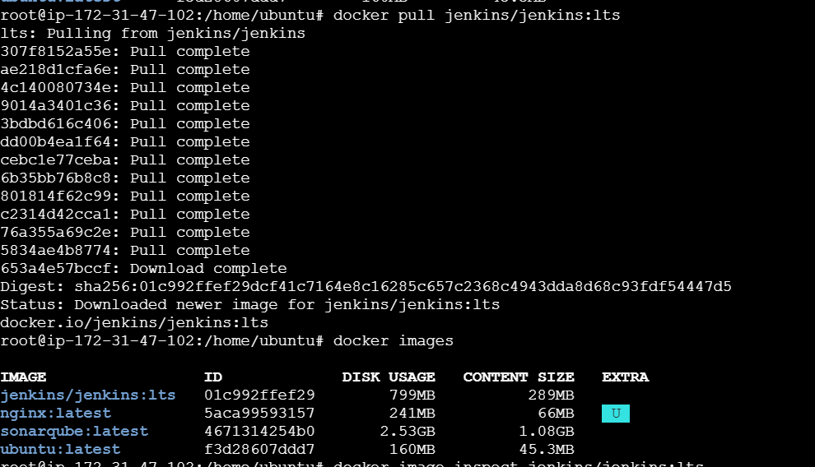
For sonarqube – docker pull sonarqube
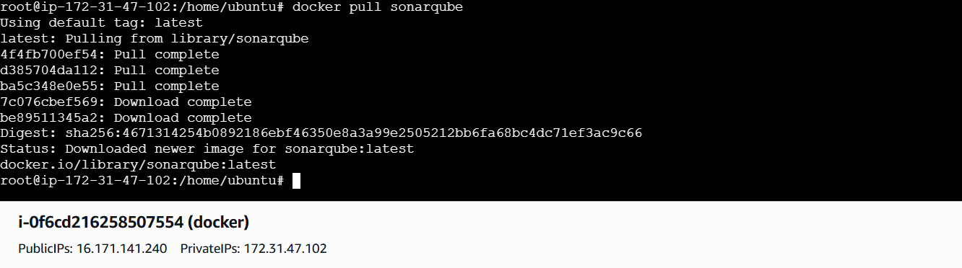
To verify
Docker images
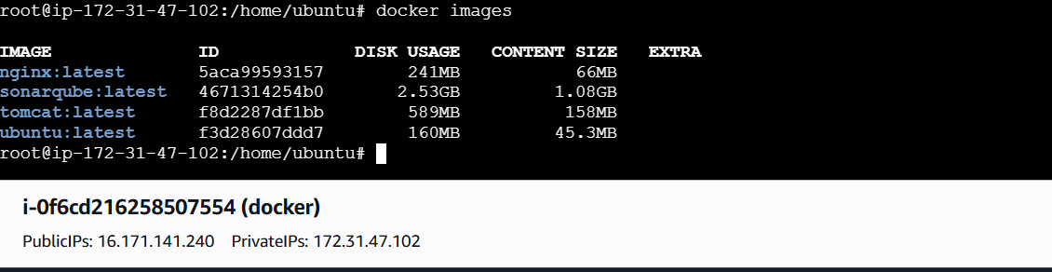

- Run nginx container and expose on port 81.
Run container
Docker run -d -name nginx-container -p 81:80 nginx
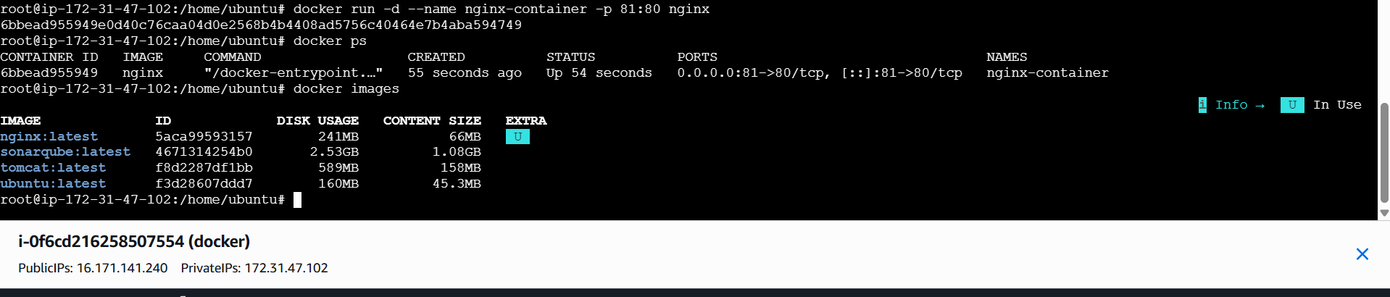
To verify browser and we are able to reach nginx page
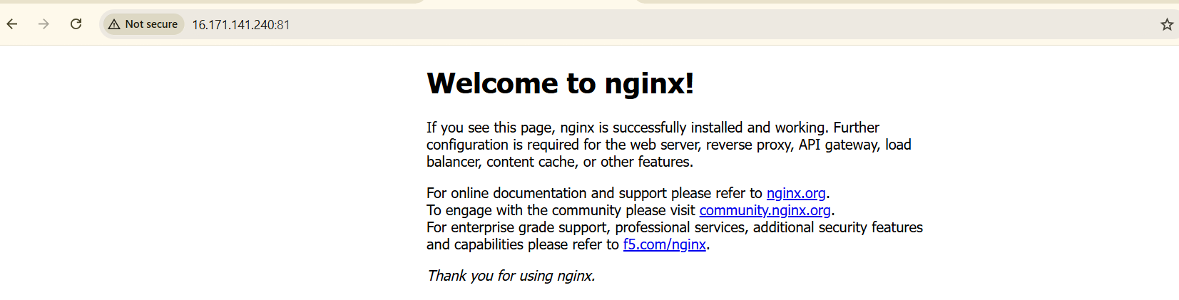
- Delete the Apache tomcat image from local.
First we can check docker images
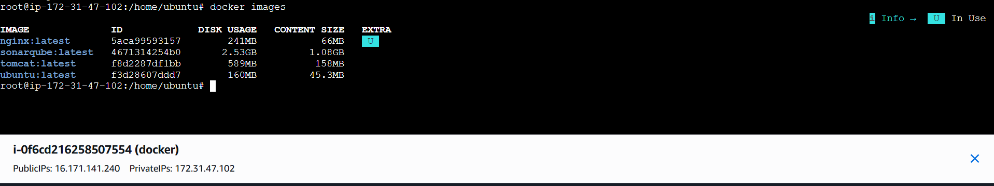
Delete tomcat image and verified
Dpcker rmi -f tomcat
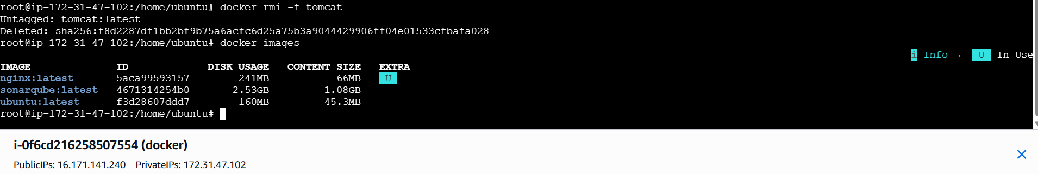

- Inspect the Jenkins image, SonarQube image.
Inspect Jenkins image
Docker image inspect Jenkins/Jenkins:lts
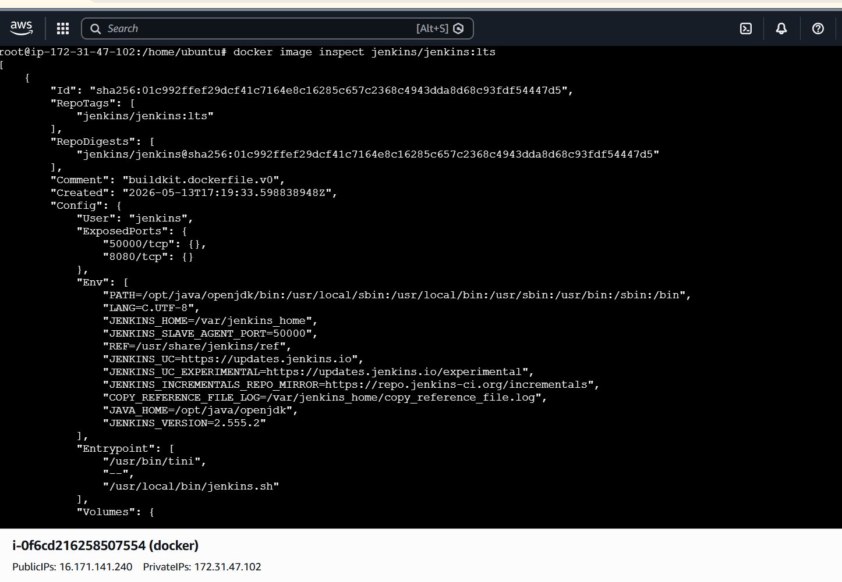
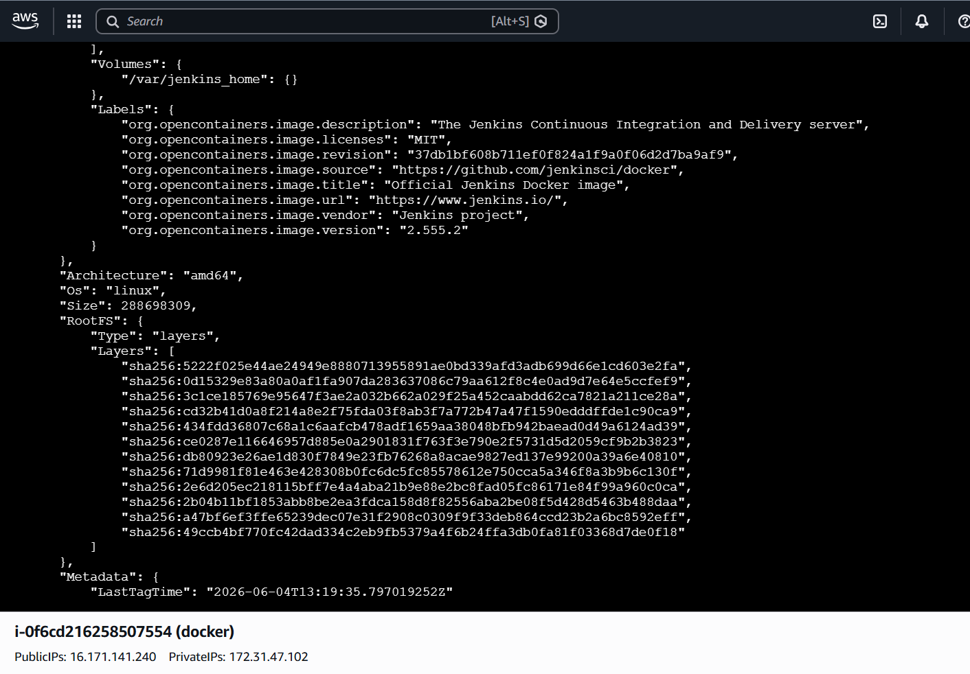
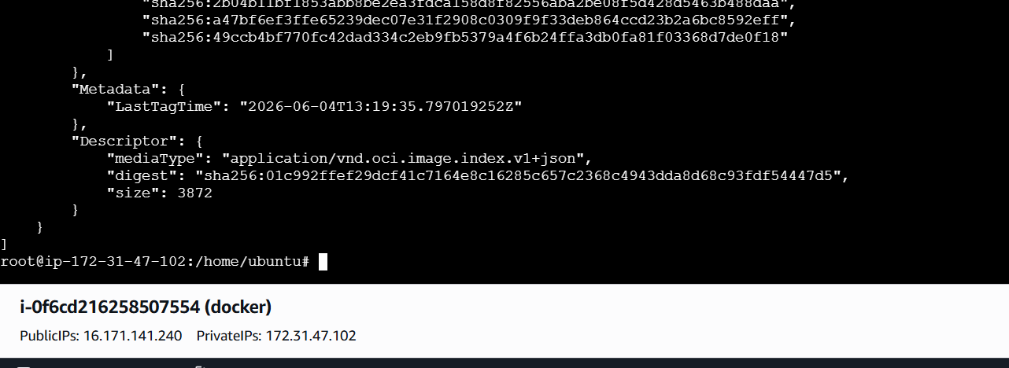
Inspect sonarqube image
Docker image inspect sonarqube
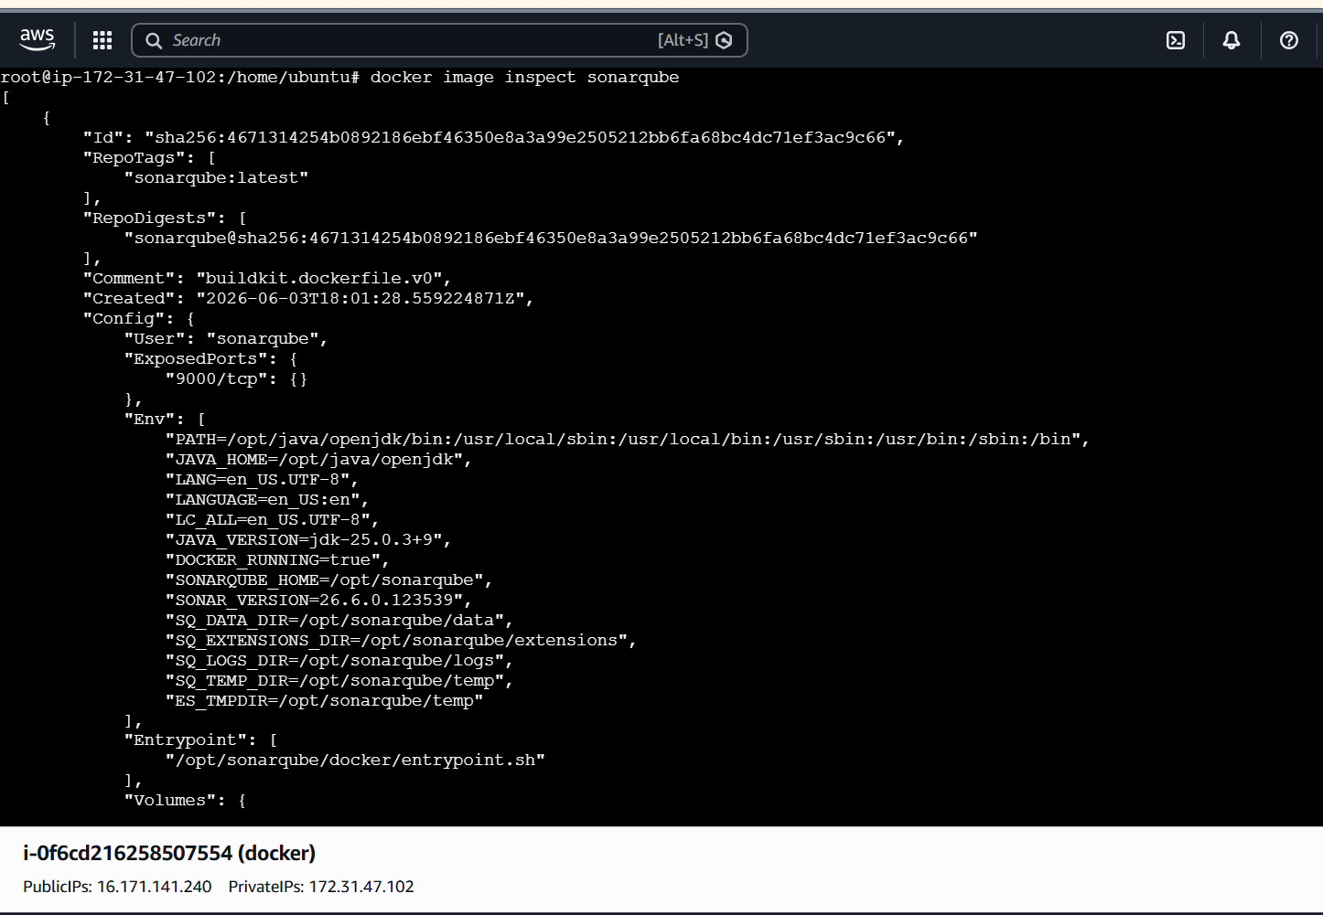
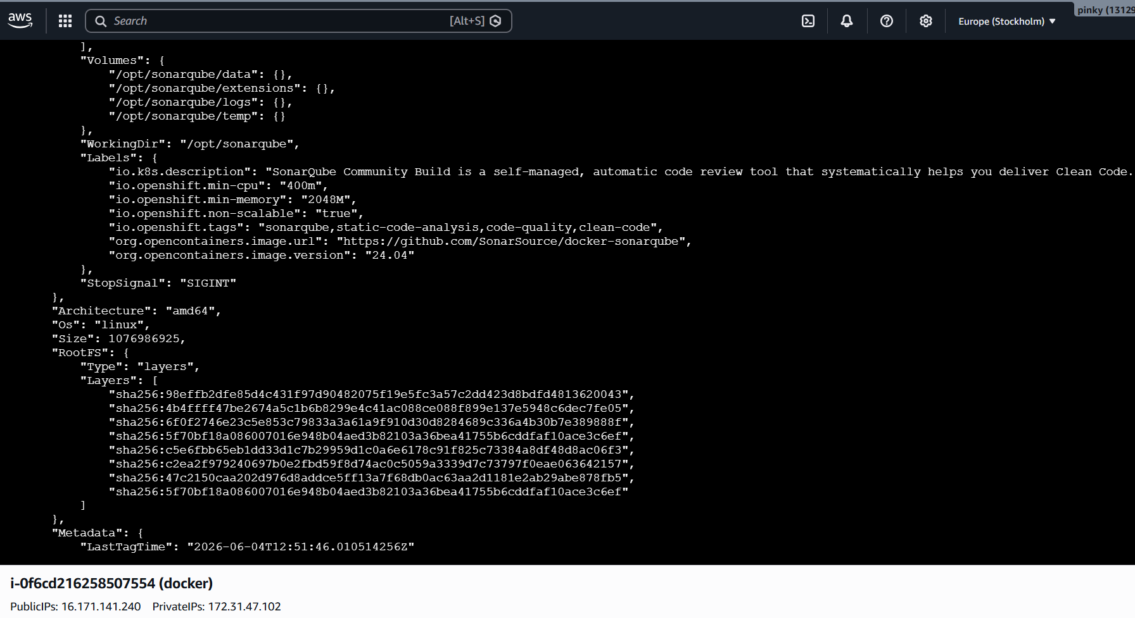
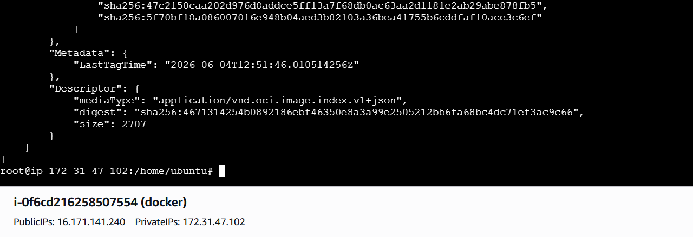

- Run Jenkins container and run one sample job.
Run Jenkins
Docker run -d \
-name Jenkins-container\
-p 8080:8080\
-p 50000:50000\
Jenkins/Jenkins:lts

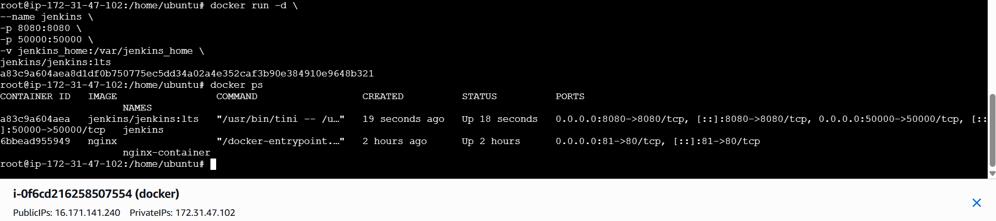
Access jenkins
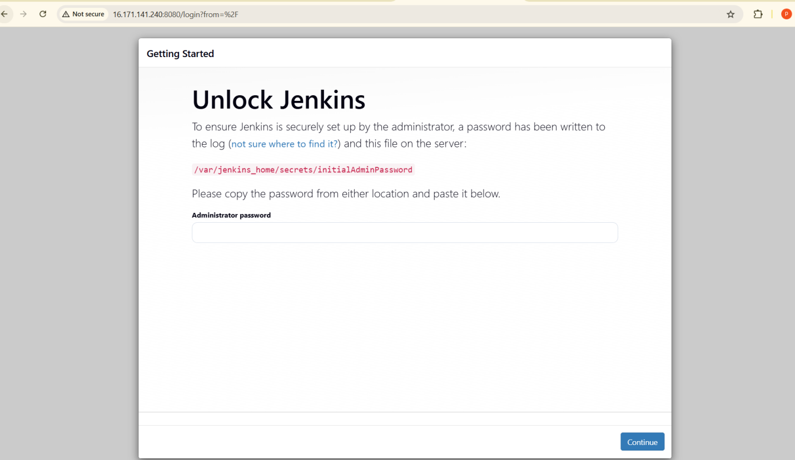
To get Jenkins initial password
Docker exec jankins-container cat/var/Jenkins_home/secrets/initialsAdminPassword

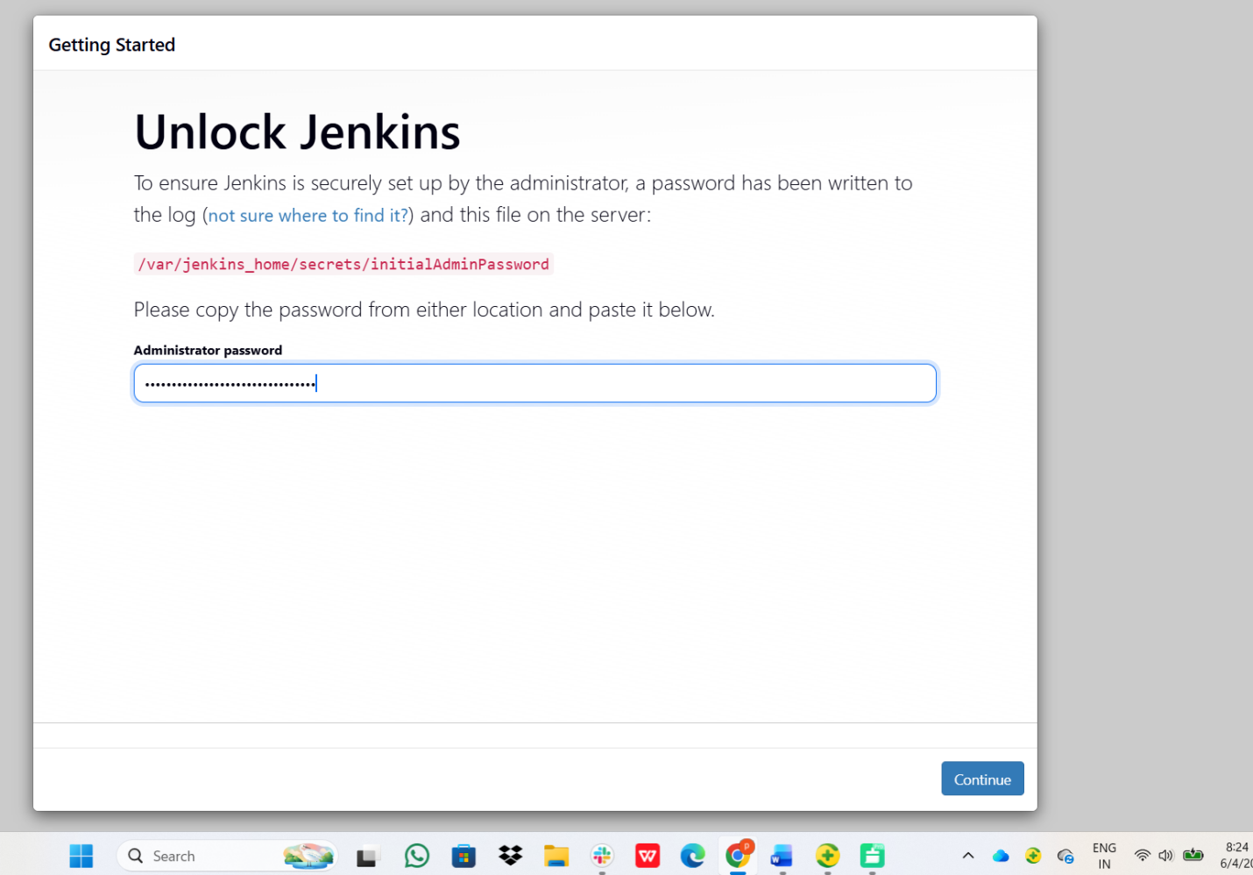
Click on Install suggested plugins
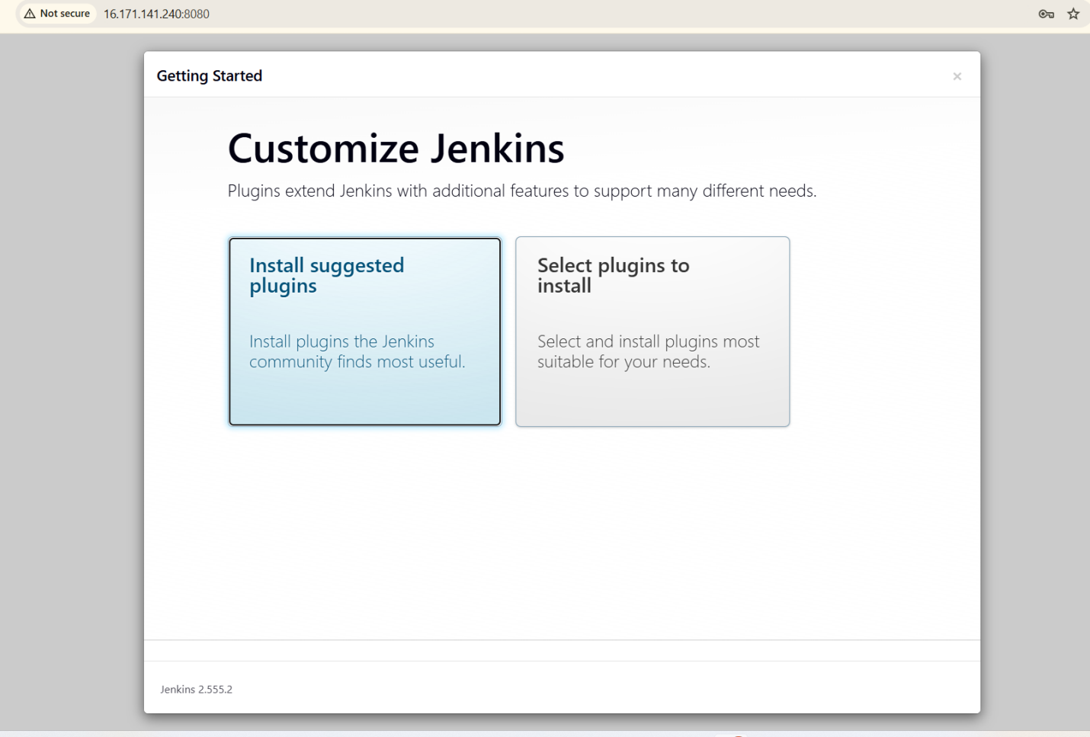
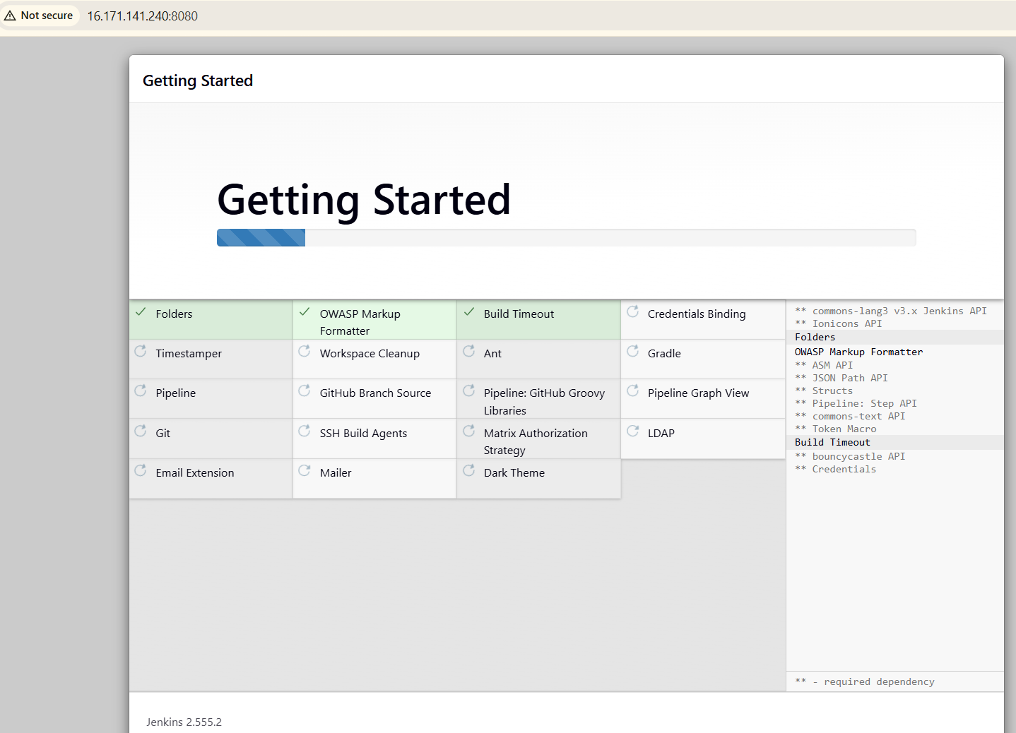
Create user and password
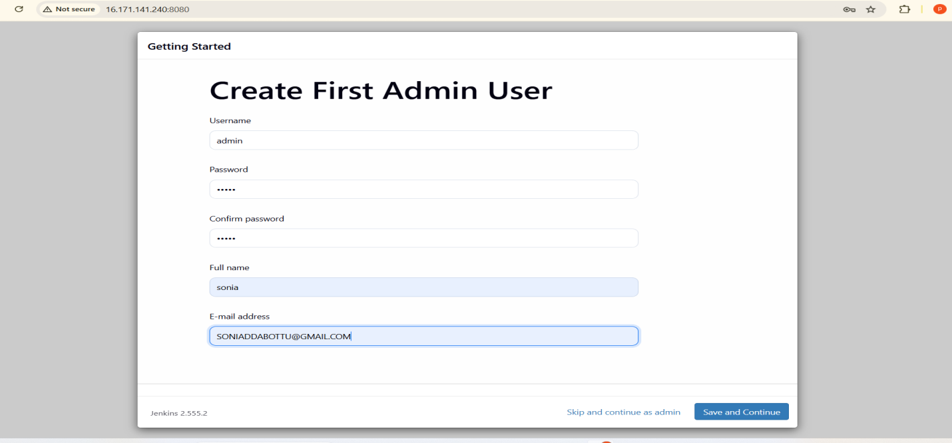
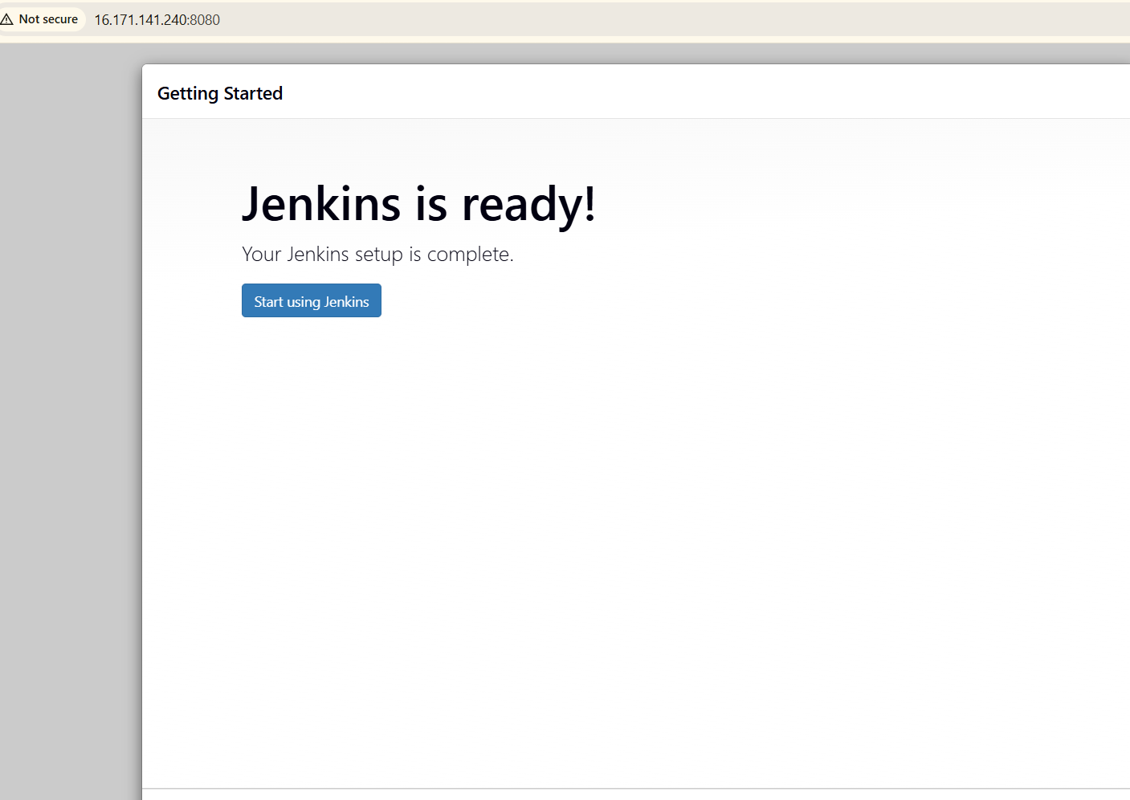
Lets create a new job

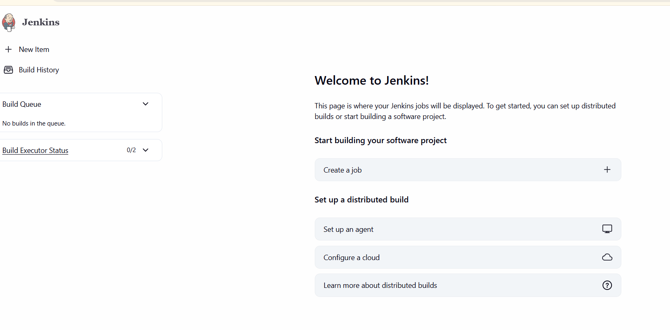
Give name and choose freesyle
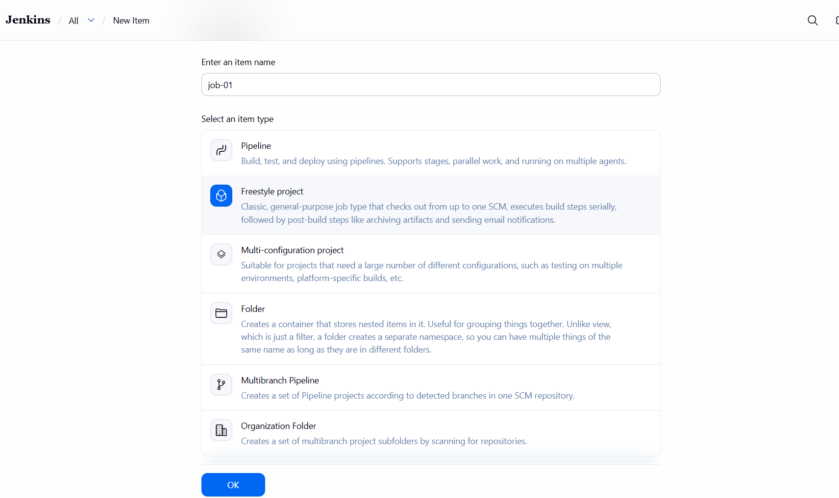
Choose execute shell
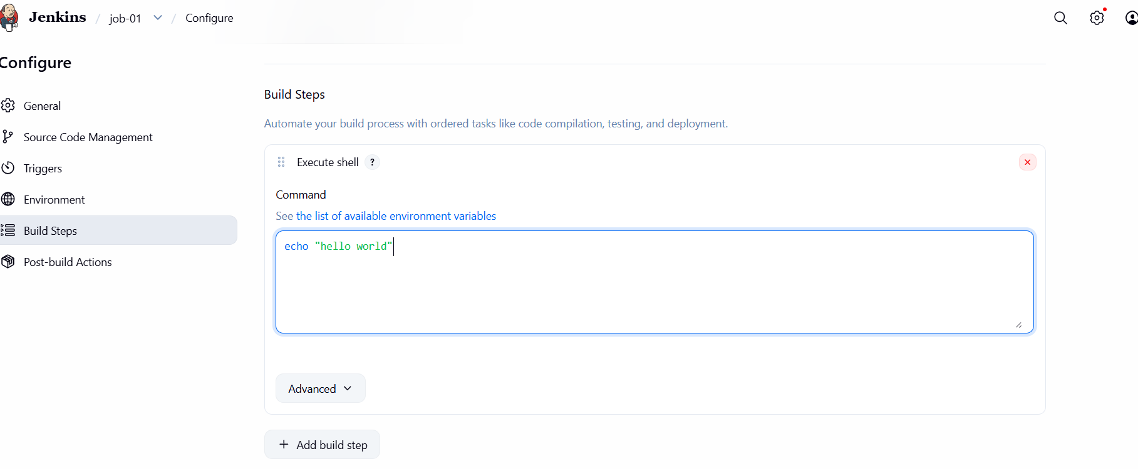
Save the build steps
Click on build now to run the job
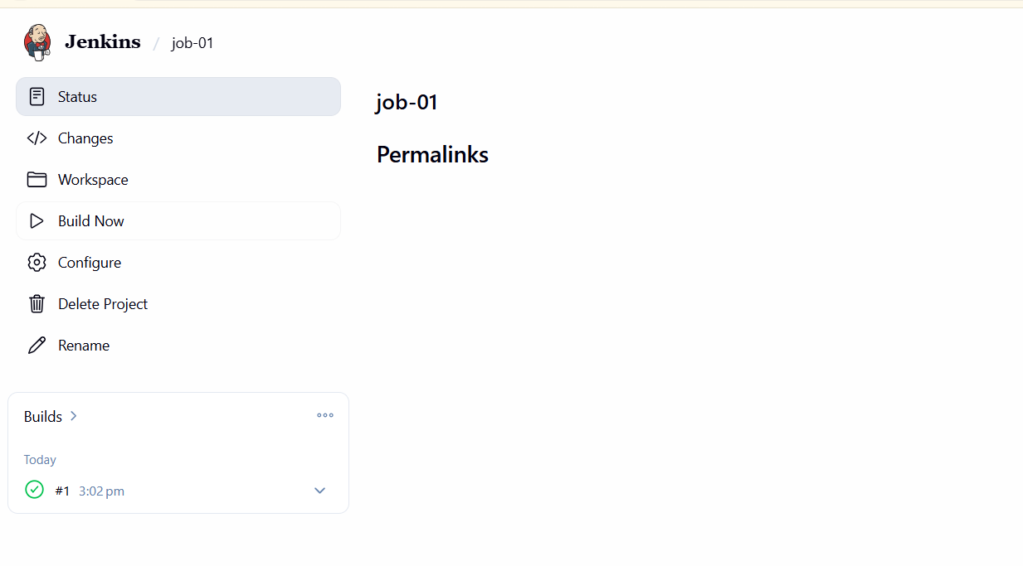
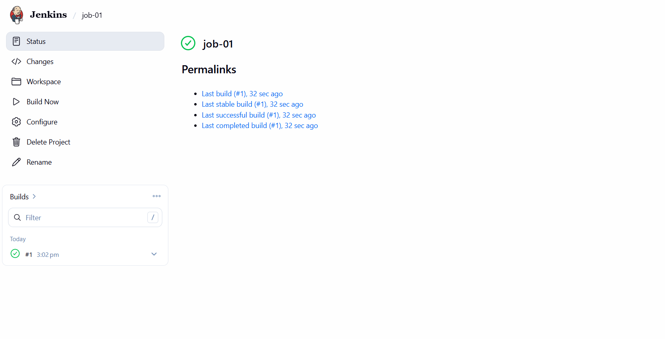
Check the console output
